PHYTOTHERAPY IN CANCER PATIENTS: SURVEY CONDUCTED IN TWO HOSPITALS IN DAKAR (SENEGAL)

ABSTRACT
In Africa and Asia, cancer mortality is proportionally higher than in other regions of the world, certainly due to poorer access to care, but also because the incidence of cancers with a worse prognosis is higher. Faced with this situation and as a therapeutic alternative, some cancer patients resort to traditional medicine, hence the use of whole plants or plant parts as herbal drugs. Indeed, the World Health Organization (WHO) estimates that 80% of the African population still relies on Traditional Medicine (TM) for primary health care. It is in this context that this study was conducted at the General Hospital Idrissa POUYE of Grand Yoff (HOGIP, Dakar/Senegal), in order to identify the different plants used by cancer patients.
Private interviews were conducted to collect ethnobotanical data on medicinal plants used during chemotherapy. For this purpose, a questionnaire was prepared. The survey involved 102 patients in the ENT and surgery departments. Plants were identified based on their vernacular names.
This study allowed us to identify 37 species distributed across 23 families and 34 genera. The most numerous family was Fabaceae. The study revealed a high prevalence of phytotherapy use (87.25%). The most cited species in our study was Annona muricata L. with a citation percentage of approximately 20.83%, followed by Moringa oleifera Lam. (16.67%), then Petroselinum crispum (Mill.) Fuss (11.25%), and finally Guiera senegalensis J.F. Gmel (10.42%). The preparation method with multi-use (simultaneous use of infusions, decoctions that they often mixed with known and/or
unknown powders, hence the term multi-use) was predominant (48.31%). Oral administration was the most commonly used route (94.38%). Leaves were the plant parts most used by patients (83.15%). Regarding dosage, the majority of respondents (33.71%) took their remedies twice a day. The main source of supply for medicinal plants was purchase at the market (51.58%). Finally, most patients were satisfied with the use of medicinal plants (42.82%).
These results offer interesting perspectives for the development of Traditionally Improved Medicines (TIM) based on the results of clinical studies that need to be conducted.
Keywords: cancer, medicinal plants, hospital, traditional medicine, HOGIP, Dakar

INTRODUCTION
Cancer is an anarchic multiplication of abnormal cells that escape cellular control mechanisms [1]. Cancers constitute one of the main causes of morbidity and mortality in the world: approximately 20 million new cancer cases and 9.7 million deaths were recorded in 2022 according to IARC, the WHO specialized agency for cancer research [2].
In Senegal, as in many African countries, patients face difficulties accessing conventional treatments (chemotherapy, radiotherapy, surgery) due to their high cost and the centralization of healthcare infrastructure [2].
In this context, many patients turn to traditional medicine, and more specifically phytotherapy, which is culturally accepted and perceived as more accessible and natural. Previous studies estimate that up to 80% of the African population has used traditional medicine at least once for their primary healthcare needs [2]. Among cancer patients, this proportion is also very high, reaching 87.25% in the studied population [1].
However, this use often occurs without the advice of medical professionals, which exposes patients to risks of plant-drug interactions, toxicity, or delays in the administration of conventional treatments. The lack of scientific data on the plants used, their preparation methods, and their perceived effects constitute an obstacle to integrated and safe care. The main objective of this study was therefore to identify the medicinal plants used by cancer patients followed at the General Hospital Idrissa Pouye (HOGIP) and the Main Hospital of Dakar (HPD), to identify preparation methods, and to evaluate user satisfaction.

- MATERIALS AND METHODS

  - Study Setting and Type
This was a cross-sectional descriptive study conducted over a six-month period, from February to March 2023 (HOGIP). The survey took place mainly in the Surgery and ENT departments of the General Hospital Idrissa Pouye (HOGIP) in Dakar.
  - Study Population
The target population consisted of cancer patients, regardless of the type or stage of the disease, followed at HOGIP. Inclusion criteria were: being over 18 years old, having a confirmed cancer diagnosis, and providing informed consent to participate in the study. Patients with major cognitive disorders or refusing to participate were excluded.
  - Data Collection
Data were collected using a pre-tested, anonymous survey form (Google form). The questionnaire included several sections:
    - Sociodemographic data: age, sex, education level, occupation
    - Clinical data: type of cancer, conventional treatments received
    - Data on phytotherapy use: prevalence of use, reasons for use, plants used (vernacular names), plant parts used, preparation methods, information sources, cost, and perception of efficacy and tolerance
Botanical identification of plant species was carried out based on vernacular names provided by patients, with the help of botany experts and by referring to the ethnobotanical literature of the region.
  - Data Analysis
The collected data were entered and analyzed using Microsoft Excel 2016 software. Qualitative variables were described in terms of frequencies and percentages, while quantitative variables were described by their means and standard deviations. The results were presented in the form of tables and figures.

- RESULTS AND DISCUSSION

The survey was conducted among 102 patients undergoing chemotherapy treatment at the Main Hospital of Dakar (HPD) and the General Hospital Idrissa Pouye (HOGIP). Data collection was conducted directly during treatment sessions.
Demographic Characteristics of the Study Population
The demographic characteristics of the studied population are as follows:

Distribution of respondents by gender
The female sex is more represented, with a percentage of 71.57% compared to the male sex at 28.43%. Figure 1 illustrates the distribution by sex.
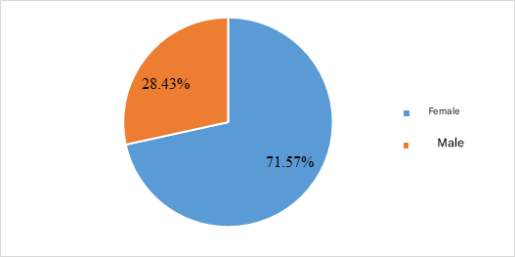

Figure 1 : Distribution of respondents by sex

The distribution of respondents according to age
The age of the patients varies from 11 to over 70 years old. Those aged between 51 and 60 years are the most represented, accounting for 23.53%. Figure 2 illustrates this distribution.

Figure 2 : Distribution of respondents by age

Distribution of respondents according to marital status
Married people make up the largest group, representing 67.65%. Figure 3 illustrates this distribution.
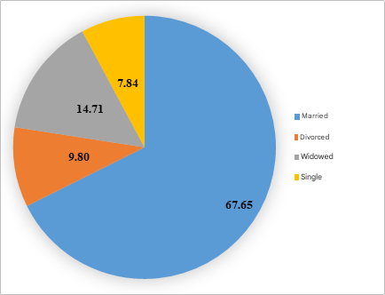

Figure 3 : Distribution of patients according to their marital status

Distribution of respondents according to their level of education
The highest number is that of those not enrolled in school, at 20.59%. The figure below illustrates the distribution.
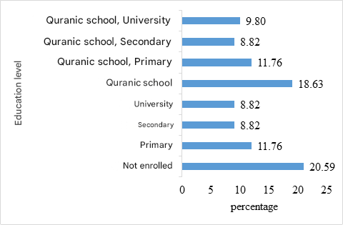

Figure 4 : Distribution of respondents according to their level of education

Distribution of respondents according to place of residence
The largest group is from Dakar, representing 66.67%. The figure below illustrates this distribution.
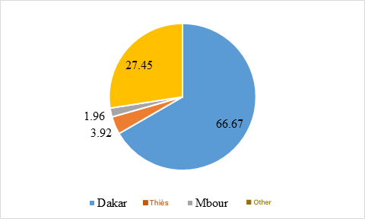

Figure 5 : Distribution of patients according to place of residence

Distribution of respondents according to socio-professional status
The majority of patients are housewives, representing 28%. Figure 6 illustrates the distribution according to the socio-professional status of the respondents.
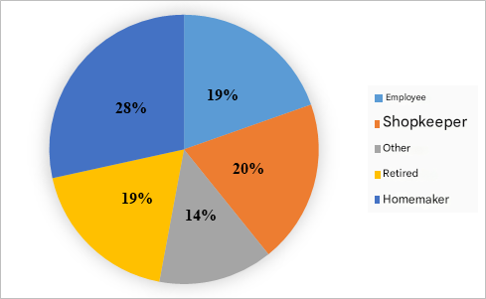

Figure 6 : Distribution of patients according to their socio-professional status

Distribution of respondents according to standard of living
During our study, we found that the standard of living for the majority of patients was somewhat difficult, at a rate of 38.23%. Figure 7 illustrates the distribution according to the respondents' standard of living.
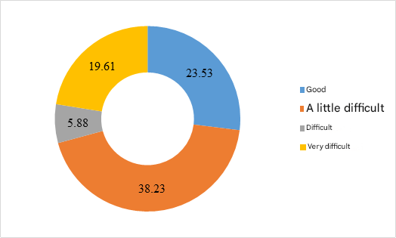

Figure 7 : Distribution according to the respondents' standard of living

Distribution of respondents according to cancer type
The figure below illustrates the distribution of respondents according to the type of cancer.
The number of breast cancer cases predominates with a percentage of 45.10%.
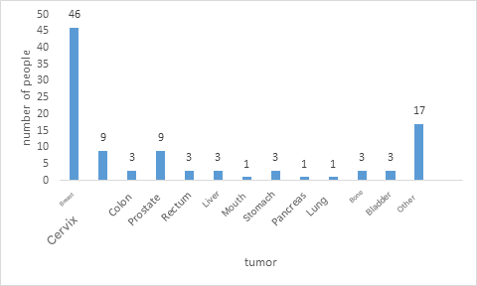

Figure 8 : Distribution according to cancer type
Medicinal Plants and Usage Patterns
Ethnobotanical analysis identified a rich therapeutic biodiversity: 37 plant species belonging to 23 botanical families and 34 different genera. The Fabaceae family stands out as the most represented in this inventory. Table 1 presents the plants most frequently cited by patients.

Table 1: Plants Most Frequently Cited by Patients

No. | Species | Family | Common and Vernacular  Names | Parts Used | Preparation Method
1 | Allium sativum L. | Amaryllidaceae | Garlic (E), Lâji (Wo) | Bulb | Decoction, Powder, Maceration
2 | Mangifera indica L. | Anacardiaceae | Mango tree (E), Mango (Wo) | Leaves | Decoction, Powder, Others
3 | Annona muricata L. | Annonaceae | Soursop (E), Ndélésor (Se) | Leaves, Fruits | Raw, Decoction, Powder, Infusion
4 | Petroselinum crispum (Mill) Fuss | Apiaceae | Parsley (E), Roof (Wo) | Leaves | Decoction, Powder, Infusion, Maceration, Others
5 | Daucus carota L. | Apiaceae | Carrot (E) | Leaves | Decoction, Powder, Others
6 | Elaeis guineensis Jacq. | Arecaceae | Oil palm (E), Garabu tir (Wo) | Leaves | Decoction, Infusion
7 | Aloe vera (L) Burm.f. | Asphodelaceae | Aloe (E) | Leaves | Decoction, Powder
8 | Brassica oleracea L. | Brassicaceae | Cabbage (E) | Leaves | Infusion
9 | Guiera senegalensis  J.F. Gmel | Combretaceae | Nger (Wo) | Roots, Leaves | Infusion
10 | Combretum glutinosum Perr.ex DC. | Combretaceae | Chigomier (F), Ratt (Wo) | Leaves | Decoction
11 | Combretum micranthum G. Don | Combretaceae | Kinkéliba (F), Sexeo (Wo) | Leaves, Fruits | Infusion
12 | Cyperus rotondus L. | Cyperaceae | Diguidié (Wo) | Leaves | Decoction, Infusion
13 | Senna italica (Mill.) Spreng | Fabaceae | African senna (E), Leydour (Wo) | Leaves | Decoction, Maceration, Infusion
14 | Vachellia nilotica (L)P.J.H.Hurter & Mabb | Fabaceae | Nep nep (Wo) | Leaves | Decoction, Maceration
15 | Senna occidentalis L. | Fabaceae | Stinking weed (E), Bantamaré (Wo) | Leaves | Decoction, Maceration
16 | Cassia sieberiana DC. | Fabaceae | Sendiegne (Wo) | Leaves | Decoction, Maceration
17 | Faidherbia albida (Del) Chev. | Fabaceae | Kade (Wo) | Leaves | Decoction, Infusion
18 | Detarium senegalense J.F.Gmel | Fabaceae | Ditax, Ditakh (Wo) | Leaves | Decoction, Infusion
19 | Laurus nobilis L. | Lauraceae | Bay leaf (E) | Leaves | Decoction, Powder, Others
20 | Lawsonia inermis L. | Lythraceae | Henna (E), Fudeun (Wo) | Leaves | Decoction, Powder, Others
21 | Adansonia digitata L. | Malvaceae | Bouye (Wo) | Leaves | Decoction, Powder, Others
22 | Grewia bicolor Juss | Malvaceae | Rabbit baobab (E) | Leaves | Decoction, Powder, Others

Usage Practices and Preparations
Monotherapy was rare. The majority of patients, 78.65%, used several plants in combination, probably seeking a synergy of therapeutic actions.
Regarding preparation methods, they were varied and often combined:
- Multi-use (48.31%): combination of infusions, decoctions, and powders
- Decoctions alone (28.09%)
- Infusions alone (16.85%)

Plant Parts Used
Leaves constituted the main resource, used by 83.15% of patients (74/89). Their availability and ease of harvesting explain this predominance.
Route of Administration
Oral route was predominantly used and represented 94.38% of administration routes. A minority of respondents (2.25%) combined oral route with other routes such as inhalation or gargling.

Dosage
The most common frequency of intake was 2 times per day, adopted by 33.71% of patients, demonstrating an established therapeutic routine.
Supply Channels
- Local markets (51.68%)
- At home (8.99%)
- Mixed: home and market (7.86%)
- Traditional practitioners (7.86%)
- Gifts (5.62%)
Patient Satisfaction
- Satisfied patients: 42.82%
- Mixed opinions: 20.22%
- Somewhat satisfied: 17.98%
- Disappointed: 17.98%
The plants help to alleviate the side effects of chemotherapy (vomiting, weight loss, and a general decline in health, etc.).
Our study showed that 87.25%, or eighty-nine patients, reported having used medicinal plants for treatment. This fairly high percentage could be explained by the fact that medicinal plants are more accessible than modern medicine. It could also be due to the fact that medicinal plants appear harmless and are considered by the population as gentle medicine as opposed to medicine consisting of chemical drugs [1].
In our study, regarding tumor locations, we noted a predominance of breast cancer with a percentage of 45.10% followed by cervical cancer with a rate of 8.82%. Indeed, epidemiologically according to IARC, breast cancer was the most frequent in 2020, which confirms our results.
During our survey, we found that plants were more often used in combination with a percentage of 78.65%. However, the most cited medicinal plants were Annona muricata
L. with a citation percentage of 20.83% followed by Moringa oleifera Lam. with 16.67%.
The predominance of Annona muricata L. is remarkable compared to other plants, and this could be justified by its long history of traditional use due to its therapeutic potential, particularly anti-inflammatory, antioxidant, insecticidal, and cytotoxic for tumor cells [3]. Moreover, Annona muricata L., also called Graviola, is a fruit tree of the Annonaceae family cultivated in tropical and subtropical regions of the world. Its fruits, leaves, seeds, and roots have multiple uses in traditional medicine [4]. The aerial parts of Graviola have been extensively studied with several in vitro and in vivo pharmacological activities reported, and have proven effective in managing several types of cancer [5].
According to another study, out of 150 patients who reported using plant-based remedies used as food, Annona muricata L. (soursop) was the most popular species. Indeed, during this study, 80.7% of respondents stated using its leaves, bark, fruits, and seeds [6].
Regarding the preparation method, the majority of patients took several methods simultaneously (infusions, decoctions, powders), or 48.31%. Then we had those who only took decoctions (28.09%), and infusions (16.85%). Other authors reported that during their surveys, decoctions were the most used with a percentage of 59.23% followed by infusions with a percentage of 15.38%.
During our study, we noticed that the oral route was the most used (94.38%). Then, we had inhalation and gargling (2.25%). Our results were similar to those of a study conducted in Burkina Faso, which found that 65% of plant-based products are administered orally and 35% in external applications [7].
The parts of medicinal plants most used during our study were leaves (83.15%). Moreover, the same study conducted in Burkina Faso showed that leaves were the most used plant part [8].
The majority of patients obtained medicinal plants from the market (51.68%), at home (8.99%), both at home and at the market (7.86%), and from traditional practitioners (7.86%). Sometimes medicinal plants are acquired as gifts (5.62%), purchased at the supermarket, or harvested in fields or forests.

According to the distribution of patient satisfaction levels, those who were satisfied were the most numerous (42.82%), followed by those who were somewhat satisfied (17.98%). Disappointed patients had the same percentage as those who were somewhat satisfied (17.98%). Finally, those who had mixed opinions represented 20.22% of the surveyed patients. Our results corroborate those of another study reporting that patients satisfied following treatment with medicinal plants were in the majority with a rate of 53% [9].

CONCLUSION
This study confirms that phytotherapy is an extremely widespread practice among cancer patients in Senegal. It highlights the diversity of plants used, with a strong predominance of Annona muricata L., and the complexity of preparation methods. The use of these traditional remedies is deeply rooted in a cultural and social context where modern medicine sometimes remains inaccessible or insufficient to meet all patient expectations.
Faced with this reality, it is imperative to promote open and non-judgmental dialogue between patients and healthcare professionals. Better knowledge of the plants used,
their potential pharmacological effects, and their toxic risks is essential to ensure patient safety. More in-depth research, particularly phytochemical and pharmacological studies on the most cited species, is necessary to scientifically validate their use and potentially integrate them safely into the therapeutic arsenal. The development of Traditionally Improved Medicines paves the way for the development of medicinal plant-based formulations. Finally, training healthcare professionals on the realities of traditional medicine could improve the overall and integrative care of cancer patients
Consent
As per international standards or university standards, patient(s) written consent has been collected and preserved by the author(s).

Disclaimer (Artificial intelligence)

Author(s) hereby declare that NO generative AI technologies such as Large Language Models (ChatGPT, COPILOT, etc.) and text-to-image generators have been used during the writing or editing of this manuscript.

REFERENCES
  - Artru P, Bennouna J, Lievre A, Ducreux M, Lledo G. Metastatic colorectal cancer: To stop or not to stop? Bull Cancer. 2018; 105(4): 408-414.
  - Clin, B., & Pairon, J.-C. (2022). Occupational risk factors for bronchopulmonary cancers, epidemiological data, identification of exposures and medico-social issues: Asbestos as a paradigm. Revue des Maladies Respiratoires Actualités, 14(2, Supplement 1): 2S5-2S9. https://doi.org/10.1016/S1877-1203(22)00094-5
  - Prescrire Editorial Staff. Phytotherapy: rarely spontaneously reported. Prescrire. 2006; 26(268): 27.
  - Djabir Daddiouaissa, Azura Amid, Neissereldeen A Kabbashi, Fazia AA Fuad, Ahmed M. Elnour, Mohamad AKMS Epandy. Antiproliferative activity of ionic liquid graviola fruit extract against human breast cancer cell lines (MCF-7) using flow cytometry technique. J Ethnopharmacol, 2019.

  - Islam Rady et al. Anticancer properties of graviola (Annona muricata): A comprehensive mechanistic review. Oxidative Medicine and Cellular Longevity, 2018.
  - Yuri N. Clement, et al. Herbal remedies and functional foods used by cancer patients attending specialist oncology clinics in Trinidad. BMC Complement Altern Med. 2016; 16: 399.
  - Kampadilemba Ouoba, Hélène Lehmann, Arsène Zongo, Jean-Yves Pabst, Rasmané Semdé. Prevalence of use and adverse events of traditional pharmacopoeia medicines in Burkina Faso: a population-based cross-sectional survey. Ann Pharm Françaises. 2021.
  - Patrice Zerbo, Jeanne Millogo-Rasolo-dimby, Odile Germaine Nacoulma-Ouedraogo, Patrick Van Damme. Medicinal plants and practices in Burkina Faso: The case of the Sanan. Bois et Forêts des Tropiques, 2011, N°307 (1).
  - Nafissatou GUIRE. Plants used by cancer patients at the YALGADO OUEDRAOGO University Hospital Center. Thesis N°, 2022.

