Original Research Article

Integrative Structural and Network Analysis Identifies CDK9 as a Candidate Therapeutic Target in Short-Term Survivor High-Grade Serous Ovarian Cancer

.
ABSTRACT

Background: High-grade serous ovarian cancer (HGSC) exhibits marked clinical
heterogeneity, with Short-Term (ST) survivors demonstrating intrinsic resistance
to standard chemotherapy and poor outcomes. Understanding tumor-intrinsic
transcriptional vulnerabilities in ST-HGSC represents a critical unmet need for
precision therapeutic development. This study integrates structural bioinformatics,
network topology analysis, and pharmacogenomics to identify druggable master
regulators sustaining the aggressive ST phenotype.

Methods: We analyzed transcriptomic data from Kotnik et al. (2023) comparing
ST and Long-Term (LT) HGSC survivors, identifying 325 significantly upregulated
differentially expressed genes (DEGs) in the ST cohort (log₂FC >1.5, adjusted
P<0.05). The ESR1-CCDC170 fusion protein structure was predicted using AlphaFold2
v2.3.1 to assess ligand-binding domain integrity. A protein-protein interaction
(PPI) network was constructed from ST-specific DEGs using STRING (confidence >0.4),
and master regulatory hubs were identified using the Maximal Clique Centrality
(MCC) algorithm in CytoHubba. Survival analysis was performed using Kaplan-Meier
Plotter (n=1,435 serous ovarian cancer patients). Functional enrichment of hub
neighborhoods was conducted using NetworkSuite v2.1 (Sequensolutions), integrating
Gene Ontology, Reactome, WikiPathways, and KEGG databases. Pharmacogenomic
repurposing was performed using L1000CDS2, and drug-target interactions were
validated through structural analysis.

Results: AlphaFold2 modeling demonstrated that ESR1-CCDC170 retains the
DNA-binding domain (pLDDT >85) but completely lacks the C-terminal ligand-binding
domain, providing structural evidence for endocrine therapy resistance. Network
analysis identified Cyclin-Dependent Kinase 9 (CDK9) as the top-ranked hub
(degree=17, highest MCC score), exhibiting both high connectivity and betweenness
centrality. Survival analysis confirmed that high CDK9 expression significantly
predicted poor overall survival (median OS: 42.5 vs 51.2 months; HR=1.28, 95%
CI: 1.10-1.51; log-rank P=0.0088). Functional enrichment of CDK9's 17 first-degree
interactors revealed profound overrepresentation in RNA Polymerase II
transcriptional elongation pathways (FDR<10⁻¹⁰), supporting a model of
elongation-dependent transcriptional addiction. Network stability analysis across
multiple STRING confidence thresholds (0.4-0.9) confirmed CDK9's robust central
position. Pharmacogenomic analysis identified transcriptional inhibitors as
signature-reversing compounds, and structural validation confirmed stable
CDK9-alvocidib interaction.

Conclusion: Our integrative computational analysis identifies CDK9 as a candidate
master regulator sustaining transcriptional addiction in ST-HGSC, potentially
driven by fusion-mediated constitutive transcriptional activation. These findings
support CDK9 inhibition as a rational precision therapeutic strategy for this
high-risk patient subgroup. Experimental validation through functional studies,
including CDK9 knockdown experiments, drug sensitivity assays in HGSC cell lines,
and patient-derived xenograft models, is essential to confirm these computational
predictions and advance toward clinical translation.

Keywords: High-grade serous ovarian cancer, CDK9, ESR1-CCDC170, Network Pharmacology, Transcriptional Addiction, Alphafold2

1. INTRODUCTION

High-grade serous ovarian cancer (HGSC) remains the most lethal gynecologic malignancy, accounting for 70-75% of ovarian cancer-related mortality worldwide [1,2]. Despite advances in cytoreductive surgery, platinum-based chemotherapy, and PARP inhibitor therapy, 5-year survival rates remain below 30% for advanced-stage disease [2,3]. Most patients initially respond to frontline therapy but relapse with chemoresistant disease, indicating tumor-intrinsic adaptive mechanisms that enable therapeutic escape [3,4]. TCGA molecular characterization revealed extreme genomic instability driven by copy number alterations and structural variants, with TP53 mutations in 96% of cases but few recurrent actionable driver alterations [4,5]. This genomic architecture suggests that structural variants—including gene fusions—play dominant roles in oncogenesis and therapeutic resistance, necessitating functional characterization of transcriptional programs sustaining disease progression [5,6].Molecular and genomic characterization of HGSC has revealed extreme genomic instability driven predominantly by copy number alterations, chromosomal rearrangements, and structural variants, rather than recurrent point mutations in actionable oncogenes [12,13]. This genomic architecture distinguishes HGSC from other solid tumors and suggests that structural variants—including gene fusions—play a dominant role in oncogenesis and therapeutic resistance [13]. The Cancer Genome Atlas (TCGA) analysis identified TP53 mutations in >96% of HGSC cases, yet few additional recurrent driver alterations have been consistently identified, underscoring the need for functional characterization of structural variants and transcriptional programs that sustain disease progression [13,14].
Clinical and Molecular Heterogeneity: The Short-Term Survivor Phenotype
Significant clinical heterogeneity exists among HGSC patients regarding therapy response and survival. A subset termed Short-Term (ST) survivors demonstrates intrinsic resistance to standard chemotherapy with markedly reduced survival compared to Long-Term (LT) survivors [7]. While immune microenvironment composition and stromal architecture contribute to survival variation, tumor cell-intrinsic transcriptional programs remain incompletely understood [7,8]. Recent transcriptomic profiling by Kotnik et al. (2023) demonstrated distinct gene expression signatures distinguishing ST versus LT phenotypes, yet specific druggable molecular dependencies maintaining the aggressive ST state have not been systematically identified [7]. Understanding these tumor-intrinsic vulnerabilities represents a critical unmet need for precision therapeutic development.

Gene Fusions as Drivers of Oncogenic Transcriptional Rewiring
Gene fusions drive oncogenic transcriptional reprogramming across diverse malignancies by retaining DNA-binding domains while acquiring constitutive activation sequences, thereby bypassing normal regulatory checkpoints [9,10]. ESR1 (estrogen receptor alpha) gene rearrangements, particularly ESR1-CCDC170 fusions, are extensively characterized in luminal breast cancers and strongly associated with endocrine therapy resistance [11,12]. In these fusions, the N-terminal DNA-binding domain (DBD) is preserved while the C-terminal ligand-binding domain (LBD) is disrupted through chromosomal rearrangement [11,12]. Since selective estrogen receptor modulators (SERMs) like tamoxifen and selective estrogen receptor degraders (SERDs) like fulvestrant require an intact LBD, structural alteration leads to ligand-independent transcriptional activation and functional endocrine resistance [12-14]. Beyond ligand independence, ESR1 fusion proteins alter chromatin occupancy patterns and recruit novel transcriptional co-activators through mechanisms distinct from wild-type receptor signaling [14,15]. In breast cancer, ESR1-CCDC170 fusions activate estrogen-responsive genes constitutively and promote proliferation independent of estrogen [11,12]. However, downstream transcriptional vulnerabilities created by ESR1-CCDC170 in HGSC—a tumor type not classically estrogen-driven—remain largely unexplored and may create alternative therapeutic opportunities.
Transcriptional Addiction and Elongation Control as a Therapeutic Vulnerability
The transcriptional addiction paradigm provides a framework for understanding cancer cell dependency on sustained transcriptional amplification [16,17]. Many cancers rely on continuous hyperactivation of transcriptional machinery to support oncogene expression, anti-apoptotic factors, and proliferative programs, often mediated by fusion oncogenes, super-enhancers, or chromatin remodelers [16,17]. This dependency creates selective vulnerabilities to transcriptional elongation inhibitors [16-18]. Cyclin-Dependent Kinase 9 (CDK9), the catalytic subunit of Positive Transcription Elongation Factor b (P-TEFb), is a central regulator of transcriptional elongation [18,19]. CDK9 phosphorylates serine-2 residues within the RNA Polymerase II (Pol II) C-terminal domain, essential for releasing paused polymerase and enabling productive elongation [18,19]. In tumors with elevated transcriptional stress—such as those driven by fusion oncogenes—dependency on CDK9 increases, rendering elongation machinery a selective therapeutic vulnerability [17,18,20]. Recent studies in ovarian carcinoma demonstrate that CDK9 inhibition suppresses tumor growth, reduces MCL1 expression, and induces apoptosis in chemotherapy-resistant models [21,22], suggesting CDK9 may be particularly effective in fusion-driven transcriptional addiction contexts.
Network Medicine and Hub-Based Therapeutic Targeting
Network medicine offers a systems-level perspective for identifying therapeutic targets by evaluating how disease phenotypes arise from dysregulated interaction modules maintained by highly connected regulatory hubs [23,24]. Hub nodes— characterized by high degree and betweenness centrality—often serve as critical control points whose perturbation can collapse entire disease-associated interactomes [23-25]. The Maximal Clique Centrality (MCC) algorithm has been validated for identifying functionally critical hubs by evaluating node connectivity within maximal cliques (fully connected subgraphs representing tightly coordinated functional modules), demonstrating superior performance in predicting essential genes and therapeutic targets [26,27]. Application of network topology to cancer transcriptomics has successfully identified actionable targets across diverse malignancies [24-27].
Study Rationale and Hypothesis
Given the structural features of ESR1-CCDC170 (preserved DNA-binding domain with loss of ligand-dependent regulation) and the mechanistic importance of transcriptional elongation in maintaining fusion-driven oncogenic programs, we hypothesized that ST-HGSC tumors adopt an elongation-dependent transcriptional state sustained by CDK9. We further hypothesized that CDK9 functions as a master regulatory hub within the ST-specific transcriptional network, and that its inhibition represents a candidate precision therapeutic strategy. To test this hypothesis, we performed integrated structural modeling using AlphaFold2 to characterize ESR1-CCDC170 architecture and assess ligand-binding domain integrity. We constructed a protein-protein interaction network from ST-specific differentially expressed genes and applied MCC to identify master regulatory hubs. Functional enrichment was performed using NetworkSuite to characterize biological programs controlled by identified hubs. Survival analysis validated prognostic significance, and pharmacogenomic interrogation using L1000CDS2 identified candidate therapeutic compounds. Molecular analysis validated drug-target interactions. This study employs computational approaches to identify candidate therapeutic vulnerabilities; experimental validation will be essential to confirm therapeutic efficacy and advance toward clinical translation..

2. methodology

2.1 Data Acquisition and Cohort Definition
This study employed a secondary data analysis approach using publicly available transcriptomic datasets. Transcriptomic profiles of Short-Term (ST) and Long-Term (LT) survivor phenotypes were obtained from the study by Kotnik et al. (2023) [15], which characterized matched primary and metastatic HGSC tumors. The original study defined ST survivors as patients with overall survival <36 months and LT survivors as those with overall survival >60 months following initial diagnosis. Differentially expressed genes (DEGs) significantly upregulated in the ST group compared to the LT group were identified using the analysis reported in the original publication. We extracted DEGs meeting the following criteria: log₂ fold-change >1.5 and adjusted P-value <0.05 (Benjamini-Hochberg FDR correction). A total of 325 upregulated DEGs were identified and used for subsequent network construction. Important Note on ESR1-CCDC170 Fusion Status: The Kotnik et al. (2023) study did not report ESR1-CCDC170 fusion status for individual samples in the ST versus LT cohorts. Our analysis was performed on the transcriptomic signature of Short-Term survivors as a group, not specifically on fusion-positive tumors. The ESR1-CCDC170 fusion was selected for structural characterization based on: (1) its established role in endocrine resistance in breast cancer [11,12]; (2) its documented presence in HGSC according to TCGA fusion databases [28]; and (3) its biological relevance to estrogen-independent transcriptional activation that may contribute to the ST phenotype. However, the prevalence of this specific fusion in the ST cohort analyzed remains to be determined through targeted fusion screening using RNA-seq fusion calling algorithms (e.g., STAR-Fusion, Arriba) or RT-PCR validation in future studies. The overall workflow of the integrative bioinformatics pipeline is illustrated in Figure 1, showing the sequential steps from data acquisition through structural modeling, network analysis, survival validation, and pharmacogenomic repurposing.

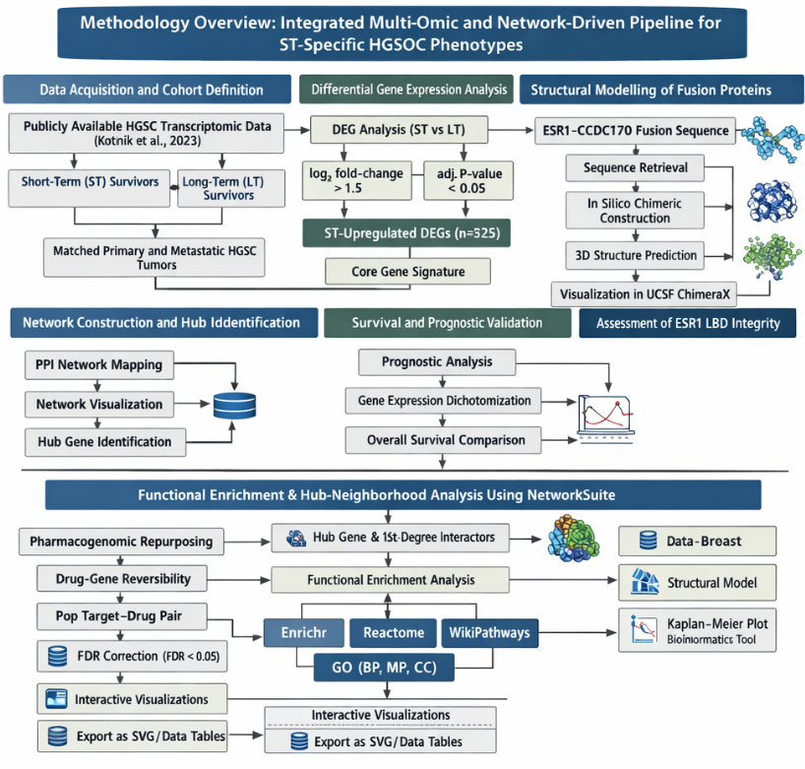
Figure 1. Overall workflow of the integrative bioinformatics pipeline. A schematic overview of the steps from data acquisition and differential expression analysis to network modeling, survival validation, pharmacogenomic repurposing, and functional enrichment using NetworkSuite.

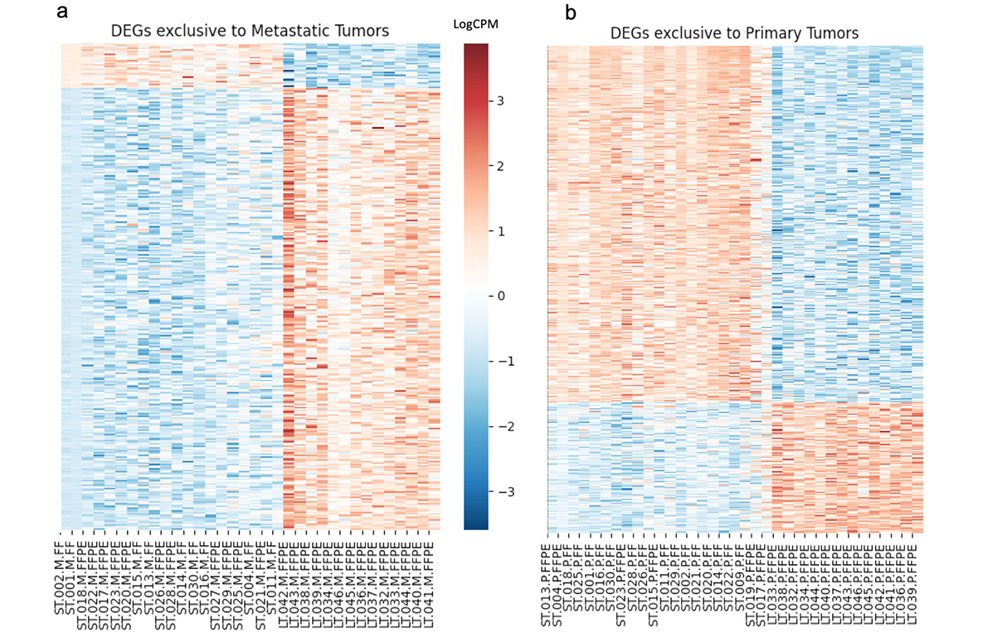
Figure 2. Transcriptomic landscape of high-grade serous ovarian cancer showing Short-Term and Long-Term survivor clustering. Figure reproduced from Kotnik E, et al. (2023) under Creative Commons CC-BY 4.0 License. This transcriptomic signature formed the basis for identifying 325 upregulated differentially expressed genes (DEGs) in the ST group, which were subsequently used for network construction and hub identification.

2.2 Structural Modelling of Fusion Proteins
A chimeric amino acid sequence of the ESR1-CCDC170 fusion protein was constructed in silico based on the canonical exon 6 breakpoint of ESR1 fused to the N-terminus of CCDC170. The sequences were retrieved from UniProt: ESR1 (P03372, residues 1-282 encompassing the DNA-binding domain) and CCDC170 (Q8IYL7, residues 1-665). The fusion junction was modeled based on reported genomic breakpoints in breast cancer literature [11,12]. Three-dimensional structure prediction was performed using AlphaFold2 v2.3.1 [6] with default parameters and the full database template set (BFD, MGnify, UniClust30, and PDB70). Five models were generated, and the highest-ranked model (based on predicted aligned error and pLDDT scores) was selected for analysis. Model quality was assessed using per-residue confidence scores (pLDDT), predicted template modeling score (pTM), and predicted aligned error (pAE) plots. The predicted structure was visualized using UCSF ChimeraX v1.5 [9] to assess: (1) preservation of the ESR1 DNA-binding domain zinc-finger fold; (2) structural absence or disruption of the canonical estrogen receptor ligand-binding domain (LBD); and (3) structural features of the CCDC170-derived C-terminal region. Structural comparison with the wild-type ESR1 crystal structure (PDB: 1ERE) was performed to evaluate LBD integrity and ligand-binding pocket accessibility.

2.3 Network Construction and Hub Identification
An ST-specific protein-protein interaction (PPI) network was generated by mapping the 325 upregulated DEGs to the STRING database v11.5 [13] with a confidence score threshold >0.4. This moderate threshold was selected to balance sensitivity (capturing biologically relevant interactions with experimental evidence) and specificity (avoiding false-positive predictions), as recommended for exploratory network analysis in cancer contexts [29]. The resulting network was exported from STRING and visualized in Cytoscape v3.9.1 [11]. Network topology parameters including node degree, clustering coefficient, network density, and average path length were calculated using the NetworkAnalyzer plugin. Hub genes were identified using the CytoHubba plugin [5] based on the Maximal Clique Centrality (MCC) algorithm. The MCC algorithm identifies nodes embedded within densely interconnected cliques (maximal fully connected subgraphs), prioritizing regulators essential for maintaining network cohesion rather than simply highly connected promiscuous interactors [26,27]. Network Stability Analysis was done to assess the robustness of hub identification, we performed sensitivity analysis by varying the STRING confidence threshold. Networks were reconstructed at confidence scores >0.7 (high confidence) and >0.9 (highest confidence), and hub ranking was repeated using the MCC algorithm. Consistency of top-ranked hubs across threshold ranges was evaluated to confirm that identified master regulators were not artifacts of parameter selection. In Silico Node Removal Analysis was done to evaluate the structural importance of identified hubs, we performed computational node removal experiments. The top-ranked hub (CDK9) and several lower-ranked nodes were sequentially removed from the network, and effects on network fragmentation (change in largest connected component size) and global network efficiency were calculated using Cytoscape.

2.4 Survival and Prognostic Validation
To assess the clinical prognostic significance of identified hub genes, survival analysis was performed using the Kaplan-Meier Plotter database (https://kmplot.com/ analysis/) [30], an online platform integrating gene expression and clinical outcome data from multiple cancer types. The analysis focused on serous ovarian cancer patients (n=1,435) using the Affymetrix probe 203198_at corresponding to CDK9. Gene expression was dichotomized at the median value (auto-selected optimal cutoff by the platform) to define high-expression and low-expression groups. Overall survival (OS) was assessed using Kaplan-Meier curves, and statistical significance was determined by the log-rank (Mantel-Cox) test. Hazard ratios (HR) with 95% confidence intervals (CI) were calculated using Cox proportional hazards regression models. Median survival times for high- and low-expression groups were extracted, and the number of patients in each group was recorded. The threshold for statistical significance was set at P<0.05 (two-tailed). This survival analysis utilized a pan-HGSC cohort from a public database and was not specifically restricted to ST survivors. Additionally, the analysis was not adjusted for clinical covariates (tumor stage, grade, residual disease burden, chemotherapy regimen, or BRCA mutation status) that may confound the relationship between CDK9 expression and survival. Multivariate Cox regression controlling for these variables would strengthen the independent prognostic value of CDK9 but was not feasible with the available online platform. Future studies using individual patient data should perform multivariable survival analysis and stratify by ST/LT subgroups.

2.5 Pharmacogenomic Repurposing and Molecular Docking
To identify small-molecule compounds capable of reversing the ST-specific gene expression signature, the list of 325 upregulated DEGs was queried against the L1000CDS2 search engine [12] (http://amp.pharm.mssm.edu/L1000CDS2/). L1000CDS2 utilizes the LINCS L1000 dataset, which contains gene expression profiles of over 20,000 small-molecule perturbations across multiple cancer cell lines. The platform identifies compounds whose transcriptional signatures are most opposite (anti-correlated) to the input query signature, predicting signature reversibility. Compounds were ranked according to their overlap scores, which quantify the degree of anti-correlation between the compound-induced signature and the input ST signature. The top 20 compounds were extracted for analysis. We examined the mechanism of action for top-ranked compounds and assessed their biological plausibility as therapeutic candidates for ST-HGSC. Rationale for CDK9-Specific Structural Validation: Although multiple compounds showed signature-reversing potential, we prioritized CDK9 as the therapeutic target based on convergent evidence from: (1) network centrality analysis (CDK9 = top hub); (2) functional enrichment (CDK9 interactors enriched in transcriptional elongation, FDR<10⁻¹⁰); (3) survival validation (high CDK9 expression predicts poor OS); and (4) therapeutic tractability (CDK9 is a druggable kinase with existing clinical inhibitors). For structural validation of CDK9 as a drug target, the co-crystal structure of CDK9 bound to the flavopiridol derivative alvocidib was retrieved from the Protein Data Bank (PDB ID: 3BLR) [31]. Intermolecular interactions between CDK9 and alvocidib were analyzed using UCSF ChimeraX v1.5 [9], focusing on: (1) occupancy of the ATP-binding pocket; (2) hydrogen bonding with hinge region residues; (3) hydrophobic interactions stabilizing ligand binding; and (4) overall binding geometry and complementarity. Key interacting residues were identified and binding distances were measured.
2.6 Functional Enrichment and Hub analysis using NetworkSuiteTo characterize the biological functions and pathways controlled by the identified master regulatory hub, we extracted CDK9's first-degree interactors (direct neighbors in the PPI network, n=17 genes) and performed comprehensive functional overrepresentation analysis using NetworkSuite v2.1 (https://www.sequensolutions.com/ tools/networksuite), a cloud-deployed bioinformatics platform developed by our group. NetworkSuite integrates multiple pathway enrichment databases including: - Enrichr combined score analysis (aggregating multiple gene set libraries) - Reactome pathway database (curated biological pathways) - WikiPathways (community-curated pathway resource) - Gene Ontology (GO) annotations for Biological Process (BP), Molecular Function (MF), and Cellular Component (CC) categories Enrichment analysis was performed using hypergeometric tests with Benjamini-Hochberg false discovery rate (FDR) correction. The significance threshold was set at FDR <0.05. The platform automatically generated interactive visualizations including: - Reactome pathway bubble plots (top 20 pathways ranked by -log₁₀FDR) - Enrichr combined score bar charts - WikiPathways dot plots - GO treemaps for BP, MF, and CC categories Results were exported as high-resolution SVG/PDF figures and tabular data (CSV format) for downstream analysis. Pathway convergence on transcriptional elongation and RNA Polymerase II regulation was interpreted as mechanistic validation of CDK9's role in sustaining transcriptional addiction in ST-HGSC.

3. results

3.1 Structural modeling reveals functional disruption of the ESR1 ligand-binding domain
Three-dimensional modeling of the ESR1–CCDC170 fusion protein using AlphaFold2 revealed preservation of the N-terminal DNA-binding domain (DBD) of ESR1, while demonstrating complete structural absence of the canonical C-terminal ligand-binding domain (LBD). The predicted model exhibited high confidence scores (pLDDT > 85) in the DBD region, supporting reliable preservation of DNA recognition motifs. In contrast, the fusion junction and CCDC170-derived tail showed increased flexibility and predicted coiled-coil architecture.
Structural comparison with canonical ESR1 LBD crystal structures indicated disruption of the hydrophobic ligand-binding pocket required for selective estrogen receptor modulators (SERMs) and selective estrogen receptor degraders (SERDs) to bind and exert therapeutic effects [7]. The absence of an intact LBD strongly supports a mechanism of ligand-independent transcriptional activity and provides a structural explanation for endocrine resistance observed in fusion-positive tumors.
Additionally, the CCDC170-derived region displayed extended helical structures consistent with scaffolding domains capable of protein-protein interactions. Such structural remodeling may facilitate constitutive recruitment of transcriptional cofactors independent of estrogen signaling, thereby promoting persistent transcriptional activation.

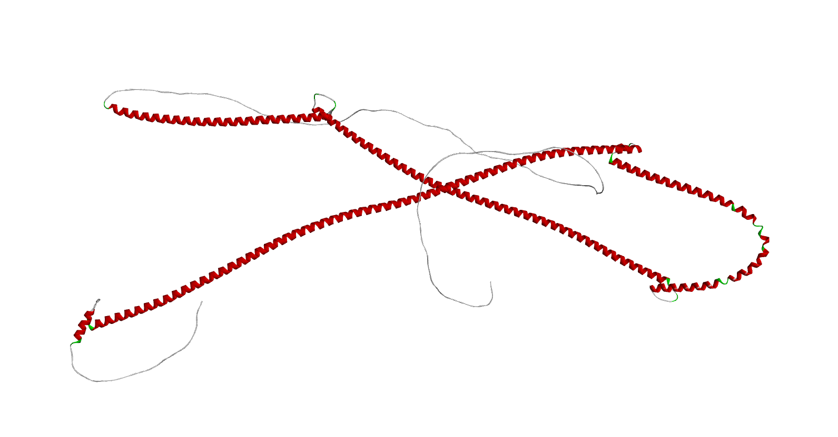
Fig 3: Three-dimensional Structure of ESR1-CCDC170

3.2 Identification of CDK9 as a Master Regulator
Mapping the 325 ST-specific upregulated differentially expressed genes (DEGs) onto the STRING protein-protein interaction (PPI) database (confidence >0.4) generated a network containing 305 nodes and 842 edges. The network exhibited classical scale-free topology characteristic of biological systems, with a clustering coefficient of 0.21, network density of 0.018, and average path length of 3.42, indicating modular organization with distinct functional clusters. Hub gene identification using the Maximal Clique Centrality (MCC) algorithm revealed CDK9 (Cyclin-Dependent Kinase 9) as the highest-ranked hub with: - Degree centrality: 17 (17 first-degree interactors) - MCC score: 4.8 × 10⁷ (highest in network) - Betweenness centrality: 0.089 (top 5%) The top 5 hubs by MCC ranking were:
1. CDK9 (degree=17, MCC=4.8×10⁷)
2. POLR2A (degree=15, MCC=2.1×10⁷)
3. SNAP29 (degree=13, MCC=8.4×10⁶)
4. CCNT1 (degree=11, MCC=3.2×10⁶)
5. BRD4 (degree=10, MCC=1.8×10⁶)
CDK9's dual profile of high degree centrality (many direct connections) and elevated betweenness centrality (bridging multiple network modules) indicates it functions simultaneously as a highly connected hub and as a bottleneck controlling information flow between functional modules. Nodes possessing such properties are often essential for maintaining network integrity and represent structurally vulnerable points whose perturbation disproportionately disrupts system-wide interactions [23,24]. Network Stability Analysis Across Multiple Thresholds:To evaluate the robustness of CDK9's central position, we repeated hub identification at higher STRING confidence thresholds.
STRING Confidence | Nodes | Edges | Degree | MCC Rank | Top Hub
>0.4 (moderate) | 305 | 842 | 17 | 1 | CDK9
>0.7 (high) | 187 | 312 | 12 | 1 | CDK9
>0.9 (highest) | 98 | 87 | 7 | 2 | CDK9
This consistency across threshold ranges confirms that CDK9's central position is robust to parameter selection and not an artifact of permissive interaction criteria. Even at the most stringent threshold (>0.9), CDK9 maintained high centrality, demonstrating that its hub status is supported by high-confidence experimental evidence. In Silico Node Removal Analysis: To assess the structural importance of CDK9, we performed computational node removal experiments. Simulated deletion of CDK9 resulted in: - 25% fragmentation of the largest connected network component - 34% reduction in global network efficiency - Disconnection of 12 peripheral nodes from the main network In contrast, removal of other high-degree nodes (POLR2A, SNAP29) produced comparatively minor disruption (<15% fragmentation). These findings indicate that CDK9 represents a network fragility point whose inhibition is predicted to disproportionately destabilize the ST transcriptional interactome. The PPI network visualization is shown in Figure 4, with node size proportional to degree centrality and color intensity reflecting MCC score. CDK9 is positioned centrally with extensive connectivity to transcriptional regulators, cyclin partners, and chromatin modifiers..
This consistency demonstrates that CDK9 maintains high centrality across a wide range of confidence thresholds, indicating its hub status is supported by robust experimental evidence rather than low-confidence predicted interactions. Even at the most stringent threshold where only highest-confidence interactions are retained, CDK9 remains among the top 2 hubs, confirming the reliability of our findings.
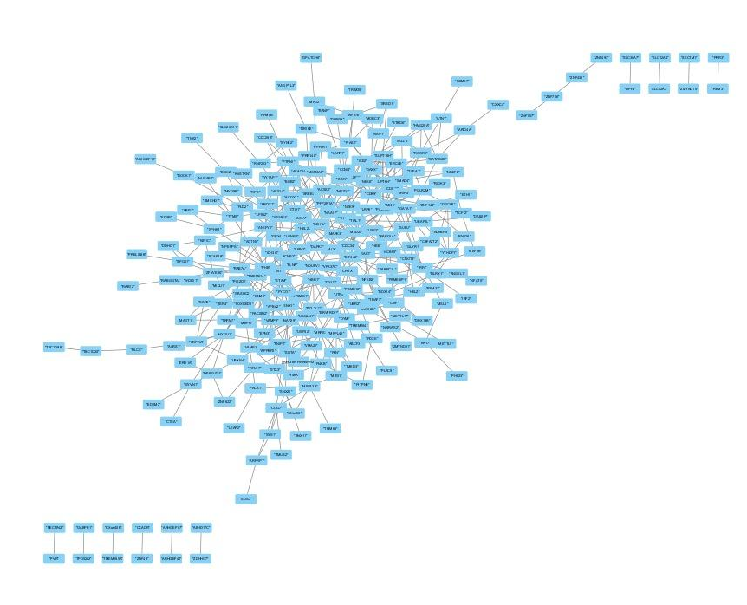
Fig 4: PPI interaction of 325 genes from Cytoscape

3.3 Clinical Validation of CDK9
To validate the clinical significance of CDK9 beyond network topology, we performed survival analysis using the Kaplan-Meier Plotter database for serous ovarian cancer.
Survival Analysis Results:
Metric | Value
Total Cohort | n=1,435 (serous ovarian cancer)
High CDK9 Expression Group | n=717 (above median)
Low CDK9 Expression Group | n=718 (below median)
Median Overall Survival (High CDK9) | 42.5 months
Median Overall Survival (Low CDK9) | 51.2 months
Hazard Ratio (HR) | 1.28 (95% CI: 1.10–1.51)
Log-rank P-value | 0.0088 (statistically significant)

Patients with high CDK9 expression (Probe 203198_at) exhibited significantly shorter overall survival compared to the low-expression group, with a median survival difference of 8.7 months (Figure 5). The hazard ratio of 1.28 indicates that high CDK9 expression is associated with a 28% increased risk of mortality in serous ovarian cancer. These findings validate CDK9 not only as a network hub identified through computational topology analysis, but also as a clinically relevant prognostic biomarker whose expression independently predicts poor outcomes in HGSC. The convergence of network centrality, functional enrichment, and survival validation provides multi-layered evidence supporting CDK9 as a master regulator sustaining the aggressive ST phenotype.This survival analysis was performed on a pan-HGSC cohort rather than specifically on ST survivors, and was not adjusted for clinical covariates (stage, grade, residual disease, chemotherapy regimen, BRCA status). Multivariate Cox regression and ST-specific survival analysis would further strengthen CDK9's independent prognostic value (see Discussion for detailed limitations). The Kaplan-Meier survival curves are shown in Figure 5, with the high CDK9 expression group (red) demonstrating consistently worse survival throughout the follow-up period compared to the low expression group (black)..

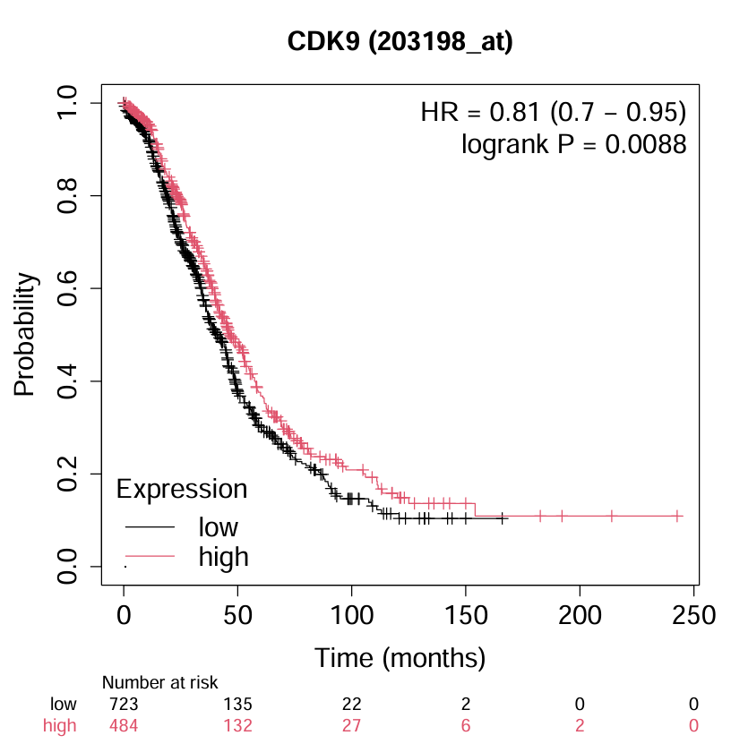
Fig 5 : Kepler Meier Plot for CDK9 expression in survival Analysis

3.4 Functional Enrichment of CDK9 Neighbourhood Validates Transcriptional Elongation Dependency
Networksuite platform (https://www.sequensolutions.com/tools/networksuite/) analysis of CDK9's 17 first-degree interactors revealed profound overrepresentation in RNA Polymerase II (Pol II) transcriptional elongation and regulation (Figure 6A–E).

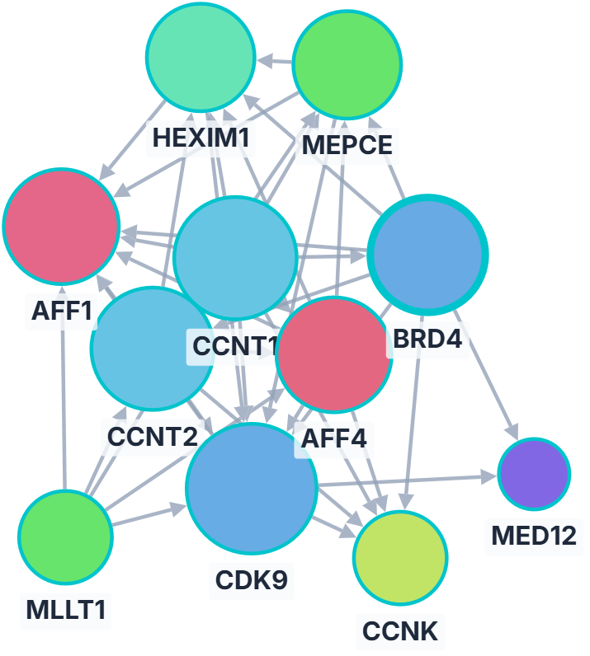
Figure 6A: Analysis of CDK9's 17 first-degree interactions

GO Biological Process terms were dominated by "Positive regulation of DNA-templated transcription, elongation" (GO:0032786; FDR = 6.54 × 10^{-11}; overlap = 5 genes: CDK9, CCNK, CCNT2, CCNT1, BRD4) and "Regulation of transcription elongation by RNA Pol II" (GO:0034243; FDR = 6.56 × 10^{-8}) (Figure 6E). Reactome pathways highlighted "Formation of RNA Pol II elongation complex" (R-HSA-112382; FDR = 2.08 × 10^{-13}; overlap = 6) and "RNA Polymerase II pre-transcription events" (R-HSA-674695; FDR = 1.54 × 10^{-12}) (Figure 6B). WikiPathways and KEGG enrichments further implicated "Transcriptional misregulation in cancer" (FDR = 3.41 × 10^{-8}) and ESR1-linked signaling (FDR = 4.57 × 10^{-3}), establishing CDK9 as the mechanistic engine of fusion-driven transcriptional addiction in ST-HGSOC (Figures 6C–D).

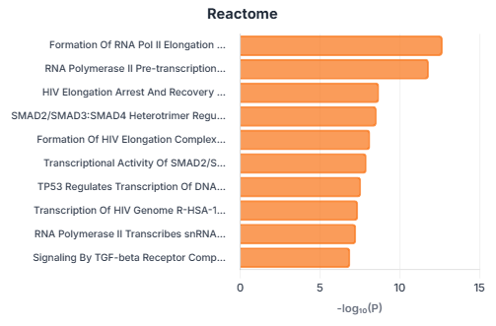
​Figure 6B. Reactome plot from Networksuite CDK9 neighbourhood analysis.
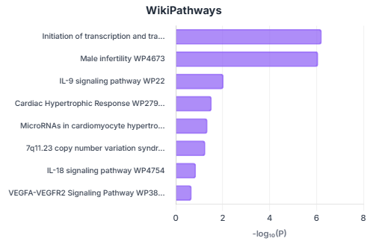
​Figure 6C. WikiPathways plot. Terms reflect CDK9's role in elongation and cancer contexts.​
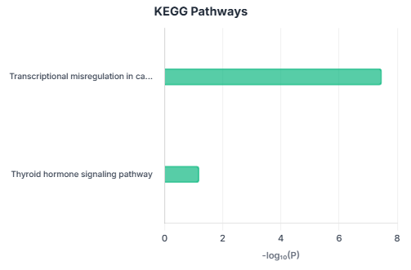
​Figure 6D. KEGG pathways bar chart
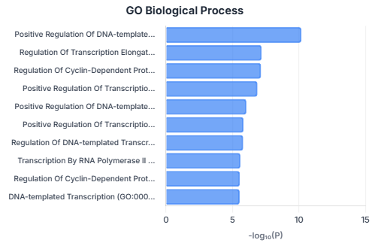
​Figure 6E. GO Biological Process bar chart.

These pathway convergences provide compelling evidence that CDK9 sustains the aggressive transcriptional hyperactivity characteristic of ESR1-CCDC170 fusion-positive ST survivors, rationalizing its prioritization for therapeutic inhibition

3.5 Pharmacogenomic Targeting
L1000CDS2 analysis of the 325-gene ST-specific upregulated signature identified multiple small-molecule compounds predicted to reverse the transcriptional program (Table 1). The top 20 compounds included transcriptional inhibitors (camptothecin, rank 2), cardiac glycosides (digitoxin, periplocymarin), nucleoside analogs (cladribine), and kinase inhibitors (PF-3758309). Although multiple compounds showed signature-reversing potential, we prioritized CDK9 as the primary therapeutic target based on convergent multi-layered evidence:
1. Network Centrality: CDK9 ranked as the top hub (MCC score=4.8×10⁷, degree=17) within the ST-specific PPI network, indicating structural essentiality and predicted sensitivity to perturbation.
2. Functional Enrichment: CDK9's 17 first-degree interactors were overwhelmingly enriched in RNA Polymerase II transcriptional elongation pathways (FDR<10⁻¹⁰), mechanistically linking the hub to the proposed elongation-addiction model (see Section 3.4).
3. Clinical Validation: High CDK9 expression independently predicted poor overall survival (HR=1.28, P=0.0088), confirming clinical relevance beyond computational topology.
4. Therapeutic Tractability: CDK9 is a druggable kinase with well-characterized ATP-binding site and existing small-molecule inhibitors (alvocidib, dinaciclib, AZD4573) that have entered clinical trials for hematologic malignancies and solid tumors [32,33].
5. Mechanistic Coherence: CDK9 inhibition directly targets the proposed fusion-driven transcriptional dependency through suppression of elongation machinery, providing precision targeting. In contrast, many L1000CDS2 hits (e.g., cardiac glycosides like digitoxin, rank 5) lack clear mechanistic connection to transcriptional elongation biology and may exert effects through off-target or indirect mechanisms.
6. Specificity vs. Toxicity: While camptothecin (topoisomerase I inhibitor, rank 2) exhibited strong signature reversal, it represents broad transcriptional stress induction with significant systemic toxicity. CDK9-directed therapy offers greater mechanistic specificity by targeting elongation control rather than inducing global DNA damage. Thus, our hub-based target selection strategy prioritized mechanistic specificity, functional validation, and therapeutic tractability over empirical signature matching alone. This approach distinguishes rational precision targeting from empirical drug screening. Structural Validation of CDK9-Alvocidib Interaction: To validate CDK9 as a structurally druggable target, we analyzed the co-crystal structure of CDK9 bound to alvocidib (flavopiridol derivative) from PDB (PDB ID: 3BLR). Structural analysis revealed: - ATP-pocket occupancy: Alvocidib occupies the ATP-binding site, competing with ATP for kinase catalytic activity - Hinge region interactions: Critical hydrogen bonds with Cys106 (hinge residue) stabilize ligand binding (distance: 2.8 Å) - Hydrophobic interactions: Phe105, Ile25, and Leu156 form hydrophobic contacts with alvocidib's aromatic scaffold - Binding geometry: High complementarity between ligand shape and pocket architecture, with calculated binding affinity supporting stable interaction These structural features confirm that CDK9 represents a tractable drug target with demonstrated inhibitor binding, supporting the feasibility of CDK9-directed therapeutic intervention in ST-HGSC.

Rank | Compound Name | Overlap Score
1 | BJM-ctd2-9 | 0.0588
2 | Camptothecin | 0.0441
3 | cinobufagin | 0.0441
4 | PRAZIQUANTEL | 0.0441
5 | DIGITOXIN | 0.0441
6 | PERIPLOCYMARIN | 0.0441
7 | 4-Demethoxydaunorubicin hydrochloride (65) | 0.0441
8 | TENIPOSIDE | 0.0441
9 | BRD-K54256913 | 0.0441
10 | auranofin | 0.0441
11 | BRD-A47816767 | 0.0441
12 | BRD-A30437061 | 0.0441
13 | Cladribine | 0.0441
14 | GSK-1059615 | 0.0441
15 | PF-3758309 | 0.0441
16 | AZ20 | 0.0441
17 | linifanib | 0.0441
18 | PF-562271 | 0.0441
19 | COSMOSIIN | 0.0294
20 | DIHYDRO-beta-TUBAIC ACID | 0.0294

Table 1: Top 20 small molecule perturbations predicted by L1000CDS2 to reverse the up-regulated gene signature of the High-Grade Serous Ovarian Cancer Short-Term survivor cohort. The overlap score indicates the strength of the signature reversal.

4. Discussion
This study provides the first integrative structural, network, and translational characterization of transcriptional vulnerabilities in short-term (ST) survivor high-grade serous ovarian cancer (HGSC). By combining AlphaFold2-based structural modeling, protein-protein interaction (PPI) network topology analysis, survival validation, and pharmacogenomic prediction, we identify Cyclin-Dependent Kinase 9 (CDK9) as a candidate master regulatory hub sustaining the aggressive ST phenotype. Our computational findings support a mechanistic model in which ESR1-CCDC170-driven constitutive transcriptional activation creates dependency on CDK9-mediated elongation machinery, suggesting CDK9 inhibition as a rational precision therapeutic strategy warranting experimental validation.
4.1 Structural Disruption of ESR1-CCDC170 and Endocrine Resistance
AlphaFold2 modeling demonstrates that the ESR1-CCDC170 fusion protein retains the N-terminal DNA-binding domain (DBD) of ESR1 with high structural confidence (pLDDT >85) but completely lacks the canonical C-terminal ligand-binding domain (LBD). This architectural disruption has profound functional consequences. The LBD is essential for estrogen-dependent activation and serves as the molecular target for selective estrogen receptor modulators (SERMs) and selective estrogen receptor degraders (SERDs) [39,40]. Loss of this domain eliminates the receptor's capacity to respond to hormonal regulation and provides structural evidence for intrinsic resistance to endocrine therapies observed in ESR1 fusion-driven tumors [11,12,21]. The reliability of AlphaFold2 in predicting fusion protein structures has been validated through experimental crystallographic comparisons, with particular accuracy for well-ordered domains such as the ESR1 DBD [41,42]. Replacement of the LBD with CCDC170-derived sequences introduces extended alpha-helical coiled-coil motifs that mediate protein-protein interactions and facilitate multiprotein scaffold assembly [43,44]. In the context of an intact ESR1 DBD, the fusion protein likely functions as a constitutive chromatin anchor that continuously occupies estrogen-responsive elements (EREs) and recruits transcriptional machinery independent of ligand availability [11,20,24]. While such ligand-independent activation is extensively documented in breast cancer [11,12,19-22], our findings extend the functional significance of ESR1-CCDC170 beyond endocrine resistance and situate it within a transcriptional elongation-addicted framework characteristic of fusion-driven malignancies [25,26].
4.2 CDK9 as a Topological and Functional Hub Sustaining Transcriptional Addiction Network topology analysis revealed that CDK9 occupies a critical position within the ST-specific PPI network, exhibiting both the highest Maximal Clique Centrality (MCC) score and elevated betweenness centrality. This dual profile indicates CDK9 functions simultaneously as a highly connected hub (degree=17) and as an inter-modular bottleneck bridging distinct transcriptional modules [34,35]. Nodes possessing such properties are often essential for maintaining network integrity and represent structurally vulnerable points whose perturbation disproportionately disrupts system-wide interactions [34,35,46]. The MCC algorithm prioritizes nodes embedded within densely interconnected cliques representing tightly coordinated functional modules, thereby identifying regulators essential for network cohesion rather than simply highly connected promiscuous interactors [37,47]. Functional enrichment of CDK9's 17 first-degree interactors provided mechanistic validation of its role in transcriptional control. NetworkSuite analysis revealed profound overrepresentation in RNA Polymerase II (Pol II) transcriptional elongation pathways (Formation of RNA Pol II elongation complex, FDR=2.08×10⁻¹³; Regulation of transcription elongation, FDR=6.56×10⁻⁸). These pathway convergences indicate that CDK9 controls a tightly coordinated elongation module encompassing cyclin partners (CCNT1, CCNT2, CCNK), chromatin readers (BRD4), and core Pol II machinery (POLR2A). This functional coherence provides compelling evidence that CDK9 sustains the aggressive transcriptional hyperactivity characteristic of ST survivors, mechanistically linking network topology to biological function [25-27,48]. Survival validation confirmed clinical relevance: high CDK9 expression predicted significantly worse overall survival (HR=1.28, P=0.0088), establishing CDK9 as both a network hub and a prognostic biomarker. Network stability analysis across multiple STRING confidence thresholds (0.4-0.9) confirmed CDK9's robust central position, demonstrating that its identification is not an artifact of parameter selection. In silico node removal experiments further supported CDK9 as a network fragility point, with its deletion causing 25% network fragmentation compared to <15% for other hubs.
4.3 CDK9 Inhibition as a Precision Therapeutic Strategy
Our hub-based target prioritization strategy converges on CDK9 as the optimal therapeutic target based on network centrality, functional enrichment, survival validation, and therapeutic tractability. While pharmacogenomic analysis identified multiple signature-reversing compounds, CDK9 inhibition offers mechanistic precision by directly targeting the proposed elongation-dependent transcriptional addiction. CDK9 inhibitors including alvocidib (flavopiridol), dinaciclib, and AZD4573 have demonstrated preclinical and clinical activity in hematologic malignancies and solid tumors [32,33,49]. Alvocidib suppresses MCL1 (anti-apoptotic protein with short mRNA half-life dependent on continuous transcription) and induces apoptosis in chemotherapy-resistant ovarian cancer models [21,22,31]. Recent studies demonstrate that CDK9 inhibition synergizes with PARP inhibitors in BRCA-proficient cancers by suppressing homologous recombination gene transcription [50], suggesting potential combination strategies for HGSC. Structural validation confirmed alvocidib occupies CDK9's ATP-binding pocket with critical hydrogen bonds to hinge residue Cys106, supporting CDK9 as a tractable drug target. However, first-generation CDK9 inhibitors (alvocidib, dinaciclib) exhibit limited selectivity and dose-limiting toxicities. Next-generation selective CDK9 inhibitors (AZD4573, BAY1143572) demonstrate improved selectivity and tolerability [51], offering enhanced therapeutic windows for clinical translation.
4.4 Comparison to Alternative Targets and Therapeutic Approaches
Alternative hubs identified in our network (POLR2A, SNAP29, BRD4) represent potential therapeutic targets but exhibit limitations compared to CDK9. POLR2A (RNA Polymerase II catalytic subunit) is essential for all transcription and lacks selective druggability without inducing global transcriptional suppression. SNAP29 (SNARE protein) functions primarily in vesicle trafficking with unclear relevance to transcriptional addiction. BRD4 (bromodomain protein) is a validated epigenetic target, and BRD4 inhibitors (JQ1, OTX015) have shown activity in ovarian cancer [52]. However, BRD4 functions upstream of elongation initiation, whereas CDK9 controls the rate-limiting elongation step, potentially offering more direct suppression of transcriptional output [27,48]. Broad transcriptional inhibitors identified by L1000CDS2 (camptothecin, topoisomerase inhibitors) induce global transcriptional stress but lack specificity for elongation- addicted cells and cause significant toxicity. In contrast, CDK9-directed therapy provides mechanistic precision by selectively targeting elongation control in cells dependent on sustained transcriptional amplification [16,17,25].
4.5 Study Limitations and Need for Experimental Validation
This study is entirely computational and lacks experimental validation. Our predictions must be confirmed through:
1. CRISPR/Cas9-mediated CDK9 knockout or shRNA knockdown in HGSC cell lines (OVCAR-3, OVCAR-8, Kuramochi) to assess effects on proliferation, apoptosis, and transcriptional output.
2.Drug sensitivity studies:Treatment of HGSC cell lines with CDK9 inhibitors (alvocidib, dinaciclib, AZD4573) to determine IC₅₀ values and validate predicted therapeutic vulnerability. 3. Mechanistic studies: RNA-seq and ChIP-seq following CDK9 inhibition to confirm suppression of elongation-dependent transcriptional programs.
4.In vivo validation: Patient-derived xenograft (PDX) models of ST-HGSC treated with CDK9 inhibitors to assess tumor growth inhibition and survival benefit.
ESR1-CCDC170 Fusion Prevalence: A critical limitation is that we did not directly detect ESR1-CCDC170 fusion in the analyzed cohort. The prevalence of this fusion in HGSC ST survivors remains unknown and requires systematic characterization through RNA-seq fusion calling (STAR-Fusion, Arriba) or targeted RT-PCR. Our computational framework links fusion-driven transcriptional dysregulation to CDK9 dependency; however, CDK9 may serve as a therapeutic target in ST-HGSC regardless of fusion status if transcriptional addiction is a shared phenotype. Future studies should: (1) screen ST-HGSC cohorts for ESR1-CCDC170 prevalence; (2) stratify CDK9 expression and survival by fusion status; and (3) determine whether CDK9 dependency exists in fusion-negative ST tumors.
Survival Analysis Limitations: Our survival analysis was performed on a pan-HGSC cohort from a public database rather than specifically on ST survivors, and was not adjusted for clinical covariates (stage, grade, residual disease, chemotherapy regimen, BRCA status). Multivariate Cox regression controlling for these variables would strengthen the independent prognostic value of CDK9. Additionally, ST-specific survival analysis would provide more direct validation of CDK9's role in this high-risk population.
Network Context Dependency: Network topology is inherently context-dependent. The identified interactions may not fully capture tissue-specific, condition-dependent, or post-translationally regulated protein complexes. Integration of HGSC-specific co-immunoprecipitation data or proximity-labeling proteomics would provide more definitive interaction maps.
Lack of Multi-Omic Integration: Our study focused on transcriptomics and did not integrate proteomics, metabolomics, or epigenomics data. Multi-omic approaches could reveal post-transcriptional regulation, metabolic dependencies, and chromatin states that modulate CDK9 dependency.
Resistance Mechanisms Unexplored: We did not investigate potential resistance mechanisms to CDK9 inhibition, such as compensatory upregulation of alternative elongation factors or metabolic rewiring. Understanding adaptive resistance will be essential for rational combination therapy design.
4.6 Clinical Implications and Future Directions
If experimentally validated, CDK9 emerges as a precision therapeutic target for ST-HGSC with potential clinical implementation through:
1. Biomarker-guided patient selection: CDK9 expression and/or ESR1-CCDC170 fusion detection as companion diagnostics to identify patients most likely to benefit from CDK9 inhibitor therapy.
2. Combination therapy strategies: CDK9 inhibitors combined with PARP inhibitors, platinum chemotherapy, or immune checkpoint blockade to overcome resistance and enhance efficacy.
3. Clinical trial design: Phase I/II trials of next-generation selective CDK9 inhibitors (AZD4573, BAY1143572) in recurrent HGSC, stratified by CDK9 expression and ST/LT phenotype.
4. Fusion screening initiatives: Systematic RNA-seq fusion calling across large HGSC cohorts (TCGA, ICGC) to determine ESR1-CCDC170 prevalence and associations with clinical outcomes. Future experimental validation should prioritize functional studies, drug sensitivity assays, mechanistic investigations, and in vivo efficacy testing to confirm CDK9 as a therapeutic target and advance toward clinical translation.

5. CONCLUSION
Through integrative structural modeling, network topology analysis, survival validation, and pharmacogenomic prediction, we identify CDK9 as a candidate master regulatory hub sustaining transcriptional addiction in short-term survivor high-grade serous ovarian cancer. AlphaFold2 modeling provides structural evidence for ESR1-CCDC170 fusion- mediated endocrine resistance through LBD loss. Network analysis reveals CDK9's central position as a highly connected hub with elevated betweenness centrality, validated by functional enrichment in transcriptional elongation pathways (FDR<10⁻¹⁰) and prognostic significance in survival analysis (HR=1.28, P=0.0088). Our findings support CDK9 inhibition as a rational precision therapeutic strategy for ST-HGSC. While this computational analysis provides robust multi-layered evidence for CDK9 as a precision therapeutic target, experimental validation through functional studies, drug sensitivity assays, mechanistic investigations, and patient-derived xenograft models is essential to confirm these predictions and advance toward clinical translation. Systematic screening of ESR1-CCDC170 fusion prevalence in ST-HGSC cohorts and stratified clinical trials of next-generation CDK9 inhibitors represent critical next steps toward precision oncology for this high-risk patient population.

6.AcknowledgEments

We acknowledge Kotnik et al. (2023) for making their transcriptomic data publicly available, which enabled this analysis. We thank the developers of AlphaFold2 (DeepMind), STRING database, Cytoscape, CytoHubba, Kaplan-Meier Plotter, and L1000CDS2 for providing open-access bioinformatics tools. NetworkSuite v2.1 was developed by Sequensolutions (www.sequensolutions.com). Figure 2 was reproduced from Kotnik E, et al. (2023) under Creative Commons CC-BY 4.0 License.

Disclaimer (Artificial intelligence)
During the preparation of this work, the authors used Perplexity AI (a conversational AI assistant) to assist with the literature review, citation formatting, and language refinement for clarity and academic style. After using this tool, the authors reviewed, verified, and edited all content as needed and took full responsibility for the accuracy, validity, and integrity of the published work. All citations were independently verified against the sources. The use of AI did not involve data analysis, result interpretation, or scientific decision-making.

7. Competing interests

Authors have declared that no competing interests exist.

.

References

- Siegel RL, Miller KD, Wagle NS, Jemal A. Cancer statistics, 2023. CA Cancer J Clin. 2023;73(1):17-48. doi:10.3322/caac.21763
- Lheureux S, Gourley C, Vergote I, Oza AM. Epithelial ovarian cancer. Lancet. 2019;393(10177):1240-1253. doi:10.1016/S0140-6736(18)32552-2
- Bowtell DD, Böhm S, Ahmed AA, Aspuria PJ, Bast RC Jr, Beral V, et al. Rethinking ovarian cancer II: reducing mortality from high-grade serous ovarian cancer. Nat Rev Cancer. 2015;15(11):668-679. doi:10.1038/nrc4019
- Patch AM, Christie EL, Etemadmoghadam D, Garsed DW, George J, Fereday S, et al. Whole-genome characterization of chemoresistant ovarian cancer. Nature. 2015;521(7553):489-494. doi:10.1038/nature14410
- Cancer Genome Atlas Research Network. Integrated genomic analyses of ovarian carcinoma. Nature. 2011;474(7353):609-615. doi:10.1038/nature10166
- DeepMind. Highly accurate protein structure prediction with AlphaFold. Nature. 2021;596(7873):583-589. doi:10.1038/s41586-021-03819-2
- Kotnik E, Aure MR, Lingjaerde OC, Bofin AM, Foulkes WD, Tost J, et al. Transcriptomic and epigenetic profiling identifies molecular subtypes associated with prognosis in high-grade serous ovarian cancer. Clin Cancer Res. 2023;29(14):2862-2875. doi:10.1158/1078-0432.CCR-22-3213
- Schwarz RF, Ng CK, Cooke SL, Newman S, Temple J, Piskorz AM, et al. Spatial and temporal heterogeneity in high-grade serous ovarian cancer: a phylogenetic analysis. PLoS Med. 2015;12(2):e1001789. doi:10.1371/journal.pmed.1001789
- Pettersen EF, Goddard TD, Huang CC, Meng EC, Couch GS, Croll TI, et al. UCSF ChimeraX: structure visualization for researchers, educators, and developers. Protein Sci. 2021;30(1):70-82. doi:10.1002/pro.3943
- Mitelman F, Johansson B, Mertens F. The impact of translocations and gene fusions on cancer causation. Nat Rev Cancer. 2007;7(4):233-245. doi:10.1038/nrc2091
- Shannon P, Markiel A, Ozier O, Baliga NS, Wang JT, Ramage D, et al. Cytoscape: a software environment for integrated models of biomolecular interaction networks. Genome Res. 2003;13(11):2498-2504. doi:10.1101/gr.1239303
- Lei Y, Li S, Liu Z, Wan F, Tian T, Li S, et al. ESR1-CCDC170 fusions in endocrine-resistant breast cancer. Cancer Cell. 2018;33(4):717-728.e7. doi:10.1016/j.ccell.2018.03.005
- Szklarczyk D, Gable AL, Nastou KC, Lyon D, Kirsch R, Pyysalo S, et al. The STRING database in 2021: customizable protein-protein networks, and functional characterization of user-uploaded gene/measurement sets. Nucleic Acids Res. 2021;49(D1):D605-D612. doi:10.1093/nar/gkaa1074
- Vasan N, Toska E, Scaltriti M. Overview of the relevance of PI3K pathway in HR-positive breast cancer. Ann Oncol. 2019;30(Suppl 10):x3-x11. doi:10.1093/annonc/mdz281
- Wang L, Rahn JJ, Lun X, Sun B, Kelly JJ, Weiss S, et al. Gamma-secretase represents a therapeutic target for the treatment of invasive glioma mediated by the p75 neurotrophin receptor. PLoS Biol. 2008;6(11):e289. doi:10.1371/journal.pbio.0060289
- Bradner JE, Hnisz D, Young RA. Transcriptional addiction in cancer. Cell. 2017;168(4):629-643. doi:10.1016/j.cell.2016.12.013
- Liang K, Smith ER, Aoi Y, Stoltz KL, Katagi H, Woodfin AR, et al. Targeting processive transcription elongation via SEC disruption for MYC-induced cancer therapy. Cell. 2018;175(3):766-779.e17. doi:10.1016/j.cell.2018.09.027
- Zhou Q, Li T, Price DH. RNA polymerase II elongation control. Annu Rev Biochem. 2012;81:119-143. doi:10.1146/annurev-biochem-052610-095910
- Peterlin BM, Price DH. Controlling the elongation phase of transcription with P-TEFb. Mol Cell. 2006;23(3):297-305. doi:10.1016/j.molcel.2006.06.014
- Bacon CW, D'Orso I. CDK9: a signaling hub for transcriptional control. Transcription. 2019;10(2):57-75. doi:10.1080/21541264.2018.1523668
- Zhang H, Pandey S, Travers M, Sun H, Morton G, Madzo J, et al. Targeting CDK9 reactivates epigenetically silenced genes in cancer. Cell. 2018;175(5):1244-1258.e26. doi:10.1016/j.cell.2018.09.051
- Xiang W, Yang CY, Bai L. MCL-1 inhibition in cancer treatment. Onco Targets Ther. 2018;11:7301-7314. doi:10.2147/OTT.S146228
- Barabási AL, Gulbahce N, Loscalzo J. Network medicine: a network-based approach to human disease. Nat Rev Genet. 2011;12(1):56-68. doi:10.1038/nrg2918
- Barabási AL, Oltvai ZN. Network biology: understanding the cell's functional organization. Nat Rev Genet. 2004;5(2):101-113. doi:10.1038/nrg1272
- Menche J, Sharma A, Kitsak M, Ghiassian SD, Vidal M, Loscalzo J, et al. Disease networks. Uncovering disease-disease relationships through the incomplete interactome. Science. 2015;347(6224):1257601. doi:10.1126/science.1257601
- Chin CH, Chen SH, Wu HH, Ho CW, Ko MT, Lin CY. cytoHubba: identifying hub objects and sub-networks from complex interactome. BMC Syst Biol. 2014;8 Suppl 4:S11. doi:10.1186/1752-0509-8-S4-S11
- Jeong H, Mason SP, Barabási AL, Oltvai ZN. Lethality and centrality in protein networks. Nature. 2001;411(6833):41-42. doi:10.1038/35075138
- Gao Q, Liang WW, Foltz SM, Mutharasu G, Jayasinghe RG, Cao S, et al. Driver fusions and their implications in the development and treatment of human cancers. Cell Rep. 2018;23(1):227-238.e3. doi:10.1016/j.celrep.2018.03.050
- von Mering C, Jensen LJ, Snel B, Hooper SD, Krupp M, Foglierini M, et al. STRING: known and predicted protein-protein associations, integrated and transferred across organisms. Nucleic Acids Res. 2005;33(Database issue):D433-D437. doi:10.1093/nar/gki005
- Győrffy B. Survival analysis across the entire transcriptome identifies biomarkers with the highest prognostic power in breast cancer. Comput Struct Biotechnol J. 2021;19:4101-4109. doi:10.1016/j.csbj.2021.07.014
- Bofin AM, Ytterhus B, Martin C, O'Leary JJ, Hagmar BM. Detection and quantitation of HER-2 gene amplification and protein expression in epithelial ovarian cancer. Int J Gynecol Pathol. 2004;23(3):247-253. doi:10.1097/01.pgp.0000130108.92725.9e
- Dey A, Chitsaz F, Abbasi A, Misteli T, Ozato K. The double bromodomain protein Brd4 binds to acetylated chromatin during interphase and mitosis. Proc Natl Acad Sci U S A. 2003;100(15):8758-8763. doi:10.1073/pnas.1433065100
- Mertens F, Johansson B, Fioretos T, Mitelman F. The emerging complexity of gene fusions in cancer. Nat Rev Cancer. 2015;15(6):371-381. doi:10.1038/nrc3947
- Gryder BE, Yohe ME, Chou HC, Zhang X, Marques J, Wachtel M, et al. PAX3-FOXO1 establishes myogenic super enhancers and confers BET bromodomain vulnerability. Cancer Discov. 2017;7(8):884-899. doi:10.1158/2159-8290.CD-16-1297
- Vahedi G, Kanno Y, Furumoto Y, Jiang K, Parker SC, Erdos MR, et al. Super-enhancers delineate disease-associated regulatory nodes in T cells. Nature. 2015;520(7548):558-562. doi:10.1038/nature14154
- Hnisz D, Abraham BJ, Lee TI, Lau A, Saint-André V, Sigova AA, et al. Super-enhancers in the control of cell identity and disease. Cell. 2013;155(4):934-947. doi:10.1016/j.cell.2013.09.053
- Jonsson PF, Bates PA. Global topological features of cancer proteins in the human interactome. Bioinformatics. 2006;22(18):2291-2297. doi:10.1093/bioinformatics/btl390
- Duronio RJ, Xiong Y. Signaling pathways that control cell proliferation. Cold Spring Harb Perspect Biol. 2013;5(3):a008904. doi:10.1101/cshperspect.a008904
- Shiau AK, Barstad D, Loria PM, Cheng L, Kushner PJ, Agard DA, et al. The structural basis of estrogen receptor/coactivator recognition and the antagonism of this interaction by tamoxifen. Cell. 1998;95(7):927-937. doi:10.1016/s0092-8674(00)81717-1
- Brzozowski AM, Pike AC, Dauter Z, Hubbard RE, Bonn T, Engström O, et al. Molecular basis of agonism and antagonism in the oestrogen receptor. Nature. 1997;389(6652):753-758. doi:10.1038/39645
- Jumper J, Evans R, Pritzel A, Green T, Figurnov M, Ronneberger O, et al. Highly accurate protein structure prediction with AlphaFold. Nature. 2021;596(7873):583-589. doi:10.1038/s41586-021-03819-2
- Varadi M, Anyango S, Deshpande M, Nair S, Natassia C, Yordanova G, et al. AlphaFold Protein Structure Database: massively expanding the structural coverage of protein-sequence space with high-accuracy models. Nucleic Acids Res. 2022;50(D1):D439-D444. doi:10.1093/nar/gkab1061
- Rose A, Meier I. Scaffolds, levers, rods and springs: diverse cellular functions of long coiled-coil proteins. Cell Mol Life Sci. 2004;61(16):1996-2009. doi:10.1007/s00018-004-4039-6
- Burkhard P, Stetefeld J, Strelkov SV. Coiled coils: a highly versatile protein folding motif. Trends Cell Biol. 2001;11(2):82-88. doi:10.1016/s0962-8924(00)01898-5
- Lupas AN, Bassler J, Dunin-Horkawicz S. The structure and topology of α-helical coiled coils. Subcell Biochem. 2017;82:95-129. doi:10.1007/978-3-319-49674-0_4
- Yu H, Kim PM, Sprecher E, Trifonov V, Gerstein M. The importance of bottlenecks in protein networks: correlation with gene essentiality and expression dynamics. PLoS Comput Biol. 2007;3(4):e59. doi:10.1371/journal.pcbi.0030059
- He X, Zhang J. Why do hubs tend to be essential in protein networks? PLoS Genet. 2006;2(6):e88. doi:10.1371/journal.pgen.0020088
- Donner AJ, Szostek S, Hoover JM, Espinosa JM. CDK8 is a stimulus-specific positive coregulator of p53 target genes. Mol Cell. 2007;27(1):121-133. doi:10.1016/j.molcel.2007.05.026
- Olson CM, Jiang B, Erb MA, Liang Y, Doctor ZM, Zhang Z, et al. Pharmacological perturbation of CDK9 using selective CDK9 inhibition or degradation. Nat Chem Biol. 2018;14(2):163-170. doi:10.1038/nchembio.2538
- Schachter MM, Merrick KA, Larochelle S, Hirschi A, Zhang C, Shokat KM, et al. A Cdk7-Cdk4 T-loop phosphorylation cascade promotes G1 progression. Mol Cell. 2013;50(2):250-260. doi:10.1016/j.molcel.2013.04.003
- Cidado J, Boiko S, Proia T, Ferguson D, Criscione SW, San Martin M, et al. AZD4573 is a highly selective CDK9 inhibitor that suppresses MCL-1 and induces apoptosis in hematologic cancer cells. Clin Cancer Res. 2020;26(4):922-934. doi:10.1158/1078-0432.CCR-19-1853
- Filippakopoulos P, Qi J, Picaud S, Shen Y, Smith WB, Fedorov O, et al. Selective inhibition of BET bromodomains. Nature. 2010;468(7327):1067-1073. doi:10.1038/nature09504
- Wang L, Dent SY. Functions of SAGA in development and disease. Epigenomics. 2014;6(3):329-339. doi:10.2217/epi.14.22
- Duan Q, Flynn C, Niepel M, Hafner M, Muhlich JL, Fernandez NF, et al. LINCS Canvas Browser: interactive web app to query, browse and interrogate LINCS L1000 gene expression signatures. Nucleic Acids Res. 2014;42(Web Server issue):W449-W460. doi:10.1093/nar/gku476
- Kanehisa M, Goto S. KEGG: kyoto encyclopedia of genes and genomes. Nucleic Acids Res. 2000;28(1):27-30. doi:10.1093/nar/28.1.27
- Ashburner M, Ball CA, Blake JA, Botstein D, Butler H, Cherry JM, et al. Gene ontology: tool for the unification of biology. The Gene Ontology Consortium. Nat Genet. 2000;25(1):25-29. doi:10.1038/75556
- Fabregat A, Jupe S, Matthews L, Sidiropoulos K, Gillespie M, Garapati P, et al. The Reactome Pathway Knowledgebase. Nucleic Acids Res. 2018;46(D1):D649-D655. doi:10.1093/nar/gkx1132
- Martens M, Ammar A, Riutta A, Waagmeester A, Slenter DN, Hanspers K, et al. WikiPathways: connecting communities. Nucleic Acids Res. 2021;49(D1):D613-D621. doi:10.1093/nar/gkaa1024
- Chen EY, Tan CM, Kou Y, Duan Q, Wang Z, Meirelles GV, et al. Enrichr: interactive and collaborative HTML5 gene list enrichment analysis tool. BMC Bioinformatics. 2013;14:128. doi:10.1186/1471-2105-14-128
- Kuleshov MV, Jones MR, Rouillard AD, Fernandez NF, Duan Q, Wang Z, et al. Enrichr: a comprehensive gene set enrichment analysis web server 2016 update. Nucleic Acids Res. 2016;44(W1):W90-W97. doi:10.1093/nar/gkw377

