Review Article
ORAL MUCOSITIS IN CANCER PATIENTS: PREVENTION AND TREATMENT

ABSTRACT:
Oral mucositis is a common and potentially severe complication of cancer therapy, particularly affecting high-risk populations such as pediatric patients, hematopoietic stem cell transplant recipients, and individuals with head and neck cancer. The incidence and severity of oral mucositis vary depending on cancer type, treatment modality, dose intensity, and patient-related factors, with the highest burden observed in head and neck cancer patients undergoing chemoradiotherapy. The pathogenesis of oral mucositis is complex and involves a multistep biological process characterized by epithelial injury, generation of reactive oxygen species, activation of pro-inflammatory cytokines, signal amplification, ulceration, and subsequent healing. These pathological changes compromise oral mucosal integrity and contribute to secondary infections and nutritional difficulties. Various preventive and therapeutic strategies have been investigated to mitigate oral mucositis. Evidence from randomized controlled trials and systematic reviews supports the use of preventive measures such as oral cryotherapy, low-level laser therapy (photobiomodulation), benzydamine mouthwash, and keratinocyte growth factor (palifermin) in selected patient populations. In addition, nutritional supplements and natural agents, including honey, glutamine, zinc, aloe vera, and probiotics, have demonstrated potential benefits, although clinical outcomes remain heterogeneous. Management of established oral mucositis is primarily supportive and focuses on pain control, maintenance of oral hygiene, prevention of infection, and preservation of nutritional status. Current international guidelines emphasize a multidisciplinary, evidence-based approach for optimal prevention and management. Despite advances in supportive care, oral mucositis continues to pose a significant clinical challenge, highlighting the need for standardized assessment tools, personalized interventions, and further high-quality research to improve patient outcomes.
KEY WORDS:
Oral mucositis, cancer patients, chemotherapy-induced mucositis, radiotherapy-induced mucositis, prevention, treatment, supportive care, oral care protocols, photobiomodulation therapy, oral cryotherapy, keratinocyte growth factor, inflammatory pathways, pain management, quality of life, head and neck cancer.
INTRODUCTION
Despite significant advances in cancer diagnosis and treatment, treatment-related toxicities continue to pose major challenges in oncology care. Oral mucositis is one of the most common and debilitating complications experienced by cancer patients undergoing chemotherapy, radiotherapy, or hematopoietic stem cell transplantation, and it remains a significant cause of morbidity worldwide [1, 3]. It is characterized by inflammation and ulceration of the oral mucosa, resulting in pain, erythema, and impaired oral function. Oral mucositis occurs due to the cytotoxic effects of cancer therapies on rapidly dividing epithelial cells of the oral mucosa. The condition is particularly prevalent in patients receiving head and neck radiotherapy, high-dose chemotherapy, or combined chemoradiotherapy, with reported incidence rates exceeding 80% in certain high-risk populations [4, 7]. The severity and duration of mucositis depend on multiple factors, including the type of cancer therapy, cumulative dose, treatment schedule, and patient-related risk factors.
Clinically significant oral mucositis is associated with severe pain, dysphagia, nutritional compromise, increased risk of local and systemic infections, and a substantial decline in quality of life. In many cases, severe mucositis necessitates opioid analgesia, enteral or parenteral nutrition, prolonged hospitalization, and intensive supportive care [8, 11]. Moreover, oral mucositis frequently leads to chemotherapy dose reductions, treatment delays, or premature discontinuation of cancer therapy, which may negatively impact therapeutic outcomes and survival [12, 14]. The pathogenesis of oral mucositis is complex and involves a multistep biological process rather than simple epithelial injury. Current evidence describes a five-phase model encompassing initiation by reactive oxygen species, upregulation of inflammatory cytokines, signal amplification, ulceration with microbial colonization, and eventual tissue healing [15, 18]. This understanding has facilitated the development of targeted preventive and therapeutic interventions aimed at interrupting these pathogenic pathways. Despite growing awareness and the availability of various preventive and treatment strategies, oral mucositis remains underdiagnosed and suboptimally managed in routine clinical practice. Therefore, a comprehensive and evidence-based approach is essential for reducing its incidence and severity. This review aims to summarize the current understanding of the epidemiology, pathophysiology, prevention, and treatment of oral mucositis in cancer patients, with emphasis on clinically relevant strategies supported by recent literature and international guidelines [19–20]. Oral mucositis remains one of the most clinically significant complications of cancer therapy, leading to severe pain, increased risk of infection, treatment interruption, and reduced quality of life. Despite advances in oncologic treatments, effective prevention and management remain challenging, particularly in high-risk populations such as pediatric patients, hematopoietic stem cell transplant recipients, and individuals with head and neck cancer [21-22].
This review integrates current understanding of pathogenesis with evidence-based preventive and therapeutic strategies. By consolidating updated clinical guidelines and research findings, the manuscript aims to support improved patient-centered management in oncology practice. Oral mucositis is a hazardous and clinically significant complication affecting cancer patients of all age groups, including pediatric and adult populations receiving chemotherapy, radiotherapy, targeted therapy, or hematopoietic stem cell transplantation. It increases susceptibility to infection, morbidity, and nutritional compromise and may result in treatment delays or dose reductions, thereby affecting therapeutic outcomes. Given its substantial clinical burden, a comprehensive understanding of preventive and therapeutic strategies is essential to support the development of effective management guidelines worldwide.
EPIDEMIOLOGY AND INCIDENCE
Oral mucositis is a frequently encountered complication in patients receiving cancer therapy, with its incidence varying widely depending on the type of malignancy, treatment modality, and patient-related factors. In patients receiving conventional chemotherapy, the reported incidence of oral mucositis ranges from approximately 20% to 40%, while higher rates are observed with high-dose chemotherapy regimens [1, 3]. The condition is particularly prevalent among patients undergoing hematopoietic stem cell transplantation, where the incidence may exceed 75% due to intensive conditioning regimens [4, 5]. Radiotherapy-induced oral mucositis is most observed in patients with head and neck cancers. The incidence in this population is reported to be between 80% and 100%, especially in those receiving cumulative radiation doses exceeding 50 Gy or concurrent chemoradiotherapy [6, 8]. Combined chemotherapy and radiotherapy significantly increase both the incidence and severity of oral mucositis compared with either modality alone [9, 10]. Pediatric cancer patients have been reported to have experienced a higher frequency and greater severity of oral mucositis than adults, possibly due to higher epithelial turnover rates and differences in drug metabolism [11,12]. Additionally, interindividual variability in the incidence of oral mucositis has been attributed to genetic predisposition, oral microbiota composition, and differences in supportive care practices across institutions [13, 15]. Collectively, these findings highlight oral mucositis as a common and clinically significant adverse effect across diverse oncologic settings.
ETIOLOGY AND RISK FACTORS
The etiology of oral mucositis is multifactorial and primarily related to the direct and indirect cytotoxic effects of anticancer therapies on the oral mucosa. Chemotherapeutic agents such as antimetabolites, alkylating agents, and platinum-based compounds damage rapidly proliferating basal epithelial cells, leading to mucosal thinning, inflammation, and ulceration [16, 18]. Radiotherapy contributes to mucosal injury through direct DNA damage, generation of reactive oxygen species, and disruption of normal tissue regeneration, particularly when the oral cavity lies within the radiation field [19, 20]. Several treatment-related factors influence the risk of developing oral mucositis, including the type of anticancer agent, dosage, treatment duration, fractionation schedule, and the use of combined modality therapy [21, 23]. Concurrent chemoradiotherapy has been consistently associated with a higher incidence and severity of mucositis compared to single-modality treatment [24].
Patient-related factors also play a significant role in susceptibility to oral mucositis. Advanced age, poor nutritional status, compromised oral hygiene, tobacco and alcohol use, and the presence of comorbid conditions such as diabetes or renal impairment have been identified as important risk factors [25, 27]. Additionally, genetic variations affecting inflammatory pathways, drug metabolism, and tissue repair mechanisms may predispose certain individuals to more severe mucosal injury [28, 29]. Local factors, including pre-existing oral infections, dental trauma, and alterations in the oral microbiome, further contribute to the development and progression of oral mucositis [30,32]. The interaction between treatment-related toxicity and host-specific factors underscores the complex nature of oral mucositis and emphasizes the importance of individualized risk assessment and preventive strategies in cancer care.
PATHOPHYSIOLOGY
Oral mucositis is a complex, multifactorial process that extends beyond simple epithelial injury and involves interactions between epithelial cells, submucosal tissues, immune mediators, and the oral microbiome. Current evidence describes the pathogenesis as a multistage biological cascade consisting of five overlapping phases: initiation, message generation, signal amplification, ulceration, and healing [1,4]. The initiation phase occurs immediately after exposure to cytotoxic cancer therapy, where chemotherapeutic agents or ionizing radiation cause direct DNA damage in basal epithelial cells and generate reactive oxygen species (ROS) [5, 6]. This oxidative stress triggers downstream signaling pathways and cellular injury, setting the stage for mucosal breakdown as shown in figure 1. During the message generation phase, damaged epithelial and submucosal cells release pro-inflammatory cytokines such as tumor necrosis factor-alpha (TNF-α), interleukin-1 beta (IL-1β), and interleukin-6 (IL-6), which amplify the inflammatory response and recruit immune cells to the site of injury [7,9]. This leads to the signal amplification phase, where feedback loops further enhance tissue injury through upregulation of additional cytokines, activation of transcription factors like NF-κB, and promotion of apoptosis in neighboring epithelial cells [10,11]. The ulceration phase is characterized by the development of painful mucosal lesions, which are often colonized by oral bacteria. Microbial invasion exacerbates inflammation and may predispose patients to secondary infections, contributing to systemic complications [12,14]. Clinically, this phase is when patients experience the most significant pain, dysphagia, and nutritional compromise. Finally, the healing phase involves epithelial proliferation, differentiation, and tissue remodeling, which restore the integrity of the oral mucosa. The speed and extent of healing depend on the severity of the initial injury, host immune response, and supportive care interventions [15, 17]. Understanding these pathogenic mechanisms has informed the development of targeted preventive and therapeutic strategies, including anti-inflammatory agents, growth factors, low-level laser therapy, and cryotherapy, aimed at interrupting this cascade and reducing the severity of oral mucositis [18,20].
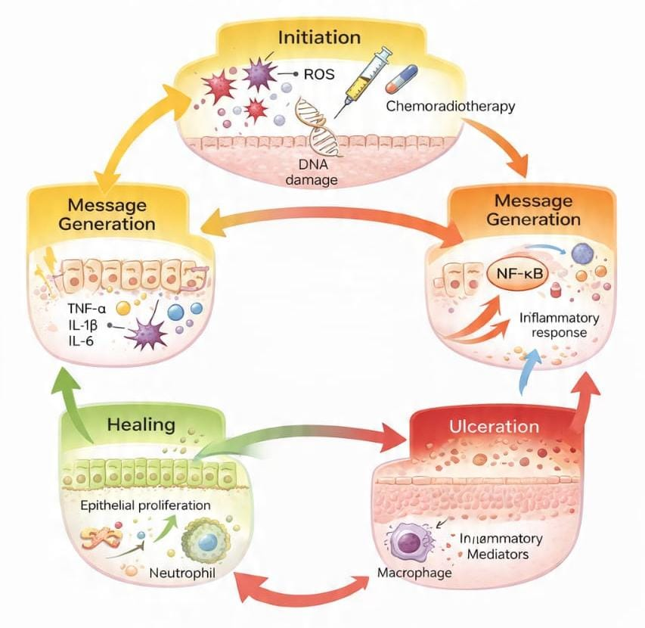
Figure 1: Pathophysiology of oral mucositis.
Schematic representation of the multistep pathophysiological process of oral mucositis induced by chemotherapy and radiotherapy, including initiation with reactive oxygen species and DNA damage, cytokine-mediated message generation and signal amplification, ulceration with inflammatory cell infiltration and microbial colonization, followed by epithelial proliferation and healing.
CLINICAL MANIFESTATIONS
Oral mucositis typically presents a spectrum of clinical manifestations ranging from mild erythema to extensive, painful ulcerations of the oral mucosa. The initial clinical signs often include mucosal redness, edema, and a burning sensation, which may progress to the formation of pseudomembranous lesions and deep ulcerations as the condition worsens [1,3], as shown in figure 2. These changes most commonly affect the non-keratinized mucosal surfaces, including the buccal mucosa, soft palate, floor of the mouth, and ventral surface of the tongue. Pain is the most prominent and distressing symptom of oral mucositis and may be severe enough to impair basic oral functions such as speaking, chewing, and swallowing. As ulcerations deepen, patients frequently experience dysphagia, odynophagia, and altered taste sensation, leading to reduced oral intake and subsequent nutritional deficiencies [4, 6]. In severe cases, patients may require enteral or parenteral nutritional support. The ulcerative phase of oral mucositis is often accompanied by secondary microbial colonization of the disrupted mucosal barrier. This increases the risk of local infections and may serve as a portal of entry for systemic infections, particularly in immunocompromised patients with neutropenia [7, 9]. Fever and bacteremia associated with oral mucositis have been reported, contributing to increased morbidity and the need for hospitalization. Clinically severe oral mucositis significantly impacts patients’ quality of life by causing sleep disturbances, psychological distress, and functional impairment. The intensity of symptoms often necessitates the use of opioid analgesics and comprehensive supportive care measures [10, 12]. Moreover, the severity of clinical manifestations is closely correlated with treatment interruptions, dose reductions, and premature discontinuation of anticancer therapy, which may adversely affect overall treatment outcomes [13, 15].
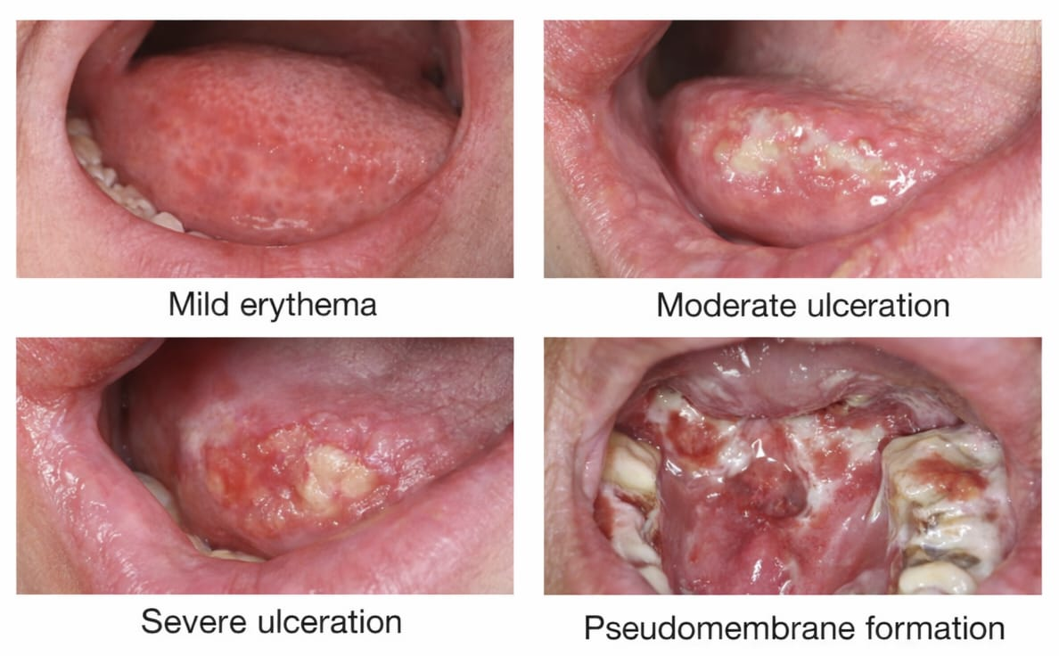
Figure 2: Clinical manifestations of oral mucositis
Schematic representation of progression from mild erythema to severe ulceration and pseudomembrane formation.
GRADING AND ASSESSMENT OF ORAL MUCOSITIS
Accurate grading and assessment of oral mucositis are essential for determining disease severity, guiding clinical decision-making, and ensuring standardized reporting in clinical practice and research [1,3]. Several validated grading systems are commonly used to assess oral mucositis in cancer patients. The World Health Organization (WHO) oral mucositis grading scale is one of the most widely applied tools in routine clinical settings. It combines objective clinical findings with functional outcomes, particularly the patient’s ability to tolerate oral intake. The WHO grading system classifies oral mucositis into five grades, ranging from grade 0 (no mucositis) to grade 4 (severe ulceration with inability to eat or drink), as summarized in Table 1 [4,5].
Table 1: WHO grading of oral mucositis
GRADE | CLINICAL DESCRIPTION
Grade 0 | No oral mucositis
Grade 1 | Soreness and/or erythema
Grade 2 | Erythema, ulcers; patients able to eat solid food
Grade 3 | Ulcers with extensive erythema; patient able to consume liquid diet only
Grade 4 | Severe ulceration; alimentation not possible
Source: Adapted from WHO Oral Toxicity Scale [4, 5].
The National Cancer Institute Common Terminology Criteria for Adverse Events (NCI-CTCAE) provides a standardized framework for reporting oral mucositis as a treatment-related toxicity in oncology clinical trials. This system emphasizes symptom severity, pain intensity, and functional interference with oral intake. The grading criteria for oral mucositis according to the NCI-CTCAE are presented in Table 2 [6, 8].
Table 2: NCI-CTCAE grading of oral mucositis
GRADE | DESCRIPTION
Grade 1 | Asymptomatic or mild symptoms; intervention not indicated
Grade 2 | Moderate pain; not interfering with oral intake
Grade 3 | Severe pain; interfering with oral intake
Grade 4 | Life-threatening consequences: urgent intervention indicated
Grade 5 | Death
Source: Based on NCI-CTAE Criteria [6, 8].
The Oral Mucositis Assessment Scale (OMAS) is a more detailed and quantitative assessment tool that evaluates specific anatomical sites within the oral cavity for erythema and ulceration. Unlike the WHO and CTCAE scales, OMAS allows precise measurement of lesion size and severity, making it particularly useful for research studies and interventional trials. The key components and scoring criteria of OMAS are outlined in Table 3 [9, 11].
Table 3: Oral Mucositis Assessment Scale (OMAS)
PARAMETER | SCORING CRITERIA
Ulceration | 0= None  1= <1cm²  2= 1-3cm²  3= >3cm²
Erythema | 0= None  1= Mild  2= Severe
Sites assessed | Lips, cheeks, tongue, floor of mouth, soft palate
Source: Adapted from Sonis et al. [9, 11].
In addition to clinician-based grading systems, patient-reported outcome measures are increasingly recognized as important adjuncts in the assessment of oral mucositis. These tools capture subjective symptoms such as pain, swallowing difficulty, and impact on quality of life, thereby complementing objective clinical assessments [12,14].
IMPACT OF ORAL MUCOSITIS ON CANCER THERAPY
Oral mucositis significantly affects the delivery and outcomes of cancer treatment by increasing treatment-related morbidity and compromising therapeutic intensity. Severe mucositis is associated with intense oral pain, dysphagia, and nutritional impairment, which often necessitate opioid analgesics, enteral feeding, or hospitalization [1,3]. These complications substantially reduce patients’ functional status and overall quality of life during cancer therapy. The presence of oral mucositis frequently leads to interruption, dose reduction, or delay of chemotherapy and radiotherapy, thereby affecting treatment efficacy. In patients receiving head and neck radiotherapy, severe mucositis has been identified as a major dose-limiting toxicity that can compromise locoregional tumor control [4, 6]. Similarly, chemotherapy-induced oral mucositis may require modification or discontinuation of cytotoxic regimens, increasing the risk of disease progression or suboptimal treatment response. Oral mucositis also predisposes patients to secondary infections, particularly in immunocompromised individuals. Ulcerated mucosal surfaces serve as portals of entry for bacteria and fungi, increasing the risk of local and systemic infections, including bacteremia and sepsis [7,9]. This risk is especially pronounced in patients with neutropenia, where mucosal barrier injury can lead to serious infectious complications. From a health economics perspective, oral mucositis contributes to increased healthcare utilization and costs. Hospital admissions, prolonged inpatient stays, use of supportive medications, and nutritional interventions significantly increase the financial burden on healthcare systems and patients [10,12]. These economic implications further highlight the need for effective preventive and therapeutic strategies. Overall, the impact of oral mucositis extends beyond oral discomfort, influencing cancer treatment continuity, clinical outcomes, infection risk, quality of life, and healthcare costs. Recognizing and addressing the burden of oral mucositis is therefore essential for optimizing comprehensive cancer care [13,15].
PREVENTION STRATEGIES
General Preventive Measures
General preventive measures form the foundation of oral mucositis prevention and should be implemented in all cancer patients before and throughout anticancer therapy. These measures focus on maintaining oral health, minimizing mucosal trauma, and reducing exposure to local irritants that may exacerbate mucosal injury. Early identification and correction of pre-existing oral conditions through comprehensive oral assessment prior to cancer treatment are strongly recommended [1, 3]. Maintenance of good oral hygiene is essential to reduce microbial load and prevent secondary infections. Patients should be advised to use soft-bristled toothbrushes, non-abrasive toothpaste, and gentle oral rinses such as saline or sodium bicarbonate solutions. Alcohol-based mouthwashes and irritant substances should be avoided. Lifestyle modifications, including cessation of tobacco and alcohol use, adequate hydration, and avoidance of spicy or acidic foods, further contribute to mucosal protection [4, 6]. Patient education and regular monitoring by healthcare professionals play a crucial role in early detection and prevention of disease progression. Proper oral hygiene plays a fundamental role in the prevention and management of oral mucositis. Regular use of a soft-bristled toothbrush, saline or sodium bicarbonate mouth rinses, and pre-treatment dental evaluation are essential components of supportive care. Patient education regarding structured oral hygiene practices has been shown to reduce the severity of mucositis, particularly in pediatric oncology patients undergoing induction chemotherapy [53-54].
Pharmacological Prevention of Oral Mucositis
Pharmacological agents are used for the prevention of oral mucositis, particularly in patients at high risk due to intensive chemotherapy, radiotherapy, or hematopoietic stem cell transplantation. These agents act by protecting epithelial cells, modulating inflammatory pathways, and enhancing mucosal regeneration [7, 9]. Palifermin, a recombinant human keratinocyte growth factor, has demonstrated significant efficacy in reducing the incidence, severity, and duration of oral mucositis in patients undergoing high-dose chemotherapy and stem cell transplantation. Benzydamine hydrochloride mouthwash has shown benefit in preventing radiotherapy-induced oral mucositis in head and neck cancer patients due to its anti-inflammatory and analgesic properties [10, 12]. Chlorhexidine gluconate mouthwash has been evaluated as an antiseptic agent in oncology patients to reduce oral microbial colonization and support oral hygiene maintenance. Some studies have explored its role in decreasing the severity of oral mucositis when compared with saline rinses, suggesting potential supportive benefits in certain clinical settings. However, evidence remains variable, and its role is generally considered adjunctive within comprehensive oral care protocols rather than a definitive preventive intervention [51–52]. Other agents such as glutamine, zinc supplements, and antioxidant formulations have been investigated for preventive use; however, evidence supporting their routine application remains variable. Therefore, pharmacological prevention should be individualized based on patient risk profile, treatment modality, and current clinical guidelines [13, 15]. Recent randomized controlled trials and meta-analyses published in the last two years continue to support the effectiveness of selected preventive interventions.
Non-Pharmacological Preventive Measures
Non-pharmacological preventive strategies offer effective, low-risk options for reducing the burden of oral mucositis and are often used alongside pharmacological interventions. These approaches aim to minimize mucosal injury and promote tissue repair without drug-related adverse effects [16, 18]. Oral cryotherapy is an established preventive method for chemotherapy-induced oral mucositis, particularly with short-infusion chemotherapeutic agents. By inducing local vasoconstriction, cryotherapy reduces drug exposure to the oral mucosa. Photobiomodulation therapy (low-level laser therapy) has also gained strong evidence support for its role in preventing oral mucositis across various cancer treatment settings, including radiotherapy and stem cell transplantation [19, 21]. Supportive oral care measures, including professional dental care and continuous oral monitoring, further contribute to prevention by enabling early identification of mucosal changes and timely intervention. Prevention strategies for oral mucositis should be individualized based on patient-specific risk factors such as age, type of malignancy, treatment modality, radiation dose, chemotherapy regimen, and baseline oral health status. For example, patients receiving high-dose chemotherapy or hematopoietic stem cell transplantation may require intensive oral care protocols and growth factor support, whereas head and neck cancer patients undergoing radiotherapy may benefit from topical anti-inflammatory agents and structured oral hygiene programs. Risk-adapted preventive strategies may improve clinical outcomes and reduce treatment interruptions.
Natural and Herbal Agents in the Prevention of Oral Mucositis
Natural and herbal agents have been increasingly explored as adjunctive preventive strategies due to their anti-inflammatory, antioxidant, antimicrobial, and wound-healing properties. These agents are generally well tolerated and may provide additional benefit when used alongside conventional preventive measures [22, 24]. Honey has been extensively studied and shown to reduce the incidence and severity of oral mucositis, particularly in patients receiving radiotherapy for head and neck cancers. Aloe vera, curcumin, chamomile, green tea extracts, and propolis have also demonstrated potential preventive effects by reducing inflammation and oxidative stress and promoting mucosal healing [25, 28]. Natural agents such as honey have demonstrated potential benefits in reducing the severity and duration of chemoradiotherapy-induced oral mucositis, possibly due to their anti-inflammatory, antimicrobial, and wound-healing properties. Despite promising findings, variability in study design, formulations, and dosing limits the routine recommendation of many herbal agents. Further high-quality randomized controlled trials are required to establish standardized protocols and confirm long-term safety and efficacy [29, 31].
TREATMENT STRATEGIES FOR ORAL MUCOSITIS
Symptomatic Management of Oral Mucositis
Symptomatic management is the cornerstone of oral mucositis treatment, focusing on alleviating pain, maintaining oral function, preventing secondary infections, and improving quality of life. Since there is no single curative therapy for established mucositis, supportive care is essential across all grades [1,3]. Pain control is critical, with mild to moderate pain often managed using topical anesthetics such as lidocaine-based mouth rinses. Severe pain may require systemic analgesics, including opioids, to allow adequate oral intake and maintain treatment adherence [4, 6]. Maintaining oral hygiene and mucosal hydration is vital to prevent further injury and secondary infections. Gentle oral care, frequent rinsing with bland solutions, and avoidance of irritants, including alcohol-based mouthwashes or acidic foods, are strongly recommended [7, 9]. Nutritional support is equally important, with soft diets, nutritional supplements, and, in severe cases, enteral feeding to prevent malnutrition and weight loss [10,12]. Overall, a multidisciplinary approach involving oncologists, nurses, dentists, pharmacists, and dietitians is essential for effective symptomatic management, ensuring patient comfort and continuity of cancer therapy [13, 15].
Pharmacological Treatment of Oral Mucositis
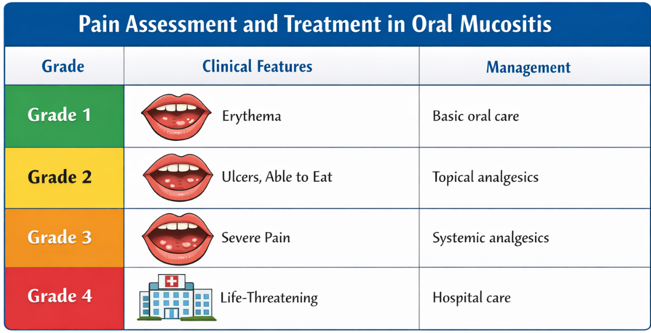
The therapeutic management of oral mucositis should be aligned with its multistep pathogenesis. The initiation phase involves oxidative stress and DNA damage, followed by upregulation and amplification of inflammatory cytokines, ulceration, and subsequent healing. Therefore, preventive and therapeutic interventions target different stages of this biological cascade, including antioxidant strategies, anti-inflammatory agents, antimicrobial measures, and epithelial growth promoters [15-16]. Pharmacological treatment is aimed at controlling symptoms, reducing inflammation, and promoting mucosal healing. Selection of agents depends on mucositis severity, cancer treatment type, and patient-specific factors [16,18]. Topical agents such as lidocaine, benzocaine, and protective oral gels provide short-term pain relief and mucosal protection. Anti-inflammatory agents like benzydamine hydrochloride mouthwash reduce inflammation and pain, particularly in patients receiving radiotherapy for head and neck cancers [19, 21]. Systemic analgesics, including non-opioid and opioid medications, are employed for moderate to severe mucositis. Pain control is essential to maintain oral intake and prevent interruptions in cancer therapy. Management of secondary infections using antifungal or antibacterial therapy may be necessary in immunocompromised patients, guided by clinical and microbiological findings [22, 24]. Pharmacological treatment should be individualized, integrated with non-pharmacological care, and guided by clinical guidelines to optimize outcomes [25, 27]. Pain severity is a critical determinant of therapeutic decision-making in oral mucositis management. Standardized assessment tools such as the WHO Oral Toxicity Scale or Visual Analog Scale (VAS) are commonly used to grade severity and guide treatment intensity. Management approaches vary according to grade, ranging from topical analgesics in mild cases to systemic opioids, nutritional support, and hospitalization in severe cases [57], as shown in figure 3.
Figure 3: WHO Oral Toxicity Scale for Grading Oral Mucositis Severity
Schematic representation of the WHO Oral Toxicity Scale illustrating grading of oral mucositis severity from mild erythema (Grade 1) to severe ulceration requiring parenteral support (Grade 4). The grading system assists clinicians in assessing pain severity and guiding appropriate therapeutic interventions.
Non-Pharmacological Treatment Approaches
Non-pharmacological treatments are essential adjuncts to pharmacological therapy, focusing on tissue repair, reduction of inflammation, and pain relief without drug-related adverse effects [28, 30]. Photobiomodulation therapy (low-level laser therapy) is highly effective in reducing the severity and duration of oral mucositis by promoting epithelial regeneration and modulating inflammatory responses. Oral cryotherapy, through vasoconstriction, reduces chemotherapy-induced mucosal injury, particularly with short-infusion chemotherapeutic agents [31, 33]. Supportive oral care, including professional dental assessment and ongoing oral hygiene, is critical for early detection of lesions and prevention of secondary infections. Nutritional counselling and patient education enhance adherence to these measures, improving overall outcomes [34, 36].
Role of Complementary and Alternative Therapies
Complementary and alternative therapies (CAM) serve as adjuncts to conventional treatment for symptom relief and mucosal healing. These therapies include herbal products, nutritional supplements, and mind-body approaches [37, 39]. Herbal and natural products, such as honey, aloe vera, chamomile, curcumin, green tea extracts, and propolis, have shown anti-inflammatory, antioxidant, and wound-healing effects. These interventions may help reduce the severity and duration of mucositis, especially when used as mouth rinses or gels [40–43]. Nutritional supplements, including glutamine and zinc, have been investigated to support mucosal integrity, while mind-body interventions such as relaxation techniques and stress management may improve pain perception and overall quality of life [44, 46]. While promising, CAM therapies should not replace standard care. Their use should be individualized, carefully monitored, and integrated with evidence-based pharmacological and non-pharmacological strategies. Further high-quality trials are needed to establish standardized protocols for their use [47, 49].
SPECIAL POPULATIONS
Oral Mucositis in Pediatric Cancer Patients
Oral mucositis is a common and clinically significant complication in pediatric cancer patients receiving chemotherapy or radiotherapy. Children are particularly susceptible due to the high mitotic activity of the oral epithelium and differences in drug metabolism compared to adults. Oral mucositis in this population can lead to severe pain, feeding difficulties, dehydration, and increased risk of infection, often necessitating hospitalization and parenteral nutrition [1,3]. Additionally, mucositis-related discomfort may impair treatment adherence and negatively affect psychological well-being and quality of life in children. Preventive and therapeutic strategies in pediatric patients must be age-appropriate, emphasizing gentle oral care, effective pain control, and family-centered education [4, 6].
Oral Mucositis in Hematopoietic Stem Cell Transplantation
Oral mucositis is one of the most frequent and severe toxicities observed in patients undergoing hematopoietic stem cell transplantation (HSCT), particularly following high-dose chemotherapy and total body irradiation. The incidence of severe oral mucositis in this population is markedly high due to profound immunosuppression and mucosal barrier injury [7, 9]. Mucositis in HSCT patients is associated with intense pain, increased opioid requirements, risk of systemic infections, prolonged hospitalization, and increased healthcare costs. Pharmacological agents such as palifermin and non-pharmacological interventions like photobiomodulation therapy have shown benefit in reducing mucositis severity in selected HSCT settings. Early recognition and aggressive supportive care are essential to minimize complications and improve transplant outcomes [10, 12].
Oral Mucositis in Head and Neck Cancer Patients
Patients with head and neck cancer are at exceptionally high risk for developing oral mucositis, particularly when treated with radiotherapy or concurrent chemoradiotherapy. Nearly all patients receiving radiation to the oral cavity develop some degree of mucositis, with severe forms significantly impairing oral intake, speech, and swallowing [13, 15]. Oral mucositis in this population often leads to treatment interruptions, dose reductions, and increased reliance on enteral feeding. The anatomical location of tumors and cumulative radiation dose contribute to prolonged and severe mucosal injury. Multidisciplinary management, incorporating preventive oral care, symptom control, and nutritional support, is critical for maintaining treatment continuity and preserving quality of life in head and neck cancer patients [16, 18].
GUIDELINES AND CONSENSUS
Current Clinical Practice Guidelines for Oral Mucositis
Current clinical practice guidelines for the prevention and management of oral mucositis are primarily developed by international expert groups to standardize care, improve patient outcomes, and promote evidence-based interventions. Among these, the Multinational Association of Supportive Care in Cancer/International Society of Oral Oncology (MASCC/ISOO) guidelines are the most widely accepted and frequently cited in oncology practice [1, 3]. The MASCC/ISOO guidelines emphasize a risk-based, multidisciplinary approach to oral mucositis management, incorporating preventive oral care, patient education, and early intervention. Routine oral assessment before and during cancer therapy, maintenance of good oral hygiene, and avoidance of mucosal irritants are strongly recommended across all patient populations [4, 5]. For prevention, the guidelines support the use of photobiomodulation therapy in patients receiving radiotherapy, chemotherapy, or hematopoietic stem cell transplantation, based on strong evidence demonstrating reduced severity and duration of oral mucositis. Oral cryotherapy is recommended for patients receiving short-infusion chemotherapy agents, while benzydamine mouthwash is advised for prevention in head and neck cancer patients undergoing radiotherapy [6, 8]. In terms of treatment, the guidelines focus on symptom-directed management, particularly pain control, nutritional support, and management of secondary infections. The use of topical anesthetics, systemic analgesics including opioids for severe pain, and appropriate antimicrobial therapy when indicated is endorsed. However, the guidelines do not recommend routine use of several agents, such as chlorhexidine or sucralfate, due to insufficient or inconsistent evidence [9, 11]. Importantly, the guidelines highlight the limited evidence supporting many interventions and stress the need for individualized clinical judgment. Regular updates to recommendations reflect evolving evidence, underscoring the importance of continuous research and adherence to the most recent guideline versions [12–14]. Overall, current clinical practice guidelines provide a structured framework for the prevention and management of oral mucositis, promoting consistency in care while allowing flexibility based on patient-specific factors and available resources [15, 17].
FUTURE AND EMERGING THERAPIES
Emerging Therapies and Future Directions
Despite advances in supportive care, oral mucositis remains a significant unmet clinical challenge, highlighting the need for novel preventive and therapeutic strategies. Emerging therapies focus on targeted modulation of molecular pathways involved in mucosal injury, enhancement of tissue regeneration, and personalization of mucositis management based on patient- and treatment-related risk factors [1,3]. Recent research has explored biological and molecular-targeted agents aimed at interrupting key inflammatory and apoptotic pathways implicated in oral mucositis pathogenesis. Agents targeting cytokines, oxidative stress mediators, and epithelial growth pathways show promise in reducing mucosal injury and accelerating healing. Ongoing clinical trials are evaluating newer growth factors, cytokine inhibitors, and signalling pathway modulators for their potential role in mucositis prevention and treatment [4,6]. Advances in cell-based and regenerative therapies represent another emerging area. The use of stem cell–derived products, extracellular vesicles, and tissue engineering approaches may offer novel means to promote epithelial regeneration and restore mucosal integrity. Although still largely experimental, these strategies may provide long-term solutions for severe or recurrent oral mucositis in the future [7, 9]. The role of personalized and precision medicine is gaining increasing attention. Identification of genetic, molecular, and microbiome-related risk factors may allow stratification of patients based on mucositis risk and enable tailored preventive and therapeutic interventions. Such approaches have the potential to improve efficacy while minimizing unnecessary interventions [10, 12]. Technological innovations, including advanced photobiomodulation devices, digital symptom monitoring tools, and artificial intelligence–assisted risk prediction models, may further enhance early detection and management of oral mucositis. Integration of these technologies into routine oncology practice could improve clinical decision-making and patient outcomes [13, 15]. In conclusion, future directions in oral mucositis management emphasize a shift toward targeted, regenerative, and personalized approaches. Continued translational research, well-designed clinical trials, and multidisciplinary collaboration are essential to translate emerging therapies into effective clinical practice [16, 18].
LIMITATIONS OF CURRENT EVIDENCE
Despite substantial research on oral mucositis, several limitations persist in the current body of evidence, which restrict the generalizability and consistent application of preventive and therapeutic strategies. One of the major challenges is the heterogeneity of study designs, including variations in cancer type, treatment modality, mucositis grading scales, and outcome measures, making direct comparison across studies difficult [1,3]. Many clinical trials evaluating interventions for oral mucositis involve small sample sizes, short follow-up periods, or single-center designs. These limitations reduce statistical power and may overestimate treatment effects, particularly for newer pharmacological and complementary therapies [4, 6]. Additionally, pediatric populations, elderly patients, and individuals with multiple comorbidities are often underrepresented in clinical studies. Another significant limitation is the inconsistency in mucositis assessment tools. The use of different grading systems, such as WHO, NCI-CTCAE, and OMAS, leads to variability in reporting severity and treatment response. This lack of standardization complicates evidence synthesis and guideline development [7,9]. Evidence supporting several commonly used interventions, particularly natural, herbal, and complementary therapies, remains limited or conflicting. Variability in formulations, dosing regimens, and routes of administration further challenges the interpretation of results and limits reproducibility across studies [10, 12]. Furthermore, many studies focus primarily on short-term clinical outcomes, such as reduction in mucositis severity, while long-term outcomes, including quality of life, cost-effectiveness, and impact on cancer treatment survival outcomes, are less frequently evaluated [13, 15]. Overall, these limitations highlight the need for well-designed, large-scale, multicenter randomized controlled trials with standardized outcome measures. Addressing these gaps is essential to strengthen the evidence base and improve clinical decision-making in the management of oral mucositis [16, 18].
CLINICAL IMPLICATIONS FOR HEALTHCARE PROFESSIONALS
Oral mucositis represents a significant clinical challenge in oncology practice, necessitating a proactive and multidisciplinary approach by healthcare professionals. Early identification of patients at high risk for oral mucositis and timely implementation of preventive strategies are essential to minimize morbidity and maintain continuity of cancer therapy. Routine oral assessment before, during, and after anticancer treatment should be integrated into standard clinical practice [1, 3]. Healthcare professionals, including oncologists, dentists, nurses, and pharmacists, play a critical role in patient education, emphasizing the importance of oral hygiene, symptom reporting, and adherence to supportive care measures. Effective communication and coordinated care enable early intervention, reduce symptom severity, and prevent progression to severe mucositis and its associated complications [4, 6]. Pain management, nutritional support, and infection control require individualized clinical judgment and continuous monitoring. Pharmacists contribute by optimizing supportive medication use and identifying potential drug interactions, while nurses play a key role in daily assessment and patient counselling. Adoption of evidence-based clinical guidelines, such as those from MASCC/ISOO, can support consistent and standardized management across healthcare settings [7,9]. Overall, incorporation of structured oral care protocols and interdisciplinary collaboration can significantly improve patient outcomes, quality of life, and treatment adherence, underscoring the importance of oral mucositis management as a core component of comprehensive cancer care [10,12].
RISK-ADAPTED PREVENTIVE STRATEGIES:
Preventive and therapeutic strategies for oral mucositis should be prioritized according to patient-specific risk factors and treatment modalities. For instance, benzydamine mouthwash is recommended particularly for patients receiving radiotherapy for head and neck cancer [12]. Palifermin has demonstrated benefit in patients undergoing hematopoietic stem cell transplantation receiving high-dose chemotherapy. Strict oral hygiene protocols remain fundamental in pediatric oncology populations to reduce severity and associated complications. Additionally, non-pharmacological interventions such as low-level laser therapy have shown promising results in high-risk individuals. Therefore, individualized and risk-adapted prevention strategies may improve clinical outcomes and reduce treatment interruptions.
CONCLUSION
Oral mucositis is a common, debilitating, and often dose-limiting complication of cancer therapy that significantly affects patient comfort, quality of life, and treatment outcomes. Its multifactorial pathogenesis and variable clinical presentation necessitate a comprehensive approach encompassing prevention, early detection, and effective management. This review highlights current evidence on the epidemiology, pathophysiology, clinical manifestations, assessment, prevention, and treatment of oral mucositis, with special consideration of high-risk populations and emerging therapeutic strategies. While several preventive and therapeutic interventions have demonstrated benefit, limitations in existing evidence underscore the need for further high-quality research and standardized outcome measures. This review synthesizes current evidence on the multistep pathogenesis of oral mucositis and the corresponding preventive and therapeutic strategies. By integrating biological mechanisms with clinical interventions, it highlights the importance of stage-specific and risk-adapted management approaches. Such an integrative perspective may improve individualized patient care and reduce treatment-related morbidity. Future advances in targeted therapies, regenerative medicine, and personalized care hold promise for improving mucositis management. Until such strategies are fully established, adherence to evidence-based guidelines, multidisciplinary collaboration, and patient-centered supportive care remain essential for reducing the burden of oral mucositis and optimizing cancer treatment outcomes.

COMPETING INTERESTS DISCLAIMER:
Authors have declared that they have no known competing financial interests OR non-financial interests OR personal relationships that could have appeared to influence the work reported in this paper.

Disclaimer (Artificial intelligence)

Author(s) hereby declare that NO generative AI technologies such as Large Language Models (ChatGPT, COPILOT, etc.) and text-to-image generators have been used during the writing or editing of this manuscript.

REFERENCES
- Sonis ST. Pathobiology of mucositis. Semin Oncol Nurs. 2004; 20(1): 11–15.
- Sonis ST, Elting LS, Keefe D, et al. Perspectives on cancer therapy-induced mucosal injury. Cancer. 2004;100(9 Suppl):1995–2025.
- Dodd MJ, Dibble SL, Miaskowski C, et al. Chlorhexidine mouthwash for the treatment of chemotherapy-induced oral mucositis. Cancer Nurs. 2000;23(6):431–441.
- Cheng KKF, Chang AM, Yuen MP. Prevention of chemotherapy-induced oral mucositis in pediatric patients: a randomized controlled trial. Cancer Nurs. 2001; 24(4):300–308.
- Awidi A, El-Sharkawi S, Al-Sheikh A. Oral pilocarpine for prevention of oral mucositis in cancer patients. Bone Marrow Transplant. 2002; 29: 915–919.
- Peterson DE, Bensadoun RJ, Roila F. Management of oral and gastrointestinal mucositis: ESMO clinical practice guidelines. Ann Oncol. 2005;16(Suppl 2):ii78–ii84.
- Barber C, Powell R, Ellis A, et al. Gelclair versus standard therapy for radiotherapy-induced oral mucositis. Support Care Cancer. 2007; 15:1381–1387.
- Elting LS, Keefe DM, Sonis ST, et al. Burden of illness associated with oral mucositis in cancer patients. Cancer. 2008; 113(10): 2704–2713.
- Zanin T, Zanin F, Carvalhosa AA, et al. Low-level laser therapy in prevention of radiotherapy-induced oral mucositis. Photomed Laser Surg. 2009;27(2):297–302.
- Arbabi-Kalati F, Deghatipour M. Zinc sulfate in prevention of chemotherapy-induced oral mucositis. J Dent (Tehran). 2012; 9(4): 313–318.
- da Cruz Campos M, Ribeiro C, de Oliveira R. Oral mucositis in cancer treatment: natural history, prevention, and treatment. Mol Clin Oncol. 2014;2(3):337–340.
- Lalla RV, Bowen J, Barasch A, et al. MASCC/ISOO clinical practice guidelines for the management of mucositis. Cancer. 2014; 120(10): 1453–1461.
- Villa A, Sonis ST. Mucositis: pathobiology and management. Curr Opin Oncol. 2015;27(3):159–164.
- van Sebille YZA, Gibson RJ, Wardill HR, et al. Mucositis: causes and consequences. Support Care Cancer. 2015; 23: 2787–2799.
- Rastogi M, Goyal S, Gupta S, et al. Benzydamine hydrochloride for prevention of radiation-induced oral mucositis. Support Care Cancer. 2017; 25: 265–271.
- Kooshyar MM, Khorasani G, Momeni M, et al. Quercetin for prevention of chemotherapy-induced oral mucositis: a randomized trial. Support Care Cancer. 2017; 25: 2057–2063.
- Hosseinjani H, Mansouri P, Shirani F. Erythropoietin mouthwash for prevention of chemotherapy-induced oral mucositis. Support Care Cancer. 2018; 26:367–374.
- van der Velden WJFM, Herbers AHE, Netea MG, et al. Cryotherapy for prevention of chemotherapy-induced oral mucositis. Support Care Cancer. 2019;27:189–197.
- Hong BY, Sobue T, Choquette L, et al. Chemotherapy-induced oral mucositis is associated with oral microbiota dysbiosis. J Oral Microbiol. 2019;11(1):1609832.
- Widjaja NA, Chen CW, Chen SH, et al. Oral glutamine for prevention of chemotherapy-induced oral mucositis in pediatric patients. Nutrients. 2020;12(9):2768.
- Glowacka-Mrotek I, Kornafel J, Mrotek J, et al. Network meta-analysis of interventions for oral mucositis prevention. Support Care Cancer. 2020; 28:3675–3687.
- Alkhouli M, Laflouf M, Alomari A, et al. Aloe vera gel for prevention of oral mucositis in children with acute lymphoblastic leukemia. Pediatr Hematol Oncol. 2021;38(3):210–218.
- Kitagawa J, Arai Y, Yamashita K, et al. Polaprezinc prevents severe oral mucositis in hematopoietic stem cell transplantation. Support Care Cancer. 2021;29:5461–5469.
- Elhadad MA, El-Shazly M, Ali AA. Topical chamomile for prevention of chemotherapy-induced oral mucositis. Support Care Cancer. 2022;30:507–515.
- Mohammadi S, Dehghan M, Sadeghi A. Zinc chloride mouthwash in management of oral mucositis. BMC Oral Health. 2022;22:507.
- Jahangard-Rafsanjani Z, Sarayani A, Hadjibabaie M, et al. Selenium supplementation for prevention of oral mucositis in HSCT. Support Care Cancer. 2022;30:1031–1039.
- van Sebille YZA, Bowen JM, Gibson RJ, et al. Emerging therapies for the prevention of mucositis. Support Care Cancer. 2022;30:733–74 2.
- Braguês R, Costa E, Barbosa A, et al. Oral mucositis management in pediatric cancer patients. Cancers (Basel). 2024; 16(8): 1548.
- Zhang L, Wang P, Chen Q, et al. Incidence and clinical impact of oral mucositis in adult cancer patients. J Clin Med. 2024;13(19):5723.
- Kang J, Zhang Y, Wang Y, et al. Chemotherapy- and radiotherapy-induced oral mucositis: updated management strategies. Cancer Treat Rev. 2025;122:102883.
- Wang X, Li S, Chen Y, et al. Oral care interventions for anticancer therapy-induced oral mucositis: systematic review. Oral Oncol Rep. 2025;3:100759.
- Peterson DE, Srivastava R, Lalla RV. Oral mucositis in cancer therapy: evolving paradigms. J Clin Oncol. 2025;43(4):215–223.
- Bowen JM, Gibson RJ, Keefe DM, et al. New insights into the pathogenesis of oral mucositis. Curr Opin Support Palliat Care. 2025; 19(1): 45–52.
- Sonis ST. Oral mucositis in cancer therapy: pathogenesis and emerging therapies. Nat Rev Cancer. 2025; 25: 215–228.
- Li Y, Chen L, Zhang H. Natural products in prevention of oral mucositis. Phytomedicine. 2025; 132: 15569 3.
- Ahmed S, Khan MN, Rahman A. Pain management strategies in oral mucositis. Support Care Cancer. 2025; 33:1123–1134.
- Huang Y, Lin X, Chen J. Low-level laser therapy in oral mucositis: updated evidence. Photomed Laser Surg. 2025;43(2):89–97.
- Silva GB, Costa L, Rocha R. Honey-based therapies for oral mucositis. Clin Oral Investig. 2025;29:167–176.
- Kim JH, Lee JH. Oral microbiome modulation in mucositis prevention. Oral Dis. 2025;31:412–421.
- Martin M, Bowen J, Elting L. Health-economic impact of oral mucositis. Support Care Cancer. 2025; 33: 901–910.
- Patel V, Singh R. Complementary therapies in oral mucositis management. Integr Cancer Ther. 2025; 24: 1534735425.
- Zhao Q, Wang T. Cryotherapy in pediatric oral mucositis: updated evidence. Pediatr Blood Cancer. 2025;72:e30945.
- Lalla RV, Saunders DP, Peterson DE. Management of oral mucositis in clinical practice. Oral Oncol. 2025;149:106743.
- Keefe DM, Bowen JM. Gastrointestinal and oral mucositis: clinical challenges. Lancet Oncol. 2025;26(3):e129–e138.
- Chen Y, Zhou X. Biomarkers in oral mucositis severity prediction. Oral Dis. 2025;31:655–664.
- Singh A, Verma P. Advances in pharmacological management of oral mucositis. Drugs. 2025; 85:1213–1226.
- Gupta N, Sharma A. Oral mucositis in head and neck cancer patients. Head Neck. 2025;47:198–207.
- Rossi M, Conti G. Stem cell transplantation-associated oral mucositis. Bone Marrow Transplant. 2025; 60: 845–853.
- Li X, Sun Y. Future directions in oral mucositis research. Front Oncol. 2025;15:1298745.
- Bowen JM, Sonis ST. Oral mucositis: current understanding and future perspectives. CA Cancer J Clin. 2025;75(2):95–110.
- Debela DT, et al. New approaches and procedures for cancer treatment. SAGE Open Med. 2021;9:20503121211034366.
- Prakash D, Reshmi S. Chlorhexidine and saline on oral mucositis among cancer patients. Int J Basic Appl Sci (IJBPAS). 2025; 14(5): 2698–2706.
- Islam R, Jamal CY, Nargis W, et al. The impact of oral hygiene practice on the severity of oral mucositis in children with acute lymphoblastic leukemia receiving induction chemotherapy. Cancer J Bangladesh. 2024; 5(2): 62–68.
- Kostak MA, Semerci R, Eren T, et al. Effects of oral health care education on the severity of oral mucositis in oncology patients. Turk J Oncol. 2020;35(4):422–429.
- Lalla RV, Bowen J, Barasch A, et al. MASCC/ISOO clinical practice guidelines for the management of mucositis secondary to cancer therapy. Cancer. 2020;126(19):4423–4431.
- Oberoi S, Zamperlini-Netto G, Beyene J, et al. Effect of prophylactic low-level laser therapy on oral mucositis: a systematic review and meta-analysis. BMJ Support Palliat Care. 2014; 4(4): 349–358.
- Agnes J, János S, Katalin G, et al. Patient-reported measurements of oral mucositis in pediatric patients with cancer. Oral Health Dent Manag. 2016;15(6):1–10.
- Jicman D, Sârbu MI, Fotea S, et al. Oral mucositis induced by chemoradiotherapy in head and neck cancer: therapeutic management and the benefits of bee honey. Medicina (Kaunas). 2022; 58(6): 751.

