Effect of Silt-Fortified Organic Manures on Soil Chemical and Biological Properties under Cassava (Manihot esculenta Crantz) cultivation in Kuttanad Soils of Kerala

.
ABSTRACT

The promotion of safe and sustainable organic farming necessitates production and availability of quality organic inputs in adequate quantities. A field experiment was conducted in Kuttanad, Kerala during 2023-2024 in RCBD with seven treatments and replicated thrice to evaluate the effect of silt and silt fortified organic manures on soil chemical properties and enzymatic activities at different growth stages of cassava. The treatments included fortified poultry manure, fortified crop-residue composts (paddy straw, banana pseudostem, and water hyacinth), fortified farmyard manure, silt alone, and farmyard manure alone (control). At harvest, fortified poultry manure recorded the highest available nitrogen (265.33 kg ha⁻¹), phosphorus (52.90 kg ha⁻¹), and potassium (345.22 kg ha⁻¹), indicating superior enhancement of soil fertility. Fortified organic amendments significantly improved soil pH, organic carbon, and available N, P, and K compared to control and silt alone. Crop-residue composts also improved soil carbon status and potassium availability, whereas silt applied alone was comparatively less effective. Overall, the results demonstrate that silt-fortified organic manures, particularly poultry manure and crop-residue composts, are effective for improving soil chemical fertility and biological functioning as evidenced by increased dehydrogenase, urease, and phosphatase activities in cassava-based systems of Kuttanad.

Keywords: Cassava, fortified organic sources, soil enzymes, soil properties

1. INTRODUCTION

Sustainable alternative agricultural methods, such as organic farming, have garnered attention owing to the growing awareness of food safety, environmental pollution, soil quality and human health. Cassava (Manihot esculenta Crantz) is a major starchy root crop cultivated widely across tropical and subtropical regions and serve as staple food and industrial raw material. In southern India, particularly in Kerala, cassava contributes significantly to rural livelihoods and agro-industrial sectors. India produces 6.6 MT of cassava, with Kerala contributing substantially to national production [1]. Sustained productivity of cassava depends largely on effective soil fertility management.
In the wetland ecosystem of Kuttanad, cassava cultivation is practiced on bunds and raised lands that escape seasonal flooding. These soils are characterized by high water tables, soil acidity, periodic leaching losses, and poor aeration, which collectively influence nutrient availability and microbial activity [2]. Continuous cultivation and inadequate nutrient replenishment have contributed to soil health degradation, necessitating location-specific and sustainable nutrient management strategies.

Recycling locally available organic resources offers a viable approach for improving soil fertility in such fragile ecosystems. Organic amendments enhance soil organic carbon, nutrient availability, cation exchange capacity, and microbial-mediated nutrient cycling [3]. Poultry manure was selected due to its high content of readily mineralizable nitrogen, phosphorus, and potassium, and its ability to improve soil organic carbon and ameliorate soil acidity through the release of basic cations during decomposition [4]. Crop residue compost was included for its potential to increase stable organic carbon fractions, improve soil structure, enhance cation exchange capacity, and promote nutrient retention [5]. Fish pond silt, an abundant by-product of aquaculture activities in Kuttanad, accumulates nutrients and organic matter during pond operation and may enrich soil nutrient pools and microbial activity when used for fortification [6]. However, systematic field-based evaluation of silt-fortified organic amendments under cassava cultivation in Kuttanad soils remains limited. Therefore, the present study was undertaken to evaluate the effects of recycling and fortifying locally available organic manures with fish pond silt on soil chemical and biological properties under cassava cultivation in Kuttanad soils of Kerala.

2. material and methods

2.1.Experimental site and conditions
The field experiment was conducted in Kuttanad, AEU 4 located at 9º62’N latitude, 76 º 43’E longitude and at an altitude 3 m above mean sea level. The soil was silty clay in texture and highly acidic (pH 5.46), with medium organic carbon (1.04%), low available nitrogen (224.09 kg ha⁻¹) and potassium (210.33 kg ha⁻¹), and high available phosphorus (31.80 kg ha⁻¹).

The experiment was laid out in randomized complete block design (RCBD) with seven treatments replicated thrice: T₁- silt + paddy straw compost, T₂- silt + banana pseudostem compost, T₃- silt + water hyacinth compost, T₄- silt + poultry manure, T₅- silt + farmyard manure, T₆ - silt alone and T₇- control. In T₇ (control), farmyard manure alone was applied as organic manure.

Cassava (Manihot esculenta Crantz) was selected as the test crop considering its economic importance in Kerala and high nutrient demand. Poultry manure and crop residue composts were chosen as locally available organic inputs, while fish pond silt was used as a fortifying material due to its regional availability and potential to enhance nutrient retention. The materials were selected to evaluate a location-specific organic nutrient management strategy for Kuttanad soils.

Three-noded setts of the early-maturing cassava variety Vellayani Hraswa (6–7 months duration) were planted at a spacing of 90 cm × 90 cm, with two nodes of each sett placed below the soil surface and the remaining nodes kept above the soil. Organic inputs were mixed with fish pond silt in the ratio 2:1 (v/v) and these constituted the treatments T₁ to T₅. Silt and silt-fortified organic inputs were used to substitute the recommended organic manure dose (12.5 t ha⁻¹) on N-equivalent basis and constituted treatments T₁ to T₆.

The nutrient dose of 100:100:100 kg NPK ha⁻¹ was applied uniformly in all treatments. The full dose of phosphorus was applied as basal, while nitrogen and potassium were applied in three equal splits (basal, 1 month after planting (MAP), and 2 MAP) using urea, rajphos, and muriate of potash. The NPK content of silt and silt-fortified organic manures are presented in Table 1.

Table 1. NPK content of silt and silt-fortified organic manures

Treatments | N (%) | P (%) | K (%)
T₁ | 1.33 | 0.45 | 2.80
T₂ | 1.08 | 1.20 | 3.69
T₃ | 1.01 | 0.12 | 2.36
T₄ | 2.04 | 1.60 | 3.93
T₅ | 1.32 | 0.42 | 1.27
T₆ | 0.13 | 0.11 | 0.10
T₇ | 0.93 | 0.28 | 0.25

2.2 Soil analysis

Samples were collected at 0-15 cm depth from the treatment plots at 2 MAP, 4 MAP and at harvest. The samples were air-dried and sieved through a 2 mm sieve for chemical analyses, including soil pH, electrical conductivity (EC), and available nitrogen (N), phosphorus (P), and potassium (K). For the estimation of soil organic carbon (OC), the samples were further sieved through a 0.5 mm sieve.

Soil pH was determined in a 1: 2.5 (w/v) soil-water suspension using a pH meter. EC was measured by conductimetry and expressed in dSm⁻¹ [7]. Organic carbon was estimated by wet oxidation method and expressed in percentage [8]. Available N was determined by alkaline potassium permanganate distillation [9], Bray extractable P by ammonium molybdo-blue colour method [10], and available K by flame photometry using neutral normal ammonium acetate as extractant [7].

Urease activity was estimated using a modified spectrophotometric method [11]. Dehydrogenase activity was determined using 2,3,5-triphenyl tetrazolium chloride reduction [12], and acid phosphatase activity was measured using p- nitrophenyl phosphate (pNPP) as substrate [13].

2.3 Statistical analysis

The experimental data were statistically computed by applying the technique of analysis of variance (ANOVA) for RCBD experiment and the significance was tested by F test at P ≤ 0.05 using GRAPES (General R-based Analysis Platform for Experimental Statistics) Stat software, an online agriculture data analysis tool [14].

3. results and discussion

3.1 Soil chemical properties
Soil samples were collected from each treatment plot at bimonthly intervals to evaluate the changes in soil chemical properties, including soil pH, EC, O.C, and available N, P, K. The results are presented in Tables 2-7 and Figure 1.

3.1.1 Temporal changes in soil pH

Soil pH was significantly influenced by silt-fortified organic amendments at different crop growth stages (Table 2). Compared to the initial soil pH (5.46), all treatments recorded relatively higher values during the early stage (2 MAP), followed by a gradual decline towards harvest.

At 2 MAP, soil pH ranged from 5.84 in the control (T₇) to 6.51 in fortified banana pseudostem compost (T₂), indicating a shift from strongly acidic to moderately acidic conditions. Treatments T₂ (silt + banana pseudostem compost), T₄ (silt + poultry manure), and T₅ (silt + farmyard manure) recorded significantly higher pH values than the control. The increase in soil pH during the early stage may be attributed to the release of exchangeable base cations (Ca²⁺, Mg²⁺, and K⁺) during decomposition of organic materials, which displace H⁺ and Al³⁺ from soil exchange sites and thereby reduce soil acidity [16,17]. The buffering capacity imparted by organic matter and the liming effect of poultry manure further contributed to pH amelioration.

At 4 MAP, a gradual decline in pH was observed across most treatments. The lowest pH was recorded in the silt-alone treatment (T₆; 5.71), whereas T₄ (fortified poultry manure) maintained comparatively higher pH (6.27). The reduction in soil pH at this stage may be attributed to intensified microbial activity, organic acid production, and nitrification during active mineralisation, leading to proton (H⁺) release and subsequent acidification [18]. The comparatively stable pH under T₄ suggests a sustained buffering effect due to higher nutrient content and faster mineralization of poultry manure.

At harvest, soil pH further declined, ranging from 5.50 in fortified paddy straw compost (T₁) to 6.15 in fortified poultry manure (T₄). The more pronounced reduction in treatments involving high-carbon residues such as paddy straw and banana pseudostem may be associated with their wider C:N ratio and slower decomposition, resulting in prolonged organic acid production and sustained acidifying effects. Residues rich in lignocellulosic fractions have been reported to induce gradual soil acidification during mineralisation due to continuous formation of low molecular weight organic acids [19].

Overall, although a declining trend in soil pH was observed with crop progression, silt-fortified poultry manure (T₄) consistently maintained relatively higher pH levels throughout the cropping period. This indicates its superior buffering capacity and potential role in ameliorating soil acidity in the acid wetland soils of Kuttanad.

3.1.2 Phasic trend in electrical conductivity (EC)

Soil electrical conductivity (EC) as influenced by different fortified organic inputs and silt is presented in Table 3. At 2 MAP, EC values ranged from 0.172 to 0.218 dS m⁻¹, indicating low to moderate soluble salt concentration across treatments. Among the treatments, fortified farmyard manure (T₅) recorded the highest EC (0.218 dS m⁻¹), followed by fortified poultry manure (T₄) with 0.195 dS m⁻¹, while the lowest EC was observed in fortified water hyacinth compost (T₃) (0.172 dS m⁻¹). The initially higher EC at 2 MAP, particularly in treatments receiving fortified farmyard manure and poultry manure, can be attributed to the release of soluble salts and exchangeable ions such as Ca²⁺, Mg²⁺, K⁺, NH₄⁺, and accompanying anions during the early mineralization of organic inputs. Fortification with fish pond silt, which is rich in fine particles and adsorbed nutrients, further contributed to the temporary increase in ionic concentration in the soil solution [20].

At 4 MAP, EC values ranged from 0.170 to 0.201 dS m⁻¹, and differences among treatments were statistically non-significant. The slight decline or stabilization observed at this stage may be associated with active nutrient uptake by cassava, microbial immobilization, and possible leaching losses under the humid tropical conditions of Kuttanad [21]. Similar phasic reductions in EC following organic amendments have been reported due to assimilation of released ions into plant biomass and microbial pools [17].

At harvest, EC values varied between 0.179 and 0.198 dS m⁻¹, with no significant differences among treatments. Although fortified treatments maintained numerically higher EC compared to the control (T₇), values remained within the non-saline range (< 2 dS m⁻¹). The slight stabilization or marginal increase in EC in some treatments may be attributed to reduced nutrient uptake during crop maturity and decomposition of root residues [22]. Importantly, the EC values throughout the cropping period were well below salinity threshold levels, indicating that application of silt-fortified organic inputs did not induce salinity stress in cassava, which is moderately sensitive to saline conditions [23].

Table 2. Effect of silt fortified organic manures on soil pH at different crop growth stages

Treatments | 2 MAP | 4 MAP | Harvest
T₁ | 6.23^{ab} | 5.73^{b} | 5.50^{b}
T₂ | 6.51ª | 5.69_{b} | 5.73^{b}
T₃ | 6.10^{bc} | 5.73_{b} | 5.73^{b}
T₄ | 6.37^{ab} | 6.27ª | 6.15ª
T₅ | 6.28^{ab} | 6.17ª | 6.13ª
T₆ | 5.86^{c} | 5.71^{b} | 5.64^{b}
T₇  Sem (±)  CD (0.05) | 5.84^{c}  0.11  0.35 | 5.78^{b}  0.06  0.18 | 5.74^{b}  0.08  0.25

Table 3. Effect of silt fortified organic manures on soil EC (dS m⁻¹) at different crop growth stages

Treatments | 2 MAP | 4 MAP | Harvest
T₁ | 0.174^{b} | 0.175 | 0.182
T₂ | 0.188^{b} | 0.183 | 0.187
T₃ | 0.172^{b} | 0.178 | 0.179
T₄ | 0.195^{b} | 0.193 | 0.196
T₅ | 0.218ª | 0.201 | 0.198
T₆ | 0.176^{b} | 0.170 | 0.184
T₇  Sem (±)  CD (0.05) | 0.184^{b}  0.007  0.23 | 0.187  0.007  NS | 0.183  0.006  NS

3.1.3 Temporal changes in soil available organic carbon

Soil organic carbon (OC) content was significantly influenced by fortified organic inputs at different crop growth stages (Table 4). At 2 MAP, OC content ranged from 1.53% in the control (T₇) to 1.78% in fortified paddy straw compost (T₁). Treatments receiving crop residue–based fortified composts (T₁, T₂, and T₃) recorded significantly higher OC compared to the control and silt-alone treatment. The higher OC under T₁ (1.78%), T₂ (1.77%), and T₃ (1.75%) may be attributed to their lignocellulosic nature and wider C:N ratio, resulting in slower microbial mineralization and reduced carbon loss during early decomposition. In contrast, fortified poultry manure (T₄; 1.72%) recorded comparatively lower OC at this stage, likely due to its narrow C:N ratio and higher proportion of labile organic fractions, which undergo rapid microbial decomposition [22].

Fortification with fish pond silt, rich in fine clay particles and polyvalent cations (Ca²⁺, Mg²⁺, Fe³⁺), may have enhanced organo-mineral interactions, thereby stabilizing organic carbon through mineral associations. Such stabilization mechanisms are widely reported in alluvial and wetland soils where clay-mediated protection reduces microbial accessibility to organic substrates [25].

At 4 MAP, a marginal decline in OC was observed in most treatments; however, differences remained statistically significant. Fortified poultry manure (T₄) maintained OC at 1.72%, followed by T₂ and T₃ (1.68%). The relatively stable OC under T₄ between 2 and 4 MAP suggests rapid microbial assimilation of labile carbon fractions and subsequent formation of microbial-derived organic matter, which contributes to comparatively stable soil carbon pools.
The control (T₇) showed a slight increase in OC from 1.53% to 1.57% at 4 MAP, possibly due to rhizodeposition and root biomass contribution during active vegetative growth. The period between 2 and 4 MAP corresponds to peak vegetative growth of cassava, during which increased root exudation may partially compensate for carbon losses due to mineralization [26].

By harvest, OC declined across treatments, ranging from 1.43% to 1.63%, and differences among treatments were statistically non-significant (CD = NS). The decline reflects progressive mineralization of added organic matter during the cropping period [28]. Although treatments such as fortified water hyacinth compost (T₃; 1.63%) and fortified paddy straw compost (T₁; 1.55%) recorded numerically higher OC compared to the control (1.43%), the absence of statistical significance indicates convergence of carbon levels toward the end of the cropping cycle. The comparatively higher residual OC in crop residue–based treatments may be associated with their recalcitrant carbon fractions, which decompose slowly and contribute to more stable soil carbon pools [29]. Overall, fortified organic inputs enhanced soil organic carbon during early and mid-crop stages, while gradual mineralization reduced differences among treatments at harvest. This trend highlights the role of fortified composts in short-term carbon enrichment and stabilization in the acid wetland soils of Kuttanad.

Table 4. Effect of silt fortified organic manures on soil OC (%) at different crop growth stages

Treatments | 2 MAP | 4 MAP | Harvest
T₁ | 1.78ª | 1.66^{abc} | 1.55
T₂ | 1.77^{ab} | 1.68^{ab} | 1.47
T₃ | 1.75^{ab} | 1.68^{ab} | 1.63
T₄ | 1.72ª | 1.72ª | 1.48
T₅ | 1.67^{ab} | 1.60^{bcd} | 1.55
T₆ | 1.66^{c} | 1.53^{d} | 1.52
T₇  Sem (±)  CD (0.05) | 1.53^{b}  0.04  0.11 | 1.57^{cd}  0.03  0.11 | 1.43  0.05  NS

3.1.4 Available N content in soil

Available soil nitrogen varied across treatments at different crop growth stages (Table 5). At 2 MAP, available N ranged from 225.79 to 275.96 kg ha⁻¹. Although numerically higher values were observed in fortified organic treatments as compared to the initial soil status (223.46 kg ha⁻¹), the differences among treatments were statistically non-significant. The higher numerical values under fortified poultry manure (T₄) may be attributed to its higher nitrogen content and rapid mineralization, resulting in early release of ammonium and nitrate forms of nitrogen [30].

At 4 MAP, differences among treatments became statistically significant. Fortified poultry manure maintained comparatively higher available N, followed by fortified farmyard manure and residue-based composts. The increase at this stage reflects continued mineralization of organic inputs synchronized with peak vegetative growth of cassava.

Towards harvest, available N declined across treatments, corresponding with nitrogen uptake and redistribution by cassava during tuber development [23]. Despite the overall reduction, fortified poultry manure sustained relatively higher nitrogen availability, likely due to its balanced nutrient release pattern and higher mineralization rate [31].

Compost-based treatments such as fortified paddy straw compost and banana pseudostem compost showed moderate nitrogen release due to slower decomposition of lignin-rich residues, which supply nitrogen in a phased manner [32,33]. The comparatively lower available N under silt-alone treatment may be due to limited nitrogen content and possible microbial immobilization.

Overall, while early-stage differences were statistically non-significant, fortified organic inputs particularly poultry manure enhanced nitrogen availability during active crop growth and supported sustained nitrogen supply throughout the cropping period [34].

Table 5. Effect of silt fortified organic manures on available soil N (kg ha⁻¹) at different crop growth
Stages

Treatments | 2 MAP | 4 MAP | Harvest
T₁ | 259.23 | 238.33^{ab} | 236.44^{ab}
T₂ | 242.51 | 229.97^{bc} | 227.26^{bc}
T₃ | 250.87 | 225.79^{bc} | 224.91^{bc}
T₄ | 275.96 | 265.89ª | 265.33ª
T₅ | 238.33 | 242.52^{ab} | 239.95^{ab}
T₆ | 225.78 | 199.20^{c} | 199.57^{c}
T₇  Sem (±)  CD (0.05) | 234.15  10.93  NS | 224.26^{bc}  11.32  34.90 | 221.09^{bc}  10.09  31.10

3.1.5 Available P content in soil

The available P content in soil varied significantly among the treatments across different crop growth stages (Table 6). At 2 MAP, fortified poultry manure recorded the highest available P (61.52 kg ha⁻¹) which was significantly superior to all other treatments, followed by fortified paddy straw compost (49.50 kg ha⁻¹). The lowest available P was observed in silt (35.80 kg ha⁻¹).
At 4 MAP, available P decreased across all treatments, with poultry manure still maintaining the highest value (58.83 kg ha⁻¹). Fortified water hyacinth compost and farmyard manure showed moderate levels (41.02 and 40.05 kg ha⁻¹, respectively), while silt continued to record the lowest P (35.35 kg ha⁻¹). By harvest, available P declined further, showing a cumulative depletion due to crop uptake. Fortified poultry manure (52.90 kg ha⁻¹) still sustained the maximum available P, whereas the minimum was in fish pond sediment/silt (31.32 kg ha⁻¹). The control showed intermediate values throughout the crop cycle. Available P declined progressively from initial stages to harvest, due to plant uptake for tuber development and potential soil fixation [35]. Poultry manure was most effective at maintaining higher P availability, aligning with studies that credit its solubility, fast mineralization, and organic acid production for releasing fixed phosphorus. Other fortified composts provided a moderate, sustained release of P. In contrast, fish pond sediment was least effective due to its low inherent P content and high P-sorption capacity. This trend is consistent with cassava's known P uptake pattern, which is concentrated in the first 4-6 months for vegetative growth and tuber initiation [36].

Table 6. Effect of silt fortified organic manures on available soil P (kg ha⁻¹) at different crop growth stages

Treatments | 2 MAP | 4 MAP | Harvest
T₁ | 49.50^{b} | 48.23^{b} | 41.96^{b}
T₂ | 45.84^{c} | 45.91^{b} | 41.43^{b}
T₃ | 41.36^{d} | 41.02^{c} | 37.78^{c}
T₄ | 61.52ª | 58.83ª | 52.90ª
T₅ | 42.59^{cd} | 40.05^{c} | 34.23^{d}
T₆ | 35.80e | 35.35^{d} | 31.32e
T₇  Sem (±)  CD (0.05) | 41.36^{d}  1.09  3.38 | 40.43^{c}  1.28  3.95 | 33.03de  0.88  2.72

3.1.6 Available K content in soil

The available K content in soil exhibited significant variation across treatments and growth stages (Table 7). At 2 MAP, fortified poultry manure recorded the maximum available K (365.04 kg ha⁻¹), closely followed by fortified paddy straw compost (350.52 kg ha⁻¹). The lowest potassium content was observed in silt (227.17 kg ha⁻¹). At 4 MAP, a slight decline in available K was observed across all treatments. Poultry manure (355.41 kg ha⁻¹) and paddy straw compost (344.73 kg ha⁻¹) remained the highest, whereas fish pond sediment continued to record the lowest (222.54 kg ha⁻¹). By harvest, potassium availability further declined in most treatments. Fortified poultry manure still sustained a higher level (345.22 kg ha⁻¹), whereas fortified farmyard manure and water hyacinth compost dropped to 260.21 and 269.54 kg ha⁻¹, respectively. The lowest K availability was in fish pond sediment (213.95 kg ha⁻¹).

The general declining trend of available K from 2 MAP to harvest can be attributed to continuous crop uptake, leaching losses in the Kuttanad ecosystem, and partial fixation in clay minerals. Cassava is a high K-demanding crop, requiring potassium for root bulking, starch accumulation, and overall yield formation [37]. Among the amendments, fortified poultry manure consistently recorded the highest available K, indicating its superior nutrient-releasing potential. Poultry manure is known to release exchangeable K through rapid mineralization of organic matter and also enhances cation exchange capacity, which reduces leaching losses [38].

The high performance of paddy straw compost can be linked to its relatively high K content and gradual mineralization, which aligns with reports that straw-based amendments are particularly effective in replenishing soil K reserves [39]. Conversely, silt showed the lowest available K due to its inherently low K content and stronger binding of K to sediment particles, reducing release into soil solution [40].

The near-stability of available K in the control treatment (FYM alone) may be due to the added chemical fertilizer component, which ensures steady K availability but lacks the buffering capacity of organic inputs to sustain higher levels at later stages. In contrast, poultry manure and crop residue composts more effectively sustained soil potassium availability through improved cation exchange capacity and microbial activity [41].

Table 7. Effect of silt fortified organic manures on available soil K (kg ha⁻¹) at different crop growth stages

Treatments | 2 MAP | 4 MAP | Harvest
T₁ | 350.51^{ab} | 344.73ª | 346.30ª
T₂ | 288.43^{c} | 274.39^{c} | 288.36^{bc}
T₃ | 301.91^{c} | 277.23^{c} | 269.54c^{d}
T₄ | 365.04ª | 355.41ª | 345.21ª
T₅ | 295.82^{c} | 268.38^{c} | 260.21^{d}
T₆ | 227.17^{d} | 222.54^{d} | 213.95e
T₇  Sem (±)  CD (0.05) | 315.35^{bc}  14.77  45.53 | 310.42^{b}  10.57  32.58 | 312.36^{b}  8.43  25.97

3.1.7 Trends in urease, dehydrogenase and phosphatase activities in soil

The application of different fortified organic amendments significantly influenced the activity of soil enzymes like urease, dehydrogenase, and phosphatase in the cassava rhizosphere at different crop growth stages.
Urease activity, which is crucial for N mineralization, showed a distinct temporal pattern across all treatments as shown in fig 1a. The initial soil urease activity was 26.81 µg g⁻¹ h⁻¹ and application of fortified organic inputs showed marked variations across crop growth stages. At 2 MAP, urease activity ranged from 32.68 to 47.62 µg g⁻¹ h⁻¹, with fortified paddy straw compost (T₁) recording the highest activity, on par with fortified poultry manure (T₄). The lower activity under silt (T₆) reflected its limited supply of labile organic nitrogen and weaker microbial stimulation [42]. A distinct peak in urease activity was observed at 4 MAP, coinciding with the active vegetative phase of cassava. Values ranged from 39.81 to 56.21 µg g⁻¹ with T₁ and T₄ registering significantly higher activity. This enhancement may be attributed to increased microbial biomass, root exudation, and rapid mineralization of organic nitrogen, particularly under amendments with narrow C:N ratios [43]. By harvest, urease activity declined (24.29-37.63 µg g⁻¹ h⁻¹), likely due to substrate depletion and reduced rhizospheric activity. Nevertheless, organically fortified treatments maintained higher urease activity than silt and control treatments, indicating sustained nitrogen transformation [44].

Soil dehydrogenase activity increased markedly in all treatments compared to the initial value of 5.82 µg TPF g⁻¹ h⁻¹, indicating strong microbial stimulation following the application of organic inputs as shown in fig 1b. At 2 MAP, fortified organic amendments significantly enhanced dehydrogenase activity over the control and silt treatments, with fortified paddy straw compost (T₁) and fortified poultry manure (T₄) recording the highest activities. This early increase reflects the availability of readily decomposable carbon and nutrients that stimulate microbial respiration and intracellular enzyme synthesis [45]. At 4 MAP, dehydrogenase activity peaked across treatments, with T₄ (33.61 µg TPF g⁻¹ h⁻¹) showing a statistically superior response, followed by T₁ and T₂. The peak activity at this stage can be attributed to the combined effect of active root growth, higher root exudation, and sustained mineralization of organic substrates [46]. Poultry manure, due to its narrow C:N ratio and higher nutrient density, is known to promote rapid microbial proliferation and enzymatic activity [47]. By harvest, dehydrogenase activity declined in all treatments but remained higher than the initial soil status, with T₄ and T₅ maintaining comparatively greater activity. The reduction at harvest is commonly associated with depletion of labile carbon pools and reduced rhizosphere activity as the crop approaches maturity [48]. The consistently lower dehydrogenase activity under fish pond sediment (T₆) highlights the limited role of mineral-rich but carbon-poor inputs in stimulating soil microbial activity.

Soil phosphatase activity increased markedly over the initial value of 296.77 µg p-nitrophenol g⁻¹ h⁻¹ in all fortified organic treatments, indicating enhanced biological phosphorus mineralization as shown in fig 1c. At 2 and 4 MAP, significantly higher activity was recorded under fortified poultry manure (T₄), followed by fortified water hyacinth (T₃) and banana pseudostem compost (T₂), while fish pond sediment and the control showed the lowest values. The peak at 4 MAP coincided with active crop growth and higher root exudation, which stimulates microbial and root-derived phosphatase production [49]. By harvest, phosphatase activity declined in all treatments but remained higher than the initial soil status, particularly in T₄, reflecting sustained mineralization of organic P. The relatively lower activity under sediment alone confirms that carbon-rich organic inputs are essential for enzyme synthesis [50]. Overall, fortified organic manures, especially poultry manure, effectively enhanced soil phosphatase activity and thereby improved P cycling and soil biological health.

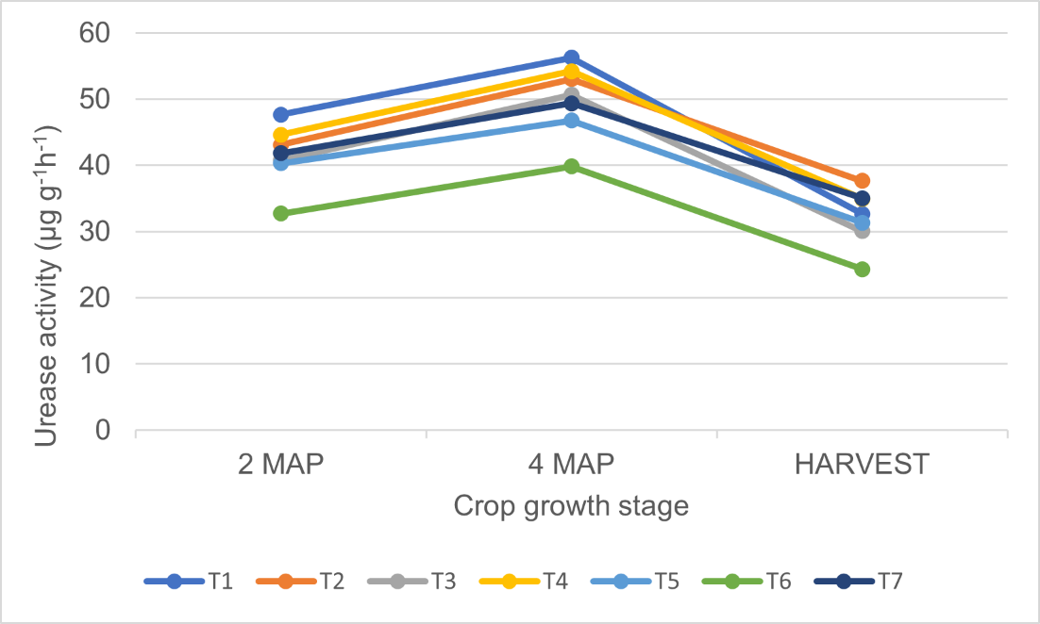

Fig. 1a

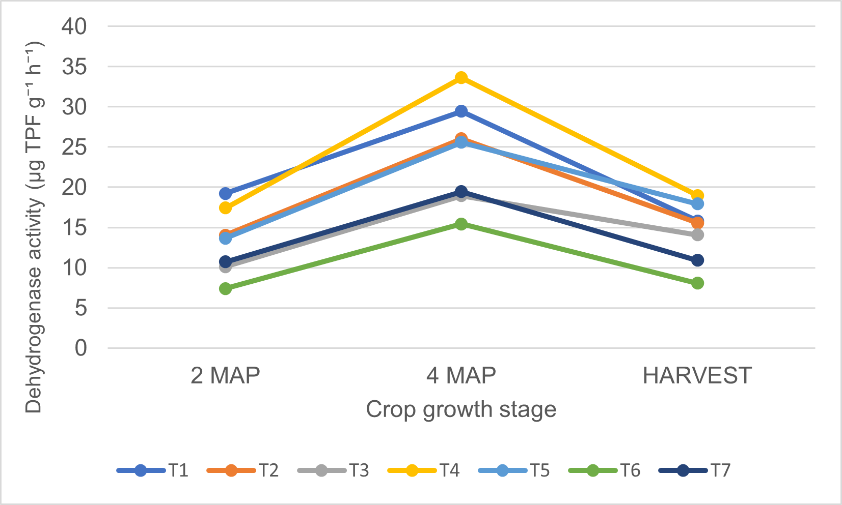

Fig. 1b

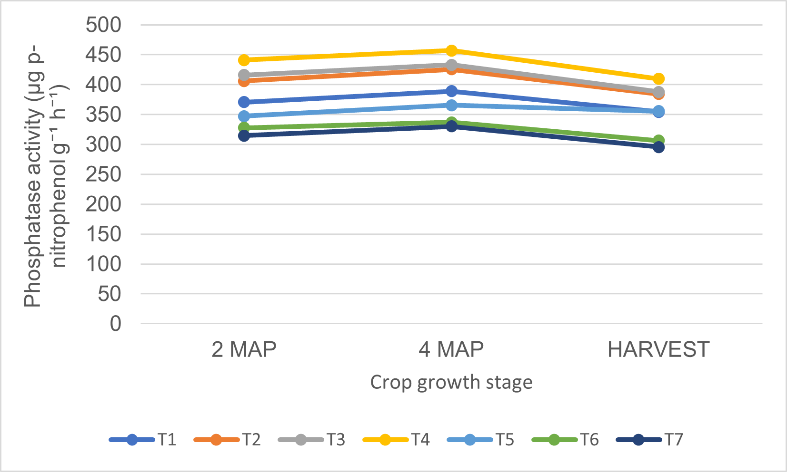

Fig. 1c

Fig. 1(a,b,c). Pattern of soil enzyme activities under silt-fortified organic manure treatments at different crop growth stages

4. Conclusion

The present study demonstrated that fortification of locally available organic resources significantly improved soil chemical properties under cassava cultivation in the Kuttanad ecosystem. At harvest, fortified poultry manure (T₄) recorded the highest soil pH (6.15), available nitrogen (265.33 kg ha⁻¹), available phosphorus (52.90 kg ha⁻¹), and available potassium (345.22 kg ha⁻¹), indicating superior enhancement of soil fertility compared to other treatments and control. Soil organic carbon levels were also maintained at higher values under fortified organic treatments (1.48-1.63%) compared to the control (1.43%).

Fortified crop-residue composts (T₁ and T₃) also performed well, particularly in improving soil organic carbon (up to 1.63%) and available potassium (up to 346.30 kg ha⁻¹ in T₁), demonstrating their potential for sustaining soil nutrient reserves. In contrast, fish pond silt applied alone (T₆) recorded comparatively lower available N (199.57 kg ha⁻¹), P (31.32 kg ha⁻¹), and K (213.95 kg ha⁻¹), highlighting that fortification with nutrient-rich organic materials is essential for maximizing its effectiveness.

Based on the consistent improvement in soil pH, organic carbon, and available NPK status, fortified poultry manure can be recommended as a sustainable and location-specific nutrient management strategy for cassava cultivation in Kuttanad soils. The integration of silt-fortified organic amendments provides a practical approach for recycling local bioresources, improving soil fertility, and enhancing resilience of cassava-based production systems in fragile wetland agroecosystems.
DISCLAIMER (ARTIFICIAL INTELLIGENCE)
Author(s) hereby declare that NO generative AI technologies such as Large Language Models (ChatGPT, COPILOT, etc.) and text-to-image generators have been used during the writing or editing of this manuscript.

References
- Department of Agriculture Development & Farmers’ Welfare, Government of Kerala (2025) Karshakan: The first English farm journal from the House of Kerala Karshakan, Vol. 14, Issue 06, November 2025. Farm Information Bureau, Kerala.

- Vijayan, D. & Ray, J.G., 2015. Ecology and diversity of Cyanobacteria in Kuttanadu paddy wetlands, Kerala, India. American Journal of plant sciences, 6(18): 2924-2938.

- Nangsankupar, S., Meera, A.V., Rani, B., Bindhu, S. and Leno, N., 2025. Effect of Organic Amendments on Soil Health in Wetland Rice Growing Soils of Southern Kerala, India. Journal of Scientific Research and Reports, 31(12), pp.608-617.

- Agbede, T.M., Oyewumi, A., Agbede, G.K., Adekiya, A.O., Adebiyi, O.T.V., Abisuwa, T.A., Ijigbade, J.O., Ogundipe, C.T., Wewe, A.O., Olawoye, O.D. and Eifediyi, E.K., 2024. Impacts of poultry manure and biochar amendments on the nutrients in sweet potato leaves and the minerals in the storage roots. Scientific Reports, 14(1), p.16598.

- Kumari, M., Sheoran, S., Prakash, D., Yadav, D.B., Yadav, P.K. and Jat, M.K., 2024. Long-term application of organic manures and chemical fertilizers improve the organic carbon and microbiological properties of soil under pearl millet-wheat cropping system in North-Western India. Heliyon, 10(3).

- Viswanathan, D., Isaac, S.R., Pillai, S. & Shimi, G., 2024. Potential of Amended Silt as Nutrient Input in Agriculture-A Chemical Composition Analysis. Journal of the Indian Society of Coastal Agricultural Research, 42(2), pp.129-135.

- Jackson, M. L. 1973. Soil Chemical Analysis. Prentice Hall of India Pvt. Ltd., New Delhi, 991р.

- Walkley, A. J. & Black, I. A. 1934. Estimation of soil organic carbon by chromic acid titration method. Soil Sci. 31: 29-38.

- Subbiah, B. V. & Asija, G. L. 1956. A rapid procedure for the estimation of available nitrogen in soils. Curr. Sci. 25: 259-260.

- Bray, R.H. and Kurtz, L.T., 1945. Determination of total, organic, and available forms of phosphorus in soils. Soil science, 59(1), pp.39-46.

- Broadbent,F.E., Hill G N & Tyler K B. 1958. Transformations and movement of urea in soils. Soil Science Society of America Proceedings 22: 303–7.

- Casida LE, Kelvin Jr D A & Santoro T. 1964. Soil dehydrogenase activity. Soil Science 98: 371–6.

- Tabatabai, M. A., & J. M. Bremner. 1969. Use of P-nitrophenol phosphate in assay of soil phosphatase activity. Soil Biology and Biochemistry 1 (4):301–7.

- Gopinath, P.P., Parsad, R., Joseph, B. & Adarsh, V.S., 2020. GRAPES: General rshiny based analysis platform empowered by statistics. Journal of Open Source Software, 6(63), p.3437.

- Xu, J., Li, Y. & Li, L., 2025. A Comprehensive Review of the Effects of Organic Amendments on Soil Health and Fertility: Mechanisms, Greenhouse Gas Emissions, and Implications for Sustainable Agriculture. Agronomy. 15(12), p.2705.

- Haynes, R.J. & Mokolobate, M.S., 2001. Amelioration of Al toxicity and P deficiency in acid soils by additions of organic residues: a critical review of the phenomenon and the mechanisms involved. Nut cycl agroecosystems. 59(1): 47-63.

- Brady, N.C. & Weil, R.R., 2016. The nature and properties of soils. Columbus. EUA Pearson Education.

- Awwal, Y.A., Angyu, M.D. & Afolabi, R.J., 2025. Impact of various soil amendments on temporal NPK release, soil quality and maize yield in tropical Alfisols of Zaria, Nigeria. Scientific Reports, 15(1), p.41856.

- Abbas, A., Naveed, M., Shehzad Khan, K., Ashraf, M., Siddiqui, M.H., Abbas, N., Mustafa, A. & Ali, L., 2024. The efficacy of organic amendments on maize productivity, soil properties and active fractions of soil carbon in organic-matter deficient soil. Span. J. Soil Sci. 14, p.12814.

- Reddy, K.R., DeLaune, R.D. & Inglett, P.W., 2022. Biogeochemistry of wetlands: science and applications. CRC press.

- Kim, H.N. & Park, J.H., 2024. Monitoring of soil EC for the prediction of soil nutrient regime under different soil water and organic matter contents. Applied Biological Chemistry, 67(1):1.

- Ahmad, M.N., Anuar, M.I., Abd Aziz, N. & Murdi, A.A., 2025. Function and application of Soil Electrical Conductivity (EC) sensor in agriculture: A Review. Advances in Agricultural and Food Research Journal, 6(1).1.

- Howeler, R.H., 2014. Sustainable soil and crop management of cassava in Asia: A reference manual.

- Sarkar, D., Mukherjee, S., Pratibha, G. & Kundu, S. 2025. Managing Crop Residue for Soil Health Improvement in India. Soil Health and Sustainability in India, p.451.

- Rani, S., 2021. Clay mineralogy: soil carbon stabilization and organic matter interaction. In Soil Carbon Stabilization to Mitigate Climate Change (pp. 83-123). Singapore: Springer Singapore.

- Cheng, H., Hill, P.W., Bastami, M.S. & Jones, D.L., 2017. Biochar stimulates the decomposition of simple organic matter and suppresses the decomposition of complex organic matter in a sandy loam soil. GCB Bioenergy, 9(6), pp.1110-1121.

- Hao, X., Ma, X., Sun, L., Liu, S., Ji, J., Zhou, B., Zhao, Y., Zheng, Y., Kuang, E., Liu, Y. & Zhao, S., 2025. High ratio of manure substitution enhanced soil organic carbon storage via increasing particulate organic carbon and nutrient availability. Plants, 14(13): p.2045.

- Lal, R., 2020. Managing soils for resolving the conflict between agriculture and nature: The hard talk. Eur. J. Soil Sci. 71(1): 1-9.

- Dash, P.K., Padhy, S.R., Bhattacharyya, P., Pattanayak, A., Routray, S., Panneerselvam, P., Nayak, A.K. & Pathak, H., 2022. Efficient lignin decomposing microbial consortium to hasten rice-straw composting with moderate GHGs fluxes. Waste Biomass Valor.13(1): 481-496.

- Kacprzak, M., Malińska, K., Grosser, A., Sobik-Szołtysek, J., Wystalska, K., Dróżdż, D., Jasińska, A. & Meers, E., 2023. Cycles of carbon, nitrogen and phosphorus in poultry manure management technologies–environmental aspects. Crit. Rev. Environ.Sci.Technol. 53(8): 914-938.

- Byju, G., Nedunchezhiyan, M., George, J., Sunitha, S., Soman, S. & Hridya, A.C. 2020. Evaluation of fertilizer best management practices by SSNM and customized fertilizers for cassava (Manihot esculenta) cultivation in India. Current Horticulture, 8(1): 56-64.

- Reetika, Kaur, J., Singh, T., & Sain, K.S. 2023. Influence of rice straw incorporation and integrated nutrient management on growth, yield, and nutrient uptake in potato (Solanum tuberosum) and onion (Allium cepa) under rice (Oryza sativa)–potato-onion cropping system. Indian J. Agron. 68 (4): 420-425.

- Mehta, A., Rijwan, S., Rakesh, B., Navina, Y., & Sneha, K. 2023. Effects of fermented banana pseudo-stem sap (Musa Acuminate L.) on the growth and yield attributing characters of marigold variety Karma 555-Orange. J. Agric. Appl. Biol. 4(2):116-130.

- Biratu, G.K., Elias, E., Ntawuruhunga, P. & Nhamo, N., 2018. Effect of chicken manure application on cassava biomass and root yields in two agro-ecologies of Zambia. Agriculture, 8(4), p.45.

- Setu, H., 2022. Effect of phosphorus and potassium fertilizers application on soil chemical characteristics and their accumulation in potato plant tissues. Appl. Environ. Soil Sci. 22(1): 5342170.

- Enesi, R.O., Hauser, S., Pypers, P., Kreye, C., Tariku, M. & Six, J., 2022. Understanding changes in cassava root dry matter yield by different planting dates, crop ages at harvest, fertilizer application and varieties. Eur. J. Agron. 133, p.126448.

- Howeler, R., 2011. Short-and long-term N, P, and K requirements of cassava. The cassava handbook. A reference manual based on the Asian regional cassava training course, Thailand, pp.429-454.

- Agbede, T.M. 2025. Poultry manure improves soil properties and grain mineral composition, maize productivity and economic profitability. Scientific Reports, 15(1):16501.

- Parshad, J., Kumar, R., Chhokar, V., Patil, N., Beniwal, V., Singh, N., Kumar, A., Singh, N., Yogi, R., Kumar, M. & Vikram, P. 2024. Paddy straw management: Alternative strategies and emerging technology for sustainable ecosystem. Pedosphere [online].

- Xu, J., Wang, J., Lin, S., Hou, L., Ma, S., Lv, Y., Chen, R., He, X. & Hou, J., 2023. The effect of novel aquaculture mode on phosphorus sorption-release in pond sediment. Sci. Total Env. 905(1):167019.

- Depel, G., Polat, H., Çaycı, G., Demir, Z. & Koca, C. 2021. Effects of Composted poultry manure and rice husk+ poultry manure on potato tuber yield and physico-chemical properties of clay loam soil. Commun. Soil Sci. Plant Anal. 52(21): 2623-2643.

- Nannipieri, P., Trasar-Cepeda, C. & Dick, R.P., 2018. Soil enzyme activity: a brief history and biochemistry as a basis for appropriate interpretations and meta-analysis. Biol. Fertil. Soils 54(1): 11-19.

- Sinsabaugh, R.L., Hill, B.H. & Follstad Shah, J.J., 2009. Ecoenzymatic stoichiometry of microbial organic nutrient acquisition in soil and sediment. Nature, 462(7274): 795-798.

- Gupta, s., Yildirim, S., Andrikopoulos, B., Wille, U. & Roessner, U. 2023. Deciphering the interactions in the root–soil nexus caused by urease and nitrification inhibitors: a review. Agronomy, 13(6), p.1603.

- Bharadwaj, A., Bharadwaj, P., Gupta, M., Thakur, D. & Devi, A., 2025. Unraveling labile carbon and soil enzyme dynamics across seasons and sediment layers in Deepor Beel: a degraded freshwater wetland in Assam, India. Environ. Monit. Assess. 197(8): 874.

- Chiewchankaset, P., Thaiprasit, J., Kalapanulak, S., Wojciechowski, T., Boonjing, P. & Saithong, T., 2022. Effective metabolic carbon utilization and shoot-to-root partitioning modulate distinctive yield in high yielding cassava variety. Front. plant sci. 13, p.832304.

- Minkina, T., Sushkova, S., Delegan, Y., Bren, A., Mazanko, M., Kocharovskaya, Y., Filonov, A., Rajput, V.D., Mandzhieva, S., Rudoy, D. & Prazdnova, E.V., 2023. Effect of chicken manure on soil microbial community diversity in poultry keeping areas. Environ. Geochem. Health 45(12): 9303-9319.

- Pankaj, Sharma, S., Singh, V. & Angmo, P., 2023. Changes in soil biological and chemical environment during wheat growth stages under nitrogen and straw management practices in rice-wheat system. J. Plant Nutr. 46(15): 3599-3616.

- Pang, J., Wen, Z., Kidd, D., Ryan, M.H., Yu, R.P., Long, L., Cong, W.F., Siddique, K., Lambers, H., Havlin, J. & Schlegel, A.J., 2023. Instant Insights: Phosphorus uptake and use in crops (Vol. 73). Burleigh Dodds Science Publishing.

- Ma, S., Dong, X., Luo, C., & Xu, J., 2023. Enrichment of organic carbon increases the flux of phosphorus from sediment in mariculture ponds. Aquaculture, 565, p.739148.

