IDENTIFICATION OF HIGH ZINC AND IRON RICH GENOTYPES THROUGH GERMPLASM SCREENING IN RICE

Abstract: The present study was conducted to evaluate genetic variability for grain micronutrient content in rice and to identify promising donor genotypes for biofortification. Fifty rice germplasm entries were assessed for grain zinc (Zn), iron (Fe), manganese (Mn), and copper (Cu) concentrations at RARS, Nandyal, during Kharif 2024 using a randomized block design with three replications. Significant variation was observed among the germplasm lines, with Zn content ranging from 13.74 to 37.60 ppm and Fe from 3.17 to 28.54 ppm, indicating ample scope for genetic improvement. Genotypes RTCNP-102, RTCNP-104, RTCNP-106, RTCNP-118, and RTCNP-111 recorded high Zn levels (>30 ppm), while RTCNP-104, RTCNP-106, RTCNP-152, and RTCNP-155 exhibited higher Fe concentration. Notably, RTCNP-104 showed a desirable combination of high Zn (34.85 ppm) and Fe (28.54 ppm), suggesting its potential as an elite donor for biofortification breeding programmes. Considerable variability was also observed for Mn and Cu, contributing to the overall micronutrient balance in grains.
Keywords: Rice, Germplasm, Zinc, Iron, Biofortification, Micronutrients
Introduction
Micronutrient malnutrition, especially deficiencies of zinc (Zn) and iron (Fe), is a major public health concern in many rice-eating regions. Since polished rice contains very low levels of essential minerals, populations that depend predominantly on rice as a staple food often suffer from “hidden hunger.” Biofortification, which involves developing crop varieties with higher nutrient density, is considered a sustainable and cost-effective strategy to address micronutrient deficiencies (Bouis and Saltzman, 2017; HarvestPlus, 2024).
Rice exhibits substantial natural genetic variability for grain micronutrients such as Zn, Fe, manganese (Mn), and copper (Cu). This variability is present in landraces, traditional cultivars, and diverse germplasm collections, making them valuable genetic resources for improving grain nutritional quality through breeding programmes. Several studies have emphasized that exploitation of this variability is essential for developing nutrient-dense rice varieties suitable for biofortification (Swamy et al., 2016). Earlier reports have also indicated that specific metal transporter genes regulate the uptake, translocation, and accumulation of micronutrients in rice grains, suggesting a strong genetic basis for micronutrient enrichment (Gregorio et al., 2000; Senguttuvel et al., 2023).
Screening and identification of high-Zn and high-Fe genotypes is therefore a critical step toward the development of nutritionally enriched rice varieties. Such promising genotypes can serve as donor parents in conventional breeding, marker-assisted selection, and genomic-assisted biofortification programmes. Recent studies have highlighted the importance of integrating germplasm evaluation with quantitative genetic parameters to accelerate the development of biofortified rice cultivars (Venkata Ratnam et al., 2024). Hence, the present study was undertaken to evaluate fifty (50) rice germplasm lines for grain micronutrient content to identify promising donors for improving the nutritional quality of rice.
Material and Methods:
Germplasm: A total of fifty rice germplasm entries were obtained from the Rice Germplasm Repository of the Plant Breeding (Rice) Department, Regional Agricultural Research Station, Nandyal. These lines were selected to represent a broad genetic diversity for grain micronutrient content.
Experimental Design and Field Management: The germplasm lines were sown in a randomized block design (RBD) in three replications during Kharif 2024 at the Regional Agricultural Research Station, Nandyal. The crop was grown with the recommended agronomic practices, including irrigation, fertilization, and pest management, which were followed to ensure uniform crop growth.
Grain Sample Collection: At physiological maturity, paddy samples were harvested from the central rows of each plot to avoid border effects. The harvested grains were collected and air-dried, dehusked, and milled using a standard rice milling machine to obtain polished rice for micronutrient analysis.
Micronutrient Analysis: Grain samples were analysed for Zn, Fe, Mn and Cu concentrations. Weighed 0.5 g of finely ground rice powder was digested using a mixture of concentrated nitric acid (HNO₃) and perchloric acid (HClO₄) following the standard wet digestion method. The micronutrient concentrations in the digested samples were estimated using an Atomic Absorption Spectrophotometer (AAS).
Quality Control: Standard reference samples and blank samples were included in each batch of analysis to ensure accuracy and precision. All measurements were repeated three times, and the mean values were used for further statistical analysis.
Data Analysis: Descriptive statistics such as mean, range, and standard deviation were calculated for each micronutrient. Analysis of variance (ANOVA) was performed to test the significance of treatment effects as per the procedure described by Gomez and Gomez (1984) to detect significant differences among germplasm lines. Correlation analysis was conducted to examine relationships among micronutrients, and genotypes with high Zn and Fe contents were identified as potential donors for biofortification breeding programmes.
Results and Discussion
Mean Performance of Rice Germplasm Lines for Micronutrient Traits:
The evaluation of fifty (50) rice germplasm lines revealed substantial genetic variability for grain micronutrients (Zn, Fe, Mn and Cu). Zinc (Zn) concentrations ranged from 13.74 to 37.60 ppm, demonstrating the presence of favourable alleles for enhanced uptake, translocation, and deposition in grains. Genotypes RTCNP-102, RTCNP-104, RTCNP-106, RTCNP-118 and RTCNP-111 with Zn >30 ppm represents valuable sources of Zn enrichment (Gregorio et al., 2000; Harvest Plus, 2014). Metal transporter genes such as ZIP, YSL, and HMA play a key role in Zn loading into grains, as reported by Ishimaru et al. (2005) and Morrissey and Guerinot (2007).
Iron (Fe) concentration ranged from 3.17 to 28.54 ppm. High-Fe genotypes RTCNP-104, RTCNP-106, RTCNP-152, and RTCNP-155 indicate the existence of natural genetic diversity for Fe enrichment. Notably, RTCNP-104, combining high Zn (34.85 ppm) and Fe (28.54 ppm), emerged as an elite donor for biofortification. Multiple Fe-associated QTLs on chromosomes 1, 3, 7, and 12 have been reported, aligning with the genotype-dependent Fe accumulation observed in this study (Stangoulis et al., 2007; Zhang et al., 2014). No strong antagonistic relationship between Zn and Fe was observed, supporting simultaneous improvement of both traits (Welch and Graham, 2004).
Mn and Cu concentrations also varied considerably, contributing to a balanced micronutrient profile. High-Mn genotypes (RTCNP-90, RTCNP-93, RTCNP-153) and high-Cu genotypes (RTCNP-105, RTCNP-162) reflect favourable physiological mechanisms for micronutrient acquisition and storage (Li et al., 2019; Jiang et al., 2008). These genotypes may serve as useful genetic material for broad-spectrum micronutrient improvement.
Overall, high-Zn and Fe lines, particularly RTCNP-104, RTCNP-106, RTCNP-118, RTCNP-142, RTCNP-146, RTCNP-150, RTCNP-154, and RTCNP-163, offer promising potential for future rice improvement programmes. Their nutritional superiority supports direct use in hybridization, QTL mapping, marker-assisted selection (MAS), and genomic-assisted breeding. This study underscores the importance of utilizing native genetic diversity from landraces and germplasm collections to develop nutrient-dense rice varieties and combat hidden hunger (Bouis et al., 2011).

Genetic Parameters for Micronutrient Traits:
The estimates of mean, range, phenotypic and genotypic coefficients of variation (PCV and GCV), broad-sense heritability, and genetic advance as percent of mean (GAM) for zinc (Zn), iron (Fe), manganese (Mn), and copper (Cu) revealed substantial genetic variability among the 50 rice germplasm lines studied (Table 2). Such wide variability is a prerequisite for effective selection and genetic improvement, particularly for rice biofortification programmes (Gregorio et al., 2000; Swamy and Kumar, 2013).
Grain zinc content recorded a mean of 25.35 ppm with a wide range from 13.74 to 37.60 ppm. The close correspondence between GCV (24.12%) and PCV (25.67%) indicates minimal environmental influence on Zn expression. High heritability (88.30%) coupled with high GAM (46.69%) suggests the predominance of additive gene action, indicating good scope for improvement through direct selection. Similar observations for grain Zn variability and inheritance have been reported earlier in rice germplasm (Anuradha et al., 2012; Babu et al., 2014).
Iron content exhibited very high variability, as reflected by high GCV (50.59%) and PCV (51.46%), along with very high heritability (96.60%) and GAM (102.43%). These results indicate strong genetic control over grain iron concentration and suggest that phenotypic selection would be highly effective. The wide range (3.17–28.54 ppm) further confirms the availability of superior genotypes for iron enrichment, consistent with earlier findings that reported multiple genomic regions governing grain Fe concentration in rice (Norton et al., 2010; Zhang et al., 2014).
Manganese and copper also showed high variability, heritability, and genetic advance. Mn recorded high heritability (91.20%) with GAM of 54.43%, while Cu exhibited the highest GCV (61.11%), PCV (61.90%), heritability (97.50%), and GAM (124.26%). Although Mn and Cu are not primary targets of global biofortification initiatives, their genetic variability contributes to balanced micronutrient composition and overall grain nutritional quality (Fageria et al., 2011).

Principal component analysis (PCA) revealed that four principal components explained 100% of the total variation among the germplasm (Table 3). The first two principal components accounted for 58.67% of the total variability, indicating that a limited number of micronutrients largely influenced genetic diversity. Factor loadings (Table 4) showed that Zn contributed strongly to PC1, Mn and Cu to PC2, and Fe to PC3, highlighting both independent and combined contributions of micronutrients to total variation. Similar PCA patterns for grain micronutrients have been reported in rice by Swamy and Kumar (2013) and Zhang et al. (2014).
Overall, the PCA results confirmed the presence of substantial genetic diversity among the evaluated rice germplasm and highlighted Zn and Fe as major contributors to variability, thereby supporting their prioritisation in biofortification breeding programmes.
The PCA biplot (fig.1) illustrates the distribution of fifty rice germplasm lines based on four grain micronutrient traits, namely zinc (Zn), iron (Fe), manganese (Mn), and copper (Cu). The first two principal components (PC1 and PC2), which together explained 58.67% of the total variation, were used to construct the biplot. Vectors representing Zn, Fe, Mn, and Cu indicate the direction and magnitude of their contribution to genetic divergence among the germplasm.
Zn showed a strong positive association with PC1, whereas Mn and Cu contributed predominantly to PC2, confirming their major role in explaining variability among genotypes. Fe showed an independent contribution, consistent with its high loading in PC3. Genotypes positioned in the direction of Zn and Fe vectors exhibited higher concentrations of these micronutrients, highlighting their potential as donors for biofortification breeding. The spatial separation of genotypes in different quadrants reflects substantial genetic diversity and indicates the possibility of selecting superior lines with desirable micronutrient combinations.
The scree plot depicts (fig.2) the eigenvalues associated with the four principal components derived from PCA of grain micronutrient traits. The gradual decline in eigenvalues from PC1 to PC4 indicates the relative importance of each component in explaining total variability.
The first principal component (PC1) showed the highest eigenvalue (1.384), accounting for 34.60% of the total variation, followed by PC2 (24.06%), PC3 (23.78%), and PC4 (17.55%). The absence of a sharp break after the first component suggests that multiple micronutrient traits contribute meaningfully to genetic variability. Together, all four components explained 100% of the total variation, confirming the suitability of PCA for summarizing the multidimensional micronutrient data in rice germplasm.
Conclusion
The study revealed significant genetic variability among the fifty rice germplasm lines for grain micronutrient traits (Zn, Fe, Mn, and Cu). High heritability coupled with substantial genetic advance indicated that these traits are largely governed by additive gene action and can be effectively improved through selection. Genotypes such as RTCNP-104, RTCNP-106, RTCNP-118, RTCNP-142, RTCNP-146, RTCNP-150, RTCNP-154, and RTCNP-163 were identified as promising donors for micronutrient enrichment. These lines can be utilized in biofortification breeding programmes to develop nutritionally improved rice varieties for combating hidden hunger.
Disclaimer (Artificial intelligence)
Author(s) hereby declare that NO generative AI technologies such as Large Language Models (ChatGPT, COPILOT, etc.) and text-to-image generators have been used during the writing or editing of this manuscript.
References:
- Bouis, H.E., & Saltzman, A. (2017). Improving nutrition through biofortification: A review of evidence from HarvestPlus, 2003 through 2016. Global Food Security: 12. 49–58.
- Bouis, H.E., Hotz, C., McClafferty, B., Meenakshi, J.V., & Pfeiffer, W.H. (2011). Biofortification: A new tool to reduce micronutrient malnutrition. Food and Nutrition Bulletin. 32(1): S31–S40.
- Gomez, K.A., & Gomez, A.A. (1984). Statistical Procedures for Agricultural Research. 2nd Edition, John Wiley and Sons. New York: 680 p.
- Gregorio, G.B., Senadhira, D., & Graham, R.D. (2000). Breeding for trace mineral density in rice. Food and Nutrition Bulletin. 21(4): 382–386.
- HarvestPlus. (2014). Breeding crops for better nutrition. Annual Technical Report. HarvestPlus, Washington DC.
- HarvestPlus. (2024). Biofortification breeding targets for zinc and iron in staple food crops.
HarvestPlus Technical Report, HarvestPlus, International Food Policy Research Institute (IFPRI), Washington, DC.
- Ishimaru, Y., Suzuki, M., & Tsukamoto, T. (2005). Zinc, iron, and manganese transporters in rice. Rice. 2:155–164.
- Jiang, S. L., Wu, J. G., Thang, N. B., Feng, Y., Yang, X. E., & Shi, C. H. (2008). Genotypic variation of mineral elements contents in rice (Oryza sativa L.). European Food Research and Technology. 228(1): 115–122.
- Li, J., Wang, Y., Zheng, L., Li, Y., Zhou, X., & Li, J. (2019). The intracellular transporter AtNRAMP6 is involved in Fe homeostasis in Arabidopsis. Frontiers in Plant Science. 10: 1124.
- Morrissey, J., & Guerinot, M. L. (2009). Iron uptake and transport in plants: The good, the bad, and the ionome. Chemical Reviews. 109(10): 4553–4567.
- Senguttuvel, P., Padmavathi, G., Jasmine, C., Sanjeeva Rao, D., Neeraja, C. N., Jaldhani, V., Beulah, P., Gobinath, R., Aravind Kumar, J., Sai Prasad, S. V., Subba Rao, L. V., Hariprasad, A. S., Sruthi, K. S., Shivani, D., Sundaram, R. M., & Govindaraj, M. (2023). Rice biofortification: Breeding and genomic approaches for genetic enhancement of grain zinc and iron contents. Frontiers in Plant Science. 14.
- Stangoulis, J., Huynh, B., Welch, R., Choi, E.-Y.,& Graham, R. (2007). Quantitative trait loci for phytate in rice grain and their relationship with grain micronutrient content. Euphytica. 154(3): 289-294.
- Swamy, B. P. M., Rahman, M. A., Inabangan-Asilo, M. A., Amparado, A., Manito, C., Chadha-Mohanty, P., Reinke, R., & Slamet-Loedin, I. H. (2016).
Advances in breeding for high grain zinc in rice. Rice. 9: 49.
- Venkata Ratnam, T., Ravi Kumar, B. N. V. S. R., Subba Rao, L. V., Srinivas, T., & Anand Kumar, A. D. V. S. L. P. (2024). Assessment of genetic variability, character association and path analysis for yield and quality traits in zinc and iron rich landraces of rice. Journal of Cereal Science. 44(2): 289–294.
- Welch, R.M., & Graham, R.D. (2004). Breeding for micronutrients in staple food crops from a human nutrition perspective. Journal of Experimental Botany. 55(396): 353–364.
- Zhang, M., Pinson, S. R. M., Tarpley, L., Huang, X.-Y., Lahner, B., Yakubova, E., Baxter, I., Guerinot, M. L.,& Salt, D. E. (2014). Mapping and validation of quantitative trait loci associated with concentrations of 16 elements in unmilled rice grain. Theoretical and Applied Genetics. 127(1): 137–165.

Table: 1 Mean Grain Micronutrient Concentrations (Zn, Fe, Mn and Cu) in Rice Genotypes
S.No | Entry name | Zn | Fe | Mn | Cu | S.No | Entry name | Zn | Fe | Mn | Cu
ppm |  |  |  |  |  |  |  | ppm
1 | RTCNP- 37 | 20.74 | 3.71 | 1.00 | 0.22 | 26 | RTCNP-142 | 30.47 | 13.24 | 0.74 | 0.34
2 | RTCNP- 72 | 24.30 | 17.24 | 1.19 | 0.33 | 27 | RTCNP-144 | 25.58 | 7.63 | 0.96 | 0.28
3 | RTCNP- 73 | 23.57 | 7.50 | 0.70 | 0.52 | 28 | RTCNP-146 | 33.20 | 10.34 | 1.03 | 0.26
4 | RTCNP- 90 | 28.42 | 9.69 | 1.83 | 0.63 | 29 | RTCNP-149 | 29.40 | 9.34 | 0.92 | 0.47
5 | RTCNP- 93 | 21.47 | 6.98 | 1.19 | 0.40 | 30 | RTCNP-150 | 32.41 | 10.58 | 0.88 | 0.02
6 | RTCNP- 98 | 33.24 | 5.97 | 0.91 | 0.19 | 31 | RTCNP-151 | 24.36 | 16.34 | 0.64 | 0.31
7 | RTCNP- 96 | 24.38 | 4.11 | 0.80 | 0.26 | 32 | RTCNP-152 | 18.20 | 22.42 | 0.87 | 0.44
8 | RTCNP- 99 | 22.44 | 3.17 | 0.67 | 0.19 | 33 | RTCNP-153 | 17.30 | 6.34 | 1.08 | 0.69
9 | RTCNP- 100 | 18.36 | 19.26 | 1.37 | 0.34 | 34 | RTCNP-154 | 30.82 | 16.34 | 0.64 | 0.34
10 | RTCNP- 102 | 33.40 | 11.36 | 0.73 | 0.25 | 35 | RTCNP-155 | 26.41 | 22.08 | 0.74 | 0.85
11 | RTCNP- 104 | 34.85 | 28.54 | 1.26 | 0.25 | 36 | RTCNP-156 | 20.22 | 13.24 | 0.62 | 0.54
12 | RTCNP- 105 | 32.36 | 6.84 | 1.30 | 1.05 | 37 | RTCNP-157 | 19.30 | 10.74 | 0.77 | 0.46
13 | RTCNP- 106 | 34.41 | 27.70 | 0.99 | 0.22 | 38 | RTCNP-159 | 22.41 | 11.36 | 0.96 | 1.01
14 | RTCNP- 111 | 37.60 | 7.19 | 0.86 | 0.18 | 39 | RTCNP-161 | 26.38 | 8.34 | 1.03 | 0.87
15 | RTCNP- 112 | 13.74 | 3.59 | 1.06 | 0.19 | 40 | RTCNP-162 | 20.30 | 10.36 | 0.84 | 1.05
16 | RTCNP- 118 | 30.25 | 14.83 | 1.05 | 0.25 | 41 | RTCNP-163 | 31.48 | 16.42 | 0.67 | 0.67
17 | RTCNP- 126 | 14.78 | 14.76 | 0.95 | 0.13 | 42 | RTCNP-165 | 22.45 | 10.78 | 0.92 | 0.85
18 | RTCNP- 127 | 32.47 | 5.02 | 1.20 | 0.13 | 43 | RTCNP-166 | 18.47 | 4.69 | 0.14 | 1.03
19 | RTCNP- 130 | 30.74 | 6.99 | 1.00 | 0.13 | 44 | RTCNP-166a | 16.34 | 8.34 | 0.64 | 0.64
20 | RTCNP- 135 | 33.44 | 6.41 | 0.86 | 0.11 | 45 | RTCNP-167 | 19.24 | 12.54 | 0.94 | 0.53
21 | RTCNP-136 | 14.32 | 10.34 | 0.75 | 0.38 | 46 | RTCNP-167a | 30.42 | 10.38 | 0.70 | 0.15
22 | RTCNP-137 | 16.87 | 13.25 | 0.84 | 0.45 | 47 | RTCNP-170 | 28.47 | 6.74 | 1.08 | 0.66
23 | RTCNP-138 | 20.39 | 11.36 | 0.68 | 0.36 | 48 | RTCNP-171 | 26.34 | 12.36 | 0.75 | 0.38
24 | RTCNP-139 | 27.36 | 14.35 | 0.74 | 0.67 | 49 | RTCNP-172 | 23.41 | 9.41 | 0.88 | 0.74
25 | RTCNP-141 | 25.85 | 8.34 | 1.03 | 0.88 | 50 | RTCNP-174 | 23.62 | 17.68 | 0.72 | 0.18
 | Range |  |  |  |  |  |  | 13.74-37.60 | 3.17-28.54 | 0.14-1.83 | 0.02-1.05

Table 2: Mean, Range, Coefficient of variation, Heritability, Genetic Advance as per cent of mean in 50 rice germplasm
S.No | Character | Mean | Range |  | Coefficient of variation | Heritability (%)h²(bs) | Genetic advance as % of mean (GAM)
 |  |  | Minimum | Maximum
1 | Zn | 25.35 | 13.74 | 37.6 | 24.122 | 25.671 | 88.30 | 46.69
2 | Fe | 11.33 | 3.17 | 28.54 | 50.587 | 51.462 | 96.60 | 102.43
3 | Mn | 0.90 | 0.14 | 1.83 | 27.669 | 28.970 | 91.20 | 54.43
4 | Cu | 0.45 | 0.02 | 1.05 | 61.105 | 61.897 | 97.50 | 124.26
PCV and GCV: Phenotypic and genotypic coefficients of variation, h²(bs): Broad-sense heritability, GAM: Genetic advance as a percentage of the mean

Table 3: Total variances explained by different principal components in 50 rice germplasm
S. No |  | Principal Components
S. No |  | PC 1 | PC 2 | PC 3 | PC4
1. | Eigen Value | 1.384 | 0.963 | 0.951 | 0.702
2. | Explained % of variance | 34.603 | 24.063 | 23.779 | 17.555
3. | Cumulative % of variance | 34.603 | 58.667 | 82.445 | 100

Table 4: Factor loading of different characters with respect to different principal factor in 50 rice germplasm
Principal components | PC1 | PC2 | PC3 | PC4
Zn | 0.655 | -0.04 | -0.145 | 0.741
Fe | 0.35 | -0.063 | 0.925 | -0.131
Mn | 0.397 | 0.843 | -0.141 | -0.333
Cu | -0.54 | 0.532 | 0.321 | 0.568

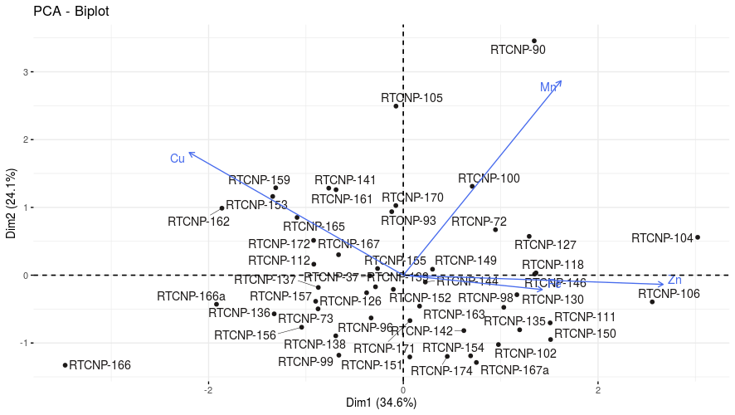
Fig 1: Biplot depicting 50 rice germplasm for four quality traits

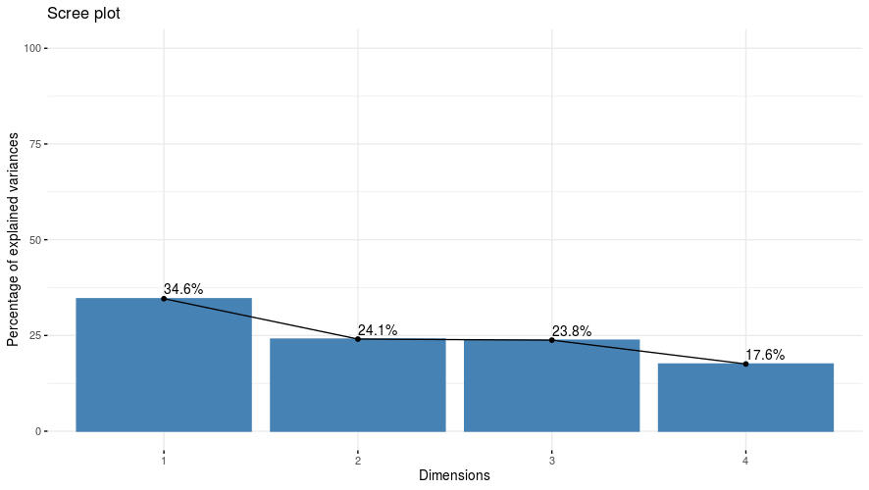
Fig 2: Scree plot showing the eigenvalue variation for four quality traits in 50 rice germplasm

