Characterization and Classification of Soils in the Lesser Himalayan Region of Bhimtal Block of Nainital District, Uttarakhand

ABSTRACT
The present study was undertaken to systematically characterize and taxonomically classify soils distributed across diverse topographic settings in the Bhimtal block of Nainital district, Uttarakhand. An intensive soil survey was conducted using a simple random sampling strategy, complemented by detailed examination of master soil profiles with the support of a Landscape Ecological Units (LEU) map prepared at a scale of 1:10,000.The high-resolution remote sensing data products of the Sentinel-II and SRTM Digital Elevation Model (DEM) downloaded from USGS official website and GIS approaches were used. Three major landforms viz. lower hillside slope, upper hillside slope and intermountain valley were identified and delineated. Seven representative pedons (covering all the soil types) were studied for their morphological, physical and chemical properties. These soils were shallow to very deep, very dark grayish brown, brown to dark grayish brown/dark brown, dark grayish brown to brown/ dark yellowish brown and brown to dark grayish in colour. Structure of the surface soils varied from massive to single grain. The soils are, in general, sandy loam to sandy loam, loam to loam, loamy sand to sandy loam, strongly acidic to acidic and neutral in reaction, moderately saline and non-calcareous. The electric conductivity exhibited a range from 0.13–2.29 dS m-1 in surface horizons and from 0.05–2.67 dS m-1 in the sub-surface, accompanied by organic carbon content categorized as medium (0.50-0.75%) to high (>0.75%). The exchangeable cations, specifically Ca2+, Mg2+, Na+, and K+, demonstrated variability ranging from 6.40–13.40, 1.60–5.40, 0.30–0.80 and 0.20–0.70 cmol(p+) kg-1, respectively, in surface horizons. Base saturation (BS) varied from 80–95% in surface horizons and from 79–97% in the sub-surface horizons. The cation exchange capacity (CEC) varied between 10.80–21.00 cmol(p+) kg-1 in surface horizons and from 5.20–19.90 cmol(p+) kg-1 in the sub-surface horizons. The soils were qualifying for typic eutrudepts, dystric eutrudepts lithic udorthents at subgroup. To ensure sustainable agricultural production within these soils, it is imperative to implement appropriate management strategies to mitigate the impacts of soil degradation.

Keywords: Landforms, soil characterization, soil classifications, soil physico-chemical properties, western Himalayas.

- INTRODUCTION
Soil constitutes a fundamental natural resource that sustains agricultural and ecological systems by supporting the production of food, fodder, fibre, and fuel for the rapidly increasing human and livestock populations. In mountainous regions, particularly the hilly landscapes, the area available for cultivation and biomass generation is inherently limited. Moreover, soil productivity in these regions is strongly influenced by spatial variations in physicochemical attributes such as soil depth, drainage conditions, texture, and soil reaction (pH). These limitations are further intensified by ongoing soil degradation caused by fragile geological formations, steep topography, unsustainable agricultural practices, indiscriminate deforestation, and the growing impacts of climate change (1,2). The Lesser Himalayas exhibit pronounced heterogeneity in elevation, slope, and climatic regimes, which collectively govern soil formation processes, properties, and land-use potential. Consequently, the diversity in soil characteristics determines their suitability for different land uses, including agriculture, forestry, horticulture, and pasture development. In the warm and humid zones of the Lesser Western Himalayas, soil resources are predominantly associated with steep to very steep slopes, making them highly vulnerable to moderate to extreme soil erosion hazards (3,24,25). Such terrain-induced constraints pose serious challenges to sustainable land management and agricultural productivity. Soil physicochemical properties in the Western Himalayan region are known to vary considerably with changes in altitude and vegetation cover (4). Differences in forest types across elevation gradients significantly influence soil texture, organic carbon content, nutrient availability, and moisture regimes. Empirical studies conducted in mid-Himalayan environments have demonstrated that both physical and chemical soil characteristics respond distinctly to altitudinal variations (5). These findings emphasize the importance of altitude-specific and vegetation-based soil management strategies to ensure sustainable utilization of soil resources. Hilly agro-ecosystems are inherently constrained by biophysical limitations, rendering them highly vulnerable to climatic variability and possessing limited resilience to climate change (6,7). Rainfed agricultural systems in these regions are increasingly exposed to moisture stress due to erratic rainfall patterns, high-intensity precipitation events, and prolonged dry spells. Under such conditions, the restructuring of rainfed agriculture through soil and water conservation measures, rainwater harvesting, crop diversification, and the adoption of eco-friendly and climate-resilient agricultural practices has been strongly advocated (8). Therefore, a systematic and scientific assessment of soil resources is essential to identify their limitations, potentials, land capability, and suitability for diverse land uses (9,10,11). A comprehensive soil database serves as a critical foundation for scientific land-use planning, conservation of natural resources, enhancement of farm productivity, and the implementation of site-specific climate-resilient technologies. Such efforts are particularly vital for the ecologically fragile and socio-economically disadvantaged Himalayan regions. Accordingly, a detailed soil survey of the Bhimtal block in Nainital district of Uttarakhand was undertaken using advanced geospatial techniques to develop a robust soil resource database for informed land-use planning and sustainable soil management.
MATERIALS AND METHODS
2.1 Description of the Study Area
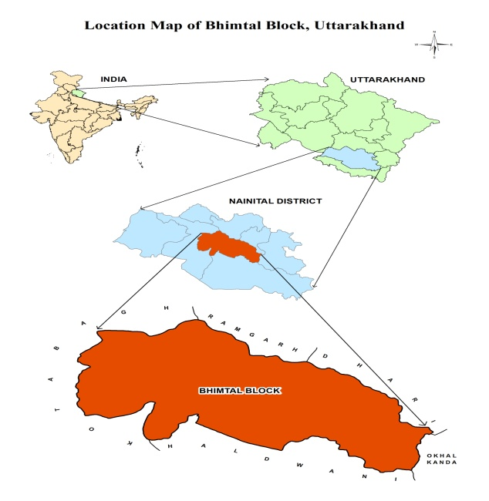
Fig.1: Location map of Bhimtal block, Nainital District, Uttarakhand
The study was carried out in Bhimtal block (29°13’34”N to 29°26’18”N latitudes and 79°19’47”E to 79°41’19”E, TGA:11064 ha) of Nainital district in Uttarakhand state, located on the outer ranges of the mid-Himalayas (Fig.1). It falls in foothills of Kumaun Himalayas (subdued), warm humid/perhumid environment agro-ecological sub-region (14.5) of the country (12). The physiographic setting of the block is marked by rugged mountainous terrain comprising prominent peaks, deeply incised gorges, and narrow valleys. Geologically, the area belongs to the Nagthat Formation, which forms an integral component of the Lesser Himalayan belt situated between the Siwalik range to the south and the Greater Himalaya to the north. The landscape is characterized by undulating relief with a succession of ridges, minor spurs, and intervening valleys drained by seasonal and perennial streams. Slope conditions vary considerably across the block, reflecting complex geomorphological processes. The underlying lithology primarily consists of BhimtalVolcanics associated with the Nagthat Formation, which originated during the Meso- to Palaeoproterozoic era.
The soils are predominantly medium to deep, loamy Tarai soils with moderate available water-holding capacity and a length of growing period ranging from approximately 270 to 300 days (AESR 14.5). The climatic conditions of the block are generally pleasant, with mild summers and cold winters. Summer temperatures typically range between 15 °C and 29 °C, whereas winter temperatures vary from about 4 °C to 18 °C. The months from March to June and September to December are considered climatically favorable, while winters become increasingly cold during December. Monsoonal rainfall occurs from late June to early September and is often associated with slippery terrain and difficult field conditions, making agricultural and survey operations challenging during this period. Agriculture in the region follows a distinct seasonal pattern. Major crops grown during the kharif season include maize, rice, and finger millet, whereas wheat, barley, and various vegetable crops dominate the rabi season. The natural vegetation of the block comprises a diverse assemblage of forest species, including Sal, Pine, Oak, Burans, and Kaphal at lower elevations, extending up to approximately 6,000 feet. At higher altitudes, tree species such as Deodar and Surai are commonly observed. Cultivated land is limited and fragmented, interspersed with horticultural plantations and fruit orchards. The region supports a wide variety of fruit crops, including apricot, orange, peach, pear, lemon, kafal, strawberry, banana, apple, and litchi, with orchard cultivation being particularly prominent in the Ramgarh and Mukteshwar belts near the Bhimtal region.
2.2 Remote Sensing Data
High-resolution remote sensing datasets with a spatial resolution of 10 m, including Sentinel-2 imagery and SRTM-derived digital terrain model (Fig.2) obtained from the United States Geological Survey repository, were processed and enlarged to a working scale of 1:10,000.
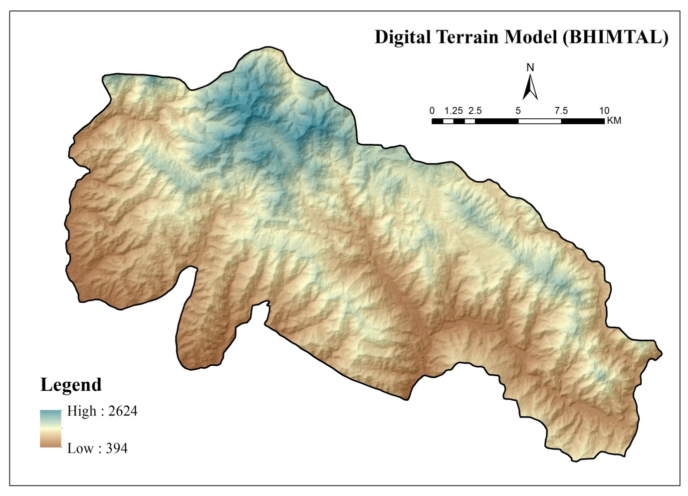
Fig.2: Relief map of Study area
The satellite data were interpreted using both digital techniques and visual analysis by examining key photomorphic characteristics such as tonal contrast, surface texture, spatial pattern, size, and shape. These elements were employed to identify and delineate various landforms and surface features across the study area. High-resolution Google Earth data at a comparable scale were utilized to extract land use and land cover information corresponding to different landform units. Terrain analysis was carried out through satellite data interpretation to derive topographic attributes including elevation, relief, contour patterns, drainage networks, slope gradients, landform types, and land use/land cover. Based on these attributes, thematic maps were generated to support landscape characterization. An automated approach was adopted for the delineation of landforms and the development of Landscape Ecological Units (LEUs) using terrain-based parameters. The base map for the study was prepared with precision by transferring spatial details from Survey of India toposheets, which were subsequently reduced to a scale of 1:10,000 without applying any generalization. This spatial information layer was then overlaid onto the LEU map, resulting in a comprehensive base map that served as the foundation for systematic field investigations.
2.3 Soil Survey and Soil Sampling Techniques
A systematic and intensive soil survey was undertaken using a simple random sampling approach, supported by the Landscape Ecological Units (LEU) map (Fig.3) having 21 units has been prepared at a scale of 1:10,000.
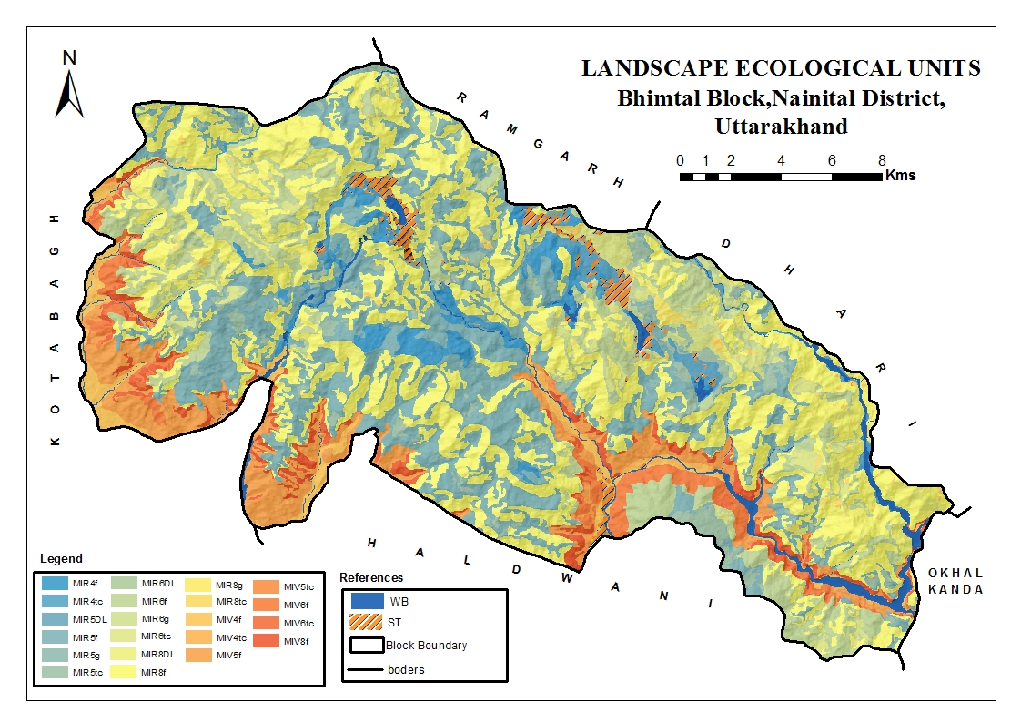
Fig.3: Landscape Ecological Units map of Bhimtal block
Master soil profiles were examined in detail to understand soil variability across the landscape (14). Within each identified LEU, representative pedons were carefully selected and investigated. Detailed field observations of soil profiles enabled the differentiation of soils based on their morphological features and physicochemical attributes. Considering the relationship between soil characteristics and site-specific factors, the soils were grouped into distinct soil series. Each soil series represents a relatively homogeneous unit characterized by comparable horizon development and soil properties, exhibiting similar responses under defined management conditions. The primary criteria used to distinguish the soil series in the study area included effective soil depth, textural composition, colour patterns, degree of calcareousness, occurrence of salinity, and horizon arrangement. In total, seven representative pedons encompassing all major landform units (Table 1) were selected for detailed soil characterization, and soil samples were collected systematically from all genetic horizons of the selected pedons.
  - Physico-Chemical Characterization of Soil Samples
Soil samples collected from individual horizons of the selected representative pedons were air-dried and processed to obtain the fine earth fraction (2 mm). This fraction was subjected to laboratory analysis to determine key physical and chemical properties, including particle-size distribution, soil reaction (pH), electrical conductivity (EC), organic carbon content, cation exchange capacity, and exchangeable base cations, following established and standardized analytical protocols (15,16,17). In addition to laboratory analyses, horizon-wise morphological characteristics—such as depth, colour, structural development, textural class, gravel content, soil consistence, and the presence of nodules—were systematically recorded in the field in accordance with standard soil profile description guidelines (18). Based on the integrated evaluation of morphological, physical, and chemical attributes, the soils were taxonomically classified using the criteria outlined in the Keys to Soil Taxonomy (19).
- RESULT AND DISCUSSION
  - Morphological Characteristics
The soil profiles exhibited considerable variability in effective depth across the studied pedons. Pedons P6 and P7 were classified as very deep, exceeding 150 cm in depth, whereas pedons P4 and P5 were moderately deep. Pedon P3 fell under the moderately shallow category, while pedons P1 and P2 were identified as shallow soils (Table 2). These differences in soil depth are primarily influenced by variations in landform elevation, slope gradients, topographic position, and past geomorphological processes typical of sub-humid environments. Comparable patterns of depth variability across different landforms have also been reported in warm humid to perhumid and sub-humid regions of Almora district(20).
Pedon P7 exhibited soil colours ranging from brown to dark grayish brown, with Munsell notations of 10YR 4/3 and 4/2. In contrast, pedons P6 and P4 showed colour variations from dark grayish brown to brown and further to dark yellowish brown (10YR 4/2, 4/3, and 4/4). The colour of pedon P3 ranged from brown to dark grayish brown (10YR 4/3 and 4/2), whereas pedon P5 was uniformly dark grayish brown (10YR 4/2). Pedons P1 and P2 were characterized by very dark grayish brown hues (10YR 3/2). The observed differences in soil colour across surface and subsurface horizons are largely governed by variations in soil chemical composition and mineralogical constituents (21). The 10YR hue observed in the pedons P1, P2, P3, P4, P5, P6 and P7 could be due to moderate weathering of basaltic parent material (22).
The structural development of the soils showed limited variability, with structure size ranging from grade 0 to 1 and structural strength varying from weak to medium. Surface horizons exhibited differences in structural form, ranging from single-grained structure in pedon P6 to predominantly massive structure in pedons P1, P2, P3, P4, P5, and P7. Overall, structural variation in the surface layers was minimal, which may be attributed to the combined influence of slope conditions, low organic matter content, and active erosion processes prevailing in the area.

Table 1. Site characteristics and land use of studied pedons
Pedon | Landform | Elevation  (m) | Slope  (%) | Drainage | Run-off | Erosion | Present land use
P1 | Upper hillside slopes | 1356 | 25-33 | Well | Medium | very severe | Wheat, barley
P2 | Upper hillside slopes | 943 | 15-25 | somewhat excessive | Rapid | moderate | Wheat, maize, lentil, barley
P3 | Lower hillside slopes | 1580 | 25-33 | moderately well | Medium | very severe | Wheat, barley, pea, potato
P4 | Lower hillside slopes | 1004 | 10-15 | well | moderately rapid | Severe | Wheat, paddy, maize
P5 | Lower hillside slopes | 1352 | 25-33 | moderately well | moderately rapid | moderate | Wheat, paddy, maize
P6 | Intermountain Valley | 1173 | 15-25 | well | moderately rapid | Severe | Wheat, maize, barley, mustard
P7 | Intermountain Valley | 1150 | 15-25 | moderately well | moderately rapid | moderate | Wheat, paddy, maize, barley

Table 2. Morphological characteristics of the studied pedons
Pedon | Depth (cm) | Horizon | Boundary | Munsell Colour (Moist) | Structure | Gravel (%) | Plasticity | Roots
P1 | 0-10 | Ap | c s | 10YR 3/2 | massive | >70 | sp | m vf f
P1 | 10-20 | AC | g s | 10YR 3/2 | massive | >80 | sp | vf c
P1 | 20-38 | C |  | 10YR 3/2 | massive | >80 | sp | vf c
P2 | 0-13 | Ap | c s | 10YR 3/2 | massive | 70 | sp | m vf f
P2 | 13-29 | A₁₂ | g s | 10YR 3/2 | massive | >80 | sp | m vf f
P2 | 29-47 | AC |  | 10YR 3/2 | massive | >80 | sp | vff
P3 | 0-18 | Ap | c s | 10YR 4/3 | massive | >80 | sp | m vf f
P3 | 18-38 | AC | g s | 10YR 4/3 | massive | >70 | sp | m vf f
P3 | 38-53 | C1 | g s | 10YR 4/2 | massive | >70 | sp | vff
P3 | 53-70 | C2 |  | 10YR 4/2 | massive | >70 | sp | -
P4 | 0-17 | Ap | c s | 10YR 4/2 | massive | >80 | sp | m vf f
P4 | 17-42 | B_{W1} | g s | 10YR 4/3 | m 1 sbk | 50 | sp | vf f c
P4 | 42-65 | B_{W2} | g s | 10YR 4/4 | m 1 sbk | 50 | sp | m vf
P4 | 65-82 | B_{W3} | g s | 10YR 4/4 | m 1 sbk | 50 | sp | vf c
P4 | 82-98 | BC |  | 10YR 4/4 | m 1 sbk | 40 | sp | vf c
P5 | 0-14 | Ap | c s | 10YR 4/2 | massive | >70 | sp | m vf f
P5 | 14-37 | B_{W1} | g s | 10YR 4/2 | m 1 sbk | 50 | sp | m vff
P5 | 37-56 | B_{W2} | g s | 10YR 4/2 | m 1 sbk | 50 | sp | vf c
P5 | 56-82 | BC |  | 10YR 4/2 | m 1 sbk | >70 | sp | vff
P6 | 0-18 | Ap | c s | 10YR 4/2 | f 0 sg | >80 | p0 | m vf f
P6 | 18-43 | B_{W1} | g s | 10YR 4/3 | m 1 sbk | 50 | sp | m vf
P6 | 43-75 | B_{W2} | g s | 10YR 4/4 | m 1 sbk | 50 | sp | -
P6 | 75-103 | B_{W3} | g s | 10YR 4/4 | m 1 sbk | 40 | sp | -
P6 | 103-128 | BC | g s | 10YR 4/4 | m 1 sbk | 40 | sp | -
P6 | 128-157 | C |  | 10YR 4/4 | m 1 sbk | 40 | sp | -
P7 | 0-18 | Ap | c s | 10YR 4/3 | massive | >70 | sp | m vf f
P7 | 18-42 | B_{W1} | g s | 10YR 4/3 | m 1 sbk | 40 | sp | m vf f
P7 | 42-73 | B_{W2} | g s | 10YR 4/3 | m 1 sbk | 40 | sp | m vf f
P7 | 73-120 | B_{W3} | g s | 10YR 4/3 | m 1 sbk | 40 | sp | m vf f
P7 | 120-142 | B_{W4} | g s | 10YR 4/3 | m 1 sbk | 50 | sp | vf c
P7 | 142-158 | BC |  | 10YR 4/2 | m 1 sbk | 50 | sp | vf c

3.2 Physical Characteristics
The physical characteristics of the seven representative pedons are summarized in Table 3. The proportion of sand in the surface horizons ranged from 39-78%, whereas in the subsurface layers it varied between 32.15-71.90%. Across all pedons, sand distribution with depth was inconsistent and did not follow a uniform pattern. Silt content in the surface horizons ranged from 12.50-40.50%, while subsurface horizons exhibited values between 10.60-45.85%. Similar to sand, silt fractions also displayed an irregular depth-wise distribution within the soil profiles. Clay content varied from 9.50-20.50% in the surface layers and from 10.50-22.50% in the subsurface horizons. In most pedons, subsurface layers contained a higher proportion of clay compared to surface horizons; however, pedon P2 showed a declining trend in clay content with increasing depth.
The textural composition of the soils exhibited considerable variation across the pedons. In the surface horizons, textures ranged from sandy loam in pedons P1, P2, P3, P4, and P7 to loam in P5 and loamy sand in P6. Subsurface horizons were predominantly sandy loam in pedons P1, P2, P3, P4, P6, and P7, while pedon P5 maintained a loam texture throughout the profile. The predominance of loamy skeletal, fine loamy, and coarse loamy soil groups observed in the present investigation reflects typical soil characteristics of sub-humid environments. Comparable textural patterns have also been documented in earlier studies conducted in similar sub-humid regions (13, 20, 26).

3.3 Chemical Characteristics
Soil reaction (pH) varied from 5.29 to 7.28 in surface horizons and from 5.21 to 8.44 in the sub-surface horizons (Table 4). The pH ranges from 5.5 to 6.5 indicates that pedons P5 and P7 are acidic in nature while pedons P1, P2, P3, P4 and P6 are neutral (Table 4). The most of the soils are neutral, non-calcareous, mixed in mineralogy and have thermic soil temperature and udic soil moisture regimes (23). EC varied from 0.13 to 2.29 dS m-1 in surface horizons and from 0.05 to 2.67 dS m-1 in the sub-surface horizons. The EC, generally, increased with depth but in this study EC decreased with depth, where the surface horizons had higher EC than their sub-surface horizons (Table 4). However, the most soils were generally, non-saline due to lower value of EC i,e. <1 dS m-1.
Organic carbon (OC) contents varied from 1.03-6.71% in surface and from 0.02-6.50% in the sub-surface soils. Most of the soils fall in medium in organic carbon which includes mostly very severely eroded soil and intensively cultivated land followed by high level of organic carbon due to dense vegetation cover and slow decomposition (13, 24, 27).
The exchangeable cations Ca²⁺, Mg²⁺, Na⁺ and K⁺ varied from 6.40-13.40, 1.60-5.40, 0.30-0.80 and 0.20-0.70 cmol(p+) kg-1, respectively, in surface horizons. In the sub-surface horizons, the bases varied from 3.20-10.80, 1.00-4.90, 0.10-0.80 and 0.10-0.90 cmol(p+) kg-1 in the same order. Base saturation (BS) varied from 80-95% in surface and from 79-97% in the sub-surface.
The cation exchange capacity (CEC) varied from 10.80-21.00 cmol(p+) kg-1 in surface and from 5.20-19.90 cmol(p+) kg-1 in the sub-surface. Nutrient holding capacity of pedons P1, P2, P3, P4, P6 and P7 soils was very low to medium as revealed from cation exchange capacity (CEC) which ranged from 5.20-21.00 cmol(p+) kg-1. This is due to coarse texture having very less clay content. The higher CEC value of surface soils in comparison to clay content is due to higher organic matter content in top soils. The pedons P5 exhibited medium nutrient holding capacity as reflected in their CEC values which ranged from 9.80-10.80 cmol(p+) kg-1, as these soils are loam in texture and have comparatively high clay content.

Table 3. Physical characteristics of the studied pedons
Pedon | Depth (cm) | Horizon | Sand (%) | Silt (%) | Clay (%) | Texture
P1 | 0-10 | Ap | 55.60 | 27.90 | 16.50 | Sandy loam
P1 | 10-20 | AC | 54.00 | 28.75 | 17.25 | Sandy loam
P1 | 20-38 | C | 56.30 | 25.95 | 17.75 | Sandy loam
P2 | 0-13 | Ap | 55.00 | 27.00 | 18.00 | Sandy loam
P2 | 13-29 | A₁₂ | 55.30 | 27.70 | 17.00 | Sandy loam
P2 | 29-47 | AC | 64.00 | 22.00 | 14.00 | Sandy loam
P3 | 0-18 | Ap | 56.45 | 27.80 | 15.75 | Sandy loam
P3 | 18-38 | AC | 58.00 | 26.00 | 16.00 | Sandy loam
P3 | 38-53 | C1 | 54.50 | 28.75 | 16.75 | Sandy loam
P3 | 53-70 | C2 | 55.50 | 27.50 | 17.00 | Sandy loam
P4 | 0-17 | Ap | 61.00 | 28.50 | 10.50 | Sandy loam
P4 | 17-42 | B_{W1} | 63.15 | 24.85 | 12.00 | Sandy loam
P4 | 42-65 | B_{W2} | 63.65 | 23.85 | 12.50 | Sandy loam
P4 | 65-82 | B_{W3} | 67.80 | 18.45 | 13.75 | Sandy loam
P4 | 82-98 | BC | 69.85 | 17.65 | 12.50 | Sandy loam
P5 | 0-14 | Ap | 39.00 | 40.50 | 20.50 | Loam
P5 | 14-37 | B_{W1} | 36.40 | 41.10 | 22.50 | Loam
P5 | 37-56 | B_{W2} | 38.10 | 40.15 | 21.75 | Loam
P5 | 56-82 | BC | 32.15 | 45.85 | 22.00 | Loam
P6 | 0-18 | Ap | 78.00 | 12.50 | 9.50 | Loamy sand
P6 | 18-43 | B_{W1} | 57.75 | 31.75 | 10.50 | Sandy loam
P6 | 43-75 | B_{W2} | 57.25 | 31.75 | 11.00 | Sandy loam
P6 | 75-103 | B_{W3} | 54.30 | 34.45 | 11.25 | Sandy loam
P6 | 103-128 | BC | 56.00 | 27.50 | 16.50 | Sandy loam
P6 | 128-157 | C | 55.50 | 27.50 | 17.00 | Sandy loam
P7 | 0-18 | Ap | 67.25 | 19.25 | 13.50 | Sandy loam
P7 | 18-42 | B_{W1} | 67.10 | 18.65 | 14.25 | Sandy loam
P7 | 42-73 | B_{W2} | 65.95 | 17.55 | 16.50 | Sandy loam
P7 | 73-120 | B_{W3} | 68.40 | 14.60 | 17.00 | Sandy loam
P7 | 120-142 | B_{W4} | 71.90 | 10.60 | 17.50 | Sandy loam
P7 | 142-158 | BC | 70.50 | 11.75 | 17.75 | Sandy loam

Table 4. Chemical characteristics of the studied pedons
Pedon | Depth (cm) | Horizon | pH | EC  (dS m⁻¹) | OC  (%) | Exch.  Ca | Exch.  Mg | Exch.  Na | Exch.  K | CEC | BS  (%)
 |  |  |  |  |  | ------------------c mol p⁺kg⁻¹------------------- |  |  |  |  | BS  (%)
P1 | 0-10 | Ap | 7.28 | 0.14 | 5.55 | 13.00 | 5.40 | 0.50 | 0.50 | 21.00 | 92
P1 | 10-20 | AC | 7.20 | 0.13 | 4.50 | 10.60 | 4.40 | 0.40 | 0.30 | 19.90 | 79
P1 | 20-38 | C | 7.28 | 0.12 | 2.61 | 10.40 | 3.40 | 0.40 | 0.30 | 16.20 | 90
P2 | 0-13 | Ap | 6.78 | 2.29 | 6.71 | 13.40 | 4.80 | 0.50 | 0.70 | 20.50 | 95
P2 | 13-29 | A₁₂ | 6.86 | 2.67 | 6.50 | 10.80 | 4.90 | 0.70 | 0.90 | 18.70 | 93
P2 | 29-47 | AC | 7.69 | 0.30 | 0.66 | 6.20 | 2.40 | 0.40 | 0.50 | 11.20 | 85
P3 | 0-18 | Ap | 7.03 | 0.17 | 2.9 | 12.00 | 3.40 | 0.80 | 0.40 | 17.70 | 94
P3 | 18-38 | AC | 6.86 | 0.25 | 2.3 | 10.60 | 3.60 | 0.80 | 0.80 | 16.30 | 97
P3 | 38-53 | C1 | 6.86 | 0.16 | 1.01 | 6.20 | 3.00 | 0.70 | 0.70 | 11.50 | 92
P3 | 53-70 | C2 | 6.95 | 0.15 | 0.83 | 6.20 | 3.00 | 0.40 | 0.30 | 10.70 | 93
P4 | 0-17 | Ap | 7.28 | 0.13 | 1.26 | 7.40 | 2.20 | 0.40 | 0.20 | 12.80 | 80
P4 | 17-42 | B_{W1} | 7.44 | 0.09 | 0.72 | 7.20 | 2.20 | 0.40 | 0.30 | 11.20 | 90
P4 | 42-65 | B_{W2} | 7.53 | 0.07 | 0.14 | 6.80 | 2.80 | 0.30 | 0.10 | 10.80 | 93
P4 | 65-82 | B_{W3} | 7.53 | 0.06 | 0.06 | 5.60 | 2.60 | 0.30 | 0.20 | 9.50 | 92
P4 | 82-98 | BC | 7.36 | 0.10 | 0.02 | 6.40 | 2.40 | 0.40 | 0.40 | 10.00 | 96
P5 | 0-14 | Ap | 5.95 | 0.23 | 1.03 | 6.40 | 2.20 | 0.40 | 0.30 | 10.80 | 86
P5 | 14-37 | B_{W1} | 5.95 | 0.16 | 0.7 | 6.00 | 2.40 | 0.40 | 0.20 | 10.20 | 88
P5 | 37-56 | B_{W2} | 6.12 | 0.07 | 0.37 | 6.50 | 2.10 | 0.30 | 0.10 | 9.80 | 92
P5 | 56-82 | BC | 6.20 | 0.05 | 0.62 | 6.20 | 2.80 | 0.40 | 0.20 | 10.20 | 94
P6 | 0-18 | Ap | 6.86 | 0.21 | 1.36 | 8.40 | 2.20 | 0.40 | 0.30 | 12.00 | 94
P6 | 18-43 | B_{W1} | 7.36 | 0.11 | 0.94 | 7.00 | 2.20 | 0.30 | 0.20 | 10.80 | 90
P6 | 43-75 | B_{W2} | 8.27 | 0.08 | 0.34 | 6.00 | 2.10 | 0.30 | 0.20 | 9.40 | 91
P6 | 75-103 | B_{W3} | 8.35 | 0.10 | 0.34 | 7.50 | 2.50 | 0.30 | 0.20 | 12.40 | 85
P6 | 103-128 | BC | 8.19 | 0.09 | 0.58 | 4.60 | 1.60 | 0.40 | 0.30 | 8.00 | 86
P6 | 128-157 | C | 8.44 | 0.07 | 0.24 | 5.40 | 1.80 | 0.40 | 0.20 | 9.00 | 87
P7 | 0-18 | Ap | 5.29 | 0.45 | 1.2 | 8.00 | 1.60 | 0.30 | 0.20 | 11.20 | 90
P7 | 18-42 | B_{W1} | 5.21 | 0.18 | 0.72 | 4.00 | 1.40 | 0.10 | 0.10 | 6.00 | 93
P7 | 42-73 | B_{W2} | 5.21 | 0.10 | 0.62 | 4.40 | 1.20 | 0.30 | 0.10 | 6.30 | 95
P7 | 73-120 | B_{W3} | 5.54 | 0.06 | 0.58 | 3.20 | 1.00 | 0.30 | 0.10 | 5.80 | 79
P7 | 120-142 | B_{W4} | 5.71 | 0.05 | 0.68 | 3.40 | 1.00 | 0.30 | 0.10 | 5.20 | 92
P7 | 142-158 | BC | 5.79 | 0.06 | 0.74 | 3.60 | 1.00 | 0.30 | 0.10 | 6.20 | 81

3.4 Soil Classification
The soils of the study area occur under an udic soil moisture regime and were grouped into two soil orders, namely Entisols and Inceptisols. Pedons P1 and P2 were classified as loamy-skeletal, mixed, thermic lithic udorthents. Pedon P3 was identified as coarse-loamy, mixed, thermic typic udorthents, while pedon P5 fell under the fine-loamy, mixed, thermic typic udorthents category. Pedon P4 was classified as coarse-loamy, mixed, thermic typic eutrudepts. Pedons P6 and P7 were placed in the coarse-loamy, mixed, thermic dystric eutrudepts at subgroup level.

- CONCLUSION
The study provides a systematic assessment of soil resources of the Bhimtal block, Nainital district, using detailed field investigations integrated with remote sensing and GIS techniques to support sustainable land-use planning. Seven pedons were characterized for their morphological, physical, and chemical properties The soils erosion severity, primarily controlled by landform position, slope, and topography. The soils were classified into Entisols and Inceptisols, with shallow to moderately shallow in depth, erosion-prone soils dominating hillside slopes, while relatively deeper and better-developed soils occur in intermountain valleys. The presence of severe to very severe soil erosion, along with low to medium cation exchange capacity, restricts the suitability of sloping lands for intensive agriculture. Based on these findings, site-specific soil conservation measures such as bench terracing, contour farming, vegetative barriers, mulching, agroforestry, and rainwater harvesting are strongly recommended to reduce soil loss and enhance moisture retention. Overall, the study provides a scientific soil database essential for sustainable land management in the fragile Lesser Himalayan ecosystem.

Disclaimer (Artificial intelligence)

Author(s) hereby declare that NO generative AI technologies such as Large Language Models (ChatGPT, COPILOT, etc.) and text-to-image generators have been used during the writing or editing of this manuscript.

REFERENCES
- Blum WEH. Basic concepts: degradation, resilience, and rehabilitation. In Methods for Assessment of Soil Degradation (R. Lal, W.R.H. Blum, C. Valentine and B.A. Stewart, Eds.), CRC Press, New York. 1997; 1-16.
- Aulakh MS, Sidhu GS. Soil degradation in India: Causes, major threats, and management options. In: MARCO Symposium 2015 - Next Challenges of Agro Environmental research in Monsoon Asia. National Institute for Agro Environmental Sciences (NIAES), Tsukuba, Japan. 2015; 151-156.
- Nagdev R, Mahapatra SK. Assessment of soil resources of Pauri Garhwal district of Uttarakhand for sustainable productivity. Journal of Soil and Water Conservation. 2020; 19(1):17-25.
- Maurya UK, Roy T, Bihari B, Singh M, Bishnoi R, Kadam DM, Singh L, Shrimali SS, Muruganandam M, Kumar S, Sharma SK. Impact of altitude on soil physico-chemical properties in a topo-sequence in mid himalayan watershed: A case study from dehradun district, Uttarakhand. Journal of the Geological Society of India. 2023; 99(3):421-9.
- Rawat DS, Das DS, Tiwari P, Naithani P, Tiwari JK. Physicochemical Properties of Soil under Different Forest Types in the Western Ramganga Valley (Uttarakhand Himalaya, India). Asian Plant Research Journal. 2021; 8(4):1-4.
- Meena, R. K., Verma, T. P., Yadav, R. P., Mahapatra, S. K., Surya, J. N., Singh, D., & Singh, S. K. Local perceptions and adaptation of indigenous communities to climate change: Evidences from High Mountain Pangi valley of Indian Himalayas. Indian Journal of Traditional Knowledge. 2019; 18(1): 58-67.
- Nagdev R, Mahapatra SK, Meena RK, Surya JN, Yadav RP and Singh SK. Study of agri-climatic characteristics in north western himalayas for enhancing productivity a case study of Nagrota Bagwan block of Kangra district in Himachal Pradesh, India. Asian Journal of Microbiology, Biotechnology & Environmental Sciences. 2017; 19(4): 997-1004.
- UAPCC. Uttarakhand action plan on climate change, Govt. of Uttarakhand, India. 2014.
- Prasad J, Ray SK, Gajbhiye KS, Singh SR. Soils of Selsura research farm in Wardha district, Maharashtra and their suitability for crops. Agropedology. 2009; 19(2):84-91.
- Sashikala, G., Naidu, M. V. S., Ramana, K. V., Nagamadhuri, K. V., Reddy, A., Sudhakar, P., & Krishna, T. G. Characterization and classification of soils in semi-arid region of Tatrakallu village of Anantapuramu District in Andhra Pradesh. Journal of the Indian Society of Soil Science. 2019; 67(4): 389-401.
- Mahapatra SK, Nagdev R, Gopal R, Surya JN, Meena RK, Yadav RP, Singh SK. Characterization and Classification of the Soils of Buraka Micro-Watershed in Haryana for Integrated Development. Journal of the Indian Society of Soil Science. 2019; 67(2):137-50.
- Velayutham M, Mandal DK, Mandal C and Sehgal J. Agro-ecological subregions of India for planning and development. NBSS Publ. 35, NBSS&LUP, Nagpur, India. 1999; 1-372.
- Walia CS, Surya JN, Dhankar RP, Sharma JP, Sarkar D. Generation of soil database for Khulgad watershed development in Almora district of Uttarakhand. NBSS Publication 1043, NBSS&LUP, Nagpur, India. 2013; 1-130.
- AIS&LUS. Soil Survey Manual. All India Soil and Land Use Survey Organization, IARI, New Delhi.1970; 1-63.
- Black CA (Ed.). Methods of Soil Analysis. Part I. American Society Madison, Wisconsin, USA. 1965.
- Jackson M L. Soil Chemical Analysis. Prentice Hall of India (Pvt.) Ltd., New Delhi. 1973.
- Sharma VAK, Krishnan P, Budhial SL. Laboratory Methods: Soil Resource, Mapping of Different States in India. Bulletin 14, NBSS&LUP, Nagpur. 1987.
- Soil Survey Division Staff. Soil Survey Manual (Indian Print), USDA Handbook 18, US Govt. Printing Office, Washington. 2015.
- Soil Survey Staff. Keys to Soil Taxonomy twelfth ed., United States Department of Agriculture, Natural Resources Conservation Service, Washington DC. 2014.
- Nagdev R, Mahapatra SK, Yadav RP, Singh SK. Assessment of Soil Resource Potential of Warm Humid Kumaon Himalayas for Sustainable Productivity. Journal of the Indian Society of Soil Science. 2017b; 65(2): 138-147.
- Geetha Sireesha PV, Naidu MVS. Studies on genesis, characterization and classification of soils in semi-arid agro-ecological region: a case study in Banaganapalle mandal of Kurnool district in Andhra Pradesh. Journal of the Indian Society of Soil Science. 2013; 61(3): 167-178.
- Nayak AK, Rao GC, Chinchmalatpure AR, Singh R. Characterization and classification of some salt-affected soils of Bhal region of Gujarat. Agropedology. 2000; 10(2): 152-158.
- Sharma VK, Sharma PD, Sharma SP, Acharya CL, Sood RK. Characterization of cultivated soils of Neogal watershed in North-West Himalayas and their suitability for major crops. Journal of the Indian Society of Soil Science. 2004; 52(1): 63-68.
- Ingle SN, Nagaraju MSS, Sahu N, Kumar N, Tiwary P, Srivastava R and Nasre RA. Characterization, classification and evaluation of land resources for management of Bareli watershed in Seoni district, Madhya Pradesh using Remote Sensing and GIS. Journal of Soil and Water Conservation. 2019; 18(1): 1-10.
- Ingle SN, Nagaraju MSS., Kumar N, Prasad J, Tiwary P, Srivastava R, Sahu N, Lal B, Das SP, Pradhan AK, Beura K, Karad GU. Soil quality assessment and mapping in basaltic terrain of Central India for sustainable soil and crop management using integrated PCA and GIS. Plant Science Today. 2024; 11(3): 800-812.
- Borse AA, Nagaraju MSS, Dash B, Sahu N, Ingle SN and Srivastava R. Characterization and Evaluation of Land Resources for Management of Barela Village in Seoni district, Madhya Pradesh using High Resolution Satellite Data and GIS. Agropedology. 2018; 28(01): 48-59.
- Kuchanwar OD, Gabhane VV and Ingle SN. Remote sensing and GIS application for land resources appraisal of Ridhora watershed in Nagpur district, Maharashtra. Journal of Soil and Water Conservation. 2021; 20(2): 139–153.

