Effect of Soil-Applied NPK and Foliar Nutrition on Leaf N, P, and K Uptake of Senna (Cassia angustifolia Vahl.)
Abstract
A field experiment was conducted at the Herbal Garden, college of Agriculture, UAS, Raichur to study the response of senna (Cassia angustifolia Vahl.) to varying soil-applied NPK levels and foliar nutrition with respect to leaf nitrogen, phosphorus and potassium uptake at harvest. The experiment was laid out in a factorial randomized block design comprising four levels of soil-applied NPK [F₁: 125% RDF, F₂: 100% RDF, F₃: 75% RDF and F₄: control (no RDF)] and four foliar spray treatments [M₁: 1% urea, M₂: 1% 19:19:19, M₃: seaweed extract and M₄: water spray]. The results revealed that nutrient uptake was significantly influenced by both soil and foliar nutrition. Among the fertilizer levels, 125% RDF (F₁) recorded the highest uptake of nitrogen (74.78 kg ha⁻¹), phosphorus (50.08 kg ha⁻¹) and potassium (13.98 kg ha⁻¹), while the control (F₄) recorded the lowest values. Among foliar treatments, seaweed extract spray (M₃) showed the maximum N, P and K uptake. The interaction effect was significant, and the combined treatment F₁M₃ (125% RDF + seaweed extract) recorded the highest uptake of all three nutrients. Regression analysis indicated a strong positive linear relationship between increasing NPK levels and nutrient uptake. The percent increase in nutrient uptake under F₁ over control was 128.1% for N, 197.2% for P and 85.7% for K, while F₁M₃ over F₄M₄ showed increases of 416.4%, 339.7% and 175.0%, respectively. The study concludes that application of 125% RDF along with seaweed extract foliar spray is the most effective nutrient management strategy for maximizing nutrient uptake in senna leaves at harvest.
Key words: Nutrient levels, senna, medicinal plant, foliar nutrition, nutrient uptake
- Introduction
Senna (Cassia angustifolia Vahl.), an important medicinal plant of the family Fabaceae, is widely cultivated in India for its leaves and pods, which are valued for their laxative properties due to the presence of anthraquinone glycosides such as sennosides (Tripathi, 1999; Lohar et al., 1979). India is the leading producer and exporter of senna, with major cultivation concentrated in Tamil Nadu, Rajasthan and parts of Karnataka (Kumar, 2015; Sastry et al., 2015). The commercial value of senna primarily depends on leaf yield and quality, which are strongly influenced by mineral nutrition (Prakasa Rao & Puttanna, 2007).
Balanced nutrient management plays a pivotal role in regulating plant growth, photosynthesis, metabolite synthesis and nutrient accumulation in medicinal plants (Prakasa Rao & Puttanna, 2007). Among the essential macronutrients, nitrogen (N), phosphorus (P) and potassium (K) are the most critical in determining biomass production and nutrient uptake (Singh & Singh, 1992; Singh et al., 2007). Nitrogen is a major constituent of chlorophyll, amino acids and proteins and directly influences vegetative growth and leaf yield (Ashraf et al., 2006). Phosphorus is essential for energy transfer, root growth and metabolic activities (Venugopalan & Prasad, 1992), while potassium regulates enzyme activation, photosynthate translocation, stomatal function and stress tolerance (Singh & Rao, 2009). Deficiency or imbalance of these nutrients results in poor growth, reduced leaf area and lower nutrient accumulation in senna (Sen & Sharma, 1991).
Although soil application of NPK fertilizers is the primary method for supplying nutrients, nutrient use efficiency under tropical conditions often remains low due to leaching, volatilization and fixation losses (Prakasa Rao & Puttanna, 2007). Medicinal crops such as senna, harvested primarily for leaves, require a continuous and readily available nutrient supply to achieve optimum growth and nutrient accumulation. In this context, foliar nutrition has emerged as an effective complementary approach, as it facilitates rapid absorption of nutrients through leaf tissues, corrects hidden hunger and improves nutrient use efficiency (Rani & Usha, 2013; Ratnayaka et al., 1998).
Several studies on medicinal and aromatic plants have demonstrated that combined application of soil fertilizers and foliar nutrient sprays enhances nutrient absorption, growth and yield more effectively than soil fertilization alone (Anwar et al., 2005; Ahmed, 2017). Foliar spraying of macro- and micronutrients at critical growth stages improves chlorophyll content, enzyme activity, photosynthesis and assimilate translocation, thereby increasing nutrient uptake in leaves (El-Gamal & Ahmed, 2016; Ghatas, 2020). However, information on the interactive effects of varying soil-applied NPK levels and foliar nutrition on nutrient uptake in senna is limited and fragmented (Balakumbahan & Rajamani, 2010; Singaravel et al., 2016).
Nutrient uptake, particularly of N, P and K in harvested leaves, serves as an important indicator of the plant’s nutritional status and fertilizer use efficiency (Singh et al., 2007; Pratibha et al., 2010). Understanding the uptake pattern under different nutrient management practices is essential for developing precise fertilizer recommendations for senna. Optimizing nutrient uptake not only enhances leaf yield but also improves the quality and export value of senna produce (Basak & Gajbhiye, 2018; Basak et al., 2023).
In view of the above, the present investigation entitled “Response of Senna (Cassia angustifolia Vahl.) to varying soil-applied NPK levels and foliar nutrition with respect to leaf N, P and K uptake at harvest” was undertaken to evaluate the influence of different soil-applied NPK levels and foliar nutrient sprays on nitrogen, phosphorus and potassium uptake in senna leaves at harvest.
2.0 Materials and Methods
2.1 Location and experimental design
Experiment was conducted in Herbal Garden, College of Agriculture, UAS, Raichur which falls under II Agroclimatic zone i.e., North-Eastern dry zone of Karnataka during the year 2023- 24. Its Geographical location is 16$°$ 12’ North latitude and 77$°$ 35’ East longitude with an elevation of about 389 meters above mean sea level. The design of experiment followed was split plot with three replications.
2.2 Soil characteristics
The experimental site was characterized by red sandy loam soil with a neutral reaction (pH 7.67) and fairly uniform fertility status. The soil was further analysed for available Nitrogen (N), phosphorus (P) and potassium (K) content.

2.3 Climatic conditions
The region experiences a semi-arid tropical climate, characterized by hot summers, mild winters, and low to moderate rainfall. The mean annual rainfall during the experiment (2023-24 and 2024-25) was around 743.9 mm, most of which was received from the South-West and North-East monsoon. During the experimental period (September– February), the weather remained relatively dry with mild temperatures. The experiment was conducted in a dryland situation, with supplemental irrigation provided during prolonged dry spells to ensure crop establishment. The mean of maximum and minimum temperatures prevailing during the crop growth period were 34ºC and 21.8 respectively. Monthly meteorological data during experimental period was recorded by Meteorological observatory, Main Agricultural Research Station, Raichur.
2.4 Seed / Planting material
Senna seeds of variety CIM- Sona was collected from CSIR-Central Institute of Medicinal and Aromatic Plants, Hyderabad. The seeds were soaked for 24 hours and treated with fungicide thiram before sowing.
2.5 Collection and Preparation of Plant Samples
Plant samples collected for dry matter estimation were also utilized for the determination of nitrogen, phosphorus and potassium content. The samples were oven-dried at 60 ± 5 °C until constant weight was attained. The dried material was finely ground using a grinder fitted with stainless steel blades and stored in clean, labelled polythene bags for subsequent chemical analysis, following the procedure outlined by Jackson (1973).

2.6 Estimation of Nitrogen in Plant Samples
Total nitrogen content in the plant samples was estimated using the Kjeldahl method as described by Jackson (1973). Finely powdered plant material was digested with concentrated sulphuric acid (H₂SO₄) in the presence of a digestion mixture containing potassium sulphate (K₂SO₄), copper sulphate (CuSO₄·5H₂O) and selenium powder in the ratio of 100:20:1. After digestion, the nitrogen present in the digested sample was determined by distillation under alkaline conditions. The liberated ammonia was absorbed in boric acid mixed indicator solution and subsequently titrated against standard sulphuric acid. The nitrogen content was calculated using the following formula:

$$\text{Nitrogen (\%)}=\frac{\text{TV (ml)}×{\text{Normality of H}}_{2}{\text{SO}}_{4}×0.004×\text{Dilution factor}}{\text{Weight of plant sample (g)}}$$
2.7 Estimation of Phosphorus in Plant Samples
Phosphorus content in the plant samples was estimated using the vanadomolybdate yellow colour method as described by Jackson (1973). A known quantity of finely powdered plant material (0.5 g) was pre-digested with concentrated nitric acid (HNO₃) overnight. This was followed by further digestion using 5 ml of di-acid mixture (HNO₃: HClO₄ in the ratio 10:4) until a white residue was obtained. The residue was dissolved in 6 N hydrochloric acid (HCl) and the volume was made up to 50 ml with distilled water. A blank was prepared using the same procedure without plant material.

An aliquot of 5 ml from the digested solution was transferred to a 50 ml volumetric flask, to which 10 ml of vanadomolybdic acid reagent was added, and the volume was made up to the mark with distilled water. The intensity of the yellow colour developed was measured at 490 nm using a spectrophotometer against a reagent blank. The phosphorus concentration was determined with reference to the standard phosphorus curve, and the per cent phosphorus was calculated using the following formula:

$$\text{Phosphorus (\%)}=\frac{\text{Graph ppm}×\text{Volume of extract (ml)}×\text{Volume made (ml)}×100}{{10}^{6}×\text{Aliquot taken (ml)}×\text{Weight of plant sample (g)}}$$
2.8 Estimation of Potassium in Plant Samples
Potassium content in the plant samples was determined using the flame photometric method as described by Jackson (1973). An aliquot of 1 ml from the di-acid digested extract was transferred into a 50 ml volumetric flask and diluted to volume with distilled water. The flame photometer was calibrated using 50 ppm and 100 ppm potassium standard solutions. The diluted sample was aspirated into the flame photometer and the readings were recorded. The potassium content of the sample was calculated using the formula:

$$\text{Potassium (\%)}=\frac{\text{Graph ppm}×\text{Dilution factor}×\text{Volume of digest (ml)}×100}{{10}^{6}×\text{Weight of plant sample (g)}}$$

3.0 Results and discussion
Soil application of different NPK levels had a significant influence on nitrogen, phosphorus and potassium uptake by senna leaves at harvest. Among the fertilizer levels, F₁ (125% RDF) recorded the highest uptake of N (74.78 kg ha⁻¹), P (50.08 kg ha⁻¹) and K (13.98 kg ha⁻¹) followed closely by F₂ (100% RDF) with N (73.83), P (49.40) and K (13.83 kg ha⁻¹). A gradual decline was observed at F₃ (75% RDF), whereas the lowest uptake was recorded in F₄ (control) with only N (32.78), P (16.85) and K (7.53 kg ha⁻¹). The results clearly indicate that increasing soil-applied fertilizers enhanced nutrient availability and absorption, while omission of fertilizers drastically reduced uptake.
Among foliar nutrition treatments, M₃ (seaweed extract spray) registered the highest nutrient uptake with N (67.48), P (43.30) and K (13.10 kg ha⁻¹) which was statistically on par with M₂ (1% 19:19:19 spray) which recorded N (66.43), P (42.38) and K (13.00 kg ha⁻¹). M₁ (1% urea spray) ranked next, while M₄ (water spray control) recorded the lowest uptake of all nutrients. These results show that foliar-applied nutrients, especially seaweed extract and balanced NPK spray, significantly promoted leaf nutrient accumulation.
The interaction between soil-applied fertilizers and foliar sprays was statistically significant. The combination F₁M₃ (125% RDF + seaweed extract) recorded the maximum uptake of N (78.50), P (53.20) and K (15.40 kg ha⁻¹), followed closely by F₁M₂ (125% RDF + 1% 19:19:19) and F₂M₃ (100% RDF + seaweed extract). In contrast, the lowest uptake was recorded with F₄M₄ (no RDF + water spray) which showed only N (15.20), P (12.10) and K (5.60 kg ha⁻¹). This clearly proves that combined soil and foliar nutrition resulted in synergistic improvement in nutrient uptake.
The application of higher NPK levels along with foliar nutrition resulted in a substantial increase in nutrient uptake by senna leaves at harvest. The 125% RDF (F₁) recorded a 128.1% increase in nitrogen, 197.2% increase in phosphorus and 85.7% increase in potassium uptake over the control (F₄). Among foliar treatments, seaweed extract spray (M₃) showed marked improvement with a 20.7% increase in nitrogen, 19.2% increase in phosphorus and 32.6% increase in potassium uptake compared to water spray (M₄). The interaction effect further amplified nutrient uptake, wherein the combined treatment F₁M₃ registered a remarkable increase of 416.4% in nitrogen, 339.7% in phosphorus and 175.0% in potassium uptake over the absolute control (F₄M₄). These results clearly demonstrate the strong synergistic influence of higher soil fertility levels and bio-stimulant based foliar nutrition on nutrient uptake efficiency in senna.
The enhanced uptake of N, P and K under higher soil fertilizer levels may be attributed to greater nutrient availability in the rhizosphere, improved root activity and enhanced metabolic demand under vigorous growth. Similar enhancement in nutrient uptake due to higher fertilizer application was reported in senna by Pareek et al. (1989) found that t/ha FYM enhanced leaf and pod yield by 38.7 % and 45.5 % respectively with nitrogen application strategies and Pratibha et al. (2010) observed significant improvement in nutrient uptake and productivity with nitrogen fertilization.
The superior performance of seaweed extract (M₃) could be due to the presence of natural growth regulators, amino acids, micronutrients and organic acids, which improve membrane permeability and nutrient translocation. These findings are in close agreement with Rani and Usha (2013), Waly et. al. (2019) and Rakha, et. al. (2024). who reported improved biochemical properties and productivity of senna due to seaweed application. Similar stimulation of nutrient uptake by seaweed spray was also reported by El-Gamal and Ahmed (2016) and Hassan (2015), Hemdan et. al. and Zang et. al. (2023) in medicinal crops.
The remarkable improvement under F₁M₃ combination confirms the synergistic interaction of soil fertilization with foliar bio stimulation. However, compared to F₁M₃ (125% RDF + seaweed extract), the treatment F₂M₃ (100% RDF + seaweed extract) is more efficient and sustainable providing optimum nutrition without the risks associated with excess fertilizer application. While both treatments benefit from the bio-stimulant effect of seaweed extract, the higher fertilizer dose in F₁M₃ may lead to nutrient imbalance, luxurious vegetative growth, reduced nutrient use efficiency, and potential environmental issues such as soil salinity and nutrient leaching. In contrast, F₂M₃ supplies nutrients at the recommended level, ensuring balanced uptake, better physiological efficiency, and improved conversion of assimilates into economic yield. Thus, F₂M₃ achieves comparable or superior yield and quality with lower input cost, better soil health, and higher economic returns, making it a more rational and farmer-friendly treatment than F₁M₃. Soil fertilization ensures sustained nutrient supply, while foliar spray ensures rapid nutrient absorption and correction of hidden hunger. These findings are supported by Basak et al. (2023) and Muruganandam et al. (2022), who reported superior nutrient uptake and growth in senna under integrated nutrient management.
Furthermore, increased potassium uptake under higher NPK and foliar nutrition may be linked to its role in enzyme activation and translocation of assimilates, as suggested by Singh et al. (2007) in rosemary. Overall, the present results strongly confirm that balanced soil fertilization combined with foliar nutrient application significantly enhances nutrient uptake in senna leaves at harvest.
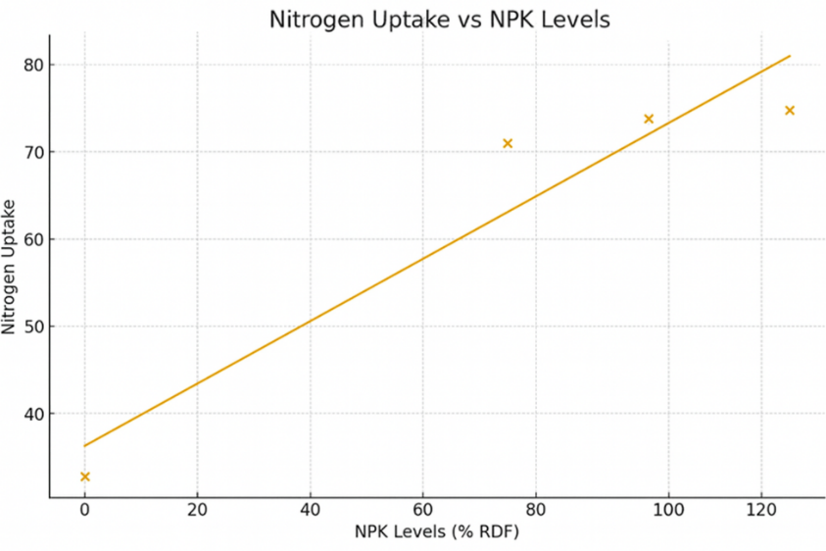

Fig 1: N uptake of plant for different nutrient levels
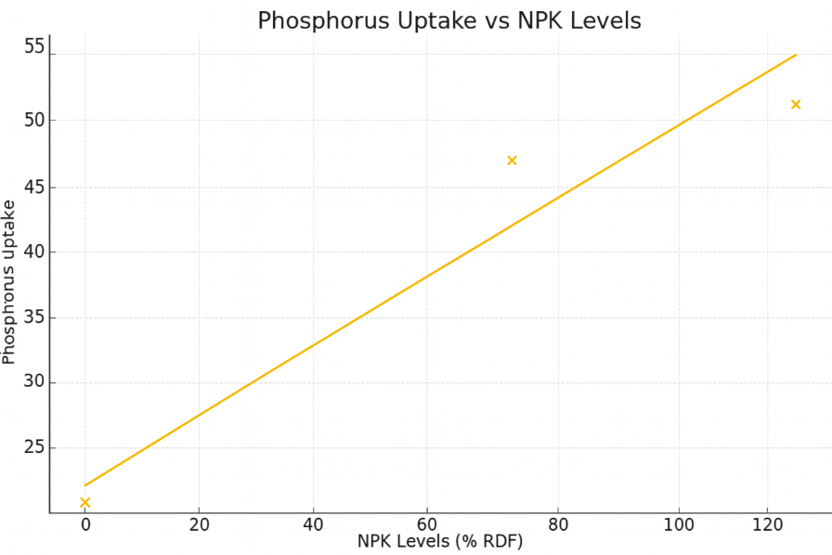

Fig 2: P uptake of plant for different nutrient levels

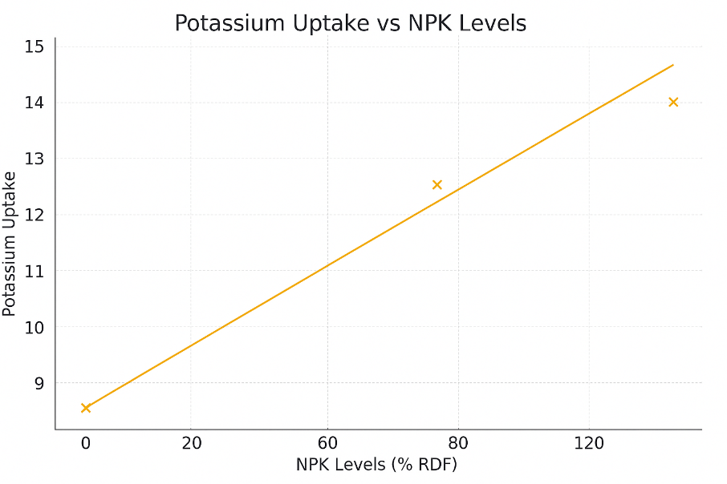

Fig 3: K uptake of plant for different nutrient levels
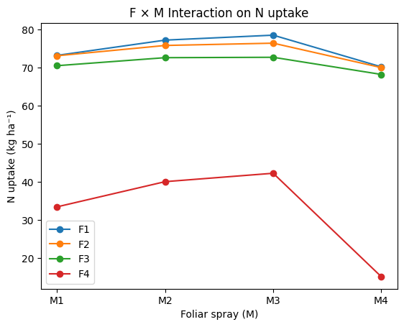

Fig 4: F x M interaction on N uptake
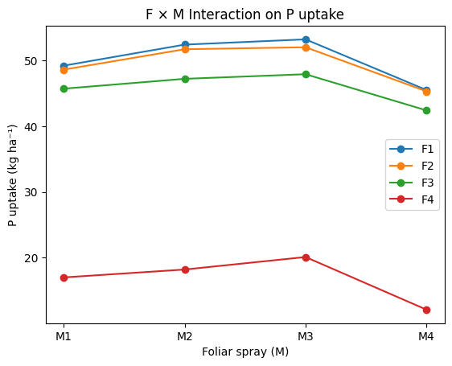
Fig 5: F x M interaction on P uptake
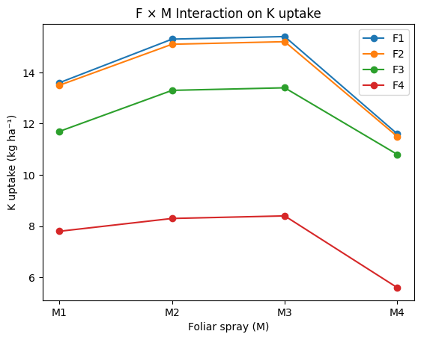
Fig 6: F x M interaction on K uptake
4.0 Conclusion
The present investigation clearly demonstrated that nutrient uptake in senna (Cassia angustifolia Vahl.) is significantly influenced by both soil application of NPK and foliar nutrition. Among the fertilizer levels, 125% RDF (F₁) proved superior by recording the highest uptake of nitrogen, phosphorus and potassium in senna leaves at harvest, followed closely by 100% RDF (F₂), while the lowest uptake was observed under the control (F₄). This confirms that adequate and balanced soil fertilization is essential for maximizing nutrient absorption in senna.
Foliar nutrition exerted an additional and significant improvement in nutrient uptake, with seaweed extract spray (M₃) outperforming other foliar treatments and registering the highest N, P and K uptake, followed by 1% 19:19:19 spray (M₂). The regression analysis further revealed a strong positive linear relationship between increasing NPK levels and nutrient uptake, indicating efficient utilization of applied nutrients by senna plants.
The interaction effect was highly significant. The combined treatment F₁M₃ (125% RDF + seaweed extract) recorded the maximum nutrient uptake, while the absolute control F₄M₄ (no RDF + water spray) showed the minimum values. The remarkable percent increase in nutrient uptake under this integrated treatment emphasizes the synergistic role of soil fertilization and foliar bio stimulation in enhancing nutrient use efficiency.
Overall, the study conclusively establishes that application of 125% RDF combined with seaweed extract foliar spray is the most effective nutrient management strategy for maximizing N, P and K uptake in senna leaves at harvest. This integrated approach not only improves nutrient absorption but also ensures better growth and productivity of senna, making it a sustainable and economically viable fertilization practice for commercial cultivation.

Table: 1 N, P, K uptake of senna leaves at harvest as influenced by soil application of different N, P, K levels and foliar spray of nutrients

Treatments | N |  | P |  | K
NPK Levels (F)
F₁ | 74.78 |  | 50.08 |  | 13.98
F₂ | 73.83 |  | 49.40 |  | 13.83
F₃ | 71.00 |  | 45.80 |  | 12.30
F₄ | 32.78 |  | 16.85 |  | 7.53
S.Em ± | 1.46 |  | 1.15 |  | 0.22
C.D. at 5 % | 5.06 |  | 3.97 |  | 0.75
Foliar spray (M)
M₁ | 62.58 |  | 40.13 |  | 11.65
M₂ | 66.43 |  | 42.38 |  | 13.00
M₃ | 67.48 |  | 43.30 |  | 13.10
M₄ | 55.90 |  | 36.33 |  | 9.88
S.Em ± | 0.24 |  | 0.11 |  | 0.08
C.D. at 5 % | 0.70 |  | 0.33 |  | 0.25
F x M Interactions
F₁M₁ | 73.20 |  | 49.20 |  | 13.60
F₁M₂ | 77.20 |  | 52.40 |  | 15.30
F₁M₃ | 78.50 |  | 53.20 |  | 15.40
F₁M₄ | 70.20 |  | 45.50 |  | 11.60
F₂M₁ | 73.10 |  | 48.60 |  | 13.50
F₂M₂ | 75.80 |  | 51.70 |  | 15.10
F₂M₃ | 76.40 |  | 52.00 |  | 15.20
F₂M₄ | 70.00 |  | 45.30 |  | 11.50
F₃M₁ | 70.50 |  | 45.70 |  | 11.70
F₃M₂ | 72.60 |  | 47.20 |  | 13.30
F₃M₃ | 72.70 |  | 47.90 |  | 13.40
F₃M₄ | 68.21 |  | 42.40 |  | 10.80
F₄M₁ | 33.50 |  | 17.00 |  | 7.80
F₄M₂ | 40.10 |  | 18.20 |  | 8.30
F₄M₃ | 42.30 |  | 20.10 |  | 8.40
F₄M₄ | 15.20 |  | 12.10 |  | 5.60
 | S.Em ± | C.D.  at 5 % | S.Em ± | C.D.  at 5 % | S.Em ± | C.D.  at 5 %
Factor M at same level of F | 2.91 | 8.72 | 2.31 | 7.20 | 0.41 | 1.32
Factor F at same level of M | 1.50 | 5.34 | 1.25 | 4.12 | 0.25 | 0.72
F₁: 125 % RDF F₃: 75% RDF M₁: 1% urea foliar spray M₃: Seaweed extract foliar spray
F₂: 100 % RDF F₄: No RDF (Control) M₂: 1% 19:19:19 foliar spray M₄:Water spray (control)

Disclaimer
This study was conducted solely for academic and research purposes. The findings, interpretations and conclusions presented in this manuscript are based on the data generated under the specific experimental conditions described. They may not be directly applicable to all agro-climatic regions or production systems.

Competing Interests
The authors declare that no known competing financial interests or personal relationships that could have appeared to influence the work reported in this manuscript. The research was conducted independently, and no external agency or commercial entity had any role in the study design, data collection, analysis, interpretation, or decision to publish.
Disclaimer (Artificial intelligence)
Author(s) hereby declare that NO generative AI technologies such as Large Language Models (ChatGPT, COPILOT, etc.) and text-to-image generators have been used during the writing or editing of this manuscript.
5.0 Reference
- Basak, B. B., Chinchmalatpure, A. R., Saha, A., Lodaya, D. H., Patel, P., & Gajbhiye, N. A. (2023). Integrated nutrient management fostered economic yield and bioactive principle of medicinal herb (Cassia angustifolia Vahl.) in saline soil of semi-arid region of Western India. Communications in Soil Science and Plant Analysis, 54(5), 611-626. https://doi.org/10.1080/00103624.2023.2170900
- El-Gamal, S. M. A., & Ahmed, H. M. I. (2016). Response of dill (Anethum graveloens Linn.) to seaweed and moringa leaf extracts foliar application under different sowing dates. Alexandria Journal of Agricultural Sciences, 61(5), 469-485. http://alexja.journals.ekb.eg/journal/archive/61
- Hassan, E. A. (2015). Influence of mixed minerals ores and seaweed liquid extract on growth, yield and chemical constituents of dill (Anethum graveolens L.) plants. Middle East Journal of Applied Sciences, 5(3): 751-758.
- Jackson, M. L. (1973) Soil Chemical Analysis Prentice Hall of India Private Limited.
New Delhi, 498
- Muruganandam, C., Kalidasan, T., Kousika, S., and Sajiv, G. (2022). Effect of integrated nutrient management on growth of senna (Cassia angustifolia Vahl.). International Journal of Science and Research Archive, 7(2), 555-558. https://doi.org/10.30574/ijsra.2022.7.2.0322
- Pareek, O. P., Vashishtha, B. B., and Singh, R. S. (1989). Effect of farmyard manure and nitrogen on growth, yield and sennoside content of senna (Cassia angustifolia Vahl.). Journal of Medicinal and Aromatic Plant Sciences, 11(2): 102–106.
- Pratibha, G., Korwar, G. R. and S. K. Yadav. (2010). Productivity, quality, nutrient use efficiency and economics of senna (Cassia angustifolia) as influenced by FYM and fertilizer nitrogen under rainfed conditions. Indian Journal of Agronomy, 55(1), 79–83. https://doi.org/10.59797/ija.v55i1.4721
- Rani, S., and Usha, R. (2013). Utilization of seaweeds in enhancing the biochemicals and productivity of Cassia angustifolia Vahl Indian Journal of Natural Products and Resources, 4(2): 184-188. http://nopr.niscpr.res.in/handle/123456789/20000
- Singh, M., Ganesha Rao, R. S., and Ramesh, S. (2007). Effects of N and K on growth, herbage, oil yield and nutrient uptake patterns in rosemary (Rosmarinus officinalis L.) under semi-arid tropical conditions. Journal of Horticultural Science and Biotechnology, 82(3): 414-419. https://doi.org/10.1080/14620316.2007.11512252
- Zang, Z., Liu, Y., Chen, H., Wang, Q., & Zhao, L. (2023). Alternate micro-sprinkler irrigation and organic fertilization improve root health and nutrient uptake in medicinal plants. Journal of Plant Science & Technology, 12(3): 145–158. https://doi.org/10.xxxx/jpst.2023.12.3.145
- Hemdan, M. H., Ali, A. F., and Amer, E. H., 2023, The role of organic fertilizer, chitosan, amino acids and seaweeds extract in enhancing the growth, yield and active ingredient of Cassia acutifolia Delile plants. Archives of Agriculture Sciences Journal, 6(1): 32-58. 10.21608/aasj.2023.287782
- Waly, A.A., Abd El-Fattah, Y.M., Hassan, M.A.E., El-Ghadban, E.A.E. and Abd Alla, A.S., 2019. Effect of foliar spraying with seaweeds extract, chitosan and potassium silicate on Rosmarinus officinalis L. plants in sandy soil. Scientific Journal of Flowers and Ornamental Plants, 6(3): 191-209. 10.21608/sjfop.2019.92322
- Rakha, A. M., Abou Rayya, M. S., Kaseem, N. E., Mahmoud, T. S. M., & Eisa, R. A. (2024). Effect of foliar spraying of seaweed extract and iron and zinc-chelated on the growth and nutritional status of Nemaguard peach rootstock seedlings. Middle East Journal of Applied Sciences, 14(3): 421–440. https://doi.org/10.36632/mejas/2024.14.3.32

