Succeeding Legume Crop Response to Residues from Cereal–Vegetable Sequences under Different Land Configuration and Nutrient Management Practices

Abstract
The field experiment was carried out during Kharif, Rabi and Summer seasons of 2022-23 and 2023-24 at Instructional Farm, Department of Agronomy, College of Agriculture, Dapoli. Dist. Ratnagiri (M.S.). The field experiments were laid out in a strip plot design comprising of twelve treatment combinations replicated thrice. The vertical strips consist of four land configurations with or without mulch treatment viz., M₁: Raised bed with mulch, M₂: Raised bed without mulch, M₃: Flatbed with mulch and M₄: Flatbed without mulch and horizontal strips comprising three fertilizer management practices viz., F₁: RDF through straight fertilizer, F₂: Konkan Annapurna Briquettes (KAB) + Remaining N, P₂O₅ and K₂O through fertigation and F₃: RDF through fertigation. Results indicated that the treatment flat bed with mulch increased grain and stover yield and it was statistically at par with the flat bed without mulch. An economic feasibility analysis revealed that the flat bed without mulch produced the highest net returns and benefit cost (B:C) ratio, followed closely by the flat bed with mulch. Additionally, the study examined the effects of various fertilizer management practices previously applied to rice and okra during the Kharif and Rabi seasons, with a common recommended dose of fertilizer used for green gram (Vigna radiata (L.) R. Wilczek). The residual impact of the treatment involving Konkan Annapurna Briquettes combined with additional N, P₂O₅ and K₂O through fertigation resulted in the highest grain and stover yields (kg/ha), as well as the maximum net returns and B:C ratio. This treatment performed on par with the RDF through fertigation during both study years and in the pooled data. In terms of soil nutrient availability, the highest levels of N, P₂O₅ and K₂O were recorded under the raised bed with mulch, followed by the flat bed with mulch. Furthermore, the application of Konkan Annapurna Briquettes plus N, P₂O₅ and K₂O through fertigation significantly enhanced soil nutrient levels, followed by the treatment RDF through fertigation.
Keywords: Economics, Fertigation, Green gram, Konkan Annapurna Briquettes (KAB) and Yield
- Introduction
Green gram scientifically known as (Vigna radiata (L.) R. Wilczek) is a plant species in the legume family and commonly called as mung bean, moong in India. India is its primary origin and is mainly cultivated in East Asia, South-East Asia and the Indian subcontinent. It is the third important pulse crop of India grown in nearly 16 per cent of the total pulse area of the country. It contains protein rich seed with 20-25 percent protein and sometimes plants are cut and ploughed into the soil to enrich with soil nitrogen.
India is the major producer of green gram in the world and grown in almost all the States. It is grown in about 4.5 million hectares with the total production of 2.5 million tonnes with a productivity of 548 kg/ha and contributing 10 percent to the total pulse production. According to Government of India third advance estimates, green gram production in 2020-21 is at 2.64 million tonnes. The important green gram producing states in the country are Rajasthan, Maharashtra, Andhra Pradesh, Madhya Pradesh and Bihar. Andhra Pradesh ranks 6th in green gram production with 0.83 lakh tonnes under an area of 1.13 lakh ha with productivity of 735 kg/ha (Anonymous, 2021). Rajasthan and Madhya Pradesh states showed an increased in the area grown over the two decades while the states Andhra Pradesh, Bihar, Karnataka and Maharashtra showed a decreased area grown over twice decades. The reason behind the decline in green gram production is improved irrigation facilities, which allows to grow-intensive crops such as rice and wheat.
This research investigates the benefits of a rice–okra–green gram cropping sequence on permanent raised beds, focusing on growth, yield, economics and efficient fertilizer use. The study examines water savings attributed to raised beds by analysing soil water balance components like percolation and evapotranspiration. Additionally, using appropriate land configurations and mulching enables sequential sowing without extra land preparation, reducing costs and enhancing moisture retention, soil temperature stability and microbial activity. The research highlights that okra and green gram are strong alternative crops in the Konkan region after rice, enriching soil nutrients and increasing farmers' income. Fertilizer management, including fertigation and using water-soluble fertilizers as well as used of briquettes, enhances nutrient uptake, reduces nutrient loss and improves yield by up to 30 per cent, while saving on fertilizer, time and labour costs.
Sequential cropping is a form of multi-cropping where two or three crops in years are grown in sequence on the same field. The second crop is planted after the harvest of primary. In history, sequential cropping has always played a fundamental role in adapting to changing climatic conditions. The implementation of sequential cropping is particularly interesting to study because it is becoming possible in previously less suitable areas, and because the interaction between different crop species could be designed and managed to improve crop production and provide important ecosystem services. In this regard, sequential cropping can be used for its potential stability and greater yields compared to monocropping, as well as for reducing the risk of complete crop failure in variable environments. Besides the direct benefits of crop production, sequential cropping systems were observed to improve the functioning of agricultural systems, reducing the environmental impacts associated with agricultural production. Without the implementation of such a type of system, world food production could have not increased at the rate it did and more natural ecosystems would have been converted to agriculture. However, this has come with a cost in terms of environmental degradation, reducing biodiversity and all its related ecosystem services. Hence, the challenge of agriculture today is to contribute to current and future food security with the implementation of more sustainable and resilient practices.
Sustainable intensification through sequential cropping is vital for boosting productivity while conserving resources. In the Konkan region of Maharashtra, rice dominates the Kharif season, but post-rainy season land remains underutilized due to moisture loss and lack of timely field preparation. Permanent raised beds with mulching offer a solution by conserving moisture and improving soil conditions, enabling successful sequential cropping. Despite the known benefits of cereal–vegetable–legume systems, research is limited on the performance of rice–okra–green gram sequences under permanent raised beds conditions in humid tropics. There is a notable gap in understanding their impact on water use, nutrient efficiency, soil health and profitability, particularly with integrated fertilizer practices like fertigation, briquettes and straight fertilizer.
- Materials and methods
2.1 Experimental Design and Treatments
The experiment was arranged in a strip plot design with twelve treatment combinations replicated three times, four vertical strips of land configurations with or without mulch treatment viz., M₁: Raised bed with mulch, M₂: Raised bed without mulch, M₃: Flatbed with mulch and M₄: Flatbed without mulch and horizontal strips comprised three fertilizer management practices viz., F₁: RDF through straight fertilizer, F₂: Konkan Annapurna Briquettes (KAB) + Remaining N, P₂O₅ and K₂O through fertigation and F₃: RDF through fertigation, respectively.
2.2 Treatment Note
The layout used for preceding rice and okra crop was used for cultivation of succeeding green gram without disturbing the mulch, land configuration and soil. Green gram was grown by applying a common recommended fertilizer dose through fertigation irrespective of treatments along with residual availability of nutrients from preceding crops i.e., kharif rice and rabi okra.
For Rice crop; In Treatment (F₃):- In case of fertigation treatments fertilizers were applied through water soluble fertilizers namely 19:19:19 grade and urea. Fertigation was given through the Venturi of 0.75 inches. For the first 15 days no fertigation was given. The dose of 100 per cent N, P₂O₅ and K₂O was given through 19:19:19 water soluble grade fertilizer and urea. Fertigation was given in 12 equal splits through fertigation at 7 days interval.
In Treatment (F₂):- Konkan Annapurna Briquettes (KAB) was applied at 15 DAS and remaining dose of fertiliser for fulfilment of RDF was applied through water soluble fertilizer. The partial dose of fertilizer was given through 19:19:19 grade fertilizer, sulphate of potash (SOP) and urea. Fertigation was given in 10 equal splits at 7 days interval and started the split at 30 DAS.
The briquettes were applied at 15 DAS of rice. The Konkan Annapurna briquettes were applied as per the treatment i.e., 100 per cent RDF for F₂ treatment and remaining fulfilment of RDF were completed from fertigation. The briquettes were applied 4-5 cm away from the stem of plant at depth of 4 to 5 cm depth. Single briquette fixed in square of four plants and covered with soil.
The recommended dose of fertilizers (RDF) for okra was applied using similar management practices as those followed for the preceding rice crop.
2.3 Geographical coordinates and altitude
The two-year field experiment on a rice–okra–green gram cropping sequence was conducted at the instructional farm of the Department of Agronomy, Dapoli, Maharashtra. The site features flat topography with sandy clay loam soil, low in nitrogen and phosphorus, medium in potassium, and acidic in nature. Dapoli (17.7677° N latitude, 73.1910° E longitude; ~180 m elevation) lies in the Konkan coastal belt, known for its hilly terrain and humid tropical climate, making it well-suited for diversified cropping and sustainable agricultural studies.
2.4 Crop management and data collection
The field experiment was carried out using the ‘Ratngairi-1’ variety of rice, ‘Konkan bhendi’ variety for okra and ‘Taiwan’ variety for green gram crop during both years. The plots measured 4.5 × 3.6 m² and planting was carried out following spacing of 15 × 15 cm, 45 × 30 cm and 30 × 15 cm for rice, okra and green gram crop, respectively. Five random plants from each plot were tagged for data collection. Standard irrigation and cultivation practices were followed, including necessary crop protection measures and need based pesticide applications. Three pickings were conducted at the harvest stage of green gram.
2.5 Initial soil nutrient status
The initial nutrient status in soil during 2022-23 to 2023-24 was, Available Nitrogen: 219.33 kg/ha; Available Phosphorus: 9.60 kg/ha and Available Potassium: 261.14 kg/ha.
2.6 Data analysis and visualization
Data from field and laboratory experiments were analysed by SPD (Strip Plot Design), using standard methods (Panse and Sukhatme, 1978). Differences between treatment means were compared using the least significant difference at the 0.05 probability level.
- Results and discussion
3.1 Effect of varying land configuration with or without mulch
3.1.1 On Grain and Stover yield
The findings from the study indicated that the use of a flat bed with mulch (M₃) was statistically comparable to the flat bed without mulch (M₄). Both these treatments demonstrated a significant improvement in grain and stover yield (kg/ha) as compared to the other land configuration practices, irrespective of whether mulch was used or not. This trend was consistently observed across both years of the experiment and further confirmed by the pooled data analysis (Tables 1). The incorporation of mulch, whether on flat beds, proved to be a highly effective practice for enhancing productivity in comparison to other treatments without mulch. The findings highlight the importance of mulch in land management strategies, as it significantly contributed to the superior performance of both M₁ and M₃ treatments over the other practices tested during the study period (See the Fig. 1 and 2). Comparable effects were noted in the study by Jat et al., (2012), Bahar et al., (2017) and Bochliya et al., (2020) in green gram crop.
The land configuration had a notable impact on the yield attributes and productivity of green gram. Sowing on flat beds significantly increased the yield attributes and yield of green gram. This improvement was attributed to enhanced plant growth, reflected in higher dry matter accumulation, increased branching and more trifoliate leaves, which collectively improved photosynthetic efficiency and nutrient utilization, leading to better sink development. However, despite these advantages, the flat bed with mulch outperformed in terms of grain and stover yields due to the highest plant population, which compensated for the yield attributes, resulting in overall maximum productivity. Such findings corroborate the studies conducted by Jat et al., 2012. The improved seed filling in the unstressed environment provided by mulching created a favourable microclimate, which significantly increased pod, haulm and kernel yields compared to no mulch. This enhanced environment under mulch facilitated better development of sound seeds, resulting in higher seed yield. The positive correlation observed between these factors and the seed yield of peanut highlights the beneficial impact of mulching on yield quality and productivity. These results are in accordance with those reported by Jain et al., 2018.
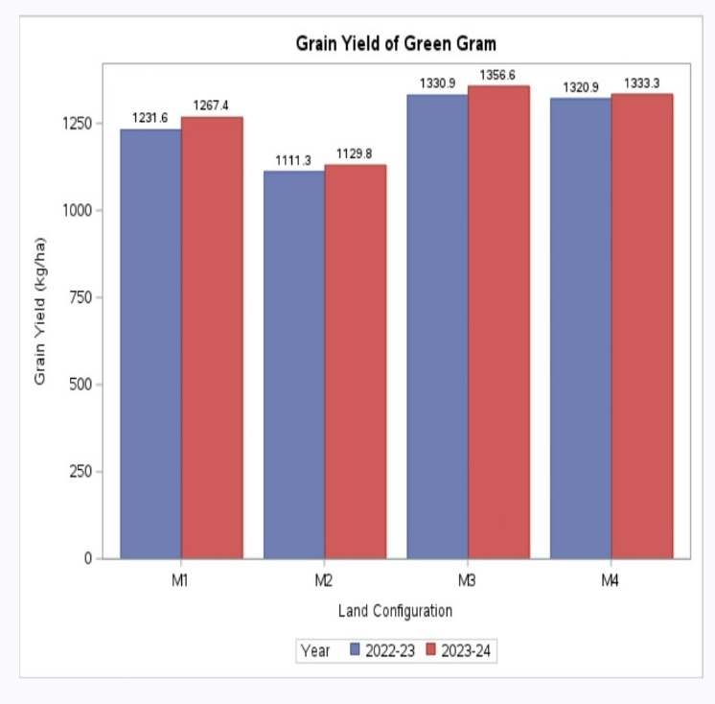 | 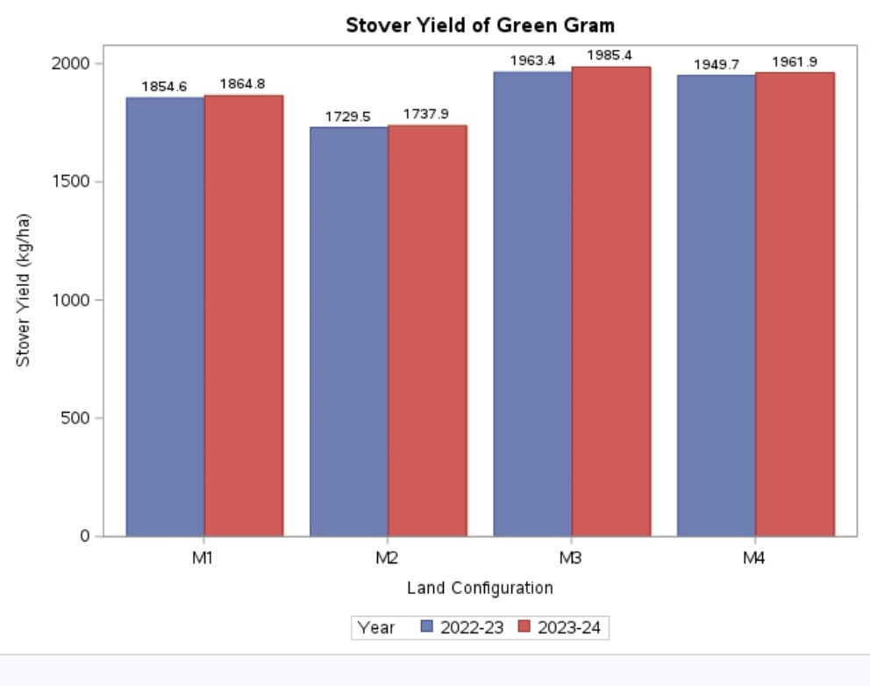
Fig.1 Grain yield affected by different land configuration practices | Fig.2 Stover yield affected by different land configuration practices
3.1.2 On Economics of green gram
The economic feasibility study (Table 2) on various land configurations with or without mulch for green gram indicated that the treatment flat bed with mulch (M₃) recorded highest cost of cultivation and gross return but on the other hand the treatment flat bed without mulch (M₄) produced significantly higher net returns and benefit to cost ratio followed closely by flat bed with mulch (M₃) for both summer seasons and in the pooled data. Conversely, sowing green gram on raised beds without mulch (M₂) yielded the lowest net returns and benefit to cost ratio. These results clearly demonstrate that land configuration with or without mulch generally enhances grain and stover yield in green gram, contributing to greater economic viability. These patterns are in agreement with the research conducted by Jat et al., 2012 and Joshi et al., 2018.
3.2 Effect of different fertilizer management practices
3.2.1 On Grain and Stover yield
The data presented in the Table 1 demonstrate the notable effects of various fertilizer management practices applied to preceding rice and okra crop during the kharif and rabi seasons, along with a common recommended dose of fertilizer irrespective of treatments in green gram crop. The residual effect of treatment Konkan Annapurna Briquettes plus remaining N, P₂O₅ and K₂O through fertigation (F₂) produced the higher grain and stover yield (kg/ha). This treatment performed at par with treatment RDF through fertigation (F₃) during both years of study and in the pooled data (See the Fig. 1 and 2). This outcome may be attributed to the high residual nutrient availability of treatment, fertigation and briquettes applied to kharif rice and rabi okra, which provided a carryover effect that benefited the succeeding green gram crop. Additionally, this treatment enhanced soil fertility which positively influenced the growth attributes, yield components and grain yield of the subsequent green gram crop. These results support those of Ghosh et al., 2013.
3.2.2 On Economics of green gram
The residual effect of preceding treatment i.e., Konkan Annapurna Briquettes plus remaining N, P₂O₅ and K₂O through fertigation (F₂) recorded maximum and significantly higher cost of cultivation, gross and net returns as well as B:C ratio from summer green gram (Table 2) during both the years as well as in pooled data followed by RDF through fertigation (F₃). However, lowest net returns and benefit to cost ratio recorded under residual impact of treatment RDF through straight fertilizer (F₁).
3.3 Impact of varying land configuration with or without mulch techniques and different fertilizer management practices on post-harvest soil fertility
In general, there was an improvement in the availability of N, P₂O₅ and K₂O nutrients under all land configurations with or without mulch and fertilizer management treatments, after harvest of green gram crop (See the Fig. 3, 4, 5, 6, 7 and 8. This improvement over initial levels indicates an overall enhancement of soil fertility after harvesting green gram during both years as well as in the pooled data.
The available N, P₂O₅ and K₂O contents in the soil (Table 3) after green gram harvest were significantly influenced by different land configurations with or without mulch techniques and various fertilizer management practices. The higher levels of available N, P₂O₅ and K₂O in the soil were observed under the treatment raised bed with mulch (M₁) followed by the treatment flat bed with mulch (M₃). Furthermore, the application of Konkan Annapurna Briquettes plus N, P₂O₅ and K₂O through fertigation (F₂) resulted in significantly higher soil nutrient levels followed by the treatment of RDF through fertigation (F₃).
The integrated application of briquettes and fertigation significantly improved the available nitrogen, phosphorus and potassium content in the soil compared to its initial fertility levels. This improvement can be attributed to the addition of organic matter from root biomass, fallen leaves of rice, okra and green gram, as well as inputs from FYM or vermicompost. Enhanced soil fertility through the partial substitution of chemical fertilizers with organic sources has also been reported in previous studies, such as by Ghosh et al., 2013.
The availability of soil nutrients largely depends on the soil's physical and chemical properties, which influence nutrient transformation. The raised bed method of planting maintained an optimal soil moisture regime and reduced canopy temperature, enhancing phosphorus uptake, consistent with findings by Halli et al., 2019. Additionally, the combined application of briquettes and fertigation improved the availability of potassium, a nutrient known for its stability and immobility in soil, with notable increases observed after the cropping sequence. These results support the conclusions drawn by et al., 2011.
Conclusion
The study found that flat beds with mulch maximized yield, while flat beds without mulch gave the highest net returns. Fertigation with Konkan Annapurna Briquettes significantly boosted yield, profitability and soil fertility. Integrating mulch and fertigation improved soil moisture, nutrient availability and sustainability, making this combination the most effective strategy for enhancing productivity and long-term soil health in cereal–vegetable–legume systems.

Disclaimer (Artificial intelligence)
Option 1:

Author(s) hereby declare that NO generative AI technologies such as Large Language Models (ChatGPT, COPILOT, etc.) and text-to-image generators have been used during the writing or editing of this manuscript.

References
- Anonymous, 2021. Green gram outlook report-2021.
- Bahar, F.A., Dar, S.A., Ajaz A., Lone, S., Ansarul Haq, B.A., Alie, Z.A., Dar, M.A., Bhat and Zaffar, G. 2017. Effect of land configuration and weed management on mung bean productivity under temperate conditions of Kashmir. International Journal of Current Microbiology and Applied Sciences ISSN: 2319-7706 Volume 6; Number 10 pp. 863-870.
- Bochliya, R., Reager, M.L. and Swetha, C. 2020. Effect of mulches and varieties on yield attributes and yield of green gram (Vigna radiata L.). Int. J. Curr. Microbiol. App. Sci 9(6): 2280-2286.
- Ghosh, A.K., Duary, B. and Ghosh, D.C. 2013. Nutrient Management in summer Sesame (Sesamum indicum L.) and its Residual Effect on Black Gram (Vigna mungo L.). International Journal of Bio-resource and Stress Management, 4 (4):541-546.
- Halli, H.M. and Angadi, S.S. 2019. Influence of land configuration and deficit irrigation on nutrient uptake and grain yield of maize (Zea mays L.). J. Farm Sci., 32 (4): (397-402).
- Jain, N.K., Jat, R.A., Yadav, R.S., Bhaduri, D., and Meena, H.N. 2018. Polythene mulching and fertigation in peanut (Arachis hypogaea): Effect on crop productivity, quality, water productivity, and economic profitability. Indian Journal of Agricultural Sciences, 88 (8), 1168–1178.
- Jat, R.A., Arvadia, M.K., Tandel, B., Patel, T.U. and Mehta, R.S. 2012. Response of saline water irrigated green gram (Vigna radiata) to land configuration, fertilizers and farm yard manure in Tapi command area of south Gujarat. Indian Journal of Agronomy 57 (3): 270-274.
- Joshi, J.R., Patel, V.M., Barad, H.I., Macwan, S.M. and Ehsas, J. 2018. Effect of land configuration and fertilizer management practices on growth, yield and yield attributes and economics of summer cowpea under South Gujarat Condition. Int. J. Curr. Microbiol. App. Sci 7 (1): 1148-1155.
- Panse, V.C., and Sukhatme, P.V. 1978. Statistical methods for agricultural workers (3rd Rev. Ed.). ICAR, New Delhi.
- Singh, K.K., Srinivasarao, Ch., Swarnalakshmi, K., Ganeshamurthy, A.N. and Kumar, N. 2011. Influence of legume residues management and nitrogen doses on succeeding wheat yield and soil properties in Indo-Gangetic Plains. Journal of Food Legumes, 25 (2), 116-120.

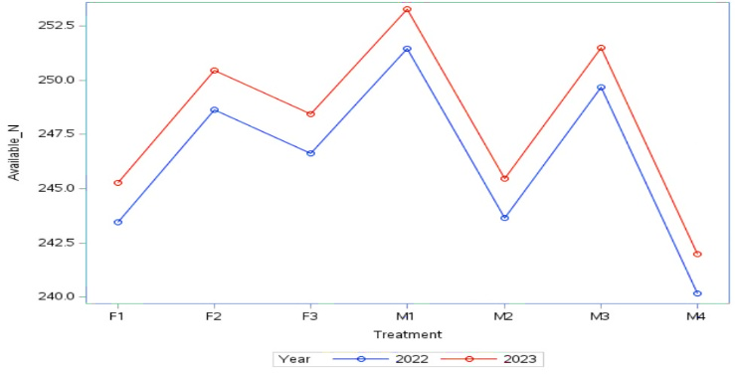 | 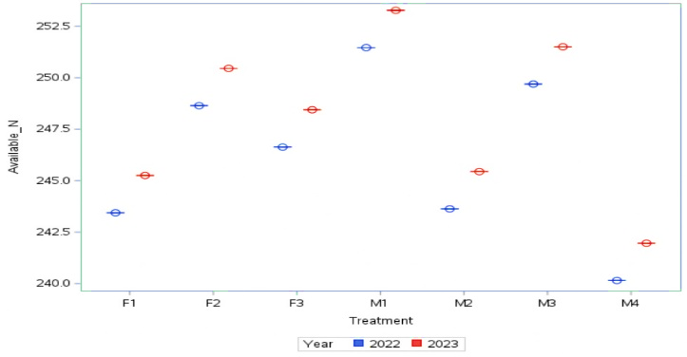
Fig. 3 Interaction plot for Available N | Fig. 4 Box plot for Available N in Soil
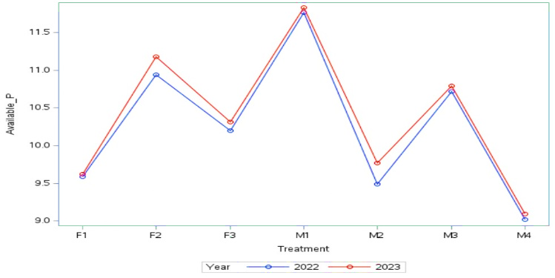 | 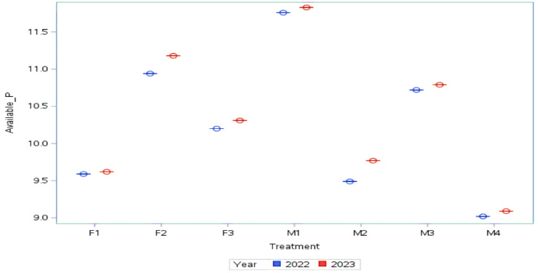
Fig. 5 Interaction plot for Available P | Fig. 6 Box plot for Available P in Soil
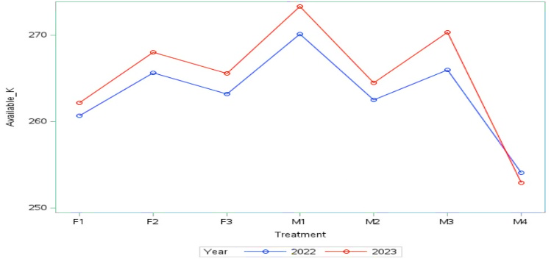 | 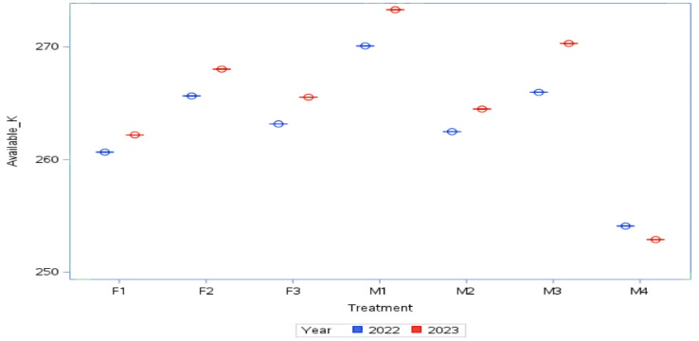
Fig. 7 Interaction plot for Available K | Fig. 8 Box plot for Available K in Soil

Table 1. Grain and stover yield (kg/ha) of green gram as influenced by different treatments during summer 2022-23, 2023-24 and in pooled data
Treatments | Grain yield (kg/ha) |  |  | Stover yield (kg/ha)
Treatments | 2022-23 | 2023-24 | Pooled | 2022-23 | 2023-24 | Pooled
Vertical strips: Land configuration with or without mulch (M)
M₁: Raised bed with mulch | 1231.60 | 1267.41 | 1249.51 | 1854.63 | 1864.78 | 1859.70
M₂: Raised bed without mulch | 1111.31 | 1129.83 | 1120.57 | 1729.49 | 1737.92 | 1733.71
M₃: Flat bed with mulch | 1330.93 | 1356.61 | 1343.77 | 1963.41 | 1985.43 | 1974.42
M₄: Flat bed without mulch | 1320.86 | 1333.26 | 1327.06 | 1949.72 | 1961.88 | 1955.80
S.Em.± | 17.63 | 14.59 | 14.63 | 21.62 | 31.12 | 24.64
C.D. at 5% | 61.01 | 50.48 | 50.64 | 74.82 | 107.70 | 85.28
Horizontal strips: Fertilizer Management (F)
F₁: RDF through straight fertilizer | 1177.02 | 1204.20 | 1190.61 | 1792.62 | 1804.00 | 1798.31
F₂: KAB + Remaining N, P₂O₅ and K₂O through fertigation | 1308.04 | 1319.94 | 1313.99 | 1939.65 | 1943.76 | 1941.71
F₃: RDF through fertigation | 1260.98 | 1291.19 | 1276.08 | 1890.66 | 1914.75 | 1902.70
S.Em.± | 16.22 | 20.89 | 18.12 | 24.69 | 27.89 | 26.15
C.D. at 5% | 63.67 | 82.04 | 71.16 | 96.94 | 109.49 | 102.66
Interaction (M×F)
S.Em.± | 40.65 | 57.05 | 37.95 | 47.92 | 45.41 | 36.00
C.D. at 5% | N.S. | N.S. | N.S. | N.S. | N.S. | N.S.

Table 2. Cost of cultivation, gross and net return (₹ ha⁻¹) and B:C ratio of green gram as influenced by different treatments during summer 2022-23, 2023-24 and in pooled data
Treatments | Cost of cultivation (₹ ha⁻¹) |  |  | Gross return (₹ ha⁻¹) |  |  | Net return (₹ ha⁻¹) |  |  | B:C ratio
Treatments | 2022-23 | 2023-24 | Pooled | 2022-23 | 2023-24 | Pooled | 2022-23 | 2023-24 | Pooled | 2022-23 | 2023-24 | Pooled
Vertical strips: Land configuration with or without mulch (M)
M₁: Raised bed with mulch | 104120.53 | 98179.50 | 101150.01 | 110037.32 | 114698.26 | 112367.79 | 5916.79 | 16518.76 | 11217.77 | 1.06 | 1.17 | 1.11
M₂: Raised bed without mulch | 96200.84 | 89984.14 | 93092.49 | 99429.53 | 102436.40 | 100932.96 | 3228.68 | 12452.26 | 7840.47 | 1.03 | 1.14 | 1.08
M₃: Flat bed with mulch | 108504.78 | 102442.74 | 105473.76 | 118809.74 | 122744.62 | 120777.18 | 10304.97 | 20301.88 | 15303.42 | 1.09 | 1.20 | 1.15
M₄: Flat bed without mulch | 100242.06 | 93981.69 | 97111.88 | 117913.86 | 120658.73 | 119286.30 | 17671.80 | 26677.04 | 22174.42 | 1.18 | 1.28 | 1.23
Horizontal strips: Fertilizer Management (F)
F₁: RDF through straight fertilizer | 101210.92 | 95134.43 | 98172.67 | 105210.81 | 109058.96 | 107134.88 | 3999.89 | 13924.53 | 8962.21 | 1.04 | 1.14 | 1.09
F₂: KAB + Remaining N, P₂O₅ and K₂O through fertigation | 103140.94 | 96867.43 | 100004.19 | 116790.94 | 119456.99 | 118123.96 | 13650.00 | 22589.55 | 18119.78 | 1.13 | 1.23 | 1.18
F₃: RDF through fertigation | 102449.30 | 96439.19 | 99444.25 | 112641.09 | 116887.56 | 114764.32 | 10191.79 | 20448.37 | 15320.08 | 1.10 | 1.21 | 1.16

Table 3. Available N, P₂O₅ and K₂O (kg/ha) in soil after harvest of green gram crop as influenced by different treatments during 2022-23, 2023-24 and in pooled data
Treatments | Available N (kg/ha) |  |  | Available P₂O₅ (kg/ha) |  |  | Available K₂O (kg/ha)
Treatments | 2022-23 | 2023-24 | Pooled | 2022-23 | 2023-24 | Pooled | 2022-23 | 2023-24 | Pooled
Vertical strips: Land configuration with or without mulch (M)
M₁: Raised bed with mulch | 251.46 | 253.27 | 252.37 | 11.76 | 11.83 | 11.79 | 270.09 | 273.30 | 271.69
M₂: Raised bed without mulch | 243.63 | 245.44 | 244.54 | 9.49 | 9.77 | 9.63 | 262.48 | 264.49 | 263.49
M₃: Flat bed with mulch | 249.69 | 251.50 | 250.60 | 10.72 | 10.79 | 10.75 | 265.97 | 270.31 | 268.14
M₄: Flat bed without mulch | 240.15 | 241.96 | 241.06 | 9.02 | 9.09 | 9.06 | 254.10 | 252.90 | 253.50
S.Em.± | 0.67 | 0.87 | 0.74 | 0.27 | 0.44 | 0.35 | 1.37 | 1.15 | 1.02
C.D. at 5% | 2.34 | 3.00 | 2.56 | 0.93 | 1.54 | 1.22 | 4.74 | 3.96 | 3.52
Horizontal strips: Fertilizer Management (F)
F₁: RDF through straight fertilizer | 243.44 | 245.25 | 244.34 | 9.59 | 9.62 | 9.61 | 260.66 | 262.19 | 261.42
F₂: KAB + Remaining N, P₂O₅ and K₂O through fertigation | 248.64 | 250.45 | 249.55 | 10.94 | 11.18 | 11.06 | 265.65 | 268.03 | 266.84
F₃: RDF through fertigation | 246.63 | 248.44 | 247.53 | 10.20 | 10.31 | 10.25 | 263.16 | 265.54 | 264.35
S.Em.± | 0.68 | 0.89 | 0.77 | 0.21 | 0.15 | 0.18 | 0.37 | 0.64 | 0.38
C.D. at 5% | 2.66 | 3.51 | 3.01 | 0.83 | 0.59 | 0.69 | 1.44 | 2.51 | 1.48
Interaction (M×F)
S.Em.± | 2.50 | 2.50 | 2.50 | 0.35 | 0.34 | 0.34 | 2.13 | 2.05 | 2.03
C.D. at 5% | N.S. | N.S. | N.S. | N.S. | N.S. | N.S. | N.S. | N.S. | N.S.

