Case report
Guyon’s canal syndrome
secondary to a giant lipoma
A Rare clinical case report
and Literature Review

.
ABSTRACT

Aims: To report a rare case of ulnar nerve compression at Guyon’s canal caused by an extraneural lipoma and to emphasize the role of MRI and surgical management.
Presentation of case: A 52-year-old man presented with a painless, slowly enlarging mass on the ulnar side of the right wrist evolving over two years, associated with numbness of the ring and little fingers for three months. Clinically, the mass measured approximately 3 cm, while imaging revealed a larger lesion. Examination showed decreased sensation in the ulnar nerve distribution and a positive Tinel’s sign without motor deficit. Nerve conduction studies confirmed severe ulnar compressive neuropathy at the wrist. MRI demonstrated a well-defined lipomatous mass extending into Guyon’s canal and displacing the ulnar nerve. Surgical excision was performed, and histopathology confirmed a lipoma. Recovery was uneventful with full sensory improvement and no recurrence.
Discussion: Guyon’s canal syndrome is uncommon and most frequently caused by ganglion cysts, whereas lipomas represent a rare etiology. Symptoms vary depending to the level of nerve involvement and may be subtle despite significant compression. MRI is essential to identify the underlying cause and its anatomical relationships. Surgical decompression with lesion excision is the treatment of choice and generally provides excellent outcomes.
Conclusion: Lipoma should be considered among the differential diagnoses of Guyon’s canal syndrome. MRI allows accurate diagnosis and surgical planning, and complete excision leads to favorable functional recovery.

Keywords: Ulnar nerve; Guyon’s canal; Nerve entrapment; Lipoma; MRI.

1. INTRODUCTION

Ulnar nerve compression at the wrist is an uncommon neuropathy compared with other upper limb entrapment syndromes. Guyon’s canal was first described by Guyon in 1861: it is a confined anatomical space on the ulnar side of the wrist, and any reduction in its volume may lead to nerve compression with sensory or motor symptoms depending on the level of involvement (Pierre Jerome et al., 2011; Quang et al., 2022).
Although ganglion cysts are the most frequent cause, other space-occupying lesions such as lipomas are rarely reported. We describe a rare case of acute ulnar nerve compression secondary to an extraneural lipoma extending into Guyon’s canal, successfully treated with surgical excision.

2. CASE PRESENTATION

A 52-year-old right-handed male doctor presented with a slowly enlarging painless mass on the ulnar side of his right wrist that had been evolving for two years (Fig. 1). Over the preceding three months, he reported numbness affecting the ring and little fingers. He had been previously healthy and denied any other history of medical disease.
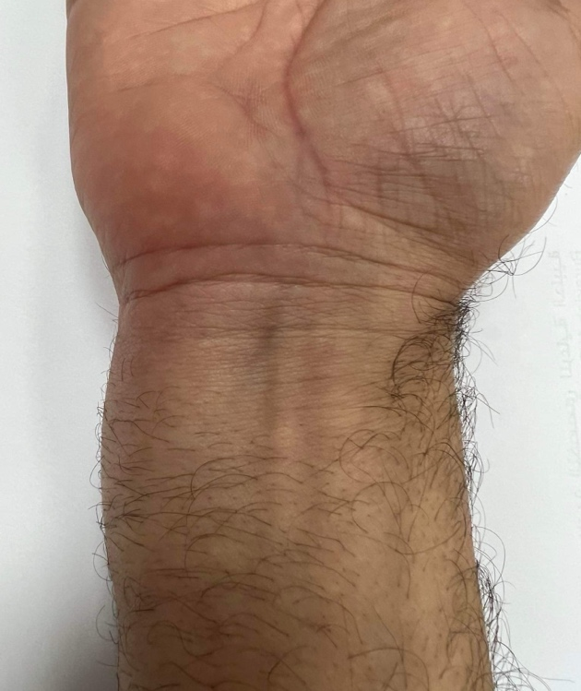
Fig. 1: Swelling at the medial edge of the right wrist

Physical examination revealed a soft, well-defined oval mass measuring 3 cm in long axis sited over the course of Guyon’s canal. No visible muscle atrophy was observed, and hand strength and digital range of motion were preserved. Sensory testing demonstrated decreased light touch and impaired two-point discrimination along the ulnar nerve distribution compared with the contralateral hand. Tinel’s sign over the mass was positive. Wartenberg’s and Froment’s sign were assessed and were negative, indicating absence of intrinsic muscle weakness despite severe compression on electrophysiological studies. He had no other mass-like lesions and no neurological abnormalities in other extremities.
Magnetic resonance imaging (MRI) showed a well-circumscribed elongated mass of 8.37 x 2.14cm, surrounded by a thin fibrous capsule, starting at the anteromedial distal part of the forearm and extending through the Guyon’s canal and the hypothenar region. The mass was hyperintense in T1W sequence (Fig. 2a), isointense to subcutaneous fat, displaying homogeneous suppression, consistent with lipoma, on the fat-supression T1W image and splaying the ulnar nerve on the axial T1W FS image (Fig. 2b).
Fig. 2a: Coronal T1W MR image of wrist revealing a hyperintense lipomatous mass (arrow) extending through the Guyon’s canal the hypothenar region

Fig. 2b: Axial T1W FS MR image of wrist displaying a lipomatous mass (black arrow) in Guyon’s canal splaying the ulnar nerve (white arrow)

Surgical exploration was performed under regional anesthesia with tourniquet control through a curved incision centered over Guyon’s canal. Careful dissection was carried down through the subcutaneous tissue with identification and protection of the ulnar neurovascular bundle. The volar carpal ligament was incised to fully decompress the canal. A well-encapsulated yellowish mass (7×4×2 cm) was identified surrounding and displacing the ulnar nerve. The mass was all around the nerve with an extension into Guyon’s canal and overflowing to the hypothenar region (Fig. 3). Meticulous blunt and sharp dissection allowed complete excision while preserving the nerve and vascular structures. Hemostasis was achieved, and the wound was closed in layers. A soft dressing was applied postoperatively.
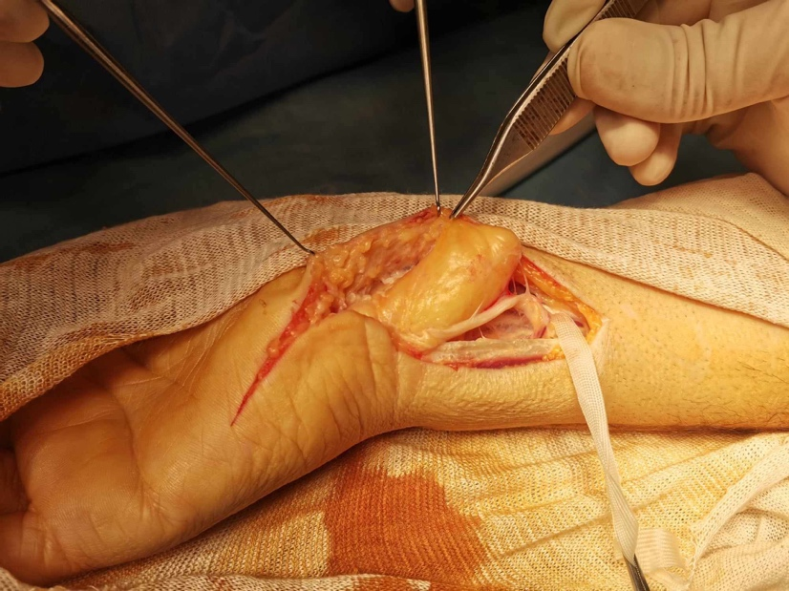
Fig. 3: Intra operative view showing a giant lipoma extended through the Guyon’s canal compressing the ulnar nerve

Histopathological examination confirmed mature adipose tissue consistent with lipoma.
The postoperative course was uneventful. At eight-week follow-up the patient reported complete resolution of sensory symptoms with normal hand function and no evidence of recurrence.

3. discussion

Guyon’s canal syndrome results from compression of the ulnar nerve at the wrist and is considerably less frequent than entrapment at the elbow. Clinical manifestations depend on the level of nerve involvement and may include sensory disturbances, motor weakness, or both. In some cases, significant compression may occur with minimal clinical deficits, as observed in our patient who presented without motor impairment despite severe electrophysiological findings (Pierre Jerome et al., 2011; Rohilla et al., 2009).
Anatomical knowledge of the distal ulnar nerve is critical as the symptoms and signs are determined by the location of the lesion (Gan et al., 2016). Inside the Guyon's canal, the ulnar nerve is a mixed nerve which divides into superficial sensory and deep motor branches along its course. Therefore, in 1969, Shea and McClain classified ulnar lesions based on affected regions which can be defined as 3 zones.
Zone 1: The proximal part of the ulnar nerve inside the Guyon's canal: proximal to the motor/sensory bifurcation, causing both motor and sensory symptoms. Zone 2: Distal to the bifurcation and affecting deep motor branches only, causing motor deficits and muscle atrophy. This is the most commonly affected region. Zone 3: Distal to the bifurcation and affecting the superficial sensory fibers only, causing sensory symptoms (Quang et al., 2022).
Space-occupying lesions (tumors, vascular malformations, ulnar artery aneurysms, nodular synovitis) are recognized etiologies of compression within the canal. While ganglion cysts are most commonly encountered, lipomas are rarely implicated due to their typically slow growth. However, when located within a confined space, they may produce progressive nerve compression. The unusually large size and proximal extension of the lesion in our case likely explain the severity of nerve involvement (Ozdemir et al., 2007; Yoshii et al., 1999).
Schwannomas should also be considered among the causes of ulnar nerve compression that should not be overlooked, as they may present diagnostic confusion due to their close relationship with the nerve. They are often among the first differential diagnoses considered because their clinical presentation can be similar, typically overcome in late middle age to early elderly patients, characterized by a long-standing and insidious course, with definitive diagnosis confirmed by histopathological examination (Joseph et al., 2020).
However, due to the variation of clinical presentations, the clinical diagnosis is not always straightforward, particularly when the sensory symptoms are atypical or absent (Quang et al., 2022).
Adipose tumors affecting peripheral nerves may arise adjacent to the nerve or, less commonly, within the neural sheath (Lee et al., 2015). Extraneural lipoma, which is simply called lipoma, as observed in our patient, compress the nerve externally and may remain asymptomatic until they reach sufficient size (Spinner et al., 2012).
The diagnosis of adipose tumor is based on clinical findings and radiologic studies. MRI plays a central role in the evaluation of suspected compressive neuropathies of the wrist. It allows accurate detection and detailed characterization of tissue composition and also, assessment of its relationship with adjacent neurovascular structures. (Lee et al., 2015). Radiologic evaluation is diagnostic in up to 71% of cases. Typical imaging features demonstrate signal isointense to subcutaneous fat on all pulse sequences with high signal on T1W and T2W sequences (Ozdemir et al., 2007).
Management depends on symptom severity and underlying pathology. In case of mechanical compression caused by tumors, surgical decompression with complete excision is considered the treatment of choice. Careful identification of the ulnar nerve and its branches is essential to avoid iatrogenic injury and ensure adequate release (Quang et al., 2022). After ulnar nerve identification and incision of the volar carpal ligament, the bifurcation point of the ulnar nerve should be located. All potentially compressive structures such as mass, tight bands, tendinous arcades, or anomalous muscles constricting along the nerve and its branch should be meticulously released.
Post- operative care includes hand elevation, appropriate rest of the hand, and restriction of heavy lifting until the suture is removed. Physical therapy to promote nerve gliding and muscles strength of the hand is indicated. Splint is not routinely but can be prescribed in patients who have a tendency to put mechanical load on the Guyon's canal (Quang et al., 2022).
Our case highlights the importance of considering uncommon etiologies when evaluating patients with ulnar neuropathy at the wrist. Early diagnosis and surgical intervention can lead to excellent functional recovery, as demonstrated by the favorable outcome in our patient.

4. Conclusion

Compression of the ulnar nerve at Guyon' canal is less common than other upper limb entrapment syndromes but should be considered in patients presenting with sensory or motor changes in the ulnar distribution. Although rare, lipoma can act as a causative lesion when located within this confined space. MRI is invaluable for diagnosis and surgical planning. Complete surgical removal can yield excellent results, although at this time, case series and comparative studies are uncommon because of the rarity of this condition.

Consent
All authors declare that ‘written informed consent was obtained from the patient for publication of this case report and accompanying images.

Ethical approval

All authors hereby declare that all experiments have been examined and approved by the appropriate ethics committee and have therefore been performed in accordance with the ethical standards laid down in the 1964 Declaration of Helsinki.

COMPETING INTERESTS DISCLAIMER:
Authors have declared that they have no known competing financial interests OR non-financial interests OR personal relationships that could have appeared to influence the work reported in this paper.

Disclaimer (Artificial intelligence)

Author(s) hereby declare that NO generative AI technologies such as Large Language Models (ChatGPT, COPILOT, etc.) and text-to-image generators have been used during the writing or editing of this manuscript.

References

Pierre-Jerome C, Moncayo V, Terk MR. (2011). The Guyon’s canal in perspective: 3-T MRI assessment of the normal anatomy, the anatomical variations and the Guyon’s canal syndrome. Surg Radiol Anat, 33(10):897‑903. DOI: 10.1007/s00276-011-0842-6
Quang VP, Quoc HH, Nguyen B, Quang CN, Chi HN, Nguyen N. (2022). Guyon’s canal resulting from lipoma: A case report and review of the literature. Int J Surg Case Rep. 95:107182. DOI: 10.1016/j.ijscr.2022.107182
Huang CW, Yin CY, Huang HK, Chen TM, Hsueh KK, Yang CY, et al. (2021). Influential factors of surgical decompression for ulnar nerve neuropathy in Guyon’s canal. J Chin Med Assoc. 84(9):885‑9. DOI: 10.1097/JCMA.0000000000000583
Rohilla S, Yadav RK, Dhaulakhandi DB. (2009) Lipoma of Guyon’s canal causing ulnar neuropathy. J Orthop Traumatol. 10(2):101‑3. DOI: 10.1007/s10195-009-0051-9
Gan LP, Tan JSW. (2016) Concomitant Lipoma and Ganglion Causing Ulnar Nerve Compression at the Wrist: A Case Report and Review of Literature. Ann Plast Surg. 76(4):472‑3. DOI: 10.1097/SAP.0000000000000379
Ozdemir O, Calisaneller T, Altinors N. (2007) Compression of the Ulnar Nerve in Guyon’s Canal by an Arteriovenous Malformation. J Hand Surg Eur Vol. 32(5):600‑1. DOI: 10.1016/J.JHSE.2007.04.005
Yoshii S, Ikeda K, Murakami H. (1999) Ulnar nerve compression secondary to ulnar artery true aneurysm at Guyon’s canal. J Neurosurg Sci.43(4):295‑7. PMID: 10864392
Joseph CM, Cherian M, Mishra M, Chase A. (2020). Ancient Schwanomma of the Distal Ulnar Nerve: A Rare Presentation. 4. 1 -4. 10.36648/molecular-pathology.4.1.24. DOI:10.36648/molecular-pathology.4.1.24
Lee HM, Kim YS, Kim JP, Huh DJ. (2015) Entrapment of the dorsal sensory branch of the ulnar nerve by circumferential extraneural lipoma. J Orthop Sci. 20(5):919‑22. DOI: 10.1007/s00776-014-0550-2
Spinner RJ, Scheithauer BW, Amrami KK, Wenger DE, Hébert-Blouin MN. (2012) Adipose lesions of nerve: the need for a modified classification: Clinical article. J Neurosurg. (2):418‑31. DOI: 10.3171/2011.8.JNS101292

