A rare presentation of Solitary perforated jejunal diverticulum associated with lipomatous jejunal polyp

ABSTRACT

Introduction: Small intestinal diverticula are rare; their incidence ranging from 0.05% to 6 %. Duodenal diverticula are the most common type of small intestinal diverticula, followed by diverticula of the jejunum and ileum. Typically, a jejunal diverticulum is usually asymptomatic. Perforation of a jejunal diverticulum is a rare clinical entity. Jejunal diverticulum with lipomatous polyp is a further rare condition.
Case: We report a case of a 70-year-old female who presented with acute abdominal pain , and diagnosed as an abscess resulting from a perforated solitary jejunal diverticulum and associated lipomatous polyp, which was effectively treated with initial resuscitation and definitive surgery - resection and anastomosis of the involved jejunal segment was performed.
Conclusion: Early diagnosis and treatment of complicated jejunal diverticula are crucial ; delay in management can cause life-threatening complications and mortality.

Keywords –jejunum, diverticula, lipomatous polyp, perforation, laparotomy

Introduction :

“The incidence of small intestinal diverticula varies between 0.05 and 6%” [1]. “All diverticula are typically acquired, with the exception of meckel’s diverticulum, which is congenital. Among these, duodenal diverticula are the most frequent (in 79% of patients), followed by diverticula of the jejunum or ileum (18%)” [2]. “Diverticula are more common in older people, with the most cases occurring between the ages of 60 and 80. A jejunal diverticulum is usually asymptomatic; only 29% of the patients exhibit symptoms such as nausea, abdominal pain, and malabsorption. Complications like perforation, adhesion, fistula, and peritonitis are more common than massive lower gastrointestinal bleeding, accounting for 10% of cases” [1, 3,22,23]. Surgery is the definitive treatment option in case of complicated diverticulitis. Solitary jejunal diverticulum associated with lipomatous polyp is very rare in literature.

Case presentation:

A 70-year-old female presented with abdominal pain and bilious vomiting for one day associated with constipation. No h/o obstipation, GI bleed, significant weight loss, jaundice, or fever. She is known to have hypothyroidism and underwent a hysterectomy 35 years ago. On examination, she was conscious and oriented. She was afebrile; her heart rate was 88/min, blood pressure was 110/70 mm Hg and oxygen saturation was 97% on room air. Per abdomen – Tenderness and guarding in umbilical and hypogastric regions. A lower midline scar was present. Rectal examination was normal. She was evaluated with an X-ray of the abdomen and an ultrasound of the abdomen, which were inconclusive. On haematological investigations – Haemoglobin was 11.8 gm%, total leukocyte count were 6900, platelets was 2.57 Lakhs, creatinine was 0.7, liver function tests were normal , and albumin was 4.1. She was evaluated with a CT abdomen with contrast, which showed An ill-defined thin- to thick-walled collection measuring approx. 5.3x4.7x4.6 cm in the supra pubic region associated with internal irregular air foci and multiple peripheral calcified foci along the rim of the lesion (Figs. 1 and 2).

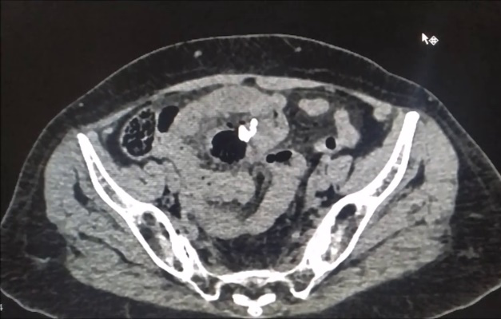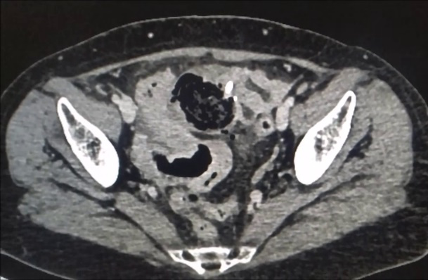
Fig 1 Fig 2
Fig 1 and Fig 2: Supra pubic region associated with internal irregular air foci and multiple peripheral calcified foci along the rim of the lesion

On endoscopy no duodenal diverticulae were present ( done in follow-up, not done preoperatively in view of acute abdomen) . After resuscitation, diagnostic laparoscopy was done – intraoperative findings were omental adhesions to previous scar were present and small bowel was dilated. So exploratory laparotomy was done – 6 x 4 cm jejunal diverticulum at 40 cm from the duodenojejunal flexure on the mesenteric border (Figs. 3 and 4), which was perforated leading to an abscess ( 20cc ). Lipomatous polyp of size 4 cm just adjacent to diverticulum(Fig. 5). The diverticular segment of the jejunum was resected, and an end to end jejunal anastomosis was done. Postoperative recovery was uneventful except for surgical site infection. The final histopathological examination report was jejunal diverticulitis along with lipomatous polyp.

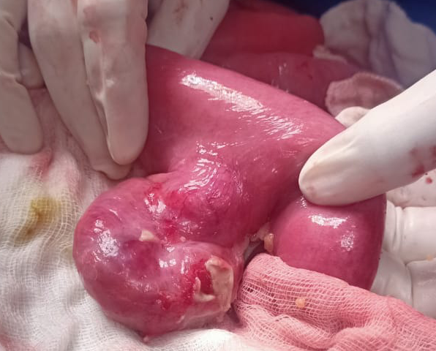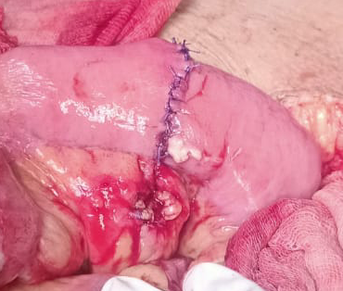
Fig 3 Fig 4
Fig 3 & Fig 4: Exploratory Laparotomy showing the distance of the jejunal diverticulum from the Duodenojejunal flexure on the mesenteric border

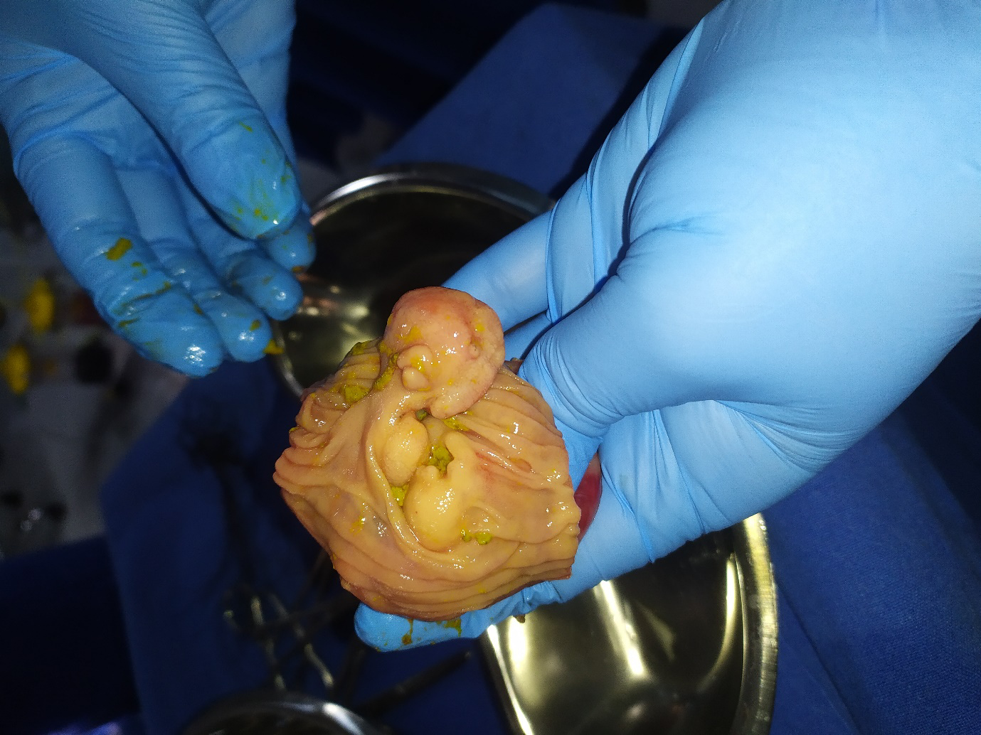
Fig 5
Fig 5: Lipomatous polyp adjacent to Diverticulum

Discussion :

In 1794, a case of jejunoileal diverticula was first documented by Sömmering and Baille [4]. Jejunal diverticula are usually multiple and widespread in the proximal jejunum. The prevalence is 2% in the general population, slightly higher in men than women, and slightly higher in elderly patients” [5, 6]. “They develop due to herniation of the mucosa, submucosa, and serosa through the muscular layer of the bowel at the point where the vasa recta enter the muscularis propria (the locus minoris resistentiae of the small intestine). It is a pseudodiverticulum, because it does not covered by all layers of the bowel wall. These diverticula are commonly associated with disorders of intestinal motility, such as progressive systemic sclerosis, visceral neuropathies, and myopathy. Their causes are unclear, but intestinal dyskinesia, abnormal peristalsis, and high intraluminal pressure are implicated in their pathogenesis. In this case , jejunal diverticulum is associated with lipomatous polyp which is a rare. To our knowledge there are no published case reports describing the perforated jejunal diverticulum in association with the lipomatous polyp. Lipoma is the third most common benign small bowel tumour arising from either submucosal adipose tissue or serosal fat” [7]. “The occurrence of lipoma increases from the duodenum to the ileum. Incidence of Intestinal lipomas ranges from 0.035% to 4.4 %” (8). “Lipomas can arise throughout the gastrointestinal tract with the small bowel accounting for 25%” (9). “These benign tumors arise from submucosa in 90 % of the cases” (10). “Lipomas can cause gastrointestinal bleed due to ulceration , obstruction due to intussusception or volvulus” (11) . In this case lipomatous polyp leads to partial bowel obstruction and increased intraluminal presuure precipitating solitary jejunal diverticulum.

Jejunal diverticulosis is usually asymptomatic; only 29% of the patients experience symptoms [12], and 10% develop complications [3] including perforation, obstruction, adhesion, fistula, peritonitis, and lower gastrointestinal bleeding. “Acute complications are related to the mucosal inflammation. Since the diverticulum occurs on the mesenteric border, perforation will remain concealed within the mesentery, resulting in abscess and localized peritonitis” [13], as in our patient. Jejunal diverticular perforation is a serious complication that occurs in 2–6% of cases [14]. “Diagnosis is often challenging; therefore, a high degree of clinical suspicion is required. A plain abdominal radiograph is the initial imaging modality of choice, since it can show signs of perforation, such as the presence of free air, or signs of intestinal obstruction, such as the presence of air-fluid levels. CT scan can help in diagnosing the condition, exposing signs of inflammation, thickening of the bowel wall with outpouchings, lesions, free air, and air-fluid levels” [15]. “Mortality from jejunal diverticulitis ranges from 0 to 5%, increasing to 40% in case of perforation” [16].

Management of acute uncomplicated jejunal diverticulitis is with intravenous fluids, bowel rest, and broad spectrum antibiotics [17]. Jejunal diverticular perforation with localized abscess without features of generalized peritonitis can be managed by bowel rest, Intravenous antibiotics, and imaging-guided percutaneous drainage. Acute complicated diverticulitis causing perforation with generalized peritonitis needs surgical intervention such as laparotomy with segmental small bowel resection with primary anastomosis or stoma. Overall mortality after surgery is 24% because of poor prognostic factors such as advanced age and delay in diagnosis and treatment.
Altemeier and associates [18] suggested that, “if there is evidence of a dilated, hypertrophied segment of bowel with large diverticula, representing a progressive form of disease, the diverticular segment should be resected”. “This suggestion has been supported by other authors based on collected data” [19, 20, 21]. “Most authors agree that the removal of a solitary non-meckelian small bowel diverticulum in an adult is not warranted” [19,20]
Malignancy arising in a jejunal diverticulum is very rare; types of malignancy reported were adenocarcinoma, gastrointestinal stromal tumour (GIST), carcinoid, and lymphoma.

Conclusion:
Isolated jejunal diverticulum is a rare entity and usually asymptomatic. Colonic diverticulitis is typically suspected in an elderly patient who presents with abdominal pain and fever, but jejunal diverticulitis should also be taken into consideration as a differential diagnosis. It requires a high degree of clinical suspicion, because of low incidence of the condition. Early diagnosis and prompt treatment are essential because they can lead to life-threatening complications and mortality. Resection of the involved jejunal segment and primary anastomosis is the treatment of choice, although conservative treatment has been reported. Jejunal diverticulum associated with lipomatous polyp is a further rare condition.

Ethical Approval:

As per international standards or university standards written ethical approval has been collected and preserved by the author(s).

Consent
As per international standards or university standards, patient(s) written consent has been collected and preserved by the author(s).

Authors’ Contributions

All Authors involved in the surgical management of the case. Author A formulated abstract
and manuscript of the article. All authors read and approved the final manuscript.

Disclaimer (Artificial intelligence)

Authors hereby declare that NO generative AI technologies such as Large Language Models (ChatGPT, COPILOT, etc.) and text-to-image generators have been used during the writing or editing of this manuscript.

References :

- Staszewicz W, Christodoulou M, Proietti S, Dermartines N. Acute ulcerative jejunal diverticulitis: case report of an uncommon entity. World J Gastroenterol. 2008 Oct;14(40):6265–7.
- Akhrass R, Yaffe MB, Fischer C, Ponsky J, Shuck JM. Small-bowel diverticulosis: perceptions and reality. J Am Coll Surg. 1997 Apr;184(4):383–8.
- Transue DL, Hanna TN, Shekhani H, Rohatgi S, Khosa F, Johnson JO. Small bowel diverticulitis: an imaging review of an uncommon entity. Emerg Radiol. 2017 Apr;24(2):195–205.
- Soemmering ST, Baille M. Anatomie des krankhaften Baues voneinigen der wichtigsten Teile im menschlichen Körper. Berline: In Vossiche Buchhandlung. 1974.
- Maglinte DD, Chernish SM, DeWeese R, Kelvin FM, Brunelle RL. Acquired jejunoileal diverticular disease: subject review. Radiology. 1986 Mar;158(3):577–80.
- Fintelmann F, Levine MS, Rubesin SE. Jejunal diverticulosis: findings on CT in 28 patients. AJR Am J Roentgenol. 2008 May;190(5):1286–90.
- Milovic V . Small Bowel Diverticula . In: Basow DS , ed. Waltham, Massachusetts : UpToDate 2011 .
- A. Agrawal, K.J. Singh Symptomatic intestinal lipomas: our experience Med J. Armed Forces India, 67(4) (2011), pp.374-376 - [Internet]. 2011/10/22. Elsevier https://pubmed.ncbi.nlm.nih.gov/27365853
- A. Manouras, E.E. Lagoudianakis, D. Dardamanis, D.K. Tsekouras, H. Markogiannakis, M. Genetzakis, et al. Lipoma induced jejunojejunal intussusception , World J Gastroenterol WJG, 13(26) (2007), p.3641 Baishideng Publishing Group Inc
- A.J. Taylor, E.T. Stewart, W.J. Dodds Gastrointestinal lipomas : a radiologic and pathologic review. Am J Roentgenol . Ray Soc., 155 (6) (1990), pp.1205 - 1210,10.2214/ajr.155.6.2122666
- Farkas, N., Wong, J., Bethel, J., Monib, S., Frampton, A., & Thomson, S. (2020). A systematic review of symptomatic small bowel lipomas of the jejunum and ileum. Annals of Medicine and Surgery, 58, 52-67.
- Singal R, Gupta S, Airon A. Giant and multiple jejunal diverticula presenting as peritonitis a significant challenging disorder. J Med Life. 2012 Sep;5(3):308–10.
- Herrington J. I. Perforation of acquired diverticula of the jejunum and ileum. Surgery, 1962, 51 : 426-433.
- Sibille A, Willocx R. Jejunal diverticulitis. Am J Gastroenterol. 1992 May;87(5):655–8.
- Butler JS, Collins CG, McEntee GP. Perforated jejunal diverticula: a case report. J Med Case Reports. 2010 Jun;4:172.
- Kassir R, Boueil-Bourlier A, Baccot S, Abboud K, Dubois J, Petcu CA, et al. Jejuno-ileal diverticulitis: etiopathogenicity, diagnosis and management. Int J Surg Case Rep. 2015;10:151–3.
- de Bree E, Grammatikakis J, Christodoulakis M, Tsiftsis D. The clinical significance of acquired jejunoileal diverticula. Am J Gastroenterol. 1998 Dec;93(12):2523–8.
- Altemeier W. A., Bryant L. R., Wulsin J. H. The surgical significance of jejunal diverticulosis. Arch Surg, 1963, 86 : 733-745.
- Wilcox R. D., Shatney C. H. Surgical implications of jejunal diverticula. South Med J, 1988, 781 : 1386-1391.
- Longo W. E., Vernava A. M. III. Clinical implications of jejunoileal diverticular disease. Dis Colon Rectum, 1992, 35 : 388-381.
- Akhrass R., Yaffe M. B., Fischer C., Ponsky J., Shuck J. M. Small bowel diverticulosis : Perceptions and reality. J Am Coll Surg, 1997, 184 : 383-388.
- Gurala, D., Idiculla, P. S., Patibandla, P., Philipose, J., Krzyzak, M., & Mukherjee, I. (2020). Perforated jejunal diverticulitis. Case reports in gastroenterology, 13(3), 521-525.
- Mohanty, A. (2021). Perforation in a Rare Solitary" True" Jejunal Diverticulum. Asian journal of case reports in surgery, 4(2), 671-674.

