Case Report

Nephroblastoma in Pediatric Urinary Retention: A Rare Clinical Presentation in Sekadau General Hospital

.
ABSTRACT

Introduction: Wilms’ tumor (WT) is the most common malignant renal neoplasm in children and classically presents as an asymptomatic abdominal mass in early childhood. Urological manifestations related to urinary tract obstruction are rare and may obscure the underlying diagnosis, particularly in older children and in settings where delayed presentation is common.
Presentation of Case: A 7-year-old boy presented with acute urinary retention caused by extrusion of necrotic soft tissue through the urethral meatus. The patient had a four-month history of progressive abdominal distension without hematuria, trauma, or prior urinary instrumentation. Physical examination revealed a necrotic mass protruding from the urethra and a palpable left-sided abdominal mass. Emergency extraction of the obstructing tissue resulted in immediate relief of urinary retention; histopathological evaluation demonstrated necrotic material. Abdominal ultrasonography identified a solid left renal mass with associated pelvicalyceal system dilatation. The patient subsequently underwent radical nephrectomy. Histopathological examination of the nephrectomy specimen confirmed nephroblastoma with extensive tumor necrosis and capsular infiltration. The postoperative course was uneventful, with complete resolution of obstructive urinary symptoms, and the patient was commenced on risk-adapted adjuvant chemotherapy.
Discussion: Urinary tract obstruction in Wilms’ tumor is most commonly associated with intrapelvic extension, while gross hematuria remains an uncommon feature. Necroturia resulting in acute urinary retention has not previously been reported as a presenting manifestation of WT. This extreme clinical phenotype likely reflects advanced intrapelvic tumor necrosis with migration of devitalized tissue into the urinary tract, underscoring the biological and anatomical heterogeneity of Wilms’ tumor.
Conclusion: Wilms’ tumor may rarely present with necroturia and acute urinary retention. Recognition of such atypical presentations broadens the clinical spectrum of WT and highlights the importance of thorough abdominal examination in children presenting with unusual lower urinary tract symptoms.

Keywords: Wilms’ tumor, Nephroblastoma, Necroturia, Acute urinary retention, Pediatric urology

1. INTRODUCTION

Wilms’ tumor (WT), also known as nephroblastoma, was originally characterized by Max Wilms (Olukayode et al., 2014). It represents the fifth most prevalent malignancy in the pediatric population and is the second most common intra-abdominal tumor encountered in childhood. Nephroblastoma predominantly affects children under the age of five, with about 90% of diagnoses occurring before the age of three. The clinical presentation often includes a palpable abdominal mass, which is usually painless and may be accompanied by other symptoms such as hematuria or hypertension (Neagu et al., 2025). The majority of cases occur in children younger than five years, with approximately 75% diagnosed within this age group, and the highest incidence observed between two and three years of age (Malkan et al., 2015). Tumour histology and initial therapy remain the mainstay of factors that influence the survival of patients with disease recurrence. Although some studies have advocated that complete resection and radiation of previously non-radiated fields have chances of improved survival rate, these roles in the management of relapsed disease had not been precisely defined. This includes the role of high dose chemotherapy with stem cell rescue as well (Karim et al., 2021, 2023).
Earlier investigations reported poor outcomes for Wilms’ tumor, with overall survival rates below 30% (Wabada et al., 2017). In contrast, contemporary studies demonstrate survival exceeding 90%, positioning this malignancy as one of the notable successes of modern oncologic management. Previous analyses have also shown that increasing age at diagnosis is significantly associated with higher risks of disease recurrence and mortality (Abdullah et al., 2013). Consequently, therapeutic strategies for Wilms’ tumor are primarily risk-adapted, focusing on the likelihood of disease progression and relapse. Prognosis is predominantly influenced by tumor stage and histopathological characteristics, patient age, and specific biological markers.
In this report, we describe a 7-year-old child presenting with exceptionally rare clinical manifestations, including acute urinary retention caused by soft tissue protruding through the urethra. Emergency extraction of the obstructing tissue was performed, followed by definitive nephrectomy for nephroblastoma case. Such an atypical presentation, as illustrated in this index case, necessitates a high index of clinical suspicion to establish an accurate diagnosis. To the best of our knowledge, no similar cases have been previously reported in the literature

2. PRESENTATION OF CASE

A 7-year-old boy was referred to our institution with a 12-hour history of acute urinary retention, accompanied by straining, painful abdominal distension, and extrusion of a fleshy mass from the urethral meatus, which became more prominent during straining. There was no preceding history of abdominal or perineal trauma, urethral foreign body insertion, hematuria, or febrile illness. Notably, the patient had experienced progressive abdominal enlargement over the preceding four months.
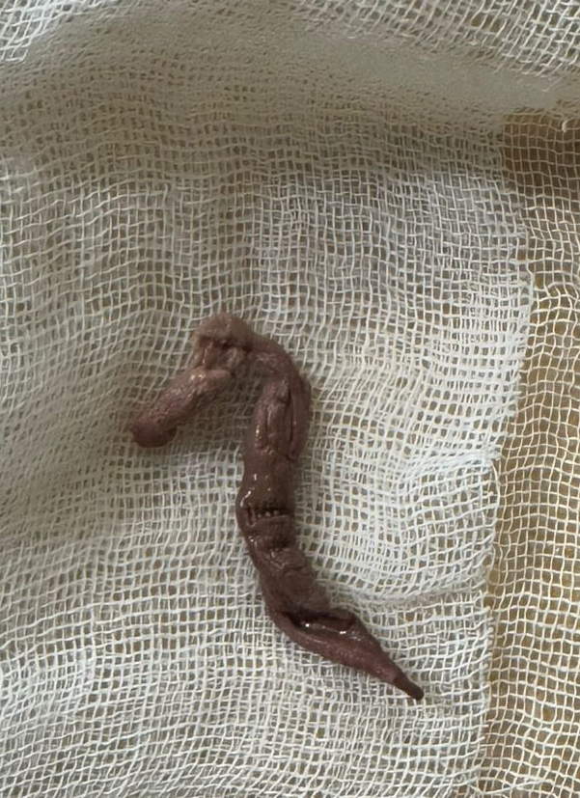
Figure 1. (a) Clinical picture of penile, (b) Necrotic tissue after extraction in emergency department of Sekadau General Hospital.

On physical examination, the child appeared acutely distressed. A necrotic, fleshy mass measuring approximately 6 cm was observed protruding from the urethral meatus, with active bleeding noted at its distal end. The protruding tissue was manually extracted and submitted for histopathological analysis (Figure 1). Abdominal examination revealed generalized distension with a tender suprapubic fullness. A firm, non-tender, non-ballotable mass was palpable in the left flank, not crossing the midline, and ascites was present. Pelvic radiography was unremarkable (Figure 2).

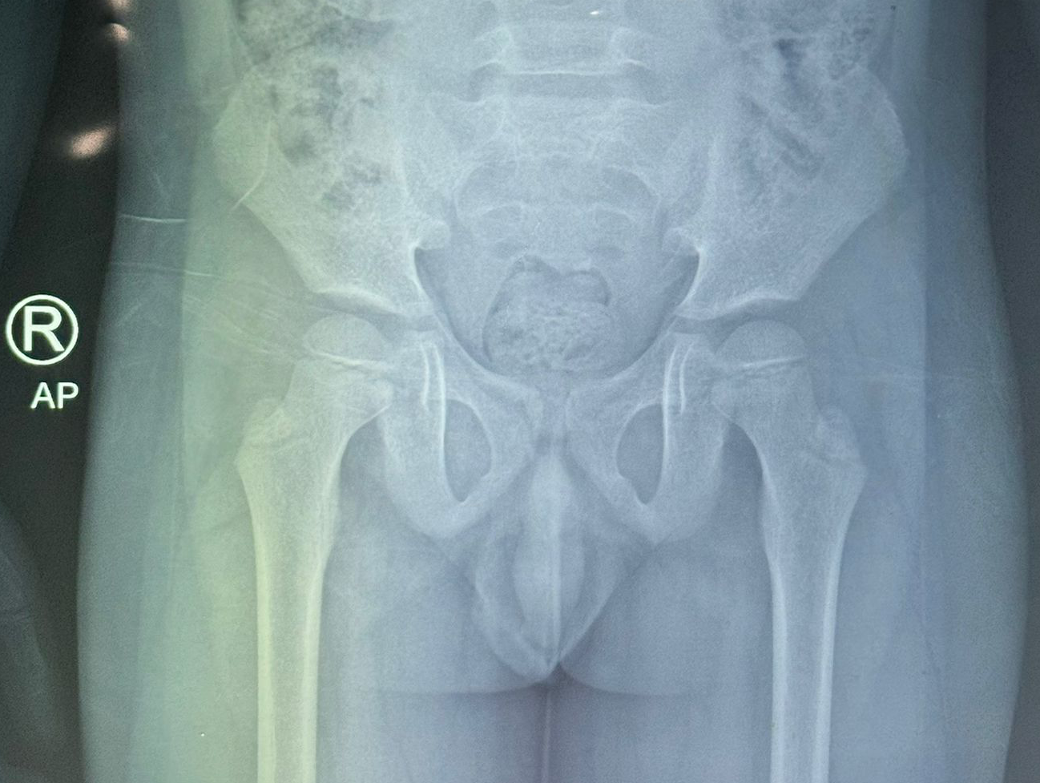
Figure 2. Pelvic X-Ray examination showed normal structure of pelvic organs.

Urethral catheterization yielded 350 mL of clear urine. Laboratory evaluation demonstrated a packed cell volume of 30% and microscopic hematuria, while renal function parameters were within normal limits. Abdominal ultrasonography revealed a solid left renal mass measuring 11.2 × 5.39 cm, associated with dilatation of the pelvicalyceal system and absence of calculi. The lesion exhibited mixed echogenicity with multiple cystic components, measuring approximately 7.65 × 5.49 cm, predominantly arising from the inferior pole of the kidney.
Histopathological examination of the extracted urethral tissue confirmed necrotic material. Chest radiography showed no evidence of metastatic disease. Based on clinical and radiological findings, a provisional diagnosis of left-sided Wilms’ tumor was established, and the patient subsequently underwent nephrectomy (Figure 3). Definitive histopathological analysis of the nephrectomy specimen demonstrated a neoplastic proliferation composed predominantly of diffusely arranged undifferentiated blastemal cells with an accompanying stromal component. The blastemal cells were characterized by small round-to-oval, hyperchromatic nuclei, scant cytoplasm, a high nuclear-to-cytoplasmic ratio, coarsely distributed chromatin, and a mitotic count exceeding 30 per 10 high-power fields. The stromal component consisted of fibrous tissue with extensive areas of necrosis and haemorrhage. Tumor infiltration of the renal capsule was also identified. Based on these histopathological features, a final diagnosis of necroturia caused by left-sided nephroblastoma was established.
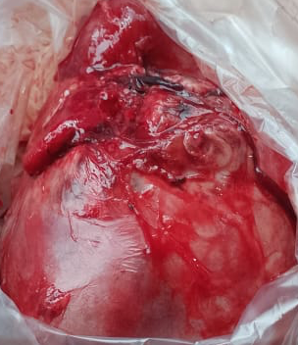
Figure 3. Left Renal after Nephrectomy

3. discussion

Nephroblastoma is an embryonal malignancy originating from persistent nephrogenic blastemal cells and is characterized by heterogeneous differentiation patterns that recapitulate various stages of renal organogenesis (Pastore et al., 2006). Histologically, the tumor frequently demonstrates triphasic components reflecting the developmental architecture of the fetal kidney.
Wilms’ tumor, also referred to as nephroblastoma, represents the most prevalent pediatric abdominal malignancy in Sub-Saharan Africa (Osuoji et al., 2011). Although the disease predominantly presents as a unilateral renal mass, bilateral involvement has been reported in approximately 5–7% of affected children (Nguyen., 2016). It constitutes the most common genitourinary malignancy in the paediatric population, with an estimated incidence of 1 per 10,000 children. The median age at diagnosis is approximately 3.5 years, with nearly 98% of cases occurring before the age of 10 years; nonetheless, sporadic occurrences have been documented across all age groups (Nguyen., 2016). Approximately 10% of nephroblastoma’s are associated with well-defined congenital dysmorphic syndromes. Olukayode et al reported a notably high incidence of bilateral nephroblastoma (25%) based on computed tomography findings among 12 male patients presenting with abdominal distension at Lagos University Teaching Hospital (Olukayode et al., 2014).
In the developed world, Wilms’ tumor is typically diagnosed at an early stage, contributing significantly to improved survival outcomes (Abdullah et al., 2013). Conversely, delayed presentation remains a substantial challenge in resource-limited environments. The most common clinical manifestation is a painless abdominal mass, often detected incidentally during routine pediatric examination or while bathing the child (Olukayode et al., 2014). However, systemic symptoms such as fever, abdominal discomfort, fatigue, and anemia may also occur (Yarboro., 1969). Osuoji et al reported in a retrospective analysis of 35 patients that all cases presented at an advanced stage with abdominal masses, accompanied by additional features including hematuria, fever, weight loss, varicocele, cough, and pleural effusion (Osuoji et al., 2011).
Gross hematuria is not a typical presenting feature of classic Wilms’ tumor (Senthilnathan et al., 2004). However, it is more frequently observed in intrapelvic tumors or in cases where tumor invasion or rupture into the renal pelvis has occurred (Ozyoruk et al., 2014). Such tumors may exhibit atypical clinical presentations that deviate from the conventional manifestations of Wilms’ tumor (Nakachi et al., 2017). In the present case, the clinical presentation was particularly unusual, with necroturia likely attributable to tumor necrosis arising from the intrapelvic component of the right renal mass. To the best of our knowledge, there are no previously published reports describing necroturia accompanied by acute urinary retention as a presenting feature of Wilms’ tumor. While intrapelvic Wilms’ tumors have been reported to present predominantly with hematuria, the occurrence of necrotic tissue passage via the urinary tract remains undocumented. Although cystoscopic evaluation was not performed in this case, we strongly postulate that the necrotic material originated from one of the renal tumors (Yang et al., 2007).
The management of nephroblastoma, particularly in complex presentations, remains challenging. Nonetheless, preoperative chemotherapy typically results in significant tumor volume reduction, thereby facilitating nephron-sparing or renal salvage surgical approaches (Nguyen., 2016). In this patient, radical nephrectomy was performed, leading to marked clinical improvement and resolution of symptoms.
Nephrectomy remains the cornerstone of Wilms’ tumor management and constitutes an essential component of definitive treatment (Nakachi et al., 2017). This is conventionally preceded by neoadjuvant chemotherapy aimed at tumor downstaging, minimizing the risk of intraoperative tumor rupture and facilitating surgical excision based on clinical and radiological assessment, often prior to histological confirmation. Definitive diagnosis and staging are subsequently established through histopathological examination of the excised specimen, guiding postoperative therapeutic strategies, which may include adjuvant chemotherapy and, in selected cases, radiotherapy (Yarboro., 1969).
The most critical prognostic determinants in Wilms’ tumor include disease stage, histopathological subtype, and the presence of loss of heterozygosity (LOH) at chromosomes 1p and 16q in chemotherapy-naïve tumors. Over the past decade, age at diagnosis has also emerged as a potential prognostic factor (Ozyoruk et al., 2014). Several studies have demonstrated that diagnosis at or beyond 4 years of age is associated with inferior outcomes, with one study specifically highlighting adverse prognostic implications in adolescent patients (Pastore et al., 2006). Even among patients with favorable histology, increasing age at diagnosis appears to correlate with an elevated risk of relapse and mortality, although traditional prognostic variables such as tumor stage and histology remain more influential (Abdullah et al., 2013). Additional factors contributing to poorer survival in older children include delayed diagnosis, advanced disease stage at presentation, and potential differences in underlying tumor biology. Wilms’ tumor is widely regarded as one of the most curable pediatric malignancies, with overall survival rates approaching 85% (Yang et al., 2007).
However, outcomes are significantly less favorable in older children, with reported 5-year overall survival rates of approximately 63% among patients aged 10–14 years at diagnosis (Nakachi et al., 2017) .
4. Conclusion

Nephroblastoma, commonly referred to as Wilms’ tumor, constitutes the most frequent malignant renal neoplasm in the pediatric population, accounting for approximately 90% of all solid renal tumors in children. The disease predominantly affects young children between 1 and 5 years of age, with occurrence beyond early childhood being distinctly uncommon.
The present case illustrates an unusual clinical presentation, such as necroturia from Wilms’ tumor that posed a significant diagnostic challenge. This observation underscores the continued importance of meticulous abdominal examination in pediatric patients presenting to healthcare facilities, as early detection of abdominal masses remains critical for timely diagnosis and improved oncological outcomes.

Consent
As per international standards, parental written consent has been collected and preserved by the author(s).

Disclaimer (Artificial intelligence)

Author(s) hereby declare that NO generative AI technologies such as Large Language Models (ChatGPT, COPILOT, etc.) and text-to-image generators have been used during the writing or editing of this manuscript.

References
Abdullah, Y., Karpelowsky, J., Davidson, A., (2013). Management of nine cases of Wilms’ tumour with intracardiac extension: A single-centre experience. Journal of Pediatric Surgery, 48(2), 394–399.
Malkan, A. D., Loh, A., Bahrami, A., (2015). An approach to renal masses in pediatrics. Pediatrics, 135(1), 142–158.
Nakachi, S., Matsumoto, H., Nakazato, I., & Yoshimi, N. (2017). Botryoid Wilms tumor of the renal pelvis: A case report. Human Pathology: Case Reports, 9, 10–12.
Nguyen, S. N. (2016). A case report of Wilms’ tumor. Journal of Rare Diseases: Diagnosis & Therapy, 2, 3–5.
Olukayode, A. A., Osuoji, R., Akinola, R., (2014). Pattern of computed tomography scan findings in children with Wilms’ tumor in a tertiary hospital in Lagos, Nigeria. Indian Journal of Medical and Paediatric Oncology, 35, 31–35.
Osuoji, R., Williams, O., Ajai, O., (2011). Wilms’ tumour: Experience in a developing tertiary center in Nigeria. East and Central African Journal of Surgery, 16, 51–57.
Özyörük, D., & Emir, S. (2014). The management of bilateral Wilms tumor. Translational Pediatrics, 3, 34–38.
Pastore, G., Znaor, A., Spreafico, F., Graf, N., Pritchard-Jones, K., & Steliarova-Foucher, E. (2006). Malignant renal tumours incidence and survival in European children (1978–1997): Report from the Automated Childhood Cancer Information System project. European Journal of Cancer, 42, 2103–2114.
Senthilnathan, R., Bagdu, R., Senthilganesh, K., & Senthilbarathi, C. (2004). Interesting presentation of Wilms’ tumour. Journal of Indian Association of Pediatric Surgeons, 9, 193–197.
Wabada, S., Abubakar, A., Adamu, A., Kabir, A., & G. I. B. (2017). Retroperitoneal extrarenal Wilms’ tumour: A case report. Nigerian Journal of Clinical Practice, 20, 388–391.
Yang, S. O., Joung, Y., Han, K. S., (2007). Adult’s Wilms’ tumor mimicking renal pelvis tumor. Korean Journal of Urology, 48, 558–560.
Yarboro, T. L. (1969). Atypical presentation of Wilms’ tumor: Evaluation and early diagnosis. Journal of the National Medical Association, 90, 51–53.
Abd Karim, S. H., Daud, M. A. M., Nasir, A., & Mohamad, N. (2021). Recurrent nephroblastoma in the bladder: Successful transurethral resection. Journal of Pediatric Surgery Case Reports, 74, 102055.

Karim A, Shaikhyzada K, Abulkhanova N, Altyn A, Ibraimov B, Nurgaliyev D, Poddighe D. Pediatric Extra-Renal Nephroblastoma (Wilms' Tumor): A Systematic Case-Based Review. Cancers (Basel). 2023 Apr 29;15(9):2563. doi: 10.3390/cancers15092563. PMID: 37174029; PMCID: PMC10177564.

Neagu, M. C., David, V. L., Iacob, E. R., Chiriac, S. D., Muntean, F. L., & Boia, E. S. (2025). Wilms’ Tumor: A Review of Clinical Characteristics, Treatment Advances, and Research Opportunities. Medicina, 61(3), 491. https://doi.org/10.3390/medicina61030491

