Original Research Article

PREVALENCE OF GLAUCOMA IN EYE CLINIC FEDERAL MEDICAL CENTRE, OWO, ONDO STATE, NIGERIA

Abstract
Purpose: Glaucoma remained one of the leading causes of irreversible blindness globally, and early diagnosis was essential for preventing vision loss. Understanding its risk factors was particularly important in rural and semi-urban settings where awareness and access to eye care were limited. This study assessed the prevalence of glaucoma among patients attending the Federal Medical Center (FMC) Owo Eye Clinic.

Materials and Methods: A hospital-based cross-sectional study was conducted among patients who presented to the FMC Owo Eye Clinic. Data were collected using structured clinical records, including demographic characteristics, occupation, age, and glaucoma diagnosis. Statistical analysis was conducted to determine associations between glaucoma incidence between the year 2019-2022 and the patients’ characteristics.
Results: The findings revealed a notable incidence of glaucoma in the facility, leading to the rejection of the null hypothesis. Age showed a strong association with glaucoma, indicating that older patients were more likely to present with the condition. Certain occupations—particularly farming and trading—were identified as higher-risk groups. The results also indicated that 63.3% of females were more susceptible to glaucoma than males (36.7%).

Discussion/ Conclusion: The study concluded that glaucoma remained a significant eye health challenge at FMC Owo, with age, occupation, and gender emerging as important risk factors. Strengthened public health awareness campaigns and early screening programs are urgently needed, especially in rural areas where awareness of glaucoma is low. Incorporating protective eye care practices and promoting routine eye examinations may help reduce the burden of the disease.

Keywords: Glaucoma, Risk Factors, Age, Occupation, Gender, Blindness.
Introduction
Glaucoma is a chronic progressive ocular disease characterized by optic nerve damage and is one of the primary causes of irreversible blindness globally.¹ Glaucoma remains a leading cause of irreversible blindness globally, with its prevalence exhibiting significant regional variations. According to recent estimates, approximately 76 million people are affected by glaucoma worldwide, with projections suggesting that this number may escalate to 112 million by 2040 due to aging populations and disparities in healthcare access.² The Global Burden of Disease Study highlighted that sub-Saharan Africa harbors exceptionally high prevalence rates of glaucoma-related disability-adjusted life years (DALYs), further emphasizing the urgent need for targeted interventions in this region.² Among various forms of glaucoma, primary open-angle glaucoma (POAG) and primary angle-closure glaucoma are the most prevalent, with substantial public health implications particularly in low-to-middle-income countries such as Nigeria.^{3,4} The disease often presents asymptomatically in its early stages, leading to a population that is largely undiagnosed. This lack of awareness and understanding of the disease can exacerbate its progression, resulting in severe visual impairment and increasing the burden on healthcare systems.^{5,6}
Research indicates that Nigeria has a high prevalence of glaucoma, with recent studies reporting figures ranging from 11.55% to 18.15% among populations screened in various settings.^{3,4} The urban and rural divide also appears significant, as access to eye care services and health education remain limited in rural areas compared to urban centers.^{7,8} This disparity is crucial to understanding how socioeconomic factors influence glaucoma care and management, as individuals in these disadvantaged settings often present at more advanced disease stages.
The burden of glaucoma in Nigeria is profound, particularly in regions where resources for timely diagnosis and treatment are scarce. For instance, a study of 5,482 patients over five years revealed that 995 were diagnosed with glaucoma, indicating an alarming prevalence rate of 18.15%.³ Furthermore, a significant portion of the population remains ignorant of their condition; only 32.5% of individuals aware of their glaucoma could answer basic questions pertaining to the disease.¹ Ineffectively managed, glaucoma poses a substantial economic burden on individuals and healthcare systems, with costs associated with medical treatment, loss of productivity, and the need for caregiving in advanced cases.^{4,9}
Statistics highlight that glaucoma accounts for approximately 11% of global irreversible vision loss.⁴ With the increasing prevalence of this condition, the Federal Medical Centre (FMC) faces growing challenges in managing an influx of patients, many of whom are already presenting with late-stage disease. This calls for an urgent need for effective screening programs to identify at-risk individuals early.^{7,10}
Addressing the prevalence of glaucoma at the Federal Medical Centre (FMC), Owo is critical for multiple reasons. First, FMC serves as a tertiary referral center, making it essential in shaping local and national eye care policies and practices. Insights gathered from studying the prevalence of glaucoma and its management can inform better healthcare strategies and resource allocation. For instance, identifying the socio-demographic factors that contribute to high disease prevalence may enable targeted interventions and health education initiatives to improve awareness and screening rates among at-risk populations.^{5,8}
Moreover, understanding the barriers to effective glaucoma care—ranging from limited healthcare resources to low public awareness—will facilitate the development of tailored strategies to enhance patient management and adherence to therapy.^{4,7} Consequently, this investigation is not merely an academic endeavor but rather a necessary step towards mitigating the significant public health challenge posed by glaucoma in Nigeria. In conclusion, a thorough exploration of glaucoma's prevalence and associated socio-economic implications at FMC, Owo provide critical evidence needed to boost awareness, improve patient outcomes, and ultimately reduce the burden of this sight-threatening disease in Nigeria.
Materials and Methods

Research Design
The study employed a hospital-based retrospective study of patients’ records in the archives of Federal Medical Center, Eye Clinic.
Target Population
The target population were 150 Glaucoma patients registered at Federal Medical Center, Owo in the year 2019-2022.

Study Area
This study design was carried out at the premises of the Federal Medical Center in Owo; this facility is a Federal medical hospital with the full complement of eye care staff.
Sample Size and Participant Recruitment
All records of attending glaucoma between the years 2019 and 2022 were collected for this
project.

Method of Data Collection and Data Analysis
The mode of data collection used for this study was data sampling from medical records of the Federal Medical Center Owo eye clinic. All glaucoma patients from the years 2019-2022, both genders, all ages, and all occupations were included. Patients with other eye diseases were excluded. Only socio-demographic and clinical data on the first visit were included in the analysis, while data on subsequent visits for patients with records of multiple visits were excluded. Data collection involved the use of data extraction sheet to collect a data on the first visits of patients on sociodemographic, visual acuities, intraocular pressure, and the management of glaucoma. The data on socio-demographics of patients included sex, age, ethnicity, and occupational status. The clinical profiles recorded were presenting visual acuities, presenting intraocular pressures, and management modality of glaucoma at the eye clinic center. Data were analyzed using the International Business Machines Corporation’s Statistical Package for the Social Sciences (IBM SPSS), version 21 (SPSS Inc., Chicago, USA). Categorical data were presented as frequencies. Descriptive statistics were computed for all variables after the data had been screened.
Results
One thousand six hundred and twenty (1,620) folders/files were retrieved from the eye center’s archives for the speculated years. A total of 833 participants met the inclusion criteria. The prevalence of glaucoma at the eye center for the three years was 833 out of 1,620 representing 51% of the cases reported to the eye clinic.

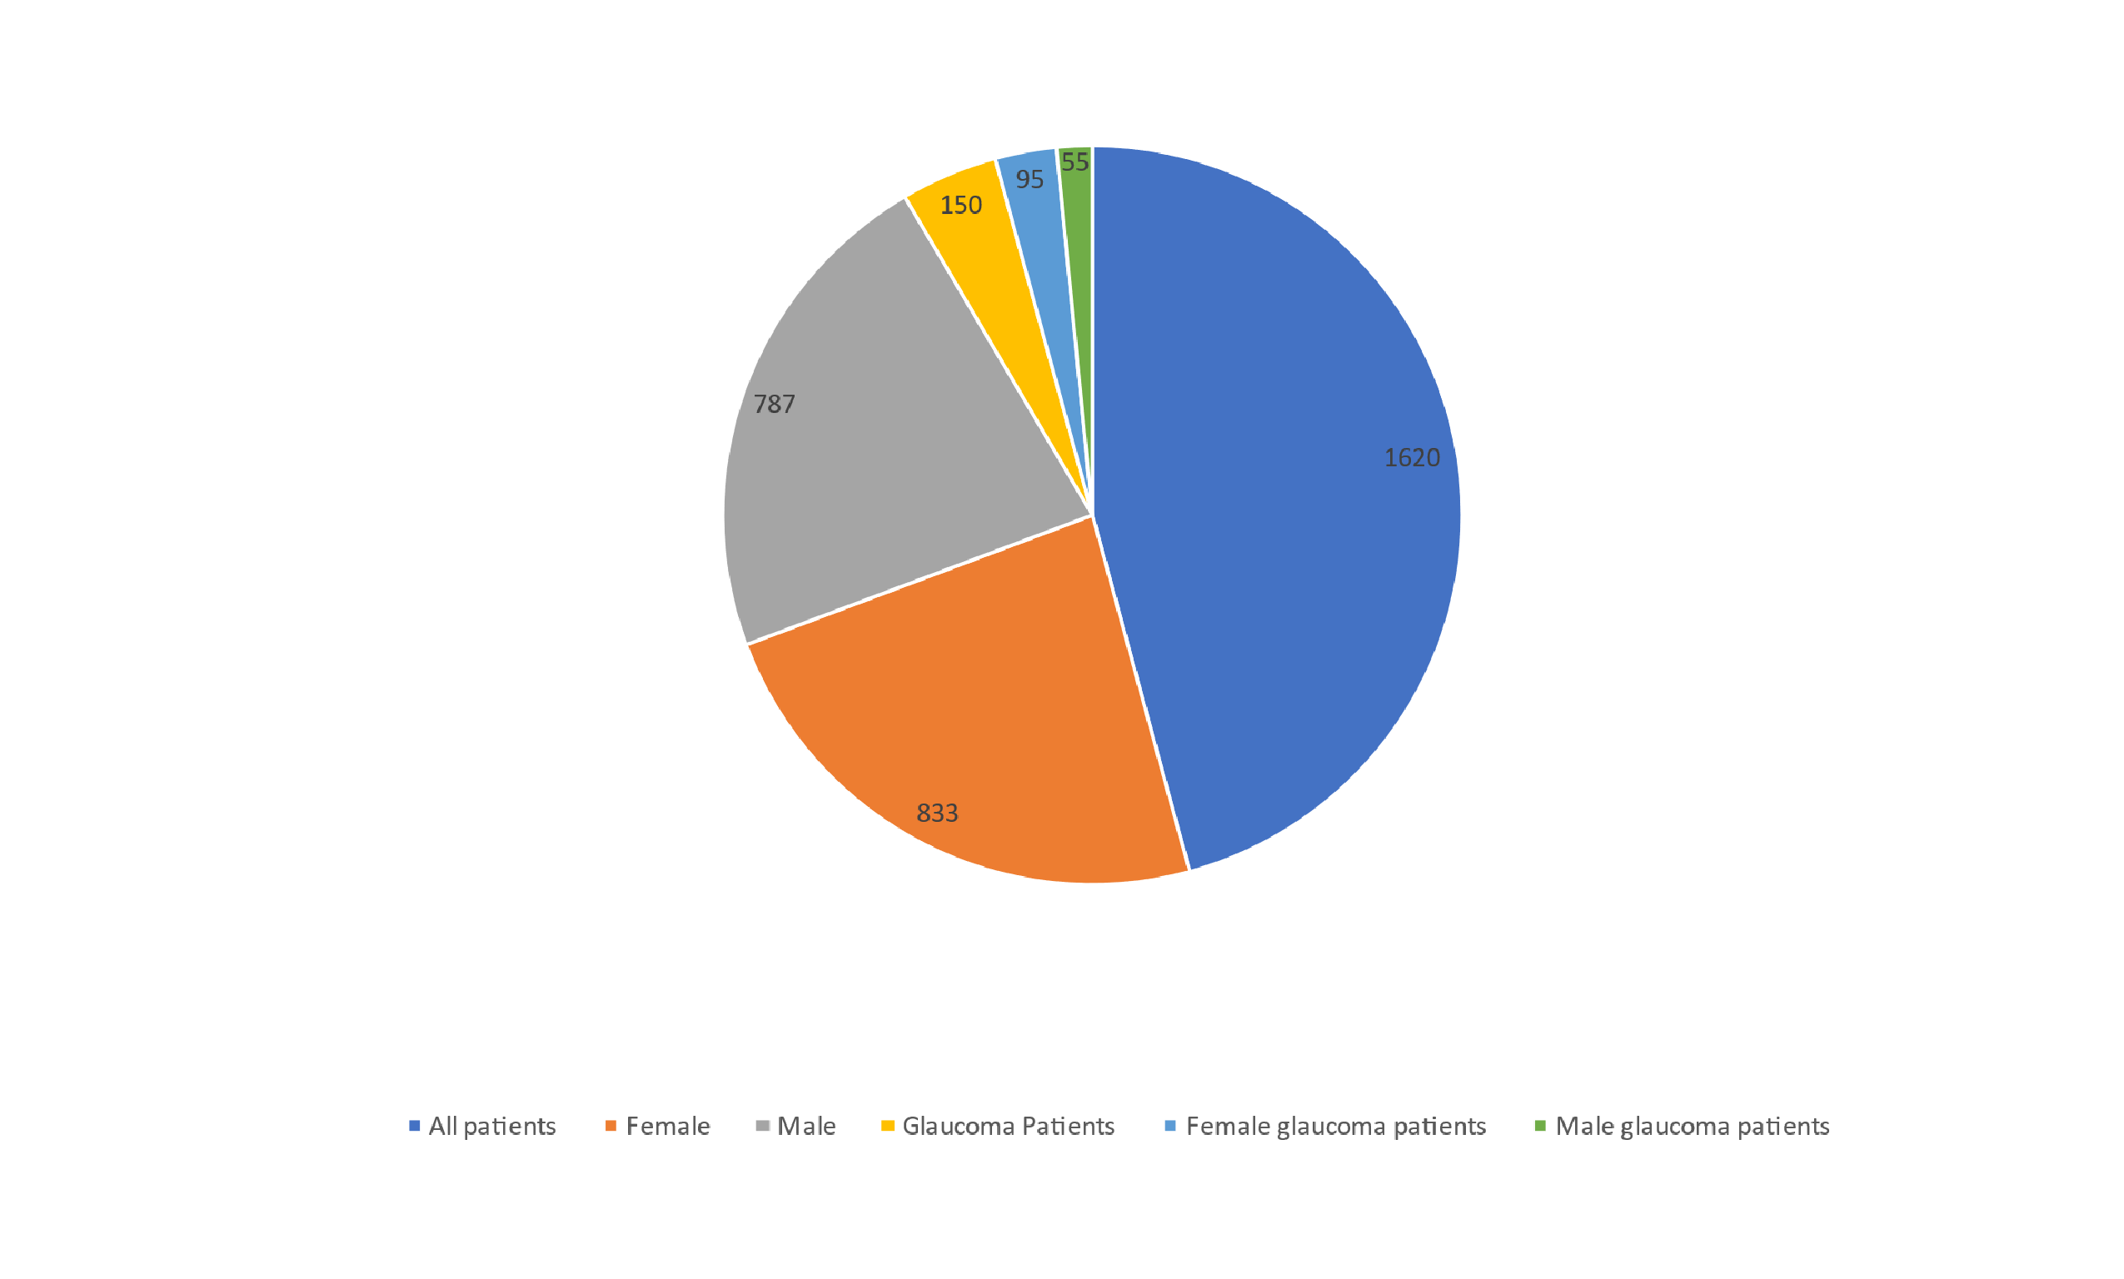
Figure 1. Cases of glaucoma reported to the clinic

Cases of glaucoma reported to the clinic included juveniles but the age frequency suggested most cases of glaucoma were of adult-onset (Figure 1).
The highest frequency occupations with occurrence of glaucoma are farmers 54 (36%) and traders 30 (20%)
TABLE 1: GENDER DISTRIBUTION

GENDER FREQUENCY PERCENT

FEMALE 95 | 63.3
MALE 55 | 36.7

150 case studies were picked out of 833 patients that met the inclusion criteria.
Their ages ranged from 10 to 100 years with age 71-100 holding the highest frequency. Cases of glaucoma reported to the clinic included juveniles but the age frequency suggested most cases of glaucoma were of adult-onset.

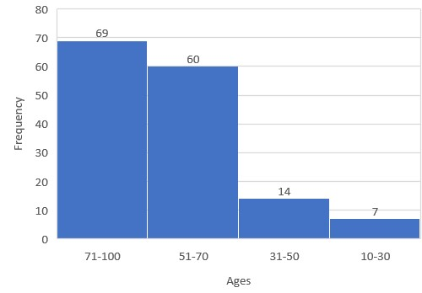
Figure 2: AGE DISTRIBUTION OF THE GLUCOMA PATIENTS

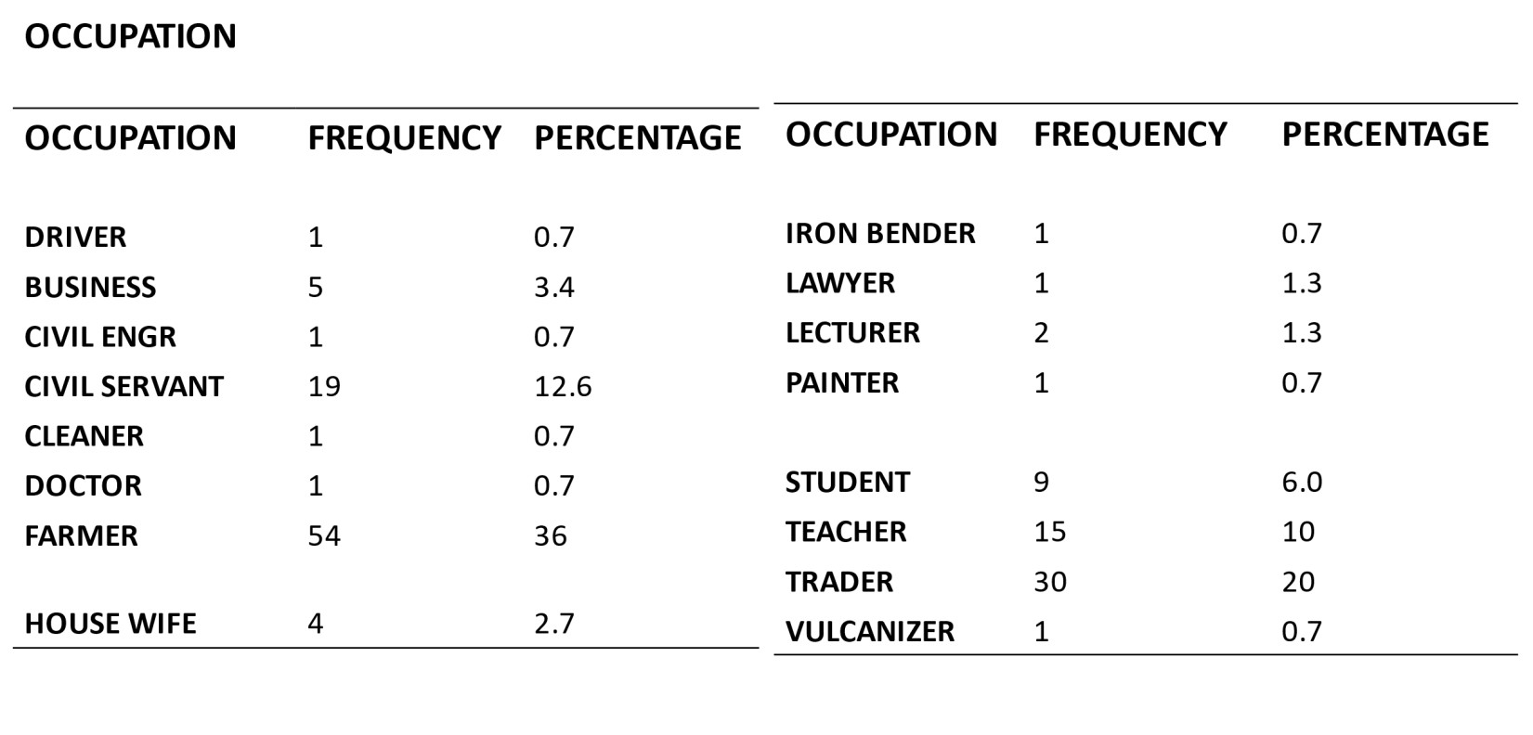
Table 2: Occupation
Discussion
It was impossible to overstate the importance of maintaining good eye health. This study highlighted the sociodemographic characteristics of glaucoma patients receiving tertiary care at the Federal Medical Centre (FMC), Owo. Most of the participants were elderly, suggesting that glaucoma occurred at an exceptionally high rate among older adults. Age had long been identified as a major risk factor, and studies in Africa consistently reported that the average age of individuals living with glaucoma was 50 years or above.
Globally, women outnumbered men among glaucoma cases and also lived longer, which increased their lifetime risk of the disease. Consistent with previous evidence, this study found that women were more likely than men to develop glaucoma. A study conducted by Tehrani and published in Current Eye Research in 2015 similarly reported that women were at a greater risk of glaucoma.¹¹ Although angle-closure glaucoma appeared more common in women, the evidence for sex differences in open-angle glaucoma remained inconclusive. Some studies suggested that female sex hormones might offer some protection to the optic nerve, while reduced lifetime exposure to estrogen was thought to increase the risk of open-angle glaucoma. However, the evidence remained inconsistent, and there was still insufficient data to recommend hormone replacement therapy for glaucoma prevention.
Women also tended to carry a higher burden of glaucoma-related blindness, partly due to their longer life expectancy and their lower socioeconomic status in many African settings. This socioeconomic disadvantage often limited their access to quality eye care services. This was reflected in the finding that some female participants were housewives, which may have contributed to late diagnosis. Tehrani further reported that women were more likely to present with glaucoma at a later stage, increasing the risk of severe visual impairment. Additionally, the higher prevalence of diabetes among women had been implicated as a contributory factor to their increased glaucoma risk. These findings suggested that women might require more frequent glaucoma screening.
This study identified a 51% prevalence of glaucoma in the tertiary healthcare setting, which aligned with findings from similar hospital-based studies. In Nigeria, glaucoma-related disability had significant social and economic consequences. It had been estimated that up to 75% of blindness cases in developing countries were preventable; however, prevention and treatment remained challenging due to poverty and limited access to healthcare, especially in remote areas.
The study also showed that traders and farmers had the highest rates of glaucoma. This could be attributed to prolonged exposure to ultraviolet (UV) radiation due to the nature of their outdoor work. A study by Cáceres-Vélez et al. also identified UV exposure as a contributing factor to glaucoma development.¹² Evidence from a 2014 study in JAMA Ophthalmology further supported this association, indicating that increased sun exposure and corresponding oxidative stress might elevate glaucoma risk. Research by Dr. Louis Pasquale and colleagues at Harvard Medical School found reduced superoxide dismutase activity in the trabecular meshwork of glaucoma patients. Blood and plasma samples from affected individuals also showed diminished antioxidant status and elevated oxidative stress markers, including protein carbonyls, advanced glycation end products, malondialdehyde, and the DNA damage marker 8-hydroxy-2'-deoxyguanosine (8-OHdG).¹³
Historical studies by Noell and colleagues demonstrated that light—particularly blue light—could induce retinal damage through photochemical pathways that generated reactive oxygen intermediates (ROI). Blue light (450–490 nm) was shown to be especially harmful due to its ability to produce singlet oxygen, superoxide, hydrogen peroxide, and hydroxyl radicals, which damaged cellular proteins and lipids. Although the eye possessed enzymatic defenses such as superoxide dismutase, catalase, and glutathione peroxidase, as well as antioxidant vitamins (A, C, and E), excessive light exposure could overwhelm these systems. Photosensitizers like lipofuscin, melanin, and mitochondrial enzymes such as cytochrome oxidase played a role in generating these harmful intermediates. Studies by Jung et al. and Godley et al. showed that exposure to blue light increased ROI production and caused mitochondrial DNA damage, further supporting the link between oxidative stress and glaucoma pathogenesis.
A major limitation of this study was its hospital-based design, which restricted the ability to generalize the findings to the wider community. The data were skewed toward individuals who were already receiving treatment and might not reflect the true prevalence of glaucoma in the general population. Therefore, future research should include population-based studies to provide more representative data and strengthen the understanding of glaucoma epidemiology in Nigeria.

Conclusion and Recommendation
Glaucoma remained one of the leading causes of blindness, and its impact could be reduced through early diagnosis and improved understanding of its associated risk factors. The study conducted at the Federal Medical Center (FMC), Owo Eye Clinic revealed a notable incidence of glaucoma, leading to the rejection of the null hypothesis and acceptance of the alternative hypothesis. The findings provided strong evidence that age was a significant risk factor among patients presenting to the clinic. Additionally, certain occupational groups—particularly farmers and traders—were found to be at greater risk of developing glaucoma. The study also showed that females were more susceptible to glaucoma than males.
Importantly, based on these findings, the study recommended that public health awareness campaigns be strengthened to improve early detection, especially in rural communities where knowledge and access to eye care remained limited.
Ethics Statement:
I testify on behalf of all co-authors that our article was submitted in accordance with ethical principles in publishing.
All authors agree that:
- This research presents an accurate account of the work performed, all data presented are accurate and methodologies detailed enough to permit others to replicate the work.
- This manuscript represents entirely original works and or if work and/or words of others have been used, that this has been appropriately cited or quoted and permission has been obtained where necessary.
- This material has not been published in whole or in part elsewhere.
- The manuscript is not currently being considered for publication in another journal.
- That generative AI and AI-assisted technologies have not been utilized in the writing process or if used, disclosed in the manuscript the use of AI and AI-assisted technologies and a statement will appear in the published work.
- That generative AI and AI-assisted technologies have not been used to create or alter images unless specifically used as part of the research design where such use must be described in a reproducible manner in the methods section.
- All authors have been personally and actively involved in substantive work leading to the manuscript and will hold themselves jointly and individually responsible for its content.

Conflict of interest: The authors have declared that no competing interests exist.
Ethical Consideration: Approval was granted by the Research Ethics Committee of the Federal Medical Center Owo with reference number FMC/OW/380/VOL.CLXV/74 dated 12th January 2023.
Ethical Considerations
Approval was granted by the Research Ethics Committee of the Federal Medical Center Owo with reference number FMC/OW/380/VOL.CLXV/74 dated 12th January 2023.

COMPETING INTERESTS DISCLAIMER:
Authors have declared that they have no known competing financial interests OR non-financial interests OR personal relationships that could have appeared to influence the work reported in this paper.

Disclaimer (Artificial intelligence)

Author(s) hereby declare that NO generative AI technologies such as Large Language Models (ChatGPT, COPILOT, etc.) and text-to-image generators have been used during the writing or editing of this manuscript.

References
1. Olawoye O, Fawole O, &, Ashaye A. Eye Care Practices, Knowledge and Attitude of Glaucoma Patients at Community Eye Screening Outreaches in Nigeria. 2020;
2. Wu H, Wang Y, Li F, Liu Z, &, Shi F. The national, regional, and global impact of glaucoma as reported in the 2019 Global Burden of Disease Study. Archives of Medical Science. 2023;19(6):1913–9.
3. Ezinne N, Ojukwu C, Ekemiri K, Akano O, Ekure E, &, Osuagwu U. Prevalence and clinical profile of glaucoma patients in rural Nigeria—A hospital based study. PLoS One. 2021;16(12):e0260965.
4. Obasuyi O, Yeye-Agba O, &, Ofuadarho O. Factors limiting glaucoma care among glaucoma patients in Nigeria: A scoping review. Plos Global Public Health. 2024;4(1):e0002488.
5. Ocansey S, Ekure E, Osuagwu U, Ekpenyong B, Ovenseri-Ogbomo G, Kyeremeh S, … &, et al. Profiling and factors associated with glaucoma diagnostic practice in sub-Saharan Africa-a cross sectional study of Nigerian and Ghanaian optometrists. BMC Ophthalmol. 2023;
6. Enesi I, Ndife T, Kyari F, &, Odi A. Central Corneal Thickness and Its Association with the Severity of Primary Open-Angle Glaucoma. Journal of West African College of Surgeons. 2025;15(2):146–56.
7. Amoah-Smith O, Eghaghara J, Ryan B, &, Robinson D. Glaucoma case finding and management among optometrists in Ghana and Nigeria. Optometry and Vision Science. 2025;102(9):529–35.
8. Anajekwu C, Eze G. Pattern of Ocular Morbidity in Patients Attending Urban Specialist Eye Clinic in South East, Nigeria. Asian Journal of Medicine and Health. 2023;21(3):56–62.
9. Onwubiko S, Nwachukwu N, &, Eze B. Glaucoma medications: issues with adherence in a tertiary hospital in Nigeria. Family Medicine & Primary Care Review. 2020;22(24):302–6.
10. Anthony O, Anthony E, Ijeoma A, Malachy E, Chukwunonyerem O, &, Chinyelu U. Glaucoma Screening among Relatives of Glaucoma Patients in Anambra State, Nigeria. Adv Res. 2024;25(3):175–85.
11. Tehrani S. Gender differences in glaucoma: A review of the literature. Curr Eye Res. 2015;40(2):201–11.
12. Cáceres-Vélez PR, Gómez-Olivas JD, &, Hernández-Mendoza FA. Occupational ultraviolet exposure and its association with glaucoma progression. Int J Ophthalmic Res. 2022;8(3):45–52.
13. Sorkhabi R, Chitsazian F, Aghdam KA, &, Amini H. Oxidative stress markers in aqueous humor of patients with primary open-angle glaucoma. Mol Vis. 2011;41–6.

