Clinical and therapeutic epidemiological aspects of ballistic eye trauma cases admitted to the Armed Forces Hospital Centre (CHA)

ABSTRACT
Ballistic eye injuries are very rare ophthalmic emergencies, but they are potentially serious as they can lead to blindness. The prevailing insecurity in the Sahel has led to a multitude of cases that pose a problem in terms of treatment. The objective of the study was to describe the epidemiological, clinical, and therapeutic aspects of ballistic trauma cases at the Armed Forces Hospital (CHA). This was a descriptive, prospective study over six years, conducted from January 1, 2019, to April 30, 2024. All patients admitted to the CHA for ballistic eye trauma were included. The parameters studied were sociodemographic, the affected eye, the nature of the injuries, the causative agent, and the therapeutic modalities. Ten male patients of an average age of 24 years were included in the study. All of the patients were non-commissioned officers; seven of the patients (70%) belonged to the Nigerien Armed Forces. Eye trauma due to homemade mine explosions was the most common (n=9, or 90%). All patients had adnexal contusion (n=10). Three patients (30%) had globe rupture, five (50%) had corneal damage, and two (20%) patients had posterior segment damage. Evisceration was performed in 30% (n=3) of patients, and posterior segment surgery was performed in two patients. A dry eye syndrome occurred in 30 (n=3) patients. Six patients (60%) became monocular. Only one patient recovered without sequelae. Despite emergency treatment, ballistic eye injuries remain serious due to their severity and potential to lead to blindness. The limitation of the study lies in its small sample size, which is ten patients, and this low statistical power prevents any generalisation of the results to a larger population and reduces the ability to identify significant associations between injury characteristics, treatments, and prognoses. Therefore, it is recommended that larger, multicenter prospective studies should be developed to consolidate knowledge.
KEY-WORDS: Eye injuries, ballistic, blindness, epidemiological aspects.
Introduction
Ocular trauma is a public health concern and a significant cause of vision impairment globally. The prevalence of ocular trauma to be 2.4% of the population in an urban city in India, 11.4% of these are blind. The incidence of eye injuries may be higher in developing countries (Bhaskar et al., 2024). In addition to causing health problems for the person, ocular injuries also lead to mental suffering, reduced quality of life, cosmetic problems, and reduced efficiency with a significant loss of working days. (Hashemi et al., 2023).
The Projectile eye injuries (ballistic trauma) are a rare but extremely serious ophthalmic emergency, with a high risk of permanent vision loss. The resurgence of insecurity in the Sahel region has led to a significant increase in these cases, presenting healthcare systems with complex challenges in terms of treatment. The management of these injuries requires technical resources and specific expertise, which are often limited in these contexts. In this context, a study was conducted in Niger with the main objective of providing an accurate picture of these injuries. It aimed to analyse their epidemiological characteristics (patient profiles, circumstances of occurrence), describe their clinical presentations (nature and extent of eye and orbital injuries), and evaluate the therapeutic strategies implemented and their outcomes. This detailed description is essential for a better understanding of the impact of this public health problem and to guide improvements in prevention and care in resource-constrained settings.

Patients and Methods
This research was conducted using a retrospective and descriptive methodology, analysing data over an extended period of six years and four months, specifically from January 1, 2019, to April 30, 2024. Recruitment took place at an Armed Forces Hospital centre (CHA), where all patients hospitalised for ballistic eye trauma were systematically included in the study. The analytical framework focused on several key dimensions: the sociodemographic characteristics of the patients (age, sex, context), clinical aspects including the affected eye and the precise type of injury, identification of the causative agent (type of projectile), and the therapeutic modalities implemented, from initial care to surgical interventions. An important clarification must be made regarding the inclusion criteria: the study protocol specifically targeted projectile (ballistic) trauma. Thus, non-ballistic eye injuries such as those caused by explosions without projectile impact, blunt objects, or chemical agents in a conflict setting did not meet the eligibility criteria and were therefore not included in this analysis. This rigorous selection process was intended to ensure the homogeneity of the cohort around the main injury mechanism studied.

Results
Ten patients were included in our study (16 eyes). The mean age was 24 years, ranging from 21 to 30 years. All of our patients were male, and 90% of the eye injuries were caused by improvised explosive devices. Both eyes were affected identically.

Graph 1: Frequency of affected structures.
The eyelids and cornea are the most commonly affected organs in our study.

Graph 2: Types of lesions encountered
Adnexal contusions and corneal ulcers are the most common lesions.

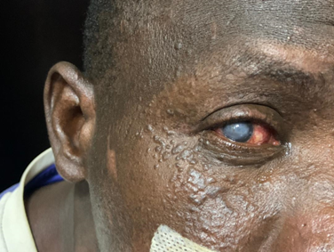
Figure 1: showing a total white cataract, associated with skin abrasions.
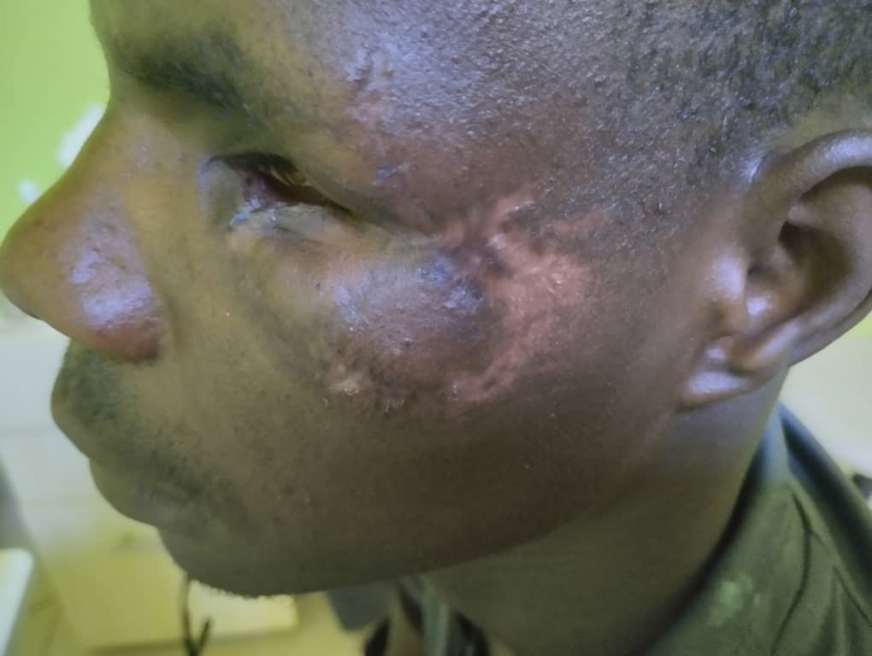
Figure 2: Burst globe and enophthalmos, associated with skin abrasions.
Medical treatment was initiated in 50% of cases, often in combination with surgical treatment.
Three patients underwent evisceration, two underwent filtering surgery, and one patient underwent endo-ocular posterior segment surgery.
Nine patients had an unfavourable outcome (eye loss, chronic dry eye).

Graph 3: Evolution of lesions.

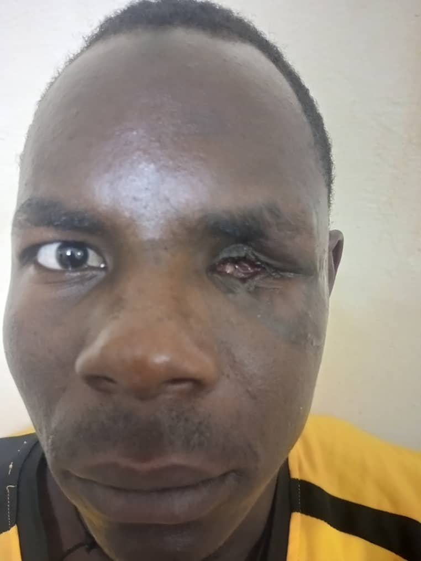
Figure 3: Eviscerated eye.
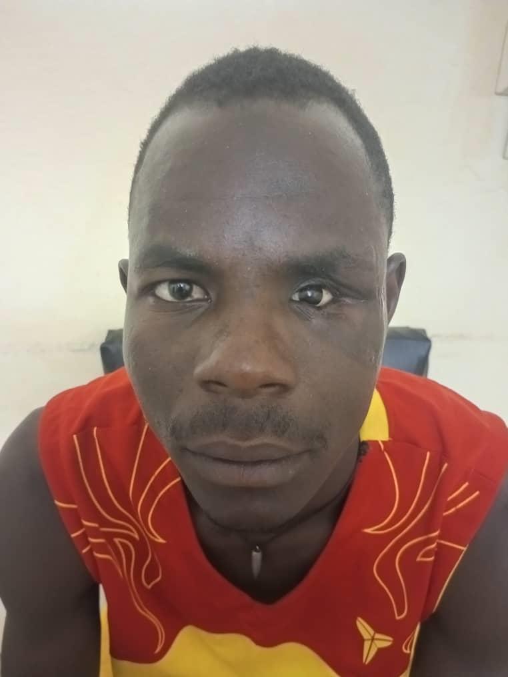
Figure 4: Left ocular prosthesis in a war casualty.
Discussion
In a turbulent geopolitical context marked by an increase in armed conflicts around the world, the prevalence of ballistic trauma has risen exponentially. In terms of eye injuries, these are predominantly suffered by young males, as shown by our study, with an average age of 24. Other studies confirm the youth of victims, with higher average ages. In particular, the study by P. Bile et al. conducted in Côte d'Ivoire found an average age of 32.16 years 1. The sex ratio is dominated by men due to their direct involvement in conflicts, with varying percentages but always above 80%. In our study, all patients are male, which is confirmed by the literature, as in the study by H. Aboubakar et al. 2-3. The ballistic eye injuries are a serious and growing complication of modern armed conflicts around the world. Their epidemiology is directly linked to the intensity and nature of hostilities. Asymmetric and urban conflicts, with the use of explosive weapons and snipers, expose both combatants and civilians to increased risk. Studies estimate that eye injuries can account for up to 10-15% of war injuries, a proportion that is increasing with the widespread use of improvised explosive devices. The victims are mainly young men, but contemporary conflicts are causing a significant number of injuries among women and children. The prognosis is grim: a large proportion of these injuries result in permanent unilateral or bilateral blindness due to the severity of the damage (ruptured eyeballs, complex orbital and facial trauma) 4. These injuries place a heavy long-term burden on the already fragile health systems in conflict regions.
In terms of eye injuries, all structures can be affected to varying degrees, ranging from simple scratches or superficial wounds to a ruptured eyeball. The eyelids were the most commonly affected site in our study, consistent with other data in the literature 5. In most cases, functional vision was poor, demonstrating the severity of the eye injuries. Ninety per cent of the patients in our study had an unfavourable outcome. In 2018, nearly half of those injured in Cameroon in the armed conflict with the Boko Haram sect had poor visual function and were close to blindness 6. The aetiology of these various traumas is diverse. It includes homemade mines, knives, and firearms. Mine explosions are the most common mechanism due to the new modus operandi of armed terrorist groups. Studies in Iraq and Afghanistan have found the same mechanism 7-8.
Ballistic eye injuries caused by high-velocity projectiles (bullets, shrapnel, metal fragments) present a clinical picture of extreme severity. The initial presentation is often dramatic, combining open injuries to the eyeball (rupture or penetration), complex orbital and facial trauma with orbital wall fractures, and frequently associated cranio-cerebral or maxillofacial injuries. The initial examination, when possible, reveals a profound decrease in visual acuity, chemosis and significant eyelid hematoma, hyphema (blood in the anterior chamber), a deformed or collapsed pupil, and sometimes exposure of intraocular tissues (uvea, vitreous). Imaging (orbital-brain CT scan without injection) is essential to map the extent of the damage: it objectively shows fractures, the presence of radio-opaque intraocular or intraorbital foreign bodies, and the condition of adjacent structures. The anatomical and functional prognosis is immediately guarded, directly correlated with the kinetic energy transmitted to the globe. The immediate post-traumatic evolution is marked by two major vital and functional risks. On the one hand, infection, with a high risk of post-traumatic endophthalmitis (purulent inflammation of the entire eye cavity), whose germs, often polymicrobial, may include Bacillus cereus, which is particularly dangerous. On the other hand, damage to the optic nerve, either direct through sectioning or contusion, or indirect through compressive hematoma, can permanently seal the visual prognosis. Primary surgical management, often carried out in austere conditions (field hospitals), has limited but essential objectives: exploration and tight closure of the wounds of the globe, excision of irrecoverable tissue, careful removal of accessible foreign bodies, and prevention of infection through abundant washing and broad-spectrum systemic and local antibiotic therapy. This salvage surgery does not restore vision, but seeks to preserve the anatomical integrity of the globe for subsequent reconstruction. Even after optimal initial treatment, the medium- and long-term prognosis is fraught with serious sequelae. Post-traumatic cataracts are almost always present. Retinal detachment, caused by vitreous traction and retinal lacerations, is a major cause of functional failure. Retrolenticular fibrosis and vitreoretinal proliferation transform the interior of the eye into scar tissue, destroying all light transmission. In the anterior segment, secondary glaucoma due to angle blockage or synechiae is common and difficult to control. Atrophy of the eyeball (phthisis bulbi), the final stage of healing failure, results in a small, non-functional and sometimes painful eye. Orbital sequelae, such as enophthalmos (sunken eye) or ocular motility disorders (diplopia), add a significant aesthetic and functional handicap. These complications require highly specialised surgical procedures (vitrectomy, detachment surgery, implant placement, orbital surgery) that are often unavailable in theatres of operation, necessitating complex medical evacuation. Final visual rehabilitation is often modest, with a high rate of permanent unilateral blindness, highlighting the devastating nature of these injuries and the absolute necessity of prevention through the wearing of ballistic eye protection. 9
The management of ballistic eye injuries in conflict situations represents an extreme medical and surgical challenge, requiring adaptation to logistical, security, and resource constraints. It revolves around an integrated chain of care, beginning with advanced medical support in the field, where the priority is to stop life-threatening periorbital bleeding and protect the eyeball without manipulation. Evacuation to an advanced medical post must be rapid. The initial hospital phase, often in a field hospital, follows the ATLS (Advanced Trauma Life Support) protocol with assessment of associated injuries (craniofacial, neurological). The urgent ophthalmological assessment, if possible by a specialist, uses portable imaging to evaluate the eyeball and look for intraocular foreign bodies. Primary surgical management, under general anaesthesia, aims to preserve the anatomy: careful closure of the wounds of the eyeball, excision of necrotic tissue, removal of accessible foreign bodies, and maximum preservation of structures. Broad-spectrum intravenous antibiotic therapy is initiated to prevent endophthalmitis. Orbital and facial reconstruction surgery, as well as complex vitreoretinal procedures, are generally deferred to specialised tertiary care centres, accessible after medical evacuation. This multidisciplinary, phased approach, combining emergency medicine, war surgery, and specialised ophthalmology, aims to save the globe, prevent catastrophic infections, and lay the groundwork for subsequent visual rehabilitation in a context of limited resources and ongoing violence. The ballistic eye injuries, caused by the impact of high-velocity projectiles (shrapnel, bullets, metal fragments), are extremely serious ophthalmological emergencies. They involve a destructive shock wave and frequent intraocular penetration, causing complex and multivisceral lesions. The initial damage, which is often devastating to the cornea, lens, and retina, is systematically aggravated by secondary complications: vitreous haemorrhage, retinal detachment, infection, and the development of hypotony or globe atrophy. Treatment, initially surgical, must be extremely rapid and multidisciplinary, aiming to preserve the anatomy and, in less severe cases, visual potential. Prevention through the use of appropriate eye protection remains absolutely essential in high-risk contexts, whether military or civilian, as the final functional prognosis is often poor, with a high rate of irreversible blindness.10
The management of ballistic eye trauma requires a multidisciplinary approach that is both urgent and sequential. The initial priority is to assess and stabilise vital functions, with treatment of the eye only being considered after ruling out any life-threatening injuries. A specialised ophthalmological examination measures visual acuity and assesses the anterior and posterior structures using imaging techniques. The goal of emergency surgery is to preserve the anatomy: closing wounds to the eyeball, removing accessible foreign bodies, and performing early vitrectomy in cases of endophthalmitis or detachment. Systemic and topical broad-spectrum antibiotic therapy and tetanus prevention are routinely implemented. The visual prognosis depends on the initial severity, the presence of foreign bodies, and the time taken to provide treatment.11-12
The outlook for the treatment of ballistic eye injuries is moving towards integrated, technological optimisation of the care chain, from the point of injury to long-term rehabilitation. In the field, research is developing more effective personal protective equipment and specific advanced pre-hospital care protocols, including the use of hemostatic agents and stabilising eye dressings for evacuations. Telemedicine and tele-expertise are proving crucial in guiding non-specialist surgeons in advanced facilities, thanks to the transmission of images and biometric data. In hospitals, progress is based on robot-assisted microsurgery for precision procedures in constrained environments, and on innovative biomaterials (artificial corneas, retinal substitutes, customised orbital implants using 3D printing) for complex reconstructions. Finally, visual rehabilitation is benefiting from the development of cortical and retinal visual prostheses, offering hope for light perception even after anatomical loss of the eyeball. This multidisciplinary and technological approach aims to radically improve the functional prognosis for these war-wounded. 13
Conclusion
Despite emergency treatment, eye injuries caused by projectiles (ballistic trauma) continue to have a particularly poor prognosis. This persistent severity is linked to the very nature of the injuries, which are often complex and devastating to the fragile structures of the eye and orbit. The damage can be multiple: rupture of the eyeball, intraocular haemorrhages, optic nerve damage, or the presence of intraorbital foreign bodies. These injuries carry a very high risk of profound visual impairment or even irreversible blindness, even when treated quickly. In the face of this threat, primary prevention is a crucial and effective measure. The systematic wearing of appropriate eye protection (certified ballistic glasses or visors) in high-risk situations is the most reliable strategy for drastically reducing both the incidence of these accidents and the severity of injuries when they do occur. Thus, beyond improving emergency treatment, promoting and providing access to personal protective equipment remains essential in combating the dramatic consequences of these injuries.

Limitations
Although this study provides valuable data on a rare clinical condition, it has several important limitations, mainly due to its small sample size, which is limited to ten patients. This low statistical power prevents any generalisation of the results to a larger population and reduces the ability to identify significant associations between injury characteristics, treatments, and prognoses. The retrospective and single-centre nature of the study introduces inherent selection and information biases; the data, which depend on the quality and completeness of medical records, may be incomplete or heterogeneous. The absence of a control group or comparison with other types of eye trauma limits the ability to isolate the specificities related to the ballistic mechanism. Finally, the short-term or absent follow-up in such a study does not allow for the assessment of long-term sequelae (glaucoma, late retinal detachment, globe atrophy) or definitive functional outcomes, which are nevertheless major issues in these traumas. These limitations highlight the need for larger, multicenter prospective studies to consolidate knowledge.

Disclaimer (Artificial intelligence)

Author(s) hereby declare that NO generative AI technologies such as Large Language Models (ChatGPT, COPILOT, etc.) and text-to-image generators have been used during the writing or editing of this manuscript.

References

1- Bile, P. E. F. K., Ahnoux-Zabsonre, A., Diomande, G., Diomande, I., Diabate, Z., Ouattara, Y., ... & KOFFI, K. (2016). Epidémiologie et prise en charge des traumatismes oculaires balistiques au centre hospitalier et universitaire de Bouake. Revue SOAO, 2, 27-32.

2- Aboubakar, H., Djamilatou, D., Ndongo, J. A., Nyouma, P. J., Nyamsi, P. B., Mbogos, C., ... & Koki, G. (2024). Résultats fonctionnels et facteurs pronostiques des traumatismes oculaires par armes à feu chez les militaires en zones de conflits au Cameroun. Journal Français d'Ophtalmologie, 47(8), 104238.
3-Seck SM, Diakhaté M, Ndiaye Sow MN, Dieng M, Agboton G, Gueye NN. (2017). Etiologies et prognostic des traumatismes oculaires par armes de guerre dans l’armée sénégalaise. J Fr Ophtalmol ; 40 : 118-121
4-Bhende, P., Susvar, P., & Sanghvi, K. (2023). Ocular Trauma in Armed Conflicts: Manifestations, Management, and Outcomes—Complex Case Scenarios. In Ocular Trauma in Armed Conflicts (pp. 219-233). Singapore: Springer Nature Singapore.

5- Boukhriss, K. (2021). LES TRAUMATISMES OCULO-ORBITO-PALPEBRAUX PAR PROJECTILES DE GUERRE.
6- Koki, G., Aboubakar, H., Biangoup, P., Noa, G., Kodji, D., Epée, E., ... & Mvogo, C. E. (2018). Profil des Traumatismes Oculo-Palpébraux en Zone d’Insécurité à l’Extrême Nord du Cameroun. HEALTH SCIENCES AND DISEASE, 19(4 S 1).
7- Scanzera, A. C., Leiderman, Y. I., Cortina, M. S., & Shorter, E. S. (2022). Open globe injuries from projectile impact: Initial presentation and outcomes. Indian journal of ophthalmology, 70(3), 860-864.
8-Rakotoarimanana, F. V. A., Rasolondraibe, A. F., Haminason, L. S., Andriamanantena, R. H., Ralahy, M. F., & Randriamanantena, T. (2021). Traumatisme balistique: études étiologiques et balistiques. Head and Neck, 2, 248-55.
9- Sia, R. K., Ryan, D. S., Brooks, D. I., Kagemann, J. M., Bower, K. S., French, L. M., ... & Colyer, M. H. (2022). The impact of combat ocular trauma and traumatic brain injury on vision-and health-related quality of life among US Military casualties. Military medicine, 187(1-2), 209-215.
10-Akıncıoğlu, D., Kucukevcilioglu, M., & Durukan, A. H. (2022). Combat-related ocular trauma and visual outcomes during counter-terrorism urban warfare operations in Turkey. Turkish Journal of Trauma & Emergency Surgery, 28(5), 648.
11-Ifantides, C., Deitz, G. A., Christopher, K. L., Slingsby, T. J., & Subramanian, P. S. (2020). Less-lethal weapons resulting in ophthalmic injuries: a review and recent example of eye trauma. Ophthalmology and therapy, 9(3), 1-7.
12-Castro, H. M., Gross, A., Chuang, A., Mankiewicz, K. A., Richani, K., & Crowell, E. L. (2020). Characteristics of open globes secondary to gunshot wounds presenting at a level 1 trauma center. Investigative Ophthalmology & Visual Science, 61(7), 2106-2106.
13-Moshtaghi, Z., Jahangiri, R., Mahmoodi, T., Taheri, F., Jahanshahi, A., Mirghazanfari, S. S., ... & Sarnaghy, F. J. Shadi Nouri.
Bhaskar, A., & Gupta, R. K. (2024). Clinical Profile of Ocular Trauma at a Tertiary Care Hospital. Ophthalmology Research: An International Journal, 19(4), 32–42.
Hashemi, A., Khabazkhoob, M., Mehri, A., Yekta, A., Mortazavi, A., & Hashemi, H. (2023). Epidemiology of ocular trauma in the elderly: a population-based study. Journal of Current Ophthalmology, 35(1), 79-85.

