The Significance of Eosinophils in Acute Appendicitis: A comparative study

ABSTRACT

Background: Acute appendicitis is one of the most common abdominal emergencies worldwide. Bacterial infection is the most common cause. Even though it is rare, acute eosinophilic appendicitis (AEA) is an overlooked entity by both clinicians and histopathologists in Sri Lanka that may contribute to the clinical presentation of acute appendicitis.
Objectives: This study aimed to evaluate the prevalence of AEA compared to a control group from post-mortem cases unrelated to sepsis and to increase awareness among clinicians to consider it in the differential diagnosis and the possibility of treating medically in addition to usual treatment with antibiotics.
Methodology: Previously reported appendectomy cases (N=257) were reassessed by two histopathologists blinded to each other. The frequencies of possible causes of all cases with concordant diagnoses were compared to the control group. Fisher’s Exact Test was used to compare the prevalence of AEA between groups.
Results: Acute eosinophilic appendicitis was identified in 16/257 (6.22%) of the study group and in 0/100 (0%) of the control group. The difference in prevalence was statistically significant (Fisher’s Exact Test, p = 0.0045), supporting AEA as a probable cause for clinical appendicitis.
Conclusions and Recommendations: AEA may represent an overlooked contributor to acute appendicitis. As it is a type I hypersensitivity reaction, there is a possibility of treating it medically. Increased recognition of this entity could be considered as a hypothesis and develop more studies on it to reduce surgical interventions. Clinical trials by surgeons may value further validating these findings. This is a flatform for future studies and invention of novel investigations on that.

INTRODUCTION
The appendix is a normal true diverticulum of the caecum that is prone to acute and chronic inflammation and various types of neoplastic diseases. Acute appendicitis is one of the most common abdominal emergencies worldwide. (1) The exact function of the normal appendix and the pathogenesis of appendicitis is not known. Acute and chronic appendicitis are caused by luminal obstruction of the appendix due to multiple causes such as bacterial infections, hyperplasia of the lymphoid follicles, fecalith, parasites, tumours and sometimes due to type I hypersensitivity reactions. This is followed by distension and increased pressure within the lumen, resulting in ischemic changes and subsequent bacterial infection. The most likely cause can only be identified after histopathological examination of the resected appendix.
Among the causative factors, eosinophilic appendicitis is a rare disease. It is often confused with acute suppurative appendicitis due to similar clinical presentations, but the defining factor is the presence of eosinophils and the absence of neutrophils, which can be diagnosed only by histologically. Eosinophils are normal constituents of the appendix in the lamina propria and submucosa, but not in the muscularis propria. The histological features of acute eosinophilic appendicitis are infiltration of eosinophils in the muscle layer and oedema with separation of muscle fibers (eosinophil oedema). In a study in Nepal, they have shown that the presence of increased mural eosinophils might represent acute inflammation; however, the cut-off value for eosinophils has not been established. (1) The role of mast cells in the pathogenesis of appendicitis has also been studied by a few authors. (2)
Acute eosinophilic appendicitis might simulate uncomplicated appendicitis. (1) The standard treatment approach for complicated acute appendicitis is appendicectomy, but the uncomplicated cases can be treated with antibiotic therapy. High negative appendicectomy rate still prevails on conventional histological examination. (1) There are a few other possible causes which can only be identified histologically, like submucosal lymphoid hyperplasia, a parasite in the lumen, faecolith in the lumen and acute eosinophillic appendicitis, which is overlooked most of the time. If the case is eosinophilic appendicitis, then antibiotic therapy may not be effective. In such cases, if the imaging suggests evidence of inflammation, the possibility of acute eosinophilic appendicitis must be considered in the clinical differential diagnosis and can be treated medically; therefore, unnecessary surgeries can be avoided. (1) In the management of suspected cases of acute appendicitis, the factors leading to allergic reactions should be investigated and treated. This is often misdiagnosed as the clinical picture is similar to acute appendicitis
Many studies are done in the world as well as in Sri Lanka in reference to Alvarado score (3), laparoscopic appendicectomy (4), clinical characteristics and management outcome (5) and so on. But no study has found type I hypersensitivity reaction as a causative factor in acute eosinophillic appendicitis. Therefore, it is worth assessing how common eosinophilic appendicitis is, and it is underdiagnosed in our setup, so that we can consider it in the clinical differential diagnosis of acute appendicitis. It will help to reduce the number of surgeries as it can be treated medically. In the meantime, this will in turn reduce the rare but lethal complications of acute eosinophillic appendicitis, like gastrointestinal hemorrhage. The purpose of this study is to increase the awareness of the condition as a causative factor for acute appendicitis among Sri Lankan clinicians and to assess the prevalence in Sri Lanka.

OBJECTIVES
Our main objective was the assessment of the significance and the role of eosinophils in acute appendicitis in addition to the assessment of general demographic data of the study group. This was done in the following order.
- Calculation of the percentage of cases of acute eosinophilic appendicitis from the number of total cases presented with acute symptoms and undergone appendicectomy.
- Calculation of the percentage of cases of acute eosinophilic appendicitis from the autopsy cases of the appendix not related to appendicitis.
- Comparison of the percentages and assessment of the statistical significance

METHODOLOGY
This is a study done in the Department of Histopathology, Teaching Hospital, Kurunegala. The ethical approval was obtained from the ethical review committee in the same hospital.
All the already reported cases of appendicitis during the last two years were included in the study up to a maximum of 257 cases. The appendices from a hundred autopsies not related to sepsis or any other special pathology were taken to compare with the study group. The cases of gangrenous appendices and neoplasms were excluded from the study.
The post-mortem cases were taken by the Consultant Judicial Medicine from the bodies, as much as possible, to be normal in deaths like trauma and road traffic accidents, following an informed written consent from the relatives. (Annexure 1) The approval was taken from the Director, Teaching Hospital, Kurunegala, for the reassessment of already reported cases anonymously and also to study the post-mortem specimens. The histopathology slides from autopsy cases were prepared according to the routine histopathology processing. All the reported cases were re-numbered randomly with a specific number. The control cases were also labelled separately and entered in the specimen register. All the cases, including the post-mortems, were reported independently by two Pathologists blinded to each other and were included in one of the following categories.
- Acute suppurative appendicitis
- Submucosal lymphoid hyperplasia
- Fibrotic appendix
- Acute eosinophillic appendicitis
- Faecolith in the lumen
The cases not included in one of those categories, including the appendices with parasites in the lumen and the tumors, were classified as others.
The diagnostic criteria taken to diagnose eosinophilic appendicitis are: eosinophils more than 25 per high-power fields in the muscularis mucosa and the muscularis propria (best seen in the circular muscle layer), presence of edema separating muscle fibers and absence of neutrophils in the muscularis propria. Presence of other findings that could lead to eosinophil infiltration are excluded like parasites, granulomatous inflammation and malignancies.
The cases with different opinions from two pathologists were excluded from the study.
The data was anonymously collected through a specific data collection form. (Annexure 2). All the data is summarized and taken into a table. (Annexure 3)
The data were entered in a data collection table (Annexure 4). The results were assessed by SPSS. The statistical significance was assessed by using Fisher’s exact test.

RESULTS
In our study, we reassessed 257 already reported cases received by the Department during the last few years. In addition, 100 post-mortem cases were taken to compare with the study group. The autopsy cases were considered as close to normal because, as acute eosinophilic appendicitis is a histopathological entity, there is no other way to get a normal appendix to compare. This is just to give a message to the clinicians that this entity is not present in non-pathological cases and can be seen only in pathological cases. The cases in which there is a diagnostic discrepancy between two pathologists were rejected from the study. Among the diseased cases, 146 were males and which is 56.8%. Among those 111 cases were females, which is 43.1%. In the control group, 62 were males and 38 were females, indicating 62% and 38%. Most of the cases in the study group were in the age group of 15- 59 years.

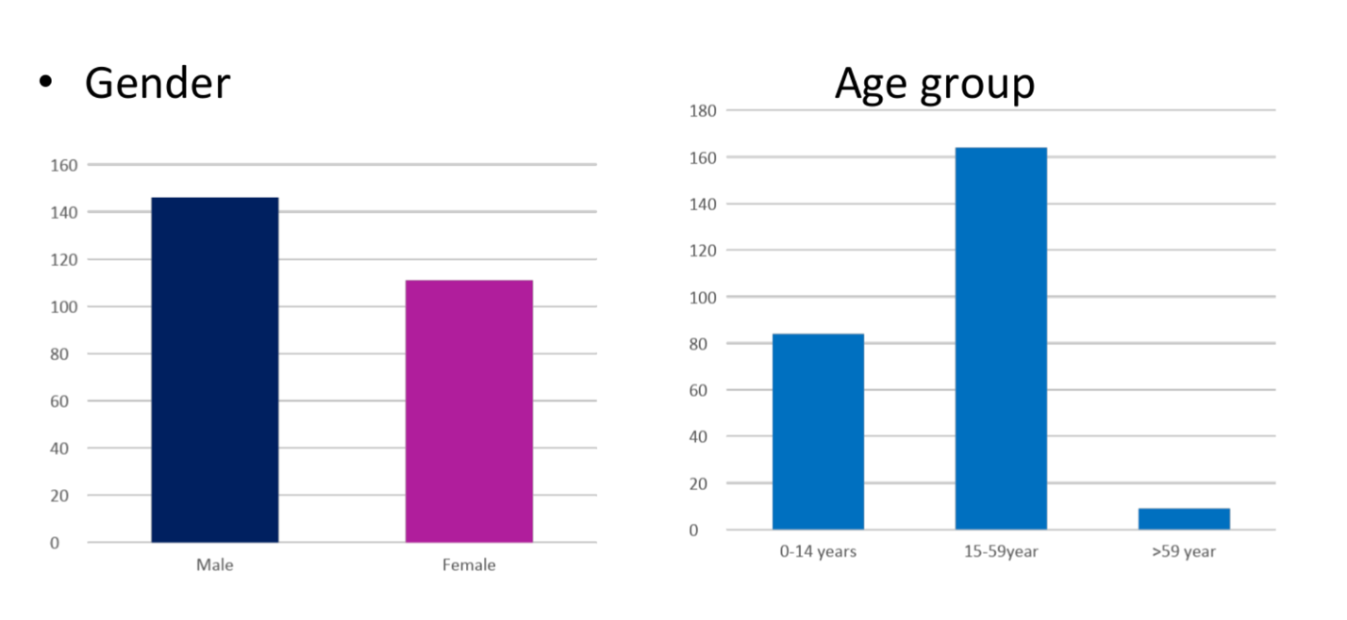
Figure 1. Distribution of the Gender and Age Groups of the diseased cases

During the analysis of received data, we found that the majority of diseased cases were acute suppurative appendicitis; 143 cases out of 257 (55.6%), and 16 cases were acute eosinophillic appendicitis, indicating 6.22%. Interestingly, not a single post-mortem case showed either acute suppurative inflammation or acute eosinophilic inflammation, confirming that not all the autopsy cases are related to sepsis and could be considered as normal.

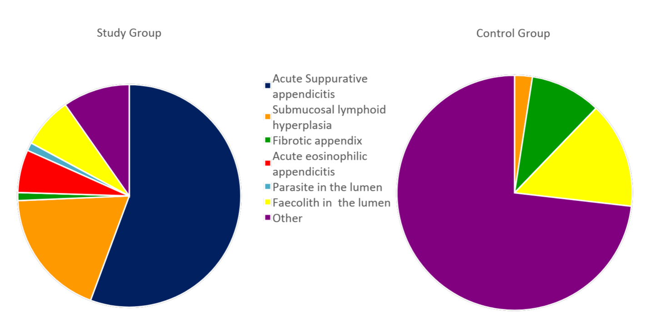
Figure 2. Pie chart showing the distribution of the Prevalence of the Disease between two groups

TABLE 1. Contingency Table
 | Eosinophilic Appendicitis | Not Eosinophilic Appendicitis
Diseased Group (n=257) | 16 | 241
Control Group (n=100) | 0 | 100

The above findings were assessed using Fisher’s exact test. The χ² value was 6.53, and the P value was 0.0106. As the P value is less than 0.05, the result is statistically significant, indicating a significantly higher proportion of acute eosinophilic appendicitis in the diseased group compared to the autopsy group.
Figure 3. Distribution of Acute Eosinophilic Appendicitis Cases between two groups
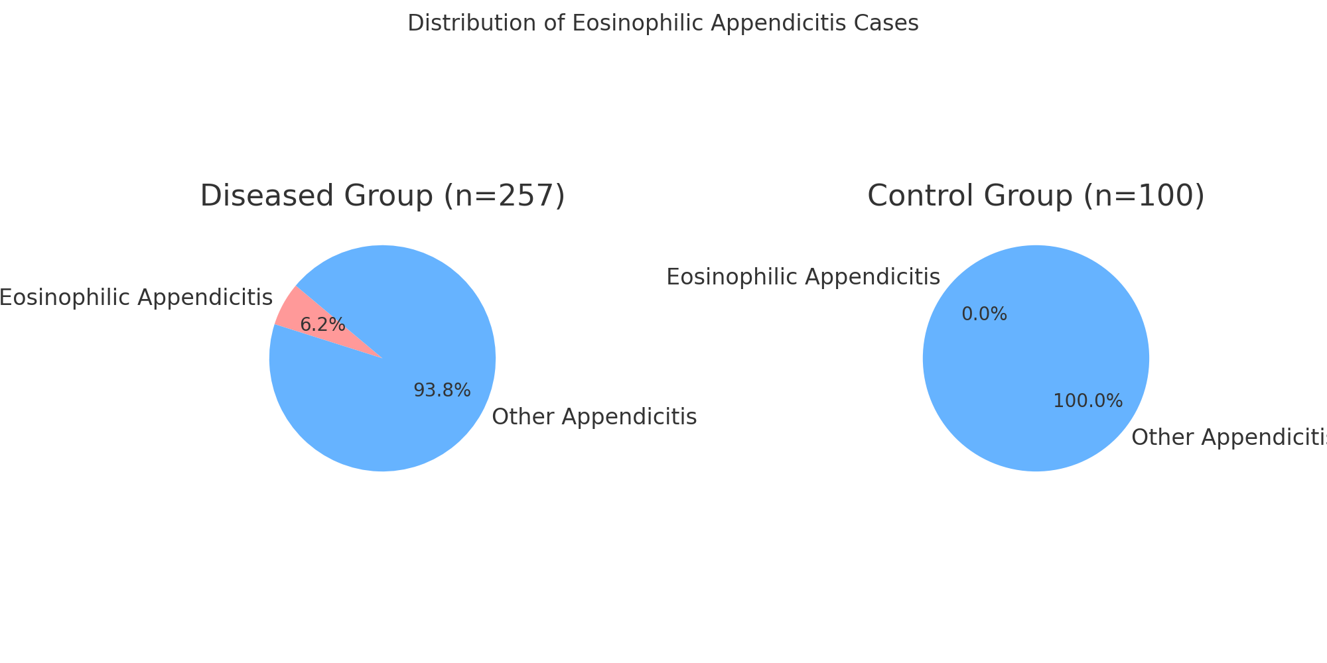

DISCUSSION
Many studies have been done regarding acute appendicitis in the world as well as in Sri Lanka, among those, some are about acute eosinophilic appendicitis. But in Sri Lanka, I could not find the studies of acute eosinophilic appendicitis. One study says that the lifetime risk of appendicitis for a person is 7% (6). Another study mentioned that there is a chance of 6-20% among the general population of experiencing appendicitis during their lifetime. (7) Some say that a rising incidence of appendicitis has been linked to the adoption of Western standards of living. (8)
The literature describes allergic gastro intestinal disorders like, eosinophilic esophagitis, allergic enterocolitis and allergic proctocolitis. In the meantime studies are done and shown that although the etiology of appendicitis is multifactorial, among those, inflammation triggered by type I hypersensitivity response is a recently described factor, and it shares similar morphological features to acute appendicitis. (9) It is a rare disease of unknown etiology. The literature shows that the term eosinophil oedema lesion may at first glance appear unwarranted or grandiose, but is seen in patients with acute symptoms only. (10) In a study done in Turkey, it is mentioned that eosinophils and mast cells are increased in acute appendicitis and correlate with the degree of the inflammation of the appendix. (2) Some studies have shown that an eosinophilic infiltrate in the appendix might be a reflection of a resolving or regression phase of acute appendicitis. (6) Some studies say that eosinophil infiltration in the muscularis propria is an early event universally seen in acute appendicitis, and the bacterial infection is a later consequence. (6) The studies show that the significance of mucosal neutrophils in the absence of muscle involvement is contentious. (8)
Cases of acute eosinophilic appendicitis presented as lower gastrointestinal hemorrhage (10) and mucocele (11) have been reported, and may also be associated with eosinophilic gastroenteritis. A case of acute eosinophilic appendicitis that developed on an allergic background caused by amoebiasis has been reported. (12) Another case has been reported in the literature as acute eosinophilic appendicitis of a 6-year-old male patient following a purpuric skin reaction; possibly allergic origin. (13)
Some researchers say that the mean count of eosinophils and ganglion cells was significantly increased in acute appendicitis. Atypical localization of ganglion cells in the circular layer was noted in both acute and recurrent appendicitis. (7)
Finally, in a research done in Sri Lanka, it has been mentioned that, even though the surgeon’s clinical skill and basic investigations are good in the diagnosis of acute appendicitis, the final diagnosis must be with histology. (13)
Recent studies suggest that further research is needed to assess the pathogenesis and the management of eosinophilic appendicitis. (14) In another study recently done in India, it is said that although it is a rare condition, for the effective management of patients, it needs to be thoroughly investigated. The mainstay for the diagnosis continues to be histopathology. (15)
Some studies showed that there was no peripheral blood eosinophilia, no history of allergies or parasite infestations confirming that unknown etiology for acute eosinophillic appendicitis. (17) Another study says that tissue and peripheral blood eosinophil counts were directly correlated although there was negative correlation between tissue and white blood cell counts. (18)
Acute appendicitis is one of the most common abdominal emergencies even in Sri Lanka. Diagnosis of acute appendicitis is usually done by clinical findings and is still the mainstay of deciding the management plan. But in the case of atypical presentations, some of the laboratory and imaging tests are helpful. Preoperative diagnosis of acute appendicitis is still a challenge, since the possibility of appendicitis must be entertained in any patient presenting with an acute abdomen. Although biomarkers and imaging are valuable adjuncts to history and examination, their limitations mean that clinical assessment is still the mainstay of diagnosis. (7) The management depends on the clinical classification, which includes simple non-perforated cases and complex gangrenous or perforated cases, although many patients remain with an equivocal diagnosis. (7) Simple cases might be self-limiting and may respond to antibiotics alone. But the complex cases need surgery. Appendectomy is one of the most frequently performed surgical procedures worldwide and represents an important burden on modern health systems.
The effective strategy to manage appendicitis through conservative treatment and/or delayed appendectomy was first proposed in 2004 in pediatric perforated cases. According to a study successful rate of non-operative management has been reported to be relatively high, ranging from 80% to 95 % (8). A study was done recently in Teaching Hospital Kurunegala, and they showed that non-operative management was successful in the patients they assessed and suggested treating the cases with antibiotics with close follow-up. (19) In a study done in Canada, they found that the presence of an appendicolith is associated with an increased risk for recurrent appendicitis after no operative treatment. So, they have suggested that the patients with appendicolith should have an interval appendicectomy. There are so many studies assessing the mechanisms of gastrointestinal allergic disorders. In one study they say that gastrointestinal allergic disease is an umbrella term. They have discussed the latest findings on the molecular and cellular mechanisms that govern the gastrointestinal allergic diseases and how those have set the stage for preventive and treatment strategies. (20) In the same way eosinophilic appendicitis is also a door to study the pathogenesis, find diagnostic markers and develop immunotherapies for the modern world.
Even though there are so many studies of the causative factors of acute appendicitis, acute eosinophillic appendicitis remains less concern in our country.
All the appendectomy cases are further analyzed, and the probable cause is always diagnosed by histopathology. According to the analyzed data, we could see that acute eosinophillic appendicitis is a significant cause for the clinical symptoms of acute appendicitis, even though it is rare. It also could be underdiagnosed in our country because of a lack of awareness among clinicians as well as pathologists.

CONCLUSION
Although the appendicitis is diagnosed by clinical findings, blood counts and radiological findings, the final diagnosis of the cause for it is histology. Acute eosinophillic appendicitis; histopathological entity is a causative factor for the cases presenting with symptoms and signs of acute appendicitis. Although it is rare, there is a possibility of treating it medically in addition to antibiotics, which will be more beneficial and cost-effective than surgery. This is a hypothesis, and it will increase the concern of clinicians to consider it as a differential diagnosis in cases presenting with clinical signs and symptoms of acute appendicitis.

RECOMMENDATION
We would like to suggest to the clinicians that there might be a positive effect in treating uncomplicated appendicitis cases with antihistamines with or without steroids in addition to antibiotics. However, close monitoring of the patients is mandatory to identify the complications early. In addition, the clinicians can do further studies to assess the relationship between acute eosinophilic appendicitis with the eosinophil count in blood. Further, this research is a jump start and a good flatform for further studies to validate the effectiveness of medical treatment for this type of case and to develop novel investigations.

COMPETING INTERESTS DISCLAIMER:
Authors have declared that they have no known competing financial interests OR non-financial interests OR personal relationships that could have appeared to influence the work reported in this paper.
Disclaimer (Artificial intelligence)
Author(s) hereby declare that NO generative AI technologies such as Large Language Models (ChatGPT, COPILOT, etc.) and text-to-image generators have been used during the writing or editing of this manuscript.
REFERENCES
1. Takabatake, K., Imanishi, T., & Yoshikawa, T. (2018). Acute eosinophilic appendicitis simulating uncomplicated appendicitis. BMJ Case Reports, 11(1), e227178. https://doi.org/10.1136/bcr-2018-227178
2. Setia, M., Gupta, C., & Gupta, A. (2018). A histological study of surgically resected appendices in clinically suspected appendicitis with special reference to eosinophils and mast cells. International Journal of Medical Research Professionals, 4(6), 1–4.
3. Gomez D, Jayarajah U, Seneviratne S. (2021) Left Sided Acute Appendicitis; Clinical Characteristics, Management and Outcomes: a Systematic Review. Journal of Gastroenterology and Hepatology, 111.
4. Harivallavan, N., Jayawardene, M.D., Piyarathne, S.A., Arulprashath, A. et al. (2020). Is Laparoscopic Appendicectomy Safe in the hands ofJuniorr trainees in Surgery ?. The Sri Lanka Journal of Surgery, 38(2), 1-5.
5. Abeysinghe, G.B., Tennakoon, S.U.B., Fahim, H.M. et al. (2021). Alvarado Score in Predicting Acute Appendicitis Among patients presenting to a Secondary care unit in Sri Lanka: A new cut value. Sri Lanka Journal of Surgery, 39(1), 13-17
6. Aravindan, K. P. (1997). Eosinophils in acute appendicitis: Possible significance. Indian Journal of Pathology & Microbiology, 40, 491–498.
7. Susmitha, S., & Bommanahalli, B. P. (2019). Diagnostic significance of ganglion cells and eosinophils in appendicitis: An adjunct to histopathological diagnosis. Annals of Pathology and Laboratory Medicine, 6(6), 520–526.
8. Aravindan, K. P., Vijayaraghavan, D., & Manipadam, M. (2010). Acute eosinophilic appendicitis and the significance of eosinophil-edema lesion. Indian Journal of Pathology & Microbiology, 53(2), 258–261. https://doi.org/10.4103/0377-4929.64343
9. Patel, S., Soni, H., Kesarwani, V., Nandedkar, S., & Purohit, M. (2021). Infiltration of appendix with eosinophils in acute appendicitis: A prospective study. Tropical Journal of Pathology & Microbiology, 7(5), 226–231.
10. Ahn, S. R., & Lee, J. H. (2021). Acute eosinophilic appendicitis: A rare cause of lower gastrointestinal haemorrhage. The Korean Journal of Gastroenterology, 78(2), 134–137. https://doi.org/10.4166/kjg.2021.063
11. Jagtap, S. V., Nikumbh, D. B., Kshirsagar, A. Y., Kanetkar, S. R., & Bohra, A. (2012). Eosinophilic appendicitis presented as mucocele: A rare clinical entity. International Journal of Health Sciences and Research, 2(2), 73–76.
12. Okudan, M., Taşkesen, F., & Cel, S. Y. (2013). Acute eosinophilic appendicitis: An unusual variant of appendix inflammation. Indian Journal of Surgery, 75(1), 61–62.
13. Ciani, S., & Chuaqui, B. (2000). Histological features of resolving acute, non-complicated phlegmonous appendicitis. Pathology Research and Practice, 196(2), 89–93. https://doi.org/10.1016/S0344-0338(00)80038-2
14. Abeysinghe, A. H. M. G. B., Samarasinghe, N. R., Abeysinghe, A. H. M. C. D., & Wimalasena, G. A. D. N. B. (2023). Acute appendicitis: Clinical decision and histopathological correlation. International Clinical Medicine Case Reports Journal, 2(12), 1–9.
15. Llera, B., Hanna, I., & Jureller, M. (2024). Eosinophilic appendicitis: An insidious and fortuitous diagnosis. Journal of Surgical Case Reports, 2024(6), rjae380. https://doi.org/10.1093/jscr/rjae380
16. Tiwar, A., Frayez, M., & Kumar, N. (2024). Infiltration of the appendix with eosinophils in acute appendicitis. Indian Journal of Public Health Research and Development, 15(2), 56–60.
17. Dr. Vanita Kumar, Dr. Anuradha, Dr. Neelu Gupta. (2017). Acute Eosinophillic Appendicitis: A prospective study in consequative 400 appendicectomy cases. IOSR Journal of Dental and Medical Sciences (IOSR JDMS), 16(10), 77-90.
18. Shahla J. Hussein, Sarmad Raheem Kareem. (2023). Demonstration of tissue and peripheral blood eosinophils in patients with acute appendicitis. ZANCO Journal of Pure and Applied Sciences, 35(6); 118-130.
19. Weerawardena, W.A.K., Rushki, S.H.M., Nishshanka, N.M.P.S., Madushani, V.G.S., Gunawardhana, L.D.S.W., Walisundara, W.M.M.N., et al (2024). Non-operative management of acute appendicitis in a single surgical unit. Kurunegala Medical Journal, 13, 7-10
20. Nurit P Azouz, Marc E Rothenberg. (2019). Mechanisms of gastrointestinal allergic disorders. JCI The Journal of Clinical Investigation, 129(4); 1419-1430.

Annexure 1

Postmortem Appendix UtilUtilisationMedical Research

Ethical Considerations and Informed Consent for Next-of-Kin

Name of the deceased individual: ______________________________________________
Age of the deceased individual _______________________________________________
National ID number: ________________________________________________________
Address ________________________________________________________________________

I acknowledge and understand that the appendix of the deceased will be used solely fto serveas a control in the aforementioned medical research study

- I understand that the identity of the deceased individual will be kept confidential and not disclosed at any point during the study

I have read and understand the above information regarding the research study and the use of the deceased individual's appendix. If I have any questions or unclear details, I have consulted with my doctor and received satisfactory answers.As the next of kin, I freely and voluntarily provide my consent for the deceased individual's appendix to be used in this medical research study without reservation.

Date : ______/_________/_______

Signature : ___________________

Annexure 2
වෛද්‍ය අධ්‍යාපනික පරීක්ෂණයන් සඳහා මියගිය පුද්ගලයන්ගේ උණ්ඩුක පුච්චය ලබාදීමට ඥාතීන්ගේ කැමැත්ත ප්‍රකාශ කිරීම

1.මියගිය ඥාතී පුද්ගලයාගේ නම:-...........................................................................................
2. මියගිය ඥාතී පුද්ගලයාගේ වයස:-........................................................................................
3.හැදුනුම්පත් අංකය:-.............................................................................................................
4.ලිපිනය:-..............................................................................................................................

1.වෛද්‍ය අධ්‍යාපනික පරීක්ෂණයෙහි පාලන පරීක්ෂණයන් සඳහා මියගිය ඥාතීයාගේ උණ්ඩුක පුච්චය (පමණක්) ලබාගන්නා බව අවබෝධ කර ගතිමි.
2.මෙම පරීක්ෂණයේදී කිසිම අවස්ථාවක මියගිය ඥාතීයාගේ අනන්‍යතාවය හෙලි නොකරන/ භාවිතා නොකරන බව අවබෝධ කර ගතිමි.
ඉහත සඳහන් සියලු කරුණු මා විසින් කියවා බලා අපැහැදිලි දේ වෛද්‍යවරයාගෙන් නැවත අසා දැනගෙන අවබෝධ කරගත් බවත් ඉහත සඳහන් පරීක්ෂණයට මාගේ ඥාතියාගේ උණ්ඩුක පුච්චය යොදා ගැනීමට මාගේ විරෝධතාවයක් නොමැති බව මෙයින් ප්‍රකාශ කරමි.

දිනය:-......................... අත්සන:-...........................

Annexure 3

மருத்துவ ஆராய்ச்சியில் பிரேத பரிசோதனை பயன்பாடு

நெறிமுறை பரிசீலனைகள் மற்றும் அடுத்த உறவினருக்கான தகவலறிந்த ஒப்புதல்

இறந்த நபரின் பெயர் : _____________________________________________________
இறந்த நபரின் வயது : ______________________________________________________
தேசிய அடையாள எண் : ___________________________________________________
முகவரி : ________________________________________________________________________

- இறந்தவரின் குடல் வளரி மேற்கூறிய மருத்துவ ஆராய்ச்சி ஆய்வில் ஒரு கட்டுப்பாட்டாக பணியாற்றும் நோக்கத்திற்காக மட்டுமே பயன்படுத்தப்படும் என்பதை நான் ஒப்புக்கொள்கிறேன், புரிந்துகொள்கிறேன்

- இறந்த நபரின் அடையாளம் ரகசியமாக வைக்கப்படும் மற்றும் ஆய்வின் போது எந்த நேரத்திலும் வெளியிடப்படாது என்பதை நான் புரிந்துகொள்கிறேன்

ஆராய்ச்சி ஆய்வு மற்றும் இறந்த நபரின் குடல் வளரி யின் பயன்பாடு தொடர்பான மேற்கண்ட தகவல்களைப் படித்து புரிந்துகொண்டேன். என்னிடம் ஏதேனும் கேள்விகள் அல்லது தெளிவற்ற விவரங்கள் இருந்தால், நான் எனது மருத்துவரிடம் ஆலோசனை மற்றும் திருப்திகரமான பதில்களைப் பெற்றேன். அடுத்த உறவினர்களைப் பொறுத்தவரை, இறந்த நபரின் குடல் வளரி க்கு முன்பதிவு இல்லாமல் இந்த மருத்துவ ஆராய்ச்சி ஆய்வில் பயன்படுத்தப்பட வேண்டும் என்று நான் சுதந்திரமாகவும் தானாகவும் முன்வைக்கிறேன்.

தேதி : ______/_________/_______

கையொப்பம் : _________________

Annexure 4
Is Acute Eosinophilic Appendicitis Underdiagnosed?
Data Collection form

- ACCEPTED

- REJECTED
Lab number
Age
Sex
Diagnosis | Pathologist
Acute suppurative appendicitis
Parasite infestation
Fecalith in the lumen
Chronic/Resolving appendicitis
Eosinophilic appendicitis

