Case report

Stroke with a Hidden Tumor: Retroperitoneal Paraganglioma Presenting as Catecholamine-Induced Cerebrovascular Accident

ABSTRACT

Background:
Paragangliomas are rare neuroendocrine tumors arising from extra-adrenal chromaffin tissue of the autonomic nervous system. Functioning paragangliomas may secrete catecholamines, leading to hypertensive crises and serious cardiovascular and cerebrovascular complications.

Case Presentation:
We report a 46-year-old female with no prior medical history who presented with sudden-onset headache, palpitations, and unilateral sensory disturbance. Neuroimaging revealed an acute cerebrovascular accident. Persistent accelerated hypertension prompted endocrine evaluation, which demonstrated markedly elevated catecholamine metabolites. Contrast-enhanced CT revealed a 3 cm retroperitoneal mass compressing the inferior vena cava, consistent with a functioning paraganglioma. Following adequate preoperative alpha blockade, the tumor was excised without complication. Postoperatively, the patient remained normotensive with complete resolution of symptoms.

Conclusion:
Catecholamine-secreting paragangliomas represent a rare but important secondary cause of stroke in relatively young and middle-aged patients. Early recognition, biochemical evaluation, and multidisciplinary management are crucial to prevent recurrent cerebrovascular events and ensure favorable outcomes.

Keywords: Paraganglioma, catecholamines, pheochromocytoma, hypertension, stroke, retroperitoneal tumor

INTRODUCTION
Paragangliomas are rare extra-adrenal neuroendocrine tumors that arise from paraganglionic tissue distributed along the sympathetic and parasympathetic nervous systems. Sympathetic paragangliomas typically occur within the abdomen and retroperitoneum and are more likely to be biochemically active, secreting catecholamines such as norepinephrine, epinephrine, and dopamine. Excess catecholamine release may result in paroxysmal or sustained hypertension, tachyarrhythmias, diaphoresis, anxiety, and multisystem end-organ damage. Parasympathetic paragangliomas, by contrast, are usually non-secretory and are more commonly located in the head and neck region.

While the cardiovascular, metabolic, and renal sequelae of functioning paragangliomas are well documented, neurological manifestations are comparatively uncommon and may pose a diagnostic challenge. Cerebrovascular events—including transient ischemic attacks, ischemic stroke, and intracranial hemorrhage—have been rarely reported in association with catecholamine-secreting paragangliomas. These events are believed to arise from catecholamine-mediated mechanisms such as severe hypertensive crises, reversible cerebral vasoconstriction, endothelial injury, oxidative stress, and hypercoagulability, which may lead to both reversible and irreversible cerebrovascular injury. Due to the rarity of such presentations and their overlap with more common stroke etiologies, the underlying endocrine disorder may remain unrecognized for a prolonged period.

The diagnostic complexity is further compounded by the diverse anatomical locations and variable clinical behavior of paragangliomas, which may delay diagnosis until significant end-organ involvement occurs. Early recognition is therefore crucial to prevent recurrent neurological complications and reduce long-term morbidity. In this report, we describe a case of retroperitoneal paraganglioma presenting with stroke in a relatively young patient accompanied by persistent accelerated hypertension, highlighting the importance of considering catecholamine-secreting tumors in the differential diagnosis of atypical cerebrovascular events. The diagnostic and therapeutic considerations relevant to such cases are discussed.

CASE PRESENTATION

A 46-year-old female with no significant medical history presented with acute-onset headache, palpitations, and altered sensation involving the left upper and lower limbs. Three months prior to the current presentation, she had been diagnosed with an acute infarct involving the caudate nucleus and left thalamus. Carotid Doppler ultrasound at that time revealed atheromatous plaque in the distal common carotid artery and carotid bulbs, and she was managed conservatively.
Despite therapy, the patient developed persistent accelerated hypertension on follow-up. Biochemical evaluation revealed markedly elevated catecholamine metabolites: 24-hour VMA 16.8 mg/24 h (normal < 8 mg/24 h), plasma free normetanephrine 580.68 pg/mL (normal < 180 pg/mL), and free metanephrine 12.58 pg/mL (normal < 88 pg/mL).
CT abdomen and pelvis demonstrated a homogeneous 2.6 × 3.2 × 3.3 cm precaval mass indenting the inferior vena cava, consistent with a functioning retroperitoneal paraganglioma. Bilateral adrenal glands were normal.
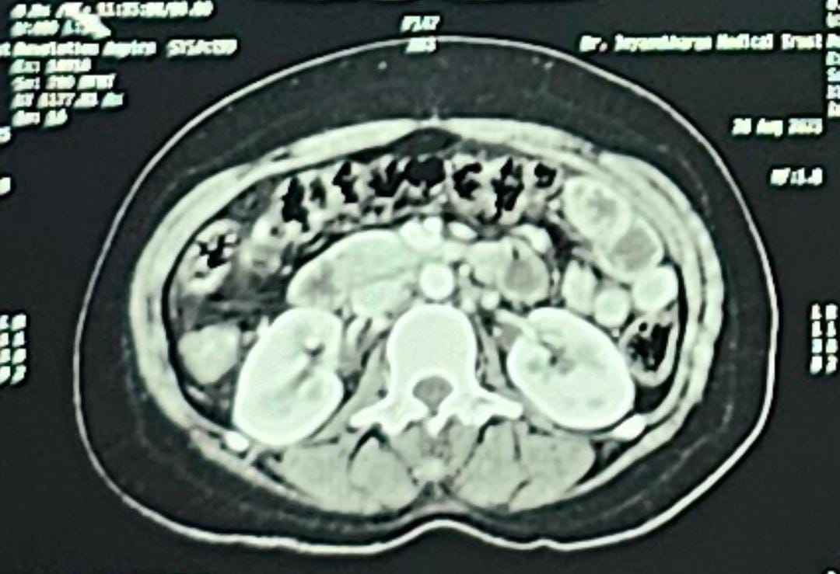
Figure 1. CT showing retroperitoneal mass indenting the inferior vena

Preoperative optimization included alpha blockade followed by beta blockade, calcium channel blockers, and salt supplementation. After achieving adequate blood pressure control, surgical excision was performed via chevron incision with extended Kocherization. A 3×3 cm mass between the aorta and inferior vena cava was dissected and excised in toto.

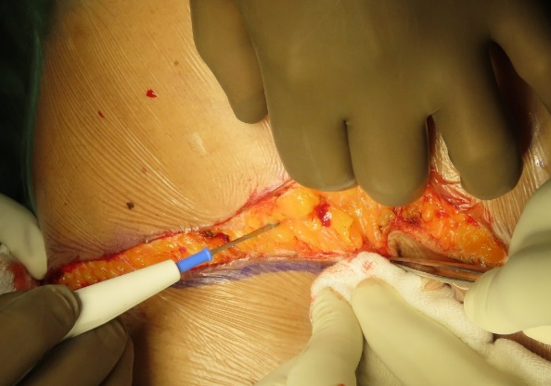
Figure # 2: Chevron incision

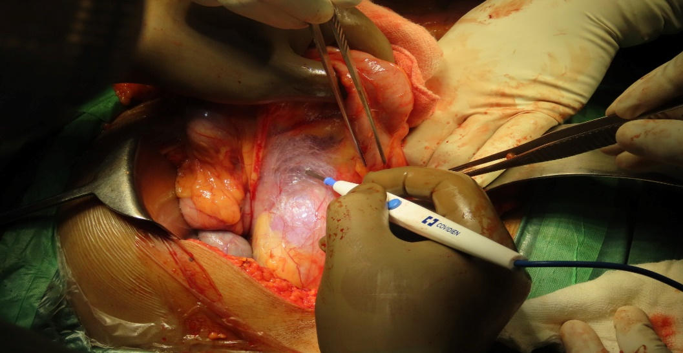
Figure # 3: extended Kocherisation

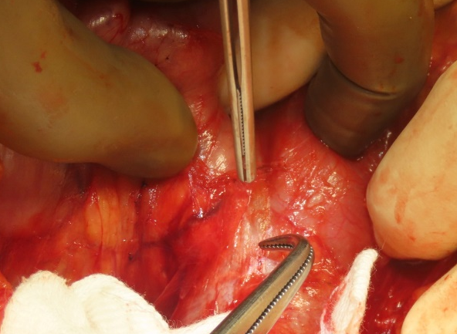
Figure # 4: Mass identified

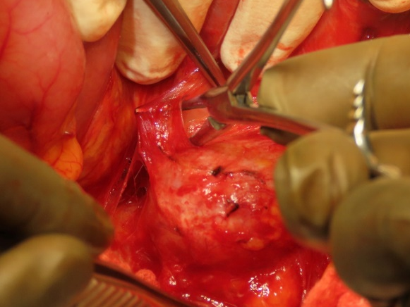
Figure #5: Mass dissected

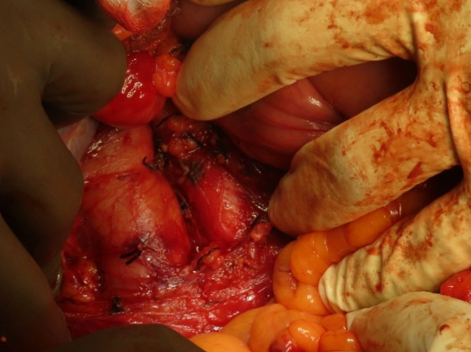
Figure # 6: feeder vessel ligated

Figure # 7: post resection
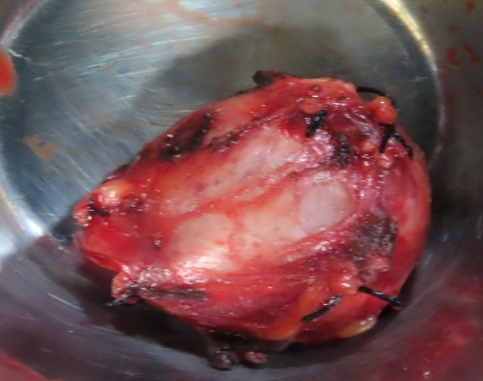
Figure #8: specimen

Figures 2–7. Intraoperative findings: chevron incision, extended Kocherization, identification of mass, vessel ligation, and post-resection field.
Intraoperatively, transient hypertensive surges were noted and managed with nitroprusside and beta-blocker infusion. The postoperative course was uneventful. The patient maintained normotension without antihypertensive therapy and was discharged on day 3.
Gross examination showed a globular 4.5 × 4 × 3 cm lesion with hemorrhagic areas.

Microscopy demonstrated round-to-polygonal cells with eosinophilic cytoplasm, vesicular nuclei, and stippled chromatin. Lymph nodes showed reactive changes. Features were consistent with pheochromocytoma, and immunohistochemistry was recommended for confirmation.
Short-term follow-up revealed sustained normotension and complete resolution of symptoms.

DISCUSSION
The present case is noteworthy due to the unusual neurological presentation preceding the diagnosis of a catecholamine-secreting retroperitoneal paraganglioma. Unlike the more typical presentation with paroxysmal hypertension and adrenergic symptoms, the initial manifestation was a cerebrovascular accident, which delayed recognition of the underlying endocrine etiology. Such presentations remain sparsely reported in literature, with fewer than 100 cases described worldwide, underscoring the rarity and diagnostic challenge associated with this entity.
Paragangliomas represent a rare and heterogeneous group of neuroendocrine tumors arising from extra-adrenal paraganglionic tissue associated with the sympathetic and parasympathetic nervous systems. Sympathetic paragangliomas are typically localized in the abdomen and retroperitoneum and are often catecholamine-secreting, whereas parasympathetic tumors usually arise in the head and neck and are non-secretory (Neumann et al., 2019). The incidence of paraganglioma and pheochromocytoma is estimated at 2–8 per million individuals annually, although improved imaging and genetic testing are likely to increase reported prevalence (Taïeb et al., 2019). While many patients present with classical manifestations of catecholamine excess such as headache, palpitations, diaphoresis, and paroxysmal hypertension, atypical presentations may delay diagnosis for months to years. The case presented here underscores an uncommon but clinically significant presentation—a cerebrovascular accident in a relatively young patient secondary to catecholamine surge from a retroperitoneal paraganglioma.

Paraganglioma and Cerebrovascular Events

Stroke is an unusual manifestation of catecholamine-secreting tumors. The pathophysiological mechanisms proposed include hypertensive crisis, vasospasm, endothelial dysfunction, oxidative stress, pro-thrombotic effects, and microvascular injury (Sutton & Doran, 2020). Catecholamines may induce reversible cerebral vasoconstriction syndrome (RCVS), leading to transient vasoconstriction of cerebral arteries and resulting in focal ischemia or hemorrhage (Calabrese et al., 2019). In parallel, paroxysmal hypertension may precipitate small vessel lipohyalinosis, blood-brain barrier disruption, or intracranial hemorrhage. Additionally, excessive catecholamines trigger platelet activation and increase von Willebrand factor, which may further contribute to thrombosis (Gupta et al., 2020). In relatively young patients without conventional cerebrovascular risk factors, these mechanisms should raise suspicion for a secondary endocrine etiology, especially when associated with persistent or refractory hypertension.
The association between catecholamine-secreting tumors and stroke remains underrecognized, with fewer than 100 cases described globally in literature over several decades (Sutton & Doran, 2020). Younger age at presentation further complicates clinical evaluation, as initial neurological events may overshadow systemic symptoms. In the presented case, the patient’s first manifestation was an acute cerebrovascular accident involving the caudate nucleus and thalamus, followed by persistent accelerated hypertension. This pattern is consistent with recently described catecholamine-driven stroke presentations in literature from south and East Asia, suggesting possible underreporting in these regions (Lee et al., 2021; Hsu et al., 2020).

Diagnostic Considerations

Diagnostic evaluation of suspected paraganglioma relies on biochemical confirmation followed by anatomical and functional imaging. Plasma free metanephrines and normetanephrines remain the most sensitive biochemical markers, demonstrating >95% sensitivity (Lenders et al., 2020). In this case, elevated urinary VMA and markedly elevated plasma normetanephrine and metanephrine levels supported the diagnosis.
It is notable that normetanephrine elevation often correlates with extra-adrenal sympathetic tumors, whereas metanephrine elevation is more prominent in adrenal pheochromocytomas (Eisenhofer et al., 2020).
Cross-sectional imaging using CT or MRI provides anatomical delineation and surgical planning. CT typically reveals a hypervascular retroperitoneal mass with soft-tissue attenuation (Mannelli et al., 2020). MRI may demonstrate the classical “light-bulb” T2-weighted appearance, although this is neither universal nor specific. Functional imaging—including ^123I-MIBG, ^18F-FDOPA PET, ^68Ga-DOTATATE PET/CT, and ^18F-FDG PET—is recommended for metastatic or hereditary disease and for localization of multifocal tumors (Taïeb et al., 2019). Recent meta-analyses show superior sensitivity of ^68Ga-DOTATATE PET/CT over MIBG scintigraphy, especially in SDHB-mutated tumors (Han et al., 2019). In regions where somatostatin receptor PET availability remains limited, CT and MRI continue to serve as primary diagnostic tools.
Perioperative Optimization and Surgical Management
Surgical excision remains the definitive curative therapy for paraganglioma (Neumann et al., 2019). However, perioperative management is critical to mitigate catecholamine-induced hemodynamic instability. Preoperative alpha-adrenergic blockade with agents such as phenoxybenzamine or doxazosin is considered the standard of care; beta-blockers may be added subsequently to control tachyarrhythmias (Pacak et al., 2021). Adequate hydration and salt-loading promote intravascular volume expansion to counteract postoperative hypotension. In the presented case, preoperative alpha blockade followed by beta blockade and calcium channel blockers achieved satisfactory blood pressure control prior to tumor excision
The surgical approach—open versus minimally invasive—depends on tumor size, location, vascular relationships, and surgeon expertise. Retroperitoneal paragangliomas located adjacent to major vessels such as the aorta or inferior vena cava may necessitate open surgery to permit safe dissection. Laparoscopic and robotic approaches are increasingly used for smaller or anatomically favorable lesions (Crona & Ghosal, 2020). Intraoperative hypertensive surges are common during tumor manipulation and require careful anesthetic management. In this case, hypertensive episodes were managed with nitroprusside and beta-blocker infusion, and the postoperative course was uneventful.

Prognosis, Recurrence, and Malignancy

Paragangliomas possess highly variable malignant potential. Unlike most solid tumors, histological differentiation alone does not reliably distinguish benign from malignant behavior. Malignancy is defined by the presence of metastases in non-chromaffin tissue such as bone, liver, or lung (Crona & Lamarca, 2019). Recurrence rates can reach 17–20% in sporadic tumors and up to 60% in hereditary variants (Buffet et al., 2020). SDHB mutation is associated with particularly aggressive behavior, early metastasis, and poorer survival (Amar et al., 2021). Therefore, long-term surveillance is recommended for all patients, particularly those with extra-adrenal tumors, large lesions, or genetic predisposition.

Implications for Asian Clinical Settings

Asian case series demonstrate differences in presentation, genetic distribution, and diagnostic delay (Chong et al., 2021). In many South and Southeast Asian centers, limited access to functional imaging or genetic testing may result in underdiagnosis or delayed recognition. The presented case typifies a scenario in which neurological presentation masked the underlying endocrine disease, leading to a gap between cerebrovascular onset and tumor identification. Increasing awareness of catecholamine-induced stroke among neurologists and endocrinologists may improve early detection and prevent recurrent vascular events in relatively young patients.

FOLLOW-UP AND SURVEILLANCE

Following complete tumor resection, the patient achieved sustained normotension and remained asymptomatic on short-term follow-up. Long-term postoperative surveillance is essential due to risk of recurrence, metastatic transformation, and delayed clinical manifestations. Current guidelines recommend annual biochemical monitoring of plasma or urine metanephrines for at least 10 years and lifelong surveillance in hereditary cases (Lenders et al., 2020). Imaging-based surveillance is warranted for high-risk features including extra-adrenal primary tumor, large tumor size, SDHB mutation, or pediatric onset (Taïeb et al., 2019).

Stroke risk also warrants neurological follow-up. Catecholamine-driven vasoconstriction often reverses post-resection, reducing recurrent stroke risk. However, structural cerebrovascular damage may persist, necessitating secondary prevention strategies including blood pressure optimization and metabolic risk assessment (Lee et al., 2021). For Asian contexts where prevalence of relatively young stroke is increasing, the case highlights a need for integrated endocrine-neurology care pathways.

GENETIC CONSIDERATIONS

Up to 40% of paragangliomas harbor germline mutations, most commonly involving the succinate dehydrogenase (SDH) complex, VHL, RET, NF1, MAX, and TMEM127 (Fishbein et al., 2017). Although genetic testing was not performed in this patient, its consideration is justified given the extra-adrenal location and the relatively young age at presentation. SDHB mutation in particular confers increased risk of malignancy and poorer prognosis due to pseudohypoxia-driven tumorigenesis and metabolic reprogramming (Buffet et al., 2020). Genetic testing is increasingly recommended for all patients with paraganglioma, irrespective of age or family history (Crona et al., 2019). Asian cohorts have reported differing mutation spectra, with SDHB and SDHD variants predominating in several recent studies (Chong et al., 2021).

Genetic assessment also informs surveillance intensity, family counseling, and therapeutic decisions. In tumors expressing somatostatin receptor 2 due to SDHx mutations, ^68Ga-DOTATATE PET may serve both diagnostic and therapeutic functions via peptide receptor radionuclide therapy (PRRT) in metastatic settings.

LEARNING POINTS

• Catecholamine-secreting paragangliomas constitute a rare but important secondary cause of stroke in relatively young patients.
• Persistent hypertension following cerebrovascular events should prompt evaluation for endocrine etiologies.
• Biochemical testing with plasma metanephrines is highly sensitive for diagnosis.
• Surgical excision following adequate alpha blockade remains definitive therapy.
• Long-term surveillance and genetic counseling are integral to management due to recurrence and hereditary risk.
• Awareness of this entity is crucial in Asian populations where diagnostic delay remains common.

CONCLUSION
This case highlights the importance of recognizing retroperitoneal paraganglioma as a secondary and potentially reversible cause of stroke in relatively young and middle-aged patients. Persistent hypertension following an initial cerebrovascular event should prompt biochemical assessment for catecholamine excess to avoid delays in diagnosis. Multidisciplinary coordination of care is essential to ensure safe perioperative management and optimized surgical outcomes. Furthermore, postoperative follow-up and genetic considerations are warranted due to the malignant potential and hereditary predisposition associated with paragangliomas. Greater awareness of such atypical presentations may aid clinicians in improving diagnostic accuracy and preventing recurrent neurological sequelae.
Consent
As per international standards or university standards, patient(s) written consent has been collected and preserved by the author(s).

Ethical Approval:

As per international standards or university standards written ethical approval has been collected and preserved by the author(s).

COMPETING INTERESTS DISCLAIMER:
Authors declare that they have no known competing financial or non-financial interests or personal relationships that could have influenced the work reported in this paper.

Disclaimer (Artificial intelligence)
Author(s) hereby declare that NO generative AI technologies such as Large Language Models (ChatGPT, COPILOT, etc.) and text-to-image generators have been used during the writing or editing of this manuscript.

REFERENCES

- Neumann HPH, Young WF Jr., Eng C. Pheochromocytoma and Paraganglioma. N Engl J Med. 2019;381(6):552–565.

- Taïeb D, Shah MH, Kebebew E, et al. Pheochromocytoma and Paraganglioma: Update on Diagnosis, Prognosis, and Management. Lancet Diabetes Endocrinol. 2019;7(10):728–742.

- Sutton T, Doran M. Catecholamine-induced stroke: A systematic review. J Neurol Sci. 2020;412:116719.

- Calabrese LH, Duna G, Calabrese C. Reversible Cerebral Vasoconstriction Syndrome Update. Lancet Neurol. 2019;18(4):324–334.

- Gupta N, Raval M, Madsen B, et al. Catecholamine Surge-Induced Thrombotic and Microvascular Injury Mechanisms. Stroke. 2020;51(4):1321–1328.

- Lee H-Y, Chen C-L, Chou Y-C, et al. Unusual Stroke Etiologies in Young Patients: A 10-Year Asian Cohort Study. Neurology Asia. 2021;26(3):529–538.

- Hsu C-Y, Chen Y-H, Wu C-L, et al. Pheochromocytoma Presenting as Recurrent Ischemic Stroke in a Young Female. J Stroke Cerebrovasc Dis. 2020;29(7):104871.

- Lenders JWM, Duh Q-Y, Eisenhofer G, et al. Endocrine Society Clinical Practice Guidelines: Pheochromocytoma and Paraganglioma. J Clin Endocrinol Metab. 2020;105(9):285–325.

- Eisenhofer G, Pacak K, Huynh T, et al. Diagnostic Value of Plasma Metanephrines in Pheochromocytoma and Paraganglioma. Clin Chem. 2020;66(3):427–439.

- Mannelli M, Castellano M, Schiavi F, et al. Paraganglioma: Clinical and Diagnostic Insights. Eur J Endocrinol. 2020;182(1):R11–R25.

- Han S, Suh CH, Woo S, et al. Diagnostic Accuracy of 68Ga-DOTATATE PET/CT in Pheochromocytoma and Paraganglioma: Systematic Review and Meta-analysis. J Nucl Med. 2019;60(3):369–376.

- Crona J, Ghosal S, et al. Precision Management in Pheochromocytoma and Paraganglioma. Cancer Treat Rev. 2020;86:102013.

- Crona J, Lamarca A, Ghosal S, et al. Genotype–Phenotype Correlations in PPGL: Meta-analysis. Endocr Relat Cancer. 2019;26(5):539–550.

- Buffet A, Burnichon N, Favier J, et al. SDHB Mutations and Risk Stratification in Paraganglioma. J Clin Oncol. 2020;38(9):1033–1043.

- Amar L, Baudin E, Burnichon N, et al. SDHB Gene Mutations Predict Survival in Paraganglioma. J Clin Endocrinol Metab. 2021;106(3):e1160–e1170.

- Fishbein L, et al. Comprehensive Molecular Characterization of PPGL. Cancer Cell. 2017;31(2):181–193.

- Chong ST, et al. Clinical and Genetic Spectrum of Paraganglioma in Southeast Asia. Endocr Pract. 2021;27(6):578–587.

- Pacak K, Preoperative Management of Pheochromocytoma. Endocrinol Metab Clin North Am. 2021;50(2):389–404.

- Hescot S, et al. Outcomes and Recurrence in Extra-Adrenal Paraganglioma. Eur J Cancer. 2020;135:67–75.

- Young WF Jr. Diagnostic Approach to Adrenal Incidentalomas. N Engl J Med. 2007;356(6):601–610. (classic guideline reference)

- Benn DE, Gimenez-Roqueplo AP, et al. Penetrance of PPGL Syndromes. J Clin Endocrinol Metab. 2006;91(3):827–836. (global genetics reference)

- Jimenez C, Rohren E, Habra MA. Current and Future Treatments for Metastatic Paraganglioma. Curr Oncol Rep. 2019;21(6):54.

- Sbardella E, et al. Role of Functional Imaging in PPGL Follow-up. Eur J Endocrinol. 2018;169(6):785–793.

- Favier J, Amar L, Gimenez-Roqueplo AP. PPGL: Genetics to Personalized Medicine. Nat Rev Endocrinol. 2015;11(2):101–111. (classic & still cited)

