Original Research Article

Seasonal Dietary Patterns and Hunting Strategies of the Indian Panthers (Panthera pardus fusca) in the Aravalli Hills of Southern Rajasthan: A Long-term Scatological Analysis

Abstract:
For efficient conservation of apex predators of any region in remaining fragmented forest and wildlife areas of that region it is important to better understand their dietary habits and patterns in relation to seasons, variety of animals, and region (urban, village). Semi-arid landscapes of the Aravalli hills in southern Rajasthan of Indian sub-continent is primarily dominated by Indian Panther (Panthera pardus fusca) an apex carnivore of the region. Present study investigates the dietary habits, dietary composition and hunting behaviour of the Indian Panther in Sisarma Banki Forest (SBF) and Sajjangarh Wildlife Sanctuary (SWS) of Southern Rajasthan during the four years of study time period from November 2014 to October 2018. Through the scatological investigation and analysis of 150 scats (86 - SBF & 64 - SWS) collected between 2014 and 2018, total thirteen distinct prey species were identified through microscopic hair and bone examination (8 - wild and 5 - domestic) which revealed a diverse spectrum for Panther prey-base ranging from small rodents to large ungulates. While rodents remained a consistent and primary dietary staple across most seasons with notable exception of summer, a significant transitional increase toward domestic livestock hunting was observed during the summer and winter months in Panthers dietary proportions. Statistical evidence suggests reliance on domestic animals was significant which accounted about 57.85% of the diet in winter and 63.14% during summer exhibiting profound behavioural plasticity of Panthers with increasing cases of exploiting domestic prey -bases when compared to seasonal wild prey-base fluctuations. All these findings agrees to the fact that due to depleting natural prey-base in their fragmented wild landscapes, Panthers without any alternative choice were forced to remain an ecological generalist driving their increased dependency on domestic livestock, which calls an urgent attention to all stakeholders for immediate action to restore natural prey-base and practical implementation of landscape-level conservation strategies on ground-level to mitigate potential Human-Panther Conflicts (HPC).

Keyword: Scatological, prey-base, Human-Panther Conflicts (HPC), Indian Panther (Panthera pardus fusca), Aravalli hills, apex carnivore

1. Introduction:

Survival for any apex predator depends heavily on its habitat, spatio-temporal movement patterns, and the availability of natural prey-base species in natural environment (Krebs, 1978; Bekoff, et al., 1984; Sunquist and Sunquist, 1989; Avinandan et al., 2003; Avinandan et al., 2008; Sharma, 2019). The Indian Panther (Panthera pardus fusca) are ecological generalist capable of adopting and adapting its dietary pattern to include a wide range of prey-base size and variety, ranging from small-sized mammals and reptiles to large-sized herbivores birds, reptiles and even the decaying flesh of animals on the basis of availability, approach and easy capture priorities may be inside or outside its natural territory preferring minimum efforts and energy expenditure on prey-hunt, at the same time while maintaining its ferocious and solitary behaviour (Grobler and Wilson, 1972; Schaller, 1967; Muckenhirn and Eisenberg, 1973; Hamilton, 1976; Schaller, 1972; Smith, 1977, 1978; Bertram, 1982; Smithers, 1983; Bothma and Le Riche, 1984; Mills, 1984; Bothma and Le Riche, 1986; Johnsingh, 1992; Bailey, 1993; Daniel, 1996; Sharma, 2019; Kandel, 2025 ).
In the semi-arid climatic conditions of the Aravalli Hills of southern Rajasthan, understanding food habits is critical for conservation, as prey population dynamics are directly under the control of the predators (Harihar, 2005; Rueda et al., 2013; Perilli et al., 2016; Porfirio et al., 2017; Sharma, 2019; Flores-Turdera et al., 2021; Plimpton et al., 2021). While Indian Panthers prefer small and medium-sized prey to maximize hunt success and save energy with minimum efforts (Johnsingh, 1983; Karanth and Sunquist, 1995; Rabinowitz, 1989; Schaller, 1972; Sunquist, 1981; Grassman, 1999; Sharma, 2019) like rodents (Johnson et al., 1993; Sharma, 2019), they often transition to domestic animals when natural wild prey-base is depleting very quickly and is almost unavailable in their natural fragmented habitats. Complex predator-prey dynamics in the Aravalli Hills of Southern Rajasthan, is now facing huge challenges in the coexistence of Panthers with human populations due to deforestation, increasing mining (Sharma, 2016) and anthropogenic interferences created in its natural habitat. Present research study investigates the scat samples of Indian Panthers (Schaller, 1967); Wilpattu National Park, Sri Lanka (Eisenberg and Lockhart, 1972); Bandipur Tiger Reserve (Johnsingh, 1983); Tamil Nadu (Sathyakumar, 1992); Wolong Reserve, China (Johnson et al., 1993); Nagarhole Tiger Reserve (Karanth and Sunquist, 1995); Panna Tiger Reserve (Chundawat, 2001); Pauri Garhwal District, Uttaranchal (Chauhan and Goyal, 2001); Pench Tiger Reserve (Biswas and Sankar, 2002); Sanjay Gandhi National Park, Maharashtra (Edgaonkar and Chellam, 2002); Ranthambore Tiger Reserve (Bagchi et al., 2003); Mudumalai Tiger Reserve (Ramesh et al., 2008); Sariska Tiger Reserve (Sankar and Johnsingh, 2002; Avinandan et al., 2008; Sankar et al., 2010 and Mondal et al., 2011); Sisarma Banki Reserve Forests, Udaipur, Rajasthan (Sharma, 2019) and Sajjangarh Wildlife Sanctuary, Udaipur, Rajasthan (Sharma, 2019) and tries to explore and examine how seasonal changes and habitat management is influencing the dietary choices of Panthers in this unique semi-arid landscape. The present study aims to quantify these dietary shifts over a four-year time-period in fragmented hilly landscape of Southern Rajasthan.

2. Materials and Methods:

The research was conducted in the Aravalli hills of Sisarma Banki Forest (SBF) (20.4 km²) and Sajjangarh Wildlife Sanctuary (SWS) (7.95 km²) in the Udaipur district of Southern Rajasthan, India (Figure1).
A total of 150 scat samples (faeces) were collected (86 from SBF and 64 from SWS) between November 2014 and October 2018 across three seasons viz. winter, summer, and monsoon (Table 1). Scats of Indian Panther were categorized by its natural degradation stages into fresh (Figure 2: a), moderately degraded (Figure 2: b.), degraded (Figure 2: c.) and highly-degraded (Figure 2: d.) stages. Occurrence of prey items and type of prey species in the collected Panther scats were done on the basis of scat analysis process which includes careful washing, drying, cleaning and separating, and sorting the hair and bone pieces collected from Indian Panther scat samples, and further investigating them under high resolution and high magnification power research microscope (Olympus CH20i). During hair investigation the prey species were identified through microscopic examination of hair medullary and cuticular patterns (Brunner and Coman, 1974; Putman, 1984; Oli, 1993; Mukherjee et al., 1994; Karanth and Sunquist, 1995; Chauhan and Goyal, 2001; Sujai, 2004; Edgaonkar, 2008; Kumar, 2011; Sharma, 2019), as well as small bone fragments found in the scat samples, compared against standard references (Corbett, 1989; Harvey, 1989; Bowen, 2000; Zabala and Zuberogoitia, 2003; Tollit et al., 2004; Sharma, 2019).

3. Results and Discussions:

Examination of scat samples of Indian Panthers collected from the study areas of SBS and SWS confirmed and detected both natural and domestic prey base. Wild prey-base was represented by wild boar, nilgai, deer, common Indian langur, wild hare, porcupine, mouse, birds, reptiles while domestic prey-base included cattle, goat, sheep, dog, and poultry in its diet. Specifically, major wild prey-base for SBF and SWS were shown in Table 2.
3.1 Scato-analytical results in SBF
On the basis of collected scat samples of Indian Panthers during winter (N=37), summer (N=31) and monsoon (18), Table 3 showed the season wise number and frequency estimation (in percentage) of the existence of prey species in the Indian Panthers’ diet in SBF during the time period 2014 to 2018. Figure 3 depicts statistical inference for the study area of SBF, that, in the season winter, rodents (% F=27.39) were maximum in Indian Panthers diet followed by sheep, and was minimum for dogs followed by reptiles (% F=1.17). Similarly, during summer season cattle (% F=23.29) showed highest precent frequency followed by rodents with minimum percent frequency occurrence of wild boar followed by reptiles (% F=0.69). Monsoon season in SBF showed maximum percent frequency for rodents (% F=34.93) followed by cattle and a minimum for porcupine (% F=0.56) followed by dog (% F=0.00) which were absent in the estimation (Figure 3).

3.2 Scato-analytical results in SWS
During the time period from 2014 to 2018 for the study area of SWS, on the basis of collected scat samples of Indian Panthers in season winter (N=30), summer (N=23) and monsoon (11), Table 4 showed the season wise number and frequency estimation (in percentage) of the existence of prey species in the Indian Panthers’ diet. Figure 4 depicts statistical inference that in the case of SWS, rodents were in major proportion in Indian Panthers diet in all the seasons - winter (% F=26.21), summer (% F=26.95) and monsoon (% F=30.04) followed by cattle (winter % F=18.98, summer % F=25.76, monsoon % F=16.79). Wild boar shows least proportion in Panther’s food in all the seasons (winter % F=0.91, summer % F=0.31, monsoon % F=1.19) followed by reptiles in winter (% F=1.07) and summer (% F=0.34) and porcupine in monsoon season (% F=1.24) (Figure 4).

4. Conclusion:

Scat sample investigation for the estimation and analysis of Indian Panthers diet in the study areas of SBF and SWS from 2014 to 2018 time periods revealed variety of animals both wild as well as domestic in its prey-base. Further investigation showed that rodents were maximum in Indian Panthers diet in all the seasons except summer season when cattle were in majority, in this region of Aravalli Hills of Southern Rajasthan. Present study concludes that except monsoon season, dietary pattern of Indian Panthers comprise of more domestic animals (winter = 57.85% and summer = 63.14%) as compared to wild animals (winter = 52.06% and summer = 47.54%) which is almost similar to the studies and observations on the dietary habits of Panthers globally by Grobler and Wilson, 1972; Johnsingh et al., 1993; Chauhan and Goyal, 2001; Edgaonkar and Chellam, 2002; Sankar and Johnsingh, 2002; Henschel et al., 2005; Arivazhagan et al., 2007; Shah et al., 2009; Akrim et al., 2018; Luca and Mpunga, 2018; Sharma, 2019 and Kandel, 2025. The present study also concludes that the Indian Panthers in the Aravalli’s acts as a highly adaptive generalist and its presence in human-habituation shows its increasing reliance and dependency on domestic prey-base enforcing these wild apex carnivores to leave its natural fragmented forest patches and wildlife sanctuaries due to lack or unavailability of natural-prey-base in their natural environment, giving rise to more and increasing occurrences of Human-Panther Conflicts (HPC), adversely affecting both humans and Indian Panthers, causing major losses to the animal at all the times which is in consonance with the studies of Sharma and Chishty, 2016; Sharma and Chishty, 2018; Sharma and Chishty, 2019 and Sharma, 2019 on Indian Panthers. High frequency of domestic prey-base in the diet of Indian Panthers indicates its significant interface with human settlements. Restoring and replenishing the natural wild prey-base of Indian Panthers (such as nilgai, sambar, wild-hare, wild boar etc.) is an immediate and essential call to restrict the movement of Indian Panthers to its fragmented forest areas and wildlife sanctuaries which will potentially reduce the instances of HPC and simultaneously realizing and achieving the goals and targeted aims of wildlife conservation including this apex-carnivore in the study areas of SBF and SWS.

Disclaimer (Artificial Intelligence)
Author hereby declares that NO generative AI technologies such as Large Language Models (ChatGPT, COPILOT, etc.) and NO text-to-image generators have been used during the writing or editing of this manuscript.

Acknowledgements
The author wishes to express his sincere gratitude to Prof. Sunita Farkya, Head, Division of Educational Kits, NIE, NCERT, New Delhi, for her invaluable feedback and guidance. The author would also like to thank Professor Dinesh Prasad Saklani, Director, National Council of Educational Research and Training (NCERT), for his steady support and inspiration. Similar appreciation is also extended to Ministry of Education (MoE), Government of India (GoI). Special thanks to Dr. Arun Pratap Sikarwar for his support. The author did not receive any monetary grants and hereby declare no conflict of interest in the conduct and publication of this study.

Competing Interests
Author have declared that no competing interests exist.
Authors’ contributions: This work was originally carried out solely by the author only and the author solely read and approved the final manuscript.

Consent & Ethical approval
The author had taken authentic written permissions granted from Department of Forests, Government of Rajasthan for working in protected areas of forest and wildlife sanctuary of the study area with all ethical implication’s followed during the course of study time period which will the sole responsibility of author only.

References:

- Akrim, F., Mahmood, T., Nadeem, M. S., Andleeb, S., & Qasim, S. (2018). Spatial distribution and dietary niche breadth of the leopard Panthera pardus (Carnivora: Felidae) in the northeastern Himalayan region of Pakistan. Turkish Journal of Zoology, 42, 585–595.
- Arivazhagan, C., Arumugam, R., & Thiyagesan, K. (2007). Food habits of leopard (Panthera pardus fusca) dhole (Cuon alpinus) and striped hyena (Hyaena hyaena) in a tropical dry thorn forest of southern India. Journal of the Bombay Natural History Society, 104(2), 178–187.
- Avinandan, D., Sankar, K., & Qureshi, Q. (2003). Food habits of tiger (Panthera tigris tigris) in Sariska Tiger Reserve, Rajasthan [Master's dissertation, Saurashtra University].
- Avinandan, D., Sankar, K., & Qureshi, Q. (2008). Prey selection of tiger (Panthera tigris tigris) in Sariska Tiger Reserve, Rajasthan. Journal of the Bombay Natural History Society, 105, 247–254.
- Bagchi, S., Goyal, S. P., & Sankar, K. (2003). Prey abundance and prey selection by tigers in a semi-arid, dry deciduous forest in western India. Journal of Zoology, London, 260, 285–290.
- Bailey, T. N. (1993). The African leopard: A study of the ecology and behavior of a solitary felid. Columbia University Press.
- Bekoff, M., Daniels, T. J., & Gittleman, J. L. (1984). Life history patterns and the comparative social ecology of carnivores. Annual Review of Ecology and Systematics, 15, 191–232.
- Bertram, B. C. R. (1982). Leopard ecology as studied by radio tracking. Symposia of the Zoological Society of London, 49, 341–352.
- Biswas, S., & Sankar, K. (2002). Prey abundance and food habit of tigers (Panthera tigris tigris) in Pench National Park, Madhya Pradesh, India. Journal of Zoology, London, 256, 411–420.
- Bothma, J. Du P., & Le Riche, E. A. N. (1984). Aspects of the ecology and the behaviour of the leopard Panthera pardus in the Kalahari Desert. Koedoe Supplement, 27, 259–279.
- Bothma, J. Du P., & Le Riche, E. A. N. (1986). Prey preference and hunting efficiency of the Kalahari desert leopard. In S. D. Miller & D. D. Everett (Eds.), Cats of the world: Biology, conservation and management (pp. 381–414). National Wildlife Federation.
- Bowen, W. D. (2000). Reconstruction of pinniped diets: Accounting for complete digestion of otoliths and cephalopod beaks. Canadian Journal of Fisheries and Aquatic Sciences, 57, 898–905.
- Brunner, H., & Coman, B. (1974). The identification of mammalian hair. Shanghai Printing Press Ltd.
- Chauhan, D., & Goyal, S. P. (2001). Study on distribution relative abundance and food habits of leopard (Panthera pardus) in Garhwal Himalayas [Technical Report]. Wildlife Institute of India.

- Chundawat, R. S. (2001). Tiger conservation in dry tropical forests of India [Report submitted to Centre for Wildlife Studies].
- Corbett, L. K. (1989). Assessing the diet of dingoes from feces: A comparison of 3 methods. Journal of Wildlife Management, 53(2), 343–346.
- Daniel, J. C. (1996). The leopard in India: A natural history. Nataraj Publishers.
- Edgaonkar, A. (2008). Ecology of the leopard (Panthera pardus) in Bori Wildlife Sanctuary and Satpura National Park, India [Doctoral thesis, University of Florida].
- Edgaonkar, A., & Chellam, R. (2002). Food habit of the leopard, Panthera pardus, in the Sanjay Gandhi National Park, Maharashtra, India. Mammalia, 66(3), 353–360.
- Eisenberg, J. F., & Lockhart, M. (1972). An ecological reconnaissance of Wilpattu National Park, Ceylon. Smithsonian Contributions to Zoology, 101, 1–118.
- Flores-Turdera, C., Ayala, G., Viscarra, M., & Wallace, R. (2021). Comparison of big cat food habits in the Amazon piedmont forest in two Bolivian protected areas. Therya, 12(1), 75-83.
- Grassman, L. I. Jr. (1999). Ecology and behaviour of the Indochinese leopard in Kaeng Krachan National Park, Thailand. Natural History Bulletin of the Siam Society, 47, 77–93.
- Grobler, J. H., & Wilson, V. J. (1972). Food of the leopard (Panthera pardus) (Linn) in the Rhodes Matopos National Park, Rhodesia, as determined by faecal analysis. Arnoldia Rhodesia, 35(5), 1–9.
- Hamilton, P. H. (1976). The movements of leopards in Tsavo National Park, Kenya, as determined by radio-tracking [Master's thesis, University of Nairobi].
- Harihar, A. (2005). Population, food habits and prey densities of tiger in Chilla Range, Rajaji National Park, Uttaranchal, India.
- Harvey, J. T. (1989). Assessment of errors associated with harbor seal (Phoca vitulina) fecal sampling. Journal of Zoology, London, 219, 101–111.
- Johnsingh, A. J. T. (1983). Large mammalian prey-predators in Baiulipur. J. Bombay Nat. Hist. Soc., 80: 1-57.
- Johnsingh, A. J. T. (1992). Prey selection in three large sympatric carnivores in Bandipur. Mammalia, 56: 517-526.
- Johnsingh, A. J. T., Goyal, S. P., Rawat, G. S. and Mukherjee, S. (1993). Food habits of tiger and leopard in Rajaji, North-West India. In: Abstract compilation of International Symposium on the tiger. Ministry of Environment and Forest, Government of India, New Delhi.
- Johnson, K. G., Wang, W., Reid, D. G. and Hu, J. (1993). "Food Habits of Asiatic Leopards (Panthera pardus fusca) in Wolong Reserve, Sichuan, China". Journal of Mammalogy, 74 (3): 646-650.
- Kandel, S. R. (2025). Diet Analysis of Tiger Panthera tigris and Leopard Panthera pardus (Mammalia: Carnivora: Felidae) Around the Banke‐Bardia Complex. Advances in Zoology and Botany, 13(5), 97-104.
- Karanth, K. U., & Sunquist, M. E. (1995). Prey selection by tiger, leopard and dhole in tropical forests. Journal of Animal Ecology, 64(4), 439–450.
- Krebs, J. R. (1978). Optimal foraging: decision rules for predators. Ch. 2 in: J. R. Krebs and N. B. Davies (eds.). Behavioural Ecology: and evolutionary approach. Blackwell Scientific Publications, Oxford.
- Kumar, D. (2011). Study of leopard menace, food habits and habitat parameters in Mandi District, Himachal Pradesh [Doctoral thesis, Saurashtra University].
- Mondal, K., Gupta, S., Qureshi, Q., & Sankar, K. (2011). Prey selection and food habits of leopard (Panthera pardus fusca) in Sariska Tiger Reserve, Rajasthan, India. mammalia, 75(2), 201.
- Muckenhirn, N., & Eisenberg, J. F. (1973). Home ranges and predation in the Ceylon leopard. In R. L. Eaton (Ed.), The world’s cats, Vol. I: Ecology and conservation (pp. 142–175). World Wildlife Safari.
- Mukherjee, S., Goyal, S. P., & Chellam, R. (1994). Standardization of scat analysis techniques for leopards (Panthera pardus) in Gir National Park, Western India. Mammalia, 58(1), 139–143.
- Oli, M. K. (1993). A key for the identification of the hair of mammals of a snow leopard (Panthera uncia) habitat in Nepal. The Zoological Society of London.
- Perilli, M. L., Lima, F., Rodrigues, F. H., & Cavalcanti, S. M. (2016). Can scat analysis describe the feeding habits of big cats? A case study with jaguars (Panthera onca) in Southern Pantanal, Brazil. Plos one, 11(3), e0151814.
- Plimpton, L. D., Henger, C. S., Munshi-South, J., Tufts, D., Kross, S., & Diuk-Wasser, M. (2021). Use of molecular scatology to assess the diet of feral cats living in urban colonies. Journal of Urban Ecology, 7(1), juab022.
- Porfirio, G., Sarmento, P., Foster, V., & Fonseca, C. (2017). Activity patterns of jaguars and pumas and their relationship to those of their potential prey in the Brazilian Pantanal. Mammalia, 81(4), 401-404.
- Putman, R. J. (1984). Facts from faeces. Mammals Rev., 14: 79-97.
- Rueda, P., Mendoza, G. D., Martínez, D., & Rosas-Rosas, O. C. (2013). Determination of the jaguar (Panthera onca) and puma (Puma concolor) diet in a tropical forest in San Luis Potosi, Mexico. Journal of Applied Animal Research, 41(4), 484-489.
- Sankar, K., & Johnsingh, A. J. T. (2002). Food habit of tiger (Panthera tigris) and leopard (Panthera pardus) in Sariska Tiger Reserve, Rajasthan, India as shown by scat analysis. Mammalia, 66, 285–289.
- Sankar, K., Qamar, Q., Nigam, P., Malik, P. K., Sinha, P. R., Mehrotra, R. N., Gopal, R., Bhattacharjee, S., Mondal, K., & Gupta, S. (2010). Monitoring of reintroduced tigers in Sariska Tiger Reserve, Western India: Preliminary findings on home range, prey selection and food habits. Journal of Tropical Conservation Science, 3(3), 301–318.
- Sathyakumar, S. (1992). Food habits of leopard (Panthera pardus) on Mundanthurai plateau, Tamil Nadu, India. Tiger Paper, 19(2), 8–9.
- Schaller, G. B. (1967). The deer and the tiger: A study of wildlife in India. University of Chicago Press.
- Schaller, G. B. (1972). The Serengeti lion: A study of predator-prey relations. University of Chicago Press.
- Sharma, P. & N. Chishty (2016). Increasing mining and industrialization in the Aravalli's of southern Rajasthan: Vanishing natural habitat and natural prey leading to increasing human-panther conflicts. Proceedings of the National Conference on Advances in Chemical, Environmental and Biological Sciences 72–73.
- Sharma, P. & N. Chishty (2018). Human-Panther Conflicts in the Aravalli Hills of Southern Rajasthan-A Case Study. Indian Journal of Ecology 45(3): 489–493.
- Sharma, P. & N. Chishty (2019). Machine Learning Based Modelling of Human Panther Interactions in Aravalli Hills of Southern Rajasthan. Indian Journal of Ecology 46(1): 126–131.
- Sharma, P. (2019). Population and behavioural Studies on Panthera pardus fusca in the Aravalli Hills of Southern Rajasthan [Doctoral Thesis, Mohan Lal Sukhadia University, Udaipur, Rajasthan, India]. INFLIBNET Centre: Shodhganga, http://hdl.handle.net/10603/303755
- Sujai, R. (2004). Diet profile of three large sympatric carnivores in Central India [Master's thesis, Bharathidasan University].
- Sunquist, M. E. (1981). The social organization of tigers (Panthera tigris) in Royal Chitwan National Park, Nepal. Smithsonian Contributions to Zoology, 336, 1–98.
- Sunquist, M. E., & Sunquist, F. C. (1989). Ecological constraints on predation by large felids. In J. L. Gittleman (Ed.), Carnivore behavior, ecology, and evolution (pp. 283–301). Cornell University Press.
- Tollit, D. J., Heaslip S. G., Zeppelin, T. K., Joy, R., Call, K. A. and Trites, A. W. (2004). A method to improve size estimates of walleye pollock (Theragra chalcogramma) and Atka mackerel (Pleurogrammus monopterygius) consumed by pinnipeds: digestion correction factors applied to bones and otoliths recovered in scats. Fish. Bull., 102: 498-508.
- Zabala, J. and Zuberogoitia, I. (2003). Badger, Meles meles (Mustelidae, Carnivora), diet assessed through scat-analysis: a comparison and critique of different methods. Folia Zool., 52 (1): 23–30.

Table 1: Season wise and year wise number of India-Panthers scat collected from SBF & SWS during 2014 - 2018
Season | Timeline |  |  |  |  |  |  |  | Total
Season | November 2014 to  October 2015 |  | November 2015 to  October 2016 |  | November 2016 to  October 2017 |  | November 2017 to  October 2018
Season | SBF | SWS | SBF | SWS | SBF | SWS | SBF | SWS | SBF | SWS
Winter | 7 | 7 | 10 | 9 | 9 | 7 | 11 | 7 | 37 | 30
Summer | 9 | 8 | 8 | 8 | 5 | 3 | 9 | 4 | 31 | 23
Monsoon | 5 | 4 | 5 | 2 | 2 | 1 | 6 | 4 | 18 | 11
Total | 21 | 19 | 23 | 19 | 16 | 11 | 26 | 15 | 86 | 64

Table 2: Wild prey base of Indian-Panthers in SBF & SWS during 2014 - 2018
Study Area | Legal Status | Area  (in sq km) | Major Wild Prey Species
Sisarma Banki Forest  (SBF) | Reserve Forest | 20.4 | Wild boar, Nilgai, Sambar, Wild hare, Peafowl, Mongoose, Small Indian civet
Sajjangarh Wildlife Sanctuary  (SWS) | Wildlife  Sanctuary | 7.95 | Spotted deer, Sambar, Nilgai, Wild hare, Peafowl,

Table 3: Season wise estimated number and percent frequency occurrence of prey species in the diet of SBF Indian Panthers during scat sample investigation from 2014 to 2018
Prey Species | Season
Prey Species | Winter |  | Summer |  | Monsoon
Prey Species | Number of  Panther Scats  analyzed to find prey species | Percent Frequency  of Prey Species occurrence  in Panther’s diet | Number of  Panther Scats  analyzed to find prey species | Percent Frequency  of Prey Species occurrence  in Panther’s diet | Number of  Panther Scats  analyzed to find prey species | Percent Frequency  of Prey Species occurrence  in Panther’s diet
Prey Species | N=37 | (%F) | N=31 | (%F) | N=18 | (%F)
Rodents | 11 | 27.39 | 4 | 23.23 | 7 | 34.93
Nil-gai | 10 | 6.1 | 21 | 4.3 | 5 | 7.9
Hare | 3 | 3.05 | 8 | 2.98 | 4 | 3.12
Wild pig | 4 | 2.09 | 3 | 0.81 | 2 | 2.33
Porcupine | 5 | 1.81 | 6 | 1.45 | 2 | 0.56
Birds | 7 | 7.22 | 15 | 7.75 | 9 | 6.63
Langur | 19 | 3.23 | 7 | 6.33 | 11 | 2.47
Reptiles | 7 | 1.17 | 7 | 0.69 | 8 | 3.11
Cattle | 1 | 17.19 | 3 | 23.29 | 8 | 19.93
Buffalo | 2 | 3.31 | 9 | 4.36 | 11 | 5.93
Sheep | 15 | 17.76 | 17 | 14.21 | 9 | 12.11
Goat | 2 | 15.77 | 7 | 19.88 | 13 | 9.54
Dog | 1 | 1.39 | 1 | 1.4 | 0 | 0
Vegetation | 3 | 2.43 | 0 | 0 | 2 | 2.79

Table 4: Season wise estimated number and percent frequency occurrence of prey species in the diet of SWS Indian Panthers during scat sample investigation from 2014 to 2018
Prey Species | Season
Prey Species | Winter |  | Summer |  | Monsoon
Prey Species | Number of  Panther Scats  analyzed to find prey species | Percent Frequency  of Prey Species occurrence  in Panther’s diet | Number of  Panther Scats  analyzed to find prey species | Percent Frequency  of Prey Species occurrence  in Panther’s diet | Number of  Panther Scats  analyzed to find prey species | Percent Frequency  of Prey Species occurrence  in Panther’s diet
Prey Species | N=30 | (%F) | N=23 | (%F) | N=11 | (%F)
Rodents | 18 | 26.21 | 10 | 26.95 | 4 | 30.04
Nil-gai | 19 | 2.5 | 12 | 6.1 | 11 | 1.47
Hare | 1 | 3.05 | 5 | 2.98 | 3 | 3.12
Wild pig | 21 | 0.91 | 5 | 0.31 | 10 | 1.19
Porcupine | 2 | 2.54 | 4 | 1.97 | 7 | 1.24
Birds | 3 | 9.48 | 2 | 15.34 | 8 | 12.64
Langur | 12 | 5.43 | 21 | 7.54 | 5 | 4.65
Reptiles | 5 | 1.07 | 9 | 0.34 | 6 | 2.87
Cattle | 2 | 18.98 | 1 | 25.76 | 1 | 16.79
Buffalo | 25 | 4.6 | 19 | 5.89 | 4 | 7.59
Sheep | 17 | 7.13 | 18 | 5.32 | 10 | 8.45
Goat | 1 | 18.46 | 2 | 17.52 | 3 | 4.66
Dog | 1 | 4.31 | 2 | 1.9 | 2 | 5.34
Vegetation | 13 | 2.85 | 0 | 0 | 9 | 1.22

Figure 1: Location of the study areas of SBF and SWF in Udaipur, Rajasthan, India
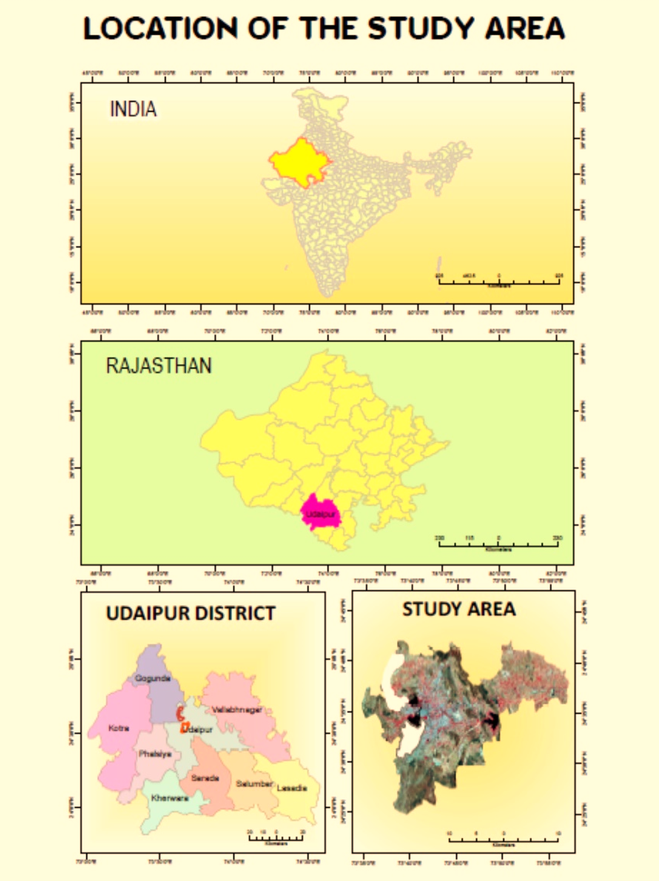

Figure 2: Stages of natural degradation of Panther scat in the study areas of SBF and SWS from 2014 to 2018 - a. Fresh Panther scats, b. Moderately degraded Panther scats and c. Degraded Panther scats.
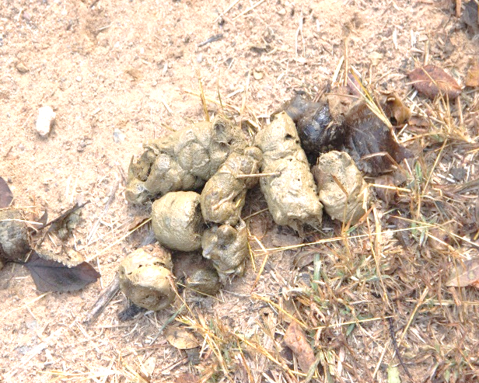
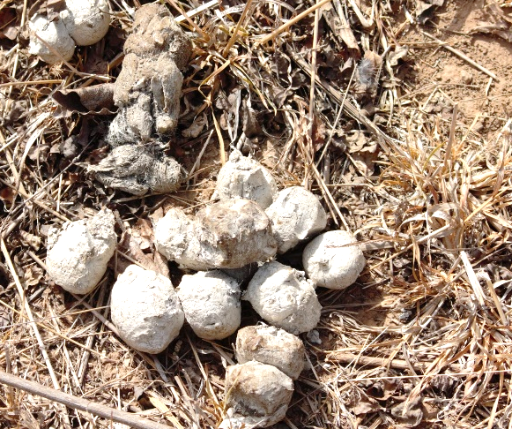

a. Fresh Panther scats b. Moderately degraded Panther scats
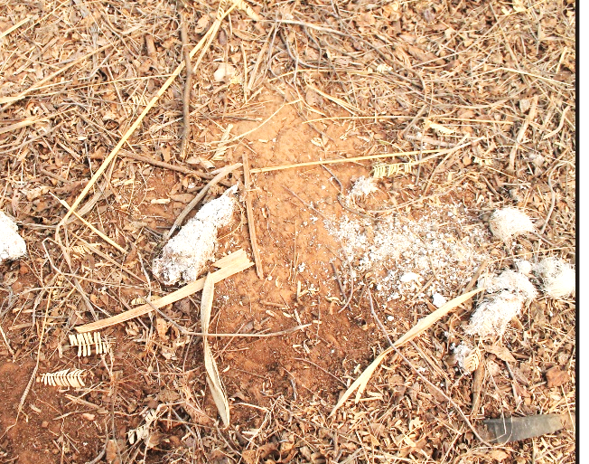
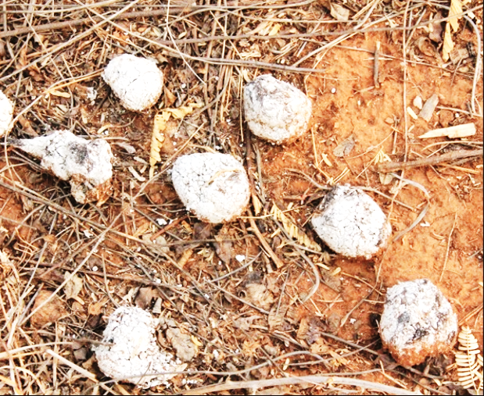

c. Degraded Panther scats d. Highly- Degraded Panther scats

Figure 3: Graph depicting Season wise number and frequency estimation (in percentage) of the existence of prey species in the Indian Panthers’ diet in SBF during time period 2014 to 2018
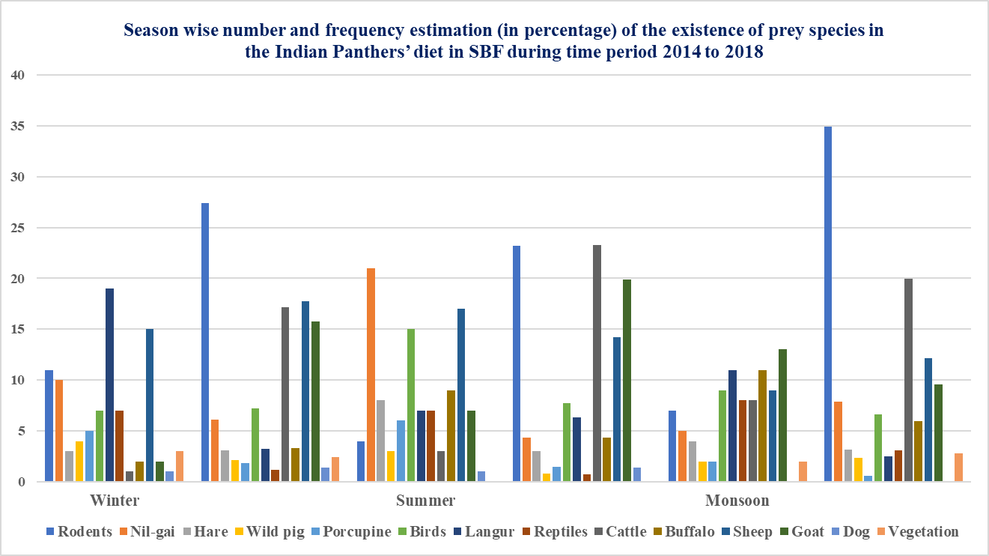

Figure 4: Graph depicting Season wise number and frequency estimation (in percentage) of the existence of prey species in the Indian Panthers’ diet in SWS during time period 2014 to 2018
