Original Research Article
Morphometric Analysis and Sexual Dimorphism in the Golden Orb-Weavers (Arachnida: Araneae: Araneidae)

Abstract
In this study, we examined body size, leg segment morphology, eye arrangement, genital structure, and web architecture to provide an integrated description of functional adaptations in golden orb-weaver Nephila pilipes.
Females possess a large, elongated abdomen (30.14 ± 0.43 mm in length), while males have a very small abdomen (3.83 ± 0.11 mm). The extremely negative Sexual Dimorphism Index (SDI) values for abdominal length (−6.87) and width (−10.93) highlight the magnitude of this difference. Females possessed elongated first and fourth legs, particularly in the femur, tibia, and metatarsus, while the third leg was consistently shorter, reflecting functional specialization. One-way ANOVA showed significant differences among legs for most segments (P < 0.001), except claw length, which remained uniform. Males exhibited a similar leg-length pattern but at a much smaller scale. Female reproductive morphology was characterized by a strongly sclerotized, compact epigynum with large paired spermathecae, a short median septum, and closely positioned copulatory openings, features diagnostic of Nephila. The palp of male has a proximal femur. This femur is elongate, reddish-orange, and V-shaped at the distal end. Next is a compact annular patella. The tibia is triangular. It bears a retro-lateral undulate apophysis. The cymbium is tawny and spoon shaped. It houses the dominant black palpal bulb. This article has been registered in ZooBank under the Life Science Identifier (LSID):
urn: lsid: zoobank.org:pub:6B0C37B8-9994-4A57-9F05-8F49E51D576D
Keywords:
Nephila pilipes; sexual dimorphism index; orb-web architecture; epigynum; functional adaptation, ZooBank
- INTRODUCTION
Members of the genus Nephila Leach, 1815 (Arachnida: Araneae: Araneidae) exhibit a global distribution and pronounced sexual dimorphism, with females conspicuously larger and more colourful than males. Nephila pilipes (Fabricius, 1793) is a common species in the forests of Kalahandi, part of India's Eastern Ghats, renowned for constructing large, spectacular webs with golden silk containing yellow pigments (Craig et al., 1996), earning them the common name "golden orb-weavers" (Harvey et al., 2007). These features coupled with their ability to capture abundant prey via expansive webs have established Nephila species as intensively studied model organisms in fields like sexual selection, including male-male competition, female choice, sexual size dimorphism, sexual cannibalism, sexual conflict, and sperm competition (Fromhage and Schneider, 2006; Kuntner et al., 2009). Female gigantism, characteristic of Nephilidae, is particularly well-documented (Chuang et al., 2023; Agnarsson et al., 2024; Kumar et al., 2026). Molecular studies have further elucidated the genetic basis of their silk (Hayashi et al., 2004; Hu et al., 2006), while recent research highlights Nephila as the most prominent and researched tropical arachnid genus (Xie et al., 2025; Kuntner et al., 2025; Kuntner et al., 2026; Kumar et al., 2026). According to the World Spider Catalog (http://wsc.nmbe.ch/, accessed 25 November 2025), the genus comprises 7 accepted species out of 10 proposed, with Nephila and Trichonephila uniquely producing true golden silk (Lertkulvanich et al., 2025).
Despite records of N. pilipes in Odisha checklists (e.g., Eastern Ghats surveys) and recent observations in Kalahandi, detailed morphological and ecological studies remain scarce in India, particularly lacking baseline data from this region. This study provides the first integrated description of N. pilipes body size, leg segment morphology, eye arrangement, sexual dimorphism, genital structure, and web architecture from Kalahandi forests, highlighting functional adaptations and supporting future taxonomic work.
- MATERIAL AND METHODS
Study Area
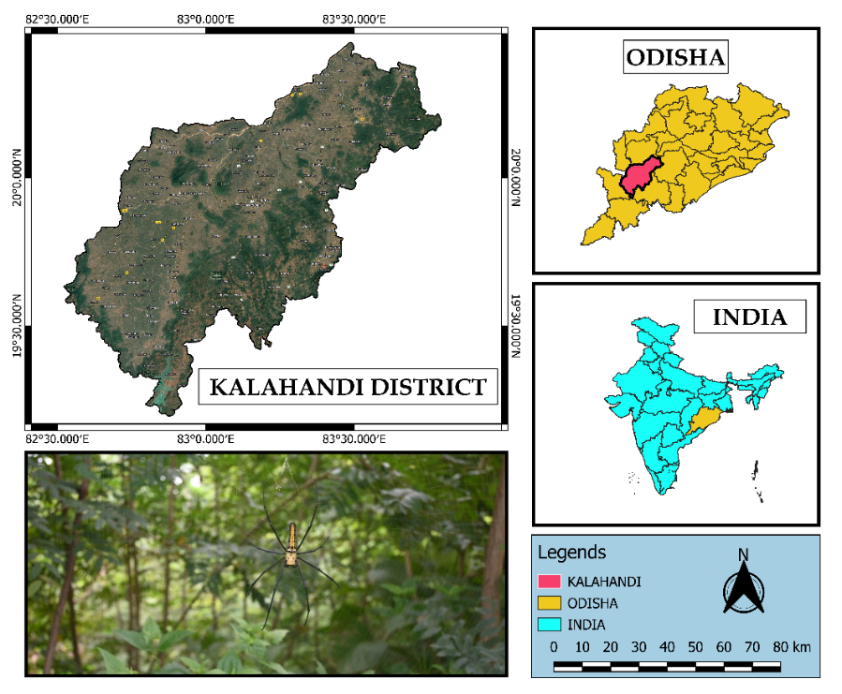
Figure 1. Study area and sampling sites in Kalahandi district (western Odisha, India).

The study was conducted in Kalahandi District, southern Odisha, India (19°55′09″N, 83°10′27″E; Fig. 1), spanning multiple sites across this region of the Eastern Ghats. Kalahandi District lies between 19.3–21.5°N and 82.20–83.47°E, covering 8,364.89 km² of varied topography including plains, hills, and mountains.
Methodology
Study Period and Field Observations
Fieldwork was conducted from July to November 2025. Observations and specimen collection were carried out during peak activity periods, namely morning hours (06:00–10:00 h) and evening hours (17:00–19:00 h).
Collection and Handling of Specimens
After collection, live specimens were rendered temporarily unconscious by placing them in a deep freezer at 0 °C for 3–5 minutes, depending on body size. This method ensured immobilization without causing physical damage.
Identification and Morphological Examination
Specimens were identified to the species level based on external morphology and genital characters using standard taxonomic keys and illustrations, primarily Tikader’s Handbook of Indian Spiders (1987), along with additional literature (Siliwal et al., 2005; Singh et al., 2023). Species identifications were further verified through comparison with relevant published descriptions.
Morphological examinations were conducted under a stereo zoom binocular microscope. Digital photographs were captured using a digital camera, and morphometric measurements were taken using a digital vernier caliper.
Genitalia Preparation
For detailed examination of genital structures, dissected genitalia were cleared using 10% potassium hydroxide (KOH). The genitalia were soaked for 10–30 minutes at room temperature, which effectively removed soft tissues, muscles, and fat, allowing clear visualization of sclerotized structures (Álvarez-Padilla & Hormiga, 2007).
Preservation and Deposition
Selected voucher specimens were preserved in 70% ethanol and deposited in the Zoology Department Museum, Maa Manikeshwari University, Bhawanipatna, for academic reference and student practical purposes. Remaining individuals were released unharmed into their natural habitat after examination.
Statistical Analysis
A one-way analysis of variance (ANOVA) was employed to test for differences in mean lengths of leg segments among the four legs (Legs I–IV) of female N. pilipes, with leg type as the independent factor and segment length as the dependent variable. Given that multiple leg measurements were obtained from the same individuals, the non-independence of observations was acknowledged. Repeated-measures ANOVA, which accounts for within-subject dependence and reduces error variance, is considered statistically more appropriate for such data (Herzog et al., 2019). Conventional one-way ANOVA assumes independent samples and may not fully account for repeated measurements from the same subjects (Sawyer, 2009).

3. RESULT AND DISCUSSIONS
N. pilipes females are among the world's largest web-building spiders, crafting massive golden silk orbs tougher than steel (Blamires, 2022). With black-yellow bodies, eight eyes, and extreme sexual dimorphism (Fig. 2), they passively hunt via web vibrations in tropical forests harmless to humans. N. pilipes is best known for its giant size, golden web, and elegant web architecture, making it one of the most fascinating spiders in nature (Kuntner & Coddington, 2009). Female species usually mark at the centre of web (Fig. 2a, b, c & e), whereas male spider position not fixed in the web.

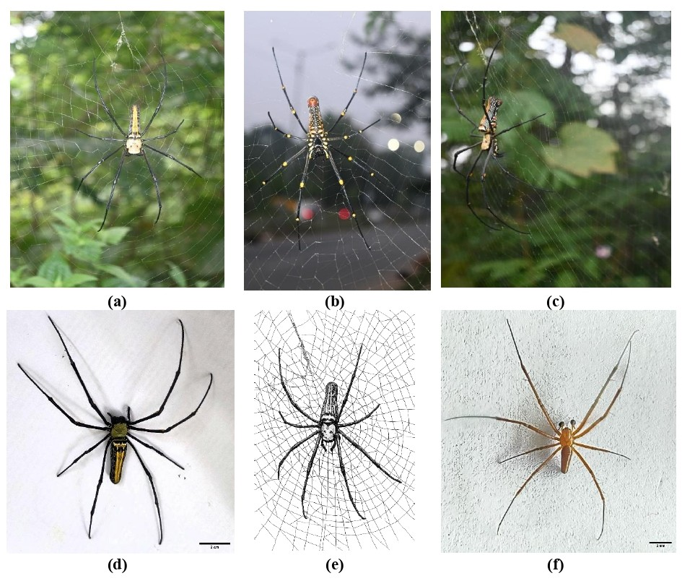
Figure 2. (a) Dorsal view in situ of ♀, (b) ventral view in situ of ♀, (c) lateral view in situ of ♀, (d) dorsal view in laboratory of ♀, (e) sketch showing spider with web (♀), (f) dorsal view of ♂.
Leg segment measurements of female (♀) N. pilipes (n = 23) show clear size differences among the four walking legs (Table 1). Overall, the first and fourth legs are the longest, while the third leg is consistently the shortest across all segments. In the first leg, the metatarsus is the longest segment (32.01 ± 0.92 mm), followed by the femur (25.26 ± 0.51 mm) and tibia (19.63 ± 0.46 mm). A similar pattern is observed in the second and fourth legs, where the metatarsus and femur contribute most to total leg length. The third leg displays markedly reduced dimensions, particularly in the tibia (7.60 ± 0.10 mm) and patella (2.50 ± 0.02 mm), indicating a more limited role in locomotion or prey handling.
Table 1. Leg segment measurements of female Nephila pilipes (mm; mean ± SD, n=23)
Leg | Femur (mm) | Patella (mm) | Tibia (mm) | Metatarsus (mm) | Tarsus (mm) | Claw (mm)
1st leg | 25.26 ± 0.51 | 4.32 ± 0.34 | 19.63 ± 0.46 | 32.01 ± 0.92 | 4.36 ± 0.22 | 0.23 ± 0.02
2nd leg | 20.96 ± 0.32 | 4.15 ± 0.10 | 15.33 ± 0.12 | 26.30 ± 0.16 | 2.91 ± 0.10 | 0.25 ± 0.09
3rd leg | 14.93 ± 0.08 | 2.50 ± 0.02 | 7.60 ± 0.10 | 15.14 ± 0.02 | 2.83 ± 0.01 | 0.13 ± 0.02
4th leg | 24.53 ± 0.50 | 3.99 ± 0.12 | 15.59 ± 0.30 | 24.78 ± 0.32 | 4.56 ± 0.41 | 0.36 ± 0.18

Standard deviations are generally low, suggesting limited individual variation and a consistent leg morphology among females. Functionally, the elongation of the first and fourth legs likely supports web construction, prey capture, and stability (Foelix, 2025). These are critical behaviours in orb-weaving spiders. The shorter third leg may primarily assist in body support rather than active manipulation. Overall, the observed leg asymmetry reflects functional specialization linked to the ecological and behavioural demands of N. pilipes.
Table 2. One-way ANOVA Comparing Leg Segments Among Different Legs
Segment | F value | P value | Significance
Femur | 430.324 | < 0.001 | Significant
Patella | 44.682 | < 0.001 | Significant
Tibia | 846.813 | < 0.001 | Significant
Metatarsus | 492.390 | < 0.001 | Significant
Tarsus | 50.466 | < 0.001 | Significant
Claw | 3.529 | 0.056 | Not significant

One-way ANOVA revealed significant differences in the lengths of most leg segments among the four legs of female N. pilipes (Table 2). Femur, patella, tibia, metatarsus, and tarsus lengths all differed strongly among legs (P < 0.001), with especially high F values for the tibia and metatarsus, indicating pronounced variation and segment specialization. In contrast, claw length showed no significant difference among legs (P = 0.056), suggesting a relatively uniform role in substrate attachment. These results support functional differentiation of major leg segments, while distal claw morphology remains conserved across legs.
Table 3. Leg segment measurements of male Nephila pilipes (mm; mean ± SD, n=20)
Leg | Femur | Patella | Tibia | Metatarsus + Tarsus + Claw
1st | 4.40 ± 0.27 | 0.88 ± 0.08 | 4.37 ± 0.45 | 7.56 ± 0.40
2nd | 3.59 ± 0.38 | 0.85 ± 0.14 | 3.44 ± 0.30 | 6.86 ± 0.16
3rd | 2.98 ± 0.03 | 0.48 ± 0.09 | 1.21 ± 0.10 | 3.22 ± 0.12
4th | 3.80 ± 0.02 | 0.80 ± 0.06 | 2.97 ± 0.04 | 5.81 ± 0.07

Male (♂) N. pilipes show clear differences in leg segment lengths among the four legs (Table 3). The first leg is the longest overall, with relatively large femur (4.40 ± 0.27 mm) and tibia (4.37 ± 0.45 mm), followed by the second and fourth legs. The third leg is markedly shorter, particularly in the tibia (1.21 ± 0.10 mm) and distal segments, indicating reduced functional importance. Low standard deviations suggest consistent morphology among males. This leg length pattern likely reflects functional specialization related to movement, mating behaviour, and positioning on the female’s web.
Table 4. Body measurements of Nephila pilipes (mm; mean ± SD) with Sexual Dimorphism Index (SDI)
Category | Body part | Length (mm) | Width (mm) | Sample size (n)
Female | Head | 11.37 ± 0.55 | 9.73 ± 0.38 | 23
Male | Head | 1.23 ± 0.09 | 1.36 ± 0.09 | 20
SDI | Head | −8.24 | −6.15 | —
Female | Abdomen | 30.14 ± 0.43 | 10.38 ± 0.49 | 23
Male | Abdomen | 3.83 ± 0.11 | 0.87 ± 0.08 | 20
SDI | Abdomen | −6.87 | −10.93 | —
Female | Epigynum | 3.57 ± 0.04 | 1.86 ± 0.05 | 23

Body measurements of N. pilipes reveal extreme sexual size dimorphism between females and males (Table 4). Females are substantially larger than males in all measured body parts, particularly in the head and abdomen. Female head length and width (11.37 ± 0.55 mm and 9.73 ± 0.38 mm) greatly exceed those of males (1.23 ± 0.09 mm and 1.36 ± 0.09 mm), reflected by strongly negative SDI values (−8.24 for length and −6.15 for width). This indicates distinct female-biased dimorphism. The abdomen shows even greater disparity. Females possess a large, elongated abdomen (30.14 ± 0.43 mm in length), while males have a very small abdomen (3.83 ± 0.11 mm). The extremely negative SDI values for abdominal length (−6.87) and width (−10.93) highlight the magnitude of this difference. Such enlargement in females is likely associated with reproductive investment, including egg production and storage, which requires increased abdominal volume. Male body dimensions remain consistently small with low variation, suggesting strong selective pressure favouring reduced size (Blanckenhorn, 2000). Smaller male size may enhance mobility on the female’s web, reduce detection or aggression by females, and lower energetic costs during mate searching. In contrast, the large female body size likely improves fecundity and survival. Overall, the findings highlight how life-history trade-offs and asymmetric selection pressures between males and females can produce extreme sexual dimorphism. N. pilipes thus represents a compelling example of how fecundity selection, mating strategies, and survival constraints interact to shape morphological evolution in sexually dimorphic species. The female epigynum, measured only in females, shows relatively low variation (3.57 ± 0.04 mm length; 1.86 ± 0.05 mm width), suggesting structural stability of this reproductive organ. Overall, these results confirm N. pilipes as a species with extreme female-biased sexual dimorphism, reflecting distinct ecological and reproductive roles between sexes.
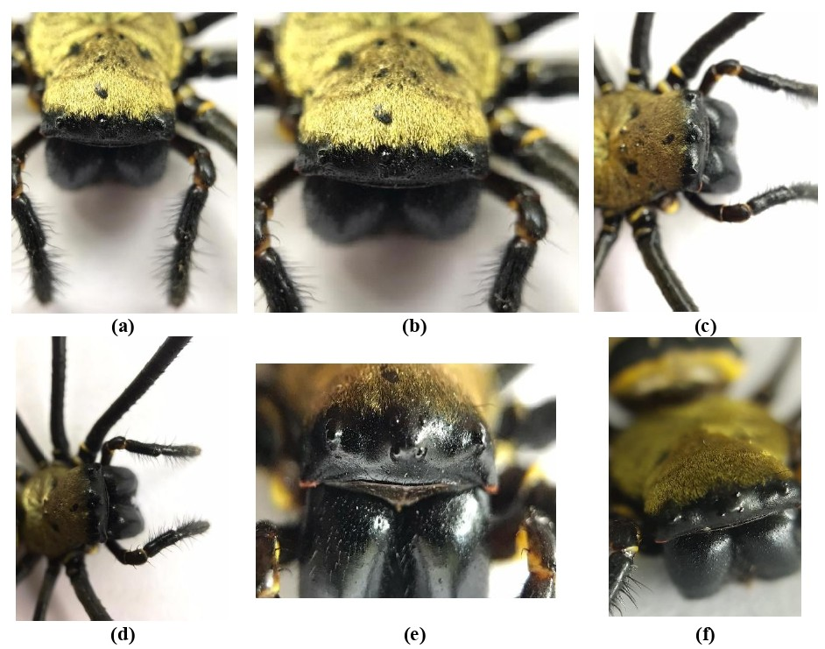
Figure 3. Eye arrangement in female N. pilipes from different angles: (a–f).

The eye arrangement of N. pilipes follows the typical pattern of orb-weaving spiders, with eight eyes arranged in two horizontal rows (Figure 3). The anterior row consists of four eyes that are slightly curved, with the anterior median eyes being the largest and forward-facing, while the lateral eyes are smaller and directed outward. The posterior row also contains four eyes that are more evenly spaced and generally smaller. Together, these eyes form a broad, gently curved rectangular pattern that provides wide visual coverage rather than high visual acuity. This eye configuration reflects the ecological strategy of N. pilipes. As a web-building spider, it relies primarily on vibrations transmitted through its orb web to detect and locate prey, reducing the need for highly specialized vision. In contrast, actively hunting spiders such as jumping spiders possess large, forward-facing eyes adapted for sharp vision and depth perception (Morehouse, 2020; Nelson, 2023), while wolf spiders show complex eye rows suited for motion detection in low light (Foelix, 2025). The moderate, symmetrical eye arrangement of N. pilipes therefore represents an adaptation to a sit-and-wait predatory lifestyle, where sensory input from the web is more important than precise visual tracking.
The epigynum of Nephila sp. is a prominent and strongly sclerotized structure located on the ventral surface of the female abdomen (Figure 4). It forms a compact, robust epigynal plate with a generally triangular outline. Anteriorly, two large, rounded spermathecae are clearly visible as paired, symmetrical bulbous structures, indicating well-developed sperm storage capacity. The median septum is short and broad, dividing the epigynal plate but not extending deeply, which contributes to the overall compact appearance of the genitalia. The copulatory openings are positioned ventrally near the base of the spermathecae and are closely spaced, suggesting short copulatory ducts that directly connect to the spermathecae. Posteriorly, the epigynal plate becomes wider and darker, with diffuse margins that blend into the surrounding cuticle. This robust and relatively simple morphology is characteristic of Nephila females. Functionally, the enlarged spermathecae reflect an adaptation for effective sperm reception and storage, which is important in species where mating opportunities may be limited. Taxonomically, the combination of large paired spermathecae, a short median septum, and a compact epigynal plate is diagnostic for Nephila (Kuntner, 2007) and is widely used for species-level identification (Yang et al., 2024).

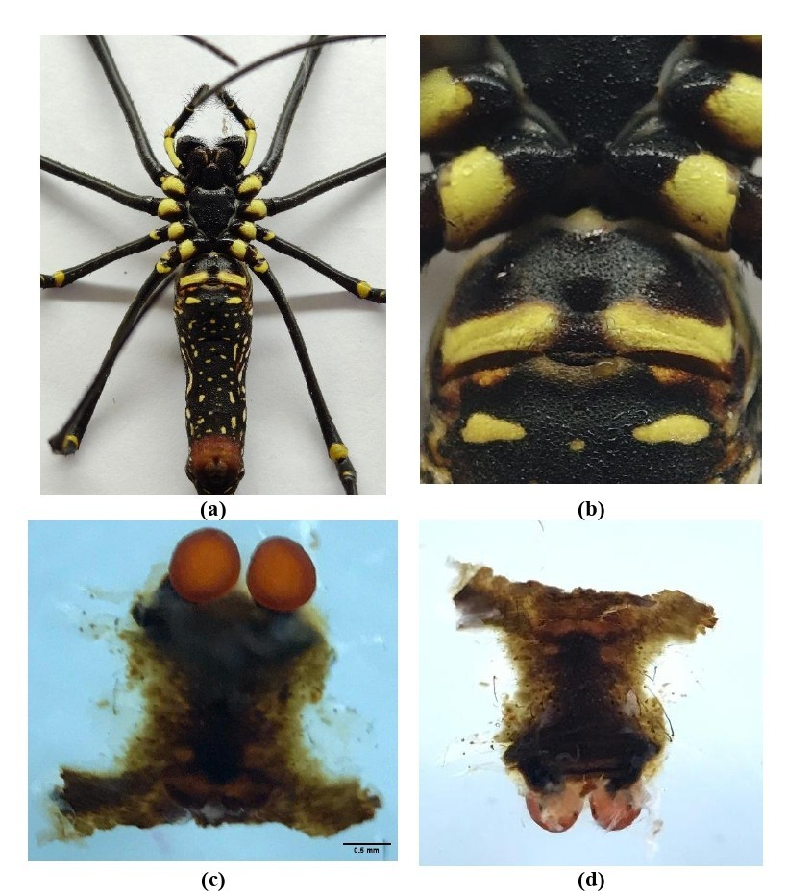

Figure 4. Genitalia of N. pilipes (♀): (a) position of female genitalia, (b) enlarged view of position of female genitalia, (c) ventral view of epigynum, (d) dorsal view of epigynum.
The male palp of N. pilipes (Figure 5) shows adaptations for sperm transfer during sexual conflict. It has a proximal femur. This femur is elongate, reddish-orange, and V-shaped at the distal end. Next is a compact annular patella. The tibia is triangular. It bears a retro-lateral undulate apophysis. The cymbium is tawny and spoon shaped. It houses the dominant black palpal bulb. This structure dominates the ~5 mm male's morphology. The bulb occupies ~3/4 of the cymbium. It features a stout pointy embolus. The embolus emerges from the posterior ventral tegulum. An inflatable haematodocha supports eversion during copulation. The cymbium has dense short gold setae. These contrast sparse elongate setae proximally. They aid grip on the female's epigyne. The creamish white distal cymbial tip enhances maneuverability. Dissected specimens show prolateral embolus protrusion. They also show orange basal hues. These underscore species-specific locking mechanisms. Males often use one palp per mating. They favor the fuller bulb. This counters polyandry and emasculation risks.
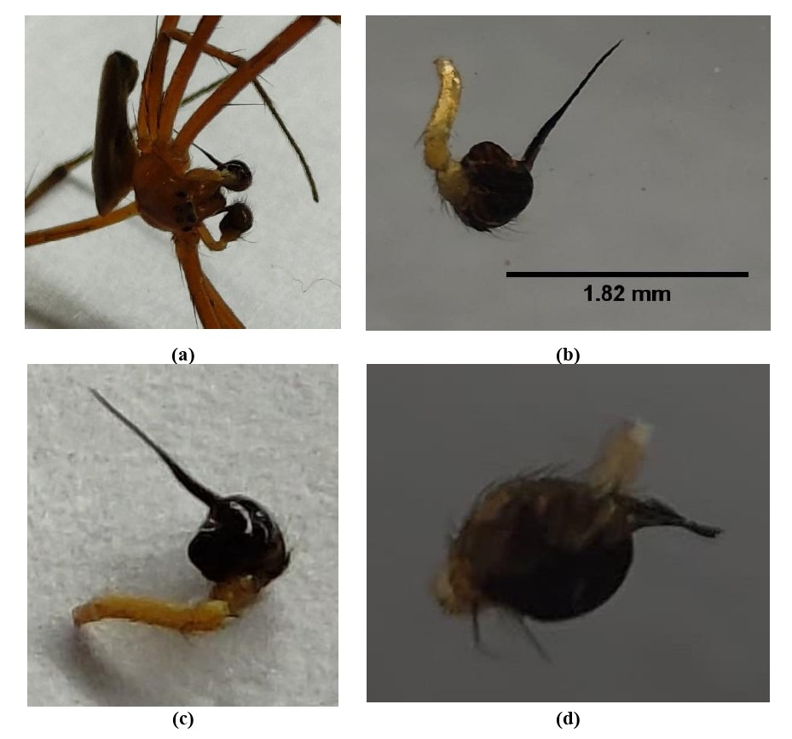

Figure 5. Male (♂) pedipalps of N. pilipes. (a) Both right and left palps (ventral view). (b) Right palp with scale bar. (c) Right palp (prolateral angle). (d) Palpal bulb (close-up).

Nephilid spiders construct three distinct web architectures that reflect differences in habitat use and web function. Nephila produce large, fully aerial orb webs that often exceed 100 cm in diameter (Kuntner & Coddington, 2009). The orb web shown in the image illustrates (Figure 2, a-c) the highly organized structure typical of aerial nephilid webs, with evenly spaced radial threads, sticky spiral threads, and a central hub where the spider detects vibrations. Quantitative measures such as web area, hub displacement, and ladder index highlight increasing asymmetry from aerial to ladder-type webs. Overall, variation in nephilid web architecture represents adaptive responses to different ecological conditions, balancing web size, stability, and prey capture efficiency.
4. CONCLUSION
N. pilipes shows extreme female-biased sexual dimorphism, specialized leg morphology, conserved sensory and reproductive structures, and highly organized orb-web architecture. Together, these traits reflect strong functional and ecological adaptations that enhance prey capture, reproduction, and survival in a web-based lifestyle.
COMPETING INTERESTS DISCLAIMER:
Authors have declared that they have no known competing financial interests OR non-financial interests OR personal relationships that could have appeared to influence the work reported in this paper.

Disclaimer (Artificial intelligence)

Author(s) hereby declare that NO generative AI technologies such as Large Language Models (ChatGPT, COPILOT, etc.) and text-to-image generators have been used during the writing or editing of this manuscript.

5. REFERENCES

Agnarsson, I., Goodnight, C., & Higgins, L. (2024). Developmental asynchrony: A potential cost of extreme sexual size dimorphism in seasonal environments. The Journal of Arachnology, 52(1), 75-85.
Álvarez-Padilla, F., & Hormiga, G. (2007). A protocol for digesting internal soft tissues and mounting spiders for scanning electron microscopy. The Journal of Arachnology, 35(3), 538-542.
Blamires, S. (2022). Silk: exploring nature’s superfibre. Xlibris Corporation.
Blanckenhorn, W. U. (2000). The evolution of body size: what keeps organisms small?. The quarterly review of biology, 75(4), 385-407.
Chuang, A., Deitsch, J. F., Nelsen, D. R., Sitvarin, M. I., & Coyle, D. R. (2023). The Jorō spider (Trichonephila clavata) in the southeastern US: an opportunity for research and a call for reasonable journalism. Biological Invasions, 25(1), 17-26.
Craig, C. L., Weber, R. S., & Bernard, G. D. (1996). Evolution of predator-prey systems: spider foraging plasticity in response to the visual ecology of prey. The American Naturalist, 147(2), 205-229.
Foelix, R. (2025). Neurobiology. In Spider Biology (pp. 87-136). Cham: Springer Nature Switzerland.
Fromhage, L., & Schneider, J. M. (2006). Emasculation to plug up females: the significance of pedipalp damage in Nephila fenestrata. Behavioral Ecology, 17(3), 353-357.
Harvey, M. S., Austin, A. D., & Adams, M. (2007). The systematics and biology of the spider genus Nephila (Araneae: Nephilidae) in the Australasian region. Invertebrate Systematics, 21(5), 407-451.
Hayashi, C. Y., Blackledge, T. A., & Lewis, R. V. (2004). Molecular and mechanical characterization of aciniform silk: uniformity of iterated sequence modules in a novel member of the spider silk fibroin gene family. Molecular biology and evolution, 21(10), 1950-1959.
Herzog, M. H., Francis, G., & Clarke, A. (2019). Anova. In Understanding statistics and experimental design: how to not lie with statistics (pp. 67-82). Cham: Springer International Publishing.
Hu, X., Vasanthavada, K., Kohler, K., McNary, S., Moore, A. M. F., & Vierra, C. A. (2006). Molecular mechanisms of spider silk. Cellular and Molecular Life Sciences CMLS, 63(17), 1986-1999.
Kumar, M., Ranjan, R., Srivastava, R., & Sinha, M. P. (2026). DNA barcoding and phylogenetic analysis of spider Nephila pilipes from Latehar, Jharkhand (India). Vat-Vriksha, 2(1), OM02.
Kuntner, M. (2007). A monograph of Nephilengys, the pantropical ‘hermit spiders’(Araneae, Nephilidae, Nephilinae). Systematic Entomology, 32(1), 95-135.
Kuntner, M., & Coddington, J. A. (2009). Discovery of the largest orbweaving spider species: the evolution of gigantism in Nephila. PLoS One, 4(10), e7516.
Kuntner, M., Coddington, J. A., & Schneider, J. M. (2009). Intersexual arms race? Genital coevolution in nephilid spiders (Araneae, Nephilidae). Evolution, 63(6), 1451-1463.
Kuntner, M., Kuntner, M., Kuntner, E., Kuntner, I., Faganeli Pucer, J., Štrumbelj, E., & Li, D. (2025). Nephila spider male aggregation: preference for optimal female size and web clustering. Integrative zoology, 20(4), 793-799.
Kuntner, M., Yu, K.-P., Turk, E., Čandek, K., Gregorič, M., Anderson, G. J., Coddington, J. A., & Cheng, R.-C. (2026). The Other Side of the Coin: Taxonomic Updates and Species Key of Herennia (Araneae: Nephilidae). Diversity, 18(1), 54. https://doi.org/10.3390/d18010054
Lertkulvanich F, Swatdipong A, Warrit N, Nipitwattanaphon M. 2025. Morphology and genetic diversity of golden silk orbweaver (Nephila) spiders in Thailand. Zool Stud 64:53.
Levi, H. W. (1980). The orb-weaver genus Mecynogea, the subfamily Metinae and the genera Pachgnatha, Glenognatha and Azilia of the subfamily Tetragnathinae north of Mexico (Araneae: Araneidae). Bull. Mus. Comp. Zool., 149, 271-318.
Morehouse, N. (2020). Spider vision. Current Biology, 30(17), R975-R980.
Nelson, X. J. (2023). A road map of jumping spider behavior. The Journal of Arachnology, 51(2), 139-154.
Sawyer, S. F. (2009). Analysis of variance: the fundamental concepts. Journal of Manual & Manipulative Therapy, 17(2), 27E-38E.
Siliwal, M., Molur, S., & Biswas, B. K. (2005). Indian spiders (Arachnida: Araneae): updated checklist 2005. Zoos'print Journal, 20(10), 1999-2049.
Singh, R., Verma, A. K., Singh, B. B., & Singh, G. (2023). Spider Fauna of India. Asian Biological Research Foundation, Prayagraj.
Tikader, B. K. (1987). Hand book of Indian spiders. Ed. Director Zool. Surv. India, Calcutta: 251 pp
Xie, Q., Yang, L., Tan, L., Jia, F., Zhao, S., Lu, Y., ... & Luan, T. (2025). Regional pollution and diet drive organohalogen contaminant accumulation in mangrove-settled spiders (Nephila pilipes). Environmental Pollution, 373, 126100.
Yang, L., He, Q., & Yao, Z. (2024). Taxonomic study of four closely related species of the Pholcus yichengicus species group (Araneae, Pholcidae) from China’s Qinling Mountains: An integrated morphological and molecular approach. Zoosystematics and Evolution, 100(1), 279-289.

