Histopathological changes of different organs due to acute hypoxia in zebrafish (Danio rerio)

ABSTRACT

The production of ornamental fish has increased in recent years. The zebrafish (Danio rerio) is a popular model organism used in scientific research across various fields. Hypoxia, or a reduction in the level of dissolved oxygen in water, is a critical condition that directly affects the survival and maintenance of many aquatic organisms, including fish. In this case report, we describe a zebrafish that experienced hypovolemic shock resulting from hypoxia caused by a sudden drop in dissolved oxygen levels. This case study describes a bioterium in which a power outage caused a drop in dissolved oxygen levels, resulting in a high mortality rate. Histopathology was used to evaluate the tissues, which were fixed in 10% formalin, processed in an automatic processor and embedded in paraplast. Tissue blocks were sectioned at a thickness of 3 µm and stained in haematoxylin and eosin for observation. Microscopically, the myocardium appeared slightly hypertrophic and the pericardium showed dense haemorrhages. The kidney tubular cells showed pronounced oedema with a whitish, foamy cytoplasm. Some tubular cells showed pronounced eosinophilia and necrotic cells were observed detaching from the tubular basement membrane in some tubules. The brain parenchyma showed pericellular oedema, increased Virchow-Robin spaces and mild glial proliferation. Therefore, we conclude that the underlying cause of death was a decrease in environmental oxygen levels combined with pre-existing branchial lesions, which generated hypoxia resulting in cardiac failure due to diffuse haemorrhages.

Keywords: Ornamental fish, Oxygen, Hypovolemia, Histopathology

INTRODUCTION
The production of ornamental fish has increased in recent years, particularly those intended for scientific research. Among these species, the most important is the zebrafish (Danio rerio).
The zebrafish (Danio rerio) is a tropical freshwater teleost species belonging to the order Cypriniformes and the subfamily Danioninae. It is native to freshwater habitats in South Asia, where it occurs in India, Pakistan, Bangladesh, Nepal, and Bhutan (Whiteley et al., 2011; Engeszer et al., 2007). It typically inhabits clear, shallow waters such as streams, ponds, canals, ditches, and rice fields (Spence et al., 2006). The water pH ranges from neutral to basic, and the optimal temperature lies between 16.5 and 34 °C (MacClure et al., 2006). The zebrafish is widely used in scientific research as a model organism in various fields of science(Orger & Polavieja, 2017).
Most teleost fish breathe through their gills. The functions of this organ are multiple and of great importance to fish, including osmoregulation, excretion of nitrogenous compounds, and ion regulation. For branchial respiration to be efficient, the gills require a highly specialized structure characterized by a thin epithelium and a large surface area that allows gas exchange between the blood and the surrounding environment, ensuring the transport of oxygen and nutrients to different tissues. Conversely, both external and internal factors can impair the efficiency of the gill apparatus, such as elevated levels of nitrogenous compounds, parasitic diseases, branchial hyperplasia, and gill necrosis, among others (Laurent & Perry, 1991; Kim et al., 2019; Ahmad et al., 2021).
Hypoxia, defined as a reduction in dissolved oxygen levels in water, is a critical condition that directly affects the maintenance and survival of various aquatic organisms, including fish (Wang et al., 2023). When dissolved oxygen (DO) concentrations fall below 1.5 mg/L, the respiratory capacity of fish may be compromised (Wannamaker & Rice, 200). Several factors can cause this condition, such as water pollution, nutrient overload leading to algal blooms, overpopulation, and inadequate water recirculation in aquariums and tanks, among others (Pollock et al., 2007). As oxygen levels decrease, fish tend to exhibit metabolic and physiological alterations, including difficulty performing gas exchange through the gills, lethargy, behavioral changes, and, in more severe cases, death (Wang et al., 2023). Thus, hypoxia is a condition in which an organism’s body does not receive sufficient oxygen, regardless of the underlying cause (Convertino et al., 2019).
Hypovolemic shock, in turn, is characterized by a significant loss of intravascular volume, whether due to hemorrhagic mechanisms (external or internal bleeding) or non-hemorrhagic mechanisms (vomiting, diarrhea, extensive burns, among others) (Taghavi et al., 2023). This loss of volume leads to a reduction in venous return and, consequently, a decrease in cardiac output, resulting in tissue hypoperfusion and impaired delivery of oxygen and nutrients to vital organs. If not diagnosed and treated promptly, it can progress to progressive cellular dysfunction and multiple organ failure (Alencar et al., 2025).
Here, we report a case of hypovolemic shock in zebrafish (Danio rerio) resulting from hypoxia caused by a sudden drop in dissolved oxygen (DO) levels. Macroscopically, the fish exhibited gill pallor, skin lesions, and hemorrhages.

Case presentation
The study was conducted in the Immunology and Pathology of Aquatic Organisms facilities at the Federal University of Rio Grande in Brazil. Eight Danio rerio specimens were studied. According to the background information, a high mortality rate was observed following a decrease in dissolved oxygen (DO) levels caused by a power outage.
The animals were euthanised by immersion in benzocaine (500 mg/L) and necropsies were performed in accordance with the Eiras et al. (2000) protocol. Samples were collected from the kidney, brain, gut, heart, spleen, gills and liver for histopathological analysis.
The tissues were fixed in 10% buffered formalin for 48 hours, then transferred to 70% alcohol.
Tissue samples were subjected to routine histological processing in a Leica TP1020 automatic tissue processor, including dehydration, clearing, impregnation, and paraffin embedding. Dehydration was performed using graded ethanol solutions (70%, 80%, 90%, and two changes of absolute ethanol), with 1 h per step. Clearing was conducted in two successive xylene baths, each lasting 1 h, to ensure complete removal of ethanol prior to paraffin impregnation.
Tissue blocks were sectioned at a thickness of 3 µm using a Leica RM2245 microtome, deparaffinised, and stained with haematoxylin and eosin for analysis under an optical microscope (Luna, 1968). Microphotographs were obtained using an Zeiss Primo Star optical microscope equipped with an Axiocam ERC5s AxioCam (LE) câmera and Zen Lite system in order to evaluate the tissue architecture and presence of lesions.

DISCUSSION
At necropsy, cutaneous hemorrhagic lesions were observed during macroscopic examination. The microscopic examination revealed the following histological alterations: In the heart, the myocardium showed mild hypertrophy, the endocardium exhibited no lesions, and the pericardium presented dense hemorrhages occupying the entire pericardial cavity. In the abdominal cavity, the abdominal organs exhibited preserved architecture, with isolated foci of intrahepatic hemorrhages and massive hemorrhages throughout the cavity.
The renal parenchyma displayed preserved architecture. In the interstitium, lymphohematopoietic elements were observed. The renal glomeruli showed no significant alterations, whereas the tubular cells exhibited marked edema with whitish, foamy cytoplasm (hydropic degeneration). In other areas, tubular cells showed pronounced eosinophilia (cloudy swelling). Finally, in some tubules, necrotic cells were observed detaching from the tubular basement membrane and lying free within the tubular lumen (Fig. 1A and 1B).
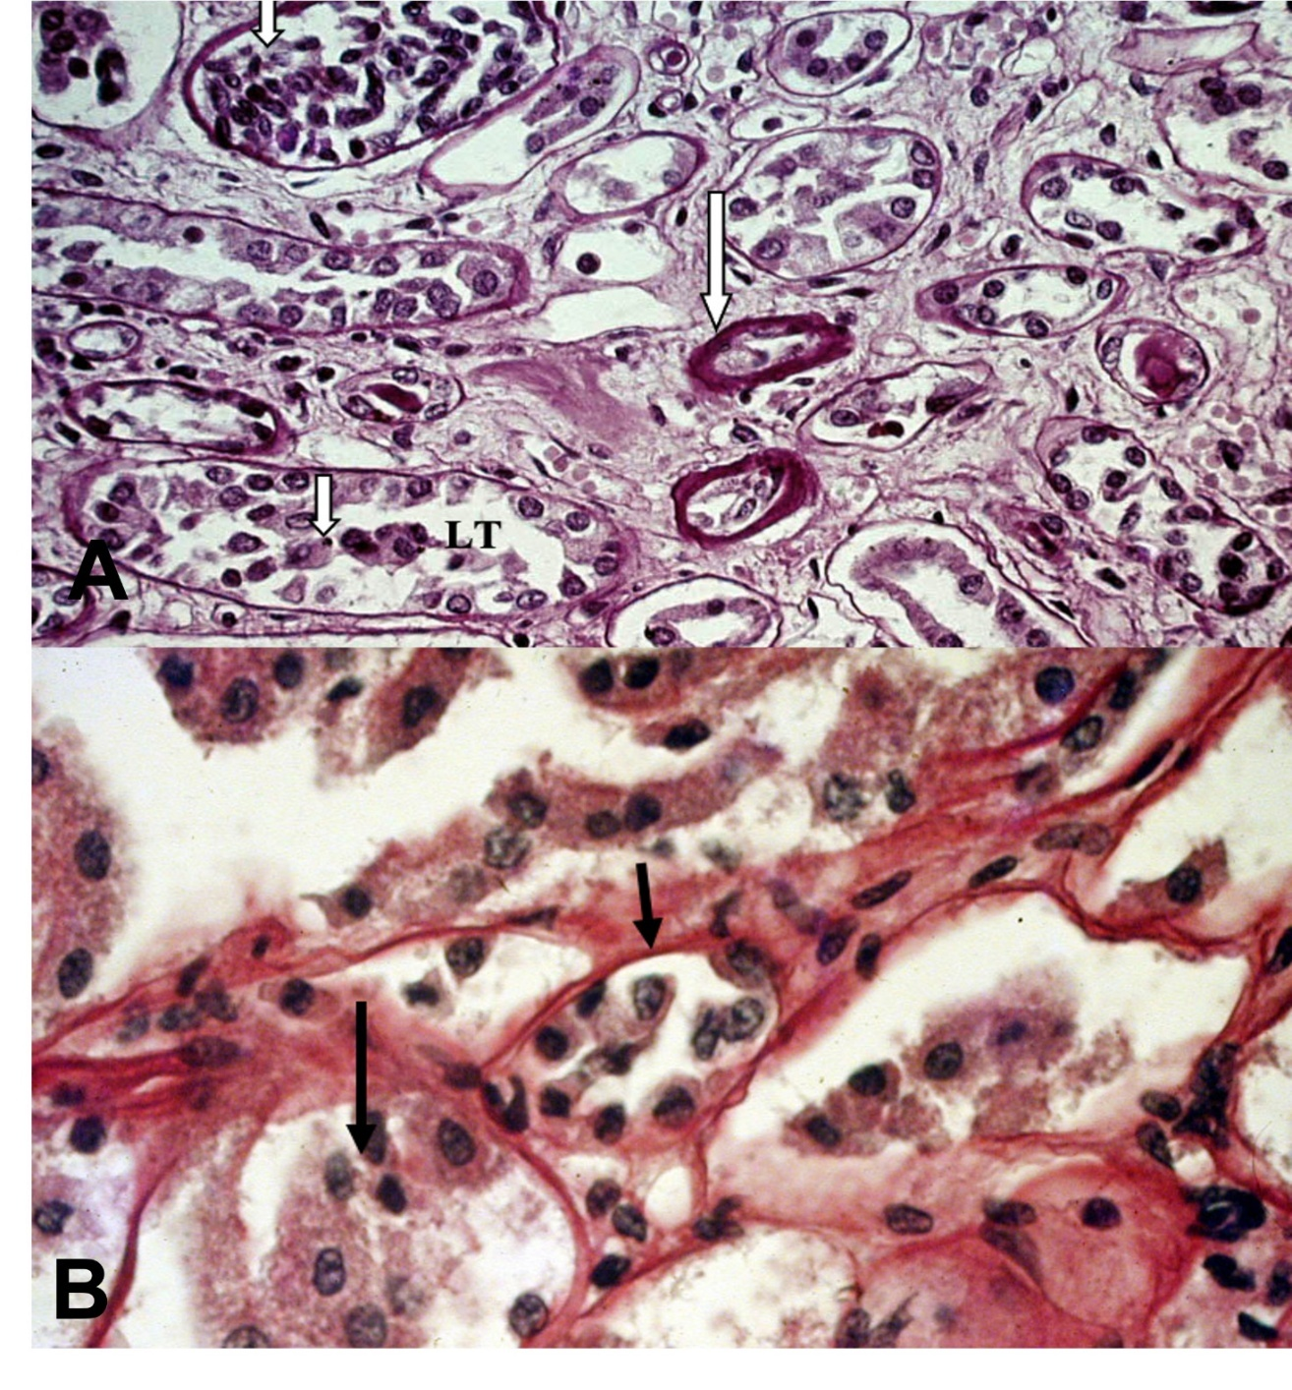Figur e 1: Kidney. A: Tubules with thickened basement membranes (long arrow) and necrotic tubular cells detached from the tubular basement membrane (short arrow), occupying the tubular lumen (TL). 40× magnification. B: Higher magnification of Figure A showing basement membranes (short arrow) and necrosis of tubular cells with detachment from the basement membrane and accumulation within the tubular lumen. H-E 100 X.
LT

The encephalic parenchyma exhibited preserved architecture. Pericellular edema, enlargement of the Virchow–Robin spaces, and mild glial proliferation were observed (Fig. 2A and 2B).
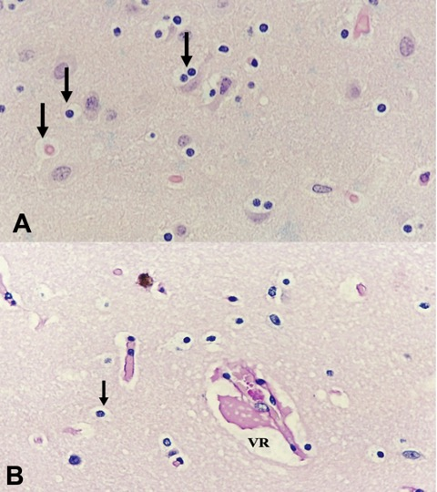
Figure 2: Brain. A: Cerebral parenchyma showing marked pericellular edema (arrows). H&E, 40× magnification. B: Cerebral parenchyma with pronounced pericellular edema (arrow) and enlarged Virchow–Robin space (VR). H-E 40 X.

The zebrafish is a species widely used as an experimental model for mammals, including humans, since fish have been increasingly recommended for experimental designs involving human diseases (Orger & Polavieja, 2017).
In aquaculture-related research, this species serves as an important model for understanding the effects of farming conditions on animal physiology (Kent et al., 2002; Spitsbergen et al., 2003; Spence et al., 2007). Hypoxia, a common condition affecting the production of ornamental fish, particularly impacts zebrafish, as this species is highly susceptible to decreased oxygen levels. Hypoxia affects the entire organism and can produce noticeable effects in virtually all fish organs.
Although hypoxia also causes gill lesions (Randall & Daxboeck, 1994; Araújo-Luna et al., 2018; Abdel-Tawwab et al., 2019), in the case described here, the gill lesions appear to have been pre-existing. Therefore, pre-existing gill damage, combined with a decrease in dissolved oxygen, led to a reduced capacity for blood oxygenation and subsequent systemic effects on other organs.
Li et al. (2021) described physiological responses in cardiac tissue under hypoxic conditions, including effects on structure, enzymatic activity, and gene expression in the heart of silver carp (Hypophthalmichthys molitrix). Along with acute cardiac injury, renal lesions were also observed. These lesions are typical of hypovolemia, as indicated by the diffuse tubular necrosis found in the histopathological examination (Pacheco et al., 2022; Turgut et al., 2023), wich were described in this study.
The physiology of hypovolemic shock consists of a significant loss of intravascular volume due to haemorrhage and a decrease in cardiac output. This results in tissue hypoperfusion, impaired oxygen and nutrient delivery to vital organs, progressive cellular dysfunction and multiple organ failure (Alencar et al., 2025).
Another tissue affected by hypovolemia was the brain, where glial proliferation, signs of neuronal damage, and enlargement of the Virchow–Robin spaces were observed. Such alterations are systematically seen in cases of hypovolemia, since nervous tissue is highly susceptible to reduced oxygen levels (Sekhon et al., 2017; Ineichen et al., 2022; Lacerte et al., 2023).

CONCLUSION
Based on the findings discussed above, we conclude that the fundamental cause of mortality in zebrafish was a decrease in environmental oxygen which, combined with pre-existing gill lesions, led to hypoxia and diffuse hemorrhages.

Disclaimer (Artificial intelligence)

Author(s) hereby declare that NO generative AI technologies such as Large Language Models (ChatGPT, COPILOT, etc.) and text-to-image generators have been used during the writing or editing of this manuscript.

REFERENCES

- Abdel-Tawwab, M., Monier, M.N., Hoseinifar, S.H., Faggio, C., (2019). Fish response to hypoxia stress: growth, physiological, and immunological biomarkers. Fish Physiol Biochem 45, 997–1013. https://doi.org/10.1007/s10695-019-00614-9
- Ahmad, I., Ahmed, I., Fatma, S., Peres, H., (2021). Role of branched‐chain amino acids on growth, physiology and metabolism of different fish species: A review. Aquacult Nutr 27, 1270–1289. https://doi.org/10.1111/anu.13267
- Alencar, W.D.S.D., Pinheiro, J.L., Barbosa, L.B.A., Souza, J.L.D.A.S., Narcizo, I.O., Nunes, L.G.D.S., Vigatti, T.P.P., Neves, A.D.C.D., Ferreira, L.G.N.M., Andrade, M.D.S.R., Couto, M.E.D.C., Machado, A.R.G., Pena, T.C., Pires, P.L., Tymniak, J.R., Lopes, D.A., (2025). Abordagem integrada no choque hipovolêmico traumático: relato de caso. Revft 29, 45–46. https://doi.org/10.69849/revistaft/ni10202503231045
- Araújo-Luna, R., Ribeiro, L., Bergheim, A., Pousão-Ferreira, P., (2018). The impact of different rearing condition on gilthead seabream welfare: Dissolved oxygen levels and stocking densities. Aquac Res 49, 3845–3855. https://doi.org/10.1111/are.13851
- Barton, B.A., Taylor, B.R., (1996). Oxygen Requirements of Fishes in Northern Alberta Rivers with a General Review of the Adverse Effects of Low Dissolved Oxygen. Water Quality Research Journal 31, 361–410. https://doi.org/10.2166/wqrj.1996.022
- Convertino, V. A., Lye, K. R., Koons, N. J., & Joyner, M. J. (2019). Physiological comparison of hemorrhagic shock and V $O_{2}$max: A conceptual framework for defining the limitation of oxygen delivery. Experimental biology and medicine (Maywood, N.J.), 244(8), 690–701. https://doi.org/10.1177/1535370219846425
- Eiras, J. C.; Takemoto, R. M.; Pavanelli, G. C. Métodos de estudo e técnicas laboratoriais em parasitologia de peixes. Maringá: EdUEM, 2000.
- Engeszer, R.E., Patterson, L.B., Rao, A.A., Parichy, D.M., (2007). Zebrafish in The Wild: A Review of Natural History And New Notes from The Field. Zebrafish 4, 21–40. https://doi.org/10.1089/zeb.2006.9997
- Ineichen, B.V., Okar, S.V., Proulx, S.T., Engelhardt, B., Lassmann, H., Reich, D.S., (2022). Perivascular spaces and their role in neuroinflammation. Neuron 110, 3566–3581. https://doi.org/10.1016/j.neuron.2022.10.024
- Kent, M.L., Bishop-Stewart, J.K., Matthews, J.L., Spitsbergen, J.M., (2002). Pseudocapillaria tomentosa, a nematode pathogen, and associated neoplasms of zebrafish (Danio rerio) kept in research colonies. Comp Med 52, 354–358.
- Kim, Jun-Hwan, Kang, Y.J., Kim, K.I., Kim, S.K., Kim, Jong-Hyun, (2019). Toxic effects of nitrogenous compounds (ammonia, nitrite, and nitrate) on acute toxicity and antioxidant responses of juvenile olive flounder, Paralichthys olivaceus. Environmental Toxicology and Pharmacology 67, 73–78. https://doi.org/10.1016/j.etap.2019.02.001
- Lacerte, M., Hays Shapshak, A., Mesfin, F.B., (2025). Hypoxic Brain Injury, in: StatPearls. StatPearls Publishing, Treasure Island (FL).
- Laurent, P., Perry, S.F., (1991). Environmental Effects on Fish Gill Morphology. Physiological Zoology 64, 4–25. https://doi.org/10.1086/physzool.64.1.30158511
- Li, X., Li, F., Zou, G., Feng, C., Sha, H., Liu, S., Liang, H., (2021). Physiological responses and molecular strategies in heart of silver carp (Hypophthalmichthys molitrix) under hypoxia and reoxygenation. Comparative Biochemistry and Physiology Part D: Genomics and Proteomics 40, 100908. https://doi.org/10.1016/j.cbd.2021.100908
- McClure, M. M., McIntyre, P. B., & McCune, A. R. (2006). Notes on the natural diet and habitat of eight danionin fishes, including the zebrafish Danio rerio. Journal of Fish Biology, 69(2), 553-570.
- ]Orger, M.B., de Polavieja, G.G., (2017). Zebrafish Behavior: Opportunities and Challenges. Annu Rev Neurosci 40, 125–147. https://doi.org/10.1146/annurev-neuro-071714-033857
- Pacheco, L.P., Pereira, A.C.V., Silva, A.D.C.D., Brock, D.P.P., Abreu, F.M.D.S., Silva, L.E.D.A., Andrade, L.M.N., Tissi, L.S., Carneiro, Y.V., Miura, F.K., (2022). Abordagem atualizada da Lesão Renal Aguda (LRA): uma revisão narrativa. Acervo Médico 7, e10162. https://doi.org/10.25248/reamed.e10162.2022
- Pollock, M.S., Clarke, L.M.J., Dubé, M.G., (2007). The effects of hypoxia on fishes: from ecological relevance to physiological effects. Environ. Rev. 15, 1–14. https://doi.org/10.1139/a06-006
- Randall, D., Daxboeck, C., (1984). 5 Oxygen and Carbon Dioxide Transfer Across Fish Gills, in: Fish Physiology. Elsevier, pp. 263–314. https://doi.org/10.1016/S1546-5098(08)60321-0
- Sekhon, M.S., Ainslie, P.N., Griesdale, D.E., (2017). Clinical pathophysiology of hypoxic ischemic brain injury after cardiac arrest: a “two-hit” model. Crit Care 21, 90. https://doi.org/10.1186/s13054-017-1670-9
- Spence, R., Fatema, M.K., Reichard, M., Huq, K.A., Wahab, M.A., Ahmed, Z.F., Smith, C., (2006). The distribution and habitat preferences of the zebrafish in Bangladesh. Journal of Fish Biology 69, 1435–1448. https://doi.org/10.1111/j.1095-8649.2006.01206.x
- Spitsbergen, J.M., Kent, M.L., (2003). The State of the Art of the Zebrafish Model for Toxicology and Toxicologic Pathology Research—Advantages and Current Limitations. Toxicol Pathol 31, 62–87. https://doi.org/10.1080/01926230390174959
- Taghavi, S., Nassar, A.K., Askari, R., (2025). Hypovolemia and Hypovolemic Shock, in: StatPearls. StatPearls Publishing, Treasure Island (FL).
- Turgut, F., Awad, A., Abdel-Rahman, E., (2023). Acute Kidney Injury: Medical Causes and Pathogenesis. JCM 12, 375. https://doi.org/10.3390/jcm12010375
- Wang, S., Sun, M., Ning, Z., Chen, Y., Zhou, H., Mu, W., (2023). The effects of sustained and diel-cycling hypoxia on high-latitude fish Phoxinus lagowskii. Comparative Biochemistry and Physiology Part D: Genomics and Proteomics 45, 101059. https://doi.org/10.1016/j.cbd.2023.101059
- Wang, Z., Pu, D., Zheng, J., Li, P., Lü, H., Wei, X., Li, M., Li, D., Gao, L., (2023). Hypoxia-induced physiological responses in fish: From organism to tissue to molecular levels. Ecotoxicology and Environmental Safety 267, 115609. https://doi.org/10.1016/j.ecoenv.2023.115609
- Wannamaker, C.M., Rice, J.A., (2000). Effects of hypoxia on movements and behavior of selected estuarine organisms from the southeastern United States. Journal of Experimental Marine Biology and Ecology 249, 145–163. https://doi.org/10.1016/S0022-0981(00)00160-X
- Whiteley, A.R., Bhat, A., Martins, E.P., Mayden, R.L., Arunachalam, M., Uusi‐Heikkilä, S., Ahmed, A.T.A., Shrestha, J., Clark, M., Stemple, D., Bernatchez, L., (2011). Population genomics of wild and laboratory zebrafish ( Danio rerio ). Molecular Ecology 20, 4259–4276. https://doi.org/10.1111/j.1365-294X.2011.05272.x

