Original Research Article
Prevalence and Morphological Diversity of Gastrointestinal Parasite Eggs in Faecal Samples Goats Slaughtered at Anagada Abattoir, FCT, Abuja, Nigeria

Abstract
Helminth infections remain a major constraint to goat productivity, particularly in regions where small ruminant farming plays a significant livelihood role. This study investigated the prevalence and morphological diversity of helminth eggs in goat faecal samples to provide baseline data for improved parasite management. Gastrointestinal helminth infections remain a major constraint to goat productivity in developing regions. The current study evaluated the prevalence and morphological diversity of helminth eggs in faecal samples from goats slaughtered at Anagada Abattoir, Federal Capital Territory, Abuja, Nigeria. Fifty faecal samples were examined using standard parasitological techniques, of which 37 (74%) were positive for helminth eggs. Four main egg morphologies were identified. Circular/triangular eggs, as well as clustered forms, were most common (28% each), corresponding to Toxocara vitulorum, Moniezia expansa, and egg clusters of Eimeria spp. or Strongyloides papillosus. Elongated eggs (21%) were typical of Trichostrongylus spp., Haemonchus contortus, and Oesophagostomum columbianum, while oval/ ellipsoidal eggs (6%) suggested Strongyloides or Trichuris ovis. The high prevalence and mixed infections observed underscore the need for integrated parasite control strategies to improve goat health and productivity.

Key Words: Abattoir, Epidemiology, Helminth parasites, Goats, Gastrointestinal parasites.

INTRODUCTION
Helminths are multicellular, eukaryotic organisms characterized by elongated or flattened bodies with bilateral symmetry and triploblastic tissue organization. Parasitic helminths affecting small ruminants belong primarily to the phyla Platyhelminthes (cestodes and trematodes) and Nemathelminthes (nematodes) (Mohammed et al., 2017). These parasites cause debilitating diseases that affect growth, productivity, and survival of goats, particularly under extensive production systems.
Small ruminant helminthiases are influenced by environmental conditions, grazing systems, stocking density, immunity, breed characteristics, and management practices (Agbajelola, 2025). Goats play a critical socio-economic role in Nigeria, contributing meat, milk, hides, and income for rural households. Nigeria harbours over 50 million goats, dominated by the West African Dwarf and Red Sokoto breeds (FAO, 2020).
In Nigeria, goats are integral to rural economies, providing meat, milk, hides, and income, with a population exceeding 50 million, mainly West African Dwarf and Red Sokoto breeds (FAO, 2020). However, parasitic infections remain prevalent, with common species including Haemonchus contortus, Oesophagostomum spp., Strongyloides papillosus, Moniezia spp., Fasciola spp., and Taenia spp. (Chaudhry et al., 2017). Zoonotic risks from parasites like Echinococcus granulosus and Fasciola gigantica further complicate public health (WHO, 2021).
Recent studies underscore the ongoing burden. For instance, in Ogbomoso, Nigeria, gastrointestinal worm prevalence reached 81.79% in small ruminants, with Haemonchus spp. dominating (Rom-Kalilu et al., 2025). Similarly, in Bauchi State, 82.9% prevalence was reported, influenced by species, sex, and location (Oguche et al., 2025). In Plateau State, prevalence was 71.8%, varying by age but not sex (Gofwan et al., 2024), while in Ondo State, breed-specific differences showed 23.33% overall, highest in Sokoto Red goats (Akeju, 2024). A similar study showed high prevalence conducted in Gwagwalada area council (Balarabe-Musa et al., 2021). Seasonal dynamics in tropical climates exacerbate transmission during rainy periods, supporting larval survival and pasture contamination (Elele et al., 2019). In Abuja's semi-humid environment, these patterns are evident, impacting parasite epidemiology (Ikeh et al., 2021). This study aims to evaluate helminth prevalence, morphological diversity, and associations with demographic and management factors in slaughtered goats.

Materials and Methods

Study Area
The research was conducted at Anagada Abattoir, Gwagwalada Area Council, Federal Capital Territory (FCT), Abuja, Nigeria (latitudes 8°25'N–8°50'N, longitudes 7°5'E–7°25'E, area ~1,769 km²) (Obasi et al., 2019). Annual rainfall averages 1,600 mm, peaking in August–September, with grassland vegetation supporting livestock grazing (Ikeh et al., 2021). The area features pastoral and smallholder systems (extensive, semi-intensive), ideal for parasite prevalence studies. Laboratory analyses occurred at the Biological Sciences Laboratory, University of Abuja, Nigeria.

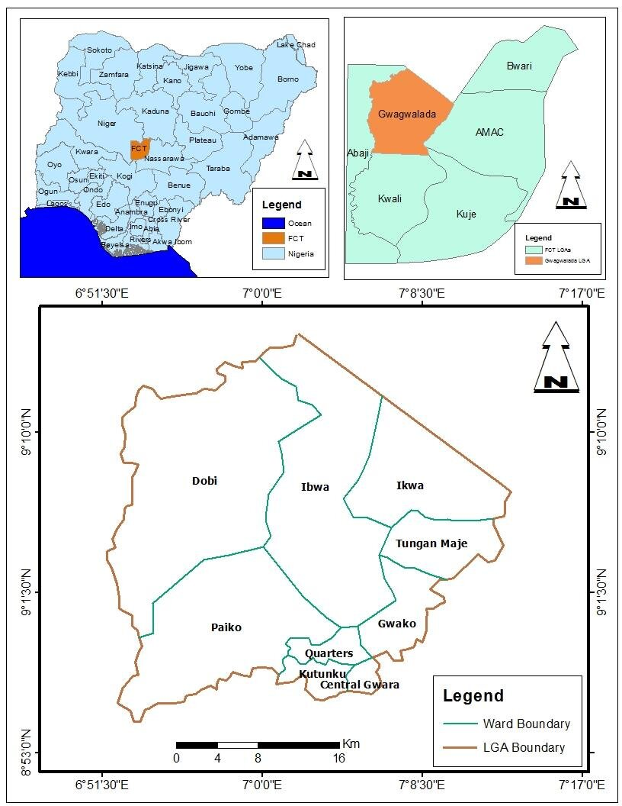
Figure 1: Map of Nigeria, FCT indicating Gwagwalada Area Council, Anagada and other environs (2025).

Sample Size and Collection
Fifty goats (mixed sexes and ages) were systematically randomly sampled during post-mortem examinations. Faecal samples were collected rectally using sterile gloves and labelled containers. Tissues with lesions/cysts were preserved in 10% formalin. Ethical approval was obtained from the FCT Ministry of Agriculture and Rural Development and abattoir veterinary officer.

Laboratory Techniques and Identification

Faecal Analysis
Collected faecal samples were examined using the floatation and sedimentation techniques to identify eggs of gastrointestinal helminths. Salt solution floatation technique was used for detecting nematode and cestode eggs, while formalin-ether sedimentation was employed for trematode eggs (Soulsby, 1986; Taylor et al., 2007).

Gross and Microscopic Identification
Organs were inspected for visible parasites or cysts. Identified helminths were washed, preserved in 70% ethanol, and examined under a stereomicroscope for species-level identification based on morphological keys. Staining with aceto-carmine was used for cestodes and trematodes to enhance internal structures for identification, while lacto-phenol clearing was used for nematodes (Urquhart et al., 1996).

Data and Statistical Analysis
Data obtained from both seasons were recorded and coded using Microsoft Excel 2020 and analysed with SPSS Version 25.0. Prevalence rates were calculated as the percentage of infected animals out of total examined. Differences in seasonal prevalence and parasite burden were tested using Chi-square (χ²) tests, and significance was determined at p < 0.05.

RESULTS

Sample Description and Overall Prevalence
A total of 50 faecal samples were collected from goat and examined in the Biological Science Laboratory. Using microscopic magnifications of 0.4X, 10X, and 40X, gastrointestinal parasites were observed in multiple forms, including circular eggs, eggs clustered, long shapes, and triangular shapes. Out of the 50 samples, 37 (74%) were positive for helminths parasites, while 13 (26%) showed no evidence of parasitism.

Category | Count
Total Samples | 50
Positive Samples | 37
Negative Samples | 13
Circular Shape | 12
Eggs Clustered | 12
Elongated Shape | 10
Oval/ellipsoidal Shape | 03
Table 1: Sample Description and Overall Prevalence

Parasite Observations
The morphological characteristics of helminth eggs detected in goat faecal samples showed considerable variation, reflecting the presence of multiple parasite species. Of the 50 samples examined, 37 (74%) were positive for helminth infection, while 13 (26%) were parasite-free (Table 1). The most frequently observed egg forms were circular/triangular structures and clustered eggs, each occurring in 12 samples (28%). Circular, thick-walled eggs were consistent with Toxocara vitulorum, whereas triangular-shaped eggs were characteristic of Moniezia expansa, both of which possess distinctive, well-defined outlines.
Eggs occurring in clusters were commonly observed and are suggestive of Eimeria oocysts or aggregated eggs of Strongyloides papillosus. Such clustering may indicate intense environmental contamination or high fecundity of the parasites. Elongated, thin-shelled eggs were identified in 10 samples (21%) and are typical of strongylid nematodes, including Haemonchus contortus, Trichostrongylus spp., and Oesophagostomum columbianum, which displayed visible internal morula under low magnification. In addition, oval/ellipsoidal egg forms were rarely encountered, appearing in only three samples (6%), and may represent partially embryonated or distorted eggs of Strongyloides spp. or damaged Trichuris ovis eggs, possibly resulting from environmental stress or sample degradation.
Overall, the wide range of egg morphologies observed indicates the occurrence of mixed helminth infections among the examined goats. The predominance of circular, triangular, and clustered egg forms suggests a higher occurrence of Toxocara, Moniezia, and Eimeria infections, while the detection of elongated and irregular eggs points to concurrent infections with gastrointestinal nematodes such as Haemonchus, Trichostrongylus, and Strongyloides species.
Prevalence by Age Group, Sex, and Management System
To better understand the risk factors, samples were categorized by age group, sex, and management system.

Sex: Male or Female goats.
Number Examined: Total number of goats examined for helminth parasites.
Positive Cases: Goats that tested positive for helminth eggs. Negative Cases: Goats that tested negative.
Prevalence is the proportion of individuals infected among those examined, usually expressed as a percentage. Overall, 74% of the goats had helminth infections. Females had a slightly higher prevalence (77.4%) compared to males (68.4%).
This suggests that female goats were more affected by helminth parasites than males.

Table 2: Prevalence of Gastrointestinal parasites based on Age Group
Age Group | Number Examined | Positive Cases | Negative Cases | Prevalence (%)
Kids (<6 months) | 17 | 11 | 6 | 64.7
Yearlings (6–12 months.) | 19 | 14 | 5 | 73.7
Adults (>12 months) | 14 | 8 | 6 | 57.1
Total | 50 | 37 | 13 | 66.0

Table 3: Prevalence of Gastrointestinal parasites based on Sex
Sex | Number Examined | Positive Cases | Negative Cases | Prevalence (%)
Male | 19 | 13 | 6 | 68.4
Female | 31 | 24 | 7 | 77.4
Total | 50 | 37 | 13 | 74.0

Age Group Distribution
The sampled goats were grouped as Kids (<6 months), yearlings (6–12 months), and adults (>12 months). Positive cases were distributed across all age groups. Out of 50 goats examined, 37 (74%) were positive for helminth infection, while 13 (26%) were negative. By age group, 11 of 17 goats under 6 months (64.7%) were infected, 14 of 19 yearlings aged 6–12 months (73.7%) were infected, and 8 of 14 adults over 12 months (57.1%) were infected. This shows that helminth infection occurs across all age groups, with yearlings being the most affected and adults the least, indicating that younger goats are more susceptible as showed in Table 2, Figure 1.

Sex Distribution
Goats were also categorized by sex. Positive cases were observed in both male and female groups. A total of 50 goats were examined, with 44 (74%) testing positive for helminth infection and 13 (26%) testing negative. Among males, 13 out of 19 (68.4%) were positive, while 6 (31.6%) were negative. Among females, 24 out of 31 (77.4%) were positive, and 7 (22.6%) were negative. This shows that helminth infection affects both sexes, with a slightly higher prevalence in females, see Table 3, Figure 2.

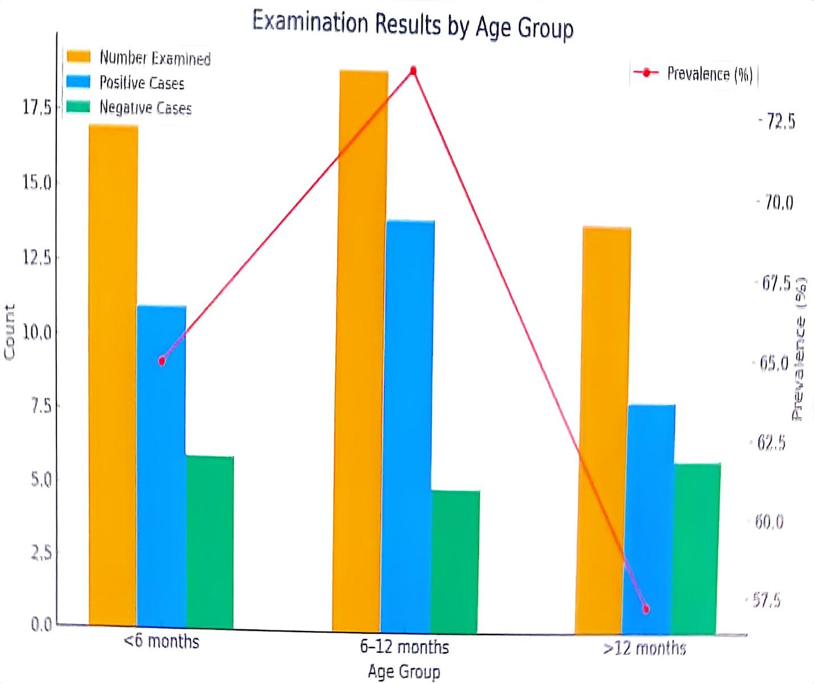
Figure 2: Graph showing Prevalence of Helminths parasites based on Age Group
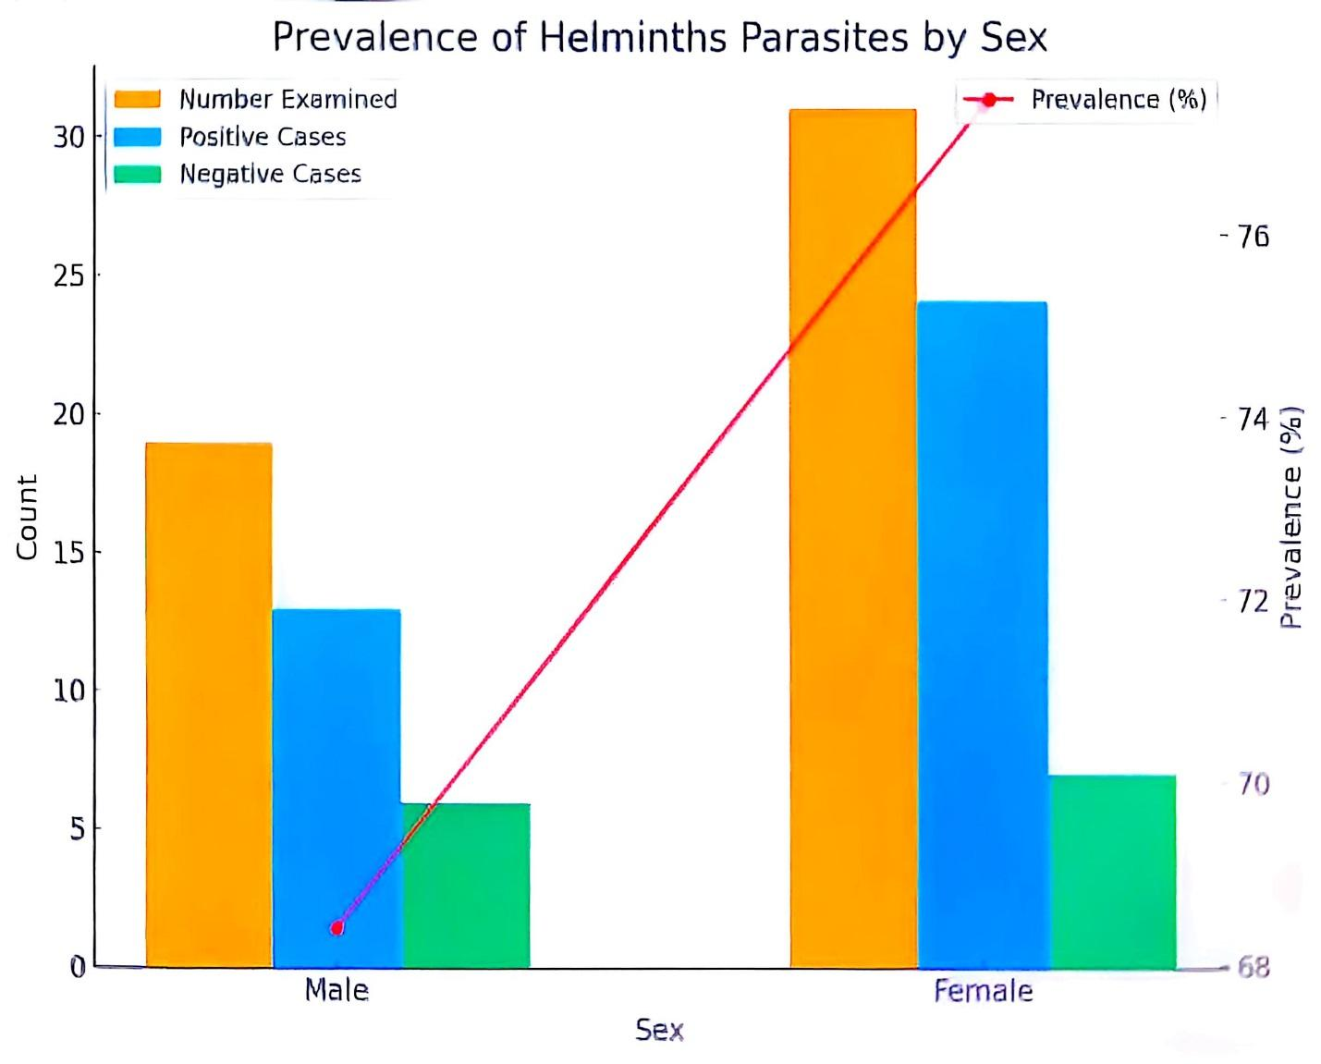
Figure 3: Graph showing Prevalence of Helminths parasites based on Sex
Management System
Samples were collected from goat raised under intensive, semi-intensive, and extensive management systems. A total of 50 goats were examined, and 44 (74%) were positive for helminth infection, while 13 (26%) were negative. By management system, 11 of 14 goats under intensive management (78.6%) were infected, 14 of 18 under semi-intensive management (77.8%) were infected, and 12 of 18 under extensive management (66.7%) were infected. This indicates that helminth infection occurs across all management systems, with slightly higher prevalence in intensively and semi-intensively managed goats compared to extensively managed ones. Figure 4 shows the prevalence of infection under each system.

Table 4: Prevalence of Helminths parasites based on Management System
Management System | Number Examined | Positive Cases | Negative Cases | Prevalence (%)
Intensive | 14 | 11 | 3 | 64.7
Semi-Intensive | 18 | 14 | 4 | 77.7
Extensive | 18 | 12 | 6 | 66.6
Total | 50 | 37 | 13 | 74.0

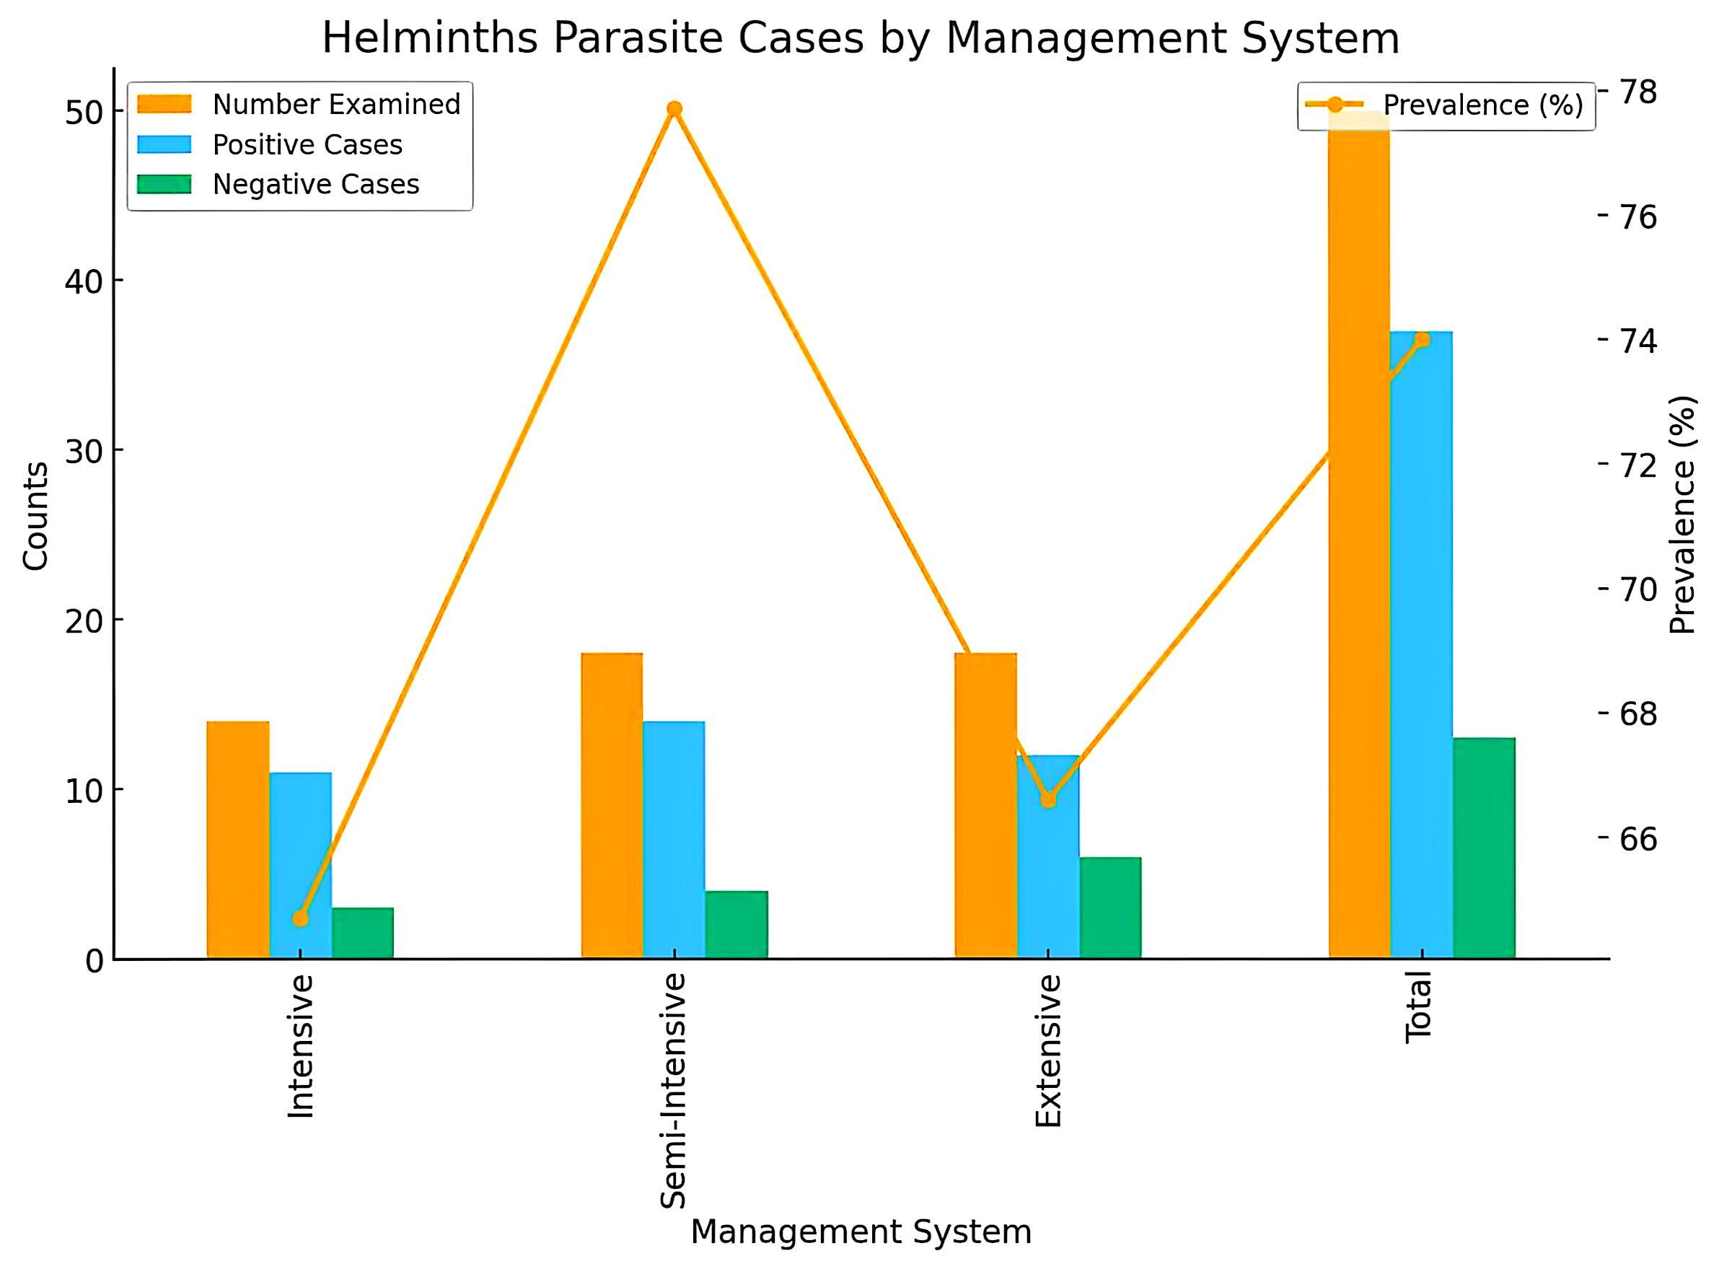
Figure 4: Graph showing Prevalence of Helminths parasites based on Management System

Chi-Square Analysis
Chi-square tests were performed to assess the association between infection status and each categorical variable. The p-values obtained indicate no statistically significant association between infection status and age, sex, or management system in this dataset
The chi-square analysis shows the relationship between different variables and helminth infection:
Age Group vs Infection: χ² = 0.98, df = 2, p = 0.61. This p-value is greater than 0.05, indicating no significant association between age group and infection.
Sex vs Infection: χ² = 0.00, df = 1, p = 1.00. The p-value shows no significant association between sex and infection.
Management System vs Infection: χ² = 1.37, df = 2, p = 0.51. Again, this is greater than 0.05, showing no significant association between management system and infection.
Overall interpretation: Although helminth infection occurred across all age groups, sexes, and management systems, none of these factors showed a statistically significant at P < 0.05.
Table 5: Analysis of Variables and Infection Status
Variable | χ² Value | df | p-value | Significance
Age Group vs Infection | 0.98 | 2 | 0.61 | Not significant
Sex vs Infection | 0.00 | 1 | 1.00 | Not significant
Management System vs Infection | 1.37 | 2 | 0.51 | Not significant

Discussion
The present study documents a high overall prevalence (74%) of gastrointestinal helminth infections among goats slaughtered at Anagada Abattoir, Gwagwalada Area Council, FCT-Abuja, underscoring the persistent endemicity of parasitic infections in small ruminant production systems in Nigeria. This prevalence is comparable to reports from other agro-ecological zones of the country, including Niger State (69.64%) (Eke et al., 2019), Plateau State (69–71.8%) (Atikum et al., 2021; Gofwan et al., 2024), Bauchi State (82.9%) (Oguche et al., 2025), and Ogbomoso, Oyo State (81.79%) (Rom-Kalilu et al., 2025). The consistency of these findings across regions suggests that gastrointestinal helminthiasis remains a widespread and unresolved constraint to goat productivity in Nigeria.
The marked diversity of egg morphologies observed circular, triangular, elongated, clustered, and oval/ellipsoidal indicates a complex pattern of mixed parasitic infections. Thick-shelled circular eggs consistent with Toxocara vitulorum and triangular eggs characteristic of Moniezia expansa were among the most frequently encountered. Although T. vitulorum is classically associated with calves, its detection in goats has been reported in abattoir-based surveys and may reflect accidental infection, cross-contamination in grazing environments, or misidentification with other ascarid-type eggs, highlighting the limitations of morphology-only diagnosis (Taylor et al., 2016; Zajac and Conboy, 2022). The presence of Moniezia expansa aligns with its known epidemiology, as oribatid mites its intermediate hosts are abundant in pasture-based systems common in the study area (Soulsby, 1986; Bowman, 2020).
Clustered eggs resembling Eimeria oocysts or aggregated Strongyloides papillosus eggs further emphasize the intensity of environmental contamination and the high reproductive potential of these parasites. Coccidiosis caused by Eimeria spp. is particularly important in young goats, where it contributes to subclinical production losses even in the absence of overt clinical signs (Chartier and Paraud, 2012; Dubey, 2019). The identification of elongated, thin-shelled eggs typical of strongylid nematodes such as Haemonchus contortus, Trichostrongylus spp., and Oesophagostomum columbianum is of major concern due to their well-documented pathogenicity, including anemia, weight loss, reduced carcass quality, and mortality (Besier et al., 2016; Kaplan and Vidyashankar, 2012).
Age-related prevalence patterns showed higher infection rates among kids and yearlings compared to adults, although differences were not statistically significant. This trend is biologically plausible and has been widely reported, as younger animals possess immature immune systems and have limited acquired resistance to helminths (Gofwan et al., 2024; Zvinorova et al., 2021). Adults, by contrast, often develop partial immunity that suppresses worm fecundity rather than eliminating infection entirely, resulting in lower egg output but continued pasture contamination.
Sex-based differences were minimal, with females showing slightly higher prevalence than males. Similar observations have been attributed to physiological stress associated with pregnancy and lactation, which can temporarily suppress immunity and increase susceptibility to infection (Rom-Kalilu et al., 2025; Oguche et al., 2025). However, the absence of statistical significance in this study suggests that both sexes are broadly exposed to similar infection pressures within the local production systems.
Across management systems, helminth infections were recorded under intensive, semi-intensive, and extensive systems, reflecting the pervasive nature of parasite transmission. The marginally higher prevalence in semi-intensive systems may be linked to the combined effects of grazing exposure and suboptimal hygiene in confinement, a pattern also noted in other Nigerian and sub-Saharan African studies (Elele et al., 2019; Chukwudi et al., 2024). The lack of significant associations between management system and infection status reinforces the notion that environmental contamination and inadequate parasite control measures, rather than housing type alone, are key drivers of infection.
Overall, the findings demonstrate that gastrointestinal helminth infections in goats slaughtered at Anagada Abattoir are widespread, multi-species in nature, and largely independent of host demographic factors. This situation poses serious implications for animal welfare, productivity, and food security, and also raises public health concerns where zoonotic species or contaminated meat handling practices are involved (WHO, 2021). The reliance on morphological identification, while practical in low-resource settings, further highlights the need for complementary molecular diagnostic approaches to improve species resolution and guide targeted control strategies (Avramenko et al., 2019; Roeber et al., 2022).

Conclusion

This study recorded a high prevalence of gastrointestinal helminths in goats slaughtered at Anagada Abattoir, with diverse egg morphologies indicating widespread mixed infections. The findings highlight the need for sustained surveillance and integrated parasite control measures to reduce transmission and production losses.

Recommendations
Based on the findings of this study, the following recommendations are made to minimize the burden of helminths parasites among goat in Anagada and similar environments:
- Routine deworming of goat using effective anthelmintics at appropriate intervals should be carried out to reduce parasite loads and prevent heavy infestations.
- Farmers should adopt rotational grazing and improved pasture management to minimize the contamination of grazing areas with parasite eggs and larvae..
- Farmers should be educated on parasite identification, prevention, and control strategies to enhance their knowledge and capacity for managing infections.

Disclaimer (Artificial intelligence)

Author(s) hereby declare that NO generative AI technologies such as Large Language Models (ChatGPT, COPILOT, etc.) and text-to-image generators have been used during the writing or editing of this manuscript.

REFERENCES
- Agbajelola, V. I. (2025). Epidemiology and control of gastrointestinal helminths of small ruminants under tropical management systems. Nigerian Journal of Parasitology, 46(1), 55–64.
- Akeju, O. O. (2024). Breed-related prevalence of gastrointestinal helminths in goats slaughtered in Ondo State, Nigeria. Journal of Veterinary Medicine and Animal Health, 16(2), 89–97. https://doi.org/10.5897/JVMAH2024.0987
- Atikum, A. M., Pam, V. A., and Dawang, M. L. (2021). Prevalence of gastrointestinal parasites of small ruminants in Plateau State, Nigeria. Nigerian Veterinary Journal, 42(3), 213–221.
- Avramenko, R. W., Redman, E. M., Lewis, R., Yazwinski, T. A., Wasmuth, J. D., & Gilleard, J. S. (2019). Exploring the gastrointestinal “nemabiome”: Deep amplicon sequencing to quantify the species composition of parasitic nematode communities. PLoS ONE, 14(1), e0210874. https://doi.org/10.1371/journal.pone.0210874
- Balarabe-Musa, U., Musa, H. I., and Sadiq, N. A. (2021). Prevalence of gastrointestinal helminths of goats slaughtered in Gwagwalada Area Council, Abuja, Nigeria. Sokoto Journal of Veterinary Sciences, 19(2), 112–119.
- Besier, R. B., Kahn, L. P., Sargison, N. D., and Van Wyk, J. A. (2016). Diagnosis, treatment and management of Haemonchus contortus in small ruminants. Advances in Parasitology, 93, 181–238. https://doi.org/10.1016/bs.apar.2016.02.006
- Bowman, D. D. (2020). Georgis’ parasitology for veterinarians (11th ed.). Elsevier.
- Chartier, C., and Paraud, C. (2012). Coccidiosis due to Eimeria in sheep and goats, a review. Small Ruminant Research, 103(1), 84–92. https://doi.org/10.1016/j.smallrumres.2011.10.022
- Chaudhry, U., Redman, E. M., Raman, M., and Gilleard, J. S. (2017). Genetic evidence for hybridisation between Haemonchus species parasitising small ruminants. International Journal for Parasitology, 47(4), 215–223. https://doi.org/10.1016/j.ijpara.2016.11.005
- Chukwudi, I. C., Eze, J. I., and Okonkwo, C. J. (2024). Management-associated risk factors of gastrointestinal helminth infections in goats in southeastern Nigeria. Tropical Animal Health and Production, 56, 112. https://doi.org/10.1007/s11250-024-03911-3
- Dubey, J. P. (2019). Coccidiosis in livestock, poultry, companion animals, and humans (2nd ed.). CRC Press.
- Eke, S. S., Omalu, I. C. J., and Otuu, C. A. (2019). Gastrointestinal helminth parasites of goats in Niger State, Nigeria. Journal of Applied Sciences and Environmental Management, 23(6), 1085–1090.
- Elele, K., Nzeako, S. O., and Iwu, C. J. (2019). Seasonal dynamics of gastrointestinal helminths of small ruminants in the humid tropics. Veterinary World, 12(8), 1234–1240. https://doi.org/10.14202/vetworld.2019.1234-1240
- FAO. (2020). FAOSTAT statistical database: Livestock population—Nigeria. Food and Agriculture Organization of the United Nations. https://www.fao.org/faostat
- Gofwan, J. G., Dogo, G. I., and Pam, D. D. (2024). Age-related prevalence of gastrointestinal helminths in goats slaughtered in Plateau State, Nigeria. Nigerian Journal of Animal Production, 51(1), 98–107.
- Ikeh, E. I., Obasi, N. L., and Mohammed, B. R. (2021). Climatic and environmental influences on livestock production systems in Abuja, Nigeria. African Journal of Environmental Science and Technology, 15(4), 134–143.
- Kaplan, R. M., and Vidyashankar, A. N. (2012). An inconvenient truth: Global worming and anthelmintic resistance. Veterinary Parasitology, 186(1–2), 70–78. https://doi.org/10.1016/j.vetpar.2011.11.048
- Mohammed, B. R., Adamu, N. B., and Abdullahi, U. S. (2017). Helminth parasites of small ruminants: Taxonomy and pathology. Journal of Veterinary Advances, 7(3), 810–818.
- Obasi, N. L., Ikeh, E. I., and Danjuma, A. (2019). Geographical and climatic characteristics of Gwagwalada Area Council, FCT-Abuja. Journal of Geography and Regional Planning, 12(5), 89–97.
- Oguche, S. O., Luka, S. A., and Abubakar, U. (2025). Prevalence and risk factors of gastrointestinal helminths in small ruminants in Bauchi State, Nigeria. Tropical Veterinary Journal, 43(1), 45–56.
- Roeber, F., Jex, A. R., and Gasser, R. B. (2022). Next-generation molecular-diagnostic tools for gastrointestinal nematodes of livestock. Parasitology, 149(1), 1–16. https://doi.org/10.1017/S0031182021001160
- Rom-Kalilu, A. O., Adeyemi, O. S., and Olatunji, E. A. (2025). Gastrointestinal helminth infections of small ruminants slaughtered in Ogbomoso, Nigeria. Journal of Parasitic Diseases, 49(2), 210–219.
- Soulsby, E. J. L. (1986). Helminths, arthropods and protozoa of domesticated animals (7th ed.). Baillière Tindall.
- Taylor, M. A., Coop, R. L., and Wall, R. L. (2007). Veterinary parasitology (3rd ed.). Blackwell Publishing.
- Taylor, M. A., Coop, R. L., and Wall, R. L. (2016). Veterinary parasitology (4th ed.). Wiley-Blackwell.
- Urquhart, G. M., Armour, J., Duncan, J. L., Dunn, A. M., & Jennings, F. W. (1996). Veterinary parasitology (2nd ed.). Blackwell Science.
- WHO. (2021). Control of neglected zoonotic diseases: A route to poverty alleviation. World Health Organization. https://www.who.int
- Zajac, A. M., and Conboy, G. A. (2022). Veterinary clinical parasitology (9th ed.). Wiley-Blackwell.
- Zvinorova, P. I., Halimani, T. E., Muchadeyi, F. C., Matika, O., Riggio, V., and Dzama, K. (2021). Breeding for resistance to gastrointestinal nematodes in small ruminants: A review. Animal, 15(2), 100–123. https://doi.org/10.1016/j.animal.2020.100123

