Original Research Article
Insights into Human–Animal Conflict in Southern Tamil Nadu

ABSTRACT
The study is aimed to explore the patterns, causes, and consequences of human-animal conflict (HAC) from the southern districts of Tamil Nadu, Tirunelveli (6,191 Sq. Km), Tenkasi (532.48 Sq. Km), Thoothukudi (4,707 Sq. Km), and Kanyakumari (1684 Sq. Km) between March 2024 and February 2025, totally 106 newspapers collected from Daily Thanthi and Thinakaran. During this period 94 conflict incidents were documented. The highest number of cases occurred in Tirunelveli (53.19%), followed by Tenkasi (38.3%), Thoothukudi (6.38%) and Kanyakumari (2.13%). Most conflicts occurred in agricultural areas (54.12%) and were concentrated during the night (45.88%) and daytime (43.53%). The primary causes of conflict included agricultural damage, livestock losses, infrastructure damage, and attacks on humans (injury/ kills), involving species such as elephants, wild pigs, bonnet macaques, langurs, and aggressive dogs. However, most conflict area was noted from Tirunelveli district, nearby Kalakad-Mundanthurai Tiger Reserve Forest boundary. This study emphasises the urgent need for mitigation measures, such as public awareness programs, better terrestrial-use planning, and coordinated efforts by forest authorities to balance conservation goals with human safety.
Keywords: Human-animal conflict, Newspapers, KMTR, Dog attacks, Tamil Nadu.

Garphical abstract
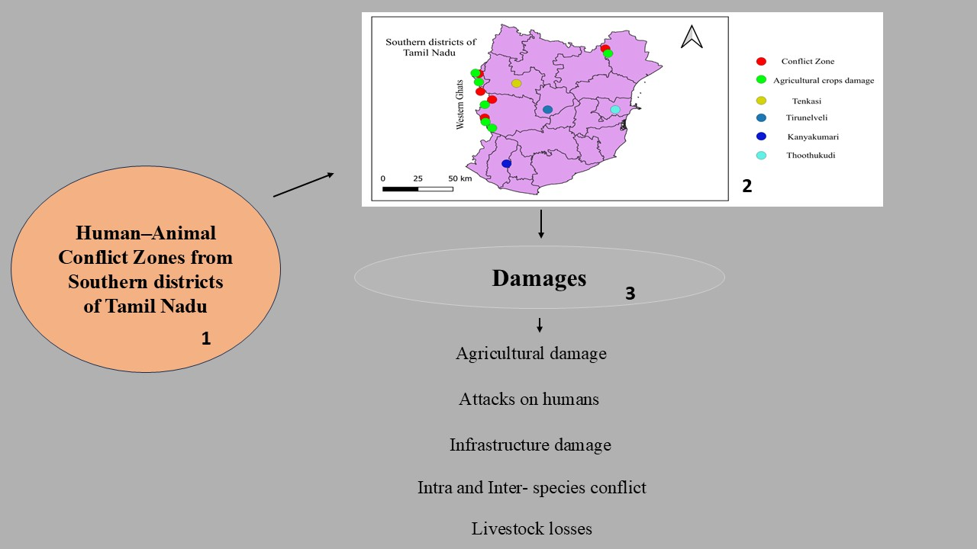
1. INTRODUCTION
Human-animal conflict (HAC) refers to interactions between wild animals and humans that result in either negative or positive consequences for both groups, it is a continuing global issue in our society (Kidane et al., 2024; König et al., 2020; Nyhus, 2016;). Most incidents are reported as negative, involving crops and livestock damage, property loss, and, in rare cases, leading to injury or loss of human life due to animal attacks and some of positive interaction like, environment enrichment, relaxation, animal learning etc., (Bharti et al., 2025; Gulati et al., 2021; Prasad, 2025; Ramseena, 2022; Rault et al., 2020; Senthilkumar et al., 2025). A significant number of conflict events have taken place outside designated protected forests. In contrast, nearly one-third have been recorded within legally protected zones such as national parks, wildlife sanctuaries, elephant and tiger reserves, and reserved forests (Anand & Radhakrishna, 2017). Elephants, wild boars, and bonnet macaques cause most agricultural damage, these wild animals damage major crops such as paddy, coconut, rubber, banana, jackfruit, areca palm, and mango, particularly in the Western Ghats. (Chitrambigai et al., 2025; Nair & Jayson, 2021; Ramseena, 2022;). The Western Ghats are a biodiversity hotspot, and the Kalakkad Mundanthurai Tiger Reserve (KMTR), located in this region, is one of the protected areas and it harbours endangered and endemic plant and animal species, including tigers, leopards, Asian wild dogs, Indian elephants, wild pigs, bonnet macaques, and tufted grey langurs (Annamalai, 2004; Vanaraj et al., 2024). In Tamil Nadu's conflict zones within the Western Ghats, a noted conflict area within KMTR spans about 3 km², followed by the Nellai Wildlife Sanctuary at 157 km² (Milda et al., 2023). Factors contributing to HAC include increasing human populations, land-use changes due to growing land demands, deforestation, food scarcity in the wild, climate change, and rising wildlife populations (Chitrambigai et al., 2025; Distefano, 2005; Singh & Singh, 2023; Somu and Palanisamy, 2022; Treves et al., 2009). Therefore, this study aims to address the human-animal conflict in the southern part of Tamil Nadu using the regional newspapers.
2. MATERIALS AND METHODS
This study examines human-animal conflict (HAC) in the southern districts of Tamil Nadu, including Tirunelveli (latitude 8°4301 N and longitude 77°4556 E (6,191 Sq. Km)), Tenkasi (latitude 8° 5728 N and longitude 77°1855 E (532.48 Sq. Km)), Thoothukudi (latitude 8° 4601 N and longitude 78° 0803 E (4,707 Sq. Km)), and Kanyakumari (latitude 8° 0516 N and longitude 77° 3253 E (1684 Sq. Km)) (Figure. 1), based on reports from regional newspapers such as Daily Thanthi and Thinakaran. The data were collected from 106 newspapers during the March 2024 – February 2025. In this period totally 94 incidents were recorded, with repeated incidents omitted. Data were selected based on specific criteria: biting (humans injured or killed by animals), hunting (animals injured or killed by humans), natural (natural deaths and flood-related incidents), and damages (agricultural loss, infrastructure destruction, and interspecies conflict).
3. Result and Discussion
3.1 Taxonomy Classification
Table 1. Taxonomy Classification and Common name of wild animals.

S. No | Kingdom | Phylum | Class | Order | Family | Genus and Species | Common name
1 | Animalia | Chordata | Mammalia | Proboscidea | Elephantidae | Elephas maximus (Linnaeus, 1758) | Asian elephant
2 | Animalia | Chordata | Mammalia | Carnivora | Felidae | Panthera tigris (Linnaeus, 1758) | Tiger
3 |  |  |  |  |  | Panthera pardus (Linnaeus, 1758) | Leopard
4 |  |  |  |  | Ursidae | Melursus ursinus (Shaw, 1791) | Sloth bear
5 |  |  |  |  | Viverridae | Paradoxurus hermaphroditus (Pallas, 1777) | Asian palm civet
6 | Animalia | Chordata | Mammalia | Artiodactyla | Suidae | Sus scrofa (Linnaeus, 1758) | Wild pig
7 |  |  |  |  | Cervidae | Rusa unicolor  (Kerr, 1792) | Sambar deer
8 | Animalia | Chordata | Mammalia | Primates | Cercopithecidae | Macaca radiata (É. Geoffroy Saint-Hilaire, 1812) | Bonnet macaque
9 |  |  |  |  |  | Semnopithecus priam  Thersites (Blyth, 1847) | Gray langur
10 | Animalia | Chordata | Reptilia | Squamata | Pythonidae | Python molurus (Linnaeus, 1758) | Indian Python
11 |  |  |  |  | Elapidae | Ophiophagus hannah (Cantor, 1836) | King Cobra
12 |  |  |  |  | Viperidae | Daboia russelii (George Shaw, 1797) | Russell’s Viper

3.2 Human – Animal Conflict (HAC)
Most of the conflict incidents occurred in areas surrounding the Western Ghats Forest, particularly in northern Tenkasi (Puliyarai Reserve Forest), central Tirunelveli (Kalakad-Mundanthurai Tiger Reserve - KMTR), and southern Kanyakumari (Kanyakumari Wildlife Sanctuary), where forest boundaries are shared with Tamil Nadu and, to the west, with the Periyar Tiger Reserve in Kerala.
During the period from March 2024 to February 2025, a total of 94 conflict-related reports were documented in newspapers, with Tirunelveli recording the highest number of incidents (50 reports, 53.19%), followed by Tenkasi (36 reports, 38.3%), Thoothukudi (6 reports, 6.38%), and Kanyakumari (2 reports, 2.13%) (Figure 2 - A), while the most dominant incidence in agricultural crop damage (24), followed by wild animal attacks on humans (16), people being scared by wild animals (15), intraspecies conflict (14), and the forest department rescuing wild animals from the residency area (10) (Figure 2 - B). Analysis of temporal activity patterns revealed that 45.88% of animal activity occurred during the night, followed by 43.53% during the daytime, 8.25% in the evening, and 2.35% in the morning hours (Figure 3 A). During this period, 54.12% of wild animal encounters occurred in agricultural areas, which was higher compared to nearby forest and residential areas. The wild animals are damage crops such as banana, coconut, palmyra palm, jackfruit, mango, and paddy, and also caused damage to infrastructure in residential zones near forests (Gemeda & Meles, 2018) (Figure 4). Several farmers were injured by wild animal attacks (Kandel et al., 2023; Wani, 2023), particularly in forest-adjacent regions, and wild animals were also reported to attack domestic animals like goats and street dogs (Derebe et al., 2022; Pant et al., 2023) (Table 2 and Figure 3 B). Residents living near forest areas expressed fear of wild animal activity during both day and night. In areas like V.K. Puram and Papanasam, bonnet macaques and grey langurs were reported to bite humans and damage infrastructure, leading to multiple injuries (Karayathil et al., 2023) (Figure 4 and Table 2). Table 3 documents aggressive dog attacks on both humans and other animals in three districts. Additionally, many reptiles, leopards, and monkeys were recovered by the forest department from residential areas.
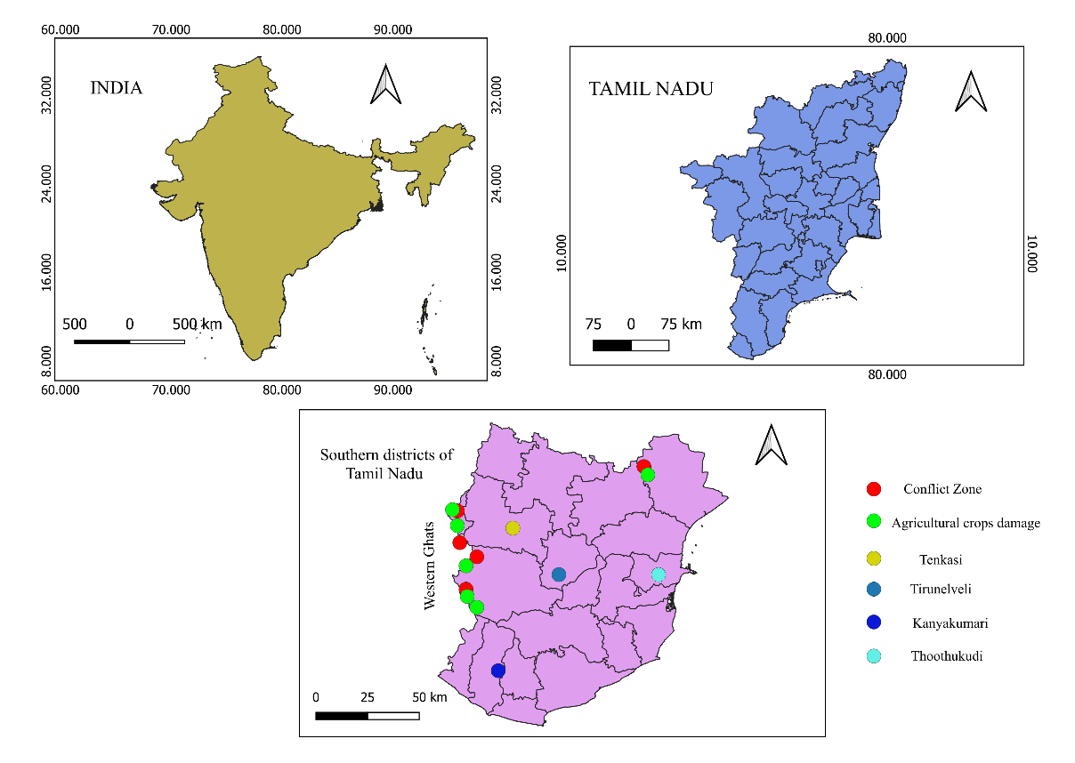
Fig. 1. Human–Animal Conflict and Crop Damage Zones in the Southern Districts of Tamil Nadu, India

In some cases, natural disasters – such as floods – led to wildlife fatalities; for example, two elephants were found dead, one at Papanasam (Servalar dam) and another near Courtallam Falls. Inter-species conflicts, such as an elephant death reported from Sengottai (Table 2), also contributed to the conflict records. Furthermore, incidents of illegal hunting were documented, including the poaching of elephants for tusks, and hunting of wild pigs (Table 2), monitor lizards, and rabbits. And forest department apprehended individuals who involved in these illegal activities. Finally, most of the conflict zone was noted nearby the protected area of the Kalakad-Mundanthurai Tiger Reserve Forest boundary (Papanasam, Sivanthipuram, V.K. Puram, Manimutharu, Kalakad, and Thirukkurungudi) from Tirunelveli district compare to other three districts.
3.3 Consequences of Human – Animal Conflict
In this exploration, we noted the consequences from human animal conflict during this present study area were evident at social, livelihood, and conservation. Agriculture crop damage was repeated incident are reported in newspapers, this damage’s reducing agriculture yield and psychological stress among the societies. Livestock attack was commonly document from the forest boundary areas nearby villages. Sometimes, human animal conflict follow-on retaliatory strikes against wildlife (Habib et al., 2015). These action posing challenges to the conservation efforts.

Table 2. The list of Human - Animal Conflict from three districts of Tamil Nadu.
S. No | District | Place | Coordinates | Damage Caused by Animal/Human | Injured/ Killed by animal attack | Date and Newspaper
1 | Tirunelveli | Papanasam | latitude 8°4252 N and longitude 77° 2200 E | Human | One Wild pig killed by hunting | 3/3/2024 (DK)
1 | Tirunelveli | Sivanthipuram | latitude 8° 4150 N and longitude 77° 2422E | Bonnet macaque | Two persons injured | 06/05/2024 (DT)
1 | Tirunelveli | V.K. Puram | latitude 8°4305 N and longitude 77°2302 E | Grey langur | One person injured | 21/05/2024 (DT)
1 | Tirunelveli | Kalakad | latitude 8°3055 N and longitude 77°3303E | Sloth bear | One person Injured | 19/06/2024 (DT)
1 | Tirunelveli | Panagudi | latitude 8°1858 N and longitude 77°3421E | Leopard | Seven Goats killed | 30/07/2024 (DT)
1 | Tirunelveli | Kalakad | latitude 8°3055 N and longitude 77°3303E | Wild pig | One farmer injured | 10/09/2024 (DT)
1 | Tirunelveli | Thirukkurungudi | latitude 8°2606 N and longitude 77°3401E | Wild pig | One farmer injured | 21/09/2024 (DT)
1 | Tirunelveli | Sivanthipuram | latitude 8°4150 N and longitude  77°2422 E | Indian Python | One hen killed | 22/09/2024 (DT)
1 | Tirunelveli | Manimutharu | latitude 8°4002 N and longitude 77°2437E | Leopard | One goat killed | 25/09/24 (DK)
1 | Tirunelveli | V.K. Puram | latitude 8°4305 N and longitude 77°2302E | Leopard | One Street dog injured | 28/11/2024 (DT)
1 | Tirunelveli | Manimutharu | latitude 8°4002 N and longitude 77°2437E | Leopard | Two goats killed | 29/11/2024 (DT)
2 | Tenkasi | Sengottai | latitude 8°5822 N and longitude 77°1453E | Asian elephant | Killed by same species | 31/05/2024 (DT)
 |  |  |  | Asian elephant | One person injured | 27/08/2024 (DT)
2 | Tenkasi | Kadayam | latitude 8°4908 N and longitude 77°2215 E | Leopard | One dog death | 29/09/2024 (DT)
2 | Tenkasi | Alwarkurichi | latitude 8°4644 N and longitude 77°2328 E | Sloth bear | One person injured | 15/10/2024 (DT)
2 | Tenkasi | Kadayanallur | latitude 9°0527 N and longitude 77°1854E | Unknown animal | One goat killed | 03/12/2024 (DK)
 |  |  |  | Indian Python | One goat killed | 17/01/2025 (DT)
3 | Thoothukudi | Thoothukudi | latitude 8°4421 N and longitude 78°0640 E | Asian elephant | One person killed | 19/05/2024 (DT)
3 | Thoothukudi | Ettayapuram | latitude 9°0852 N and longitude 78°0009E | Wild pig | Three persons was injured | 23/11/2024 (DT)
* DT- Daily Thandi and DK – Dinakaran.

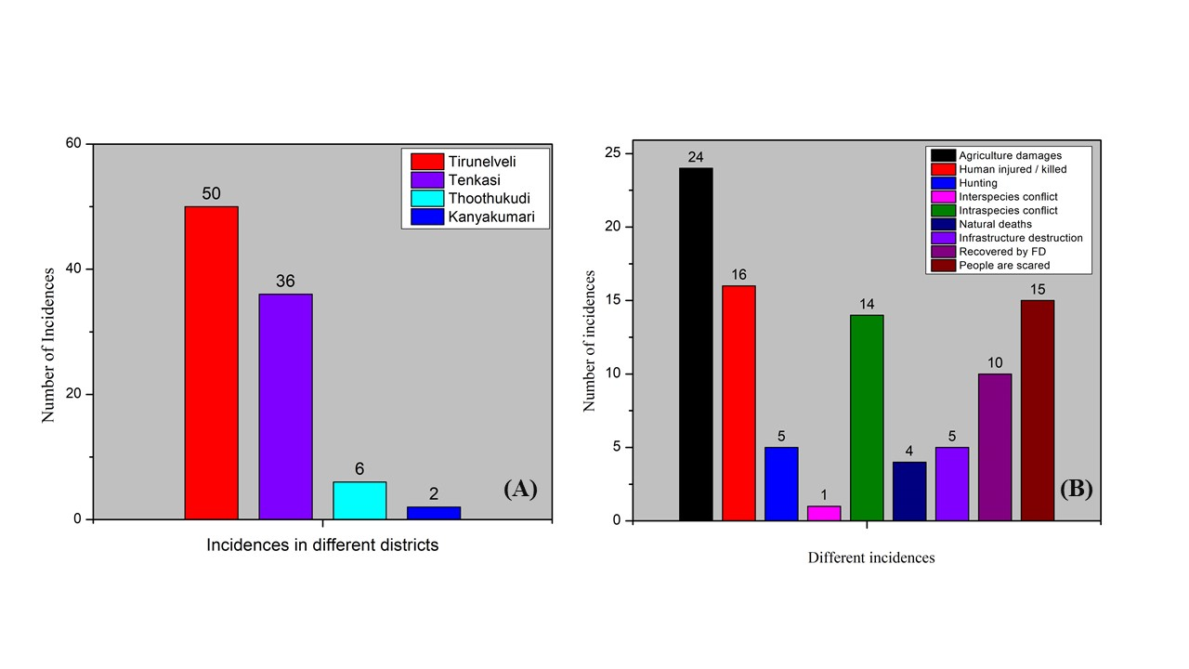
Fig. 2 A. - Number of incidents from different districts and B - Number of different incidents from March 2024 – February 2025.

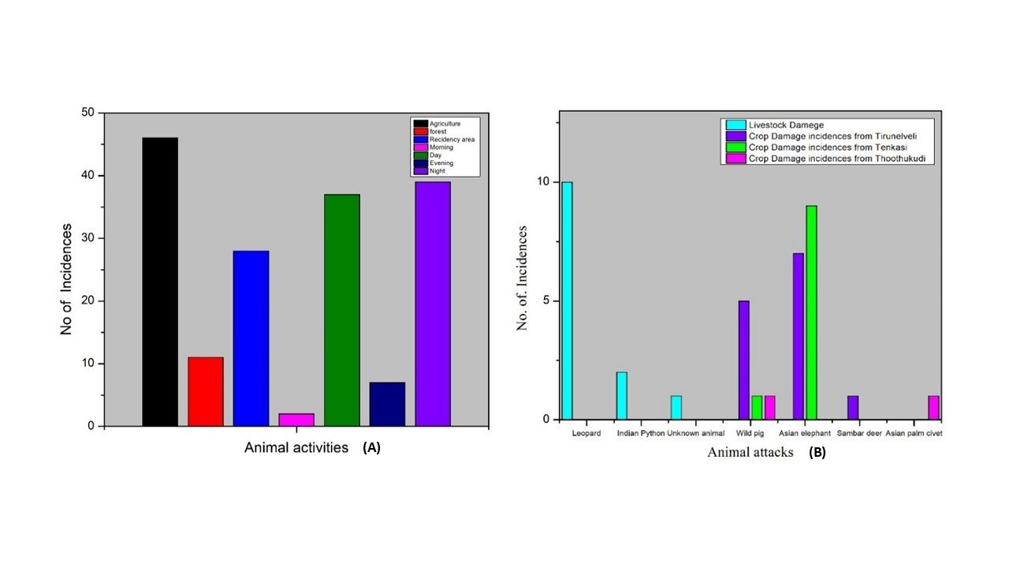

Fig. 3. (A) Animal activities from different area, and (B) Livestock and crop damage from March 2024 – February 2025.

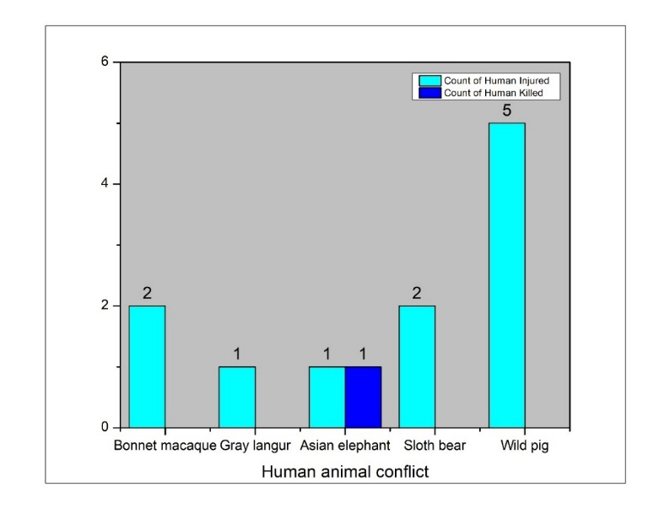

Fig. 4. Human injured / killed by wild animals from March 2024 – February 2025

Table 3. Dog attack on humans and livestock’s
S. No | District | Place | Coordinates | Newspaper, Date and Area | Bite  (Injured/ death)
1 | Tirunelveli | Panagudi | latitude 8°1858 N and longitude 77°3421 E | 30/06/2024 DT (AG) | Fifteen Goats death
2 | Tenkasi | Sengottai | latitude 8°5810 N and longitude 77°1409 E | 23/06/2024 DK (RES) | One Persons Injured
2 | Tenkasi | Kadayanallur | latitude 9°0439 N and longitude 77°1932 E | 23/07/2024 DT (RES) | One Persons Injured
2 | Tenkasi | Alwarkurichi | latitude 8°46'45"N and longitude 77°23'40"E | 29/07/2024 DK (RES) | One Persons Death
2 | Tenkasi | Surandai | latitude 8°58'37"N and longitude 77°24'52"E | 26/08/2024 DT (RES) | Eight Persons was Injured
3 | Thoothukudi | Sathankulam | latitude 8°26'56"N and longitude 77°55'09"E | 13/03/3025 DT (AG) | Thirty goat deaths
* DT- Daily Thandi and DK – Dinakaran. Area – (AG- Agriculture area and RES - Residency area).

A total of 11 wildlife reserves is located in India, more than 5,100 households, where farmers experience negative relationships with wild animals such as elephants, nilgai, and wild pigs (Gulati et al., 2021). Karanth et al., (2012) further investigation and concluded that the majority of conflict is reported during September and December, and the highest number reported in October from central India’s protected area. Mishra et al., (2025) reported that in the state of Odisha, sloth bears have been entering the forest edges during the day or night, resulting in injuries and deaths to humans. The agriculture crops massive loss due to Asian Elephants from the surrounding area of Chhattisgarh's protected area was also reported (Natarajan et al., 2025) and noted in our present study from the surrounding the protected area. Qureshi et al., (2024) reported that leopard’s attack and consumes livestock and sometimes attack and consume humans as their preys. In Wayanad wildlife sanctuary, Münster and Münster (2012) reported that elephants have been moving out from the sanctuary and damaging agriculture crops and killing humans, and the highest number of conflicts was reported from the state of Kerala, India (Akhilraj and Sendhil, 2025). As per the report from Anand and Radhakrishna (2017), 90% of India is now affected due to Human animal Conflicts. However, despite the high number of HWCs reported from various regions. Stevens et al., (2025) reported from their survey 60% of the people have shown concerns and responsibility towards conserving wildlife, and most people have shown negative attitudes towards killing wild animals and have shown positive attitudes towards conserving and protecting wild animals and their habitats. Milda et al., (2023) reported from their survey conducted among 1,460 households from the Western Ghats region of Tamil Nadu that 50% reported crop damage by wild pigs at various growth stages and 43% reported attacks on matured crops or harvest -stages crops. similarly, most of the incidence was noted on agriculture crop damages from western ghats region of Tirunelveli and Tenkasi district. Shameer et al., (2025) observed that gaur-related events are high in frequency from December to March, crop damage and injuries to humans by gaur are common in various forest divisions in Tamil Nadu. Besides, Senthilkumar et al., (2024) observed that a large or small group of monkeys entering villages in Chengalpattu district poses a threat.
4. Conclusion
The present study highlights the growing human- animal conflict from the southern districts of Tamil Nadu, particularly in Tirunelveli and Tenkasi districts are sharing the protected area boundary line from the western ghats. These boundary Nearby villages wild animals are led more consequences like, agriculture crop damage, livestock loss, human injuries, and infrastructure destruction. The findings emphasise the urgent need for conflict mitigation strategies, awareness programs, early warning system, and collaborative efforts between forest departments and local communities to ensure both human safety and wildlife conservation as an outline of recommendation.
Ethical Clearance
This study is based on secondary data from the newspaper. And we do not involve direct interaction with human participants and animals. So, ethical clearance is not required for this work.

Disclaimer (Artificial Intelligence)
Author(s) hereby declare that no AI technologies have been used during the writing or editing of
Manuscripts (including Photos).
REFERENCES
- Akhilraj, M, & Sendhil, R. (2025). Managing Human-animal Conflict in India: Insights from a Meta-analysis, PREPRINT (Version 1) available at Research Square, https://doi.org/10.21203/rs.3.rs-7348868/v1
- Akhilraj, M., & Sendhil, R. (2025). Managing Human-animal Conflict in India: Insights from a Meta-analysis. https://doi.org/10.21203/rs.3.rs-7348868/v1
- Anand, S., and Radhakrishna, S. (2017). Investigating trends in human-wildlife conflict: is conflict escalation real or imagined?. Journal of Asia-Pacific Biodiversity, 10(2): 154-161. https://doi.org/10.1016/j.japb.2017.02.003
- Annamalai. R. (2004). Biodiversity of Kalakad mundanthurai Tiger Reserve. Lovely offset printer Sivakasi Tamilnadu, 80.
- Bharti, S., Kumar, G., & Kapoor, G. (2025). Navigating Human-wildlife Conflict: Key Species, Impacts, Mitigation and Challenges in Himachal Pradesh, India. Asian Journal of Research in Zoology, 8(1), 33-49. https://doi.org/10.9734/ajriz/2025/v8i1180.
- Chitrambigai, K., Prabu, M., Kathiravan, G., Sreekumar, C., & Senthilkumar, K. (2025). Analysis of factors influencing human-wildlife conflict in the western Ghats of Tamil Nadu. International Journal of Advanced Biochemistry Research, 9(8): 41-44. https://www.doi.org/10.33545/26174693.2025.v9.i8a.5076
- Derebe, B., Derebe, Y., & Tsegaye, B. (2022). Human‐Wild Animal Conflict in Banja Woreda, Awi Zone, Ethiopia. International Journal of Forestry Research, 2022(1): 4973392. https://doi.org/10.1155/2022/4973392
- Distefano, E. (2005). Human-Wildlife Conflict worldwide: collection of case studies, analysis of management strategies and good practices. Food and agricultural organization of the United Nations (FAO), Sustainable agriculture and rural development initiative (SARDI), Rome, Italy. Available from: FAO Corporate Document repository, http://www. fao. org/documents
- Gemeda, D. O., & Meles, S. K. (2018). Impacts of human-wildlife conflict in developing countries. Journal of Applied Sciences and Environmental Management, 22(8): 1233-1238. https://dx.doi.org/10.4314/jasem.v22i8.14
- Gulati, S., Karanth, K. K., Le, N. A., & Noack, F. (2021) Human casualties are the dominant cost of human–wildlife conflict in India. Proceedings of the National Academy of Sciences, 118(8), e1921338118. https://doi.org/10.1073/pnas.1921338118
- Habib, A., Nazir, I., Fazili, M. F., & Bhat, B. A. (2015). Human-wildlife conflict-causes, consequences and mitigation measures with special reference to Kashmir. The Journal of Zoology Studies, 2(1), 26-30.
- Kandel, S., Silwal, T., Yadav, S. K., & Dhakal, S. (2023). Temporal and spatial pattern of wildlife attacks on human in Chitwan National Park, Nepal. Nepalese Journal of Zoology, 7(1): 7-13. https://doi.org/10.3126/njz.v7i1.56305
- Kanya. T. (2025). Conflict Or Co-Existence: Study on Human Animal Interactions in Sirumugai’s Forest Villages. International Journal of Creative Research Thoughts (IJCRT). 13, (1): f174- 178
- Karanth, K. K., Gopalaswamy, A. M., DeFries, R., & Ballal, N. (2012) Assessing patterns of human-wildlife conflicts and compensation around a central Indian protected area. PloS one, 7(12): e50433. https://doi.org/10.1371/journal.pone.0050433
- Karayathil, A. K., Gurusiddappa, L. H., & Shivasundari, R. S. M. (2023). Human-monkey (Macaca Radiata) conflict in chamundi hill-Mysuru, Karnataka. World Journal of Environmental Biosciences, 12: 19-25. https://doi.org/10.51847/dpGQL4yAXY
- Kidane, E. E., Kiros, S., Berhe, A., & Girma, Z. (2024). Human Wildlife conflict and Community Perceptions Towards Wildlife Conservation in and Around a Biodiverse National Park, Northern Ethiopia. Global Ecology and Conservation, 54 e03072. https://doi.org/10.1016/j.gecco.2024.e03072.
- König, H. J., Kiffner, C., Kramer‐Schadt, S., Fürst, C., Keuling, O., & Ford, A. T. (2020). Human–wildlife coexistence in a changing world. Conservation Biology, 34(4): 786-794. https://doi.org/10.1111/cobi.13513
- Milda, D., Ramesh, T., Kalle, R., Gayathri, V., Thanikodi. M., & Ashish, K. (2023). Factors driving human–wild pig interactions: implications for wildlife conflict management in southern parts of India. Biological Invasions, 25(1): 221-235. http://dx.doi.org/10.1007/s10530-022-02911-6
- Mishra, S. P., Barik, S. R., Sahu, D. K., & Padhi, S. (2025). Mapping Human-Wildlife Conflict Hotspots in Odisha, India: Trends, Impacts, and Mitigation Strategies. Annual Research & Review in Biology, 40(3): 116-141. http://dx.doi.org/10.9734/arrb/2025/v40i32216
- Münster, D., & Münster, U. (2012). Human-animal conflicts in Kerala: Elephants and ecological modernity on the agrarian frontier in South India. RCC Perspectives; 5: 41-50.
- Nair, R. P, & Jayson, E. A. (2021). Estimation of economic loss and identifying the factors affecting the crop raiding behaviour of Asian elephant (Elephas maximus) in Nilambur part of the southern Western Ghats, Kerala, India. Current Science, 121(4): 521-528. http://dx.doi.org/10.18520/cs/v121/i4/521-528
- Natarajan, L., Nigam, P., & Pandav, B. (2025). Human–elephant conflict in expanding Asian elephant range in east-central India: implications for conservation and management. Oryx, 1-9. https://doi.org/10.1017/S0030605324000930
- Nyhus P. J. Human–wildlife conflict and coexistence. Annual review of environment and resources 2016; 41(1): 143-171. https://doi.org/10.1146/annurev-environ-110615-085634
- Pant, B., Sharma, H. P., Dahal, B. R., Regmi, S., & Belant, J. L. (2023). Spatio-temporal patterns of human-wildlife conflicts and effectiveness of mitigation in Shuklaphanta National Park, Nepal. PLoS One, 18(4): e0282654. https://doi.org/10.1371/journal.pone.0282654
- Prasad, R. N. (2025). Patterns and Drivers of Livestock Depredation in Human-Wildlife Conflict Zones: A Case Study from Valmiki Tiger Reserve, India. Asian Journal of Research in Zoology, 8(4), 257-265. https://doi.org/10.9734/ajriz/2025/v8i4236.
- Qureshi, Q., Jhala, Y. V., Yadav, S. P., Tiwari, V. R., Garawad, R., & Mallick, A. (2024) Status of leopards in India, 2022. National Tiger Conservation Authority, Government of India, New Delhi, and Wildlife Institute of India, Dehradun, (No. 2023/03, p. 5).
- Ramseena, P. P. (2022) "The Effects of Human-Wildlife Conflict on Women and it’s Alternatives: Experiences from Kerala." Changing Status of Women In post-independence India, 117.
- Rault, J. L., Waiblinger, S., Boivin, X., & Hemsworth, P. (2020). The power of a positive human–animal relationship for animal welfare. Frontiers in veterinary science, 7, 590867.
- Senthilkumar, K. Mathialagan, P. Manivannan, C. (2025). Economic impact of human-wildlife conflicts on agriculture-based livelihood in the forest buffer zones of Tamil Nadu. Int J Agric Extension Social Dev, 8(6S):91-93. DOI: 10.33545/26180723.2025.v8.i6Sb.2039
- Senthilkumar, K., Mathialagan, P., & Manivannan, C. A. (2024). case study on conflict between human and monkey at Chengalpet district, Tamil Nadu. International Journal of Veterinary Sciences and Animal Husbandry, 9(1): 1205-1207. https://doi.org/10.22271/veterinary.2024.v9.i1q.1105
- Shameer, T. T., Routray, P., Udhayan, A., Kanchana, R., Sekar, S., Shankar, S., & Subramaniyam, S. (2025). Ecological and temporal drivers of human-gaur conflict in Tamil Nadu, India. Discover Animals, 2(1): 1-19. https://doi.org/10.1007/s44338-025-00100-y
- Singh, S, & Singh, S. (2023). Human-wildlife conflict and coexistence. Biophilia Insights, 1(2). http://dx.doi.org/10.52679/bi.e202312004
- Somu, Y., & Palanisamy, S. (2022). Human–wild animal conflict. In Animal Welfare-New Insights. IntechOpen. DOI: 10.5772/intechopen.107891
- Stevens, M., Rawat, S., & Satterfield, T. (2025) Care, conflict, and coexistence: Human–wildlife relations in community forests. People and Nature, 7(1): 231-246. DOI: https://doi.org/10.1002/pan3.10760
- Treves, A., Wallace, R. B., & White, S. (2009). Participatory planning of interventions to mitigate human–wildlife conflicts. Conservation biology, 23(6): 1577-1587.
- Vanaraj, G, Pragasan, L. A, & Mutheeswaran, S. (2024). Observations of interspecific grooming in Tufted grey langurs (Semnopithecus priam priam). Species, 25: e10s1636 https://doi.org/10.54905/disssi.v25i75.e10s1636
- Wani, A. A. (2025). Human Wild Life Conflict in Chenab Region of Jammu and Kashmir, Its Consequences and Mitigation Strategies. Haya Saudi J Life Sci, 10(5): 170-175. https://doi.org/10.36348/sjls.2025.v10i05.003

