Original Research Article
Climate Variability and Rice Production Vulnerability in Coastal Bangladesh: A District-Level Panel Data Analysis

ABSTRACT

Rice is a primary staple crop and a key contributor to food security in Bangladesh; however, rice production in coastal regions is increasingly threatened by climate variability, particularly fluctuations in temperature and precipitation. Despite growing concern, district-level analyses linking climatic factors with rice production in coastal Bangladesh remain limited. This study therefore examines the influence of major climatic parameters on rice production across 19 coastal districts using data from the Bangladesh Bureau of Statistics (BBS) and the Bangladesh Meteorological Department (BMD) covering 2006-2020.
Descriptive statistics were used to assess production trends, while unit root tests and fixed and random effects (FE/RE) panel data regression were applied to evaluate the relationship between climatic variables and rice production. The results reveal clear spatial variation in seasonal rice cultivation, with Aus predominating in Chattogram, Aman in Jessore, and Boro in Bhola districts. Climate-yield relationships were found to be complex: moderate temperature increases supported Aus and Aman production by accelerating crop growth, whereas excessive heat during critical growth stages reduced yields. Increased rainfall and cultivated land availability were positively associated with production across all major rice seasons.
The findings emphasize the importance of adaptive strategies, including improved water management and stress-tolerant cultivation practices, to reduce climate-related risks. Policy recommendations include promoting climate-resilient rice varieties, targeted water management, and extension services to strengthen coastal food security under changing climatic conditions.

Keywords: Rice production, Climate change, Panel regression, Coastal region.
- INTRODUCTION
Bangladesh features over 11.54 million acres of rice-growing area, making it the fourth-largest rice-producing nation globally. About 95.4% of the nation's total cereal production is made up of rice alone (BBS, 2006). Over the years, rice has been the fundamental means of sustenance, and almost 70% of the country’s arable land is being used for rice farming (Karim et al., 2012). In Bangladesh, rice is farmed in three distinct growing seasons: Aus, Aman, and Boro. Aus is the pre-monsoon season and Aman is the monsoon season for rice cultivation. On the other hand, rice that has been watered is grown during the Boro dry season (Bhattacharya et al.,2019). Boro is the most productive of these seasons, contributing over 54% of the total rice produced (BBS, 2019; BRRI, 2019). However, anthropogenic interference, recurrent droughts, and saline intrusion-all brought on by climate change have a significant negative impact on the production of rice during the Boro season (Chowdhury et al., 2011; Paul and Vogl, 2011; Islam et al., 2021). Over many years, several challenges related to climate change have affected Bangladesh's rice output. Bangladesh's coastal regions are vulnerable to climate-related events, salinity, and waterlogging, all of which affect the country's agricultural output. Climate change refers to the experience of changing patterns of the climatic parameters of rainfall, temperature, humidity, sunshine hour, etc. Rice production is interrelated to climatic conditions that can affect crops through evaporation, transpiration, and condensation having adverse impacts on production (Rahman et al., 2017). Roughly 71% of all field crops are rice, with HYV Boro rice making up the majority of Bangladesh's rice production (Shahid, 2011). Numerous research has evaluated the predicted effects of temperature and precipitation variations on the crop yield of HYV Boro because of its significance. For instance, others found that rainfall did not affect the yield of Boro, while the maximum temperature had a statistically significant adverse effect on yield (Sarkeret al., 2012). The lowest temperatures had a statistically significant positive effect. This time series analysis covered the years 1972–2002. In 12 regions of Bangladesh, another study projected that by 2050, the yield of two kinds of Boro would fall by 20%, mostly as a result of rising both maximum and lowest temperatures (Basaket al., 2010).
Rice production, especially in Bangladesh, is greatly impacted by coastal territories. The coastal area of Bangladesh comprises 19 districts facing or near the Bay of Bengal, encompassing 148 sub-districts such as Jessore, Narail, Gopalganj, Shariatpur, Chandpur, Satkhira, Khulna, Bagerhat, Pirozpur, Jhalakati, Barguna, Barisal, Patuakhali, Bhola, Lakshmipur, Noakhali, Feni, Chittagong, and Cox's Bazar. The coastal area covers about 20% of the country and over 30% of the net cultivable area. The country's coastline makes up 20% of its land area and more than 30% of its net cultivable area. 150 kilometers are covered by it inland from the coast. Of the total rice produced in Bangladesh, 18% comes from the coastal region, which produces 22% of the nation's rice (BBS, 2009–10). These regions usually have good soils, irrigation water availability, and climates conducive to rice cultivation. Climate can have a significant effect on rice production in coastal areas.
Coastal regions often benefit from moderate temperatures due to the influence of oceanic climates, which can provide favorable conditions for rice cultivation. Due to anthropogenic activity excessive greenhouse gas emissions will speed up global warming (Sun et al., 2013). The Fifth Assessment Report of the IPCC (IPCC, 2013) states that during the past century, global temperatures elevated by 0.74 °C. These increases have had an impact on agricultural crop yields around the world, both in terms of time and space. Geographically, the coastal region is in the tropical climate zone, where the Kharif season, which lasts from April to September, is characterized by heavy rainfall and the rest of the year by relatively low rainfall. The Rabi season, which lasts from October to March, is characterized by somewhat cool temperatures and lots of sunlight from November to February and there are 2,654 mm of rain on average per year (Haqueet al., 2019). The monsoon season, which lasts from May to October, brings around 80–90% of total rainfall. Especially during the monsoon season, coastal areas are vulnerable to excessive rainfall. Rainfall that is too much can damage rice fields by causing floods and waterlogging. Long-term waterlogging reduces the roots' capacity to get enough oxygen, which causes nutritional shortages, root asphyxiation, and increased disease susceptibility (Kaur et al., 2020). Additionally, lodging from flooding might result in yield losses since the water flattens plants.
Increased paddy production is negatively impacted by either high or low humidity. For maximum yield, paddy crops always absorb soil nutrients when there is enough humid air available. Relative humidity affects rice yields, disease incidence, photosynthesis, and leaf growth, all of which are indirectly influenced by the connection between plants and water. Plants require solar radiation to function properly, produce food, and endure throughout time. Conversely, too much sunshine has negative impacts on agricultural productivity that are similar to those of high temperatures. Thus, there could be many significant effects of climate change on paddy output.
Salinity is a global issue. Bangladesh is likewise dealing with the issue, with salinity having an impact on the southern region of the nation. About 53% of the coastal areas are affected by salinity (Haque, 2006). The salty area along the shore is located between 1.5 and 11.8 meters above mean sea level. Greater height exists in the Ganges River meander floodplain systems than in the adjacent tidal areas. Numerous interconnected tidal rivers and creeks cut across the peculiar, nearly flat ground surface of the tidal floodplain (Haqueet al., 2019). River erosion and fresh alluvial deposits result in continual form and location changes for the estuarine islands. Bangladesh's coastal regions already experience saltwater difficulties which climate change is predicted to make worse, and sea level rise is producing unusually high tides. Saline water travels up to 240 kilometers through the interior of the nation during the dry season, when upstream water flows substantially decrease. Currently, there is a significant salinity issue in 31 Upazilas in Jessore, Satkhira, Khulna, Narail, and Bagerhat. Farmers in such Upazilas cannot cultivate numerous crops in a year as a result of shifting agricultural practices and cropping intensities.
The main objective of the study is to find out the volatility of rice production in coastal areas and find the impact of climatic factors. The specific objectives are to (i) measure the volatility of Aus, Aman, and Boro rice production in coastal regions; and (ii) find out the impact of climatic factors on coastal areas at the district level. Several climate-related factors are endangering Bangladesh's coastal region's ability to produce rice sustainably. Crop productivity varies from cycle to cycle as a function of the following climate factors: temperature, relative humidity, daylight hours, rainfall, and sunshine. Sea level rise, stronger storms, the loss of wetlands, and the increased salinity of saltwater from seawater are some of the effects of these climate changes on coastal locations. Climate change therefore has a significant impact on rice output, even though most coastal inhabitants rely on rice crops for their livelihoods.
Measuring the volatility of Aus, Aman, and Boro rice production and the impact of climatic conditions is necessary for building a major insurance strategy to prevent rice agriculture risk. Recognizing the possibility of improving risk mitigation, resilience, and sustainable rice production in the face of shifting climatic conditions. Forecasting the future trend of climatic elements and establishing a relationship between input variables, climatic factors, and rice production is crucial for formulating policies about natural disasters.

- material and methods

  - Sources of Data
The impact of climate change on rice production was analyzed using secondary data. Secondary data on Aus, Aman, and Boro rice area and production were collected from the Bangladesh Bureau of Statistics (BBS) and rainfall, and maximum temperature and minimum temperature data of rice production of Bangladesh were gathered from Bangladesh Meteorological Department (BMD) from (2006-2020) for 19 districts of coastal region such as Jashore, Khulna, Bagerhat, Satkhira, Narail, Gopalganj, Shariatpur, Barishal, Bhola, Patuakhali, Pirojpur, Jhalokathi, Barguna, Lakshmipur, Feni, Noakhali, Chittagong, Chandpur, and Cox’s Bazar.
  - Statistical Methods
With descriptive statistics, data is analyzed and summarized to reveal the key features of the data. It was utilized in the thesis to determine how climate change is affecting rice production, particularly in coastal regions. In this study, the following data were presented: mean, standard deviation, standard error, coefficient of variation, graphical presentation (line graph), and tabular presentation (percentage).
2.3 Standard Deviation
The standard deviation is a statistic that expresses how much variance or dispersion there is in a group of numbers. While a high standard deviation suggests that the values are dispersed over a wider range, a low standard deviation suggests that the values tend to be close to the mean (also known as the anticipated value) of the collection (Walpole et al., 2012). For the sample, the standard deviation of a series of values X₁, X₂, . . . , Xn is – SD=$\sqrt{\left\{\frac{1}{n-1}\sum{{(x_{i}-\overline{x})}^{2}}\right\}}$

2.4 Standard error
How representative the sample is of the population can be determined by calculating the standard error. The sample is representative of the population if the standard error is minimal. By dividing the standard deviation by the square root of the sample size, the standard error can be estimated (Montgomery & Runger, 2018).
Mathematically, the standard error is –
SE = $\frac{SD}{\sqrt{n}}$Where,SD = standard deviation of the sample, √n = the square root of the sample size
  - Coefficient of Variation
The coefficient of variation can be used to compare the variability of two or more series. A higher coefficient of variation indicates less consistency and vice-versa (Gomez & Gomez, 1984).
For the series of values, X₁, X₂, . . . , Xn the coefficient of variation is –
CV= $\frac{SD}{\overline{X}}$ x 100 Where, $\overline{X}$= Arithmetic mean and SD = Standard deviation

2.6 Line Graph
The most popular visual aid for visual examination, interpretation, and dissemination of experimental results is the line graph. A line graph, which consists of a set of data points connected by straight line segments on two axes, is frequently used to show change over time. Since one set of data is constantly dependent on the other, the line graph aids in illustrating the link between the two sets of numbers. It is frequently used to show patterns and alterations throughout time. The dependent variable being measured is typically represented by the y-axis (vertical axis), whereas the x-axis (horizontal axis) typically reflects time or another independent variable (Edward R. Tufte, 2001).
2.7 Panel Regression
Panel regression, also known as panel data regression or fixed effects regression, is a statistical method used to analyze data that contains both cross-sectional and time-series dimensions. It is commonly used in econometrics and social sciences to study the relationships between variables when data is collected over multiple entities (cross-sections) and periods. Panel data allows researchers to compensate for individual heterogeneity and examine the dynamics of variables across time, combining the benefits of cross-sectional and time-series data. Panel regression models allow for the estimate of both within-group and between-group differences by accounting for individual-specific effects as well as time-specific effects (Wooldridge, 2010).
Types of Panel Regression
There are two main types of panel regression models
i) Fixed effects (FE) models
ii) Random effects (RE) models

2.7.1 Fixed Effects (FE) Models
In fixed effects models, individual-specific effects are included as fixed parameters. These fixed effects capture time-invariant characteristics of the entities being studied. By controlling for individual heterogeneity, fixed effects models focus on within-group variations and estimate the relationships based on changes over time within each entity. Fixed effects models are appropriate when there is a concern for unobserved individual-specific factors that may bias the estimated relationships.
2.7.2 Random Effects (RE) Models
Individual-specific effects are treated as random variables according to specified distributions in random effects models. Random effects models, in contrast to fixed effects models, presuppose that the individual-specific effects and the regresses are uncorrelated. Random effects models concentrate on differences between groups and calculate the average associations among things. When there is no worry about individual-specific effects that could skew the predicted associations, random effects models make sense.
Panel regression allows researchers to control for individual-specific characteristics, capture time dynamics, and account for unobserved heterogeneity, making it a powerful tool for analyzing longitudinal data. It enables the investigation of both individual-level and aggregate-level relationships, providing insights into both within-entity and between-entity variations over time

- RESULT
3.1 Descriptive analysis for rice production in the coastal region
3.1.1 Descriptive analysis for Aman rice production in the coastal region
From Table 1, it can be observed that the mean of Aman rice production in Chattogram is 462642.60 metric tons which is the highest value among other districts of the coastal belt. On the other hand, the lowest amount of Aman is produced in the Shariatpur district which has the lowest average value of 20806.00 metric tons. The variability of the variable in Jessore is quite modest compared to its mean, with a CV of 0.072. It suggests that the Aman rice output is generally consistent with its average value. The low CV indicates that the standard deviation of 25184.33 metric tons is relatively low compared to the mean. This suggests that the variable under study in Jessore has excellent precision of measurement. While Gopalganj district's Aman production is rather erratic due to its high CV value of 0.310 and standard deviation is 11414.48 metric tons.

District | District Code | Obs | CV | Mean | Median | Minimum | Maximum | Std. Dev | Skewness | Kurtosis
Bagerhat | 1 | 15 | 0.215 | 152033.73 | 159030 | 63137 | 195978 | 32639.23 | -1.425 | -1.425
Barguna | 4 | 15 | 0.225 | 154593.60 | 167538.00 | 61566 | 182560 | 34781.41 | -1.869 | -1.869
Barishal | 6 | 15 | 0.153 | 222476.13 | 230758 | 126893 | 263150 | 34080.45 | -1.783 | -1.783
Bhola | 9 | 15 | 0.218 | 340986.27 | 337660.00 | 198124 | 434140 | 74534.54 | -.674 | -.074
Chandpur | 13 | 15 | 0.170 | 74969.53 | 77183.00 | 42389 | 99443 | 12724.92 | -.657 | 2.787
Chattogram | 15 | 15 | 0.052 | 462642.60 | 469112.00 | 409541 | 495198 | 24140.49 | -.741 | -.075
Cox's Bazar | 22 | 15 | 0.084 | 201230.47 | 201325.00 | 174746 | 224699 | 17002.22 | -.254 | -1.249
Feni | 30 | 15 | 0.160 | 167878.67 | 176883.00 | 104925 | 196532 | 26885.66 | -1.122 | .704
Gopalganj | 35 | 15 | 0.310 | 36825.67 | 38251.00 | 15537 | 61972 | 11414.48 | .154 | .734
Jessore | 47 | 15 | 0.072 | 349399.33 | 346735.00 | 313555 | 411518 | 25184.33 | 1.095 | 1.755
Jhalokathi | 42 | 15 | 0.156 | 76709.60 | 77925.00 | 58609 | 95646 | 11941.47 | -.003 | -.933
Khulna | 40 | 15 | 0.171 | 214183.47 | 215848.00 | 125844 | 266182 | 36628.90 | -.805 | 1.009
Lakshmipur | 51 | 15 | 0.212 | 172735.73 | 187673.00 | 96891 | 210042 | 36697.28 | -1.140 | .067
Noakhali | 75 | 15 | 0.284 | 251563.13 | 235917.00 | 125346 | 395848 | 71516.94 | .560 | .088
Norail | 65 | 15 | 0.212 | 83304.13 | 85418.00 | 59750 | 125844 | 17677.56 | .893 | .811
Patuakhali | 78 | 15 | 0.243 | 317156.47 | 339887.00 | 108973 | 395482 | 77041.85 | -1.749 | 3.062
Pirojpur | 79 | 15 | 0.150 | 108397.67 | 112594.00 | 65157 | 137785 | 16257.59 | -1.107 | 3.108
Satkhira | 87 | 15 | 0.233 | 237989.33 | 250523.00 | 63137 | 287569 | 55469.06 | -2.425 | 7.347
Shariatpur | 86 | 15 | 0.272 | 20806.00 | 20499.00 | 8612 | 8612 | 5649.51 | -.038 | .841
Table 1: Scenario analysis of Aman rice production in the coastal area

3.1.2 Descriptive analysis for Boro rice production in the coastal region
From Table 2, It can be observed that Jessore has the maximum average rice production in the district with a mean of 636268.93 metric tons, signifying a higher average level of Boro rice output overall. With a mean rice production of 5240.73 metric tons, Patuakhali has the lowest rice output on average when compared to other districts.
The district with the lowest CV, Gopalganj, has a production of rice that is quite evenly distributed across the entire area at 0.067. This means that rice output in Gopalganj is more likely to remain steady or consistent at a level close to its average value. With a CV of 3.556, Barguna has the highest amount of variability in rice production when compared to other districts. This suggests that Barguna's rice output has more volatility or variances from its mean value. With a standard deviation of 128227.26 metric tons, Barguna has the biggest spread or dispersion of rice output data points relative to the mean. This implies that there are considerable variations or swings in the district's levels of rice output. The lowest standard deviation is seen in Patuakhali, where it is 3248.52, indicating a substantially narrower range or variance in rice output data points. This suggests that rice output within the district is distributed more consistently or densely.
The greatest average rice output is found in Jessore, indicating a rather healthy agricultural sector and perhaps favorable circumstances for Boro rice farming in the area. The lowest average rice output is found in Patuakhali, indicating probable difficulties or limitations in rice cultivation, such as unfavorable weather conditions or few resources. Low levels of output variability in Gopalganj demonstrate a more regular and predictable pattern of Boro rice production. Agricultural planning and management may benefit from this stability. The output of Boro rice in the district varies and fluctuates significantly, with Barguna showing the largest coefficient of variation and standard deviation. This implies a higher degree of risk and unpredictability in the production of rice, maybe as a result of many factors including weather patterns and agricultural technique

Table 2: Scenario analysis of Boro rice production in the coastal area
District | District Code | Obs | CV | Mean | Median | Minimum | Maximum | Std. Dev | Skewness | Kurtosis
Bagerhat | 1 | 15 | 0.313 | 192786.67 | 178202 | 89507 | 293943 | 60376.25 | .131 | -.865
Barguna | 4 | 15 | 3.556 | 36052.77 | 1037. | 377 | 499126 | 128227.26 | 3.861 | 14.930
Barishal | 6 | 15 | 0.258 | 198311.71 | 209042. | 36356 | 243112 | 51273.29 | -2.502 | 7.433
Bhola | 9 | 15 | 0.332 | 170434.12 | 171108 | 4842 | 286069 | 56596.14 | -1.340 | 6.226
Chandpur | 13 | 15 | 0.220 | 249627.09 | 237576.3 | 205306 | 436136 | 54995.02 | 3.098 | 10.881
Chattogram | 15 | 15 | 0.125 | 221770.53 | 227322. | 160608 | 260882 | 27695.65 | -.698 | .143
Cox's Bazar | 22 | 15 | 0.136 | 176863.21 | 169475 | 120848. | 212835 | 24097.93 | -.417 | .753
Feni | 30 | 15 | 0.101 | 110856.19 | 111634 | 94490 | 129323. | 11228.49 | -.150 | -1.225
Gopalganj | 35 | 15 | 0.067 | 350036.59 | 354393.9 | 286069 | 378580 | 23581.83 | -1.507 | 2.841
Jessore | 47 | 15 | 0.137 | 636268.93 | 649269 | 368316 | 749344 | 87632.399 | -2.054 | 6.371
Jhalokati | 42 | 15 | 0.357 | 36287.08 | 32379 | 25718 | 79712 | 12982.25 | 2.999 | 10.103
Khulna | 40 | 15 | 0.228 | 186002.07 | 176698 | 113713 | 269538 | 42482.89 | .506 | -.029
Lakshmipur | 51 | 15 | 0.102 | 104560.28 | 103391 | 86665 | 121887 | 10696.20 | .028 | -.806
Noakhali | 75 | 15 | 0.1952 | 255942.5 | 259655 | 156504 | 356197 | 49791.66 | .175 | .346
Norail | 65 | 15 | 0.2379 | 170045.13 | 157436 | 112351 | 248491 | 40400.94 | .663 | -.527
Patuakhali | 78 | 15 | 0.620 | 5240.73 | 3557 | 851 | 11456 | 3248.52 | .774 | -.536
Pirojpur | 79 | 15 | 0.385 | 79160.823 | 70660 | 44419 | 173804 | 30505.63 | 2.275 | 6.713
Satkhira | 87 | 15 | 0.279 | 253452.8 | 270255 | 14193 | 305563 | 70795.92 | -3.095 | 10.654
Shariatpur | 86 | 15 | 0.399 | 103605 | 115805 | 3 | 133527. | 41420.68 | -2.074 | 3.312

3.1.3 Descriptive analysis for Aus rice production in the coastal region
From Table 3, we can see that the district's average level of Aus rice output is highest in Bhola, where the mean rice production is 114682.2 metric tons, showing a considerably higher amount overall. With a mean rice production of 4480.73 metric tons, Gopalganj has the lowest rice output per capita in comparison to other districts, indicating a lower average level of Aus rice production. The district with the lowest CV, Chattogram, has a production of Aus rice that is pretty uniformly distributed across the region at 0.104. As a result, it may be inferred that Aus rice production in Chattogram tends to be more constant to its average value. The yield of Aus rice varies the most from district to district, with Norail having the greatest CV (1.084), indicating a considerable increase in variability. This suggests that Aus rice production in Norail has more notable changes around its average value.
Bhola has the highest standard deviation of 38311.17 metric tons, indicating a larger dispersion of Aus rice output data points around the mean. This suggests that there are significant fluctuations in Aus rice production levels within the district. Gopalganj has the lowest standard deviation of 2843.18 metric tons, suggesting a relatively smaller variation in Aus rice output data points. This indicates a more consistent clustered distribution of Aus rice production within the district.
The greatest average Aus rice output is found in Bhola, which may indicate a fairly robust farming industry and potentially advantageous circumstances for Aus rice growing in the district. The lowest average Aus rice output is found in Gopalganj, indicating probable difficulties in Aus rice cultivation, such as adverse weather or scarce resources.

Table 3: Scenario analysis of Aus production in the coastal area Aus rice

District | District Code | Obs | CV | Mean | Median | Minimum | Maximum | Std. Dev | Skewness | Kurtosis
Bagerhat | 1 | 15 | 0.331 | 13390.07 | 13879.00 | 6040 | 22426 | 4437.083 | .318 | -.056
Barguna | 4 | 15 | 0.380 | 83974.60 | 88875.00 | 16949 | 140059 | 31915.23 | -.630 | .802
Barishal | 6 | 15 | 0.250 | 43963.13 | 44104.00 | 20507 | 60966 | 10985 | -.398 | -.002
Bhola | 9 | 15 | 0.334 | 114682.2 | 109977.0 | 62360 | 176699 | 38311.17 | .629 | -.961
Chandpur | 13 | 15 | 0.125 | 23421.47 | 24282.00 | 15610 | 27283 | 2922.09 | -1.389 | 2.652
Chattogram | 15 | 15 | 0.104 | 97483.93 | 101908.0 | 77092 | 110758 | 10124.9 | -.570 | -.672
Cox's Bazar | 22 | 15 | 0.678 | 5365.40 | 4747.00 | 1557 | 13572 | 3640.99 | .847 | -.028
Feni | 30 | 15 | 0.172 | 23938.47 | 24875.00 | 14768 | 29897 | 4129.04 | -.845 | .226
Gopalganj | 35 | 15 | 0.634 | 4480.73 | 3953.00 | 1194 | 13842 | 2843.18 | 2.757 | 9.394
Jessore | 47 | 15 | 0.295 | 78908.13 | 78144.00 | 49574 | 111964 | 23307.81 | .009 | -1.620
Jhalokati | 42 | 15 | 0.158 | 36968.60 | 36671.00 | 25136 | 44909 | 5863.94 | -.409 | -.666
Khulna | 40 | 15 | 0.593 | 8115.20 | 6677.00 | 3552 | 19150 | 4810.75 | 1.359 | 1.140
Lakshmipur | 51 | 15 | 0.172 | 55419.87 | 56982.00 | 44473 | 71060 | 9529.87 | .356 | -1.386
Noakhali | 75 | 15 | 0.208 | 79413.67 | 86027.00 | 47722 | 96321 | 16518.64 | -.941 | -.501
Norail | 65 | 15 | 1.084 | 15607.33 | 9619.00 | 5859 | 61503 | 16926.52 | 2.324 | 4.359
Patuakhali | 78 | 15 | 0.321 | 83368.00 | 84711.00 | 34671 | 132169 | 26779.53 | .084 | -.453
Pirojpur | 79 | 15 | 0.265 | 41922.33 | 39368.00 | 26584 | 61796 | 11121.90 | .307 | -1.255
Satkhira | 87 | 15 | 0.557 | 13623.47 | 16156.00 | 2955 | 23451 | 7591.91 | -.230 | -1.756
Shariatpur | 86 | 15 | 0.472 | 12427.87 | 11676.00 | 6678 | 30321 | 5871.51 | 2.131 | 6.038

3.2 Descriptive analysis of climatic factors
In Figure 1, The coastal districts such as Bagerhat, Jessore, Narail, Gopalganj, Shariatpur, Chandpur, Satkhira, Khulna, Pirojpur, Jhalokathi, Patuakhali, Chattogram, Cox's Bazar and Barguna exhibiting a stationary trend in rice production indicate a relatively stable rice production pattern over time.
The average rice production level in these districts remains relatively constant or exhibits minor fluctuations around a stable mean value over time. This stability may be attributed to factors such as consistent agricultural practices, favorable climate conditions, effective resource management, or minimal variations in market forces since the mean and variance of the data remain unchanged over time from 2006 to 2021. The presence of a non-stationary trend in Barishal, Bhola, Feni, Lakshmipur, and Feni suggests that there are factors influencing rice production in these districts that result in consistent changes in production levels over time. The average level of rice output in these districts fluctuates over time. Instead, it displays a noticeable upward or downward trend, indicating a significant shift in rice production levels over the analyzed period. These factors could include changes in agricultural practices, weather patterns, infrastructure development, or market dynamics.From Figure 1, we can see that the highest production of Aman rice was found in the Chattogram district from 2014 to 2015 which was above 480000 M.Ton. On the other hand, the lowest rice production was in the Gopalganj region from 2006 to 2007 which was below 20000 M.Ton among other districts.
According to Figure 2, the Barguna region produced more than 7,00,000 M.ton of Boro rice between 2014 and 2015. This region also shows a stagnant pattern in production over time. The Patuakhali district produced 10,000 M.ton of rice the least between 2010 and 2011.The production of Boro rice is stagnant in the other 14 coastal districts, including Jessore, Gopalganj, Shariatpur, Chandpur, Satkhira, Pirozpur, Jhalakati, Barguna, Barisal,Bhola, Lakshmipur, Feni, Chattogram, and Cox's Bazar. This shows that throughout time, the average amount of Boro rice production in these regions demonstrates little changes within a stable mean value. As the data's mean and variance altered over time.The districts, Bagerhat, Khulna, Noakhali, Norail, and Patuakhali show a non-stationary pattern in the production of Boro rice. It illustrates that the average amount of Boro rice output in these regions varies over time.The non-stationary trend in the production of Boro rice in these regions shows there are variables such as rainfall, and temperature affecting the production of Boro rice in these districts that cause steady deviations in output levels over time.
In Figure 3, Aus rice production in the coastal region has been demonstrated through trend analysis to illustrate how Aus rice output has increased in the coastal region. It was discovered that Bhola produced a significant amount of rice during 2019 and 2020 about 175000 M.ton. This area shows a non-stationary trend in rice production as output changes drastically over time. However, Bagerhat, which produced less than 5000 M.ton of rice in the years 2006 to 2007, was the region with the lowest rice output. It exhibits a stationary pattern because the production remains relatively constant or exhibits minor fluctuations around a stable mean value over time. These areas Bhola and Noakhali show a non-stationary trend in the production of rice in Australia. The average Aus rice production level in these areas shows a non-stationary pattern that shows considerable fluctuations over time. The coastal regions where Aus rice output has exhibited a stationary trend suggest that production patterns have been mostly consistent over time. This stability may be ascribed to elements like dependable farming methods, a favorable climate, efficient resource management, or little fluctuation in market dynamics.

Figure 1: Trend analysis of Aman rice production in the coastal area.

Figure 2: Trend analysis of Boro rice production in the coastal area.
Figure 3: Trend analysis of Aus rice production in the coastal area.
3.3 Panel data analysis
Screening the predictors for each response, a scatter matrix has been applied. A scatter matrix is a matrix of scatter plots used to visualize bivariate relationships between combinations of variables. Each scatter plot in the matrix visualizes the relationship between a pair of variables, allowing many relationships to be explored in one chart.
The scatter matrix's rising trend indicates that when the area under cultivation grows, the production of Aman rice similarly increases, indicating a positive link between rice output and area (figure 4). Also with the increase of the minimum temperature, the pattern shows a steady trend of the Aman rice production which indicates a positive link between rice production and minimum temperature.
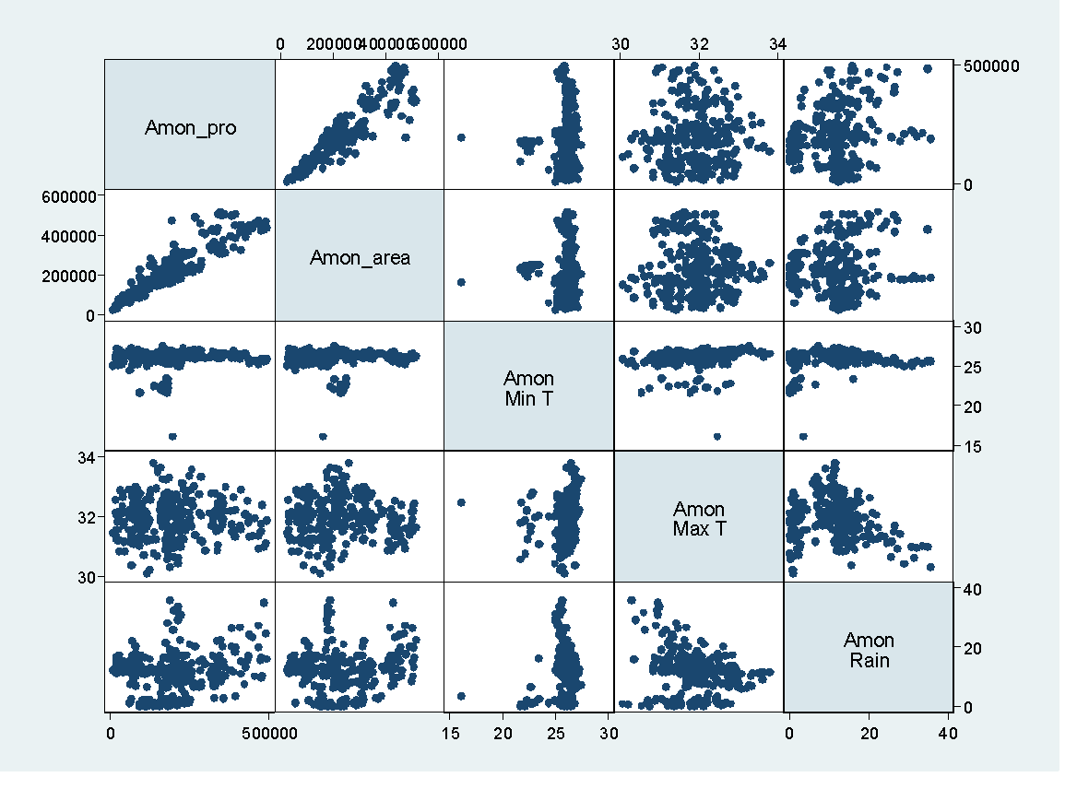
Figure 4: Scatter matrix of Aman rice production and climatic factors in the coastal area.
However, due to the scattered pattern of production in case of maximum temperature and rainfall, it can be expected that Aman rice production is increasing along with these factors.
In Figure 5, the increasing scatter matrix trend illustrates a positive relationship between rice output and area, with an increase in Boro rice production occurring as the area under cultivation expands. The pattern of Boro rice production also shows a distributed tendency with a rise in minimum temperature, maximum temperature, and rainfall; it is reasonable to assume that Boro rice production is rising along with these parameters.
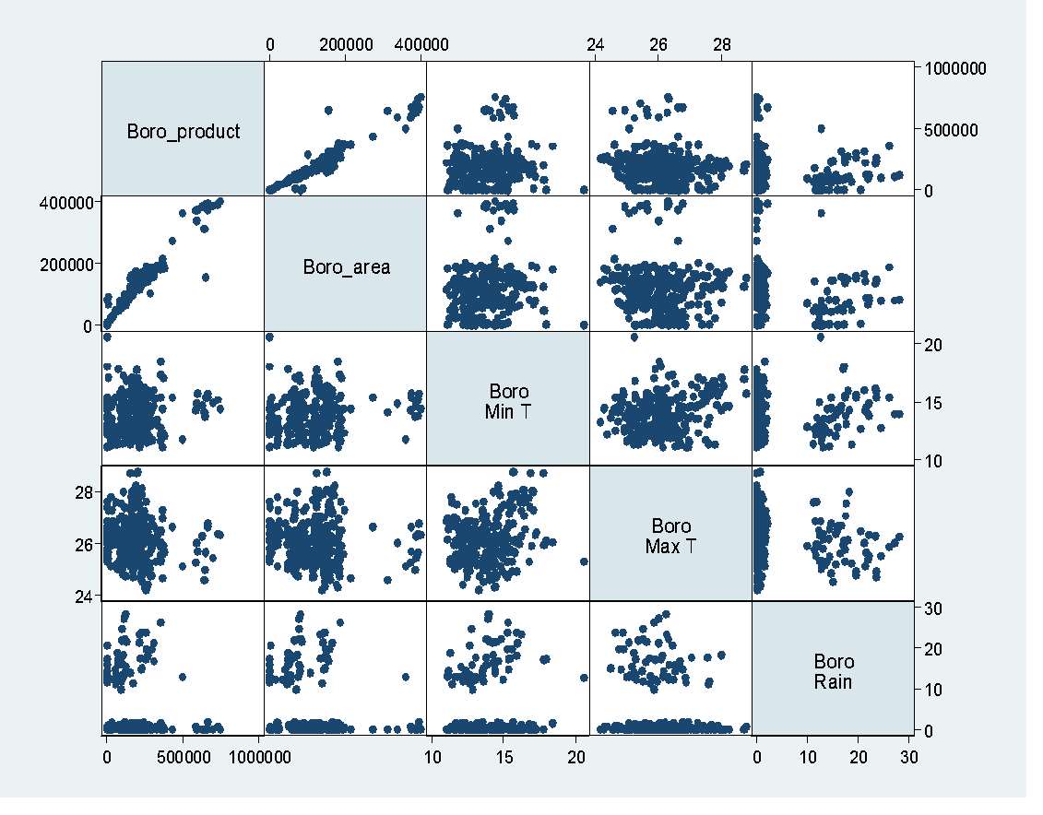
Figure 5: Scatter matrix of Boro rice production and climatic factors in the coastal area
In Figure 6, the rising scatter matrix trend shows a correlation between rice production and area that is positive, with Aus rice production rising as cultivable land area increases. With a rise in minimum temperature, maximum temperature, and rainfall, as well as a dispersed tendency in the pattern of Aus rice production, it is plausible to predict that Aus rice production is also increasing along with these variables.
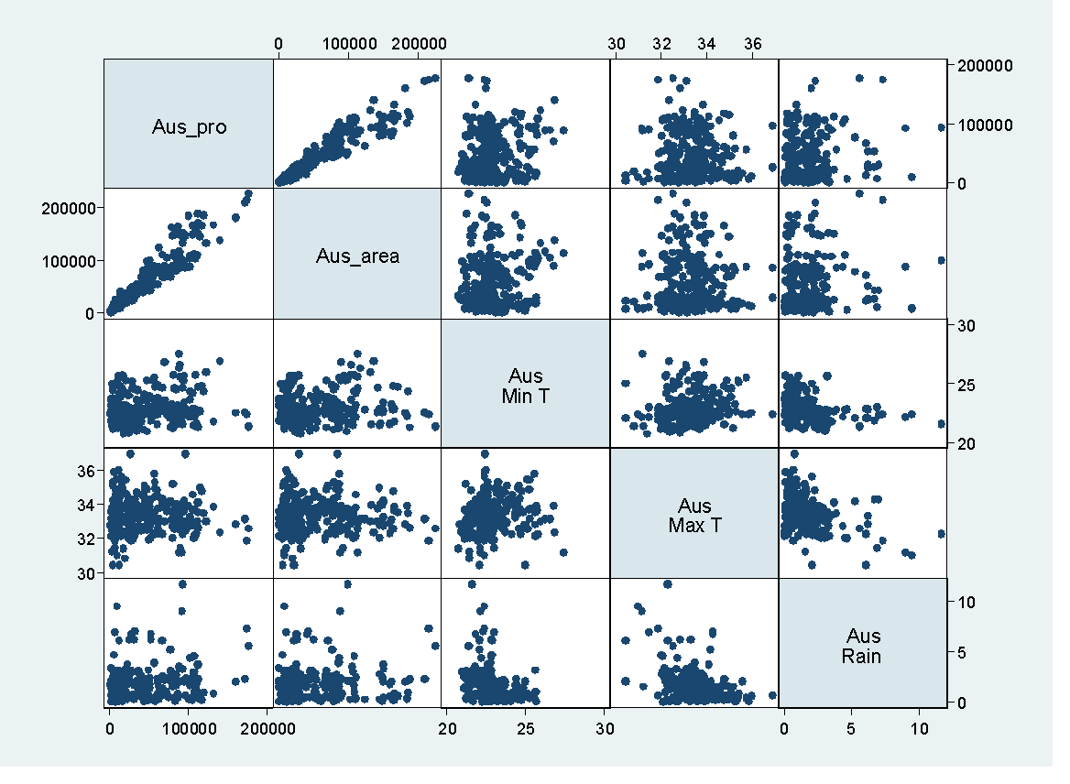

Figure 6: Scatter matrix of Aus rice production and climatic factors in the coastal area

Table 4: Panel regression analysis to find the impact of climatic factors on rice production
Panel Regression Model | Variable  (s) | Coefficient |  | $$σ_{u}^{2}$$ | $$σ_{e}^{2}$$ | $$ρ$$ | R² | Hausman test |  | LM Test
Panel Regression Model |  | $$\hat{β}$$ | SE |  |  |  |  | Statistic | P value | Statistic | P value
Fixed Effect (Aman Rice Production) | Land Area | 0.716*** | 0.05 | 43624.24 | 28058.43 | 0.71 | 0.85 | 1.62 | 0.45 | 740.63 | 0.00
Fixed Effect (Aman Rice Production) | Temperature | 12948.31*** | 3281.36
Fixed Effect (Aman Rice Production) | Rainfall | 1186.21*** | 500.45
Fixed Effect (Aman Rice Production) | Constant | -396109*** | 106802.7
Random Effect (Aman Rice Production) | Land Area | 0.759*** | 0.04 | 40274.86 | 28058.43 | 0.67 | 0.85
Random Effect (Aman Rice Production) | Temperature | 12603.1*** | 3245.89
Random Effect (Aman Rice Production) | Rainfall | 1269.60*** | 477.86
Random Effect (Aman Rice Production) | Constant | -395853*** | 105840.5
Fixed Effect (Boro Rice Production) | Land Area | 1.31*** | 0.06 | 44207.42 | 30685.99 | 0.67 | 0.92 | 43.62 | 0.00 | 95.91 | 0.00
Fixed Effect (Boro Rice Production) | Temperature | -34.20 | 2843.20
Fixed Effect (Boro Rice Production) | Rainfall | 1104.35 | 1091.90
Fixed Effect (Boro Rice Production) | Constant | 29712.57 | 75015.11
Random Effect (Boro Rice Production) | Land Area | 1.52*** | 0.05 | 19419.7 | 30685.99 | 0.29 | 0.93
Random Effect (Boro Rice Production) | Temperature | -1708.44 | 2827.70
Random Effect (Boro Rice Production) | Rainfall | 169.99 | 636.62
Random Effect (Boro Rice Production) | Constant | 51756.48 | 74825.62
Fixed Effect (Aus Rice Production) | Land Area | 0.68*** | 0.03 | 9339.19 | 8540.87 | 0.54 | 0.91 | 0.29 | 0.96 | 326.57 | 0.00
Fixed Effect (Aus Rice Production) | Temperature | 835.95 | 791.33
Fixed Effect (Aus Rice Production) | Rainfall | 1213.46*** | 380.23
Fixed Effect (Aus Rice Production) | Constant | -25272 | 26907.26
Random Effect (Aus Rice Production) | Land Area | 0.7*** | 0.03 | 7038.86 | 8540.87 | 0.4 | 0.90
Random Effect (Aus Rice Production) | Temperature | 1035.8 | 783.02
Random Effect (Aus Rice Production) | Rainfall | 1382.77*** | 381.34
Random Effect (Aus Rice Production) | Constant | -33205.8 | 26639.49
Source: Statistical analysis (*** denotes 1%, level of significance)
Given that the p-value of the Hausman test for Aman rice is larger than 0.05 (P>0.05) and the p-value of the LM test is less than 0.05, it is clear that the random effect model is the more suitable one for predicting the production of Aman rice. According to Table 4, rice output is positively correlated with land area, temperature, and rainfall. Given that land area has a coefficient of 0.759, an increase in land area results in a 0.759 metric ton increase in rice output. The other two coefficients for temperature and rainfall including p values show that rice production is significantly (p<0.01) and positively influenced by temperature and rainfall.
The p-value for the Hausman and LM tests for boro rice is less than 0.05, suggesting that the random effect model is better suitable for Boro rice production. Here, the yield of Boro rice is favorably and significantly (p<0.01) connected with both land areas. However, the output is negatively impacted by temperature. Production will grow by 1.52 metric tons for every unit increase in land area. Since the coefficient of rainfall is 169.99, an increase in rainfall will increase production. The production will fall if the temperature is raised.
In the circumstance of aus rice, both the p-value of the LM test and the Hausman test's p-value are larger than 0.05 (P>0.05), indicating that the random effect model is better appropriate for predicting the production of Aus rice. Table 4 shows a positive association between land area, temperature, rainfall, and the production of Aus rice. The output of Aus rice increases by 0.7 metric tonsfor every unit increase in land value because of the coefficient of land area, which is 0.7. The other two coefficients of temperature and rainfall are 1035.8 and 1382.77, respectively, which show that rice production is positively influenced by temperature and rainfall.

- DISCUSSION
This study shows that rice production in Bangladesh’s coastal regions is strongly shaped by climatic variability, reinforcing conclusions from earlier econometric research. The panel data analysis indicates that expansion of cultivated land consistently boosts rice production across Aus, Aman, and Boro seasons. However, the influence of rainfall and temperature varies by rice type, reflecting the distinct growing conditions and sensitivities of each season, as also reported in previous studies (Akter & Sarker, 2021). The positive relationship between rainfall and the production of Aman and Aus rice is expected, as these crops depend heavily on monsoon rainfall for adequate water supply. In contrast, rising temperatures have a negative effect on Boro rice yields, supporting earlier findings that excessive heat during the dry season disrupts crop development and reduces yield potential (Islam & Wadud, 2022; Basak et al., 2014). Marked spatial differences in rice production-such as the relatively stable Aman yields in Chattogram and the dominance of Aus rice in Bhola-highlight the role of localized climatic, ecological, and socio-economic conditions in shaping production outcomes. This district-level variation is consistent with previous research emphasizing that climate impacts on agriculture are highly heterogeneous across Bangladesh’s agro-ecological zones (Rahman et al., 2017).
New projections using advanced crop and climate models suggest that climate change could start affecting major crops, including rice, sooner than expected, with notable yield declines likely in key growing regions even before 2040 (Jägermeyr et al., 2021). Recent global assessments suggest that climate change has already begun to slow agricultural productivity growth and is expected to further reduce rice yields in tropical regions as warming continues (Ortiz-Bobea et al., 2021). The vulnerability of coastal rice production is further intensified by extreme climate events, including cyclones and salinity intrusion. Recent studies confirm that salinity intrusion is intensifying under sea-level rise, posing a significant threat to high-yielding rice varieties in coastal South Asia (Hasan et al., 2022). Evidence shows that cyclones have caused substantial rice production losses in districts such as Khulna and Satkhira, illustrating how sudden climatic shocks compound longer-term climatic trends (Basu, 2025). In addition, rising sea levels are accelerating soil and water salinization, which threatens the productivity of high-yielding rice varieties in coastal areas and underscores the urgency of addressing salinity in adaptation planning (Dasgupta et al., 2017). The findings also indicate mixed effects of temperature changes on rice production, where moderate warming may benefit vegetative growth in Aus and Aman rice, but excessive or prolonged warming reduces productivity.
Overall, the results emphasize the importance of climate-smart agriculture and targeted adaptation strategies in coastal regions. Although farmers are increasingly adopting salt-tolerant rice varieties, improved management practices, and training programs, challenges such as limited institutional support and knowledge gaps continue to hinder widespread adaptation (Momin et al., 2025). Taken together, these findings support the need for policies that promote climate-resilient rice varieties, improved water and salinity management, and stronger agricultural extension services. Such measures are essential for sustaining rice production, ensuring food security, and protecting the livelihoods of coastal farming communities in the face of growing climatic risks. These findings align with the climate-smart agriculture framework, which emphasizes enhancing productivity, strengthening adaptive capacity, and building resilience under climate stress (Lipper et al., 2020).

- Conclusion
This study examined the volatility of Aus, Aman, and Boro rice production in the coastal regions of Bangladesh and assessed the district-level impacts of climatic conditions on rice yield. Using descriptive statistics, trend analysis, and panel data regression, the findings reveal a complex relationship between climate variables and rice production. Temperature and rainfall influence rice varieties differently across locations, highlighting the importance of spatial heterogeneity in climate impacts. The results show that Aman rice production is relatively stable in Chattogram, Boro rice production is higher in Jessore, and Aus rice dominates in Bhola. Rainfall and location positively affect Aman and Boro rice yields, while higher temperatures negatively influence Boro production. At the same time, rising temperatures may favor Aus and Aman rice, whereas increased rainfall and land availability support Boro cultivation.
Climate change presents both risks and opportunities for rice production in coastal areas. To ensure resilience and sustainability, proactive adaptation strategies are essential. These include the adoption of climate-resilient rice varieties, improved water management practices, integrated pest management, infrastructure development to reduce salinity and flooding risks, and capacity-building programs for farmers. Supportive policies and continued research are also crucial to facilitate climate-smart agricultural practices.
Overall, strengthening adaptive capacity through coordinated efforts among farmers, policymakers, and research institutions can help safeguard rice production, enhance food security, and promote the long-term economic well-being of coastal communities under changing climatic conditions.

Disclaimer (Artificial intelligence)

Author(s) hereby declare that NO generative AI technologies such as Large Language Models (ChatGPT, COPILOT, etc.) and text-to-image generators have been used during the writing or editing of this manuscript.

REFERENCES
- Akter, M. (2019). Impacts of climate factors influencing rice production in Bangladesh (Doctoral dissertation, DEPARTMENT OF AGRICULTURAL STATISTICS).
- Basak, J. K., M.A. Ali, M.N. Islam, and M.A. Rashid (2010). “Assessment of the Effect of Climate Change on Boro Rice Production in Bangladesh using DSSAT Model”. Journal of Civil Engineering (IEB) 38(2): 95–108.
- Basak, J. K., Ali, M. A., & Islam, M. N. (2014). Assessing the effects of climate change on rice yields: An econometric investigation using Bangladeshi panel data. Ecological Economics, 105, 147–160. https://doi.org/10.1016/j.eap.2014.11.004
- Bangladesh Bureau of Statistics (BBS) (2006). Agricultural Statistical Yearbook of Bangladesh, Dhaka, Government of Bangladesh.
- Bangladesh Bureau of Statistics (BBS) (2010). Agricultural Statistical Yearbook of Bangladesh, Dhaka, Government of Bangladesh.
- Basu, S. (2025). Impacts of climate change and tropical cyclones on rice farming in coastal Bangladesh. Asian Journal of Water, Environment and Pollution, 22(4), 41–63. https://doi.org/10.36922/AJWEP025100063
- BBS (2019). Bangladesh Bureau of Statistics, Statistical Yearbook of Bangladesh, Statistics and Informatics Division, Ministry of Planning, Government of the People’s Republic of Bangladesh.
- Bangladesh Meteorological Department (BMD). (2021). Meteorological data records (2006–2020). https://www.bbs.gov.bd.
- Bhattacharya, J., Saha, N. K., Mondal, M. K., Bhandari, H., and Humphreys, E. (2019). “The feasibility of high yielding aus-aman-rabi cropping systems in the polders of the low salinity coastal zone of Bangladesh”. Field Crops Research, 234, 33-46. https://doi.org/10.1016/j.fcr.2019.01.007
- BRRI (2019). Bangladesh Rice Research Institute. Annual Report. http://brri.portal.gov.
- Chowdhury, M. A., Khairun, Y., Salequzzaman, M., & Rahman, M. M. (2011). Effect of combined shrimp and rice farming on water and soil quality in Bangladesh. Aquaculture International, 19(6), 1193-1206.
- Dasgupta, S., Hossain, M. M., Huq, M., & Wheeler, D. (2017). Climate change, salinization and high-yield rice production in coastal Bangladesh. Agricultural and Resource Economics Review. Cambridge University Press. https://doi.org/10.1017/age.2017.14
- Gomez, K. A., & Gomez, A. A. (1984). Statistical procedures for agricultural research (2nd ed.). John Wiley & Sons.
- Hasan, M. K. et al. (2022). Salinity stress and rice productivity under climate change scenarios. Science of the Total Environment.
- Haque, S. A. (2006). “Salinity problems and crop production in coastal regions of Bangladesh”. Pakistan Journal of Botany, 38(5), 1359-1365.
- Haque, A., Rahman, M. H., & Rahman, D. (2019). An evaluation of sea level rise vulnerability and resilience strategy to climate change in the coastline of Bangladesh. International Journal of Environmental Sciences and Natural Resources, 18(1), 555983. DOI: 10.19080/IJESNR.2019.18.555983
- Stocker, T. (Ed.). (2014). Climate change 2013: the physical science basis: Working Group I contribution to the Fifth assessment report of the Intergovernmental Panel on Climate Change. Cambridge university press.
- Islam, M. A., Shelia, V., Ludwig, F., De Bruyn, L. L., ur Rahman, M. H., & Hoogenboom, G. (2021). Bringing farmers’ perceptions into science and policy: Understanding salinity tolerance of rice in southwestern Bangladesh under climate change. Land Use Policy, 101, 105159. https://doi.org/10.1016/j.landusepol.2020.105159
- Islam, M. N., & Wadud, M. A. (2022). Climate change impact on rice production in Bangladesh: An econometric analysis. International Journal of Science and Business.
- Jägermeyr, J., Müller, C., Ruane, A. C., Elliott, J., Balkovic, J., Castillo, O., ... & Rosenzweig, C. (2021). Climate impacts on global agriculture emerge earlier in new generation of climate and crop models. Nature food, 2(11), 873-885. https://doi.org/10.1038/s43016-021-00400-y
- Karim, M. R., Ishikawa, M., Ikeda, M., & Islam, M. T. (2012). Climate change model predicts 33% rice yield decrease in 2100 in Bangladesh. Agronomy for sustainable development, 32(4), 821-830.
- Kaur, G., Singh, G., Motavalli, P. P., Nelson, K. A., Orlowski, J. M., & Golden, B. R. (2020). Impacts and management strategies for crop production in waterlogged or flooded soils: A review. Agronomy Journal, 112(3), 1475-1501. https://doi.org/10.1002/agj2.20093
- Lipper, L. et al. (2020). Climate-smart agriculture for food security. Nature Sustainability. https://doi.org/10.1038/nclimate2437
- Montgomery, D. C., & Runger, G. C. (2010). Applied statistics and probability for engineers. John wiley & sons.
- Momin, M. R., Sarker, M. A., Hasan, M. M., Raihan, M. L., & Mukul, M. H. R. (2025). Adaptation Strategies used by the Coastal Farmers Coping with Consequences of Climate Change. Journal of the Bangladesh Agricultural University, 23(2), 157-165. https://doi.org/10.3329/jbau.v23i2.82583
- Ortiz-Bobea, A. et al. (2021). Anthropogenic climate change has slowed global agricultural productivity growth. Nature Climate Change.
- Paul, B. G., & Vogl, C. R. (2011). Impacts of shrimp farming in Bangladesh: Challenges and alternatives. Ocean & Coastal Management, 54(3), 201-211. https://doi.org/10.1016/j.ocecoaman.2010.12.001
- Rahman, M. A., Kang, S., Nagabhatla, N., & Macnee, R. (2017). Impacts of temperature and rainfall variation on rice productivity in major ecosystems of Bangladesh. Agriculture & Food Security, 6(1), 10.
- Sarker, M. A. R., Alam, K., and amp; Gow, J. (2012). “Exploring the relationship between climate change and rice yield in Bangladesh: An analysis of time series data”. Agricultural Systems, 112, 11–16. https://doi.org/10.1016/j.agsy.2012.06.004
- Shahid, S. (2011). “Impact of climate change on irrigation water demand of dry season Boro rice in northwest Bangladesh”. Climatic change, 105(3), 433-453.
- Sun, S., Chen, H. and Ju, W. (2013). “Effects of climate change on annual streamfow using climate elasticity in Poyang Lake Basin, China”. TheorApplClimatol 112(1–2):169–183.
- Tufte, E. R., & Graves-Morris, P. R. (1983). The visual display of quantitative information (Vol. 2, No. 9). Cheshire, CT: Graphics press.
- Walpole, R. E., Myers, R. H., Myers, S. L., & Ye, K. (1993). Probability and statistics for engineers and scientists (Vol. 5, pp. 326-332). New York: Macmillan.
- Wooldridge, J. M. (2010). Econometric analysis of cross section and panel data. MIT press.

