Original Research Article

EFFECT OF SEED PRIMING ON GERMINATION AND SEEDLING GROWTH OF BITTER GOURD (Momordica charantia) AT GAURADAHA, JHAPA

.
ABSTRACT

Bitter gourd (Momordica charantia) has a thick seed coat that often obstructs germination and seedling development. Seed priming, also called pre-soaking of seed, accelerates the germination of seed and promotes the growth of the seedling. To study the effect of seed priming treatments on germination and seedling growth of bitter gourd, an experiment was conducted at Gauradaha Agriculture Campus, Jhapa, Nepal in 2024. The experiment was carried out in Completely Randomized Design(CRD) where six treatments(T1: Control, T2: Cow urine soaked for 12 hours, T3: Cow milk soaked for 6 hours, T4: Hot water at 50º C soaked for 1 hour, T5: Gibberellic acid of 500 ppm soaked for 6 hours, T6: Tap water soaked for 12 hours) were used. Pale variety of bitter gourd was sown on germinating trays using growing media of field soil, fine sand, and cocopeat in the ratio 1:1:2. The observation on germination percentage, mean germination time, seedling height, no. of true leaves, stem diameter, and root length were examined. The highest germination percentage was observed in Control (95.23%), followed by tap water (88.09%). Mean germination time was highest in hot water (7.08 days) and least in tap water (5.67 Days). The maximum height was observed in gibberellic acid (31.22Cm), followed by tap water (30.14Cm) at 15 DAS. Similarly, the number of true leaves and the number of internodes in gibberellic acid were highest among others. The diameter of the stem was almost similar in all treatments. The root length was seen to be maximum in gibberellic acid (15.56Cm), followed by tap water (12.06Cm) at 5 DAS. Thus, study showed that seeds treated with gibberellic acid were effective in seedling growth.

Keywords: Bitter gourd, Germination, Priming, Seedling growth

1. INTRODUCTION

BACKGROUND:
Bitter gourd (Momordica charantia L.), popular with names such as karela, bitter melon, wild cucumber, and bitter apple, is one of the key market vegetables in Eastern and South Asia (Krawinkel et al., 2006). Bitter gourd, Momordica charantia (Cucurbitaceae), is a monoecious annual crop having epigeal germination, which is mostly grown from January to June. It is one of the most important summer vegetables in Nepal, which is cultivated in all ecological belts. The plant requires a warm and hot climate and grows well on sandy loam soil with pH 6.0 to 6.7 (Palada, 2003), and altitude range up to 1000 m with optimal germination and growth at the temperature range of 25–28˚C (Peter et al., 1998) and 24–27˚C (Baig et al., 2020) respectively. Gourds are highly adaptive in both tropical and subtropical regions. 83% of the production area was covered by Asia, 3% by Africa, and 2% by Central America (Dhillon et al., 2020). Bitter gourd has tremendous economic and dietary importance. Immature fruit is a good source of Vitamin C, and also contains Vitamin A. Bitter gourd is a blood purifier, activates the spleen and liver, and is highly beneficial in diabetes (Yibchok et al., 2006).
Field emergence is always a problem in bitter gourd, even with the seeds of high germination, due to the thick seed coat. To overcome this problem, pre-sowing treatments soaking or priming of seeds, can be practiced. Pre-germinated seeds proved superior in emergence from the soil and in stand establishment. The additional advantages of this treatment include (i) lower seed rate, (ii) dead seeds can be discarded before sowing, and (iii) germinating, but low vigor seeds can be removed before sowing. Recent studies on a series of crop species demonstrate speedy germination, early emergence, and vigorous seedlings accomplished by seed soaking in water for a while, followed by surface drying before sowing, which may lead to higher crop yield (Harris et al., 2000). Seed priming is a physiological seed quality enhancement treatment. During priming, imbibition take place in a controlled manner (Pill et al., 2023) (phase I). This controlled imbibition activates the hydrolytic enzymes, which lead to the breakage of complex stored products like starch, carbohydrate, and proteins into simple, easily available products (i.e., glucose and amino acids) (phase II). Then, before the radical protrusion stage, seeds were brought to their original moisture content (phase III) by shade drying for long-term safe storage (Annuals of Applied Biology, 1998). Priming activates pre-germinative physiological and biochemical processes in advance of field establishment, which leads to early emergence during field establishment even under low moisture levels (Taylor et al., 1990). Some commonly used priming methods are hydro priming, osmo priming, bio priming, chemical priming, matrix priming, nutrient priming, halo priming, and thermo priming (Afzal et al., 2011). Inclusion of antioxidants, chemicals, PGR, and nutrients during priming improves seed performance and early plant growth and development, especially in harsh environments such as extreme temperatures or salty conditions (Wang et al., 2002).
Pre-sowing seed treatments resulted in higher germination and earlier seedling emergence, strong growth, early flowering, maturity, and high yields. Speedily germinating seedlings also produce a deep root system and improved seedling establishment in many crops (Bakht et al., 2011). The main causes of the bitter gourd's low yield include poor seedling germination, hampered emergence, and slow growth. Bitter gourd's poor seedling issue is brought on by the embryo being encased in a thick seed coat that prevents germination and embryo development (Rawat, 2020).

STATEMENT OF PROBLEM:
Bitter gourd (Momordica charantia) is an economically significant vegetable crop known for its health benefits and nutritional value. However, inconsistent germination and improper seedling growth often hinder its cultivation efficiency and yield. Seed treatments, such as priming with water, growth hormones, or biological methods, have been proposed as potential solutions to enhance germination rates and seedling vigor in various crops.
Seed dormancy due to a hard seed coat is a significant factor affecting the germination and establishment of many plant species. The hard seed coat acts as a physical barrier that prevents water uptake and gas exchange, thereby inhibiting the germination process. This type of dormancy, known as physical dormancy, can lead to delayed or uneven germination, which affects seedling growth and crop establishment (Baskin & Baskin, 2014).
Methods such as mechanical scarification or chemical treatments are commonly used to break physical dormancy, but their effectiveness can vary depending on the seed species and environmental conditions (Murray & Wareing, 1975; Sauer & Waller, 1980).

RATIONALE OF STUDY:
Bitter gourd (Momordica charantia) holds considerable agricultural and economic importance globally, primarily valued for its medicinal properties and culinary uses. However, the crop faces challenges related to inconsistent seed germination and improper seedling growth, which can lead to reduced crop establishment and overall yield. These issues are affected by variable environmental conditions and seed quality factors.
This study aims to evaluate the different kinds of priming treatment for breaking dormancy of bitter gourd, germination percentage, and seedling growth parameters. The primary problem addressed by this research is to systematically evaluate and compare the effects of different seed treatments on the germination percentage and early seedling growth parameters of bitter gourd. The findings from this research are expected to benefit farmers, seed producers, and agricultural practitioners involved in bitter gourd cultivation. The rationale for conducting this study lies in its potential to fill a significant knowledge gap and provide practical solutions to enhance bitter gourd cultivation.

2. material and methods
2.1 Site Selection and seed collection:
The research was carried out from second of May to last week of August, 2024. The research was conducted at Gauradaha Agriculture Campus, Gauradaha-2, Jhapa, Koshi Province. The research was conducted during the summer- rainy season in 2024. Geographically, it covers an area of 1,606 km² (620 sq. mi). It lies in the easternmost district of Nepal and has the fertile Terai plains. Latitude: 26° 33' 42" N, Longitude: 87° 43' 02" E, Altitude: 79 masl. The available variety of bitter gourd(Palee F1) was collected from the local agrovet of Gauradaha, Jhapa.

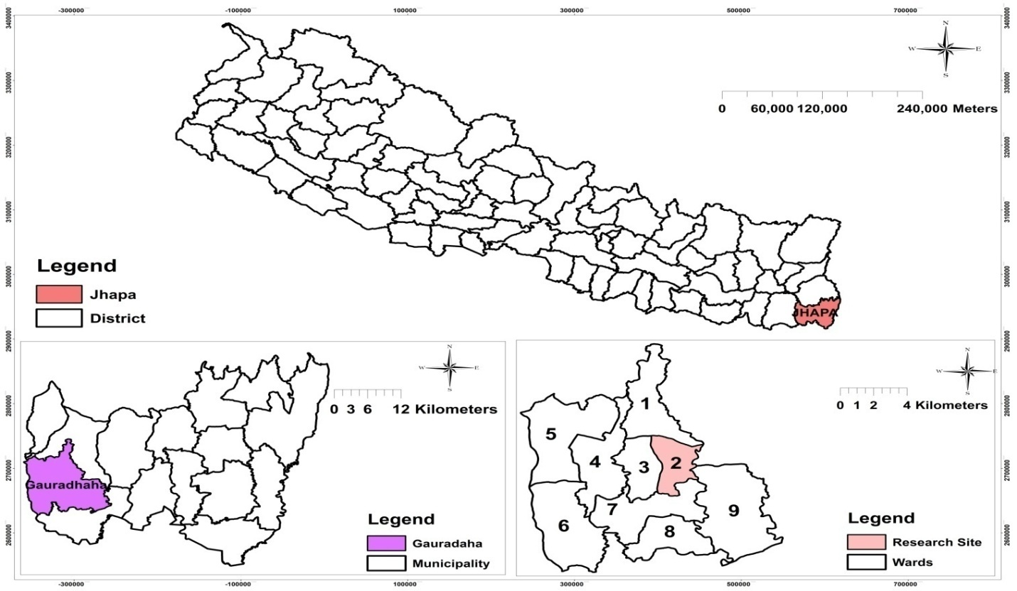
Figure 1 : Map showing the location of the Research site
2.2 Treatment and Experimental Design
The experiment was laid out in a complete randomized design (CRD). There were six treatments used, and each treatment was replicated 3 times (6*3).
Table 1: Treatment Details
S.N. | Treatments | Details
 | Control (T1) | No treatment, directly seeded
2. | Cow Urine (T2) | 12 hours of soaking
3. | Cow milk (T3) | 6 hours of soaking
4. | Hot water (T4) | Soaking at 50℃ for 1 hour
5. | Gibberellic Acid (T5) | 500 ppm for 6 hours soaking
 | Tap water (T6) | 12 hours of soaking
The experiment was carried out in the germinating tray. The 18 larger germinating trays of 21 cell each were used for the research. The seeds were then sown in each hole of the tray.

2.3 Media Preparation and sowing:
As a growing media the mixture of field soil, fine sand and cocopeat were used in the proportions of 1:1:2. The mixture was well sterilized in autoclave at 121°C;15 psi for 45 minutes.. Altogether 18 trays were required for to experiment, and each tray was used as a plot. The sowing of seeds was done on June 9, 2024. The prepared media was filled in all the cells of the germinating tray. A single seed was sown in each cell of the germinating tray. 21 seeds were sown in each tray, and altogether 63 seeds were sown per treatment for the experiment
2.4 Irrigation:
Generally, Bitter gourd requires frequent irrigation to maintain enough soil moisture during its growth and development. Irrigation was done by observing the soil and media conditions at regular intervals. Watering through the rose can was done to maintain the proper moisture condition for its germination and development.
2.5 Data Collection:
For the observation, three randomly selected sample plants were taken from each plot. The sample plants were tagged for further observation. The data were collected at regular intervals of 5 days from the day after sowing (i.e., 5 DAS, 10 DAS, 15 DAS) throughout the research period.
2.5.1 Germination Parameters:
I. Germination Percentage:
Germination percentage is an estimate of the viability of a population of seeds. The germination rate provides a measure of the time course of seed germination. The equation to calculate germination percentage is:
Germination Percentage = seeds germinated/total seeds sown x 100.
II. Mean Germination Time:
Mean germination time (MGT) was calculated by using the equation:
MGT = ∑(n × d) / N,
where n = number of seeds germinated on each day,
d = number of days from the beginning of the test, and
N = total number of seeds germinated at the termination of the experiment
2.5.2 Seedling Parameters:
I. Seedling Height :
Plant height was measured in centimeters (cm) with the help of a measuring scale and measured from the soil surface to the tip in three randomly selected plants from all plots, and averaged. Those three randomly selected plants were further used for taking other observations at an interval of 5 days.
II. Number Of True Leaves:
Randomly selected three plants as samples from each plot were taken to count the total number of true leaves per plant during its growth period at an interval of 5 days, and these were averaged, which represents the number of true leaves per plant.
III. Number Of Internodes:
Randomly selected three plants in each plot were used to count the total number of internodes per plant during its growth period at an interval of 5 days, and these were averaged, which represents the number of internodes per plant.
IV. Stem Diameter:
Stem diameter was measured in centimeters (cm) by using Vernier Calipers. The measurement was taken at the stem height of 1Cm above the soil surface from the randomly selected sample plants from each plot and then averaged. Those randomly selected plants were used for further observations. The data was taken at an interval of 5 days.
v. Root Length:
Root Length was measured in centimeters (cm) using a ruler and measured from the soil surface to the tip of the root in randomly selected sample plants from each plot and then averaged. Further observation was made at an interval of 5 days.
2.6 Statistical Analysis:
The collected data were compiled by using the MS Excel V16.0 program and subjected to analysis of variance using R-Stat V4.4.1 software package. Means of separation were done by Fisher’s LSD Model at 5% level of significance. Graphs, tables, and diagrams were constructed using Excel.

3. results and discussion

3.1. Effect of Seed Priming on Mean Germination Time:
From The figure 2, the result shows that the mean germination time of bitter gourd seeds varied among the treatments. The seeds soaked in hot water had a mean germination time of 7.08 days which is highest among all, while seeds soaked in tap water showed the minimum mean germination time of 5.67 days.
Priming may induce physiological changes that prepare seeds for germination. Enhanced hydration levels and pre-activation of enzymes could be critical factors in shortening germination periods, as supported by the findings of Jones et al. (2021). The shorter mean germination time for seeds soaked in tap water is consistent with existing literature that emphasizes the importance of adequate hydration for rapid seed germination. According to Bewley et al. (2013), water is essential for the metabolic processes that trigger germination, including enzyme activation and respiration. Tap water, providing optimal hydration conditions, facilitates these processes more effectively than treatments that involve temperature extremes. Furthermore, the differences in mean germination times may reflect the inherent characteristics of bitter gourd seeds and their responses to various soaking conditions. As highlighted by Mohan et al. (2015), different seeds exhibit varying degrees of sensitivity to temperature and moisture levels, which can significantly influence their germination dynamics. This variability suggests that the soaking method should be tailored to the specific needs of the seed type to optimize germination outcomes

3.2. Effect of Seed Priming on Germination Percentage:
The statistical analysis indicated significant difference among the treatments with the Control showing highest germination percentage i.e. 92.23% followed by seed soaked in Tap water (88.09 %) after 15 DAS. The least germination percentage was obtained in seed soaked in Cow urine i.e. 47.61%. at 15 DAS. The results demonstrate that the control group, with a germination percentage of 95.23%, significantly outperformed the primed seeds, especially those soaked in cow urine, which showed only 47.61% germination.
In this study, the Control treatment likely provided optimal conditions, allowing for maximum seed hydration and gas exchange, which are essential for germination (Bewley et al., 2013). The tap water treatment also yielded a high germination percentage, which aligns with findings by Kahn et al. (2015), who reported that soaking seeds in water enhances hydration and promotes enzyme activation necessary for germination. However, the decline in germination rates observed in the cow urine treatment suggests that the constituents of cow urine may be detrimental to seed germination. It has been noted that high concentrations of certain nutrients or phytotoxic compounds in animal urine can inhibit germination (Zhang et al., 2020). This inhibitory effect could be attributed to the presence of nitrogenous compounds or salts that may create a toxic environment for seedling development (Huang et al., 2019). Given the results, farmers should be cautious about using cow urine as a priming agent for bitter gourd, as it may reduce germination rates.

3.3 Effect of Seed Priming on Plant Height:
The effect of seed priming on the plant height of bitter gourd was assessed at various days after sowing. The results showed a significant differences in plant height among the treatments. At 5 DAS, the highest average height was recorded in gibberellic acid treatment (4.92Cm), while the control had a height of 4.06Cm which was the least among all. By 10 DAS, plant heights across the treatments showed a marked increase, with the gibberellic acid treatment continuing to lead at 27.34Cm, significantly outperforming the other treatments, including cow milk (21.71Cm), cow urine (20.40Cm). At 15 DAS, the trend continued with gibberellic acid showing the greatest height (31.22Cm), followed by tap Water (30.14Cm) and cow milk (29.14Cm).
The results highlighted the critical role of seed priming in enhancing germination and early growth characteristics. The positive effects observed with gibberellic acid align with findings from previous studies, which indicated that the plant hormones can accelerate growth processes by promoting cell elongation and division (Sharma et al., 2020). The sustained advantage of GA3 in promoting plant height can be attributed to its role in enhancing metabolic processes associated with growth and development (Kumar et al., 2018). This is consistent with findings by Youssef et al. (2021), who observed that GA3 application led to increased plant heights and overall vigor in various crops due to its effects on photosynthesis and nutrient uptake. The significant differences observed in plant height among treatments at various growth stages suggest that seed priming is a viable agronomic practice for improving the growth and development of bitter gourd.

3.4. Effect of Seed Priming on Number of True Leaves:
The impact of various seed priming treatments on the no. of true leaves of bitter gourd (Momordica charantia) was evaluated at different intervals: 5 DAS, 10 DAS, and 15 DAS. The result indicated that seed priming significantly influences the development of true leaves. At 5 DAS, the control group produced an average of 1.41 true leaves, which was consistent across all treatments, with the cow urine and cow milk treatments yielding almost similar results (1.41 and 1.74, respectively). However, the Gibberellic acid treatment showed a higher leaf count at this stage, with an average of 1.98 leaves. By 10 DAS, there was a noticeable increase in the number of true leaves across all treatments. The control group reached an average of 3.66 leaves, while the cow urine treatment produced 4.44 leaves. The cow milk treatment remained competitive at 3.55 leaves, but Gibberellic acid continued to demonstrate superior performance, achieving an average of 4.55 leaves. The tap water treatment also showed a positive response, resulting in 4.22 leaves. At 15 DAS, the number of true leaves didn’t show significance as the no. of true leaves remained almost similar in all.
The findings of this study showed that seed priming has a positive effect on the no. of true leaves produced by bitter gourd seedlings during the very early days after sowing. Gibberellic acid (GA3) showed a notably higher average of 1.98 true leaves. This enhanced performance can be attributed to GA3's role in promoting cell elongation and division, as well as its ability to stimulate the synthesis of growth-promoting hormones (Kumar et al., 2018). This initial advantage of GA3 is consistent with previous studies indicating that gibberellins can enhance leaf development and overall seedling vigor (Khan et al., 2014). The increase in leaf no. is crucial as it directly relates to the plant's ability to photosynthesize and grow efficiently (Jiang et al., 2019).

3.5. Effect of Seed Priming on Number Of Internodes:
The research on the effect of seed priming treatments on the no. of internodes in bitter gourd at 5 DAS, 10 DAS, 15 DAS showed a significant result. At 5 DAS, the control group displayed an average of 1.888 internodes, which was lowest among all. Cow urine produced a count of 2.00 internodes, while cow milk showed a significantly higher average of 2.55 internodes. Notably, the Gibberellic acid treatment led to the highest count at this stage with 3.00 internodes followed by Tap Water (2.83), indicating a positive impact on early stem development (p < 0.05). At 10 and 15 DAS there was no significance among the treatments as every treatments showed quiet a similar mean no. of internodes.
The treatment on gibberellic acid led to the highest internode count at 5 DAS. The initial boost in internode number from gibberellic acid treatment aligns with existing literature that demonstrates how this plant hormone can promote stem elongation and node formation (Khan et al., 2018). The non-significant differences in internode numbers at 10 DAS and 15 DAS suggested that while initial priming is critical, the effects may moderate over time as the plants acclimate and grow. At 10 and 15 DAS, the number of internodes across all treatments did not show significant differences, suggesting that while early priming treatments had an immediate impact on internode development, the effects may have leveled off as the plants continued to grow. This could imply that other environmental factors or intrinsic plant physiological processes became more influential as the plants matured. Research by Nascimento and Nixon (2008) supports this notion, indicating that early growth responses can often stabilize, leading to similar growth patterns as the plants develop.

3.6. Effect of Seed Treatment on Diameter of Stem:
The statistical result of seed priming treatments on the diameter of the stem in bitter gourd was assessed at 5, 10, and 15 days DAS. The result showed that there was no significant difference among the treatments on stem diameter of bitter gourd at 5, 10 & 15 DAS.
The findings indicated that seed priming treatments, while showing slight variations in the diameter of stems, did not produce statistically significant results across all measurement periods.

3.7. Effect of Seed Priming on Root Length:
The statistical analysis performed on seed priming treatments on root length in bitter gourd was done at 5, 10, 15 DAS. At 5 DAS, treatment on gibberellic acid was highly significant (15.566Cm) among others followed by tap water (12.06Cm), hot water (11.12Cm). The least was observed in Control i.e. 6.73Cm. At 10 and 15 DAS, the results observed were not significant as in the earlier days.
The results of this study showed the crucial role of seed priming in enhancing root length in bitter gourd seedlings at earlier days. The significantly longer roots observed with gibberellic acid treatment align with the findings that emphasize the importance of growth regulators in stimulating root development (Jiang & Zhang, 2019). The positive effects of GA3 can be attributed to its role in stimulating cell elongation and division, which are critical processes in root growth (Kumar et al., 2018). The significant increase in root length under GA3 treatment supports findings from Farooq et al. (2012), who reported enhanced root growth in various crops following gibberellin application. Such improvements in root development can lead to better nutrient uptake and water absorption, ultimately contributing to healthier plants. This effect can be attributed to gibberellic acid's ability to promote cell division and elongation, which are key processes in root growth.

Figure 2: Bar diagram showing mean germination time on different treatments

Table 2 : Effect of Seed priming on Germination Percentage
Treatment | Germination Percentage(%)
Treatment | 5 DAS | 10 DAS |  | 15 DAS
Control | 9.52± 4.76^{c} |  | 90.47 ±2.38ª | 95.23±2.38ª
Cow Urine | 4.76±2.38^{c} |  | 47.61±8.54^{c} | 47.61±8.58^{c}
Cow Milk | 19.04±4.76^{bc} |  | 69.04±9.52^{abc} | 69.04±9.52^{bc}
Hot Water | 26.19±2.38^{b} |  | 83.33±8.58^{ab} | 83.33±8.58^{ab}
Gibberellic Acid | 30.95±6.29^{ab} |  | 59.52±10.37^{bc} | 64.28±10.91^{bc}
Tap Water | 42.85±7.14ª |  | 88.09±6.29ª | 88.09±6.29^{ab}
LSD_{(0.05)} | 15.272 |  | 24.879 | 25.237
F Value | ** |  | * | *
CV | 38.631 |  | 19.153 | 19.015
Grand Mean | 22.222 |  | 73.015 | 74.6
Signif. codes: 0 ‘***’ 0.001 ‘**’ 0.01 ‘*’ 0.05 ‘.’ 0.1 ‘ NS’ 1
Non-significant (NS), Significant (*), highly significant (**), Very highly significant (***) at 95% level of confidence

Table 3 : Effect of Seed priming on Plant Height
Treatment | Plant Height(cm)
Treatment | 5 DAS | 10 DAS | 15 DAS
Control | 4.06±0.76^{c} | 19.35±1.32^{c} | 23.86±2.32
Cow Urine | 4.27±0.41^{bc} | 20.40±0.25^{c} | 23.56±0.70
Cow Milk | 4.29±0.62^{bc} | 21.71±1.70^{bc} | 29.14±3.16
Hot Water | 4.20±0.46^{c} | 20.40±0.72^{bc} | 27.50±1.43
Gibberellic Acid | 4.92±1.25ª | 27.34±1.77ª | 31.22±2.97
Tap Water | 4.52±1.17^{b} | 23.66±1.56^{b} | 30.14±1.33
LSD_{(0.05)} | 0.029 | 4.143 | 6.729
F Value | *** | * | NS
CV | 3.730 | 10.415 | 13.718
Grand Mean | 19.220 | 22.359 | 27.575
Signif. codes: 0 ‘***’ 0.001 ‘**’ 0.01 ‘*’ 0.05 ‘.’ 0.1 ‘NS ’ 1
Non-significant (NS), Significant (*), highly significant (**), Very highly significant (***) at 95% level of confidence

Table 4 : Effect of Seed priming on Number of True Leaves
Treatment | Number of True Leaves
Treatment | 5 DAS | 10 DAS | 15 DAS
Control | 1.41±0.00^{c} | 3.66±0.19 | 5.00±0.50
Cow Urine | 1.41±0.00^{c} | 4.44±0.11 | 5.33±0.19
Cow Milk | 1.74±0.58^{ab} | 3.55±0.44 | 6.00±0.33
Hot Water | 1.63±0.00^{bc} | 4.44±0.22 | 5.92±0.39
Gibberellic Acid | 1.98±0.67ª | 4.55±0.48 | 5.66±1.01
Tap Water | 1.91±0.19^{ab} | 4.22±0.44 | 5.94±0.20
LSD_{(0.05)} | 0.317 | 1.073 | 0.509
F Value | ** | NS | NS
CV | 10.583 | 14.745 | 5.069
Grand Mean | 2.925 | 4.092 | 5.645
Signif. codes: 0 ‘***’ 0.001 ‘**’ 0.01 ‘*’ 0.05 ‘.’ 0.1 ‘NS ’ 1
Non-significant (NS), Significant (*), highly significant (**), Very highly significant (***) at 95% level of confidence

Table 5 : Effect of Seed priming on Number of Internodes
Treatment | Number of Internodes
Treatment | 5 DAS |  | 10 DAS |  | 15 DAS
Control | 1.88±0.11^{d} | 1.69±0.11 |  | 4.00±0.33
Cow Urine | 2.00±0.00^{cd} | 1.73±0.00 |  | 4.44±0.11
Cow Milk | 2.55±0.29^{abc} | 1.66±0.38 |  | 5.00±0.38
Hot Water | 2.33±0.00^{bcd} | 1.73±0.00 |  | 4.67±0.19
Gibberellic Acid | 3.00±0.33ª | 1.79±0.19 |  | 4.89±0.72
Tap Water | 2.83±0.09^{ab} | 1.74±0.34 |  | 4.89±0.11
LSD_{(0.05)} | 0.588 | 0.126 |  | 1.161
F Value | ** | NS |  | NS
CV | 13.592 | 4.110 |  | 14.04
Grand Mean | 2.435 | 3.015 |  | 4.685
Signif. codes: 0 ‘***’ 0.001 ‘**’ 0.01 ‘*’ 0.05 ‘.’ 0.1 ‘NS ’ 1
Non-significant (NS), Significant (*), highly significant (**), Very highly significant (***) at 95% level of confidence

Table 6 : Effect of Seed priming on Diameter of Stem
Treatment | Diameter Of Stem(cm)
Treatment | 5 DAS | 10 DAS | 15 DAS
Control | 0.51±0.00 | 0.55±0.02 | 0.57±0.01
Cow Urine | 0.52±0.01 | 0.56±0.01 | 0.58±0.01
Cow Milk | 0.52±0.02 | 0.56±0.01 | 0.57±0.00
Hot Water | 0.54±0.02 | 0.57±0.01 | 0.57±0.02
Gibberellic Acid | 0.51±0.01 | 0.54±0.01 | 0.55±0.02
Tap Water | 0.52±0.02 | 0.56±0.01 | 0.58±0.02
LSD_{(0.05)} | 0.052 | 0.040 | 0.046
F Value | NS | NS | NS
CV | 5.616 | 4.085 | 4.579
Grand Mean | 0.277 | 0.318 | 0.337
Signif. codes: 0 ‘***’ 0.001 ‘**’ 0.01 ‘*’ 0.05 ‘.’ 0.1 ‘NS ’ 1
Non-significant (NS), Significant (*), highly significant (**), Very highly significant (***) at 95% level of confidence

Table 7 : Effect of Seed priming on Root Length
Treatment | Root Length(cm)
Treatment | 5 DAS | 10 DAS | 15 DAS
Control | 6.73±0.78^{c} | 10.70±1.08 | 13.33±0.76
Cow Urine | 10.03±1.12^{bc} | 10.06±0.94 | 18.20±2.03
Cow Milk | 9.20±1.50^{bc} | 14.46±2.55 | 14.60±1.47
Hot Water | 11.12±1.68^{b} | 13.36±5.13 | 18.53±2.96
Gibberellic Acid | 15.56±0.43ª | 14.20±4.53 | 14.96±2.61
Tap Water | 12.06±1.13^{ab} | 12.50±3.68 | 15.68±2.11
LSD_{(0.05)} | 3.659 | 4.449 | 6.535
F Value | ** | NS | NS
CV | 19.069 | 19.928 | 23.125
Grand Mean | 11.194 | 12.283 | 15.672
Signif. codes: 0 ‘***’ 0.001 ‘**’ 0.01 ‘*’ 0.05 ‘.’ 0.1 ‘NS ’ 1
Non-significant (NS), Significant (*), highly significant (**), Very highly significant (***) at 95% level of confidence

4. Conclusion

The research conducted on the effect of seed priming on the germination and seedling growth of bitter gourd has yielded significant insights into the potential benefits of this pre-sowing technique. The findings indicate that seed priming enhances germination rates, reduces the time to germination, and promotes more vigorous seedling growth compared to non-primed seeds. Based on the study's findings, various seed priming techniques have a substantial impact on the germination and growth of bitter gourd seedlings. The seeds soaked in hot water had a mean germination time of 7.08 days which is highest among all, while seeds soaked in tap water showed the minimum mean germination time of 5.67 days. Control showed the maximum germination percentage i.e. 95.23%. at 15 DAS. The seed treated in gibberellic acid showed significant result with maximum plant height, no. of true leaves, no. of internodes and root length among the treatments in earlier period after sowing. There was no significant effect of treatments on diameter of stem.
The seed treated in gibberellic acid showed significant result with maximum plant height, no. of true leaves, no. of internodes and root length among the treatments in earlier period after sowing. So this study concludes, implementing seed priming in bitter gourd cultivation with gibberellic acid can significantly contribute to improved seed quality.

Competing interests
Authors have declared that no competing interests exist.

Acronyms:

& And
% Percentage
℃ Degree Celsius
cm Centimeter
CRD Completely Randomized Design
CV Coefficient of Variance
DAS Days after sowing
g Gram
IAAS Institute of Agriculture and Animal Science
i.e. That is
Km² Square kilometre
masl Metre above sea level
mg Milligram
ml Millilitre
N North
no. Number
PGR Plant growth regulators
ppm Parts per Million
S South
Signif. Significance
Sq. Square

Disclaimer (Artificial intelligence)

Author(s) hereby declare that NO generative AI technologies such as Large Language Models (ChatGPT, COPILOT, etc.) and text-to-image generators have been used during the writing or editing of this manuscript.

References

1. Afzal I., Basra S., Ahmad N. (2011). Hormonal priming induces salt tolerance in wheat through enhanced antioxidant defence system.. Cereal Res. Commun, 3(9), 334-342.
2. Baig KK., Ara N., Ali S., Khan BP., Wahab A., Rabbani U. (2020). Effect of seed priming on bitter gourd with different sources of phosphorus at various soaking durations. Pure Appl Biol, 9(1), 80–90.
3. Bakht J., Shafi M., Jamal Y., Sher H.(2011). Response of maize (Zea mays L.) to seed priming with NaCl and salinity stress. Spanish Journal of Agricultural Research, 9(1), 252-261.
4. Baskin., C. C., & Baskin., J. M. (2014). Seeds: Ecology, Biogeography, and Evolution of Dormancy and Germination (2nd ed.). Academic Press.
5. Bewley, J. D., Bradford, K. J., Hilhorst, H. W. M., & Nonogaki, H. (2013). Seeds: Physiology of development and germination. Springer Science & Business Media.
6. Chandan S., Sudha G., Sujan k., Barun P., Januka D.(2023). Effect of Seed Priming Treatments on Seed Germination and Seedling Growth of Bitter Gourd (Momordica charantia L). Asian Journal of Research in Crop Science, 8(4), 490-504.
7. Chauhan JS., Tomar Yk., Singh NI., Seema A., Debarati. (2009). Effect of growth hormones on seed germination and seedling growth on seed germination and seedling growth of black gram and horse gram. Journal of American Science, 5(5): 79-84.
8. Dhillon NP., Laenoi S., Srimat S., Pruangwitayakun S., Mallappa A., Kapur A., et al. (2020). Sustainable cucurbit breeding and production in Asia using public–private partnerships by the world vegetable center. Agronomy, 10(8), 1171.
9. Farooq, M., Hussain, M., Jabran, K., & Hussain, N. (2012). Enhancing the performance of dry seeded rice by seed soaking in hot water. Rice Science, 19(2), 114-120. https://doi.org/10.1016/S1672-6308(12)60014-2.
10. Harris D., R. S. Tripathi., and A. Joshi. (2000). On-farm seed priming to improve crop establishment and yield in dry direct-seeded rice. Paper presented at the workshop on dry seeded rice Technology, Bangkok, Thailand.
11. Jiang, Y., & Zhang, J. (2019). Influence of seed priming on plant growth and development: A review. Frontiers in Plant Science, 10, 1234.
12. Krawinkel, M. B., & Keding, G. B.(2006). Bitter gourd (Momordica charantia): a dietary approach to hyperglycemia. Nutrition reviews, 64(7), 331-337.
13. Khan, M. A., & AI- Shahwan, I. M. (2018). Effects of natural and synthetic seed priming on the growth and yield of bitter gourd. Journal of Plant Growth Regulation, 37(1), 123-135.
14. Kumar, A., Singh, J., & Kumar, S. (2018). Gibberellic acid application influences growth and yield of bitter gourd (Momordica charantia). International Journal of Current Microbiology and Applied Sciences, 7(3), 1415-1422. https://doi.org/10.20546/ijcmas.2018.703.173.
15. Muhammad S.S. ( Jan 2013) Effect of Seed Soaking on Seed Germination and Growth of Bitter Gourd Cultivars. IOSR Journal of Agriculture and Veterinary Science, 6(6), 07-11.
16. Murray, D. R., & Wareing, P. F. (1975). The effect of seed coat structure on dormancy in legume seeds. Journal of Experimental Botany, 26(4), 657-666.
17. Mohan, B., Singh, J., & Singh, R. (2015). Germination behavior of bitter gourd (Momordica charantia L.) seeds under different soaking conditions. International Journal of Current Microbiology and Applied Sciences, 4(9), 543-552. https://doi.org/10.20546/ijcmas.2015.409.063.
18. Nascimento, W. M., & Nixon, R. (2008). Seed germination of three species in response to salinity. Brazilian Journal of Botany, 31(3), 443-449. https://doi.org/10.1590/S0100-84042008000300014
19. Palada MC., Chang LC. (2003). Suggested Cultural Practices for Moringa. Int Coop Guid, 1-5.
20. Pawan kumar N., Sam Rubam J., Anburani A., Chinmaya p. (2024).Influence of Different Pre-Sowing Treatments on Seed Germination and Seedling Characteristics: A Case Study of Bitter Gourd (Momordica charantia L.), Bottle Gourd (Lagenaria siceraria) and Ridge Gourd (Luffa acutangula). Journal of Advances in Biology & Biotechnology, 27(8), 946-954.
21. Peter K V., Sadhu MK., Raj M., Prasanna KP. (1998). Improvement and cultivation: bitter gourd, snake gourd, pointed gourd, and ivy gourd. Science Publishers.
22. Pill W, Finch‐Savage WE. (2023). Effects of combining priming and plant growth regulator treatments on the Poovarasu et al.; Int. J. Environ. Clim. Change, 13(10), 1333-1343.
23. Qusay A.M., Ahmed F.S., Dunia M.M. (2022). Efficacy of Seed Priming through Plant Hormones on the Germination of Bitter Melon (Momordica charantia L.): Hormonal seed priming effects on germination, 59(3), 1-8.
24. Rawat M. (2020). Effects of seed priming and it ’s duration on bitter gourd,9(6), 1950–1953. DOI:https://doi.org/10.22271/phyto.2020.v9.i6ab.13237.
25. Sharma, P., Kumari, M., & Sethi, N. (2016). Influence of seed treatments on seedling growth of cucumber and bitter gourd. Journal of Applied and Natural Science, 8(1), 515-520. https://doi.org/10.31018/jans.v8i1.910.
26. Sharma P., Reddy K.R. (2020). Role of gibberellic acid in plant growth and development. Plant Physiology and Biochemistry,147, 21-29
27. Synchronisation of carrot seed germination. (1988). Annuals of Applied Biology, 113(2), 383-389.
28. Taylor A., Harman G. (1990). Concepts and technologies of selected seed treatments. Annual review of phytopathology, 28(1), 321-339.
29. Wang, H. Y., C. L. Chen and J. M. Sung.( 2002). Both warm water soaking and solid priming treatments enhance anti-oxidation of bitter gourd seeds germinated at sub-optimal temperature. Seed Sci. Technol, 31, 47-56.
30. Yibchok, A. S., S. Adisakwattana, C. Y. Yao, P. Sangvanich, S. Roengsumran and W. H. Hsu. (2006). Slow acting protein extract from fruit pulp of Momordica charantia with insulin mimetic activities, 29, 1126-1131.
31. Youssef, A. H., Youssef, M. M., & Alshammari, A. M. (2021). The impact of gibberellic acid on growth parameters of tomato plants. Plant Growth Regulation, 93(1), 21-30. https://doi.org/10.1007/s10725-021-00679-2 .

APPENDIX : Photographs From Research
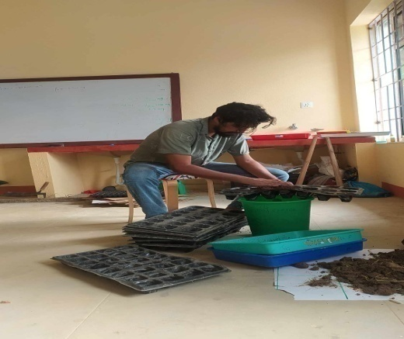
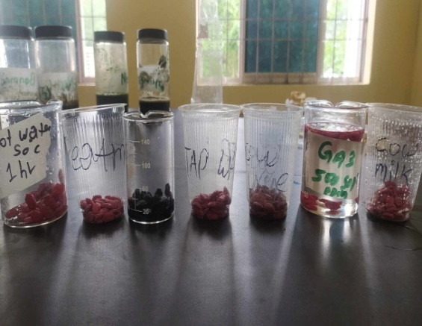

Picture 1: Treatments of Research Picture 2: Filling of media into germinating tray

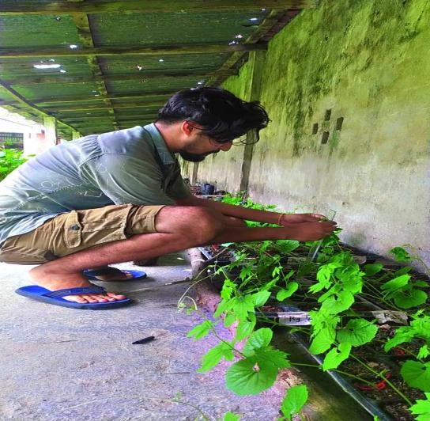
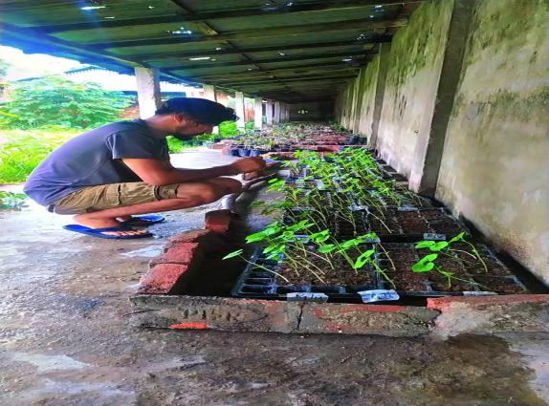

Picture 3: Taking data on sampled plants

Picture 4: Measurement on Plant height

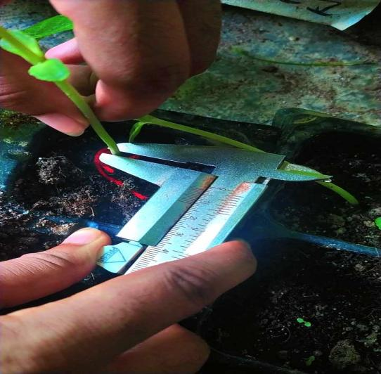

Picture 5: Measurement on stem Diameter

