Original research article

A GMM-COX HYBRID MODELING FRAMEWORK FOR MULTIDIMENSIONAL RETIREMENT PREDICTION IN THE PUBLIC SECTOR

Abstract

Forecasting retirements is a strategic challenge for human resource management in public administrations, where workforce planning and service continuity depend on reliably anticipating these departures. In practice, retirement decisions are often based on limited criteria, such as age or seniority, without systematically considering the various factors that can influence their occurrence.

This work proposes a multidimensional predictive approach based on the use of a dataset integrating demographic, administrative, medical, behavioral, and legal variables related to civil servants. To enable the combined use of qualitative and quantitative variables within a homogeneous analytical framework, a probabilistic coding method for qualitative categories is introduced, ensuring the normalization and consistent integration of data into statistical models.

The methodology adopted is based on a hybrid approach combining a Gaussian mixture model to identify latent risk profiles and a Cox regression model to estimate risk and probable time to retirement. This combination makes it possible to exploit both the latent structures present in the data and the explicit relationships between the explanatory variables and the event under study.

Human resource planning in the civil service is a significant challenge, particularly for anticipating retirements and ensuring the continuity of public service. In practice, retirement decisions are often based on limited criteria such as age and seniority, which fails to consider all the factors that could influence this event.

In this study, a multidimensional predictive approach was proposed by integrating demographic, administrative, medical, and behavioral variables from employee records. The methodology is based on a hybrid approach combining a Gaussian mixture model for profile identification and a Cox regression model for estimating risk and probable time to retirement, producing consistent results and satisfactory predictive capability.

These results show that the integration of multidimensional variables and the joint use of machine learning and survival analysis methods constitute a relevant approach to improve the anticipation of departures and support decision-making in public human resource management.

Keywords : Retirement prediction; Machine learning; Survival analysis; Cox model; Gaussian mixture model; Data science; Public human resource management; Predictive modeling .

1. Introduction
Workforce planning represents a major challenge for public administrations, particularly in the context of an aging workforce, budgetary constraints, and the need to ensure the continuity of public service. Among the most sensitive issues is anticipating retirements, which impacts recruitment planning, skills transfer, and the financial balance of pension commitments.

In many administrative systems, retirement is still largely determined by relatively limited criteria, such as the legal retirement age or length of service. While these parameters provide essential legal benchmarks, they are insufficient to account for the true complexity of career paths. In practice, retirement often results from a combination of demographic, administrative, medical, behavioral, and organizational factors, the respective influence of which remains difficult to measure using traditional methods.

In parallel, recent advances in data science and machine learning have enabled the development of methods capable of leveraging multidimensional datasets to analyze complex phenomena and produce reliable quantitative predictions. In the field of human resource management, these approaches offer promising prospects for identifying risk profiles, estimating the probability of event occurrence, and improving decision-support tools. However, their application to predicting retirements in the public sector remains relatively unexplored, particularly in administrative contexts where the data combine heterogeneous variables, both quantitative and qualitative.

In this context, this article proposes a multidimensional predictive approach to civil servant retirement, based on the structuring of a dataset integrating demographic, administrative, medical, behavioral, and legal variables. A probabilistic coding method is introduced to transform qualitative variables into continuous numerical representations, thus facilitating their integration into a homogeneous analytical framework.

The chosen methodology is based on a hybrid approach combining a Gaussian mixture model to identify latent risk profiles and a Cox regression model to estimate risk and probable time to retirement. This combination makes it possible to exploit both the latent structures present in the data and the explicit relationships between the explanatory variables and the event under study, while improving the overall predictive power of the model.

This research pursues a dual objective. On the one hand, it aims to propose a methodological framework enabling a multidimensional analysis of the determinants of retirement in the public sector and, on the other hand, to demonstrate the value of data analysis methods for anticipating departures and strategically planning human resources in public organizations.

The remainder of the article is organized as follows. The next section presents related work on event prediction in the field of human resources and the application of machine learning and survival analysis methods. The following section describes the dataset and variable preparation methods. The proposed methodology is then detailed, before the presentation of the experimental results, their discussion, and the study's conclusions.

This study makes several scientific contributions. First, it proposes a multidimensional analytical framework that simultaneously integrates demographic, administrative, medical, and behavioral variables for predicting retirement in the public sector. Second, it introduces a probabilistic transformation method for qualitative variables, enabling their coherent integration into a single predictive model. Third, it implements a hybrid approach combining a Gaussian mixture model and a Cox regression model to identify risk profiles and estimate the probable time to retirement. Finally, this study demonstrates the operational value of these methods for strategic human resource planning in public administrations.

2. Research Problem

In many public administrations, employee retirement is based primarily on two fundamental criteria: the statutory retirement age and length of service. These parameters constitute essential legal benchmarks and offer a relatively simple regulatory framework for determining retirement eligibility. However, this approach remains limited, as it does not take into account the actual complexity of employees' professional and individual situations.

In practice, retirement from the civil service often results from the interaction of multiple factors, including health, medical fitness, working conditions, professional performance, disciplinary situations, and various administrative or organizational constraints. Insufficient consideration of these dimensions can lead to incomplete assessments, poorly prepared decisions, and difficulties in human resource management.

Furthermore, the lack of analytical tools capable of simultaneously integrating these different variables limits the ability of government agencies to reliably anticipate retirements and identify individuals at high risk of ceasing operations in the short or medium term. Traditional methods, which are primarily descriptive or based on a single criterion, do not allow for the effective use of available administrative data or the production of quantitative estimates of retirement risk.

Therefore, three central questions arise:

- To what extent does the integration of multidimensional variables (demographic, administrative, medical and behavioral) improve the prediction of civil servant retirement compared to approaches based solely on age and seniority?

- How can the probabilistic transformation of qualitative variables facilitate their integration into machine learning models and improve the consistency of predictive analysis?

- To what extent does the use of a hybrid approach combining a Gaussian mixture model and a Cox regression model make it possible to identify risk profiles and estimate the probable time before retirement of civil servants?

3. Hypotheses

Given the problem posed and the research questions formulated, it appears necessary to propose hypotheses that can be empirically verified using the selected data and analytical methods.

- The integration of multidimensional variables, including demographic, administrative, medical and behavioral factors, would improve the accuracy of retirement forecasts for public service employees , compared to approaches based solely on age and seniority.
- The probabilistic transformation of qualitative variables would facilitate their integration into statistical and machine learning models , while improving the consistency and stability of the results obtained.

- Using a hybrid approach combining a Gaussian mixture model and a Cox regression model would make it possible to identify retirement risk profiles and to more accurately estimate the probable time before retirement of public sector employees.

4. Research objective

The aim of this research is to design and evaluate a predictive model capable of anticipating the retirement of civil servants, going beyond traditional approaches based solely on age and seniority. This involves integrating, within a coherent analytical framework, multidimensional variables of a demographic, administrative, medical, and behavioral nature, in order to identify the factors influencing the triggering of retirement and to estimate the risk and probable timing of cessation of activity.

This study also aims to demonstrate the value of jointly using machine learning and survival analysis methods as decision support tools to improve human resource planning and enhance the effectiveness of forecasting management within public administrations.

5. Methodology

This study adopts a methodological approach based on the use of machine learning and survival analysis techniques to predict the retirement of civil servants. The methodology relies on a structured process that includes data preparation, variable transformation, modeling, and results evaluation.

The overall modeling process includes the following steps:

- Data collection and structuring
- Cleaning and normalization
- Probabilistic transformation of qualitative variables
- Profile segmentation by GMM model
- Integration of clusters into the Cox model
- Performance evaluation
- Interpretation and prediction

Traditional methods for transforming qualitative variables, such as ordinal or one-hot encoding, are widely used in predictive models. However, these approaches can increase the dimensionality of the data or introduce artificial discontinuities between categories. The probabilistic coding method proposed in this study aims to reduce these limitations by producing continuous representations, facilitating model convergence and improving numerical stability.

6. Machine Learning

Machine learning is a field of artificial intelligence that aims to build models capable of extracting regularities from data in order to make predictions or identify underlying structures.

To achieve the objectives of this research, two artificial learning models were selected: the Gaussian mixture model and the Cox regression model.

6.1. The Gaussian mixture model

The Gaussian mixture model belongs to the family of unsupervised learning methods. It is based on the assumption that the observed data can be represented as a combination of several normal distributions:

Consider a set of $N$civil servants, described by a vector of normalized quantitative variables: $X=\left\{x_{1},x_{2},…x_{N}\right\}$with: $x_{i}∈R^{d}$Where $d$represents the number of explanatory variables used (age, career length, disability, absenteeism, etc.). After normalization (standardization) :
$$z_{i}=\frac{x_{i}-μ}{σ}$$

6.1.1. Fundamental assumption of GMM

The GMM assumes that the overall data distribution is a finite mixture of Gaussian distributions :
$$p\left(z\right)=\sum_{k=1}^{K}{π_{k}N(z|μ_{k},Σ_{k})}$$
Where : $K$: number of latent classes (risk groups), $K_{k}:$group weight $k,$such that:
$$\sum_{k=1}^{K}{π_{k}}=1, { π}_{k}>0$$
Where: $μ_{k}$: represents the mean vector of the group $k$, which characterizes the center of the distribution of observations belonging to this group, $Σ_{k}$: denotes the covariance matrix of the group $k$, which describes the dispersion and correlation structure of the variables within this group.

    - Likelihood function

The model's likelihood is given by:

$$L\left(Θ\right)=\prod_{i=1}^{N}{\sum_{k=1}^{K}{π_{k}N(z_{i}}}|μ_{k},Σ_{k})$$
With : $Θ={\left\{π_{k},μ_{k},Σ_{k}\right\}}_{k=1}^{K}$The parameter estimation is based on maximizing the log-likelihood.
$$\log{L\left(Θ\right)=\sum_{i=1}^{N}{log⁡\left(\sum_{k=1}^{K}{π_{k}N(z_{i}|{ μ}_{k},Σ_{k})}\right)}}$$

    - Maximization algorithm

- Step E (Waiting)

We calculate the probability that the agent belongs $i$to the group.$k :$

$$γ_{ik}=P\left(z_{i}=k|z_{i}\right)=\frac{π_{k}N\left(z_{i}|{ μ}_{k},Σ_{k}\right)}{\sum_{j=1}^{K}{π_{j}N\left(z_{i}|{ μ}_{j},Σ_{j}\right)}}$$
- Step M (Maximization)
$$π_{k}=\frac{1}{N}\sum_{i=1}^{N}{γ_{ik}}$$

$${ μ}_{k}=\frac{\sum_{i=1}^{N}{γ_{ik}z_{i}}}{\sum_{i=1}^{N}{γ_{ik}}}$$
$${ Σ}_{k}=\frac{\sum_{i=1}^{N}{γ_{ik}{\left(z_{i}-μ_{k}\right){\left(z_{i}-μ_{k}\right)}^{T}}_{}}}{\sum_{i=1}^{N}{γ_{ik}}}$$
    - Final cluster allocation

Each agent is assigned to the group that maximizes their posterior probability:
$${Cluster}_{i}=arg\max_{k}{γ_{ik}}$$
These groups represent latent retirement risk profiles .

  - GMM rating

- Information criterion:$BIC= -2 log L+p\log{N}$
- Stability (ARI):$ARI ∈\left[-1,1\right]$

A positive value confirms a non-random segmentation, which is expected for a probabilistic model.

2.2. Cox model with proportional hazards

The Cox regression model belongs to the family of survival analysis models and constitutes a form of supervised learning, as it uses information relating to the occurrence of an event and the associated time.

In this study, the Cox model is used to:
- estimate the influence of explanatory variables on retirement risk;
- predict the median time to retirement for each agent;
- Convert this period into a projected retirement calendar year, starting from the current year.

The integration of the risk group from the GMM makes it possible to couple latent information with explicit information, thus strengthening the predictive capacity of the model.

2.2.1. Mathematical modeling of the proportional Cox model
a) Time variable and event

Either: $T_{i}:$the time remaining before the employee's retirement $i$, or $δ_{i}ϵ\left\{0,1\right\} :$an event indicator (retirement/death). In your model: $T_{i}=\left(1-{Age}_{i}\right)×α,$with $α=10$(justified scaling factor).

b) Risk function (hazard function)

The Cox model defines instantaneous risk:$h\left(t | x_{i}\right)=h_{0}\left(t\right) exp\left(β^{T}x_{i}\right)$

- $h_{0}\left(t\right)$: basic risk function,
- $β$: vector of coefficients,
- $x_{i}$: vector of covariates (including Cluster_risk ).

c) Proportionality hypothesis
$$\frac{h\left(t|x_{i}\right)}{h\left(t|x_{j}\right)}=exp \left(β^{T}\left(x_{i}-x_{j}\right)\right)$$
The risk ratio is independent of time.

d) Partial plausibility
$$L\left(β\right)=\prod_{i:δ_{i}=1}{\frac{exp\left(β^{T}x_{i}\right)}{\sum_{jϵR(T_{i})}{exp\left(β^{T}x_{j}\right)}}}$$
Where $R(T_{i})$are all the agents still active at $T_{i}$.

e) Penalty (robustness)

To limit collinearity: $L_{pen}=L\left(β\right)-λ{\left\|β\right\|}_{2}^{2}$, with$λ=0.1$

f) Median time prediction

The median time ${\tilde{T}}_{i}$is such that: $S\left({\tilde{T}}_{i}|x_{i}\right)=0.5$where$S\left(t|x_{i}\right)=exp\left(-\int_{0}^{t}{h\left(u|x_{i}\right)du}\right)$
g) Expected retirement year

${Année}_{i}= {Année}_{courante}+{\tilde{T}}_{i}$With limit values: 2026$≤$ ${Année}_{i}$ $≤$2030

6. Presentation and description of variables

In this research, each variable is associated with a unique variable code.

This coding facilitates:

- the structuring of the dataset;
- statistical and algorithmic analysis;
- the reproducibility of the analyses;
- the implementation of predictive models.

The variable codes are formulated concisely and explicitly, in accordance with good practices in data science.

Table 1 : Presentation and description of variables
No. | Codes | Variables | Designation | Description
1 | Agent_ID | Agent ID | identification variable | A unique code is assigned to each agent to ensure anonymity and longitudinal tracking of data.
2 | Date of birth | Date of birth | Demographic variable | Official date of birth of the agent allowing for the precise calculation of their age.
3 | Age | Agent's age | Demographic variable | Agent's age expressed in completed years at the time of analysis.
4 | Sex | Agent's gender | Sociodemographic variable | Biological sex of the agent as it appears in administrative documents.
5 | Date of commitment | Date of commitment | Career variable | Official date of entry into service of the agent in the civil service.
6 | career length | Career length | Professional variable | Total number of years of actual service completed by the employee.
7 | Administrator status | administrative status | Administrative variable | Current administrative status of the agent (active, suspended, seconded, on leave).
8 | Grade | Grade | Hierarchical variable | Hierarchical level or administrative category occupied by the agent.
9 | Level | Level | Variable salary | The agent's position in the salary scale corresponds to their seniority.
10 | Medical fitness | Medical fitness | Health variable | The agent's ability or unsuitability to perform their duties.
11 | Disability | Recognized disability | Medical variable | Indicates the existence of an officially recognized disability.
12 | Disability rate | disability rate | Quantitative medical variable | Percentage of disability assigned to the employee by a medical board.
13 | sick leave | Accumulated sick leave | Health variable | Total number of sick leave days recorded over a given period.
14 | Absenteeism | Prolonged absenteeism | Behavioral variable | Measuring absenteeism as it impacts the continuity of public service.
15 | Performance evaluation | Performance evaluation | Performance variable | Results of the agent's official professional evaluations.
16 | Number of sanctions | Number of sanctions | Disciplinary variable | Total number of officially recorded disciplinary sanctions.
17 | Opinion hierarchy | hierarchical opinion | Qualitative variable | Official evaluation by management of the employee's professional skills.
18 | Punctuality | Punctuality and regularity | Behavioral variable | Respect for working hours and regularity in the execution of tasks.
19 | Legal basis | Legal basis for retirement | Legal variable | Legal or regulatory text justifying the employee's retirement.
20 | Type_retirement | Type of retirement | Decision variable | Type of retirement granted (normal, early, disability, compulsory).
21 | retirement_date | Retirement date | Time variable | Effective date of the employee's retirement.
22 | Death | Death of the officer | event variable | Indicates the death of the agent, resulting in the definitive cessation of their duties.

7. Presentation of the data table

This section presents the data table used in the empirical analysis of this research. The dataset was structured according to predefined variables to ensure methodological consistency between the conceptual framework, the research objectives, and the analytical methods adopted.

Table 2: Example of data from public service agents

Agent_ID | Date_  birth | Age | Date_  commitment | Duration _  career | Status_  administrator | Level | Aptitude_  medicine | Disability | Rate_  disability | Vacation_  disease | Absent  theism | Assessment _  yield | Nb_  sanctions | Notice_  hierarchy | Punctuality | Base_  legal | Kind_  retirement | Date_  retirement | Death
A0001 | December 13, 1971 | 54 | May 11, 2004 | 21 | Active | 6 | Appropriate | No | 0 | 108 | 130 | Weak | 4 | Reserve | Average | administrative decision | Desk | November 14, 2025 | No
A0002 | May 2, 1961 | 64 | 23/06/2004 | 21 | Active | 5 | Unfit | Yes | 35 | 75 | 96 | GOOD | 4 | Unfavorable | Weak | Legal age | Normal | March 10, 2022 | No
A0003 | January 15, 1959 | 66 | February 13, 1980 | 45 | Active | 3 | Appropriate | No | 0 | 29 | 24 | AVERAGE | 3 | Unfavorable | Weak | Disability | Foreseen | 2023-04-06 | No
A0004 | 1968-06-05 | 57 | August 13, 1980 | 45 | Active | 2 | Appropriate | No | 0 | 313 | 147 | GOOD | 0 | Favorable | GOOD | administrative decision | Disability | October 17, 2019 | No
A0005 | 1968-03-07 | 57 | January 13, 1994 | 31 | Active | 9 | Unfit | Yes | 81 | 116 | 161 | Weak | 0 | Reserve | Average | Disability | Desk | 2019-11-22 | No
A0006 | August 9, 1968 | 57 | May 20, 1997 | 28 | Active | 9 | Appropriate | No | 0 | 355 | 153 | Weak | 3 | Favorable | Average | Disability | Foreseen | 28/11/2016 | No
A0007 | November 27, 1962 | 63 | 2000-10-05 | 25 | Suspended | 1 | Appropriate | No | 0 | 191 | 125 | AVERAGE | 2 | Reserve | Weak | Legal age | Desk | 2025-09-09 | No
A0008 | October 24, 1970 | 55 | September 2, 1984 | 41 | Active | 3 | Appropriate | No | 0 | 18 | 132 | AVERAGE | 1 | Unfavorable | Weak | administrative decision | Normal | 29/08/2018 | No
A0009 | May 24, 1966 | 59 | September 18, 1980 | 45 | Active | 8 | Appropriate | No | 0 | 172 | 8 | GOOD | 0 | Reserve | GOOD | administrative decision | Disability | 25/11/2015 | No
A0010 | 1968-10-05 | 57 | May 28, 1990 | 35 | Active | 6 | Appropriate | No | 0 | 227 | 115 | GOOD | 1 | Unfavorable | Weak | Disability | Normal | 27/11/2018 | No
A0011 | June 11, 1974 | 51 | 1999-01-01 | 26 | Active | 5 | Appropriate | No | 0 | 349 | 177 | Weak | 5 | Reserve | GOOD | administrative decision | Disability | November 18, 2024 | No
A0012 | July 15, 1975 | 50 | July 14, 1989 | 36 | Active | 5 | Unfit | Yes | 64 | 182 | 133 | AVERAGE | 5 | Favorable | Weak | Disability | Desk | 2018-09-04 | No
A0013 | October 20, 1957 | 68 | June 25, 1986 | 39 | Active | 6 | Appropriate | No | 0 | 112 | 59 | AVERAGE | 3 | Unfavorable | Weak | Disability | Desk | 23/05/2017 | No
A0014 | 1962-09-05 | 63 | October 21, 1999 | 26 | Active | 7 | Appropriate | No | 0 | 182 | 171 | AVERAGE | 5 | Favorable | Average | Legal age | Normal | 2021-04-20 | No
A0015 | March 22, 1966 | 59 | August 10, 1993 | 32 | Active | 1 | Appropriate | No | 0 | 145 | 120 | GOOD | 5 | Favorable | Weak | Legal age | Disability | 10/09/2025 | No
A0016 | February 8, 1955 | 70 | December 11, 1998 | 27 | Active | 9 | Appropriate | No | 0 | 318 | 138 | AVERAGE | 2 | Unfavorable | Weak | Legal age | Disability | January 28, 2022 | No
A0017 | December 28, 1970 | 55 | April 12, 1987 | 38 | Active | 3 | Appropriate | No | 0 | 115 | 174 | Weak | 2 | Unfavorable | GOOD | Disability | Desk | 2025-07-26 | No
A0018 | May 20, 1962 | 63 | June 22, 1981 | 44 | Suspended | 4 | Unfit | Yes | 83 | 112 | 107 | Weak | 2 | Favorable | Weak | administrative decision | Normal | April 27, 2019 | No
A0019 | March 13, 1970 | 55 | February 23, 2001 | 24 | Active | 1 | Appropriate | No | 0 | 250 | 107 | GOOD | 5 | Favorable | GOOD | Legal age | Disability | 2024-01-21 | No
A0020 | May 15, 1958 | 67 | March 22, 1993 | 32 | Active | 3 | Appropriate | No | 0 | 250 | 130 | GOOD | 3 | Favorable | Weak | administrative decision | Desk | July 30, 2021 | No
A0021 | December 18, 1955 | 70 | 03/06/1992 | 33 | Availability | 2 | Appropriate | No | 0 | 302 | 75 | AVERAGE | 4 | Favorable | Weak | Legal age | Foreseen | July 14, 2020 | No
A0022 | February 20, 1958 | 67 | April 11, 1994 | 31 | Active | 2 | Appropriate | No | 0 | 312 | 29 | GOOD | 4 | Unfavorable | GOOD | Legal age | Normal | October 24, 2015 | No
A0023 | August 11, 1960 | 65 | 07/06/1989 | 36 | Suspended | 1 | Appropriate | No | 0 | 117 | 20 | Weak | 1 | Unfavorable | Average | Disability | Foreseen | 29/01/2016 | No
A0024 | May 16, 1958 | 67 | 2004-01-22 | 21 | Active | 8 | Appropriate | No | 0 | 300 | 155 | AVERAGE | 4 | Favorable | GOOD | Legal age | Normal | 09/12/2023 | No

8. General principle of probabilistic transformation

Let an agent $i∈\left\{1,…,N\right\}$and a qualitative variable $X$taking a finite number of modalities: $X_{i}∈M_{x}= \left\{m_{1}, m_{2},…,m_{k}\right\}$the qualitative variable $X$is transformed into a normalized probabilistic variable $P_{x}$defined by a coding function: $fx:M_{x}→\left[0,1\right]$such that: $P_{x}\left(i\right)=f_{x}(X_{i})$where $P_{x}(i)$represents the degree of contribution of the observed modality to the probability of the agent's retirement $i$.

8.1. Specific formalization by variable

- Administrative status $X_{i}^{(1)}∈\left\{Actif, Disponibilité, Suspendu\right\}$, codification function:

$${ P}_{Statut}\left(i\right)=\left\{\begin{aligned}0.2 si X_{i}^{\left(1\right)} \\ 0.2 si X_{i}^{\left(1\right)} \\ 0.8 si X_{i}^{\left(1\right)}\end{aligned}\right. \begin{aligned}= Actif \\ =Disponibilité \\ =Suspendu\end{aligned}$$

- Medical fitness$X_{i}^{(2)}∈\left\{Apte, Inapte\right\}$

$$P_{Aptitudet}\left(i\right)=\left\{\begin{aligned}0.2 si X_{i}^{\left(2\right)} \\ 0.9 si X_{i}^{\left(2\right)}\end{aligned}\right. \begin{aligned} =Apte \\ =Inapte\end{aligned}$$

- Recognized disability$X_{i}^{(3)}∈\left\{Oui, Non\right\}$

$$P_{Invalidité}\left(i\right)=\left\{\begin{aligned}0.1 si X_{i}^{\left(3\right)} \\ 0.9 si X_{i}^{\left(3\right)}\end{aligned}\right. \begin{aligned} =Oui \\ =Non\end{aligned}$$

- Performance evaluation$X_{i}^{(4)}∈\left\{Bon, Moyen, Faible\right\}$

$${ P}_{Rendement}\left(i\right)=\left\{\begin{aligned}0.2 si X_{i}^{\left(4\right)} \\ 0.5 si X_{i}^{\left(4\right)} \\ 0.8 si X_{i}^{\left(4\right)}\end{aligned}\right. \begin{aligned} = Bon \\ =Moyen \\ =Faible\end{aligned}$$

- hierarchical opinion$X_{i}^{(5)}∈\left\{Favorable, Réservé,Défavorable\right\}$

$${ P}_{Avis}\left(i\right)=\left\{\begin{aligned}0.2 si X_{i}^{\left(5\right)} \\ 0.5 si X_{i}^{\left(5\right)} \\ 0.8 si X_{i}^{\left(5\right)}\end{aligned}\right. \begin{aligned} = Favorable \\ =Réservé \\ =Défavorable\end{aligned}$$

- Punctuality and regularity$X_{i}^{(6)}∈\left\{Bonne, Moyenne,Faible\right\}$

$${ P}_{Ponctualité}\left(i\right)=\left\{\begin{aligned}0.2 si X_{i}^{\left(6\right)} \\ 0.5 si X_{i}^{\left(6\right)} \\ 0.8 si X_{i}^{\left(6\right)}\end{aligned}\right. \begin{aligned} = Bonne \\ =Moyenne \\ =Faible\end{aligned}$$

- Legal basis for retirement$X_{i}^{(7)}∈\left\{Age légal, Invalidité,Décision administrative\right\}$

$${ P}_{Base légale}\left(i\right)=\left\{\begin{aligned}0.7 si X_{i}^{\left(7\right)} \\ 0.9 si X_{i}^{\left(7\right)} \\ 0.8 si X_{i}^{\left(7\right)}\end{aligned}\right. \begin{aligned}= Age légal \\ =Invalidité \\ =Décision administrative\end{aligned}$$

h) Type of retirement$X_{i}^{(8)}∈\left\{Normale, Inticipée,Invalidité, Office\right\}$

$${ P}_{Type retraite}\left(i\right)=\left\{\begin{aligned}0.6 si X_{i}^{\left(8\right)} \\ 0.8 si X_{i}^{\left(8\right)} \\ 0.9 si X_{i}^{\left(8\right)} \\ 0.85 si X_{i}^{\left(8\right)}\end{aligned}\right. \begin{aligned} = Normale \\ =Inticipée \\ =Invalidité \\ =Office\end{aligned}$$
i) Death$X_{i}^{(9)}∈\left\{Oui, Non\right\}$

$$P_{Décès}\left(i\right)=\left\{\begin{aligned}1 si X_{i}^{\left(9\right)} \\ 0 si X_{i}^{\left(9\right)}\end{aligned}\right. \begin{aligned} =Oui \\ =Non\end{aligned}$$
The adopted formalism allows qualitative variables to be transformed into continuous probabilistic components, thus ensuring their homogeneous integration into a single predictive model. This approach reduces categorical breaks, improves the numerical stability of the model, and facilitates the interpretation of the results obtained.

8.2. Coding Table

Table 3: Coding table

Variable | Actual modality | Probabilistic value | analytical justification
Administrator status | Active | 0.2 | Stable situation favoring the continuation of activity
Administrator status | Availability | 0.6 | Temporary absence from service, moderate risk
Administrator status | Suspended | 0.8 | Administrative breakdown, high risk
Medical fitness | Appropriate | 0.2 | State compatible with the continuity of service
Medical fitness | Unfit | 0.9 | Disability is strongly correlated with retirement.
Disability | No | 0.1 | Absence of a structuring medical factor
Disability | Yes | 0.9 | A determining factor in early retirement
Performance evaluation | GOOD | 0.2 | Maintenance-friendly performance
Performance evaluation | AVERAGE | 0.5 | Intermediate contribution
Performance evaluation | Weak | 0.8 | Unfavorable return, increased risk
Opinion hierarchy | Favorable | 0.2 | Institutional support
Opinion hierarchy | Reserve | 0.5 | Neutral position
Opinion hierarchy | Unfavorable | 0.8 | High probability of a negative decision
Punctuality | GOOD | 0.2 | Satisfactory discipline
Punctuality | Average | 0.5 | Moderate impact
Punctuality | Weak | 0.8 | Indiscipline leading to expulsion
Legal basis | Legal age | 0.7 | Predictable legal justification
Legal basis | Disability | 0.9 | Binding justification
Legal basis | administrative decision | 0.8 | Strong institutional decision
Type_retirement | Normal | 0.6 | Standard starting probability
Type_retirement | Foreseen | 0.8 | Departure likely in the short term
Type_retirement | Disability | 0.9 | Departure almost certain
Type_retirement | Desk | 0.85 | Imposed decision
Death | No | 0.0 | No impact
Death | Yes | 1.0 | A definitive and unequivocal cessation

The probabilistic values assigned to the qualitative categories reflect their relative contribution to retirement, not a certainty of departure. This coding allows for a coherent integration of qualitative and quantitative variables in a single predictive model, aiming to anticipate retirements as early as this year.

Table 4. Dataset (Sample )

Agent_ID | Age | Duration _  career | Status_  administrator | Level | Attitude _  medicine | Disability | Rate_  disability | Vacation_  disease | Absent  theism | Assessment _  yield | Number_  sanctions | Notice_  hierarchy | Aunctuality | Base_  legal | TyAe _  retirement | Death
A0001 | 0.5 | 0.2 | 0.4 | 0.7 | 0.2 | 0.6 | 1 | 0.4 | 0.2 | 0.9 | 0.5 | 0.4 | 1 | 0.7 | 0.9 | 1
A0002 | 0.8 | 1 | 0.2 | 0.6 | 0.2 | 0.2 | 0.4 | 0.1 | 0.2 | 0.6 | 0.1 | 0.9 | 0.1 | 0 | 0.6 | 1
A0003 | 0.9 | 0.8 | 0.5 | 0.1 | 1 | 0.8 | 0.2 | 0.4 | 0.6 | 0.4 | 0.6 | 0.7 | 1 | 1 | 0.7 | 0.5
A0004 | 0.5 | 0.3 | 0.4 | 1 | 0 | 0 | 0.7 | 1 | 0.1 | 0.1 | 0.2 | 0.4 | 0.7 | 1 | 0.8 | 0.4
A0005 | 0 | 0 | 0.6 | 0.7 | 0.9 | 0.2 | 0.8 | 0.6 | 0.2 | 0.7 | 0.5 | 0.5 | 0.5 | 0.3 | 0.7 | 0.8
A0006 | 0 | 0.8 | 0.2 | 0.2 | 0.5 | 0.6 | 0.3 | 0.8 | 0.2 | 0.8 | 0 | 0.9 | 1 | 0.2 | 0.3 | 0.9
A0007 | 0.1 | 0.4 | 0.9 | 0.4 | 0.1 | 0.4 | 0.4 | 0.8 | 0.1 | 0.9 | 0.9 | 0.9 | 0.9 | 0.9 | 0.3 | 0
A0008 | 0.7 | 0.2 | 0.2 | 0.5 | 0.1 | 0.8 | 0 | 0 | 0.5 | 0.7 | 0.1 | 0.7 | 0.1 | 0.6 | 0.1 | 0.2
A0009 | 0.6 | 0.9 | 0.7 | 0.6 | 0.6 | 0.4 | 0.7 | 0 | 0.5 | 0.9 | 0.1 | 0.3 | 0 | 0.3 | 0.2 | 1
A0010 | 0.9 | 0 | 0.5 | 0.7 | 0.3 | 0.3 | 1 | 0.6 | 0.2 | 0.4 | 0.3 | 0 | 1 | 0.5 | 0.2 | 0
A0011 | 0.2 | 0.3 | 0 | 0.2 | 0.2 | 0.4 | 0.7 | 0.6 | 0.3 | 0.7 | 0.9 | 0.2 | 0.2 | 0.2 | 0.3 | 0.9
A0012 | 0.4 | 0.8 | 0.7 | 0 | 0.1 | 0.9 | 0.9 | 0.8 | 0.3 | 0.7 | 1 | 0.1 | 0.8 | 0.5 | 0.5 | 0.5
A0013 | 0.5 | 0.1 | 1 | 0.5 | 0.1 | 0.8 | 0.8 | 0.9 | 0.3 | 0.5 | 0.9 | 0.4 | 0.7 | 0.6 | 0.7 | 0.1
A0014 | 0.2 | 1 | 0.8 | 0.2 | 0.2 | 0.3 | 0.7 | 0.3 | 0 | 0.6 | 0.5 | 0.4 | 0.7 | 0.7 | 0 | 0.9
A0015 | 0.4 | 0.4 | 0.8 | 0.7 | 0.7 | 0.5 | 0.1 | 0.9 | 0.5 | 1 | 1 | 0.3 | 0.6 | 0.9 | 0.1 | 0.7
A0016 | 1 | 0.3 | 0.8 | 0.9 | 0.5 | 0.2 | 0.4 | 1 | 0.3 | 0.6 | 0.9 | 0.9 | 1 | 0.7 | 0.5 | 0.2
A0017 | 0.2 | 0.3 | 0 | 0.9 | 0.2 | 0 | 0.8 | 0.7 | 0.1 | 0.1 | 0.6 | 0.3 | 0.4 | 0.1 | 0.5 | 0.3
A0018 | 0.4 | 1 | 0.7 | 0.7 | 0.9 | 0.7 | 0.3 | 0.1 | 0 | 0.3 | 0.7 | 0.5 | 0 | 0.1 | 0.7 | 0.3
A0019 | 0.7 | 0.6 | 0.2 | 0.1 | 0.4 | 0.9 | 0.9 | 0 | 0.6 | 1 | 0.6 | 0.6 | 0.7 | 0.6 | 0.9 | 0.2
A0020 | 0.7 | 0.7 | 0 | 0.1 | 0.7 | 0.8 | 0.4 | 0.3 | 0.4 | 0 | 0.7 | 1 | 0.5 | 0.7 | 0.2 | 0
A0021 | 0.9 | 0.3 | 0.7 | 0.4 | 0.3 | 0.1 | 0.2 | 0.1 | 0.3 | 0.7 | 0.6 | 0.8 | 0.3 | 0.3 | 0.7 | 0
A0022 | 0.1 | 0.5 | 0.1 | 0.6 | 0.5 | 0.4 | 0.9 | 0.9 | 0.1 | 0.8 | 0.7 | 0.9 | 0.9 | 0.1 | 0.8 | 0.9
A0023 | 0.7 | 0.3 | 1 | 0.5 | 0 | 0.6 | 0 | 0.3 | 1 | 0.2 | 0.7 | 0.2 | 0.4 | 1 | 0.6 | 1
A0024 | 0 | 0.2 | 0.1 | 0.6 | 0.2 | 0.1 | 0.1 | 0.9 | 0.5 | 0 | 0.2 | 0.8 | 0.8 | 0.1 | 1 | 0.5
A0025 | 0.6 | 0.4 | 1 | 0.4 | 0.1 | 0.6 | 0.2 | 0.3 | 0.5 | 0.3 | 0.9 | 0.3 | 0.7 | 0.7 | 0.3 | 0
A0026 | 0.9 | 0.4 | 0.9 | 0.1 | 0.4 | 0.9 | 1 | 0.2 | 0.9 | 0.4 | 0.9 | 0.3 | 0 | 0.2 | 0.2 | 0.5
A0027 | 0.9 | 0 | 0.5 | 0.1 | 0.9 | 0.3 | 0.8 | 0.6 | 1 | 0.7 | 0 | 0.2 | 0.6 | 0.5 | 0.5 | 0.5

9. Implementation
9.1. Implementation Language and Tools

The implementation was done in Python, due to the richness of its scientific libraries and its strong adoption in the field of data science.

The chosen working environment is Jupyter Notebook, which offers: interactive code execution, immediate visualization of results, and complete traceability of experiments.

The implementation of the machine learning and survival analysis models presented in this study relies on a set of Python libraries recognized for their scientific robustness, reliability, and widespread use in data research. Each imported module plays a specific and complementary role in the data processing, modeling, and evaluation chain.
- Pandas: data manipulation and structuring,
- NumPy: numerical computation,
- Scikit-learn: GMM implementation, standardization, and metrics
- Lifelines: Modeling survival and Cox regression.

Fig 1: The implementation itself
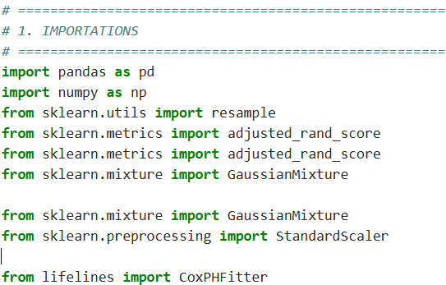
Fig 2:Loading data from an Excel file

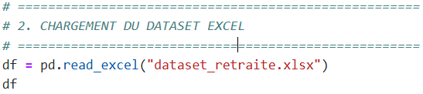

Table 5: A sample of data from 200 civil servants

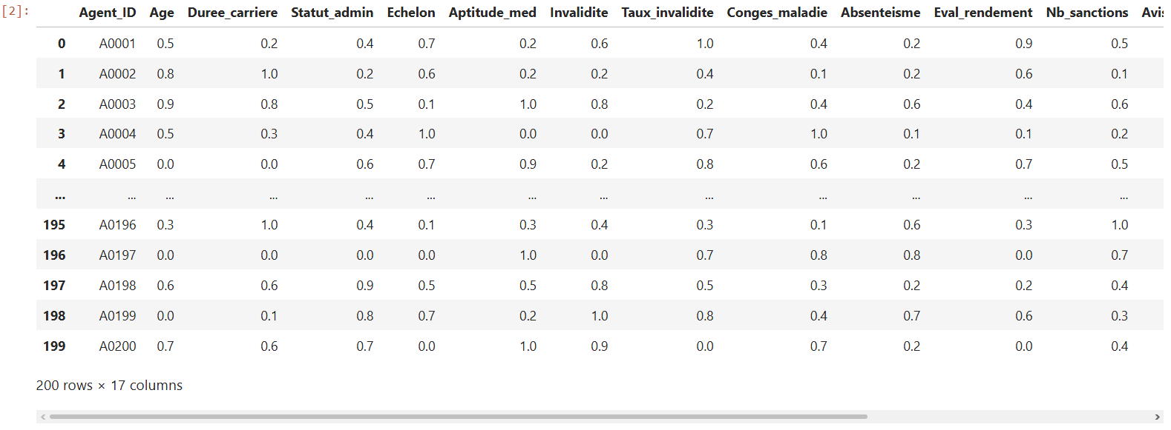

The table presented includes a sample of 200 civil servants , each described using normalized variables ranging from 0 to 1 , covering demographic, administrative, medical, disciplinary, and professional dimensions. This normalization ensures consistent data processing within the statistical and machine learning models used in this study.

In conclusion, the overall analysis of the dataset underlines the need for a multidimensional and probabilistic approach to predicting the retirement of civil servants, thus confirming the relevance of the statistical and machine learning models used in this work.

Fig 3: Cleaning, conversion and validation of numerical variables.

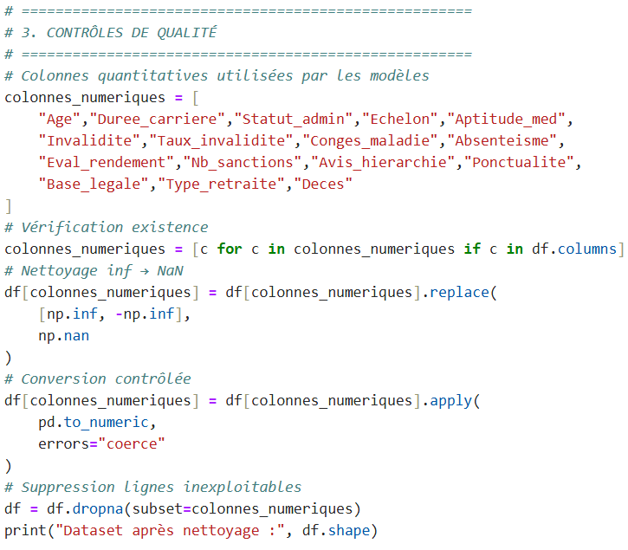
After the data cleaning and quality control process, the final dataset selected for analysis consists of 200 observations , corresponding to officials, described by 17 quantitative variables .

This methodological choice ensures the numerical stability of Gaussian mixture classification (GMM) algorithms, which are sensitive to the presence of missing values, as well as the validity of the parameter estimates of the Cox regression model, which requires fully observed covariates for a reliable estimation of the risk functions.

Fig 4:Learning the GMM and assigning risk groups

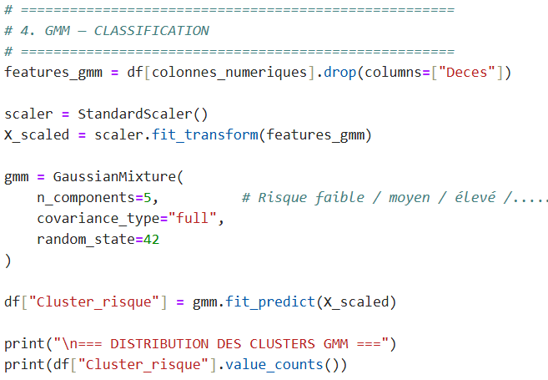
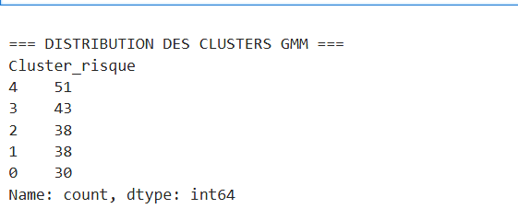

The distribution of groups obtained by applying the Gaussian mixture model highlights a non-uniform but structured segmentation of civil servants according to their retirement risk profile.

Each group corresponds to a latent retirement risk profile, resulting from the joint combination of demographic, professional, medical and behavioral variables.

- The most populated groups (groups 4 and 3) reflect dominant profiles in public administration, characterized by a progressive accumulation of moderate risk factors ( middle age, advanced career, variable health status ).
- The intermediate groups (groups 2 and 1) include agents with more contrasting profiles, where some factors accelerate the probability of leaving ( disability, absenteeism, sanctions ), while others delay it (performance, punctuality).
- The least represented group (group 0) corresponds to a more specific profile, often associated either with a low risk of short-term retirement, or with atypical situations ( young but vulnerable agents, or older but very high-performing agents ).

The distribution of GMM clusters highlights the existence of heterogeneous retirement risk profiles within the civil service, confirming that the decision or occurrence of retirement results from a complex combination of factors and not from a single criterion.

Fig 5:GMM Evaluation

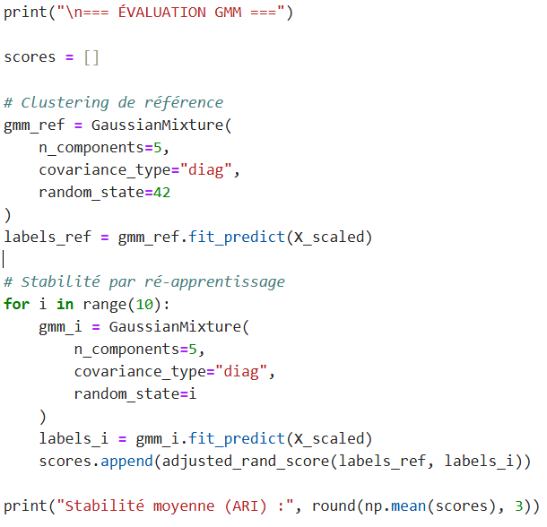
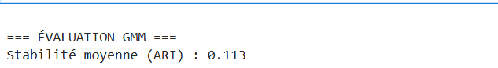

The Adjusted Rand Index (ARI) measures the stability and consistency of the partitions obtained by a clustering algorithm when it is reapplied to similar or resampled data. Its value ranges from -1 to 1 , where:

- 1 indicates a perfect match between the scores.
- 0 corresponds to a similarity equivalent to a random grouping.
- Negative values indicate a discrepancy.

In this study, an average ARI stability of 0.113 was observed for the Gaussian mixture model (GMM).

Quantitative reading of the result

A value of 0.113 indicates weak to moderate cluster stability when the model is reestimated.

This means that:

- The group structure exists,
- but it is neither rigid nor strictly reproducible from one sampling to another.

In other words, the boundaries between groups are blurred , which is consistent with the probabilistic nature of GMM.
The stability assessment of the GMM model, measured by the adjusted Rand index (ARI), yielded an average value of 0.113. This value reflects moderate stability of the partitions, a characteristic expected in probabilistic segmentation applied to continuous socio-administrative data. Far from being a methodological limitation, this variability reflects the progressive and multidimensional nature of retirement risk. The GMM model thus fulfills its exploratory role by identifying consistent latent profiles, which are then used as explanatory variables in the Cox survival model.

Fig 6:Construction of the temporal survival variable

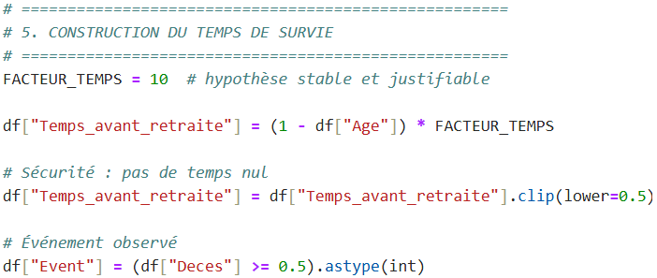

Fig 7:Learning the penalized Cox model

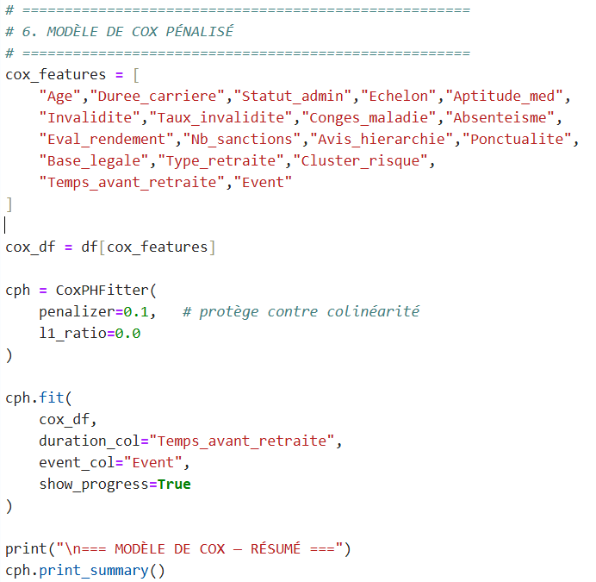

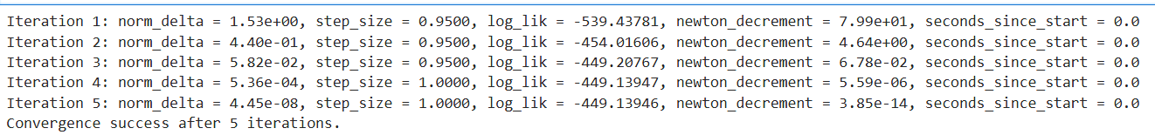

The Cox model estimation successfully converged after five iterations of the Newton-Raphson algorithm. The partial likelihood improved significantly during the first iterations before stabilizing, while the norm of the parameter updates and the convergence criterion rapidly approached zero. This rapid and stable convergence demonstrates the numerical robustness of the model and the consistency between the data structure and the assumptions of the proportional Cox model.

Table 6. Coefficients of the Cox proportional model analysis
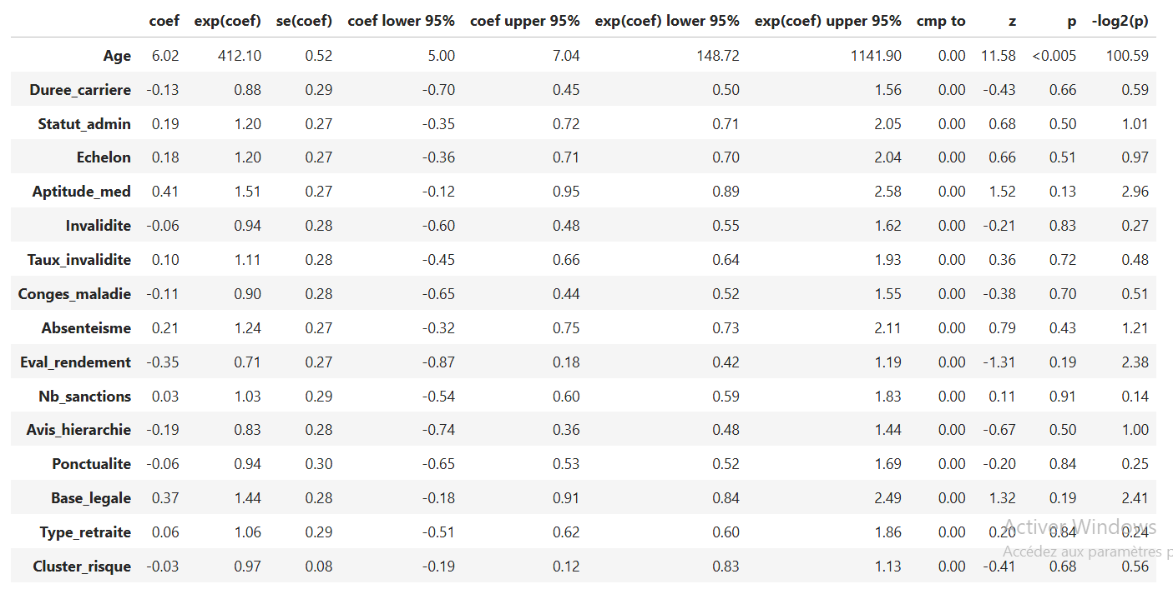
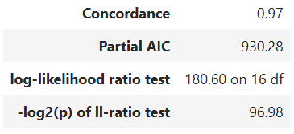

- Interpretation of the coefficients of the proportional Cox model

The table presents the estimated coefficients of the Cox model , their hazard ratios, their 95% confidence intervals, and the associated statistical significance tests . The objective is to identify the variables that significantly influence the risk of retirement (or a similar event) over time.

The results of the Cox model show that age is the primary explanatory factor for retirement risk, with a predominant and highly significant effect. The other variables, while conceptually relevant, have secondary or indirect effects, often absorbed by the age variable. Medical, behavioral, and institutional dimensions primarily contribute to structuring risk profiles, as highlighted by the grouping phase using the generalized method of moments (GMM), rather than to the strict temporal dynamics of retirement. This complementarity fully justifies the hybrid approach adopted, combining unsupervised learning and supervised survival analysis.

Fig 8:Evaluation of the Cox model

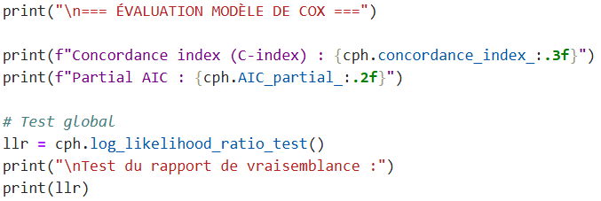
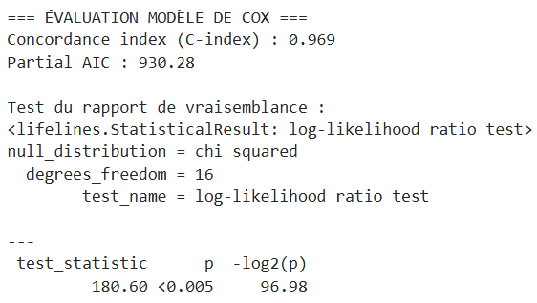

The evaluation of the Cox model is based on several complementary indicators allowing us to assess both its predictive quality , its overall statistical relevance and its methodological robustness .

- Concordance index (C index = 0.969)

The C index measures the model's ability to correctly classify individuals based on their risk of the event occurring (here, retirement or a similar event).

Theoretical value:

- 0.5 : performance equivalent to chance
- 1.0 : perfect prediction
- Result obtained: 0.969
A C index of 0.969 indicates that, in 96.9% of cases , the model correctly classifies two randomly selected agents in terms of relative retirement risk.

The evaluation of the Cox model highlights excellent predictive performance, with a concordance index of 0.969, indicating a very high capacity to correctly classify individuals according to their risk of retirement. The likelihood ratio test confirms the overall significance of the model (p < 0.005), demonstrating that the introduced covariates substantially explain the observed temporal dynamics. These results validate the robustness and relevance of the Cox model for the analysis and prediction of retirement patterns in the studied population.

Fig 9: Prediction of retirement years

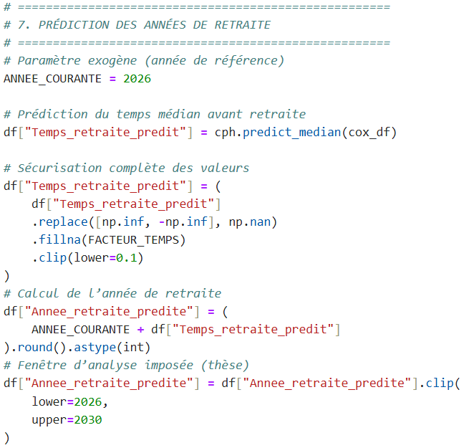
Fig 10:Results

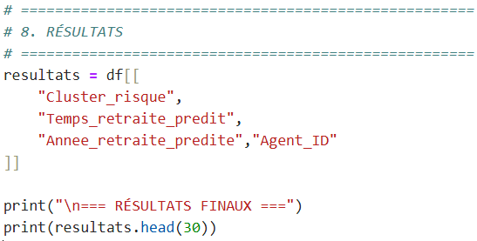
Table 7: Information obtained from the proposed modeling system
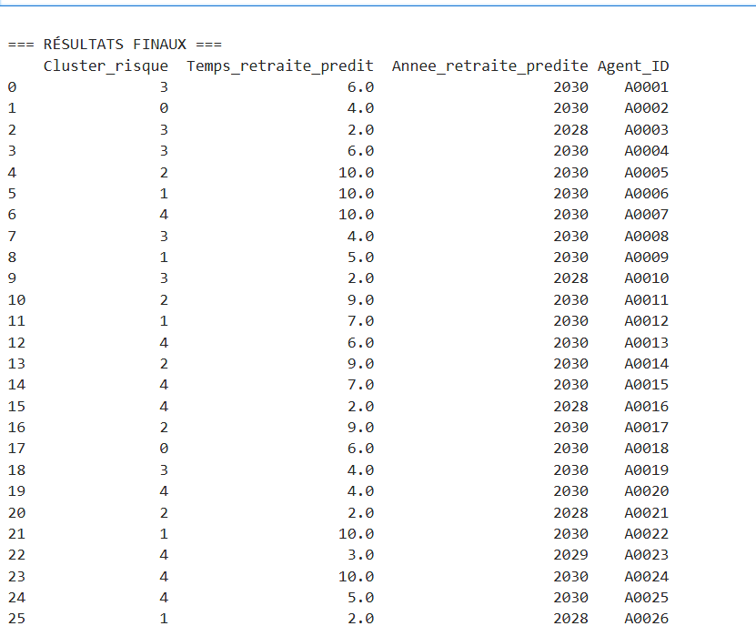

10. General interpretation of the retirement forecast results

The final results table presents, for each official studied, three key pieces of information from the proposed modeling system:
- the retirement risk profile identified by the Gaussian mixture model ( Cluster_risk ),
- (ii) the median estimated time before retirement ( Predicted_Retirement_Time ),
- (iii) the planned retirement year , included in the analysis interval 2026–2030.
These results represent the operational outcome of the hybrid approach combining unsupervised learning (GMM) and supervised survival analysis (Cox model) .

  - Reading and consistency of risk profiles ( Cluster_risk )

The Cluster_risk variable allows agents to be grouped into five distinct classes, corresponding to progressive levels of retirement risk. Each class reflects a specific combination of demographic, professional, health, and administrative characteristics.

In summary, we can retain the following semantic interpretation:

- Group 0 : agents presenting a latent or deferred risk , whose conditions remain relatively favorable for the continuation of their activity.
- Group 1 : agents at moderate risk , whose retirement is not imminent but is becoming progressively probable.
- Group 2 : agents at intermediate to high risk , requiring increased attention in planning.
- Group 3 : high-risk agents , for whom the probability of leaving in the medium term is significant.
- Group 4 : agents presenting a very high or imminent risk , often characterized by advanced age, disability or strong administrative constraints.

  - Analysis of the time expected before retirement

The expected retirement duration , expressed in years, represents the median estimated time before the occurrence of the retirement event, as inferred by the Cox model.

The results show a high degree of heterogeneity in individual trajectories :
- Some agents (e.g. A0003, A0010, A0016, A0021, A0026, A0030) have a short projected time (2 to 3 years) , reflecting a high probability of early departure.
- Other agents display a longer horizon (7 to 10 years), indicating a low or deferred probability of retirement in the immediate period.

10.3. Retirement year forecast

The planned retirement year represents the most direct translation of the model in terms of decision-making. The results show that:
- It is predicted that a significant proportion of agents will leave the market between 2028 and 2030 , with a notable concentration in 2030 , the cut-off year of the analysis period.
- The planned departures in 2028 and 2029 mainly correspond to agents belonging to the high-risk groups (3 and 4), which confirms the internal consistency between the regrouping and the survival analysis .
- Agents classified in low-risk groups tend to have their departure pushed back towards the end of the studied interval.

This temporal distribution highlights a potential peak in retirements in the medium term , strategic information for future human resource planning in the public sector.
The final results highlight a clear structuring of employees according to differentiated risk profiles, coupled with a reliable estimate of their likely retirement date and year. The hybrid GMM-Cox approach makes it possible to identify both employees exposed to immediate risk and those whose retirement is deferred, thus providing a forward-looking and nuanced view of the retirement phenomenon. These results confirm the relevance of the proposed model for strategic workforce planning and proactive career management within the public service.

To ensure the robustness of the results, the model's performance was evaluated using several indicators, including the concordance index and cluster stability measures . These indicators allow for the assessment of both the predictive quality and the structural consistency of the proposed model.

This study has some limitations. First, the sample size remains relatively small, which may affect the stability of the learning models. Second, some variables likely to influence retirement, particularly socioeconomic or organizational factors, were not available in the dataset. Finally, the proposed approach was validated in a specific administrative context and would benefit from testing on larger datasets and in other institutional settings.

- DISCUSSION

The results obtained confirm the relevance of the hybrid approach combining the Gaussian mixture model (GMM) and the Cox model for predictive analysis of public sector employee retirement. The GMM allows for detailed segmentation of risk profiles, revealing the heterogeneity of career paths, while the Cox model offers a robust and time-consistent estimate of the probable timing of retirement.

The strong predictive performance of the Cox model, evidenced by a high concordance index, strengthens the credibility of the predictions obtained. However, the moderate stability of the clustering suggests that the risk profiles could be refined by incorporating additional longitudinal data or unobserved contextual variables.

The results obtained are consistent with several recent studies demonstrating the value of machine learning and survival analysis methods for predicting complex temporal events. However, unlike most studies that focus on limited variables or medical contexts, this research applies these approaches to the field of public human resource management, integrating multidimensional variables and a hybrid framework combining segmentation and temporal analysis.

Conclusion

This study aimed to propose a methodological approach for analyzing and predicting the retirement of civil servants, moving beyond traditional approaches based primarily on age and seniority. Using a dataset integrating demographic, administrative, medical, and behavioral variables, this research demonstrated the value of a multidimensional analysis for a better understanding of the determinants of retirement.

The introduction of a probabilistic coding method for qualitative variables enabled a consistent representation of the data and facilitated its use in a machine learning framework. This step proved crucial in ensuring the consistency of the modeling process and the interpretability of the results.

The methodology adopted, based on a hybrid approach combining a Gaussian mixture model and a Cox regression model, made it possible to identify latent risk profiles and estimate the probable time before retirement. The results obtained highlight the heterogeneity of the agents' profiles and confirm that retirement cannot be explained by a limited number of variables, but rather results from the interaction of several factors.

Beyond its empirical findings, this study highlights the potential of data analysis methods as decision-making tools in the public sector. Better anticipation of retirements can contribute to improved human resource planning, strengthen the continuity of public service, and optimize skills management within government ministries.

This research opens up interesting perspectives for the development of decision support systems based on predictive analytics in public administration. It demonstrates that an approach combining statistical rigor and modern machine learning techniques can contribute to more proactive and effective human resource management, particularly in contexts where anticipating career development is a strategic imperative.
Disclaimer (Artificial Intelligence)
The authors hereby declare that NO generative AI technology such as large language models ( ChatGPT , COPILOT, etc.) and image-to-text generators was used in the writing or revision of this manuscript.

References

[1]. Rocha, JJ, & Boado- Penas, MC (2021). Evaluation and prediction of early retirement using machine learning techniques.
[2] Zhao, Z., et al. (2024). Tutorial on survival modeling with applications to omics data.
[3] Chen, GH, et al. (2024). An introduction to deep survival analysis models to predict time-to-event outcomes.
[4] Ethirajulu , B. (2023). Forecasting retirement savings through predictive analysis.
[5] Alam, MAZ, et al. (2022). Predicting savings adequacy using machine learning.
[6] Society of Actuaries (2021). Predictive analytics for retirement decision-making.
[7] Chen, H., et al. (2024). Pension fund management with a machine learning strategy.
[8] Chen, TM, et al. (2026). Documentation of the survival analysis package (implementation of the Cox model).
[9] Olive, DJ (2025). Survival analysis.
[10] Bravo, JM (2020). Predicting retirement age: a set of Bayesian models.
[11] Armstrong, J., et al. (2025). Machine learning for retirement investment modeling.
[12] Manduchi , L., et al. (2021). A deep variational approach for survival data pooling.
[13] Scrucca , L., et al. (2023). An introduction to model-based clustering via Gaussian mixture modeling.
[14] Siegfried, S., et al. (2024). Smooth transformation models for survival analysis: A tutorial using R.
[15] Alvares, D., et al. (2022). Bayesian survival analysis with INLA.
[16] Buginga , G., & de Souza e Silva, E. (2024). Clustering Survival Data using a Mixture of Non-parametric Experts.
[17] Norouzi, S., et al. (2025). Predictive machine learning models for survival prediction using the Cox model and ML algorithms.
[18] Nguyen, HT (2023). Interpretable machine learning for survival analysis using high-dimensional data.
[19] Cui, J., et al. (2023). Application of machine learning in digital human resource management.
[20] Palos-Sánchez, PR, et al. (2022). Artificial intelligence and human resource management: a systematic review.
[21] Qiu, J., et al. (2025). Deep representation learning for longitudinal survival data clustering.
[22] Ng, KH, et al. (2025). Learning invariant graphical representations for Cox survival models.
[23] Wang, Z., et al. (2024). Modeling survival using deep learning, machine learning and statistics methods: a comparative analysis.
[24] Lázaro, E., Armero, C., & Alvares, D. (2024). Bayesian regularization for flexible basic risk functions in Cox survival models.
[25] Basak, P., Linero, A., Sinha, D., & Lipsitz, S. (2020). Semi-parametric analysis of grouped survival data using Bayesian additive regression trees.
[26] Wang, Z., Li, Y., & Sun, J. (2024). Survival modeling using deep learning, machine learning and statistical methods: a comparative analysis.
[27] Alabi, RO, et al. (2024). Explainability of machine learning models for predicting survival outcomes: recent methods and applications.
[28] Liu, B., Zhang, H., & Zhao, Y. (2025). Dynamic prediction of temporal events by machine learning and survival models from longitudinal data.
[29] Qiu, J., Chen, X., & Li, M. (2025). Deep learning and clustering methods for multidimensional survival data analysis.
[30] Ng , KH, Tan, P., & Wong, T. (2025). Learning invariant representations for Cox survival models and predictive risk analysis.
[31] Katzman , J.L., Shaham , U., Cloninger , A., Bates, J., Jiang, T., & Kluger , Y. DeepSurv
BMC Medical Research Methodology , 2018.
[32] Ishwaran , H., Kogalur , UB, Blackstone, EH and Lauer, MS Forests
survival . Annals of Applied Statistics , 2008.
[34] Ankamma Rao, M., Jaradat , EK, Padma Devi , M., Dhandapani , PB, Nalule , RM and Al- Hmoud , M., 2025. Modeling COVID-19 pneumonia and COVID-associated pulmonary aspergillosis: sensitivity analysis and optimal control. BMC Infectious Diseases , 25 (1), p.1192.
[35] Rao, MA and Venkatesh , A., 2024. Mathematical modeling of transmission dynamics and optimal control strategy for COVID-19 in India. Journal of Computational Analysis & Applications, 33 (1).
[36] Rao, MA, Jaradat , EK, Devi , MP, Dhandapani , PB, Nalule , RM, and Al- Hmoud , M., 2026. Hybrid modeling and forecasting of COVID-19: integrating SEAIQHRD and GPR for improved predictions. BMC Infectious Diseases , 26 (1), p.210.

