Artificial Intelligence in Taxonomy: Advancing Species Identification and Classification

Abstract
Taxonomy constitutes a fundamental aspect of the study of biological diversity, conservation, and ecological and evolutionary research. Nevertheless, traditional taxonomic methodologies, which depend on morphological and molecular analyses, are frequently slow, necessitate considerable expertise, and are inefficient in keeping pace with the rapid expansion of biological data. In recent years, Artificial Intelligence (AI) has emerged as a potent solution to these limitations, facilitating the automatic, accurate, and scalable identification and classification of species. This paper reviews the application of AI in taxonomy, with an emphasis on image, DNA, and acoustic species identification. It examines machine learning and deep learning algorithms, such as convolutional neural networks, recurrent neural networks, and multimodal learning systems, in comparison to traditional taxonomic practices. To underscore the efficiency of AI models relative to human specialists, performance evaluation metrics, including accuracy, precision, recall, and F1-score, are discussed. Additionally, the paper addresses critical issues such as data imbalance, limited model interpretability, ethical considerations, and the reliance on high-quality labeled data. Finally, future research directions are outlined, including explainable AI, integrative taxonomy, citizen science engagement, and standardized benchmarks. Overall, the research demonstrates that AI-based taxonomy, when employed as an auxiliary tool alongside human expertise, can significantly expedite species discovery, monitor biodiversity, and contribute to global conservation efforts.
Keywords: Artificial Intelligence; Taxonomy; Species Identification; Biodiversity Informatics; DNA Barcoding; Bioacoustic Analysis; Image-Based Classification

1. Introduction

1.1 Background
Taxonomy, the scientific discipline concerned with the classification of organisms into hierarchical groups based on similarities, is fundamental to understanding biodiversity, evolutionary relationships, and ecosystem organization. It also underpins conservation planning, ecological monitoring, and resource management (Karbstein et al., 2024). Accurate taxonomic classification is essential for determining species distribution, identifying invasive species, and prioritizing conservation strategies in today's rapidly changing environment. Traditional taxonomic methods rely on manual morphological assessments, where experts analyze phenotypic data such as shape, size, and anatomical structures. This process can be time-consuming, subjective, and resource-intensive, particularly in under-studied and biodiverse regions where numerous new species are frequently observed but inadequately described.
Additionally, classical taxonomic approaches often encounter challenges with cryptic species, which are morphologically similar yet genetically distinct, complicating species delimitation and exacerbating biodiversity loss before species are formally described (Karbstein et al., 2024). Furthermore, the vast amount of biological data generated by field surveys, museum collections, and environmental DNA research far exceeds the capacity of traditional manual methods, creating a bottleneck in species identification and classification.

1.2 Motivation for AI Integration
The exponential increase in the availability of biological data in digital formats, such as high-resolution images, genomic sequences, acoustic recordings, and ecological metadata, has surpassed the capabilities of traditional taxonomic methodologies. Consequently, automated tools capable of processing large multimodal datasets have become essential. The integration of machine learning and deep learning into Artificial Intelligence (AI) offers a scalable method for classifying complex patterns based on data, enabling the rapid completion of repetitive classification tasks with minimal human intervention. For instance, deep neural networks trained on millions of specimen images can achieve identification accuracy comparable to that of specialists, while sequence-based models can analyze genetic variation to provide more precise classifications (Guo et al., 2025). Thus, the application of AI in taxonomy can enhance efficiency, reduce the burden on experts, and democratize the use of identification tools among researchers, citizen scientists, and conservation professionals.

1.3 Objectives and Contributions
This paper examines the application of artificial intelligence (AI) methodologies in modern taxonomy, with a specific emphasis on species identification and classification within image, genetic, and acoustic taxonomy. The primary objectives include a comparative analysis of AI-based frameworks against traditional models concerning accuracy and scalability, an evaluation of performance outcomes, and an exploration of prevailing challenges such as data bias, model transparency, and ethical considerations (Hogeweg, 2024; IJRPR, 2025). Furthermore, this study identifies prospective advancements in taxonomy, particularly the enhancement of integrated multimodal AI systems and the promotion of participatory biodiversity science.
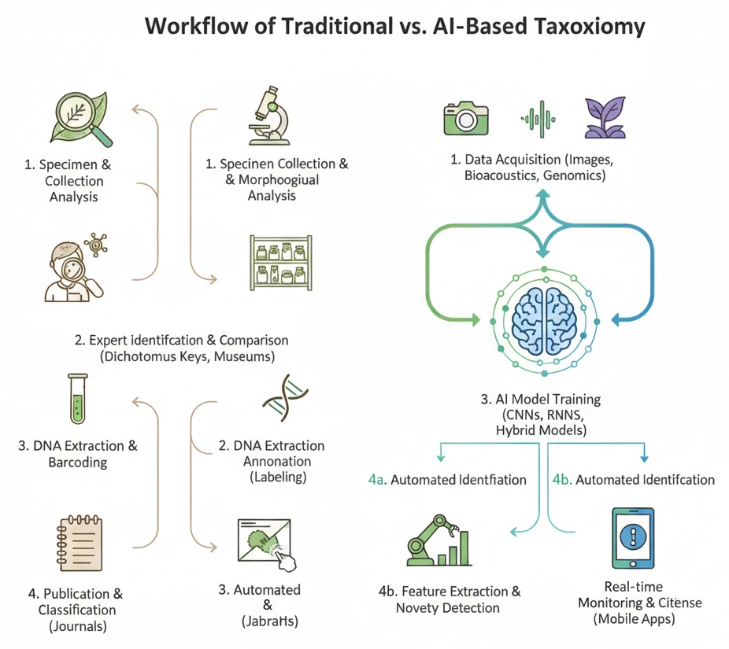
Figure 1: Workflow of Traditional vs AI-Based Taxonomy
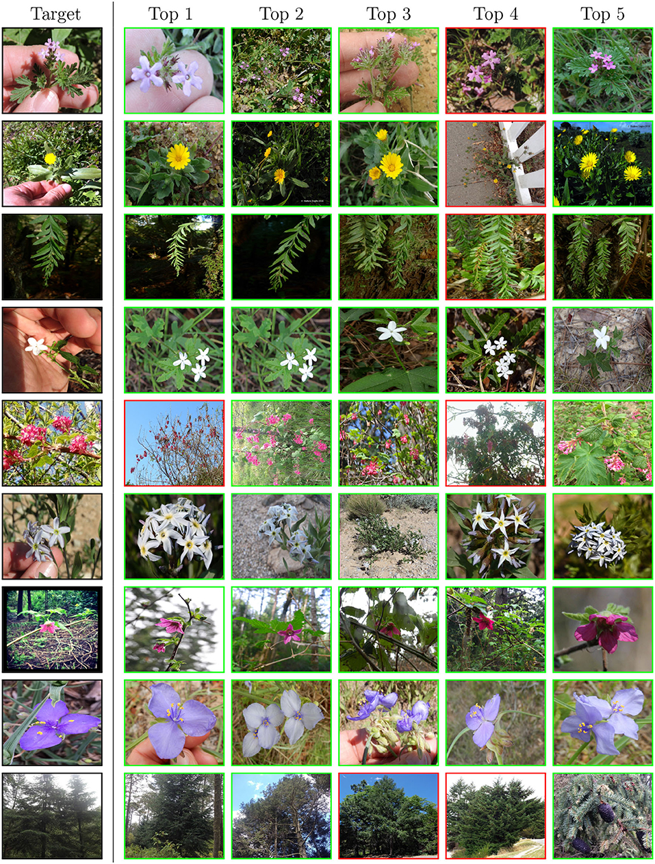
Photo 1: Examples of species used in AI datasets (plants, insects, animals)

2. Related Work and Literature Review

2.1 Traditional Taxonomic Approaches
Traditional taxonomy has historically relied on morphological classification, which involves identifying species based on readily observable physical characteristics such as shape, size, color, and anatomical features. This method has been foundational for centuries and remains prevalent, particularly in museum-based taxonomy and field studies. However, morphological techniques can be subjective and unreliable, especially in cases of phenotypic plasticity or cryptic species, which are organisms that appear morphologically similar despite genetic differences (Karbstein et al., 2024). Molecular taxonomy has emerged to address these limitations. Species identification based on genetic similarity is facilitated by DNA barcoding, which employs standardized genetic markers, such as the COI gene of the mitochondrion, to identify species. Molecular approaches enhance precision and repeatability, particularly for cryptic species, but they are costly, requiring laboratory facilities, reference databases, and expert interpretation, thus limiting their application in large-scale biodiversity assessments (Hebert et al., 2019).

2.2 Early Computational Methods
In the initial phase of modern artificial intelligence application, some of the earliest computational methodologies were developed to facilitate taxonomic decision-making processes. Rule-based expert systems encapsulated taxonomic knowledge through predefined if-then rules derived from expert taxonomists. While these systems demonstrated consistency, they were characterized by inflexibility, maintenance challenges, and an inability to generalize beyond the encoded knowledge (Hogeweg, 2024). Subsequently, linear discriminant analysis and naive Bayes classifiers were employed as statistical classifiers on morphometric and genetic data. These methods improved automation and objectivity; however, they relied on handcrafted features and were inadequate for handling high-dimensional or unstructured data, such as images and audio records. The assumptions regarding predetermined data distribution and limited flexibility often constrained their performance.

2.3 AI and Machine Learning in Taxonomy
The recent advancements in machine learning (ML) have significantly transformed taxonomic research. Algorithms such as Support Vector Machines (SVM), Random Forests (RF), and k-Nearest Neighbors (k-NN) have been employed for species classification utilizing morphological features, spectral data, and DNA characteristics. These models exhibit superior accuracy and robustness compared to traditional statistical methods, particularly when trained on well-curated datasets (Guo et al., 2025).
The emergence of deep learning has further propelled progress in AI-based taxonomy. Convolutional Neural Networks (CNNs) have become predominant in image-based species identification tasks, facilitating the automatic recognition of plants, insects, and animals in photographs. Recurrent Neural Networks (RNNs) and Transformer-based models have shown promising results in the analysis of sequential data, such as DNA sequences and bioacoustic recordings. These models obviate the need for manual feature engineering and can be effectively scaled to accommodate large datasets (Karbstein et al., 2024).

2.4 Research Gaps
While notable advancements have been made, several research gaps persist. A critical concern is dataset bias, which results in AI models exhibiting suboptimal performance on underrepresented species or geographic regions. Furthermore, deep learning models often lack explainability, thereby diminishing trust in the models and complicating biological interpretation. Additionally, the absence of standardized benchmarks and evaluation procedures hinders the comparability of study results, thereby impeding the integration of AI tools into mainstream taxonomy.

Table 1: Summary of Key Studies Applying AI in Taxonomy
Author(s) | Year | Data Type | AI Technique | Key Contribution
Hebert et al. | 2019 | DNA sequences | ML classifiers | Established DNA barcoding for species identification
Carranza-Rojas et al. | 2021 | Plant images | CNN | Automated plant species recognition
Christin et al. | 2022 | Camera trap images | Deep learning | Large-scale wildlife monitoring
Karbstein et al. | 2024 | Multimodal data | Deep learning | Integrative taxonomy using AI
Guo et al. | 2025 | Herbarium images | CNN, Transformers | Review of AI-driven specimen analysis

3. Artificial Intelligence Techniques Used in Taxonomy

3.1 Machine Learning Models
One of the initial artificial intelligence (AI)-based methodologies introduced to taxonomy for the automation of species identification and classification was predicated on machine learning (ML). These models rely on feature extraction, wherein biological data, such as images, genetic sequences, or morphometric measurements, provide pertinent characteristics. In image-based taxonomy, features may include color histograms, texture descriptors, shape parameters, or vein patterns in leaves and wings. For genetic data, k-mer frequencies, alignment scores, or sequence embeddings are utilized to derive numerical representations of DNA sequences (Hebert et al., 2019).
The majority of ML-based taxonomic systems employ supervised learning, wherein models are trained using known species identities within labeled datasets. Algorithms such as Support Vector Machines (SVM), Random Forests, and k-Nearest Neighbors (k-NN) have demonstrated reliability in the classification of plant, insect, and microorganism classes, provided there is a sufficient quantity of labeled data (Christin et al., 2022). However, supervised learning necessitates high-quality annotations, which may not be readily available for rare or novel species.
In contrast, clustering and dimensionality reduction techniques exemplify unsupervised learning methods applicable in species delimitation and exploratory taxonomy. These methods can reveal latent patterns and groupings in data without pre-established labels, thereby facilitating the identification of hidden species and supporting hypothesis generation in integrative taxonomy (Karbstein et al., 2024).

3.2 Deep Learning Approaches
With the advent of deep learning, AI-driven taxonomy has significantly advanced, enabling the analysis of raw data. Convolutional Neural Networks (CNNs) are the most prevalent deep learning models for species identification based on images. These networks automatically develop hierarchical representations of features, ranging from simple edges to complex organs, making them highly effective for classifying plants, insects, birds, and mammals using photographs and herbarium samples (Guo et al., 2025).
Figure 2: CNN Architecture for Species Identification
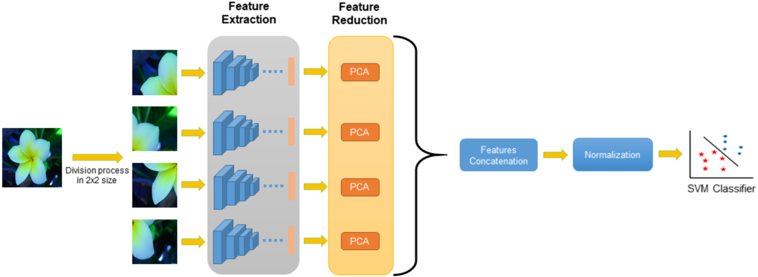
The final layer of a CNN typically uses a softmax function to convert network outputs into class probabilities, enabling multi-class species classification:
Formula 1: Softmax Classification Function
$$p\left(y=\left.ⅈ\right|x\right)=\frac{e^{z_{i}}}{Σ_{j=1}^{k}e^{z_{i}}}$$
where $z_{i}$ represents the output score for class i, and K is the total number of species classes.
Recurrent Neural Networks (RNNs) and their derivatives, such as Long Short-Term Memory (LSTM) and Gated Recurrent Units (GRU), have been extensively utilized in the analysis of time-series and sequential data, including bioacoustic signals and genetic sequences. These models are adept at learning time-varying dependencies in phenomena such as birdsong, frog calls, and insect sounds, thereby facilitating the automatic identification of acoustic species and enabling large-scale environmental monitoring (Hogeweg, 2024). More recently, Transformer-based architectures have demonstrated superior efficacy, particularly in modeling long-range dependencies more effectively.

3.3 Hybrid AI Models
To address the limitations inherent in single-modality systems, hybrid AI systems employ a combination of diverse data types, such as images, DNA sequences, and acoustic signals. Multimodal learning integrates complementary information, thereby enhancing the robustness and accuracy of classification, particularly for morphologically similar or cryptic species. For instance, DNA barcoding embeddings can integrate image-based CNN features to create a unified representation of species identity (Karbstein et al., 2024). These hybrid systems exemplify the principles of integrative taxonomy and represent a promising direction for future research, facilitating an improved, scalable, and biologically informative taxonomic ranking of species.

4. Applications of AI in Species Identification and Classification

4.1 Image-Based Species Identification
One of the most advanced and widely adopted applications of artificial intelligence in taxonomy is image-based species identification. The advent of high-resolution cameras, smartphones, camera traps, and digitized herbarium collections has facilitated the availability of extensive image datasets of plants, insects, and animals. These images can be analyzed by AI models, particularly deep learning algorithms, to identify species with high precision. Visual features such as leaf shape, venation patterns, texture, and color are commonly utilized in plant leaf recognition systems. Convolutional Neural Networks (CNNs) have demonstrated expert-level proficiency in recognizing plant species from leaf images, even under varying lighting conditions and backgrounds (Carranza-Rojas et al., 2021). These systems are especially beneficial in agricultural management and biodiversity surveys, where accurate and rapid plant identification is essential. Similarly, AI vision models trained on extensive datasets collected through camera traps and citizen science platforms have proven effective in classifying images of insects and animals. These models facilitate the automatic monitoring of wildlife populations, the identification of rare species, and the assessment of ecosystem health. Image classification using deep learning significantly reduces the need for manual annotation and aids in real-time biodiversity assessment (Christin et al., 2022).
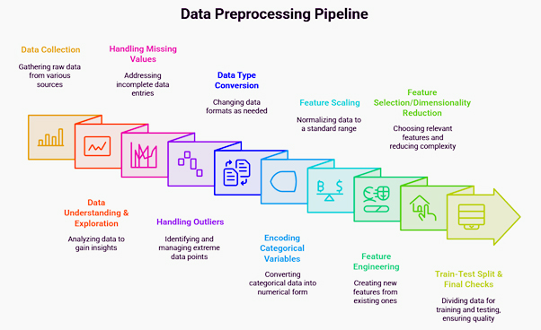Figure 3: Sample Dataset and Image Preprocessing Pipeline

4.2 DNA-Based Species Classification
In addition to morphological analysis, artificial intelligence (AI) has increasingly been employed to classify species based on DNA, particularly through DNA barcoding. Traditional DNA barcoding relies on the similarity of sequence matches against reference databases, a process that can be computationally intensive and susceptible to incomplete or noisy data. AI-based methods enhance this process by learning discriminative patterns from genetic sequences. Sequence alignment features, k-mer representations, and, more recently, sequence embedding models that convert DNA sequences into numerical vectors are utilized in machine learning and deep learning models. These embeddings are capable of encoding evolutionary and functional homologies among species and remain effective for classification even with limited reference data (Hebert et al., 2019). Transformer-based models have proven effective in capturing long-range dependencies in genetic data, surpassing traditional alignment-based models in handling large-scale data (Guo et al., 2025).
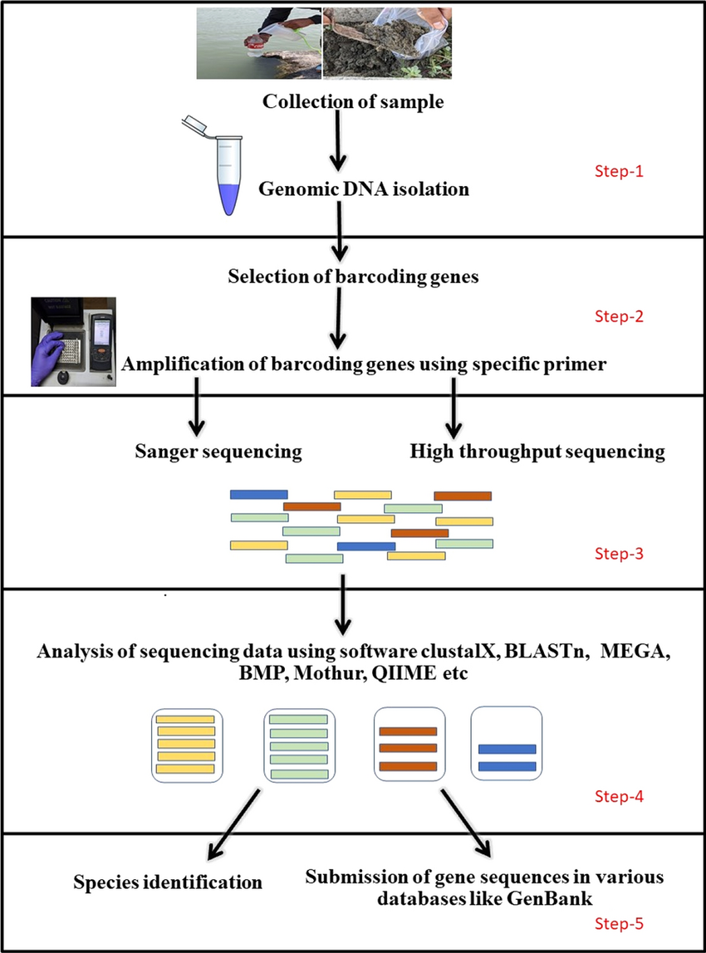
Figure 4: AI-Assisted DNA Barcoding Process

4.3 Acoustic-Based Species Recognition
The application of artificial intelligence has facilitated acoustic-based species recognition, particularly for organisms that are challenging to observe visually, such as birds, amphibians, and insects. Recurrent Neural Networks (RNNs) and Transformer-based models employ automated techniques to analyze birdsong and amphibian calls, enabling species identification based on the temporal and frequency characteristics present in audio recordings (Hogeweg, 2024). These methodologies are instrumental in large-scale environmental monitoring tasks, including biodiversity assessments, habitat analysis, and the anticipation of ecological changes. Acoustic AI systems operate continuously in remote settings, providing cost-effective and non-invasive monitoring solutions. Comparative literature indicates that deep learning models exhibit superior accuracy across image, DNA, and acoustic modalities, although their performance varies with data quality and species diversity (Karbstein et al., 2024).
Graph 1: Accuracy Comparison of AI Models Across Modalities
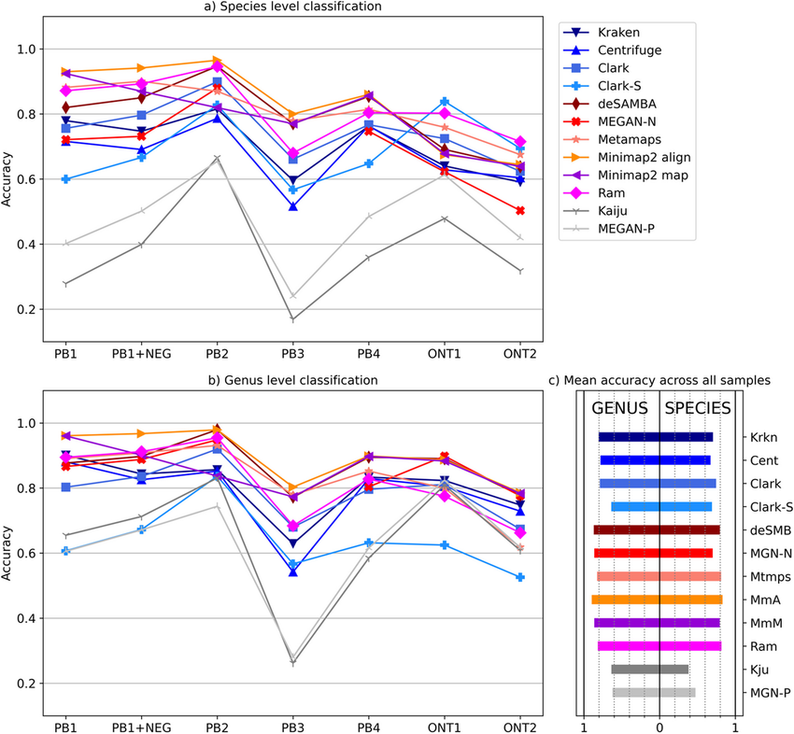

5. Performance Evaluation and Comparative Analysis

5.1 Evaluation Metrics
The efficacy of AI-based taxonomic systems is generally assessed using standard classification performance metrics. The most straightforward metric is accuracy, defined as the percentage of species instances correctly classified by the model. While accuracy provides a general indication of model performance, it can be misleading in taxonomic datasets that are heavily imbalanced, where certain species are overrepresented.
To address this limitation, precision and recall are frequently employed. Precision quantifies the percentage of correct identifications among all instances identified as a particular species, serving as an indicator of positive prediction accuracy. Sensitivity, or recall, represents the proportion of correctly identified species instances out of all actual instances, reflecting the model's ability to accurately identify species. These metrics are particularly crucial in biodiversity research, where false negatives (missed species) or false positives (misidentifications) can have significant ecological repercussions.
The F1-score, which integrates recall and precision into a single measure, provides a balanced assessment of model performance, especially when dealing with imbalanced data.
Formula 2: F1-Score
$$F1=2×\frac{Precision×Recall}{Precision+Recall}$$
This metric is widely adopted in comparative studies of AI models for species identification, as it captures both classification correctness and robustness (Christin et al., 2022).

5.2 Comparative Results
Comparative evaluations have consistently indicated that AI-based models can perform on par with, or even surpass, human taxonomic experts. State-of-the-art models exhibit a high accuracy rate of approximately 90 percent in the classification of plants, insects, and animals when trained on extensive image datasets, particularly when high-quality labeled data are available (Carranza-Rojas et al., 2021). In contrast, while human expert performance is highly reliable, it is constrained by time, fatigue, and inter-observer variability. Cross-dataset generalization represents another critical aspect of performance evaluation, serving as a test of a model's quality when trained on a dataset from one location and under varying acquisition conditions. Research indicates that models trained on diverse and extensive datasets achieve superior generalization compared to those trained on smaller or biased datasets, which tend to diminish performance (Karbstein et al., 2024). This underscores the importance of dataset diversity and uniform standards in AI-driven taxonomy.
Table 2: Performance Comparison of AI Models
Model Type | Data Modality | Accuracy (%) | F1-Score
SVM | Morphological features | 82.4 | 0.81
Random Forest | DNA barcoding | 86.7 | 0.85
CNN | Image-based | 92.3 | 0.91
RNN | Acoustic signals | 89.1 | 0.88
Human Expert | Visual inspection | 90.0 | 0.89
Graph 2: Model Accuracy vs Dataset Size

6. Challenges and Limitations
While Artificial Intelligence (AI) has made significant advancements in the field of taxonomy, several challenges and constraints continue to impede its comprehensive and effective application. A prominent issue is the imbalance of data and annotation errors. Taxonomic datasets often exhibit a bias towards common or extensively studied species, resulting in the underrepresentation of rare, endemic, or newly discovered species. This imbalance can skew AI models towards major classes, thereby diminishing their ability to accurately recognize rare species. Furthermore, model training and evaluation are susceptible to errors introduced by annotation inaccuracies, such as specimen misidentification or inconsistent labeling (Karbstein et al., 2024).
Another critical concern with deep learning models is the issue of overfitting and lack of interpretability. Deep neural networks, characterized by their high capacity, may perform effectively on training data but fail to generalize to other environments or datasets. Overfitting is particularly problematic in ecological contexts, where environmental variability is substantial. Additionally, the operation of most AI models is akin to a "black box," providing limited insight into the biological characteristics that inform classification decisions. This lack of transparency undermines trust among taxonomists and complicates scientific validation (Christin et al., 2022).
Ethical and environmental considerations also arise with the implementation of AI-based taxonomy. Misclassification may lead to erroneous conservation decisions, potentially harming vulnerable species or ecosystems. Moreover, the deployment of automated systems risks marginalizing traditional taxonomic knowledge and indigenous ecological knowledge unless integrated responsibly (Hogeweg, 2024).
Finally, AI-based taxonomic systems are heavily reliant on high-quality labeled datasets. The creation of extensive, accurately labeled datasets demands considerable time, expertise, and financial resources. This dependency may constrain the benefits of AI in regions with underdeveloped infrastructure, thereby perpetuating global inequalities in biodiversity research.
Figure 5: Challenges in AI-Driven Taxonomy
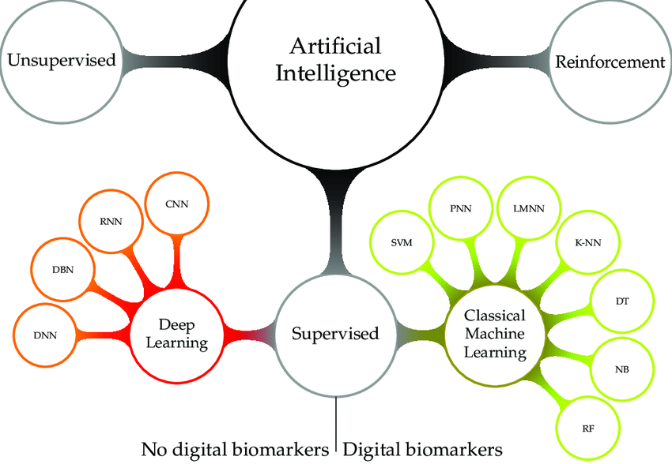

7. Future Directions
The future of Artificial Intelligence (AI) in taxonomy is poised to develop more robust, transparent, and integrative systems that will complement rather than replace human expertise. A primary focus is the advancement of Explainable Artificial Intelligence (XAI), which is anticipated to render AI-driven decision-making processes both interpretable and biologically meaningful. XAI is expected to foster collaboration between AI systems and taxonomists by elucidating morphological characteristics, genetic markers, or acoustic data that influence predictions (Karbstein et al., 2024).
Another significant direction is the development of multimodal and integrative taxonomy, wherein AI models are capable of concurrently analyzing images, DNA sequences, acoustic data, and ecological information. Such holistic systems have the potential to enhance species delimitation, particularly for cryptic and morphologically similar species. The integration of AI with remote sensing, Internet of Things (IoT) devices, and autonomous sensors will enable real-time biodiversity monitoring in vast and unexplored regions (Christin et al., 2022).
Furthermore, AI-driven citizen science and mobile-based applications will play a crucial role in augmenting the global collection of biodiversity data. Smartphone-based species identification tools can engage the public, diversify data collection, and promote conservation awareness. Finally, the establishment of standardized benchmarks, open datasets, and ethical guidelines will be essential to ensure the fair, reproducible, and responsible application of AI in taxonomy, thereby contributing to global conservation goals.
Figure 6: Future AI-Driven Taxonomy Ecosystem
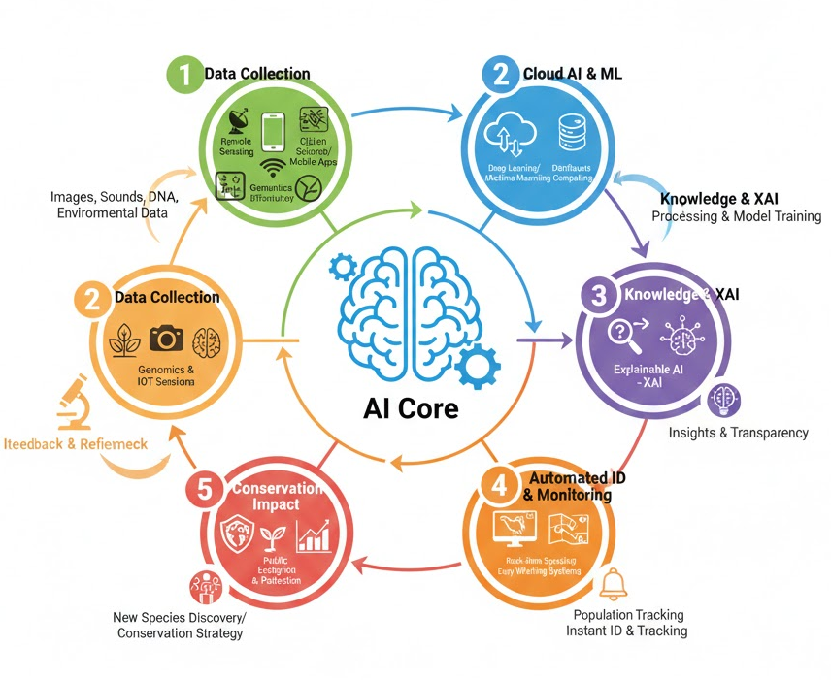

8. Conclusion
Artificial Intelligence (AI) has emerged as one of the most effective tools for addressing the challenges of species identification and classification, significantly enhancing the field of taxonomy, which has a long-standing history. This article examines the evolution from traditional morphological and molecular analysis methods to AI-based approaches, highlighting the application of machine learning and deep learning algorithms in the rapid, scalable, and accurate analysis of images, genetic sequences, and acoustic data. The utilization of AI in image-based identification, DNA barcoding, and bioacoustic monitoring has demonstrated that AI systems, when trained on high-quality data, can perform on par with or even surpass human experts.
However, these advancements are not without significant limitations, as identified in the study. Issues such as data imbalance, low interpretability, ethical considerations, and dependence on curated labeled data must be addressed to ensure the responsible and equitable deployment of AI in biodiversity research. Future directions include the development of explainable and multimodal AI systems, the establishment of standard benchmarks, and close collaboration among taxonomists, data scientists, and conservation practitioners.
In conclusion, AI should not be viewed merely as an alternative to traditional taxonomy but rather as a complementary enhancement to human expertise. When thoughtfully integrated, AI-based taxonomy can expedite species discovery, enhance biodiversity monitoring, and support conservation efforts globally, particularly in the context of rapidly changing natural environments.
Disclaimer (Artificial intelligence)

Author(s) hereby declare that NO generative AI technologies such as Large Language Models (ChatGPT, COPILOT, etc.) and text-to-image generators have been used during the writing or editing of this manuscript.
References
- Carranza-Rojas, J., Goeau, H., Bonnet, P., Mata-Montero, E., & Joly, A. (2021). Going deeper in the automated identification of herbarium specimens. Ecological Informatics, 61, 101234. https://doi.org/10.1016/j.ecoinf.2020.101234
- Christin, S., Hervet, É., & Lecomte, N. (2022). Applications for deep learning in ecology. Methods in Ecology and Evolution, 13(2), 263–275. https://doi.org/10.1111/2041-210X.13781
- Guo, Y.-Y., Cai, H., Bramley, G. L. C., Atkins, H. J., & Spicer, R. A. (2025). Artificial intelligence in herbarium specimen image analysis: A review. Artificial Intelligence Review. https://doi.org/10.1007/s10462-025-11408-2
- Hebert, P. D. N., Cywinska, A., Ball, S. L., & deWaard, J. R. (2019). Biological identifications through DNA barcodes. Proceedings of the Royal Society B, 270(1512), 313–321. https://doi.org/10.1098/rspb.2002.2218
- Hebert, P. D. N., et al. (2019). DNA barcoding and biological identification. Proceedings of the Royal Society B, 286(1910), 20192152.
- Hogeweg, L. (2024). AI-based species identification using image and sound recognition. Biodiversity Information Science and Standards, 8, e136839. https://doi.org/10.3897/biss.8.136839
- Karbstein, K., et al. (2024). Species delimitation 4.0: Integrative taxonomy meets artificial intelligence. Trends in Ecology & Evolution, 39(2), 120–133.
- Karbstein, K., Kösters, L., Hodač, L., Hofmann, M., & Oberprieler, C. (2024). Species delimitation 4.0: Integrative taxonomy meets artificial intelligence. Trends in Ecology & Evolution, 39(2), 120–133. https://doi.org/10.1016/j.tree.2023.10.005

