From Raw Data to Reliable Predictions: The Significance of Data Processing in COVID-19 Modelling

Abstract:
Accurate predictive models are essential for analysing COVID-19 mortality trends. This study evaluates the effect of a novel customised data pre-processing pipeline on ten machine learning models predicting COVID-19 mortality in India, using data from Our World in Data (OWID). Our pipeline diverges significantly from a standard pre-processing pipeline in four main steps. First, it corrects administrative reporting delays by converting weekly reported totals into daily figures, reducing reporting biases and delivering precise estimates. Second, it applies momentum-preserving local outlier processing to retain data variability and improve accuracy. Third, it enforces mathematical relationships among features to ensure strict data consistency. Finally, it integrates an iterative feature selection process to optimise the feature set and boost model performance. Results demonstrate considerable improvement with the custom pipeline: the MLP Regressor achieved a test RMSE of 83.663 and a test R² of 0.986, outperforming the Gradient Boosting Regressor from the standard pipeline, which had a test RMSE of 171.525 and a test R² of 0.859. A primary contribution of this research is the formal validation of model stability via a newly introduced diagnostic: RMSE Variance. This metric quantifies the consistency of predictive performance across multiple iterations, distinguishing authentic generalizability from stochastic success. These results highlight the necessity of tailored pre-processing, providing a transferable framework for global health datasets facing non-stationary noise and reporting inconsistencies.
Keywords: COVID-19 Mortality Prediction, Data Pre-processing, Custom Pipeline, Feature Selection, Predictive Modelling, Machine Learning.
Introduction
The COVID-19 pandemic has profoundly disrupted global health systems and daily life. It created unprecedented challenges in disease management and resource allocation. Since the emergence of Severe Acute Respiratory Syndrome Coronavirus 2 (SARS-CoV-2) in December 2019, the pandemic has resulted in extensive morbidity and mortality worldwide. In India, where the first cases were reported in January 2020 (Andrews et al., 2020), the impact has been particularly severe, with over 45 million confirmed cases and more than 530,000 deaths as of August 2024 (OWID, 2020). The pandemic disproportionately affected older adults and individuals with pre-existing health conditions such as hypertension, diabetes, and cardiovascular disease (Mueller et al., 2020; Petretto and Pili, 2020).
The progression of the pandemic intensified the demand for accurate predictive models to inform healthcare planning and resource allocation (An et al., 2020; Rustam et al., 2020; Das et al., 2020; Booth et al., 2021; Subudhi et al., 2021; Mahdavi et al., 2021; Krithika & Rohini, 2021). Because the reliability of these forecasts is fundamentally contingent upon data quality and the robustness of the preceding pipeline (Wang et al., 2019; Rahm and Do, 2000; Guyon and Elisseeff, 2003; Bergstra et al., 2011), rigorous pre-processing is required to transform raw inputs into viable features. This includes structural adjustments such as pruning irrelevant variables (Winston, 2022; Moustakidis et al., 2022; Sha’ban et al., 2023; Eryilmaz et al., 2021; Pourhomayoun and Shakibi, 2021), engineering new feature sets (Schrarstzhaupt et al., 2024), and standardizing nomenclature (Beattie, 2021).
To maintain data continuity, missing values are addressed through various imputation strategies—including zero, mean, or median replacement—alongside complex interpolation and extrapolation techniques (Hu et al., 2020; Khan et al., 2021; Zubair et al., 2021; Jerez et al., 2010; Batista and Monard, 2003; Vaid et al., 2020; Moustakidis et al., 2022; Chowdhury et al., 2021; Pan et al., 2020). Simultaneously, outlier management via trimming, transformation, or winsorization preserves integrity by mitigating the impact of statistical anomalies (Turlapati & Prusty, 2020; Brzezińska & Hory´n., 2021; Herawati et al., 2022). Model performance is further optimised through feature selection methods, such as correlation analysis (Moulaei et al., 2022), Principal Component Analysis (PCA) (Pan et al., 2020), random feature exploration (Moustakidis et al., 2022). By leveraging univariate/multivariate filters and wrapper methods (Pourhomayoun and Shakibi, 2021; Tulu et al., 2023), practitioners can effectively reduce multicollinearity and eliminate redundant predictors (Gambhir et al., 2020). Ultimately, these combined interventions are essential for securing the accuracy and structural reliability of high-stakes predictive frameworks (García et al., 2016; Gudivada et al., 2017).
Despite advancements in predictive modelling, many approaches prioritise architectural complexity over rigorous data restoration. This model-centric bias often neglects inherent data dependencies, resulting in logical contradictions that undermine the structural integrity of the dataset. For example, failing to adjust for weekly reporting cycles—where fluctuations reflect administrative lag rather than viral dynamics—obfuscates the authentic training signal.
Similarly, ignoring computational dependencies between features introduces logical contradictions that undermine dataset integrity. Standard global outlier detection also fails in non-stationary contexts; using fixed thresholds like global Z-scores often misidentifies legitimate surges as anomalies while missing local deviations during low-transmission periods. Finally, the absence of disciplined feature selection leads to multicollinearity and redundancy, triggering overfitting and compromising model reliability.
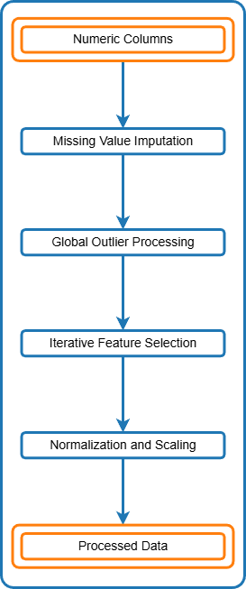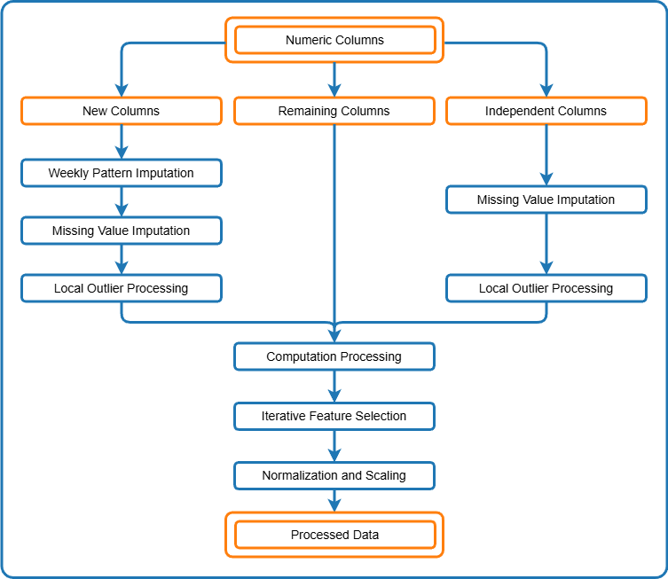
(a) Standard Pre-processing Pipeline (b) Custom Pre-processing Pipeline
Figure 1: COVID Data Pre-processing Pipelines for (a) Standard and (b) Custom approaches
This study addresses these gaps by introducing a novel custom pre-processing pipeline (see Figure 1(b)) designed to address the unique challenges of COVID-19 datasets. Ten machine learning models, representing diverse algorithmic approaches from linear regression to deep learning, were selected to benchmark the pipeline's versatility. To ensure the findings are not merely a result of overfitting, we employ a rigorous validation strategy centred on RMSE variance. Furthermore, while the custom pipeline is optimised for the temporal nuances of the Indian dataset, the underlying logic of momentum-preserving clipping and computational consistency is designed for broad generalisability, albeit with recognised limitations regarding the smoothing of ultra-fine-grained daily volatility. The primary objective is to enhance data consistency and coherence through comprehensive exploration, meticulous cleaning, and effective pre-processing. The custom pipeline incorporates several innovative steps:
- Weekly Pattern Imputation: Transforms weekly reported totals into daily updates by averaging the weekly sum and distributing it evenly across each day, thereby correcting summing errors and addressing reporting inconsistencies.

- Local Outlier Processing: Employs a 30-day non-centred rolling window to calculate dynamic statistical boundaries. Rather than removing detected anomalies, this approach utilises momentum-preserving clipping to constrain extreme values within local variance limits, thereby maintaining the data’s temporal trend while mitigating volatility.

- Computation Processing: Calculates column values by leveraging inter-column dependencies, thereby preserving data consistency.

- Iterative Feature Selection: Employs advanced techniques such as Permutation Feature Importance (PFI) (Michelucci, 2024), Mutual Information (MI) (Kraskov et al., 2004), Single Feature Impact (SFI) (Guyon & Elisseeff, 2003), and the Variance Inflation Factor (VIF) (Greene, 2003) to systematically eliminate redundant and collinear features while retaining the most significant ones. This approach refines the feature set by balancing predictive power, addressing multicollinearity, and improving overall model performance.
Our results show that all tested models benefit from the custom pre-processing pipeline, with non-linear models achieving the highest scores as anticipated. The consistent and stable performance across training, validation, and test sets highlights the novel contributions of this custom pre-processing pipeline in improving predictive accuracy and reliability. These findings offer valuable insights for researchers, policymakers, and healthcare professionals, supporting improved decision-making in pandemic management and future health crises.
The remainder of this paper is organised as follows. Section 2 outlines the data sources, pre-processing techniques, and machine learning models and evaluation strategies used in this study. Section 3 compares the model performance across different pre-processing pipelines and discusses the impact of various pre-processing techniques, and summarises the key findings. Finally, Section 4 summarises the findings, highlights the contributions, and offers recommendations for future research.
2. Data and Methodology
2.1 Data
The dataset used in this study is sourced from Our World in Data (OWID), comprising over 400,000 records across 67 variables. While the global dataset encompasses 244 countries and diverse income levels, our analysis focuses specifically on India. The temporal scope ranges from January 5, 2020, to August 12, 2024, totalling 1,682 daily records. The data includes categorical identifiers and 62 numeric columns; of these, 35 exhibit the variability required for meaningful longitudinal analysis.
2.2 Standard Pre-processing Pipeline: The standard pre-processing pipeline (see Figure 1(a)) follows traditional data preparation methods:
- Extracting Numeric Features: We focused only on numeric columns, as categorical columns remained constant across countries and did not contribute to the analysis.

- Missing Value Imputation: Missing values were addressed using a hierarchical two-step approach. First, linear interpolation was employed to estimate interior gaps, while extrapolation was used for missing values at the temporal boundaries of the series. Subsequently, zero imputation was applied to any remaining undefined values, typically occurring where data was non-existent prior to the first reported case. The orange line in Figure 6 visually demonstrates this process as applied to the $positive_rate$ feature.

- Global Outlier Processing: Outliers were identified using a global Z-score approach, where a static threshold of 2 was applied based on the mean and standard deviation of the entire temporal range. Data points exceeding this threshold were classified as anomalies and subsequently replaced using linear interpolation. Figure 2 demonstrates this method's effect on the $new_vaccinations$ feature, where extreme values are smoothed relative to the global mean.
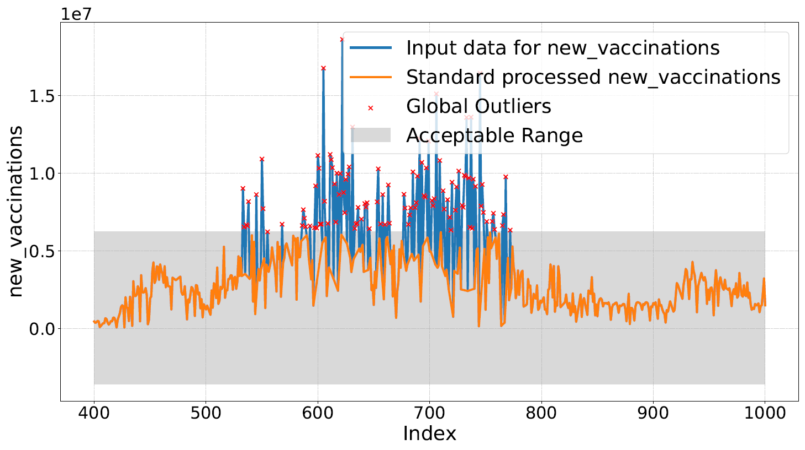
Figure 2: Global outlier detection and processing with the standard pipeline for the $new_vaccinations$ column from index 400 to 1000.
4. Iterative Feature Selection: We systematically identified the most relevant features for our predictive model and addressed multicollinearity through iterative feature selection as detailed in Algorithm 1. The key steps included:
- Correlation Filtering: We removed features with correlations above 0.8 (${corr}_{th}$ = 0.8) to minimise redundancy and multicollinearity. We also discarded constant features (those with zero variance) and empty features (containing only null values), as they lack the information density required for predictive modelling.

- Calculating Importance Metrics: We assessed the importance of each remaining feature using three metrics:
- Permutation Feature Importance (PFI): Measures the impact on model performance when feature values are shuffled, reflecting overall predictive power.
- Mutual Information (MI): Quantifies the information a feature provides about the target, capturing both linear and non-linear dependencies.
- Single Feature Impact (SFI): Evaluates the predictive power of each feature in isolation, offering a baseline view of its importance.
The integration of these metrics provided a multi-dimensional perspective on feature importance: PFI accounted for feature interactions, MI identified complex non-linear dependencies, and SFI established a baseline for individual predictive strength.
- Variance Inflation Factor (VIF): We quantified multicollinearity using the Variance Inflation Factor (VIF), defined as:
${VIF}_{j}$= $\frac{1}{1-R_{j}^{2}}$ ……….. (1)
where $R_{j}^{2}$ is the coefficient of determination when regressing feature j on all other features. The generally accepted thresholds for VIF are:
- VIF = 1: No multicollinearity.

- 1 < VIF < 5: Moderate multicollinearity, generally acceptable.

- VIF > 5: High multicollinearity, posing a potential challenge to numerical stability.
We set a threshold of 10 to flag features for removal, reconciling the mitigation of multicollinearity while maintaining a sufficient feature set for model stability and interpretability.
- Iterative Removal of Features: We refined the feature set by iteratively removing features with high VIF and low combined importance. First, features with VIF values exceeding the defined threshold were identified; subsequently, we systematically removed the feature exhibiting the lowest combined importance score among those flagged.

- Regularisation for Further Refinement: We further refined the feature set by eliminating features with zero coefficients.
- Termination Condition: The iterative process concluded when all remaining features had VIF values below the threshold, ensuring a relevant feature set with minimal redundancy.
Algorithm 1: Iterative Feature Selection (IFS)
1: Input: Restored features X, Target $y$, thresholds $ρ_{th}$ = 0.8, ${VIF}_{th}$ = 10
2. Phase 1: Correlation Filtering
3. Remove $f ∈ X$ where $\left|corr\left(f,y\right)\right| >ρ_{th}$or $corr\left(f,y\right)$ = NaN / 0
4. repeat
5. Phase 2: Importance Evaluation
6. Calculate $PFI, MI, SFI → CI ← \frac{1}{3}\left(PFI + MI + SFI\right)$
7. Phase 3: Multicollinearity Check
8. Compute ${VIF}_{f }∀ f∈X$
9. if $max\left(VIF\right)＞{ VIF}_{th}$ then
10. $F_{high}$ $←$ {f ∈ X | ${VIF}_{f }$> ${VIF}_{th}$}
11. $F_{kill}←$ ${argmin}_{ f ∈ F_{high}}$(${CI}_{f}$)
12. $X ←$ $X \backslash$ {$F_{kill}$}
13. end if
14. Phase 4: Regularisation Pass
15. Prune $f ∈X$ with zero coefficients via Lasso ($α=1.0)$
16. until max ($VIF) ≤ { VIF}_{th}$
17. Return Selected Feature Set $X$
- Normalisation and Scaling: We standardised the shortlisted features to have a mean of zero and a standard deviation of one. This normalisation ensured equal contribution of all features to model performance, facilitating effective comparison and analysis.
2.3 Custom Pre-processing Pipeline: We designed the custom pre-processing pipeline (see Figure 1(b)) to enhance data quality and model performance through several tailored pre-processing steps. This section outlines the unique procedures employed, their underlying methodological rationale, and the subsequent impact on data integrity and model performance.
- Grouping Columns: We grouped columns into three categories to apply specialised pre-processing methods:

- New Columns: We identified columns such as $new_cases$ and $new_deaths$ as having weekly update patterns, which required specific handling to avoid bias.

- Independent Columns: We classified columns such as $new_tests$, $new_vaccinations$, $reproduction_rate$, $people_vaccinated$, $people_ fully_vaccinated$, $total_boosters$, and $stringency_index$ as not exhibiting weekly patterns, and we did not consider any computational dependencies for them.

- Remaining Columns: We designated the remaining columns as either constant or having computational dependencies.

- Pre-processing `New Columns': For `New Columns', we applied the following pre-processing methods:

- Weekly Pattern Imputation: We corrected the weekly update pattern by redistributing total weekly values evenly across all days. This adjustment aimed to prevent bias, particularly in the $new_deaths$ data, which showed weekly variations that could distort model predictions. Figure 3 visually represents the effectiveness of this imputation compared to the standard approach, highlighting the removal of bias introduced by weekly patterns.

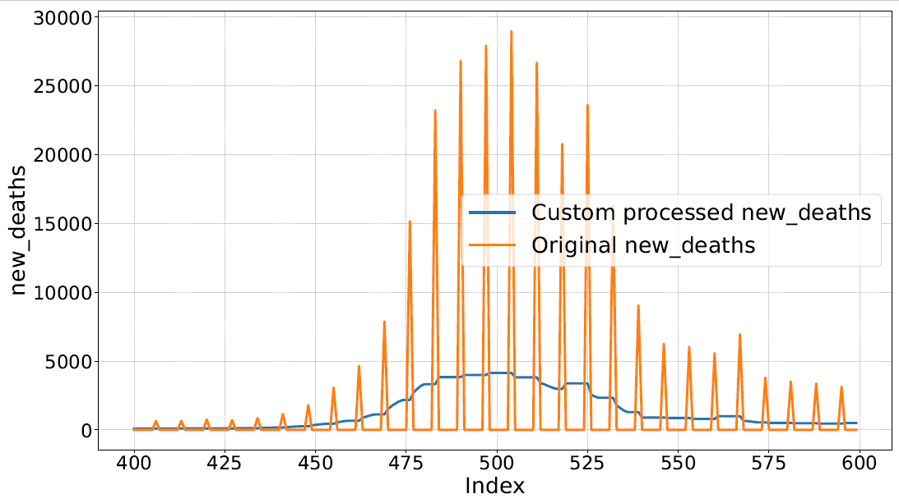
Figure 3: Comparison of Original vs. Custom Processed $new_deaths$ Data (Zoomed-In View of Samples from index 400 to 600): Highlighting the Effectiveness of Weekly Pattern Imputation.

- Missing Value Imputation: We handled missing values with linear interpolation followed by zero imputation, consistent with the standard pipeline approach to ensure comparability (see Section 2.2).
- Local Outlier Processing: We addressed local extrema in the time-series data with a rolling-window clipping approach. Using a 30-day non-centred window and a Z-score threshold of 2, we calculated dynamic statistical bounds for each data point. Unlike standard interpolation, this method clipped outliers to the nearest boundary instead of removing them. This approach preserved momentum in the data and kept the model sensitive to recent data trends while reducing extreme volatility. Figure 2 and Figure 4 compare global and local outlier detection methods, showing how momentum-preserving clipping constrains outliers while maintaining the underlying signal's direction.

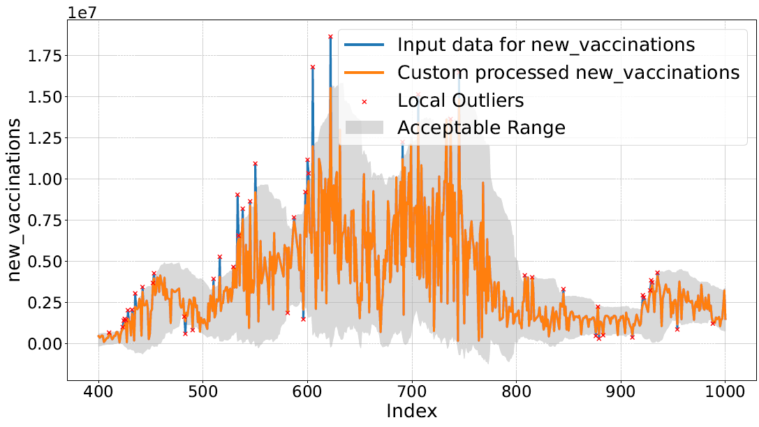
Figure 4: Local outlier detection and processing with the custom pipeline for the $new_vaccinations$ column from index 400 to 1000.
- Pre-processing `Independent Columns': We applied the same pre-processing steps to `Independent Columns' as those used for `New Columns' (See ‘New Columns’ in 2.3 section), except for weekly pattern imputation. This uniform treatment ensured consistency across different column types.

- Pre-processing `Remaining Columns': For the `Remaining Columns', we applied the following computation processing as-

Computation Processing: We leveraged computational dependencies among columns to ensure consistency and resolve discrepancies. Figure 5 illustrates the dependencies and computation orders for the death-related columns. We processed $new_deaths$ first, followed by $total_deaths$ (using equation 3), $new_deaths_smoothed$ (using equation 6), and $new_deaths_per_million$ (using equation 7) as they share the same processing order (order 2). Subsequently, we processed $total_deaths_per_million$ and $new_deaths_smoothed_per_million$ (using equation 7) with processing order 3. Adhering to these manually determined but logically sequenced processing orders ensured both the consistency of computations and the mathematical integrity of the dataset.

Figure 6 compares the standard imputation method and our computation-based approach for the $positive_rate$ column. While the standard pipeline imputed missing values with constant values (depicted by the orange line), our custom method calculated $positive_rate$using Equation 4. This approach, predicated on processed $new_cases$ and $new_tests$, yielded consistent results that captured intrinsic volatility (highlighted in the shaded region) in contrast to the static output of the standard pipeline.
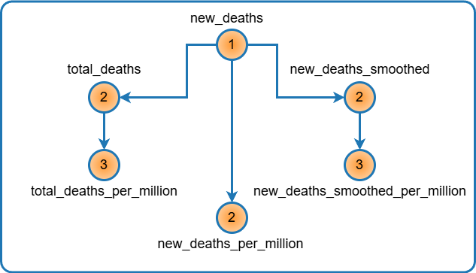
Figure 5: Column dependency graph for the ‘death’ columns with processing orders
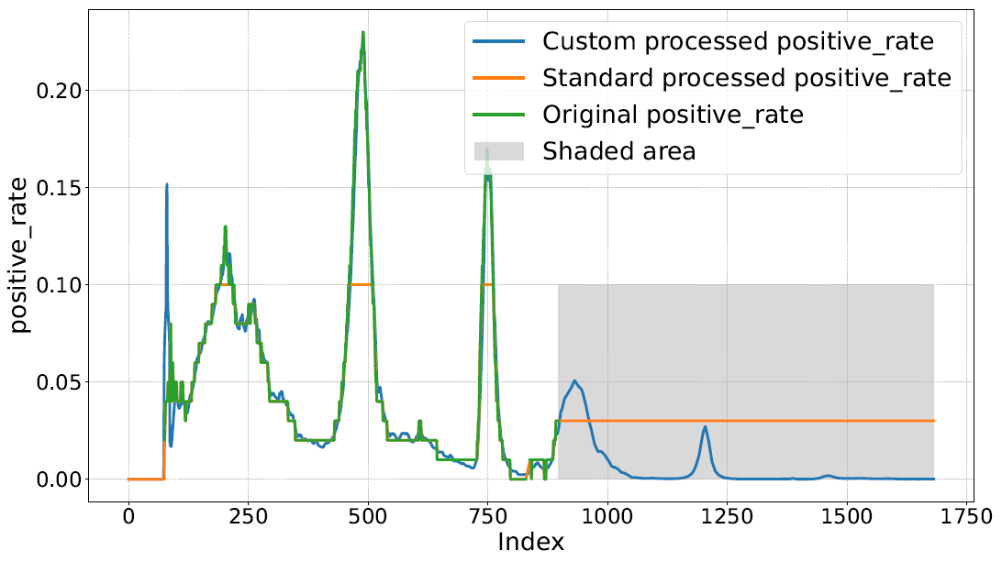Figure 6: Plotting for the computation processing of the $positive_rate$ column.
- new Columns: Computed as the difference between total column values at the current index t and the previous index t − 1:

$X_{new}^{t}$= $\left\{\begin{aligned}X_{total}^{t} , if t=0 \\ X_{total}^{t}-X_{total}^{t-1} ,if t>0\end{aligned}\right.$ ………. (2)
In our custom pipeline, we engineered $new_people_vaccinated$ by applying Equation 2 to the cumulative $people_vaccinated$ series, thereby transforming cumulative totals into daily incremental counts.
- total Columns: These columns represent the cumulative sum of the corresponding new column counterparts:

$X_{total}^{t}$= $\sum_{i=0}^{I}{X_{New}^{i}}$ …………… …………….. (3)
We employed Equation 3 to calculate total metrics from their daily counterparts, including $new_cases$, $new_deaths$, $new_tests$, and $new_vaccinations$.
- $positive_rate$: This represents the proportion of positive test results among the total tests conducted, calculated as a 7-day moving average of daily ratios of $new_cases$ and $new_tests$:
$X_{positive_rate}^{t}$ = $\frac{1}{N}$ $\sum_{i=0}^{N-1}{\frac{X_{new_cases}^{t-i}}{X_{new_tests}^{t-i}}}$ ………………. (4)
where N = min (t+1, 7). Refer to Figure 6 for a visualisation of the $positive_rate$ computation.
- $tests_per_case$: This feature represents the number of tests conducted per confirmed case of COVID-19, defined as the reciprocal of $positive_rate$:

$X_{tests_per_case}^{t}$ = $\frac{1}{X_{positive_rate}^{t}}$ ………… (5)

- smoothed Columns: These columns are calculated as the 7-day moving average of the corresponding raw daily values:

$X_{smoothed}^{t}$ = $\frac{\sum_{i-0}^{6}{X_{raw}^{t-i}}}{7}$ ………………... (6)
This equation is applied to columns such as $new_cases$, $new_deaths$, $new_tests$, $new_vaccinations$, and $new_people_vaccinated$ to mitigate short-term reporting noise.
- $per_million Column$: These metrics are calculated by normalising the raw values against the total population in millions:

$X_{per_million}^{t}$ = $\frac{X_{raw}^{t} X {10}^{6}}{population}$ ………… . (7)

We used equation 7 was used to derive the population-adjusted values for features including $per_million$ values for columns such as $total_cases$, $new_cases$, $total_deaths$, $new_deaths$, $new_deaths_smoothed$, $new_cases_smoothed$, and $new_vaccinations_smoothed$.
- $per_thousand Column$: Similarly, population-adjusted values for these columns were derived using a scaling factor of 1000:

$X_{per_thousand}^{t}$ = $\frac{X_{raw}^{t} X {10}^{3}}{population}$ ………… (8)

This formula was applied to derive $per_thousand$ values for columns including $total_tests$, $new_tests$, and $new_tests_smoothed$.

- $per_hundred Column$: For these columns, the scaling factor was changed to 100.

$X_{per_hundred}^{t}$ = $\frac{X_{raw}^{t} X {10}^{2}}{population}$ ……….. (9)
This formula was used to derive $per_hundred$ values for columns such as $total_vaccinations$, $people_vaccinated$, $people_ fully_vaccinated$, $total_boosters$, and $new_people_vaccinated_smoothed$.
Following pre-processing, we partitioned the dataset into training, validation, and test sets. The training partition subsequently underwent iterative feature selection, followed by normalisation and scaling, consistent with the methodologies employed in the standard pipeline.
2.4 Model Training and Evaluation: To evaluate the efficacy of the custom pipeline across varying architectural complexities, we implemented ten distinct regression models: Linear, Ridge, Lasso, and $ElasticNet$ Regression; Support Vector Regression (SVR); Random Forest and Gradient Boosting ensembles; Decision Tree Regression; K-Nearest Neighbours (KNN); and an Artificial Neural Network (Multilayer Perceptron).
The training phase was governed by a 5-fold cross-validation framework to ensure the models' generalisability beyond the training partition. For each model, hyperparameter tuning was conducted using a grid search approach to identify the optimal configuration for each pipeline. This rigorous validation strategy was employed to mitigate overfitting and to ensure that any observed performance improvements were attributable to the pre-processing methodology rather than stochastic weight initialisation or sub-optimal parameter settings.
Evaluation Methods: The performance of the models was evaluated using three key metrics: Root Mean Squared Error (RMSE), the Coefficient of Determination (R²), and a novel stability metric, RMSE Variance.
While RMSE and R² serve as standard benchmarks for predictive accuracy and explanatory power, they do not inherently account for performance stability across distinct data partitions. To quantify the structural robustness of the models, we introduced RMSE Variance, which measures the dispersion of error across the training, validation, and testing datasets as follows:
$RMSE Variance$ = $\frac{1}{n}\sum_{i}^{n}{{({RMSE}_{i}-\overline{RMSE})}^{2}}$ ……….. (10)
Where ${RMSE}_{i}$ represents the RMSE for the $i^{th}$ dataset (training, validation, and testing), and $\overline{RMSE}$ is the mean RMSE across these partitions, and n=3.
The Holistic Interpretation Framework: It is critical to note that RMSE Variance is not an independent indicator of success. A low variance indicates consistency, but the value of that consistency is contingent upon the magnitude of error:
- Type I Stability (Desirable): Low RMSE + High R² + Low RMSE Variance. This indicates a model that is consistently accurate and generalises well (the “Dual-Win'').
- Type II Stability (Stagnation): High RMSE + Low R² + Low RMSE Variance. This indicates a model that is “consistently poor,'' often a symptom of underfitting where the model fails to capture the signal across any partition.
By evaluating these metrics in conjunction across both the standard and custom pipelines, we facilitate a multidimensional analysis of how pre-processing affects not only the magnitude of error but also the authenticity of the resulting predictions.
2.5 Implementation Details
The methodology was implemented in Python using a modular Jupyter Notebook framework designed for portability across both cloud-based and local environments. Initial development and benchmarking were conducted on Google Colab (Intel Xeon CPU @ 2.20GHz, 12.6 GB RAM), while final optimisations and local execution were performed using the Visual Studio Code (VS Code) IDE. The unified notebook architecture facilitates a seamless workflow, ensuring end-to-end reproducibility. The entire pipeline, spanning data ingestion, custom restoration, and multi-model evaluation maintains a minimal computational footprint, achieving a full execution cycle in approximately 5 minutes on standard CPU configurations.
Source Code: The complete source code, including the custom pre-processing pipeline and feature selection logic, is provided as a single comprehensive Jupyter Notebook. This can be accessed via the following GitHub repository (https://github.com/dassangita844/Preprocessing_COVID-19_Dataset_India)
3. Results and Discussion
3.1 Model Performance Benchmarking and Stability: This section presents a comparative analysis of various regression models evaluated under both standard and custom pre-processing pipelines. The empirical results, summarised in Table 1, reveal a transformative gap in predictive accuracy, generalizability, and architectural reliability.
Table 1: Performance Metrics for Various Models Using Standard and Custom Pipelines
Pipeline | Model | Test RMSE | Test R² | RMSE Variance
Standard | $$GradientBoosting$$ | 171.525 | 0.859 | 523.011
 | $$RandomForest$$ | 210.795 | 0.787 | 0.650
 | $$DecisionTree$$ | 230.207 | 0.747 | 293.141
 | $$SVR$$ | 238.538 | 0.728 | 137.361
 | $$KNN$$ | 321.598 | 0.505 | 4731.228
 | $$MLP$$ | 327.819 | 0.486 | 4530.804
 | $$ElasticNet$$ | 384.558 | 0.293 | 930.709
 | Ridge | 385.901 | 0.288 | 971.665
 | $$LinearRegression$$ | 386.626 | 0.285 | 991.632
 | Lasso | 386.801 | 0.284 | 997.769
Custom | $$MLP$$ | 83.663 | 0.986 | 258.799
 | $$GradientBoosting$$ | 84.55 | 0.986 | 437.371
 | $$KNN$$ | 136.149 | 0.963 | 1357.925
 | SVR | 180.649 | 0.935 | 1779.604
 | $$DecisionTree$$ | 188.825 | 0.929 | 3256.484
 | $$RandomForest$$ | 196.472 | 0.924 | 3674.827
 | $$LinearRegression$$ | 336.744 | 0.776 | 2400.871
 | Lasso | 339.915 | 0.772 | 1737.16
 | Ridge | 342.217 | 0.768 | 1178.305
 | $$ElasticNet$$ | 363.642 | 0.739 | 606.848
Source: Authors’ calculation
- Test Results: Observations and Quantitative Analysis: The custom pre-processing pipeline, utilising rolling momentum clipping and deterministic restoration, consistently outperformed the standard approach across the entire suite of algorithms. While Table 1 focuses on key metrics, these results are part of a comprehensive evaluation. A complete performance matrix including Model Size, Hyperparameter Tuning Time, and granular RMSE and R² scores across Training, Validation, and Testing phases is available in the GitHub repository.
The quantified gains resulting from the custom pipeline are summarised in Table 2.
Table 2: Quantified Gains in Model Performance – Standard vs. Custom Pipeline
Model | RMSE Reduction (%) | R² Increase (%) | Variance Change (Ratio)
MLP | 74.5% | 102.9% | 17.5x Reduction
Gradient Boosting | 50.7% | 14.8% | 1.2x Reduction
KNN | 57.7% | 90.7% | 3.5x Reduction
SVR | 24.3% | 30.4% | 13.0x Increase*
Decision Tree | 18.0% | 24.4% | 11.1x Increase*
Random Forest | 6.8% | 17.4% | 5653.6x Increase*
Linear Regression | 12.9% | 172.3% | 2.4x Increase*
Lasso | 12.1% | 171.8% | 1.7x Increase*
Ridge | 11.3% | 166.7% | 1.2x Increase*
ElasticNet | 5.4% | 152.2% | 1.5x Reduction
Mean Gain | 27.4% | 84.4% | -
Note: Variance increases in specific models indicate a transition from “stable stagnation” (consistently predicting a flattened signal) to an active engagement with the authentic, high-variance epidemic signal preserved by the custom pipeline.
Several key observations emerge from this comparative analysis:
- Universal Performance Elevation: As detailed in Table 2, every evaluated model achieved superior results in both Test RMSE and $R^{2}$ under the custom pipeline. On average, models realised a 27.4% reduction in RMSE and an 84.4% increase in $R^{2}$. This universal shift confirms that the custom interventions addressed fundamental data quality issues rather than model-specific weaknesses.
- The MLP Transformation and Data-Centric Implications: The transformation of the $MLPRegressor$is the most significant result in Table 1. In the standard pipeline, it was a poor performer ($R^{2}$ = 0.486); however, under the custom pipeline, it emerged as the top architecture $R^{2}$= 0.986), achieving a 102.9% $R^{2}$ increase. This jump implies that the model's failure in the standard pipeline was not inherent to its architecture, but a consequence of the corrupted data on which it was trained. Once mathematical integrity was restored, the MLP's capacity for complex non-linear mapping was fully unlocked.
- Superiority of the Custom Baseline: A cross-comparison reveals that the worst-performing non-linear model in the custom pipeline (Random Forest, $R^{2}$ = 0.924) significantly outperformed the best performing model in the standard pipeline (Gradient Boosting, $R^{2}$= 0.859). This suggests that high-quality preprocessing is a more significant determinant of success than the relative complexity of the chosen algorithm.
- Restoration of Explanatory Power: As evidenced by the $R^{2}$ results, the custom pipeline tightly compressed the performance range within a high-accuracy band (0.739 to 0.986). In contrast, the standard pipeline exhibits a massive decay in explanatory power, dropping to a negligible 0.284 for linear models. This highlights the custom pipeline's ability to unmask a strong underlying signal that was previously obscured by processing-induced noise.
Table 3: Combined Feature Importance Scores and VIF Values for Shortlisted Features in Standard and Custom Pipelines
Pipeline | Features | Combined Importance | VIF
Standard | $$new_cases$$ | 0.804 | 1.088
 | $$new_deaths_smoothed$$ | 0.335 | 3.258
 | $$total_tests_per_thousand$$ | 0.287 | 2.93
 | $$new_people_vaccinated_smoothed$$ | 0.27 | 7.517
 | $$tests_per_case$$ | 0.234 | 3.219
 | $$new_vaccinations_smoothed$$ | 0.211 | 8.204
 | $$stringency_index$$ | 0.163 | 4.961
Custom | $$new_cases$$ | 1.815 | 1.785
 | $$total_cases$$ | 1.492 | 2.638
 | $$stringency_index$$ | 0.949 | 2.999
 | t$ests_per_case$ | 0.897 | 1.451
 | $$new_people_vaccinated$$ | 0.695 | 1.747
 | $$new_tests$$ | 0.685 | 3.473
Source: Authors’ calculation
2) Generalisability and Stability Analysis: The “Dual-Win”: While $R^{2}$ and RMSE measure predictive power, RMSE Variance (Equation 10) is the definitive indicator of generalizability. In pandemic forecasting, a common failure is achieving high accuracy on a specific split while suffering from high variance elsewhere, a hallmark of overfitting to transient noise. Using the stability framework established in Section 2, we evaluate whether the models achieved true structural robustness or merely converged on spurious patterns.
- From Type II Stagnation to Active Engagement: In the standard pipeline, models such as Random Forest and SVR exhibited remarkably low RMSE Variances (0.650 and 137.361). In isolation, these suggest stability; however, cross-referenced with their mediocre $R^{2}$ values, they represent Type II Stability (Stagnation) or “stable underfitting.” The global smoothing in the standard pipeline stripped away authentic volatility, forcing models to converge on a flat, featureless signal that was consistently inaccurate.

Conversely, the variance increases for these models in the custom pipeline (e.g., the 5653x increase for Random Forest) indicates a transition to active engagement with the restored epidemic signal. While these lower-capacity architectures lacked the complexity to fully model the high-momentum pandemic waves, their significantly improved $R^{2}$ scores demonstrate that they were capturing a more authentic epidemiological signal than was possible under the standard approach.

- Type I Stability: The “Dual-Win”: The high-capacity models, specifically the $MLPRegressor$ and $GradientBoostingRegressor$ achieved the highly desirable Type I Stability. The $MLPRegressor$ demonstrated a staggering 17.5-fold reduction in variance while simultaneously doubling its $R^{2}$. This “Dual-Win” proves that when administrative noise is replaced by a mathematically consistent signal, sophisticated models stop overfitting to local artefacts and converge on a stable, globalised pattern.

- Test-Set Superiority and Model Honesty: A striking outcome of the custom pipeline is that for several models (e.g., SVR and Linear Regression), the Test RMSE was lower than the Validation RMSE (e.g., SVR Custom: Val 283.854 vs Test 180.649). In the standard pipeline, Test RMSE was almost universally higher than training or validation error. This reversal indicates that the custom pipeline’s features align so closely with the true epidemic trajectory that the models generalise exceptionally well to unseen data, further validating the “Model Honesty” of the custom approach.

- Mechanics of Dependability: The performance delta observed between the pipelines is the aggregated result of replacing heuristic-based cleaning with deterministic restoration. While the standard pipeline's global methods introduced “processing noise”—forcing models to learn spurious artefacts—the custom pipeline achieved structural dependability by:

- Weekly Pattern Imputation: Correcting administrative lags to restore the authentic seven-day biological cycle.
- Local Outlier Processing: Preserving epidemiological momentum by clipping spikes within a temporal context rather than global means.
- Computation Processing: Eliminating “logical friction” by enforcing mathematical integrity between coupled variables.
- Iterative Feature Selection: Serving as a final filter to presen7t only features with maximum information density to the learners.
3.2 Deconstructing the Pre-processing “Why”: Impact of Custom Interventions: The performance gains observed in Table 2 are not incidental but are direct consequences of the custom pipeline's ability to resolve specific structural pathologies in pandemic-scale datasets.
- Restoring the Seven-Day Cycle: Impact of Weekly Pattern Imputation: The raw data displayed a severe “bureaucratic ripple” in $new_deaths$ reporting. By redistributing weekly totals (see Figure 2), the custom pipeline restored the underlying epidemiological trend. This removed the need for models to learn artificial periodicity, contributing to the 17.5-fold reduction in RMSE Variance for the MLP architecture.

- Local Momentum vs. Global Scaling: Preserving Wave Intensity: A critical flaw in standard pre-processing is the reliance on global outlier detection. In non-stationary time series such as COVID-19 death tolls, high-intensity phases like the Delta variant surge are frequently misclassified as extreme outliers when evaluated against the global mean of a multi-year horizon. This failure to account for shifting baseline variances leads to the inadvertent suppression of the most critical epidemiological signals. This leads to the “scalping” of the most informative data points—the pandemic peaks.

As illustrated in Figure 2, the standard pipeline's global clipping restricted the signal range for $new_vaccinations$ to a narrow band between 0.0 and (0.6 X ${10}^{7}$). In contrast, our Rolling Momentum Clipping allowed for a biologically authentic range of 0.0 to (1.5 X ${10}^{7}$)

This disparity reveals that the deceptively low RMSE variance (0.650) of the standard-pipeline Random Forest is an artefact of over-processing; the model achieves apparent stability only because globalised outlier detection has stripped the dataset of its essential epidemiological variance. By utilising a localised temporal window, the custom pipeline successfully filtered unnatural spikes (e.g., data entry errors) while preserving the high-momentum surges essential for accurate forecasting. This preservation of wave intensity is a primary driver of the superior $R^{2}$ values observed in the custom suite, as the models are trained on the true magnitude of the pandemic rather than an artificially suppressed signal.

- Enforcing Deterministic Laws: Computation Processing and Mathematical Integrity: Standard pre-processing typically treats features as independent entities, an approach that introduces “Mathematical Drift”. This occurs when variables that are logically coupled such as the identity between total and daily cases become decoupled due to independent heuristic interpolation. To resolve this, our custom pipeline employs a Computation Processor (see point 4 of Section 3.2) to enforce deterministic laws across the feature set.

A primary example of this restoration is the reconstruction of the $positive_rate$. As illustrated in Figure 5, the standard pipeline (yellow line) handles missing data (grey shaded area) through constant-value extrapolation, a method that fails to capture the underlying epidemiological dynamics. In contrast, the custom pipeline utilises the relationship defined in Equation 4 to recompute the $positive_rate$ as a direct function of the restored $new_cases$ and $new_tests$ signals.

As shown in the shaded regions of Figure 5, this deterministic approach uncovers two minor peaks that are entirely omitted by standard extrapolation. These signals represent genuine epidemiological shifts that no general-purpose algorithm could predict without the context of the parent variables. This restoration proves that computation processing can "reclaim" lost signals that heuristic methods simply ignore.
The Logic of Infinite VIF: This computational enforcement provides the logical justification for the infinite VIF values observed in the custom pipeline's initial state (see Table 5 in Appendix A). In statistical modelling, an infinite VIF indicates perfect multicollinearity. While typically dismissed as a numerical error in standard workflows, the emergence of infinite VIF values here serves as definitive evidence that the variables have been restored to their deterministic mathematical identities. This state confirms that the custom pipeline has successfully re-established the foundational relationships inherent in the epidemiological data.
Conversely, the standard pipeline yielded finite VIF values of approximately ${10}^{13}$ (Table 4 in Appendix A). These high-but-finite numbers prove that the mathematical identities had been degraded into noisy, loose approximations. By shifting from heuristic cleaning to deterministic, rule-based restoration, the custom pipeline eliminated the 'logical friction' and internal contradictions that typically impede the convergence of gradient-descent learners. This structural alignment allows the optimisation algorithm to traverse a smoother loss landscape toward a more stable global minimum. This mathematically sound foundation was the prerequisite for the near-perfect convergence observed in the $MLPRegressor$.
3.3 Iterative Feature Selection (IFS) and the Signal Unmasking Effect: Utilising the IFS framework established in Section 2, both pipelines achieved significant dimensionality reduction. However, the resulting feature architectures reveal a fundamental divergence in structural integrity and predictive density, as summarised in Table 3.
- Evolutionary Mechanics: Custom Integrity vs. Standard Leakage: While the standard pipeline converged at 7 features, the selection remained plagued by moderate multicollinearity (${VIF}_{Max}$ = 8.204). Critically, this pipeline suffered from Target Contamination—the selection of $new_deaths_smoothed$ as a predictor for daily deaths. This represents a form of temporal data leakage where the predictor implicitly contains "look-ahead" information about the target, leading to deceptive performance metrics that would inevitably fail in real-time deployment.

In contrast, the custom pipeline converged at a leaner, more efficient set of 6 features. By the final iteration (Round 16), the maximum VIF was reduced to 3.473. This confirms a feature architecture that is not only highly predictive but structurally independent, meeting the stability criteria established in Section 2 without sacrificing the model's ability to converge on a complex signal.

- The “Signal Unmasking” Phenomenon: The most compelling evidence of the custom pipeline's efficacy is the transition observed between the final rounds of selection (see Appendix A, Tables 6 and 7).

In Round 15, the features $new_cases$ and $new_cases_per_million$ existed as perfectly collinear twins (VIF = $∞$). Because the model could not mathematically distinguish between the two, the predictive weight was split, yielding a Permutation Feature Importance (PFI) for $new_cases$ of only 0.331. In Round 16, once the IFS algorithm pruned the redundant per-capita variant, the VIF for $new_cases$ collapsed from $∞$ to a stable 1.785. Simultaneously, its PFI surged to 1.112—a 236% increase.

We term this the “Signal Unmasking Effect.” It demonstrates that by removing the “fog'' of multicollinearity that standard pipelines typically preserve or ignore, the custom approach allows the model to finally access the full, undistorted predictive power of core features. This unmasking is essential for building models that are both statistically accurate and biologically interpretable.

- Comparative Feature Density: As shown in Table 3, the custom pipeline achieved significantly higher Combined Importance (CI) scores across the board. Notably, the importance score for $new_cases$ (1.815) in the custom pipeline is more than double that of its standard counterpart (0.804).

By enforcing deterministic laws and local processing, the custom pipeline produced a feature set with significantly higher Information Density. The standard pipeline’s reliance on noisy approximations and decoupled features resulted in lower importance scores, as the models struggled to extract a clear signal from degraded mathematical identities. This confirms that preserving deterministic dependencies—even those that initially produce infinite VIF, is a prerequisite for reaching a state of true feature clarity and architectural dependability.
3.4 Summary and Recommendations:
Based on these findings, we propose four pillars for high-stakes predictive modelling:
- Priority of Temporal Locality: Use rolling context to preserve wave intensity; global scaling “scalps” critical information.

- Restoration of Mathematical Integrity: Explicitly restore computational dependencies to prevent Mathematical Drift.

- Vigilance Against Target Contamination: Use IFS to purge features with implicit look-ahead bias (e.g., administrative smoothing).

- Signal Unmasking via IFS: Resolve collinear ambiguities to increase information density and model interpretability.
Summary and Future Outlook:
This comprehensive evaluation demonstrates that the predictive failures often attributed to model architecture are, in many instances, symptomatic of degraded data integrity. By replacing heuristic-based cleaning with a deterministic, domain-aware pipeline, we have shown that even standard algorithms can achieve near-perfect convergence and structural stability.
However, certain limitations remain; the current framework relies on manual identification of computational dependencies and localised window parameters optimised for the Indian context. Future research will focus on establishing broader model independence by testing this framework across diverse international datasets. We aim to conduct detailed ablation studies to quantify the specific performance gains attributable to each individual pre-processing step (e.g., the isolation of weekly imputation versus local clipping). This granular validation is critical to establishing data-centric restoration as a robust methodological standard, ensuring predictive reliability within the inherently volatile datasets characteristic of global health crises.
4. Conclusion
This study establishes that the efficacy of epidemiological forecasting is fundamentally dictated by data-centric restoration rather than model-centric refinement. Through rigorous Exploratory Data Analysis (EDA), we developed a custom pipeline incorporating weekly pattern imputation, local momentum clipping, and deterministic computation that restored structural coherence to noisy administrative data. By subsequently employing Iterative Feature Selection (IFS) to isolate high-density predictors, the choice of model architecture and hyperparameter intensity became secondary considerations, as the restored signal allowed for near-universal convergence.
The custom pipeline yielded universal improvements, characterised by a mean RMSE reduction of 27.4% and an $R^{2}$ increase of 84.4%. The superiority of this approach is evidenced by the fact that the custom pipeline's worst-performing non-linear model ($R^{2}$ = 0.924) significantly outperformed the standard pipeline's best performer ($R^{2}$ = 0.859). Furthermore, a 17.5-fold reduction in RMSE Variance for the MLP architecture signalled a transition from “stable stagnation” to authentic structural generalizability.
A pivotal discovery was the “Signal Unmasking Effect'' facilitated by IFS. By resolving multicollinearity, the predictive importance score for $new_cases$ surged from 0.804 to 1.815, effectively doubling the information density available to the learners. Ultimately, this framework provides a deterministic roadmap for resolving Mathematical Drift, ensuring that machine learning models learn from the authentic progression of a pandemic rather than the artefacts of its reporting.
Appendix A: Empirical Evidence of Feature Consistency and VIF Evolution
Table 4: Feature Importance Table After Round 0 for Standard Pipeline (Noisy State)
Feature Variable | PFI | SFI | MI | CI | VIF
$$new_cases_per_million$$ | 0.348 | 0.815 | 0.426 | 0.53 | 810616132.5
$$new_cases$$ | 0.216 | 0.815 | 0.409 | 0.48 | 810616497.2
$$new_tests_smoothed$$ | 0.006 | 0.763 | 0.102 | 0.29 | 15111.35
$$new_tests$$ | 0.02 | 0.778 | 0.042 | 0.28 | 38210.5
$$total_tests$$ | 0.002 | 0.758 | 0.066 | 0.275 | 14643566622
$$total_tests_per_thousand$$ | 0.002 | 0.758 | 0.062 | 0.274 | 14643566622
$$tests_per_case$$ | 0.008 | 0.653 | 0.044 | 0.235 | 4.723
$$new_deaths_smoothed$$ | 0.139 | 0.218 | 0.253 | 0.204 | 12634.32
$$people_fully_vaccinated$$ | 0.001 | 0.48 | 0.083 | 0.188 | 123232658.9
$$new_vaccinations$$ | 0.026 | 0.484 | 0.052 | 0.188 | 8.386
$$total_vaccinations$$ | 0.001 | 0.484 | 0.069 | 0.185 | 760947427.8
$$new_people_vaccinated_smoothed$$ | 0.009 | 0.49 | 0.043 | 0.181 | 1200.13
$$new_vaccinations_smoothed$$ | 0.004 | 0.486 | 0.04 | 0.177 | 37742740.77
$$total_vaccinations_per_hundred$$ | 0.002 | 0.484 | 0.044 | 0.177 | 667742052.4
$$people_fully_vaccinated_per_hundred$$ | 0.002 | 0.467 | 0.059 | 0.176 | 101855375
$$people_vaccinated$$ | 0.001 | 0.486 | 0.04 | 0.176 | 236549676.5
$$people_vaccinated_per_hundred$$ | 0.001 | 0.472 | 0.053 | 0.175 | 209924470.9
$$new_vaccinations_smoothed_per_million$$ | 0.007 | 0.446 | 0.048 | 0.167 | 37737677.08
$$stringency_index$$ | 0.005 | 0.389 | 0.089 | 0.161 | 15.167
$$new_deaths_smoothed_per_million$$ | 0.124 | 0.168 | 0.188 | 0.16 | 12653.773
$$new_cases_smoothed_per_million$$ | 0.02 | 0.257 | 0.108 | 0.128 | 66309758.11
$$new_cases_smoothed$$ | 0.017 | 0.261 | 0.086 | 0.121 | 66313333.12
$$new_tests_per_thousand$$ | 0.017 | 0.305 | 0.031 | 0.118 | 38007.585
$$reproduction_rate$$ | 0.054 | 0.213 | 0.025 | 0.097 | 4.249
$$new_tests_smoothed_per_thousand$$ | 0.012 | 0.224 | 0.056 | 0.097 | 14802.293
$$total_deaths_per_million$$ | 0.001 | 0.218 | 0.063 | 0.094 | 2994930395
$$total_deaths$$ | 0.002 | 0.218 | 0.049 | 0.09 | 2994775054
$$total_cases$$ | 0.003 | 0.219 | 0.047 | 0.089 | 20105355479333
$$total_cases_per_million$$ | 0.001 | 0.219 | 0.046 | 0.088 | 20105355479333
$$total_boosters_per_hundred$$ | 0.002 | 0.114 | 0.103 | 0.073 | 17825354.85
$$total_boosters$$ | 0.001 | 0.12 | 0.047 | 0.056 | 19249620.56
$$new_people_vaccinated_smoothed_per_hundred$$ | 0.004 | 0.088 | 0.048 | 0.046 | 1218.644
$$positive_rate$$ | 0.001 | 0.04 | 0.046 | 0.029 | 11.12
$$female_smokers$$ | 0 | 0 | 0.042 | 0.014 | 0
$$median_age$$ | 0 | 0 | 0 | 0 | 0
$$life_expectancy$$ | 0 | 0 | 0 | 0 | 0
$$gdp_per_capita$$ | 0 | 0 | 0 | 0 | 0
$$cardiovasc_death_rate$$ | 0 | 0 | 0 | 0 | 0
$$extreme_poverty$$ | 0 | 0 | 0 | 0 | 0
$$handwashing_facilities$$ | 0 | 0 | 0 | 0 | 0
aged_70_older | 0 | 0 | 0 | 0 | 0
$$diabetes_prevalence$$ | 0 | 0 | 0 | 0 | 0
$$hospital_beds_per_thousand$$ | 0 | 0 | 0 | 0 | 0
Source: Authors’ calculation

Table 5: Feature Importance Table After Round 0 for Custom Pipeline (Integrity State)
Feature Variable | PFI | SFI | MI | CI | VIF
$$new_cases$$ | 0.259 | 0.983 | 3.34 | 1.528 | inf
$$new_cases_per_million$$ | 0.262 | 0.983 | 3.335 | 1.527 | inf
$$total_cases_per_million$$ | 0 | 0.999 | 3.443 | 1.481 | inf
$$total_cases$$ | 0.001 | 0.999 | 3.44 | 1.48 | inf
$$total_deaths$$ | 0.001 | 0.999 | 3.405 | 1.468 | inf
$$total_deaths_per_million$$ | 0.001 | 0.999 | 3.402 | 1.468 | inf
$$people_vaccinated$$ | 0 | 0.928 | 2.814 | 1.248 | inf
$$people_vaccinated_per_hundred$$ | 0.001 | 0.928 | 2.812 | 1.247 | inf
$$total_tests$$ | 0 | 0.999 | 2.603 | 1.201 | inf
$$total_tests_per_thousand$$ | 0.001 | 0.999 | 2.6 | 1.2 | inf
$$total_vaccinations$$ | 0.001 | 0.928 | 2.657 | 1.195 | inf
$$total_vaccinations_per_hundred$$ | 0 | 0.928 | 2.654 | 1.194 | inf
$$people_fully_vaccinated_per_hundred$$ | 0 | 0.926 | 2.605 | 1.177 | inf
$$people_fully_vaccinated$$ | 0.001 | 0.926 | 2.596 | 1.174 | inf
$$positive_rate$$ | 0.01 | 0.9 | 1.816 | 0.909 | 11.312
$$tests_per_case$$ | 0.013 | 0.9 | 1.752 | 0.888 | 1.65
$$stringency_index$$ | 0.076 | 0.679 | 1.906 | 0.887 | 7.308
$$new_people_vaccinated_smoothed_per_hundred$$ | 0.001 | 0.82 | 1.607 | 0.809 | inf
$$new_people_vaccinated_smoothed$$ | 0.001 | 0.82 | 1.594 | 0.805 | inf
$$new_tests_smoothed_per_thousand$$ | 0.016 | 0.915 | 1.404 | 0.778 | inf
$$new_vaccinations_smoothed$$ | 0.018 | 0.782 | 1.523 | 0.774 | inf
$$new_vaccinations_smoothed_per_million$$ | 0.018 | 0.782 | 1.523 | 0.774 | inf
$$new_tests_smoothed$$ | 0.011 | 0.915 | 1.395 | 0.774 | inf
$$total_boosters$$ | 0 | 0.221 | 1.905 | 0.709 | inf
$$total_boosters_per_hundred$$ | 0 | 0.221 | 1.888 | 0.703 | inf
$$new_people_vaccinated$$ | 0.002 | 0.826 | 1.254 | 0.694 | 16.533
$$new_tests$$ | 0.001 | 0.909 | 1.141 | 0.684 | inf
$$new_tests_per_thousand$$ | 0.001 | 0.909 | 1.124 | 0.678 | inf
$$new_vaccinations$$ | 0.001 | 0.777 | 1.117 | 0.632 | 17.543
$$reproduction_rate$$ | 0.012 | 0.393 | 1.042 | 0.482 | 2.992
$$hospital_beds_per_thousand$$ | 0 | 0 | 0.026 | 0.009 | 0
$$female_smokers$$ | 0 | 0 | 0.014 | 0.005 | 0
$$handwashing_facilities$$ | 0 | 0 | 0 | 0 | 0
$$gdp_per_capita$$ | 0 | 0 | 0 | 0 | 0
$$median_age$$ | 0 | 0 | 0 | 0 | 0
$$extreme_poverty$$ | 0 | 0 | 0 | 0 | 0
$$life_expectancy$$ | 0 | 0 | 0 | 0 | 0
$$cardiovasc_death_rate$$ | 0 | 0 | 0 | 0 | 0
aged_70_older | 0 | 0 | 0 | 0 | 0
$$diabetes_prevalence$$ | 0 | 0 | 0 | 0 | 0
Source: Authors’ calculation

Table 6: Feature Importance Table After Round 15 for Custom Pipeline (Pre-Convergence)
Feature Variable | PFI | SFI | MI | CI | VIF
$$new_cases$$ | 0.331 | 0.983 | 3.333 | 1.549 | inf
$$new_cases_per_million$$ | 0.263 | 0.983 | 3.34 | 1.529 | inf
$$total_cases$$ | 0.029 | 0.999 | 3.439 | 1.489 | 2.638
$$stringency_index$$ | 0.296 | 0.679 | 1.889 | 0.955 | 2.999
$$tests_per_case$$ | 0.04 | 0.9 | 1.752 | 0.898 | 1.451
$$new_people_vaccinated$$ | 0.014 | 0.826 | 1.245 | 0.695 | 1.747
$$new_tests$$ | 0.024 | 0.909 | 1.102 | 0.678 | 3.473
Source: Authors’ calculation

Table 7: Feature Importance Table After Round 16 for Custom Pipeline (Final State)
Feature Variable | PFI | SFI | MI | CI | VIF
$$new_cases$$ | 1.112 | 0.983 | 3.348 | 1.815 | 1.785
$$total_cases$$ | 0.031 | 0.999 | 3.447 | 1.492 | 2.638
$$stringency_index$$ | 0.292 | 0.679 | 1.877 | 0.949 | 2.999
$$tests_per_case$$ | 0.046 | 0.9 | 1.745 | 0.897 | 1.451
$$new_people_vaccinated$$ | 0.015 | 0.826 | 1.243 | 0.695 | 1.747
$$new_tests$$ | 0.023 | 0.909 | 1.122 | 0.685 | 3.473
Source: Authors’ calculation

Acknowledgements
The authors acknowledge the use of artificial intelligence-assisted tools and Grammarly software solely for language refinement, formatting, grammar and spelling correction during the preparation of the manuscript. All novel ideas, methodologies, critical analyses, tables, and figures were developed entirely by the authors. The authors take full responsibility for the content and integrity of the research presented.
Statements
Funding Statement
This research received no specific grant from any funding agency in the public, commercial, or not-for-profit sectors.
Conflict of Interest Disclosure
The authors declare no conflict of interest.
Disclaimer (Artificial intelligence)
Option 1:
Author(s) hereby declare that NO generative AI technologies such as Large Language Models (ChatGPT, COPILOT, etc.) and text-to-image generators have been used during the writing or editing of this manuscript.

References:
Andrews, M. A., Areekal, B., Rajesh, K. R., Krishnan, J., Suryakala, R., Krishnan, B., ... & Santhosh, P. V. (2020). First confirmed case of COVID-19 infection in India: A case report. Indian Journal of Medical Research, 151(5), 490-492. DOI: 10.4103/ijmr.IJMR_2131_20.
Mathieu, E., Ritchie, H., Rodés-Guirao, L., Appel, C., Gavrilov, D., Giattino, C., ... & Roser, M. (2020). Excess mortality during the Coronavirus pandemic (COVID-19). Our world in data. Retrieved from: https://ourworldindata.org/excess-mortality-covid?ref=svtv.org

Mueller, A. L., McNamara, M. S., & Sinclair, D. A. (2020). Why does COVID-19 disproportionately affect older people?. Aging (albany NY), 12(10), 9959. Doi: https://doi.org/10.18632/aging.103344

Petretto, D. R., & Pili, R. (2020). Ageing and COVID-19: What is the role for elderly people?. Geriatrics, 5(2), 25. https://doi.org/10.3390/geriatrics5020025

An, C., Lim, H., Kim, D. W., Chang, J. H., Choi, Y. J., & Kim, S. W. (2020). Machine learning prediction for mortality of patients diagnosed with COVID-19: a nationwide Korean cohort study. Scientific reports, 10(1), 18716. https://doi.org/10.1038/s41598-020-75767-2

Rustam, F., Reshi, A. A., Mehmood, A., Ullah, S., On, B. W., Aslam, W., & Choi, G. S. (2020). COVID-19 future forecasting using supervised machine learning models. IEEE access, 8, 101489-101499. https://doi.org/10.1109/ACCESS.2020.2997311

Das, A. K., Mishra, S., & Gopalan, S. S. (2020). Predicting CoVID-19 community mortality risk using machine learning and development of an online prognostic tool. PeerJ, 8, e10083. https://doi.org/10.7717/peerj.10083

Booth, A. L., Abels, E., & McCaffrey, P. (2021). Development of a prognostic model for mortality in COVID-19 infection using machine learning. Modern Pathology, 34(3), 522-531. https://doi.org/10.1038/s41379-020-00700-x

Subudhi, S., Verma, A., Patel, A. B., Hardin, C. C., Khandekar, M. J., Lee, H., ... & Jain, R. K. (2021). Comparing machine learning algorithms for predicting ICU admission and mortality in COVID-19. NPJ digital medicine, 4(1), 87. https://doi.org/10.1038/s41746-021-00456-x

Mahdavi, M., Choubdar, H., Zabeh, E., Rieder, M., Safavi-Naeini, S., Jobbagy, Z., ... & Kamrani, E. (2021). A machine learning based exploration of COVID-19 mortality risk. Plos one, 16(7), e0252384. https://doi.org/10.1371/journal.pone.0252384

Krithika, D. R., & Rohini, K. (2021, March). Comparative intrepretation of machine learning algorithms in predicting the cardiovascular death rate for COVID-19 data. In 2021 International Conference on Computational Intelligence and Knowledge Economy (ICCIKE) (pp. 394-400). IEEE. https://doi.org/10.1109/ICCIKE51210.2021.9410777.

Wang, H., Bah, M. J., & Hammad, M. (2019). Progress in outlier detection techniques: A survey. Ieee Access, 7, 107964-108000. https://doi.org/10.1109/ACCESS.2019.2932769

Rahm, E., & Do, H. H. (2000). Data cleaning: Problems and current approaches. IEEE Data Eng. Bull., 23(4), 3-13.

Guyon, I., & Elisseeff, A. (2003). An introduction to variable and feature selection. Journal of machine learning research, 3(Mar), 1157-1182.

Bergstra, J., Bardenet, R., Bengio, Y., & Kégl, B. (2011). Algorithms for hyper-parameter optimization. Advances in neural information processing systems, 24.

Winston, L., McCann, M., & Onofrei, G. (2022). Exploring socioeconomic status as a global determinant of COVID-19 prevalence, using exploratory data analytic and supervised machine learning techniques: algorithm development and validation study. JMIR Formative Research, 6(9), e35114. https://doi.org/10.2196/35114

Moustakidis, S., Kokkotis, C., Tsaopoulos, D., Sfikakis, P., Tsiodras, S., Sypsa, V., ... & Paraskevis, D. (2022). Identifying country-level risk factors for the spread of covid-19 in europe using machine learning. Viruses, 14(3), 625. https://doi.org/10.3390/v14030625

Sha'ban, T., Hailat, H., Nawafleh, A., & Najadat, H. (2023, November). Assessing the effectiveness of covid-19/sars-cov-2 vaccinations in terms of mortality rates. In 2023 14th International Conference on Information and Communication Systems (ICICS) (pp. 1-6). IEEE. https://doi.org/10.1109/ICICS60529.2023.10330502

Eryılmaz, M., Ertan, Ö., Yalçınkaya, F., & Kara, E. (2021). A prediction study about the pandemic era based on machine learning methods. International Journal on Recent and Innovation Trends in Computing and Communication, 9(12), 01-07. https://doi.org/10.17762/IJRITCC.V9I12.5492

Pourhomayoun, M., & Shakibi, M. (2021). Predicting mortality risk in patients with COVID-19 using machine learning to help medical decision-making. Smart health, 20, 100178. https://doi.org/10.1016/j.smhl.2020.100178

Schrarstzhaupt, I. N., Bragatte, M. A. D. S., Kawano-Dourado, L., Oliveira, L. R. D., Vieira, G. F., Diaz-Quijano, F. A., & Fontes-Dutra, M. (2024). Interactive monitoring dashboards for the COVID-19 pandemic in the world anticipating waves of the disease in Brazil with the use of open data. Revista Brasileira de Epidemiologia, 27, e240004. https://doi.org/10.1590/1980-549720240004

Beattie, K. A. (2021). Worldwide bayesian causal impact analysis of vaccine administration on deaths and cases associated with covid-19: A bigdata analysis of 145 countries. Department of Political Science University of Alberta Alberta, Canada.

Hu, C., Liu, Z., Jiang, Y., Shi, O., Zhang, X., Xu, K., ... & Chen, X. (2020). Early prediction of mortality risk among patients with severe COVID-19, using machine learning. International journal of epidemiology, 49(6), 1918-1929. https://doi.org/10.1093/ije/dyaa171

Khan, I. U., Aslam, N., Aljabri, M., Aljameel, S. S., Kamaleldin, M. M. A., Alshamrani, F. M., & Chrouf, S. M. B. (2021). Computational intelligence-based model for mortality rate prediction in COVID-19 patients. International journal of environmental research and public health, 18(12), 6429. https://doi.org/10.3390/ijerph18126429

Kotva Goudoungou, S., Dayang, P., Tchomte, N. D., Ngossaha, J. M., Moffo, F. M., & Mitton, N. (2023, October). Covid-19 Data Preprocessing Approach in Machine Learning for Prediction. In International Conference on Safe, Secure, Ethical, Responsible Technologies and Emerging Applications (pp. 328-344). Cham: Springer Nature Switzerland. https://doi.org/10.1007/978-3-031-56396-6_21

Zubair, M., Asif Iqbal, M. D., Shil, A., Haque, E., Moshiul Hoque, M., & Sarker, I. H. (2020, December). An efficient k-means clustering algorithm for analysing covid-19. In International conference on hybrid intelligent systems (pp. 422-432). Cham: Springer International Publishing. https://doi.org/10.1007/978-3-030-73050-5_43

Jerez, J. M., Molina, I., García-Laencina, P. J., Alba, E., Ribelles, N., Martín, M., & Franco, L. (2010). Missing data imputation using statistical and machine learning methods in a real breast cancer problem. Artificial intelligence in medicine, 50(2), 105-115. https://doi.org/10.1016/j.artmed.2010.05.002

Batista, G. E., & Monard, M. C. (2003). An analysis of four missing data treatment methods for supervised learning. Applied artificial intelligence, 17(5-6), 519-533. https://doi.org/10.1080/713827181

Vaid, A., Somani, S., Russak, A. J., De Freitas, J. K., Chaudhry, F. F., Paranjpe, I., ... & Glicksberg, B. S. (2020). Machine learning to predict mortality and critical events in a cohort of patients with COVID-19 in New York City: model development and validation. Journal of medical Internet research, 22(11), e24018. https://doi.org/10.2196/24018

Chowdhury, M. E., Rahman, T., Khandakar, A., Al-Madeed, S., Zughaier, S. M., Doi, S. A., ... & Islam, M. T. (2024). An early warning tool for predicting mortality risk of COVID-19 patients using machine learning. Cognitive Computation, 16(4), 1778-1793. https://doi.org/10.1007/s12559-020-09812-7

Pan, P., Li, Y., Xiao, Y., Han, B., Su, L., Su, M., ... & Xie, L. (2020). Prognostic assessment of COVID-19 in the intensive care unit by machine learning methods: model development and validation. Journal of medical Internet research, 22(11), e23128. https://doi.org/10.2196/23128

Turlapati, V. P. K., & Prusty, M. R. (2020). Outlier-SMOTE: A refined oversampling technique for improved detection of COVID-19. Intelligence-based medicine, 3, 100023. https://doi.org/10.1016/j.ibmed.2020.100023

Brzezińska, A. N., & Horyń, C. (2021). Outliers in covid 19 data based on rule representation-the analysis of lof algorithm. Procedia Computer Science, 192, 3010-3019. https://doi.org/10.1016/j.procs.2021.09.073

Herawati, N., Nisa, K., & Saidi, S. (2022, October). Implementation of the trimmed k-means clustering method in mapping the distribution of Covid-19 in Indonesia. In AIP Conference Proceedings (Vol. 2563, No. 1, p. 050012). AIP Publishing LLC. https://doi.org/10.1063/5.0103175

Moulaei, K., Shanbehzadeh, M., Mohammadi-Taghiabad, Z., & Kazemi-Arpanahi, H. (2022). Comparing machine learning algorithms for predicting COVID-19 mortality. BMC medical informatics and decision making, 22(1), 2. https://doi.org/10.1186/s12911-021-01742-0

Tulu, T. W., Wan, T. K., Chan, C. L., Wu, C. H., Woo, P. Y. M., Tseng, C. Z. S., ... & Chan, K. H. K. (2023). Machine learning-based prediction of COVID-19 mortality using immunological and metabolic biomarkers. BMC Digital Health, 1(1), 6. https://doi.org/10.1186/s44247-022-00001-0

Gambhir, E., Jain, R., Gupta, A., & Tomer, U. (2020, September). Regression analysis of COVID-19 using machine learning algorithms. In 2020 International conference on smart electronics and communication (ICOSEC) (pp. 65-71). IEEE. https://doi.org/10.1109/ICOSEC49089.2020.9215356

García, S., Ramírez-Gallego, S., Luengo, J., Benítez, J. M., & Herrera, F. (2016). Big data preprocessing: methods and prospects. Big data analytics, 1(1), 9. https://doi.org/10.1186/s41044-016-0014-0

Gudivada, V., Apon, A., & Ding, J. (2017). Data quality considerations for big data and machine learning: Going beyond data cleaning and transformations. International Journal on Advances in Software, 10(1), 1-20.

Michelucci, U. (2024). Feature importance and selection. In Fundamental Mathematical Concepts for Machine Learning in Science (pp. 229-242). Cham: Springer International Publishing. https://doi.org/10.1007/978-3-031-56431-4_10

Kraskov, A., Stögbauer, H., & Grassberger, P. (2004). Estimating mutual information. Physical Review E—Statistical, Nonlinear, and Soft Matter Physics, 69(6), 066138. https://doi.org/10.1103/PhysRevE.69.066138

Greene, W. H. (2003). Econometric analysis. Pretence Hall. https://www.ctanujit.org/uploads/2/5/3/9/25393293/_econometric_analysis_by_greence.pdf

GitHub repository link: https://github.com/dassangita844/Preprocessing_COVID-19_Dataset_India

