Original Research Article

SIMULATION AND IMPLEMENTATION OF AN INTERNET OF THINGS (IOT)-BASED SUBSTATION AUTOMATIC MONITORING AND CONTROL SYSTEM

ABSTRACT
The Nigerian electricity sector is faced with serious challenges of power outages, insufficiently regulated and controlled electricity supply and poor maintenance due to lack of system automation and smart grid systems for real-time substation monitoring. In this study, an Internet of Things (IoT)-based Substation Automatic Monitoring and Control was simulated and implemented using STM32F103CBT6 and ATmega8l-8PU Microcontrollers. Message Queuing Telemetry Transport (MQTT) was used as the protocol for remote data communication, and the client interface and broker were chosen from cloud.shiftr.io. The phase ID, which includes voltage, current, frequency, power, and ambient temperature, was packed using a JavaScript Object Notation (JSON) data structure. The results show that, the average voltage for the red phase was 209.2 V, the yellow phase was 211.8 V, and the blue phase was found to be 207.6 V for 963 sampled values. When a load was connected, the red phase's mean current and power were, respectively, 4.5 A and 946 W. The voltages were marginally below the 230 ± 6% volts, the recommended value by Nigerian Electricity Supply Industry (NESI) in 2015. The three phases' average frequency was 49 Hz, though a small decrease, but within the tolerance level. To avoid equipment loss and the risk to personnel safety, phase variables need to be routinely checked and automatically regulated when they surpass the preset values. This IoT-based system enhances the reliability and efficiency of substation operations through real-time data acquisition, analysis and control, demonstrating significant improvements in substation performance. The integration of MQTT-based communication, real-time monitoring, and automated control enhances data-driven decision-making in power infrastructure management and smart grid systems for predictive maintenance.
Keywords: Internet of Things (IoT), ATmega8L-8PU Microcontroller, Message Queuing Telemetry Transport (MQTT), JavaScript Object Notation (JSON), Predictive Maintenance.
1. INTRODUCTION
Adequate and regular electricity supply are integral to the development of any nation. In third world countries, the supply has always been scarce and poorly managed. Nigerians are more severely impacted by the regular epileptic power supply. Oloniniran (2022) reported that the National Grid system has collapsed for the seventh time in the year, resulting in a complete blackout in many places. Poor electricity supply discourages international investors from investing in such countries. Electricity is a practical and helpful source of energy. It has a more and bigger influence on our contemporary developing economy. The electrical power systems are exceedingly vast, very non-linear and complicated networks. They are integrated for financial gains, improved reliability and practical benefits (Kabeyi & Olanrewaju, 2023). Furthermore, they are among the most important components of global and national infrastructure and when these systems fail, the economy and national security are severely affected both directly and indirectly (Santhosh et al., 2022; Al‐Shetwi et al., 2025).
Substations are collections of electrical apparatus that allow clients to receive electrical power from producing facilities. According to its intended use, substations are divided into several categories including indoor and outdoor substations, generation, converter, distribution, switching, transmission, pole-mounted, and collector substations. Substations are a conglomeration of different electrical devices with transformers, conductors, insulators, isolators, circuit breakers, relays, lightning arresters, bus bars, and capacitor banks being the most crucial ones (Miracle, 2016). Transmission and distribution lines are connected by substations, which are part of the electrical grid. They assist in the distribution and transmission of power. Accordingly, a typical substation is designed to accept the electricity and depending on where the substations are located, either step up or step down the voltage before transmitting the power down the line. The substation can therefore be compared to a router in a communication network. Data is received, processed and sent to the destination by both of them. When there are abnormalities, the router can simply delete the data or take other action, but a substation cannot (Nataraja, 2012; Kapoor & Singh, 2025).
Consequently, a substation that works with power must have some sort of failure detection, fault tolerance and recovery procedures. Substation Automation Systems (SAS) were created as a result of this, as well as the fact that certain substations were placed in difficult-to-reach terrain. Substation performance in various settings were observed and priority were given to message's delay characteristics, the substation's reliability and developed novel architectures that excel in both areas (Nataraja, 2012; Zhu et al., 2025). Vincent and Yusuf (2014) recommended using a smart grid approach to address the ongoing issues with the national grid. Electrical outages can be significantly reduced via substation automation. For utility and power distribution workers, streaming substation operations saves time and money by reducing the number of outside service calls. A substation can be automated using specialized hardware and software, allowing it to be remotely or locally managed depending on the pressing demands of the utility. Substation automation can aid in eliminating errors, redundant processes and inefficiencies resulting in a system that is more productive (Critter Guard, 2022; Kapoor & Singh, 2025). When substation automation and monitoring are insufficient or not available, electricity supply will undoubtedly endure power outages and blackouts.
Wireless sensor network (WSN) technologies that enable all-pervasive sensing have had a significant impact on a number of facets of modern living. It can be used to quantify, make assumptions about, and comprehend environmental indicators related to everything from natural resources to urban environments. The Internet of Things (IoT) is a network of physical objects that are integrated with electronics, software, sensors, actuators, and network connectivity and have the capacity to recognize, collect and share data. Each object has an embedded computing system that allows for unique identification and that enables interoperability with the current internet infrastructure (Sanwar et al., 2019; Goudarzi et al., 2022). There are many IoT applications available today but the three that have gained the most prominence are social welfare, health care and home automation. To address emergency circumstances that develop in energy distribution facilities as a result of transformer, capacitor and reactor, some electrical variables such as voltage, current, frequency of the transmission lines and the temperature of the substation are collected and transmitted over the internet via the IoT module (Pankajavalli et al., 2017). For signs of aberrant transformer, capacitor and reactor operation, its technological characteristics must be watched carefully. When processed manually, the quantity of parameters that must be measured and monitored is probably prone to inaccuracy. In the case of Nigeria, the electricity sector is still facing challenges of generation deficit, transmission & distribution bottlenecks, regulatory & policy inconsistencies and metering gap & billing issues. Power outages have frequently been the consequence of insufficiently regulated and controlled electricity supply, Vandalism & poor maintenance due to lack of system automation and smart grid systems. In view of the above, this study will design, simulates and Implementation of an Internet of Things (IoT)-Based Substation Automatic Monitoring and Control System for Smart City. This suggested system offers an Internet of Things (IoT)-based real-time online electric substation monitoring system, and it can keep an eye on as many transformers spread over as many different locations as it wants. With the help of IoT, routine remote monitoring of transformers, capacitors, and reactor shutdown loss may be minimized while also producing reliable results.
2. MATERIALS & METHODS
The materials and their specification that were used for the implementation of an Internet of Things (IoT)-Based Substation Automatic Monitoring and Control System includes STM32F103CBT6 microcontroller, ACS758 current sensor, ULN2003A integrated circuit, HF105F power relays, LM1117MPX-ADJN/OPB voltage regulator, ATMega8L-8PU microcontroller, CYPC817C optocoupler, SIM7600 4G Communication and GNSS Positioning Module, FT-12 MHz crystal oscillator, ZMPT101B voltage sensor, DS18B20 temperature sensor, ST7735 TFT display module, LM2596 DC-DC buck module, 12 V, 5A AC/DC Adapter power supply module, PCB (Printed Circuit Board), Bread board.

The methods for implementation of an Internet of Things (IoT)-Based Substation Automatic Monitoring and Control System was carried out in three (3) parts including software design method, hardware construction method and circuit analysis (testing) method. The process was carried out according to the block diagram shown in Figure 1.
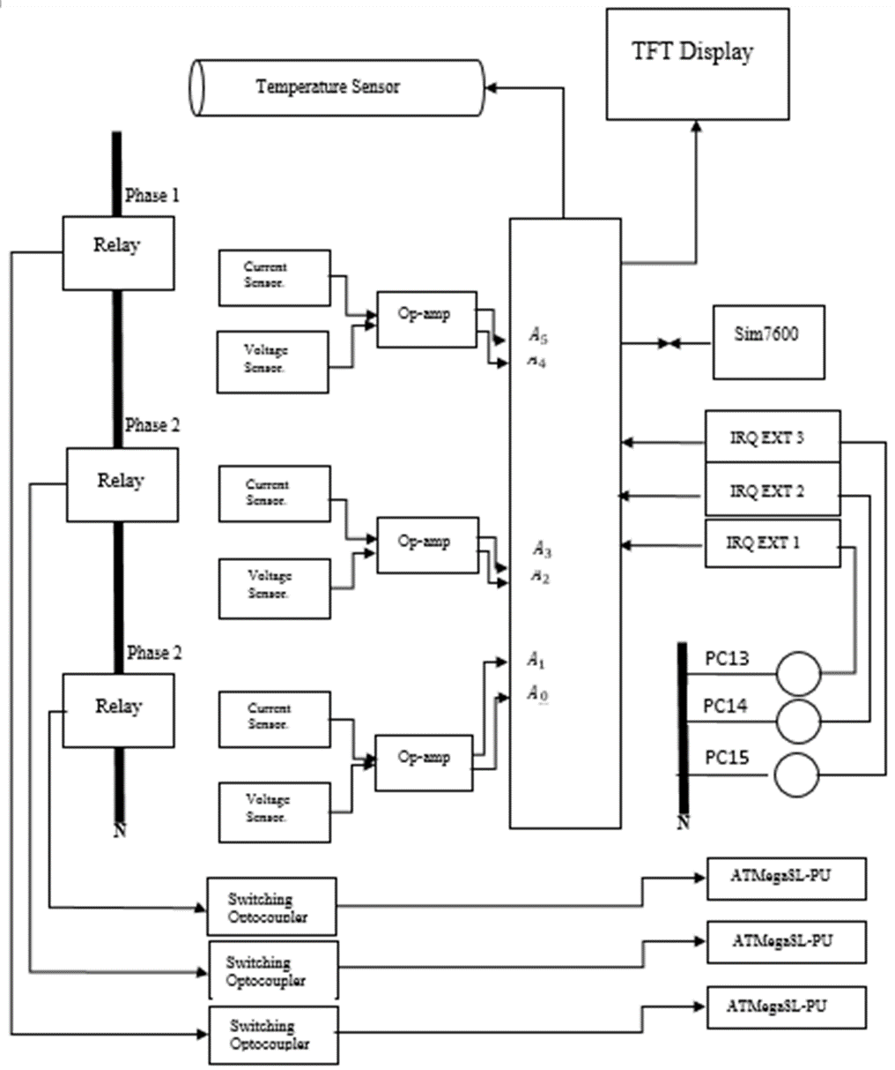
Fig. 1: Block diagram of the proposed system
3.1 Software Implementation Method
The software implementation involves flowcharts, algorithms, programming language and the programming codes. The EasyEDA (Electronics Design Automation) tool was used for the schematic capturing and PCB implementation. InteliJ Idea was used to develop the android app. It is an IDE (Integrated Development Environment) with android SDK (Software Development Kit). JSON (JavaScript Object Notation) is a widely used data format for electronic data interchange, utilizing human-readable text to store and transmit data objects like attribute-value pairs and arrays. The programming languages used are Kotlin and C++. The system implementation process is shown in Figure 2.
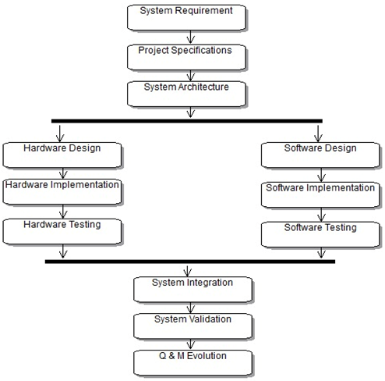
Figure 2: System implementation process
3.2 The Algorithm
- Start Initialize
- the system variables, Serial port Relays and Sensors
- Set the date and time
- If Sensors recognizes 3-phase supply continue, if not, re-initialize
- Read Temperature
- If Temp. $>$ Maximum, “OFF” the relay and re-read, If not, continue.
- Read 3-phase Voltages and Currents
- If the Voltage < Minimum and Current > Maximum, “OFF” the relay and re-read.
- If not, “ON” the relay.
- Update Buffer.
- Display data on LCD
- Send and Receive data to serial port
- Broadcast data via Sim
- Stop.

3.3 Flowchart Representations
The flowcharts used for the implementation of the software is shown in Figure 3.
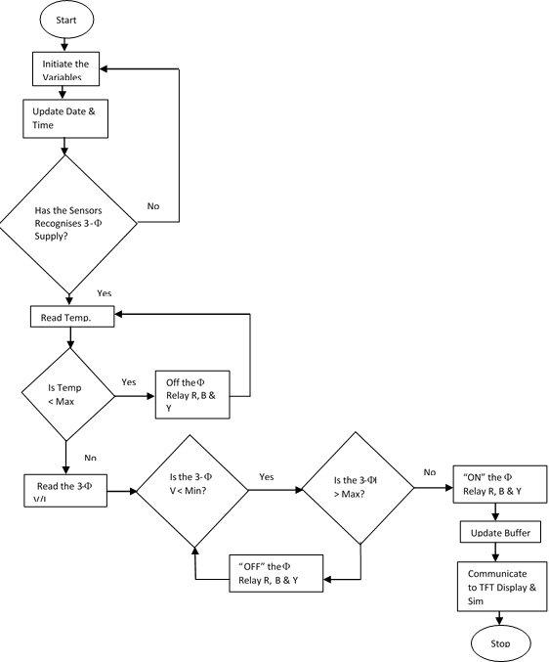
Figure 3: A Flowchart of the Implemented System
3.4 Method of Analysis and Circuit Performance Evaluation
The fabricated prototype will be subjected to real-time monitoring of mains from substation lines in the laboratory. The substation parameters such as voltage, current, frequency, and the ambient temperature of the laboratory would be displayed on the 1.8$"$ Coloured TFT Display module. These results will be related to the MQTT broker/server, the IoT communication protocol which shall specify two types of network structures: message broker and clients.
3.5 The MQTT Protocol
The MQTT protocol is a compact publish-subscribe machine-to-machine network protocol designed for IoT communication with devices and mobile phones. It operates over a transport protocol, commonly the Internet Protocol Suite (TCP/IP), and defines two categories of network entities: a message broker and various clients. Topics are arranged in a hierarchy for information organization, and a publisher sends a control message to the linked broker when it has something new to release. The broker forwards the information to any clients who have subscribed to that subject (Banks et al., 2019). In this study, the MQTT communication protocol was used as the broker while the device and the mobile phone serve as the clients. After that, the device publishes, whereas the phone subscribers. The MQTT protocol uses the TCP protocol for data transmission, with MQTT-SN, a variation, being used with Bluetooth or UDP as an alternative transport. It has no security or authentication procedures and sends connection credentials in raw text format. The broker software runs on a computer, either locally or in the cloud, and can be created by the user themselves or hosted by a third party (Hivemq, 2015). MQTT is a bi-directional communication protocol, allowing devices to post sensor data while also receiving configuration data or control commands. Clients must publish numerous messages to the broker, each with a specific topic specified, as it is not possible to broadcast the same data to multiple topics at once (Banks et al., 2019). The MQTT broker architecture separates client hardware and server software, shielding clients from knowing each other's personal information. If set up, MQTT can use Transport Layer Security (TLS) encryption with certificate, username, and password security. Backup brokers can distribute client load among numerous servers on-site, in the cloud, or a combination of these. Both conventional MQTT and MQTT for specifications complying with those specifications are supported by the broker (Cirrus-link, 2015). This model was chosen because it is very reliable in handling unreliable networks and is ideal for low-bandwidth making it great for constrained environments. It can also manage millions of connected devices. Also, while TCP provides the transport, SSL/TLS (Secure Sockets Layer/Transport Layer Security) can be layered on top for encryption, securing data between the client and broker, while ensuring broad compatibility.
4. RESULTS
4.1 Simulation Results
The simulation was carried out in stages according to the block diagram in Figure 1 and the results are presented in Figures 4 to 6. Figure 4 presents the general simulated circuit of the IoT Based Substation Automatic Monitoring and Control System, while Figures 5 to 6 presents the behavior of the circuit while monitoring substation temperature and parameters (voltage, current, frequency, and power) for the 3 phases.
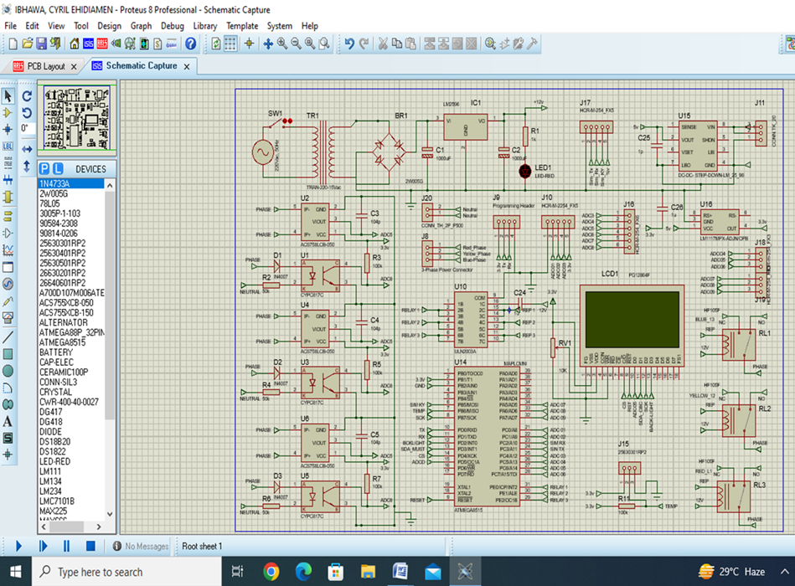
Figure 4: The simulated general circuit
4.1.1 Operational Principle of the Circuit
The system needs to be powered by 220V AC. The power supply unit stepped-down the voltage from 220V AC to input acceptable range of stable 12 V DC using rectifier and voltage regulator. This was further modified to 5 V for other components use.
Master IC is connected to every unit, so it controls their activities. 3-phase supply (Red, Blue and Yellow) has been injected as inputs to be monitored. The sensors made it possible to monitor timely and automatically the 3-phase Voltage, Current, Frequency and Power as well as Temperature in the substation. These parameters are displayed by TFT Display unit and as well as remotely monitored through Sim 7600 unit.
When the system is powered ON, the lime bright green light is displayed on the LCD to show that the system is in active mode and displays the system banner “IoT Based Substation Automatic Monitoring and Control System”. After then, it will automatically start displaying the sensed parameters of the 3-phase supply reflecting through TFT Display in the station and remotely to the intended monitor.
4.1.2 Simulated Circuit Results
Figure 5 is the simulated result of system initialization, showing LCD view displaying the banner “IoT based Substation Automatic Monitoring and Control System”. Figure 6 is the simulated circuit result when connected to the mains. The power supply unit when switch triggered “ON”, RED LED glows. This is an indication that the supply voltage of 220V AC has been stepped-down and converted to 12 V DC. Same 12 V DC which was further regulated to 5 V DC. The two voltages read different units according to each unit specified voltage. Signal present indicateor to the unit components can be seen in red, blue and gray colour.
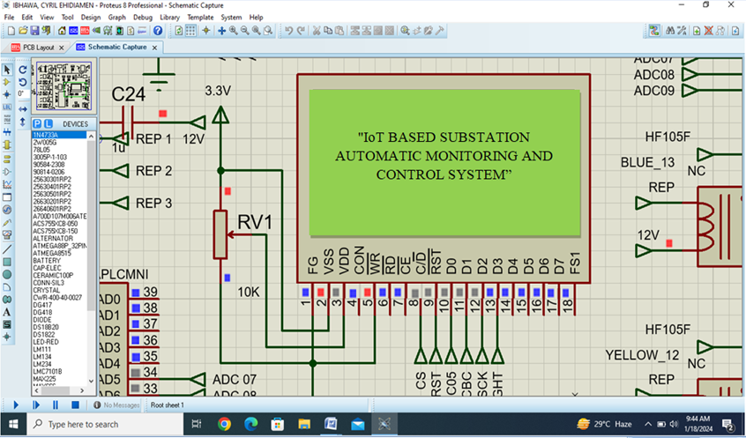
Figure 5: Simulated Result Showing LCD View after System Initialization
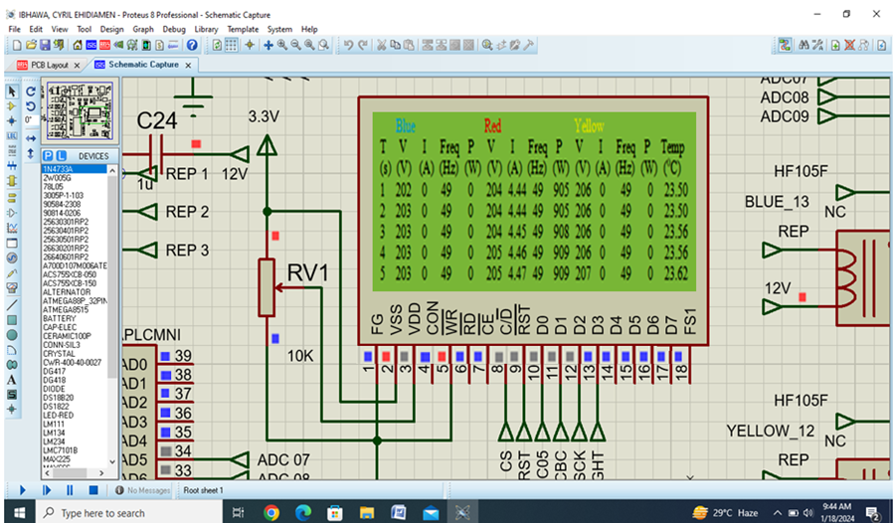
Figure 6: Simulated Results Showing Substation Temperature and Parameters (Voltage, Current, Frequency, and Power) Monitored for the 3 phases
4.2 Hardware Construction/Implementation Results
4.2.1 Etching Procedures
Following Rayming Technology (2023) the circuit was printed on a glossy paper using laser-jet. The PCB used in this work was a one-sided copper-clad laminate (CCL), with glass fiber, the reinforcing material. A soft-iron sponge was used to scrub the copper-clad board thoroughly, creating a rough surface for the design to bond to. To avoid smearing oil on the board and to shield your hands from dangerous substances, surgical hand gloves were worn. The eyes were shielded by a pair of goggles, and a nasal mask to prevent breathing in hazardous substances. The copper-clad board was washed and dried with clean water. The printed pattern was flipped over and placed on the copper surface of the board after being cut to size. Now, the paper was repeatedly pressed with a hot iron as it was on top of the board. The paper floats off the plate when submerged in a cold bath while stirring. The PCB was placed in the etching solution i.e. hydrogen chloride (HCl) and stirred for 25 to 30 minutes, or until all the copper has disappeared from the design's surrounding area. The copper board was removed, rinsed in a water bath, and dried. Subsequently, alcohol was used to rub the surface in order to remove the ink that has been transferred to the PCB. In this manner, the PCB board has been engraved, and the holes were then drilled into the PCB using a Dremel, a precision drilling tool.
4.2.2 Placement of Components in the Holes on the PCB
According to Proto-Electronics (2022), in order to prevent problems with power and signal integrity, reduce the likelihood of creating electromagnetic interference, and enhance heat dissipation, the layout must be extremely precise. The component placement on the board is shown in Figure 7 (a) while the flipped side of the board is shown in Figure 7 (b).
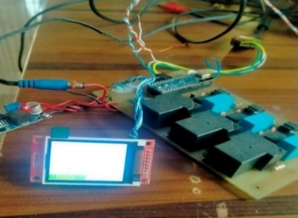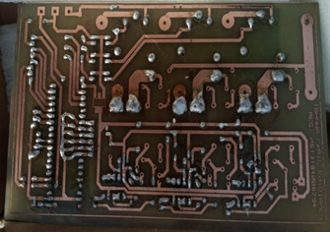
- Components on circuit board (b) Flipped side of the board
Figure 7: Circuit construction stages
4.2.3 Physical Observation of the Circuit and Preliminary Test
To ensure there were no bridges or damaged traces, the PCB was visually inspected. When the power module was powered on, the voltage of its power rails was measured using a multi-meter. Figure 8 is the constructed device circuit with components on board showing top view in casing.
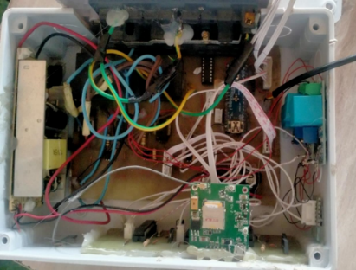
Figure 8: Top view of the constructed device in a casing
4.2.4 Casing and Packaging
A casing measuring 22.5cm x 15cm x 7.5cm was finally provided to the system for mechanical protection. The Orthographic projection has shown its three views (Front, Side and Top) in Figure 9 and the physical casing shown in Figure 10 (a) and (b). It is provided with 4-notch of 0.25 cm diameter hole within 0.5cm diameter groove at the edges of its top side for screw lock, 12-notch of 2.0cm diameter grooves which two of such used for ventilation and one used for power supply input hole. It has 8-notch 2.5cm grooves 2-notch per each side except top and bottom, one of such used for the 3-phase input supply to be monitored. While the TFT LCD Display is placed in the 8cm x 18cm glass cover on top of the casing.
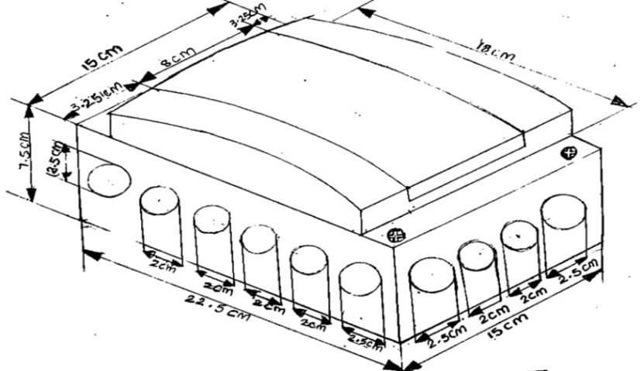
Figure 9: Isometric View of the Constructed Device
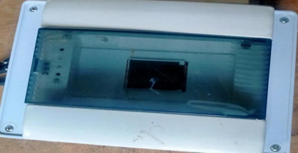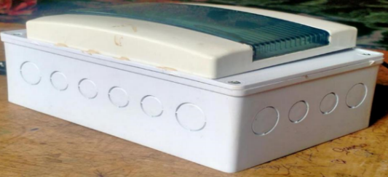
a) Top view of casing b) Side view of casing
Figure 10: The complete casing showing top and side view
4.3 Testing and Analysis of Results
The summary of the testing results is presented in Table 1 which illustrates the mean, mode, median, variance, standard deviation, and range values of voltage, power, frequency, and ambient temperature sampled every second for 16 minutes and 3 seconds i.e. 963 sampled values for the three phases. Besides, the current and the power dissipated for the Red Phase were also presented. The data were obtained in the laboratory after connecting the fabricated device to the Abuja Electricity Distribution Company (AEDC) mains from substation.
Table 1: Interpretation of the Results
 | Blue V/V | Red V/V | Yellow V/V | Blue f/Hz | Red f/Hz | Yellow f/Hz | Red I/A | Red P/W | Temp$/℃$
Mean | 207.6 | 209.2 | 211.8 | 49.0 | 49.1 | 49 | 4.5 | 946 | 23.57
mode | 208 | 209 | 212 | 49 | 49 | 49 | 4.5 | 942 | 23.62
median | 208 | 209 | 212 | 49 | 49 | 49 | 4.5 | 946 | 23.5
Var | 4.52 | 5.15 | 5.09 | 0.03 | 0.09 | 0.06 | 0.00 | 249 | 0.05
StDev | 2.13 | 2.27 | 2.26 | 0.16 | 0.31 | 0.24 | 0.04 | 15.8 | 0.23
Max | 214 | 218 | 218 | 51 | 51 | 51 | 4.64 | 997 | 25.31
Min | 200 | 203 | 204 | 49 | 49 | 49 | 4.38 | 889 | 23.37
Range | 14 | 15 | 18 | 2 | 2 | 2 | 0.3 | 108 | 1.61

From Table 1, the mean voltages for each of the three phases were 207.6V, 209.2V and 211.8V. The minimum voltages were 200V, 203V and 204V while maximum voltages were 214V, 218V and 218V for Blue, Red, and Yellow phases respectively. The deviation from the mean voltages for the three Phases were 2.13V, 2.27V, and 2.26V, corresponding to variances of 4.52V, 5.15V and 5.09V for the Blue, Red. And Yellow Phases respectively. However, the single-phase output voltage falls within the range of voltages (200 – 214) volts for the Blue Phase, (203 – 218) volts for the Red Phase, and (204 – 218) volts for the Yellow Phase. These values were lower than the approved supplied voltages range (216 – 244) volts by NESI. These could largely be attributed to many factors such as the resistance of the distribution cables, impedance in equipment of the power supply, fluctuations in load, and power quality distribution.
The current for the Red Phase ranges (4.38A - 4.64A). The mean current was 4.5A, standard deviation 0.04A and variance 0.00A.
The minimum frequencies were 49 Hz and their maximum values were 51 Hz each for the Blue, Red, and Yellow Phases. Their mean values were 49 Hz, 49.1 Hz, and 49 Hz respectively.
The minimum temperature was 23.37°C while the maximum temperature was 25.31°C. The mean ambient temperature for the three phases was recorded to be 23.7°C with deviation from the mean 0.23°C. Figure 11 is a graphical representation of the voltage current, frequency and temperature for the Red, Blue and Yellow phases.
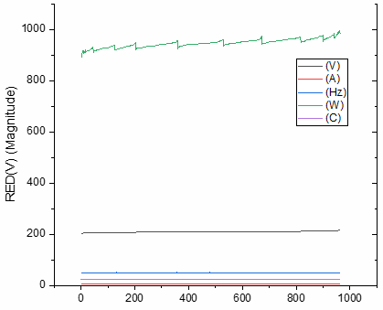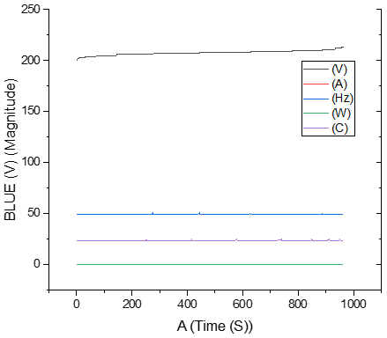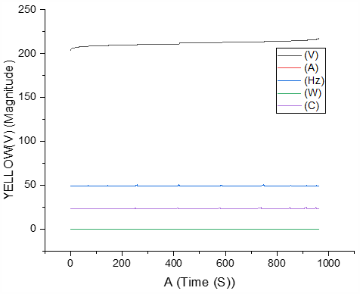
- Red Phase b) Blue Phase c) Yellow Phase
Figure 11: Voltage, Current, Frequency and Temperature for Red, Blue and Yellow phases
4.3.1 Communication Protocol Structure
The android app was developed in IntelliJ Idea, an integrated development environment (IDE) with android SDK, a software development kit, and the programming language used is Kotlin. The app provides a user interface to monitor and control the switch ON/OFF of any of the phases. A phase is switched ON/OFF using toggle state at the app interface. It uses the Wi-Fi data network of the phone to receive and transmit data. The Figure 12 (a) shows freshly launched app while Figure 12 (b) shows when the phases were switched ON. MQTT serve as the broker (server), while the smart phone and the monitoring unit are the two clients here. Figure 13, shows the communication between the app in the phone and the constructed device during test.
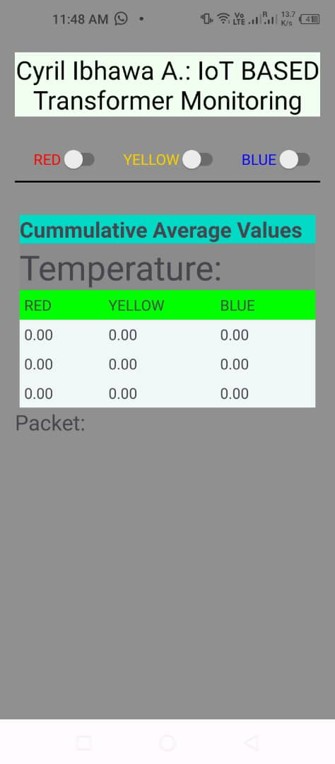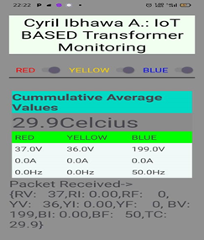
(a): Freshly launched android App. (b): Phases switched ON
Figure 12: Parameter displayed on the phone app
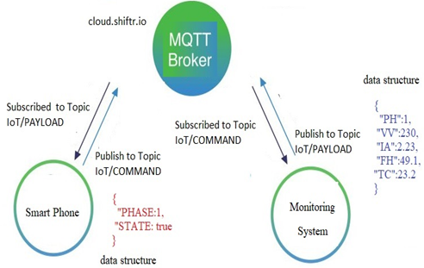
Figure 13: Communication Protocol Structure
4.3.2 A Broker User Interface
Figure 14 is a snip of the broker user interface. It illustrates a clearer communication structure between the mobile app and the monitoring device.
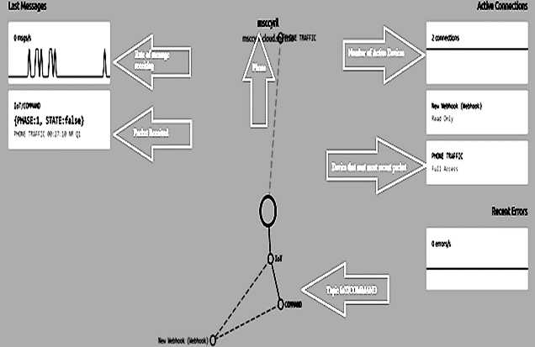
Figure 14. Broker User Interface
4.3.3 Launching the Web page
To set up the web-page, the cloud.shiftr.io platform is used and the following steps were taken:
- Launch the web-page cloud.shiftr.io
- Sign-up by creating account using a functional email
- Login to the account and create an instance of the work.
- Copy the token (password) provided for the instance. It is an encryption key that must not be edited. (Every instance must have its unique token which will grant a client access to connect to the broker)
- Launch the instance, the free version of instance is allowed to receive and transmit for maximum of 6 hours per day and also is limited to 100 devices.
- For longer duration and higher number of devices connectivity, subscription is required.
4.3.4 Validity of Results
The validity of the results obtained from the built device was confirmed by contrasting the displayed data with the suggested standard values for voltage, frequency, current and temperature by Nigerian Electricity Supply Industry (NESI). The system was configured to sample at 1sec periodically for 16 minutes. The sampled data were processed and transmitted through USART1 of the microcontroller connected to a PC using USB to the Transistor-Transistor Logic (USB-TTL) adapter. A known load was connected to the RED phase and allowed to run for 1 hour where over 5000 samples were collected and processed (filtered and scaled). The result showed near perfect synchronization of the phase frequencies. The loaded phase (RED) showed jittered current readings which also affected the output power. The observed noise in the other phases when they are not connected were either due to ADC sampling frequency, temperature change or ambient RF frequency from the DC-DC converter used in the power supply.
5. Discussion
A power distribution transformer was monitored remotely by a prototype Internet of Things (IoT)-based automatic monitoring and control system that had been designed and fabricated and put into operation. The substation's voltage, current, frequency, and ambient temperature may all be continuously monitored and controlled by the gadget. The variable values' corresponding parameters: the mean respective voltages for the Blue, Red, and Yellow phases were 207.6V, 209V and 211.8V. The mean current for the Red Phase was 4.3A. The mean values of frequency for Blue, Red, and Yellow were 49 Hz, 49.1 Hz, and 49 Hz respectively. These values were compared with those of NESI, one of the regulatory bodies in Nigeria. These could largely be attributed to many factors such as the resistance of the distribution cables, impedance in equipment of the power supply, fluctuations in load, and power quality distribution in line with the findings of Justin (2023). However, the device monitored and transmit the specification of the hardware and substation parameters at that time enabling real-time monitoring of the substation. This is in line with similar studies of Devarajan et al. (2021), Bandi (2023), Bodke and Kalage (2021), Ullah (2023), Mostak et al. (2023), Kalpana et al. (2021), and Bhavani et al. (2022).
The device in the short term will enable real-time monitoring, enhance reliability, ensure stable and high-quality power supply to consumers, streamline workflow, optimized power flow management and increased safety. While in the long term leads to data-driven decision making (through trend analysis, load forecasting and performance optimization), seamless integration, reduced operational and maintenance cost, extended equipment life via predictive maintenance, and enhanced cybersecurity to protect critical infrastructure against cyber threats.
6. CONCLUSION
A few megawatts of electricity are insufficient for developing nations like Nigeria, which have a population of roughly 200 million. The meagre output it produces is frequently mismanaged, which causes the national grid to completely collapse occasionally. The IoT-based substation prototype for automatic monitoring and control was simulated, constructed, and was used to determine the real-time (instantaneous) values of substation’s parameters. MQTT serves as transport protocol for client-server publish/subscribe messaging. It has limited settings like machine-to-machine (M2M) and Internet of Things (IoT) communication, where a tiny code footprint and/or limited network bandwidth are necessary. A high level general purpose programming language, C++ was used in this study. Phase specific variables such as voltage, current, frequency, power, and ambient temperature were packed into a JSON data structure providing long-term answers to some of these issues if deployed to substations. The analyses were in four parts, which include those for voltage, current (red phase only), frequency, ambient temperature, power (red phase only).
In order to efficiently monitor and manage the power supply chain, the Nigerian energy supplier urgently needs to adopt innovative IoT-based system approaches. This will remove the obstacles that have developed over time to personnel's easy access to remote places. Most of the deadly incidents brought on by hazardous terrain will be avoided completely. Under severe conditions of high voltage, over-current, variable frequency, and ambient temperature surges, substations can be isolated quickly and easily. This will enhance performance and the transformer will circumvent sustaining expensive damages. However, using the Optocoupler CYPC817C in the zero-crossing circuit, the power supply's frequency was ascertained. But because a 3-phase-channel oscilloscope was not available, phase sequence could not be visualized and determined.
For successful deployment of the device, key policies for integration will include adherence to the IEC 61850 standard to ensures interoperability between Intelligent Electronic Devices (IEDs) from different manufacturers by defining communication protocols, data models, and a common configuration language (SCL), IEC 60870-5-104 standard to ensure communication between the substation automation system (SAS) and the remote or main control center (SCADA Master), NERC Standards which mandate stringent cybersecurity controls for critical assets, and IEEE Standards for devices and security requirements for Intelligent Electronic Devices (IEDs). The system must also follow layered approach to manage data flow and control functions efficiently, incorporate redundancy for critical components and communication links (e.g., HSR/PRP protocols for Ethernet) to ensure high availability and prevent a single point of failure from causing a cascading outage, and mandate the use of standardized protocols to allow seamless integration of new equipment with existing legacy systems and future expansions. There is also need to integrate comprehensive security measures from the initial design phase, including network segmentation (VLANs), firewalls, encrypted communication channels, and secure access control policies, implement role-based access control (RBAC) with unique user IDs and strong passwords, and automatically log users out after a period of inactivity and rigorous Factory Acceptance Tests (FAT) and Site Acceptance Tests (SAT) to validate system performance, functionality, and interoperability before commissioning. Finally, adequate training for operators and maintenance staff on the new SCADA interface, remote control features, and troubleshooting techniques is crucial for effective utilization and plan for the entire lifecycle of the system, including ongoing maintenance, regular software updates, and patching procedures to ensure long-term reliability and security.

COMPETING INTERESTS DISCLAIMER:
Authors have declared that they have no known competing financial interests OR non-financial interests OR personal relationships that could have appeared to influence the work reported in this paper.

Disclaimer (Artificial intelligence)
Author(s) hereby declare that NO generative AI technologies such as Large Language Models (ChatGPT, COPILOT, etc.) and text-to-image generators have been used during the writing or editing of this manuscript.

Reference
- Al‐Shetwi, A. Q., Atawi, I. E., El‐Hameed, M. A. & Abuelrub, A. (2025). Digital Twin Technology for Renewable Energy, Smart Grids, Energy Storage and Vehicle‐to‐Grid Integration: Advancements, Applications, Key Players, Challenges and Future Perspectives in Modernising Sustainable Grids. The Institute of Engineering and Technology (IET) Smart Grid, 8(1), 1-37. https://doi.org/10.1049/stg2.70026.
- Bandi, N. R. (2023). Substation Monitoring Using IoT. Journal of Advanced Zoology, 44(S2), 4119-4124. Retrieved from: https://jazindia.com/index.php/jaz/article/view/1874.
- Banks, A., Briggs, E., Borgendale, K. & Gupta, R. (2019). MQTT Version 5.0 OASIS Standard. Accessed on October 15, 2023. Available at https://docs.oasisopen.org/mqtt/mqtt/v5.0/os/mqtt-v5.0-o’s.docx
- Bhavani, T., Gandhi, B., Durgaprasad, J., Madhu S. & Kalyan, A. B. (2022). Substation Monitoring and Controlling System. Journal of Engineering Sciences, 13(12), 982- 987.
- Bodke, P. & Kalage, A. A. (2021). Design of an IoT Based System for Monitoring and Controlling the Sub-Station Equipment. In Techno-Societal 2020: Proceedings of the 3rd International Conference on Advanced Technologies for Societal Applications —Volume 1 (pp. 133-139). Cham: Springer International Publishing.
- Cirrus-Link (2015). MQTT Sparkplug/Tahu. Accessed on January 9, 2023. Available at https://www.cirrus-link.com/mqtt-sparkplug-tahu/
- Critter Guard (2022). Benefits of Substation Automation. Accessed on January 9, 2023. Available at https://www.criterguard.org.
- Devarajan, R. Selvam, P., Sathish, R & Ramraj (2021). IoT-Based Monitoring and Control. Journal of Tianjin University of Science and Technology, 54(10), DOI: 10.17605/OSF.IO/JZ4RM.
- Goudarzi, A., Ghayoor, F., Waseem, M., Fahad, S. & Traore, I. (2022). A survey on IoT-enabled smart grids: emerging, applications, challenges, and outlook. Energies, 15(19), 6984. https://doi.org/10.3390/en15196984.
- Hivemq (2015). Retained Messages - MQTT Essentials: Part 8. Accessed on June 7, 2022. Available at https://www.hivemq.com/blog/mqtt-essentials,part-8-retained-mess ages/
- Justin, M. (2023). What Causes Voltage Drop in Power Supply? Accessed on October 9, 2022. Available at https://www.bravoelectro.com/blog/post/what-causes-voltage-drop-in-power-supply#:~:=
- Kabeyi, M. J. B. & Olanrewaju, O. A. (2023). Smart grid technologies and application in the sustainable energy transition: a review. International Journal of Sustainable Energy, 42(1), 685-758. https://doi.org/10.1080/14786451.2023.2222298.
- Kalpana, S., Saranya, N. & Saundariya, K. (2021). An IoT Based Real-Time Monitoring and Controlling of Sub-Station Equipment. In 2021 International Conference on System, Computation, Automation and Networking (ICSCAN) 1-5). IEEE.
- Kapoor, H. K. & Singh, D. (2025). Smart Grid Communication Technologies: Advancements, Challenges and Future Prospects. Journal of Electrical Power System Engineering and Technology, 10(1), 13-25.
- Miracle (2016). All You Would Like to Know About Electrical Substation Components. Electronic Devices Pvt Ltd. Accessed on June 13, 2023. Available at www.miracle.net.in/
- Mostak, M. S., Alam, S. T., Rahman, M. H., Das, P. & Alam, D. (2023). IoT-Based Power Monitoring and Management System of a Distribution Substation. (Doctoral Dissertation, Faculty of Engineering, American International University–Bangladesh).
- Nataraja, E. K. (2012). Design, Simulation, and Analysis of Substation Automation Networks. Texas A & M. Northcote-Green J., & Wilson, R. Control and Automation of Electrical Power Distribution System. CRC Press Taylor & Francis Group.
- Oloniniran, G. (2022). National Grid Collapses again, Lagos, others, in Blackout. Message posted to “The Punch”. http://cdn.punching.com/wpcontent/uploads/2016/06/19220759/favicon.jpg.
- Pankajavalli, P. B., Karthick, G. S., Sridhar, M. & Muniyappan, M. (2017). A System or Monitoring the Electricity Sub-Station using Internet of Things. International Journal of Advance Research in Science & Engineering, Volume, (6).
- Proto-Electronics (2022). Best Rules for PCB Components Placement. Accessed on October 28, 2023. Available at https://www.proto-electronics.com/blog/best-rules-for-pcb-components-placement
- Rayming Technology (2023). How to Design PCB in EasyEDA. Accessed on October 28, 2023. Available at https://www.raypcb.com/how-to-design-pcb-in-easyeda/#Steps_of_designing_PCB_in_EasyEDA
- Santhosh, K., Sree, K. K., Babu, B. M., Reddy, S. K. & Adithya, K. (2022). Advanced Substation and Monitoring and Control. Journal of Engineering Sciences, 13(6), 1218-1225. DOI: 10.15433.JES.2022.V13I6.43P.157.
- Sanwar, H., Mostafizur, R., Tuhin, S., Ershadul, H. & Abu, J. (2019). A Smart IoT Based System for Monitoring and Controlling the Sub-Station Equipment. DOI:10.1016/j.iot.2019.100085. Accessed on November 13, 2023. Available at https://www.researchgate.net/publication/334309761 on October18.
- Ullah, Z., Rehman, A. U., Wang, S., Hasanien, H. M., Luo, P., Elkadeem, M. R. & Abido, M. A. (2023). IoT-Based Monitoring and Control of Substations and Smart Grids with Renewable and Electric Vehicles Integration. Energy, 282, 128924.
- Vincent, E. & Yusuf, S. (2014). Integrating Renewable Energy and Smart Grid Technology into the Nigerian Electricity Grid System. Smart Grid and Renewable Energy, 5, 220. doi:10.4236/sgre.2014.59021.
- Zhu, J., Wang, G., Chen, Q., Huang, Y. & Yang, W. (2025). Application prospect of integration of smart grid and Internet of Things technology in distribution automation. Journal of Combinatorial Mathematics and Combinatorial Computing, 127b(2025), 7531--7547. DOI: 10.61091/jcmcc127b-411.

