Case report
Severe Aortic Stenosis in a Patient With Transthyretin Cardiac Amyloidosis: A Case Report
Abstract :
Transthyretin amyloidosis (ATTR) is a condition in which amyloid fibrils derived from transthyretin accumulate in tissues, which may result from hereditary factors or the ageing process. Heart problems are often observed, resulting in restrictive cardiomyopathy, causing heart failure and electrical conduction abnormalities.Aortic stenosis is the most common form of valve disease in older people. Recent research has revealed a significant link between ATTR amyloidosis, particularly the wild-type form, and severe aortic stenosis, with important implications for diagnosis, prognosis and treatment options.
In this article, we report the case of an elderly patient with severe aortic stenosis and significant left ventricular hypertrophy. Transthoracic echocardiography revealed a cockade appearance of the global lateral strain, and cardiovascular magnetic resonance imaging showed diffuse late gadolinium enhancement in both ventricles, suggesting cardiac amyloidosis. Bone scintigraphy revealed intense myocardial uptake (Perugini grade 3), confirming transthyretin cardiac amyloidosis. The patient was treated with transcatheter aortic valve implantation and started tafamidis therapy with good result
Conclusion :
Keywords : Aortic Stenosis, Transthyretin cardiac amyloidosis ,Tafamidis, bone scintigraphy,
Introduction : Transthyretin amyloidosis (ATTR) is caused by the tissue deposition of amyloid fibrils derived from transthyretin, leading to cardiac involvement with restrictive cardiomyopathy and conduction disorders. Aortic stenosis, the most common valvular heart disease in the elderly, is increasingly recognised as being associated with ATTR, particularly the wild-type form, with important diagnostic and prognostic implications. Transthyretin cardiac amyloidosis is a rare but increasingly recognised cause of cardiomyopathy, characterised by myocardial deposition of misfolded transthyretin. Clinical signs are often confused with those of common heart conditions, making diagnosis difficult. Severe aortic stenosis may coexist with ATTR-CA, an association described in the literature. We report a case of ATTR-CA in a patient with aortic stenosis, focusing on the diagnostic approach and key imaging findings. This case highlights the importance of considering cardiac amyloidosis in patients with left ventricular hypertrophy and of routinely performing global lateral strain in cases of aortic stenosis.
Case report : He is a 77-year-old patient with cardiovascular risk factors including type 2 diabetes, which is well controlled with oral antidiabetic medication, and no other significant medical history. He was admitted to the cardiology department for treatment of an inaugural episode of global heart failure.
The electrocardiogram showed a regular sinus rhythm with an average ventricular rate of 65 bpm, a left axis deviation, no left ventricular hypertrophy and no obvious secondary repolarisation abnormalities. Small pseudo-infarction Q waves were observed in the inferior leads. (Figure 1).
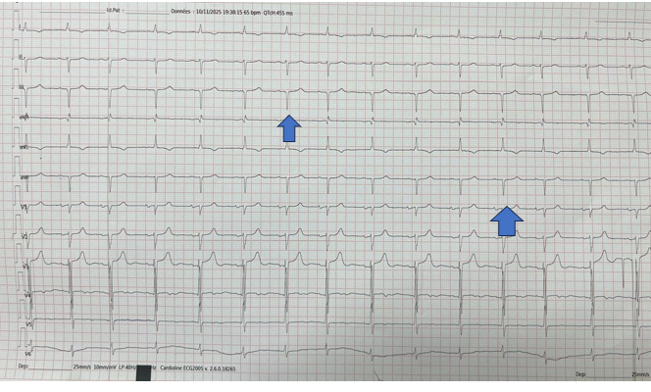
Figure 1 : 12-lead electrocardiogram showing sinus rhythm, left axis deviation, and inferior pseudo-infarction Q waves ( blue arrows)

Regarding the biological assessment, there were no obvious abnormalities, except for an elevated NT-proBNP level; the renal and hepatic assessments were normal. Transthoracic echocardiography revealed left ventricular hypertrophy with an interventricular septal thickness of 16 mm and a posterior wall thickness of 14 mm, presenting a glittering, grainy appearance of the septum. The right ventricle was also hypertrophied, with a free wall thickness of 8 mm.
There was degenerative aortic stenosis with severely calcified valves and limited opening. The indexed aortic valve area was 0.41 cm²/m², with a mean gradient of 38 mmHg and a maximum velocity of 4.04 m/s. Both atria were dilated and left ventricular filling pressures were elevated, with the inferior vena cava dilated and non-compliant on inspiration.
The left ventricular ejection fraction was preserved at 55%, but with an altered global lateral strain of -9%, showing an apical-basal gradient and a cockade appearance. (Figure 2).

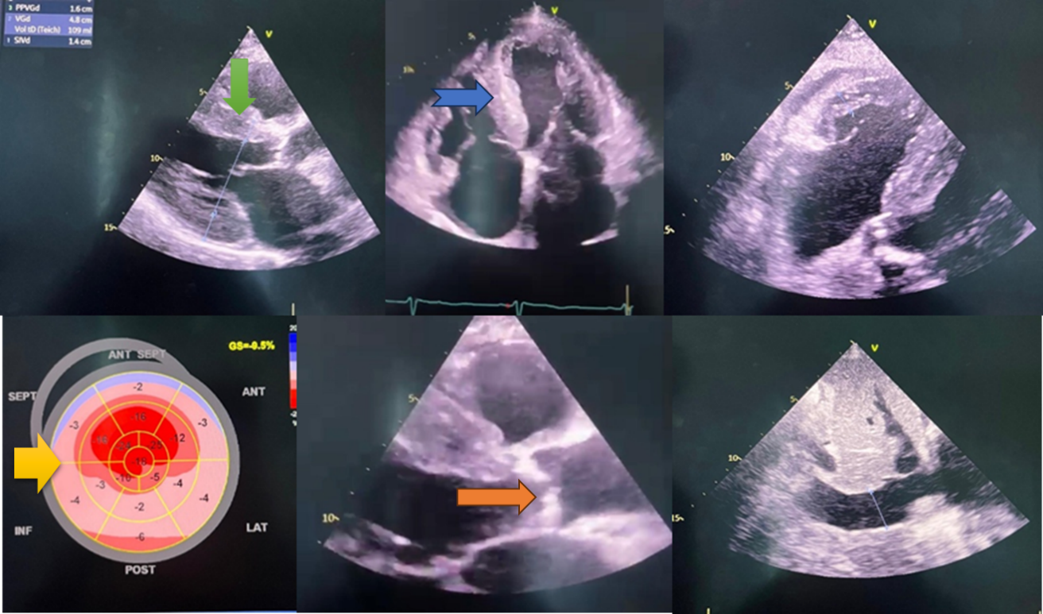
Figure 2 : Transthoracic echocardiography showing concentric left ventricular hypertrophy (green arrow) , “granular” septal appearance (blue arrow) , cockade appearance of the strain(yellow arrow) and severe aortic stenosis with calcified tricuspid aortic valve (orange arrow)
Given the caocardial appearance on transthoracic echocardiography, strongly suggesting amyloidosis, a cardiac MRI was performed, confirming the diagnosis of cardiac amyloidosis and revealing diffuse delayed gadolinium enhancement involving the atria, valves and ventricular walls. (Figure 3).
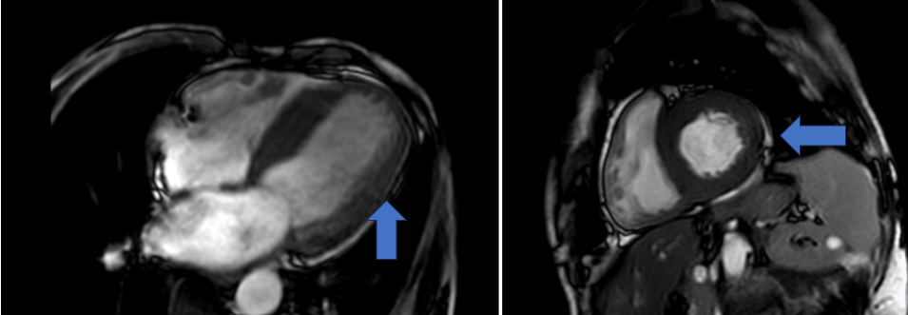
Figure 3 : Cardiac MRI demonstrating late gadolinium enhancement involving the atria, valves, and ventricular walls, consistent with cardiac amyloidosis (blue arrow).

To determine the type of cardiac amyloidosis, several tests were performed, including bone scintigraphy, protein electrophoresis, and biopsy of the accessory salivary glands. The bone scintigraphy showed marked diffuse tracer uptake in the myocardium, significantly higher than in the ribs, with reduced activity in the upper and lower limbs, corresponding to Perugini grade 3 (Figure 4).
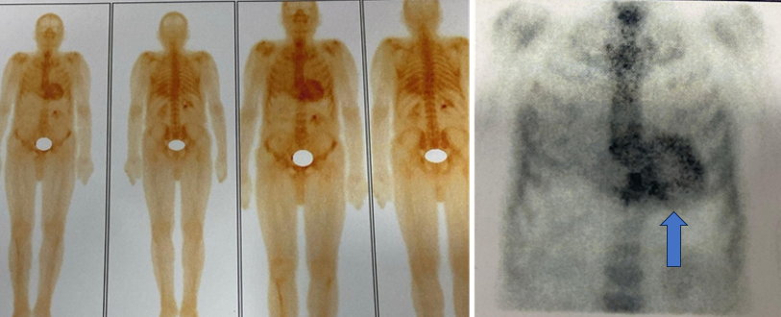
Figure 4 : Technetium-labeled bone scintigraphy showing diffuse myocardial tracer (blue arrow) uptake with Perugini grade 3, consistent with transthyretin cardiac amyloidosis
Biopsy of the accessory salivary glands and serum protein electrophoresis were negative.
All these findings led us to confirm the diagnosis of transthyretin cardiac amyloidosis associated with severe aortic stenosis.
He was transferred to the cardiovascular surgery department, where he underwent transcatheter aortic valve implantation. Pharmacological treatment with Tafamidis was initiated.
Discussion :
Cardiac amyloidosis is caused by the extracellular deposition of misfolded proteins, called amyloids, in the heart. More than 30 proteins are known to cause amyloidosis; however, transthyretin CA (ATTR-CA), has been studied much more extensively. ATTR-CA was previously classified as a rare form of infiltrative cardiomyopathy; however, recent advances in diagnostic imaging have led to a significant increase in awareness of the disease and the number of diagnoses over the past decade. Infiltration of this protein can lead to ventricular wall hypertrophy and cardiac conduction disturbances, as well as arrhythmias and decreased cardiac output. Cardiac involvement is the leading cause of death in cases of systemic amyloidosis. Aortic stenosis(AS) is a common condition that mainly affects the elderly and can be caused by age-related degeneration, rheumatic fever or congenital malformations. The disease causes changes in pressure and volume in the left ventricle (LV) due to increased afterload, and symptoms usually appear when valve obstruction becomes significant. La prévalence des maladies ATTR-CA et AS augmente avec l'âge, plusieurs études rapportant des cas d'ATTR-CA chez des patients atteints d'AS sévère (1).
Ainsi, les implications cliniques de cette association soulèvent la question de savoir si la gravité de l'AS joue un rôle dans la diagnostique de l'ATTR-CA sous-jacente (9).
Of the 30 proteins linked to amyloid aggregation, only nine are known to accumulate to varying degrees in the myocardium, the most common being amyloid light chain (AL) and the ATTR variant. The median survival rate after diagnosis is lowest for the AL subtype, at 24 months. The average age of patients with AD ranges from 74 to 90 years, with most diagnoses occurring in women aged 80 to 90 years. The two most common sites of amyloid accumulation are the heart valves and the myocardium. In the AL subtype, the accumulation of monoclonal B cells resulting from exposure to various carcinogens promotes plasmacytosis, which increases the level of immunoglobulin light chains in the plasma. The median survival rate after diagnosis is lowest for the AL subtype, at 24 months. In the AL subtype, the accumulation of monoclonal B cells resulting from exposure to various carcinogens promotes plasma cell dyscrasia, which increases the level of immunoglobulin light chains in the plasma. The ATTR subtype is thought to be the result of a genetic mutation causing misfolding, which leads to the formation of a transthyretin tetramer. Inflammation due to lipid infiltration and structural stress causes endothelial deformation, which leads to calcification and rigidity (2). Amyloid infiltration can aggravate AS by causing pressure overload, as shown by the high prevalence of amyloid infiltrates in surgically removed heart valves (10).
The diagnosis of amyloidosis presents multiple difficulties, which often lead to an underestimation of this disease in current clinical practice worldwide. This oversight can be attributed to several factors. First, the complete description of the cardiac manifestations of amyloidosis remains limited and is an area of ongoing research. In addition, a definitive diagnosis requires advanced imaging techniques such as nuclear imaging or cardiac MRI, as well as invasive procedures such as endomyocardial biopsy. In contrast, AS is a well-known valvular disease that primarily affects the elderly, with diagnosis and staging based primarily on echocardiographic evaluation. Due to its higher prevalence and well-established diagnostic protocols, clinicians are adept at identifying AS, even in its most benign forms. However, difficulties occur when both conditions coexist in the same patient. The presence of AS may mask the distinct findings of CA, which may lead to a significant number of undiagnosed cases, given the limited use of advanced diagnostic tools for AS and their availability in only certain centres (3).
Detecting CA requires increased vigilance, as routine tests cannot establish a definitive diagnosis. While many studies have focused on formulating diagnostic algorithms for isolated CA, primarily centred on advanced imaging techniques, it is essential to emphasise the importance of observations drawn from routine assessments. A recent study sought to synthesise the existing literature, elucidating the importance of the coexistence of AS and CA in routine examinations such as electrocardiogram (ECG) and transthoracic echocardiography (TTE). In doing so, it aimed to empower clinicians to promote early clinical suspicion. This initial phase is essential to pave the way for the deliberate implementation of advanced diagnostic modalities such as cardiac magnetic resonance imaging and cardiac scintigraphy, which might otherwise be omitted. Ultimately, this comprehensive approach increases the chances of obtaining an accurate diagnosis in a timely manner. (11).
Natriuretic peptides, particularly brain natriuretic peptides (BNP), have proven to be very effective in identifying ventricular dysfunction. In cases of amyloidosis, BNP concentrations are elevated in ventricular myocytes located near amyloid deposits. In patients with biopsy-confirmed systemic amyloidosis, N-terminal pro-BNP (NT-proBNP) levels exceed 332 pg/mL in the absence of renal failure or atrial fibrillation (4).
Patients diagnosed with CA usually do not have a standard ECG. Low-voltage complexes on the ECG, characterised by a QRS amplitude less than 1 mV in all precordial leads or less than 0.5 mV in all limb leads , have conventionally been considered a pathognomonic feature of CA. However, the reported incidence of low voltage complexes varies considerably between studies, with a range of 20% in ATTR-CA to 60% in AL-CA. The Sokolow-Lyon index (S wave in lead V1 + R wave in lead V5 or V6 < 1.5 mV) has been associated with a negative outcome in CA, but it may not be useful for early identification, as low voltage complexes appear later in the disease process. In addition to voltage variations, the most common type of ECG signal in people with CA is a recording resembling a heart attack, which is most evident in the anterior leads (5).
AS and CA have historically been linked to an increase in concentric LV size. Conversely, research has revealed that approximately one-third of patients with AL-CA show normal left ventricular wall thickness, i.e. 12 mm or less, and up to 79% of individuals with ATTR-CA have asymmetric septal hypertrophy. However, a recent meta-analysis has revealed that certain echocardiographic parameters associated with concentric hypertrophy, such as elevated left ventricular mass index, interventricular septal thickness, posterior wall thickness, and relative wall thickness, are reliable indicators for diagnosing CA, even when AS is present. It is important to note that among these various indicators, only the left ventricular mass index has been recognised as a predictor of mortality (6). Patients with both CA and AS tend to exhibit a low-flow, low-gradient phenotype with regard to AS severity. In a study conducted by Cavalcante et al., more than 75% of patients with both ATTR CA and AS revealed this pattern (12).
Cardiovascular magnetic resonance imaging (CMR) is currently considered the most effective non-invasive imaging technique for assessing cardiac function and characterising myocardial tissue. Cardiovascular magnetic resonance imaging offers high spatial and temporal resolution as well as intrinsic contrast between blood and tissue, making it an ideal method for identifying cardiomyopathies. The use of late gadolinium enhancement (LGE) imaging allows cardiac fibrosis to be visualised. The latest generation of CMR development, called parametric CMR mapping, includes T1, T2, and extracellular volume (ECV) mapping, which provides a pixel-by-pixel representation of T1 or T2 numerical characteristics quantified in units of time (e.g., milliseconds). This contrasts with traditional T1- or T2-weighted MRI techniques, which rely on relative imaging signal intensities to highlight and distinguish areas of normal tissue from abnormal areas. The appearance of transmural and global subendocardial LGE is typical of CA and is a prognostic indicator (7).
The assessment of cardiac amyloidosis (CA) with bone-seeking radiotracers is performed by visual comparison and semi-quantitative analysis, which can be implemented once cardiac uptake has been verified. Depending on the radiotracer chosen, planar and SPECT images are taken one and three hours after injection of Tc-99m-PYP. In the first method, visual assessment of cardiac uptake on planar and SPECT images is performed (either both tests are performed simultaneously, or SPECT is used as a screening test if the planar test is positive). The visual scoring system is based on comparisons between cardiac uptake and bone uptake (usually in the sternum or ribs) from images obtained using imaging techniques. A qualitative scoring system has been established based on relative uptake: Grade 0 indicates no cardiac uptake and normal bone uptake; Grade 1 shows slight cardiac uptake, less intense than that of the bones; Grade 2 indicates moderate cardiac uptake with reduced bone uptake; and Grade 3 is characterised by dense cardiac uptake with little or no bone uptake. A score of 2 or 3 on the qualitative visual comparison scale strongly suggests the presence of ATTR-CA (13).
The medical management of amyloidosis is divided into two parts: targeted treatment to treat amyloid deposition and general treatment to prevent complications of the disease. For ATTR-CA, targeted therapy is based on three mechanisms: reducing the production of misfolded TTR by the liver, preventing the dissociation of the TTR tetramer into further forms, and eliminating amyloid deposits in cardiac tissue.
The recommended drug is tafamidis, which acts as a TTR stabiliser. It binds to the thyroxine binding site on TTR, preventing the dissociation of TTR that leads to the formation of amyloid fibrils. In the transthyretin amyloid cardiomyopathy clinical trial (ATTR-ACT), patients receiving tafamidis experienced a reduction in hospitalisations due to cardiovascular causes and all-cause mortality. The decline in quality of life and functional capacity was significantly less pronounced in patients treated with tafamidis compared to the placebo group. The surgical treatment options for patients with severe AS are TAVR or SAVR, depending on the patient's characteristics. (14).
Conclusion :
Cardiac amyloidosis is closely associated with AS in elderly individuals. These two conditions share similar characteristics and worsen the prognosis when they occur simultaneously. The purpose of this report is to raise awareness of transthyretin-related cardiac amyloidosis, which is often misidentified as a cause of atypical heart failure. It highlights the importance of readily available non-invasive diagnostic tools to promote early diagnosis and increase recognition of the disease. In addition, the availability of non-surgical treatment options, particularly for elderly and high-risk patients, could reduce morbidity and mortality. Rapid identification allows for timely valve interventions and the initiation of disease-specific treatment, thereby improving clinical outcomes.
Disclaimer (Artificial intelligence)
Option 1:
Author(s) hereby declare that NO generative AI technologies such as Large Language Models (ChatGPT, COPILOT, etc.) and text-to-image generators have been used during the writing or editing of this manuscript.
Option 2:
Author(s) hereby declare that generative AI technologies such as Large Language Models, etc. have been used during the writing or editing of manuscripts. This explanation will include the name, version, model, and source of the generative AI technology and as well as all input prompts provided to the generative AI technology
Details of the AI usage are given below:
1. I have used artificial intelligence exclusively to improve the translation and formal language in my writing, but all scientific content is authentic and based on recent scientific articles but i have change dit.
2.
3.

Références :
1 : Bukhari, S. (2023). Prevalence, Predictors and Diagnosis of Cardiac Amyloidosis in Patients with Aortic Stenosis. Journal of Biomedical Research & Environmental Sciences. https://doi.org/10.37871/jbres1796
2 : Jaiswal, V., Ang, S. P., Chia, J. E., Abdelazem, E. M., Jaiswal, A., Biswas, M., Gimelli, A., Parwani, P., Siller-Matula, J. M., & Mamas, M. A. (2022). Echocardiographic predictors of presence of cardiac amyloidosis in aortic stenosis. European Heart Journal - Cardiovascular Imaging, 23(10), 1290-1301. https://doi.org/10.1093/ehjci/jeac146
3 : Costa, J., El-Ali, A., Morland, D., Dejust, S., Papathanassiou, D., Nazeyrollas, P., & Metz, D. (2024). Cardiac amyloidosis prevalence and 1-year outcome in patients with aortic stenosis undergoing transaortic valve implantation: Findings from the CAMPOS-TAVI study. Arch Cardiovasc Dis, 117(8-9), 461–469. https://doi.org/10.1016/j.acvd.2024.04.007
4 : Masri, A., Chen, Y., Colavecchia, A. C., Benjumea, D., Crowley, A., Jhingran, P., Kent, M., Wogen, J., Pankratova, C., Jimenez Alvir, J. M., & Bhambri, R. (2025). Coexisting Calcific Aortic Stenosis and Transthyretin Cardiac Amyloidosis: Real-World Evaluation of Clinical Characteristics and Outcomes. Journal of the American Heart Association, 14(2), e033251. https://doi.org/10.1161/JAHA.123.033251
5 : Prevalence of ATTR cardiac amyloidosis in patients with aortic stenosis: a higher risk population?. J Vasc Med Surg. 2025;3(4):2–13. doi:10.47363/JVMS/2025(3)118
6 : Gonzalez Lopez, E., et al. (2025). What Cardiologists Should Know About Amyloidosis. J. Clin. Med. https://doi.org/10.3390/jcm14186668
7 : Arshad S, Goldberg YH, Bhopalwala H, Dewaswala N, Miceli NS, Birks EJ, Vaidya GN. High prevalence of cardiac amyloidosis in clinically significant aortic stenosis: a meta-analysis. Cardiol Res 2022;13:357–371
8 : Kodali SK, Hahn RT, Eleid MF, Kumbhani DJ, Lerakis S, Williams MR, et al. Outcomes of transcatheter aortic valve replacement in patients with cardiac amyloidosis: insights from the STS/ACC TVT Registry. JACC Cardiovasc Interv. 2022;15(3):305-14
9 : Balciunaite G, Rimkus A, Zurauskas E, Zaremba T, Palionis D, Valeviciene N, Aidietis A, Serpytis P, Rucinskas K, Sogaard P, Glaveckaite S, Zorinas A, Janusauskas V. Transthyretin cardiac amyloidosis in aortic stenosis: prevalence, diagnostic challenges, and clinical implications. Hellenic J Cardiol 2020;61:92–98
10 : Kristen AV, Schnabel PA, Winter B, Helmke BM, Longerich T, Hardt S, Koch A, Sack FU, Katus HA, Linke RP, Dengler TJ. High prevalence of amyloid in 150 surgically re moved heart valves a comparison of histological and clinical data reveals a correlation to atheroinflammatory conditions. Cardiovasc Pathol 2010;19:228–235
11 : Jaiswal V, Huang H, Agrawal V, Khulbe Y, Hanif M, Hameed M, Shrestha AB, Perone F, Zacks J, Parikh C, Gomez SI, Paudel K, Grubb KJ, De Rosa S, Gimelli A. Cardiac amyloidosis and aortic stenosis: a state-of-the-art review. Eur Heart J Open. 2023;3(6):oead106. Published online 12 Oct 2023
12 : Cavalcante JL, Rijal S, Abdelkarim I, Althouse AD, Sharbaugh MS, Fridman Y, Soman P, Forman DE, Schindler JT, Gleason TG, Lee JS, Schelbert EB. Cardiac amyloidosis is prevalent in older patients with aortic stenosis and carries worse prognosis. J Cardiovasc Magn Reson 2017;19:98
13 : Singh V, Falk R, Di Carli MF, Kijewski M, Rapezzi C, Dorbala S. State-of-the-art radio nuclide imaging in cardiac transthyretin amyloidosis. J Nucl Cardiol 2019;26:158–173
14 : Maurer MS, Schwartz JH, Gundapaneni B, Elliott PM, Merlini G, Waddington-Cruz M, Kristen AV, Grogan M, Witteles R, Damy T, Drachman BM, Shah SJ, Hanna M, Judge DP, Barsdorf AI, Huber P, Patterson TA, Riley S, Schumacher J, Stewart M, Sultan MB, Rapezzi C; ATTR-ACT Study Investigators. Tafamidis treatment for patients with transthyretin amyloid cardiomyopathy. N Engl J Med 2018;379:1007–1016

