Original Research Article
HEPATOPROTECTIVE EFFECTS OF AMARANTHUS SPINOSUS EXTRACT AGAINST ALCOHOL-INDUCED LIVER INJURY IN WISTAR RATS: MODULATION OF LIPID PROFILE AND LIVER FUNCTION MARKERS

ABSTRACT
Background: Alcohol-induced liver injury is a major global health concern, characterized by oxidative stress, dyslipidemia, hepatocellular injury, and altered liver function. The present study evaluated the hepatoprotective and lipid-modulating effects of Amaranthus spinosus aqueous extract against ethanol-induced liver injury in Wistar rats.
Materials and Method: Forty-nine (49) rats were divided into groups; normal control, standard control (silymarin 50mg/kg), alcohol-exposed groups, and treatment group at 250 mg/kg and 500 mg/kg doses of the extract, with or without continued alcohol administration, over 42 days. Liver function markers (ALT, AST, total protein, albumin, bilirubin), lipid profiles (total cholesterol, triglycerides, HDL-C, LDL-C, VLDL-C), and oxidative stress indicators (SOD, GSH, MDA, LDH) were assessed. Histopathological analysis was conducted to evaluate structural liver changes.
Results: Alcohol administration significantly elevated serum ALT, AST, bilirubin, total cholesterol, triglycerides, LDL-C, and VLDL-C, while reducing HDL-C, total protein, albumin, SOD, and GSH, alongside increased MDA and LDH levels, indicating hepatocellular injury, oxidative stress, and dyslipidemia. Treatment with A. spinosus extract ameliorated these biochemical alterations in a dose- and treatment-dependent manner, restoring antioxidant enzyme activity, reducing lipid peroxidation, normalizing lipid profiles, and improving hepatic synthetic function. Histopathological examination confirmed attenuation of alcohol-induced steatosis, necrosis, and architectural distortion, particularly in rats receiving high-dose extract.
Conclusion: These findings suggest that Amaranthus spinosus exerts significant hepatoprotective, antioxidant, and lipid-modulating effects, highlighting its potential as a natural therapeutic agent against alcohol-induced liver injury. Further studies are warranted to elucidate the molecular mechanisms underlying these protective effects.
Keywords: Amaranthus spinous, hepatoprotective, alcohol-induced liver injury, lipid profile, ALT, AST, oxidative stress, non-HDL cholesterol, histopathology

INTRODUCTION

Regulatory organs, such as the liver, are responsible for various metabolic processes, including the excretion of toxic substances by breaking them down into simpler waste products and regulating the body's homeostasis (Rouf et al., 2021). These processes occur simultaneously, making the liver the largest and most active organ in the body. During metabolism, its hepatocytes are primary targets for toxins, drugs, alcohol, and other chemicals. Alcohol metabolism is a significant process that occurs in the liver, facilitated by the enzyme ADH (Alcohol dehydrogenase), which breaks down alcohol into a known carcinogen called acetaldehyde (CH3CHO), that covalently bonds to proteins, lipids, and nucleic acids, disrupting biological functions (Osna et al., 2017). This toxin often accumulates in habitual alcohol consumers, leading to alcohol-induced injury attributed to the alcohol concentration in the portal blood and the metabolic process effects (Massey & Arteel 2012).
Alcohol-induced liver injury can cause high mortality to an outrageous degree, usually manifesting as steatosis before it progresses to alcoholic hepatitis, then fibrosis and cirrhosis (Ginès et al., 2021; Lee, 2023). The liver also suffers from an alcohol-induced lipid metabolism, inflammation, and oxidative stress, which are important in the pathogenesis of liver diseases, whose progression is from cell to cell and organ to very complex organ interaction(Ceni et al., 2014; Osna et al., 2017), leading to toxic metabolites of ethanol, particularly acetaldehyde and reactive oxygen species. The hepatic free uptake of fatty acids (FA), causing upregulation of exogenous FA (Nakamura et al., 2014), stimulation of HGF (hepatocyte growth factor) for VLDL synthesis (Rojas-Chaverra et al., 2024) are all entangled in complex hepatic lipid flux. These interactions disrupt intracellular signaling and gene expression, leading to lipid accumulation, fibrogenesis, and immune activation (Zhao et al., 2020). Acetaldehyde impairs lipid homeostasis by interfering with AMPK-regulated pathways and stimulates collagen production via activation of hepatic stellate cells (Xia et al., 2023). Ethanol also compromises the integrity of the intestinal barrier, allowing lipopolysaccharide (LPS) translocation, which triggers inflammatory responses via Kupffer cells (Slevin et al., 2020). Moreover, alcohol suppresses antifibrotic immune functions, such as natural killer (NK) cell activity, and alters adaptive immunity by impairing antigen presentation (Jeong et al., 2008). Also, acetaldehyde and ROS contribute to liver carcinogenesis by forming DNA adducts and disrupting DNA methylation and repair mechanisms, thereby increasing the risk of Hepatocellular carcinoma (HCC)(Seitz & Stickel, 2006).

Over the years, alcohol consumption has become excessive, leading to alcohol-induced liver injury, and previous studies have focused on pharmacological management of alcohol induced injury such as the use of benzodiazepine(Fleenor et al., 2024),naltrexone and acamprosate(McPheeters et al., 2023), nalmefene (Müller et al., 2014),propylthiouracil and ursodeoxycholic acid(Buzzetti et al., 2017). The development of these drugs and their therapeutic effects has been a controversial topic of discussion as it pertains to patients' liver safety (Tarli et al., 2022).Consequentially, the pharmacological management with these medications is not favourable for reconstructing the biologically active liver and is, on the other hand, not sustainable due to the costs, potential side effects, and accessibility.
There is a growing shift in alternative liver-protective agents derived from medicinal plants, which contain bioactive compounds capable of modulating oxidative stress, inflammation, and lipid metabolism. Any medicinal plant's distinct nature lies in its strong hepatoprotective activity, and numerous studies on such plants have been recorded(Ali et al., 2019; Asadi-Samani et al., 2015; Ma et al., 2019). Various plant extracts with antioxidant, anti-inflammatory, and lipid-lowering effects have shown promising results in both clinical and preclinical models of liver disease(Zakaria et al., 2023). According to Sendker & Sheridan, (2017) many herbal remedies have evolved through traditional use within a specific cultural context. For some cultures, the traditional use is documented in written texts, and for others, the knowledge and traditional use are passed down orally from generation to generation (Sendker & Sheridan, 2017). Amaranthus spinous, also known as spiny amaranth, has a wide distribution in tropical and subtropical zones. It has been employed in ethnomedicine for the treatment of many ailments, viz., gastrointestinal problems, inflammation, and liver disease. According to Ganjare & Raut, (2019), traditionally, the leaves and roots are boiled and used for their laxative, diuretic, antidiabetic, antipyretic, and expectorant activities, as well as in the treatment of snake bites, leprosy, gonorrhoea, and acute bronchitis. The plant reportedly possesses anti-inflammatory, immunomodulatory, anti-androgenic, and anthelmintic activities. These pharmacological actions are thought to be due to its high content of amino acids, flavonoids, and phenolic acids, which are largely responsible for its hepatoprotective and antioxidant activities (Ganjare & Raut, 2019). In phytochemical studies by Tanmoy et al., (2014) major phytoconstituents found in its methanolic extracts are 7-coumaroyl apigenin, 4-O-β-D-glucopyranoside, spinosidexylofuranosyl uracil, β-D-ribofuranosyl uracil, β-D-ribofuranosyladenine, β-sitosterol glucoside, hydroxycinnamates, quercetin and kaempferol glycosides, and a variety of betalains including betaxanthins, betacyanins, isoamaranthine, gomphrenin, and betanin. Other interesting compounds are β-sitosterol, stigmasterol, linoleic acid, about 0.15% rutin, and beta-carotene, which together are responsible for the plant's wide range of therapeutic applications.(Rouf et al., 2021).
The use of phototherapy has proven to protect against liver injury both in vivo and in vitro settings (Farghali et al., 2015), and it is affordable, available, has diverse pharmacological activities, and has fewer side effects (Levy et al., 2004; Ma et al., 2019). This study aims to evaluate the hepatoprotective effects of Amaranthus spinosus extract on ethanol-induced liver damage in Wistar rats. Specifically, the study investigates the modulation of liver function markers and lipid profile parameters to determine the protective potential of the plant extract against alcohol-mediated hepatotoxicity.

METHODOLOGY
CHEMICALS AND REAGENT
Distilled water, ethanol(40%v/v), omeprazole, indomethacin, normal saline, ketamine, potassium chloride, 10% formalin, 1% hydrochloric acid, ammonium hydroxide, acetic anhydrid, dilute sulphiric acid, Wagner reagent, 2% sodium bicarbonate, 10% zinc sulphide, Dragendorffs reagent, Glacia acetic acid, 1,1-Diphenyl-2-Picryl-Hydrazyl (DPPH), Absolute Alcohol, Paraffin wax, Xylene, Standard 50 mg/kg Silymarin, EDTA , 0.1 M-phosphate buffer, pH 7.4, haematoxylin eosin dye.
PREPARATION OF PLANT EXTRACT

Fresh leaves of Amaranthus spinosus were collected and washed with distilled water and thoroughly dried under shade. Thereafter, the dried leaves were pulverized to fine powder using an electric blender.
Then, 300 g of plant powder was weighed using an electronic weighing balance and soaked in 2,000 ml of distilled water suspension and stored magnetically overnight at room temperature. This was then filtered out with a whatman filter paper No. 1. The filtrate was concentrated using rotatory rotary evaporator at 50 °C to obtain a crude extract.
EXPERIMENTAL ANIMALS
A total of forty nine (49) adult wistar rats of weight 160-180 g bodyweight were supplied by the breeding animal house of the Faculty of Veterinary Medicine, University of Nigeria Nsukka. They were housed in individual cages and allowed to acclimatize under laboratory conditions at room temperature for one week prior to commencement of the experiment. The animals were kept under hygienic and favourable conditions, maintained under a 12 hour light/ 12 hour dark cycle, with pelletized rat feeds and water available ad libitum.
ALCOHOL-IN INDUCED LIVER
Acute Toxicity (LD₅₀ Determination)
The index of acute toxicity is the LD₅₀. It is the dose of a substance capable of producing death in 50% of the population of animal exposed to the substance. Lorke’s (1983) method was used with slight modification as cited by (Saggar et al., 2022). This method has two different phases.
Phase I
Three groups containing three mice each were used. The Amaranthus spinosus aqueous extract was administered at concentrations of 10 mg/kg body weight (b.w) to group I mice, 100 mg/kg b.w to group II mice, and 1,000 mg/kg b.w to group III mice that formed the LD₅₀ phase one groups. Administration of extract was done orally. The animals were monitored for 24 hours for abnormal reaction or mortality.
Phase II
In this phase, three groups of mice were used with the Amaranthus spinosus aqueous extract in the concentration of 1,600 mg/kg b.w., 2,900 mg/kg b.w., and 5,000mg/kg b.w. to groups 1, group 2 and group 3 mice respectively that formed the phase two groups. They were monitored for 24 hours and the observations were recorded. Lethal dose LD50 of the extract was estimated by calculating the geometric mean of the maximum dose with 0% mortality and the minimum dose with mortality
(Lorke, 1983) Cited by (Saggar et al., 2022).
LD₅₀ = $\sqrt{\begin{aligned}maximium dose with 0\% mortality× \\ minimium dose with mortality\end{aligned}}$

EXPERIMENTAL DESIGN
The research was in two phases: Phase I – Exposure phase while Phase II was the treatment phase with the Amaranthus spinosus leaves extract and the standard drug – Silymarin.

PHASE 1: EXPOSURE PHASE
The animals were divided into 2 groups of 7 and 42 animals each in the normal control group and raw alcohol group respectively.
Group 1 Normal Control
Group 2 Raw Alcohol (Ogogoro)(40%v/v)

Those in control group 1 received food and distilled water only while those in group 2 received 10 ml/kg body weight alcohol which was administered through oral gavage. The experimental animals were offered normal diet and water ad libitum throughout the 21 days period of Phase I, during this period; all animals were observed for clinical signs and mortality patterns daily. At the end of this phase, the animals were selected randomly from the groups and blood samples were collected through ocular puncture for various biochemical analysis.

PHASE II: TREATMENT PHASE
These experimental animals were further divided into 7 groups of 7 animals each; treatments were for 21 days which are summarized below
PHASE II: TREATMENT PHASE
Group 1 | Normal control
Group 2 | 10 ml/kg of Alcohol + 50 mg/kg Silymarin (Standard control)
Group 3 | 10 ml/kg Alcohol only (No treatment)
Group 4 | 10 ml/kg Alcohol + extract 250 mg/kg b.w + discontinued induction.
Group 5 | 10 ml/kg Alcohol + extract 500 mg/kg b.w + discontinued induction
Group 6 | 10 ml/kg Alcohol + extract 250 mg/kg b.w + induction cum treatment
Group 7 | 10 ml/kg Alcohol + extract 500 mg/kg b.w + induction cum treatment

At the end of the 42-day induction and treatment period in all, an overnight fast was imposed on the animals and the final weights taken to obtain the final body weights of the rats.

Blood and Tissue Sampling
At the end of the post feeding fast, they were subjected to light diethyl ether to induce anesthesia. Blood were collected by cardiac puncture into clean and dry test-tubes without anticoagulant, allowed to stand to separate serum and then preserved in a refrigerator until used for analyses. Similarly, some quantity of the blood was collected into EDTA containers for hematological studies. The liver was harvested, cleaned and weighed (absolute weight) and separately homogenized in 5 ml cold buffer (0.1 M-phosphate buffer, pH 7.4) per gram tissue. The homogenate were be further vortexed for 15 minutes and allowed to stand and the supernatant were collected into sterile tubes and preserved in a refrigerator until used for biochemical analysis.

HISTOPATHOLOGY
Tissues of the liver were fixed in 10% neutral buffered formalin, dehydrated in graded alcohol series, and embedded in paraffin. Sections of 5 µm thickness were stained with hematoxylin and eosin (H&E) and microscopically evaluated for pathological changes such as necrosis, fatty degeneration, hepatocyte ballooning, and inflammatory infiltration.
LIVER FUNCTION TESTS (LFTS)
Serum levels of alanine aminotransferase (ALT), aspartate aminotransferase (AST), total bilirubin, direct bilirubin, albumin, and total protein were measured using standard colorimetric kits according to the manufacturer's instructions. The tests were performed to evaluate liver enzyme leakage, hepatocellular damage, and synthetic function.
LIPID PROFILING
Total cholesterol, triglycerides, high-density lipoprotein (HDL), and low-density lipoprotein (LDL) were measured using enzymatic colorimetric methods. Low-density lipoprotein (LDL) was calculated using Friedewald’s formula adopted from (Krishnaveni & Gowda, 2015). These parameters were assessed to determine alcohol-induced dyslipidemia and the lipid-lowering effects of Amaranthus spinosus extract
STATISTICAL ANALYSIS
All the values were expressed as Mean ± SEM, the results were analyzed statistically by one-way ANOVA followed by Tukey’s post-test, P<0.05 were considered significant.

RESULTS AND DISCUSSION

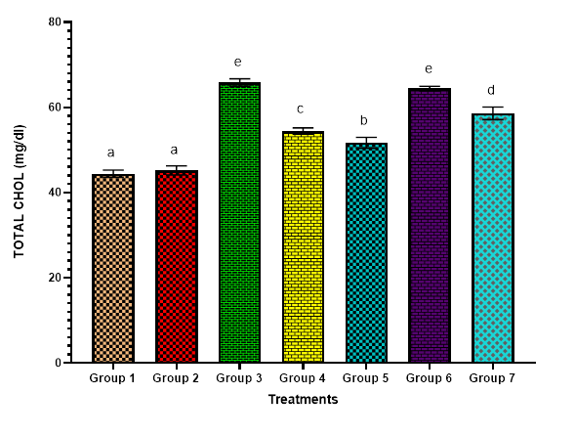

Figure 1: Effect of Amaranthus spinous extract on lipid profile markers in alcohol-Induced rats. This graph displays the total cholesterol (mg/dl) concentration across different experimental groups.
Bars represent mean ± standard deviation of triplicate determinations and bars with different alphabets indicate significant difference at p ≤ 0.05. Group 1 = normal control, group 2 =10 ml/kg of Alcohol + 50 mg/kg Silymarin (Standard control), group3= 10 ml/kg Alcohol only (No treatment), Group 4 10 ml/kg Alcohol + low dose of extract (250 mg/kg) + discontinued induction, Group 5 = 10 ml/kg Alcohol + high dose of extract (500 mg/kg) + discontinued induction, Group 6=10 ml/kg Alcohol + low dose of extract (250 mg/kg) + induction cum treatment, Group 7=10 ml/kg Alcohol + high dose of extract (500 mg/kg) + induction cum treatment

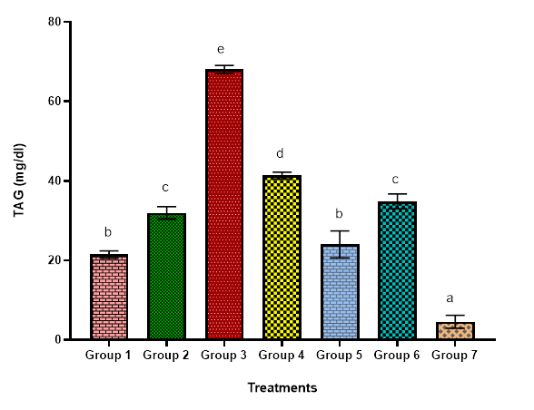

Figure 2; Effect of Amaranthus spinous extract on lipid profile markers in alcohol-induced rats. This bar graph presents the effect of various treatments on TGL (mg/dl) in experimental groups 1-7.
Bars represent mean ± standard deviation of triplicate determinations and bars with different alphabets indicate significant difference at p ≤ 0.05. Group 1 = normal control, group 2 =10 ml/kg of Alcohol + 50 mg/kg Silymarin (Standard control), group3= 10 ml/kg Alcohol only (No treatment), Group 4 10 ml/kg Alcohol + low dose of extract (250 mg/kg) + discontinued induction, Group 5 = 10 ml/kg Alcohol + high dose of extract (500 mg/kg) + discontinued induction, Group 6=10 ml/kg Alcohol + low dose of extract (250 mg/kg) + induction cum treatment, Group 7=10 ml/kg Alcohol + high dose of extract (500 mg/kg) + induction cum treatment

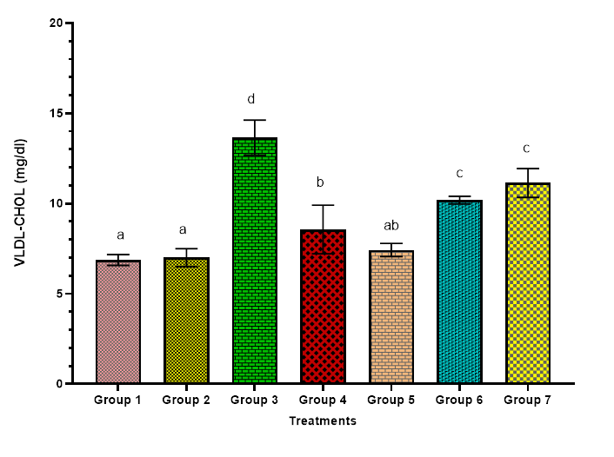

Figure 3; Effect of Amaranthus spinous extract on lipid profile markers in alcohol-induced rats. This bar graph presents the effect of various treatments on VLDL-cholesterol (mg/dl) experimental groups 1-7.
Bars represent mean ± standard deviation of triplicate determinations and bars with different alphabets indicate significant difference at p ≤ 0.05. Group 1 = normal control, group 2 =10 ml/kg of Alcohol + 50 mg/kg Silymarin (Standard control), group3= 10 ml/kg Alcohol only (No treatment), Group 4 10 ml/kg Alcohol + low dose of extract (250 mg/kg) + discontinued induction, Group 5 = 10 ml/kg Alcohol + high dose of extract (500 mg/kg) + discontinued induction, Group 6=10 ml/kg Alcohol + low dose of extract (250 mg/kg) + induction cum treatment, Group 7=10 ml/kg Alcohol + high dose of extract (500 mg/kg) + induction cum treatment

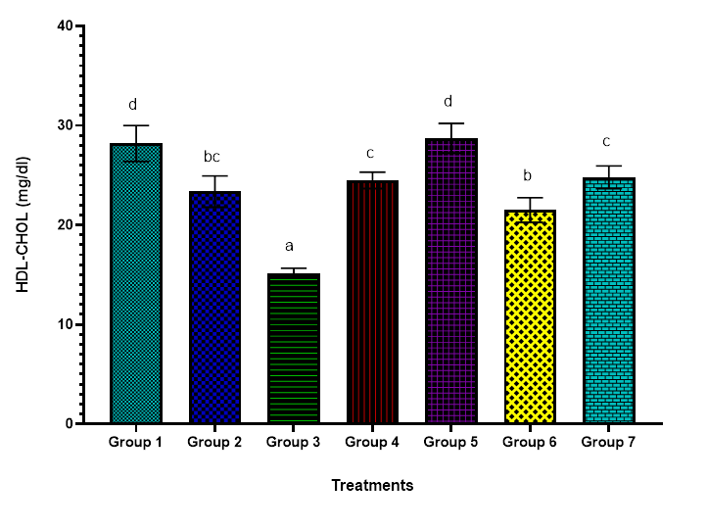

Figure 4: Effect of Amaranthus spinous extract on lipid profile markers in alcohol-induced wistar rats. The bar chart illustrates the effect of various treatments on HDL-cholesterol (mg/dl) levels in experimental groups 1-7.
Bars represent mean ± standard deviation of triplicate determinations and bars with different alphabets indicate significant difference at p ≤ 0.05. Group 1 = normal control, group 2 =10 ml/kg of Alcohol + 50 mg/kg Silymarin (Standard control), group3= 10 ml/kg Alcohol only (No treatment), Group 4 10 ml/kg Alcohol + low dose of extract (250 mg/kg) + discontinued induction, Group 5 = 10 ml/kg Alcohol + high dose of extract (500 mg/kg) + discontinued induction, Group 6=10 ml/kg Alcohol + low dose of extract (250 mg/kg) + induction cum treatment, Group 7=10 ml/kg Alcohol + high dose of extract (500 mg/kg) + induction cum treatment

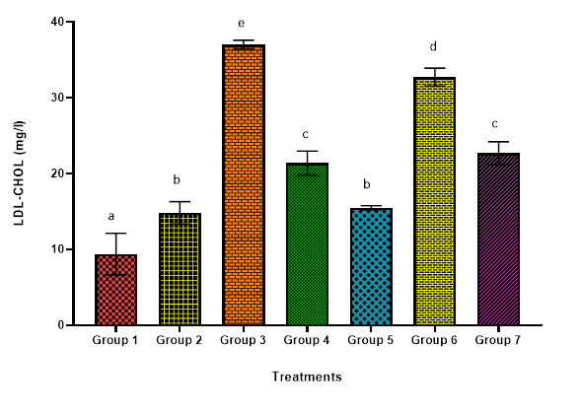

Figure 5: Effect of Amaranthus spinous extract on lipid profile markers in alcohol-induced Rats. This bar graph presents the effect of various treatments on LDL-cholesterol (mg/dl) experimental groups 1-7.
Bars represent mean ± standard deviation of triplicate determinations and bars with different alphabets indicate significant difference at p ≤ 0.05. Group 1 = normal control, group 2 =10 ml/kg of Alcohol + 50 mg/kg Silymarin (Standard control), group3= 10 ml/kg Alcohol only (No treatment), Group 4 10 ml/kg Alcohol + low dose of extract (250 mg/kg) + discontinued induction, Group 5 = 10 ml/kg Alcohol + high dose of extract (500 mg/kg) + discontinued induction, Group 6=10 ml/kg Alcohol + low dose of extract (250 mg/kg) + induction cum treatment, Group 7=10 ml/kg Alcohol + high dose of extract (500 mg/kg) + induction cum treatment

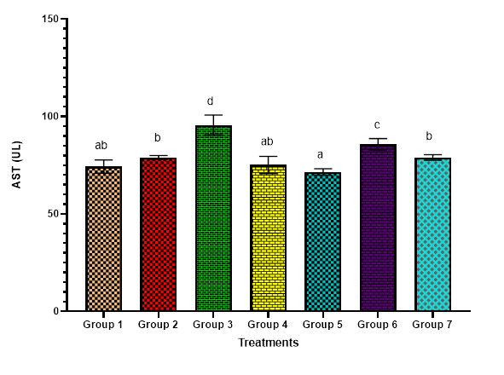

Figure 6: Effect of Amaranthus spinous extract on AST in alcohol-induced rats
Bars represent mean ± standard deviation of triplicate determinations and bars with different alphabets indicate significant difference at p ≤ 0.05. Group 1 = normal control, group 2 =10 ml/kg of Alcohol + 50 mg/kg Silymarin (Standard control), group3= 10 ml/kg Alcohol only (No treatment), Group 4 10 ml/kg Alcohol + low dose of extract (250 mg/kg) + discontinued induction, Group 5 = 10 ml/kg Alcohol + high dose of extract (500 mg/kg) + discontinued induction, Group 6=10 ml/kg Alcohol + low dose of extract (250 mg/kg) + induction cum treatment, Group 7=10 ml/kg Alcohol + high dose of extract (500 mg/kg) + induction cum treatment

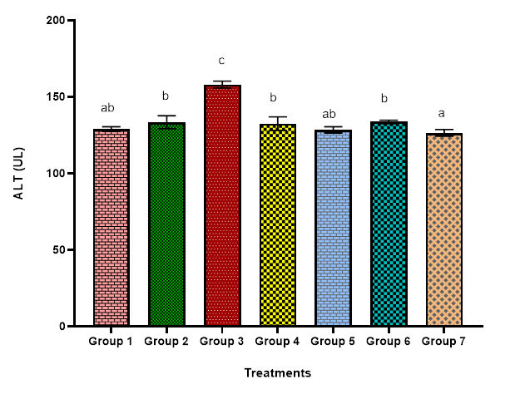

Figure 7: Effect of Amaranthus spinous extract on ALT in alcohol-induced rats
Bars represent mean ± standard deviation of triplicate determinations and bars with different alphabets indicate significant difference at p ≤ 0.05. Group 1 = normal control, group 2 =10 ml/kg of Alcohol + 50 mg/kg Silymarin (Standard control), group3= 10 ml/kg Alcohol only (No treatment), Group 4 10 ml/kg Alcohol + low dose of extract (250 mg/kg) + discontinued induction, Group 5 = 10 ml/kg Alcohol + high dose of extract (500 mg/kg) + discontinued induction, Group 6=10 ml/kg Alcohol + low dose of extract (250 mg/kg) + induction cum treatment, Group 7=10 ml/kg Alcohol + high dose of extract (500 mg/kg) + induction cum treatment

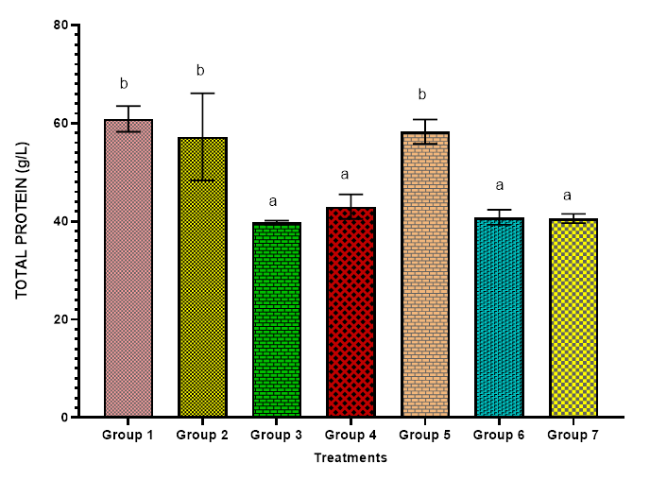

Figure 8: Protective effect of Amaranthus spinous extract on Protein serum in alcohol-induced rats
Bars represent mean ± standard deviation of triplicate determinations and bars with different alphabets indicate significant difference at p ≤ 0.05. Group 1 = normal control, group 2 =10 ml/kg of Alcohol + 50 mg/kg Silymarin (Standard control), group3= 10 ml/kg Alcohol only (No treatment), Group 4 10 ml/kg Alcohol + low dose of extract (250 mg/kg) + discontinued induction, Group 5 = 10 ml/kg Alcohol + high dose of extract (500 mg/kg) + discontinued induction, Group 6=10 ml/kg Alcohol + low dose of extract (250 mg/kg) + induction cum treatment, Group 7=10 ml/kg Alcohol + high dose of extract (500 mg/kg) + induction cum treatment

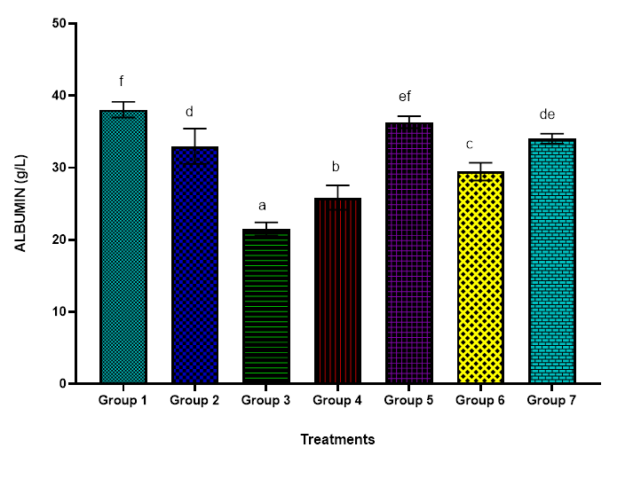

Figure 9: Protective effect of Amaranthus spinous extract on albumin serum in alcohol-induced rats.
Bars represent mean ± standard deviation of triplicate determinations and bars with different alphabets indicate significant difference at p ≤ 0.05. Group 1 = normal control, group 2 =10 ml/kg of Alcohol + 50 mg/kg Silymarin (Standard control), group3= 10 ml/kg Alcohol only (No treatment), Group 4 10 ml/kg Alcohol + low dose of extract (250 mg/kg) + discontinued induction, Group 5 = 10 ml/kg Alcohol + high dose of extract (500 mg/kg) + discontinued induction, Group 6=10 ml/kg Alcohol + low dose of extract (250 mg/kg) + induction cum treatment, Group 7=10 ml/kg Alcohol + high dose of extract (500 mg/kg) + induction cum treatment

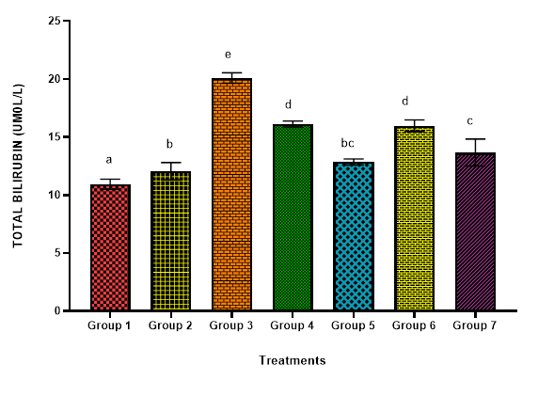

Figure 10: Protective effect of Amaranthus spinous extract on bilirubin in alcohol-induced rats.
Bars represent mean ± standard deviation of triplicate determinations and bars with different alphabets indicate significant difference at p ≤ 0.05. Group 1 = normal control, group 2 =10 ml/kg of Alcohol + 50 mg/kg Silymarin (Standard control), group3= 10 ml/kg Alcohol only (No treatment), Group 4 10 ml/kg Alcohol + low dose of extract (250 mg/kg) + discontinued induction, Group 5 = 10 ml/kg Alcohol + high dose of extract (500 mg/kg) + discontinued induction, Group 6=10 ml/kg Alcohol + low dose of extract (250 mg/kg) + induction cum treatment, Group 7=10 ml/kg Alcohol + high dose of extract (500 mg/kg) + induction cum treatment

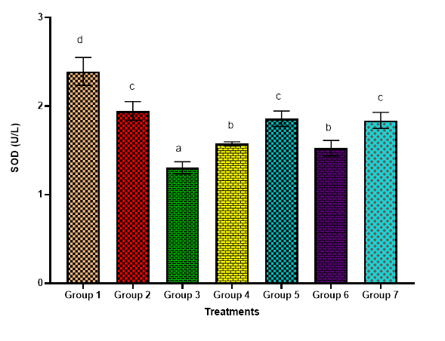

Figure 11: Effect of Amaranthus spinous extract on antioxidant markers in alcohol-induced wistar rat. This bar graph presents the effect of various treatments on Superoxide Dismutase (SOD) (U/L) experimental groups 1-7.

Bars represent mean ± standard deviation of triplicate determinations and bars with different alphabets indicate significant difference at p ≤ 0.05. Group 1 = normal control, group 2 =10 ml/kg of Alcohol + 50 mg/kg Silymarin (Standard control), group3= 10 ml/kg Alcohol only (No treatment), Group 4 10 ml/kg Alcohol + low dose of extract (250 mg/kg) + discontinued induction, Group 5 = 10 ml/kg Alcohol + high dose of extract (500 mg/kg) + discontinued induction, Group 6=10 ml/kg Alcohol + low dose of extract (250 mg/kg) + induction cum treatment, Group 7=10 ml/kg Alcohol + high dose of extract (500 mg/kg) + induction cum treatment

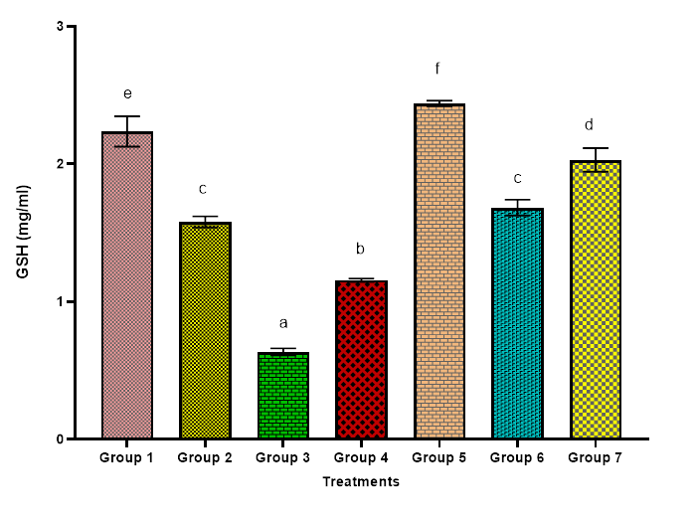

Figure 12: Effect of Amaranthus spinous extract on antioxidant markers in alcohol-induced wistar rat. This bar graph presents the effect of various treatments on Reduced glutathione (GSH) (mg/ml) experimental groups 1-7.

Bars represent mean ± standard deviation of triplicate determinations and bars with different alphabets indicate significant difference at p ≤ 0.05. Group 1 = normal control, group 2 =10 ml/kg of Alcohol + 50 mg/kg Silymarin (Standard control), group3= 10 ml/kg Alcohol only (No treatment), Group 4 10 ml/kg Alcohol + low dose of extract (250 mg/kg) + discontinued induction, Group 5 = 10 ml/kg Alcohol + high dose of extract (500 mg/kg) + discontinued induction, Group 6=10 ml/kg Alcohol + low dose of extract (250 mg/kg) + induction cum treatment, Group 7=10 ml/kg Alcohol + high dose of extract (500 mg/kg) + induction cum treatment

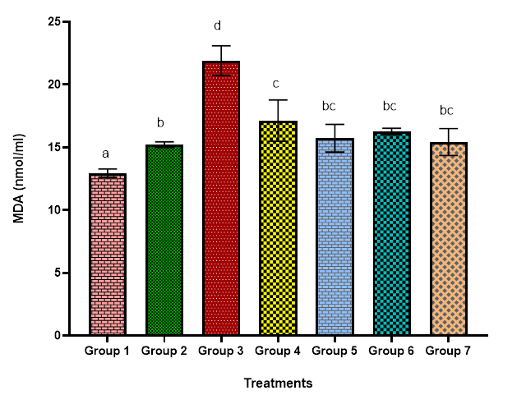

Figure 13; Effect of Amaranthus spinous extract on antioxidant markers in alcohol-induced wistar rat. This bar graph presents the effect of various treatments on Malondialdehyde (MDA) (nmol//ml) experimental groups 1-7.

Bars represent mean ± standard deviation of triplicate determinations and bars with different alphabets indicate significant difference at p ≤ 0.05. Group 1 = normal control, group 2 =10 ml/kg of Alcohol + 50 mg/kg Silymarin (Standard control), group3= 10 ml/kg Alcohol only (No treatment), Group 4 10 ml/kg Alcohol + low dose of extract (250 mg/kg) + discontinued induction, Group 5 = 10 ml/kg Alcohol + high dose of extract (500 mg/kg) + discontinued induction, Group 6=10 ml/kg Alcohol + low dose of extract (250 mg/kg) + induction cum treatment, Group 7=10 ml/kg Alcohol + high dose of extract (500 mg/kg) + induction cum treatment

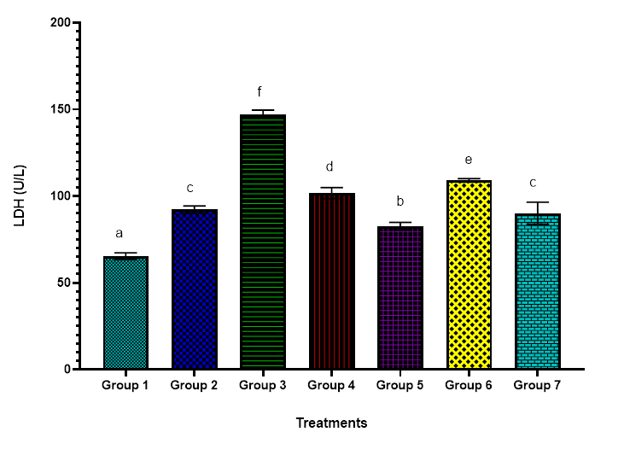

Figure 14; Effect of Amaranthus spinous extract on antioxidant markers in alcohol-induced wistar rat. This bar graph presents the effect of various treatments on Lactate Dehydrogenase) (LDH) (U/L) experimental groups 1-7.

Bars represent mean ± standard deviation of triplicate determinations and bars with different alphabets indicate significant difference at p ≤ 0.05. Group 1 = normal control, group 2 =10 ml/kg of Alcohol + 50 mg/kg Silymarin (Standard control), group3= 10 ml/kg Alcohol only (No treatment), Group 4 10 ml/kg Alcohol + low dose of extract (250 mg/kg) + discontinued induction, Group 5 = 10 ml/kg Alcohol + high dose of extract (500 mg/kg) + discontinued induction, Group 6=10 ml/kg Alcohol + low dose of extract (250 mg/kg) + induction cum treatment, Group 7=10 ml/kg Alcohol + high dose of extract (500 mg/kg) + induction cum treatment

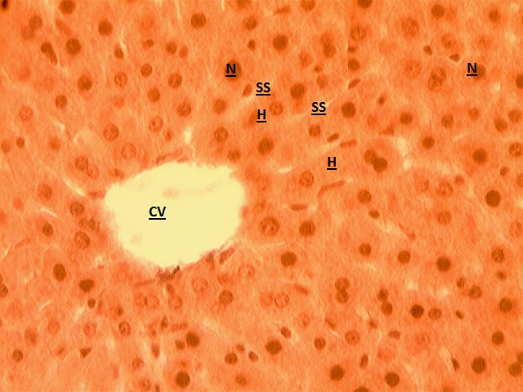

Plate 1: The photomicrograph of group 1 liver × 400 magnification in this phase 2 is showing the liver tissue, its central vein (CV) is clear and normal, the Hepatocytes (H)and Sinusoids (SS) radiate normally in its hexagonal pattern, the Nucleus (N) look open faced and healthy.

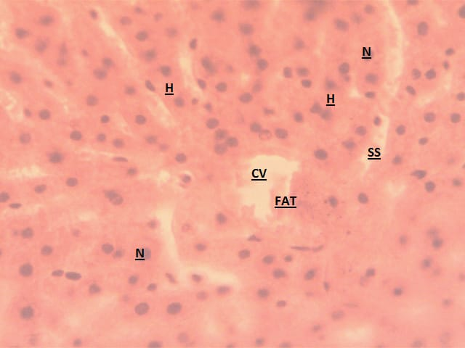

Plate 2: This group of liver shows a dilated CV with fat cells, the Sinusoids (SS) filled with fat deposits and the Hepatocytes (H) radiate partly hexagonally, the Nuclei look open faced as if it is undergoing regeneration.

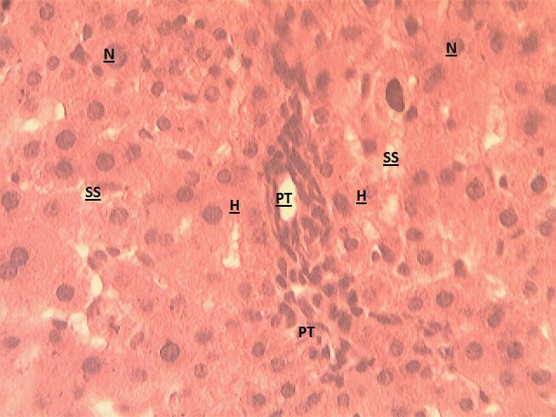

Plate 3: The cross section of group 3 liver x 400 magnification stained in H & E. The liver is not aligned in its normal architecture seen are the portal triad (PT), the Sinusoids (SS) filled with fat cells and does not radiate with the Hepatocytes (H) as in normal liver structure, one third of the Nuclei are enlarged, undergoing pathological changes.

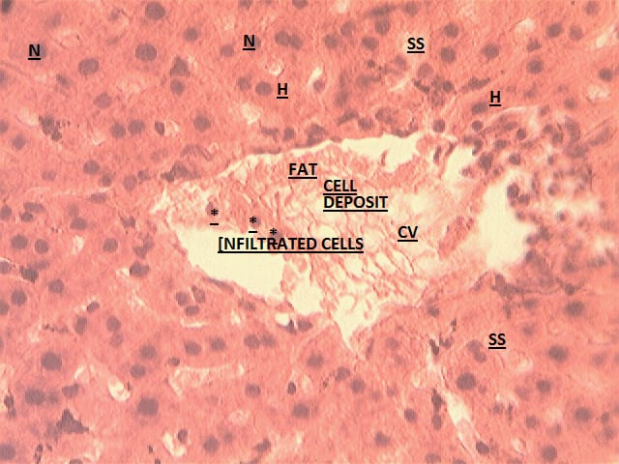

Plate 4: This group of liver looks degenerated, the central vein (CV) looks enlarged and dilated, the normal liver architecture is distorted, and the CV is also filled with fat deposit and infiltrated cells.

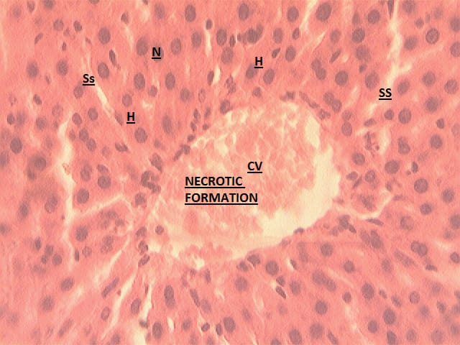

Plate 5: This group of liver looks refined in the architectural pattern of the liver, only the necrotic formation which could be as a result of healing process from the influence of its intake. Other features are normal and healthy.
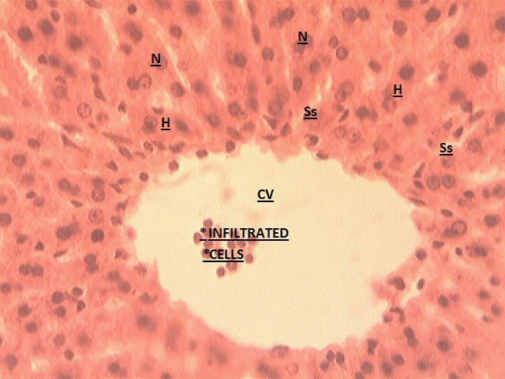

Plate 6: The liver in this group is also seen as normal, but the central vein (CV) is enlarged with few infiltrated cells, which may be due to hyper activities, other features are normal

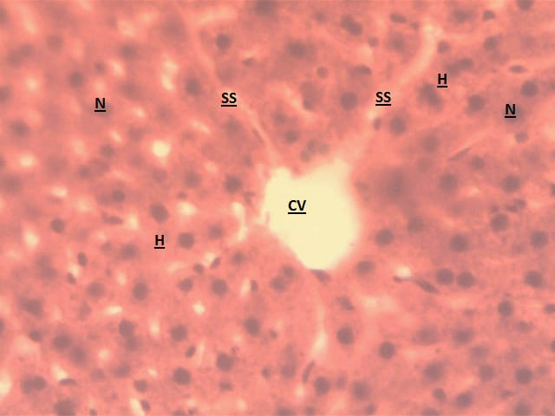

Plate 7: This group liver shows a clear central vein (CV), other features look affected or influenced by an intake as Nuclei looks darkened and not too healthy as those in group 6.

The present study investigated the hepatoprotective and lipid-modulating effects of Amaranthus spinous against alcohol-induced hepatotoxicity in rats. Alcohol exposure is a well-established cause of hepatic injury and dyslipidemia, mediated through oxidative stress, altered lipid metabolism, and hepatocellular membrane damage (Ejiofor et al., 2022; Zeashan et al., 2008a). In this study, alcohol administration produced marked biochemical and histopathological alterations, while treatment with aqueous crude extract of A. spinous ameliorated many of these effects in a dose- and treatment-dependent manner.
Chronic alcohol exposure is known to disrupt hepatic lipid homeostasis, resulting in elevated circulating cholesterol and triglycerides through increased lipogenesis and impaired lipid clearance. In the present study, rats exposed to alcohol alone (Group 3) exhibited significantly elevated total cholesterol and triglyceride levels compared with control groups, confirming alcohol-induced dyslipidemia. These findings are consistent with previous reports demonstrating alcohol-mediated alterations in lipid metabolism (Nwaobi et al., 2023). Administration of A. spinous extract resulted in a reduction of serum total cholesterol (see figure 1), particularly in Group 5, indicating a protective effect against alcohol-induced hypercholesterolemia. However, the incomplete normalization observed in some treatment groups suggests that antioxidant and lipid-modulating effects of the extract may be dose-limited, supporting reports that bioactive phytochemicals exert optimal protection only within specific concentration ranges (Munteanu & Schwartz, 2023). Serum triglyceride levels were markedly elevated in alcohol-only rats, reflecting enhanced hepatic triglyceride synthesis and reduced peripheral clearance (Ding et al., 2012). Treatment with A. spinous extract produced a dose-dependent reduction in triglyceride levels, with the greatest effect observed in Group 7. This suggests that the extract may mitigate alcohol-induced lipid dysregulation, potentially through improved hepatic lipid handling and enhanced lipid oxidation(Murray et al., 2022), although direct mechanistic confirmation was not assessed in this study.
Elevated VLDL-C is a recognized contributor to atherogenesis, particularly in the context of hepatic lipid accumulation associated with chronic alcohol consumption (Chen et al., 2025). In this study, alcohol-treated rats demonstrated increased hepatic VLDL-C levels, confirming alcohol-induced dyslipidemia following Huang & Lee, (2022)reports. Discontinuation of alcohol exposure followed by administration of A. spinous extract significantly reduced hepatic VLDL-C levels, especially in Groups 4 and 5. This reduction suggests an improvement in hepatic lipid metabolism, potentially through reduced lipogenesis or enhanced lipid clearance, though these mechanisms require further investigation. However, Delgado-Montemayor et al., (2015) reviewed index measure for the hepatoprotective effect drugs influences the hepatic normal physiological mechanism in the tissue (Delgado-Montemayor et al., 2015).
Alcohol exposure also resulted in a marked reduction in HDL-C levels, indicating impaired reverse cholesterol transport and altered lipoprotein metabolism (De Oliveira e Silva et al., 2000). Treatment with A. spinous significantly improved HDL-C levels across treatment groups, particularly following alcohol withdrawal. While changes in HDL particle size or apolipoprotein synthesis were not directly measured, the observed increase in HDL-C supports the potential role of the extract in restoring protective lipid profiles, which are associated with reduced cardiovascular risk (Sacks & Jensen, 2018).
Similarly, elevated LDL-C levels observed in alcohol-treated rats were reduced following administration of A. spinous, particularly at moderate and high doses. These findings align with previous studies reporting LDL-lowering effects of A. spinous in toxin-induced liver injury models (Zeashan et al., 2008). The pronounced reduction in LDL-C observed in high-dose treatment groups may reflect enhanced lipoprotein clearance or reduced hepatic lipid output (Azoz & Raafat, 2012). This observation is a possible synergistic interaction between high doses of extract and the induction of enzyme modulation under toxicant stress. However, these interpretations remain speculative in the absence of molecular analyses. Elevated low-density lipoprotein (LDL) cholesterol causes development of coronary heart disease through multiple stages of the process (Duran et al., 2020). With Jiang et al., (2025); Yu et al., (2020) asserting that the LDL cholesterol, is a predicator for high mortality rate which underscores atherosclerosis as a leading factor in cardiovascular risk. Our findings assume a promising effect for A. spinous as a potential cardioprotective agent, particularly when dosed correctly directed.
However, reduction in observed TAG ratio indicates low triglyceride level in the rats and improved liver function after administration under stress while as elevated levels might be a sign of other underlying factors; drug to target delivery De Carlo et al., (2025) or Insulin malfunction (Ghani et al., 2023; Welty, 2013). In collaboration to this, Boekholdt et al., (2014) assert lowering TAG levels is key to achieving a lower risk of major cardiovascular events than those achieving moderately low levels.
Alcohol-induced hepatocellular injury is characterized by increased permeability of the plasma membrane, leading to leakage of liver enzymes into circulation (Ryu et al., 2023). In this study, alcohol administration significantly elevated serum AST and ALT levels, confirming hepatic injury. Discontinuous alcohol exposure combined with moderate doses of A. spinous (Group 4 and 5) resulted in reduced AST levels, whereas continuous high-dose alcohol exposure may likely attenuated this protective effect, possibly due to sustained membrane damage or necrotic changes (Ginès et al., 2021).
ALT levels showed improvement in select treatment groups, suggesting partial hepatocellular recovery. However, variability in enzyme responses across groups indicates that the hepatoprotective efficacy of A. spinous may depend on both dose and alcohol exposure pattern (Firoozichahak et al., 2022). Differences in extraction method and phytochemical composition may also influence enzyme modulation, as previously reported (Thouri et al., 2017). Protein and albumin levels were significantly suppressed in alcohol-only rats, reflecting impaired hepatic synthetic function (Semwal et al., 2025). Restoration of these parameters, particularly in Group 5, indicates improved liver functional capacity following extract administration. Albumin, a sensitive marker of liver function and antioxidant status, supports the therapeutic potential of A. spinous. These effects may be partly attributed to the plant’s high nutritional content, including essential amino acids and proteins (Pal et al., 2013; Srivastava, 2011; Tanmoy et al., 2014).
Oxidative stress plays a central role in alcohol-induced liver injury (Mirkov et al., 2020). In the present study, alcohol exposure resulted in reduced SOD and GSH levels, alongside elevated MDA and LDH levels, indicating enhanced lipid peroxidation and membrane damage (Saggar et al., 2022; Salau et al., 2024). Treatment with A. spinous extract significantly improved antioxidant enzyme levels and reduced markers of oxidative damage across treatment groups.
The restoration of SOD and GSH levels suggests reinforcement of endogenous antioxidant defense mechanisms, while reductions in MDA and LDH reflect decreased lipid peroxidation and improved membrane integrity (Dias & Nylandsted, 2021). These findings align with previous reports highlighting the antioxidant properties of A. spinous and its phytochemical constituents, including phenolic compounds and flavonoids (Iloki-Assanga et al., 2015).
Bilirubin a player in antioxidant physiological concentrations (Qaisiya et al., 2014), as shown in Figure 10 was highest in group 3 suggesting saturation of hepatic pathways at alcoholic stress. This could also reflect enhance conjugation and excretion activity which is a compensatory mechanism that may not necessarily be hepatocellular damage (Peeriga & Manubolu, 2024). Elevated bilirubin levels observed in alcohol-treated rats may reflect saturation of hepatic conjugation pathways or compensatory antioxidant responses under oxidative stress. Normalization of bilirubin levels following extract treatment and alcohol withdrawal indicates recovery of hepatic excretory function (Idalsoaga et al., 2023). Similar hepatoprotective effects have been reported for L. speciose under alcohol-induced stress conditions (Elsheshtawy et al., 2025).
Histopathological examination further corroborated biochemical findings. Alcohol-treated rats exhibited hepatic architectural distortion, steatosis, central vein obstruction, and hepatocellular necrosis (Das & Vasudevan, 2007). In contrast, rats treated with A. spinous showed marked improvement in liver histology, indicating attenuation of alcohol-induced structural damage. Contreras-Sentelle et al. (2022), Fikry et al. (2024), and Zhang et al. (2024) have reported that alcohol involves a cytosolic oxidative pathway, where the inducible CYP2E1 system and peroxisomal catalase oxidize alcohol to generate acetaldehyde, especially under specific conditions. These observations are consistent with previous studies reporting hepatoprotective effects of A. spinous in toxin-induced liver injury models (Ashok Kumar et al., 2011; Isoje et al., 2025).
Despite promising findings, this study has limitations. molecular pathways underlying the observed effects were not directly assessed. These limitations warrant further investigation to better elucidate the mechanisms and translational relevance of A. spinous.

CONCLUSION
In conclusion, this study present evidence for hepatoprotective and lipid modulatory effects of Amaranthus spinous extracts on alcohol induced liver damaged wistar rats. These effects were mostly observed at a moderate dose of 250 mg/kg following a discontinuous induction of alcohol. The resulting efficacy of the crude extract of A. spinous is strongly influenced by dosage with time. The extracts also improve biochemical markers, including LDL, Total cholesterol, AST, ALT, and restoration of albumin and protein and another ratio inclusive. The histopathological observation corroborates with its protective effect on the liver. To further understand the mechanism of action of dose response with time, necessary studies on the interaction of each dose on the liver could be studied using computation methods.
ETHICAL APPROVAL
The study was approved by the Ethical Committee on Animal Research of the Department of Environmental Health Biology, Federal University of Technology, Owerri, Nigeria with approval number FS-26-0002
CONFLICT OF INTEREST
The authors declare no conflict of interest regarding this work. All findings and conclusions presented are based solely on the data obtained and analysed without any influence from personal, financial, or external interest.

DISCLAIMER (ARTIFICIAL INTELLIGENCE)

Author(s) hereby declare that NO generative AI technologies such as Large Language Models (ChatGPT, COPILOT, etc.) and text-to-image generators have been used during the writing or editing of this manuscript.

REFERENCE
Ali, S. A., Sharief, N. H., & Mohamed, Y. S. (2019). Hepatoprotective Activity of Some Medicinal Plants in Sudan. In Evidence-based Complementary and Alternative Medicine 2019, 2196315.
Asadi-Samani, M., Kafash-Farkhad, N., Azimi, N., Fasihi, A., Alinia-Ahandani, E., & Rafieian-Kopaei, M. (2015). Medicinal plants with hepatoprotective activity in Iranian folk medicine. In Asian Pacific Journal of Tropical Biomedicine, 5, 146–157.

Azoz, A., & Raafat, M. (2012). Effect of Lead Toxicity on Cytogenisity, Biochemical Constituents and Tissue Residue with Protective Role of Activated Charcoal and Casein in Male Rats. Australian Journal of Basic and Applied Sciences, 6(7), 497–509.
Boekholdt, S. M., Hovingh, G. K., Mora, S., Arsenault, B. J., Amarenco, P., Pedersen, T. R., Larosa, J. C., Waters, D. D., Demicco, D. A., Simes, R. J., Keech, A. C., Colquhoun, D., Hitman, G. A., Betteridge, D. J., Clearfield, M. B., Downs, J. R., Colhoun, H. M., Gotto, A. M., Ridker, P. M., … Kastelein, J. J. P. (2014). Very low levels of atherogenic lipoproteins and risk of cardiovascular events; a meta-analysis of statin trials. Journal of the American College of Cardiology, 64(5), 485.
Buzzetti, E., Kalafateli, M., Thorburn, D., Davidson, B. R., Thiele, M., Gluud, L. L., Del Giovane, C., Askgaard, G., Krag, A., Tsochatzis, E., & Gurusamy, K. S. (2017). Pharmacological interventions for alcoholic liver disease (alcohol-related liver disease): An attempted network meta-analysis. In Cochrane Database of Systematic Reviews, 3(3), CD011646.
Ceni, E., Mello, T., & Galli, A. (2014). Pathogenesis of alcoholic liver disease: Role of oxidative metabolism. World Journal of Gastroenterology, 20, 17756–17772.
Chen, Y., Lei, K., Liu, Y., Liu, J., Wei, K., Guo, J., & Su, Z. (2025). Metabolic Dysfunction-Associated Steatotic Liver Disease: From a Very Low-Density Lipoprotein Perspective. In Biomolecules 15(7).
De Carlo, S., Mrizak, H., Della Valle, A., Lunerti, V., Kyratzi, M. O., Mammone, A., Lacorte, A., Keshishian, A., Li, M., Domi, E., Qin, D., Woods, L. S., Soverchia, L., Ubaldi, M., Ciccocioppo, R., & Cannella, N. (2025). Predicting individual treatment response in alcohol use disorders: a reverse translational proof-of-concept study. Translational Psychiatry, 15(1), 212.
De Oliveira e Silva, E. R., Foster, D., Harper, M. M., Seidman, C. E., Smith, J. D., Breslow, J. L., & Brinton, E. A. (2000). Alcohol consumption raises HDL cholesterol levels by increasing the transport rate of apolipoproteins A-I and A-II. Circulation, 102(19), 2347–2352.
Delgado-Montemayor, C., Cordero-Pérez, P., Salazar-Aranda, R., & Waksman-Minsky, N. (2015). Models of hepatoprotective activity assessment. Medicina Universitaria, 17(69), 222–228.
Dias, C., & Nylandsted, J. (2021). Plasma membrane integrity in health and disease: significance and therapeutic potential. In Cell Discovery 7(1), 4.
Ding, R. B., Tian, K., Huang, L. L., He, C. W., Jiang, Y., Wang, Y. T., & Wan, J. B. (2012). Herbal medicines for the prevention of alcoholic liver disease: A review. In Journal of Ethnopharmacology 144, 457–465.
Duran, E. K., Aday, A. W., Cook, N. R., Buring, J. E., Ridker, P. M., & Pradhan, A. D. (2020). Triglyceride-Rich Lipoprotein Cholesterol, Small Dense LDL Cholesterol, and Incident Cardiovascular Disease. Journal of the American College of Cardiology, 75(17), 2122–2135.
Ejiofor, E. U., Oyedemi, S. O., Onoja, S. O., & Omeh, N. Y. (2022). Amaranthus hybridus Linn. leaf extract ameliorates oxidative stress and hepatic damage abnormalities induced by thioacetamide in rats. South African Journal of Botany, 146, 213–221.
Elsheshtawy, N. E., Abdelhamid, F. M., Risha, E. F., Mahgoub, H. A., Ateya, A. I., & El-Boshy, M. E. (2025). Lagerstroemia Speciosa (L.) Pers mitigates acetaminophen-induced acute liver toxicity in rats through modulations of oxidative stress, inflammation, apoptosis and the NF-κB/TNF-α/iNOS, Nrf2/HO-1, signaling pathways. Journal of Molecular Histology, 56:4, 56(4), 1–20.
Firoozichahak, A., Rahimnejad, S., Rahmani, A., Parvizimehr, A., Aghaei, A., & Rahimpoor, R. (2022). Effect of occupational exposure to lead on serum levels of lipid profile and liver enzymes: An occupational cohort study. Toxicology Reports, 9, 269–275.
Fleenor, L. M., Beavers, J. R., Tidwell, W. P., Atchison, L., Woo, E., Medvecz, A. J., Beyene, R. T., Kast, K., Marcovitz, D., Dennis, B. M., Guillamondegui, O. D., & Smith, M. C. (2024). Comparison of phenobarbital monotherapy to a benzodiazepine-based regimen for management of alcohol withdrawal syndrome in trauma patients. Journal of Trauma and Acute Care Surgery, 96, 493–498.
Ganjare, A., & Raut, N. (2019). Nutritional and medicinal potential of Amaranthus spinosus. Journal of Pharmacognosy and Phytochemistry, 8(3), 3149–3156.
Ghani, Z. A., Qaddori, H., & Al-Mayah, Q. (2023). Triglyceride/high-density lipoprotein ratio as a predictor for insulin resistance in a sample of healthy Iraqi adults. Journal of Medicine and Life, 16(5), 668.
Ginès, P., Krag, A., Abraldes, J. G., Solà, E., Fabrellas, N., & Kamath, P. S. (2021). Liver cirrhosis. In The Lancet, 398, 1359–1376.
Huang, J. K., & Lee, H. C. (2022). Emerging Evidence of Pathological Roles of Very-Low-Density Lipoprotein (VLDL). In International Journal of Molecular Sciences 23(8), 4300.
Idalsoaga, F., Ayares, G., Díaz, L. A., Arnold, J., Ayala-Valverde, M., Hudson, D., Arrese, M., & Arab, J. P. (2023). Current and emerging therapies for alcohol-associated hepatitis. In Liver Research, 7, 35–46.
Iloki-Assanga, S. B., Lewis-Luján, L. M., Lara-Espinoza, C. L., Gil-Salido, A. A., Fernandez-Angulo, D., Rubio-Pino, J. L., & Haines, D. D. (2015). Solvent effects on phytochemical constituent profiles and antioxidant activities, using four different extraction formulations for analysis of Bucida buceras L. and Phoradendron californicum Complementary and Alternative Medicine. BMC Research Notes, 8(1), 1–14.
Jeong, W. Il, Park, O., & Gao, B. (2008). Abrogation of the Antifibrotic Effects of Natural Killer Cells/Interferon-γ Contributes to Alcohol Acceleration of Liver Fibrosis. Gastroenterology, 134, 248–258.
Jiang, Y., Zhang, L., & Gu, Z. (2025). LDL-C/HDL-C ratio as a predictor of atherosclerosis in the Japanese population: insights from a cross-sectional study. BMC Cardiovascular Disorders, 25(1), 333
Krishnaveni, P., & Gowda, V. M. (2015). Assessing the Validity of Friedewald’s Formula and Anandraja’s Formula For Serum LDL-Cholesterol Calculation. Journal of Clinical and Diagnostic Research : JCDR, 9, BC01-4.
Lee, M. J. (2023). A review of liver fibrosis and cirrhosis regression. In Journal of Pathology and Translational Medicine 57,189–195.
Ma, Z., Zhang, B., Fan, Y., Wang, M., Kebebe, D., Li, J., & Liu, Z. (2019). Traditional Chinese medicine combined with hepatic targeted drug delivery systems: A new strategy for the treatment of liver diseases. In Biomedicine and Pharmacotherapy, 17, 109128
McPheeters, M., O’Connor, E. A., Riley, S., Kennedy, S. M., Voisin, C., Kuznacic, K., Coffey, C. P., Edlund, M. D., Bobashev, G., & Jonas, D. E. (2023). Pharmacotherapy for Alcohol Use Disorder: A Systematic Review and Meta-Analysis. JAMA, 330, 1653–1665.

Mirkov, I., Stojković, D., Aleksandrov, A. P., Ivanov, M., Kostić, M., Glamočlija, J., & Soković, M. (2020). Plant Extracts and Isolated Compounds Reduce Parameters of Oxidative Stress Induced by Heavy Metals: An up-to-Date Review on Animal Studies. Current Pharmaceutical Design, 26, 1799–1815.
Müller, C. A., Geisel, O., Banas, R., & Heinz, A. (2014). Current pharmacological treatment approaches for alcohol Dependence. In Expert Opinion on Pharmacotherapy 15, 471–481.
Munteanu, C., & Schwartz, B. (2023). The Effect of Bioactive Aliment Compounds and Micronutrients on Non-Alcoholic Fatty Liver Disease. Antioxidants, 12(4), 903.
Murray, C. J., Ikuta, K. S., Sharara, F., Swetschinski, L., Robles Aguilar, G., Gray, A., Han, C., Bisignano, C., Rao, P., Wool, E., Johnson, S. C., Browne, A. J., Chipeta, M. G., Fell, F., Hackett, S., Haines-Woodhouse, G., Kashef Hamadani, B. H., Kumaran, E. A. P., McManigal, B., Naghavi, M. (2022). Global burden of bacterial antimicrobial resistance in 2019: a systematic analysis. The Lancet, 399(10325), 629–655.
Nakamura, M. T., Yudell, B. E., & Loor, J. J. (2014). Regulation of energy metabolism by long-chain fatty acids. In Progress in Lipid Research, 53, 124–144.
Nwaobi, S., Khan, A., Ojemolon, P. E., Ugoh, A. C., & Iheme, B. C. (2023). A Case of Hypertriglyceridemia-Induced Acute Pancreatitis in the Setting of Alcohol Abuse. Cureus, 15(4), e38028
Osna, N. A., Donohue, T. M., & Kharbanda, K. K. (2017). Alcoholic Liver Disease: Pathogenesis and Current Management. In Alcohol research : current reviews, 38, 147–161.
Pal, V. C., Singh, O. V., Singh, B., & Ahamad, A. (2013). Pharmacognostical Studies of Amaranthus Spinosus Linn. Pharmaceutical and Biosciences Journal, pp 32–37.
Peeriga, R., & Manubolu, K. (2024). Effect of renal and hepatic diseases on pharmacokinetics. In A Short Guide to Clinical Pharmacokinetics, pp 67–95.
Qaisiya, M., Coda Zabetta, C. D., Bellarosa, C., & Tiribelli, C. (2014). Bilirubin mediated oxidative stress involves antioxidant response activation via Nrf2 pathway. Cellular Signalling, 26(3), 512–520.
Rojas-Chaverra, N. M., Imamura, R., Sato, H., Passioura, T., Mihara, E., Nishimura, T., Takagi, J., Suga, H., Matsumoto, K., & Sakai, K. (2024). A cyclic peptide-grafted Fc with hepatocyte growth factor functionality ameliorates hepatic fibrosis in a non-alcoholic steatohepatitis mouse model. IScience, 27(8), 110426.
Rouf, R., Ghosh, P., Uzzaman, M. R., Sarker, D. K., Zahura, F. T., Uddin, S. J., & Muhammad, I. (2021). Hepatoprotective Plants from Bangladesh: A Biophytochemical Review and Future Prospect. In Evidence-based Complementary and Alternative Medicine, 2021, 1633231.
Ryu, T., Kim, K., Choi, S. E., Chung, K. P. S., & Jeong, W. Il. (2023). New insights in the pathogenesis of alcohol-related liver disease: The metabolic, immunologic, and neurologic pathways. Liver Research, 7(1), 1–8.
Sacks, F. M., & Jensen, M. K. (2018). From High-Density Lipoprotein Cholesterol to Measurements of Function. Arteriosclerosis, Thrombosis, and Vascular Biology, 38(3), 487–499.
Saggar, S., Mir, P. A., Kumar, N., Chawla, A., Uppal, J., Shilpa, S., & Kaur, A. (2022). Traditional and Herbal Medicines: Opportunities and Challenges. Pharmacognosy Research, 14(2), 107–114.
Salau, A. K., Shehu, M. S., & Bakare-Odunola, M. T. (2024). Navigating the Challenges of Integrating African Herbal Medicines: A Path to Universal Acceptance. Fountain Journal of Natural and Applied Sciences, 13, 23–36.
Seitz, H. K., & Stickel, F. (2006). Risk factors and mechanisms of hepatocarcinogenesis with special emphasis on alcohol and oxidative stress. In Biological chemistry, 387, 349–360
Semwal, D. K., Kumar, A., Semwal, R. B., Dadhich, N. K., Chauhan, A., & Kumar, V. (2025). Glycyrrhizin (Glycyrrhizic Acid)—Pharmacological Applications and Associated Molecular Mechanisms. Drugs and Drug Candidates, 4, 44.
Sendker, J., & Sheridan, H. (2017). History and current status of herbal medicines. In Toxicology of Herbal Products 11–27.
Slevin, E., Baiocchi, L., Wu, N., Ekser, B., Sato, K., Lin, E., Ceci, L., Chen, L., Lorenzo, S. R., Xu, W., Kyritsi, K., Meadows, V., Zhou, T., Kundu, D., Han, Y., Kennedy, L., Glaser, S., Francis, H., Alpini, G., & Meng, F. (2020). Kupffer Cells: Inflammation Pathways and Cell-Cell Interactions in Alcohol-Associated Liver Disease. In American Journal of Pathology,190, 2185–2193).
Srivastava, R. (2011). Nutritional Quality Of Some Cultivated And Wild Species Of Amaranthus L. International Journal of Pharmaceutical Sciences and Research, 2(12), 3152–3156.
Tanmoy, G., Arijit, M., Tanushree, S., Jagadish, S., & Kumar, M. T. (2014). Pharmacological actions and phytoconstituents of Amaranthus spinosus Linn: A review. International Journal of Pharmacognosy and Phytochemical Research, 6(2), 405–413.
Tarli, C., Mirijello, A., & Addolorato, G. (2022). Treating Alcohol Use Disorder in Patients with Alcohol-Associated Liver Disease: Controversies in Pharmacological Therapy. Seminars in Liver Disease, 42, 138–150.
Thouri, A., Chahdoura, H., El Arem, A., Omri Hichri, A., Ben Hassin, R., & Achour, L. (2017). Effect of solvents extraction on phytochemical components and biological activities of Tunisian date seeds (var. Korkobbi and Arechti). BMC Complementary and Alternative Medicine, 17(1), 1–10.
Welty, F. K. (2013). How Do Elevated Triglycerides and Low HDL-Cholesterol Affect Inflammation and Atherothrombosis? Current Cardiology Reports, 15(9), 400.
Xia, M., Wu, Z., Wang, J., Buist-Homan, M., & Moshage, H. (2023). The Coumarin-Derivative Esculetin Protects against Lipotoxicity in Primary Rat Hepatocytes via Attenuating JNK-Mediated Oxidative Stress and Attenuates Free Fatty Acid-Induced Lipid Accumulation. Antioxidants , 12(11), 1922.
Yu, Y., Li, M., Huang, X., Zhou, W., Wang, T., Zhu, L., Ding, C., Tao, Y., Bao, H., & Cheng, X. (2020). A U-shaped association between the LDL-cholesterol to HDL-cholesterol ratio and all-cause mortality in elderly hypertensive patients: a prospective cohort study. Lipids in Health and Disease, 19(1), 238.
Zakaria, Z., Othman, Z. A., Nna, V. U., & Mohamed, M. (2023). The promising roles of medicinal plants and bioactive compounds on hepatic lipid metabolism in the treatment of non-alcoholic fatty liver disease in animal models: molecular targets. In Archives of Physiology and Biochemistry, 29, pp. 1262–1278.
Zeashan, H., Amresh, G., Singh, S., & Rao, C. V. (2008). Hepatoprotective activity of Amaranthus spinosus in experimental animals. Food and Chemical Toxicology, 46(11), 3417–3421.
Zhao, X., Kwan, J. Y. Y., Yip, K., Liu, P. P., & Liu, F. F. (2020). Targeting metabolic dysregulation for fibrosis therapy. In Nature Reviews Drug Discovery (Vol. 19, pp. 57–75). Nature Research. https://doi.org/10.1038/s41573-019-0040-5

