Short Research Article

Public Health Implications of Gastrointestinal Helminths in Red Sokoto and Sahelian White Goats Slaughtered in Bauchi Metropolis

Abstract
Goat farming is a vital sector in Nigeria's agricultural economy, with Red Sokoto and Sahelian White breeds being prized for their meat, milk, and skin. However, gastrointestinal (GI) helminthiasis severely constrains productivity, causing economic losses and public health risks due to zoonotic transmission. This study aims to determine the prevalence and public health implications of gastrointestinal helminths in Red Sokoto and Sahelian White goats slaughtered at the Bauchi Central Abattoir, Bauchi Metropolis. A cross-sectional survey was conducted involving 200 randomly selected goats (110 Red Sokoto and 90 Sahelian White), utilising post-mortem examination and laboratory analysis of faecal samples to identify parasitic burdens. The results revealed an overall prevalence of 65.0%, with Sahelian White goats showing a slightly higher infection rate (66.67%) compared to Red Sokoto goats (63.64%). The study identified a diverse range of helminths, including nematodes such as Haemonchus contortus, Trichostrongylus colubriformis, and Oesophagostomum columbianum, as well as trematodes like Fasciola species and cestodes including Moniezia expansa. Statistical analysis indicated no significant difference ($‘P>0.05‘$) in infection rates between breeds or sexes, although adult goats and males exhibited marginally higher susceptibility. The presence of zoonotic parasites, particularly Fasciola species and Trichostrongylus, highlights a critical public health risk to consumers and abattoir workers. Consequently, the study recommends rigorous meat inspection protocols, improved abattoir sanitation, and public sensitisation on proper meat processing to mitigate the risk of zoonotic transmission and ensure food safety in the metropolis.
Keywords: Abattoir, Bauchi Metropolis, Gastrointestinal Helminths, Public Health, Red Sokoto Goats, Sahelian White Goats.
1. Introduction
Small ruminant production, particularly goat farming, constitutes a significant sector of the agricultural economy in developing nations like Nigeria (Adetunmbi et al.,2023). Small ruminants are considered easy to rear, and they form an important economic position, especially in small-scale farms (Mustapha et al., 2024; Tella & Chineke, 2022). The Red Sokoto and Sahelian White goat breeds are the most predominant in Northern Nigeria, prized for their high-quality meat, milk, and skin, as well as their adaptability to the harsh semi-arid environment. These animals serve as a primary source of animal protein and a "living bank" for rural households, providing financial stability and food security. However, the optimal productivity of these breeds is frequently severely constrained by disease challenges, with gastrointestinal (GI) helminthiasis being recognised as one of the most economically damaging. The prevalence of these parasitic infections leads to reduced growth rates, lowered fertility, anorexia, and significant mortality, particularly in young stock, thereby undermining the economic viability of goat production. Gastrointestinal parasites in goats are omnipresent in various environments. They may cause poor body condition, reduced feed intake and weight gain, and weight loss, immunity, decreased milk production and lactation period, decreased work capacity, mortality, abortion, diarrhea dysentery, and anaemia (Mpofu et al., 2022; Victor et al., 2024).
In the context of Northern Nigeria, the epidemiology of GI helminths is heavily influenced by the distinct climatic conditions and management systems. The wet season, characterised by high humidity and moisture, favours the development and survival of infective larval stages of nematodes such as Haemonchus contortus, Trichostrongylus species, and Oesophagostomum species on pasture. Consequently, goats managed under extensive or semi-intensive systems, which rely on grazing, are at a heightened risk of infection. Recent studies have indicated that while the Red Sokoto breed exhibits some degree of genetic resistance to helminths compared to other breeds, the burden of infection remains high across the region due to poor management practices and inadequate veterinary intervention. Beyond the direct economic losses to livestock producers, the presence of GI helminths in slaughter goats raises critical public health concerns, a perspective central to the "One Health" framework. Several helminths identified in goats, including Fasciola species (liver fluke) and Trichostrongylus species, are zoonotic, posing a direct risk to humans. Transmission can occur through the consumption of undercooked infected offal (such as liver and intestines) or through environmental contamination. Abattoirs, such as the Bauchi Central Abattoir, act as critical convergence points where the health status of the animal population directly impacts human food safety.
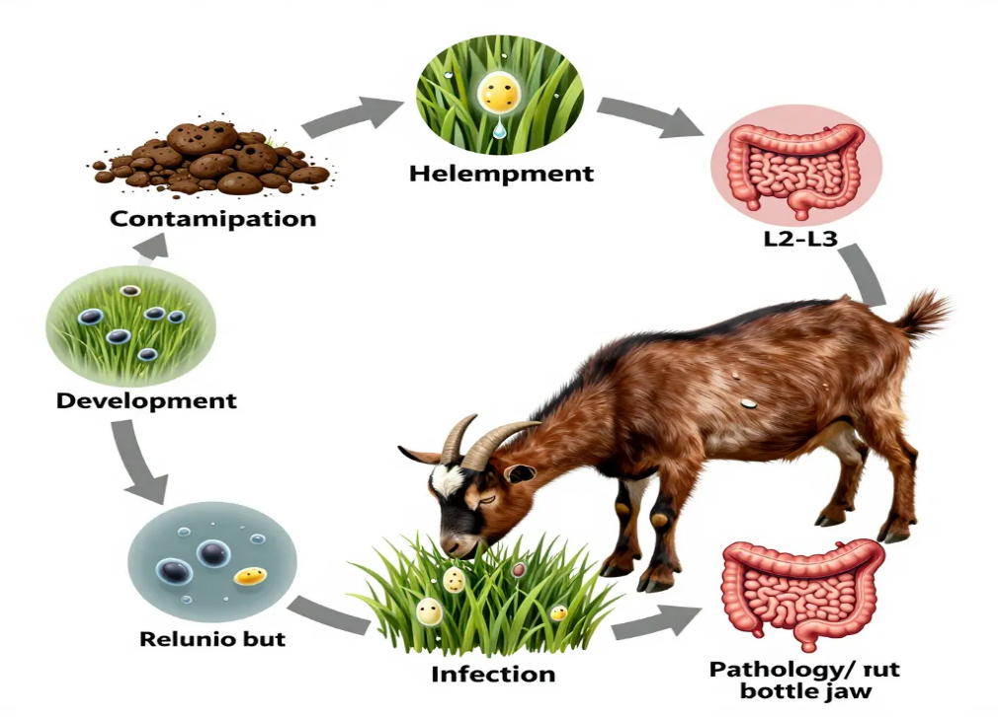
Figure 1. Schematic representation of the life cycle of gastrointestinal helminths in goats.
Figure 1 illustrates the direct transmission pathway, such as contamination of pasture with helminth eggs via faeces, development of eggs into infective larvae on herbage, infection of the host through grazing, and establishment of adult worms in the gastrointestinal tract, contributing to pathology and further egg shedding.
Unfortunately, poor sanitation, lack of potable water, and inadequate meat inspection facilities in many Nigerian abattoirs facilitate the cross-contamination of meat and the spread of zoonotic pathogens to abattoir workers and the general public. Despite the existing body of literature on small ruminant parasites in Nigeria, there is a continuous need for up-to-date surveillance to monitor prevalence trends, especially in light of changing climatic patterns and urbanisation. Specifically, in Bauchi Metropolis, there is a need to re-evaluate the current burden of helminths in the two major goat breeds to understand breed-specific susceptibility and the associated public health risks in the current abattoir setting.
Therefore, this study aims to determine the prevalence of gastrointestinal helminths in Red Sokoto and Sahelian White goats slaughtered at the Bauchi Central Abattoir. It seeks to identify the specific parasitic species present and evaluate the public health implications of these infections, providing empirical data to guide meat hygiene protocols and disease control strategies in Bauchi State.
2. Materials and Methods
2.1 Study Area
The study was conducted in Bauchi Metropolis, the capital of Bauchi State, located in the North-East geopolitical zone of Nigeria. The area lies between latitudes 10° 17' N and 10° 20' N and longitudes 9° 49' E and 9° 52' E, situated within the Northern Guinea Savannah ecological zone. The climate is characterised by two distinct seasons: a wet season from May to October and a dry season from November to April, with an annual rainfall ranging from 1000mm to 1300mm. This climatic condition provides a favourable environment for the development and survival of helminth eggs and larvae, as noted in recent epidemiological surveys of the region (Umar et al., 2018). The study focused specifically on the Bauchi Central Abattoir, a major processing point that serves the protein needs of the metropolitan population.
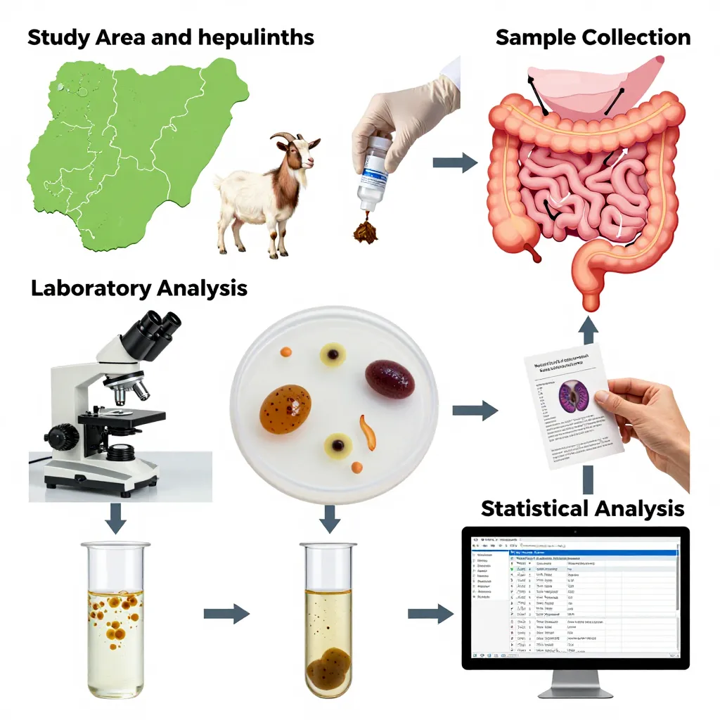
Figure 2. Schematic workflow of the experimental design.
Figure 2 illustrates the study location in Bauchi State, Nigeria, and the target breeds (Red Sokoto and Sahelian White goats), procedures showing faecal sample collection and post-mortem examination of the gastrointestinal tract, parasitological techniques utilised, including simple flotation and sedimentation methods for helminth egg identification and data processing and evaluation.
2.2 Study Population and Design
A cross-sectional study design was employed to determine the prevalence of gastrointestinal (GI) helminths. The study population consisted of goats brought for slaughter at the Bauchi Central Abattoir. A total of 200 goats were randomly selected for the study, comprising two distinct breeds: Red Sokoto (n=110) and Sahelian White (n=90). The sample size was determined based on the availability of animals during the study period, following standard epidemiological sampling protocols for abattoir surveys described by Thrusfield and cited in recent small ruminant studies (Ngongoh et al., 2015).
Prior to slaughter, the goats were physically examined to ascertain their breed, sex, and approximate age. Age was estimated using dentition methods, classifying animals as either young (deciduous teeth only) or adults (presence of permanent incisors).
2.3 Sample Collection
Sample collection was carried out between 06:00 and 09:00 hours during daily slaughter operations. Fecal samples were collected directly from the rectum of slaughtered goats using sterile disposable gloves and placed into labelled universal bottles. Additionally, for a subset of animals, post-mortem examination of the gastrointestinal tract (rumen, reticulum, omasum, abomasum, and intestines) was conducted to recover adult worms. The tracts were ligated at both ends to prevent the escape of contents and transported to the Parasitology Laboratory for immediate analysis. This dual-sampling approach ensures higher sensitivity in detecting both luminal and mucosal parasites (Karimou et al., 2024).
2.4 Laboratory Analysis
The faecal samples were subjected to standard coprological techniques to identify helminth eggs.
Simple Flotation Technique
A saturated sodium chloride solution was used as the flotation fluid to detect nematode and cestode eggs. This method remains the gold standard for qualitative analysis in resource-limited settings due to its efficacy in separating lighter eggs from debris (Rufai et al., 2019).
Sedimentation Technique
This method was employed specifically to detect heavy trematode eggs (e.g., Fasciola spp.), which do not float in standard salt solutions.
Helminth Identification
Recovered eggs and adult worms were identified morphologically based on keys described by Banwo et al. (2020) and validated in recent molecular-morphological comparative studies (Sulaiman et al., 2022).
2.5 Statistical Analysis
Data obtained were recorded in Microsoft Excel and analysed using the Statistical Package for Social Sciences (SPSS) version 25.0. Descriptive statistics were used to calculate prevalence rates (percentage). The Chi-square ($‘χ^{2}‘$) test was employed to determine the association between the prevalence of infection and risk factors such as breed, sex, and age. A probability value of $‘P<0.05‘$was considered statistically significant.
3. Results and Discussion
3.1 Overall Prevalence and Breed Distribution
A total of 200 goats were examined, comprising 110 Red Sokoto and 90 Sahelian White breeds. The overall prevalence of gastrointestinal helminths was high, with 130 (65.0%) of the goats infected.
Table 1: Overall Prevalence of Helminth Infection Across Breeds
Breed | No. Examined | No. Infected | Prevalence (%)
Red Sokoto | 110 | 70 | 63.64%
Sahelian White | 90 | 60 | 66.67%
Total | 200 | 130 | 65.00%

The overall prevalence of 65.0% indicates a significant parasitic burden in the study area. This finding aligns with recent studies in Nigeria, such as Kolo et al. (2024), who reported a prevalence of 61.2% in goats in the North-Central region, attributing it to poor management systems where animals graze on contaminated pastures. Similarly, Abdul-Rahman et al. (2022) observed high infection rates in southern Nigeria, emphasising that climatic conditions favour parasite survival.
While the Sahelian White breed showed a slightly higher prevalence (66.67%) compared to the Red Sokoto (63.64%), the difference was marginal. This contrasts with some literature suggesting Red Sokoto goats may have better genetic resistance to local parasites. However, Ngongeh et al. (2015) noted that under high environmental contamination, breed differences often become negligible as all animals are exposed to overwhelming larval challenges.
3.2 Parasite Spectrum and Species Identification
The study identified a diverse range of helminths, with Nematodes being the most dominant class, followed by Trematodes and Cestodes.
Table 2: Species of Helminths Identified in Red Sokoto and Sahelian White Goats
Class | Parasite Species | Red Sokoto (n=110) |  | Sahelian White (n=90)
 |  | No. Infected | Prevalence (%) | No. Infected | Prevalence (%)
Nematoda | Haemonchus contortus | 36 | 32.73% | 38 | 42.22%
 | Strongyloides papillosus | 27 | 27.00% | 25 | 27.78%
 | Oesophagostomum columbianum | 25 | 22.73% | 27 | 30.00%
 | Cooperia curticei | 17 | 15.45% | 9 | 10.00%
 | Trichostrongylus spp. | 15 | 13.64% | 15 | 16.67%
 | Bunostomum trigonocephalum | 12 | 10.91% | 12 | 13.33%
 | Trichuris globulosa | 10 | 9.09% | 13 | 14.44%
 | Chabertia ovina | 9 | 8.18% | 10 | 11.11%
 | Ostertagia circumcincta | 11 | 10.00% | 18 | 20.00%
 | Nematodirus spathiger | 8 | 7.27% | 11 | 12.22%
 | Gongylonema pulchrum | 5 | 4.55% | - | -
Trematoda | Fasciola spp. | 13 | 11.82% | 12 | 13.33%
 | Dicrocoelium dendriticum | 4 | 3.64% | 7 | 7.78%
Cestoda | Moniezia expansa | - | - | 2 | 2.22%

Nematodes were the most prevalent class, with Haemonchus contortus being the most frequently recovered species (32.73% in Red Sokoto, 42.22% in Sahelian White). This dominance of Haemonchus is consistent with findings by Salisu et al. (2024) in Northern Nigeria, who described it as the most economically devastating parasite due to its blood-feeding habit, causing anaemia. The high prevalence of Nematodes is likely due to their direct life cycle, which does not require an intermediate host, facilitating rapid reinfection in communal grazing lands (Omoike et al., 2015).
The presence of Fasciola spp. (Liver fluke) is of significant public health concern. Although prevalence was lower (11-13%) compared to nematodes, Adeleke et al. (2025) highlight that fasciolosis remains a major cause of liver condemnation in Nigerian abattoirs, leading to economic losses and potential zoonotic risks if raw liver is consumed.
3.3 Prevalence by Sex
The study analysed infection rates based on the sex of the animals, revealing a higher prevalence in males compared to females for both breeds.
Table 3: Prevalence of Helminth Infection by Sex
Breed | Sex | No. Examined | No. Infected | Prevalence (%)
Red Sokoto | Male | 65 | 47 | 72.31%
 | Female | 45 | 23 | 51.11%
Sahelian White | Male | 57 | 41 | 71.93%
 | Female | 33 | 19 | 57.58%

The results show a higher infection rate in males (approx. 72%) compared to females (51-57%). This finding contradicts the general consensus in parasitology, where females are often reported to have higher burdens due to the physiological stress of pregnancy and lactation, known as the "periparturient rise" in egg counts (Rufai et al., 2019).
However, our findings align with those of Mogaji et al. (2021), who suggested that in certain management systems, males might be more exposed if they are used for traction or allowed to roam further for grazing compared to nursing females kept closer to homesteads. Additionally, hormonal differences, specifically testosterone, can sometimes suppress the immune system, making males more susceptible to infections under stress (Zvinorova et al., 2015).
3.4 Prevalence by Age
The study compared infection rates between young and adult goats, finding a higher prevalence in adults.
Table 4: Prevalence of Helminth Infection by Age
Breed | Age Group | No. Examined | No. Infected | Prevalence (%)
Red Sokoto | Adult | 83 | 56 | 67.47%
 | Young | 27 | 14 | 51.85%
Sahelian White | Adult | 65 | 45 | 69.23%
 | Young | 25 | 15 | 60.00%

Adult goats showed a higher prevalence of infection (67-69%) compared to young goats (51-60%). This supports the hypothesis that adults are more exposed to pasture contamination over a longer period. Young animals, often kept indoors or relying on milk, have limited exposure to infective larvae on herbage.
This trend is supported by Sirbu et al. (2020), who observed that while young animals are more susceptible to the effects of parasites (clinical signs), adults often harbor higher burdens due to constant reinfection while grazing. However, Ntonifor et al. (2013) cautioned that adults often develop premunition (resistance to new infections), so while they may test positive, they might not show clinical signs, acting as silent carriers that contaminate pastures for vulnerable young stock.
4. Conclusion
The study reveals a high prevalence of gastrointestinal helminths in both Red Sokoto and Sahelian White goats, with nematodes like Haemonchus contortus being dominant. Contrary to typical trends, males and adults exhibited higher infection rates. Effective control strategies, including improved sanitation and targeted deworming, are essential to mitigate economic losses in goat production.

Disclaimer (Artificial intelligence)
Author(s) hereby declare that NO generative AI technologies such as Large Language Models (ChatGPT, COPILOT, etc.) and text-to-image generators have been used during the writing or editing of this manuscript.

References

Abdul-Rahman, I. I., Fuachie, P. I., & Tati, M. J. (2022). Gastrointestinal parasite infections in small ruminants relative to host sex, age and husbandry system under the Guinea savannah vegetation. Biotechnology in Animal Husbandry, 38(2), 139-155. https://doi.org/10.2298/BAH2202139A.
Adeleke, G. A., Olaleye, O. O., Folorunsho, A. O., & Ologbon, O. A. C. (2025). Prevalence, knowledge and attitude of butchers towards fascioliasis parasite at selected abattoirs in Abeokuta metropolis, Ogun State, Nigeria. Nigerian Journal of Agriculture and Agricultural Technology, 5(1A), 95-106. https://doi.org/10.59331/njaat.v5i1A.972
Adetunmbi, T., &.A. Chineke, C. (2022). Improving global foods system, human health, and alleviating poverty through small ruminant production: the nigerian gains. Global Journal of Agricultural Sciences, 21(1), 13–25. https://doi.org/10.4314/gjass.v21i1.3
Banwo, O., Jeremiah, O., Adesina, R., Adeyemo, A., & Fagbohun, O. (2024). Molecular Detection and Characterization of Haemonchus spp. in Cattle in Nigeria. Iranian journal of parasitology, 19(4), 448–456. https://doi.org/10.18502/ijpa.v19i4.17165
Karimou, I. A., Abdou, H., & Issa, M. (2024). Prevalence and risk factors for gastrointestinal parasitosis in small ruminant farms in the Sahelian zone of Niger. Veterinary Parasitology: Regional Studies and Reports, 53, 101070. https://doi.org/10.1016/j.vprsr.2024.101070
Kolo, P. S., Maye, A. O., Adama, J. Y., Dauda, K. O., Abel, S. O., & Adeniji, O. E. (2024). Prevalence of Blood Parasites among Goat sold at Livestock Markets in Niger State. International Conference of Agriculture and Agricultural Technology.
http://irepo.futminna.edu.ng:8080/jspui/handle/123456789/29225
Mogaji, H. O., Akinwale, P. I., Adekunle, O. N., Ajayi, O. A., Odoh, I. M., & Ekpo, U. F. (2021). Gastrointestinal parasites of domesticated pets and livestock in Idofin area of Ekiti State, Nigeria. FUOYE Journal of Pure and Applied Sciences (FJPAS), 6(1), 1-9.
Ngongeh, L. A., & Onyeabor, A. (2015). Comparative response of the West African Dwarf goats to experimental infections with Red Sokoto and West African Dwarf goat isolates of Haemonchus contortus. Journal of Pathogens, 2015(1), 728210. https://doi.org/10.1155/2015/728210
Ntonifor, H., Shei, S., Ndaleh, N., & Mbunkur, G. (2013). Epidemiological studies of gastrointestinal parasitic infections in ruminants in Jakiri, Bui Division, North West Region of Cameroon. J Vet Med Anim Health, 5(12), 344-52.
Omoike, A., Ikhimioya, I., & Akintayo, A. (2015). Seasonal distribution of major diseases among sheep and goats in selected sub humid areas in Nigeria. Journal of Agriculture, Science and Technology, 16(2), 87–95. https://doi.org/10.4314/jagst.v16i2.
Rufai, M. A., Ajayi, O. G., & Easter, O. O. (2019). Pasture parasite load and egg output by gastrointestinal parasites among two cattle breeds (sokoto gudali and white fulani) in some selected locations in osogbo, Southwestern Nigeria. Annales of West University of Timisoara. Series of Biology, 22(1), 25-34.
Salisu, D., Ukatu, V. E., & Isyaku, N. T. (2024). Haemonchus contortus of Small Ruminants Slaughtere at Talata Mafara Central Abattoir. Zamfara State, Nigeria. Sirbu, C. B., Imre, K., Darabus, G., Suici, T., Mates, B., & Morariu, S. (2020). Prevalence of Veterinary & Animal Sciences, 44(3), 581-587. 10.3906/vet-1912-59
Sulaiman, A. B. D. U. L. S. A. L. A. M., Huan, P. E. N. G., Shi-Ming, L., Wen-Kun, H., Ling-An, K., & De-liang, P. E. N. G. (2022). Molecular and morphological characterization of stunt nematodes of wheat, maize, and rice in the savannahs of northern Nigeria. Journal of Integrative Agriculture, 21(2), 586-595. https://doi.org/10.1016/S2095-3119(21)63696-1
Umar, Y. A., Babayo, S. A., & Mao, P. S. (2018). Gastrointestinal helminths of slaughtered cattle in Bauchi Central Abattoir, Bauchi state, Nigeria. GSC Biological and Pharmaceutical Sciences, 4(2), 58-65. https://doi.org/10.30574/gscbps.2018.4.2.0036
Zvinorova, P. I., Halimani, T. E., Muchadeyi, F. C., Matika, O., Riggio, V., & Dzama, K. (2016). Breeding for resistance to gastrointestinal nematodes–the potential in low-input/output small ruminant production systems. Veterinary parasitology, 225, 19-28. https://doi.org/10.1016/j.vetpar.2016.05.015
Mustapha, S. B., Shehu, H., Nwosu, C. N., & Malabe, K. M. (2024). Small Ruminants Production and their Uses Among Farmers in Nigeria: A Review. International Journal of Agriculture and Earth Science (IJAES), 10(4), 1-9.
Tella, A., & Chineke, C. A. (2022). Improving global foods system, human health, and alleviating poverty through small ruminant production: the nigerian gains. Global Journal of Agricultural Sciences, 21(1), 13-25.
Mpofu, T. J., Nephawe, K. A., & Mtileni, B. (2022). Prevalence and resistance to gastrointestinal parasites in goats: A review. Veterinary World, 15(10), 2442.
Victor , A. A., Adeniyi , O. T., Busayo , A. M., & Adeola, A. H. (2024). Prevalence of Gastrointestinal Parasite in Four Goat Breeds Slaughtered in Two Major Abattoirs in Akure, Ondo State, Nigeria. Asian Journal of Research in Animal and Veterinary Sciences, 7(1), 9–16. https://doi.org/10.9734/ajravs/2024/v7i1280

