Geroderma Osteodysplasticum Associated with Severe Factor V Deficiency in a Pediatric Patient: A Case Report

Abstract
Background: Geroderma osteodysplasticum (GO) is a rare autosomal recessive connective tissue disorder caused by variants in GORAB (golgin, RAB6 interacting), located on chromosome 1q24.2. The phenotype may mimic Ehlers–Danlos syndrome (EDS) or hereditary cutis laxa.
Case presentation: We report a school-aged girl born to consanguineous parents with marked skin laxity, peripheral joint hyperlaxity, and thoracic vertebral wedging (T5 and T7). Hemostasis testing showed severe factor V activity <1% with preserved factor X activity. Clinical exome sequencing identified a homozygous truncating GORAB variant (NM_152281.3:c.79C>T; p.Arg27*), confirming geroderma osteodysplasticum.
Conclusion: This case expands the clinical spectrum of geroderma osteodysplasticum by documenting an association with severe factor V deficiency. It highlights the diagnostic value of genomic testing in EDS-like phenotypes, particularly with consanguinity, and the importance of early hemostasis assessment to anticipate bleeding risk and guide peri-procedural management in pediatrics.

Keywords: Geroderma osteodysplasticum; GORAB; cutis laxa; joint hyperlaxity; vertebral compression; factor V deficiency; hemostasis; pediatrics.

Introduction
Geroderma osteodysplasticum is extremely rare worldwide and its exact prevalence is unknown. GORAB (golgin, RAB6 interacting) maps to chromosome 1q24.2 and encodes a Golgi-associated protein involved in secretory pathway organization. Because clinical overlap with Ehlers–Danlos syndrome and hereditary cutis laxa is common, genomic testing is often decisive, especially in settings of consanguinity. Systematic hemostasis assessment is important when mucocutaneous bleeding is reported, as unrecognized coagulation defects may significantly affect peri‑procedural planning.
We report a pediatric case of GO confirmed by clinical exome sequencing, associated with severe factor V deficiency identified during hemostasis workup.
Case presentation
General information
A school-aged girl born to consanguineous parents (reported genetic relationship) was referred for evaluation of joint hyperlaxity with an initial suspicion of EDS.
History
The history revealed recurrent epistaxis and easy bruising, without major bleeding. Information regarding fracture history, chronic pain, and detailed family history was not available in the documents provided.
Physical examination
- Skin: Marked skin laxity with prominent abdominal folds at rest and increased skin extensibility on pinching/traction.

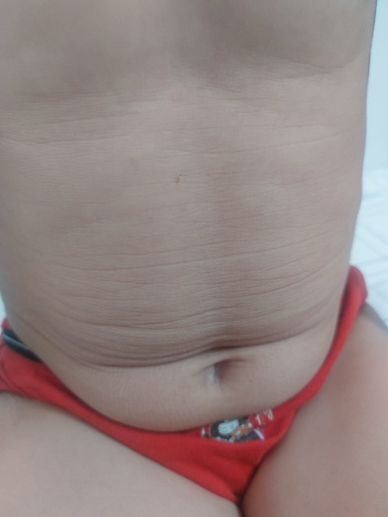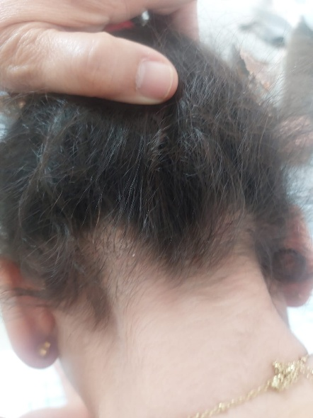
- (B)
Figure 1 : Cutaneous manifestations. (A) Prominent abdominal skin folds at rest. (B) Increased truncal skin extensibility on traction, consistent with constitutional skin laxity.

- Musculoskeletal system: Clinical peripheral hyperlaxity (ankles/feet); a Beighton score was not documented.
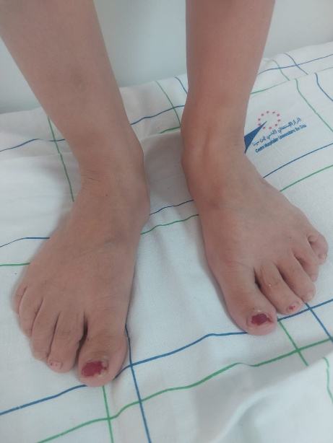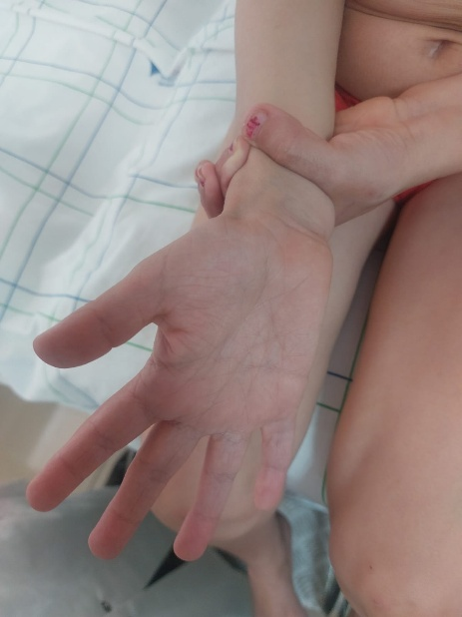
Figure 2: Clinical appearance of the feet/ankles suggesting peripheral hyperlaxity.

- Other systems: No specific abnormality reported on cardio-respiratory examination.
Investigations
Musculoskeletal imaging
Cervico-thoraco-lumbar spine radiographs (AP and lateral): Exaggerated thoracic kyphosis; mild thoracolumbar scoliosis with right convexity; predominantly anterior wedging/compression of vertebral bodies T5 and T7; no other visible disco-somatic abnormalities; smooth and harmonious posterior vertebral wall alignment.
Cardiac evaluation
Transthoracic echocardiography: Situs solitus; normal atrioventricular and ventriculoarterial connections; normal chamber size; thin valves without significant regurgitation; no atrial or ventricular septal defect; patent ductus arteriosus absent; no pericardial effusion.
Hemostasis
Factor V: <1% (reference 62–139) → severe deficiency
Factor X: 84% (reference 77–131) → normal
Factor VII: moderate decrease reported (numeric value not available in the provided documents)
A first-line workup (prothrombin time (PT)/international normalized ratio (INR), activated partial thromboplastin time (aPTT), fibrinogen, CBC/platelets, liver tests, and inhibitor evaluation depending on context) is recommended to characterize the disorder and guide peri-procedural management.
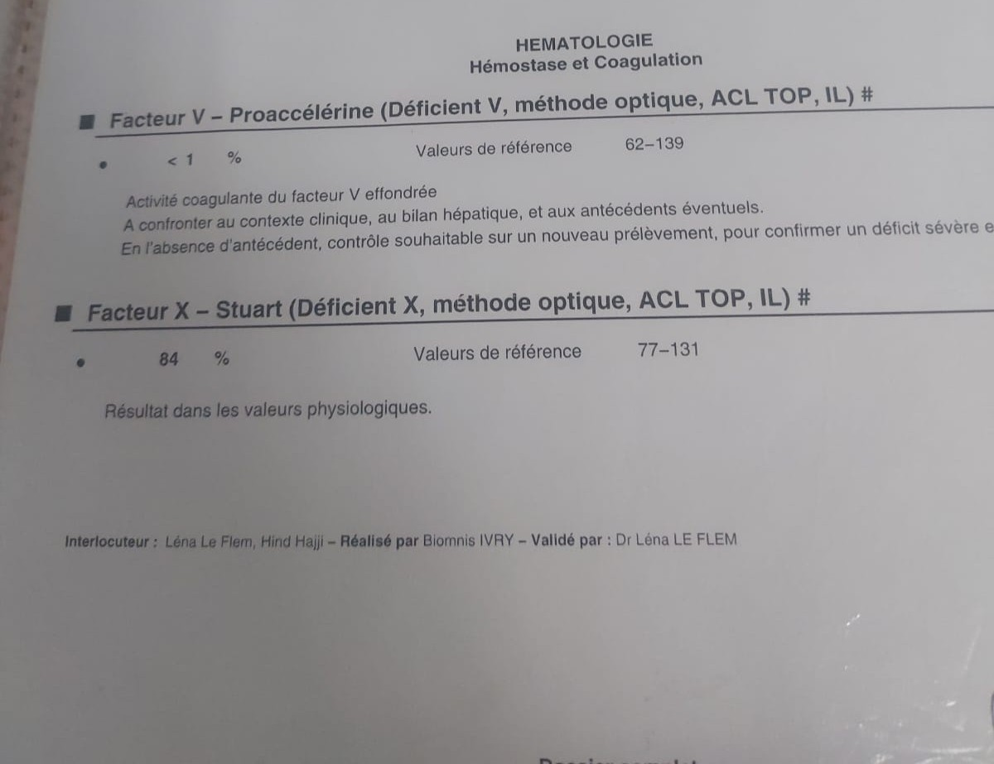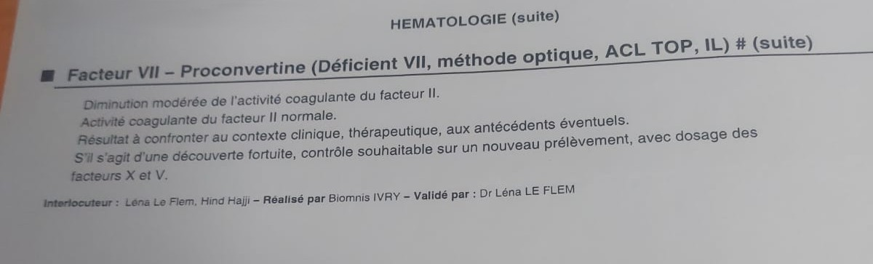
Figure 3: Hemostasis workup showing severe factor V deficiency with preserved factor X activity and a moderate reduction in factor VII activity.
Genetics
Targeted clinical exome sequencing did not identify relevant pathogenic variants in genes classically associated with EDS within the analyzed panel. It revealed a homozygous pathogenic truncating variant in GORAB: NM_152281.3:c.79C>T, p.(Arg27*), confirming the diagnosis of geroderma osteodysplasticum.
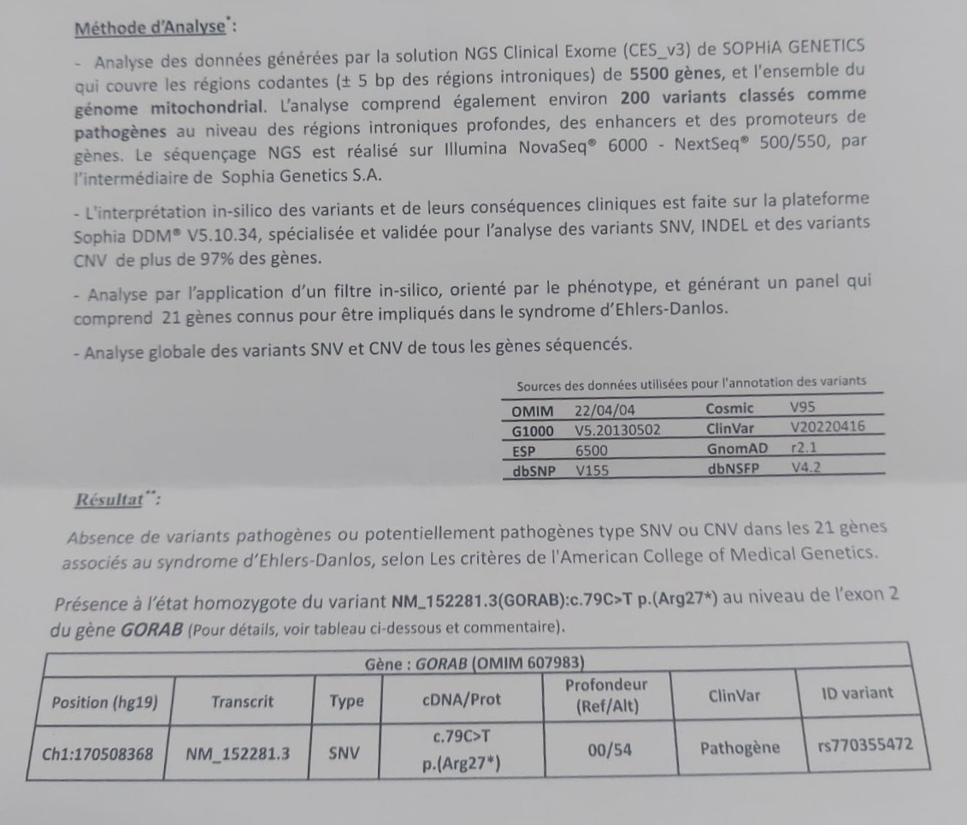
Figure 4: Clinical exome sequencing report identifying a homozygous pathogenic truncating GORAB variant (NM_152281.3:c.79C>T; p.Arg27*) with no pathogenic variants detected in the analyzed Ehlers–Danlos gene panel.
Management and follow-up
Regular orthopedic follow-up was initiated with physiotherapy and radiologic monitoring. An individualized hematology plan was discussed to prevent and manage bleeding episodes and to cover invasive procedures, considering the severe factor V deficiency, according to local protocols (often fresh frozen plasma in the absence of a specific concentrate).
Genetic counseling was offered to the family given autosomal recessive inheritance and parental consanguinity.
Discussion
1) Geroderma osteodysplasticum: a rare connective tissue disorder to recognize
Geroderma osteodysplasticum (GO) is a rare, typically autosomal recessive connective tissue disorder characterized by skin laxity (often striking over the trunk/abdomen and extremities), joint hypermobility, and skeletal fragility including osteopenia/osteoporosis, fractures, and sometimes vertebral compression and kypho-scoliosis [1–4]. Pathophysiology involves defects in proteins associated with the Golgi apparatus/secretory pathway. Historically, the gene was identified as SCYL1BP1, now named GORAB (golgin, RAB6 interacting) [1]. Rare disease resources (Orphanet, GARD/NIH) describe GO as combining lax skin, hyperlaxity, and bone complications, with autosomal recessive inheritance linked to GORAB [3,4].
2) Diagnostic rationale in this case
Several features converge in our patient:
- highly suggestive cutaneous phenotype (marked abdominal folds and skin hyperextensibility
- peripheral hypermobility
- vertebral involvement with anterior compression of T5 and T7 and exaggerated thoracic kyphosis
- consanguinity supporting an autosomal recessive condition
- decisive molecular confirmation with a homozygous pathogenic truncating GORAB variant, establishing the diagnosis [1–4]
The main differential diagnosis was EDS (especially hypermobile/classic types) and, more broadly, hereditary cutis laxa syndromes. GO shares clinical overlap with these entities, and clinical distinction can be challenging; reviews and series emphasize the importance of genetic testing in “cutis laxa/EDS-like” phenotypes [2,5,6].
3) Bone and vertebral involvement: a key feature of GO
Skeletal complications are central to the GO phenotype: osteopenia/osteoporosis, fractures, deformities, and wedge vertebrae/compression that may result in kyphosis or scoliosis [3,4]. In our case, radiographs documented T5 and T7 compression with kyphosis, consistent with the described spectrum. Case reports and reviews detail vertebral anomalies, kyphoscoliosis, and fractures/vertebral collapse in GO [2–4]. These findings support a structured management approach: orthopedic surveillance, injury prevention, physiotherapy, and consideration of bone evaluation (vitamin D/calcium status, densitometry) according to available resources [2–4].
4) Cardiovascular assessment
Some connective tissue disorders (including certain EDS subtypes) can involve vascular/valvular abnormalities; echocardiography is therefore appropriate at diagnosis. Here, transthoracic echocardiography was reassuring, with no significant valvular leak or shunt. While this does not preclude long-term surveillance depending on clinical evolution and complete phenotype, the absence of baseline structural abnormalities is favorable.
5) Severe factor V deficiency: rarity, interpretation, and practical impact
The most original and potentially publishable aspect of this case is the association with severe factor V deficiency (<1%). Congenital factor V deficiency (parahemophilia) is a rare coagulopathy, often autosomal recessive, that may present with mucocutaneous bleeding (epistaxis, bruising, gingival bleeding), with wide variability and imperfect correlation between factor level and clinical severity [7,8]. Our patient’s epistaxis and easy bruising fit this phenotype [7,8].
From a diagnostic standpoint, differentiating hereditary from acquired deficiency is essential. Reviews recommend global coagulation tests (PT and activated partial thromboplastin time (aPTT) often prolonged), mixing studies, and—in relevant contexts—inhibitor testing (notably in acquired forms) [7]. In our available documents, PT/activated partial thromboplastin time (aPTT) and mixing test results were not provided; thus, it is prudent to state that the complete evaluation should include these steps [7].
6) Treatment: why fresh frozen plasma is central
No widely available specific factor V concentrate exists; therefore, fresh frozen plasma (FFP) is classically the cornerstone of replacement therapy for significant bleeding or procedural prophylaxis [7–10]. Reference sources describe FFP as standard treatment in hereditary forms, with possible use of antifibrinolytics for mild cases and, in selected situations, platelets, PCC, or rFVIIa depending on benefit–risk and local expertise [7,9]. Transfusion guidelines specifically indicate plasma for congenital single-factor deficiencies when no specific product is available—factor V being a typical example [10]. Perioperative reports confirm the use of FFP around surgical procedures in patients with factor V deficiency [11,12].
7) Geroderma osteodysplasticum–factor V relationship: coincidental association or shared predisposition?
GO is classically linked to GORAB and is not described as a primary coagulopathy. The association of GO with severe factor V deficiency may therefore represent:
- a coincidental coexistence of two rare autosomal recessive disorders (particularly plausible in consanguinity), or
- a non-constitutional (acquired) factor V deficiency, pending full investigation [7]
In the manuscript, it is preferable to present these hypotheses in a balanced manner, emphasizing the immediate practical implication: anticipating bleeding risk in a patient who may also have tissue fragility related to the connective tissue disorder.
8) Case contributions
This case highlights:
- the value of a phenotype → imaging → genetics approach to differentiate EDS from related entities [5,6]
- the need for multidisciplinary care (pediatrics, genetics, orthopedics, cardiology, hematology)
- the importance of identifying and documenting a hemostasis disorder when mucocutaneous bleeding is present, as this changes emergency and peri-procedural management [7–12]
Conclusion
Geroderma osteodysplasticum should be considered in patients presenting with cutis laxa, joint hyperlaxity, and skeletal involvement, particularly in the setting of consanguinity. Confirmation of a GORAB pathogenic variant enables genetic counseling and multidisciplinary care. The associated severe factor V deficiency warrants an anticipatory hematologic management plan to reduce bleeding risk.

Disclaimer (Artificial intelligence)

Author(s) hereby declare that NO generative AI technologies such as Large Language Models (ChatGPT, COPILOT, etc.) and text-to-image generators have been used during the writing or editing of this manuscript.

References

- NCBI Gene. GORAB (golgin, RAB6 interacting): genomic location 1q24.2. National Center for Biotechnology Information. Accessed 2026.
- Alotaibi M, Aldhubaiban D, et al. A Case of Geroderma Osteodysplasticum Syndrome: Unique Clinical Findings. Global Medical Genetics. 2022;9:175–178.
- Slaiby N, et al. Geroderma Osteodysplastica: A Narrative Review of Its Genetic Basis, Clinical Features, and Management. Clinical Genetics. 2025. (PMID: 41457302).
- GARD/NIH. Geroderma osteodysplastica (caused by GORAB, autosomal recessive; lax skin, loose joints, bone problems).
- Kariminejad A, et al. Cutis Laxa IIA, Cutis Laxa IIB, and Geroderma Osteoplastica (review/differential, role of GORAB). [PMC] 2017.
- Uitto J, et al. Clinical heterogeneity of cutis laxa / perspective (GO among related entities, phenotypic overlap). Experimental Dermatology. 2013.
- Stoj KM. Factor V Deficiency. StatPearls (NCBI Bookshelf). 2024.
- Franchini M, Focosi D. Clinical, Laboratory, and Molecular Aspects of Factor V Deficiency. Seminars in Thrombosis and Hemostasis. 2025;51(2):111–115. doi:10.1055/s-0044-1789021.
- Medscape. Factor V Deficiency Treatment & Management. Updated 2023.
- Wong MP, et al. Guidelines for frozen plasma transfusion. British Columbia Medical Journal.
- Pan African Medical Journal. Congenital factor V deficiency: perioperative management. 2020.
- Tanaka KA, et al. Perioperative Management of Hereditary Factor V Deficiency. Journal of Cardiothoracic and Vascular Anesthesia. 2022.

