NATIVE-VALVE INFECTIVE ENDOCARDITIS COMPLICATED BY A LEFT FOOT GANGRENE IN A NIGERIAN GIRL
ABSTRACT
Background
Infective endocarditis (IE) involving native valves in children without underlying structural or acquired valvular heart disease is uncommon. Most reported paediatric cases occur in the presence of congenital cardiac defects or pre-existing valvular abnormalities that serve as a nidus for infection. IE is associated with significant morbidity and mortality, particularly when complicated by congestive cardiac failure or systemic embolization. Reports of systemic embolic phenomena complicating IE in African children are scarce, and peripheral gangrene as a presenting feature is especially rare.
Aim
To highlight an unusual presentation of paediatric native-valve infective endocarditis complicated by systemic embolization resulting in limb gangrene, and to emphasize the need for a high index of suspicion in atypical presentations.
Case Presentation
We report the case of a 7-year-old girl with no known structural heart disease who presented with left foot gangrene secondary to systemic embolization. Further evaluation revealed native-valve infective endocarditis as the underlying cause. The diagnosis was established through clinical findings, echocardiographic evidence of valvular vegetation, and supportive laboratory investigations. The patient was managed with appropriate antimicrobial therapy and multidisciplinary care for the embolic complication was planned.
Discussion
Pediatric IE is rare, particularly in children without identifiable cardiac risk factors. Its clinical presentation can be highly variable and occasionally misleading, especially when embolic phenomena precede or overshadow classical cardiac features. Systemic embolization is a recognized complication of IE, but progression to peripheral gangrene is distinctly uncommon. This case underscores the diagnostic challenge posed by atypical presentations and highlights the importance of early echocardiographic assessment and prompt treatment. The report also contributes to the limited African literature on embolic complications of IE in children.
Conclusion
This case illustrates a rare and severe complication of native-valve infective endocarditis in a child without pre-existing heart disease. Awareness of such atypical presentations is crucial for early diagnosis and timely management to prevent adverse outcomes.

INTRODUCTION
Infective endocarditis (IE) involving native valves in children without underlying structural or acquired valvular heart disease is uncommon.^{1,2} Most pediatric cases are reported in the presence of congenital heart defects or pre-existing valvular abnormalities that serve as a nidus for infection.³ IE remains a condition associated with considerable morbidity and mortality, particularly when complicated by congestive cardiac failure and systemic embolization. ⁴ Reports of systemic embolic complications of IE in African children are limited. ^{5,6}
Infective endocarditis is an inflammatory process of the endocardial surface of the heart characterized by the formation of vegetations on the cardiac valves.^{7,8} These vegetations are composed of microorganisms that are most commonly bacteria embedded within fibrin and inflammatory cells.³ In children, IE may present with non-specific features such as fever and malaise, as well as more specific findings including a new or changing heart murmur and features of heart failure.^{1,7} The clinical presentation is often variable, which may delay diagnosis. Recognized risk factors include congenital heart disease, previous IE, prosthetic valves, indwelling central vascular catheters, and recent invasive or dental procedures.⁷
Systemic septic embolization is a recognized complication of infective endocarditis, occurring when fragments of infected valvular vegetations detach and embolize through the arterial circulation, occluding vessels according to their size and anatomical destination.^{9,10} Limb gangrene in this context results from embolic obstruction of arterial blood flow by dislodged vegetative material originating from the infected cardiac valve, leading to critical distal ischemia and tissue necrosis.^{11,12} Gangrene of a limb as a consequence of infective endocarditis is an exceedingly rare clinical occurrence.^{9,13}
The most frequently implicated organisms in pediatric IE are Staphylococcus aureus and streptococci spp, others are coagulase-negative staphylococci, enterococus and gram negative bacilli among others.^{8,14} Blood culture remains central to diagnosis, while echocardiography plays a pivotal role in identifying valvular vegetations and related complications. Other imaging modalities that can be used in the evaluations are cardiac magnetic resonance, computed tomography angiography and positron emission tomography.^{8,15}
The modified Duke criteria are widely applied in establishing the diagnosis, incorporating major criteria (positive blood cultures for typical organisms and imaging evidence of endocardial involvement) and minor criteria (such as fever, predisposing cardiac conditions, vascular phenomena including embolic events, and immunologic manifestations). A definite diagnosis is made based on the combination of these criteria in accordance with established guidelines.^{8,14}
Management of IE requires prolonged, targeted antimicrobial therapy guided by the suspected organism, epidemiologic context, predisposing conditions, and blood culture results. Current clinical guidelines allows initial course of intravenous antibiotics for few weeks, with the regimen tailored to the identified pathogen and the patient’s clinical status.^{14,16} Surgical intervention is also instituted when established clinical criteria are met, particularly in the presence of uncontrolled heart failure, persisting infection, large vegetations with recurrent embolization, or significant valvular dysfunction.^{7,8}
Peripheral gangrene is an exceptionally rare manifestation of systemic embolization in IE. We therefore report the case of a 7-year-old girl who presented with left foot gangrene secondary to a systemic embolic complication of native-valve infective endocarditis, highlighting the unusual clinical presentation and the diagnostic approach in line with current pediatric guidelines

CASE REPORT
A 7 years old girl who presented with a two month old history of recurrent fever, fast breathing and paedal edema of a month and a 3 days history of darkish discoloration of the left foot. Fever was high grade, intermittent and transiently relived with antipyretics. Fast breathing was insidious in onset and associated with easy fatigability and orthopnea. Paedal edema progressively worsened with facial puffiness and abdominal distension. There was no history suggestive of a congenital heart defect and no history of fever with features of heart failure preceding this present presentation but patient had dental procedures for a chronic toothache done few weeks prior to presentation. She initially presented to the referring hospital where echocardiography done showed vegetations and a blood culture that yielded growth of staphylococcus aureus. She was being managed for an infective endocarditis complicated by a heart failure with antifailure medications and antibiotics, when she was noticed to develop darkish discoloration of the left foot by the 5th week on admission. The left foot discoloration was progressive and associated with severe pain. Doppler ultrasonography of the left lower limb showed features suggestive of an occlusive arterial thrombo-embolic disease. She was subsequently referred to our facility for multidisciplinary care.
The pregnancy, delivery, and neonatal periods were uneventful, with no reported complications. She achieved her developmental milestones at appropriate ages, with no delays. Prior to the onset of symptoms, she was a Basic Two pupil with good academic performance. Patient had received all vaccines according to the National program on immunization schedule. She was the last of four children in a monogamous family.
On examination at presentation, was dyspnoeic, febrile at 39.7C, mildly pale, acyanosed in room air, with mild pedal oedema, tachypnoeic with respiratory rate of 40cpm, breath sounds were vesicular, oxygen saturation in room air was 96%, tachycardic with a pulse rate of 140 bpm which was regular, normal volume and synchronous with other peripheral pulses, had normal blood pressure of, 95/60 mmHg for age and height. The precordium was hyperactive, apex beat was displaced, located at the 6th left intercostal space mid-axillary line, first, second heart sounds were normal with of grade 3/6 systolic murmur loudest at the apex of the heart, and radiating to the left axilla. Abdominal examination revealed a soft, smooth and tender hepatomegaly palpable 6cm below the right costal margin. Musculoskeletal system examination revealed dark discoloration of the left foot involving the 5 digits, with diffuse swelling, tender, and foul smelling, absent dorsalis paedis artery pulsation (Figure 1 -3).
A diagnosis of congestive cardiac failure in a child with infective endocarditis complicated by gangrene of the left foot was made. Patient was admitted, commenced on intranasal oxygen, nursed in a cardiac position, intravenous antibiotics meropenem, metronidazole and vancomycin, antifailure medications enalapril and furosemide, oral aspirin, strict monitoring of fluid input and output were done. Chest radiograph showed cardiomegaly. (figure 4)
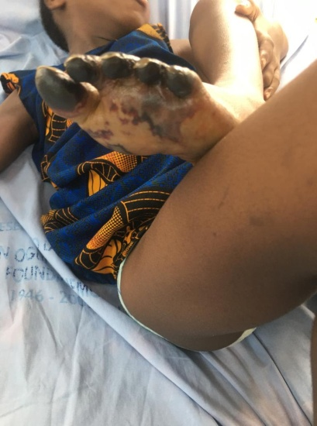Figure 1-3- Musculoskeletal examination showing thedark discolouration of the left foot
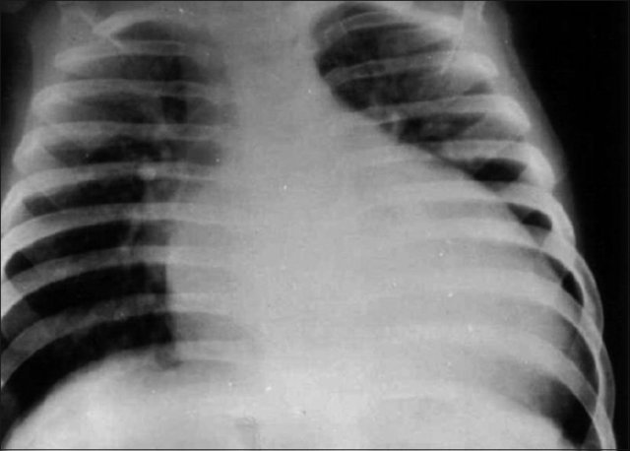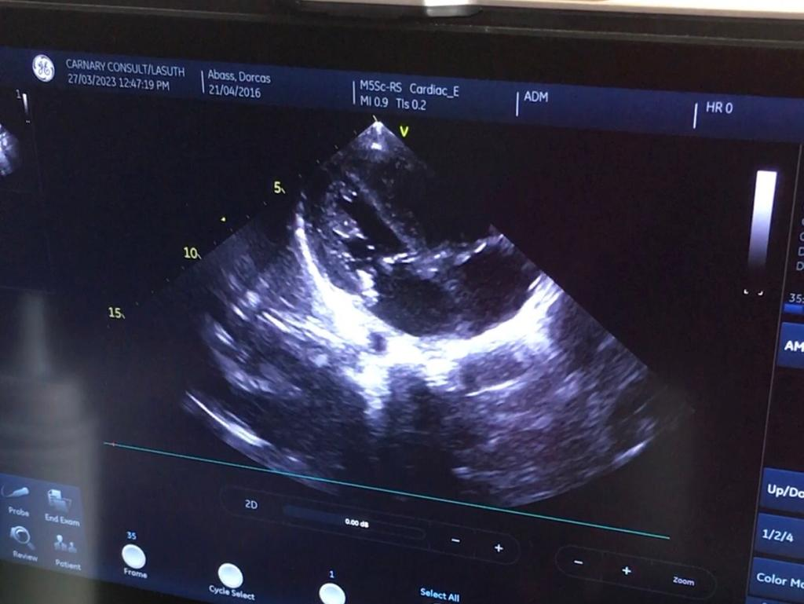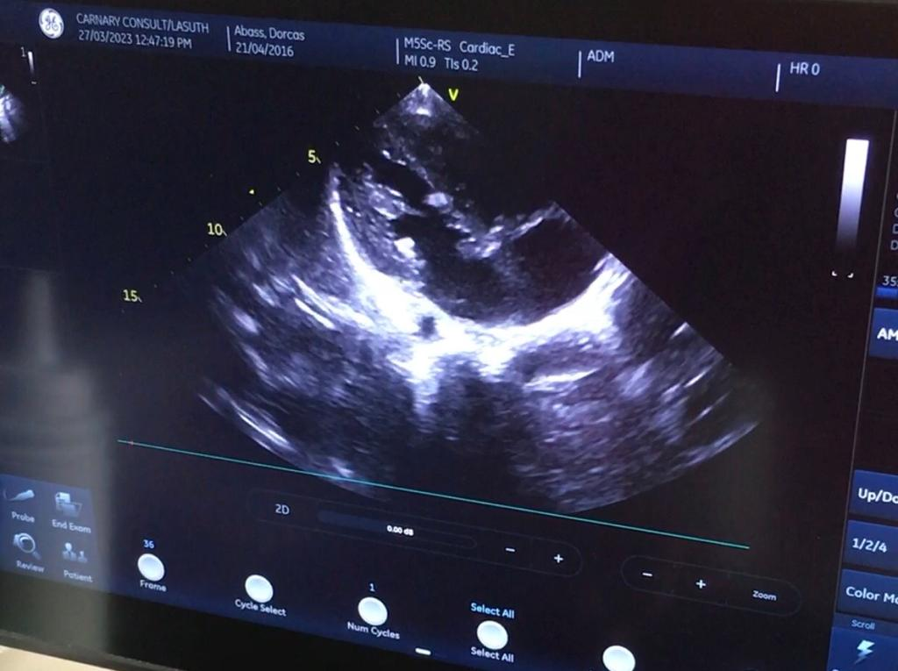Figure 4-6-Chest radiograph showing cardiomegaly; Echocardiography showing vegetation on the tricuspid valve
Echocardiography (Figure 5, 6) revealedvegetation on the tricuspid valve, severe pulmonary arterial hypertension, moderate tricuspid regurgitation and severe mitral regurgitation. The vegetation measured 11mm and was mobile.
Serum electrolytes, urea and creatinine were normal. The full blood count result showed anemia with PCV of 24%, leucocytosis with relative neutophilla, platelet count was normal, clotting profile showed INR of 1.11, normal PT and APTT,C- reactive protein was 130mg/l and D-dimer of 2.31ug/ml which are elevated and points to an ongoing inflammation with thrombus formation.¹⁷
The cardiothoracic surgical unit reviewed, requested for a CT angiogram of both lower limbs and planned for an embolectomy in conjunction with the orthopaedic unit for an ablation, patient however discharged against medical advice due to severe financial constraint. She was lost to follow-up after a change in residence, and subsequent attempts to contact the family by mobile phone were unsuccessful.
DISCUSSION
Infective endocarditis is an infection of the heart’s endocardial surface^{18,19}.The disease represents a complex interplay between a pathogen and host factors such as endothelial disruption and immune function that is still not completely understood.¹⁸ It is caused majorly by bacteria Streptococcus viridians and Staphylococcus aureus, others are viruses, fungi.²⁰In the case report above, Staphylococcus aureus was the microorganism implicated. Infective endocarditis accounts for 0.5 to 1 of every 1000 hospital admissions with a crude incidence between 1.5 and 11.6 cases per 100,000 populations globally.²¹It is commoner in the developed countries. The common predisposing factors to developing infective endocarditis in children are congenital or rheumatic heart disease, however, it can occur in native valves as is seen in the case report. Other risk factors are prosthetic valve, previous episode of bacterial endocarditis, surgical systemic to pulmonary shunts and conduits, cardiac transplantation, central venous catheters, dental manipulations among others. The girl in the case report had a dental procedure to remove a tooth about 3 weeks prior to onset of symptoms. Although, Streptococcus viridians group are the commonest microorganisms implicated following a dental procedure, Staphylococcal aureus which is known to be common in patients with no underlying heart disease was the organism cultured from the blood stream in the case above.²² Infective endocarditis can lead to morbidity and mortality especially with complications such as congestive cardiac failure and systemic embolism.⁴ The incidence of gangrene of a limb from infective endocarditis is rare, however a debilitating complication. Animasahun et al⁶ reported a case of gangrene of the left upper limb from central embolism in a fourteen months old girl with Tetralogy of Fallot and infective endocarditis from the same center in 2016. The gangrene of a limb from a septic emboli results from the travel of a detach vegetation from the infected valve in infective endocarditis^{9,10}.The vegetations on the valve infected dislodge and travel through the blood circulation and block blood vessels depending on the size and the location.⁹Adeodu and Senbanjo⁵ in 2004 at the Obafemi Awolowo University Ile-ife, reported digital gangrene complicating septicaemia in a 4 year old girl involving both hands and feet leading to auto-amputation. .
The major risk factors for septic embolism in patients with infective endocarditis are the length of the vegetation(greater than 10mm) and the mobility of the vegetation which were both significant in the case report presented above.^{13,23}
The management of septic emboli includes prolonged antibiotic therapy and surgical removal of the valve vegetations and repair of the valve involved. The antimicrobial therapy of Infective endocarditis and subsequent septic emboli usually requires 4-6 weeks of intravenous antimicrobial therapy.¹¹ The role of antithrombotic and anticoagulant therapy in infective endocarditis is limited. Infective endocarditis in itself is not an indication for antithrombotic or anticoagulant treatment unless there are coexisting conditions such as atrial fibrillation, prosthetic heart valves, or a prior history of thrombo-embolic events. The use of these agents carries a significant risk of bleeding, particularly in the context of IE-associated vascular and intracranial complications. In selected cases, low–molecular-weight heparin or unfractionated heparin has been used, although this is not routine practice and should be guided by individual risk assessment and clinical indications. In instances of large-vessel occlusion due to embolism, thrombectomy may be considered in carefully selected patients.
The prognosis ranges from asymptomatic presentation to high mortality depending on the affected organs and the combined effect of both ischemic and infectious insults.^{4,15} Acute limb ischemia from septic emboli, if severe enough may result in limb amputation due to critical limb ischemia.^{5,24}
CONCLUSION
This case underscores the rarity of native-valve infective endocarditis in a child without pre-existing heart disease and highlights an unusual complication of limb gangrene resulting from septic embolization. Recognition of such atypical and severe presentations is essential to enable early diagnosis, timely intervention, and improved clinical outcomes.

Disclaimer (Artificial intelligence)

Author(s) hereby declare that NO generative AI technologies such as Large Language Models (ChatGPT, COPILOT, etc.) and text-to-image generators have been used during the writing or editing of this manuscript. - YES

REFERENCES
1. Rashed M, Fakhri G, Zareef R, Halim NA, Ahmed M, Dbaibo G, et al. Pathogenesis and distribution of infective endocarditis in the pediatric population: a 20-year experience in a tertiary care center in a developing country. Front Cardiovasc Med. 2023;(10):1182468. doi:10.3389/fcvm.2023.1182468
2. Chambers HF, Bayer AS. Native-Valve Infective Endocarditis. N Engl J Med. 2020;383(6):567–76. doi:10.1056/nejmcp2000400
3. Park MK, Salamat M. Park’s Pediatric Cardiology. 7th ed. Park’s Pediatric Cardiology for Practitioners. Texas: Elsevier; 2021. 96–223 p.
4. David R. Murdoch, MD, MSc; G. Ralph Corey, MD; Bruno Hoen, MD; Jose´ M. Miro´, MD, PhD; Vance G. Fowler Jr, MD, MHS; Arnold S. Bayer, MD; AdolfW. Karchmer, MD; Lars Olaison, MD, PhD; Paul A. Pappas, MS; Philippe Moreillon, MD, PhD; Stephen T. Chambers, MD M. Clinical Presentation, Etiology, and Outcome of Infective Endocarditis in the 21st Century. Arch Intern Med. 2009;169(5):463.
5. Adeodu OO SI. Septicemia complicated by Digital Gangrene - A Case Report. Niger J Paediatr. 2005;31(4):137–9.
6. Animasahun BA, Amoah E. Gangrene of the Left Forearm Following Septicaemia in a Nigerian Child With Tetralogy of Fallot: A Case Report. Hear Res - Open J. 2017;4(1):6–9. doi:10.17140/hroj-4-133
7. Vicent L, Luna R, Mart M. Pediatric Infective Endocarditis : A Literature Review. J Clin Med. 2022;11:3217. doi:org/10.3390/ jcm11113217
8. Delgado V, Marsan NA, Waha S De, Bonaros N, Brida M, Burri H, et al. 2023 ESC Guidelines for the management of endocarditis Developed by the task force on the management of endocarditis of the European Society of Cardiology ( ESC ) Endorsed by the European Association for Cardio-Thoracic Surgery ( EACTS ) and the European. Eur Heart J. 2023;44:3948–4042. doi:10.1093/eurheartj/ehad193
9. Kildahl HA, Brenne EL, Dalen H, Wahba A. Systemic embolization in infective endocarditis. Indian J Thorac Cardiovasc Surg. 2024;40(Suppl 1):40–6. doi:10.1007/s12055-023-01616-2
10. Yu Z, Fan B, Wu H, Wang X, Li C, Xu R, et al. Multiple systemic embolism in infective endocarditis underlying in Barlow’s disease. BMC Infect Dis. 2016;16(1):4–8. doi:10.1186/s12879-016-1726-5
11. Galyfos G, Giannakakis S, Kerasidis S, Geropapas G, Kastrisios G, Papacharalampous G, et al. Infective endocarditis as a rare cause for acute limb ischemia. World J Emerg Med. 2016;7(3):231. doi:10.5847/wjem.j.1920-8642.2016.03.012
12. Hu W, Wang X, Su G. Infective endocarditis complicated by embolic events: Pathogenesis and predictors. Clin Cardiol. 2021;44(3):307–15. doi:10.1002/clc.23554
13. Berthelot P, Lemetayer F, Comtet C, Fresard A, Cazorla C, Fascia P, et al. Risk factors for systemic emboli in infective endocarditis. Clin Microbiol Infect. 2004;10(1):46–53. doi:10.1111/j.1469-0691.2004.00735.x.
14. Brien L, Tierney C, Thompson-brazill K. Clinical Manifesta ons of Infec ve Endocardi s. J Nurse Pract. 2025;21(9):105494. doi:10.1016/j.nurpra.2025.105494
15. Habib G, Erba PA, Iung B, Donal E, Cosyns B, Laroche C, et al. Clinical presentation, aetiology and outcome of infective endocarditis. Results of the ESC-EORP EURO-ENDO (European infective endocarditis) registry: A prospective cohort study. Eur Heart J. 2019;40(39):3222-3232B. doi:10.1093/eurheartj/ehz620
16. Singh Y. Infective endocarditis in paediatrics. Paediatr Child Health (Oxford). 2022;32(12):441–7. doi:org/10.1016/j.paed.2022.10.001
17. Demirbaǧ R. Using the D-dimer test in infective endocarditis. Turk Kardiyol Dern Ars. 2013;41(7):595–7. doi:10.5543/tkda.2013.09483
18. Bernstein D, Murray TS, Carr MR. The Cardiovascular System. In: Behrman, R.E., Kleigman, R.M., Staton, B. F., St Geme, J.W., & Schor N., editor. Nelson Textbook of Pediatrics. 21st ed. Philadelphia, PA: Elsevier Inc.; 2020. p. 9243–834.
19. Lam ACK. Infective endocarditis. Ashraf Al SD, editor. Hong Kong Pract. 2nd ed. 2003;25(11):551–61.
20. Holland TL, Baddour LM, Bayer AS, Hoen B, Miro JM, Fowler VG. Infective endocarditis HHS Public Access. Nat Rev Dis Prim. 2017;2(16059):1–49. doi:10.1038/nrdp.2016.59.Infective
21. Bin Abdulhak AA, Baddour LM, Erwin PJ, Hoen B, Chu VH, Mensah GA, et al. Global and regional burden of infective endocarditis, 1990-2010: A systematic review of the literature. Glob Heart. 2014;9(1):131–43. doi:10.1016/j.gheart.2014.01.002
22. Bumm C V., Folwaczny M. Infective endocarditis and oral health — A Narrative Review. Cardiovasc Diagn Ther. 2021;11(6):1403–15. doi:10.21037/cdt-20-908
23. Thuny F, Disalvo G, Belliard O, Avierinos JF, Pergola V, Rosenberg V, et al. Risk of embolism and death in infective endocarditis: Prognostic value of echocardiography - A prospective multicenter study. Circulation. 2005;112(1):69–75. doi:10.1161/CIRCULATIONAHA.104.493155
24. Dombrowski SC. Assessment Results. Psychoeduc Assess Rep Writ. 2020;159–72. doi:10.1007/978-3-030-44641-3_9

