Case Report

Meconium Aspiration Syndrome Complicated by Persistent Pulmonary Hypertension of the Newborn: A Case Report

Abstract

Background:
Meconium aspiration syndrome (MAS) is a significant cause of neonatal respiratory
distress and is associated with considerable morbidity and mortality, particularly when complicated by persistent pulmonary hypertension of the newborn (PPHN). Early recognition and timely intervention are crucial for improving outcomes.

Case Presentation:
We report the case of a term male neonate born at 37 weeks of gestation with a birth
weight of 2.9 kg, delivered by lower segment cesarean section in the presence of
thick meconium-stained amniotic fluid. Although the infant cried immediately after birth, he developed respiratory distress and apnea episodes within the early postnatal period and was referred to a tertiary care center. On admission, the neonate was tachypneic with poor oxygen saturation. Laboratory investigations revealed an elevated C-reactive protein level, while other hematological parameters were within normal limits. Chest radiography demonstrated bilateral patchy pulmonary opacities with areas of hyperinflation, consistent with MAS. The clinical and radiological findings supported the diagnosis of MAS complicated by PPHN.

Management and Outcome:
The neonate was treated with oxygen support, mechanical ventilation, antibiotics, and general supportive care. Echocardiography confirmed PPHN, and appropriate
heart and lung treatment was started. The baby gradually improved, was weaned off ventilatory support, and discharged in stable condition.

Conclusion:
This case highlights the importance of early imaging and comprehensive
cardiopulmonary evaluation in diagnosing MAS complicated by PPHN. Prompt
diagnosis and aggressive respiratory and supportive management can significantly improve clinical outcomes and reduce neonatal morbidity and mortality.

Keywords:
Meconium aspiration syndrome; Persistent pulmonary hypertension of the newborn; Neonatal respiratory distress; Mechanical ventilation; Case report

INTRODUCTION :

Meconium Aspiration Syndrome (MAS) is a frequently encountered neonatal respiratory disorder and remains an important contributor to neonatal morbidity and mortality. The condition is defined by the occurrence of respiratory distress in a newborn delivered through Meconium-stained amniotic fluid, with radiographic findings consistent with aspiration pneumonia and in the absence of alternative causes

of respiratory compromise.1
Meconium may or may not be present in the upper or lower airways at the time of diagnosis.MAS severity is determined by the level and duration of respiratory support required. Mild disease is characterized by the need for less than 40% supplemental oxygen for a duration of less than 48 hours. Moderate MAS requires oxygen concentrations exceeding 40% for more than 48 hours without associated air-leak syndromes, whereas severe MAS necessitates assisted ventilatory support for over 48 hours and is commonly complicated by persistent pulmonary hypertension of the newborn (PPHN).2

Over recent decades, the mortality rate associated with MAS has shown a marked decline, decreasing from earlier estimates of 22–28 per 100,000 live births to fewer than 1 per 100,000 live births.3 This improvement is largely attributed to advances in antenatal surveillance, timely obstetric intervention, and improvements in neonatal intensive care. PPHN, also referred to as persistent fetal circulation, arises from failure of the normal postnatal reduction in pulmonary vascular resistance, resulting in sustained right-to-left shunting and refractory hypoxaemia.4

Meconium represents the initial gastrointestinal discharge of the newborn and is usually passed within the first 24–48 hours of life. It is a thick, dark green material composed of water, exfoliated intestinal epithelial cells, bile pigments, pancreatic and gastrointestinal secretions, mucus, lanugo, vernix caseosa, blood glycoproteins, and swallowed amniotic fluid.5

In this report, we describe the case of a male neonate born at 37 weeks of gestation with a birth weight of 2.9 kg, delivered by lower segment cesarean section in the presence of meconium-stained amniotic fluid.

CASE REPORT :

A 28-year-old woman presented to the District Hospital, Chitradurga, in active labor. She was a second-gravida at 37 weeks of gestation with a singleton pregnancy. Owing to obstetric indications, delivery was conducted by Lower Segment Cesarean Section (LSCS). At the time of uterine incision, the amniotic fluid was noted to be thick and green in color, suggestive of Meconium-stained liquor.

A term male neonate was delivered with an immediate cry at birth. The newborn had a birth weight of 2.9 kg and a length of 49 cm. Within the early postnatal period, the infant developed two episodes of twenty apnea and subsequently showed signs of respiratory distress. Owing to clinical deterioration, the neonate was referred to a higher-level care center at Basaveshwara Medical College Hospital (BMCH).

On admission, the neonate was tachypneic, and oxygen saturation could not be adequately maintained. Laboratory evaluation revealed an elevated C-Reactive

protein (CRP) level of 15.9 mg/L, while the complete blood count was within normal limits. Other relevant laboratory findings are summarized in Table 1. On clinical examination, the heart rate was 126 beats per minute and the respiratory rate was 66 cycles per minute. Respiratory examination revealed tachypnea with positive signs of respiratory distress, including suprasternal retractions and chest radiographic abnormalities.

The neonate was managed for Meconium aspiration syndrome complicated by Persistent Pulmonary Hypertension of the Newborn (PPHN). Endotracheal intubation was performed, and the infant was initiated on mechanical ventilation with appropriate ventilatory settings. Nebulization with adrenaline (0.5 mL diluted in 7 mL of 3% normal saline) was administered hourly. By day 3 of hospitalization, the infant showed clinical improvement and was extubated, following which respiratory support was continued using bubble continuous positive airway pressure (CPAP). On day 5, nebulization with Acetylcysteine (Mucomist) was initiated in conjunction with chest physiotherapy.

Empirical intravenous antibiotic therapy with Amikacin sulfate (40 mg diluted in 10 mL normal saline, administered slowly over 1 hour once daily) was initiated to prevent secondary infection. To manage PPHN, oral Sildenafil was administered at a dose of 25 mg (0.6 mL diluted in 5 mL normal saline) four times daily. The infant was closely monitored throughout the treatment course and demonstrated gradual clinical improvement.

Investigation | Result | Normal range
HB(Hemoglobin) | 14.4 gm/dL | 14-24 gm/dL
TC(WBC Count) | 9730 cells/cumm | 9000-30000cells/cumm
Neutrophills | 59.9 % | 40-75%
Lymphocytes | 24.1 % | 20-45%
Eosinophils | 5.9 % | 1-6%
RBC Count | 4.82 million/cumm | 4.8-7.1million/cumm
Platelet Count | 3.33 lakhs/cumm | 1.40-4.40lakhs/cumm
C-Reactive protein | 15.9 mg/L | 0-10 mg/L

Table 1 : Laboratory investigation Report

DISCUSSION :

Meconium aspiration syndrome (MAS) is a serious respiratory disorder that occurs as a complication of meconium-stained amniotic fluid and predominantly affects term and near-term neonates. It is estimated to develop in approximately 5% of infants born through meconium-stained liquor. The pathogenesis of MAS is multifactorial and involves a complex interaction between mechanical airway obstruction, chemical

pneumonitis, surfactant inactivation, and inflammatory responses. Aspiration of meconium may occur in utero or during the first breaths after birth, leading to variable degrees of respiratory compromise.

Meconium causes partial or complete obstruction of the airways, resulting in uneven ventilation of the lungs. Partial obstruction produces a ball-valve effect, allowing air to enter the distal airways during inspiration while limiting expiration, thereby causing air trapping and hyperinflation. Complete airway obstruction leads to distal atelectasis. In addition to mechanical effects, meconium is chemically irritating to the lung tissue and triggers an inflammatory cascade characterized by the release of cytokines and mediators, which further damages the pulmonary epithelium and inactivates surfactant. Historically, airway obstruction was considered the primary mechanism underlying MAS, leading to routine endotracheal suctioning practices; however, current evidence suggests that inflammation and chemical injury play equally important roles in disease progression.

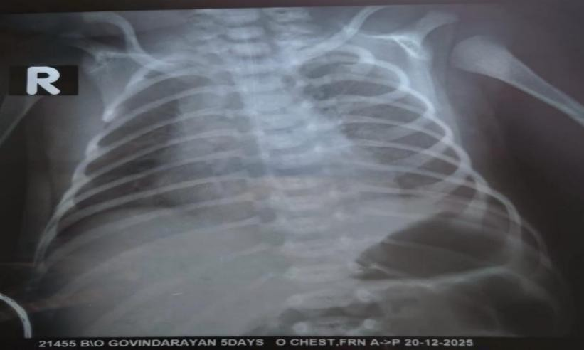

Figure -1 Chest Radiographic Features of Meconium Aspiration Syndrome with Persistent Pulmonary Hypertension in a Term Neonate

The anteroposterior chest radiograph of a 5-day-old neonate was obtained in the supine position and was technically satisfactory with appropriate exposure and positioning. The trachea was centrally located, and the mediastinal contours were normal. Both lung fields demonstrated bilateral, diffuse, coarse, and patchy pulmonary opacities with a heterogeneous distribution. These opacities were interspersed with areas of increased radiolucency, indicative of air trapping.

The lungs appeared hyperinflated, as evidenced by increased lung volumes and flattening with inferior displacement of both hemidiaphragms. Bronchovascular markings were prominent and irregular throughout both lung fields, reflecting underlying inflammatory changes. No focal consolidation or pleural effusion was identified.

These radiographic findings are characteristic of meconium aspiration syndrome and correlate with the underlying pathophysiological mechanisms, including partial airway obstruction, chemical pneumonitis, and uneven alveolar ventilation. The coexistence of patchy infiltrates and regions of hyperinflation supports the presence of

a ball-valve phenomenon caused by meconium within the airways. Severe hypoxic lung disease resulting from MAS can lead to increased pulmonary vascular resistance, thereby precipitating persistent pulmonary hypertension of the newborn (PPHN). PPHN further exacerbates hypoxemia due to right-to-left shunting across the fetal circulatory pathways, significantly increasing disease severity and the need for advanced respiratory support.

CONCLUSION :

This case highlights the importance of early radiological assessment and comprehensive cardiopulmonary evaluation in the timely diagnosis of meconium aspiration syndrome complicated by persistent pulmonary hypertension of the newborn (PPHN). Early identification of these conditions enabled prompt initiation of appropriate respiratory support and adjunctive therapies, which contributed to a favorable clinical outcome.

From a preventive perspective, careful antenatal monitoring of pregnancies at increased risk of fetal hypoxia is essential. In cases where meconium aspiration occurs, the availability of adequate respiratory support, including artificial ventilation, is crucial for effective management. However, disparities in healthcare infrastructure and availability of advanced neonatal care facilities remain evident across different regions.

Early diagnosis combined with aggressive and appropriate management of MAS associated with PPHN can substantially reduce neonatal morbidity and mortality. This highlights the need for a coordinated multidisciplinary approach involving obstetricians, neonatologists, radiologists, and nursing staff within neonatal intensive care settings.

Disclaimer (Artificial intelligence)

Author(s) hereby declare that NO generative AI technologies such as Large Language Models (ChatGPT, COPILOT, etc.) and text-to-image generators have been used during the writing or editing of this manuscript.

REFERENCES :

1. Behera MK, Kulkarni SD, Gupta RK. Meconium aspiration syndrome: a clinical study. Med J Armed Forces India. 1998;54:19–20.
2. Monfredini C, Cavallin F, Villani PE, Paterlini G, Allais B, Trevisanuto D. Meconium aspiration syndrome: a narrative review. Children (Basel). 2021;8(3):230.
3. Fan HC, Chen CM. Meconium aspiration syndrome: an overview of the literature. Tungs Med J. 2024;18(1):4–11.
4. Nandula PS, Shah SD. Persistent Pulmonary Hypertension of the Newborn. [Updated 2023 Jul 31]. In: StatPearls [Internet]. Treasure Island (FL): StatPearls Publishing; 2025 Jan-.
5. Nanlohy S, Putri YK. Pneumothorax due to meconium aspiration syndrome: a case report. Crit Care Shock. 2023;26(4):181–186.

