Enhancing Vector Autoregression with Machine Learning Techniques for Causal Analysis of Macroeconomic Indicators in African Economies

Abstract
Africa exhibits a wide variation in macroeconomic performance reflecting differences in economic diversification, natural resource dependence, governance systems, political stability, and exposure to global economic cycles. This study investigates the dynamic interactions among key macroeconomic variables, annual inflation rate, exchange rate, foreign direct investment (FDI), and government final expenditure, across eight African economies: Nigeria, South Africa, Egypt, Angola, Morocco, Ethiopia, Tanzania, and Mozambique. Using annual data spanning 1990 to 2024 obtained from the World Development Indicators (WDI), the study employs Vector Autoregression (VAR) models and extends them by integrating machine learning architectures, specifically Random Forest (RF), Multilayer Perceptron (MLP), and XGBoost, to develop VAR–machine learning hybrid forecasting models. The comparative performance of the baseline VAR and hybrid models is evaluated using Mean Absolute Error (MAE) and Root Mean Square Error (RMSE). The findings show substantial forecasting accuracy improvements when machine learning components are incorporated into the VAR framework. For inflation, the VAR+MLP model achieves the most significant reduction in forecasting errors in Nigeria, South Africa, and Morocco, with South Africa’s MAE decreasing from 1.471 (VAR) to 0.888 under the hybrid model. Similarly, FDI predictions improve markedly across nearly all countries, with Tanzania exhibiting a major decline in MAE from 0.534 (VAR) to 0.184 (VAR+XGBoost). For government expenditure, hybrid models outperform VAR in Angola, South Africa, Morocco, and Cameroon, while exchange rate dynamics show mixed outcomes, with traditional VAR excelling in more stable economies such as Nigeria and Morocco. The results demonstrate that hybrid VAR–machine learning models more effectively capture nonlinear macroeconomic relationships and yield superior predictive performance for inflation and FDI, underscoring their relevance for economic planning and policy formulation in African economies.
Keywords: Vector autoregression, Machine learning, Macroeconomic variables, Hybrid models, Africa
Introduction
Since the early 1990s, African economies have undergone profound macroeconomic transformations driven by policy liberalisation, globalisation, structural adjustment programmes, commodity price fluctuations, and recurrent external shocks. These transitions have shaped the evolution and stability of key macroeconomic indicators such as inflation, exchange rates, foreign direct investment (FDI), and government final expenditure, variables that remain central to economic growth, macroeconomic stability, and sustainable development (Chen et al., 2024; Nasir, 2022). These indicators are inherently interconnected: movements in one often transmit to others through a network of direct and indirect channels. Consequently, understanding their dynamic and causal relationships is critical for designing effective macroeconomic policy, improving investment climate conditions, and navigating the structural complexities that characterise African economies. Yet, despite extensive empirical efforts, the multidimensional and often nonlinear interactions among these indicators remain inadequately understood, particularly in environments characterised by structural breaks, policy inconsistencies, and institutional fragility.
Africa exhibits a wide variation in macroeconomic performance reflecting differences in economic diversification, natural resource dependence, governance systems, political stability, and exposure to global economic cycles (Usman and Landry, 2021). In recent decades, Africa has experienced an intricate economic landscape marked by shifts in GDP growth rates, diversification challenges, and fluctuations in productivity and technological advancements. Existing literature provides valuable insights but also reveals significant gaps that necessitate further investigation to fully understand the drivers of economic growth in Africa (Buthelezi, 2024; COULIBALY & DJEZOU, 2024). Economic diversification is an essential aspect of sustainable development as diversification enhances macroeconomic stability and promotes structural and long-term transformation not only in the economy but also in other pillars of development such as social institutions and dimensions (Jolo et al., 2022). Studies on economic diversification, such as those by, Gozgor and Paramati (2022), highlight the benefits of long-term energy diversification for major economies but outline the challenges faced by low-income African nations in realizing similar gains. Resource-rich economies such as Nigeria and Angola are highly vulnerable to global commodity price volatility, which affects government revenue, inflation dynamics, exchange rate stability, and capital inflows. In contrast, more diversified economies like Morocco and Egypt display relatively greater resilience, maintaining moderate inflation rates and stronger FDI attractiveness. South Africa’s advanced financial markets and Tanzania’s steady reform trajectory further illustrate the diversity of macroeconomic structures and policy orientations across the continent. Meanwhile, emerging economies such as Ethiopia and Mozambique demonstrate the complexities of maintaining macroeconomic stability while pursuing rapid development. These differential macroeconomic profiles highlight the need for flexible and adaptive modelling frameworks capable of capturing country-specific patterns while enabling cross-country comparisons.
The interplay among inflation, exchange rates, FDI, and government expenditure has significant implications for economic development across Africa (Olamide et al., 2022; Amoah et al., 2015). For instance, public expenditure on infrastructure may stimulate economic activity, while poorly managed fiscal expansion can fuel inflation and create exchange rate pressures. Exchange rate volatility discourages foreign investment, whereas stable macroeconomic conditions generally attract sustainable FDI inflows (Zahid, 2018). However, these causal interactions are rarely linear and often vary across countries and over time, reinforcing the need for methodological approaches that can capture their inherent complexity.
Traditional econometric frameworks, most notably Vector Autoregression (VAR), have been widely used to examine the dynamic interactions among macroeconomic variables (Lütkepohl, 2013). VAR models offer flexibility by allowing variables to influence each other endogenously, enabling impulse response analysis and Granger causality testing. Nonetheless, standard VAR models impose assumptions of linearity and time-invariant parameters, making them less suited for macroeconomic environments where structural breaks, regime shifts, and nonlinear relationships are commonplace. These limitations are especially pronounced in African economies, where policy changes, institutional constraints, and external shocks frequently disrupt macroeconomic trajectories.
Recent advances in machine learning have created new opportunities to complement and enhance traditional econometric models (Athey, 2018; Mullainathan and Spiess, 2017). Machine learning algorithms, including Random Forests, Multilayer Perceptron (MLP), and Extreme Gradient Boosting (XGBoost), are capable of capturing nonlinear interactions, identifying hidden patterns, handling noisy or incomplete data, and improving prediction accuracy. Importantly, they rely less on restrictive assumptions about data structure or functional form, making them suitable for heterogeneous and high-dimensional macroeconomic datasets commonly found in African contexts. When integrated with VAR frameworks through hybrid or ensemble modelling, machine learning can enhance causal inference, refine impulse response estimation, and provide greater robustness in forecasting. Such integration bridges the interpretability of econometric structures with the predictive strength of machine learning.
Despite these advantages, the application of machine learning to macroeconomic causal analysis in African economies remains limited (Ofori, Quaidoo, and Ofori, 2021). Existing studies typically focus either on VAR-based causal modelling or on machine-learning-based forecasting, with little effort to combine the two approaches. This gap presents an important research opportunity: developing a hybrid framework that leverages the strengths of both methodologies to uncover deeper causal dynamics among inflation, exchange rate, FDI, and government expenditure. Such a framework allows for the investigation of key questions, including: How do these indicators interact over time across different African economies? Are these interactions stable or subject to structural change? Can machine learning enhancements to VAR models improve causal inference accuracy? And how do these dynamics differ across countries with contrasting macroeconomic structures and institutional capacities?
Moreover, macroeconomic datasets in African countries often suffer from measurement errors, discontinuities, missing observations, and limited historical depth. Machine learning techniques offer considerable advantages in such settings: Random Forests handle noise effectively and rank variable importance; XGBoost incorporates regularisation to prevent overfitting; MLPs capture deep nonlinear structures. These strengths complement the interpretability and theoretical grounding of VAR models, enabling a more comprehensive and resilient causal analysis framework.
Recent empirical advances reinforce the value of integrating machine learning into macroeconomic modelling. For instance, Gbadegesin and Yameogo (2024) applied machine learning within a causal framework to evaluate FDI-related initiatives; Neghab et al. (2025) combined ML with interpretability methods to analyse exchange rate dynamics; Kumar et al. (2024) used Double Machine Learning (DML) to investigate monetary policy effects; Shi et al. (2024) used ML for variable selection in growth modelling; Ramaharo & Rasolofomanana(2023) demonstrated the superior predictive performance of ensemble ML models for GDP nowcasting. These studies collectively show that hybrid techniques yield deeper insights than either method alone.
Against this background, this study develops a comparative and integrative framework combining traditional Vector Autoregression with machine learning techniques to investigate the causal dynamics among inflation, exchange rates, FDI, and government expenditure in eight African economies: Nigeria, South Africa, Egypt, Angola, Morocco, Ethiopia, Tanzania, and Mozambique. These countries represent diverse economic structures, institutional capacities, and macroeconomic environments, making them ideal for cross-country comparative analysis. By merging the interpretability of VAR models with the flexibility and predictive power of machine learning algorithms, the study aims to advance methodological applications in macroeconomic research and generate empirically grounded insights for policy formulation across the continent. Ultimately, this integrated approach offers a novel analytical lens for understanding macroeconomic interdependencies in Africa and contributes to the broader literature on economic modelling in low- and middle-income countries.
2 Methodology
2.1 Data Collection
The data used in this study are the annual inflation rate, exchange rate, foreign direct investment, and government final expenditure for Nigeria, South Africa, Egypt, Angola, Morocco, Ethiopia, Tanzania, and Mozambique from 1990 to 2024. The data for each country are collected from the World Development Indicators (WDI).
The variables were first checked for missing values, and then the Augmented Dickey-Fuller (ADF) test was applied to check for stationarity. The variables used in this study include inflation rate, foreign direct investment, total government expenditure, and exchange rate.
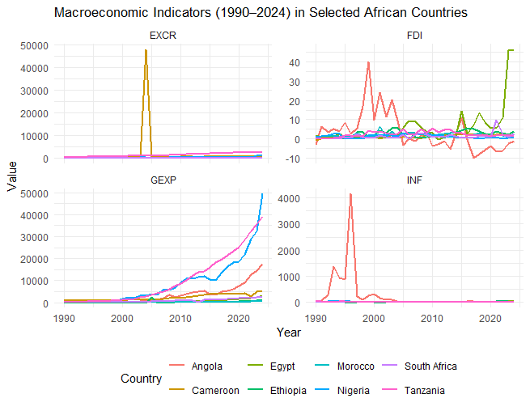
Fig. 1. Annual Inflation Rate (INF), Exchange Rate (EXCR), Foreign Direct Investment (FDI), and Government Expenditure (GEXP) from 1990 to 2024
2.2 Vector Autoregressive (VAR) Model
The Vector Autoregressive (VAR) model extends the univariate autoregressive (AR) model to capture linear interdependencies among multiple time series. Let $Y_{t}$ be an $n×1$ vector of stationary or transformed to stationary variables observed for $t=1,2,⋯,T$. A reduced form VAR of order $p$ is given as:
$$Y_{t}=c+A_{1}Y_{t-1}+A_{2}Y_{t-2}+⋯+A_{p}Y_{t-p}+ε_{t} (1)$$
where $c$ is an $n×1$ intercept or deterministic term, $A_{i}$ are $n×n$ coefficient matrices for lag $i$, $ε_{t}$ is an $n×1$ zero-mean white noise with covariance matrix $∑_{ε}=E\left[ε_{t}ε_{t}^{'}\right]$. But $ε_{t}$ is assumed to be independently identically distributed ($i.i.d.$) with finite second moments.
The $VAR(p)$ model with $n$ variables and $T$ observations, we can define:
$$Y=\left[\begin{matrix}y_{1} & y_{2} & \begin{matrix}⋯ & y_{T}\end{matrix}\end{matrix}\right]\left(T×n\right) (2)$$
Thus, equation (3.2), where $Y$ is of the dimension $\left(T×n\right)$ can be expanded as follows:
$$Y={\left[\begin{matrix}y_{1,1} & y_{1,2} & \begin{matrix}⋯ & y_{1,n}\end{matrix} \\ y_{2,1} & y_{2,2} & \begin{matrix}⋯ & y_{2,n}\end{matrix} \\ \begin{matrix}⋮ \\ y_{T,1}\end{matrix} & \begin{matrix}⋮ \\ y_{T,2}\end{matrix} & \begin{matrix}\begin{matrix}⋱ \\ ⋯\end{matrix} & \begin{matrix}⋮ \\ y_{T,n}\end{matrix}\end{matrix}\end{matrix}\right]}_{T×n} (3)$$
where $y_{t,j}$ is the observation of the $j$th variable at time $t$, $T$ is the total number of time periods, and $n$ is the number of variables.
The compact matrix form of the estimated $VAR(p)$ is given as
$$Y=XA^{'}+E (4)$$
When the observations in equation (3.4) from $t=p+1$ to $T$ are stacked, we have:
$$\left[\begin{matrix}y_{p+1}^{'} \\ y_{p+2}^{'} \\ \begin{matrix}⋮ \\ y_{T}^{'}\end{matrix}\end{matrix}\right]=\left[\begin{matrix}1 & y_{p}^{'} & \begin{matrix}y_{p-1}^{'} & ⋯ & y_{1}^{'}\end{matrix} \\ 1 & y_{p+1}^{'} & \begin{matrix}y_{p}^{'} & ⋯ & y_{2}^{'}\end{matrix} \\ \begin{matrix}⋮ \\ 1\end{matrix} & \begin{matrix}⋮ \\ y_{T-1}^{'}\end{matrix} & \begin{matrix}\begin{matrix}⋮ \\ y_{T-2}^{'}\end{matrix} & \begin{matrix}⋱ \\ ⋯\end{matrix} & \begin{matrix}⋮ \\ y_{T-p}^{'}\end{matrix}\end{matrix}\end{matrix}\right]\left[\begin{matrix}c^{'} \\ A_{1}^{'} \\ \begin{matrix}A_{2}^{'} \\ ⋮ \\ A_{p}^{'}\end{matrix}\end{matrix}\right]+\left[\begin{matrix}ε_{p+1}^{'} \\ ε_{p+2}^{'} \\ \begin{matrix}⋮ \\ ε_{T}^{'}\end{matrix}\end{matrix}\right] (5)$$
where $Y$ is the matrix of dependent variable observations, $X$ is the matrix of lagged variables and constant, $A^{'}$ is the coefficient matrix, and $E$ is the matrix of residuals or error terms.
Because each equation has the same regressors, they are estimated using ordinary least squares (OLS). From equation (4), the matrix of residuals is $E=Y-XA^{'}$, minimising the sum of squared residuals, we have:
$$S\left(A^{'}\right)=tr\left(E^{'}E\right)=tr\left({\left(Y-XA^{'}\right)}^{'}\left(Y-XA^{'}\right)\right) (6)$$
Expanding equation (6), we have:
$$S\left(A^{'}\right)=tr\left(Y^{'}Y-Y^{'}X^{'}A-{\left(XA^{'}\right)}^{'}Y+{\left(XA^{'}\right)}^{'}\left(XA^{'}\right)\right) (7)$$
$$=tr\left(Y^{'}Y\right)-tr\left(A^{'}Y^{'}X\right)-tr\left(AX^{'}Y\right)+tr\left(A^{'}X^{'}XA\right)$$
using $tr\left(A^{'}Y^{'}X\right)=tr\left(AX^{'}Y\right)$, then $S\left(A^{'}\right)$ becomes
$$S\left(A^{'}\right)=tr\left(Y^{'}Y\right)-2tr\left(AX^{'}Y\right)+tr\left(A^{'}X^{'}XA\right) (8)$$
Differentiating equation (8) with respect to $A^{'}$ and setting to zero, we have:
$$\frac{∂S\left(A^{'}\right)}{∂A^{'}}=-2X^{'}Y+2X^{'}XA^{'}=0 (9)$$
After solving equation (9) completely, we then have that
$${\hat{A}}^{'}={\left(X^{'}X\right)}^{-1}X^{'}Y (10)$$
Because $Y$ has $n$ columns for each predictor variable and $A^{'}$ has $n$ columns of coefficients, then equation (3.10) corresponds to running OLS separately for each of the $n$ equations, i.e., each column of $Y$ is regressed on the same matrix $X$. The matrix formula stacks those $n$ OLS solutions compactly.
Assuming $E\left(E | X\right)=0$ and $var\left(ε_{t}\right)=∑_{ε}$ with no serial correlation across $t$, then the unbiasedness is given as $E\left[{\hat{A}}^{'}\right]=A^{'}$, the covariance of the vectorised estimator is:
$$var\left(vec\left({\hat{A}}^{'}\right)\right)={\left(X^{'}X\right)}^{-1}⨂ ∑_{ε} (11)$$
where $⨂$ is the Kronecker product, and the residual covariance estimator is written as:
$$∑_{ε}=\frac{1}{T-p}{\hat{E}}^{'}\hat{E} with \hat{E}=Y-X{\hat{A}}^{'} (12)$$
2.3 Granger Causality
Granger causality is used to determine whether one time series $X_{t}$ can be used to forecast another $Y_{t}$. Thus, if the past of $X_{t}$ contains information that helps predict $Y_{t}$, then in the case of a restricted or univariate model, where only past values of $Y_{t}$ are used to predict itself, we have:
$$Y_{t}=α_{0}+\sum_{i=1}^{p}{α_{i}Y_{t-i}}+ε_{1t} (13)$$
For the unrestricted or bivariate model, where past values of both $Y_{t}$ and $X_{t}$ are used, we have
$$Y_{t}=β_{0}+\sum_{i=1}^{p}{β_{i}Y_{t-i}}+\sum_{i=1}^{p}{γ_{i}X_{t-i}}+ε_{2t} (14)$$
The null and alternative hypotheses are given as:
${H_{0}:γ}_{1}=γ_{2}=⋯=γ_{p}=0 \left(There is no Granger Causality\right)$
$H_{1}:At least one γ_{i}≠0 \left(X Granger causes Y\right)$
However, under the $H_{0}$, past values of $X_{t}$ do not improve the forecast of $Y_{t}$ beyond what it was before.
To test whether $X_{t}$ Granger causes $Y_{t}$, where the Granger causality test is based on comparing the residual sum of squares of the restricted and unrestricted regressions, the F-test is computed and is defined as:
$$F=\frac{{\left({RSS}_{T}-{RSS}_{ur}\right)}/p}{{{RSS}_{ur}}/{\left(T-2p-1\right)}} (15)$$
where ${RSS}_{T}$ is the residual sum of squares from the restricted model (only $Y$ lags), ${RSS}_{ur}$ is the residual sum of squares from the unrestricted model (including $X$ lags), $p$ is the number of lags included, and $T$ is the number of observations.
For the extension to a multivariate VAR system, the Granger causality is tested by checking whether lagged coefficients of one variable in another variable’s equation are jointly zero. The null and alternative hypotheses are given as:
${H_{0}:A}_{1,ij}=A_{2,ij}=⋯=A_{p,ij}=0$
$H_{1}:At least one A_{k,ij}≠0$

2.4 Multilayer Perceptron (MLP)
A multilayer perceptron (MLP) is a type of feedforward artificial neural network (ANN) consisting of multiple layers which are interconnected by nodes or neurons. An MLP learns a nonlinear mapping between input variables and output variables through training using backpropagation. An MLP consists of three layers: the input layer, which receives the feature variables. $x_{1},x_{2},⋯,x_{n}$, the hidden layer, where the feature variables are transformed using the activation function, and the output layer that produces the final prediction.
Let the input vector be $X={\left[x_{1},x_{2},⋯,x_{n}\right]}^{T}$ and one hidden layer with $h$ neurons and one output layer are considered, then the hidden neuron $j$ receives a weighted sum of the input, and this is written as:
$$z_{j}=\sum_{i=1}^{n}{w_{ji}^{(1)}x_{i}+b_{j}^{(1)}} (16)$$
However, the output of the hidden neuron is obtained by applying the sigmoid activation function, $f\left(z\right)=\frac{1}{1+e^{-z}}$, and is defined as:
$$a_{j}=f\left(z_{j}\right) (17)$$
Each output neuron $k$ computes
$$y_{k}=g\left(\sum_{j=1}^{h}{w_{kj}^{(2)}a_{j}+b_{k}^{(2)}}\right) (18)$$
where $g\left(.\right)$ Is an activation function.
Thus, the MLP model can be written as:
$$\hat{y}=g\left(W^{(2)}f\left(W^{(1)}x+b^{(1)}\right)+b^{(2)}\right) (19)$$
where $W^{(1)}$ and $W^{(2)}$ are weight matrices, and $b^{(1)}$ and $b^{(2)}$are bias vectors.
2.5 Extreme Gradient Boosting (XGBoost) Model
Extreme gradient boosting (XGBoost) is an ensemble learning method used to build a strong predictive model by combining decision trees, also known as weak learners, where each new tree is trained to correct the errors or residuals made by the previous ensemble.
Given a training dataset $D=\left[x_{1}y_{1},x_{2}y_{2},⋯,x_{n}y_{n}\right]$, where $x_{i}$ is the input vector and $y_{i}$ is the target variable. The boosting model can be expressed as:
$${\hat{y}}_{i}=\sum_{t=1}^{T}{f_{i}\left(x_{i}\right)} (20)$$
where $f_{t}∈F$ is a weaker learner and $T$ is the total number of trees.
The main goal of extreme gradient boosting is to minimize the regularized objective function, which is written as:
$$L\left(θ\right)=\sum_{i=1}^{n}{l\left(y_{i},{\hat{y}}_{i}\right)}+\sum_{t=1}^{T}{Ω\left(f_{t}\right)} (21)$$
where $l\left(y_{i},{\hat{y}}_{i}\right)$ is a differentiable convex loss function and $Ω\left(f_{t}\right)$ is a regularization term that penalizes model complexity. $Ω\left(f_{t}\right)$ is defined as:
$$Ω\left(f_{t}\right)=γT+\frac{1}{2}λ\sum_{j=1}^{T}{w_{j}^{2}} (22)$$
where $γ$ controls the penalty for adding more leaves and $λ$ controls the $L2$ regularization of leaf weights.
Extreme gradient boosting builds the model additively by adding one function$f_{t}\left(x\right)$ at a time. The additive learning is expressed as:
$${\hat{y}}_{i}^{(t)}={\hat{y}}_{i}^{(t-1)}+f_{t}\left(x_{i}\right) (23)$$
Thus, at the $t$th iteration, the extreme gradient boosting (XGBoost) minimises the objective function approximately using a second-order Taylor expression of the loss function around the current prediction ${\hat{y}}_{i}^{(t-1)}$, which is defined as:
$$L^{(t)}≈\sum_{i=1}^{n}{\left[l\left(y_{i},{\hat{y}}_{i}^{\left(t-1\right)}\right)+g_{i}f_{t}\left(x_{i}\right)+\frac{1}{2}h_{i}f_{t}^{2}\left(x_{i}\right)\right]}+Ω\left(f_{t}\right) (24)$$
where $g_{i}$ is the first derivative and $h_{i}$ is the second derivative.
Steps for Extreme Gradient Boosting (XGBoost) Algorithm
- Initialise predictions with the mean of target values for regression.
- For each of the boosting iterations $t=1,2,⋯,T$, compute the first derivative, $g_{i}$, and the second derivative, $h_{i}$, for each observation, fit a regression tree $f_{t}\left(x\right)$ using $g_{i}$ and $h_{i}$ as the target statistics; compute the optimal weights $w_{j}$ for each leaf, and update the predictions ${\hat{y}}_{i}^{(t)}$.
- Obtain the output ${\hat{y}}_{i}$.
2.6 Random Forest (RF)
Random forest is a kind of ensemble machine learning algorithm used to combine multiple decision trees, where each tree is trained on a bootstrap sample of the training data. Given the training data $D=\left[x_{1}y_{1},x_{2}y_{2},⋯,x_{n}y_{n}\right]$, where $x_{i}={\left[x_{i1},x_{i2},⋯,x_{ip}\right]}^{'}$ is a vector of predictor variables, $y_{i}$ is the response variable, and $n$ is the number of observations, the random forest builds an ensemble of $M$ decision trees:
$$T_{m}{\left(x\right)}_{m=1}^{M} (25)$$
where each tree $T_{m}$ is trained on a bootstrap sample from $M$.
Thus, for regression, the random forest (RF) prediction is the average of the predictions from all trees, defined as:
$$\hat{y}=\frac{1}{M}\sum_{m=1}^{M}{T_{m}\left(x\right)} (26)$$
Steps for Random Forest Algorithm
- For each tree $m=1,2,⋯,M$, draw a bootstrap sample $D_{m}$ of size $n$ from $D$
- Grow a decision tree $T_{m}$ from $D_{m}$, where at each node, select $k$ predictors out of the total $p$ at random.
- Out of the predictors, choose the best predictor and split point among the $k$ predictors that minimises the sum of squared residuals (SSR), and then grow the tree to its full length. The SSR is defined as:
$$SSR=\sum_{i∈R_{1}}{{\left(y_{i}-{\overline{y}}_{R_{1}}\right)}^{2}}+\sum_{i∈R_{2}}{{\left(y_{i}-{\overline{y}}_{R_{2}}\right)}^{2}} (27)$$
- Then take the average of the predictors $\hat{y}$.

2.7 Combination of VAR and ML
Combining vector autoregressive (VAR) and machine learning (MLP, XGBoost, and RF) models improves overall forecast performance. In this study, the simple averaging method is applied to combine each of the machine learning models (MLP, XGBoost, and RF) with the vector autoregressive (VAR) model, where the final prediction for VAR is ${\hat{y}}_{t}^{VAR},$ for the multilayer perceptron (MLP) is given as ${\hat{y}}_{t}^{MLP}$, for extreme gradient boosting (XGBoost) is ${\hat{y}}_{t}^{XGB}$, and random forest (RF) as ${\hat{y}}_{t}^{RF}$.
The combined forecast using the simple averaging method is given by:
$${\hat{y}}_{t}^{Hybrid}={\hat{y}}_{t}=\frac{1}{2}\left({\hat{y}}_{t}^{VAR}+{\hat{y}}_{t}^{j}\right) (28)$$
Where ${\hat{y}}_{t}^{j}$ is the final prediction for MLP, XGBoost, or RF models, i.e., ${\hat{y}}_{t}^{MLP}$, ${\hat{y}}_{t}^{XGB}$, or ${\hat{y}}_{t}^{RF}$.
2.8 Performance Evaluation Metrics
The performance evaluation metrics used in this study are mean absolute error (MAE) and root mean square error (RMSE). These metrics are used to select the best hybrid model, which combines VAR and the machine learning model.
The MAE measures the average magnitude of the forecasting errors. It is defined as:
$$MAE=\frac{1}{T}\sum_{t=1}^{T}{\left|y_{t}-{\hat{y}}_{t}\right|} (29)$$
The RMSE measures the square root of the average of squared differences between predicted and actual values. It is written as:
$$RMSE=\sqrt{\frac{1}{T}\sum_{t=1}^{T}{{\left(y_{t}-{\hat{y}}_{t}\right)}^{2}}} (30)$$

3. Results and discussion
Descriptive Statistics Results for Countries
Table 1 presents the descriptive statistics of the four macroeconomic indicators, Inflation (INF), Foreign Direct Investment (FDI), Government Expenditure (GEXP), and Exchange Rate (EXCR), across eight African countries. The indicators exhibit substantial cross-country variations, reflecting differences in macroeconomic structures, policy environments, and exposure to internal and external shocks.
Nigeria’s inflation rate shows a relatively high mean of 18.73% and a large standard deviation (15.90), indicating persistent inflationary pressure and high volatility. The positive skewness (1.97) and kurtosis above 3 suggest occasional extreme inflation spikes. FDI inflows are low and fairly stable (mean = 1.29% of GDP), with near-zero skewness, implying no major outliers. Government expenditure shows high variability (SD = 10,956.98), consistent with Nigeria’s oil-driven fiscal cycles. The exchange rate is highly volatile (SD = 288.87), with very high skewness (3.08) and kurtosis (10.55), reflecting major currency devaluations over the sample period.
Angola exhibits extremely volatile inflation, with a mean of 267.99% and a remarkably high standard deviation (739.73). The extreme skewness (4.22) and kurtosis (18.75) confirm the presence of hyperinflation episodes driven by oil-price shocks and currency crises. FDI shows high dispersion (SD = 10.16) and ranges from negative values to very high peaks, indicating instability in the investment climate. Government expenditure and the exchange rate also exhibit relatively high variability and positive skewness, reflecting significant macroeconomic instability.
South Africa displays relatively stable macroeconomic conditions compared to other countries. Inflation averages 6.61% with modest variability (SD = 3.23) and mild skewness. FDI shows moderate dispersion (SD = 1.68) but very high kurtosis (14.61), suggesting the presence of rare but extreme inflow events. Government expenditure is more predictable (SD = 716.98) with a near-normal distribution. The exchange rate also shows low variability and slight skewness, consistent with South Africa’s relatively stable monetary and fiscal framework.
Macroeconomic indicators in Morocco are among the most stable in the dataset. Inflation is low (mean = 2.59%) with minimal fluctuations (SD = 2.19). FDI shows moderate variability with positive skewness, reflecting occasional surges in investment. Government expenditure has a narrow range and near-normal distribution, indicating consistent fiscal policy. The exchange rate is very stable (SD = 0.83) with minimal skewness and kurtosis, reflecting Morocco’s managed exchange rate regime.
Egypt’s inflation is moderately high (mean = 11.20%) with substantial variability (SD = 7.60), reflecting the impact of currency devaluations and subsidy reforms. FDI is highly volatile (SD = 10.75), with significantly positive skewness and heavy-tailed distribution, indicating occasional large inflows. Government expenditure also shows considerable dispersion, indicating periods of high fiscal expansion. The exchange rate has high variability (SD = 9.92) and strong positive skewness, consistent with repeated currency adjustments.
Tanzania exhibits moderate inflation (mean = 11.12%) with relatively low skewness. FDI inflows are relatively stable (mean = 2.42%) with low kurtosis, indicating an absence of extreme investment shocks. Government expenditure shows high variability (SD = 11,499.9), reflecting expanding fiscal operations over time. The exchange rate displays moderate volatility but low skewness and kurtosis, suggesting a relatively stable depreciation path rather than sudden shocks.
Cameroon’s inflation rate is low on average (3.51%) but highly volatile (SD = 5.96), with strong positive skewness and extremely high kurtosis (19.56), indicating occasional sharp inflationary episodes. FDI is relatively stable with slight negative skewness. Government expenditure shows moderate variability. However, the exchange rate is extremely volatile (SD = 8,052.01) with very high skewness (5.42) and kurtosis (28.16), indicating extreme currency shocks and structural vulnerabilities in its foreign exchange system.
Ethiopia’s inflation rate is relatively high (mean = 12.64%) with substantial variability. FDI shows modest variation and near-normal distribution. Government expenditure is highly volatile (SD = 476.78) with strong positive skewness, reflecting significant policy-driven spending increases in some years. The exchange rate displays moderate skewness and variability, consistent with gradual but accelerating depreciation during the study period.
Table 1. Descriptive Statistics of Macroeconomic Indicators in Selected African Countries
Country | Variable | Mean | SD | Median | Min | Max | Skew | Kurtosis
Nigeria | INF | 18.73 | 15.90 | 13.01 | 5.39 | 72.84 | 1.97 | 3.08
 | FDI | 1.29 | 0.83 | 1.20 | 0.00 | 2.90 | 0.18 | -1.16
 | GEXP | 9097.51 | 10956.98 | 5630.70 | 99.77 | 49423.11 | 1.80 | 3.40
 | EXCR | 213.43 | 288.87 | 132.56 | 9.00 | 1535.82 | 3.08 | 10.55
Angola | INF | 267.99 | 739.73 | 25.75 | 1.80 | 4145.11 | 4.22 | 18.75
 | FDI | 3.42 | 10.16 | 1.90 | -10.0 | 40.20 | 1.57 | 2.97
 | GEXP | 3393.20 | 4426.93 | 1908.84 | 0.34 | 17663.50 | 1.59 | 2.04
 | EXCR | 154.79 | 222.99 | 80.37 | 0.13 | 869.85 | 1.78 | 2.10
South Africa | INF | 6.61 | 3.23 | 5.78 | 0.69 | 15.33 | 0.99 | 0.83
 | FDI | 1.32 | 1.68 | 0.90 | -0.10 | 9.70 | 3.48 | 14.61
 | GEXP | 843.34 | 716.98 | 507.54 | 118.42 | 2435.12 | 0.81 | -0.81
 | EXCR | 9.08 | 4.81 | 7.57 | 2.26 | 18.74 | 0.47 | -1.04
Morocco | INF | 2.59 | 2.19 | 1.64 | 0.30 | 7.99 | 0.99 | -0.43
 | FDI | 2.01 | 1.15 | 1.80 | 0.50 | 6.40 | 1.57 | 3.69
 | GEXP | 217.07 | 135.03 | 185.21 | 60.81 | 527.67 | 0.51 | -0.92
 | EXCR | 9.23 | 0.83 | 9.20 | 7.75 | 11.30 | 0.49 | -0.28
Egypt | INF | 11.20 | 7.60 | 10.06 | 2.27 | 33.88 | 1.29 | 1.33
 | FDI | 6.22 | 10.75 | 1.70 | -0.20 | 46.60 | 2.94 | 8.15
 | GEXP | 625.98 | 764.32 | 244.82 | 84.91 | 3188.45 | 1.58 | 1.91
 | EXCR | 9.50 | 9.92 | 5.73 | 2.00 | 50.74 | 2.41 | 6.43
Tanzania | INF | 11.12 | 9.38 | 6.20 | 3.06 | 35.83 | 1.28 | 0.39
 | FDI | 2.42 | 1.48 | 2.10 | 0.00 | 5.70 | 0.37 | -0.67
 | GEXP | 10297.0 | 11499.9 | 4841.84 | 186.84 | 39186.91 | 1.00 | -0.23
 | EXCR | 1336.69 | 721.99 | 1261.64 | 196.60 | 2506.03 | 0.16 | -1.38
Cameroon | INF | 3.51 | 5.96 | 2.44 | -3.21 | 35.09 | 4.20 | 19.56
 | FDI | 1.17 | 0.94 | 1.40 | -0.90 | 2.70 | -0.25 | -1.20
 | GEXP | 2304.07 | 1382.57 | 1541.83 | 1093.74 | 5309.37 | 0.69 | -1.06
 | EXCR | 1887.41 | 8052.01 | 546.95 | 256.45 | 48158.0 | 5.42 | 28.16
Ethiopia | INF | 12.64 | 12.14 | 9.97 | -8.48 | 44.36 | 0.72 | 0.05
 | FDI | 2.34 | 1.77 | 2.20 | 0.00 | 5.60 | 0.18 | -1.27
 | GEXP | 256.10 | 476.78 | 46.91 | 4.21 | 2457.0 | 3.05 | 10.49
 | EXCR | 17.79 | 15.66 | 9.20 | 2.07 | 56.00 | 1.30 | 0.51

VAR Results for African Countries
The Vector Autoregressive (VAR) estimation in Table 2 provides important insights into the dynamic interrelationships among inflation (INF), foreign direct investment (FDI), government expenditure (GEXP), and the exchange rate (EXCR) across the selected African countries. A key finding across several economies is the strong persistence of inflation. The first lag of inflation significantly predicts current inflation in Nigeria (β = 0.990; p < 0.001), South Africa (β = 0.778; p < 0.001), Morocco (β = 0.542; p < 0.05), Egypt (β = 0.347; p < 0.05), and Tanzania (β = 0.904; p < 0.001). These results indicate that inflationary pressures tend to persist over time in these countries. Exchange rate dynamics also play a crucial role in explaining inflation variations. Significant effects of lagged exchange rate on inflation are observed in South Africa (EXCR.l1: β = 0.403; p < 0.05; EXCR.l2: β = –0.707; p < 0.01), Egypt (EXCR.l1: β = 1.594; p < 0.01; EXCR.l2: β = –2.399; p < 0.001), and Ethiopia (EXCR.l1: β = 2.309; p < 0.05), suggesting strong exchange rate pass-through effects in these economies.
FDI dynamics exhibit moderate persistence in a few countries. Significant coefficients for lagged FDI appear in Angola (FDI.l1: β = 0.408; p < 0.05), Egypt (FDI.l1: β = 0.453; p < 0.05), and Ethiopia (FDI.l1: β = 0.511; p < 0.05), reflecting momentum effects in foreign investment inflows. Exchange rate movements significantly affect FDI in Egypt, where both the first and second lags of EXCR reduce FDI (EXCR.l1: β = 1.426; p < 0.05; EXCR.l2: β = –1.484; p < 0.05), indicating sensitivity of foreign investors to currency volatility. Additionally, inflation significantly reduces FDI in Nigeria (INF.l2: β = –0.028; p < 0.05), highlighting the adverse effect of macroeconomic instability on foreign capital.
Government expenditure is characterized by strong inertia across nearly all countries, with the first lag of GEXP significantly predicting current expenditure in Nigeria (β = 1.103; p < 0.001), Angola (β = 0.708; p < 0.01), South Africa (β = 0.391; p < 0.05), Morocco (β = 0.912; p < 0.001), Egypt (β = 1.161; p < 0.01), Tanzania (β = 1.234; p < 0.001), and Cameroon (β = 0.491; p < 0.05). In Nigeria, government expenditure is also significantly influenced by exchange rate fluctuations (EXCR.l1: β = 34.626; p < 0.001; EXCR.l2: β = –19.181; p < 0.01), reflecting fiscal exposure to external shocks. Significant exchange rate effects on GEXP are also found in Angola (EXCR.l1: β = 4.560; p < 0.05) and Cameroon (GEXP.l2: β = 0.419; p < 0.05), underscoring the sensitivity of fiscal operations to currency and price developments.
The exchange rate equation reveals strong autoregressive behavior across almost all countries, with the first lag of EXCR significantly predicting current values in Nigeria (β = 2.046; p < 0.001), Angola (β = 0.998; p < 0.001), South Africa (β = 0.710; p < 0.01), Morocco (β = 0.871; p < 0.001), Egypt (β = 0.963; p < 0.001), Tanzania (β = 0.785; p < 0.01), and Ethiopia (β = 1.557; p < 0.001). This highlights substantial persistence in exchange rate movements across the region. Fiscal policy also affects exchange rate dynamics, with significant effects of government expenditure in Nigeria (GEXP.l1: β = 0.037; p < 0.01; GEXP.l2: β = –0.028; p < 0.05) and Angola (GEXP.l1: β = 0.051; p < 0.05). Inflation influences exchange rates in Egypt (INF.l1: β = 0.123; p < 0.05; INF.l2: β = –0.146; p < 0.01), while FDI significantly affects the exchange rate in Ethiopia (FDI.l2: β = –0.221; p < 0.05).
Thus, the significant coefficients across the VAR system reveal strong autoregressive behaviour in inflation, government expenditure, and exchange rates. Exchange rate shocks emerge as a central driver of macroeconomic conditions, affecting inflationary pressures, fiscal dynamics, and foreign investment patterns in several countries. These results underscore the interconnected nature of macroeconomic variables in African economies and highlight the importance of stabilising exchange rate movements to promote macroeconomic stability and long-term growth.
Table 2. VAR Model Results for the Macroeconomic Indicators in Selected African Countries
 |  | Nigeria |  | Angola |  | South Africa |  | Morocco
Variable | Regressor | Coeff | p-value | Coeff. | p-value | Coeff | p-value | Coeff | p-value
INF | INF.l1 | 0.990 | 0.000*** | 0.171 | 0.406 | 0.778 | 0.000*** | 0.542 | 0.015**
 | FDI.l1 | 5.577 | 0.116 | 6.594 | 0.718 | 0.027 | 0.883 | 0.261 | 0.363
 | GEXP.l1 | 0.001 | 0.437 | -0.052 | 0.858 | 0.000 | 0.912 | 0.001 | 0.973
 | EXCR.l1 | 0.008 | 0.824 | 0.143 | 0.955 | 0.403 | 0.039* | 0.269 | 0.616
 | INF.l2 | -0.301 | 0.127 | 0.078 | 0.704 | -0.281 | 0.072 | -0.075 | 0.751
 | FDI.l2 | -4.320 | 0.223 | -13.564 | 0.471 | -0.197 | 0.271 | -0.479 | 0.114
 | GEXP.l2 | -0.001 | 0.713 | -0.034 | 0.905 | 0.001 | 0.306 | -0.001 | 0.952
 | EXCR.l2 | -0.068 | 0.325 | 0.451 | 0.897 | -0.707 | 0.001** | -0.358 | 0.508
 | Constant | 6.441 | 0.373 | 413.901 | 0.172 | 4.538 | 0.002** | 2.503 | 0.512
FDI | INF.l1 | 0.005 | 0.627 | 0.000 | 0.834 | -0.068 | 0.685 | -0.077 | 0.597
 | FDI.l1 | 0.322 | 0.097 | 0.408 | 0.044* | -0.108 | 0.599 | -0.225 | 0.258
 | GEXP.l1 | 0.000 | 0.802 | 0.004 | 0.259 | 0.001 | 0.632 | 0.004 | 0.817
 | EXCR.l1 | 0.003 | 0.131 | -0.005 | 0.867 | -0.013 | 0.950 | 0.154 | 0.678
 | INF.l2 | -0.028 | 0.013** | 0.003 | 0.126 | -0.118 | 0.486 | -0.164 | 0.320
 | FDI.l2 | 0.180 | 0.348 | 0.245 | 0.225 | -0.149 | 0.454 | 0.243 | 0.238
 | GEXP.l2 | 0.000 | 0.419 | -0.003 | 0.307 | 0.001 | 0.340 | -0.006 | 0.719
 | EXCR.l2 | -0.003 | 0.384 | -0.023 | 0.533 | -0.146 | 0.490 | -0.153 | 0.681
 | Constant | 1.375 | 0.002** | 0.824 | 0.794 | 2.830 | 0.069 | 3.061 | 0.248
GEXP | INF.l1 | -5.736 | 0.764 | -0.022 | 0.880 | -12.031 | 0.609 | -1.546 | 0.434
 | FDI.l1 | -281.034 | 0.412 | -13.380 | 0.312 | 16.224 | 0.576 | -1.841 | 0.491
 | GEXP.l1 | 1.103 | 0.000*** | 0.708 | 0.002** | 0.391 | 0.048* | 0.912 | 0.000***
 | EXCR.l1 | 34.626 | 0.000*** | 4.560 | 0.019 | 41.068 | 0.172 | 0.525 | 0.916
 | INF.l2 | 16.256 | 0.394 | 0.000 | 0.998 | 18.043 | 0.451 | 1.836 | 0.410
 | FDI.l2 | 559.227 | 0.113 | 7.545 | 0.576 | 12.605 | 0.652 | -0.915 | 0.740
 | GEXP.l2 | -0.259 | 0.153 | 0.157 | 0.441 | 0.358 | 0.068 | 0.169 | 0.469
 | EXCR.l2 | -19.181 | 0.008** | 3.078 | 0.226 | 9.151 | 0.757 | 2.991 | 0.554
 | Constant | -1339.078 | 0.067 | 56.070 | 0.793 | -234.957 | 0.272 | -28.479 | 0.425
EXCR | INF.l1 | 0.151 | 0.901 | 0.004 | 0.806 | -0.086 | 0.598 | -0.032 | 0.658
 | FDI.l1 | -23.094 | 0.290 | 0.907 | 0.533 | 0.033 | 0.870 | -0.120 | 0.222
 | GEXP.l1 | 0.037 | 0.004** | 0.051 | 0.035* | 0.002 | 0.078 | -0.010 | 0.228
 | EXCR.l1 | 2.046 | 0.000*** | 0.998 | 0.000 | 0.710 | 0.002** | 0.871 | 0.000***
 | INF.l2 | -0.127 | 0.916 | 0.004 | 0.799 | -0.088 | 0.596 | -0.050 | 0.537
 | FDI.l2 | 13.279 | 0.544 | 0.360 | 0.809 | 0.095 | 0.627 | -0.221 | 0.035*
 | GEXP.l2 | -0.028 | 0.020** | -0.027 | 0.230 | -0.001 | 0.681 | 0.011 | 0.219
 | EXCR.l2 | -1.637 | 0.001** | -0.402 | 0.156 | -0.076 | 0.714 | -0.105 | 0.567
 | Constant | 15.693 | 0.726 | -18.904 | 0.427 | 3.172 | 0.039* | 3.108 | 0.023*

Table 2 (Continuation). VAR Model Results for the Macroeconomic Indicators in Selected African Countries
 |  | Egypt |  | Tanzania |  | Cameroon |  | Ethiopia
Variable | Regressor | Coeff | p-value | Coeff. | p-value | Coeff | p-value | Coeff | p-value
INF | INF.l1 | 0.347 | 0.035 | 0.904 | 0.000 | -0.034 | 0.869 | 0.249 | 0.160
 | FDI.l1 | 0.070 | 0.595 | 0.038 | 0.957 | -2.222 | 0.288 | -1.914 | 0.246
 | GEXP.l1 | 0.011 | 0.669 | 0.000 | 0.992 | 0.000 | 0.916 | -0.003 | 0.589
 | EXCR.l1 | 1.594 | 0.001 | 0.007 | 0.421 | 0.000 | 0.715 | 2.309 | 0.029
 | INF.l2 | 0.026 | 0.850 | -0.224 | 0.275 | -0.101 | 0.623 | -0.138 | 0.452
 | FDI.l2 | 0.174 | 0.467 | -0.554 | 0.400 | -0.564 | 0.783 | 2.724 | 0.089
 | GEXP.l2 | -0.003 | 0.896 | 0.000 | 0.967 | 0.001 | 0.692 | 0.004 | 0.295
 | EXCR.l2 | -2.399 | 0.000 | -0.010 | 0.233 | 0.000 | 0.895 | -2.250 | 0.058
 | Constant | 6.168 | 0.005 | 6.671 | 0.197 | 6.021 | 0.060 | 3.893 | 0.360
FDI | INF.l1 | 0.049 | 0.815 | 0.042 | 0.453 | -0.009 | 0.680 | -0.042 | 0.076
 | FDI.l1 | 0.453 | 0.014 | 0.323 | 0.092 | 0.065 | 0.770 | 0.511 | 0.025
 | GEXP.l1 | 0.054 | 0.107 | 0.000 | 0.421 | 0.000 | 0.879 | 0.001 | 0.296
 | EXCR.l1 | 1.426 | 0.013 | -0.005 | 0.032 | 0.000 | 0.882 | -0.095 | 0.479
 | INF.l2 | -0.253 | 0.175 | -0.073 | 0.178 | 0.012 | 0.568 | -0.019 | 0.448
 | FDI.l2 | -0.537 | 0.096 | 0.266 | 0.129 | 0.169 | 0.442 | -0.127 | 0.539
 | GEXP.l2 | -0.051 | 0.132 | 0.000 | 0.395 | 0.000 | 0.189 | -0.001 | 0.186
 | EXCR.l2 | -1.484 | 0.014 | 0.005 | 0.029 | 0.000 | 0.460 | 0.162 | 0.292
 | Constant | 2.368 | 0.379 | 2.229 | 0.103 | 0.296 | 0.373 | 1.451 | 0.015
GEXP | INF.l1 | 2.790 | 0.188 | 30.130 | 0.215 | 7.979 | 0.614 | 0.959 | 0.899
 | FDI.l1 | 9.735 | 0.000 | 7.866 | 0.923 | 26.890 | 0.865 | 73.004 | 0.307
 | GEXP.l1 | 1.161 | 0.002 | 1.234 | 0.000 | 0.491 | 0.011 | -0.139 | 0.498
 | EXCR.l1 | 17.598 | 0.003 | 0.508 | 0.597 | -0.009 | 0.459 | -4.027 | 0.927
 | INF.l2 | -2.494 | 0.183 | -44.662 | 0.061 | 4.363 | 0.781 | 13.313 | 0.103
 | FDI.l2 | -5.262 | 0.104 | 12.718 | 0.864 | 238.200 | 0.139 | 88.157 | 0.200
 | GEXP.l2 | -0.110 | 0.742 | -0.140 | 0.540 | 0.419 | 0.046 | -0.102 | 0.580
 | EXCR.l2 | -13.006 | 0.030 | -0.809 | 0.375 | 0.000 | 0.992 | 13.598 | 0.784
 | Constant | -27.030 | 0.319 | 611.566 | 0.295 | 45.380 | 0.848 | -362.020 | 0.058
EXCR | INF.l1 | 0.123 | 0.046 | -5.224 | 0.364 | -29.980 | 0.908 | 0.030 | 0.426
 | FDI.l1 | 0.480 | 0.000 | 8.361 | 0.665 | 5309.080 | 0.052 | -0.038 | 0.913
 | GEXP.l1 | -0.017 | 0.071 | -0.023 | 0.633 | -1.823 | 0.540 | 0.000 | 0.626
 | EXCR.l1 | 0.963 | 0.000 | 0.785 | 0.002 | -0.065 | 0.753 | 1.557 | 0.000
 | INF.l2 | -0.146 | 0.009 | 5.078 | 0.359 | -37.350 | 0.885 | -0.004 | 0.909
 | FDI.l2 | -0.377 | 0.000 | 14.460 | 0.418 | 1443.050 | 0.579 | 0.168 | 0.616
 | GEXP.l2 | 0.027 | 0.009 | 0.030 | 0.578 | -2.982 | 0.372 | 0.000 | 0.904
 | EXCR.l2 | -0.519 | 0.003 | 0.135 | 0.532 | -0.096 | 0.611 | -0.554 | 0.032
 | Constant | 1.493 | 0.059 | 87.160 | 0.528 | 4647.630 | 0.240 | 0.181 | 0.842

Extension of VAR with Machine Learning Results
The comparison of the VAR and VAR–machine learning hybrid models in Table 3 reveals important differences in predictive performance across countries and macroeconomic indicators. For inflation (INF), hybrid models consistently outperform the traditional VAR model in most countries. In Nigeria, Angola, South Africa, and Morocco, the VAR+MLP model delivers the lowest MAE and RMSE for inflation, indicating superior ability to capture nonlinearities in price dynamics. For instance, in South Africa, VAR+MLP reduces the MAE from 1.471 (VAR) to 0.888, representing a substantial improvement in forecasting accuracy. Similarly, Morocco records a notable reduction in MAE from 2.682 (VAR) to 2.564 (VAR+MLP). In Tanzania and Cameroon, VAR+XGBoost and VAR+RF provide the most accurate inflation forecasts, respectively, indicating that model performance varies with country-specific economic structures. Although VAR performs moderately well in Egypt and Ethiopia, VAR+RF still yields lower MAE values in Egypt, suggesting that hybridisation generally strengthens inflation modelling.
For foreign direct investment (FDI), the hybrid models significantly outperform the VAR model across nearly all countries, with reductions in both MAE and RMSE that indicate more stable predictive behaviour. In Nigeria and Angola, VAR+MLP achieves the best performance, cutting Nigeria’s MAE nearly in half (0.519 vs. 0.912 under VAR). In Morocco and Ethiopia, VAR+XGBoost achieves the lowest RMSE values, while Tanzania shows the greatest improvement under VAR+XGBoost, which reduces the MAE from 0.534 (VAR) to 0.184. These results highlight that nonlinear machine learning layers help capture the volatile and structurally inconsistent nature of FDI inflows more effectively than the standard VAR.
The results for government expenditure (GEXP) show greater variation and indicate that traditional VAR remains competitive, particularly in countries with more stable fiscal behaviour. For example, in Nigeria and Egypt, the VAR model yields lower error metrics than most hybrid models, suggesting that government expenditure follows more linear, autoregressive patterns. Conversely, in Angola, South Africa, Morocco, and Cameroon, the VAR+XGBoost model provides the most accurate predictions, with substantial reductions in RMSE, such as Angola’s drop from 9369.910 (VAR) to 1820.516 (VAR+XGBoost). This shows that boosting-based hybridisation captures nonlinear fiscal dynamics in countries with more volatile expenditure trends.
Exchange rate (EXCR) forecasts present another differentiated pattern across economies. In Nigeria, South Africa, Morocco, and Ethiopia, the VAR model generally provides the lowest error values, suggesting that exchange rates in these countries follow strongly autoregressive processes that machine learning layers do not significantly improve. However, in Angola and Egypt, hybrid models, particularly VAR+RF and VAR+XGBoost, enhance predictive accuracy. Tanzania shows a notable improvement under the VAR+XGBoost model, with MAE decreasing from 299.710 (VAR) to 111.429. Cameroon also benefits from hybridisation, as VAR+XGBoost outperforms both VAR and other hybrid models.

Table 3. Comparison of VAR and VAR-Machine Learning Hybrid Models
 |  | Nigeria |  | Angola |  | South Africa |  | Morocco
Variable | Model | MAE | RMSE | MAE | RMSE | MAE | RMSE | MAE | RMSE
INF | VAR+RF | 13.211 | 15.588 | 1161.727 | 1343.793 | 1.138 | 1.434 | 2.652 | 3.451
 | VAR+MLP | 12.893 | 15.219 | 1162.899 | 1344.671 | 0.888 | 1.015 | 2.564 | 3.538
 | VAR+XGBoost | 14.006 | 16.613 | 1164.892 | 1346.419 | 1.602 | 1.825 | 2.935 | 3.629
 | VAR | 15.282 | 18.010 | 2320.743 | 2684.603 | 1.471 | 1.678 | 2.682 | 3.644
FDI | VAR+RF | 0.562 | 0.661 | 23.885 | 30.019 | 29.278 | 32.595 | 0.898 | 1.003
 | VAR+MLP | 0.519 | 0.597 | 22.612 | 29.064 | 29.299 | 32.591 | 0.866 | 1.001
 | VAR+XGBoost | 0.542 | 0.654 | 24.195 | 30.151 | 29.315 | 32.603 | 0.834 | 0.960
 | VAR | 0.912 | 1.057 | 47.826 | 58.887 | 55.819 | 63.482 | 1.026 | 1.269
GEXP | VAR+RF | 12935.989 | 15765.757 | 1606.708 | 1860.229 | 366.655 | 388.839 | 105.077 | 115.973
 | VAR+MLP | 17110.203 | 19268.758 | 2005.487 | 2145.159 | 735.541 | 742.771 | 147.556 | 152.489
 | VAR+XGBoost | 11615.066 | 14615.948 | 1468.078 | 1820.516 | 256.405 | 283.113 | 71.969 | 83.321
 | VAR | 8489.756 | 11466.335 | 6878.356 | 9369.910 | 113.715 | 124.538 | 35.333 | 40.562
EXCR | VAR+RF | 447.513 | 619.528 | 583.431 | 723.885 | 2.932 | 3.160 | 0.662 | 0.668
 | VAR+MLP | 525.248 | 676.576 | 527.268 | 643.704 | 5.389 | 5.476 | 0.647 | 0.653
 | VAR+XGBoost | 418.563 | 596.363 | 660.686 | 789.398 | 2.697 | 2.921 | 0.427 | 0.530
 | VAR | 379.126 | 556.130 | 1466.227 | 1755.535 | 1.602 | 1.787 | 0.675 | 0.686

Table 3 (Continuation). Comparison of VAR and VAR-Machine Learning Hybrid Models
 |  | Egypt |  | Tanzania |  | Cameroon |  | Ethiopia
Variable | Model | MAE | RMSE | MAE | RMSE | MAE | RMSE | MAE | RMSE
INF | VAR+RF | 10.602 | 13.292 | 2.652 | 2.996 | 2.938 | 3.386 | 7.175 | 8.055
 | VAR+MLP | 12.347 | 15.811 | 4.392 | 4.629 | 2.569 | 2.754 | 8.786 | 10.355
 | VAR+XGBoost | 12.981 | 16.749 | 2.498 | 2.818 | 2.910 | 3.445 | 7.333 | 9.367
 | VAR | 12.079 | 15.519 | 5.049 | 5.707 | 2.892 | 3.134 | 6.021 | 6.400
FDI | VAR+RF | 20.698 | 26.583 | 0.342 | 0.380 | 0.503 | 0.736 | 0.771 | 0.883
 | VAR+MLP | 22.971 | 28.422 | 0.584 | 0.680 | 0.515 | 0.643 | 0.916 | 1.028
 | VAR+XGBoost | 21.255 | 27.351 | 0.184 | 0.219 | 0.482 | 0.686 | 1.022 | 1.105
 | VAR | 22.336 | 26.576 | 0.534 | 0.572 | 0.625 | 0.852 | 0.969 | 1.115
GEXP | VAR+RF | 677.770 | 785.164 | 7640.285 | 7994.060 | 1089.709 | 1179.461 | 696.352 | 712.380
 | VAR+MLP | 1088.552 | 1168.282 | 12292.706 | 12529.525 | 1391.372 | 1541.969 | 716.338 | 731.700
 | VAR+XGBoost | 732.107 | 798.673 | 6872.461 | 7469.929 | 945.992 | 1075.604 | 682.204 | 700.009
 | VAR | 322.008 | 432.441 | 3055.402 | 3227.579 | 874.659 | 971.140 | 896.562 | 904.867
EXCR | VAR+RF | 9.055 | 12.824 | 63.767 | 94.198 | 709.540 | 919.010 | 11.106 | 11.308
 | VAR+MLP | 12.025 | 16.010 | 403.272 | 408.979 | 502.880 | 773.300 | 11.361 | 11.813
 | VAR+XGBoost | 8.623 | 12.377 | 111.429 | 130.094 | 1360.878 | 1480.447 | 6.291 | 6.657
 | VAR | 6.945 | 8.500 | 299.710 | 326.758 | 2699.673 | 2943.680 | 5.265 | 6.435

Figures 2, 3, 4, 5, 6, 7, 8, and 9 are the visualisations of the out-of-sample forecasts of the VAR and enhanced VAR with ML models in Nigeria, Angola, South Africa, Morocco, Egypt, Tanzania, Cameroon, and Ethiopia, respectively. There are four panels of out-of-sample forecasts in each country: the inflation rate (INF), foreign direct investment (FDI), government expenditure (GEXP), and exchange rate (EXCR). For each country, the top left panel is the out-of-sample forecast for INF, the top right panel is for the FDI, the bottom left panel visualises the GEXP, while the bottom right panel shows the out-of-sample forecast for the EXCR.
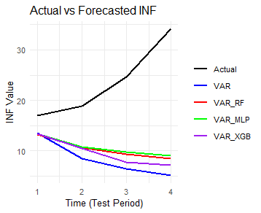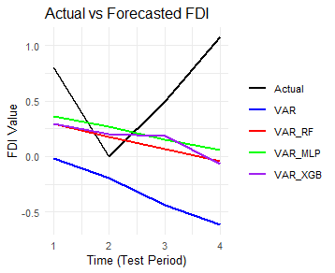
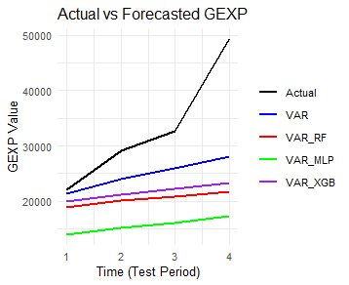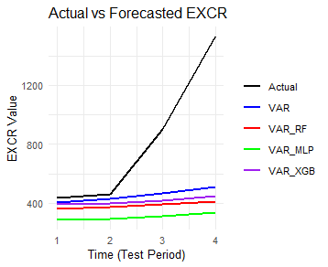
Figure 2. Out-of-Sample Forecast of the Enhanced VAR with Machine Learning Models in Nigeria

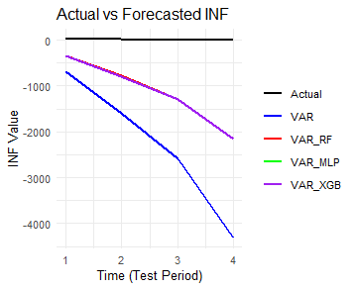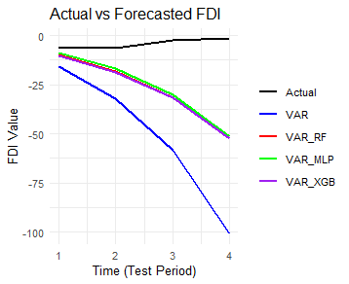
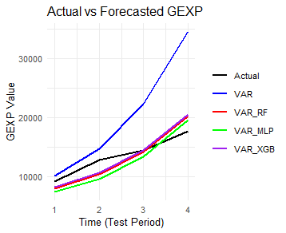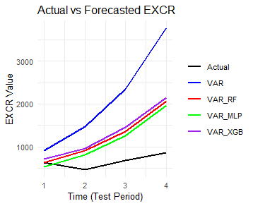
Figure 3. Out-of-Sample Forecast of the Enhanced VAR with Machine Learning Models in Angola
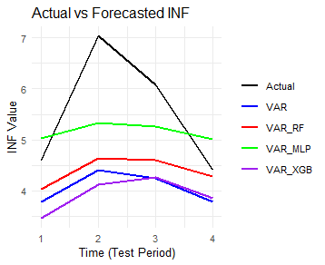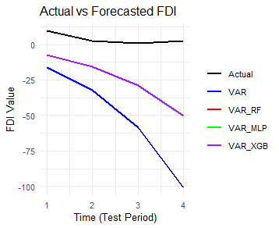
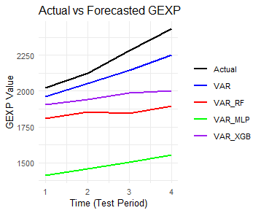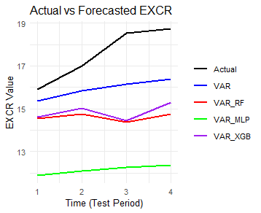
Figure 4. Out-of-Sample Forecast of the Enhanced VAR with Machine Learning Models in South Africa

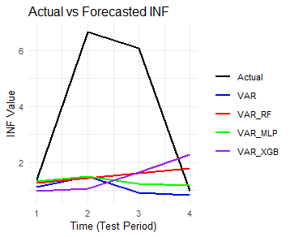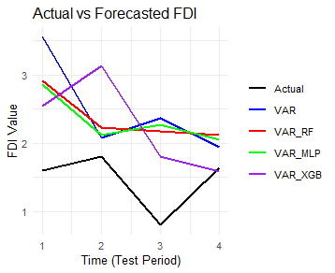
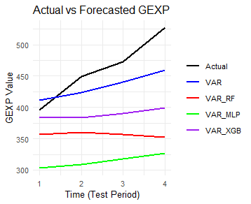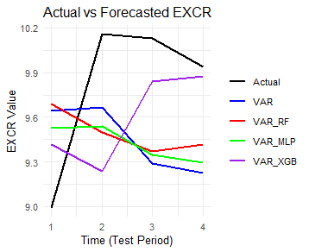
Figure 5. Out-of-Sample Forecast of the Enhanced VAR with Machine Learning Models in Morocco
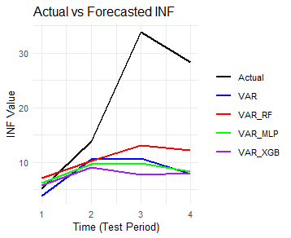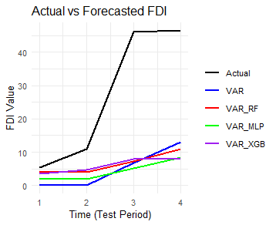
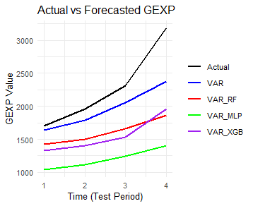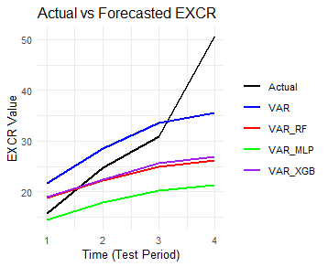
Figure 6. Out-of-Sample Forecast of the Enhanced VAR with Machine Learning Models in Egypt

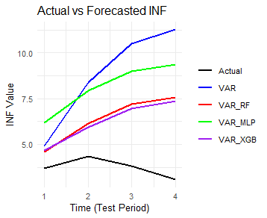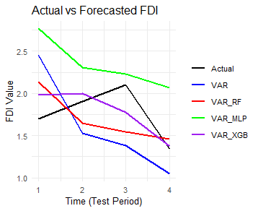
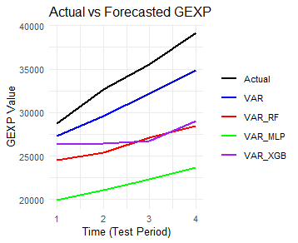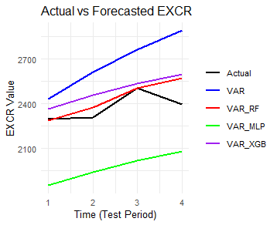
Figure 7. Out-of-Sample Forecast of the Enhanced VAR with Machine Learning Models in Tanzania
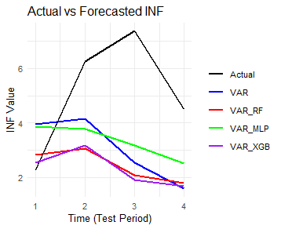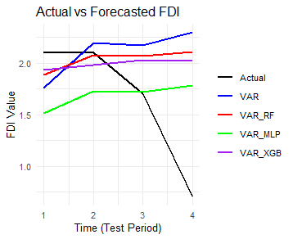
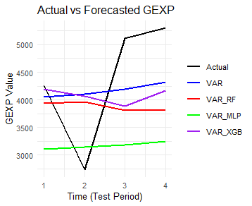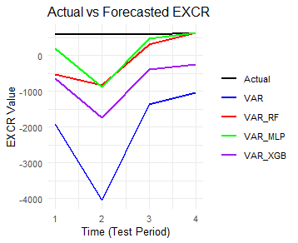
Figure 8. Out-of-Sample Forecast of the Enhanced VAR with Machine Learning Models in Cameroon

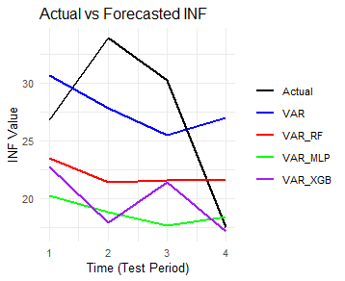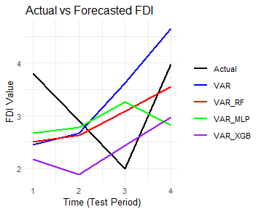
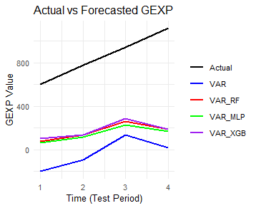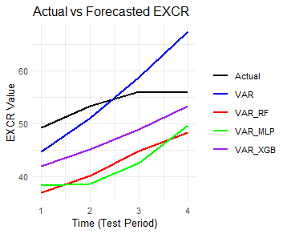
Figure 9. Out-of-Sample Forecast of the Enhanced VAR with Machine Learning Models in Ethiopia

4. Conclusion
This study set out to examine whether integrating machine learning techniques with the traditional Vector Autoregression (VAR) framework could enhance the forecasting and causal analysis of key macroeconomic indicators in African economies. The indicators under consideration, inflation, foreign direct investment, government expenditure, and exchange rates, were analysed across eight countries using a comparative evaluation of the classical VAR model and its hybrid extensions with Random Forest (RF), Multilayer Perceptron (MLP), and Extreme Gradient Boosting (XGBoost).
The results demonstrate that machine learning integration can significantly improve the performance of VAR models, particularly for indicators with high volatility and nonlinear dynamics. Inflation and FDI forecasts benefited the most from hybridisation, with VAR+MLP and VAR+RF consistently outperforming the classical VAR in several countries. Exchange rate forecasting also improved in countries with more volatile external environments, such as Angola, Tanzania, Cameroon, and Morocco, underscoring the advantage of nonlinear learning methods in capturing complex market shocks. Conversely, government expenditure was more effectively modelled by the traditional VAR in most cases, suggesting that structurally determined fiscal patterns are better represented by linear temporal relationships.
Importantly, the findings highlight that the effectiveness of VAR–machine learning hybrids is not uniform across indicators or countries. Instead, the gains are context-specific, reflecting the structural, institutional, and economic dynamics unique to each economy. This reinforces the need for tailored modelling strategies rather than a one-size-fits-all approach when applying machine learning in macroeconomic analysis.
However, enhancing VAR with machine learning techniques provides a more robust framework for capturing both linear and nonlinear causal relationships in African macroeconomic systems. By extending the predictive and explanatory power of VAR, the hybrid models contribute to more accurate short-term forecasting and deeper insights into the causal drivers of economic performance. This has important implications for policy design, as reliable forecasts of inflation, FDI, government spending, and exchange rates are critical for stabilisation strategies, investment planning, and sustainable economic growth across the continent.
Disclaimer (Artificial intelligence)
Author(s) hereby declare that NO generative AI technologies such as Large Language Models (ChatGPT, COPILOT, etc.) and text-to-image generators have been used during the writing or editing of this manuscript.

References
Amoah, E., Nyarko, E., & Asare, K. (2015). FDI, inflation, exchange rate and growth in Ghana: Evidence from causality and co-integrated analysis. European Scientific Journal, 11(31), 294-304.
Athey, S. (2018). The impact of machine learning on economics. In The economics of artificial intelligence: An agenda (pp. 507-547). University of Chicago Press.
Chen, Y., Lyulyov, O., Pimonenko, T., & Kwilinski, A. (2024). Green development of the country: Role of macroeconomic stability. Energy & Environment, 35(5), 2273-2295.
Gbadegesin, T. K., & Yameogo, N. D. (2024). Evaluating the Economic Impacts of the G20 Compact Initiative: Evidence from Causal Inference Using Advanced Machine Learning Techniques. Journal of Sustainable Development, 17(5), 1-56.
Kumar, A., Dodda, S., Kamuni, N., & Arora, R. K. (2024, May). Unveiling the impact of macroeconomic policies: A double machine learning approach to analyzing interest rate effects on financial markets. In 2024 3rd International Conference on Artificial Intelligence For Internet of Things (AIIoT) (pp. 1-6). IEEE.
Lütkepohl, H. (2013). Vector autoregressive models. In Handbook of research methods and applications in empirical macroeconomics (pp. 139-164). Edward Elgar Publishing.
Mullainathan, S., & Spiess, J. (2017). Machine learning: an applied econometric approach. Journal of Economic Perspectives, 31(2), 87-106.
Neghab, D. P., Cevik, M., Wahab, M. I. M., & Basar, A. (2025). Explaining exchange rate forecasts with macroeconomic fundamentals using interpretive machine learning. Computational Economics, 65(4), 1857-1899.
Nasir, Z. M. (2022). Macroeconomic factors shaping foreign direct investment inflows: Evidence from Pakistan. Journal of Business and Economic Options, 5(2), 29-35.
Ofori, I. K., Quaidoo, C., & Ofori, P. E. (2021). What drives financial sector development in Africa? Insights from machine learning. Applied Artificial Intelligence, 35(15), 2124-2156.
Olamide, E., Ogujiuba, K., & Maredza, A. (2022). Exchange rate volatility, inflation and economic growth in developing countries: Panel data approach for SADC. Economies, 10(3), 67.
Ramaharo, F., & Rasolofomanana, G. (2023). Nowcasting Madagascar's real GDP using machine learning algorithms. arXiv preprint arXiv:2401.10255.
Shi, L., Westerhuis, J. A., Rosén, J., Landberg, R., & Brunius, C. (2019). Variable selection and validation in multivariate modelling. Bioinformatics, 35(6), 972-980.
Usman, Z., & Landry, D. (2021). Economic diversification in Africa: How and why it matters. Available at SSRN 3842228.
Zahid, M. (2018). Economic misery, exchange rate, interest rate, and foreign direct investment: Empirical evidence from Pakistan. Journal of Policy Options, 1(2), 81-95.
Jolo, A. M., Ari, I., & Koç, M. (2022). Driving factors of economic diversification in resource-rich countries via panel data evidence. Sustainability, 14(5), 2797.
Buthelezi, E. M. (2024). Transformative pathways: understanding economic growth in Africa using the African Transformation Index. Cogent Economics & Finance, 12(1), 2426527.
Gozgor, G., & Paramati, S. R. (2022). Does energy diversification cause an economic slowdown? Evidence from a newly constructed energy diversification index. Energy Economics, 109, 105970.
COULIBALY, P. R., & DJEZOU, W. B. (2024). Economic Growth and Income Inequality in Sub-Saharan Africa: Does Environmental Policy Matter?. Journal of Economics, Management and Trade, 30(11), 63–71. https://doi.org/10.9734/jemt/2024/v30i111253

