Review Article

Bone Marrow Aspirate Concentrate in ACL reconstruction: Systematic Review and Meta-Analysis of Randomized Control Trials

.
ABSTRACT

Aims: Anterior Cruciate Ligament (ACL) tears often result in long-term instability and post-traumatic osteoarthritis. Bone Marrow Aspirate Concentrate (BMAC) has been proposed as a biological supplement to improve graft–bone healing, but its clinical effectiveness and cost-benefit ratio remain uncertain. This study provides a definitive synthesis of the therapeutic, functional, and safety outcomes of BMAC augmentation in primary ACL reconstruction (ACLR) based exclusively on randomized controlled trials (RCTs).
Study design: Meta Analysis of Randomized Control Trials
Methodology: This systematic review and meta-analysis was conducted according to PRISMA guidelines. We included six RCTs (N = 259) published up to August 15, 2025. Primary outcomes assessed included the Visual Analog Scale (VAS), Lysholm, International Knee Documentation Committee (IKDC), and Tegner scores, as well as adverse events. The study protocol was registered on PROSPERO (CRD420261304072).
Result: BMAC augmentation led to a statistically significant improvement in functional outcomes as measured by the IKDC score (MD 2.50; 95% CI: 0.89 to 4.11; P = .002), with no statistical heterogeneity (I² = 0%). While an improvement was also observed in the Lysholm score, it was only of borderline significance (MD 2.82; P = .05). Importantly, no significant difference was found in postoperative pain levels (VAS: MD 0.15; P = .26). The safety profile of BMAC was comparable to standard care, showing no increased risk of serious adverse events.
Conclusion: Although BMAC augmentation in ACLR provides a statistically detectable improvement in functional outcomes on the IKDC score, this gain may not reach the threshold for a Minimal Clinically Important Difference and does not translate into a reduction in patient pain. Given the associated procedural requirements and costs, the routine clinical adoption of BMAC is currently unsupported for the general patient population.

Keywords: ACL reconstruction, BMAC, Stem Cells

1. INTRODUCTION
Anterior cruciate ligament (ACL) tears represent a major clinical concern, particularly during non-contact activities such as deceleration, pivoting, or landing, which frequently occur in sports. Annually, more than 200,000 cases are reported in the United States, predominantly affecting younger, active individuals [1, 2]. If left untreated, ACL tears can result in diminished postural control, higher rates of meniscal injury, and earlier onset of osteoarthritis. Complete tears cause significant instability and disrupt the knee’s essential neurosensory pathways [3]. While surgical reconstruction with a tendon graft is the standard approach to restore mechanical stability, it does not replicate the original ligament’s complex biological and sensory functions. This permanent alteration in joint kinematics, combined with the initial inflammatory response, initiates a degenerative process that leads to articular cartilage deterioration [2, 4]. Consequently, post-traumatic osteoarthritis is a common long-term outcome for many patients within 15 years, even following technically successful surgery [1, 5].
ACL reconstruction presents a substantial biological challenge, specifically the integration of a soft-tissue graft within a hard-bone tunnel. This surgical interface differs fundamentally from the native ACL insertion site, or enthesis, which is characterized by a complex fibrocartilaginous zone that effectively dissipates stress between ligament and bone. In contrast, the reconstructed interface forms an abrupt connection that is susceptible to failure. The healing process is time-sensitive; although the graft is initially secured mechanically, long-term stability relies on gradual biological integration. During the early healing phase, the avascular graft undergoes "ligamentization," necessitating cellular repopulation and revascularization [1, 3]. This stage is marked by initial cell death and mechanical weakness. If biological fixation is delayed, micromotion at the graft-tunnel junction can generate shear stress, resulting in the development of weak fibrous scar tissue rather than robust fibrocartilage. This suboptimal healing is a primary contributor to tunnel widening, graft laxity, and reconstructive failure, with re-tear rates reaching up to 11.7% [2, 4, 5]. Stem cell therapy has been proposed as a targeted strategy to address these biological limitations.
BMAC is more than just a cell source; it is a complex autologous product designed to promote a better healing response [6–11]. Its therapeutic potential is broad. First, it provides a concentrated group of mesenchymal stem/stromal cells (MSCs), which have both direct and indirect healing effects. Directly, they can differentiate into the cartilage and bone cells necessary to create a more natural enthesis. Indirectly, they release signaling molecules that attract host repair cells, reduce the post-surgical inflammatory response, and promote the growth of new blood vessels, thereby speeding graft revascularization. VEGF is considered a key regulator in angiogenesis [12], and VEGF-driven angiogenesis from BMAC may facilitate bone-cartilage interactions and structural enhancement [13]. Second, BMAC contains a wealth of native growth factors (e.g., TGF-β, PDGF) and anti-inflammatory cytokines (e.g., IL-1Ra) that encourage cell growth and matrix creation while reducing harmful effects that lead to scar tissue and joint damage. TGF-β1 [14] and interleukin-10 (IL-10) are key regulators of immune homeostasis [15,16] and are involved in cartilage repair and tissue integrity [17,18]. The main idea is that by delivering this powerful biological toolkit directly to the healing area, BMAC can promote true tissue regeneration rather than fibrous scarring [6, 7, 9–11].
Despite a compelling biological rationale, a substantial gap remains between experimental research and clinical implementation, and the use of BMAC in ACL reconstruction continues to be debated. Early clinical investigations have yielded inconsistent and sometimes contradictory findings, contributing to uncertainty among clinicians and patients. This variability is likely attributable to the absence of standardized protocols for BMAC preparation, resulting in differences in cell concentration, viability, application techniques, and patient selection [6, 7, 9–11]. Additionally, BMAC is approximately four times more expensive than other biological products, with a cost of about $3,000 USD per procedure, underscoring the need for robust, evidence-based guidance [2, 19]. The current literature does not provide adequate data to inform clinical practice guidelines. Consequently, a comprehensive synthesis of high-quality evidence from randomized controlled trials (RCTs) is required to address this clinical question.

2. Material and methods
This systematic review and meta-analysis were conducted using the standards provided by the Preferred Reporting Items for Systematic Reviews and Meta-analysis (PRISMA), which may be found at http://www.prisma-statement.org/ (Fig. 1). The protocol of this study was already registered on PROSPERO (CRD420261304072)
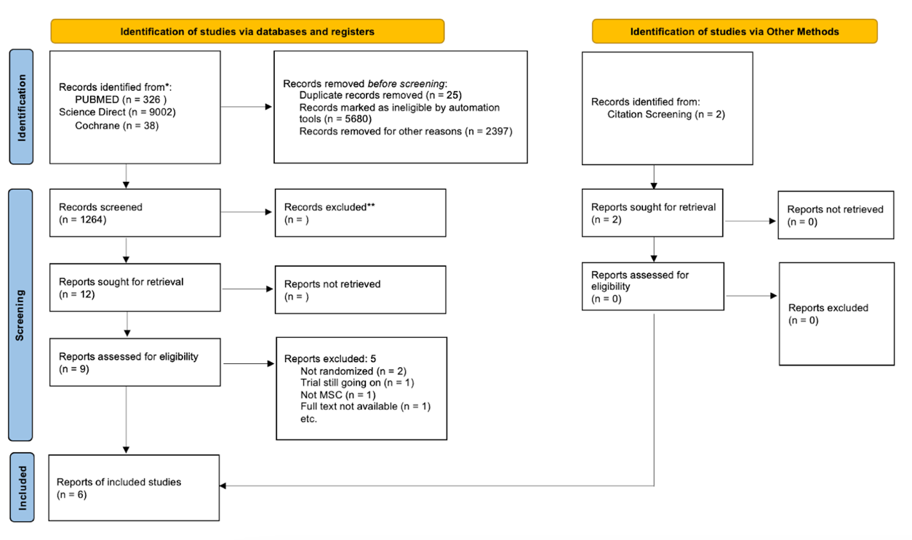
Fig. 1. PRISMA Chart

2.1 Eligibility Criteria
We included studies that met the following criteria: (1) RCTs; (2) skeletally mature patients or patients aged 18 or older; (3) patients with partial or complete ACL tears undergoing primary ACL reconstruction; (4) use of any autograft or allograft (5) incorporation of Mesenchymal Stem Cell for biological augmentation; (6) minimum follow-up of three months; and (7) reporting of at least one primary or secondary outcome. Studies were excluded if they met any of the following criteria: (1) use of synthetic grafts or xenografts; (2) non-English publications; (3) literature with incomplete data; and (4) abstract only.
2.2 Information Sources
A comprehensive literature search was conducted using the following databases and sources: science direct, PubMed, and Cochrane Library. The last search was performed on 15 august 2025
2.3 Search Strategy
We conducted individual searches of papers from PubMed, Cochrane Central Register of Controlled Trials (CENTRAL), and Science Direct using Boolean operators, namely: (”Stem Cell” OR “wharton's jelly” OR “Mesenchymal Stem Cell” “Stromal Cell” OR “Bone Marrow Stem Cell”) AND (”ACL” OR “Anterior Cruciate Ligament” OR “Cruciate Ligament” OR “Knee Ligament” OR “ACL Reconstruction” OR “ACL Repair”) The authors incorporated several Medical Subject Headings (MeSH) in combination with supplementary free-text terms were employed to construct a comprehensive and sensitive search strategy tailored to the selected electronic databases. The inclusion and exclusion criteria were predefined prior to the commencement of the literature search and were formulated in accordance with the PICO (Population, Intervention, Comparison, Outcome) framework (Table 1). This structured approach ensured methodological rigour and transparency in study selection.
No restrictions were imposed with respect to language during the database search, thereby minimising the risk of language bias and enhancing the comprehensiveness of the review. In addition, the reference lists of all included studies were systematically screened to identify further relevant publications. Following retrieval, all records were exported to reference management software, where duplicate entries were identified and removed. The remaining studies were subsequently assessed against the predefined eligibility criteria to confirm their suitability for inclusion in the review.

Table 1 . PICO Analysis
PICO | Explanation
Population | Patient undergo ACL reconstruction
Intervention | BMAC added during and/or after procedure
Comparison | placebo / without stem cell treatment
Outcome | functional scoring
Study design | RCTs

2.4 Selection Process
Titles and abstracts were screened independently in Rayyan application by reviewer to determine study eligibility. Full-text articles were then assessed against inclusion and exclusion criteria.
2.5 Data Collection Process
Data extraction was performed by two independent reviewers using a standardized data extraction form. Any disagreements among the investigators were addressed later, after all duplicated studies had been resolved. The data were acquired using a specified reporting form. The chosen studies were transferred to a Google Sheet and subsequently evaluated for suitability through deliberation until a consensus was reached. The following information was extracted from eligible studies: authors' names, year of publication, trial protocol (if any), study design, number of samples, graft type, stem cell source, intervention dose, timing of the biologic, duration of treatment, and the outcome.
2.6 Data Items
2.6.1 Primary Outcomes
The primary outcomes assessed were: VAS score, lysholm score, and IKDC score). Data for all relevant outcome measures were collected.
2.6.2 Other Variables
Additional variables extracted included adverse events. If data were missing or unclear, the following assumptions were made: the corresponding authors were contacted.
2.7 Study Risk of Bias Assessment
2.7.1 Quality assessment
The assessment of bias was conducted using the Cochrane Risk of Bias Tool (RoB 2.0) Scale for randomized controlled trials (Fig. 2). The tool evaluates a study across five key domains in which bias can be introduced. For each domain, a series of signaling questions is used to assess the risk of bias (low, some concerns, or high).
The Five Domains of Bias include:
1. Bias arising from the randomization process
2. Bias due to deviations from intended interventions
3. Bias due to missing outcome data
4. Bias in the measurement of the outcome
5. Bias in the selection of the reported result
By evaluating a study across these domains, the Cochrane tool provides a systematic, transparent way to identify potential flaws and assess the reliability of its findings.
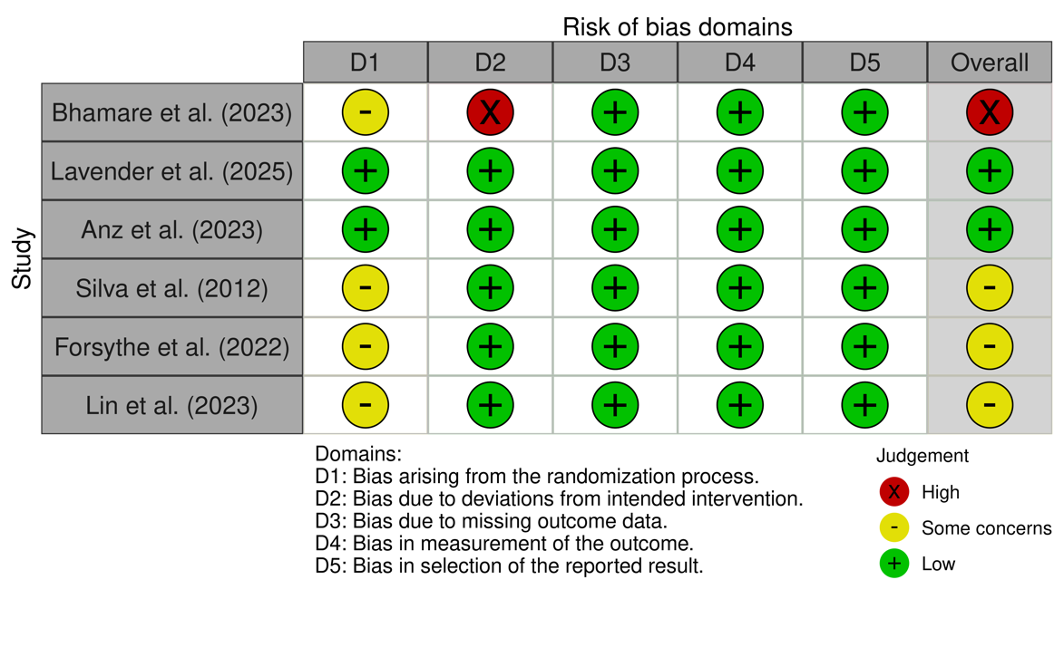
Fig 2. Risk of Bias Assesment

2.7.2 Quantitative analysis
A quantitative pooled meta-analysis was undertaken when data from multiple studies demonstrated sufficient homogeneity in terms of outcome measures and methodological characteristics. Statistical analyses were performed using Review Manager (RevMan) version 5.4 (The Cochrane Collaboration, The Nordic Cochrane Centre, Copenhagen, Denmark).
For continuous outcomes, the inverse-variance method was applied to estimate the mean difference (MD) along with its corresponding standard deviation (SD). The pooled effect size was expressed as the MD with a 95% confidence interval (CI), enabling comparison of the efficacy between the two interventions under investigation.
Dichotomous safety outcomes were analysed by calculating the risk ratio (RR) with corresponding 95% CIs. Statistical significance was defined as a two-sided P-value of less than 0.05. This analytical approach ensured a robust and standardised synthesis of the available evidence, facilitating reliable interpretation of both efficacy and safety endpoints.
3. results and discussion
3.1 Results
The systematic search identified 1,264 records, of which six randomized controlled trials (RCTs) met the eligibility criteria for final inclusion. These studies evaluated a total of 124 patients undergoing primary ACL reconstruction with autologous bone marrow aspirate concentrate (BMAC) vs 135 control (N=259), in which for baseline characteristic of the included studies shown on (Table 2).
Table 2. Baseline Characteristic of The Included RCTs Studies
No | Authors | Year | Study Design | Sample | Graft |  | Stem cell |  |  |  | Timing of biologics | Duration of treatment
 |  |  |  |  | Type | Origin | Type | Origin | Source | Dose | Timing of biologics | Duration of treatment
1 | Adam Anz et al | 2023 | prospective, single-blinded, randomized controlled  trial | 20 patients in the BMAC group & 20 patients in the control group | BTB / hamstring | Autograft | BMAC | autologous | distal  femur, the anterior iliac crest, or the posterior iliac  crest | 2mL | intraoperative | 24 month
2 | Bhamare | 2023 | RCT | 15 patients in the BMAC group & 15 patients in the control group | quadrupled | Autograft | BMAC | autologous | ipsilateral iliac crest | 3mL | intraoperative | 24 month
3 | Forsythe et al. | 2022 | Double-blinded, randomized controlled trial. | 36 patients in the BMAC group and 37 patients in the control group. | BTB | allograft | BMAC | autologous | iliac crests | 2.5 mL | intraoperative | 12 month
4 | Lavender et al. | 2025 | A single-blinded, prospective RCT | 29 patients in the augmented group: BMAC, demineralized bone matrix  (DBM), and mechanical augmentation (suture tape  augmentation [STA]) and 30 patients in the non-augmented group (group NA). | quadriceps  tendon | <25 years old: Autograft ; >=25years old: GraftLink Allograft | BMAC | autologous | proximal lateral tibia | 3mL | intraoperative | 24 month
5 | Lin et al | 2024 | RCT double blind | 9 patients in the combination of BMAC and PRP group ; 8 patients in the PRP group ; 10 patients in the control group | hamstring | Autograft | BMAC | autologous | proximal tibia area | NR | intraoperative | 12 month
6 | Bhamare | 2023 | RCT | 15 patients in the BMAC group & 15 patients in the control group | hamstring | Autograft | BMAC | autologous | ipsilateral iliac crest | 3ml | intraoperative | 9 month

This meta-analysis found no statistically significant difference in Visual Analog Scale (VAS) scores between the BMAC and control group following ACLR (Table 3). The overall pooled Mean Difference (MD) was 0.15 with a 95% Confidence Interval (CI) of -0.11 to 0.40. Because the CI crosses the no-effect (zero) line and the overall effect (P = .26) is not statistically significant, the result indicates that mesenchymal stem cell treatment did not lead to greater improvement in pain scores than the control. The analysis revealed moderate to substantial heterogeneity among the studies (I² = 59%, P = .003), indicating that the observed treatment effects varied considerably across studies or time points. This significant variability suggests that underlying differences in study protocols or patient populations may be influencing the outcomes, thus warranting caution when interpreting the pooled result.

Table 3. Comparison of VAS score overtime
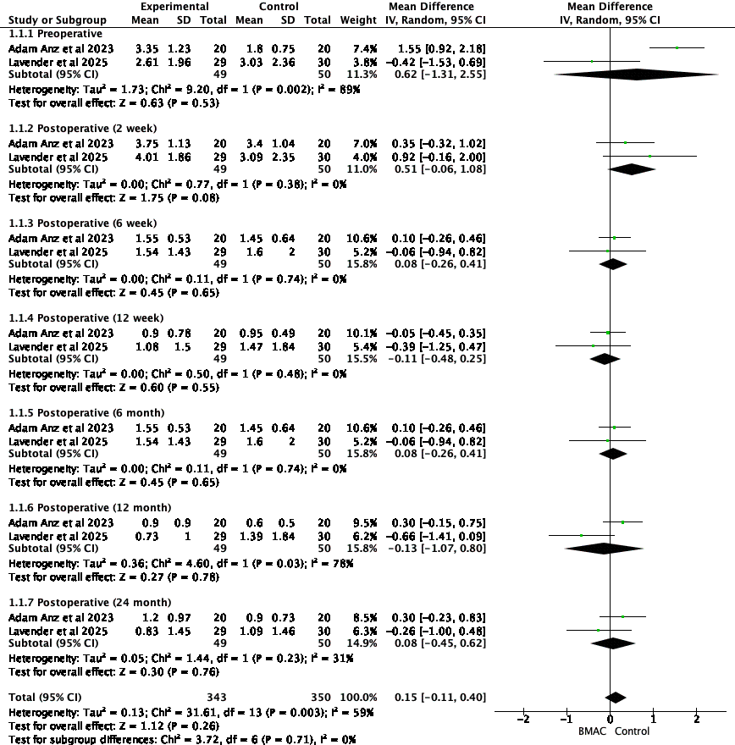

The IKDC score shows a statistically significant improvement in patients receiving BMAC compared to the control group after ACLR (Table 4). The overall pooled Mean Difference (MD) was 2.50 with a 95% Confidence Interval (CI) of 0.89 to 4.11. Since the entire confidence interval is above zero (P = .002), the result is statistically significant. This implies that BMAC treatment results in a better functional outcome, as measured by the IKDC score. Importantly, the analysis shows no statistical heterogeneity among the studies (I² = 0%, P = .77), indicating that the positive treatment effect was consistent across the different studies and time points. This homogeneity strengthens the validity of the conclusion that BMAC therapy provides a significant benefit in functional recovery after ACLR.

Table 4. Comparison of IKDC score overtime
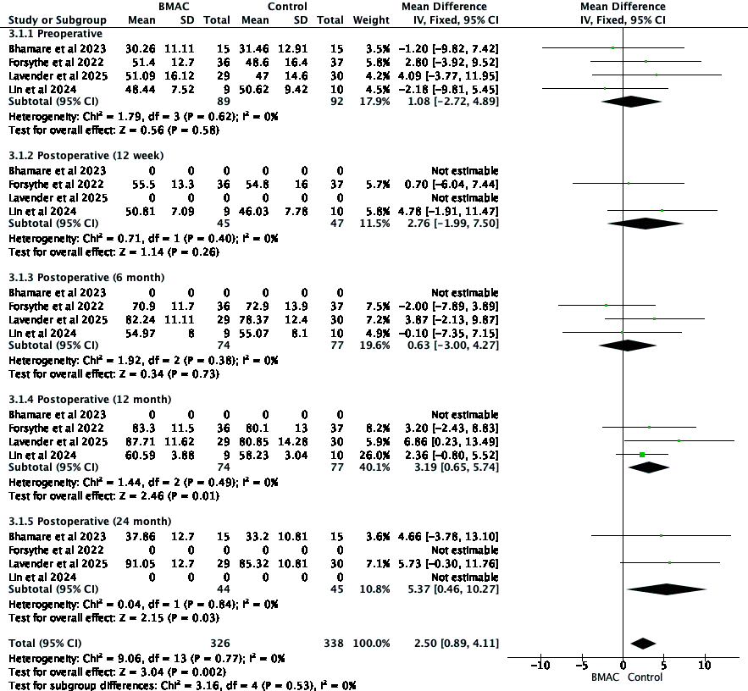

The Lysholm score shows improved functional outcomes with BMAC, though the result is borderline statistically significant (Table 5). The overall pooled Mean Difference (MD) was 2.82 in favor of the BMAC group, with a 95% Confidence Interval (CI) of -0.06 to 5.71. Because the CI just crosses the line of no effect (P = .05), the finding does not meet the conventional threshold for statistical significance. This suggests a potential positive effect that warrants further investigation but cannot be definitively concluded from this analysis. The study showed low heterogeneity (I² = 19%, P = .29), implying that the treatment effects were largely consistent across the included studies, which adds confidence to the precision of the pooled estimate.

Table 5. Comparison of Lysholm score overtime
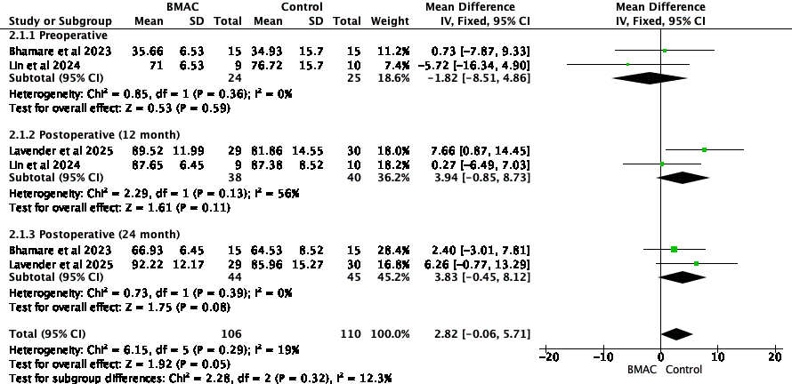

Lastly, the Tegner activity scale score shows no statistically significant difference in functional outcomes between patients receiving BMAC and those in the control group after ACLR. The overall pooled MD was negligible at .07, with a 95% confidence interval (CI) of [-0.28, 0.41] (Table 6). Because the CI broadly crosses the line of no effect (zero) and the P = .71, there is no evidence to suggest that stem cell therapy improves or worsens patients' return to physical activity levels. The analysis showed low heterogeneity (I2 = 21%, P = .28), indicating consistency across the included studies. This consistency reinforces the overall conclusion that, based on the available evidence, BMAC does not have a significant impact on the Tegner activity score.

Table 6. Comparison of Tegner score overtime
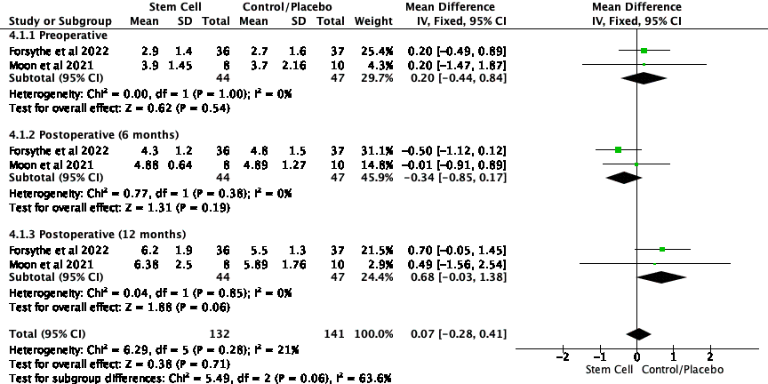

3.2 Discussion
This systematic review and meta-analysis (SRMA) evaluates the therapeutic efficacy of BMAC augmentation in ACL reconstruction (ACLR). The need for such an analysis is highlighted by persistent challenges in achieving reliable graft-to-bone healing after ACLR, with re-rupture rates as high as 11.7%. Additionally, post-traumatic osteoarthritis remains a frequent long-term complication following ACL injury, irrespective of treatment modality [2,4,5]. BMAC utilizes mesenchymal stem cells (MSCs), which are capable of self-renewal, multilineage differentiation, immunomodulation, and tissue regeneration. Bone marrow serves as a primary source of these cells, which exhibit homing properties to sites of injury and secrete growth factors that facilitate tissue repair. Although there is broad scientific consensus regarding the biological potential and procedural safety of BMAC, a notable gap persists between preclinical promise and clinical evidence. It is widely recognized that standard surgical reconstruction restores mechanical stability but does not replicate the native ligament’s complex biological and neurosensory functions, often resulting in progressive joint degeneration [2,3,9,10,19]. While autologous MSCs have demonstrated efficacy in animal models, their clinical application requires an additional invasive harvesting procedure. The present meta-analysis demonstrates that BMAC augmentation yields a statistically significant improvement in functional outcomes, as measured by the IKDC score at 12 and 24 months (MD 2.50, P = .002); however, this benefit does not extend to significant pain reduction (VAS, P = .26) and is only marginally significant for the Lysholm score (P = .05).
The finding of a statistically significant functional improvement without a corresponding reduction in pain aligns with previous research. Individual trials by Anz et al. (2023) and Lavender et al. (2025) also found no significant difference in pain between augmented and control groups. This disconnect suggests the benefits of BMAC are likely driven by enhanced biological healing rather than direct pain modulation. One potential advantage is improved structural integration; for instance, some studies indicate that BMAC may reduce bone tunnel enlargement, thereby enhancing knee stability and function without altering pain levels [9,10]. Conversely, the intervention is not without its drawbacks, as other studies have reported that BMAC may induce a greater early inflammatory response, potentially delaying graft maturation and widening the tendon-bone interface, which could temper its overall benefits. The borderline significance of the Lysholm score further supports the conclusion that the functional benefit of BMAC is not overwhelmingly strong across all metrics. Although Lavender et al. (2025) reported significantly better Lysholm scores at one year, our pooled analysis indicates this effect is less consistent than that observed with the IKDC score [10,11].
The therapeutic effect of BMAC is attributed to the mechanism of action of its cellular components, particularly MSCs. These cells possess a "homing ability," allowing them to migrate directly to the site of injury within the bone tunnels and graft substance. Once at the target tissue, MSCs can exert their effects through two primary pathways. First, they have multidirectional differentiation potential, enabling them to transform into local cell types, such as chondrocytes and osteoblasts, to facilitate the formation of a fibrocartilaginous enthesis that mimics the native tendon-to-bone insertion. Second, they secrete a host of chemokines, cytokines, and growth factors that create a pro-regenerative microenvironment by resisting inflammation and promoting angiogenesis.
Regarding safety, the most frequently reported potential side effect in the literature was postoperative stiffness. However, analysis of the available data does not suggest that BMAC increases this risk [7,10,20,21]. In the trial by Lavender et al. (2025), the rate of reoperation for stiffness was not significantly different between the augmented (10%) and control (13%) groups, and the authors suggested that the rate was influenced by other surgical factors rather than the biologic itself [10]. Other studies reported no treatment-related serious adverse events, confirming a strong safety profile for the procedure.
The principal clinical implication of this meta-analysis is that, although BMAC augmentation is a safe intervention that yields a statistically significant improvement in postoperative function, this improvement does not reach clinical significance for the average patient. While BMAC may provide a more sustained effect compared to certain standard injections, the absence of superiority beyond the Minimal Clinically Important Difference (MCID) indicates that it should not supplant standard surgical techniques in the general population. Routine use of BMAC in all ACLR procedures is not justified by current evidence, particularly in light of increased operative time, higher costs, and potential donor-site morbidity associated with bone marrow aspiration. Clinicians should carefully consider the modest and likely imperceptible functional benefit relative to these procedural drawbacks. BMAC use may be most appropriate in select cases, such as elite athletes seeking marginal gains or patients at elevated risk for graft failure, where enhanced structural integration is desirable. Additionally, the potential for reduced bone tunnel widening may be relevant for patients at high risk for revision surgery, as it could facilitate future interventions [2,3,5–11,19].
This meta-analysis is strengthened by its exclusive inclusion of level-one RCTs; however, its conclusions must be viewed in light of the limitations of the included studies. A major weakness is the significant heterogeneity in augmentation techniques, with some studies using BMAC alone and others combining it with adjuvants such as PRP, demineralized bone matrix, or suture tape. Pooling these varied protocols may obscure the true effect of BMAC as a standalone treatment. A second critical limitation is the lack of standardization in the source of bone marrow and the final concentration of MSCs across studies, both of which are key variables that influence efficacy. Future research should therefore focus on large-scale, multicenter RCTs with standardized protocols for BMAC preparation and application, including the quantification of cellular content to understand the dose-response relationship. These trials should be powered to detect clinically meaningful differences and should stratify results by patient demographics to identify which populations, if any, derive the most benefit. Finally, long-term follow-up beyond 2 years is essential to determine whether the subtle functional and radiographic benefits observed in some studies translate into improved graft survival rates and a reduced incidence of post-traumatic osteoarthritis.

Table 7. Adverse Event
Study | Time | Complication | BMAC Group, n(%) | Control Group, n(%)
Lavender et al | 6 weeks | Stiffness; release by arthroscopic and Manipulation Under Anesthesia (MUA) | 2 (6.9) | 2 (6.7)
 |  | Stiffness; release by MUA only | 1 (3.4) | 2 (6.7)
Lin et al | not reported | not reported
Adam Anz et al | none | none
Bhamare | not reported | not reported
Forsythe et al. | not reported | not reported
Moon et al. | none | none

4. CONCLUSION
Augmenting ACL reconstruction with BMAC results in a statistically significant improvement in functional outcomes, as measured by the IKDC score at 1 and 2 years. However, this improvement does not meet the established threshold for a minimal clinically important difference, suggesting it may not be perceptible to the average patient. Furthermore, the functional gain does not correspond with a significant reduction in postoperative pain. The procedure demonstrates a safety profile comparable to that of standard reconstruction, with no evidence of increased risk of adverse events, such as postoperative stiffness.

Disclaimer (Artificial intelligence)
The authors used generative AI tools (e.g., language models) to assist with language editing and manuscript text refinement. The authors confirm that all scientific content, study design, data analysis, interpretation of results, and conclusions were conceived, critically reviewed, and approved by the authors, who take full responsibility for the integrity and accuracy of the work.

REFERENCES
[1] Musahl V, Karlsson J. Anterior Cruciate Ligament Tear. New England Journal of Medicine 2019. https://doi.org/10.1056/NEJMcp1805931.
[2] Moon SW, Park S, Oh M, Wang JH. Outcomes of human umbilical cord blood-derived mesenchymal stem cells in enhancing tendon-graft healing in anterior cruciate ligament reconstruction: an exploratory study. Knee Surg Relat Res 2021;33:1–10. https://doi.org/10.1186/s43019-021-00104-4.
[3] Youn GM, Remigio Van Gogh AM, Alvarez A, Shin Yin SS, Chakrabarti MO, McGahan PJ, et al. Stem Cell–Infused Anterior Cruciate Ligament Reconstruction. Arthrosc Tech 2019;8:e1313–7. https://doi.org/10.1016/j.eats.2019.07.006.
[4] Fu X, Liu G, Halim A, Ju Y, Luo Q, Song G. Mesenchymal stem cell migration and tissue repair. Cells 2019;8. https://doi.org/10.3390/cells8080784.
[5] Wang Y, Shimmin A, Ghosh P, Marks P, Linklater J, Connell D, et al. Safety, tolerability, clinical, and joint structural outcomes of a single intra-articular injection of allogeneic mesenchymal precursor cells in patients following anterior cruciate ligament reconstruction: A controlled double-blind randomised trial. Arthritis Res Ther 2017;19:1–12. https://doi.org/10.1186/s13075-017-1391-0.
[6] Lin YC, Chen YJ, Fan TY, Chou PH, Lu CC. Effect of bone marrow aspiration concentrate and platelet-rich plasma combination in anterior cruciate ligament reconstruction: a randomized, prospective, double-blinded study. J Orthop Surg Res 2024;19:1–12. https://doi.org/10.1186/s13018-023-04512-y.
[7] Forsythe B, Chahla J, Bs AK, Lavoie-gagne O, Forlenza E, Ba CCD, et al. Bone Marrow Aspirate Concentrate Augmentation may Accelerate Allograft Ligamentization in Anterior Cruciate Ligament Reconstruction: A Double Blinded Randomized Controlled Trial. Elsevier 2022.
[8] Silva A, Sampaio R, Fernandes R, Pinto E. Is there a role for adult non-cultivated bone marrow stem cells in ACL reconstruction? Knee Surgery, Sports Traumatology, Arthroscopy 2014;22:66–71. https://doi.org/10.1007/s00167-012-2279-9.
[9] Anz AW, Jordan SE, Ostrander R V., Branch EA, Denney TS, Cohen A, et al. Augmentation of ACL Autograft Reconstruction With an Amnion Collagen Matrix Wrap and Bone Marrow Aspirate Concentrate: A Pilot Randomized Controlled Trial With 2-Year Follow-up. Orthop J Sports Med 2023;11:1–13. https://doi.org/10.1177/23259671231210035.
[10] Lavender CD, Schaver AL, Taylor S, Peluso R, Berdis G, Singh V, et al. Anterior Cruciate Ligament Reconstruction Augmentation With Bone Marrow Aspirate Concentrate, Demineralized Bone Matrix, and Suture Tape Shows No Difference in Outcomes—But Faster Functional Recovery—Versus Non-augmented Anterior Cruciate Ligament Reconst. Arthroscopy - Journal of Arthroscopic and Related Surgery 2025;41:1496–508. https://doi.org/10.1016/j.arthro.2024.06.042.
[11] Bhamare D, Nathani G, Shevate I, Deshmukh A. Functional outcome of anterior cruciate ligament reconstruction with hamstring graft along with augmentation of bone marrow aspirate concentrate. Medical Journal of Dr DY Patil Vidyapeeth 2023;16:329–32. https://doi.org/10.4103/mjdrdypu.mjdrdypu_648_20.
[12] Khallaf, S.M.; Mohammed, D.A.; ElNaggar, M.G.M.; Abdel-Hameed, M.R.; Bakry R. Predictive and prognostic values of serum VEGF in patients with multiple myelomas receiving bortezomib-based therapy. Annals of Oncology 2021. https://doi.org/10.1016/j.annonc.2021.08.139.
[13] Hernigou, J.; Vertongen, P.; Rasschaert, J.; Hernigou P. Role of Scaffolds, Subchondral, Intra-Articular Injections of Fresh Autologous Bone Marrow Concentrate Cells in Treating Human Knee Cartilage Lesions: Different Approaches and Different Results. Int J Mol Sci 2021.
[14] Abdel Hammed MR, Ahmed YA, Adam EN et al. sVCAM-1, and TGFβ1 in chronic phase, chronic myeloid leukemia patients treated with tyrosine kinase inhibitors. Egypt J Immunol 2022;29:163–73.
[15] Mohammed D, Khallaf S E-NM et al. Interleukin-10: A Potential Prognostic Marker in Patients with Newly Diagnosed Multiple Myeloma. Research in Oncology. Research in Oncology 2021. https://doi.org/10.21608/resoncol.2021.51503.1127.
[16] Fergany A, Hassanein KM, Zahran AM, Abdel Hameed MR, Kamel AM. Clinical significance of interleukin 10, interleukin 33, and interleukin 35 on induction chemotherapy in acute myeloid leukemia patients. The Egyptian Journal of Haematology 2025;50:125–32. https://doi.org/10.4103/ejh.ejh_83_24.
[17] Kim, G.B.; Seo, M.S.; Park, W.T.; Lee GW. Bone Marrow Aspirate Concentrate: Its Uses in Osteoarthritis. Int J Mol Sci 2020.
[18] Aggarwal S PMF. Human mesenchymal stem cells modulate allogeneic immune cell responses. Blood 2005;105:1815–22. https://doi.org/10.1182/blood-2004-04-1559.
[19] Han JH, Jung M, Chung K, Jung SH, Choi CH, Kim SH. Bone Marrow Aspirate Concentrate Injections for the Treatment of Knee Osteoarthritis: A Systematic Review of Randomized Controlled Trials. Orthop J Sports Med 2024;12:1–10. https://doi.org/10.1177/23259671241296555.
[20] Wei P, Bao R. Intra-Articular Mesenchymal Stem Cell Injection for Knee Osteoarthritis: Mechanisms and Clinical Evidence. Int J Mol Sci 2023;24. https://doi.org/10.3390/ijms24010059.
[21] Hur CI, Ahn HW, Seon JK, Song EK, Kim GE. Mesenchymal stem cells decrease tunnel widening of anterior cruciate ligament reconstruction in rabbit model. Int J Stem Cells 2019;12:162–9. https://doi.org/10.15283/ijsc18022.

