Case study

Outcomes and Complications of Spinal Deformity Correction Surgery: A Case Series .
ABSTRACT

Introduction: Spinal deformity correction surgery is indicated for progressive or severe deformities that cause pain, functional limitation, or cardiopulmonary compromise. Outcomes and complication profiles vary according to deformity etiology, curve magnitude, and perioperative management.

Case series: Three patients underwent spinal deformity correction surgery. Two female patients with adolescent idiopathic scoliosis (AIS) (Lenke 1 and Lenke 6B) presented with different chief complaints: one with back pain and the other with dyspnea. One male patient with ankylosing spondylitis (AS) presented with a painful kyphotic deformity. Surgical correction achieved substantial radiographic improvement in one AIS case (up to 75% Cobb angle reduction) and marked sagittal realignment in the AS case, while the severe double-curve case demonstrated partial correction. One patient developed a deep surgical site infection requiring debridement, antibiotics, and negative-pressure wound therapy.

Discussion: All patients demonstrated meaningful clinical improvement, including pain relief, improved mobility, and resolution of respiratory symptoms when present. Radiographic correction was consistent with published outcomes, although severe curves showed more limited correction. Complications were limited to one infectious event and minor sensory neurological sequelae, consistent with rates reported in the deformity surgery literature.

Conclusion: Spinal deformity correction surgery provides favorable outcomes across different deformity etiologies when appropriately indicated and managed. Individualized surgical planning, effective perioperative care, and early rehabilitation are critical to optimizing outcomes while minimizing complications.

Keywords: Spinal, Deformity Correction, AIS, AS, Outcomes
1. INTRODUCTION
Spinal deformities are defined as three-dimensional malalignments of the spine involving the coronal, sagittal, and/or axial planes.¹ The most common spinal deformity encountered in clinical practice is adolescent idiopathic scoliosis (AIS), accounting for approximately 56.7% of cases. This is followed by kyphotic deformities secondary to systemic inflammatory diseases, such as ankylosing spondylitis (AS). The incidence of spinal deformities has been reported to be 17.9 per 100,000 individuals.² Spinal deformities do not always cause symptoms and may remain mild and asymptomatic; however, progressive deformities can lead to chronic back pain, cosmetic concerns, impaired pulmonary function, and reduced quality of life.³ Scoliosis becomes clinically significant at a Cobb angle of 40–50°, where symptoms are more likely to occur.⁴ In ankylosing spondylitis, spinal rigidity and sagittal imbalance due to chronic inflammation can result in fixed kyphosis associated with pain, impaired horizontal gaze, and functional disability, often affecting young adults.⁵
Scoliosis severity can be quantified using the Cobb angle, which is measured between the most tilted vertebrae at the upper and lower ends of the spinal curve on standing radiographs. A diagnosis of scoliosis is established when the curvature exceeds 10°. This measurement is also used to monitor progression and to guide treatment thresholds.⁶ Skeletal maturity influences the risk of curve progression. Although reaching skeletal maturity does not eliminate the possibility of progression, studies have reported that more than 50% of skeletally mature patients may still experience curve progression. The Risser grade is commonly used to assess skeletal maturity by evaluating the ossification of the iliac apophysis on pelvic radiographs. Ossification is graded from 0 to 5, with lower grades indicating greater remaining growth potential and a higher risk of curve progression, while grade 5 indicates skeletal maturity.⁷
Surgical correction remains the definitive treatment for severe spinal deformities. For milder deformities, bracing and other conservative therapies may be considered.⁸˒⁹ The primary goals of treatment are to prevent progression and avoid functional deterioration. Indications for deformity correction surgery commonly include progressive curvature, functional impairment, and the need for postural correction. Surgical outcomes vary depending on the type and severity of the deformity, necessitating individualized treatment strategies.¹⁰ The Lenke classification is widely used to determine which curves require surgical correction and to guide the extent and levels of spinal fusion. It categorizes scoliosis into six curve types based on structural components and further incorporates lumbar modifiers and thoracic sagittal modifiers.¹¹
Deformity correction surgery is complex and carries multiple risks. Blood loss during spinal deformity surgery is often substantial, frequently exceeding 1,500 mL.¹² Neurological injury is rare, reported in less than 1% of cases in earlier studies,¹³ although more recent reports suggest that overall neurological complication rates may be higher.¹⁴ Other potential complications include deep infection, nonunion, cerebrospinal fluid leak, and thromboembolism. Complication rates increase with longer operative times and more extensive tissue dissection.¹⁵ Surgical site infection is generally uncommon, but when it occurs it can prolong recovery and increase morbidity. Therefore, careful perioperative monitoring—particularly in the postoperative period—is essential to optimize long-term outcomes.¹⁶
This case series reports three patients undergoing deformity correction surgery. The first patient was a 22-year-old woman with right thoracic AIS (Lenke 1CN; thoracic Cobb angle 60°). The second patient was a 25-year-old woman with severe double-curve scoliosis (Lenke 6B; thoracic Cobb angle 57° and lumbar Cobb angle 109°). The third patient was a 25-year-old man with fixed thoracolumbar kyphosis due to long-standing ankylosing spondylitis. Each patient required individualized surgical strategies and postoperative management. This case series aims to compare these cases with current evidence on deformity correction, highlighting indications and outcomes across different etiologies of spinal deformity.

2. CASE SERIES
Clinical outcomes were assessed using pain intensity (VAS), neurological status (motor and sensory examination), mobility milestones (sitting, standing, ambulation), and respiratory symptom changes when present. Pain (VAS) and neurological status were recorded daily during hospitalization. Mobility milestones (sitting, standing, and ambulation) were documented by postoperative day, and follow-up clinical status was obtained at the first outpatient visit, 2 weeks, 1 month, and 3 months when available. Standardized patient-reported outcome measures (e.g., SRS-22r/ODI) were not consistently available due to the retrospective nature of the cases and are acknowledged as a limitation. Radiographic correction was calculated using the formula: (preoperative value − postoperative value) / preoperative value × 100%. For Case 2, lumbar correction was (109° − 74.06°) / 109° × 100% = 32.1%. The thoracic curve showed no improvement on the early postoperative standing radiograph (57° preoperatively to 62.56° postoperatively); therefore, it is reported as “no correction on early postoperative measurement” rather than a percentage reduction.
Postoperative rehabilitation followed a staged institutional protocol. On postoperative day (POD) 0–1, patients received positioning education and log-rolling techniques, early range-of-motion (ROM) exercises for the extremities, and respiratory exercises (deep-breathing and chest expansion training), as clinically tolerated. From POD 2–4, rehabilitation progressed to sitting at the bedside and transfer training, followed by gradual standing practice. From POD 5 onward, ambulation training was initiated with assistance and continued progressively according to pain control, neurological status, and hemodynamic stability. A thoracolumbosacral orthosis (TLSO) was used during mobilization when prescribed. Key mobility milestones (sitting, standing, and ambulation) were recorded by postoperative day and were reported at follow-up visits.
Wound care included sterile skin preparation, perioperative intravenous antibiotic prophylaxis, meticulous hemostasis and soft-tissue handling, and routine postoperative wound assessment. When deep SSI was suspected, management consisted of early surgical debridement, microbiological culture, and culture-directed antibiotics; negative-pressure wound therapy was used as an adjunct in cases with persistent drainage or wound complications.³⁰

2.1. CASE 1
A 22-year-old woman presented with back pain and a sensation that her back was “crooked,” which she had experienced for approximately 7 years (since 2015). She had not sought medical attention for these complaints previously. She reported that the spinal curvature had progressively worsened over time. She also frequently experienced stiffness on the right side of her back when sitting for prolonged periods. The patient denied shortness of breath, a sensation of heaviness, tingling, or weakness in the upper or lower extremities. She also denied bowel or bladder dysfunction. There was no history of prior trauma and no family history of scoliosis. The patient worked as a pharmacist assistant at a community health center.
On physical examination of the thoracolumbar region, inspection revealed a spinal deformity with rib hump and pelvic tilt. Palpation showed no midline tenderness, and sensory examination was normal. Motor function was within normal limits. Shoulder tilt measured 2 cm to the left, and the plumb line was deviated 1 cm to the right. A rib hump of 2 cm to the right was noted. The body-arm distance was 2 cm on the right and 0 cm on the left, and pelvic tilt measured 2 cm to the left. Scoliometer assessment showed an angle of trunk rotation of 14.1°. The patient’s height was 155 cm and her weight was 50 kg.
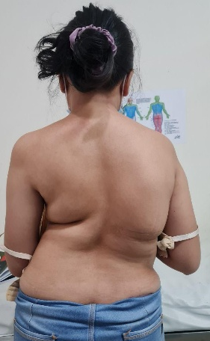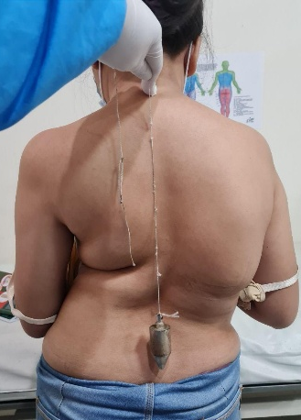
Figure 1. Clinical Picture of Patient 1.
Radiographic evaluation at Negara Hospital with thoracolumbar X-ray demonstrated a curve apex at T8 with a Cobb angle of 55°, right bending of 30°, left bending of 65°, and a Risser grade of 5. A follow-up thoracolumbar X-ray at Prof. Ngoerah Hospital showed an apex at T9, with T4 as the upper end vertebra and L1 as the lower end vertebra. The Cobb angle measured 60°, with right bending of 31° and left bending of 63°. An anteroposterior (AP) pelvic radiograph confirmed Risser stage V. The patient was assessed as having adolescent idiopathic scoliosis (AIS), Lenke type 1CN, Risser stage V. The patient underwent posterior spinal deformity correction with instrumentation and fusion; however, the exact fusion levels and any osteotomy details were not consistently documented in the available operative records for this retrospective series.
Intraoperatively, the estimated blood loss was 1,800 mL, and the patient received two units of packed red cells (PRC). Following spinal deformity correction surgery, the patient regained consciousness uneventfully. Postoperative wound pain was well controlled with a visual analog scale (VAS) score of 2–3. Motor function was intact in all four extremities. The patient denied weakness, numbness, or tingling in the upper and lower limbs and reported no additional complaints. Inspection of the thoracolumbar region showed a clean, dry dressing without leakage, and minimal drainage was noted in the drain tube at 2 hours postoperatively. Palpation revealed tenderness at the surgical site, with no hypoesthesia or anesthesia.

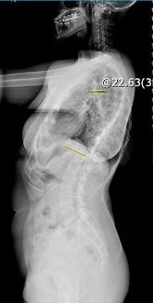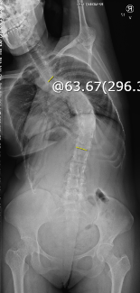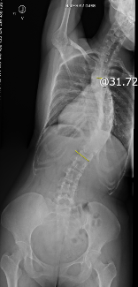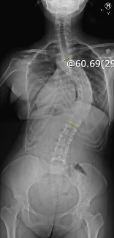
Figure 2. Scoliosis Series of Patient 1.
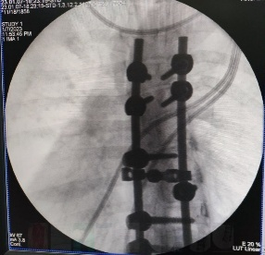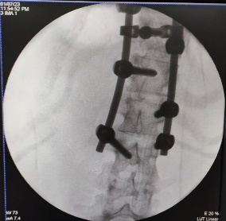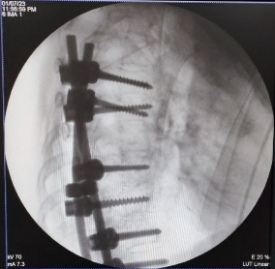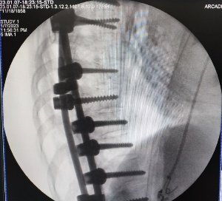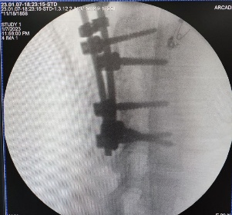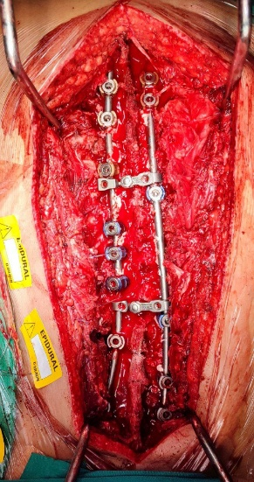
Figure 3. Surgical Site Picture and Intraoperative fluoroscopy (C-arm) during surgery (Patient 1).
Postoperative management included ceftriaxone 1 g IV twice daily, tranexamic acid 500 mg IV three times daily, vitamin K 2 mg IV three times daily, omeprazole 40 mg IV twice daily, and methylcobalamin 500 mg IV three times daily. Analgesia provided by the anesthesiology team consisted of an epidural infusion of 0.1% bupivacaine combined with morphine 1 mg in 10 mL administered every 12 hours, along with oral paracetamol 500 mg every 6 hours. The patient was also scheduled for postoperative complete blood count monitoring, PRC transfusion if hemoglobin (Hb) was <10 g/dL, postoperative radiography, mobilization with a thoracolumbosacral orthosis (TLSO), consultation with a rehabilitation medicine specialist, and wound care on postoperative day 3 or earlier if dressing leakage occurred.
On postoperative day 1, the patient was able to void via a urinary catheter. Anemia was identified, and additional PRC transfusions were administered with a target Hb >10 g/dL. The patient was also scheduled for radiographic evaluation. On postoperative day 2, the patient reported abdominal bloating since the previous night, with no passage of flatus and no bowel movement after surgery. She also complained of generalized pruritus, which was triggered by exposure to cold temperatures. At that time, the patient had received three units of PRC transfusion and was scheduled to receive an additional unit on the same day. She tolerated oral intake well and no longer required supplemental oxygen, maintaining an oxygen saturation of 99% on room air. The postoperative Cobb angle was 15.32°. Ongoing therapy was continued, with the addition of a Fleet enema suppository and loratadine 5 mg orally twice daily.
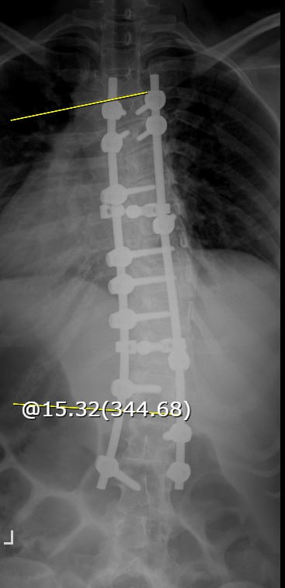
Figure 4. Cobb Angle post Operation 15.32°.
On postoperative day 3, the patient’s pruritus and abdominal bloating had improved. Her last bowel movement had occurred before the operation. Vitamin K was discontinued, and ceftriaxone was switched to oral cefixime 200 mg twice daily. PRC transfusions were stopped because the target hemoglobin level (10.0 g/dL) had been achieved. On postoperative day 4, the patient was able to void spontaneously and had a bowel movement the previous night. She was able to sit upright while leaning against the bed. The drain was removed, and the wound dressing remained dry without leakage. On postoperative day 5, the patient began ambulation exercises. Methylcobalamin was discontinued. On postoperative day 6, the patient was able to ambulate without pain. Abdominal bloating and pruritus had completely resolved. Loratadine and omeprazole were discontinued. Pain management was transitioned to oral paracetamol 500 mg four times daily. The thoracolumbosacral orthosis (TLSO) was completed and fitted on the same day, and the patient was scheduled for discharge.
At the first follow-up visit, 3 days after discharge, the patient reported improvement in postoperative pain. She was able to mobilize independently while using the TLSO. Cefixime was discontinued, and paracetamol was reduced to 500 mg orally three times daily as needed for pain. At the 2-week postoperative follow-up, the patient reported no pain, and there was no tenderness at the surgical site. Paracetamol was discontinued, and the sutures were removed. At the 1-month follow-up, a thoracolumbar radiograph was obtained for evaluation. At the 3-month follow-up, the patient was able to walk for one hour without pain and underwent repeat radiographic evaluation. At 7 months postoperatively, the patient was able to mobilize without assistance.
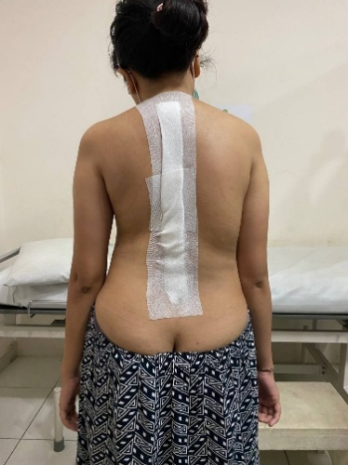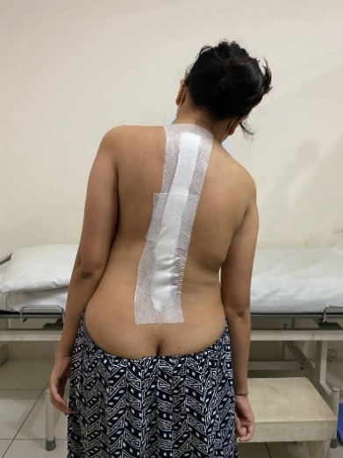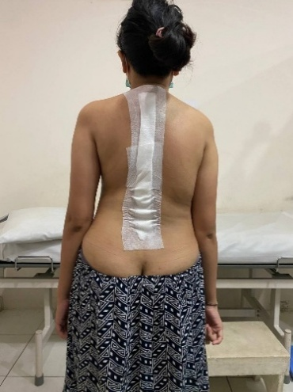
Figure 5. Post Operative Clinical Picture of Patient 1
2.2. CASE 2
A 25-year-old woman presented with a 1-year history of shortness of breath, which worsened with long-distance walking and improved with rest. She also reported spinal curvature that she had noticed since childhood. According to her parents, the curvature had been present since birth and had progressively worsened with age. She additionally complained of intermittent left-sided pain, which was aggravated by fatigue and prolonged sitting. She was unable to walk long distances due to pain and dyspnea. She denied numbness, tingling, or weakness in the upper or lower extremities. The patient was unable to bend forward because of back stiffness, and she walked with a limp, tiptoeing on her left foot. She denied bowel or bladder dysfunction and reported no prior history of trauma. She had never undergone a medical evaluation for her spinal condition. She was the first of eight siblings, and no other family members had similar complaints. Her mother reported using a corset during pregnancy to conceal the pregnancy and did not attend regular antenatal check-ups. The patient worked as a store cashier.
Physical examination of the thoracolumbar region revealed spinal deformity with a rib hump and pelvic tilt on inspection. Palpation showed no midline tenderness, and sensory examination was normal. Motor strength was within normal limits. Shoulder tilt was 0.5 cm to the left, the plumb line deviation was 2 cm to the left, and the rib hump measured 0.5 cm to the left. The body–arm distance was 0 cm on the right and 2 cm on the left. Pelvic tilt measured 7 cm to the left, and scoliometer assessment showed an angle of trunk rotation of 7°. The patient’s height was 120 cm and her weight was 50 kg.
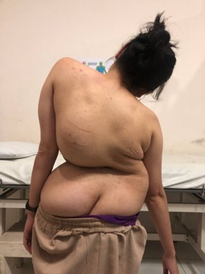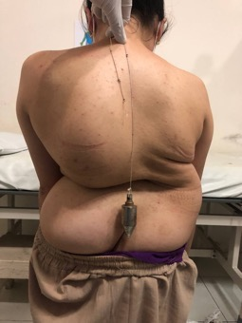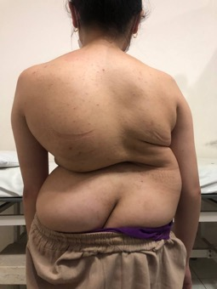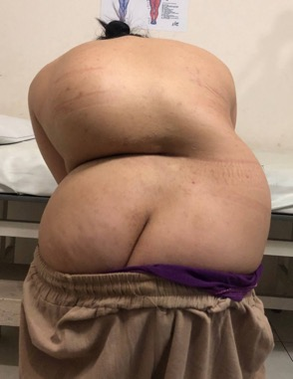
Figure 6. Clinical Picture of Patient 2.
The patient was scheduled to undergo deformity correction surgery. Prior to surgery, the rehabilitation medicine team planned preoperative traction. Physiotherapy was conducted twice weekly and evaluated after five sessions. Traction was applied as whole-body traction (Cotrel traction). The patient was also instructed to perform deep-breathing exercises to improve chest expansion.
The patient subsequently underwent a thoracolumbar multislice computed tomography (MSCT) examination with axial slices and three-dimensional reconstruction, without contrast. Radiological findings demonstrated a double-curve scoliosis involving the main thoracic and lumbar regions, wedge-shaped deformities of the T8–T9 and L2 vertebral bodies, and no evidence of spinal canal narrowing. The patient was assessed as having adolescent idiopathic scoliosis, Lenke type 6B, with Risser stage V. Preoperative laboratory results were within normal limits.
On the night following surgery, the patient remained intubated. Intraoperatively, she received three units of packed red blood cells (PRC). Postoperatively, vital signs were as follows: blood pressure 94/64 mmHg, pulse rate 94 beats/min, respiratory rate 14 breaths/min, and oxygen saturation 100% on mechanical ventilation (PEEP 5.0 cmH₂O; FiO₂ 60%). Axillary temperature was 36.1°C. Drain output within the first 2 hours postoperatively was 300 mL of hemorrhagic fluid. Postoperative medications included ceftriaxone 1 g IV twice daily, methylprednisolone 125 mg IV three times daily, pantoprazole 40 mg IV twice daily, and mecobalamin 500 mg three times daily. Analgesia was managed with patient-controlled analgesia (PCA) morphine (1 mg/mL) at a continuous rate of 0.5 mg/hour, with a demand dose of 1 mg, lockout interval of 10 minutes, and a maximum dose of 4 mg per 6 hours. In addition, the patient received paracetamol 1,000 mg IV every 8 hours and ibuprofen 400 mg orally every 6 hours.
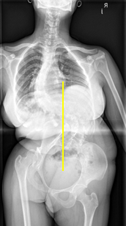
Figure 7. Scoliosis Series of Patient 2
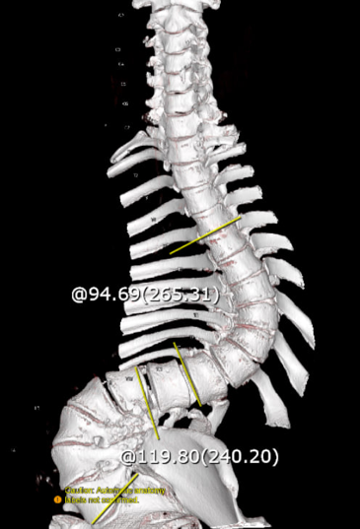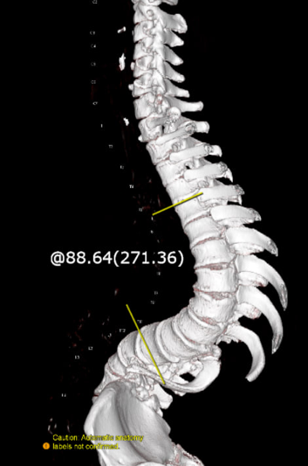
Figure 8. Thoracolumbar MSCT Axial Slice 3D Reconstruction Reformat of Patient 2.
The patient regained consciousness on postoperative day 1. Postoperative pain was well controlled with analgesics, with a VAS score of 2–3. She had difficulty lifting both thighs due to pain, but she denied lower-limb weakness. She also denied numbness or a heavy sensation in the legs. The patient had a bowel movement the day before, while urinary output was still managed via a catheter. Mobilization was limited to turning to the right and left sides in bed. The patient had been extubated. Postoperative laboratory results showed mild anemia, with a hemoglobin level of 8.3 g/dL. The initial postoperative medications were continued, with the methylprednisolone dose adjusted to 125 mg IV twice daily. The patient was scheduled to begin bladder training and to receive packed red blood cell (PRC) transfusions until the hemoglobin level reached 10 g/dL.
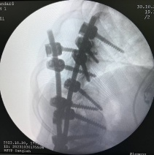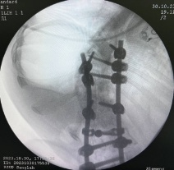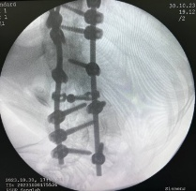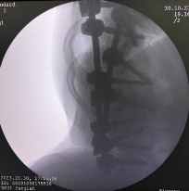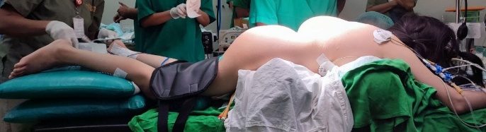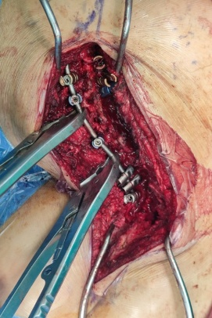
Figure 9. Surgical Site, C-Arm, and Patient 2 Positioning during Operation
Postoperative laboratory tests on day 2 showed anemia, with a hemoglobin level of 8.3 g/dL. The patient subsequently received a total of three units of packed red blood cells (PRC). On postoperative day 3, she complained of tingling and numbness at the tips of the toes on the left foot; these symptoms improved by postoperative day 5. On day 3, thoracolumbar and lumbosacral radiographs were obtained, showing a thoracic Cobb angle of 62.56° and a lumbar Cobb angle of 74.06°. On postoperative day 5, the patient was able to void spontaneously without a catheter. On day 6, she was able to sit while leaning against the bed. However, she also reported a “thick” sensation in the medial aspect of the left thigh. Physical examination revealed hypoesthesia in the left L2 dermatome. On postoperative day 7, the patient was able to sit in a chair but was still unable to ambulate. Hypoesthesia at the left L2 level persisted. She began standing on postoperative day 8 and was subsequently scheduled for outpatient follow-up.
A thoracolumbar axial MSCT with 3D sagittal reconstruction without contrast performed on postoperative day 5 demonstrated double-curve scoliosis involving the main thoracic and lumbar regions. Interpedicular screw fixation from T7 to L4 was noted with appropriate positioning. Surgical management consisted of posterior instrumentation and fusion from T7 to L4 for double-curve correction, preceded by preoperative Cotrel traction and respiratory exercises. Wedge-shaped vertebral bodies were observed at T8–T9. A drain catheter was present, with the distal tip projecting cranially to the level of T9. Additional findings included pneumonia, fibrosis in the posterior segment of the left lower lobe (suggestive of a prior inflammatory process), and bilateral pleural effusions.
The patient later returned with a non-healing surgical wound with persistent fluid discharge. Back pain persisted, particularly with leg movement. She was able to stand but still required assistance. The intermittent “thick” sensation in the left thigh was still present. She denied bowel or bladder complaints. Physical examination continued to show hypoesthesia in the left L2 dermatome. The patient was scheduled for surgical debridement and wound culture.
Following debridement, the patient continued to report back pain, particularly when lying supine, which improved when lying on her side. She denied weakness in the lower extremities but continued to experience thickening and tingling in the medial left thigh. Daily wound care was performed. Wound culture isolated Pseudomonas aeruginosa; however, its role as the causative organism required clinical correlation with infection markers. Based on the culture results, intravenous levofloxacin 500 mg three times daily was administered. The patient reported improvement in back pain by day 6 after debridement. On day 8, she experienced transient numbness in the right calf while sitting, which resolved when lying down. Hypoesthesia up to the left L2 level persisted on examination. The patient began ambulating on day 12 after debridement, or approximately one month after the deformity correction surgery. Gradual mobilization was conducted using a thoracolumbar sacral orthosis (TLSO). She was discharged for outpatient care on day 15. At the first outpatient visit, her complaints were similar to those during hospitalization, with minimal oozing noted from the wound dressing.
The patient subsequently underwent repeat debridement, culture, and vacuum-assisted dressing. At the first outpatient follow-up after vacuum dressing application, she reported slight leakage from the vacuum device, and the indicator displayed the word “leakage.” Culture results later isolated Acinetobacter baumannii; however, its significance as the causative organism also required correlation with clinical findings and infection markers. At three months postoperatively, the patient reported improvement in pain, which was controlled with paracetamol. Dyspnea had also improved. However, she continued to experience occasional thick sensation in the medial left thigh. Bowel and bladder function were normal. Physical examination still demonstrated hypoesthesia in the left L2 dermatome

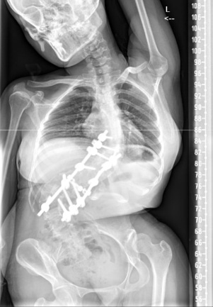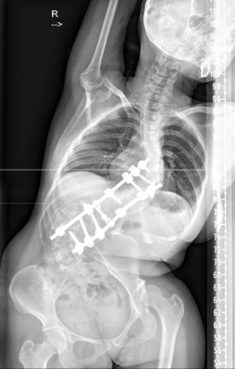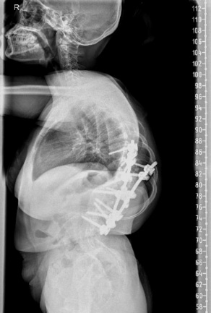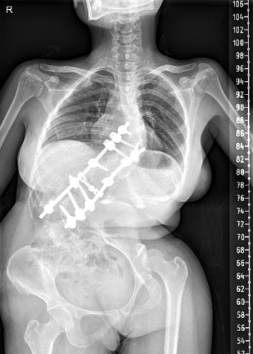
Figure 10. Postoperative standing spine radiograph (Patient 2).

2.3. CASE 3
A 25-year-old man presented with a 3-year history of low back pain, predominantly located in the lumbar region. The pain worsened with position changes, prolonged sitting, forward bending, and sleeping in the supine position. It was relieved by bending forward and lying down. He denied pain radiating to the buttocks or legs. He reported intermittent numbness and tingling, localized to the little finger and the sole of the right foot. He denied weakness in either leg. There were no bowel or bladder complaints. He was able to ambulate independently; however, the pain had begun to interfere with daily activities. The patient had a history of arthritis and had been taking etoricoxib 90 mg once daily for the past year. There was no family history of similar complaints. He worked as a villa security guard. On physical examination, a kyphotic deformity and midline tenderness at the L5–S1 level were noted. The Schober test was positive. The patient was diagnosed with ankylosing spondylitis and was scheduled for corrective deformity surgery. He underwent corrective surgery for fixed thoracolumbar kyphosis with posterior instrumentation, although the specific osteotomy technique and fusion levels were not consistently available in the retrospective records.

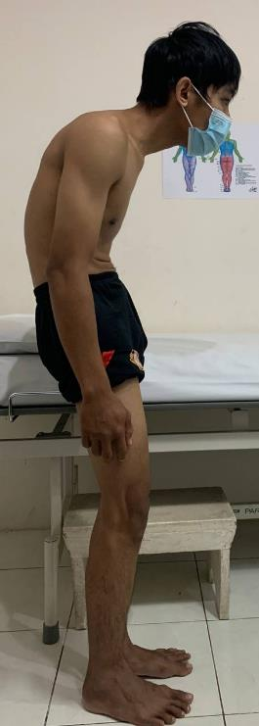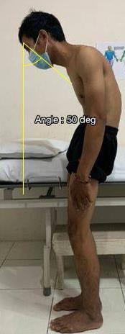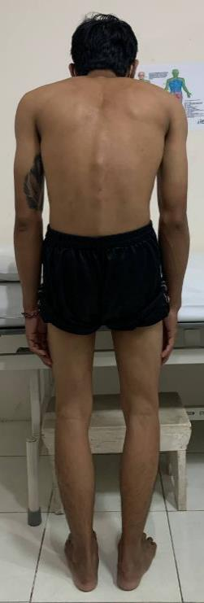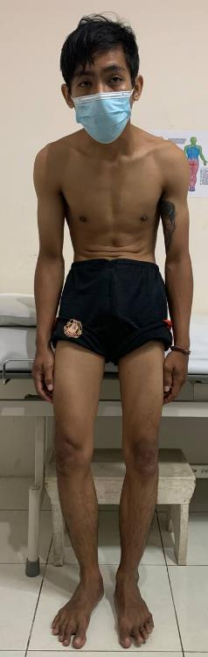
Figure 11. Clinical Picture of Patient 3, CBVA 50°.
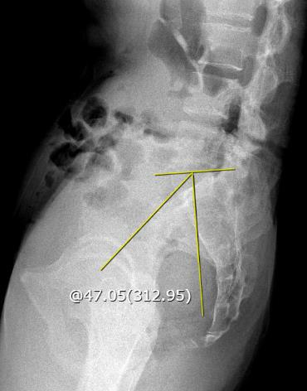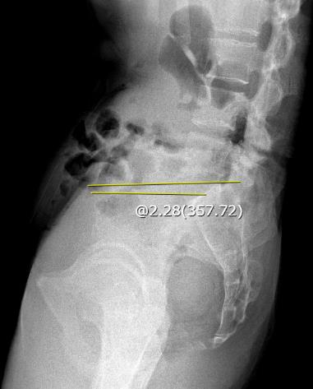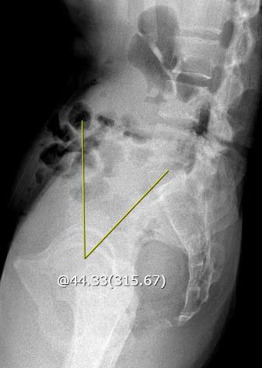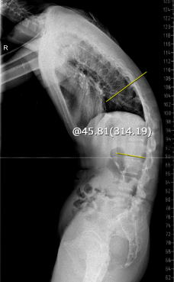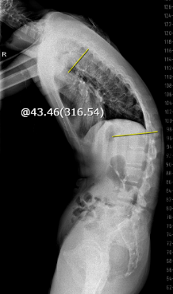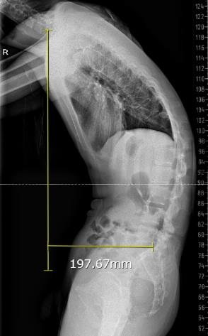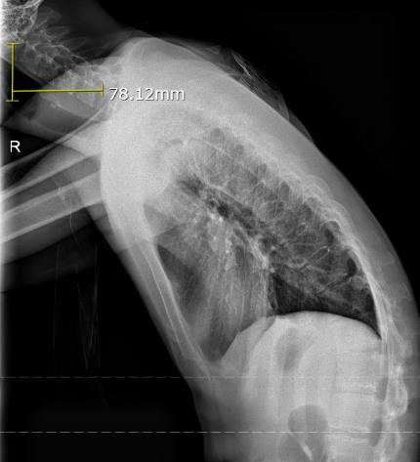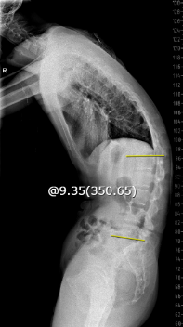
H
G
E
F
D
C
A
B
Figure 12. Lumbosacral X-ray of Patient 3. (A) C2-S7 SVA: 78.1 mm; (B) C7-S1 SVA: 197.6 mm; (C) Thoracal kyphosis: 43.4; (D) Thoracolumbal kyphosis: 45.8; (E) Lumbar lordosis: 9.3; (F) Pelvic tilt: 44.3; (G) Sacral slope: 2.2; (H) Pelvic incidence: 47.
Postoperatively, the patient remained intubated but was alert and responsive. He denied weakness or a sensation of heaviness in both lower limbs. During surgery, he received two units of packed red blood cells. The estimated intraoperative blood loss was 3,000 mL. Drain output over the first 14 hours was 140 mL of blood. Postoperative medications included ceftriaxone 1 g IV twice daily, methylprednisolone 125 mg IV three times daily, pantoprazole 30 mg IV twice daily, and mecobalamin 500 mg IV three times daily.
Subsequently, the intensivist initiated additional management, including Entramix formula 150 mL every 4 hours via nasogastric tube, lactated Ringer’s solution 2,000 mL/24 hours, fentanyl 300 mcg plus ketamine 20 mg in 50 mL infusion, 0.9% sodium chloride at 2.1 mL/hour, paracetamol 1,000 mg IV every hour, dexmedetomidine 0.8 mcg/kg/hour IV, omeprazole 40 mg IV every 24 hours, and tranexamic acid 500 mg IV every 8 hours. The patient was advised to begin passive mobilization and maintain head-of-bed elevation at 40–45°. The target blood glucose level was 140–180 mg/dL. He was scheduled for routine wound care, repeat complete blood count testing, and postoperative radiography.
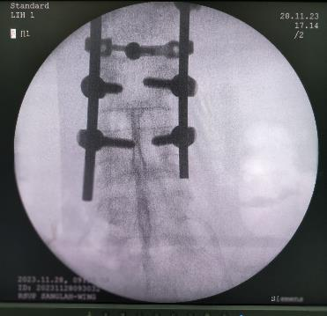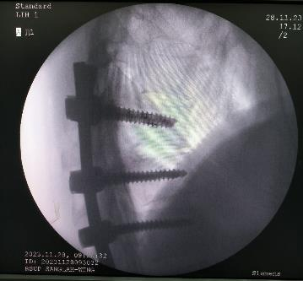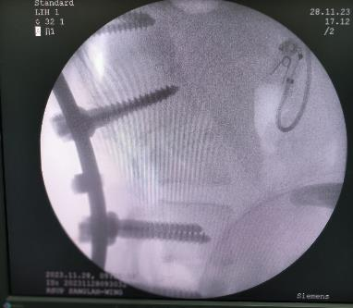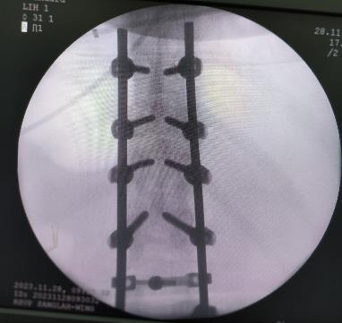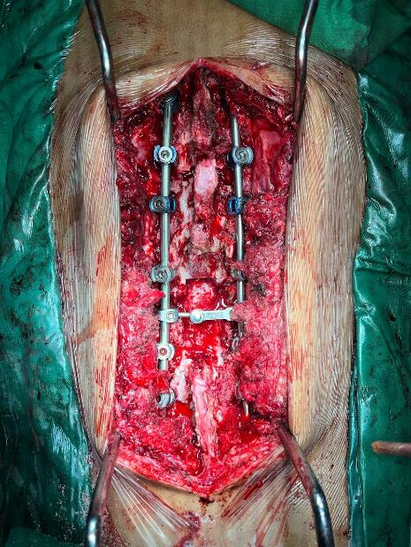
Figure 13. Surgical Site and Intraoperative fluoroscopy (C-arm) during surgery (Patient 3).
On postoperative day 1, the patient reported a mild sensation of tightness in the left calf. Postoperative pain remained well controlled with analgesics, and the treatment regimen was continued without changes. The patient was scheduled for extubation. The 24-hour drain output was 175 mL of blood. On postoperative day 3, physical examination revealed hypoesthesia, and a thoracolumbar radiograph was obtained. On day 4, the drain output became minimal and was predominantly serous. The patient began experiencing the urge to void during bladder training.
A rehabilitation program was initiated, including positioning, log-rolling techniques, chest physiotherapy, chest mobility exercises, and range-of-motion (ROM) exercises. Mobilization was planned to continue after application of the thoracolumbar sacral orthosis (TLSO).
On postoperative day 5, the patient continued to report mild pain at the surgical site, which remained controlled with analgesics. He denied weakness in all four extremities. Urination was still via catheter; however, bladder training had been attempted three times. The patient was able to reposition independently by turning to the right and left. He initially had difficulty sitting but gradually improved and began practicing standing. Physical examination revealed wound tenderness and hypoesthesia below the left L4 dermatome. On day 6, gradual standing mobilization was initiated. On day 7, the patient was able to void spontaneously and mobilize in a standing position while wearing a TLSO. By day 8, the patient no longer reported back pain. Occasional tingling was noted in the right knee. The sensation of tightness persisted but had improved in the left shin. The surgical wound appeared clean, with no signs of infection.
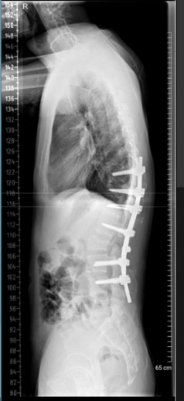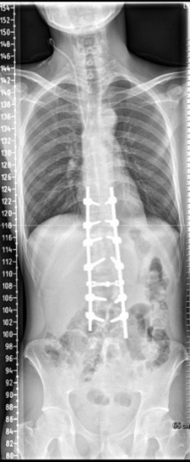
Figure 14. Postoperative standing spine radiograph (Patient 3).
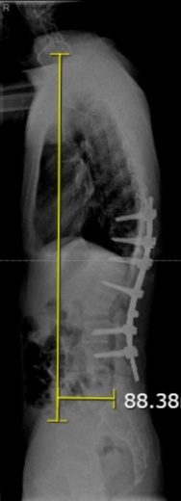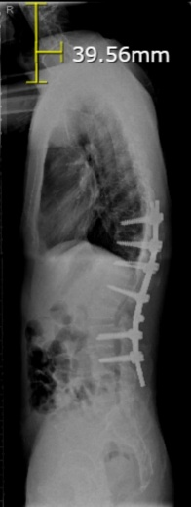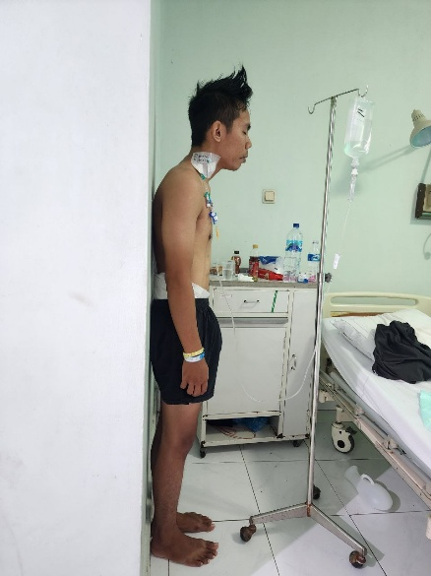
B
A
Figure 15. Postoperative comparison radiographs of Patient 3. (A) Post Op C2-C7 SVA: 39.56 mm; (B) Post Op C7-S1 SVA: 88.38 mm.

Table 1. Objective comparison of baseline characteristics, radiological parameters (pre- vs post-operative), complications, and outcomes

Item | Case 1 | Case 2 | Case 3
Diagnosis | AIS (Lenke 1CN; Risser V) | AIS (Lenke 6B; Risser V) | Ankylosing spondylitis kyphosis
Age/sex | 22/F | 25/F | 25/M
Main symptom | Back pain/cosmetic concern | Dyspnea + back pain | Back pain + fixed kyphosis
Surgery (key detail) | Deformity correction (details not reported) | Posterior instrumentation and fusion T7–L4 | Corrective surgery (details not reported)
Blood loss / transfusion | EBL 1,800 mL; PRC 2U | PRC 3U intra-op (+ post-op PRC) | EBL 3,000 mL; PRC 2U
Radiology (pre-op) | Thoracic Cobb 60° | Thoracic Cobb 57°; Lumbar Cobb 109° | C2–C7 SVA 78.1 mm; C7–S1 SVA 197.6 mm
Radiology (post-op) | Thoracic Cobb 15.32° | Thoracic Cobb 62.56°; Lumbar Cobb 74.06° | C2–C7 SVA 39.56 mm; C7–S1 SVA 88.38 mm
Radiographic correction (%) | Thoracic: (60 − 15.32)/60 ×100 = 74.5% | Lumbar: (109 − 74.06)/109 ×100 = 32.1%; Thoracic: no correction on early post-op measurement (57° → 62.56°) | C2–C7 SVA: (78.1 − 39.56)/78.1 ×100 = 49.4%; C7–S1 SVA: (197.6 − 88.38)/197.6 ×100 = 55.3%
Complications | None | Deep SSI + persistent L2 hypoesthesia | Minor sensory changes (below L4)
Clinical outcome | Pain resolved; early ambulation | Delayed ambulation (~1 month); dyspnea improved | Pain resolved by day 8; standing with TLSO day 7

Follow-up was standardized to a minimum of 3 months for cross-case comparison. Case 1 had extended follow-up to 7 months, whereas Cases 2 and 3 had follow-up data available up to 3 months.

3. discussion
Large or progressive spinal deformity curves are generally indications for deformity correction surgery. In adolescent idiopathic scoliosis (AIS), surgical correction is recommended based on the Cobb angle. Surgery is typically indicated when the Cobb angle exceeds 50° at the end of spinal growth or 40–45° in skeletally immature patients, because curves at these thresholds tend to progress even after skeletal maturity, carry a higher risk of pulmonary function impairment, and become increasingly difficult to correct as the magnitude increases.^{4,17,18} Both AIS cases in this series exceeded these thresholds (60° and 57° thoracic curves, and a 109° lumbar curve), supporting the decision to proceed with surgery. Untreated large scoliosis is associated with an increased risk of restrictive pulmonary disease and reduced lung volumes, particularly when the Cobb angle exceeds 70°.¹⁹ In this series, Case 2 presented with dyspnea and had a 57° thoracic curve and a 109° lumbar curve, which supports this association. In ankylosing spondylitis (AS), deformity surgery is generally indicated in the presence of forward-stooping posture, progressive deformity, sleep disturbance, gastrointestinal issues, respiratory problems, sagittal imbalance, and progressive pain.²⁰ In Case 3, the patient had AS with progressive back pain and postural deformity, meeting these surgical criteria.
Meaningful deformity correction was achieved in all three patients, consistent with published reports. In AIS, deformity correction surgery typically reduces major curves by approximately 60–70%. In a systematic review by Gatam et al., vertebral column resection achieved a mean Cobb angle reduction of 62.1% (mean preoperative Cobb angle 107°) but also had the highest complication rate (approximately 24%). In contrast, non-osteotomy techniques produced a similar correction rate (61.5%) with a lower complication rate (19.6%). Ponte osteotomy demonstrated the lowest complication rate (4%) with a correction rate of 60.5%.¹⁶ In this case series, Case 1 improved from 60° to 15° (approximately 75% reduction). In Case 2, early postoperative radiographs showed no thoracic curve correction (57° preoperatively to 62.56° postoperatively), whereas the lumbar curve improved from 109° to 74.06° (approximately 32% reduction). This discrepancy may reflect curve rigidity and severity, compensation between curves, and/or variability related to patient positioning and early postoperative radiographic measurement. In Case 3 (AS), sagittal realignment met expectations. Reported kyphosis correction surgeries yield an average local correction of approximately 30.9%.²⁰ In our patient, the C2–7 SVA improved from 78.12 mm to 39.56 mm (approximately 50% reduction), while the C7–S1 SVA improved from 197.6 mm to 88.38 mm (approximately 55% reduction).
Pain relief was observed within the first postoperative week in all cases. Notably, Case 1 became pain-free within six days using continuous epidural analgesia, which appeared superior to Case 2, where mild pain persisted up to three months; however, this was likely confounded by postoperative infection in Case 2. Evidence supports epidural analgesia over systemic opioids for postoperative pain management in spine surgery. Mean pain scores (0–10 scale) are approximately 1.3 points lower within 6–8 hours and about 0.8 points lower within 72 hours compared with systemic opioids.²¹ This suggests that the excellent pain control in Case 1 may be related to the epidural regimen, consistent with literature favoring epidural analgesia over PCA for early postoperative pain relief.
In Cases 1 and 3, early mobilization was achieved within 5–7 days postoperatively following structured rehabilitation. This approach aligns with evidence showing that five days of intensive postoperative rehabilitation is superior to early mobilization alone in reducing hospital length of stay and improving physical and functional outcomes.²² In Case 2, surgical site infection delayed recovery; independent ambulation was achieved at approximately one month postoperatively, and dyspnea improved around the same period. Improvement in pulmonary function after scoliosis correction is variably reported, whereas pulmonary rehabilitation demonstrates more consistent long-term respiratory benefits.²³ The perioperative plan in Case 2 aligned with this evidence, incorporating respiratory training preoperatively and continuing it as early as possible postoperatively.
Blood loss tends to increase with larger curve magnitudes. In a review by Elfakharany et al., a Cobb angle greater than 66.8° was associated with blood loss exceeding 1,000 mL.¹² In Case 1, estimated blood loss was 1,800 mL, and multiple packed red blood cell (PRC) transfusions were required. Corrective surgery in AS is also characteristically associated with higher blood loss due to rigid deformity. Additionally, AS patients may present anesthetic challenges, including chronic NSAID use and comorbidities, which can increase bleeding and cardiopulmonary risk.²⁰ This case series is consistent with these findings, as Case 3 had substantial blood loss (3,000 mL).
A serious complication occurred in Case 2, where a deep surgical site infection developed, with cultures isolating Pseudomonas aeruginosa and Acinetobacter baumannii. Instrumented surgical site infection (SSI) rates are generally low; however, consequences can be severe. Reported SSI rates are approximately 4.2% in adult kyphosis and 3.7% in adult scoliosis, and about 25% of cases involve gram-negative organisms.²⁴ Recent literature highlights that preventing and managing spinal surgical site infection requires a multimodal perioperative approach. Prophylactic closed-incisional negative pressure wound therapy (ciNPWT) may reduce wound complications and SSI after posterior instrumented fusion, especially in high-risk patients. For established deep SSI, early recognition with prompt debridement and culture-directed antibiotics remains essential, with negative-pressure therapy as an adjunct when needed. Delayed wound healing is also influenced by host factors, supporting perioperative risk stratification and optimization.²⁹ Management typically requires debridement and antibiotic therapy.²⁵ In this case, negative-pressure wound therapy was also used. Prior studies have reported benefits of vacuum-assisted closure systems for recurrent spinal SSIs, supporting the approach used in Case 2.²⁶ Fortunately, the patient’s outcome was favorable, with no major long-term sequelae aside from mild persistent sensory loss in the L2 dermatome. Case 2 developed a deep SSI requiring repeated debridement, culture-directed antibiotics, and negative-pressure wound therapy, highlighting the need for strong perioperative infection control. Systemic corticosteroids were used early postoperatively in Cases 2 and 3; while sometimes indicated, steroids may increase SSI risk and delay wound healing, so they should be considered in perioperative risk stratification (causality cannot be inferred in this case series). Literature-based SSI prevention includes alcohol-based skin antisepsis, meticulous soft-tissue handling/hemostasis, and adjuncts such as local/topical antibiotics and copious wound irrigation (e.g., diluted povidone-iodine with saline rinse). Prophylactic closed-incisional negative-pressure therapy may be considered in high-risk patients.³⁰
Neurological injury rates in deformity surgery are generally low. One review reported new neurological deficits in AIS surgery of approximately 5%.²⁷ In our cases, no motor deficits occurred. Case 2 had persistent sensory hypoesthesia at the left L2 level, and Case 3 had occasional knee paresthesia and hypoesthesia below the left L4 level. These were classified as minor neurological sequelae. Major deficits such as paralysis are rare. Overall reported neurological complication rates vary widely (0.5–17%). In one study included by Yagi et al., among 1,301 patients undergoing corrective surgery for AIS, the incidence was 0.46%, and most deficits resolved within three months.²⁸
This study has several limitations. First, this is a small retrospective case series (three patients), which limits generalizability and precludes statistical analysis. Second, follow-up duration was heterogeneous across cases and longer-term outcomes were not uniformly available, reducing the strength of conclusions regarding medium- and long-term recovery. Third, standardized patient-reported outcome measures (e.g., ODI or SRS-22r) were not consistently recorded in the medical records; therefore, clinical outcomes relied on VAS, neurological examination, mobility milestones, and symptom resolution. Finally, operative details (e.g., exact fusion levels or osteotomy technique) were not consistently documented in all cases.

4. Conclusion
In summary, this case series illustrates that deformity correction surgery must be individualized according to each patient’s underlying pathology. All three patients responded well to corrective deformity surgery. Only minor complications, such as hypoesthesia, were observed in this series. No paralysis or other major complications were reported. Preoperative planning including traction when indicated and vigilant perioperative management, including blood conservation, multimodal analgesia, and infection control, are key to achieving successful outcomes. Our experience aligns with published data, affirming that even complex deformities can be corrected safely and effectively when managed according to current best practices in spinal surgery. Future studies with larger cohorts, standardized patient-reported outcomes, and longer uniform follow-up are needed to better define medium- and long-term functional results after deformity correction surgery.
DATA AVAILABILITY
This study relied on research article data that can be requested from the corresponding author.

CONSENT
Written informed consent was obtained from the patient for publication of this case report and accompanying images. A copy of the written consent is available for review by the Editor-in-Chief of this journal on request.
ETHICAL APPROVAL
Ethical approval was waived by the author’s institution due to the observational nature of this study and multi-centre authorship.
COMPETING INTERESTS DISCLAIMER:
Authors have declared that they have no known competing financial interests OR non-financial interests OR personal relationships that could have appeared to influence the work reported in this paper.
Disclaimer (Artificial intelligence)
Author(s) hereby declare that NO generative AI technologies such as Large Language Models (ChatGPT, COPILOT, etc.) and text-to-image generators have been used during the writing or editing of this manuscript.

REFERENCES
1. Kim HJ, Yang JH, Chang DG, Lenke LG, Suh SW, Nam Y, et al. Adult spinal deformity: a comprehensive review of current advances and future directions. Asian Spine J. 2022;16(5):776.
2. Tsirikos AI, Roberts SB, Bhatti E. Incidence of spinal deformity surgery in a national health service from 2005 to 2018. Spine (Phila Pa 1976). 2020;1(3):19–28.
3. Diebo BG, Shah N V, Boachie-Adjei O, Zhu F, Rothenfluh DA, Paulino CB, et al. Adult spinal deformity. Lancet. 2019;394(10193):160–72.
4. Nam Y, Patel U, Chang DG, Lee Y Bin, Lim J, Yang JH, et al. Curve progression in adolescent idiopathic scoliosis with Cobb angles between 40 and 50 degrees at the late stage of skeletal growth: a minimum 5-year follow-up study. J Clin Med. 2025;14(15):5272.
5. Zhang H, Zhang X, Hu F, Hu W, Wang Y, Hao Y. Ankylosing spondylitis kyphosis surgical correction postoperative evaluation via SRS-22 domain investigation. J Orthop Surg Res. 2018 Jan;13(1):5.
6. Jin C, Wang S, Yang G, Li E, Liang Z. A review of the methods on cobb angle measurements for spinal curvature. Sensors. 2022;22(9):3258.
7. Sanders J. Growth and Maturity in Musculoskeletal Care. The Atlas. 2017;47.
8. Ali A, Fontanari V, Fontana M, Schmölz W. Spinal deformities and advancement in corrective orthoses. Bioengineering. 2020;8(1):2.
9. Cerillo JL, Becsey AN, Sanghadia CP, Root KT, Lucke-Wold B. Spine bracing: when to utilize—a narrative review. Biomechanics. 2023;3(1):136–54.
10. Bettany-Saltikov J, Turnbull D, Ng SY, Webb R. Management of spinal deformities and evidence of treatment effectiveness. Open Orthop J. 2017;11:1521.
11. Slattery C, Verma K. Classifications in brief: the Lenke classification for adolescent idiopathic scoliosis. Clin Orthop Relat Res. 2018;476(11):2271–6.
12. Elfakharany MM, Torky SM, Ibrahim MA, Abouelnaga BF, Shamhoot IA. Surgical Outcome of Correction of Adolescent Idiopathic Scoliosis. Arq Bras Neurocir Brazilian Neurosurg. 2025;44(04):e252–60.
13. Murphy RF, Mooney JF 3rd. Complications following spine fusion for adolescent idiopathic scoliosis. Curr Rev Musculoskelet Med. 2016 Dec;9(4):462–9.
14. Man YW, Lui JYS, Lam CY, Cheung JPY, Cheung PWH. Prevalence and Risk Factors for Postoperative Neurological Complications in Spinal Deformity Surgery: A Systematic Review and Proportional Meta-Analysis. Neurospine. 2025 Mar;22(1):243–63.
15. Luo J, Wu T, Yang Z, Duan C, Tao H. An effective strategy for treatment of severe kyphosis secondary to ankylosing spondylitis: one-level modified osteotomy combined with shoulders lifting correction method. J Orthop Surg Res. 2024 Sep;19(1):536.
16. Gatam L, Phedy P, Mahadhipta H, Husin S, Gatam AR, Kadar PD, et al. Surgical outcomes and complication rates in severe scoliosis: a systematic review. Sicot-J. 2025;11.
17. Souder C, Newton PO, Shah SA, Lonner BS, Bastrom TP, Yaszay B. Factors in Surgical Decision Making for Thoracolumbar/Lumbar AIS: It’s About More Than Just the Curve Magnitude. J Pediatr Orthop. 2017;37(8).
18. Jain A, Ahuja K, Roberts SB, Tsirikos AI. Techniques of Deformity Correction in Adolescent Idiopathic Scoliosis—A Narrative Review of the Existing Literature. Vol. 14, Journal of Clinical Medicine. 2025. p. 2396.
19. Lee SY, Lee YJ, Chiu CK, Chandirasegaran S, Hasan MS, Chan CYW, et al. Analysis of Clinical and Radiological Predictive Factors for Moderate and Severe Pulmonary Impairment in 102 Adolescent Idiopathic Scoliosis (AIS) Patients With Major Cobb Angle ≥45°: A Study of an Asian Population. Glob Spine J. 2025 Feb 17;15(7):3172–9.
20. Chehrassan M, Shakeri M, Nikouei F, Sabbaghan S, Sour B, Mahabadi EA, et al. Understanding the pros and cons of spine surgery for ankylosing spondylitis: experience from a single institution study. BMC Rheumatol. 2025;9(1):11.
21. Guay J, Suresh S, Kopp S, Johnson RL. Postoperative epidural analgesia versus systemic analgesia for thoraco-lumbar spine surgery in children. Cochrane database Syst Rev. 2019 Jan;1(1):CD012819.
22. Bazancir Z, Talu B, Korkmaz MF. Postoperative rehabilitation versus early mobilization following scoliosis surgery: A single-blind randomized clinical trial. J Orthop Sci. 2023;28(2):308–14.
23. Hashem M. Assessment of Pulmonary Function After Treatment of Scoliosis: Meta-Analysis and Review Article. Medicina (Kaunas). 2025 Jun;61(7).
24. Shillingford JN, Laratta JL, Reddy H, Ha A, Lehman RA, Lenke LG, et al. Postoperative Surgical Site Infection After Spine Surgery: An Update From the Scoliosis Research Society (SRS) Morbidity and Mortality Database*. Spine Deform. 2018;6(6):634–43.
25. Lener S, Hartmann S, Barbagallo GM V, Certo F, Thomé C, Tschugg A. Management of spinal infection: a review of the literature. Acta Neurochir (Wien). 2018;160(3):487–96.
26. Alcala-Marquez C, Torrealba R, Mehbod AA, Dawson JM, Dressel TD, Transfeldt EE. Recurrent surgical site infections in the spine after treatment with the vacuum-assisted closure (VAC) system. Clin Spine Surg. 2018;31(8):351–5.
27. Alahmari ASA, Qari SK, Asiri RI, Almohammadi TA, Alqarni MAM, Aljahdali HM, et al. An Overview on the Role of Surgical Management in Ankylosing Spondylitis. Arch Pharm Pract. 2021;12(2–2021):106–11.
28. Yagi M, Michikawa T, Hosogane N, Fujita N, Okada E, Suzuki S, et al. Risk, Recovery, and Clinical Impact of Neurological Complications in Adult Spinal Deformity Surgery. Spine (Phila Pa 1976). 2019;44(19).
29. Kramer DE, Bharthi R, Myers D, Chang P, Dabecco R, Xu C, Yu A. Prophylactic closed-incisional negative pressure wound therapy following posterior instrumented spinal fusion: a single surgeon’s experience and cost-benefit analysis. Neurosurg Rev. 2024;47:847. doi:10.1007/s10143-024-03083-8.
30. White AJ, Fiani B, Jarrah R, Momin AA, Rasouli J. Surgical site infection prophylaxis and wound management in spine surgery. Asian Spine J. 2022;16(3):451-461. doi:10.31616/asj.2020.0674.

