Decompression of Lumbar Canal Stenosis with Interlaminar vs Classic Laminectomy: A Systematic Review and Meta-Analysis

.
ABSTRACT

Purpose: This study aimed to compare the outcomes of interlaminar versus classical laminectomy approaches in the treatment of LCS.
Methods: This study conducted a meta-analysis based on the Preferred Reporting Items for Systematic Reviews and Meta-Analyses (PRISMA) guideline by including randomized controlled trials (RCTs) comparing interlaminar and classical laminectomy in patients with LCS. Relevant studies were identified through systematic searches in Cochrane, PubMed, and Scopus databases using specific keywords related to LCS and surgical outcomes. Data extraction focused on procedure duration, pain scores (VAS), functional disability (Oswestry Disability Index (ODI), and complication rates. Risk of bias was assessed using the Cochrane Risk of Bias tool. Sensitivity analyses were performed by excluding studies at high risk of bias or studies with extreme sample sizes to assess the robustness of the results. All analyses were performed using R, and the statistical significance level was set at p < 0.05, with interpretation taking into account the clinical context and existing heterogeneity.
Results: Three RCTs involving 414 patients met the inclusion criteria. The meta-analysis revealed that interlaminar decompression significantly reduced the operation duration (Mean Difference (MD) = -23.82; 95% CI: -26.49 to -21.16; p < 0.001) and postoperative VAS scores (MD = -1.33; 95% CI: -1.46 to -1.21; p < 0.001) compared to classical laminectomy. Improvements in ODI scores were also significantly better in the interlaminar group postoperatively (MD = -9.65; 95% CI: -10.72 to -8.58; p < 0.001). No significant differences were found in complication rates between the two methods.
Conclusion: Interlaminar decompression for LCS provides superior pain relief and functional recovery with shorter operative times compared to classical laminectomy.

Keywords: Lumbar spinal stenosis, laminectomy, interlaminar decompression, meta-analysis, surgical outcomes.

1. INTRODUCTION

Lumbar canal stenosis (LCS) is a neurological syndrome caused by narrowing of the spinal canal at the lumbar level, which puts pressure on the cauda equina nerve region or on the nerve roots. LCS can develop with age and is part of the degenerative process as well. Osteoarthritic intervertebral discs, vertebroplasty of the neck region, hypertrophy of the saploid joints, hypertrophy of the ligamentum flavum, and spondylolisthesis are a number of pathological conditions that accumulate and result in the invasion of the spinal canal and spine. Due to these effects, compression tends to displace the brain, which is located in the lumbar region, covering an area around the nervous system tract.¹ The pathophysiologic development of stenosis is complex and multifactorial, most commonly resulting from degenerative changes to spinal structures, including hypertrophy of the ligamentum flavum, bulging of the intervertebral disc, and facet joint arthropathy. Clinically, this often manifests in the fifth and sixth decades of life as generalized lower back pain, radicular leg pain, and/or sensorimotor deficits in the lower extremities (Chiu et al., 2020; Chen et al., 2024).
LCS is most commonly found in older individuals, with prevalence increasing with age. Approximately 20-25% of people aged 60 years and older have significant lumbar canal stenosis, and the prevalence is expected to continue to increase as the elderly population grows.² Symptoms resulting from LCS include low back pain, weakness, impaired sensation, and paresthesia of the lower extremities. These symptoms not only affect the patient's mobility but can also lead to dependence on others for daily activities, as well as increase the rate of physical disability and psychological disorders such as depression that significantly reduce the patient's quality of life.³ Minimally invasive techniques are becoming more common as technology develops. Bilateral interlaminar canal decompression is one of these minimally invasive procedures. The most frequent surgical method for LCS decompression is a conventional decompressive laminectomy (Deshmukh et al., 2021). It allows for maximum operational decompression of the neural canal and/or bilateral foramina, although it causes injury to the paraspinal muscles, posterior bone compartment, supraspinous ligament, interspinous ligament, and, on rare occasions, the capsular facet (Afridi et al., 2022).
Effective management of LCS is essential to improve the quality of life of patients. While conservative therapies such as painkillers and physiotherapy can help reduce mild to moderate symptoms, patients with more severe lumbar canal stenosis often require surgical intervention to relieve nerve compression. Decompression surgery, such as a laminectomy, aims to relieve pressure on the compressed nerve root, which can reduce pain, weakness and sensory impairment in the lower extremities.² Procedures that improve blood flow to compressed nerve structures aim to restore patients' neurological function, improve their mobility, and reduce dependence on the assistance of others, ultimately improving their overall quality of life. Patients with LCS experience impairment in daily activities due to pain or motor paralysis, but there is currently no effective preventive treatment for this condition. Furthermore, given the cost of managing therapies for patients with LCS, the development of more efficient therapies is needed to make treatment more affordable. As the elderly population continues to increase worldwide, it is expected that the number of patients with LCS will also increase.⁴ Conservative treatment options for LCS vary widely to relieve symptoms and improve quality of life without the need for surgery. These treatments are relevant for patients with mild to moderate symptoms or who are not eligible for surgery
Conservative treatment for LCS aims to reduce symptoms and improve patient functionality without the need for surgical procedures. This approach includes several key components, starting with physiotherapy that uses a multimodal approach, such as flexibility, stabilisation, and strengthening exercises tailored to each patient's condition. The duration of conservative treatment usually lasts up to three months, and if there is no improvement in symptoms, further evaluation is required to consider surgery. Patient education is an important aspect, where patients are given an understanding of their condition and ways to manage symptoms, including the importance of adherence to the recommended exercises. Techniques such as facet joint injections and epidural injections can provide pain relief in the short to medium term. Regarding exercise modules, although there is still debate as to the appropriate type of exercise, flexibility and stabilisation exercises are more commonly recommended, while extension exercises should generally be avoided. The use of a lumbosacral corset may also be recommended to help reduce lumbar lordosis, which is expected to increase the size of the spinal canal, although its effectiveness is still questionable. Psychosocial interventions can increase patient engagement in therapy and help improve treatment outcomes, although the most effective types of interventions still need to be further researched.⁵
Decompression surgery for lumbar canal stenosis aims to relieve pressure on the pinched nerves due to narrowing of the spinal canal, which is the main cause of symptoms in patients with lumbar canal stenosis. This procedure is usually performed on patients who have severe symptoms or cannot be managed with conservative treatment, as well as those whose quality of life is severely compromised due to pain or impaired motor function. During the decompression procedure, the surgeon removes the tissues or structures that are causing the narrowing of the spinal canal, such as herniated discs, protruding bones (osteophytes), or thickened ligaments. Decompression techniques can be performed by various methods, such as laminectomy (removal of part or all of the vertebral lamina), foraminotomy (cutting to widen the opening where the nerve exits the spine), or discectomy (removal of part of the intervertebral disc that is compressing the nerve). Although these procedures are often effective in relieving painful symptoms and improving mobility, the decision to perform surgery should be considered carefully, given the risks associated with surgical procedures and the importance of considering the patient's overall medical condition.⁶
A classic laminectomy is a surgical procedure to treat lumbar canal stenosis by removing the lamina, the back of the vertebrae that covers the spinal canal. This procedure helps reduce pressure on the spinal cord and nerves, which can reduce symptoms such as pain, numbness and weakness in the legs. Classical laminectomy is beneficial for patients with severe LCS who do not respond to non-surgical treatment, but may pose risks such as nerve injury, bleeding and spinal instability. The advantages of classic laminectomy include significant pain reduction and improved function in patients with lumbar canal stenosis. Long-term studies have shown that patients experience reduced pain and disability after surgery as well as improved walking ability thanks to a reduction in intermittent neurogenic claudication. The drawbacks of classic laminectomy include the risk of complications such as muscle damage, scar tissue formation and iatrogenic flatback syndrome. In addition, the reoperation rate is around 14%, indicating the possible need for further surgical intervention.⁷
The interlaminar approach for lumbar canal stenosis is a minimally invasive surgical technique that accesses the spinal canal through the interlaminar space to decompress the neural structures. This technique is particularly beneficial for treating lumbar canal stenosis as it allows for effective decompression with minimal disruption to the surrounding tissues. The advantage of this approach lies in the ability to provide an enlarged and illuminated surgical field, which facilitates proper decompression on both ipsilateral and contralateral sides without causing instability to the spine.8 The advantage of the interlaminar approach for lumbar canal stenosis is its minimally invasive nature, which reduces trauma and bleeding during the procedure. This technique also allows for effective decompression of the neural elements, which is crucial for reducing symptoms associated with lumbar stenosis.9 The drawbacks of the interlaminar approach for lumbar canal stenosis include technical complexity, although minimally invasive, the procedure requires specialised skills and equipment that may not be available in all medical facilities. Furthermore, this approach has limited indications and may not be suitable for all patients, especially those with complex spinal pathology or multi-level stenosis.^{8,9}
Based on several existing studies, the aim of this meta-analysis was to address the inconsistency of findings in studies comparing decompression of lumbar canal stenosis with the interlaminar technique and classical laminectomy. By conducting this meta-analysis, it is hoped to increase the statistical power in assessing the effectiveness of the two decompression techniques, as well as provide a clearer picture of the differences in clinical outcomes that may occur. This study aims to synthesise the available evidence to provide stronger recommendations in clinical practice regarding the management of lumbar canal stenosis.

Provide a factual background, clearly defined problem, proposed solution, a brief literature survey and the scope and justification of the work done.]

2. methodS

2.2 Study Design
This study is a systematic review and meta-analysis compiled in accordance with the Preferred Reporting Items for Systematic Reviews and Meta-Analyses (PRISMA) guidelines. The target population was adult patients with lumbar canal stenosis undergoing decompression using the interlaminar approach or classic laminectomy, with a focus on outcomes such as pain, function, duration of surgery, and postoperative complications.
2.3 Literature Search
A systematic literature search was conducted in several major electronic databases (PubMed, ScienceDirect, ProQuest, Cochrane Library, Google Scholar, and the Directory of Open Access Journals) from the database's inception until the last search. Keywords and controlled medical terms (MeSH) were combined with Boolean operators, such as "lumbar canal stenosis," "interlaminar," "laminectomy," "decompression," and "surgery," along with their Indonesian equivalents. The bibliographies of relevant articles were also manually searched to identify additional studies. Inclusion criteria included randomized clinical trials and comparative observational studies in adult patients with lumbar canal stenosis comparing interlaminar decompression with classic laminectomy, reporting at least one relevant clinical outcome (e.g., duration of surgery, Visual Analogue Scale, Oswestry Disability Index, complications, or length of hospital stay). Review articles, case reports, case series, abstracts without full text, and animal or cadaveric studies were excluded. Two reviewers independently screened titles and abstracts, followed by full-text review to determine eligibility; disagreements were resolved through discussion or by involving a third reviewer.
2.4 Data Collection Process
Data extraction was performed using a standardized, pre-tested form. Two reviewers independently extracted information related to study characteristics (author name, year of publication, country, study design), participant characteristics (number of subjects, mean age, sex, degree and level of stenosis), and intervention details (type of procedure, interlaminar or classic laminectomy, spinal level decompressed, use of special instruments, and anesthetic technique, if available). The primary outcomes collected included operative duration, intraoperative blood loss, length of hospital stay, Visual Analogue Scale pain score, Oswestry Disability Index function score, postoperative complication rate, and reoperation rate. If key quantitative data were incompletely reported, researchers attempted to contact the corresponding author or made estimates based on available data (e.g., converting median and range to mean and standard deviation using recognized formulas), assuming these were explicitly stated in the text. Differences in extraction results between reviewers were resolved by consensus.
2.5 Risk of Bias
Risk of bias assessment is performed at the study level using tools appropriate to the study design. For randomized clinical trials, the latest version of the Cochrane Risk of Bias tool (RoB 2) is used, which assesses several domains such as the randomization process, deviation from the planned intervention, missing outcome data, outcome measurement, and reporting selection. For comparative observational studies, the Newcastle-Ottawa Scale (NOS) is used, which assesses the domains of selection, comparability, and outcome measurement. Each study is assessed independently by two reviewers; discrepancies in scores are resolved through discussion until consensus is reached. Risk of reporting bias, including publication bias, is evaluated by visual inspection of funnel plots and statistical tests such as Egger's test when the number of studies in an analysis is sufficient (generally ≥10 studies). Risk of bias findings are considered in the interpretation of meta-analysis results.
2.6 Statistical analysis
Statistical analysis was performed by calculating effect sizes for each outcome comparable across studies. For continuous outcomes, the mean difference or standardized mean difference with a 95% confidence interval was used, depending on the uniformity of the measurement scale between studies. For dichotomous outcomes, the risk ratio with a 95% confidence interval was used. Quantitative synthesis was performed using a random-effects model to accommodate inter-study variation, unless statistical heterogeneity was so low that a fixed-effects model was more appropriate. The degree of heterogeneity was assessed using the I² statistic and the Cochran Q chi-square test. Subgroup analyses were planned based on study design (randomized versus observational clinical trial), degree of stenosis, or technical characteristics of the procedure when data permitted. Sensitivity analyses were performed by excluding studies at high risk of bias or studies with extreme sample sizes to assess the robustness of the results. All analyses were performed using R, and the statistical significance level was set at p < 0.05, with interpretation taking into account the clinical context and existing heterogeneity.

3. results and discussion

3.1 Study Selection
The authors focused on studies of laminectomy in patients with lumbar canal stenosis. A comprehensive search was performed in PubMed, Scopus, and the Cochrane Library using combinations of keywords such as “classic laminectomy”, “interlaminar laminectomy”, and “lumbar stenosis surgery outcomes”. A total of 517 records were identified (PubMed n = 431, Scopus n = 59, Cochrane n = 27). Before screening, 2 duplicate records and 353 records automatically judged ineligible were removed, leaving 162 records for title/abstract screening. Of these, 157 were excluded, so 5 full-text articles were sought; 1 could not be retrieved. Four reports were assessed for eligibility, and 1 was excluded for irrelevant data, resulting in 3 studies that fulfilled the criteria (comparative design, clear outcome measures, presence of classic and interlaminar groups) and were finally included in the review, as summarised in the PRISMA flow diagram (Figure 1).
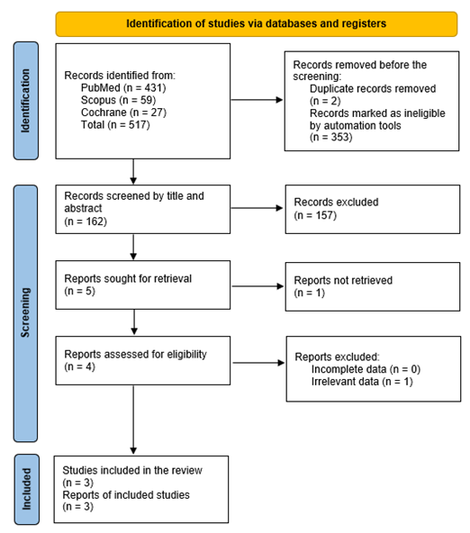
Fig 1. PRISMA Flowchart

3.2 Study Characteristics
This meta-analysis consisted of three randomised controlled trial studies published between 2019 and 2022. The three studies were conducted in Pakistan, China, and Egypt with a total of 414 patients and a mean age of 53.37 ± 4.75 years. In each study, the population was predominantly male, and the length of follow-up ranged from 0.25 to 3 years. The baseline characteristics of the included studies are detailed in Table 1.
AUTHOR (YEAR) | STUDY DESIGN | STATE | EVIDENCE LEVEL | INTERVENTIONS | FUP (year) | SUBJECT (n) | AGE (years) | L/P (%/%) | PROCEDURE DURATION (minutes) | VAS |  | ODI |  | COMPLICATIONS (%)
 |  |  |  |  |  |  |  |  |  | PRE OPERATION | POST-OPERATION | PRE OPERATION | POST-OPERATION | COMPLICATIONS (%)
Afridi et al. (2022) | RCT | Pakistan | II | BIL | 1 | 30 | 51,10 ± 5,86 | 17/13 (56,70/43,30) | 71,20 ± 7,61 | 7,90 ± 0,60 | 5,40 ± 0,62 | N/A
 |  |  |  | Classic Laminectomy | 1 | 30 | 54,50 ± 5,38 | 20/10 (66,70/33,30) | 104,70 ± 9,78 | 7,90 ± 0,54 | 3,30 ± 0,46
Cuo et al. (2021) | RCT | China | II | BIL | 0,25 | 69 | N/A | 37/31 (53,62/46,38) | 51,40 ± 9,68 | 7,36 ± 0,62 | 2,26 ± 0,43 | 78,82 ± 4,93 | 43,39 ± 4,08 | 2 (2,90)
 |  |  |  | Classic Laminectomy | 0,25 | 69 | N/A | 41/28 (59,42/40,58) | 69,78 ± 10,25 | 7,27 ± 0,58 | 4,60 ± 0,47 | 77,21 ± 5,51 | 57,33 ± 4,14 | 8 (11,59)
Soliman et al. (2019) | RCT | Egypt | II | BIL | 3 | 107 | 54,21 ± 4,54 | 56/51 (52,34/47,66) | N/A | 7,23 ± 1,22 | 2,66 ± 1,09 | 32,22 ± 5,37 | 13,62 ± 5,75 | 23 (21,49)
 |  |  |  | Classic Laminectomy | 3 | 109 | 52,88 ± 4,19 | 60/47 (55,04/44,96) | N/A | 7,44 ± 1,23 | 4,10 ± 2,13 | 33,77 ± 5,65 | 16,60 ± 7,03 | 16 (14,67)
Table 1. Characteristics of Selected Studies
*Plus-minus values are Mean ± Standard Deviation; BIL, Bilateral Interlaminar Laminectomy; FUP, Follow Up ODI, Oswestry Disability Index; L, Male; P, Female; RCT, Randomised Controlled Trial; VAS, Visual Analogue Scale; Complications include incision infection, ischaemic necrosis of the incision, dural sac tear, gastrointestinal dysfunction, epidural haematoma, and radicular deficit.

3.3 Risk of Bias in Studies
Each included study was then assessed for risk of bias using RoB 2 for assessing bias in randomised controlled trials. The risk of bias for each study was categorised as low (+), high (-), or unknown (?) across different types of bias. Overall, two studies were rated as high quality and one study as low quality due to a lack of clarity regarding data reporting, which could be a confounding factor. Details of the risk of bias can be seen in Figure 2.
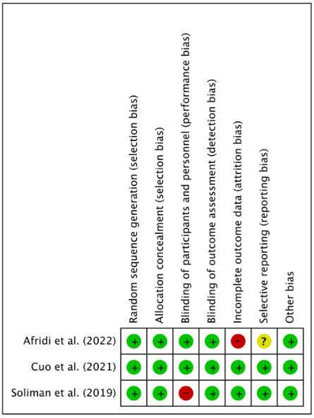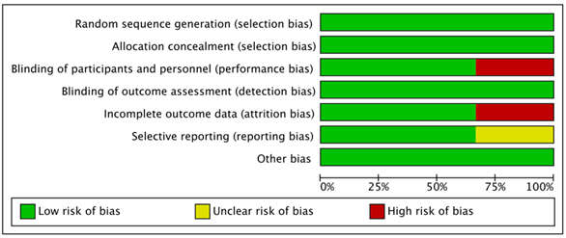
Fig 2. Risk of bias graph and summary

3.4 Results of Syntheses
The results of the analysis in Figure 3 that included the two studies showed that there was a significant difference between the interlaminar group and the classical laminectomy group in procedure duration (MD = -23.82; CI = -26.49 - (-)21.16; P < 0.00001).
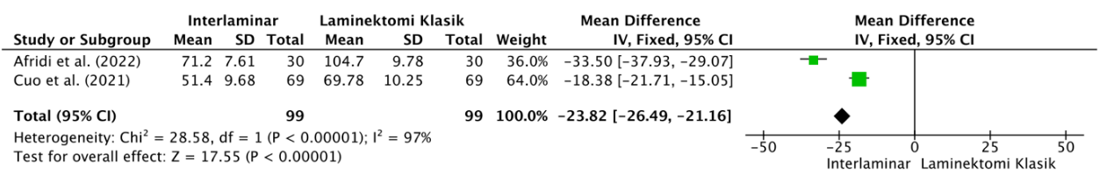
Fig 3. Forest plot relationship between interlaminar measures and procedure duration compared to classical laminectomy measures
The results of Figure 4 analysis that included all studies showed that there was no significant difference between the interlaminar group and the classical laminectomy group in the preoperative Visual Analog Scale (MD = 0.01; CI = -0.14 - 0.15; P = 0.94).
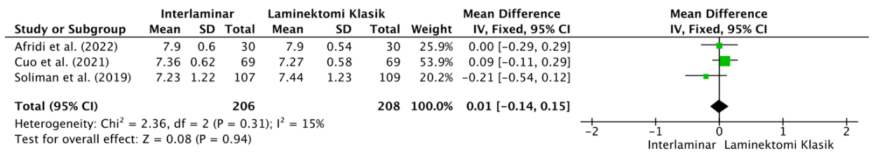
Fig 4. Forest plot relationship between interlaminar measures and preoperative Visual Analogue Scale compared with classical laminectomy measures

The analysis in Figure 5 that included all studies showed that there was a significant difference between the interlaminar group and the classical laminectomy group in the postoperative Visual Analogue Scale (MD = -1.33; CI = -1.46 - (-)1.21; P < 0.00001).

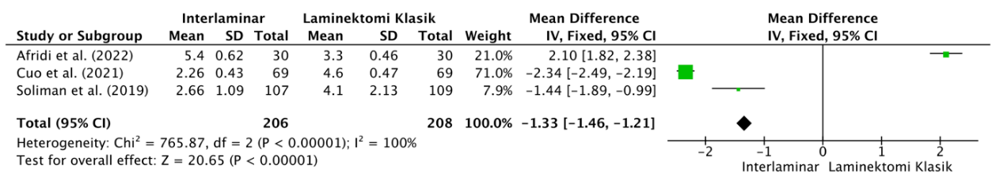
Figure 5. Forest plot relationship between interlaminar measures and postoperative Visual Analogue Scale compared with classical laminectomy measures

The results of the figure 6 analysis that included two studies showed that there was no significant difference between the interlaminar group and the classical laminectomy group in the preoperative Oswestry Disability Index (MD = -0.24; CI = -1.36 - 0.89; P = 0.68).
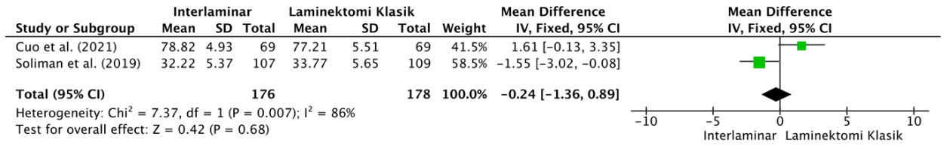
Figure 6. Forest plot relationship between interlaminar measures and preoperative Oswestry Disability Index compared with classical laminectomy measures.

The analysis in Figure 7 that included two studies showed that there was a significant difference between the interlaminar group and the classical laminectomy group in the postoperative Oswestry Disability Index (MD = -9.65; CI = -10.72 - (-)8.58; P < 0.00001).
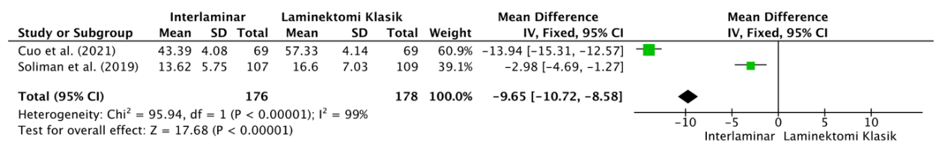
Fig 7. Forest plot relationship between interlaminar measures and postoperative Oswestry Disability Index compared with classical laminectomy measures.

The results of the figure 8 analysis that included two studies showed that there was no significant difference between the interlaminar group and the classical laminectomy group in complications (MD = 1.16; CI = 0.61 - 2.20; P = 0.66).
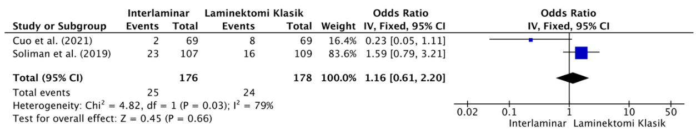
Fig 8. Forest plot relationship between interlaminar surgery and complications compared to classical laminectomy

3.5 Discussion
Interlaminar procedures are generally of shorter duration than classical laminectomy due to their less invasive nature and more focused coverage. Unlike a laminectomy, which involves removing most or all of the lamina to decompress the central spinal canal, the interlaminar technique only requires limited bone and soft tissue removal.¹⁰ This focused approach allows the operator to directly target specific problems without performing extensive decompression, making the procedure faster and more efficient. The smaller field of action, according to Qu et al., is also another reason for the shorter duration.¹¹ By accessing the spine through the space between adjacent laminae, the operator can avoid the extensive exposure required in classical laminectomy. The interlaminar method minimises dissection of the surrounding soft tissues and eliminates the need to detach muscle from bone, thus reducing the time spent on preparation and closure. In contrast, classical laminectomy often involves more extensive decompression of the spinal canal and can include multiple levels, requiring more steps and time.¹²
No significant difference was found in the preoperative visual analogue scale results in both groups could be due to the visual analogue scale value, which is not influenced by the type of procedure itself, according to Kindler et al.¹³ Fear of the unknown, fear of pain, and fear of loss of life are the most influential aspects of preoperative visual analogue scale scores in patients. In contrast to the findings of preoperative visual analogue scale values, there were significant differences in postoperative visual analogue scale values in both groups. This finding is in line with Yaman et al. in 2015 who conducted a study of 40 patients who underwent surgical treatment for lumbar spinal stenosis with two methods.¹⁴ Patients were divided into two groups for the surgical procedure. In the first group, patients underwent classic laminectomy, while in the second group patients underwent bilateral interlaminar decompression. Yaman et al. concluded that bilateral decompression is an effective method without instability effects, which provides sufficient decompression of degenerative stenosis and improves patient comfort in the postoperative period. Therefore, postoperative visual analogue scale values using the interlaminar procedure will tend to be lower.
In patients undergoing decompression surgery for lumbar canal stenosis, several factors may influence outcomes as measured by the Oswestry Disability Index (ODI). The severity of preoperative symptoms is another important determinant. Patients with chronic and severe pain or significant neurological deficits usually have higher ODI scores before surgery.¹⁵ The longer the duration of symptoms, the greater the likelihood of muscle deconditioning and reduced flexibility, all of which can impede postoperative recovery and affect ODI results. Preoperative symptoms were not mentioned in the three studies included in this study, which makes it difficult to assess the non-significant difference in preoperative ODI scores. The type of surgical procedure also significantly affected the ODI score. The degree of decompression, surgical technique, and the presence of complications such as dural tears or infection can affect recovery. Incomplete decompression or residual stenosis may result in persistent symptoms, while complications may delay rehabilitation and prolong disability. In contrast, successful decompression that alleviates nerve compression often results in substantial improvement in ODI scores.¹⁶ El Tabl et al., also supports this statement, through a study conducted on 184 patients, it was found that the interlaminar procedure was better at relieving nerve compression so that the ODI score obtained was smaller in the interlaminar group compared to classical laminectomy.¹⁷
The absence of differences in complications between groups in this study is in line with similar previous studies that have been conducted. According to Haddadi and Ganjeh, surgical complications in interlaminar decompression and classic laminectomy procedures are similar as both techniques involve access to the spinal canal through comparable anatomical structures and surgical approaches.¹⁸ Although the extent of tissue removal and degree of invasion differ, the underlying risks associated with disruption of spinal anatomy and exposure of neural elements remain consistent between the two procedures. Both procedures require a posterior midline approach to access the spine, which involves dissection through the paraspinal muscles to expose the lamina. This process can lead to muscle damage, blood loss, and postoperative pain, which are common complications regardless of whether a classic laminectomy or interlaminar decompression is performed. Furthermore, the proximity to critical structures such as the dura mater, nerve roots, and spinal cord means that accidental injury to these structures can occur in both techniques, leading to complications such as dur tear, cerebrospinal fluid (CSF) leakage, or nerve root damage.^{18,19}
This meta-analysis was based on randomised controlled trial studies, but the number of studies included was small, so the population involved was not representative enough because the three studies had subjects with a close age range. The completeness of the data from each of the included studies is still inadequate, so potential bias could still arise. However, the lack of recent studies directly comparing the interlaminar procedure and classical laminectomy in decompressing lumbar canal stenosis makes this study a valuable addition to the literature.

4. Conclusion

The interlaminar approach offers shorter operative times, reduced postoperative pain as measured by the Visual Analogue Scale, and improved function as assessed by the Oswestry Disability Index, with the added advantage of being a more minimally invasive technique. However, this technique requires specialized skills and has more limited indications. A classic laminectomy remains relevant for treating multilevel stenosis or complex cases. Appropriate patient selection, operator training, equipment availability, continued research, and patient education are key to optimizing overall and sustainable clinical outcomes and quality of life across healthcare settings.

Disclaimer (Artificial intelligence)
Option 1:
Author(s) hereby declare that NO generative AI technologies such as Large Language Models (ChatGPT, COPILOT, etc.) and text-to-image generators have been used during the writing or editing of this manuscript.
Option 2:
Author(s) hereby declare that generative AI technologies such as Large Language Models, etc. have been used during the writing or editing of manuscripts. This explanation will include the name, version, model, and source of the generative AI technology and as well as all input prompts provided to the generative AI technology
Details of the AI usage are given below:
1.
2.
3.

References

1. Shah, N. N., Yadav, P., Parmar, S., & Baldev, H. (2021). Lumbar spinal canal stenosis diagnosis and treatment. International Journal of Orthopaedics Sciences, 7(1), 972-975. https://doi.org/10.22271/ortho.2021.v7.i1o.2594 .
2. Melcher, C., Paulus, A. C., Roßbach, B. P., Gülecyüz, M. F., Birkenmaier, C., Von Schulze-Pellengahr, C., et al. (2022). Lumbar spinal stenosis - surgical outcome and the odds of revision-surgery: Is it all due to the surgeon? Technology and Health Care, 30(6), 1423–1434. https://doi.org/10.3233/THC-223389
3. Chou, R., Pinto, R. Z., Fu, R., Lowe, R. A., Henschke, N., McAuley, J. H., & Dana, T. (2022). Systemic corticosteroids for radicular and non-radicular low back pain. Cochrane Database of Systematic Reviews. https://doi.org/10.1002/14651858.CD012450.pub2
4. Fujita, N. (2021). Lumbar Spinal Canal Stenosis from the Perspective of Locomotive Syndrome and Metabolic Syndrome: A Narrative Review. Spine Surgery and Related Research, 5(5), 61–7. https://doi.org/10.22603/ssrr.2020-0112
5. Fornari, M., Robertson, S. C., Pereira, P., Zileli, M., Anania, C. D., Ferreira, A., Ferrari, S., Gatti, R., & Costa, F. (2020). Conservative Treatment and Percutaneous Pain Relief Techniques in Patients with Lumbar Spinal Stenosis: WFNS Spine Committee Recommendations. World Neurosurgery X. https://doi.org/10.1016/j.wnsx.2020.100079 .
6. Karlsson, T., Försth, P., Skorpil, M., Pazarlis, K., Öhagen, P., Michaëlsson, K., & Sandén, B. (2022). Decompression alone or decompression with fusion for lumbar spinal stenosis: a randomized clinical trial with two-year MRI follow-up. Bone Joint Journal, 104-B(12), 1343–1351. https://doi.org/10.1302/0301-620X.104B12.BJJ-2022-0340.R1
7. Sajadi, K., Azarhomayoun, A., Jazayeri, S. B., Baigi, V., Ranjbar Hameghavandi, M. H., Rostamkhani, S., Atlasi, R., Faghih Jooybari, M., Ghodsi, Z., Vaccaro, A. R., Khorasanizadeh, M., & Rahimi-Movaghar, V. (2022). Long-Term Outcomes of Laminectomy in Lumbar Spinal Stenosis: A Systematic Review and Meta-Analysis. Asian Journal of Neurosurgery, 17(2), 141–155. https://doi.org/10.1055/s-0042-1756421
8. Choi J, Akbari K, Amaya J, Rizkalla J. Interlaminar laminectomy/discectomy techniques and outcomes. Semin Spine Surg. 2024;36(1):101082.
9. Wang, H. H., Xia, D. D., Wu, X. C., & Hu, B. W. (2023). Unilateral interlaminar approach 270° circular spinal canal decompression under the iLESSYS Delta for the treatment of lumbar spinal stenosis in the elderly. Zhongguo Gu Shang, 36(11), 1070–1074. https://doi.org/10.12200/j.issn.1003-0034.2023.11.012
10. Goh, K. Y., Hsu, J. C., Lee, C. Y., Huang, T. J., Chen, C. M., & Wu, M. H. (2021). Uniportal Endoscopic Interlaminar Decompression in Lumbar Spinal Stenosis: A Comprehensive Review. International Journal of Spine Surgery. https://doi.org/10.14444/8164
11. Qu, X., Zhang, L., Xie, Z., Zhang, J., Huang, Y., Li, N., & Luo, X. (2024). Efficacy of endoscopic interlaminar decompression in lumbar spinal stenosis: a retrospective study. Scientific Reports, 14(1), 26956. https://doi.org/10.1038/s41598-024-77337-2
12. Aliabadi, H., Paul, M. S., Kusumi, M., & Chehrazi, B. (2021). Less Invasive Decompressive Laminectomy and One-Level Lumbar Fusion in the Setting of Interspinous Fixation: A Retrospective Analysis of 15 Patients. Cureus, 13(9), e17653. https://doi.org/10.7759/cureus.17653
13. Kindler, C. H., Harms, C., Amsler, F., Ihde-Scholl, T., & Scheidegger, D. (2000). The visual analog scale allows effective measurement of preoperative anxiety and detection of patients' anesthetic concerns. Anesthesia & Analgesia, 90(3), 706–712. https://doi.org/10.1097/00000539-200003000-00036
14. Yaman, O., Ozdemir, N., Dagli, A. T., Acar, E., Dalbayrak, S., & Temiz, C. (2015). A comparison of bilateral decompression via unilateral approach and classic laminectomy in patients with lumbar spinal stenosis: A retrospective clinical study. Turk Neurosurg, 25(2), 239–245. https://doi.org/10.5137/1019-5149.JTN.8710-13.1
15. Khan, M. B., Bashir, M. U., Kumar, R., & Enam, S. A. (2015). Enduring improvement in Oswestry Disability Index outcomes following lumbar microscopic interlaminar decompression: An appraisal of prospectively collected patient outcomes. Journal of Craniovertebral Junction and Spine, 6(4), 195–199. https://doi.org/10.4103/0974-8237.167881.
16. Mirzashahi, B., Yaseen Khan, F. M., Besharaty, S., Bagheri, N., Moaveni, A. K., Hasani Satehi, S., & Zarei, M. (2022). Factors Affecting the Outcome of Lumbar Canal Stenosis Surgery: A Two-year Follow-up Study. Caspian Journal of Neurological Sciences, 8(3), 143-148. https://doi.org/10.32598/CJNS.8.30.4
17. El Tabl, M. A., El Sisi, Y. B., Al Emam, S. E., Hussen, M. A., & Saif, D. S. (2020). Evaluating the outcome of classic laminectomy surgery alone versus laminectomy with fixation surgery in patients with lumbar canal stenosis regarding improvement of pain and function. Egyptian Journal of Neurosurgery, 35(1), 19. https://doi.org/10.1186/s41984-020-00087-6
18. Haddadi, K., & Ganjeh Qazvini, H. R. (2016). Outcome after Surgery of Lumbar Spinal Stenosis: A Randomized Comparison of Bilateral Laminotomy, Trumpet Laminectomy, and Conventional Laminectomy. Frontiers in Surgery, 3, 19. https://doi.org/10.3389/fsurg.2016.00019
19. Dhar, U. K., Menzer, E. L., Lin, M., O'Connor, T., Ghimire, N., Dakwar, E., Papanastassiou, I. D., Aghayev, K., Tsai, C. T., & Vrionis, F. D. (2024). Open laminectomy vs. minimally invasive laminectomy for lumbar spinal stenosis: a review. Frontiers in Surgery, 11, Article 1357897. https://doi.org/10.3389/fsurg.2024.1357897
20. Chiu, R. G., Patel, S., Zhu, A., Aguilar, E., & Mehta, A. I. (2020). Endoscopic versus open laminectomy for lumbar spinal stenosis: an international, multi-institutional analysis of outcomes and adverse events. Global spine journal, 10(6), 720-728. https://doi.org/10.1177/2192568219872157
21. Chen, L., Guan, B., Anderson, D.B. et al. Surgical interventions for degenerative lumbar spinal stenosis: a systematic review with network meta-analysis. BMC Med 22, 430 (2024). https://doi.org/10.1186/s12916-024-03653-z

22. Afridi, E. A. K., Ali, G., Wasim, M., Shahzadi, A., & Asghar, S. (2022). Lumbar Canal Stenosis Decompression Using Bilateral Interlaminar Versus Classic Laminectomy Technique. Pakistan Journal Of Neurological Surgery, 26(4), 554-561. DOI: 10.36552/pjns.v26i4.800

Mansi Deshmukh, Priyanka Telang and Rupali Thorat (2021) “Lumbar Stenosis with Necrosis of Foot a Diagnostic Approach”, Journal of Pharmaceutical Research International, 33(59B), pp. 140–146. doi: 10.9734/jpri/2021/v33i59B34362.

