Case report

Cervical Medulloblastoma Mimicking a Nerve Sheath Tumour in a Child: A Rare Extracranial Presentation

Abstract
Aims: To emphasize the diagnostic challenge of primary cervical medulloblastoma mimicking a nerve sheath tumor in pediatric patients.
Case Report: An 8-year-old boy presented with posterior neck swelling and spastic quadriparesis. MRI revealed a well-defined intradural extramedullary cervical mass with "dumbbell" extension, radiologically resembling a schwannoma. Gross total resection was performed, yielding significant neurological recovery. Unexpectedly, histopathology confirmed medulloblastoma.
Discussion: Primary spinal medulloblastomas are rare and can radiologically masquerade as benign tumors. Unlike drop metastases, they lack intracranial involvement. Management requires surgical decompression followed by craniospinal irradiation and chemotherapy.
Conclusion: Medulloblastoma should be considered in the differential of pediatric spinal masses. Early recognition and multimodal management are critical for favorable outcomes.

Keywords: Schwannoma; Cervical spine; Pediatric Oncology; Small Round Blue Cell Tumors.

Introduction
Medulloblastoma represents the most frequently diagnosed malignant brain tumor in the pediatric population, constituting approximately 20% of all childhood intracranial neoplasms [1]. Historically, these tumors are defined as embryonal neuroepithelial tumors arising within the posterior fossa, specifically from the cerebellar vermis or hemispheres [1]. However, the landscape of neuro-oncology has shifted significantly in recent years. The 2021 World Health Organization (WHO) classification of central nervous system (CNS) tumors has redefined medulloblastoma not merely by its histological appearance but as a molecularly heterogeneous entity [1]. It is now categorized into four distinct molecular subgroups—WNT-activated, SHH-activated, Group 3, and Group 4—each carrying unique demographic profiles, clinical behaviors, and prognostic implications [2].
While intracranial medulloblastomas are well-documented and studied, primary extracranial or spinal medulloblastomas are an exceptional rarity. In the vast majority of cases involving the spine, medulloblastoma presents as "drop metastases"—secondary seedings spread via the cerebrospinal fluid (CSF) from a primary intracranial mass. A primary manifestation in the cervical spine, in the complete absence of intracranial disease, is an exceedingly uncommon clinical entity that challenges standard diagnostic algorithms [3-5].
This rarity creates a significant diagnostic blind spot for clinicians. In the pediatric population, a well-defined intradural extramedullary mass in the cervical spine is statistically most likely to be a benign nerve sheath tumor, such as a schwannoma or neurofibroma, or potentially a meningioma. These benign lesions typically present with indolent growth and specific radiological signatures. The radiological mimicry between these benign tumors and the highly aggressive primary spinal medulloblastoma often leads to initial misdiagnosis and surgical surprise [6].
The differentiation is critical because the management protocols for benign nerve sheath tumors and malignant embryonal tumors are diametrically opposed. While gross total resection is often curative for schwannomas, medulloblastomas require aggressive multimodal adjuvant therapy, including craniospinal irradiation and chemotherapy, to prevent recurrence and neuraxis dissemination. We present a rare case of a primary cervical medulloblastoma in an 8-year-old boy that radiologically masqueraded as a benign nerve sheath tumor, underscoring the critical need for histopathological verification in pediatric spinal masses.

Case Presentation
An 8-year-old male child presented to the neurosurgery outpatient department with a chief complaint of a progressively enlarging swelling over the posterior aspect of the neck. The parents reported that the swelling had been noticeable for several months and was painless but firm to the touch. Coinciding with the enlargement of the mass, the child had developed functional deterioration, specifically difficulty in walking and a gradual onset of weakness involving all four limbs.
A detailed history was obtained to rule out other etiologies. There was no history of trauma, recent fever, or constitutional symptoms such as significant weight loss, night sweats, or loss of appetite, which helped to largely exclude infectious causes like Pott’s spine (tuberculous spondylitis) or parasitic cysts.
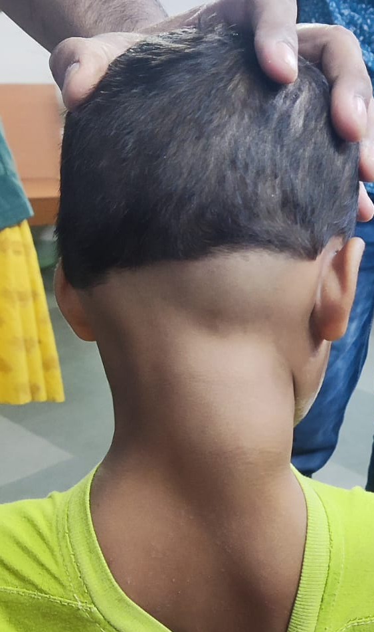
Figure 1: Preoperative clinical photograph showing a large posterior cervical swelling.

Clinical Examination
On physical examination, a prominent, firm, non-tender swelling was palpable in the posterior cervical region (Figure 1). A comprehensive neurological examination confirmed features of spastic quadriparesis. The child exhibited motor weakness in all four limbs (Medical Research Council grade 3/5), accompanied by increased tone (spasticity) and hyperreflexia, consistent with upper motor neuron involvement due to cord compression. Plantar reflexes were extensor bilaterally. Sensory examination was attempted but was limited due to the child's poor cooperation and anxiety. Cranial nerve examination was unremarkable, ruling out high cervical or brainstem involvement. Importantly, bladder and bowel functions were preserved, indicating that while the cord compression was severe, it had not yet resulted in complete autonomic failure.

Radiological Assessment
Magnetic resonance imaging (MRI) of the cervical spine was performed to delineate the anatomy of the lesion. The imaging revealed a large, well-defined solitary mass located in the posterior cervical region. The tumor demonstrated significant intraspinal extension, obliterating the subarachnoid space and causing severe compression of the cervical spinal cord (Figure 2A–C).
Radiologically, the lesion appeared extramedullary and intradural. It was isointense on T1-weighted images and heterogeneously hyperintense on T2-weighted images. The tumor exhibited a "dumbbell" morphology, extending through the neural foramen, a feature classically associated with cervical nerve sheath tumors. Based on these imaging characteristics—specifically the well-defined borders and foraminal extension—the primary radiological diagnosis was a cervical nerve sheath tumor, likely a schwannoma or neurofibroma. A screening MRI of the brain was performed to rule out a primary cranial source or other lesions; this scan was normal, confirming the spinal lesion was the primary pathology.
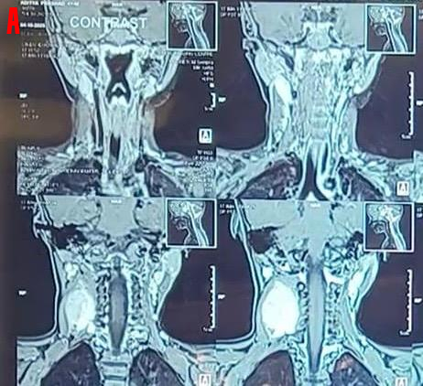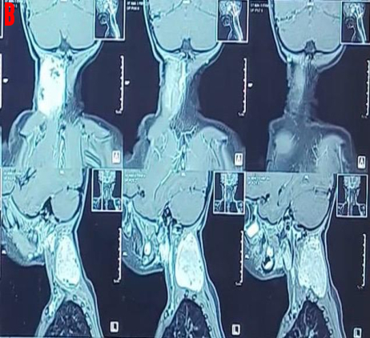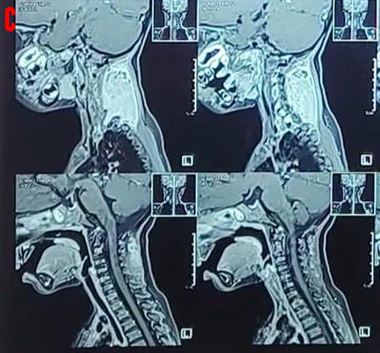
Figure 2A–C: Preoperative MRI cervical spine showing a well-defined posterior cervical mass with intraspinal extension causing significant spinal cord compression.

Surgical Management
Given the severe spinal cord compression and progressive neurological deficit, the patient was scheduled for urgent surgical decompression. The patient was positioned prone, and a posterior incision was made on the right side of the neck. A standard laminectomy was performed to expose the dura.
Intraoperatively, upon opening the dura, a well-encapsulated, grayish-pink, moderately vascular tumor was identified. The tumor was located in the posterior cervical region with extension into the spinal canal. Unlike the firm, rubbery texture typically associated with schwannomas, this tumor was noted to be relatively soft and friable. Using microsurgical techniques, the tumor was carefully dissected from the spinal cord and nerve roots. Gross total excision was achieved, resulting in immediate and adequate decompression of the spinal cord (Figure 3).
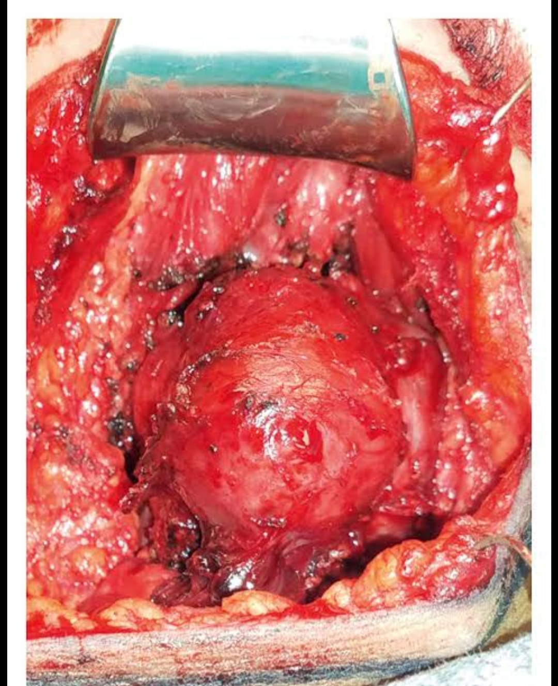
Figure 3: Intraoperative photograph showing exposure of the cervical tumor.
Postoperative Course and Histopathology
The patient was extubated on the table and transferred to the recovery unit. The postoperative course was uneventful, with no new neurological deficits. In the days following surgery, the child showed significant neurological improvement, with a reduction in spasticity and a gradual recovery of motor power in all four limbs. The surgical wound healed well by primary intention (Figure 4).
The resected specimen was sent for histopathological analysis. Microscopically, the tumor was highly cellular, composed of sheets of small round blue cells with hyperchromatic nuclei and scant cytoplasm. High mitotic activity and apoptotic bodies were frequently observed. Homer-Wright rosettes, a classic feature of medulloblastoma, were present. Immunohistochemical staining was positive for synaptophysin and Ki-67 (indicating a high proliferation index), while being negative for S-100 (excluding schwannoma), CD99 (excluding Ewing’s sarcoma), and LCA (excluding lymphoma). These features confirmed the diagnosis of medulloblastoma.
..

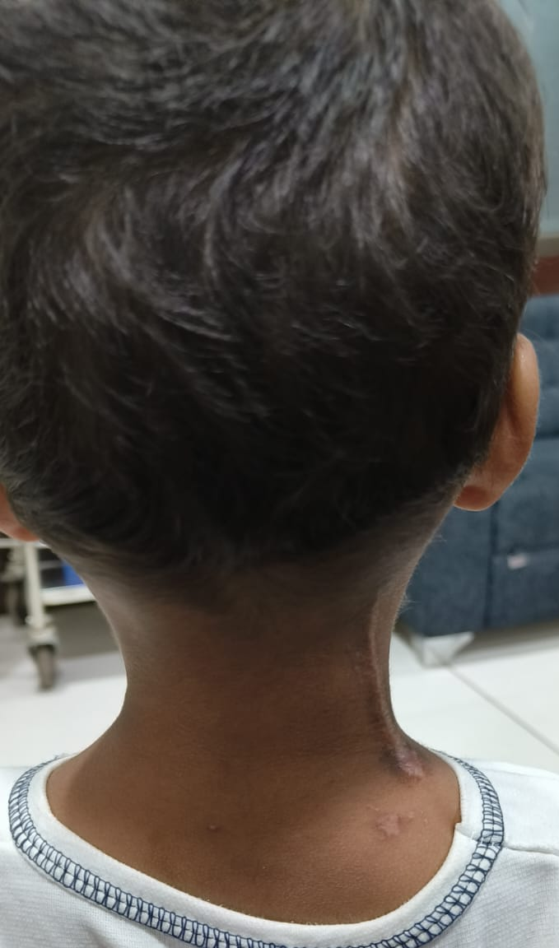
Figure 4: Postoperative clinical photograph showing healed surgical scar over the posterior cervical region.

Discussion
Pathogenesis and Origins of Spinal Medulloblastoma The occurrence of medulloblastoma outside the posterior fossa challenges the traditional embryological understanding of this tumor. While intracranial medulloblastomas arise from granule cell precursors in the cerebellum (SHH subgroup) or the dorsal brainstem cochlear nuclei (WNT subgroup), the origin of primary spinal medulloblastoma remains a subject of debate. Current hypotheses suggest three potential mechanisms. First, they may arise from the malignant transformation of ectopic embryonal cell rests—remnants of the primitive neuroectoderm that failed to migrate correctly during fetal development [7]. Second, they may stem from the aberrant migration of neuroectodermal cells into the spinal canal. Third, they may differentiate from pluripotent mesenchymal stem cells located within the spinal cord or meninges [3, 8]. Because they lack the specific developmental niche of the cerebellum, determining the molecular subgroup of spinal primaries is often difficult, and they may represent a biological entity distinct from their cranial counterparts.
Diagnostic Dilemma: The Radiological Mimicry The defining feature of this case was the radiological resemblance to a benign nerve sheath tumor. In pediatric patients, intradural extramedullary neoplasms are relatively rare. When they do occur, schwannomas and neurofibromas are the most common differentials. Schwannomas typically present as well-circumscribed, encapsulated masses that may cause widening of the neural foramen—the classic "dumbbell" sign seen in our patient [6].
Primary spinal medulloblastomas often present as isointense on T1-weighted images and hyperintense on T2-weighted images, with heterogeneous contrast enhancement [9]. Unfortunately, these signal characteristics overlap significantly with benign tumors. Schwannomas, for instance, also appear hyperintense on T2 sequences (often due to cystic degeneration or the presence of Antoni B tissue) and enhance avidly with contrast. This radiological overlap creates a "trap" for the neurosurgeon; the assumption of a benign pathology may lead to a surgical approach focused solely on resection, potentially delaying the involvement of oncologists or the planning of adjuvant therapy until pathology results return [6, 9].
Histopathological Differential Diagnosis The intraoperative finding of a soft, friable tumor, rather than the firm nature of a schwannoma, was the first clue to a different pathology. Histologically, medulloblastoma belongs to the category of "Small Round Blue Cell Tumors" (SRBCTs). In the spinal location, the differential diagnosis for SRBCTs is broad and includes Ewing’s sarcoma/PNET, non-Hodgkin’s lymphoma, neuroblastoma, and metastatic rhabdomyosarcoma.
- Ewing’s Sarcoma/PNET: These are typically CD99 positive.
- Lymphoma: These are LCA (Leukocyte Common Antigen) positive.
- Schwannoma: These are strongly S-100 positive.
- Medulloblastoma: These are Synaptophysin positive, CD99 negative, and S-100 negative. Accurate immunohistochemistry is vital, as the treatment for lymphoma (chemotherapy only) or Ewing’s (chemo-radiation) differs significantly from medulloblastoma protocols.
Therapeutic Management and Challenges The management of primary spinal medulloblastoma requires an aggressive, multidisciplinary approach. Surgical decompression is the first line of defense. It provides immediate relief from cord compression, which is crucial for preserving motor function, and yields tissue for a definitive diagnosis [10]. In our case, gross total resection was achieved. In intracranial medulloblastoma, the extent of resection is a major prognostic factor; it is widely accepted that "near-total" or "gross total" resection improves survival [11]. It is inferred that the same principle applies to spinal primaries.
However, surgery alone is never curative for medulloblastoma due to its microscopic infiltrative nature and high propensity for CSF dissemination. Post-operative management typically involves Craniospinal Irradiation (CSI) followed by a boost to the primary tumor site [12]. The standard dose is often 23.4 Gy to the neuraxis, with a boost to 54 Gy at the tumor bed.
Administering CSI in pediatric patients presents unique challenges. Radiation to the developing spine can result in vertebral growth retardation, resulting in short stature and potential spinal deformities. Furthermore, there are risks of endocrine dysfunction and neurocognitive sequelae. To mitigate these risks, chemotherapy is a cornerstone of treatment. Regimens often include agents such as Cisplatin, Vincristine, and Cyclophosphamide (the "Packer Protocol" or similar variations) [12]. In children younger than 3 years, "baby brain" protocols utilizing high-dose chemotherapy without radiation are often used to delay radiation until the child is older, though this was not applicable in our 8-year-old patient.
Prognosis The prognosis for primary spinal medulloblastoma is generally considered guarded. Because the condition is so rare, large-scale survival data is lacking compared to the robust data available for intracranial cases [11]. However, early detection, gross total resection, and adherence to aggressive adjuvant protocols are the best predictors of a favorable outcome.
Conclusion Medulloblastoma should be considered in the differential diagnosis of intradural extramedullary cervical spine tumors in children, despite its extreme rarity at this location. This case highlights that even classic-appearing "schwannomas" on MRI—demonstrating well-defined borders and foraminal extension—can turn out to be malignant embryonal tumors. Imaging characteristics alone may be misleading, and only histopathology can confirm the diagnosis [9]. This case serves as a reminder for neurosurgeons to maintain a high index of suspicion when treating pediatric spinal masses and emphasizes that early recognition and appropriate multimodal therapy are essential for favorable long-term survival.
Ethical Approval and Patient Consent This case report was conducted in accordance with the ethical standards of the institutional and national research committee and with the 1964 Helsinki Declaration and its later amendments. Ethical clearance was obtained from the Institutional Ethics Committee (IEC) prior to the preparation of this manuscript. Written informed consent was obtained from the patient’s parents for the publication of this case report and any accompanying images.
COMPETING INTERESTS DISCLAIMER Authors have declared that they have no known competing financial interests OR non-financial interests OR personal relationships that could have appeared to influence the work reported in this paper.
Disclaimer (Artificial intelligence) Author(s) hereby declare that NO generative AI technologies such as Large Language Models (ChatGPT, COPILOT, etc.) and text-to-image generators have been used during the writing or editing of this manuscript.
References
- Louis DN, Perry A, Wesseling P, et al. The 2021 WHO classification of tumors of the central nervous system: a summary. Acta Neuropathol. 2021;141(3):295–331.
- Northcott PA, Korshunov A, Pfister SM, Taylor MD. The clinical implications of medulloblastoma subgroups. Nat Rev Neurol. 2012;8(6):340–351.
- Kumar R, Achari G, Benerjee S. Primary spinal medulloblastoma: case report and review of literature. J Neurosurg. 2001;95(1 Suppl):105–108.
- Helseth E, Due-Tønnessen BJ, Meling TR. Extracranial medulloblastoma: case report and review of literature. Childs Nerv Syst. 2003;19(3):205–208.
- Aizer AA, Ancukiewicz M, Nguyen PL, et al. Natural history and management of extracranial medulloblastoma. Cancer. 2010;116(17):4090–4097.
- Patil AA, Menon G, Nair S. Cervical spinal medulloblastoma masquerading as nerve sheath tumor in a child. Neurol India. 2014;62(6):690–692.
- Riffaud L, Morandi X, Massengo S, et al. Primary extraneural medulloblastoma: a case report. Neurochirurgie. 2001;47(6):542–546.
- Rao S, Rajkumar A, Chacko G. Primary spinal medulloblastoma in children: diagnostic dilemma and management challenges. Childs Nerv Syst. 2012;28(11):1965–1969.
- Koeller KK, Rushing EJ. From the archives of the AFIP: medulloblastoma: radiologic-pathologic correlation. Radiographics. 2003;23(6):1613–1637.
- Sharma MC, Sarkar C, Gaikwad S, et al. Primary spinal medulloblastoma: a report of two cases. Clin Neurol Neurosurg. 1999;101(1):33–37.
- Rutkowski S, von Hoff K, Emser A, et al. Survival and prognostic factors of early childhood medulloblastoma: an international meta-analysis. J Clin Oncol. 2010;28(33):4961–4968.
- Pollack IF. Multidisciplinary management of childhood medulloblastoma. Curr Treat Options Neurol. 2003;5(5):403–414.

