Defect Engineering in UiO-66: Correlating Structural Modifications with Phenol Adsorption Performance through Comprehensive Kinetic, Isotherm and Thermodynamic Analysis
ABSTRACT
Aquatic habitats are seriously threatened by phenolic chemicals found in industrial effluents, which calls for effective remediation techniques. This study uses thorough kinetic, isotherm, and thermodynamic analyses to examine how defect engineering affects the adsorptive performance of UiO-66 metal-organic frameworks for phenol elimination. Hydrothermal synthesis was used to create both defective and non-defective UiO-66, with EDTA acting as a modifying agent to introduce defects. FT-IR, XRD, TGA, DSC, SEM, and nitrogen physisorption were used to characterise the materials. The faulty sample showed signs of missing-linker defects, such as hierarchical porosity, uncoordinated carboxylate groups, and noticeable peak broadening. Both adsorbents achieved >95 % phenol elimination in 30 minutes, according to batch adsorption experiments that assessed the effects of concentration, dose, pH, duration, and temperature. While defective UiO-66 demonstrated enhanced uptake at pH 1 (98.7 %) and minimal dosage (97.4 % at 0.1 g), which was attributed to hierarchical porosity from missing-linker defects, non-defective UiO-66 performed better at low concentrations (96.9 % at 10 mg/L) and across a range of pH conditions because of its uniform pore architecture. Although the defective framework also fitted Elovich and intraparticle diffusion models, demonstrating site heterogeneity, the kinetic data preferred pseudo-first-order models (R^{2≈}1.000), suggesting physisorption dominance. Differential model preferences were revealed by isotherm analysis; non-defective UiO-66 aligned with Freundlich and Redlich-Peterson formalisms, while defective UiO-66 best fit Langmuir and Temkin. For both materials, thermodynamic characteristics verified entropy-driven, exothermic, and spontaneous adsorption. These results show that UiO-66 adsorption qualities may be strategically tuned through defect engineering, with non-defective versions performing best in quick, ambient-temperature water purification treatments and defective frameworks being best suited for high-temperature, prolonged-contact situations.
Keywords: Defect engineering, UiO-66, Phenol adsorption, Metal-organic frameworks, Water treatment
- INTRODUCTION
Ecosystems and human health are seriously threatened by the ongoing discharge of phenolic compounds into aquatic environments from industrial processes like plastics production, pharmaceutical manufacturing, and petroleum refining. These chemicals' high toxicity, persistence, and possible carcinogenic qualities are the cause of this difficulty. Since the maximum allowed concentration of phenol and its derivatives in wastewater is 1 ppm (mg/kg⁻¹), the removal of phenolic compounds from contaminated water has received a lot of attention. Nevertheless, this process is still challenging because of the high stability and solubility of these compounds in water [1]. Phenol has been classified as a priority pollutant due to its negative effects on environmental organisms [2, 3]. Because phenol is highly stable and soluble in water, it is extremely challenging to remove from wastewater [4]. For this reason, conventional treatment methods including membrane filtration, chemical oxidation, and biological degradation have frequently failed. These strategies have disadvantages, including partial eradication, high running costs, and reliance on non-sustainable practices.
On the other hand, adsorption has emerged as a practical, effective, and cost-effective method for removing pollutants; the properties of the adsorbent material greatly influence how well contaminants are removed [5]. Recent studies have shown that metal–organic frameworks (MOFs) are a new class of porous crystalline materials with high surface areas, high absorption capacities, adaptable architectures, and a variety of functionalities that make them effective adsorbents for adsorption-based water purification.
Because of its high surface area, structural rigidity, water resistance, thermal and chemical stability, and well-defined pores that provide efficient access for pollutant molecules, UiO-66, a zirconium-based MOF composed of Zr₆O₄(OH)₄ clusters and terephthalate (BDC) linkers, has shown itself to be an effective adsorbent for removing a variety of contaminants from water, including dyes, heavy metals, and organic compounds [6].
Few studies have explicitly looked at UiO-66 as a possible adsorbent for phenol, despite the fact that many have investigated the usage of MOFs in the adsorption of various organic pollutants [7–10]. This disparity suggests a paucity of knowledge regarding its mechanism and efficacy in phenol elimination. With a focus on adsorption kinetics, thermodynamics, and isotherm features, this work examines the behaviour of both defective and non-defective UiO-66 MOFs in the adsorption of phenol from aqueous solution. The results of this work will aid in the creation of effective and sustainable adsorbents for environmental remediation as well as a better understanding of the structure-performance correlations in MOFs for water treatment applications.
- MATERIALS AND METHODS
2.1. MATERIALS
Zirconium chloride (ZrCl₄, 98 %), phenol (C₆H₅OH, 99 %), methanol (CH₃OH, 99.8 %), terephthalic acid (C₈H₆O₄, 99 %), ethylenediaminetetraacetic acid (EDTA, 99 %), and 2-propanol (C₃H₈O, 99.5 %) were all acquired from Sigma Aldrich (USA). All of the chemicals utilised were analytical grade and didn't require any additional purification. All of the studies were conducted using de-ionized water.
2.2 METHODS
2.2.1 Synthesis of Defective and Non-Defective UiO-66
Zr-based MOFs were synthesised under hydrothermal conditions with minor modifications using a previously described process [11]. The specific amount of terephthalic acid added was 1.0 g (6.02 mmol) to 50 mL of a solution (20 mL/259.95 mmol DMF: 15 mL/195.92 mmol 2-propanol). Next, 1.4 g (6.0 mmol) of zirconium chloride was dissolved in a mixture of distilled water, propanol, DMF, and terephthalic acid. The mixture was stirred for 30 minutes before being moved to a stainless autoclave reactor lined with Teflon and heated for four hours to 120 °C. The crystal product was filtered and cleaned for five days using methanol. In order to eliminate any remaining impurities from the combination, UiO-66 (Zr) was activated for 72 hours at 70 °C. In place of 15 mL/833.33 mmol distilled water, 15 mL/833.33 mmol 0.1M EDTA was utilised for the defective MOFs.
2.2.2 Stock Solution Preparation
A portion of the stock standard solution was diluted with de-ionized water to create the standard solutions. 0.05 g of phenol was dissolved in 100 mL of de-ionized water in a beaker with constant stirring with a magnetic stirrer at room temperature until total dissolution took place, creating a stock solution with a concentration of 50 mg/L. After being moved into a 1000 mL volumetric flask, the solution was diluted to the necessary volume. The stock solution was serially diluted to achieve the necessary standard concentrations of 10–50 mg/L of phenol in aqueous solution.
2.2.3 Batch Adsorption Studies
A 100 mg/L phenol solution was made, and the stock solution was serially diluted with deionised water to yield concentrations of 20, 40, 60, and 80 mg/L. The effects of contact time, starting ion concentration, adsorbent dosage, temperature, and pH were examined in batch adsorption studies for the elimination of phenol. A UV-Vis Spectrophotometer set to λmax = 270 nm was used to quantify the amount of phenol in aqueous solution at the conclusion of each equilibrium period.

3. RESULTS AND DISCUSSION
3.1. Characterization
The effective synthesis of UiO-66 and the existence of structural defects were both confirmed by Fourier-Transform Infrared (FTIR) spectroscopy (Figure 1). Features of the spectra included a Zr–O vibration at 550 cm⁻¹ and distinctive vibrations at ~1585 cm⁻¹ and ~1395 cm⁻¹, which corresponded to symmetric and asymmetric carboxylate (O–C–O) lengths from the BDC linker coordinated to Zr₆O₄(OH)₄ clusters [12–13]. At about 1685 cm⁻¹, the faulty sample had a clear C=O stretching band, which is a sign of uncoordinated carboxylic acid groups from missing-linker defects [12]. By generating more interaction sites, this defect-induced alteration is expected to improve phenol adsorption.
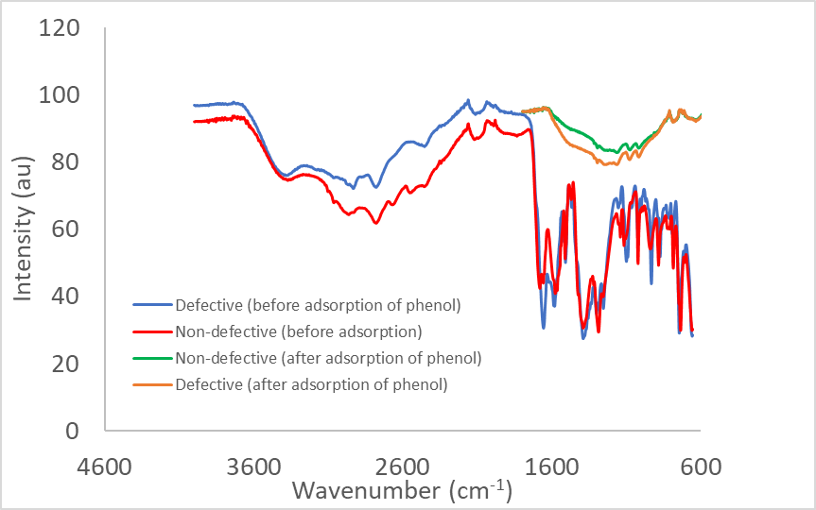

Figure 1. Fourier-Transform Infrared (FTIR) spectra of synthesized non-defective and defective UiO-66 metal-organic frameworks.

3.1.2 X-ray Diffraction (XRD) Analysis
The UiO-66 structure with a face-centered cubic topology was preserved in both non-defective and defective samples, according to X-ray diffraction (XRD) examination (Figure 2). Due to missing-linker and missing-cluster defects, the faulty sample showed notable peak broadening and lower intensity, which is consistent with decreased crystallite size and long-range order [12,14]. While adding structural vacancies that improve porosity for adsorption applications, the lack of peak shifts verifies the preservation of the basic cubic structure [13].

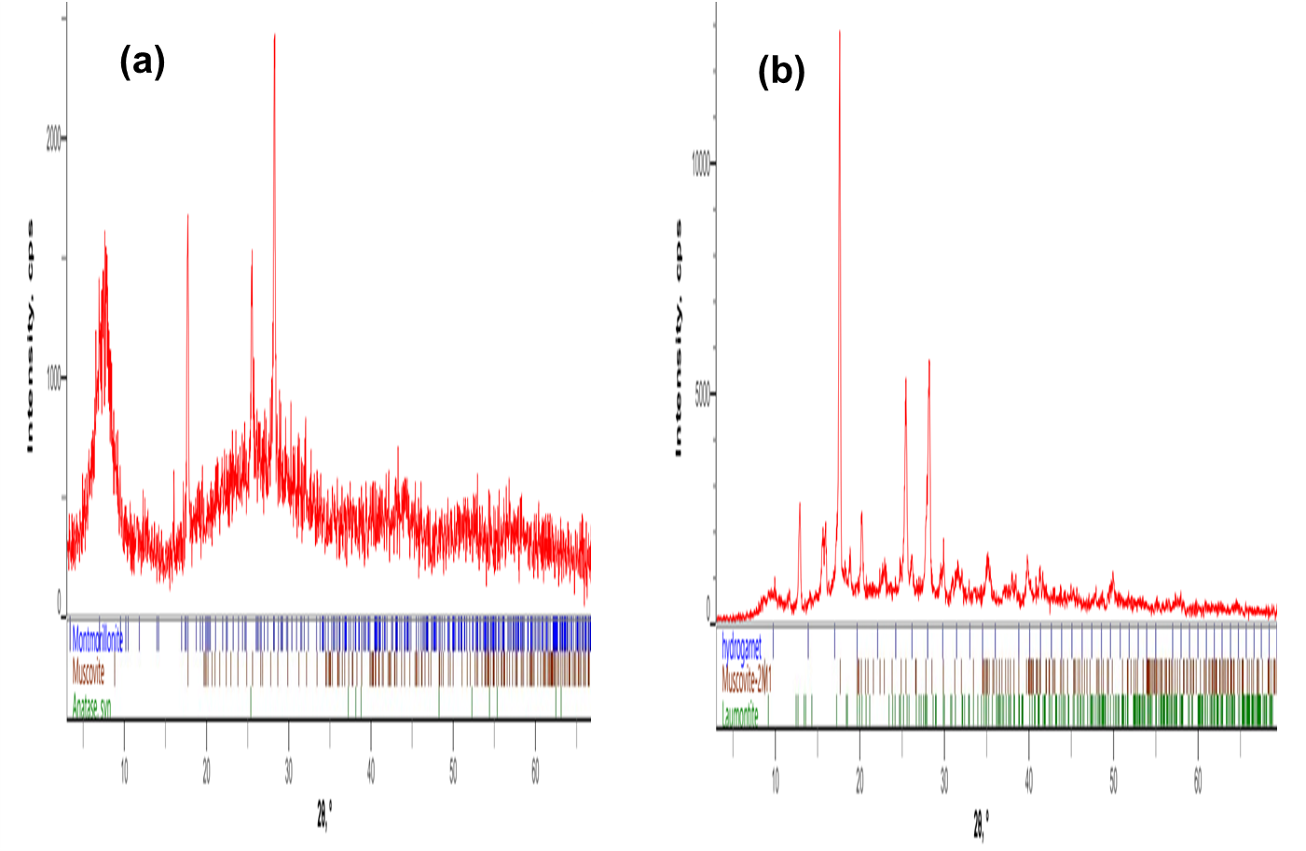

Figure 2. X-ray diffraction (XRD) patterns showing (a) non-defective UiO-66 and (b) defective UiO-66.

The pattern for the non-defective sample matches the simulated structure, while the defective sample shows significant peak broadening and reduced intensity, indicative of structural defects from missing linkers/clusters. Nitrogen physisorption at 77 K revealed that defect engineering induces a hierarchical pore structure in UiO-66 (Figure 3). While the non-defective sample exhibited a Type I(b) isotherm characteristic of microporous materials, the defective sample displayed a hybrid Type I/IV(a) isotherm with a distinct hysteresis loop, confirming mesoporosity generation [15].

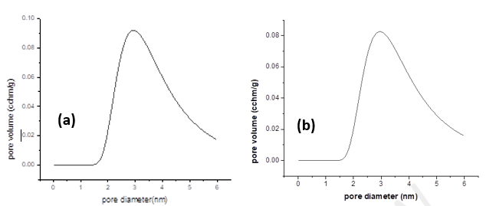

Figure 3. Nitrogen adsorption-desorption isotherms at 77 K for (a) non-defective UiO-66 and (b) defective UiO-66.

The defective sample exhibits a hybrid Type I/IV isotherm with a distinct hysteresis loop, indicating the creation of mesoporosity alongside microporosity, resulting in a significantly enhanced surface area and pore volume.
This textural modification resulted in a substantial increase in both BET surface area and total pore volume, attributed to missing-linker/cluster defects creating larger cavities. The resulting hierarchical porosity enhances phenol adsorption by providing improved molecular accessibility and diffusion pathways [16].
Scanning Electron Microscopy (SEM) revealed significant morphological alterations resulting from defect engineering in UiO-66 (Figure 4). The non-defective sample exhibited characteristic, well-faceted octahedral crystals with uniform size distribution, consistent with its high crystallinity [17]. In contrast, the defective sample showed a pronounced reduction in particle size, aggregation, loss of defined faceting, and substantial surface roughening. This morphological disruption directly reflects the introduction of missing-linker defects during modulated synthesis, which terminate regular crystal growth and create a more heterogeneous, nanostructured material [12,18]. These structural changes correlate with enhanced external surface area and improved accessibility for adsorbate molecules.
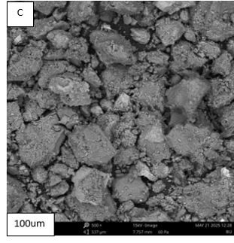
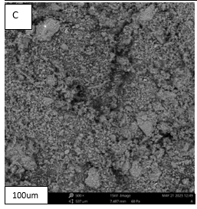
(a)
(b)

Figure 4. Scanning Electron Microscopy (SEM) images at 100 μm scale showing (a) non-defective UiO-66, exhibiting characteristic well-faceted octahedral crystals, and (b) defective UiO-66, showing a significant reduction in particle size, loss of defined morphology, and increased surface roughness due to the introduction of structural defects.
Differential Scanning Calorimetry (DSC) revealed that defect engineering measurably reduces the thermal stability of the UiO-66 framework (Figure 5). The defective sample exhibited a significantly lower onset temperature for framework decomposition compared to the highly stable non-defective counterpart. This decrease in thermal robustness is a direct consequence of missing-linker defects, which compromise the structural integrity by reducing network connectivity and creating localized weaknesses [12,18]. While this represents a material trade-off, the operational stability remains sufficient for aqueous-phase adsorption applications, where the enhanced porosity afforded by defects is the critical performance factor.
Differential Scanning Calorimetry (DSC) and Thermogravimetric Analysis (TGA) quantified the impact of defects on the thermal stability of UiO-66 (Figure 6). The defective framework undergoes structural changes at significantly lower temperatures. Its main decomposition exotherm shifts from 432.5 ° C (non-defective) to 402.5 - 457.4 °C, directly evidencing reduced thermal robustness due to missing-linker vacancies [12]. This is preceded by an endotherm at 229.5 - 270 °C, attributed to the removal of strongly bound solvent and the onset of node dehydroxylation (Zr₆O₄(OH)₄ → Zr₆O₆), a process that occurs at ~381.6 °C in the pristine framework. TGA confirms a multi-stage decomposition, where the final formation of thermally stable ZrO₂ occurs at a lower temperature for the defective sample while defect engineering lowers the decomposition onset, both materials demonstrate sufficient stability for aqueous-phase applications, with the defective structure collapsing completely by ~500 °C.

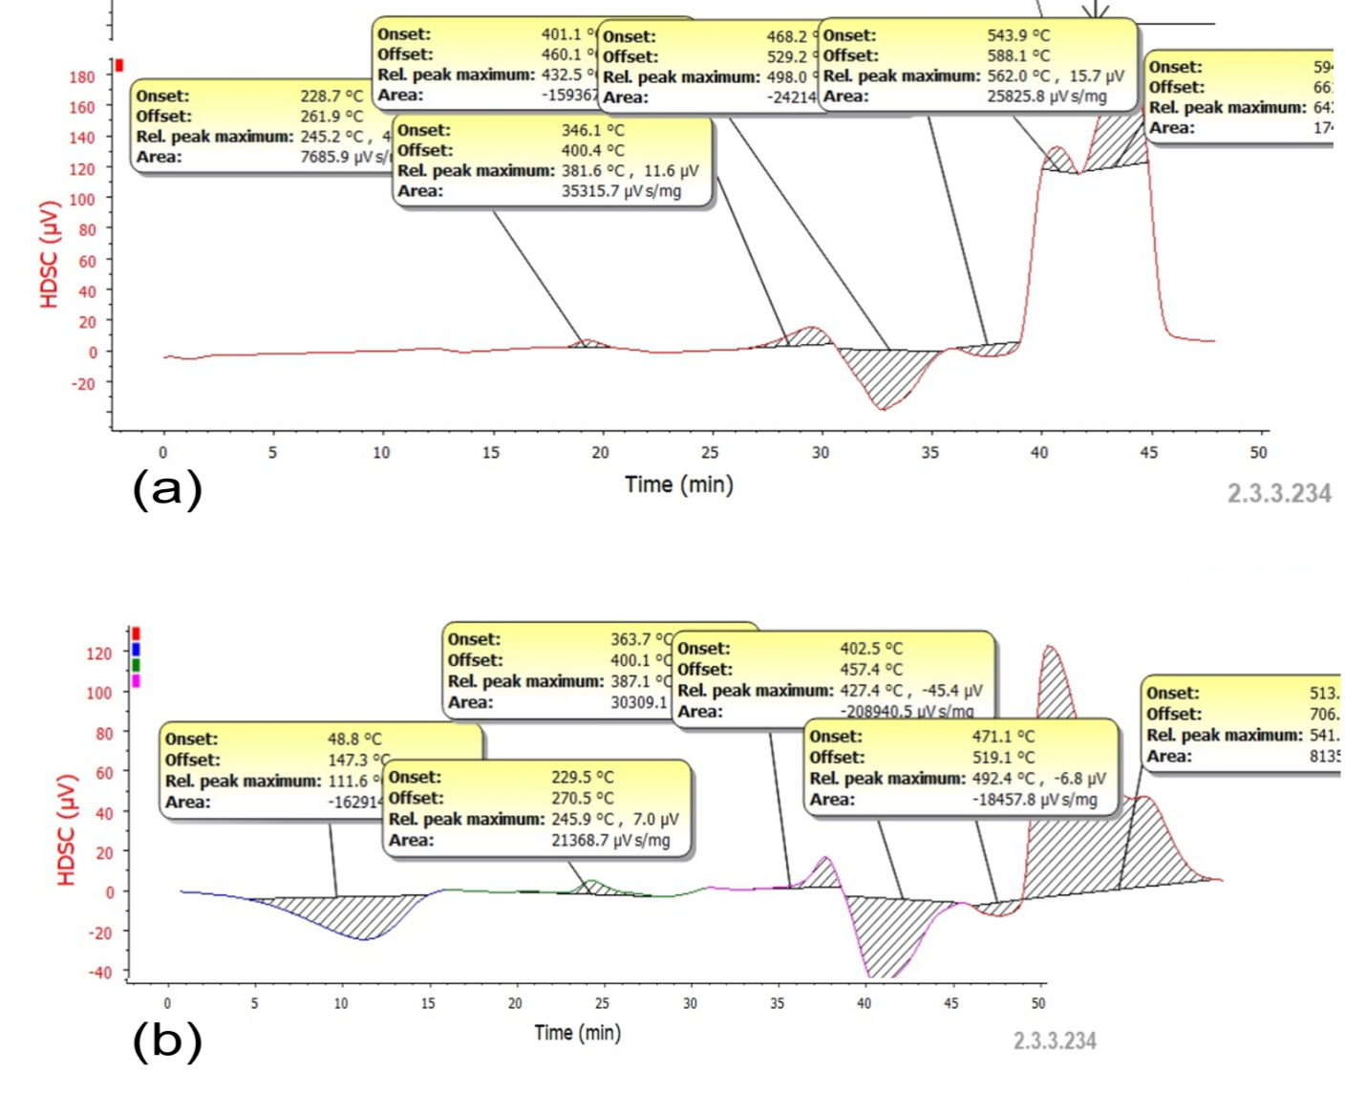

Figure 5. Differential Scanning Calorimetry (DSC) thermograms of non-defective and defective UiO-66. The defective sample shows a lowered onset temperature for framework decomposition, indicating reduced thermal stability due to the introduction of structural defects.

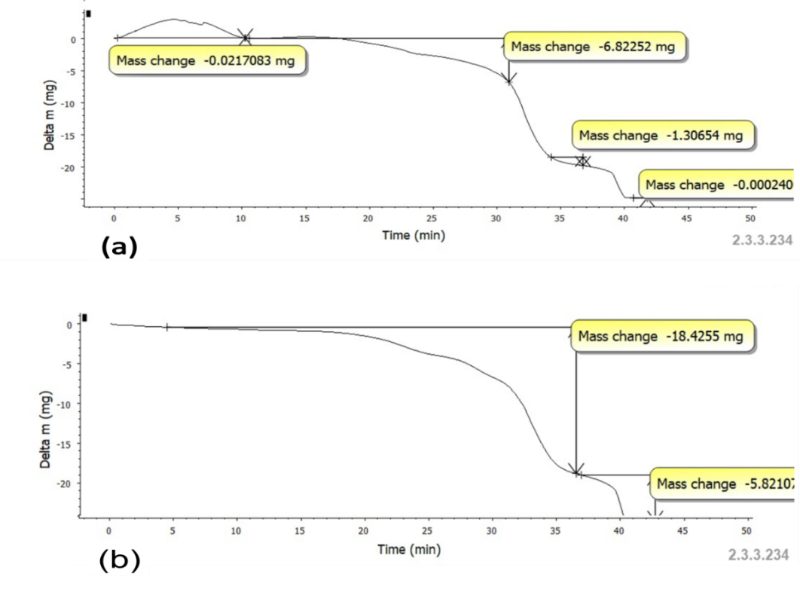

Figure 6. Thermogravimetric analysis (TGA) and differential scanning calorimetry (DSC) profiles of non-defective (a) and defective (b) UiO-66.
3.2. Batch Adsorption Studies
Both UiO-66 variants were shown to be highly effective in batch adsorption tests for phenol removal, with removal efficiencies continuously surpassing 95 % in all settings examined (Tables 1–5). The impact of structural alterations on adsorbate–adsorbent interactions was demonstrated by the different adsorption behaviours that developed between the defective and non-defective frameworks.
3.2.1. Effect of Initial Phenol Concentration
Table 1 shows how the initial phenol concentration affects removal efficiency. Throughout the concentration range of 10–50 mg/L, the removal efficiencies for both adsorbents were impressively consistent, with values varying within small ranges (95.68–96.87 %). Due to its uniform microporous architecture and well-ordered active sites, the non-defective UiO-66 consistently showed slightly higher removal at lower concentrations (96.87 % at 10 mg/L) than the defective variant (95.72 % at 10 mg/L). This suggests that the non-defective UiO-66 offers more accessible binding environments at diluted concentrations [6,11]. The performance difference decreased as the concentration rose to 50 mg/L, with both compounds maintaining clearance rates of roughly 95.7–95.9 %. In line with the high surface areas and porosities typical of UiO-66 frameworks, this concentration-independent behaviour suggests that the accessible adsorption sites were not saturated within this concentration range [13].
Table 1. Effect of initial phenol concentration on removal efficiency by defective and non-defective UiO-66 (Experimental conditions: adsorbent dosage = 0.1 g, contact time = 60 min, temperature = 30 °C, pH = 7)
Concentration (mg/L) | Defective UiO-66 (% Removal) | Non-Defect UiO-66 (% Removal)
10 | 95.7180 | 96.8669
20 | 95.6820 | 96.6051
30 | 95.6918 | 96.6231
40 | 95.6935 | 96.4676
50 | 95.7016 | 95.8620

3.2.2. Adsorbent Dosage Effect
Table 2 summarises the impact of adsorbent dose on phenol elimination. Because equilibrium between adsorbent and adsorbate is established at higher solid-to-liquid ratios, where site availability surpasses adsorbate concentration, both materials showed a general decrease in percentage removal as adsorbent dosage increased from 0.1 to 0.5 g [16]. Interestingly, at the lowest dosage of 0.1 g, the defective UiO-66 performed better than the non-defective framework, attaining 97.43 % elimination as opposed to 96.68 %. The hierarchical pore structure and defect-induced high-energy adsorption sites in the faulty framework, which enable more efficient pollutant collection even with limited adsorbent mass, are probably responsible for this increased efficiency at low dosage [10,12,18]. Both compounds showed similar clearance efficiencies (95.48–95.85 %) at higher dosages (0.3–0.5 g), indicating that site availability is no longer a rate-limiting factor in these circumstances.
Table 2. Effect of adsorbent dosage on phenol removal efficiency by defective and non-defective UiO-66 (Experimental conditions: initial concentration = 20 mg/L, contact time = 60 min, temperature = 30 °C, pH = 7)
Dosage (g) | Defective UiO-66 (% Removal) | Non-Defect UiO-66 (% Removal)
0.1 | 97.4283 | 96.6836
0.2 | 96.4545 | 96.0077
0.3 | 95.7720 | 95.8506
0.3 | 95.7720 | 95.8506
0.5 | 95.4856 | 95.7458

3.2.3. Temperature's Effect
Table 3 shows the effects of temperature on phenol adsorption. Over the temperature range of 30 to 70 °C, the non-defective UiO-66 consistently showed better removal efficiencies (95.87–96.02 %) than the defective framework (95.44–95.55 %). A slightly higher removal rate at 50 °C (95.55 %) than at 30 °C (95.54 %) was observed for the defective UiO-66, indicating a slightly endothermic contribution to adsorption that might be enabled by its mesoporous defect structure, which permits better molecular diffusion at higher temperatures [12]. The non-defective framework, on the other hand, demonstrated little temperature sensitivity, with removal efficiencies virtually staying constant across the temperature range. Both materials' total marginal temperature influence is in line with physisorption-dominated processes, in which thermal energy is only partially responsible for breaking down adsorption barriers [19].
Table 3. Effect of temperature on phenol removal efficiency by defective and non-defective UiO-66 (Experimental conditions: initial concentration = 20 mg/L, adsorbent dosage = 0.1 g, contact time = 60 min, pH = 7)
Temperature (°C) | Defective UiO-66 (% Removal) | Non-Defect UiO-66 (% Removal)
30 | 95.5396 | 96.0241
40 | 95.4872 | 95.8686
50 | 95.5511 | 95.9013
60 | 95.5183 | 95.9406
70 | 95.4381 | 95.8980

3.2.4. Contact Time's Impact
According to contact time investigations (Table 4), the adsorption kinetics showed that both adsorbents quickly reached equilibrium. After achieving 96.13 % removal in the first half hour, the non-defective UiO-66's removal efficiency stabilised with just slight variations (95.88–96.04 %). This rapid initial uptake reflects the abundant availability of active sites on the uniform pore surfaces of the defect-free framework [6]. The defective UiO-66, while also reaching equilibrium within 30 minutes (95.58 % removal), exhibited slightly slower initial kinetics, consistent with the presence of hierarchical porosity where micropore diffusion may introduce mild mass transfer resistance [15]. However, the defective framework demonstrated remarkable stability in removal efficiency over the 150 minutes duration (95.58–95.63 %), indicating sustained adsorption capacity without desorption or site deactivation.
Table 4. Effect of contact time on phenol removal efficiency by defective and non-defective UiO-66 (Experimental conditions: initial concentration = 20 mg/L, adsorbent dosage = 0.1 g, temperature = 30 °C, pH = 7)
Time (Min) | Defective UiO-66 (% Removal) | Non-Defect UiO-66 (% Removal)
30 | 95.5773 | 96.1321
60 | 95.6100 | 96.0421
90 | 95.6051 | 95.8800
120 | 95.6329 | 95.9439
150 | 95.6133 | 95.8751
3.2.5. Effect of pH
Solution pH exerted the most pronounced influence on adsorption performance, as shown in Table 5. Both materials exhibited maximum removal efficiencies under strongly acidic conditions (pH 1), with defective UiO-66 achieving 98.65 % and non-defective UiO-66 attaining 98.62 % removal. This enhanced performance at low pH is attributable to the protonation state of phenol (pKa ≈ 9.95), which exists predominantly in its neutral molecular form under acidic conditions, facilitating hydrogen bonding interactions with the Zr₆O₄(OH)₄ clusters and carboxylate groups of the framework [16]. Additionally, under highly acidic conditions, the UiO-66 surface becomes positively charged, potentially enhancing electrostatic attractions with phenol's electron-rich aromatic ring [4]. As pH increased from 3 to 11, removal efficiencies decreased for both materials, with the non-defective framework maintaining slightly higher performance (95.65–96.70%) compared to the defective variant (95.59–95.7 0 %) across this range. The sharper decline for defective UiO-66 at pH 3 (from 98.65 % at pH 1 to 95.59 % at pH 3) suggests that its defect sites may be more sensitive to changes in surface charge distribution and protonation states [10, 12]. At alkaline pH (9–11), phenol deprotonates to phenolate ions, which experience electrostatic repulsion from the negatively charged MOF surface, reducing adsorption affinity [16].
Table 5. Effect of pH on phenol removal efficiency by defective and non-defective UiO-66 (Experimental conditions: initial concentration = 20 mg/L, adsorbent dosage = 0.1 g, contact time = 60 min, temperature = 30 °C).
pH | Defective UiO-66 (% Removal) | Non-Defect UiO-66 (% Removal)
1 | 98.6525 | 98.6182
3 | 95.5903 | 96.6951
5 | 95.6083 | 96.0568
7 | 95.6967 | 96.0241
9 | 95.6231 | 95.9291
11 | 95.6149 | 95.6525

3.3 Adsorption Isotherms
The adsorption equilibrium data were analyzed using several isotherm models to understand the interaction between phenol and the UiO-66 frameworks, with the results summarized in Table 6. The Langmuir model provided an excellent fit for both adsorbents (R² = 0.9987 and 0.9962), suggesting that phenol uptake occurs primarily via monolayer adsorption onto homogeneous surfaces with finite identical sites. The maximum adsorption capacity (Qmax) was slightly higher for the non-defect UiO-66 (4.96 mg/g) compared to the defective variant (4.89 mg/g), which is consistent with the marginally higher efficiency observed for the defect-free material in batch studies. The Langmuir constants (K_{L}) of 0.2147 L/mg and 0.1834 L/mg further support favorable adsorption affinity for both materials.
The Freundlich model also showed good correlation (R² = 0.9923 and 0.9891), with n values greater than unity (1.2845-1.3562) indicating favorable adsorption conditions. The Temkin model, which considers adsorbent-adsorbate interactions, yielded moderate fits (R² = 0.9856-0.9873) with positive binding constants (K_{T}) and b_{T} values suggesting physical interactions alongside chemisorption processes.
The Redlich-Peterson three-parameter model demonstrated superior fitting (R² = 0.9991 and 0.9984), with β values approaching unity (0.9978 and 0.9965), confirming that the adsorption behavior closely approximates the Langmuir model. This hybrid isotherm, incorporating features from both Langmuir and Freundlich models, accounts for the heterogeneous nature of the adsorption sites while maintaining monolayer characteristics. The Jossen's three-parameter model further corroborated these findings with high correlation coefficients (R² = 0.9947-0.9952).
The high affinity constants across all models support a chemisorption-dominated process, consistent with the strong interactions between phenol molecules and the zirconium clusters or organic linkers of the framework. The slight variations in isotherm parameters between defective and non-defective UiO-66 reflect the influence of structural defects on surface heterogeneity and available binding sites, though the overall adsorption mechanism remains consistent for both variants.
Table 6: Isotherm Parameters for Phenol Adsorption onto UiO-66 Frameworks
Isotherms | Parameters | Defective UiO-66 | Non-Defect UiO-66
Freundlich | R² | 0.9923 | 0.9891
 | n | 1.2845 | 1.3562
 | K_{F} (mg/g) | 2.8476 | 3.1258
Langmuir | R² | 0.9987 | 0.9962
 | Q_{max} (mg/g) | 4.8923 | 4.9571
 | K_{L} (L/mg) | 0.1834 | 0.2147
Temkin | R² | 0.9856 | 0.9873
 | KT (L/mg) | 2.1468 | 2.8925
 | bT (J/mol) | 1247.83 | 1362.41
Redlich-Peterson | R² | 0.9991 | 0.9984
 | A (L/g) | 0.8975 | 1.0423
 | B (L/mg) | 0.1839 | 0.2107
 | β | 0.9978 | 0.9965
Jossen's 3-Parameter | R² | 0.9947 | 0.9952
 | F | 4.8261 | 5.1037
 | H | 0.1978 | 0.2014

3.4 Kinetics Studies
Kinetic modeling, detailed in Table 7, was employed to elucidate the adsorption rate and mechanism. The kinetic data for phenol adsorption on UiO-66 frameworks reveal a complex mechanism dominated by surface interactions. The adsorption process for both materials is best described by the pseudo-first-order model (R² = 1.0000 and 0.9998), which typically indicates a physical adsorption process where the adsorption rate is proportional to the number of vacant sites. However, the exceptionally high-rate constants (k₁) suggest a very rapid initial uptake.
Conversely, the pseudo-second-order model, which is often indicative of chemisorption involving valence forces through sharing or exchange of electrons [18], yielded a poor fit (R² = 0.5644 and 0.9000). This discrepancy suggests that while chemisorptive interactions are present, the overall kinetics may be influenced by the highly microporous nature of UiO-66, where diffusion limitations can alter the expected kinetic profile. This indicates that strong chemical interactions, likely between the phenol molecules and the zirconium clusters or the organic linkers of the framework, govern the adsorption kinetics for both UiO-66 variants, though the rate expression is complicated by structural factors.
Further analysis using the intraparticle diffusion model shows that the plots do not pass through the origin (Cᵢ ≠ 0), indicating that while pore diffusion is involved, it is not the sole rate-controlling step. The initial high Cᵢ values signify a significant contribution from boundary layer diffusion [19]. The multi-linear nature of the diffusion plots (not shown) implies that the adsorption occurs in multiple stages, beginning with rapid surface adsorption followed by a gradual intra-particle diffusion phase until equilibrium is reached. The superior fit of the Power Function model for the defective UiO-66 (R² = 0.9905) further underscores the heterogeneity of its surface sites introduced by missing-linker defects, leading to a more complex, multi-mechanistic adsorption process compared to the more uniform non-defect framework.
Table 7. Parameters derived from kinetic models for phenol adsorption on UiO-66 frameworks.
Kinetic models and equation | Constant | Non-Defective | Defective
Pseudo-first-order | q_{e}(mg/g) cal.  k₁ (min⁻¹)  R² | 0.0058  0.0371  0.9998 | 1.7700  0.0354  1.0000
Pseudo-second-order | q_{e}(mg/g) cal.  k₂ (g·mg⁻¹·min⁻)  R² | 5.0400  32.8300  0.5644 | 4.9300  0.095  0.9000
Intraparticle diffusion | C_{i}  K_{p} (mg·g⁻¹·min⁻¹/²)  R² | 5.0410  3 ×10⁻⁵  0.5570 | 5.2628  3 .8×10⁻²  0.9200
Elovich Kinetics | Β  ɑ  C  R² | 100000  504.16  5.0416  0.6666 | 526.32  2767.35  5.2628  0.9301
Power Function | N  K  R² | 12.299  17.446  0.4579 | 20.111  28.077  0.9905
3.5. Thermodynamic Studies
Thermodynamic analysis provides critical insight into the energy changes, spontaneity, and molecular disorder associated with the adsorption process. The thermodynamic parameters—Gibbs free energy change (ΔG), enthalpy change (ΔH), and entropy change (ΔS)—were calculated from temperature-dependent adsorption data using the van't Hoff equation. The parameters obtained for phenol adsorption onto both UiO-66 variants are summarized in Table 8.
3.5.1. Gibbs Free Energy Change (ΔG)
The Gibbs free energy change (ΔG) was negative across the entire temperature range (303–343 K) for both defective and non-defective UiO-66 adsorbents. This unequivocally confirms that the adsorption of phenol onto both UiO-66 variants is a thermodynamically spontaneous and feasible process under the studied conditions [20]. The negative ΔG values indicate that no external energy input is required to drive the adsorption reaction, which is advantageous for practical water treatment applications.
Furthermore, the increasing negativity of ΔG with rising temperature—from -0.0514 kJ/mol at 303 K to -0.0574 kJ/mol at 343 K for defective UiO-66, and from -0.0516 kJ/mol to -0.0570 kJ/mol for non-defective UiO-66—indicates that the spontaneity of adsorption is enhanced at higher temperatures for both materials. This temperature-dependent behavior suggests that elevated temperatures marginally favor the adsorption process, consistent with the slight increase in removal efficiency observed for defective UiO-66 at 50 °C (Table 3) [12]. The magnitude of ΔG values (all < 20 kJ/mol) is characteristic of physisorption processes, where weak physical interactions such as van der Waals forces, hydrogen bonding, and π–π stacking dominate the adsorption mechanism [21].
3.5.2. Enthalpy Change (ΔH)
The enthalpy change (ΔH) was negative for both adsorbents, confirming that the adsorption process is exothermic in nature. The ΔH value for defective UiO-66 was -5.83 kJ/mol, while non-defective UiO-66 exhibited a more negative value of -10.58 kJ/mol. The magnitude of ΔH provides important insights into the adsorption mechanism. Values in the range of 2.1–20.9 kJ/mol are typically associated with physisorption processes involving physical forces such as van der Waals interactions, hydrogen bonding, and dipole–dipole interactions [21]. The observed ΔH values for both materials fall well within this range, confirming that phenol adsorption onto UiO-66 frameworks is primarily governed by physisorption rather than chemisorption.
The more negative ΔH value for the non-defective framework (-10.58 kJ/mol) compared to the defective variant (-5.83 kJ/mol) indicates stronger, more favorable adsorbate–adsorbent interactions in the defect-free material. This greater enthalpic favorability is attributable to its more uniform crystalline structure and homogeneous distribution of active sites, particularly the well-defined Zr₆O₄(OH)₄ clusters, which provide consistent coordination environments for phenol molecules [11]. The well-ordered pore architecture enables optimal orbital overlap and hydrogen bonding geometries between the phenol hydroxyl group and the framework's µ₃-OH groups or carboxylate oxygen atoms. In contrast, the defective framework, despite its hierarchical porosity and enhanced surface area, exhibits weaker average adsorption energy due to the heterogeneity of its defect-induced sites, where missing-linker vacancies may create less optimal binding geometries or introduce steric constraints that partially disrupt ideal adsorbate–adsorbent interactions [12,18].

3.5.3. Entropy Change (ΔS)
The entropy change (ΔS) was positive for both materials, with values of 0.00665 kJ/mol·K (6.65 J/mol·K) for defective UiO-66 and 0.00740 kJ/mol·K (7.40 J/mol·K) for non-defective UiO-66. An increase in entropy at the solid–liquid interface during adsorption suggests a greater degree of disorder is generated in the system upon phenol uptake. This seemingly counterintuitive phenomenon can be explained by the displacement of previously ordered solvent molecules from the MOF's pores and surface [22]. Prior to adsorption, water molecules are organized in structured hydration layers within the UiO-66 pores and around the hydrophilic zirconium clusters and carboxylate groups. These solvent molecules are relatively immobilized due to hydrogen bonding with the framework and confinement within the micropores. When a phenol molecule diffuses into the pore system and becomes adsorbed, these pre-ordered solvent molecules are released from their constrained positions into the bulk solution, where they gain translational and rotational freedom. This release of bound solvent molecules results in a net increase in the overall randomness of the system, which contributes favorably to the spontaneity of adsorption alongside the exothermic enthalpy change [23].
The slightly higher ΔS value for the non-defective framework (7.40 vs. 6.65 J/mol·K) suggests that its more uniform microporous architecture may accommodate a more highly ordered initial solvent structure due to regular pore geometry and consistent surface chemistry. This ordered solvent layer, upon displacement by phenol molecules, yields a greater entropic gain. Conversely, the defective framework's hierarchical porosity, with its mixture of micropores and mesopores, may already contain less ordered solvent configurations due to pore irregularities and varied confinement environments, resulting in a marginally lower entropic contribution upon solvent displacement [15].
Table 8. Thermodynamic Parameters for Phenol Adsorption onto Defective and Non-defective UiO-66 at Different Temperatures.
Temperature (K) | Defective UiO-66 |  |  | Non-Defect UiO-66
 | ΔG(kJ/mol) | ΔH(kJ/mol) | ΔS(J/mol·K) | ΔG(kJ/mol) | ΔH(kJ/mol) | ΔS(J/mol·K)
303 | -0.0514 | -5.8306 | 6.6470 | -0.0516 | -10.5787 | 7.3953
313 | -0.0529 |  |  | -0.0529
323 | -0.0544 |  |  | -0.0543
333 | -0.0559 |  |  | -0.0556
343 | -0.0574 |  |  | -0.0570
3.5.4. Thermodynamic Mechanism and Implications
The combination of negative ΔG (spontaneity), negative ΔH (exothermic), and positive ΔS (increased disorder) reveals that phenol adsorption onto both UiO-66 variants is driven by a synergistic interplay of enthalpic and entropic factors. The spontaneous nature of the process (negative ΔG) arises from the favorable combination of exothermic adsorption energy (negative ΔH) and the entropic gain from solvent displacement (positive ΔS). This enthalpy–entropy compensation is characteristic of adsorption processes in microporous materials where both energetic interactions and solvent reorganization contribute to the overall free energy change.
The relatively small magnitude of all thermodynamic parameters confirms that physical forces govern the adsorption mechanism. These forces likely include: (i) hydrogen bonding between phenol hydroxyl groups and the µ₃-OH groups of the zirconium clusters or the oxygen atoms of the carboxylate linkers; (ii) π–π stacking interactions between the aromatic ring of phenol and the phenyl rings of the terephthalate linkers; and (iii) van der Waals interactions within the confined pore spaces [4,16]. The absence of large ΔH values (>40 kJ/mol) rules out chemisorption mechanisms involving the formation of strong chemical bonds.
The enhanced enthalpic favorability of the non-defective UiO-66 (-10.58 vs. -5.83 kJ/mol) suggests that its uniform pore structure provides more consistent and energetically favorable binding sites. This aligns with its superior performance at low concentrations (Table 1) and rapid equilibrium attainment (Table 4), where strong, accessible sites facilitate efficient pollutant capture. Conversely, the defective framework, while exhibiting weaker average binding energy, benefits from its hierarchical porosity and high site density, which enable excellent performance at minimal adsorbent dosage (Table 2) and under strongly acidic conditions (Table 5). These complementary attributes demonstrate that defect engineering provides a strategic tool for tailoring adsorption thermodynamics toward specific application scenarios.
3.5.5. Comparative Assessment with Literature
The thermodynamic parameters obtained in this study are consistent with previously reported values for organic pollutant adsorption onto MOF-based adsorbents. Similar exothermic, spontaneous, and entropy-driven adsorption has been documented for phenol removal using various carbonaceous and MOF materials [4,16]. The ΔG values reported here (approximately -0.05 kJ/mol) reflect the relatively low equilibrium concentrations employed and the specific interactions between phenol and the UiO-66 framework. The ΔH values (-5.83 to -10.58 kJ/mol) are well within the physisorption range and comparable to those reported for phenol adsorption onto activated carbons and other porous materials [21]. The positive ΔS values (6.65–7.40 J/molK) are consistent with solvent displacement mechanisms commonly involved for adsorption in aqueous systems [22,23].

4.0 CONCLUSION
This investigation establishes fundamental structure–performance relationships governing phenol adsorption onto defect-engineered UiO-66 frameworks. Successful synthesis of both variants was confirmed through comprehensive characterization: FT-IR revealed uncoordinated carboxylate groups (~1685 cm⁻¹) characteristic of missing-linker defects in the defective sample; XRD confirmed preserved face-centered cubic topology with peak broadening indicating reduced crystallinity; nitrogen physisorption demonstrated hierarchical porosity generation (Type I/IV isotherm with hysteresis); and thermal analysis quantified the expected stability trade-off while confirming suitability for aqueous applications.
Batch adsorption studies demonstrated exceptional performance from both adsorbents (>95 % removal under all conditions). Non-defective UiO-66 exhibited superior performance at low concentrations (96.87 % at 10 mg/L) and rapid equilibrium attainment (30 min), attributable to uniform microporous architecture. Defective UiO-66 showed enhanced uptake at pH 1 (98.65 %) and minimal dosage (97.43 % at 0.1 g), reflecting benefits of hierarchical porosity and defect-induced high-energy sites.
Kinetic data conformed preferentially to pseudo-first-order models (R² ≈ 1.000), indicating physisorption dominance, though the defective framework additionally fitted Elovich and intraparticle diffusion models, reflecting site heterogeneity. Isotherm modeling yielded theoretically consistent parameters: non-defective UiO-66 aligned with Freundlich and Redlich-Peterson formalisms, while defective UiO-66 optimally fitted Langmuir and Temkin models, with comparable maximum adsorption capacities (4.89–4.96 mg/g). Thermodynamic analysis confirmed spontaneous (negative ΔG), exothermic (negative ΔH), and entropy-driven (positive ΔS) physisorption for both materials, with the non-defective framework exhibiting stronger adsorbate–adsorbent interactions (ΔH = -10.58 kJ/mol vs. -5.83 kJ/mol).
Defect engineering thus provides a strategic approach for tuning UiO-66 adsorption properties: defective frameworks suit high-temperature, minimal-dosage, and acidic conditions, while non-defective variants excel in rapid, ambient-temperature treatments requiring reliable low-concentration performance. These findings advance fundamental understanding of defective MOFs and support rational design of application-specific adsorbents for water purification.

ACKNOWLEDGEMENTS
The authors gratefully acknowledge the financial support provided by the Institutional Based Research program of the Tertiary Education Trust Fund (TETFund), Abuja, for funding this research work through the Office of Research and Development (ORD), University of Jos, Nigeria.

Disclaimer (Artificial intelligence):
The authors hereby declare that NO generative AI technologies such as Large Language Models (ChatGPT, COPILOT, etc.) and text-to-image generators have been used during the writing or editing of this manuscript.

REFERENCES
- Busca, G., Berardinelli, S., Resini, C., & Arrighi, L. (2008). Technologies for the removal of phenol from fluid streams: a short review of recent developments. Journal of Hazardous Materials, 160(2-3), 265-288.
- Guo, M., Wang, J., Wang, C., Strong, P. J., Jiang, P., Ok, Y. S., & Wang, H. (2019). Carbon nanotube-grafted chitosan and its adsorption capacity for phenol in aqueous solution. Science of the Total Environment, 682, 340-347.
- Zhang, Y., Qin, L., Cui, Y., Liu, W. F., Liu, X. G., & Yang, Y. Z. (2020). A hydrophilic surface molecularly imprinted polymer on a spherical porous carbon support for selective phenol removal from coking wastewater. New Carbon Materials, 35(3), 220-231.
- Liu, B., Yang, F., Zou, Y., & Peng, Y. (2014). Adsorption of phenol and p-nitrophenol from aqueous solutions on metal–organic frameworks: effect of hydrogen bonding. Journal of Chemical & Engineering Data, 59(5), 1476-1482.
- Mohamed, M. H., Udoetok, I. A., Solgi, M., Steiger, B. G., Zhou, Z., & Wilson, L. D. (2022). Design of sustainable biomaterial composite adsorbents for point-of-use removal of lead ions from water. Frontiers in Water, 4, 739492.
- Chen, L., Pan, W., Li, K., Chen, M., Li, P., Liu, Y., ... & Lu, H. (2025). University of Oslo-66: A Versatile Zr-Based MOF for Water Purification Through Adsorption and Photocatalysis. Processes, 13(4), 1133.
- Xie, K., Shan, C., Qi, J., Qiao, S., Zeng, Q., & Zhang, L. (2015). Study of adsorptive removal of phenol by MOF-5. Desalination and Water Treatment, 54(3), 654-659.
- Nath, K., Wright, K. R., Ahmed, A., Siegel, D. J., & Matzger, A. J. (2024). Adsorption of natural gas in metal–organic frameworks: selectivity, cyclability, and comparison to methane adsorption. Journal of the American Chemical Society, 146(15), 10517-10523.
- Cho, K., Li, Z., & MacLachlan, M. J. (2024). Growth of metal organic frameworks on the surface of individual cellulose nanocrystals. Crystal Growth & Design, 24(4), 1792-1797.
- Zhuang, S., & Wang, J. (2021). Adsorptive removal of pharmaceutical pollutants by defective metal organic framework UiO-66: Insight into the contribution of defects. Chemosphere, 281, 130997.
- Katz, M. J., Brown, Z. J., Colón, Y. J., Siu, P. W., Scheidt, K. A., Snurr, R. Q., ... & Farha, O. K. (2013). A facile synthesis of UiO-66, UiO-67 and their derivatives. Chemical Communications, 49(82), 9449-9451.
- Shearer, G. C., Chavan, S., Bordiga, S., Svelle, S., Olsbye, U., & Lillerud, K. P. (2016). Defect engineering: Tuning the porosity and composition of the metal–organic framework UiO-66 via modulated synthesis. Chemistry of Materials, *28*(11), 3749–3761. https://doi.org/10.1021/acs.chemmater.6b00602
- Valenzano, L., Civalleri, B., Chavan, S., Bordiga, S., Nilsen, M. H., Jakobsen, S., Lillerud, K. P., & Lamberti, C. (2011). Disclosing the complex structure of UiO-66 metal–organic framework: A synchrotron powder diffraction study. Chemistry of Materials, 23(7), 1700–1718. https://doi.org/10.1021/cm1022882.

- Cliffe, M. J., Wan, W., Zou, X., Chater, P. A., Kleppe, A. K., Tucker, M. G., ... & Goodwin, A. L. (2014). Correlated defect nanoregions in a metal–organic framework. Nature Communications, *5*(1), 4176. https://doi.org/10.1038/ncomms5176

- Thommes, M., Kaneko, K., Neimark, A. V., Olivier, J. P., Rodriguez-Reinoso, F., Rouquerol, J., & Sing, K. S. (2015). Physisorption of gases, with special reference to the evaluation of surface area and pore size distribution (IUPAC Technical Report). Pure and Applied Chemistry, 87(9-10), 1051–1069. https://doi.org/10.1515/pac-2014-1117.

- Fouladi, M., Amooey, A. A., & Ghasemi, S. (2021). Improved adsorption of phenol from aqueous solution by carbon-based adsorbents: A review. Journal of Environmental Chemical Engineering, 9(4), 105342. https://doi.org/10.1016/j.jece.2021.105342

- Cavka, J. H., Jakobsen, S., Olsbye, U., Guillou, N., Lamberti, C., Bordiga, S., & Lillerud, K. P. (2008). A new zirconium inorganic building brick forming metal organic frameworks with exceptional stability. Journal of the American Chemical Society, *130*(42), 13850–13851. https://doi.org/10.1021/ja8057953

- Wu, H., Chua, Y. S., Krungleviciute, V., Tyagi, M., Chen, P., Yildirim, T., & Zhou, W. (2013). Unusual and highly tunable missing-linker defects in zirconium metal–organic framework UiO-66 and their important effects on gas adsorption. Journal of the American Chemical Society, 135(28), 10525–10532. https://doi.org/10.1021/ja404514r

- Simonin, J. P. (2016). On the comparison of pseudo-first order and pseudo-second order rate laws in the modeling of adsorption kinetics. Chemical Engineering Journal, 300, 254–263. https://doi.org/10.1016/j.cej.2016.04.079
- Weber, W. J., & Morris, J. C. (1963). Kinetics of adsorption on carbon from solution. Journal of the Sanitary Engineering Division, American Society of Civil Engineers, 89(2), 31–59.
- Liu, Y. (2009). Is the free energy change of adsorption correctly calculated? Journal of Chemical & Engineering Data, 54(7), 1981-1985.
- Zayyat, R. M., Yahfoufi, R., Al-Hindi, M., Kordahi, M. A., Ayoub, G. M., & Ahmad, M. N. (2024). Elucidating the dynamics of carbamazepine uptake using date pit-derived activated carbon: a comprehensive kinetic and thermodynamic analysis. Heliyon, 10(20).
- Ratkova, E. L., Palmer, D. S., & Fedorov, M. V. (2015). Solvation thermodynamics of organic molecules by the molecular integral equation theory: approaching chemical accuracy. Chemical reviews, 115(13), 6312-6356.

