Characterization of Rainfall Regimes in the Middle Belt States of Nigeria Using a 3-State Hidden Markov Model

.ABSTRACT
This study applies a 3-state Hidden Markov Model (HMM) to 30 years daily rainfall data for the core seven Middle Belt states (Benue, Plateau, Niger, Kogi, Nasarawa, Kwara, FCT) in Nigeria with the aim of identifying underlying rainfall regimes. Rainfall in Nigeria exhibits considerable spatial and temporal variability, particularly across the Middle Belt states, which play a vital role in agriculture and water resources. Rainfall data was categorized into seven classes: No rain, Very Light rain, Light rain, Moderate rain, Heavy rain, Very Heavy rain and Extreme rain. The rainfall regimes are classified as Dry, Moderate and Wet using the Hidden Markov Model. The results shows that Dry rainfall regime (State 1) is dominated by Classes 1 (No rain) and 2 (Very Light rain), Moderate rainfall regime (State 2) corresponds mainly to Classes 3 (Light rain) and 4 (Moderate rain) and Wet rainfall regime (State 3) is associated with Classes 5(Heavy rain), 6(Very Heavy rain), and 7 (Extreme rain). Transition probabilities (ranges from 0.89-0.96) from moderate to dry regime and wet to moderate regime is very high over Benue, Niger, Kogi, Nasarawa, Kwara and FCT. The frequency of the hidden states indicates that the dry rainfall regime predominates over most days in Benue, Niger, Nasarawa, and the Federal Capital Territory. Using the seven rainfall amount classes, the HMM was able to correctly identify three hidden states that corresponded to the Dry, Moderate, and Wet rainfall regimes. This information is crucial for describing the climate, planning agricultural projects, and managing water resources in the Middle Belt. However, the classification of rainfall into discrete classes, while useful for interpretation and modelling simplicity, may reduce sensitivity to subtle variations in rainfall intensity. Further studies should integrate additional atmospheric variables such as temperature, humidity, and wind patterns into multi-variable Hidden Markov Models to enhance understanding of rainfall-driving mechanisms in the Middle Belt. Extending the analysis to climate change projections would also help assess future shifts in rainfall regime persistence and transition behavior.

Keywords: Rainfall, Rainfall Classes, Rainfall Regimes, Hidden Markov Model, FCT

1. INTRODUCTION

One of the biggest climatic issues influencing tropical regions' agricultural production, water resource management, and environmental sustainability is rainfall variability (Adah and Agada, 2019). The Inter-Tropical Discontinuity (ITD), monsoon circulation, and regional geography all have an impact on the significant temporal variability of rainfall in Nigeria, especially in the Middle Belt region. As a transitional area between the semi-arid north and the humid south, the Middle Belt region has significant seasonal variations and moderate rainfall (Mage, 2015). In order to comprehend rainfall behavior, statistical models that can represent rainfall processes' persistence and variability are needed. The effectiveness of traditional statistical methods to depict true climate processes is limited since they frequently assume independence between subsequent rainfall readings.

Numerous researches have used statistical and climatological methods to examine rainfall variability in Nigeria (Agada et al., 2024; Ariko et al., 2024; Udeh et al., 2024; Tyubee, 2006; Lough, 1980; Olugunorisa and Adejuwon, 2013; Ayansina, 2009; Eludoyin, 2009; Olaniran, 1983; Ayoade, 2004; Adefolalu, 1986). Descriptive statistics, trend analysis, and regression techniques were the primary tools utilized in early research to comprehend rainfall variations across various ecological zones. In rainfall analysis, stochastic models like Markov chains and Hidden Markov Models (HMMs) have therefore drawn more attention because of their capacity to simulate regime transition and temporal dependency. To explain the occurrence of rainfall and the changes from wet to dry days, Markov chain models have been extensively employed in hydrology and climatology (Agada et al., 2017; Agada et al., 2025).

A Markov chain makes the assumption that a process's future state is only dependent on its current state and not on its past states (Agada et al., 2017). Conventional Markov chain models, on the other hand, make the assumption that states are directly quantifiable. Simple Markov models are inadequate for capturing underlying climate mechanisms since rainfall patterns are frequently influenced by unobserved atmospheric circumstances in reality. To overcome this limitation, Hidden Markov Models (HMMs) have been introduced. HMMs allow rainfall observations to be generated from underlying hidden climatic states such as dry, moderate, and wet regimes. These "hidden states" are a representation of many meteorological circumstances that affect rainfall behavior but cannot be readily witnessed. HMM has proven to be useful in modeling climate-related variables (Lawal et al., 2016; Zucchini and Guttorp, 1991). Not much research has been done on the Middle Belt states of Nigeria using Hidden Markov Models with categorical rainfall classification, despite the fact that numerous studies have utilized stochastic models to analyze rainfall worldwide. Most existing studies rely on distribution-based rainfall modeling or focus on single locations.

2. methodology

  - Study Area and Data Source
The study focuses on the core Middle Belt states of Nigeria, which lies within the Guinea Savannah climatic zone. The states considered in this study are: Benue, Plateau, Niger, Kogi, Nasarawa, Kwara, and FCT, Nigeria which lies between latitudes 6°N and 11°30'N and longitudes 2°42'E and 15°E (Mage, 2015). The climate of these areas is tropical wet-and-dry, with a distinct rainy season that usually lasts from April to October and a dry season that lasts from November to March. Local topography, monsoon circulation, and the seasonal movement of the Inter-Tropical Discontinuity (ITD) all affect rainfall in this area. Daily rainfall data for the core Middle Belt States in Nigeria from January1, 1991 to December 31, 2020 (30 years) was obtained from National Aeronautic and Space Administration (NASA) metrological center.
  - Data Preparation
In areas such as the middle belt states in Nigeria, where rainfall distributions are heavily skewed or contain a large number of zero values, categorical rainfall modeling is especially helpful. HMMs can accurately simulate changes in rainfall intensities without making assumptions about the underlying distribution functions by use rainfall classes as observations. In order to simplify rainfall analysis and enhance model stability, rainfall is frequently classified into intensity groups. Categories such as No Rain, Very Light Rain, Light Rain, Moderate Rain, and Heavy Rain, Very Heavy Rain and Extreme Rainfall (Table 1) were employed to analyze rainfall variability without assuming a specific probability distribution.
Table 1: Classification of Rainfall Amount
Rainfall Class | No Rain | Very Light Rain | Light Rain | Moderate Rain | Heavy Rain | Very Heavy Rain | Extreme Rain
Range (mm/day) | 0 | 0.1 – 0.9 | 1.0 – 10 | 11 – 30 | 31 – 70 | 71 – 150 | >150
Source: (IMD, 2021)
  - Model Description
A Hidden Markov Model (HMM) is a stochastic model in which the observed data are generated by an underlying sequence of unobserved (hidden) states. In this study, the observed variable is the rainfall class, while the unobserved (hidden) variable represents the rainfall regime. The rainfall process is assumed to evolve through hidden states that follow the Markov property. A three-state model was adopted based on climatological interpretation: the three hidden states are Dry, Moderate and Wet rainfall regime. Let $q_{i}∈\left\{1,2,3\right\}$ represent the three state HMM as shown below:
$States=\left\{\begin{matrix}1:Dry Rainfall regime \\ \begin{matrix}2:Moderate Rainfall regime \\ 3:Wet Rainfall regime\end{matrix}\end{matrix}\right.$ (1)
A first-order Hidden Markov model instantiates two simplifying assumptions.
First, as with a first-order Markov chain, the probability of a particular state depends only on the previous state:
Markov Assumption: $P\left({q_{i}}/{q_{1}}……..q_{i-1}\right)= P\left({q_{i}}/{q_{i-1}}\right)$ (2)
Secondly, the probability of an output observation $o_{i}$ depends only on the state that produced the observation $q_{i}$ and not on any other states or any other observations:
Output Independence: $P\left({o_{i}}/{q_{1}}…q_{i}…..q_{T, }o_{1}………o_{i}....o_{T, }\right)= P\left({o_{i}}/{q_{i}}\right)$ (3)
The transition probability $P_{ij}$ describes the probability of moving from one rainfall regime to another regime and is governed by a 3x3 matrix (Agada et al., 2020):
$P_{ij}=\left(\begin{matrix}p_{11} & p_{12} & p_{13} \\ p_{21} & p_{22} & p_{23} \\ p_{31} & p_{32} & p_{33}\end{matrix}\right)$ (4)

where $p_{ij}=P\left({q_{i}=j}/{q_{i-1}}=i\right)$, each row sums to unity. High diagonal values indicate persistence of rainfall regimes.

Since no probability distribution is assumed, rainfall observations are treated as categorical outcomes. Let the rainfall classes be:
$C=\left\{c_{1},c_{2},…….,c_{3}\right\}$ (5)
representing the seven rainfall categories.
The emission probability is defined as (Lawal et al., 2016):
$b_{j}\left(k\right)=P\left(O_{t}=c_{k}lS_{t}=j\right)$ (6)
which represents the probability of observing rainfall class $c_{k}$ when the system is in hidden state $j$. These probabilities are estimated directly from class frequencies within each hidden state.
The probability that the system starts in a particular state is defined as:
${ π}_{i}=P\left(S_{1}=i\right)$ (7)
For $=1,2,3$ , where$\sum_{i=1}^{3}{π_{i}}=1$
For a sequence of rainfall observations, the likelihood of the HMM is expressed as:
$P\left(O\right)=\sum_{s}{P\left(OlS\right)P(S)}$ (9)
where the summation is taken over all possible hidden state sequences.
Through repeated optimization processes included into the HMM technique, the model's parameters are calculated by optimizing this likelihood. Using posterior state probabilities, the most likely concealed state at each time step is identified following model estimation. This enables the identification of times when dry, moderate, or wet rainfall regimes predominate. AIC and BIC were evaluate for model adequacy (Hossain, 1998). The Hidden Markov Model estimation was performed using the depmixS4 R package.
3. results and discussion

Rainfall observations, according to the Hidden Markov Model (HMM), are produced by an underlying stochastic process made up of hidden states. A Markov process governs the evolution of the hidden states, so the likelihood of progressing to the next state is only dependent on the present state (Agada et al., 2017). In the Middle Belt region, rainfall regimes can generally be categorized into three dominant conditions: Dry regime (characterized by little or no rainfall), Moderate rainfall regime (characterized by regular but moderate rainfall) and Wet regime (characterized by heavy or extreme rainfall events). The amount of rainfall and its temporal behavior are used to infer these hidden states, which are not readily visible. A unique atmospheric condition affecting the frequency and severity of rainfall is represented by each state. This interpretation agrees with stochastic rainfall modelling studies showing that precipitation variability is controlled by transitions between persistent atmospheric regimes rather than isolated rainfall events (Wilks, 1999). Rainfall amounts are often grouped into classes such as no rain, light rain, moderate rain, heavy rain, very heavy rain and Extreme rain (Table 2). With the use of these classifications, rainfall can be examined using discrete-state stochastic models without requiring continuous probability distributions. It is observed from Table 2 and Figure 1(a-g) that the frequency of rainfall class (No rain – Light rain) has the highest value and this depicts dry atmospheric condition across the states in the middle belt of Nigeria. Extreme rainfall occurred twice in Plateau and once Kwara for the thirty-year study period.
Table 2: Frequency of Rainfall classes
Rainfall Class | Benue | Plateau | Niger | Kogi | Kwara | Nasarawa | FCT
No Rain | 2513 | 4228 | 3464 | 2020 | 2314 | 3948 | 3314
Very Light Rain | 3941 | 3148 | 2924 | 4646 | 4455 | 2988 | 3143
Light Rain | 3481 | 2745 | 3312 | 3340 | 3499 | 3088 | 3291
Moderate Rain | 921 | 734 | 1128 | 851 | 632 | 871 | 1094
Heavy Rain | 92 | 93 | 114 | 93 | 55 | 56 | 99
Very Heavy Rain | 10 | 8 | 16 | 8 | 2 | 7 | 17
Extreme Rain | 0 | 2 | 0 | 0 | 1 | 0 | 0

The Hidden Markov Model captures the permanence and variability of rainfall patterns typical of the Middle Belt climate by allowing rainfall to dynamically move from one regime to another through transition probabilities. The relationship between the hidden states and rainfall classes is summarized as follows: Dry rainfall regime (State 1) is dominated by Classes 1 (No rain) and 2 (Very Light rain), Moderate rainfall regime (State 2) corresponds mainly to Classes 3 (Light rain) and 4 (Moderate rain) and Wet rainfall regime (State 3) is associated with Classes 5(Heavy rain), 6(Very Heavy rain), and 7 (Extreme rain). Instead of representing individual rainfall intensities, this mapping demonstrates that the concealed states reflect larger climate regimes. While the three hidden states condense rainfall behavior into more general climatic regimes, the seven rainfall classes offer a comprehensive physical description of rainfall intensity (Table 3). A deeper comprehension of the dynamics of rainfall in the Middle Belt is made possible by the connection between the two methodologies.

As seen in Table 3, the seven rainfall classes were found to naturally cluster inside the three concealed regimes. Benue is not entirely rain-free, even during the Dry regime (Table 3). In other words, light rain predominates for 3,366 days, moderate rain for 921 days, and very light rain for 430 days, indicating frequent but weak rainfall events. Heavy and very heavy rain are infrequent and extreme rain is nonexistent. The term "dry season" refers to a period of low-intensity rainfall that occurs frequently, with sporadic, stronger outbursts. This affects soil moisture levels just enough to keep things from drying up completely, but not enough to result in flooding (Ayoade, 2004).

The Dry regime is nearly the opposite of the Moderate regime. Only a small number of rainfall events occur in the Moderate regime, and when they do, they are very weak (55 days) and all higher intensities are essentially nonexistent. Rainfall is dominantly absent for 2,488 days (Table 3). The "Moderate" regime seems to be a lull or transitional phase, perhaps occurring in between significant seasonal changes. Weak and sporadic rainfall indicates atmospheric conditions that inhibit convection rather than encourage consistent rain. Such transitional phases have been associated with shifts in the West African monsoon circulation and temporary reductions in convective activity (Nicholson, 1993).In the wet regime, there are three main rainfall peaks: very light rain for 3,456 days, light rain for 114 days, moderate to extreme rainfall is almost nonexistent, with only two heavy rain occurrences, and no rain for 25 days. The Wet regime is distinguished by low intensity but high frequency of rainfall. Benue gets gentle showers or steady drizzle instead of heavy downpours, which over time can nonetheless add up to significant seasonal totals.
Table 3: Distribution of Rainfall amount across Rainfall classes vs Rainfall regime
Regions | Regime | No Rain | Very Light Rain | Light Rain | Moderate Rain | Heavy Rain | Very Heavy Rain | Extreme Rain
Benue | Dry | 0 | 430 | 3366 | 921 | 90 | 10 | 0
 | Moderate | 2488 | 55 | 1 | 0 | 0 | 0 | 0
 | Wet | 25 | 3456 | 114 | 0 | 2 | 0 | 0
Plateau | Dry | 0 | 3148 | 0 | 0 | 0 | 8 | 0
 | Moderate | 4228 | 0 | 2745 | 0 | 93 | 0 | 0
 | Wet | 0 | 0 | 0 | 734 | 0 | 0 | 2
Niger | Dry | 0 | 428 | 3218 | 1128 | 112 | 14 | 0
 | Moderate | 3401 | 49 | 0 | 0 | 0 | 2 | 0
 | Wet | 63 | 2447 | 94 | 0 | 2 | 0 | 0
Kogi | Dry | 34 | 4083 | 129 | 0 | 0 | 0 | 0
 | Moderate | 1986 | 56 | 0 | 0 | 1 | 0 | 0
 | Wet | 0 | 507 | 3211 | 851 | 92 | 8 | 0
Kwara | Dry | 31 | 3750 | 139 | 0 | 0 | 0 | 0
 | Moderate | 0 | 645 | 3360 | 632 | 55 | 2 | 1
 | Wet | 2283 | 60 | 0 | 0 | 0 | 0 | 0
Nasarawa | Dry | 0 | 250 | 2989 | 871 | 56 | 7 | 0
 | Moderate | 1 | 2738 | 99 | 0 | 0 | 0 | 0
 | Wet | 3947 | 0 | 0 | 0 | 0 | 0 | 0
FCT | Dry | 0 | 426 | 3169 | 1094 | 99 | 16 | 0
 | Moderate | 3265 | 57 | 0 | 0 | 0 | 1 | 0
 | Wet | 49 | 2660 | 122 | 0 | 0 | 0 | 0

Previous methods for classifying rainfall in hydrological and agricultural research are supported by the connection between the three hidden rainfall regimes and the seven rainfall classes. Traditionally, rainfall intensity classifications have been used to assess flood danger and agricultural appropriateness by classifying rainfall into light, moderate, and heavy categories. The results of this study go beyond this method by showing that a single climatic regime may contain multiple rainfall classes which agrees with the stochastic rainfall modeling framework of Wilks (1999). Transitions from dry rainfall regime to moderate rainfall regime and from moderate rainfall regime to wet rainfall regime occurs more often than direct transitions from dry rainfall regime to wet rainfall regime (Figure 2(a-g)) which is consistent with the seasonal moisture build-up characteristic of the West African monsoon system described (Nicholson, 1993). Transition probability from moderate to dry regime and wet to moderate regime is higher over Benue, Niger, Kogi, Nasarawa, Kwara and FCT. A relatively high probability of one (1) from dry to moderate rainfall regime indicates the onset phase of the rainy season, when moisture gradually increases before heavy rainfall develops as shown in Benue, Niger, Kogi, Nasarawa and FCT (Table 4). It also means that dry spells are short-lived and that the intensity of rainfall boosts right after a dry spell. Rainfall-producing systems quickly replace steady, dry conditions in the atmosphere.
Table 4: Transitional Probability of Rainfall Regime across Location
Regions | Regime | Dry | Moderate | Wet | Regions | Regime | Dry | Moderate | Wet
Benue | Dry | 0 | 1 | 0 | Kwara | Dry | 0 | 0 | 1
 | Moderate | 0.93 | 0 | 0.07 |  | Moderate | 0.88 | 0.08 | 0.04
 | Wet | 0 | 0.94 | 0.06 |  | Wet | 0.06 | 0.94 | 0
Plateau | Dry | 0.33 | 0.33 | 0.34 | Nasarawa | Dry | 0 | 1 | 0
 | Moderate | 0.34 | 0.33 | 0.33 |  | Moderate | 0.93 | 0.07 | 0
 | Wet | 0.33 | 0.33 | 0.34 |  | Wet | 0.09 | 0.83 | 0.08
Niger | Dry | 0 | 1 | 0 | FCT | Dry | 0 | 1 | 0
 | Moderate | 0.96 | 0 | 0.04 |  | Moderate | 0.95 | 0 | 0.05
 | Wet | 0 | 0.95 | 0.05 |  | Wet | 0 | 0.94 | 0.06
Kogi | Dry | 0 | 1 | 0
 | Moderate | 0.89 | 0.04 | 0.07
 | Wet | 0.07 | 0.92 | 0.01

Dry rainfall regime dominates the majority of days in Benue, Niger, Nasarawa and FCT implying that wet regime occurs less frequently but aligns with peak rainy season (Figure 3a-g). Farmers in Benue, Niger, Nasarawa and FCT may require drought-resistant crops due to dry regime dominance which agrees with studies linking rainfall variability to crop suitability in Nigeria (Odekunle, 2004). Moderate rainfall dominates Plateau and Kwara which signifies slightly higher wet regime frequency than Benue, Niger, Nasarawa and FCT. Also Plateau and Kwara would benefits from steady moderate rainfall suitable for water storage and the elevation of the Plateau state increases mild rainfall by means of orographic lifting (Ayoade, 2004). Kogi State experiences more wet rainfall than dry rainfall, which suggests that preparation for flood management is necessary because of the state's ongoing wet cycles. Also, the fact that Kogi is situated near significant river confluences raises humidity and encourages periods of intense rainfall.
Table 5: AIC and BIC Model selection criteria
States | AIC | BIC
Benue | 15992.33 | 16160.27
Plateau | 28563.29 | 28753.14
Niger | 16032.81 | 16200.75
Kogi | 16375.16 | 16543.10
Kwara | 15967.02 | 16156.87
Nasarawa | 14535.02 | 14702.96
FCT | 16201.52 | 16369.46

AIC and BIC are statistical criteria used to select the best model among competing models by balancing the goodness of fit and model simplicity. AIC minimizes information loss and is often preferred for prediction, while BIC imposes a stronger penalty on complexity and tends to select simpler, more stable models (Schwarz, 1978). AIC selects a model that better captures rainfall variability and transitions while BIC selects a model that avoids over fitting and ensures stability of climatic regimes. Thus, their role is indirect but critical in shaping socio-economic outcomes. The socio-economic implication of using AIC and BIC in a three-state HMM rainfall analysis lies in their role in ensuring accurate identification of rainfall regimes. Proper model selection enhances agricultural planning, water resource management, infrastructure design, disaster risk reduction, and climate policy development in the Middle Belt of Nigeria. By balancing model accuracy and simplicity, AIC and BIC reduce forecasting uncertainty, thereby improving economic resilience and sustainable development in rainfall-dependent regions. The models have similar AIC and BIC values (Table 5), indicating that the 3-state Hidden Markov Model is appropriate for all states.
4. Conclusion

A thorough grasp of rainfall behavior in Nigeria's Middle Belt states is made possible by the combination of the three-state Hidden Markov Model and the seven rainfall classification system. The findings indicate that the dry rainfall regime is associated with low rainfall classes, the moderate rainfall regime with intermediate rainfall classes, and the wet rainfall regime with heavy rainfall classes. Rainfall class frequencies, state probabilities, and transition values are numerically linked, confirming that rainfall intensity changes gradually through intermediate classes as opposed to abruptly. The Middle Belt's transitional climate is shown in the gradual transition between rainfall regimes through intermediate rainfall classes. In addition to improving the interpretation of rainfall dynamics for climatic and agricultural applications, the method offers statistical and physical insight into drought variability. Future studies incorporating multi-variable climatic data and non-stationary modelling approaches could further improve the understanding of rainfall regime dynamics in the Middle Belt of Nigeria.

Disclaimer (Artificial intelligence)
Author(s) hereby declare that NO generative AI technologies such as Large Language Models (ChatGPT, COPILOT, etc.) and text-to-image generators have been used during the writing or editing of this manuscript.

References
Adah, V., and Agada, P. O. (2019). A Probabilistic Modelling Approach to Quantify and Assess the Impact of Climate Change on the Growth of Yam in Makurdi, Nigeria. Fudma Journal of Sciences-issn: 2616-1370, 3(4), 352-359.
Adefolalu, D. O. (1986). Rainfall trends in Nigeria. Theoretical and Applied Climatology 37, 205-219.
Agada, I. O., Audu, M. O., & Adah, V. (2025). Markov chain analysis of yearly precipitation amount over the South-South region in Nigeria. Asia Journal of Physical and Chemical Sciences, 13(2), 30–40. https://doi.org/10.9734/ajopacs/2025/v13i2245
Agada, I. O., Peter, O., & Eweh, E. J. (2024). Hierarchical and non-hierarchical cluster classification of precipitation time series data in Nigeria. Nigerian Journal of Theoretical and Environmental Physics, 2(1), 36–48. www.njtep.org
Agada, I. O., Udochukwu, B. C., & Utah, E. U. (2020). Investigating the effect of high and low wind speed on surplus net radiation in Makurdi, Nigeria: An implication to energy imbalance. FUDMA Journal of Sciences (FJS), 4(1), 235–245.
Agada, P. O., Agada, O. I., & Ogar, S. (2017). Stochastic simulation of daily precipitation and amount in Makurdi. Abacus: Journal of the Mathematical Association of Nigeria, 44(2), 215–232. http://man-nigeria.org.ng
Ariko, J. D., Ikpe, E., & Sawa, B. A. (2024). Analysis of rainfall trend and its relationship with sorghum yield in Sudan savanna region of Nigeria. International Journal of Scientific Research in Multidisciplinary Studies, 10(3), 1–14.
Ayoade, J. O. (2004). Introduction to climatology for the tropics. Spectrum Books Limited.
Ayansina, A. (2009). Seasonal rainfall variability in Guinea Savannah, Nigeria: A GIS approach. International Journal of Climate Change Strategies and Management, 1(3).
Eludoyin (2009). Monthly variation in the 1985-1994 and 1995-2004 rainfall distribution over five selected synoptic stations in western Nigeria. Journal of Meteorology and Climate Science.7:11-22.
Ejeh, L. U., Abdullahi, T. Y., & Bulama, L. (2024). Rainfall and temperature variability in some selected areas of Northern Nigeria: Evidence from rainfall parameter. International Journal of Geography and Regional Planning Research, 9(1), 1–12.
Indian Meterological Department (IMD), (2021). Rainfall intensity classification guidelines. Ministry of Earth Sciences.
Hossain, M.Z. (1998). AIC and BIC-The two competitive information criteria for model selection in economics and statistics. The Jahangirnagar Review,19(22), 133-140
Lawal, A., Abubakar, U. Y., Danladi, H., & Gana, A. S. (2016). Prediction of annual rainfall pattern using hidden Markov model (HMM) in Jos, Plateau State, Nigeria. Journal of Applied Sciences and Environmental Management, 20(3), 617–622.
Lough, J. M. (1980). West Africa rainfall variations and the tropical Atlantic sea surface temperature. Climate Monitor, 9, 150–157.
Nicholson, S. E. (1993). An overview of African rainfall fluctuations of the last decade. Journal of
Climate, 6, 1463–1466.
Mage, J. O. (2015). The effect of mean annual rain days on mean annual rain totals in the Middle Belt region of Nigeria. International Journal of Health and Medical Information, 4(3).
Odekunle, T. O. (2004). Rainfall and the length of the growing season in Nigeria. International Journal of Climatology, 24(4), 467–479. https://doi.org/10.1002/joc.1012
Olugunorisa, E. T., & Adejuwon, J. O. (2003). Annual rainfall trend and periodicity in the Niger Delta, Nigeria. Journal of Meteorology, 28(276), 41–45.
Olaniran, O J (1983). Flood Generating Mechanism at Ilorin, Nigeria. GeoJournal, 7.3, 271 – 27.
Schwarz, G. (1978). Estimating the dimension of the model. The Annals of Statistics, 6,461-464.

Tyubee, T. B. (2006). Persistence and periodicity in rainfall characteristics in the Middle Belt of Nigeria. Journal of Geography and Development, 1(1), 1–6.
Wilks, D. S. (1999). Simultaneous stochastic simulation of daily precipitation, temperature, and solar radiation at multiple sites in complex terrain. Agricultural and Forest Meteorology, 96(1–3), 85–101. https://doi.org/10.1016/S0168-1923(99)00037-4
Zucchini, W; Guttorp, P (1991). A hidden Markov model for space-time precipitation. Water Resources
Research, 27(8), 1917-1923

COMPETING INTERESTS DISCLAIMER:
Authors have declared that they have no known competing financial interests OR non-financial interests OR personal relationships that could have appeared to influence the work reported in this paper.

Disclaimer (Artificial intelligence)

Author(s) hereby declare that NO generative AI technologies such as Large Language Models (ChatGPT, COPILOT, etc.) and text-to-image generators have been used during the writing or editing of this manuscript.

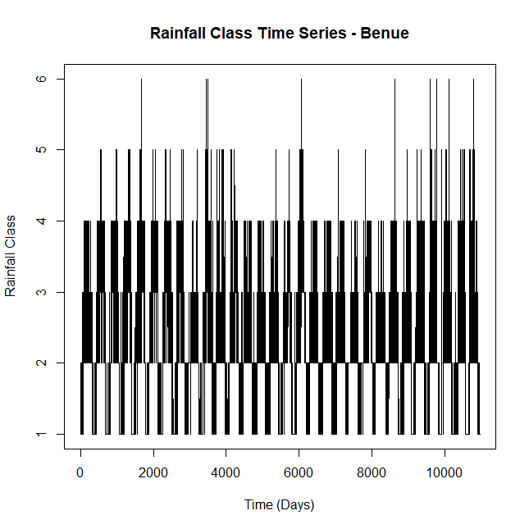
(a)
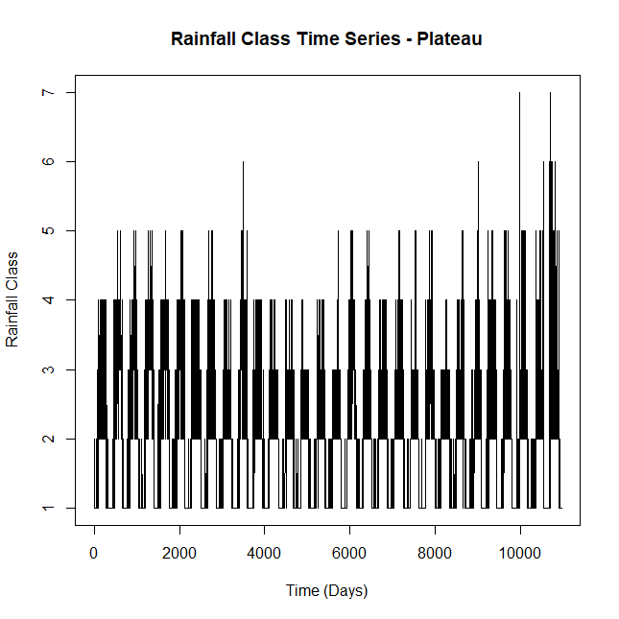
(b)
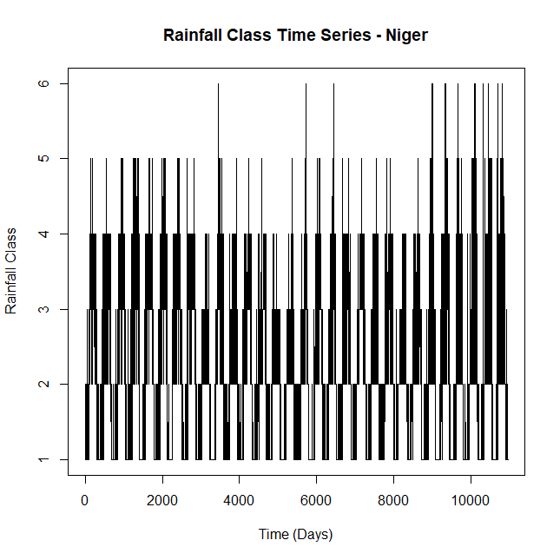
(c)
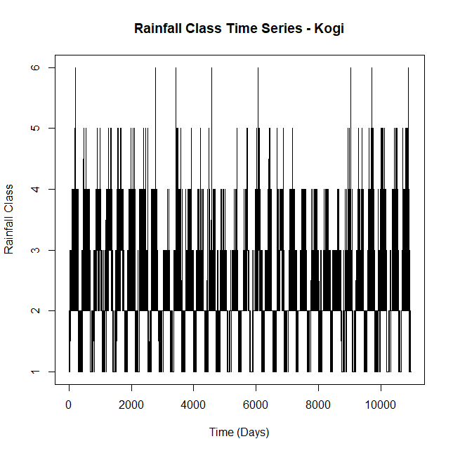
(d)
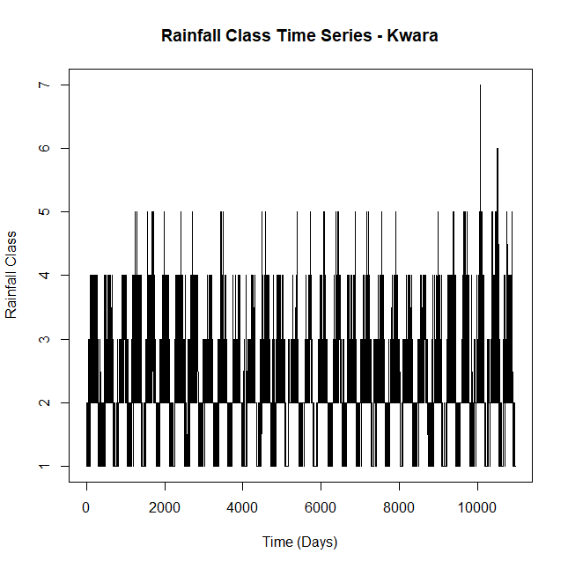
(e)
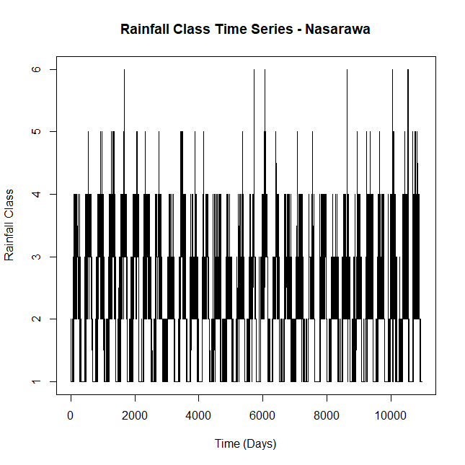
(f)
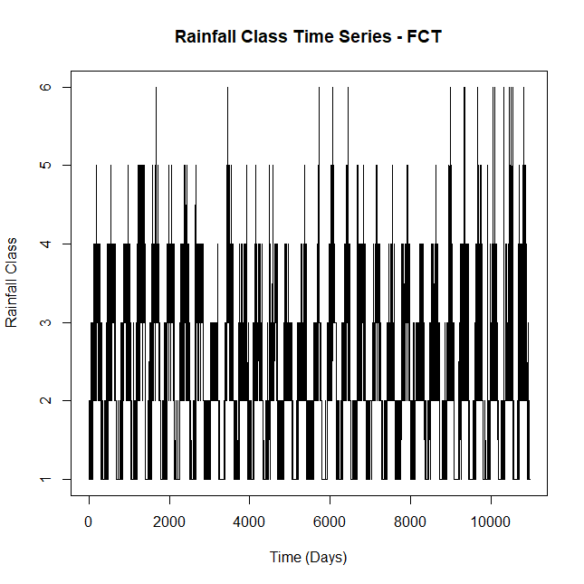
(g)
Figure 1(a-g): Time Series of Rainfall Class

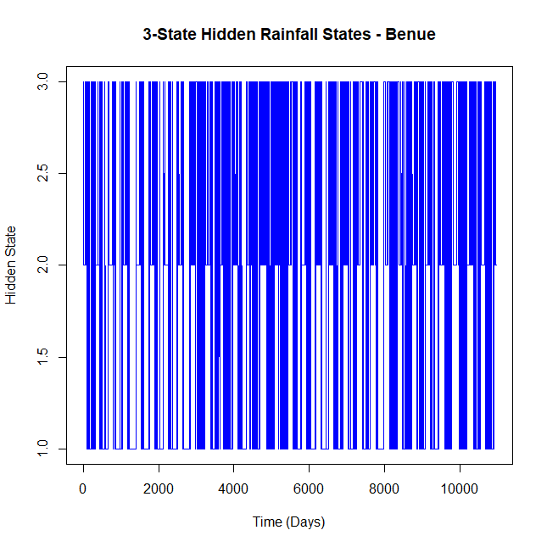
(a)
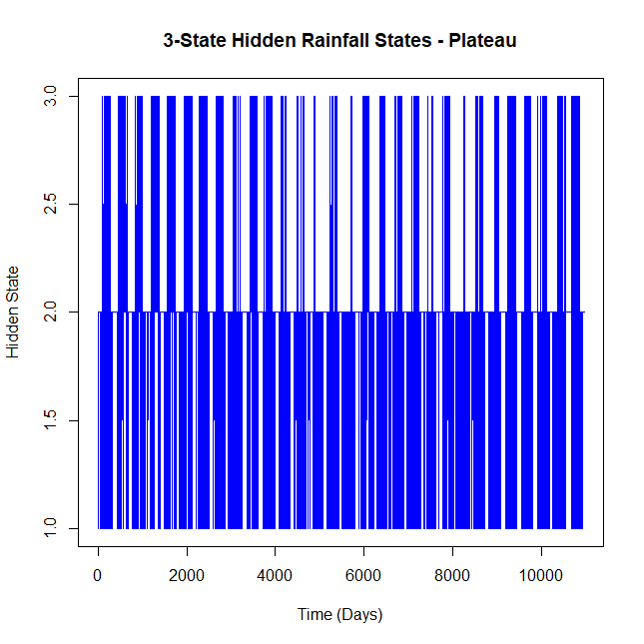
(b)
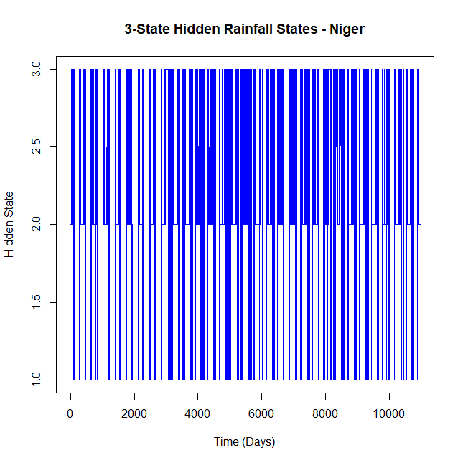
(c)
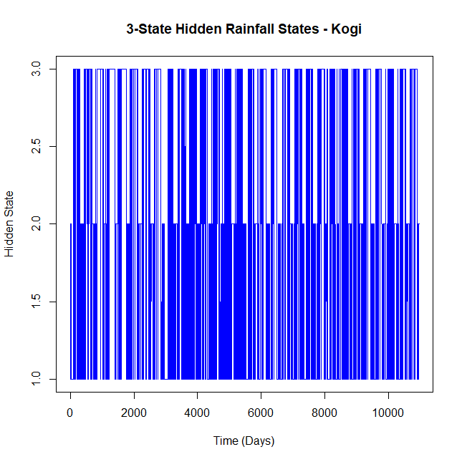
(d)
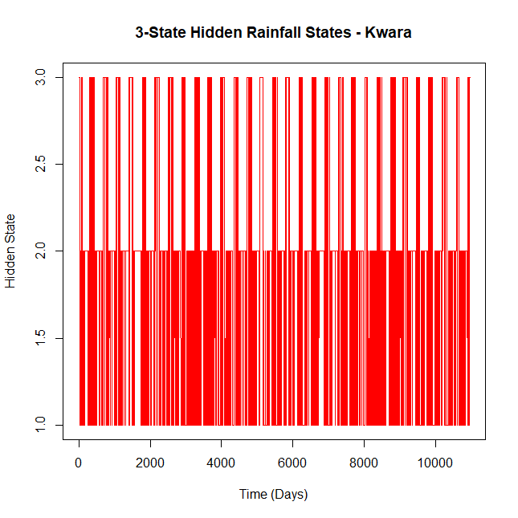
(e)
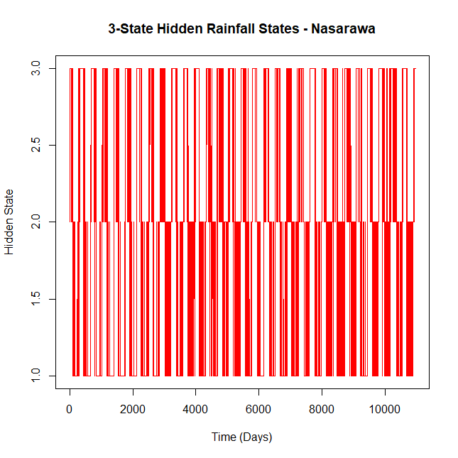
(f)
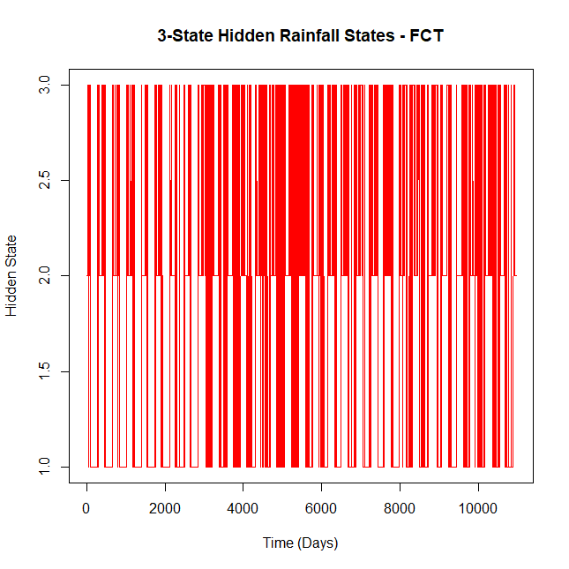
(g)
Figure 2(a-g): Hidden Rainfall States
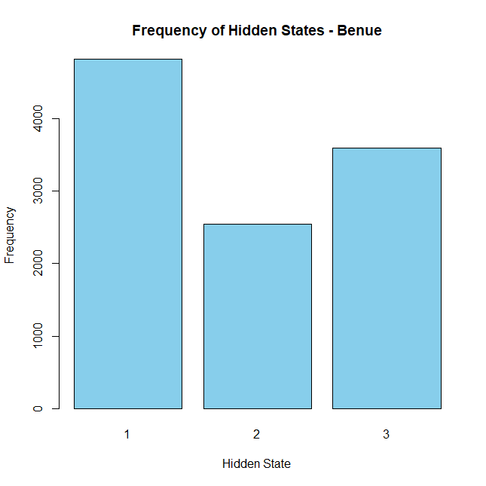
(a)
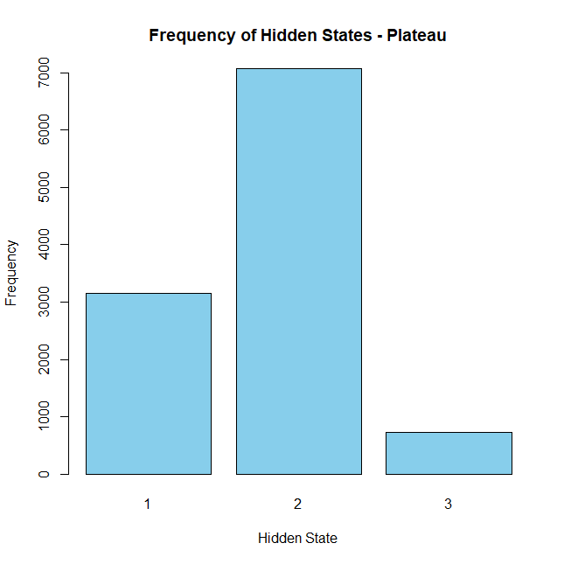
(b)
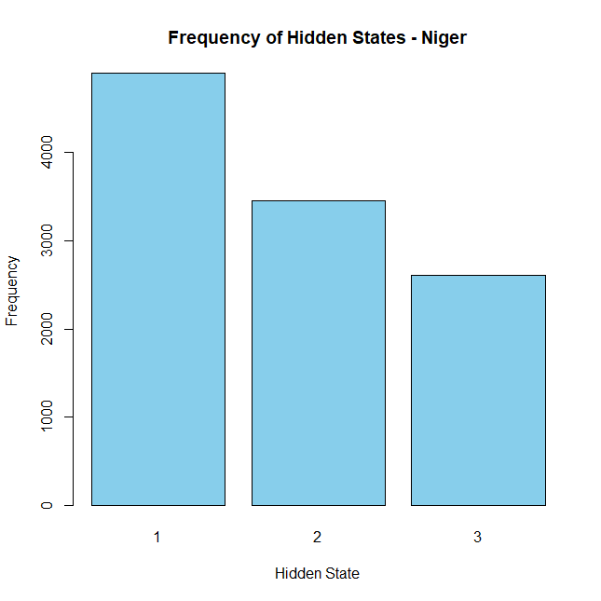
(c)
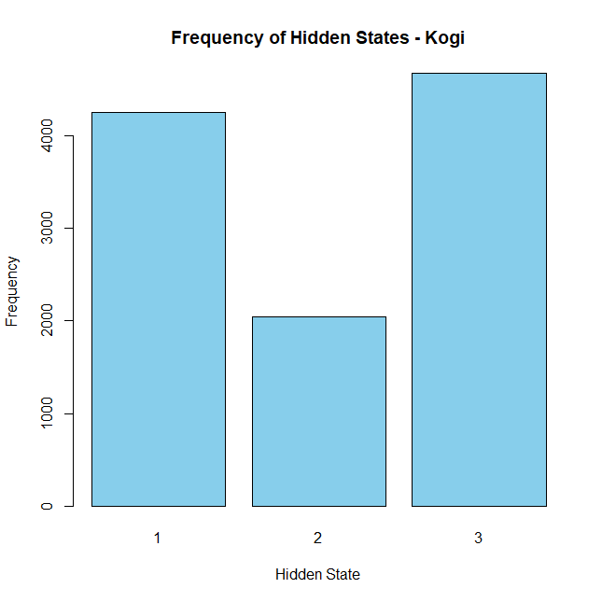
(d)
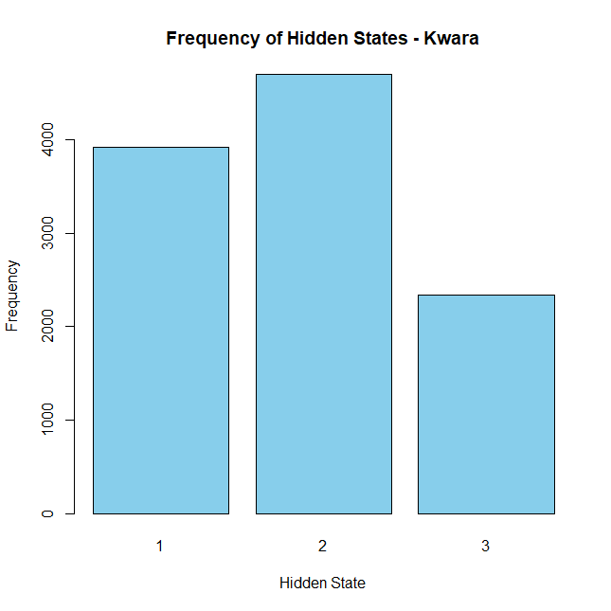
(e)
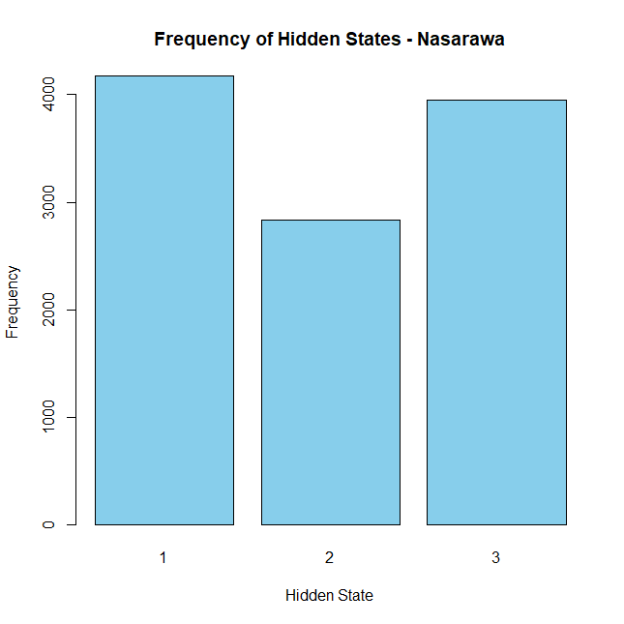
(f)

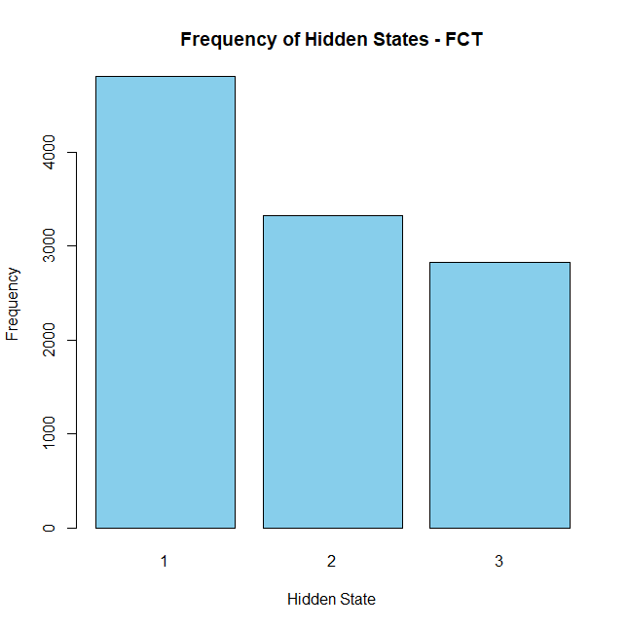
(g)
Figure 3(a-g): Frequency of Hidden state

