Simulation and Construction of An Internet of Things (IOT) Based Smart Home System with Real-Time Gas Leakage Detection

ABSTRACT
Gas leakage poses serious threats to human safety and property, as many existing detection systems are either limited to local alarms or lack real-time remote monitoring capabilities, which fail to notify users who are away or provide control over connected appliances. This study presents the simulation and construction of a WiFi-monitored smart home device with real-time gas leakage detection alerts. The system integrates gas sensors (MQ-5 and MQ-7), an ESP32 microcontroller, an Organic Light Emitting Diode (OLED) display, a buzzer, and IoT cloud connectivity to provide real-time detection and monitoring of hazardous gases such as methane, Liquefied Petroleum Gas (LPG), and carbon monoxide. The hardware and software designs were developed using Proteus 8.2 Professional and Arduino Integrated Development Environment (IDE), with the ESP32 configured as a Wi-Fi Access Point hosting a local web server and dashboard. The study found that Response times were fast (<2 seconds), validating the system’s reliability for real-time safety monitoring. Results of simulation and hardware tests show that the system successfully detected gas leaks, displayed concentration levels, and triggered a local alarm (buzzer). This confirmed stable power performance, efficient communication, and high reliability in both simulated and practical environments. The system’s user-friendly interface, low-cost design, and autonomous operation make it a viable solution for modern smart homes. Its contribution extends to improving safety standards, enabling remote monitoring, and providing a foundation for integrating predictive safety features in future IoT applications. Future studies should focus on the Integration of artificial intelligence or machine learning algorithms for predictive gas leakage detection.
Keywords: Gas leakage detection, WiFi-monitored system, ESP32 microcontroller, Proteus 8.2 simulation, Arduino IDE, Local web server, OLED display
1. INTRODUCTION
The integration of smart technologies into residential buildings has increased significantly in recent years, transforming traditional houses into intelligent, connected, and automated environments. This transition has been driven by advancements in wireless communication technologies, the rapid expansion of the Internet of Things (IoT), and a growing demand for improved household safety, comfort, and energy efficiency (Chen et al., 2020). IoT is a network of physical devices, vehicles, home appliances, and other items embedded with electronics, software, sensors, actuators, and connectivity, enabling these objects to connect and exchange data (Shafiq et al., 2022). IoT ecosystems have become indispensable in modern households (Hassan et al., 2024). As part of this trend in home automation, the design of WiFi-controlled and monitored systems with embedded safety mechanisms—such as gas leakage detection—has emerged as an important innovation for enhancing domestic security and functionality (Hussain et al.,2024).
Smart home systems consist of interconnected devices that communicate through a central hub, typically accessible via smartphone applications or web interfaces. These systems enable users to monitor and control home appliances remotely, improving convenience and operational efficiency (Chen, Xu & Wu, 2020). In addition to convenience, smart homes contribute significantly to safety by incorporating sensors that detect hazardous conditions. Among these, gas leakage detection remains a critical feature, as excess gas accumulation poses severe health and fire risks (Liu et al., 2022). Recent advancements in sensor technology, data analytics, and wireless communication have paved the way for the development of innovative solutions in the form of Smart Gas Leakage Detection systems. Thus, the integration of IoT into gas leakage detection systems has garnered considerable attention due to its potential to provide real-time monitoring, early detection, and swift alert mechanisms (Babu & Nair, 2024; Rokade et al., 2025). An essential component of modern smart home systems is the user interface, which provides real-time information, alerts, and control options. Effective interfaces allow homeowners to receive immediate updates on gas concentrations and manage other smart home functions such as lighting, temperature regulation, and security systems (Lee, Kim & Park, 2021). User interface design must therefore emphasise accessibility and rapid response in emergency situations.
Despite the benefits, implementing WiFi-monitored gas detection systems presents several challenges. The reliability and accuracy of gas sensors are crucial, as false alarms or undetected leaks reduce system effectiveness (Patel, Jain & Bhargava, 2020). Cybersecurity remains another major concern, as smart home networks are susceptible to unauthorised access and data breaches (Khan, Ali & Farooq, 2020). Furthermore, ensuring compatibility with existing home automation platforms and maintaining system performance during network interruptions are essential for uninterrupted safety (Yang et al., 2022). Beyond individual residences, smart home safety technologies have broader societal implications. Data collected from such systems can support trend analysis, inform public safety policies, and contribute to improved regulations for gas safety (Zhou, Liu & Wang, 2021). These broader impacts highlight the importance of continuous innovation in IoT-based residential safety systems.
Although various smart home solutions exist, many traditional gas detection systems remain limited to local alarms and lack integrated remote monitoring features. This absence of real-time, actionable alerts often leads to delayed responses in critical situations (Jacobsson et al., 2016; Hussain et al., 2024). Consequently, there is a pressing need for a WiFi-monitored gas leakage detection system that provides immediate alerts, supports remote access, and integrates easily with other smart home technologies. This study addresses this gap by designing and implementing a WiFi-monitored smart home system with gas leakage detection and alert capabilities. The system provides real-time monitoring, remote accessibility, and improved responsiveness to hazardous gas levels. By incorporating IoT functionality and offering a platform for future data-driven enhancements, the proposed system contributes both to modern household safety and to the growing need for intelligent, integrated home security solutions.
2. MATERIALS AND METHODS
  - Materials
The materials used in this study includes ESP32 microcontroller: Provides processing, WiFi connectivity, and local server hosting. MQ-5 and MQ-7 sensors: Detect methane/LPG and carbon monoxide, respectively. OLED display (0.96 inch): Displays real-time gas concentration data. Buzzer: Triggers local alarm during gas leakage events. Power supply module: Ensures stable input voltage. Software tools: Proteus 8.2 Professional for simulation and Arduino IDE for programming.
2.2 Methods
The method used is divided into Hardware Method and Software Method. The hardware strand covers design approach, quantitative design calculations, block and circuit diagram documentation, and construction notes. The software strand documents the development environment, local IoT cloud architecture, network and server configuration, data handling design, and operational flow. The block diagram and circuit diagram of the system are in Figures 1 and 2, respectively.
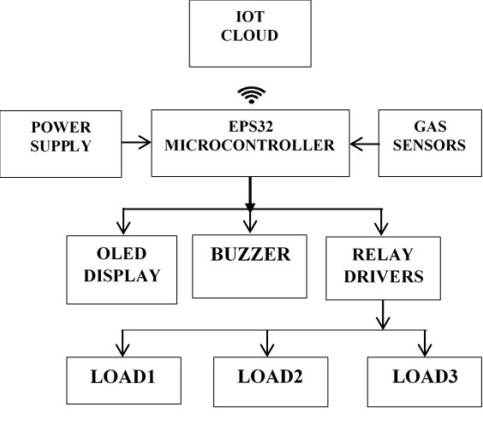
Figure 1: Block Diagram of the System
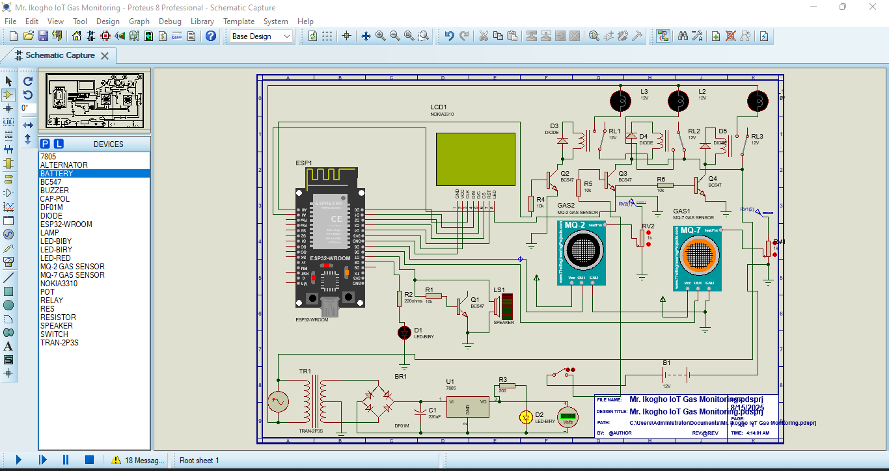
Figure 2: Complete Circuit Diagram for IoT Gas Monitoring System
2.2.1 Hardware Development Method
The system architecture integrated sensing, processing, display, alarm, and IoT communication units. The ESP32 collected analogue readings from the MQ-5 and MQ-7 sensors, processed gas concentration levels, and activated alarms or relays when thresholds were exceeded. The OLED display presented live readings and system status, while the buzzer provided audible alerts. Relay driver circuits were included to switch external loads, enabling automated ventilation or safety responses. A regulated 5 V DC supply powered the system, and necessary current-limiting resistors were calculated using:
$R=\frac{V_{S} - V_{f}}{I_{f}}$ (1)
where $V_{S}$ is the power supply voltage, $V_{f}$ is the LED voltage and $I_{f}$ is the LED forward current. For scaling the MQ sensor outputs (0–5 V) to the ESP32 ADC range (0–3.3 V), a voltage divider was designed using
$V_{ADC}=V_{IN} X \frac{R_{t}}{R_{t} x R_{b}}$ (2)
where $V_{IN}$is the input voltage, $R_{t}$ is the resistor value 1 and $R_{b}$ is the resistor value 2.
The hardware was first assembled on a breadboard for prototyping and later transferred to a Vero board for permanent mounting.
2.2.2 Software Development Method
Firmware was developed in C++ using the Arduino IDE with ESP32 board support. The code modularised sensor acquisition, threshold evaluation, alarm logic, display updates, and IoT dashboard rendering. Simulations were performed in Proteus 8.2 to validate circuit behaviour before hardware implementation.
Simulation Method: The firmware was developed and simulated using Proteus 8.2 Professional in conjunction with the Arduino Integrated Development Environment (IDE), incorporating the ESP32 board support package alongside specialised libraries for OLED display control, Wi-Fi access point configuration, and embedded web server functionality. The programming framework facilitated a modular software architecture, enabling distinct code modules for sensor data acquisition, alarm activation logic, display content management, and dynamic IoT dashboard generation. The flowchart for the system is shown in Figure 3.
IoT Cloud and Network Configuration Method: A local IoT architecture was deployed directly on the ESP32. The microcontroller operated as a Wi-Fi Access Point with a static IP (192.168.1.1), enabling offline accessibility. A lightweight HTTP server hosted a real-time monitoring dashboard, automatically refreshing every 5 seconds. The dashboard displayed methane and carbon monoxide concentrations, system status indicators, and manual/automatic appliance controls via relay outputs. A circular buffer retained the latest sensor readings to support efficient memory use and fast response.
The Algorithm
- Start the system.
- Initialise sensors: the gas sensors are activated to monitor gas levels and continuously read sensor data.
- Initialise OLED display.
- Initialise Relay Drivers
- Read data from the gas sensor.
- Check gas condition and update display/web interface:
  - If safe condition:
    - OLED shows SAFE
    - LED = OFF
    - Buzzer = OFF
    - Web status = SAFE
  - If gas is detected:
    - OLED shows GAS DETECTED
    - LED = ON
    - Buzzer = ON
    - Web status = Detected
- Update the web interface with the current status.
- Control Home Appliances represented as Loads.
- Repeat monitoring (go back to Step v continuously).
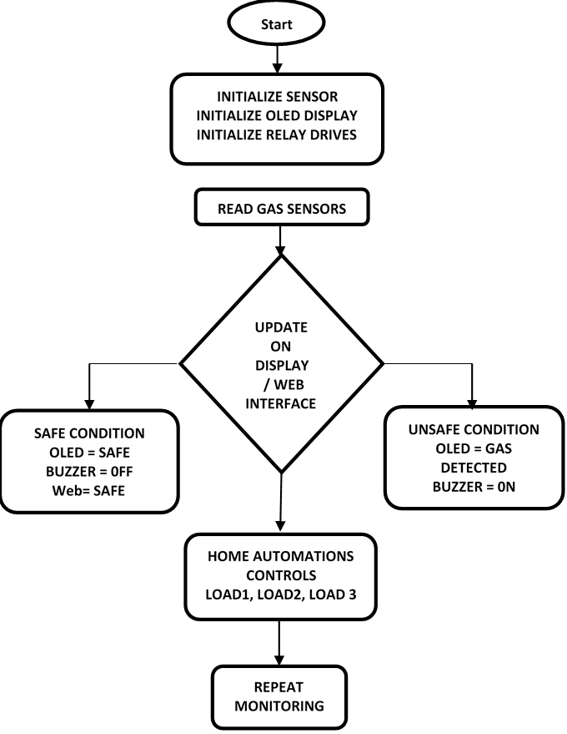
Figure 3: System Flow Chart
2.3 System Operation
Upon powering the device, the ESP32 initialised all sensors, display modules, and relays. Users connected to the ESP32’s Wi-Fi network and accessed the dashboard through a web browser. When gas concentrations exceeded safety limits, the buzzer and LED indicators were triggered, and connected appliances (e.g., exhaust fans) were automatically activated through the relay module. The system continuously monitored gas levels until conditions returned to normal, after which the system could be manually or automatically reset.
3. RESULTS
This section presents the design validation, simulation results, hardware construction, and system performance evaluation of the IoT-based smart home with a real-time gas leakage detection system.
3.1 Design Analysis
Component calculations were performed to ensure correct electrical operation. The LED current-limiting resistor was computed as 65 Ω, and the MQ-5/MQ-7 sensor outputs were scaled from 0–5 V to the ESP32’s 0–3.3 V ADC range using a 10 kΩ/20 kΩ voltage divider (0.666 VIN). These calculations ensured safe interfacing and reliable sensor readings.
3.2 Simulation Results
Proteus 8.2 simulations validated both hardware and firmware logic. The ESP32 successfully initialised, configured its Wi-Fi Access Point, and launched the embedded web server. Simulated modules, including the power supply, buzzer, OLED screen, sensors, relay driver, and the complete circuit, operated as expected. The complete simulated circuit is shown in Figure 4.
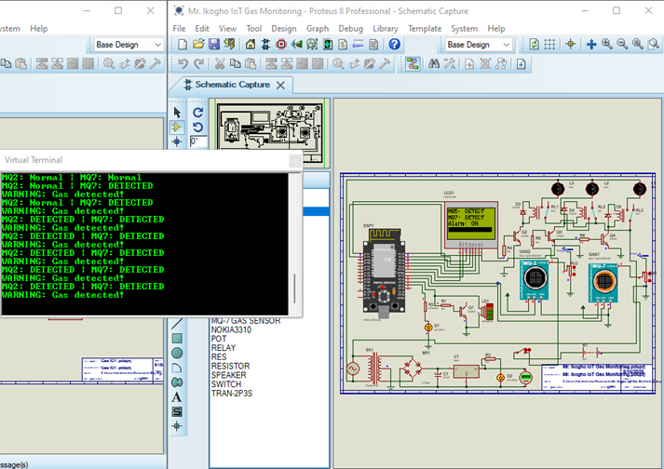
Figure 4: Circuit Simulation on Proteus Professional
3.3 Power Supply Verification
Simulation confirmed a stable 5.02 V regulated output and a consistent 3.31 V ESP32 logic voltage. Current consumption ranged from 188 mA (idle) to 276 mA (alarm), with no overheating or voltage instability, demonstrating a robust power subsystem.
3.4 Construction and Prototyping
Initial testing was performed on a breadboard, integrating the MQ-5 and MQ-7 sensors with the ESP32 to validate wiring, airflow exposure, and firmware behaviour. After successful testing, the circuit was permanently soldered onto a Vero board to improve durability. Components were arranged to reduce interference, and wiring was kept short and insulated. Figure 5 presents the top view of the constructed device in a casing.
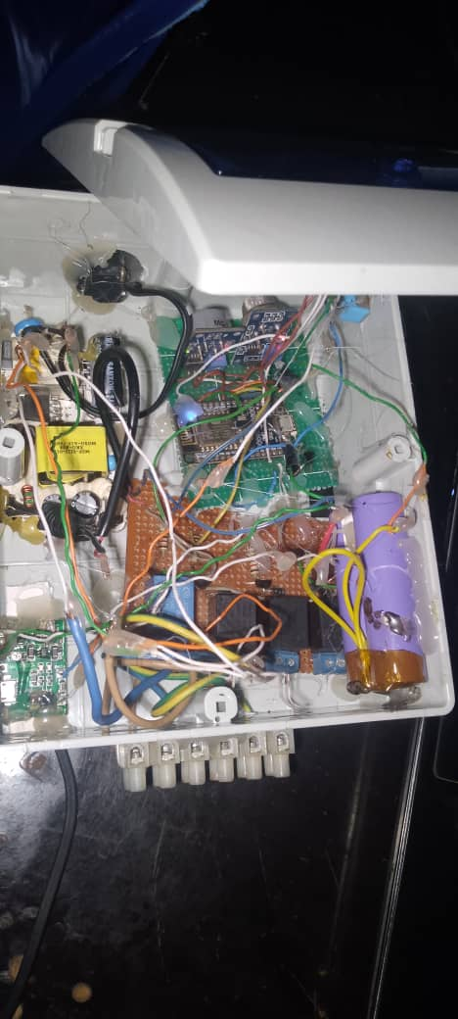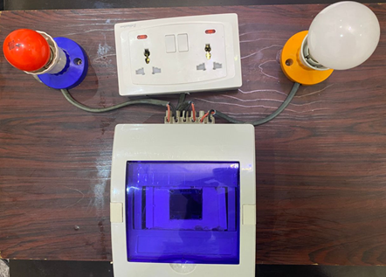
Figure 5: Constructed device in casing Figure 6: Final assembly with full casing
3.5 Casing and Packaging
The final assembly was housed in a 15 cm × 15 cm × 8 cm enclosure on top of a wooden platform. The enclosure features a transparent display cover, toggle power switch, USB charging port, terminal block for appliances, and ventilation openings for the gas sensors and buzzer. This arrangement ensured mechanical protection, easy access, and accurate gas sampling. The final packaged device with full casing is shown in Figure 6.
3.6 Gas Detection Performance
Simulated gas tests showed that the system remained in SAFE mode under normal conditions, with no LED or buzzer activation. When gas concentrations exceeded thresholds, the system immediately switched to DANGER mode, activated the alarm, and updated both the OLED screen and LED indicators. Responses were smooth, accurate, and free from false triggers.
3.7 Web Dashboard Simulation
The IoT web interface correctly displayed NORMAL or DETECTED status depending on sensor values. Elevated gas levels produced instant alarm visualisation on the dashboard, synchronised with hardware alarms, demonstrating accurate real-time remote monitoring.
3.8 Final System Operation
Real-world tests confirmed the effective operation of local and remote alerts. Under safe conditions, both the OLED and the web page displayed “SAFE.” When LPG was introduced, the system promptly updated to “DANGER,” triggered the buzzer, and sent immediate remote notifications. The dashboard updated within 1–2 seconds, confirming low-latency communication.
3.9 IoT and Appliance Control Verification
Gas readings (ppm), safety indicators, alarm status, and appliance controls (fan, light, TV) were updated correctly on the dashboard. Appliances responded instantly to manual commands and were automatically activated (e.g., fan ON) during hazardous conditions. Dashboard-to-hardware synchronisation averaged less than 2 seconds. The IoT web page interface is shown in Figure 7.
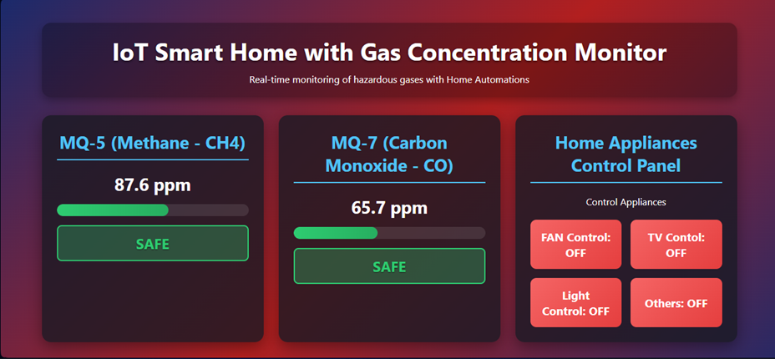
Figure 7: IoT Web Page Interface
3.10 System Evaluation Summary
Table 1 shows the test results, which showed consistent performance across simulation, hardware, and IoT stages. Under safe conditions, no alarms were triggered, and all interfaces displayed normal levels. Under hazardous conditions, alerts were activated locally and remotely, and smart appliances responded correctly. Response times were fast (<2 seconds), validating the system’s reliability for real-time safety monitoring.

Table 1: Results of Simulation, Hardware, and IoT/Web Interface Tests
Test Condition | OLED Display | LED Status | Buzzer Status | Web Interface Display | Fan | Light | TV | Response Time
No Gas Present (Safe) | SAFE | OFF | OFF | SAFE status, green indicators, normal ppm values | OFF | OFF | OFF | Instant (< 1 s)
Gas Leak Detected | DANGER / Gas Detected! | ON (Red) | ON (Active) | Hazard status, red indicators, updated ppm values | ON (Auto) | OFF | OFF | < 2 seconds
IoT/Web Update Verification | Status change shown | N/A | N/A | Dashboard updated correctly with new status | ON/OFF (Remote) | ON/OFF (Remote) | ON/OFF (Remote) | < 2 seconds (average)

3.11 Comparative Analysis
Compared with earlier works by Kumar et al. (2019) and Ali et al. (2018), this system offers improved functionality by integrating real-time gas detection, an embedded IoT dashboard, dual-mode alerts, and smart home appliance automation. Unlike cloud-dependent or Zigbee-based systems, the ESP32’s offline Access Point mode allows fully offline operation with a rich web interface. This enhances flexibility, reduces deployment constraints, and extends system capabilities beyond detection to full home automation.
4. DISCUSSION
The performance of the proposed IoT-based gas detection and alert system was systematically evaluated through simulation, prototyping, and development of a hardware prototype to validate its functionality, reliability, and real-time responsiveness. The multi-stage evaluation approach ensured both logical correctness and practical feasibility of the system. Initial simulation in Proteus verified firmware logic, power supply stability, and sensor–microcontroller interfacing without exposing hardware to risk. The system accurately distinguished between safe and hazardous gas conditions, activating appropriate local alerts via visual and audible indicators. The successful simulation of the embedded web server further confirmed the ESP32’s capability to provide real-time data visualisation and remote monitoring prior to physical implementation.
Subsequent breadboard testing demonstrated reliable real-world performance of the MQ-series gas sensors, with prompt detection of gas presence and immediate activation of alerts. The OLED display, LED, and buzzer consistently reflected system status, while sensor placement optimisation reduced noise and improved measurement accuracy. The final PCB-based hardware assembly enhanced mechanical robustness and operational stability, making the system suitable for extended use. Testing of the ESP32-hosted web interface in Access Point mode confirmed low-latency updates of sensor readings, system status, and alarm conditions. Appliance control through the web dashboard functioned reliably, allowing remote switching of household devices, with automatic fan activation during hazardous conditions to improve ventilation while retaining user override capability. Overall, the results demonstrated consistent performance across all evaluation stages, achieving real-time gas detection, synchronised local and remote alerts, and integrated smart appliance control. The system effectively met its design objectives by combining safety monitoring with IoT-enabled automation, offering a practical and responsive solution for gas hazard detection in smart home environments.
5. CONCLUSION
The proposed gas detection and IoT alert system successfully integrated physical sensing, immediate local alerting, and remote real-time monitoring into a single cohesive platform. The staged implementation strategy, starting from simulation to final deployment, ensured that design flaws were identified and corrected early, resulting in a reliable and responsive system. The system’s performance demonstrated that Gas leaks could be detected promptly through an MQ-series sensor. Local alerts (a buzzer) were activated without delay when thresholds were exceeded. The web-based interface provided near-real-time hazard updates, enabling remote monitoring without specialised applications. This approach is not only suitable for domestic safety but also has potential industrial applications in hazardous environments, offering a scalable, low-cost, and accessible solution to gas detection challenges.

6. FUTURE WORK
Future researchers can focus on the Integration of artificial intelligence or machine learning algorithms for predictive gas leakage detection and smart decision-making. In addition, the integration of cloud monitoring for remote access from far distances by using a domain setting up a Virtual Private Network (VPN) on a home router or server and incorporating additional safety features, such as automatic ventilation system activation during gas leakage, will be an added advantage to the system.

Disclaimer (Artificial intelligence)
Author(s) hereby declare that NO generative AI technologies such as Large Language Models (ChatGPT, COPILOT, etc.) and text-to-image generators have been used during the writing or editing of this manuscript.

REFERENCES
- Ali, M., Raza, S. & Khan, N. (2018). Design and implementation of an IoT-based gas leakage detection and alert system. International Journal of Engineering Research and Technology, 7(6), 245–250.
- Chen, J., Xu, L. & Wu, H. (2020). Smart home systems: Architecture, technologies, and applications. IEEE Access, 8, 215122–215135. https://doi.org/10.1109/ACCESS.2020.3040832
- Chen, Y., Li, X. & Zhang, W. (2020). Internet of Things-based smart home automation systems: A review. Journal of Ambient Intelligence and Humanized Computing, 11(8), 3345–3361. https://doi.org/10.1007/s12652-019-01529-2
- Hussain, A., Ahmad, M. & Khan, S. (2024). IoT-enabled gas leakage detection and monitoring systems for smart homes. Sensors, 24(3), 1125. https://doi.org/10.3390/s24031125
- Jacobsson, A., Boldt, M. & Carlsson, B. (2016). A risk analysis of a smart home automation system. Future Generation Computer Systems, 56, 719–733. https://doi.org/10.1016/j.future.2015.09.003
- Khan, R., Ali, M. & Farooq, U. (2020). Security challenges in IoT-based smart home environments. Journal of Network and Computer Applications, 150, 102495. https://doi.org/10.1016/j.jnca.2019.102495
- Kumar, S., Singh, A. & Verma, R. (2019). Development of an LPG gas leakage detection system using IoT. International Journal of Scientific Research in Computer Science, Engineering and Information Technology, 5(4), 231–236.
- Lee, J., Kim, D. & Park, S. (2021). User interface design considerations for smart home systems. Human–Computer Interaction, 36(5–6), 421–450. https://doi.org/10.1080/07370024.2020.1817093
- Liu, H., Zhang, Y. & Chen, Z. (2022). Gas sensor technologies and applications in smart safety systems. Sensors and Actuators B: Chemical, 355, 131298. https://doi.org/10.1016/j.snb.2021.131298
- Patel, R., Jain, S. & Bhargava, A. (2020). Performance evaluation of gas sensors for domestic safety applications. Measurement, 152, 107312. https://doi.org/10.1016/j.measurement.2019.107312
- Yang, F., Li, Q. & Zhao, Y. (2022). Reliability and fault tolerance in smart home IoT systems. IEEE Internet of Things Journal, 9(14), 11852–11863. https://doi.org/10.1109/JIOT.2021.3134872
- Zhou, X., Liu, J. & Wang, K. (2021). Data-driven safety analysis in IoT-enabled residential environments. Journal of Safety Research, 76, 210–219. https://doi.org/10.1016/j.jsr.2020.12.006
- Shafiq, M., Gu, Z., Cheikhrouhou, O., Alhakami, W., & Hamam, H. (2022). The rise of “Internet of Things”: review and open research issues related to detection and prevention of IoT‐based security attacks. Wireless communications and mobile computing, 2022(1), 8669348. https://doi.org/10.1155/2022/8669348
- Hassan, Y. G., Collins, A., Babatunde, G. O., Alabi, A. A., & Mustapha, S. D. (2024). Secure smart home IoT ecosystem for public safety and privacy protection. International Journal of Multidisciplinary Research and Growth Evaluation, 5(1), 1151-1157. https://doi.org/10.54660/.IJMRGE.2024.5.1.1151-1157
- Babu, T., & Nair, R. R. (2024). Enhancing gas leak detection with iot technology: An innovative approach. Procedia Computer Science, 235, 961-969. https://doi.org/10.1016/j.procs.2024.04.091
- Rokade, A., Shaikh, S., Nadaf, S., Attar, A., Kandekar, P., & Kaur, A. (2025). A Survey on Enhanced Safety of IOT Enabled Gas Leakage Detection System. In International Conference on ICT for Sustainable Development (pp. 206-214). Cham: Springer Nature Switzerland. https://doi.org/10.1007/978-3-032-06677-0_21

