Electrochemical Detection of 4-Dimethylaminophenol Hydrochloride (DMAP·HCl): Development of a Highly Sensitive Voltammetric Method

.
ABSTRACT

4-Dimethylaminophenol hydrochloride (DMAP-HCl) is widely recognized as a potent antidote for cyanide poisoning in both animal and human subjects. However, its clinical use is occasionally limited by severe in vivo toxicity, necessitating precise monitoring and quantification. In this study, we report the development of a highly sensitive differential pulse voltammetry (DPV) method employing a gold (Au) electrode modified with silver nanoparticles supported by carbon quantum dots (AgCDs). This modification significantly enhances the electrochemical properties of the gold electrode for the redox reaction of DMAP-HCl. Carbon quantum dots (CDs) were synthesized from pineapple peel juice via a hydrothermal approach and subsequently utilized as both reducing and stabilizing agents for the synthesis of silver nanoparticles (AgNPs). Characterization of the CDs and the AgCDs composite using KMnO4/H2SO4, bromothymol blue (BTB), and Tollens reagents confirmed the presence of alcohol, carboxyl, and carbonyl functional groups on their surface, which are essential for electrochemical activity. Under optimized conditions in a Na₂SO₄ electrolytic solution, the AgCDs/Au electrode demonstrated a linear detection range from 3 ng/mL to 70 ng/mL, with an exceptionally low limit of detection of 0.1 ng/mL. These results highlight the potential of the AgCDs/Au electrode as a robust and sensitive platform for the accurate quantification of DMAP-HCl, offering promising applications in both clinical and environmental monitoring.

Keywords: 4-Dimethylaminophenol hydrochloride, pineapple peel juice, carbon dot – silver nanoparticle, electrochemical method.

1. INTRODUCTION

4-Dimethylaminophenol hydrochloride (DMAP-HCl), with the chemical formula C₆H₁₁ON·HCl and a molecular weight of 173.5 g/mol, is a white crystalline substance that is highly soluble in water. It has been investigated in Germany as an antidote for cyanide poisoning (Hall, 2015; Zilker, 2005). However, DMAP-HCl has been linked to severe toxic effects, including reticulocytosis, nephrotoxicity, and hemolysis (Hall, 2015). Moreover, administration of DMAP-HCl to patients without significant cyanide poisoning has resulted in serious adverse reactions. In studies involving suspensions of isolated renal tubules, DMAP-HCl has been shown to inhibit gluconeogenesis and the activity of various enzymes, reduce total glutathione and free nucleotide levels, cause damage to the renal tubular cell membrane, and bind irreversibly to proteins (Szinicz and Weger, 1980).
This study focuses on the detection of DMAP-HCl using an electrochemical approach. It should be noted that the electrochemical method represents an attractive alternative for detection due to its advantages in terms of sensitivity and simplicity (Pourtaheri et al., 2020). Various electrode surface modification materials have been widely used to improve the sensitivity and chemical specificity of electrochemical sensors (Sacara et al., 2017a, 2017b; Wang et al., 2014; Zhang et al., 2012). However, the macroscopic size of most crystalline products results in poor reproducibility of the response, and the methods for synthesizing these materials are expensive, time-consuming, and environmentally toxic. To overcome this problem, an environmentally friendly and economical synthesis of carbon dots (CDs) was achieved using pineapple peel. These CDs exhibit chemical stability, good aqueous solubility, low cytotoxicity, and high biocompatibility (Wei et al., 2021). Thanks to these fascinating properties and the abundance of oxygenated functional groups (hydroxyl, carbonyl, carboxyl, and epoxy) on their surface, considered excellent electron acceptors and donors (Ma et al., 2017; Thakur et al., 2020; Wei et al., 2021; Zhuo et al., 2015). These CDs have been used as reducing and stabilizing agents, enabling the synthesis of silver nanoparticles (AgNPs) (Akhgari et al., 2020). These AgCDs have the advantage of facilitating electron transfer thanks to the surface functional groups of the carbon quantum dots (Cao et al., 2011).
To improve the sensitivity and specificity of the working electrode, these silver nanoparticles supported by carbon quantum dots (AgCDs) were used to modify the surface of a gold electrode for DMAP-HCl detection. This constitutes an innovative strategy for the development of environmentally friendly sensors.

2. material and methods

2.1. Reagents

The chemicals used were of analytical grade and were used as is, without further purification. The following chemicals were used throughout this work: 4-Dimethylaminophenol hydrochloride (C₈H₁₂ClNO, 98%) was supplied by Alta Scientific Ltd. (Tianjin, China); sodium sulfate (Na₂SO₄, 99%) was purchased from Sigma-Aldrich (St. Louis, MO, USA); silver nitrate (AgNO₃, 99%) was supplied by Alta Scientific Ltd. (Tianjin, China); potassium permanganate (KMnO₄) and bromothymol blue (BBT, 99%, LABKEN); sodium hydroxide (NaOH, 85%, CHEM-LAB); sulfuric acid (H₂SO₄, 95%, EMSURE); and copper sulfate (CuSO₄, 99%, JEULIN). Pineapple peels were obtained from pineapple vendors at the local market (Abidjan, Ivory Coast). The deionized water used throughout this study was obtained with a water purification system (Sichuan Zhuoyue Water Treatment Equipment CO., Ltd, Chengdu, China) with a resistivity of 18.25 MΩ·cm.

2.2. Equipment

Electrochemical measurements were performed using a MiniONE electrochemical system (ready-to-use) (MiniONE Instruments, Shanghai, China). A conventional three-electrode system was used: a modified gold (AgCDs/Au) working electrode (φ = 1 mm), a carbon wire counter electrode, and a saturated calomel (SCC) reference electrode. Before use, the gold electrodes were cleaned ultrasonically (Bandelin electronic super AK 255, Germany). All experiments were conducted at room temperature.
2.3. Fabrication of the AgCDs/Au electrode

2.3.1. Carbon dots (CDs) synthesis

For the synthesis of carbon quantum dots (CDs), 100 g of pineapple peel were ground with 150 mL of demineralized water and subsequently filtered (Khan et al., 2019). A volume of 25 mL of the resulting filtrate was transferred into a 50 mL hydrothermal reactor and heated at 200 °C for 3 hours. Following natural cooling, the mixture was centrifuged at 5,000 rpm for 15 minutes. The supernatant was then collected and stored at 4 °C for future use.

2.3.2. AgCDs synthesis

A mixture comprising 6 mL of the previously prepared carbon dots (CDs), 3 mL of silver nitrate (AgNO₃) solution (0.1 M), and 5 mL of sodium hydroxide (NaOH) solution (0.1 M) was heated to 90 °C under magnetic stirring at 450 rpm for 50 minutes (Sacara et al., 2017b). After allowing the solution to cool naturally, it was centrifuged at 5,000 rpm for 15 minutes. The resulting sample was washed sequentially with deionized water and ethanol. Finally, the sample was redispersed in deionized water and centrifuged again at 5,000 rpm for 15 minutes. The supernatant, containing the carbon-dot-supported silver nanoparticles (AgCDs), was collected and stored at 4 °C for subsequent use.

2.3.3. Pretreatment of the Au electrode

Before using the gold electrode, the surface of the gold disk was polished with alumina (0.05 µm diameter), then cleaned ultrasonically successively in deionized water and ethanol for two minutes at each stage. The electrode was then electrochemically cleaned in a 1 M sulfuric acid (H₂SO₄) solution by polarizing it for 60 s at -1 V and +1.75 V to form H₂ and O₂ bubbles on its surface. Cyclic voltammograms (VCs) were then recorded between -1 V and +1.75 V at 100 mV/s until reproducible cycles were obtained (Martin et al., 2021).

2.3.4. AgCDs/Au electrode fabrication process

The presence of the hydroxyl group (–OH), characteristic of alcohols, was confirmed (Fig. 1) through a controlled oxidation reaction with potassium permanganate (KMnO₄) in sulfuric acid (H₂SO₄). The observed purple decolorization of the acidified potassium permanganate solution indicates the presence of an alcohol functional group. This test rules out the presence of tertiary alcohols but does not provide specific information regarding the class of alcohols present on the carbon dots (CDs) and carbon-dot-supported silver nanoparticles (AgCDs).

2.4. Electrochimical detection of DMAP-HCl

The response of DMAP-HCl on an AgCDs/Au electrode was investigated by cyclic voltammetry (CV) and differential pulse voltammetry (DPV). For DMAP-HCl detection, 50 mL of a 10-5 M Na₂SO₄ solution was introduced into the electrochemical cell, followed by the addition of a DMAP-HCl solution at a concentration of 5 µg/mL. After homogenization, the cyclic voltammetry was recorded in the potential range of -1 V to +1.75 V. For calibration, DMAP-HCl solutions at various concentrations, from 3 ng/mL to 1500 ng/mL, were prepared and used for DPV. All DPV experiments were performed between -0.6 V and +0.7 V at a sweep rate of 50 mV/s, a pulse time of 0.02 s, a sampling time of 0.05 s, a hold time of 2 s, a step potential of 20 mV and a pulse amplitude of 100 mV.

3. results and discussion

3.1. Characterization of CDs and AgCDs

3.1.1. Test with KMnO₄∕H₂SO₄

After diluting the bromothymol blue (BTB) solution, a solution of carbon dots (CDs) or carbon-dot-supported silver nanoparticles (AgCDs) was added. A color change from blue to yellow in the BTB solution was observed (Fig. 2c). To validate the BTB test results, a pH paper test was conducted, which showed decolorization corresponding to a pH of 4–5 upon the addition of a drop of the CDs or AgCDs solution (Fig. 2a). These findings confirm the presence of carboxyl groups on the surface of the CDs and AgCDs.

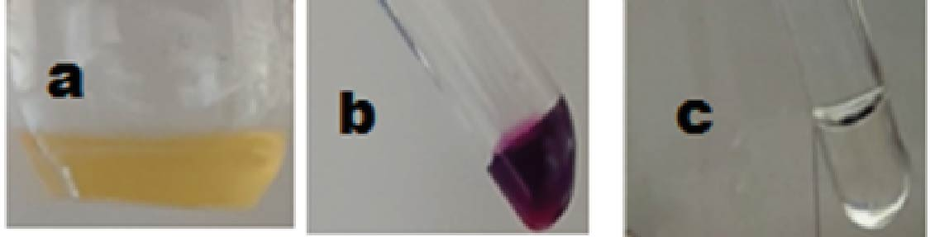
Fig. 1: Demonstration of the hydroxyl function: (a) dilute CDs or AgCDs solution, (b) acidified potassium permanganate solution and (c) decolorized potassium permanganate solution.

3.1.2. Test with Bromothymol blue (BTB) and pH paper

After diluting the bromothymol blue (BTB) solution, a solution of carbon dots (CDs) or carbon-dot-supported silver nanoparticles (AgCDs) was added. A color change from blue to yellow in the BTB solution was observed (Fig. 2c). To validate the BTB test results, a pH paper test was conducted, which showed decolorization corresponding to a pH of 4–5 upon the addition of a drop of the CDs or AgCDs solution (Fig. 2a). These findings confirm the presence of carboxyl groups on the surface of the CDs and AgCDs.

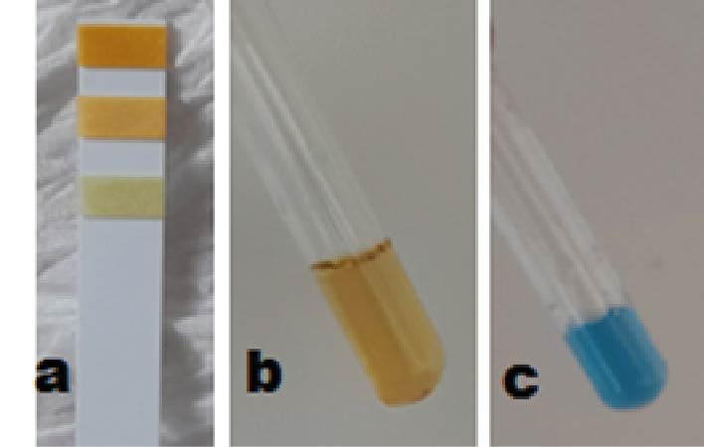
Fig. 2: Detection of carboxylic acids: (a) decolorization of pH paper, (b) change from blue to yellow color of the bromothymol blue (BTB) solution, and (c) dilute BTB solution.

3.1.3. TOLLENS reagents test

Aldehydes are characterized by the presence of the R-CHO functional group, whereas ketones contain the R'-CO-R group. Aldehydes react with Tollens' reagent, an ammoniacal silver nitrate solution, to produce a silver mirror, while ketones do not exhibit this reaction. Upon the addition of sodium hydroxide (NaOH) and silver nitrate (AgNO₃) solutions, a brown precipitate of silver oxide (Ag₂O) is formed. Subsequent addition of ammonia solution dissolves this precipitate, forming Tollens' reagent. The introduction of a carbon dots (CDs) or carbon-dot-supported silver nanoparticles (AgCDs) solution to this reagent results in a gray coloration of the solution, indicating the presence of aldehyde functional groups (Fig. 3).

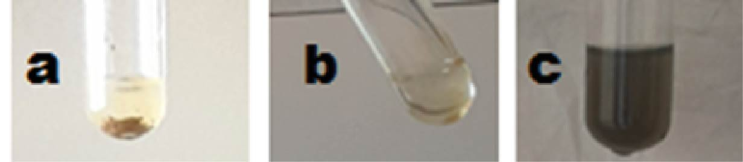
Fig. 3: Demonstration of the carbonyl function: (a) brown precipitate (Ag₂O), (b) Tollens' reagent, and (c) appearance of a gray tint.

3.1.4. Test relatif aux amines

The amine family is characterized by the presence, within the molecule, of an amino group (NH₂) bonded to a carbon atom in the carbon chain. Adding a solution containing the amino group to a dilute copper sulfate solution intensifies the blue color. The results (Fig. 4) show the transition from a blue solution to a partially blue solution, indicating that the synthesized CDs and AgCDs do not possess an amino group on their surface.

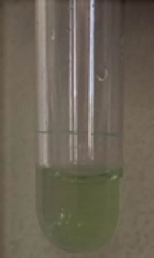
Fig. 4: Demonstration of the amine function

These various tests carried out in the present study, which are in agreement with the literature, indicate that there are carbonyl, alcohol and carboxyl functions on the surface of the synthesized CDs and AgCDs.

3.2. Electrochemical characterization of the modified Au electrode

The electrochemical behavior of the fabricated AgCDs/Au electrode was investigated using cyclic voltammetry (CV) in a 10⁻⁵ M Na₂SO₄ solution at a scan rate of 50 mV/s (Figure 3). In the absence of DMAP-HCl, two reduction peaks were observed at 0.567 V and −0.069 V, which can be attributed to the presence of ions in solution, particularly sulfate ions. Upon the addition of DMAP-HCl, an increase in the intensity of the two reduction peaks (0.567 V and −0.069 V) was observed. Additionally, a new oxidation peak emerged at approximately 0.416 V, characteristic of DMAP-HCl. The appearance of this new peak confirms electron transfer across the fabricated electrode, indicating a catalytic process involving DMAP-HCl. This electron transfer is likely facilitated by the thin film of silver nanoparticles (AgCDs) coated on the gold electrode surface (Huang and Liao, 2019).
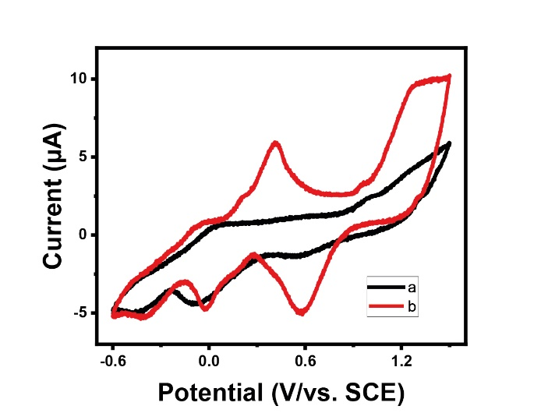
Fig. 5: Cyclic voltamograms in the absence of DMAP-HCl (a) and in the presence of 5 µg/mL of DMAP-HCl (b) on an AgCDs/Au electrode in a 10⁻⁵ M Na₂SO₄ solution at a scan rate of 50 mV/s.

3.3. Effet of scan rate

The influence of scan rate on the redox behavior of DMAP-HCl was systematically investigated over a range of scan rates from 10 mV/s to 200 mV/s. Electrochemical measurements were conducted in a 10⁻⁵ M Na₂SO₄ solution containing 5 µg/mL of DMAP-HCl (Fig. 6A). The resulting voltammograms revealed a marked dependence of both oxidation and reduction peak currents on the scan rate. Notably, the peak currents exhibited a linear relationship with the square root of the scan rate (v½), as depicted in the inset of Fig. 6B, thereby confirming a diffusion-controlled electrochemical process (Martin et al., 2021). Linear regression equations can be expressed as follows:

Ipa = 0.23189 v¹/² (V/s) + 0.8157 (R² = 0,99411) Éq. 1

Ipc = -0.21779 v¹/² (V/s) - 1.18152 (R² = 0,99022) Éq. 2.

This effect is attributed to the active sites of AgCDs. However, to avoid any potential overload during the experiments, the scan rate was fixed at 50 mV/s for all experiments.
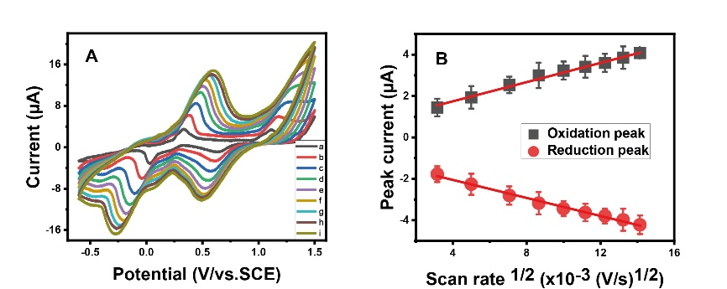
Fig. 6: A) Effect of scan rate on the voltammetric response of the AgCDs/Au electrode in the presence of 5 µg/mL of DMAP-HCl. B) Peak current intensity as a function of the square root of the scan rate.

3.4. Determination of DMAP and aux AgCDs/Au sensitivity

The sensitivity of the AgCDs/Au electrode was rigorously assessed by examining the differential pulse voltammetry (DPV) response of DMAP-HCl oxidation (Fig. 7A) in a 10⁻⁵ M Na₂SO₄ solution at pH 6. As depicted in Figs. 7B and 7C, a robust linear relationship was established between the oxidation peak current and DMAP-HCl concentration over the range of 6 ng/mL to 70 ng/mL. The corresponding linear regression equation is expressed as:

I (µA) = 0.01167 C (ng/mL) + 1.1256 (R² = 0.9931) (Eq. 3).

The limits of detection (LOD) and quantification (LOQ) were determined using the 3σ/S and 10σ/S criteria, respectively, where σ denotes the standard deviation of the blank and S the slope of the calibration curve (n = 10). The calculated LOD and LOQ values are approximately 0.1 ng/mL and 0.33 ng/mL, respectively. These exceptionally low detection limits underscore the high sensitivity of the fabricated AgCDs/Au electrode for DMAP-HCl detection, highlighting its potential for trace analysis in complex matrices.
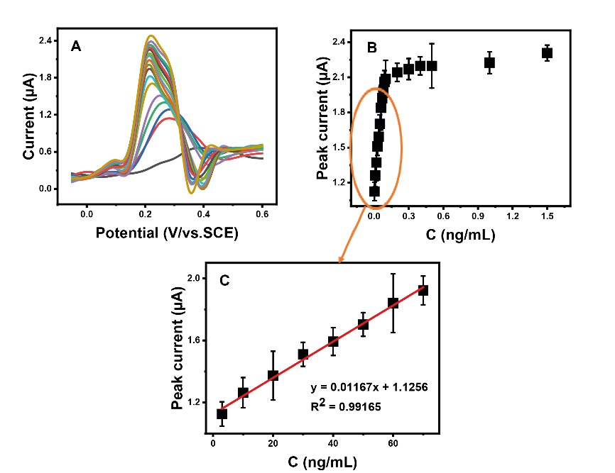
Fig. 7 A) DPV for different concentration of DMAP-HCl in ng/mL: a) 0; b) 3; c) 6; d) 10; e) 20; f) 30; g) 40; h) 50; i) 60; j) 70; k) 80; l) 90; m) 100; n) 200; o) 300; p) 400; q) 500; r)1000 and s) 1500 in 10⁻⁵ M Na₂SO₄ at pH 6. B and C) Relationship between the maximum intensity of the oxidation peak current, and the concentration of DMAP-HCl: calibration plot of the peak current against the concentration of DMAP-HCl.

3.5. Average recovery using the fabricated electrochemical sensor

The reliability of the proposed method was evaluated through recovery studies conducted at six distinct concentrations of malachite green (DMAP-HCl). The observed recovery rate reached 99% (Table 1), thereby confirming the exceptional accuracy and robustness of the analytical technique.

Table 1: Recovery using the fabricated sensor (n=3)

Added (ng/mL) | Found (ng/mL)ª | recovery (%)
6 | 5.79 | 96.5±2.4
10 | 9.85 | 98.5±3.7
15 | 14.92 | 99.4±4.5
25 | 24.87 | 99.4±7.9
35 | 34.92 | 99.7±9.2
45 | 44.91 | 99.8±4.0
55 | 54.93 | 99.8±3.9
65 | 64.87 | 99.8±4.0
a Average value of recovered MG concentration.

3.6. Average recovery using the fabricated electrochemical sensor

The reliability and accuracy of the proposed analytical method were systematically evaluated through recovery studies conducted at six distinct DMAP-HCl concentrations in a 10⁻⁵ M Na₂SO₄ solution at pH 6. The mean recovery rate obtained was approximately 99% (Table 1), thereby demonstrating the excellent accuracy and robustness of the technique for the quantitative determination of DMAP under the specified experimental conditions.

Table 2: Intra-day and Inter-day studies (n=3).

Concentration added (pg/mL) | Concentration found (ng/mL) |  |  | RSD (%) (n=3)
Concentration added (pg/mL) | Intra-day | Inter-day |  | Intra-day | Inter-day
8 | 7.96 | 7.91 |  | 4.92 | 9.27
15 | 14.87 | 14.93 |  | 6.1 | 5.09
25 | 24.92 | 24.83 |  | 8.6 | 9.73
35 | 34.90 | 34.88 |  | 2.5 | 5.56
45 | 44.85 | 44.83 |  | 1.7 | 3.51
55 | 54.91 | 54.87 |  | 3.5 | 5.3
RSD: Relative Standard Deviation.

3.7. Selectivity of the AgCDs/Au electrode

The selectivity of the fabricated electrode was rigorously assessed by evaluating the potential interference effects of various species in a 10⁻⁵ M Na₂SO₄ solution at pH 6. The experimental findings, summarized in Table 2, reveal that the presence of interfering species—including Cu⁺, Fe⁺, Zn⁺, and NaCl at concentrations tenfold higher than that of DMAP-HCl (10 ng/mL) exerted only a negligible influence on the DMAP-HCl response, with signal variations consistently below 5%. Under these conditions, the recovery rates ranged between 98% and 100%, thereby confirming the electrode’s high selectivity and its suitability for accurate DMAP-HCl quantification in complex sample matrices.

Table 3: Recovery rate of 10 ng/mL DMAP-HCl in the presence of 100 ng/mL of the selected interfering compounds (n=3).

Compounds | C(pg/mL)ª | C(pg/mL)b | Recoverey (%)
p-DAP | 10 | 10 | 100
CuSO₄ | 10 | 9.96 | 99.6
FeSO₄ | 10 | 9.93 | 99.3
Zn(NO₃)₂ | 10 | 9.91 | 99.1
NaCl | 10 | 9.89 | 98.9
Cª: Concentration added. C^{b}: Concentration found.

3.8. Reusability and stability of the manufactured electrochemical
The long-term stability and reusability of the AgCDs/Au electrode were comprehensively evaluated over a 10-day period, with 10 successive cyclic voltammetry (CV) cycles performed daily in a 10⁻⁶ M Na₂SO₄ solution at pH 6. As illustrated in Figure 8, the oxidation peak current for DMAP exhibited no significant variation in either intensity or CV profile, thereby demonstrating the electrode’s remarkable stability under repeated use. For the reusability assessment, the same AgCDs/Au electrode was employed for 10 consecutive days in freshly prepared solutions containing a constant DMAP-HCl concentration (three parallel experiments). Following each use, the electrode was thoroughly rinsed with water and ethanol, then dried at room temperature. The results, presented in Table 3, reveal that no significant decline in recovery rate was observed over the 10-day period, with the relative standard deviation (RSD) remaining below 10%. These findings collectively indicate that the AgCDs/Au electrode maintains its analytical performance and can be reliably reused over multiple days, making it a robust and cost-effective tool for DMAP-HCl detection.
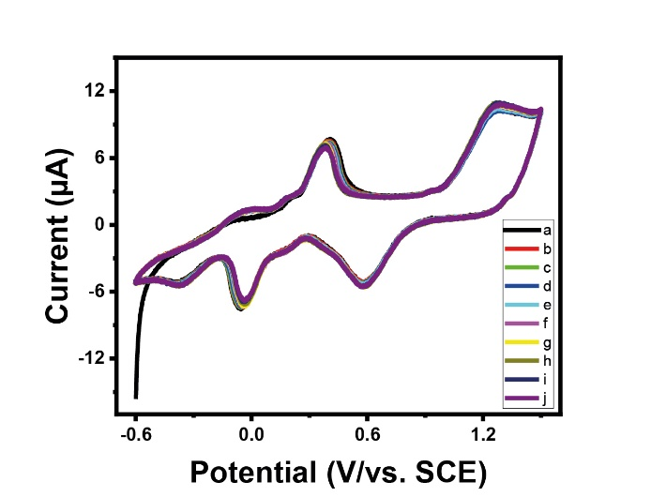
Fig. 8: Stability study of the AgCDs/Au

Table 4: Stability of the AgCDs/Au electrode.

Day | added (pg/mL)ª | Found (pg/mL)^{b} | Recovery (%) | RSD (%)  (n=3)
01 | 15 | 14.9 | 99.33 | 3.09
02 | 15 | 14.87 | 99.13 | 2.51
03 | 15 | 14.89 | 99.27 | 1.00
04 | 15 | 14.88 | 99.20 | 2.65
05 | 15 | 14.86 | 99.06 | 2.52
06 | 15 | 14.84 | 98.93 | 2.08
07 | 15 | 14.85 | 99.00 | 1.53
08 | 15 | 14.82 | 98.8 | 1.50
09 | 15 | 14.79 | 98.60 | 3.10
10 | 15 | 14.81 | 98.73 | 4.58

4. Conclusion

In this study, a novel AgCDs/Au electrode was fabricated by modifying the surface of a gold electrode with AgCDs. This AgCDs/Au electrode, using a portable workstation system, was successfully employed for the sensitive and selective detection of DMAP-HCl. This electrocatalytic activity suggests a synergistic effect of CDs, AgNPs and Au for the oxidation of DMAP-HCl on the AgCDs/Au electrode. Electrochemical analyses demonstrated that the AgCDs/Au electrode exhibits excellent catalytic activity for the oxidation of DMAP-HCl in a Na₂SO₄ medium, as evidenced by well-defined redox peaks and a diffusion-controlled process. The electrode also demonstrated remarkable stability and reusability, maintaining consistent performance over multiple cycles and during a 10-day test period. The exceptionally low limit of detection (0.1 ng/mL) underscores the method's high sensitivity, making it suitable for the measurement of trace amounts of DMAP-HCl in various matrices. Furthermore, the reliability of the approach was confirmed by high recovery rates and excellent accuracy, validated by recovery studies.
These promising results highlight the potential of the AgCDs/Au electrode as a robust, portable, and cost-effective analytical tool for DMAP-HCl detection. Future research will focus on the validation of this electrode in real-world samples, aiming to assess its applicability in environmental, pharmaceutical, or clinical settings.

Disclaimer (Artificial intelligence)
Author(s) hereby declare that NO generative AI technologies such as Large Language Models (ChatGPT, COPILOT, etc.) and text-to-image generators have been used during the writing or editing of this manuscript.

REFERENCES

- Akhgari, F., Farhadi, K., Samadi, N., Akhgari, M., 2020. Detection of Silver Nanoparticles Using Green Synthesis of Fluorescent Nitrogen-Doped Carbon Dots. Iran. J. Sci. Technol. Trans. Sci. 44, 379–387. https://doi.org/10.1007/s40995-020-00832-4
- Cao, L., Sahu, S., Anilkumar, P., Bunker, C.E., Xu, J., Fernando, K.A.S., Wang, P., Guliants, E.A., Tackett, K.N., Sun, Y.-P., 2011. Carbon Nanoparticles as Visible-Light Photocatalysts for Efficient CO₂ Conversion and Beyond. J. Am. Chem. Soc. 133, 4754–4757. https://doi.org/10.1021/ja200804h
- Hall, A.H., 2015. Cyanide antidotes in clinical use: 4‐dimethylaminophenol (4‐DMAP), in: Hall, A.H., Isom, G.E., Rockwood, G.A. (Eds.), Toxicology of Cyanides and Cyanogens. Wiley, pp. 288–291. https://doi.org/10.1002/9781118628966.ch22
- Huang, Y., Liao, W., 2019. Hierarchical carbon material of N-doped carbon quantum dots in-situ formed on N-doped carbon nanotube for efficient oxygen reduction. Appl. Surf. Sci. 495, 143597. https://doi.org/10.1016/j.apsusc.2019.143597
- Khan, Z.M.S.H., Rahman, R.S., Shumaila, Islam, S., Zulfequar, M., 2019. Hydrothermal treatment of red lentils for the synthesis of fluorescent carbon quantum dots and its application for sensing Fe3+. Opt. Mater. 91, 386–395. https://doi.org/10.1016/j.optmat.2019.03.054
- Ma, J.-L., Yin, B.-C., Wu, X., Ye, B.-C., 2017. Simple and Cost-Effective Glucose Detection Based on Carbon Nanodots Supported on Silver Nanoparticles. Anal. Chem. 89, 1323–1328. https://doi.org/10.1021/acs.analchem.6b04259
- Martin, A.A., Fodjo, E.K., Eric-Simon, Z.V., Gu, Z., Yang, G., Albert, T., Kong, C., Wang, H.-F., 2021. Cys-AgNPs modified gold electrode as an ultrasensitive electrochemical sensor for the detection of 3-chloropropane-1,2-diol. Arab. J. Chem. 14, 103319. https://doi.org/10.1016/j.arabjc.2021.103319
- Pourtaheri, E., Taher, M.A., Beitollahi, H., Hosseinzadeh, R., 2020. Co-detection of isoprenaline and paracetamol in biological and pharmaceutical media by a feather-like La3+/ZnO nano-flowers and N-(ferrocenylmethylidene)fluoren-2-amine-modified carbon paste electrode: analysis of a novel sensor. J. Iran. Chem. Soc. 17, 1447–1456. https://doi.org/10.1007/s13738-020-01870-w
- Sacara, A.M., Cristea, C., Muresan, L.M., 2017a. Electrochemical detection of Malachite Green using glassy carbon electrodes modified with CeO 2 nanoparticles and Nafion. J. Electroanal. Chem. 792, 23–30. https://doi.org/10.1016/j.jelechem.2017.03.030
- Sacara, A.M., Nairi, V., Salis, A., Turdean, G.L., Muresan, L.M., 2017b. Silica‐modified Electrodes for Electrochemical Detection of Malachite Green. Electroanalysis 29, 2602–2609. https://doi.org/10.1002/elan.201700400
- Szinicz, L.L., Weger, N., 1980. Effects of 4-dimethylaminophenol in rat kidneys, isolated rat kidney tubules and hepatocytes. Xenobiotica 10, 611–620. https://doi.org/10.3109/00498258009033795
- Thakur, A., Kumar, P., Kaur, D., Devunuri, N., Sinha, R.K., Devi, P., 2020. TiO₂ nanofibres decorated with green-synthesized P_{Au/Ag} @CQDs for the efficient photocatalytic degradation of organic dyes and pharmaceutical drugs. RSC Adv. 10, 8941–8948. https://doi.org/10.1039/C9RA10804A
- Wang, H., Wang, Y., Liu, S., Yu, J., Xu, W., Guo, Y., Huang, J., 2014. An RNA aptamer-based electrochemical biosensor for sensitive detection of malachite green. RSC Adv 4, 60987–60994. https://doi.org/10.1039/C4RA09850A
- Wei, X., Cheng, F., Yao, Y., Yi, X., Wei, B., Li, H., Wu, Y., He, J., 2021. Facile synthesis of a carbon dots and silver nanoparticles (CDs/AgNPs) composite for antibacterial application. RSC Adv. 11, 18417–18422. https://doi.org/10.1039/D1RA02600C
- Zhang, K., Song, G., Yang, L., Zhou, J., Ye, B., 2012. A novel self-assembly voltammetric sensor for malachite green based on ethylenediamine and graphene oxide. Anal. Methods 4, 4257. https://doi.org/10.1039/c2ay26039e
- Zhuo, Y., Zhong, D., Miao, H., Yang, X., 2015. Reduced carbon dots employed for synthesizing metal nanoclusters and nanoparticles. RSC Adv. 5, 32669–32674. https://doi.org/10.1039/C5RA02598B
- Zilker, T., 2005. Medical management of incidents with chemical warfare agents. Toxicology 214, 221–231. https://doi.org/10.1016/j.tox.2005.06.028

