Gold electrode modified with an alloy of silver nanoparticles and cysteine-coated carbon quantum dots for the electrochemical detection of melamine

.
ABSTRACT

This study focuses on the development of a chemical electrode sensor for detecting melamine in powdered milk. The work in this study first involved fabricating the electrochemical sensor by modifying a gold electrode with an alloy of silver nanoparticles and carbon quantum dots functionalized with L-cysteine. This new electrode was then tested using cyclic voltammetry and subsequently pulsed differential voltammetry for melamine detection. This study is part of a doctoral thesis conducted at the Doctoral School of Science, Technology and Sustainable Agriculture at Félix Houphouët-Boigny University in Abidjan, Ivory Coast. To achieve our objectives, firstly, L-cysteine ​​functionalized carbon quantum was synthesized hydrothermally from calcined lemon peel mixed with L-cysteine ​​(cCDs). Once obtained, silver nanoparticles were synthesized in the presence of cCDs (cCDs/AgNPs), and this nanomaterial alloy was then used to modify a gold electrode to obtain our working electrode: cCDs/AgNPs/Au. Secondly, the newly fabricated electrode was applied for the electrochemical detection of melamine, both in isolation and in samples of locally consumed powdered milk. This electrochemical activity between the new electrode and melamine is only possible in sodium sulfate solution and is optimized at a concentration of 0.1 M at pH 7.5, with a scan rate of 50 mV/s during the voltammetric cycles. Furthermore, the pulsed differential voltammetry study, conducted under optimal cyclic voltammetry conditions, demonstrated the linearity of melamine detection by this new electrode. This study, carried out on a range of melamine concentrations from 5 ng/mL to 50 ng/mL, established a limit of detection of 3.488 µg/L and a limit of quantification of 11.627 µg/L. Performance analysis revealed a recovery rate between 98% and 100% in the absence of interfering substances, and between 90% and 98% in a food matrix such as powdered milk with a soluble solids (RSD) content of less than 8%.
The cCDs/AgNPs/Au working electrode showed strong sensitivity with melamine dissolved in the different samples tested; however, further studies could help improve the selectivity of the new electrode with certain mineral salts used to enrich powdered milks.

Keywords: electrochemical sensor; cCDs/AgNPs-modified gold electrode; Melamine; Detection; Food safety

1. INTRODUCTION

Melamine was first synthesized in the 1830s and continues to be used in contemporary applications. It is primarily used as a key component in thermoplastic materials to improve their strength. This use of melamine presents a risk of migration into food, in minute but non-toxic quantities (Shi et al., 2020)
Furthermore, melamine is used in the manufacture of powerful nitrogen fertilizers. However, due to its slow mineralization, agricultural products are sometimes covered with melamine residues, which can be a source of contamination for consumers. (Zhu et al., 2019). Recent studies have established that certain sectors of the food industry use melamine as an additive to increase the protein content of their products. This was the case in China in 2008, where more than 294,000 children were diagnosed with urinary stones after consuming melamine-enriched powdered milk. Among these cases, 53,000 children were hospitalized and six deaths were recorded. (Xiu & Klein, 2010). Indeed, infants are more susceptible to poisoning because their bodies produce substances that react strongly with melamine. Therefore, for safety reasons, regulations have been imposed on melamine in foods intended for infants and young children. In the USA, the FDA has set the tolerable daily intake (TDI) at 0.063 mg/Kg and the maximum level of melamine in food at 1 mg/Kg; The World Health Organization has adopted a TDI for melamine of 0.2 mg/kg; the European Food Safety Authority has imposed a TDI for melamine of 0.5 mg/kg; in Canada, the TDI for melamine is set at 0.2 mg/kg and the maximum tolerated level of melamine in food is set at 0.5 mg/kg (Shi et al., 2020). In addition to these regulations, detection methods have been developed to monitor traces of melamine in food products. Indeed, the scientific literature lists several methods used. The most common methods are spectrophotometry (Haghi et al., 2021), spectrofluorimetry (Barreto et al., 2021), quenching of luminescence (Sun et al., 2021), gas chromatography-mass spectrometry (Strashnov et al., 2021), liquid chromatography-mass spectrometry (Chen & Wang, 2021), high-performance liquid chromatography (Haghi et al., 2021), fluorescence resonance energy transfer (Zhang et al., 2018), mid- and near-infrared spectroscopy (Liang et al., 2021), and enzyme-linked immunosorbent assay (Saeed et al., 2021). However, certain difficulties and constraints related to the rigorous sample preparation steps, the use of expensive and toxic solvents, or the complexity of the instrumentation contribute to a lack of attention to monitoring melamine levels in food. Therefore, the implementation of simple, inexpensive, rapid, selective, and highly reliable techniques for the detection and quantification of trace amounts of melamine in food products is essential. In this regard, electrochemical techniques appear to be a promising alternative for the design of reliable methods for monitoring traces of melamine in food products. Thus, in this work, an electrochemical sensor was designed by modifying the surface of a gold electrode with silver nanoparticles capped with carbon quantum dots functionalized with cysteine ​​(cCDs/AgNPs). This sensor was used in Na₂SO₄ medium for the determination of traces of melamine. Furthermore, the designed electrochemical sensor exploits the high reactivity of cCDs/AgNPs based on the creation of strong hydrogen bonds with the electroactive melamine polymer (pMelamine). This strong presence of hydrogen bonding could induce the adsorption of pMelamine and its ability to bind to the oxo-surface groups of the electrochemical sensor. In this study, the performance and reliability of the electrochemical sensor were elucidated by a cyclic voltammetry study; then by a pulsed differential voltammetry study for the validation of the proposed detection method.
2. material and methods

2.1. Reagents
All chemicals were used without prior treatment. To carry out this work, silver nitrate (AgNO₃, 99%) was purchased from Scharlab S.L. (Spain), glycine (C₂H₅O₂N, 98%)) and cysteine (C₃H₇NO₂S, 98%) were acquired from Merck (Darmstadt in Germany), melamine (C₃H₆N₆ , 99%) was supplied by DAMAS-BETA, magnesium chloride (MgCl₂ , 99%), soluble starch ((C₆H₁₀O₅)_{n}, 90%) were obtained from CHEM-LAB (Belgium), aluminum sulfate (Al₂(SO₄)_{3,} 18H₂O, 99%), sodium sulfate anhydrous (Na₂SO₄ , 99%), iron sulfate (FeSO₄,nH₂O, 84%) were obtained from PROLABO (France), ascorbic acid (C₆H₈O₆, 99%), sulfuric acid (H₂SO₄, 95%), anhydrous calcium sulfate (CaSO₄, 98%) and anhydrous magnesium sulfate (MgSO₄, 98%) were provided by Chem-Lab (Belgium), magnesium oxide (MgO) was synthesized according to the protocol of Ghorbani et al. (Ghorbani et al., 2015); and lemon peel samples were obtained from the fruit purchased at the local market. All experiments were done using deionized (DI) water with a resistivity of 18.25 MΩ.cm. The pH was adjusted by using sulfuric acid solution (1M) and sodium hydroxide solution (1M).

2.2. Apparatus and electrochemical measurements
Melamine detection was achieved by combining two electrochemical methods. First, a cyclic voltammetry (CV) study was performed to define the optimal conditions and parameters for melamine detection; And, a differential pulsed voltammetry (DPV) study was performed to identify the validation parameters for the proposed detection method. These various studies, conducted at room temperature, were carried out using a MiniONE electrochemical workstation from the Chinese company MiniONE Instruments based in Shanghai. In these studies, the MiniONE workstation was installed on a conventional three-electrode system, including a modified gold electrode (cCDs/AgNPs/Au) used as the working electrode (d = 1 mm), in the presence of a saturated calomel electrode (SCE) and a platinum wire, which served as the reference and counter electrodes, respectively. Furthermore, the study of the effect of the pH of the electrolyte was made using the HI2211 pH-meter equipped with a platinum probe.

2.3. Fabrication of the cCDs/AgNPs/Au electrode
Synthesis of cCDs/AgNPs: The Cys-AgNPs nanostructures were synthesized following the previously reported method (Sylvestre et al., 2025). In this procedure, 250 µL of pre-prepared cCDs were dispersed in 200 mL of deionized water. Subsequently, 0.01 g of AgNO₃ was dissolved in the cCDs solution under continuous stirring. After complete dissolution of AgNO₃, 0.025 g of NaOH was added to the mixture, which immediately developed a yellow-brown coloration. The reaction system was then maintained at 65°C with gentle magnetic stirring for 5 hours to obtain the cCDs/AgNPs nanostructures.

Pretreatment of the Au electrode: Before using the Au electrode, the surface of the disc was polished with alumina (slurry diameter of 0.05 mm), followed by cleaning with DI water and then ethanol for two minutes at each step. Then, this electrode was electrochemically cleaned in a sulfuric acid solution (H₂SO₄, 1 M) for 60 s over a potential range of -500 mV to 0 mV.

cCDs/AgNPs/Au electrode fabrication: Following the physical, chemical, and electrochemical pretreatment of the bare Au electrode, it was rinsed one final time with deionized water prior to the deposition of cCDs/AgNPs on its surface. After the application of the cCDs/AgNPs colloidal solution, the modified gold electrode was dried at room temperature (28 °C). The resultant cCDs/AgNPs/Au electrode was subsequently employed for the electrochemical detection of melamine.

2.4. Electrochemical detection of melamine
2.4.1. Cyclic voltammetric (CV) study
This technique enabled the investigation of the behavior of the cCDs/AgNPs/Au electrode in the presence of melamine over a potential range from -500 mV to 1500 mV, determined by the electrode’s sensitivity to melamine, with a scanning rate fixed at 50 mV/s. The aim of this study was to identify the optimal electrolyte for the electrochemical detection of melamine and to determine key parameters that facilitate optimal detection. These parameters include the ideal concentration of the selected electrolyte, the number of cCDs/AgNPs deposits on the bare gold electrode surface to enhance modification, the optimal scanning rate, and the ideal pH of the electrolytic solution for effective detection.

2.4.2. Differential Pulsed Voltammetry (DPV) Study
This study, based on the results obtained from the cyclic voltammetry (CV) analysis, aims to evaluate specific validation parameters of the developed analytical method. In particular, the objective is to demonstrate the linearity and selectivity of melamine detection using the cCDs/AgNPs/Au electrode, as well as to assess the limits of detection (LOD) and quantification (LOQ), accuracy (expressed as recovery rate), and precision. All differential pulse voltammetry (DPV) measurements were conducted over a potential range from -500 mV to 0 mV, with a scan rate of 50 mV/s, a pulse time of 50 ms, a sampling time of 100 ms, a rest time of 2 s, and an amplitude of 100 mV. The melamine concentration range tested was between 5 ng/mL and 50 ng/mL.

2.5. Application in a food matrix
For the purposes of these studies, various powdered milk samples were artificially contaminated with melamine in the laboratory. An extraction protocol, based on the method proposed by Kumar et al., was subsequently applied, followed by detection using the newly developed cCDs/AgNPs/Au electrode. The detection was carried out by differential pulse voltammetry (DPV) in 25 mL of 0.1 M Na₂SO₄ solution at pH 7.5, containing one milliliter (1 mL) of the extract from each powdered milk sample.

3. results and discussion

3.1. Electrochemical behavior of cCDs/AgNPs/Au in Na₂SO₄ solution
The study of electrochemical behavior of cCDs/AgNPs/Au electrode by CV in 25 mL Na₂SO₄ solution (0.1 M, 5 < pH < 9) in the presence of melamine (0.24 µg/mL) with a scan rate of 50 mV/s in the spectrum of Fig.1.
In the Na₂SO₄ solution (Fig.1. a), the Au electrode presents six characteristic peaks including three oxidation peaks (-30 mV; 486 mV; 1100 mV) and three reduction peaks (-114 mV; 166 mV and 66 mV). In this configuration of the Au electrode, the -114 mV / -30 mV and 66 mV / 1100 mV peaks could correspond to surface redox reaction peaks but not detectable. And, the 166 mV / 468 mV peaks, representing the most important characteristics of the voltammetric cycle, could reflect the rapid loss of the most active Au atoms present on the surface of the Au electrode. Moreover, the fact that the I₁₆₆ peak of the Au electrode is more intense than that of the I₁₆₆ peak of the cCDs/AgNPs/Au electrode could justify the surface modification of the Au electrode by the cCDs/AgNPs. This cCDs/AgNPs layer would act as a surface protective layer preventing the unstable surface Au atoms. Moreover, Fig. 1.c and d which respectively describe the electrochemical behavior of the Au and cCDs/AgNPs/Au electrodes in the presence of melamine reveals a sensitivity of the cCDs/AgNPs/Au electrode with melamine unlike the bare gold electrode. Indeed, the cyclic voltammogram of the cCDs/AgNPs/Au electrode presents an obvious increase at the reduction peak at 166 mV and a weak modification of the oxidation peaks at 468 mV (Fig. 1.d). It is therefore evident that the presence of cCDs/AgNPs enhances the sensitivity of the Au electrode by initiating an electron transfer process in the said reaction medium. Thus, the new electrode (cCDs/AgNPs/Au) emits an electrochemical response in the presence of melamine in the neutral medium Na₂SO₄. Indeed, in a neutral aqueous medium, melamine can undergo electropolymerization to give a very electroactive product (Esmaeily et al., 2021). Moreover, this electropolymerization of melamine necessarily requires the presence of traces of an active chlorine species (Cl , ClOH, ClO ̶ ,…) (Chen et al., 2018). Thus, the neutral medium Na₂SO₄ with a proportion of 0.001% chlorine was chosen as the ideal electrolytic medium for the detection of melamine using the cCDs/AgNPs/Au electrode. Under this condition, trace chlorine will have almost no effect on the cCDs/AgNPs present on the surface of the Au electrode.
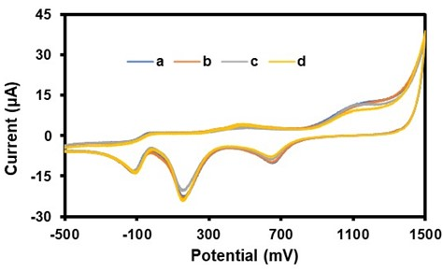
Fig. 1. Cyclic voltammograms of bare Au and cCDs/AgNPs/Au in Na₂SO₄ solution. (a) bare Au and (b) cCDs/AgNPs/Au without melamine; (c) bare Au and (d) cCDs/AgNPs/Au with melamine (2.4 µg/mL).
3.2. Optimization of Melamine Detection Conditions
To define optimal conditions for melamine detection in Na₂SO₄ solution using the cCDs/AgNPs/Au electrode, optimization studies of certain performance parameters using cyclic voltammetry were conducted. These were the electrolyte concentration (Na₂SO₄), the number of cCDs/AgNPs deposits on the Au electrode surface, the scanning speed during the tests, and the pH of the electrolyte solution. For each of these studies, the melamine concentration in the reaction medium was set at 0.240 µg/mL.

3.2.1. Effect of Na₂SO₄ Solution Concentration
In the presence of melamine, a study was conducted to determine the optimal concentration of the electrolytic solution using the cCDs/AgNPs/Au electrode. For this study, seven different Na₂SO₄ concentrations in the range from 0.005 M to 0.200 M were considered with a scan rate set at 50 mV/s. The results of this study are presented in Fig. 2 :
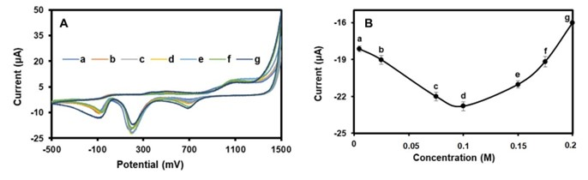
Fig. 2. A) Cyclic voltammograms of different concentrations of Na₂SO₄ solution (a) 0.005 M, (b) 0.025 M, (c) 0.075 M, (d) 0.1 M, (e) 0.150 M, (f) 0.170 M and (g) 0.2 M. B): Trend curve of Na₂SO₄ concentrations as a function of reduction current.

The spectra obtained by CV present the evolution of the characteristic peak of the reduction current as a function of the variation of the Na₂SO₄ concentration (Fig. 2.A). Moreover, the trend curve linking each concentration of Na₂SO₄ to its current peak shows that the maximum value of the reduction current peak is obtained for the 0.1 M concentration (Fig. 2.B). Thus, the 0.1 M Na₂SO₄ solution is the reaction medium favorable to a more intense formation of the electroactive derivative of melamine because of the strong presence of the active species of chlorine. Moreover, at this concentration, the formation of hydrogen bonds becomes increased between the electroactive derivative of melamine and the cCDs/AgNPs/Au electrode via the hydroxyl, carbonyl, carboxyl or even amino groups present on the surface of the cCDs/AgNPs. This strong presence of hydrogen bonds could induce an intensification of electron transfers at the origin of the increase in the reduction current at the cCDs/AgNPs/Au electrode. It follows from this study that at 0.1M Na₂SO₄, the electrochemical activity between melamine and the cCDs/AgNPs/Au electrode is optimal.

3.2.2. Effect of the number of cCDs/AgNPs deposits on the gold electrode
In this study, the surface of the gold electrode was successively coated with a number of cCDs/AgNPs deposits ranging from 1 to 3. Then, after drying at room temperature, the electrochemical behavior of the cCDs/AgNPs/Au electrode was studied in the presence of melamine in a 0.1 M Na2SO4 solution. Fig. 3 presents the results of this study.
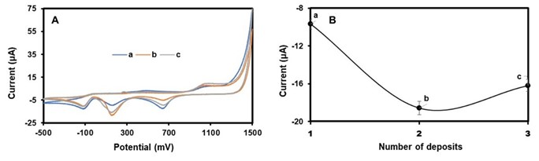
Fig. 3. A) Cyclic voltammograms for (a) 1 deposit, (b) 2 deposits and (c) 3 deposits of cCDs/AgNPs on the surface of the Au electrode; B) Trend curve of the number of cCDs/AgNPs deposition as a function of the maximum peak of the associated reduction current.

As can be seen in (Fig. 3.A, b) the peak of the reduction current is maximum for a modification made with two deposits of cCDs/AgNPs on the surface of the Au electrode. It is therefore very likely that with two deposits of cCDs/AgNPs, the electrochemical response of the cCDs/AgNPs/Au electrode seems to be more intense because of the increased availability of active sites which can strengthen the transfer of electrons in the reaction medium (Fig. 3.B). In addition, it is possible that beyond two deposits, congestion of active sites can reduce the performance of the cCDs/AgNPs/Au electrode translated by a shoulder present on the spectrum corresponding to three deposits (Fig. 3.A, c). Therefore, we opted for a two-layer deposition of cCDs/AgNPs for the fabrication of the working electrode (cCDs/AgNPs/Au) in a 0.1 M Na₂SO₄ solution.

3.2.3. Effect of Scanning rate
A study was conducted to determine the optimal scanning speed and to better understand the electroreduction process undergone by melamine in Na₂SO₄ medium in the presence of the designed cCDs/AgNPs/Au electrode. For this study, seven scanning speeds in the range 50 mV/s - 200 mV/s were chosen. Fig. 4 presents the evolution of the CV spectrum for seven selected scanning speeds.
From this study, we find that the increase in the scanning speed is accompanied by a decreasing shift in the potential (E) and with an increase in the reduction current (i_{red}).
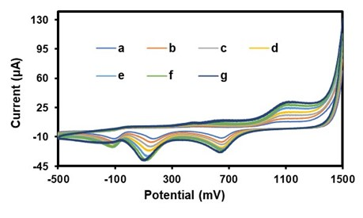
Fig. 4. Cyclic voltammograms of the cCDs/AgNPs/Au electrode for different scanning speeds (a) 50 mV/s, (b) 75 mV/s, (c) 100 mV/s, (d) 125 mV/s, (e) 150 mV/s, (f) 175 mV/s and (g) 200 mV/s in 0.1 M Na₂SO₄ solution in the presence of melamine (0.24µg/mL)

From these two parameters, it is possible to develop approaches to define the reversibility and the type of control (adsorption or diffusion) governing the reactions of melamine in the Na₂SO₄ medium in the presence of the cCDs/AgNPs/Au electrode. Indeed, by establishing the mathematical relationships between the reduction current (i_{red}) and the scanning speed (v) through the equations i_{red} = f(v^{1/2}) and ln(i_{red}) = ln(v), it is possible to deduce the type of control that governs the movement of melamine towards the cCDs/AgNPs/Au electrode in the reaction medium. Thus, Fig.5 presents the shape and the relationship obtained in each case.
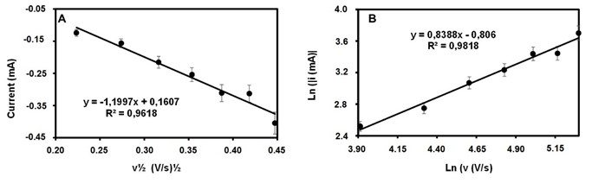
Fig. 5. A) Dependence of the reduction currents (I_{red}) on the square root of the scanning speed (v^{1/2}), B): Dependence of the logarithm of the absolute value of the reduction current on the logarithm of the scanning speed
As shown in Fig. 5.A, the graph representing the relationship ired = f(v^{1/2}) is linear with a correlation coefficient R² = 0.981. In addition, the graphical representation of the reduction current as a function of the square of the scanning speed is defined by the equation:
I_{red} = - 1.199 v^{1/2} + 0.1607 (E.1)
While Fig.6B displays the representative graph of the relation ln(i_{red}) = ln(v), also linear (R² =0.9919) and defined by the equation:
Ln(|i_{red}|) = 0.8388Ln(v) - 0.806 (E.2)

According to equation (E1), the slope (|-1.199|) closer to 1, indicates a reaction controlled by an adsorption process at the cCDs/AgNPs/Au – Na₂SO₄ interface. Similarly, the slope (0.8388) of equation (E.2) close to 1 corroborates the fact that the reaction of melamine in the medium is controlled by an adsorption process. Furthermore, the reversibility of this adsorption reaction undergone by melamine in the medium can be deduced through the graphs E = f(v) and E = f(ln(v)). The representative results of the two graphs are presented in Fig.6:
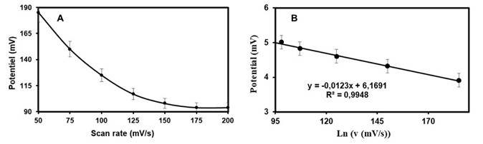
Fig. 6. A) Dependence of the potential on the scanning speed, B): Dependence of the potential on the logarithm of the scanning speed

Fig. 6.A shows the trend of the potential evolution as a function of the scanning speed. The shape of this trend curve indicates that the potential depends on the scanning speed with a strong linearity (R² = 0.9948) between the potential and the logarithm of the scanning speed (Fig. 6.B). According to the literature, only in reversible electrochemical phenomena is it possible to have a potential independent of the scanning rate (Mirceski et al., 2019) ; (Novak, 2022). Thus, the adsorption-controlled reaction at the cCDs/AgNPs/Au-Na₂SO₄ electrode interface is carried out following an irreversible process. In order to avoid any overload at our working electrode, the scanning speed of 50 mV/s was adopted as the optimal scanning speed for two-layer cCDs/AgNPs deposits on the surface of the gold electrode for the detection of melamine in 0.1 M Na₂SO₄.
3.2.4. Effect of pH variation
Like the scanning speed, the pH of the reaction medium is an important parameter for understanding the reaction mechanism that melamine could undergo with the cCDs/AgNPs/Au electrode. For this study, eight pHs were chosen over the range of 5.0 to 11.5. Representative results are summarized in Fig. 7.
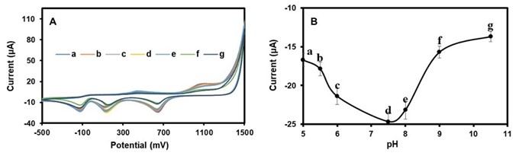
Fig. 7. A) Cyclic voltammogram of the cCDs/AgNPs/Au electrode for different values ​​(a) pH5, (b) pH5.5, (c) pH6, (d) pH7.5, (e) pH8, (f) pH9, (g) pH10.5, (h) pH11.5 in a Na₂SO₄ solution (0.1 M) in the presence of melamine (0.24 µg/mL), B) pH curve as a function of current

As we can see in Fig. 7A, the reduction current reaches its maximum value at pH =7.5 with a decreasing shift of the potential (E). Furthermore, the study of the transfer of electrons and protons is done by establishing the relationships E = f(pH) and E1/2 = f(pH), allowing to determine the number of protons and electrons exchanged by melamine with the reaction medium and the cCDs/AgNPs/Au electrode. Fig.9 represents the results obtained from this study.
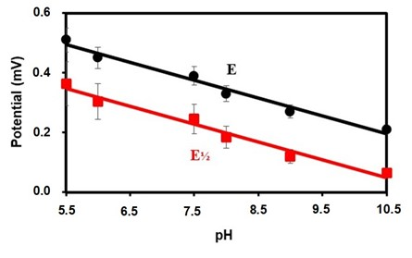
Fig. 8. Effect of pH on potential (E) and half-wave potential (E_{1/2})
Thus, the graphs of dependence of the potentials E and E_{1/2} with the pH (Fig. 9) reveal two linear plots with the equations:
E = 0,08462 -0,0617pH with R² = 0,9799 (E.3)

E_{1/2} = 0,7010 – 0,0619pH with R² = 0,9787 (E.4)
Considering Nernst's law translated by the relation:

E = E⁰ - 0,059(m/n)pH (E.5)

Where the parameters m and n represent respectively the number of protons and electrons exchanged. By relating equation (E.5) to equations (E.3) and (E.4), the ratios (m/n) give 1.045 for E and 1.049 for E_{1/2}. The fact that the ratios (m/n) are very close 1 reflects an equality between the parameters m and n. Thus, the electrochemical reaction between melamine and the cCDs/AgNPs/Au electrode is governed by a transfer of the same number of electrons and protons. This particularity of the electron-proton exchanges makes it possible to translate the mechanism of the electropolymerization reaction of melamine in the presence of active chlorine; as well as that of interaction with the cCDs/AgNPs/Au electrode:
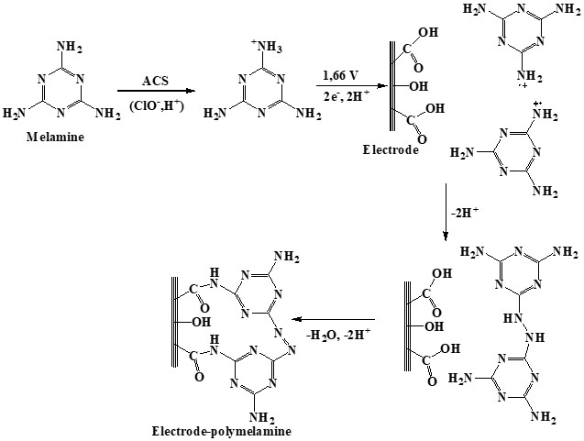
Fig. 9: Probable pathway of melamine electropolymerization (Kanagavalli et al., 2023)
3.3. Validation of the Melamine Detection Method
This part of the work focused on certain validation parameters applied to the designed analytical method. These parameters included: linearity, limits of detection (LOD) and quantification (LOQ), accuracy (or recovery rate), precision, and selectivity. These validation studies were conducted using the Differential Pulse Voltametry (DPV) technique under optimal melamine detection conditions with the cCDs/AgNPs/Au electrode in 0.1 M Na₂SO₄.

3.3.1. Linearity Study
In order to demonstrate the linearity of the implemented detection method, a calibration study was conducted in the range 0.5 ng/mL to 50 ng/mL. For this study, ten (10) different melamine concentrations were considered. Representative results are summarized in Fig. 10:
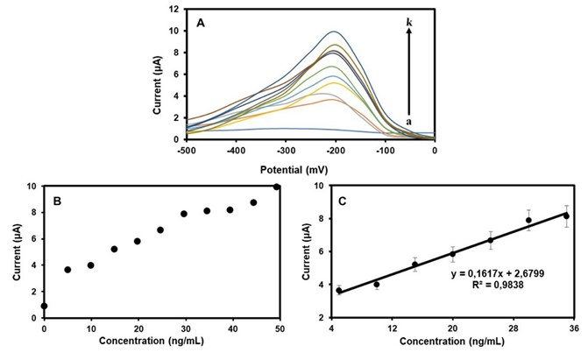
Fig. 10. A) DPV for (a) 00 ng/mL, (b) 05 ng/mL, (c) 10 ng/mL, (d) 15 ng/mL, (e) 20 ng/mL, (f) 25 ng/mL, (g) 30 ng/mL, (h) 35 ng/mL, (i) 40 ng/mL, (j) 45 ng/mL and (k) 50 ng/mL of melamine in 0.1M Na₂SO₄ in the presence of the cCDs/AgNPs/Au electrode, B) and C) Correlations between current and melamine concentration

Fig. 10.A shows the evolution of the DPV spectra of the current with the increase in the concentration of melamine in the detection medium. The observation is that the current seems to increase linearly with the concentration of melamine. Moreover, this hypothesis is confirmed by the extrapolation of the results of Fig. 10.B and 10.C which made it possible to obtain an equation defined by the expression:
i (µA) = 0,1617C (ng/mL) + 2,6799 with R² = 0,9838

So, the implemented detection method has good linearity (R² = 0.9838). Using the slope (S) and standard deviation of deviation (s) of the calibration curve (E.7), the value obtained by calculation for the detection limit is 3.488 ng/mL and 11.627 ng/mL for the quantification limit. However, according to certain regulatory agencies working in the field of food safety, such as the FDA (Food and Drug Administration) in the USA, the recommended limit for excess melamine is 1 µg/mL in dairy foods for infants and 2.5 µg/mL for other individuals. As for the World Health Organization (WHO), it has set the limit for excess melamine at 0.2 µg/ml in dairy products (Ingelfinger, 2008). In the context of our work, the detection limit obtained is well below the limit values ​​adopted by the FDA and the WHO. And, given that in Côte d'Ivoire and in many countries in sub-Saharan Africa, legislation and analyses aimed at providing evidence of the presence of melamine in dairy products are very weak, the popularization of our work will therefore be a relief for many countries in sub-Saharan Africa (Akinyemi et al., 2021).

3.3.2. Detection Method Accuracy Study
To demonstrate the reliability of the designed detection method, a study was conducted to evaluate the cCDs/AgNPs/Au electrode's ability to recover melamine of known concentrations. This study involved the analysis of six melamine standard solutions with concentrations ranging from 0 to 50 ng/mL. The results are summarized in Table 1. It appears from this study that the melamine recovery rates by the cCDs/AgNPs/Au electrode vary between 98.2% and 100.8%. Therefore, the cCQDs/AgNPs/Au electrode has an excellent melamine recovery capacity which confirms the reliability of the analytical method.

Table 1. Recovery rates in different melamine solutions (n ​​= 3)
Added (ng/mL) | Found (ng/mL) | Recovery (%)
07.3 | 07.28 | 099.7 ± 1.9
12.3 | 12.08 | 098.2 ± 2.4
17.2 | 17.02 | 098.9 ± 2.3
22.2 | 22.04 | 099.3 ± 3.5
27.0 | 27.18 | 100.7 ± 1.9
32.0 | 32.25 | 100.8 ± 2.4

3.3.3. Detection Method Accuracy Study
Following the optimized parameters, the accuracy of the designed detection method was evaluated through intra-/inter-day detection tests. This study aimed to evaluate the relative standard deviation (RSD) of the intra-day and inter-day detection tests of melamine. And for this study, the six melamine concentrations chosen for the accuracy study were repeated. Table 2 presents the summary of the results obtained :

Table 2. Relative Standard Deviation (RSD)
Added (ng/mL) | Found (ng/mL) |  |  | RSD (%)
 | Intra-day ± SD | Inter-day± SD |  | Intra-day | Inter-day
07.3 | 07.29 ± 0.31 | 07.30 ± 0.31 |  | 4.2 | 4.2
12.3 | 12.11 ± 0.96 | 12.06 ± 0.31 |  | 7.9 | 2.6
17.2 | 17.06 ± 1.20 | 17.00 ± 0.26 |  | 7.0 | 1.5
22.2 | 22.05 ± 0.98 | 22.10 ± 0.85 |  | 4.4 | 3.8
27.0 | 27.10 ± 1.57 | 27.19 ± 0.16 |  | 5.8 | 0.6
32.0 | 32.09 ± 1.65 | 32.09 ± 2.32 |  | 5.1 | 7.2

This study shows that the RSD for intra-day detection tests varies between 4.2% and 7.9%; while that for inter-day detection tests vary between 0.6% and 7.2%. Thus, the detection of melamine using the cCDs/AgNPs/Au electrode has an overall RSD of less than 8%. This result therefore confirms the good accuracy of our method and its usability for the control and prevalence of melamine under the conditions established by our work.

3.3.4. Detection Method Selectivity Study
The performance of the designed detection method is closely related to its ability to respond to melamine in a charged medium. Based on this principle, the cCDs/AgNPs/Au electrode was used to detect and quantify melamine in the presence of interfering potentials commonly used to fortify commercial powdered milk. These interferents included inorganic compounds (Na₂SO₄, FeSO₄, CaSO₄, MgSO₄), protein-like substances (glycine, cysteine) or carbohydrate-like substances (starch), and vitamins (ascorbic acid (Vit C)). For this study, each of these interferents was added at a concentration 10 times higher than that of melamine. Representative results are summarized in CHART 1:
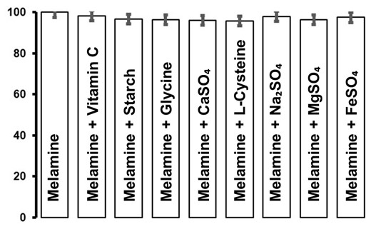
CHART. 1. Selectivity of the cCDs/AgNPs/Au electrode in the detection of 1 µg/mL of melamine in the presence of 10 µg/mL of interferent

Overall, the melamine recovery rate by the cCQDs/AgNPs/Au electrode in this charged medium varies between 95% and 100%, demonstrating the performance of the method. However, in the presence of ascorbic acid (97.9%) or starch (97.95%) or glycine (98.84%) or cysteine ​​(95.65%), the melamine recovery rate by the cCDs/AgNPs/Au electrode appears slightly impacted. This effect is explained by the fact that, firstly, in the presence of ascorbic acid, the hydroxyl groups ( ̶ OH) bind to melamine by the amine functions ( ̶ NH2) through strong hydrogen bonds. This characteristic of ascorbic acid tends to reduce the availability of melamine and thus interferes with its detection. Second, in the presence of starch, melamine is able to release nitrogen in the form of ammonia by relying on the strong hydrogen bonds between the hydroxyl groups of starch and the amine functions of melamine (Giroto et al., 2019). In addition, starch has the ability to associate with melamine to form the resin via strong hydrogen bonds (Amanda S. Giroto et al., 2020). All these parasitic effects of starch impact the detection of melamine by the cCDs/AgNPs/Au electrode. Third, it is possible that under certain pH conditions (pH > 7), glycine is able to associate with melamine to form a glycine-melamine network acting as an oxygen reduction However, the absence of ferric ion (Fe³⁺) reduces the parasitic nature of this network during melamine detection. Fourth, cysteine, unlike glycine, has an organothiol group (R-SH₂) in its structure that can impact the stability of cCDs/AgNPs present on the surface of the gold electrode. This effect has the ability to deactivate the active sites available at the cCDs/AgNPs/Au electrode, thus reducing its melamine detection capacity.
Concerning inorganic interferents (CaSO₄, MgSO₄, Na₂SO₄ and FeSO₄), frequently encountered in commercial powdered milk, our work presents very low interference of these substances in the detection of melamine by the cCDs/AgNPs/Au electrode. However, the presence of Fe³⁺ and Fe²⁺ ions in powdered milk suspected of containing melamine is considered because these ions have high sensitivity with cCDs/AgNPs. In summary, the cCDs/AgNPs/Au electrode shows good selectivity for melamine, however, it is necessary to perform melamine extraction before any detection in commercial powdered milk.

3.3.5. Reusability of the cCDs/AgNPs/Au Electrode
To demonstrate the reusability of the cCDs/AgNPs/Au electrode, a detection series of five (05) tests was carried out under optimal melamine detection conditions. For each detection series, the melamine concentration was set at 0.246 µg/mL. In this study, the objective was to determine the recovery rate and the relative standard deviation for each test. During the process, the surface of the cCDs/AgNPs/Au electrode was washed with ultrapure water, then with ethanol before being dried for the next test. Table 3 shows representative results for each detection series.

Table 3. Recovery rate and relative standard deviation for a series of 5 tests
Essai | Added (ng/mL) | Found (ng/mL) | Recovery (%) | RSD % (n = 3)
01 | 0.246 | 0.2457 ± 0.0043 | 99.9 | 1.7
02 | 0.246 | 0.2402 ± 0.0218 | 97.6 | 9.1
03 | 0.246 | 0.2394 ± 0.0044 | 97.3 | 1.8
04 | 0.246 | 0.2453 ± 0.0175 | 99.7 | 7.1
05 | 0.246 | 0.2414 ± 0.0087 | 98.1 | 3.6

This study shows that for all five tests, the recovery rate ranges between 97% and 99%, with a relative standard deviation ranging from 1.8% to 9.1%. Overall, the cCDs/AgNPs/Au electrode exhibits an excellent recovery rate with an RSD of less than 10%. Thus, the reusability of the cCDs/AgNPs/Au electrode is confirmed for to melamine detection tests under the conditions established in this work.

3.3.6. Detection of melamine in a real environment
The new cCDs/AgNPs/Au electrode was used to determine traces of melamine in powdered milk extracts. To do this, five samples of powdered milk (Bonnet Rouge, Nido, Lait en Poudre (Lp), Laity, and Top-Lait), widely marketed on national and international markets, were recollected, then were contaminated in the laboratory (5 mg melamine added to 2.5 g milk powdered, or 2 mg/g) for the purposes of this study. The detection of melamine was done using the liquid extracts of each of the powdered milk samples mentioned above. Fig. 11 presents the results of this study.
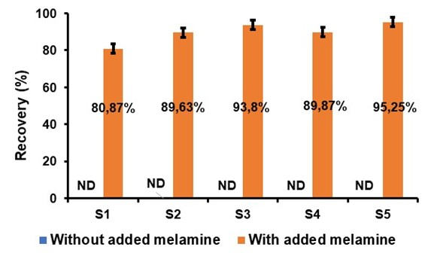
Fig. 11. Melamine recovery diagram in different milk powder samples with S1: extract from Bonnet rouge sample, S2: extract from Nido sample, S3: extract from Lait en Poudre Lp sample, S4: extract from Laity sample and S5: extract from Top-Lait sample

This study shows that the powdered milks present on the Ivorian market and subjected to the detection test do not contain any traces of melamine. This result provides proof of the credibility of the various manufacturers and suppliers of powdered milk in Côte d'Ivoire and the good quality of the powdered milk made available to consumers. Furthermore, in the event of accidental or intentional contamination of these powdered milks with melamine, the method implemented by this work is capable of revealing its presence and assessing its quantity with a recovery rate of between 90% and 98%. Thus, the proposed method is a promising alternative for monitoring and prevalence of melamine contamination. However, it is necessary to establish legislation to restrict the addition of certain vitamins such as vitamins A and D whose hydroxyl or carboxyl groups could interfere with the detection process and reduce the recovery capacity of the proposed method; or vitamins B2 (C₁₇H₂₀N₄O₆) and B12 (C₆₃H₈₈CoN₁₄O₁₄P), whose structures contain nitrogen atoms that could be used as a shield to cover the presence of melamine by reducing the sensitivity of the cCDs/AgNPs/Au electrode.

3.3.7. Comparative Study
To reaffirm the reliability of the melamine detection method implemented, a comparative study was conducted with other melamine detection methods already made public and validated by the scientific community. This comparative study is summarized in Table 4 :

Table 4. Comparison with other published methods for the detection of melamine
Electrode | Plage de Conc. | LOD* | Reference
GCE/P-Arg/ErGO | 1.0x10⁻⁸ – 9.0x10⁻⁸ M | 0.631 µg/L | (Daizy et al., 2019)
OMC/GCE | 1.0x10⁻⁸ – 2.0x10⁻⁵ M | 0.252 µg/L | (Guo et al., 2018)
Fc-ECG/SPCE | 8.0x10⁻⁶ – 8.0x10⁻⁴ M | 16.4 µg/L | (An et al., 2022)
MIP-MIL/GCE | 1.0x10⁻¹¹ – 1.0x10⁻⁶ M | 1.03x10⁻³ µg/L | (An et al., 2019)
MIPAptamer/AuNPs/GCE | 1.0x10⁻¹² – 1.0x10⁻⁴ M | 8.64x10⁻⁴ µg/L | (Yu et al., 2021)
MI-PANI-GCE | 6.0x10⁻⁹ – 1.6x10⁻⁸ M | 0.19 µg/L | (Regasa et al., 2020)
CAONSs/Nafion/GCE | 0.5x10⁻⁸ – 5.0x10⁻⁸ M | 1.77x10⁻³ µg/L | (Rahman & Ahmed, 2018)
GCE* | 2.0x10⁻⁹ – 8.0x10⁻⁹ M | 0.075 µg/L | (El-Shahawi & Khraibah, 2020)
MIP | 5.0x10⁻⁷ – 1.0x10⁻⁵ M | 0.35 µg/L | (Biabani et al., 2020)
cCDs/AgNPs/Au | 4.0x10⁻⁹ – 4.0x10⁻⁶ M | 3.488 µg/L | This work

It follows from this study that the detection method proposed by this work proves to be an advantageous alternative due to the simplicity of design of the cCDs/AgNPs/Au electrode and application of the method. In addition, the limit of detection (LOD) obtained is in the order of magnitude of the methods already proposed and validated. It even proves to be lower than the LOD of some of them. Furthermore, the method implemented does not require any derivatization and contributes to sustainable development through its green analytical character based on the recovery of lemon zest, waste from agriculture. In addition, this fast and efficient method is based on an electrochemical sensor, highly sensitive and selective, easy to design at low cost.

4. Conclusion

In the search for new green analytical methods, the cCDs/AgNPs/Au electrode was designed and used for the detection and quantification of melamine in aqueous media. The performance of this electrode is linked to the increased reactivity of cCDs by AgNPs; and to the stability of the cCDs/AgNPs nanocomposite on the surface of the Au electrode in the sodium sulfate (Na₂SO₄) solution. The detection limit of this method is 3.488 ng/mL, comparable to that of other proposed, validated and frequently used methods for the detection of melamine. This detection limit, lower than the limits set by the WHO and the US FDA in milk and dairy products intended for infants and young children, suggests that the proposed method is effective and can therefore be used on a large scale for monitoring melamine levels in food products. Thus, this method appears as a reliable alternative in the fight against food insecurity. Furthermore, its low cost, simplicity, high sensitivity, and excellent reproducibility make it a prime alternative for preventing another global scandal linked to melamine contamination.

Disclaimer (Artificial intelligence)

Author(s) hereby declare that NO generative AI technologies such as Large Language Models (ChatGPT, COPILOT, etc.) and text-to-image generators have been used during the writing or editing of this manuscript.

References

Akinyemi, M. O., Ayeni, K. I., Ogunremi, O. R., Adeleke, R. A., Oguntoyinbo, F. A., Warth, B., & Ezekiel, C. N. (2021). A review of microbes and chemical contaminants in dairy products in sub-Saharan Africa. Comprehensive Reviews in Food Science and Food Safety, 20(2), 1188‑1220. https://doi.org/10.1111/1541-4337.12712
Amanda S. Giroto, Rodrigo H.S. Garcia, Luiz A. Colnago, Artur Klamczynski, Greg M. Glenn, & Caue Ribeiro. (2020). Role of urea and melamine as synergic co-plasticizers for starch composites for fertilizer application. International Journal of Biological Macromolecules, 144, 143‑150. https://doi.org/10.1016/j.ijbiomac.2019.12.094
An, J., Li, L., Ding, Y., Hu, W., & Et., A. (2019). A novel molecularly imprinted electrochemical sensor based on Prussian blue analogue generated by iron metal organic frameworks for highly sensitive detection of melamine. Electrochimica Acta. https://doi.org/10.1016/j.electacta.2019.134946
An, Q.-Q., Feng, X.-Z., Zhou, Z.-F., Zhan, T., & Et., A. (2022). One step construction of an electrochemical sensor for melamine detection in milk towards an integrated portable system. Food Chemistry. https://doi.org/10.1016/j.foodchem.2022.132403
Barreto, M. C., Braga, R. G., Lemos, S. G., & Fragoso, W. D. (2021). Determination of melamine in milk by fluorescence spectroscopy and second-order calibration. Food Chemistry. https://doi.org/10.1016/j.foodchem.2021.130407
Biabani, M., Nezhadali, A., Nakhaei, A., & Nakhaei, H. (2020). Melamine Recognition : Molecularly Imprinted Polymer for Selective and Sensitive Determination of Melamine in Food Samples. International Journal of Analytical Chemistry. https://doi.org/10.1155/2020/8864144
Burke, L. D., Moran, J. M., & Nugent, P. F. (2003). Cyclic voltammetry responses of metastable gold electrodes in aqueous media. Journal of Solid State Electrochemistry, 7(9), 529‑538. https://doi.org/10.1007/s10008-003-0359-y
Chen, S., Liu, S., Wen, A., Zhang, J., Nie, H., Chen, J., Zeng, R., Long, Y., Jin, Y., & Mai, R. (2018). New insight into electropolymerization of melamine. I : Chloride promoted growth of polymelamine in different pH medium. Electrochimica Acta, 271, 312‑318. https://doi.org/10.1016/j.electacta.2018.03.146
Chen, X., & Wang, L. (2021). Analysis of the Application of High Performance Liquid Chromatography. IOP Conference Series: Earth and Environmental Science, 769(3), 032020. https://doi.org/10.1088/1755-1315/769/3/032020
Daizy, M., Tarafder, C., Al-Mamun, Md. R., Liu, X., Aly Saad Aly, M., & Khan, M. Z. H. (2019). Electrochemical Detection of Melamine by Using Reduced Graphene Oxide–Copper Nanoflowers Modified Glassy Carbon Electrode. ACS Omega, 4(23), 20324‑20329. https://doi.org/10.1021/acsomega.9b02827
El-Shahawi, M. S., & Khraibah, N. H. (2020). Development of a highly sensitive voltametric sensor for trace determination of melamine residues in milk and water samples. Microchemical Journal. https://doi.org/10.1016/j.microc.2020.105087
Esmaeily, Z., Madrakian, T., Afkhami, A., Ghoorchian, A., & Ghasemzadeh-Mohammadi, V. (2021). Electropolymerization as an electrochemical preconcentration approach for the determination of melamine in milk samples. Electrochimica Acta, 390, 138897. https://doi.org/10.1016/j.electacta.2021.138897
Ghorbani, H. R., Mehr, F. P., Pazoki, H., & Rahmani, B. M. (2015). Synthesis of ZnO nanoparticles by precipitation method. Orient. J. Chem, 31(2), 1219‑1221.
Giroto, A. S., Guimarães, G. G., Colnago, L. A., Klamczynski, A., Glenn, G., & Ribeiro, C. (2019). Controlled release of nitrogen using urea-melamine-starch composites. Journal of Cleaner Production, 217, 448‑455. https://doi.org/10.1016/j.jclepro.2019.01.275
Guo, Z., Zhao, Y., Li, Y., Bao, T., Sun, T., Li, D., Luo, X., & Fan, H. (2018). A Electrochemical Sensor for Melamine Detection Based on Copper-Melamine Complex Using OMC Modified Glassy Carbon Electrode. Food Analytical Methods, 11(2), 546‑555. https://doi.org/10.1007/s12161-017-1025-9
Haghi, E., Shakoori, A., Alimohammadi, M., Razeghi, F., & Et., A. (2021). HPLC and spectrophotometry methods for measuring melamine migration from melamine dishes to food simulants. MethodsX. https://doi.org/10.1016/j.mex.2021.101284
Ingelfinger, J. R. (2008). Melamine and the Global Implications of Food Contamination. New England Journal of Medicine, 359(26), 2745‑2748. https://doi.org/10.1056/NEJMp0808410
Ji, Z., Chen, W., Wang, E., & Deng, R. (2017). Electropolymerized Molecular Imprinting & Graphene Modified Electrode for Detection of Melamine. International Journal of Electrochemical Science, 12(12), 11942‑11954. https://doi.org/10.20964/2017.12.34
Kanagavalli, P., Natchimuthu Karuppusamy, M., Ganesan, V. S., Saravanan, H. P., Palanisamy, T., & Veerapandian, M. (2023). Electropolymerized Melamine on Electrochemically Reduced Graphene Oxide : Growth Mechanistics, Electrode Processing, and Amperometric Sensing of Acyclovir. Langmuir, 39(9), 3512‑3525. https://doi.org/10.1021/acs.langmuir.3c00128
Kar, P., Tatard, F., Lamblin, G., Banet, P., Aubert, P. H., Plesse, C., & Chevrot, C. (2013). Silver nanoparticles to improve electron transfer at interfaces of gold electrodes modified by biotin or avidin. Journal of Electroanalytical Chemistry, 692, 17‑25. https://doi.org/10.1016/j.jelechem.2012.12.020
Li, J., Kuang, D., Feng, Y., Zhang, F., Xu, Z., & Liu, M. (2012). A Novel Electrochemical Method for Sensitive Detection of Melamine in Infant Formula and Milk using Ascorbic Acid as Recognition Element. Bulletin of the Korean Chemical Society, 33(8), 2499‑2507. https://doi.org/10.5012/bkcs.2012.33.8.2499
Liang, W., Zhu, Z., Yang, B., Zhu, X., & Et., A. (2021). Detecting melamine‐adulterated raw milk by using near‐infrared transmission spectroscopy. Journal of Food Process Engineering. https://doi.org/10.1111/jfpe.13685
Liu, X., Song, M., & Li, F. (2017). Triplex DNA-based Bioanalytical Platform for Highly Sensitive Homogeneous Electrochemical Detection of Melamine. Scientific Reports, 7(1), 4490. https://doi.org/10.1038/s41598-017-04812-4
Mirceski, V., Stojanov, L., & Ogorevc, B. (2019). Step potential as a diagnostic tool in square-wave voltammetry of quasi-reversible electrochemical processes. Electrochimica Acta, 327, 134997. https://doi.org/10.1016/j.electacta.2019.134997
Novak, I. (2022). Efficiency of reversible reaction : A graphical approach. Chemistry Teacher International, 4(3), 271‑277. https://doi.org/10.1515/cti-2022-0004
Rahman, M. M., & Ahmed, J. (2018). Cd-doped Sb2O4 nanostructures modified glassy carbon electrode for efficient detection of melamine by electrochemical approach. Biosensors and Bioelectronics. https://doi.org/10.1016/j.bios.2017.12.007
Regasa, M. B., Soreta, T. R., Femi, O. E., Ramamurthy, P. C., & Et., A. (2020). Molecularly imprinted polyaniline molecular receptor–based chemical sensor for the electrochemical determination of melamine. Journal of Molecular Recognition. https://doi.org/10.1002/jmr.2836
Saeed, S., Rashid, A. A., Rizvi, S. Y. A., Shehzad, K., Nawaz, S., & Yasir, M. (2021). Screening of Melamine in Milk and Milk-based Products Using Enzyme-linked Immunosorbent Assay. Nutrition & Food Sciences Research, 8(4), 29.
Shi, X., Dong, R., Chen, J., Yuan, Y., & Et., A. (2020). An assessment of melamine exposure in Shanghai adults and its association with food consumption. Environment International. https://doi.org/10.1016/j.envint.2019.105363
Strashnov, I., Karunarathna, N. B., Fernando, B. R., Dissanayake, C., & Binduhewa, K. M. (2021). An isotope dilution liquid chromatography-mass spectrometry method for detection of melamine in milk powder. Food Additives & Contaminants: Part A, 38(11), 1805‑1816. https://doi.org/10.1080/19440049.2021.1937709
Sun, M., Li, Y., Zhao, L., Zhang, X., Zhang, C., Jin, X., Shan, D., & Li, G. (2021). Luminescence-Color-Changing Sensing toward Melamine Based on a White-Light-Emitting Film. ACS Applied Polymer Materials, 3(6), 2998‑3008. https://doi.org/10.1021/acsapm.1c00162
Yu, C., Li, L., Ding, Y., Liu, H., & Et., A. (2021). A sensitive molecularly imprinted electrochemical aptasensor for highly specific determination of melamine. Food Chemistry. https://doi.org/10.1016/j.foodchem.2021.130202
Zhang, C., Gao, Z., Wang, Q., Zhang, X., Yao, J., Qiao, C., & Liu, Q. (2018). Highly Sensitive Detection of Melamine Based on the Fluorescence Resonance Energy Transfer between Conjugated Polymer Nanoparticles and Gold Nanoparticles. Polymers, 10(8). https://doi.org/10.3390/polym10080873
Zhu, H., Wang, Y., Sun, H., & Kannan, K. (2019). Fertilizers as a Source of Melamine and Cyanuric Acid in Soils : A Nationwide Survey in China. Environmental Science & Technology Letters, 6(2), 55‑61. https://doi.org/10.1021/acs.estlett.8b00711

