Study of Luminescence Dependence of ZnO and SiO₂:Pr³⁺ Nanophosphor Concentration and Temperature

Abstract
The emission peaks located at 890 and 1005 nm relate to the ¹D₂→F_{2,3,4} transitions, respectively. They detected these at 884 and 1060 nm when Pr3+ was added to SiO₂. The primary broad emission peak occurs at 309 nm in the UV spectral region; SiO₂ samples with Pr³⁺ concentrations of 0.05, 0.1, 0.2, and 0.5 mole% showed single exponential luminescence decay. These represent the luminescence decay curves for ZnO, SiO₂:0.2 mole% Pr³⁺ and ZnO emissions captured at room temperature. When the temperature increases from 8 K to 300 K, the lifetime of ¹D₂ decreases. The rapid decrease of the Pr³⁺ ¹D₂→³H₄ emission from SiO₂: Pr³⁺, which has a lifetime of 144 µs, indicated that both SiO₂:Pr³⁺ and ZnO exhibited similar emission characteristics from the Pr³⁺ ion, primarily featuring red emission peaks at 605 nm when excited by VUV light targeting the 4f, 5d state of the Pr³⁺ phosphors containing SiO₂ and Pr³⁺ particles. The ultraviolet spectrum from 200 to 300 nm relate to particles with diameters ranging from 2 to 10 nm. The ³H₆ and ³H₄ produce red lines at 605 and 614 nm, correspondingly.
Keywords: Photoluminesence, Cathodoluminesence, HRTEM, TEM, EDS, VUV
Introduction;
“Enhancing the luminescence efficiency from transitions in the ¹D₂ or ³P₀ emission levels of Pr³⁺ has been difficult due to the commonly seen self-quenching of luminescence” [1-6]. “The quenching effect can happen due to several reasons, including (i) multiphoton relaxation, (ii) cross relaxation among pairs of Pr³⁺ ions, and (iii) energy transfer to quenching centers. The following two steps depend on the concentration of Pr^{3+”} [7-13]. “Semiconductor nanocrystals, or quantum dots, have garnered significant interest as potential sensitizing centers for the radiative relaxation of activator ions due to their large excitation cross sections and efficient band absorptions. Previous studies have explored glass matrices infused with rare earth ions featuring sol-gel synthesized semiconductor nanocrystals” [13-19]. Optimized energy transfer from silicon quantum dots to rare earth ions enhanced their brightness. This could be advantageous for PDP technology, potentially enhancing luminescence efficiency. The transfer of energy from ZnO nanoparticles incorporated in sol-gel silica results in enhanced Pr³⁺ emission, as explained in this research [19-20]. “Measurements of luminescence decay curves were conducted to determine the lifetimes of the ¹D₂ Pr³⁺ state at different temperatures. The self-quenching of the ¹D₂ emission with increasing Pr³⁺ concentration and the influence of temperature on the multiple lifespan of ¹D₂ were examined. Also covered is the potential process by which Pr³⁺ and ZnO transmit energy in a SiO₂ host. The study of luminescence in Pr³⁺ doped silica and ZnO co-doped systems thus sits at the intersection of fundamental spectroscopy and applied materials science” [21-22]. From a fundamental standpoint, investigating the interactions between Pr³⁺ ions and the ZnO-modified silica matrix sheds light on energy transfer dynamics, local structural changes, defect-mediated processes, and radiative versus nonradiative decay channels. From an application perspective, optimizing such materials can contribute to the development of new phosphors for solid-state lighting, multicolour emission sources, up conversion devices for bioimaging, and optical components for communication technologies. Considerable attention has been directed in recent years toward hybrid systems where inorganic matrices like SiO₂ host semiconducting nanoparticles that couple to rare-earth activators. Such composite systems offer tunable luminescence by exploiting both host and dopant contributions, and they highlight the synergy achievable through nanoscale engineering.
Experimental Methodology:
Sample Preparation
- ZnO Nanocrystals
Over the past two decades, studies have focused on methods for creating colloidal solutions of ZnO nanoparticles in alcoholic solvents. A ZnO nanocrystal solution was made by dissolving 0.459 g of Zn(CH₃COO)₂·2H₂O in 30 ml of boiling pure ethanol, stirring for about 1 hour to obtain a transparent solution, and then cooling it in ice water. A 0.2 g solution of Nao in 10 ml of pure ethanol was dissolved in an ultrasonic bath maintained at room temperature. The solution was cooled in ice water prior to being slowly added to the Zn²⁺ ethanol suspension while stirring vigorously. The resulting transparent sol was left at room temperature for one day to promote nanoparticle nucleation and growth. Subsequently, it was centrifuged and rinsed several times with heptane to remove any unwanted Na⁺ and CH₃COO⁻ ions. The ZnO precipitate was obtained either through re-dispersion in ethanol or by drying in an oven at 90°C for 2 hours.
- SiO₂:Pr³⁺ and ZnO.SiO₂:Pr³⁺ phosphor powders
As a catalyst, nitric acid (HNO₃), tetraethyl orthosilicate (TEOS), de-ionized water, ethanol, and Pr (NO)₃.6H₂O were used to prepare Pr³⁺ doped SiO₂ samples by a sol-gel procedure. After 1 hour of stirring at room temperature, a clear solution was obtained by adding 1 mole% of Pr (NO) _{3.}6H₂O dissolved in 5 ml of ethanol. The combination, which included 0.05 mole of TEOS, 0.1 mole of H₂O, 0.1 mole of ethanol, and 0.145 mole of dilute nitric acid, was then agitated for 30 minutes. Two portions of the resulting SiO₂:Pr³⁺ (1 mole %) sol were separated. A petri dish was used to dry the first portion, and then, after vigorously swirling at room temperature for one hour, the second portion was mixed with an ethanol mixture containing 1 mole% of ZnO nanoparticles. After eight days of room temperature drying, the gels were crushed with a mortar and pestle and subjected to a two-hour heat treatment in ambient air at 600°C.
The phosphor powders of SiO₂:Pr³⁺ and ZnO.SiO₂:Pr³⁺ were analyzed at the Deutsche Elektronen-Synchrotron (DESY) in Hamburg, Germany, using the equipment at his lab's superluminal experimental facility, to examine their excitation and emission spectra. Lifetime measurements were obtained with an optical parametric oscillator (OPO Continuum Sure Lite) excited by the third harmonics of a Nd:YAG laser. The TDS 3052 digital oscilloscope from Tektronix was utilized to detect and document the decay signals. The measurements were carried out with a cryostat (CF-1204 Oxford Instruments) in continuous flow mode at temperatures matching those of liquid helium. The PL spectra of micro- and nano-sized ZnO particles in ethanol were captured using an LS 55 Fluorescence Spectrophotometer
Result and Discussion;
Particle morphology (HRTEM)
Nanoparticles of zinc oxide are shown in Figure 1. (a) in a Transmission Electron Microscopy (TEM) picture. The picture shows a cluster of particles with hexagonal shapes. The average diameter of the particles was 4 nm. Particles appeared to have been spread at random, as shown in Figure 1. (b) of the High Resolution Transmission Electron Microscopy (HRTEM) picture, which displays bands in various orientations. This picture also made the hexagonal ZnO's lattice fringes more apparent. Additional examination of this picture led to a determined d-spacing of 2.6 Å, which is in agreement with the ZnO (110) plane.
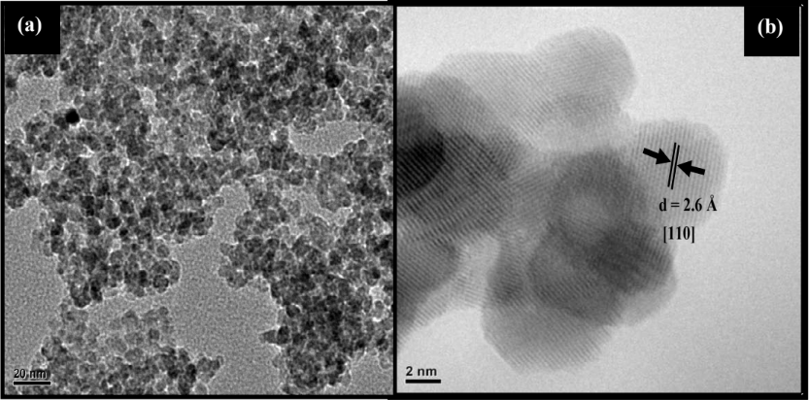
Figure 1: (a) TEM and (b) HRTEM images of the clustered ZnO nanoparticles
Results from the Energy Dispersive X-ray Spectrometer (EDS) and TEM analyses validated the existence of doped ion or particle clusters embedded in the amorphous silica matrix. Here is a TEM picture of amorphous SiO₂ (Figure 2 (a)). An aggregation of spherical particles was revealed by the field emission scanning electron microscopy picture of SiO₂ . Zooming in on ZnO.SiO₂:Pr^{3+,} we can see its TEM picture in Figure 2 (b). It reveals uniform distribution of tiny particles in amorphous SiO₂. These particles ranged in size from 2 to 10 nm in diameter and were spherical, as seen in the insert of figure 2 (b). The particles in the TEM image of figure 2 (b) consisted of Si, O, Zn, and Pr elements, as corroborated by the EDS data in figure 3. This proves that the nanoparticles of Pr³⁺ and ZnO were successfully incorporated into the SiO₂ host. When researchers saw a homogeneous distribution of particles of Eu³⁺ and ZnO co-doped in SiO₂, they also reported similar results.
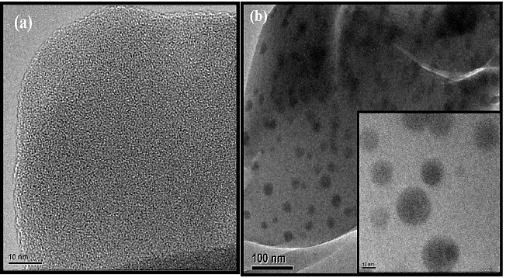
Figure 2: TEM images of (a) SiO₂ nanoparticles, (b) ZnO.SiO₂:Pr³⁺ nanophosphor and the insert of HRTEM image of ZnO.SiO²:Pr^{3+.}
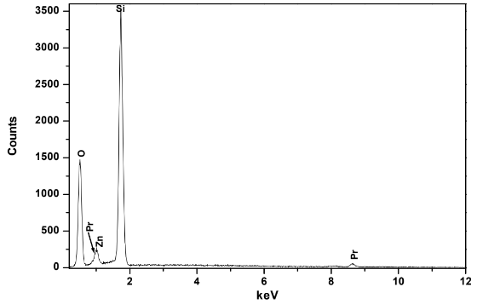
Figure 3: Energy dispersive X-Ray spectrum of 1 mole% ZnO.SiO₂:0.2 mole% Pr³⁺ phosphor.
PL properties of Pr³⁺ singly doped SiO₂
In theory, two types of emission transitions can occur from Pr³⁺ when excited by Vacuum Ultraviolet (VUV) light: inter-configurational 4f,5d→4f² and intra-configurational 4f²→4f². A host greatly influences the energetic position of the 4f5d states concerning the ¹S₀ state. The inter-configurational 4f, 5d→4f² transition, which is allowed by parity, can be induced by a high-energy excitation if the lowest 4f, 5d state is positioned beneath the ¹S₀ state. This wide emission is generated by the lowest 4f, 5d level. The intense emission bands in the Ultraviolet (UV) range from 200 to 300 nm, noted in the CaSO₄: Pr³⁺ phosphor after VUV excitation at 190 nm, are ascribed, for example, to the parity-allowed 4f¹, 5d¹→4f² transitions of Pr³⁺. According to this data, the ¹S₀ level is above the 4f¹, 5d¹ levels. Conversely, when Pr³⁺ was added to SrSO₄ and BaSO₄ systems, a sharp emission peak at 400 nm was observed, suggesting that the 4f¹, 5d¹ levels are positioned above the ¹S₀ level. The PL excitation and emission spectra for SiO₂:0.2 mole% Pr³⁺ are displayed in figure 4. Employing synchrotron light, the excitation spectra were recorded by monitoring the Pr³⁺ emission at 605 nm. Faint bands can be observed in the spectral range of 140–240 nm in this spectrum. These bands can be described as shifts from the 4f² ground state to the lowest 4f, 5d sublevels of Pr³⁺, since possible charge transfer transitions from Pr³⁺ to O²⁻ happen at very short wavelengths. This aligns with the researchers' findings, indicating that the excitation efficiency of Ca₃Sc₂Si₃O₁₂:0.2%Pr³⁺ peaks at 75 nm and is lowest in the 85–160 nm spectral range. Figure 4. shows the emission spectrum, which corresponds to the parity-allowed transitions from the lowest excited state of the 4f, 5d configuration to the ³H_{4, 5, 6} and ³F₂ of the 4f² configurations. The first broad emission peak, centres at 309 nm in the UV spectral region, was seen. These findings corroborate your findings for the YBO₃ system doped with Pr^{3+.} Emission peaks in the orange, red, and infrared regions follow this blue peak; these peaks are likely caused by transitions from the ³P₀ and ¹D₂ levels to the ³H_{4,5,6}, and ³F_{2,3,4} levels. The ¹D₂→³H₄ transition of Pr³⁺ can be attributed to the wide band seen between 600 and 630 nm, with a conspicuous red emission peak centered at 605 nm.
The transitions ³P₀→³H₆ and ³P₀→³F₂ correspond to the small shoulders located at approximately 614 and 660 nm, respectively. The results for Pr³⁺ incorporated in tellurite glasses align well with the emission peak assignments presented here. The emission peaks located at 890 and 1005 nm correspond to the ¹D₂→³F₂ and ¹D₂→³F_{3,4} transitions, respectively. Investigators additionally identified these at 884 and 1060 nm when Pr³⁺ was incorporated into SiO₂. The luminescence decay profiles of the Pr³⁺ emission for the ³P₀→³H₆ and ¹D₂→³H₄ transitions are depicted in Figure 5 (a) and (b). The lifetimes of ³P₀ and ¹D₂ are 1.8 µs and 179 µs, respectively, determined from the decay curve data through first order exponential fitting. These results indicate that the ³P₀ level of Pr³⁺ experienced a significantly shorter lifetime because of its faster degradation when compared to the ¹D₂ level. Researchers discovered indications of concurrent emissions from the ³P₀ and ¹D₂ levels, reinforcing the presence of these emissions. Pr³⁺ doped materials, including glasses and crystals, have demonstrated self-quenching of the ¹D₂ luminescence of Pr³⁺. Different Pr³⁺ concentrations in SiO₂ were assessed at room temperature and graphed alongside the luminescence decay curves of the ¹D₂ level, as shown in figure 6
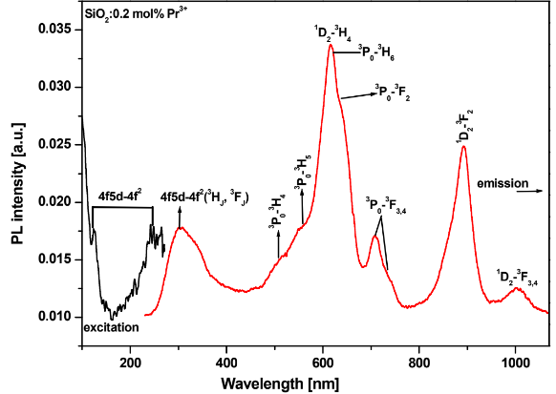
Figure 4: VUV excitation spectrum and emission spectrum of 0.2 mol% Pr³⁺ single doped SiO₂.
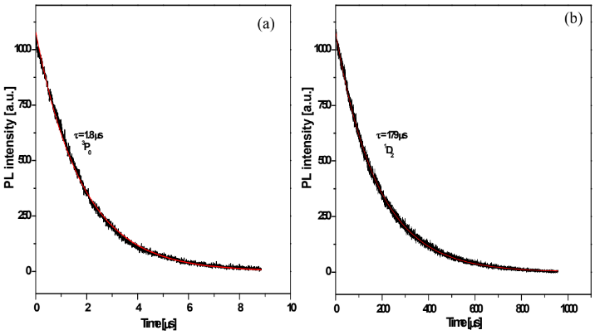

Figure 5: Luminescence decay curves of the ³P₀ and ¹D₂ levels of Pr³⁺
The lifetimes derived from the decay curves via single exponential fitting were 138, 141, and 144 for Pr³⁺ concentrations of 0.05, 0.1, and 0.2, respectively, and it was observed that the fluorescence intensity from the Pr³⁺ ¹D₂→³H₄ emission decreased gradually at these concentrations. However, the Pr³⁺ ¹D₂→³H₄ emission diminished notably more quickly with a lifetime of 123 as the concentration increased to 0.5 mole%. There have been earlier reports of similar findings. As the quantity of Pr³⁺ in zinc borate glass increased (0.5, 1, and 2%), the researchers found that the ¹D₂ level decreased over time. The author also mentioned that the ¹D₂ level's lives were reduced when the concentration of Pr³⁺ in fluorophosphates glass increased from 0.1 to 1 mol %. The typical decay mechanism of the ¹D₂ Pr³⁺ ion emission level is controlled by a combination of various competing mechanisms, including radiative decay, non-radiative decay via multi-phonon relaxation, and non-radiative decay through energy transfer to the Pr³⁺ ions. The non-radiative multi-phonon relaxation from ¹D₂ to ¹G₄ is expected to be minimal due to the large energy gap between the ¹D₂ and ¹G₄ states. Moreover, the dependency on concentration implies that energy transfer processes, rather than single ion multi-phonon activities, are the primary mechanisms during the depopulation of the ¹D₂ state. Self-quenching of luminescence takes place in highly concentrated systems due to ion-ion interactions. When the cross-relaxation process is enabled by the energy level structure of luminous ions, this process in particular becomes efficient.
Luminescence decay curves are traditionally exponential, but this breaks down if the migration rate of excitation energy is minimal relative to the cross-relaxation rate. Single exponential luminescence decays were observed in SiO₂ samples with concentrations of 0.05, 0.1, 0.2, and 0.5 mole% Pr^{3+.} The rapid reduction in lifespan observed at Pr³⁺ concentrations greater than 0.2 mole% may be primarily caused by the migration of the excitation energy, which occurs via resonance energy transfer among Pr³⁺ ions, to the quencher center.
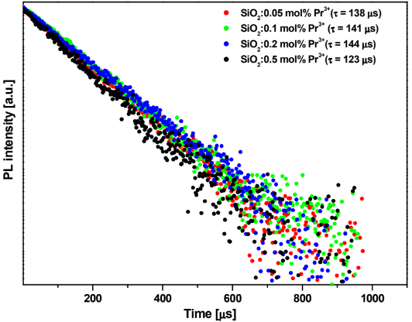
Figure 6: Luminescence decay curves of the ¹D₂→³H₄ emission for various concentrations of Pr³⁺ (0.2 mole%) in SiO₂.
Figure 7. shows the luminescence decay profiles from the ¹D₂ state, recorded at temperatures between 8 and 300K, when the ¹D₂ was directly excited using a pulsed laser. As the ¹D₂ lifespan decreased from 179μs at 8K to 148s at 300K, the luminescence decay curves conformed to a single exponential, as shown in the figure. It has been previously noted that the ¹D₂ lifespan depends on temperature. Transitions from the ground state of acceptor ions that originate in thermally populated crystal field components are expected to follow a temperature dependent process once the resonance condition is met. Lattice phonons will have to help with the energy mismatch if this is not the case, and temperature controls the cross relaxation rate. As the temperature rises from 8 K to 300 K, the ¹D₂ lifetime drops. This drop is not due to non-radiative decay via multi-phonon relaxation, but to the non-resonant cross relaxation process. This is because, in most host matrices, the rate of multi-phonon decay at the ¹D₂ level is much lower than the rate of radiative decay, because of the large energy gap between ¹D₂ and ¹G₄. It is thought that the self-quenching process's cross relaxation mechanism moves through the intermediate ¹G₄ and ³F₄ levels.
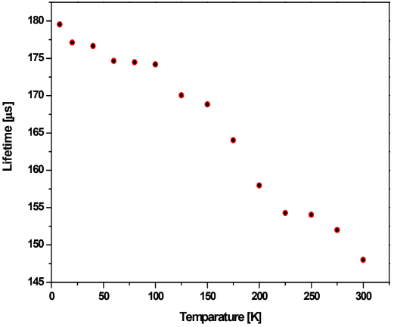
Figure 7: Lifetimes Pr³⁺ doped in SiO₂ plotted against the temperature .
Energy Transfer from Zno Nanoparticles to Pr³⁺ Ions in Sio₂.
Figure 8 shown the PL emission spectra for ZnO and SiO₂:0.2 mole% Pr³⁺. SiO₂:0.2 mole% Pr³⁺ phosphors were excited by synchrotron radiation at 90 nm. SiO₂:Pr³⁺ and ZnO showed identical characteristic emissions from the Pr³⁺ ion, with main red emission peaks at 605 nm when stimulated with VUV light on the 4f, 5d state of Pr³⁺ phosphors containing SiO₂ and Pr³⁺ particles. Even though the amount of Pr³⁺ in ZnO.SiO₂:Pr³⁺ was less, the green light emission from ZnO nanoparticles decreased, while the Pr³⁺ emission intensity was approximately twice that of SiO₂:Pr³⁺. The dampening of green ZnO emission due to increased Pr³⁺ emission demonstrates the sensitivity of Pr³⁺ emission centers by ZnO nanoparticles.
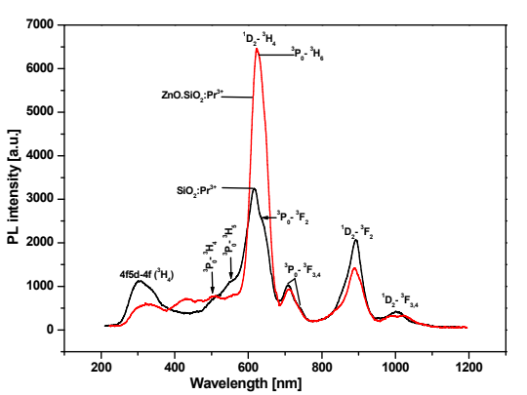
Figure 8: PL emission spectra of SiO₂:Pr³⁺ and ZnO.SiO₂:Pr³⁺ after VUV excitation at synchrotron radiation.
Figure 9. shows the PL excitation spectra of ZnO.SiO₂:Pr^{3+,} which, when compared to pure SiO₂:Pr^{3+,} exhibit significantly stronger bands. This supports the idea that ZnO has an energy-transfer impact on the 4f electron excitation in Pr³⁺ ions.
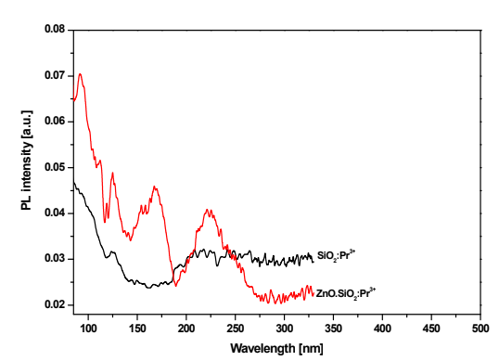
Figure 9 : PL excitation spectra of SiO₂:Pr³⁺ with and without ZnO nanophosphors monitoring the emission peak at 605 nm.
Figures 10. (a) and (b) show the luminescence decay curves of ZnO, SiO₂:0.2 mol% Pr³⁺ and ZnO emissions measured at room temperature. The rapid decay of the Pr³⁺ ¹D₂→³H₄ emission from SiO₂:Pr³⁺, with a lifespan of 144 µs, is evident from figure 10 (a). This is nearly twice as short as the lifetime of ZnO.SiO₂:Pr^{3+,} which was 236 µs. Figure 10 (b) shows that the lifetime of pure ZnO nanoparticles was found to be 2 µs, which is significantly shorter than the lifetimes of SiO₂:Pr³⁺ with and without ZnO, and the decay curve for these particles likewise followed a first-order exponential profile.
These findings are consistent with what the researchers found. In theory, the radiative recombination rate of SiO₂:Pr³⁺ should remain constant both before and after the addition of ZnO. Assuming no change to the non-radiative decay time, a shorter decay time would be expected, suggesting the presence of energy transfer via other non-radiative paths. Defects formed at the surface or borders of ZnO nanocrystals can facilitate energy transmission in the system and explain the longer lifetime seen from ZnO.SiO₂:Pr³⁺ in the present studies. The existence of electron-or hole-trapped surface levels in pure ZnO nanocrystals is undeniable, as the bandgap widens with decreasing particle sizes (365 nm). Additionally, ZnO contains oxygen vacancies and other inherent flaws. Some of the sites created by these flaws can act as non-radiative recombination centers, capturing free electrons in the process. Incorporating ZnO into SiO₂:Pr^{3+,} on the other hand, drastically reduces the non-radiative decay rate due to the strong interaction between the Pr³⁺ ion near the border between the two materials and the photo-generated trapped electron or hole at the surface. Therefore, extra nonradioactive decay routes were not a factor in the longer lifespan found for SiO₂:Pr³⁺ with ZnO.
Figure 11. illustrates an energy level diagram of Pr³⁺ and ZnO, detailing the emission processes and transitions involved in the energy transfer from ZnO to Pr³⁺. The visible ultraviolet light exposure of the ZnO.SiO₂:Pr³⁺ nanocomposite phosphor leads to the ZnO absorbing the excitation energy, subsequen3tly transferring the electrons from the valence band to the conduction band. This leads to the formation of an exciton, followed by the non-radiative transition to the defect states. The energy transfer from ZnO to Pr³⁺ was quicker than complete entrapment and recombination of electrons in the valence band, evidenced by the quenching of ZnO emission, resulting in an increased red emission from Pr³⁺. Thus, part of the recombination energy was transferred to Pr³⁺ ions, elevating their electrons from the ground state (⁴f₂) to the excited state (³P₂), which decayed non-radiatively to P₀ and ¹D₂, respectively, subsequently relaxing radiatively to ³H₆ and ³H₄, emitting red lines at 605 and 614 nm, respectively. Due to the absence of spectral overlap between the emission of the ZnO donor and the excitation of the Pr³⁺ acceptor, which could have facilitated energy transfer from ZnO to Pr³⁺, phonon mediated processes are suggested as the probable mechanism for this transfer. The researchers also proposed a similar method for Eu³⁺ doped SiO₂ that includes embedded ZnO nanoparticles.
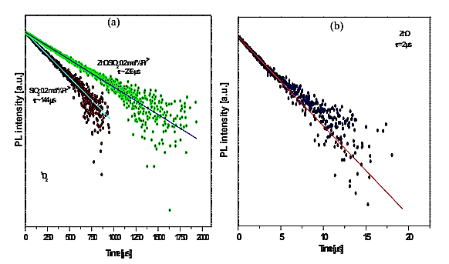
Figure 10 : Luminescence decay curves of (a) SiO₂:Pr³⁺ , ZnO.SiO²:Pr³⁺ nanophosphors and (b) ZnO nanocrystals.
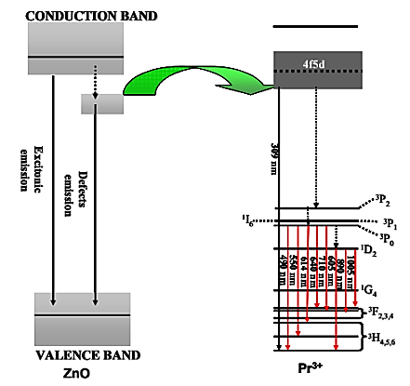
Figure 11 : Schematic energy level diagram showing the transition localized within Pr³⁺ ions and ZnO nanoparticles.
Both the SiO₂:Pr³⁺ with and without embedded ZnO nanoparticles emitted red light, which might be attributed to the ³P₀ and ¹D₂ Pr³⁺ emission levels. According to luminescence decay statistics, the ¹D₂ level has a longer lifetime than the ³P₀ level. Studying the Pr³⁺ luminescence in SiO₂ with respect to Pr³⁺ concentration showed that ¹D₂ lifespan decreases as Pr³⁺ concentration increases, i.e., beyond 0.2 mol%. It was believed that the primary consequence the ¹D₂ level was the concentration quenching effect caused by the transit of excitation energy Pr³⁺ ions. As the ¹D₂ level's lifetime gradually dropped from 8 to 300 K, it was also determined that temperature plays a role. Incorporating ZnO nanoparticles into Pr³⁺ doped SiO₂ increased its red emission, suggesting that ZnO functions as a potent sensitizer for Pr³⁺ emission. The decrease in green emission from ZnO and the subsequent increase in luminescence from Pr³⁺ were thought to be caused by energy being transferred from ZnO to Pr³⁺.
Conclusion;
The co-doping of Ce³⁺ into SiO₂:Pr³⁺ was examined to evaluate its effects on CL intensity under different beam voltages and current densities. Ce³⁺ ions, being efficient sensitizers, were found to significantly influence the energy transfer dynamics within the SiO₂ host. The presence of Ce³⁺ enhanced the CL intensity of Pr³⁺ 5d–4f transitions of Ce³⁺ to the 4f level of Pr³⁺. However, this enhancement was strongly dependent on Ce³⁺ concentration, as excessive Ce³⁺ led to competitive absorption and non-radiative energy losses, thereby diminishing overall luminescence. Furthermore, the dependence of CL intensity on beam voltage and current revealed the critical role of excitation density in activating defect states and facilitating energy transfer. At moderate beam voltages, enhanced CL emission was observed, while excessively high beam currents induced local heating, defect generation, and luminescence degradation. Thus, an optimum balance of Ce³⁺ concentration and excitation conditions was established as a prerequisite for maximizing CL efficiency in SiO₂:Pr³⁺– Ce³⁺ systems.

Disclaimer (Artificial intelligence)
Author(s) hereby declare that NO generative AI technologies such as Large Language Models (ChatGPT, COPILOT, etc.) and text-to-image generators have been used during the writing or editing of this manuscript.

Reference;
- Nadiia Rebrova. Synthesis and Upconversion Luminescence of LiY₉(SiO₄)6O₂ Phosphor Doped with Pr^{3+.}The Journal of Physical Chemistry C 2024, 128 (22),9090 -9098. https://doi.org/10.1021/acs.jpcc.3c08163
- Srivastava, A. M. The Interconfigurational (4f¹5d¹→4f²) Luminescence of Pr³⁺ in LuPO₄, K₃Lu(PO₄)₂ and LiLuSiO₄. Opt. Mater. 2012, 34, 1347– 1352, DOI:10.1016/j.
optmat.2012.02.016
- Srivastava, A. M. Aspects of Pr³⁺ Luminescence in Solids. J.Lumin .2016, 169, 445- 449, DOI: 10.1016/j.jlumin.2015.07.001
- WU, J.; Zheng, H. UVC Up conversion Material Under Sunlight Excitation: LiYF₄: Pr³⁺. Opt. Lett. 2016, 41 (4), 792– 795, DOI: 10.1364/OL.41.000792
- Espinoza, S.; Müller, M. Characterization of Micro- and Nanoscale LuPO₄:Pr³⁺, Nd³⁺with Strong UV-C Emission to Reduce X-Ray Doses in Radiation Therapy. Part. Part. Syst. Charact. 2019, 36 (10), 1900280 DOI:10.1002/ppsc. 201900280
- Cates, E. L. Visible-to-UVC Up conversion Efficiency and Mechanisms of Lu₇O₆F₉:Pr³⁺ and Y₂SiO₅:Pr³⁺ Ceramics. J. Lumin. 2015, 160, 202– 209, DOI: 10.1016/j.jlumin.2014.11.049
- LV, P.; Li, L.; Wang, C.; Wu, Z.; Qiu, J.; Yang, Y. 450 nm Photon-Pumped Ultraviolet-C Luminescence for Multifunctional Applications. Laser Photonics Rev. 2022, 16, 2200389 DOI: 10.1002/lpor.202200389
- Lai, F.; Xu, X.; Shen, J.; Wang, Y.; Yan, Y.; Nie, Y.; You, W.; Wu, D.; Han, L.; Xiao, Z. Structure and Upconversion Luminescence Properties of Pr³⁺-Doped Y₂SiO₅ Phosphor. Silicon. 2023, 15, 1913– 1923, DOI: 10.1007/s12633-022-02148-x
- Yin, Z. Q.; Yuan, P.; Zhu, Z.; Li, T. Y.; Yang, Y. M. Pr³⁺ Doped Li₂SrSiO₄: an Efficient Visible-Ultraviolet C Up-conversion Phosphor. Ceram. Int. 2021, 47, 4858– 4863, DOI: 10.1016/j.ceramint.2020.10.058
- Zhou, W.; Pan, F.; Zhou, L.; Hou, D.; Huang, Y.; Tao, Y.; Liang, H. Site Occupancies, Luminescence, and Thermometric Properties of LiY₉(SiO₄)₆O₂:Ce³⁺ Phosphors. Inorg. Chem. 2016, 55, 10415– 10424, DOI: 10.1021/acs.inorgchem.6b01656
- Li, J.-Y.; Hou, D.; Zhang, Y.; Li, H.; Lin, H.; Lin, Z.; Zhou, W.; Huang, R. Luminescence, Energy Transfer and Temperature Sensing Property of Ce³⁺, Dy³⁺ doped LiY₉(SiO₄)₆O₂ phosphors. J. Lumin. 2019, 213, 184– 190, DOI: 10.1016/j.jlumin.2019.05.027
- Zhang, Z.; Wang, L.-J.; Yang, S.-S.; Chen, W.-G.; Chu, X.-J.; Wang, D.-J. Luminescence Properties of a Novel Promising Red Phosphor LiY₉(SiO₄)₆O₂:Eu³⁺. Mater. Lett. 2017, 204, 101– 103, DOI: 10.1016/j.matlet.2017.05.118
- Zhang, J.; Jin, C. Structure, Morphology and Upconversion Luminescence of Rare Earth Ions Doped LiY₉(SiO₄)₆O₂ for Temperature Sensing. Ind. Eng. Chem. Res. 2019, 58, 3490– 3498, DOI: 10.1021/acs.iecr.8b05543
- Redhammer, G. R.; Roth, G. Lithium and Sodium Yttrium Orthosilicate Oxyapatite, LiY₉(SiO₄)₆O₂ and NaY₉(SiO₄)₆O₂, at both 100 K and Near Room Temperature. Acta Crystallogr. C Struct. Chem. 2003, 59, 120– 124, DOI: 10.1107/S0108270103023321
- Shannon, R. D. Revised Effective Ionic Radii and Systematic Studies of Interatomic Distances in Halides and Chalcogenides. Acta Crystallogr. 1976, A32, 751– 767, DOI: 10.1107/S0567739476001551
- Malyukin, Yu.V.; Masalov, A. A.; Zhmurin, P. N.; Znamenskii, N. V.; Petrenko, E. A.; Yukina, T. G. Two Mechanisms of ¹D₂ Fluorescence Quenching of Pr³⁺-Doped Y₂SiO₅ Crystal. Phys. Stat. Sol. (b). 2003, 240 (3), 655– 662, DOI: 10.1002/pssb.20030190
- Li, K.; Lian, H.; Shang, M.; Lin, J. A Novel Greenish Yellow-Orange Red Ba₃Y₄O₉:Bi³⁺, Eu³⁺ Phosphor with Efficient Energy Transfer for UV-LEDs. Dalton Trans. 2015, 44, 20542– 20550, DOI: 10.1039/C5DT03565A
- Rebrova, N.; Zdeb, P.; Lemański, K.; Macalik, B.; Bezkrovnyi, O.; Dereń, P. J. Upconversion Luminescence Properties of Pr³⁺ Doped BaYF₅ Nanoparticles Prepared by Microwave Hydrothermal Method. Inorg. Chem. 2024, 63 (6), 3028– 3036, DOI: 10.1021/acs.inorgchem.3c03821
- Dereń, P. Spectroscopic Characterization of LaALO₃ Crystal Doped with Pr³⁺ Ions. J. Lumin. 2007, 122–123, 40– 43, DOI: 10.1016/j.jlumin.2006.01.081
- Yina, M.; Krupa, J. C.; Antic-Fidancev, E.; Makhov, V. N.; Khaidukov, N. M. Excitation Spectroscopy of K₂YF₅:Pr³⁺ Crystals. J. Lumin. 2003, 101, 79– 85, DOI: 10.1016/S0022-2313(02)00391-5
- Sun, Y.; Wang, Y.; Hu, C.; Zhou, X.; Hao, J.; Li, W.; Li, H. Energy Transfer from Pr³⁺ to Gd³⁺ and Upconversion Photoluminescence Properties of Y₇O₆F₉:Pr³⁺, Gd³⁺. Mater. 2022, 15, 7680, DOI: 10.3390/ma15217680
- Hu, C.; et al. Visible-to-Ultraviolet Upconversion in Pr³⁺:Y₂SiO₅ Crystals. Chem. Phys. 2006, 325 (2–3), 563– 566, DOI: 10.1016/j.chemphys.2006.01.037

