The Influence of Chemical Redox Waste and Industrial Waste on River and Groundwater Quality in Bathinda, Punjab, India

Abstract
The Malwa region of Punjab, India, is an important agricultural and industrial centre, but it is also experiencing growing environmental problems because of industrialisation and the improper disposal of waste. This research aims to investigate the impact of chemical redox waste and industrial waste on the rivers and surrounding areas of the Malwa region. Redox processes of a chemical nature involving the transfer of electrons are commonly leading to contamination of water bodies through changing their chemical constitution and causing degradation of the quality of water. Furthermore, disposal of waste from industries consisting of heavy metals, toxic chemicals, and non-treated effluent contributes to aggravating water pollution affecting local rivers like the Sutlej, Beas, and Ravi. These rivers, crucial for irrigation, potable water supply, and local ecosystems, have been subjected to heavy levels of pollution, causing harmful effects on aquatic life and human health. The study employed a random stratified sampling approach to collect water samples from surface water locations, industrial effluent discharge points, and groundwater sources in Bathinda, Punjab, India. Samples were collected during the monsoon and winter seasons in pre-conditioned HDPE containers and preserved according to standard protocols. Physicochemical and heavy metal analyses were conducted using standard methods to assess water quality and identify major pollutants. The research analyses water and soil samples from different points throughout the region to determine the magnitude of pollution, the major pollutants, and their effects on the environment. The study shows that effluents from industries, agricultural run-offs, and untreated sewage play a role in changing the redox potential of river water, influencing levels of dissolved oxygen, metal toxicity, and loss of aquatic biodiversity. The effect is worse in rivers along industrial regions, where redox-active pollutants of high concentration have been identified. Through a focus on the patterns of chemical and industrial waste discharge, the study is set to highlight the negative impacts on water resources and the larger ecological system. The results accentuate the importance of proper waste management practices, environmental regulations, and public awareness to counter the harmful impacts of industrial pollution and protect the water quality and ecological well-being of the Malwa region for the coming generations.
Keywords: Waste Water, Chemical Waste, Rivers, Groundwater Quality

1. INTRODUCTION

Water is a fundamental ingredient that is both plentiful and valuable. Water contamination is caused when groundwater runs persistently to pick up and transport salts, organic pollutants, sewage, and industrial effluents. Different kinds of industrial activities and disposal procedures produce effluents that may include pollutants at concentrations that are harmful to aquatic life and the quality of receiving waterways (Chaturwedi et al., 2024; Jahan & Singh, 2023). Chemical redox waste and industrial waste are major sources of river pollution in India. This problem arises mainly from unregulated industrial growth, poor infrastructure, and a lack of adherence to environmental laws. Industries such as textiles, tanneries, electroplating units, chemical plants, paper mills, and pharmaceuticals release wastewater filled with dangerous chemicals, synthetic dyes, solvents, and heavy metals into rivers. Chemical redox waste specifically affects oxidation-reduction reactions in water, creating harmful by-products and making water chemically unstable (Savchyna et al., 2024). Rivers like the Sutlej and the northern Indian stretch of the Ghaggar are significant recipients of this waste. This has led to a severe decline in water quality. The ongoing release of untreated waste boosts biochemical oxygen demand (BOD) and chemical oxygen demand (COD), which lowers dissolved oxygen levels and makes river water unfriendly to aquatic life (Sinha, 2024).
The contamination of surface water arises from various sources, classified into point and non-point sources. Point sources are specific, identifiable origins of pollution that release pollutants directly into water bodies through pipes or channels, allowing for easier identification and management, e.g., industrial discharges, sewage treatment plants, and landfills. However, non-point sources originate from widespread activities across expansive areas and present challenges due to their diffuse nature and multiple pathways of contamination, e.g., agricultural runoff, urban storm water runoff, and atmospheric deposition (Singh et al., 2024; Ebuete et al., 2019).
The long-term effects of industrial pollution go beyond immediate toxicity. They can cause irreversible harm to river ecosystems. Heavy metals, including chromium, cadmium, lead, mercury, and arsenic, can stay in the environment for decades. They build up in sediment and get into aquatic food webs. Prolonged exposure to these pollutants negatively impacts fish growth, enzyme activity, reproductive health, and immune systems, causing genetic mutations and deformities. The decline of key species disrupts the ecological balance, leading to algal blooms, growth of invasive species, and decreased ecosystem resilience. In severe cases, rivers lose their natural ability to recover, turning into lifeless channels that can no longer support biodiversity or provide essential ecosystem services (Briffa et al., 2020).
From a human health viewpoint, industrial water pollution poses serious risks that can affect multiple generations. Communities near polluted rivers often rely on this water for their daily needs due to a lack of alternatives. Chronic exposure to contaminated water from drinking, bathing, and agriculture leads to toxin accumulation in the body. Heavy metal poisoning can result in neurological issues, liver and kidney damage, hormonal disruptions, reproductive problems, and developmental delays in children. Crops irrigated with polluted river water take up toxic substances, introducing contaminants into the human food chain and raising long-term health risks. Additionally, polluted rivers facilitate the spread of waterborne diseases, which puts even more strain on public health systems.
Regulatory and institutional issues significantly impede the effective management of industrial and chemical redox waste in India. Although there are comprehensive environmental laws, their enforcement is often weak due to limited monitoring resources, insufficient staff, outdated testing methods, and poor cooperation among regulatory bodies. Many industries avoid using effluent treatment plants to save money, and illegal dumping at night or during monsoon season is common. The lack of real-time water quality monitoring and transparent reporting adds to the challenges of controlling pollution. Addressing these issues requires stricter enforcement of current laws and policy changes that encourage cleaner production methods, zero-liquid discharge systems, and circular economy strategies. Promoting accountability in industry, strengthening pollution control boards, investing in better wastewater treatment technologies, and increasing community involvement are vital steps needed to restore river health and secure sustainable water resources for future generations.
The objective of this study is to investigate the influence of chemical redox waste and industrial waste on the water quality of rivers and groundwater in Bathinda, Punjab, India, with a focus on identifying the extent of pollution, major pollutants, and their environmental and health implications.

2. LITERATURE REVIEW

The influence of chemical redox waste and industrial effluents on rivers and groundwater in Bathinda presents significant environmental and health challenges. Rapid industrialisation has led to the introduction of heavy metals and other pollutants into local water bodies, altering redox conditions that affect the mobility and toxicity of these contaminants. Studies indicate that rivers like the Ghaggar are heavily impacted, with increased levels of pollutants disrupting aquatic ecosystems and microbial communities. Groundwater, a vital resource for local communities, is also at risk, as contaminants can leach into aquifers, posing serious health risks such as neurological disorders and increased cancer rates. Effective remediation strategies, including stricter regulations on industrial discharges and the promotion of sustainable practices, are essential to mitigate these impacts and protect water quality in the region. Continued research and monitoring are crucial for safeguarding public health and ensuring the sustainability of water resources in Bathinda.

  - Types of Chemical Redox Waste
- Industrial Redox Waste

Metal-containing waste: Comprises waste containing metals such as chromium (Cr³⁺/Cr⁶⁺), iron (Fe²⁺/Fe³⁺), and copper (Cu⁺/Cu²⁺). Chemical manufacturing waste: Wastes from acid, alkali, and oxidising/reducing agents-producing industries (e.g., sodium hypochlorite, hydrogen peroxide).
- Organic Redox Waste
Petroleum and hydrocarbon waste: Oxidised hydrocarbons, used oils, and organic solvents capable of redox reactions. Pharmaceutical waste: Certain drug production processes produce waste containing active redox compounds.
- Biological and Agricultural Redox Waste

Fermentation waste: Redox-active metabolites such as alcohol and organic acids are present. Manure and compost: Decomposition of organic matter comprises microbial redox reactions. Pesticide waste: Certain pesticides have redox-active constituents, e.g., organophosphates.
- Electronic and Battery Waste
Battery waste: Lithium-ion, lead-acid, and nickel-cadmium batteries comprise redox reactions in energy storage. E-waste (electronic waste): Circuit boards, capacitors, and other units may consist of redox-active metals.

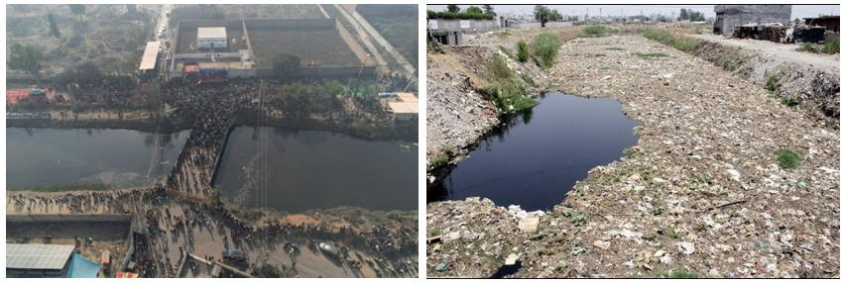
Figure 1: Waste in the Sutlej River and Protest Against Pollution
Source: Reference for waste in the Sutlej

4.1 Sensitive Elements in River Samples

These are the Safety Level Parameters as shown in Table 1 (https://moef.gov.in/).

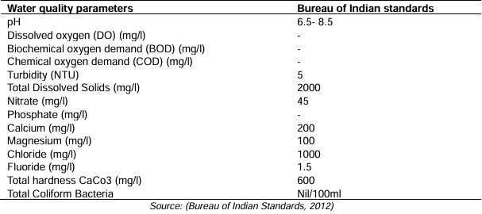
Table 1 Sensitive Elements in River Samples.
level heading.]

2. Methodology
2.1 Study Area Description
This study took place in the Bathinda district of the Malwa region, Punjab, India. This area has seen rapid industrial growth and intensified farming practices in recent decades. The district is an important environmental hotspot. It has fertiliser plants, thermal power stations, cement factories, textile dyeing units, milk processing industries, paint stores, and chemical-based industries, all in close proximity. These industrial facilities produce large amounts of wastewater filled with redox-active compounds, nutrients, suspended solids, and heavy metals. The lack of proper effluent treatment and poor waste disposal has contaminated nearby rivers, canals, drains, and reservoirs. Groundwater, which is the main source of drinking and irrigation water for local residents, is especially at risk of contamination from seepage, leaching, and underground transport of pollutants.
2.2 Sampling Strategy and Site Selection
Sampling sites were chosen to represent a wide range of environmental conditions. The sites fell into three categories:
- Surface water locations, including rivers and canals, both upstream and downstream
- Industrial effluent discharge points, where wastewater directly enters natural water bodies
- Groundwater sources, like hand pumps, bore wells, and tube wells, are near industrial and agricultural areas
A random stratified sampling approach was used to minimise spatial bias and capture differences in pollutant distribution. Sampling occurred during the monsoon and winter seasons to reflect seasonal impacts on hydrology, pollutant dilution, redox conditions, and microbial activity. Analysing seasonal variations showed how runoff increases contamination during the monsoon and how pollution concentrations change during low-flow winter periods.
2.3 Sample Collection, Handling, and Preservation
Water samples were collected in 2 L high-density polyethene (HDPE) containers. These containers were chosen for their chemical stability and suitability for analysing trace levels. All containers were acid-washed, rinsed with distilled water, and pre-conditioned with sample water before use. Samples for heavy metal analysis were preserved right away by adding concentrated nitric acid to keep the pH < 2. This step prevents metal precipitation, adsorption, and biological changes. Samples were stored at 4°C and transported to the lab under controlled conditions. Strict chain-of-custody and labelling protocols were in place to maintain sample integrity.
2.4 Physicochemical Parameter Analysis
In-situ measurements of temperature, pH, and electrical conductivity (EC) were taken with calibrated portable meters to reduce analytical errors. Laboratory tests were done for:
- Turbidity (nephelometric method)
- Total Dissolved Solids (TDS)
- Total Suspended Solids (TSS)
- Total Solids (TS)
These parameters give important insights into ionic concentration, particulate matter, and the physical state of water. All analytical processes followed standards set by the American Public Health Association (APHA) and Bureau of Indian Standards (BIS: IS 10500, 1991; 1998).
2.5 Redox Conditions and Oxygen Demand Assessment
Redox conditions were assessed by measuring dissolved oxygen (DO) using the Winkler iodometric method. Biochemical Oxygen Demand (BOD) and Chemical Oxygen Demand (COD) were measured to evaluate biodegradable and total oxidizable organic matter. High BOD and COD values show excessive organic and inorganic loading, which leads to reduced oxygen levels, changes in redox potential, and stress on aquatic organisms. These parameters are essential for understanding the impact of industrial waste on aquatic environments.
2.6 Nutrient, Ionic, and Geochemical Characterisation
Nutrients like nitrate, nitrite, sulfate, chloride, and phosphate were analysed using standard spectrophotometric and titrimetric methods. High concentrations of these nutrients indicate potential eutrophication and increased microbial redox activity. Major cations and anions, including Ca²⁺, Mg²⁺, Na⁺, K⁺, total hardness, and alkalinity, were analysed to understand salinity, buffering capacity, and mineral dissolution processes. These factors affect metal movement, solubility, and redox changes in aquatic environments.
2.7 Heavy Metal Quantification and Pollution Indices
Heavy metals (Pb, Cd, Cr, Ni, As, Hg, Cu, and Zn) were quantified using Atomic Absorption Spectroscopy (AAS) after acid digestion. To assess contamination levels, the following indices were used:
- Contamination Factor (CF)
- Heavy Metal Pollution Index (HPI)
- Metal Index (MI)
These indices offer a numerical assessment of pollution levels and help identify areas at high risk. The measured concentrations were compared with the WHO and BIS permissible limits to evaluate potential health risks.
2.8 Industrial Wastewater Characterisation
Wastewater samples from National Fertiliser Limited (NFL), Milk Plant (MP), Paint Store (PS), Ambuja Cement Factory (ACF), Guru Nanak Dev Thermal Power Plant (GNDTPP), and Textile Dye Shops (TDS) were analysed to determine their pollution load. The analysis covered physical properties (such as colour, odour, and temperature), chemical characteristics (including pH, turbidity, EC, TDS, TSS, and TS), oxygen demand parameters (BOD, COD), and heavy metal concentrations. This helped to identify industrial sources that contribute significantly to redox imbalance and water contamination.
2.9 Quality Assurance and Quality Control (QA/QC)
All measurements were taken in triplicate, and results were reported as mean ± standard deviation. Instruments were calibrated daily with standard solutions. Reagent blanks, duplicate samples, and standard reference materials were analysed to ensure accuracy and precision. QA/QC protocols were strictly followed throughout the study.
2.10 Statistical and Correlation Analysis

Statistical analysis involved descriptive statistics and correlation analysis to find relationships between physicochemical parameters, redox indicators, and heavy metal levels. Correlation matrices helped identify possible pollution sources and connections between redox processes and metal mobility.
2.11 Spatial Interpretation and Mapping
The spatial distribution of selected parameters was analysed to find contamination hotspots. Sampling locations were plotted to illustrate the spatial differences in water quality and pollution levels across the Bathinda region. This information supports environmental planning and management.
2.12 Water Quality Classification and Health Risk Assessment
Water samples were classified using Davis–DeWeist (TDS) and Durfor–Becker (Total Hardness) classification systems to determine their suitability for drinking and irrigation. The health risk assessment focused on long-term exposure to heavy metals through drinking water and food. Potential health risks like cancer, neurological disorders, and gastrointestinal issues were evaluated based on established toxicological standards.
2.13 Methodological Limitations
The study faced limitations due to time constraints and the availability of advanced analytical tools. Long-term monitoring and the inclusion of biological indicators would give a fuller understanding of ecosystem impacts. Nonetheless, the methods used provide a solid framework for assessing industrial water pollution driven by redox processes.
3. results and discussion

The study aimed to assess the influence of chemical redox waste and industrial waste on the quality of water in various rivers and groundwater samples from the Bathinda region. Samples were collected from several locations, including river bodies and groundwater sources, during the monsoon and winter seasons. The analysis of these samples was done to determine the concentration of various pollutants, particularly focusing on redox-active compounds, industrial waste components, and overall water quality.

3.1 Physicochemical Parameters:
pH Levels: The pH of river and groundwater samples from Bathinda varied between 6.5 and 8.3, indicating that the water was slightly acidic to neutral. A higher pH was observed near industrial areas, suggesting the possible influence of chemical effluents.
Dissolved Oxygen (DO): In most river samples, DO levels were found to be lower (2–4 mg/L), especially near industrial discharge points, which signifies oxygen depletion due to the presence of organic and inorganic pollutants. Groundwater samples showed slightly higher DO levels (4–6 mg/L), indicating less contamination.
Electrical Conductivity (EC): The EC of river water ranged from 400 to 1,200 µS/cm, indicating the presence of high ionic content, primarily from industrial discharge. Groundwater samples showed a relatively lower conductivity (250–800 µS/cm), indicating fewer pollutants.
3.2 Redox-Active Compounds:
Nitrate and Nitrite Concentration: In the river samples, the concentration of nitrate was found to range from 25 to 50 mg/L, which is above the permissible limit of 45 mg/L as per the WHO standards, particularly near areas with industrial waste. Groundwater nitrate levels were relatively lower (10–20 mg/L) but still raised concerns over potential contamination.
Heavy Metals: The concentration of heavy metals like lead (Pb), cadmium (Cd), and chromium (Cr) was elevated in several river samples. Lead levels ranged from 0.5 to 1.5 mg/L, and cadmium was found in concentrations as high as 0.3 mg/L, especially near industrial zones. Groundwater samples showed trace amounts of these metals, but not exceeding safe limits.
Table 2 Wastewater characteristics from industrial sites (NFL, MP, PS, ACF, GNDTPP, TDS).
Parameter | NFL,  Bathinda | MP, Bathinda | PS, Bathinda | ACF, Bathinda | GNDTPP  Bathinda | TDS, Bathinda
Color | Blackish | Light to  medium grey | - | Blackish | Grey | Black
pH | 8.68±0.46 | 9.8±0.12 | 9.1±0.48 | 6.60±0.52 | 7.27±0.25 | 5.8±0.72
TempºC | 28.8±1.24 | 26.5±1.50 | 28.1±1.10 | 27.8±1.76 | 32.3±1.53 | 27.3±1.26
Turbidity  (NTU) | 80.9±2.0 | 50.33±1.53 | 158±1.10 | 88±1.0 | 67.3±2.2 | 105±3.0
EC (µS/cm) | 3260±1.0 | 1552±2.5 | 4805±1.0 | 4302±1.15 | 3226±2.65 | 3173±3.21
TDS mg/l | 1998.97±2.0 | 1027.17±2.29 | 2904±4.58 | 3150.33±4.51 | 2779±3.0 | 3353.67±3.21
TSS mg/l | 131.93±2 | 180±2.00 | 240.33±2.02 | 150.10±1.93 | 120.30±2.14 | 497±2.68
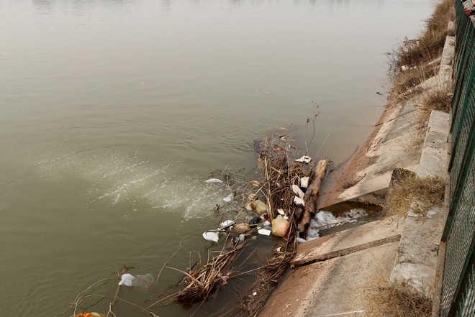

Figure 2 Wastages near Dams.

- Waste Water Being Released in Rivers

Wastewater had colour, an unpleasant smell and the highest turbidity. Physical parameters analysed were pH, temperature, turbidity, conductivity, Total Dissolved Solids (TDS), Total Suspended Solids (TSS) and Total Solids (TS). Chemical characteristics analysed were odour, BOD, COD, chlorides, calcium, and heavy metals such as arsenic, cadmium, chromium, nickel and lead, etc. The results were compared with the desirable limit of BIS (1998) standards, IS:10500, 1991 [11].

All the wastewater samples were colored from light grey to grey and blackish. It was observed that all the samples have an unpleasant smell. pH is a measure of the acidity or alkalinity of water, and most of the chemical reactions in the aquatic environment are controlled by any change in pH value. pH is the most important factor in deciding the quality of wastewater or effluent. Either a highly acidic or alkaline pH would kill marine life. Heavy metal toxicity also gets enhanced at a particular pH. The desirable range of pH for water is 6.5-8.5 [11]. The minimum pH observed was 5.8±0.72 from Textile Dyes Shop (TDS, Bathinda), and the maximum pH value of 9.8±0.12 was observed in Milk Plant (MP, Bathinda). Both the values are below and above the desirable/permissible limits. Temperature is one of the most important ecological features that control the behavioural characteristics of organisms, the solubility of gases and salts in water. An increase in temperature causes an increase in the rate of microbial activity. The major sources of thermal pollution in industries are cooling systems in manufacturing or power plants. In the present investigation, the average temperature of wastewater varies between a minimum of 26.5±1.50 °C from Milk Plant Bathinda and a maximum of 32.3±1.53 °C for the effluents from GNDTPP, Bathinda. Turbidity is the measure of suspended matter in water. Suspended matter often includes mud, clay and silt. The excessive turbidity in water causes problems with the water purification process. All the samples were highly turbid, i.e. above the desirable limit of 5-10 NTU by IS (1991). National Fertiliser Limited (NFL, Bathinda) has a turbidity value of 80.9±2.0 NTU, Milk Plant (MP, Bathinda) 50.33±1.53 NTU, Paint Store (PS, Bathinda) 158±1.10 NTU, Ambuja Cement Factory (ACF, Bathinda) 88±1.0 NTU, Guru Nanak Dev.

- Environmental Impacts

Degradation of Water Quality: Wastewater has pollutants that can lower the oxygen content of rivers, causing hypoxia. Low oxygen would kill aquatic life like fish that need oxygen-rich water to live. This can result in "dead zones" within rivers and estuaries where aquatic life cannot survive. Eutrophication and Algal Blooms: Nitrogen and phosphorus nutrients, usually in the form of agricultural runoff or unprocessed sewage, drive the growth of algae in bodies of water. When these algae die and rot, a lot of oxygen is used up, which further reduces the oxygen content in the river. This could also result in the release of toxins that are toxic to both wildlife and humans.

Toxicity and Bioaccumulation: Industrial effluent may carry heavy metals (such as mercury, lead, and cadmium), chemicals, and other toxic substances that could be dangerous to aquatic life and human beings who rely on the river for use as a drinking water supply or for fishing. Some of these contaminants may bioaccumulate through the food chain, with toxins becoming more concentrated in fish and other organisms eaten by humans or wildlife.

Loss of Biodiversity: Contamination of wastewater typically results in changes to river biodiversity. Sensitive species will be eliminated, but more tolerant bacterial, algae, or plant species can develop in contaminated waters. This alteration in species mix can result in lower ecosystem resilience and loss of essential ecological function.

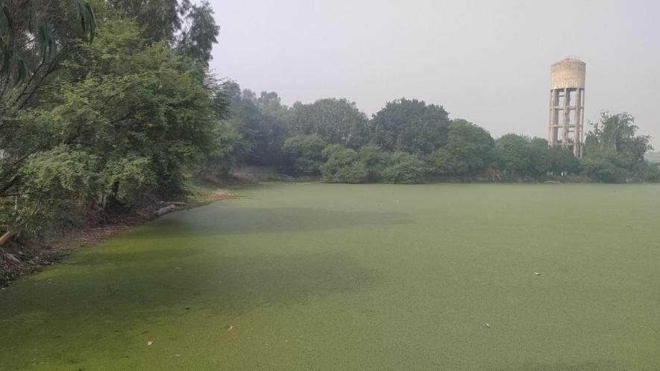
Figure 3: Untreated waste and wastewater in pond in Teona village of Bathinda block in Bathinda district
Source: Reference to untreated waste and wastewater.

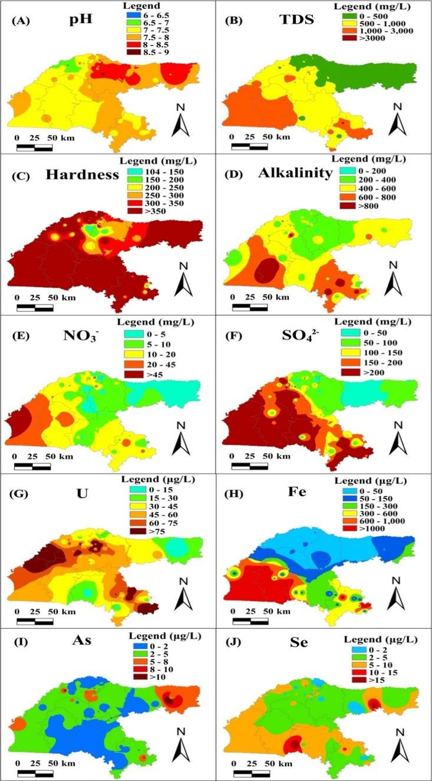
Figure 4: Spatial Interpretation and Mapping showing the contamination hotspots
Source: ISROSET (april 2016) international journal of scientific research in chemical sciences (3) issue 2.

The EC and TDS value ranges from 296.88 μS/cm to 5265.63 μS/cm and 190 mg/L to 3370 mg/L with an average of 1081.74 ± 85.17 μS/cm and 692 ± 54.51 mg/L, respectively. High electrical conductivity and TDS values are due to salt dissolution and chemical weathering. According to Davis–DeWeist classification of TDS, 45% of groundwater samples are desirable for drinking (TDS <500 mg/L), 32% of groundwater samples are at a permissible stage of drinking (500–1000 mg/L), 22% of groundwater samples are useful for irrigation only (1000–3000 mg/L), and 1% groundwater samples are unfit for both (>3000 mg/L). (31) The southwest region of Punjab also faces waterlogging and salinisation problems.

Total hardness ranges from 88 mg/L to 2536 mg/L with an average of 429 ± 36 mg/L. According to Durfor–Becker classification of TH, no water samples come in the soft water class (0–60 mg/L), 11% of samples come in the moderately hard water class (60–120 mg/L), 5% come in the hard water class (120–180 mg/L), and 84% groundwater samples come into the very hard water class (>180 mg/L) as depicted in Figure 2. (32) Alkalinity ranges from 102.96 to 1383.20 mg/L with an average of 448.90 ± 27.84 mg/L. 84% of groundwater samples exceed the BIS permissible limit of alkalinity.

These groundwater samples have high alkalinity values, as shown in Figure 2. Anions in groundwater samples with their mean concentration range in the order of HCO3– > SO42– > Cl– > NO3– > Br– > F– with an average value of 448.90 ± 27.84 mg/L, 152.58 ± 17.44 mg/L, 64.53 ± 13.44 mg/L, 13.23 ± 1.73 mg/L, 1.51 ± 0.30 mg/L, and 0.07 ± 0.03 mg/L, respectively. Sulfate excess in groundwater samples can be due to the breakdown of organic substances from weathered soil, human activities, fertilisers, and pesticides. The phosphate values are below the detection limit of the instrument. HCO3– usually derived from rock weathering. (33,34) Fluoride concentrations are minimal, as well.

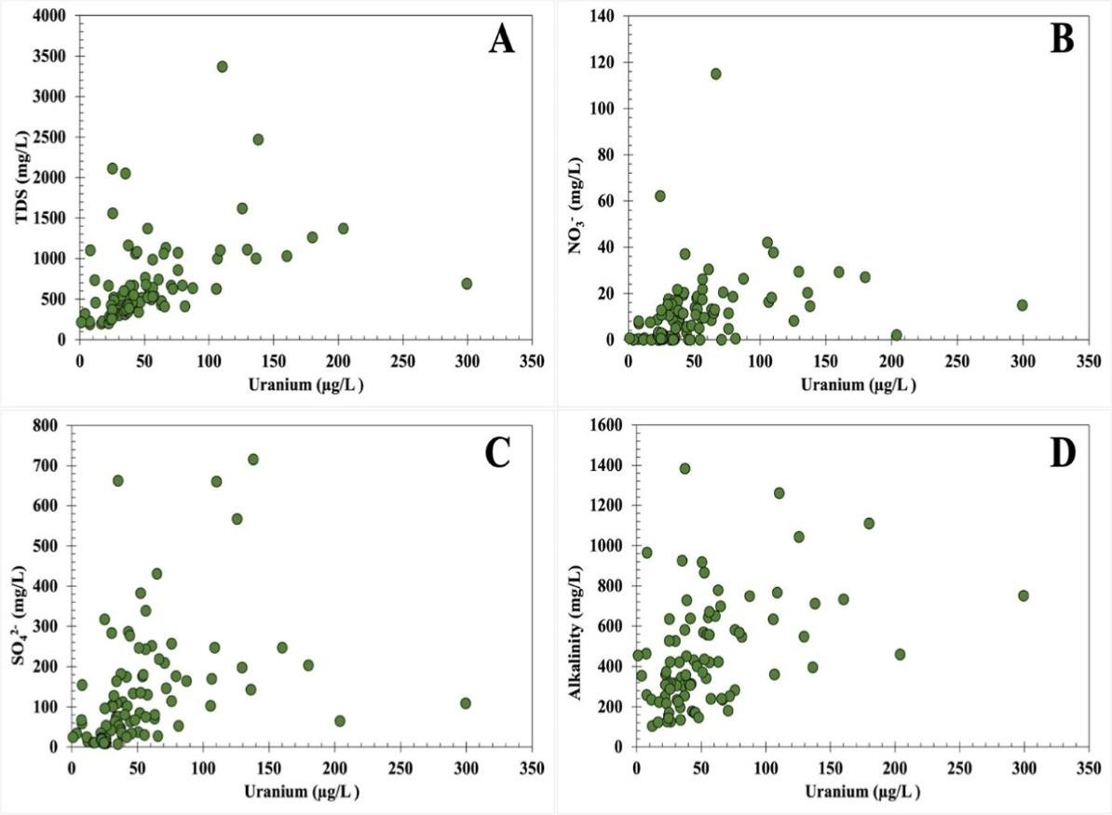
Among cations, mean concentration follows the order Na+ > Mg2+ > Ca2+ > K+ > Ba2+ > Li+ with average values of 154.42 ± 14.42 mg/L, 77.89 ± 6.51 mg/L, 43.35 ± 5.50 mg/L, 6.29 ± 0.59 mg/L, 0.75 ± 0.16 mg/L, and 0.21 ± 0.00 mg/L, respectively. Na concentration is much higher than K concentration. The concentrations of Ca2+ and Mg2+ are also relatively high, resulting in high water hardness values. Arenicolids is a chronic sickness caused by drinking water with high arsenic levels for an extended period of time. Recent research reveals that relatively little cadmium exposure might cause skeletal damage, including low bone mineral density (osteoporosis) and fractures. High levels of mercury can have negative consequences such as nerve, brain and kidney damage, lung.
Figure 5: Scatter plot showing the correlation between physicochemical parameters, redox indicators, and heavy metal levels.
Source: ISROSET (april 2016) international journal of scientific research in chemical sciences (3) issue 2.

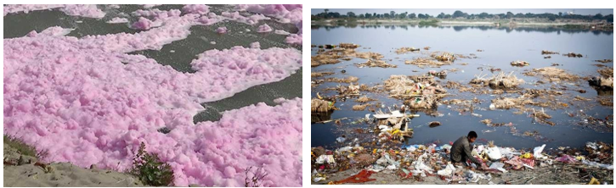
Figure 6: Health risks associated with heavy metal contamination in local communities.
4. Conclusion

The research on the effect of chemical redox waste in different Indian rivers suggests important environmental and ecological impacts. The study shows that effluents from industries, agricultural run-offs, and untreated sewage play a role in changing the redox potential of river water, influencing levels of dissolved oxygen, metal toxicity, and loss of aquatic biodiversity. The effect is worse in rivers along industrial regions, where redox-active pollutants of high concentration have been identified. These results highlight the imperative to establish stricter industrial waste disposal regulations, enhanced wastewater treatment facilities, and frequent monitoring of redox-sensitive contaminants in river ecosystems. Resolving this problem demands a collaborative response from government offices, industries, and communities to address sustainable water management and ecological preservation.
Subsequent research must include creating cost-efficient remediation processes, determining the long-term effects of ecology, and evaluating the effectiveness of the current environmental regulations. By following preventive measures, India can curtail the ill effects of chemical redox waste and preserve its precious freshwater sources for generations to come. The results of physicochemical properties show that the wastewater is highly contaminated, containing inorganic, organic materials and heavy metals in high concentration. All the samples have an unpleasant smell and are light grey to grey and black in colour. All the samples have pH values below and above the permissible limit. Values of turbidity, EC, TDS, TSS, TS, BOD, COD, Ca, and chloride are very high. Wastewater contains a high concentration of heavy metals, also above the permissible limit. In most cases, effluents are not treated and are simply thrown into natural water bodies, where they cause eutrophication by adding phosphorus and nitrogen compounds to natural water bodies, which contaminate the surface water, groundwater and the soils of the fields. Due to this contamination, people of Bathinda (Malwa region, Punjab) are highly prone for immediate health diseases e.g. cancer, fluorosis and gastro-intestinal irritation, anemia, leucopenia, abdominal pain, vomiting, diarrhea, muscular pain, weakness with flushing of the skin followed by numbness, tingling of the extremities, muscular cramping, and the appearance of an erythematous rash etc. There is an immediate need for some cheap wastewater treatment technology for the removal of contaminants from wastewater so that this water can be reused.

Disclaimer (Artificial intelligence)

Author(s) hereby declare that NO generative AI technologies such as Large Language Models (ChatGPT, COPILOT, etc.) and text-to-image generators have been used during the writing or editing of this manuscript.

References

- Pandey.K (26 august , 2024) " 81 Indian rivers , tributaries have extremely high concentration of one or more heavy metals " (downtoearth.org.in) .
- Kumari.P & Jangra.MS (2023) "Status of River Water in India: A Review" , International Journal of Environment and Climate Change (13) Issue 11 Page (2049-2059) .
- khushu , Gulati.R , Sushma , kour.A , Verma.D , Sharma.P & Devi.P (2022) " Ecological impacts of heavy metals on aquatic organisms and human health " , (august 1 , 2022 ) , Acta Scientific Agriculture , (6) Issue 12 .
- Chauhan.N , Krause.S , Singh.J , Dehbandi.R , V. Kumar.P , Kumar.P , Toor Pal.A , Srivastava.A (2025) , "Assessment and Mitigation of Heavy Toxic Elements with Emphasis on Uranium in the Malwa Region of Punjab, India" (February 4, 2025) ACS Publications , (5) issue 2 .
- Tere.T (2025) "plastic waste is passe : socks pollution rising in mahi river (25 jan 205) times of india.
- TNN (2018) "activites worry over rising pollution of chambal river" (july 19 , 2018) times of india.
- Goyal.D (2024) "chambal rivers of india : map and origin" (30 december 2024) riverinsight.
- Divya.G (2024) "dyeing units polluting ludhiana's buddha nullah : 3 CETPs found not complying with green norms , CPCB informs NGT" (august 15 , 2024) indian express.
- Virk singh.H (2023) " A Study of Groundwater Contamination of Patiala District as a ‘HOT SPOT’ in Punjab" (29 june 2023) (10) issue 1.
- Krishnamurthy.R (2023) "poisoned punjab: mystery illness haunt this fazilka hamlet dependent on canal water" (01 june 2023) down to earth.
- Shah.J , Sharma.R & Sharma.I " Study of the waste water quality of Malwa region , bathinda " (april 2016) international journal of scientific research in chemical sciences (3) issue 2.
- Bhasin.S (2023) "sirhind canal turning into health hazard " (2 april 2023) The Tribune
- Groundwater Contamination in Bathinda, India: A Case Study in the Malwa Region https://www.taylorfrancis.com/chapters/edit/10.1201/9781032665443-76/groundwater-contamination-bathinda-india-case-study-malwa-region-rajni-verma-tanu-nimisha-singh
- Physio-Chemical Analysis on Assesment of Ground water in Malwa region https://www.thepharmajournal.com/archives/?year=2023&vol=12&issue=1&ArticleId=18344
- Chaturwedi, A. K., Kashyap, K., Gupta, P., Biswas, S., Shriwas, S. K., Vaishnav, M. M., & Hait, M. (2024). Industrial effluents and their impact on water pollution-an overview. ES General, 5, 1203.
- Jahan, S., & Singh, A. (2023). Causes and impact of industrial effluents on receiving water bodies: a review. Malaysian Journal of Science and Advanced Technology, 111-121.
- Savchyna, L. A., Klymenko, N. A., & Samsoni-Todorova, O. O. (2024). Redox Reactions in Natural and Waste Water Treatment Processes. Journal of Water Chemistry and Technology, 46(1), 64-73.
- Sinha, A. K. (2024). Ephemeral Flows: a comprehensive overview of the state of water quality in a transient river system in northwest India. Antrocom: Online Journal of Anthropology, 20(1).
- Briffa, J., Sinagra, E., & Blundell, R. (2020). Heavy metal pollution in the environment and their toxicological effects on humans. Heliyon, 6(9).
- Singh, P. K., Kumar, U., Kumar, I., Dwivedi, A., Singh, P., Mishra, S., ... & Sharma, R. K. (2024). Critical review on toxic contaminants in surface water ecosystem: sources, monitoring, and its impact on human health. Environmental Science and Pollution Research, 31(45), 56428-56462.
- Ebuete, A. W., Bisong, A. E., Chukuma, O., Ndiwari, L. E., & Ebuete, I. Y. (2019). Spatial Variability of Heavy Metals in Surface Water and Sediment in the Kolo Creek Water Body in the Niger Delta of Nigeria and Geochemical Factors that Influence their Interactions Using Geo-accumulation Index. Current Journal of Applied Science and Technology, 37(3), 1–9. https://doi.org/10.9734/cjast/2019/v37i330290

