Biomarker distribution and implications for organic matter input and depositional environment of shales from the Utapate Oilfield, Southeastern Niger Delta Basin, Nigeria

Abstract
Biomarker geochemistry provides a powerful means of reconstructing organic matter provenance, depositional environment, and thermal maturity of sedimentary source rocks. This study investigates the distribution of saturated and aromatic biomarkers in two shale samples from the Utapate Oilfield, Southeastern Niger Delta Basin, Nigeria, using gas chromatography–mass spectrometry (GC–MS). Diagnostic biomarker parameters derived from hopanes, steranes, tricyclic terpanes, oleanane, gammacerane, methylphenanthrenes, dibenzothiophenes, and triaromatic steranes were employed to evaluate organic matter input, paleoenvironmental conditions, and hydrocarbon generation potential. Results show that the shale extracts are dominated by saturated hydrocarbons (≈61–62%), with moderate aromatic fractions and very low asphaltene contents, indicating good oil quality and negligible biodegradation. Sterane distributions characterized by dominant C₂₉ steranes (≈38%), high oleanane/hopane ratios (>1.0), and supporting aromatic biomarker ratios (high P/DBT and low DBT/C₄N) indicate mixed marine–terrestrial organic matter input and Type II/III kerogen. Tricyclic terpane and hopane parameters, low gammacerane indices, and high diasterane/sterane ratios suggest deposition in a siliciclastic delta-front to prodelta environment under predominantly oxic to suboxic conditions, with episodic marine incursions. Thermal maturity indicators from both saturate and aromatic biomarkers (Ts/Tm, sterane isomerization ratios, MPI, F1, and F2) consistently place the shales within the main oil-generation window. The strong similarity in biomarker signatures between SEM-4 and UDY-5 well samples support a common source facies and robust oil–source rock correlation.

Keywords: Biomarkers, Organic matter provenance, Depositional environment, Thermal maturity, Deltaic source rocks

- INTRODUCTION
The characterization of organic matter input and depositional environment is fundamental to understanding the petroleum generation potential of sedimentary basins. Organic geochemical studies, particularly biomarker analysis, provide powerful tools for reconstructing the origin, accumulation, and preservation of organic matter in sedimentary rocks. Biomarkers are molecular fossils derived from specific biological precursors and retain diagnostic structural features that reflect source organisms, depositional conditions, and post-depositional alteration processes [1] [2]. As such, biomarker distributions are widely applied in petroleum system analysis to infer organic matter provenance, redox conditions, salinity regimes, and paleoenvironmental settings.
In deltaic basins, organic matter accumulation is strongly controlled by the interaction between terrestrial sediment supply and marine processes. Variations in fluvial influx, relative sea-level change, and water-column oxygenation result in complex depositional environments characterized by mixed marine and terrestrial organic inputs [3] [2] [4]. Biomarker parameters such as sterane and hopane distributions, tricyclic terpanes, oleanane abundance, gammacerane indices, and aromatic sulphur compounds have proven effective in distinguishing between marine, deltaic, and fluvial depositional systems and in evaluating the relative contributions of algal, bacterial, and higher-plant organic matter [5] [6] [7].
Previous geochemical investigations of Niger Delta source rocks and oils indicate that the organic matter is predominantly of mixed marine–terrestrial origin, reflecting the strong influence of deltaic sediment supply and episodic marine transgressions [12] [4]. Biomarker studies have revealed the widespread presence of Type II/III kerogen, variable redox conditions ranging from oxic to anoxic, and depositional environments spanning fluvial, delta-front, prodelta, and shallow-marine settings [2] [9]. However, despite extensive regional studies, detailed field-scale investigations that constrain organic facies variability within individual oilfields remain limited.
The Utapate Oilfield, located within the Niger Delta Basin, contains shale intervals interpreted to be potential petroleum source rocks associated with the Agbada Formation prodeltaic facies. A comprehensive understanding of the organic matter sources and depositional environments of these shales is critical for refining petroleum system models and improving hydrocarbon exploration strategies in the area. Nevertheless, biomarker-based assessments focusing specifically on the Utapate oilfield shales are sparse.
This study applies gas chromatography–mass spectrometry (GC–MS) analysis of saturated and aromatic hydrocarbon fractions to evaluate biomarker distributions in shale samples from the Utapate Oilfield. The results provide new insights into the paleoenvironmental evolution and organic facies development of the Utapate shales and contribute to a broader understanding of deltaic source rock systems in the Niger Delta Basin.

- REGIONAL GEOLOGICAL SETTING

The Utapate Oilfield is situated in the southeastern Niger Delta Basin, southern Nigeria, within the onshore to shallow offshore transition zone (Fig. 1). The Niger Delta Basin is a major Tertiary sedimentary basin along the Gulf of Guinea and ranks among the world’s most productive hydrocarbon provinces. Its evolution is linked to Late Jurassic–Early Cretaceous rifting and the subsequent opening of the South Atlantic, which established a passive continental margin setting [13] [ 9]. Since the Paleogene, basin development has been dominated by rapid delta progradation driven by high sediment supply from the Niger River system, coupled with syn-sedimentary subsidence and fluctuations in relative sea level.
Structurally, the basin comprises a series of seaward-younging depobelts that record successive phases of delta advance from the Eocene to Recent times [14] [9]. Each depobelt represents a discrete depositional episode governed by sediment flux, accommodation space, and marine influence. Growth faults, rollover anticlines, and shale diapirism characterize the structural framework and exert a primary control on sediment dispersal and hydrocarbon trapping.
Stratigraphically, the Niger Delta Basin consists of three major lithostratigraphic units arranged in a regressive offlap succession: the Akata, Agbada, and Benin formations [8] (Fig. 2). The basal Akata Formation is composed mainly of deep-marine to prodelta shales deposited under low-energy, commonly dysoxic to anoxic conditions, and constitutes the principal source rock of the Niger Delta petroleum system [10] [11] [39]. Overlying this unit, the Agbada Formation comprises alternating sandstones and shales deposited in delta-front, distributary-channel, and prodelta settings, reflecting repeated transgressive–regressive cycles and the interplay of fluvial and marine processes [9] [39]. Shales within the lower to middle Agbada Formation commonly contain mixed marine–terrestrial organic matter and form important secondary source rocks capable of generating both oil and gas [12] [4]. The uppermost Benin Formation consists predominantly of continental fluvial sands with minor shale interbeds that contains little organic matter of petroleum significance, and represents the final stage of basin infilling under delta-plain conditions [8].

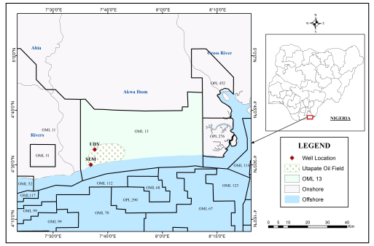

Fig. 1: Map of OML13 showing Utapate Oilfield and well locations

Fig. 1: Map of OML13 showing Utapate Oilfield and well locations

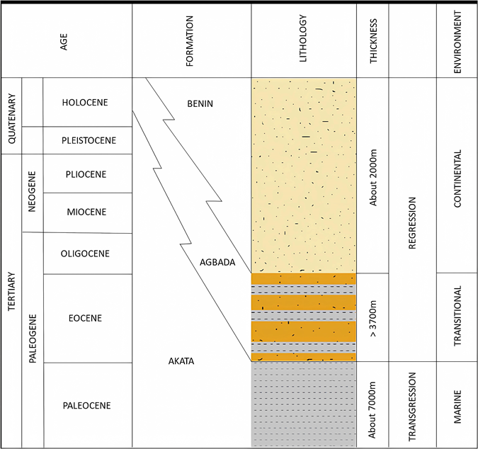

Fig 2: Stratigraphic Units in the Niger Delta Basin (Adapted from Obaje, 2019)

- MATERIALS AND METHODS
3.1 Sample Collection and Preparation
Shale samples used in this study were obtained from the Utapate Oilfield, Niger Delta Basin, Nigeria. A total of eleven samples (six from UDY well and five from SEM well) were selected from subsurface intervals that belong to the Agbada Formation. The intervals selected for the sample collection were 4075–4135 ft and 4100–4175 ft for SEM and UDY wells respectively as shown in Table 1. To minimize contamination, fresh cuttings were used. All samples were cleaned to remove drilling mud residues, air-dried, and crushed to a fine powder using an agate mortar to ensure homogeneity prior to geochemical analysis. Based on the total organic carbon (TOC) content results, one sample each (with the highest TOC) from SEM and UDY was selected as representative for biomarker analysis (Table 1). The selection of the highest TOC samples is justified because intervals with elevated organic carbon content typically provide stronger biomarker signals and more reliable molecular distributions for paleoenvironmental and maturity interpretations. SEM-4 and UDY-5 are considered representative of the organic-rich facies within the studied intervals, as they reflect peak organic matter preservation conditions recorded in each well. However, it should be noted that biomarker interpretations derived from two samples may not fully capture small-scale vertical heterogeneity within the formation. Despite this limitation, the close stratigraphic proximity of the samples and the similarity of their geochemical characteristics support their suitability as representative end-members for evaluating organic matter input, depositional environment, and thermal maturity in the Utapate Oilfield.
Table 1: Depth, Stratigraphic unit, Lithology and TOC of SEM and UDY Well Samples
Well names | SEM-1 | SEM-2 | SEM-3 | SEM-4 | SEM-5 | UDY-1 | UDY-2 | UDY-3 | UDY-4 | UDY-5 | UDY-6
Sample depth (ft) | 4075 | 4090 | 4105 | 4129 | 4135 | 4100 | 4115 | 4130 | 4145 | 4160 | 4175
Stratigraphic unit | AF | AF | AF | AF | AF | AF | AF | AF | AF | AF | AF
Lithology | Shale | Shale | Shale | Shale | Shale | Shale | Shale | Shale | Shale | Shale | Shale
TOC | 3.77 | 3.92 | 3.88 | 3.95 | 3.90 | 3.80 | 3.89 | 3.83 | 3.86 | 3.95 | 3.87
AF = Agbada Formation; TOC = Total organic carbon

Organic Matter Extraction
Approximately 30 g of each powdered shale sample was subjected to Soxhlet extraction for 48–72 hours using a dichloromethane/methanol (93:7 v/v) solvent mixture. The resulting total organic extract (TOE) was concentrated under a gentle stream of nitrogen to remove excess solvent. Asphaltenes were precipitated from the extract by the addition of excess n-hexane (40:1 solvent ratio) and separated by filtration after allowing the mixture to stand for at least 24 hours.
Fractionation of Extractable Organic Matter
The de-asphalted maltene fraction was separated into saturated hydrocarbons, aromatic hydrocarbons, and polar (resin) fractions using column chromatography. A glass column packed with activated silica gel and alumina was employed. The saturated fraction was eluted with n-hexane, the aromatic fraction with a mixture of n-hexane and dichloromethane (2:1, v/v), and the polar fraction with methanol. Each fraction was concentrated under nitrogen and stored in amber vials prior to instrumental analysis.
Gas chromatography-mass spectrometry (GC-MS)
Biomarker characterization of the aliphatic and aromatic fractions was conducted using an Agilent 6890N gas chromatograph coupled to an Agilent 5973N mass-selective detector (MSD). Chromatographic separation was achieved on a 60 m × 0.25 mm × 0.25 μm DB-1 capillary column using helium as the carrier gas at a flow rate of 1.2 mL/min. For the saturated fractions, the oven temperature was programmed from 150°C to 300°C at a ramp rate of 2°C/min to ensure effective elution of high–molecular-weight hydrocarbons. The mass spectrometer operated at an ionization energy of 70 eV in selected ion monitoring (SIM) mode, which enabled enhanced sensitivity by monitoring specific diagnostic ions with dwell times of 50–100 ms and an overall cycle time of approximately 0.7 seconds. Prior to injection, the aliphatic and aromatic hydrocarbon fractions were individually dissolved in pentane and dichloromethane (DCM), respectively, each in the presence of an internal standard, and diluted to a final volume of 1.0 mL. A 1.0 μL aliquot of each prepared solution was introduced into the GC–MS system. During chromatographic separation, compounds eluting from the GC column were transferred directly into the mass spectrometer, where they underwent electron ionization to produce positively charged molecular ions and characteristic fragment ions. These fragments, defined by unique mass-to-charge (m/z) ratios resulting from specific structural cleavages within each biomarker compound, were subsequently sorted in the mass analyzer and detected according to their relative abundances. The resulting mass spectra, presented as plots of ion abundance versus m/z, provided molecular fingerprints for each compound. Spectral data were compared with reference spectra stored in the instrument’s library to identify individual biomarker constituents within both the saturated and aromatic fractions. Quantification of biomarker distributions was carried out using peak area or peak height measurements obtained from the corresponding chromatograms, enabling detailed interpretation of source input, depositional conditions, and thermal maturity [15] [42].
- RESULTS
4.1 Bulk Hydrocarbon Composition
The bulk compositional fractions (saturates, aromatics, resins, and asphaltenes) provide a broad overview of hydrocarbon quality and alteration level [3] [1]. Both Utapate shale extracts are dominated by saturated hydrocarbons, which constitute 61.5–61.7 % of the total extractable organic matter (EOM). Aromatic hydrocarbons account for ~18 %, while NSO (resin) compounds make up approximately 17–18 %, and asphaltenes form a minor fraction of ~2 %. The proportional contributions of these fractions, calculated from the total extract mass, are illustrated in the bar charts for SEM-4 and UDY-5 samples (Fig. 3).

b

Fig. 3: Bulk Composition of C₁₅+ in: (a) SEM-4 sample extract from SEM well (b) UDY-5 sample extract from UDY well in Utapate oilfield, Niger Delta Basin, Nigeria.

4.2 Biomarker Distributions (Saturate Fractions)
The GC-MS analysis of the Utapate shale extracts revealed a rich distribution of triterpane and sterane biomarkers. Sixty seven (67) distinct peaks with measurable concentrations were identified, representing a combination of steranes, tricyclic terpanes, and other pentacyclic hydrocarbons. Table 2 shows the peak definition of the identified compounds. The mass chromatograms for m/z 191 and m/z 217, representing terpane and sterane distributions, respectively, for samples SEM-4 and UDY-5, are provided in Fig. 4. The m/z 191 chromatograms reveal well-developed tricyclic and pentacyclic terpane suites in both samples. Tricyclic terpanes spanning C₁₉T to C₃₅T were identified in SEM-4 and UDY-5, with C₂₃T emerging as the most abundant homologue (124 and 164 ppm), followed by C₂₁T (80 and 105 ppm) and C₂₄T (75 and 99 ppm) as shown in Fig. 5. Pentacyclic terpanes (C₂₇T - C₃₅T) are also present, with oleanane displaying the highest relative abundance (391 and 563 ppm), closely followed by C₃₀ hopane (367 and 524 ppm). Trisnorhopane (TM), 151 and 212 ppm) dominates over trisnorneohopane (TS, 57 and 81 ppm), and only low concentrations of gammacerane (GA, 11 and 16 ppm) (Table 2) are observed in both samples. The relative abundances of pentacyclic terpanes are summarized in Fig. 6. Hopane biomarkers provides important insights into depositional environment, bacterial contribution, and thermal maturity [17] [1] [4] [18] [19]. Both SEM-4 and UDY-5 display consistent trends based on the quantified parameters: C₃₀ hopane is moderately abundant with the concentration of 367 ppm and 524 ppm for SEM and UDY wells respectively. C₂₉ hopane/C₃₀ hopane ratios of SEM and UDY are 0.77 and 0.79 while C₃₁R/C₃₀ hopane ratios are 0.14 and 0.15 and C₃₅S/C₃₄S ratios are 0.46 and 0.47 respectively. Both SEM and UDY shale sample extracts possess the same ratios for Ts/Tm (0.38) and C₂₆/Ts (0.68) (Table 3).

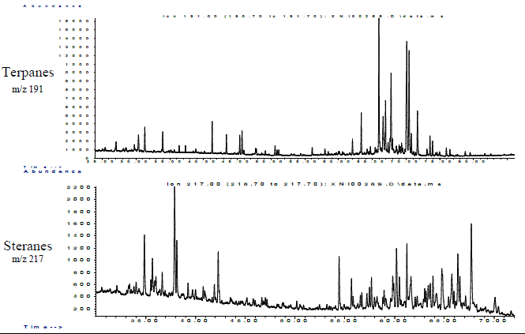
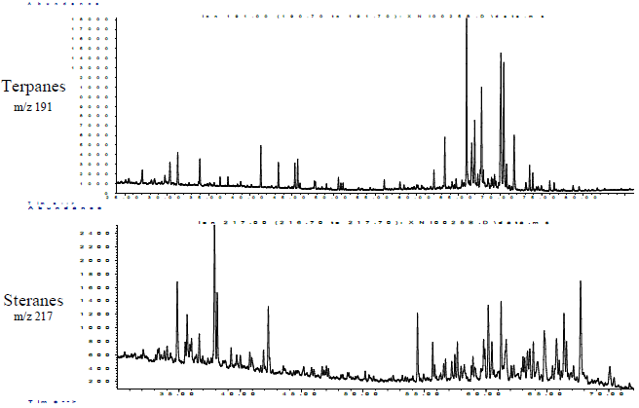
UDY-5
SEM-4

Fig.4: Mass Chromatograms (m/z 191 and m/z 217) of extracts from SEM-4 and UDY-5 Wells

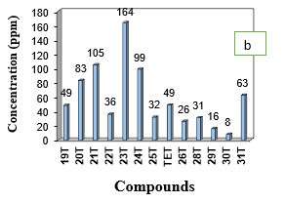
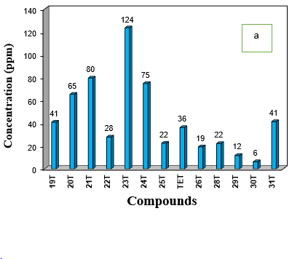

Fig. 5: Distribution of tricyclic terpanes biomarkers of: (a) SEM-4 oil shale sample from SEM well (b) UDY-5 oil shale sample extract from UDY well in Utapate oilfield, Niger Delta Basin, Nigeria.

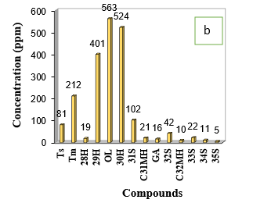
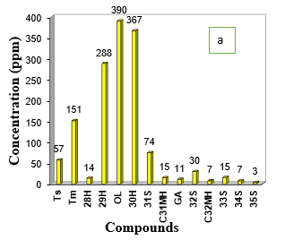

Fig 6: Distribution of pentacyclic terpanes biomarkers of: (a) SEM-4 sample extract from SEM well (b) UDY-5 sample extract from UDY well in Utapate oilfield, Niger Delta Basin, Nigeria

Fig. 7: Distribution of steranes biomarkers of: (a) SEM-4 sample extract from SEM well (b) UDY-5 sample extract from UDY well, Utapate oilfield, Niger Delta Basin, Nigeria.

The sterane distributions derived from m/z 217 for SEM-4 and UDY-5 show moderate concentrations of C₂₇ (cholestane), C₂₈ (ergostane), and C₂₉ (stigmastane) steranes. Among these homologues, C₂₉ sterane is the most abundant in both extracts (Fig. 7). The percentage distribution of saturated biomarkers for both samples is presented in Fig. 8. Quantitatively, the sterane distributions in the Utapate samples fall within the following ranges: C₂₇ steranes: 30.6 and 30.7%, C₂₈ steranes: 31.2 and 31.5%, C₂₉ steranes: 37.9 and 38.2%. Maturity indicators for SEM-4 and UDY-5 samples: C₂₉ 20S/(20S + 20R) are 0.39 and 0.40 whereas C₂₉ ββ/(ββ + αα) = 0.34 and 0.35 respectively (Table 3).

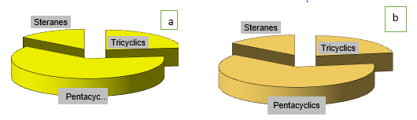

Fig. 8: Percentage distribution of saturated biomarkers of: (a) SEM-4 sample extract from SEM well, (b) UDY-5 sample extract from UDY well in Utapate oil field, Niger Delta Basin, Nigeria

Table 2: Identified saturated biomarkers of SEM and UDY Wells shale extracts.
Peak # | m/z | Compound | Names of saturated biomarkers identified | SEM-4 | UDY-5
 |  |  |  | Height (ppm) | Height (ppm)
 | Tricyclic Terpanes
1 | 191 | C19T | C₁₉ tricyclic terpane | 41 | 49
2 | 191 | C20T | C₂₀ tricyclic terpane | 65 | 83
3 | 191 | C21T | C₂₁ tricyclic terpane | 80 | 105
4 | 191 | C22T | C₂₂ tricyclic terpane | 28 | 36
5 | 191 | C23T | C₂₃ tricyclic terpane | 124 | 164
6 | 191 | C24T | C₂₄ tricyclic terpane | 75 | 99
7 | 191 | C25S | C₂₅ tricyclic terpane (S isomer) | 22 | 32
8 | 191 | C25R | C₂₅ tricyclic terpane (R isomer) | 22 | 30
9 | 191 | TET | Tetracyclic terpane | 36 | 49
10 | 191 | C26S | C₂₆ tricyclic terpane (S isomer) | 19 | 26
11 | 191 | C26R | C₂₆ tricyclic terpane (R isomer) | 20 | 27
14 | 191 | ET-C28S | Extended C₂₈ tricyclic terpane (S isomer) | 22 | 31
15 | 191 | ET-C28R | Extended C₂₈ tricyclic terpane (R isomer) | 14 | 18
16 | 191 | ET-C29S | Extended C₂₉ tricyclic terpane (S isomer) | 12 | 16
17 | 191 | ET-C29R | Extended C₂₉ tricyclic terpane (R isomer) | 11 | 16
18 | 191 | ET-C30S | Extended C₃₀ tricyclic terpane (S isomer) | 6 | 8
19 | 191 | ET-C30R | Extended C₃₀ tricyclic terpane (R isomer) | 12 | 15
20 | 191 | ET-C31S | Extended C₃₁ tricyclic terpane (S isomer) | 41 | 63
21 | 191 | ET-C31R | Extended C₃₁ tricyclic terpane (R isomer) | 38 | 54
 |  |  | TRICYCLICS | 687 | 922
 | Pentacyclic Terpanes
29 | 191 | Ts | 18α(H)-22,29,30-trisnorneohopane | 57 | 81
30 | 177 | C27T | C₂₇ hopane | 8 | 12
32 | 191 | Tm | 17α(H)-22,29,30-trisnorhopane | 151 | 212
37 | 177 | C28DM | C₂₈ demethylated hopane | 40 | 55
42 | 191 | C28H | C₂₈ hopane | 14 | 19
45 | 177 | C29DM | C₂₉ demethylated hopane | 17 | 25
47 | 191 | C29H | C₂₉ hopane | 288 | 401
48 | 191 | C29D | Rearranged C₂₉ hopane (diahopane) | 39 | 57
49 | 191 | C30X | Rearranged C₃₀ hopane (extended hopane) | 28 | 40
50 | 191 | OL | Oleanane | 390 | 563
51 | 191 | C30H | C₃₀ αβ-hopane | 367 | 524
52 | 205 | C31 2MeH | C₃₁ 2-methylhopane | 15 | 21
53 | 191 | C30M | Moretane (C₃₀ ββ-hopane) | 161 | 228
54 | 191 | C31S | C₃₁ 22S αβ-hopane | 74 | 102
55 | 205 | C32 2MeH S | C₃₂ 22S 2-methylhopane | 7 | 10
56 | 191 | C31R | C₃₁ 22R αβ-hopane | 53 | 76
57 | 191 | GA | Gammacerane | 11 | 16
58 | 191 | C32S | C₃₂ 22S αβ-hopane | 30 | 42
59 | 191 | C32R | C₃₂ 22R αβ-hopane | 24 | 34
60 | 191 | C33S | C₃₃ 22S αβ-hopane | 15 | 22
61 | 191 | C33R | C₃₃ 22R αβ-hopane | 12 | 18
62 | 191 | C34S | C₃₄ 22S αβ-hopane | 7 | 11
63 | 191 | C34R | C₃₄ 22R αβ-hopane | 5 | 8
64 | 191 | C35S | C₃₅ 22S αβ-hopane | 3 | 5
65 | 191 | C35R | C₃₅ 22R αβ-hopane | 3 | 5
 |  |  | PENTACYCLICS | 1821 | 2587
Steranes
12 | 217 | S1 | C₂₇ regular sterane (ααα 20R) | 41 | 54
13 | 217 | S2 | C₂₇ regular sterane (ααα 20S) | 23 | 31
22 | 217 | S3 | C₂₈ regular sterane (ααα 20R) | 18 | 25
23 | 217 | S4 | C₂₈ regular sterane (ααα 20S) | 43 | 59
24 | 218 | S4B | C₂₈ ββ sterane | 35 | 47
25 | 217 | S5 | C₂₉ regular sterane (ααα 20R) | 21 | 30
26 | 218 | S5B | C₂₉ ββ sterane | 25 | 35
27 | 217 | S6 | C₂₇ diasterane | 46 | 64
28 | 217 | S7 | C₂₈ diasterane | 24 | 33
31 | 217 | S8 | C₂₉ diasterane | 12 | 17
33 | 217 | S9 | C₂₇ rearranged sterane | 17 | 24
34 | 218 | S9B | C₂₇ rearranged sterane (ββ) | 31 | 42
35 | 217 | S10 | C₂₈ rearranged sterane | 21 | 31
36 | 218 | S10B | C₂₈ rearranged sterane (ββ) | 25 | 36
38 | 217 | S11 | C₂₉ rearranged sterane | 25 | 35
39 | 217 | S12 | C₂₇ sterane (isomer) | 24 | 34
40 | 217 | S13 | C₂₈ sterane (isomer) | 39 | 55
41 | 218 | S13B | C₂₈ sterane (ββ isomer) | 146 | 207
43 | 217 | S14 | C₂₉ sterane (isomer) | 21 | 29
44 | 218 | S14B | C₂₉ sterane (ββ isomer) | 30 | 44
67 | 221 | ISTD | Internal sterane standard | 362 | 543
46 | 217 | S15 | C₃₀ sterane | 60 | 87
 |  |  | STERANES | 436 | 607

4.3 Aromatic Biomarkers
The m/z 178 + 192 chromatograms indicate that phenanthrene (P, 2028 and 2059 ppm) is present in significant quantities in both samples. High abundances of 2-methylphenanthrene (2MP, 1301 and 1303 ppm), 9-methylphenanthrene (9MP, 1123 and 1135 ppm), and 3-methylphenanthrene (3MP, 1124 and 1125 ppm) are also observed in high abundance, whereas 1-methylphenanthrene (1MP, 784 and 797 ppm) is the least abundant of the phenanthrene-related compounds (Table 2). These chromatograms for SEM-4 and UDY-5 are provided in Fig. 9. The m/z 184 + 198 chromatograms show that 4-methyldibenzothiophene (4MDBT, 142 and 144 ppm) is more abundant than 1-methyldibenzothiophene (1MDBT, 28 ppm apiece) in both samples. Dibenzothiophene (DBT, 80 and 83 ppm) is also present at higher concentrations than 1MDBT (Table 2 and Fig. 9). The triaromatic sterane (TAS) distributions derived from m/z 231 for SEM-4 and UDY-5, provided in Fig. 10, show that C₂₀TAS (39 and 40 ppm) is more abundant than C₂₁TAS (23 and 24 ppm) and C₂₆TAS (18 and 19 ppm). The TAS1–TAS5 ratios are less than 1 for both samples (Table 2), indicating low relative contributions of higher-order triaromatic homologues. Additional aromatic biomarkers, including aryl isoprenoids (m/z 133) and aromatic dinosteroids (m/z 245), were also identified. Their distributions for SEM-4 and UDY-5 are presented in Fig 11. Aromatic biomarker ratios provide further maturity and redox information [34] [4]. Both Utapate samples show: Methylphenanthrene Index (MPI-1) = 0.92, (equivalent to Ro ≈ 0.85 - 0.9 %). Methyl Dibenzothiophene Ratios (MDR) for SEM-4 and UDY-5 samples are 5.12 and 5.14 and Phenanthrene/Dibenzothiophene (P/DBT) ratios are 24.55 and 25.71 while DBT/C₄-naphthalene ratios are 0.22 and 0.25. Triaromatic steranes (TAS 1–TAS 5) and aromatic dinosteroids provide information on marine algal input and maturity [23]. The Utapate samples display consistent TAS patterns: TAS1 = 0.63, TAS2 = 0.44, TAS3 = 0.28, TAS4 = 0.48, TAS5 = 0.77. Dino 3/9 ≈ 1.0.

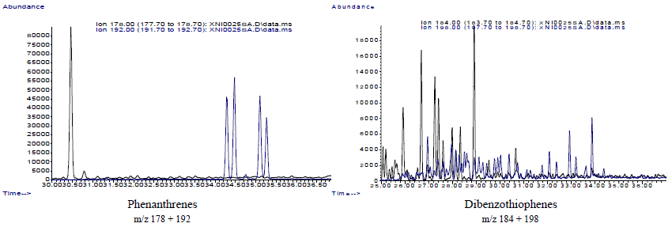
SEM-4

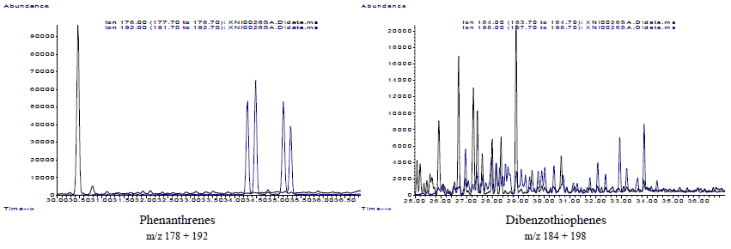
UDY-5

Fig.9: Mass Chromatograms of Aromatic Hydrocarbon Fractions (m/z 178 + 192 and 184 + 198) of Extracts from SEM-4 and UDY-5 Well Samples
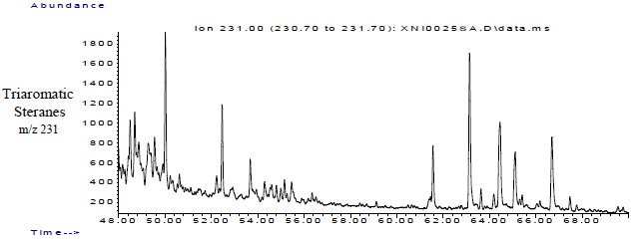
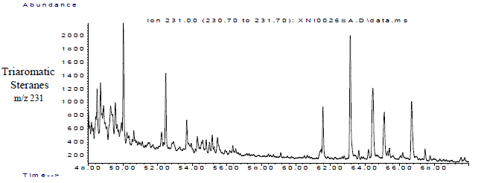
SEM-4
UDY-5

Fig. 10: Mass Chromatograms of Aromatic Hydrocarbon Fractions (m/z 231) of Extracts from SEM-4 and UDY-5 Well Samples.
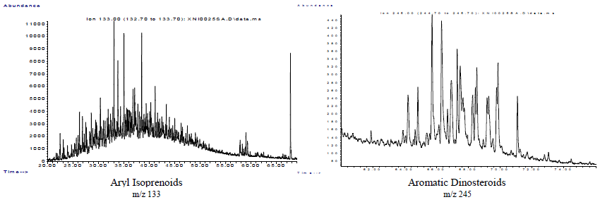
SEM-4

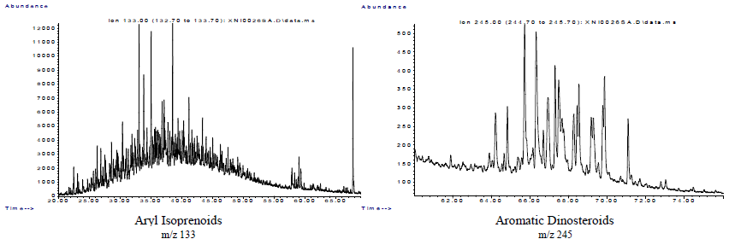
UDY-5

Fig. 11: Mass Chromatograms of Aromatic Hydrocarbon Fractions (m/z 133 and m/z 245) of Extracts from SEM-4 and UDY-5 Well Samples

- DISCUSSION

5.1 Bulk Hydrocarbon Composition
The relatively high proportion of saturates (Fig. 3a and b) indicates that these shale sample extracts (bitumen) are derived from light to medium mature oils with minimal biodegradation [16] [41] [42]. Similarly, the Saturate/Aromatic ratio (Sat/Aro) of 3.26–3.37 suggests that the oil extracts are largely unaltered and contain a high proportion of paraffinic hydrocarbons [2] [41]. Low asphaltene contents (≤ 2.3 %) and low NSO fractions further indicate high-quality, low-sulphur oils. These characteristics are consistent with hydrocarbons generated from Type II or mixed Type II/III kerogen, which produce paraffinic to paraffinic–naphthenic oils [4] [44].
5.2 Source of Organic Matter and Kerogen Type
The combined saturate and aromatic biomarker signatures of the SEM-4 and UDY-5 shale samples indicate a mixed organic matter origin derived from both terrestrial higher plants and marine algal–bacterial sources (Tables 3 and 4; Figs. 4, 7, 8). This interpretation is supported by sterane distributions showing moderate proportions of C₂₇ (≈30–31%) and C₂₈ (≈31%), together with a dominant C₂₉ sterane component (≈38%) (Table 3; Figs. 7; Fig. 12). Such sterane patterns are characteristic of mixed marine–terrestrial organic matter inputs, where higher-plant debris is supplied by deltaic systems and algal biomass contributes during periods of marine influence [3] [1] [43] [45] [52] [59]. The high oleanane/hopane ratios (1.06–1.08; Table 3; Fig. 6) provide strong evidence for significant angiosperm-derived organic matter, consistent with Tertiary continental vegetation typical of Niger Delta source rocks [24] [22] [25] [2] [26] [42][43] [53].Tricyclic terpane ratios (e.g., C₁₉/C₂₃ and C₂₁/C₂₃ < 1; Table 3; Fig. 5) further reflect dominant C₂₃ tricyclic terpanes, suggesting marine algal input, while the presence of lower homologues confirms terrestrial contributions [27] [4] [56] [57]. Aromatic biomarkers independently corroborate this mixed provenance (Table 4; Figs. 9–11). Very high phenanthrene concentrations relative to dibenzothiophene (P/DBT = 24.55 and 25.71) and low DBT/C₄N ratios (0.22 and 0.25) indicate dominant terrestrial organic matter input deposited under sulphur-poor, siliciclastic conditions [6] [7] [28]. Collectively, these biomarker characteristics indicate that the Utapate oilfield shales contain Type II/III kerogen, capable of generating both oil and gas upon maturation [3] [4] [51] [55].

Table 3: Saturated biomarker parameters of SEM and UDY Wells
S/N | Parameters | Names of Biomarkers | Ratio
S/N | Parameters | Names of Biomarkers | SEM | UDY
1. | C19/C23 | normal alkanes | 0.33 | 0.30
2. | C22/C21 | normal alkanes | 0.35 | 0.35
3. | C21/C23 | normal alkanes | 0.64 | 0.64
4. | C22/C23 | normal alkanes | 0.22 | 0.22
5. | C24/C23 | normal alkanes | 0.61 | 0.60
6. | C26/C25 | normal alkanes | 0.88 | 0.87
7. | Tet/C23 | Tetracyclic terpane / C23 tricyclic terpane | 0.29 | 0.30
8. | S1/S6 | Short-chain vs long-chain tricyclic terpanes | 0.84 | 0.84
9. | %C27 | Steranes | 30.70 | 30.60
10. | %C28 | Steranes | 31.50 | 31.20
11. | %C29 | Steranes | 37.90 | 38.20
12. | 20S/20R | Sterane isomerization ratio | 0.39 | 0.39
13. | Ster/Terp | Total steranes / total terpanes | 0.38 | 0.38
14. | C27 Ts/Tm | 18α(H)-22,29,30-trisnorneohopane/ 17α(H)-22,29,30-trisnorhopane | 0.38 | 0.38
15. | C29 Ts/Tm | 18α(H)-22,29,30-trisnorneohopane/ 17α(H)-22,29,30-trisnorhopane | 0.14 | 0.14
16. | 29D/29 | C29 diasterane / C29 regular sterane | 0.14 | 0.14
17. | C27T/27 | C27 tricyclic terpane / C27 hopane | 0.04 | 0.04
18. | DM/H | Diahopane / hopane | 0.05 | 0.05
19. | C26/Ts | C26 tricyclic terpane / Ts | 0.67 | 0.67
20. | C27/H | Hopanes relative to total hopanes | 0.56 | 0.56
21. | C28/H | Hopanes relative to total hopanes | 0.04 | 0.04
22. | C30X/H | C30 rearranged hopane/ total hopanes | 0.08 | 0.08
23. | C29/H | Hopanes relative to total hopanes | 0.79 | 0.77
24. | M/H | Moretane / hopane | 0.43 | 0.43
25. | OL/H | Oleanane / hopane | 1.06 | 1.08
26. | C31R/H | C31 22R hopane / hopanes | 0.14 | 0.15
27. | GA/C31R | Gammacerane / C31 hopane | 0.21 | 0.21
28. | GA/H | Gammacerane / total hopane | 0.03 | 0.03
29. | C31/H | C31 hopane / total hopanes | 0.15 | 0.15
30. | C35S/C34S | Hopane ratio | 0.46 | 0.47
31. | C23/H | C23 tricyclic terpane / hopanes | 0.31 | 0.31
32. | C31MH/H | methylhopane / hopanes | 0.04 | 0.04
33. | C32MH/H | methylhopane / hopanes | 0.02 | 0.02
34. | Dia/Reg | Total diasteranes / regular steranes | 0.89 | 0.84
35. | C29 20S/R | Sterane isomerization ratio | 0.40 | 0.39
36. | C29 bbS/aaR | Sterane epimerization maturity parameter | 0.35 | 0.34

Table 4: Aromatic biomarker parameter of SEM and UDY Wells oil shales
S/N | Parameters | Aromatic biomarker abundance (ppm) and ratio
S/N | Parameters | SEM | UDY
1. | Phenanthrene (P) | 2028 | 2059
2. | 1-Methylphenanthrene (1MP) | 784 | 797
3. | 2-Methylphenanthrene (2MP) | 1301 | 1303
4. | 3-Methylphenanthrene (3MP) | 1124 | 1125
5. | 4-Methylphenanthrene (4MP) | 1135 | 1123
6 | Dibenzothiophene (DBT) | 83 | 81
7. | 1-Methyldibenzothiophene (1MDBT) | 28 | 27
8. | 4-Methyldibenzothiophene (4MDBT) | 144 | 142
9. | C4-Napthalene (C4N) | 381 | 325
10. | Methylphenanthrene Index (MPI) | 0.92 | 0.92
11. | Methylphenanthrene Ratio 1 (F1) | 0.56 | 0.56
12. | Methylphenanthrene Ratio 2 (F2) | 0.30 | 0.30
13. | Phenanthrene/Dibenzothiophene (P/DBT) | 24.55 | 25.71
14. | Dibenzothiophene/ C4-alkylnaphthalenes (DBT/C4N) | 0.22 | 0.25
15. | Methyl Dibenzothiophene Ratio (MDR) | 5.12 | 5.14
16. | Triaromatic sterane - TAS1 | 0.63 | 0.63
17. | Triaromatic sterane - TAS2 | 0.44 | 0.44
18. | Triaromatic sterane - TAS3(CR) | 0.28 | 0.28
19. | Triaromatic sterane -TAS4 | 0.48 | 0.48
20. | Triaromatic sterane TAS5 | 0.77 | 0.78
21. | aromatic dinosteroids - Dino 3/9: | 0.99 | 1.05

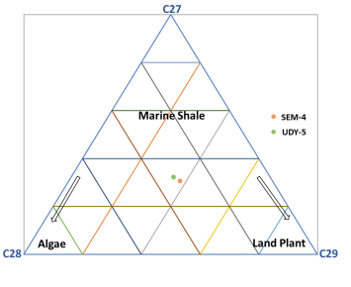

Fig. 12: Ternary diagram showing relative distribution of C27, C28 and C29 regular steranes in SEM-4 and UDY-5 samples extracts

5.3 Depositional Environment
Saturate biomarker parameters indicate deposition in a marginal-marine to deltaic environment dominated by siliciclastic sedimentation (Table 1; Figs. 4–6). C₂₆/C₂₅ tricyclic terpane ratios close to unity (0.87 and 0.88; Table 1; Fig. 5) suggest mixed marine–terrestrial depositional conditions typical of delta-front to prodelta settings [29] [30] [. The abundance of C₃₀ hopane, coupled with C₂₉H/C₃₀H ratios < 1 (0.77 and 0.79; Table 1; Fig. 6), indicates deposition under predominantly oxic to suboxic conditions characteristic of siliciclastic deltaic systems [31] [4] [43] [46] [49]. C₃₅S/C₃₄S ratios (0.46 and 0.47) point to deposition under reducing (suboxic to anoxic) bottom-water conditions, where bacterial sulphate reduction and early diagenetic reworking were significant [20] [4]. A cross plot of C₃₅S/C₃₄S ratios versus C₂₉H/C₃₀H ratios confirms oxic to suboxic depositional conditions (Fig. 13) [46] [47] [54]. Very low gammacerane indices (GA/H ≈ 0.03; Table 1; Fig. 6) suggest low salinity and minimal water-column stratification, ruling out hypersaline or strongly restricted marine conditions and supporting fluvial–deltaic influence [32] [42] [. High diasterane/regular sterane ratios (0.84–0.89; Table 1; Fig. 7) further indicate clay-rich sediments deposited under oxic to suboxic conditions, typical of delta-front and prodelta muds [4] [33]. Aromatic biomarkers refine this interpretation (Table 2; Figs. 9–11). Elevated P/DBT ratios (>24) and low DBT/C₄N values confirm a sulphur-poor, oxic to sub-oxic, siliciclastic depositional environment dominated by terrestrial input [7] [40] [42]. However, relatively high methyl dibenzothiophene ratios (MDR ≈ 5.1) and moderate triaromatic sterane (TAS) indices indicate episodic marine influence and intervals of reducing conditions during deposition [34] [2] [28][49] [58]. These combined signals suggest a delta-front to prodelta depositional system influenced by transgressive–regressive cycles, consistent with the Agbada Formation of the Niger Delta [8] [9] [41][42].
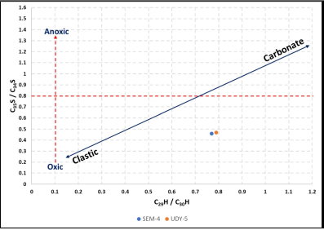

Fig. 13: Plot of C35S/C34S Versus C29H/C30H displaying depositional conditions and lithology

5.4 Thermal Maturity
Both saturate and aromatic biomarker parameters consistently place the SEM-4 and UDY-5 samples within the main oil-generation window (Tables 1 and 2). Sterane isomerization ratios C₂₉ 20S/(20S + 20R) (0.39 and 0.40) and C₂₉ ββ/(ββ + αα) (0.34 and 0.35) are below equilibrium values but clearly exceed immature levels, indicating early to mid-oil-window maturity [35] [21] [1] [2] [48] [50] [58]. C₃₁R/C₃₀ hopane ratios (0.14 and 0.15) reflect moderate thermal maturity, consistent with other maturity indicators. Ts/(Ts + Tm) ratios (~0.38; Table 1, Fig. 14) and moretane/hopane ratios (~0.43) further support moderate thermal maturity. Aromatic maturity parameters strongly corroborate this interpretation (Table 2; Figs. 9–11). The Methylphenanthrene Index (MPI = 0.92) corresponds to an equivalent vitrinite reflectance of approximately 0.85–0.9%, characteristic of peak oil generation [34] [4] [28] [48]. F1 (0.56) and F2 (0.30) ratios derived from methylphenanthrene isomers also indicate advanced maturity within the oil window. The close similarity of maturity parameters between the two wells suggests a uniform burial and thermal history across the Utapate Oilfield.

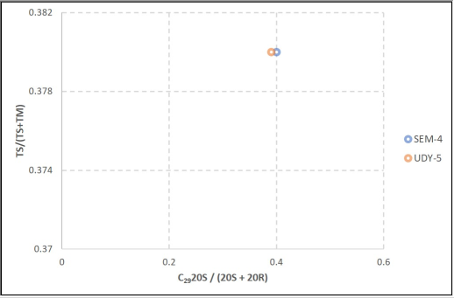

Fig. 14: TS/(TS + TM) ratio versus C₂₉20S/(20S + 20R) sterane of the studied sample extracts in Utapate oilfield.

  - Biodegradation and Post-Generative Alteration
Several parameters suggest negligible biodegradation or secondary alteration. The chromatograms show no unresolved complex mixtures (UCMs), the Sat/Aro ratio is high (≈ 3.3), and asphaltenes are low (< 2.3%). These features indicate that the oils have not undergone significant microbial degradation or water washing [16] [42]. Therefore, the biomarker data are reliable for source correlation and environmental interpretation [36]

  - Oil–Source Correlation
The strong similarity in saturate and aromatic biomarker distributions between SEM-4 and UDY-5 (Tables 3–4; Figs. 4–11) indicates that the two shale samples were deposited under comparable paleoenvironmental conditions and share a common source facies. Identical sterane distributions, oleanane indices, gammacerane values, and aromatic maturity ratios (MPI, F1, F2, MDR) suggest that hydrocarbons generated from these shales would be genetically related and sourced from the same prodeltaic organic facies. The dominance of C₂₉ steranes, high oleanane abundance, elevated P/DBT ratios, and low DBT/C₄N values are consistent with oils generated from Niger Delta mixed marine–terrestrial source rocks of the Agbada–Akata petroleum system [12] 11] [4][41] [42] [52]. These biomarker similarities support a strong oil–source rock correlation, indicating that the Utapate Oilfield shales constitute effective source rocks capable of contributing to hydrocarbon accumulations within the field.
5.7 Hydrocarbon Potential and Exploration Implications
The geochemical data demonstrate that the Utapate oilfield shales are excellent source rocks with substantial petroleum potential. The high saturate fractions, moderate aromatic content, and low asphaltenes suggest efficient expulsion of light oils [1] [37]. Because the kerogen is mixed Type II/III, these shales are capable of generating both liquid hydrocarbons and associated gas at greater depths [3] [38] [44] [52] [59]. The maturity data indicate that the shales are in the peak oil window, and ongoing hydrocarbon generation is likely. Moreover, the absence of biodegradation and high-quality oil character make the Utapate system economically attractive. The genetic correlation between the two wells also implies that the productive interval is laterally extensive, enhancing the exploration prospectivity of the field [11].

CONCLUSION
Integrated saturate and aromatic biomarker data indicate that the Utapate Oilfield shales were deposited in a delta-front to prodelta setting within the Niger Delta Basin under predominantly siliciclastic sedimentation and fluctuating marine influence. Organic matter input reflects a mixed terrestrial and marine origin, evidenced by dominant C₂₉ steranes, elevated oleanane, and supporting aromatic indices, confirming the presence of mixed Type II/III kerogen. Biomarker maturity parameters consistently place the shales within the peak oil window, demonstrating that the source rocks are thermally mature and capable of generating both liquid hydrocarbons and associated gas. Depositional proxies suggest mainly oxic to suboxic conditions with intermittent marine transgressions, favorable for preserving reactive organic matter. The strong biomarker correlation between SEM-4 and UDY-5 indicates a common source facies and supports strong oil–source rock correlation across the field. The absence of significant biodegradation and favorable hydrocarbon composition further enhance petroleum quality. The Utapate shales, therefore, represent an effective, mature deltaic source rock system with strong hydrocarbon generation potential, reinforcing the exploration prospectivity of the Utapate Oilfield and surrounding Niger Delta Basin.

Disclaimer (Artificial intelligence)
Author(s) hereby declare that NO generative AI technologies such as Large Language Models (ChatGPT, COPILOT, etc.) and text-to-image generators have been used during the writing or editing of this manuscript.

REFERENCES
[1] Peters, K. E. & Moldowan, J. M. (1993). The Biomarker Guide, Interpreting Molecular Fossils in Petroleum and Ancient Sediments. Prentice Hall, New Jersey, p.363.

[2] Hunt, J. M. (1996). Petroleum Geochemistry and Geology, 2nd edition. W.H. Freeman and Company, New York 743 p.

[3] Tissot, B. P., & Welte, D. H. (1984). Petroleum formation and occurrence (2nd ed.). Springer-Verlag.
[4] Peters, K. E., Walters, C. C., & Moldowan, J. M. (2005). The biomarker guide: Biomarkers and isotopes in petroleum exploration and earth history (2nd ed., Vols. 1–2). Cambridge University Press. https://doi.org/10.1017/CBO9780511524868
[5] Seifert, W. K., & Moldowan, J. M. (1978). Applications of steranes, terpanes and monoaromatics to the maturation, migration and source of crude oils. Geochimica et Cosmochimica Acta 42, 77–95.
[6] Radke, M., Willsch, H., & Welte, D. H. (1991). The methylphenanthrene index (MPI): A maturity parameter based on aromatic hydrocarbons. Organic Geochemistry 17, 479–493. https://doi.org/10.1016/0146-6380(91)90040-3
[7] Hughes, W. B., Holba, A. G., & Dzou, L. I. P. (1995). The ratios of dibenzothiophene to phenanthrene and pristane to phytane as indicators of depositional environment and lithology of petroleum source rocks. Geochimica et Cosmochimica Acta, 59, 3581–3598. https://doi.org/10.1016/0016-7037(95)00225-O
[8] Short, K. C., & Stauble, A. J. (1967). Outline of geology of the Niger Delta. AAPG Bulletin, 51, 761–779.
[9] Doust, H., & Omatsola, E. (1990). Niger Delta. In J. D. Edwards & P. A. Santogrossi (Eds.), Divergent/passive margin basins (AAPG Memoir No. 48, pp. 239–248). American Association of Petroleum Geologists.
[10] Avbovbo, A. A. (1978). Tertiary lithostratigraphy of the Niger Delta. AAPG Bulletin, 62, 295–300.
[11] Ekweozor, C. M., & Daukoru, E. M. (1994). Northern delta depobelt portion of the Akata–Agbada petroleum system, Niger Delta, Nigeria. AAPG Bulletin, 78, 388–405.
[12] Nwachukwu, J. I., & Ekweozor, C. M. (1989). Petroleum source-bed evaluation of Tertiary Niger Delta. AAPG Bulletin, 73, 229–248.
[13] Whiteman, A. J. (1982). Nigeria: Its petroleum geology, resources and potential. Graham & Trotman, p 394.
[14] Evamy, B. D., Haremboure, J., Kamerling, P., Knaap, W. A., Molloy, F. A., & Rowlands, P. H. (1978). Hydrocarbon habitat of the Niger Delta. AAPG Bulletin, 62, 1–39.
[15] Oladejobi, F. F.., Akpan, I. O., Achugasm, O., & Ogali, R. E. (2022). Gas chromatography-mass spectrometry characterization and antibacterial activity of stem-bark extracts of Dacryodes edulis (African pear). Researchers Journal of Science and Technology, 2(1): 34-49.
[16] Connan, J. (1984). Biodegradation of crude oils in reservoirs. In J. Brooks & D. Welte (Eds.), Advances in Petroleum Geochemistry 1, 299–335. Academic Press

[17] Waples, D. W. & Machihara, T. (1991). Biomarkers for Geologists: A practical Guide to the Application of Steranes and Triterpanes in Petroleum Geology. AAPG Methods in Exploration, 9. https://www.amazon.com/Biomarkers-Geologists-Application-Triterpanes-Exploration/dp/0891816593

[18] El-Sabagh, S. M., El-Naggar, A. Y., El-Nady, M. M., Ebiad, M. A., Rashad, A. M., & Abdullah, E. S. (2018). Distribution of triterpanes and steranes biomarkers as an indication of organic matters input and depositional environments of crude oils of oilfields in Gulf of Suez, Egypt. Egyptian Journal of Petroleum 27(4), 969-977.

[19] Yalcin Erik, N. & Ay F. (2020). Use of petrological and organic geochemical data in determining hydrocarbon generation potential of coals: Miocene coals of Malatya Basin (Eastern Anatolia – Turkey). International Journal of Coal Science and Technology 8, 510 - 533. https://doi.org/10.1007/s40789-020-00376-3

[20] Powell, T. G., & McKirdy, D. M. (1973). Relationship between ratio of pristane to phytane, crude composition and geological environment in Australia, Nature, 243, 37-39.

[21] Mackenzie, A. S., Patience, R. L., Maxwell, J. R., Vandenbroucke, M., & Durand, B. (1980). Molecular parameters of maturation in the Toarcian shales, Paris Basin, France-1. Changes in the configuration of acyclic isoprenoid alkanes, steranes, and triterpanes. Geochimica et Cosmochimica Acta 44, 1709-1721.

[22] Ekweozor, C. M. & Okogun, J. I. (1985). Organic geochemistry of the Niger Delta crude oils in relation to their source rocks. Nigerian Journal of Minning and Geology 22, 57-64.

[23] Brocks, J. J. & Summons, R. E. (2003). Biomarker evidence for microbial diversity in early life. Annual Review of Earth and Planetary Sciences, 31, 429-482.

[24] Ekweozor, C. M., Okogun, J. I., Ekong, D. E. U., & Maxwell, J. R. (1979). Preliminary Organic Geochemical Studies of Samples from the Niger Delta, Nigeria: Part 1, Analysis of Crude Oils for Triterpenes. Chemical Geology, 27, 11-28 https://doi.org/10.1016/0009-2541(79)90100-1
[25] Udo, O. T. & Ekweozor, C. M. (1990). Significance of oleanane occurrence in shales of Opuama Channel Complex, Niger Delta. Energy and Fuels 4(3), 248-254 https://doi.org/10.1021/ef00021a006
[26] Uzoegbu, M. U. & Ugwueze, C. U. (2023). Geochemistry and Depositional Environment of Organic Matter from Oil Shale, Abakaliki Fold Belt, Southeast Nigeria. International Journal of Innovative Scientific & Engineering Technologies Research 11(3): 124-140.
[27] Aquino Neto, F. R., Trendel, J. M., Restle, A., Connan, J. & Albrecht, P. A. (1983). Occurrences and formation of tricyclic and tetracyclic terpanes in sediments and petroleum, in M. Bjoroy et al., (Eds), Advances in Organic Geochemistry, Wiley & sons, New York, pp. 659-676.

[28] Korkmaz, S., Kara-Gulbay, R. Khoitiyn, T. & Erdogan M. S. (2022). Biomarker geochemistry of the Alpagut oil shale sequence: an evaluation of depositional environment and source rock potential from Dodurga-Corum basin (N-Turkey). Journal of Petroleum Exploration and Production Technology 12, 2173-2189. https://doi.org/10.1007/s13202-021-01450-5
[29] Burwood, R., Leplat, P., Mycke, B. & Paulet, J. (1992). Rifted margin source rock deposition: a carbon isotope and biomarker study of a West African lower Cretaceous “Lacustrine” section. Organic Geochemistry 19(1-3), 41-52. https://doi.org/10.1016/0146-6380(92)90026-T
[30] Hakimi, M H. & Al-Sufi S. A. (2018). Organic geochemical investigations of crude oils from Bayout oilfield in the Masila Basin, east Yemen and their implication for origin of organic matter and source-related type. Egyptian Journal of Petroleum 27 (1), 37-54
[31] Volkman, J. K., Alexander, R., Kagi, R. I., & Woodhouse, G. W. (1983). Demethylated hopanes in crude oils and their applications in petroleum geochemistry. Geochimica et Cosmochimica Acta, 47(4), 785-794. https://doi.org/10.1016/0016-7037(83)90112-6
[32] Grantham, P.J. (1986). Sterane isomerization and moretane/hopane ratios in crude oils derived from Tertiary source rocks. Organic Geochemistry 9(6), 293-304.

[33] Hakimi, M. H. & Abdullah, W. H. (2013). Organic geochemical characteristics and oil generating potential of the Upper Jurassic Safer Shale sediments in the Marib-Shabowah Basin, western Yemen. Organic Geochemistry 54, 115-124

[34] Radke, M., Welte, D. H., & Willsch, H. (1982). Geochemical study on a well in the western Canada Basin: Relation of the aromatic distribution pattern to maturity of organic matter. Geochimica et Cosmochimica Acta, 46, 1–10. https://doi.org/10.1016/0016-7037(82)90285-X
[35] Seifert, W. K. & Moldowan, J. M. (1981). Paleoconstruction by biologicalmarkers. Geochimica et Cosmochimica Acta 45(6), 783-794.

[36] Fowler, M. G. (1992). The influence of migration and mixing on petroleum geochemistry in exploration. In R. P. Philip (Ed.), Advances in organic Geochemistry pp 81-103. Pergamon Press.

[37] Dembicki, H. Jr, (2017). Source Rock Evaluation. In: Practical Petroleum Geochemistry for Exploration and Production, P. 61 – 133. https://doi.org/10.1016/C2014-0-03244-3
[38] Krooss, B. M., Friberg, L., Littke, R. (2005). Petroleum generation and expulsion processes inferred from laboratory simulation experiments. Petroleum Geoscience, 11(4), 315-322.

[39] Nwajide, C. S., 2013. Geology of Nigeria’s Sedimentary Basins. CSS Press, Lagos, 548p.
[40] Ogbesejana, A. B., Liu, B., Gao, S., Akinyemi, S. A., Bello, O. M. and Song, Y. (2023). Applying biomarkers as paleoenvironmental indicators to reveal the organic matter enrichment of shale during deep energy exploration: a review. RSC Advances 13(36), 25635-25659. https://doi.org/10.1039/d3ra04435a
[41] Onojake, M.C., Nkanta, N.E., Osakwe, J. O., Akpuluma, D. A., Ohenhen, I. & Osuji, L. C. (2024). Organic geochemical evaluation of crude oils from some producing fields in the Niger Delta Basin, Nigeria. Journal of Petroleum Exploration and Production Technology 14, 1799 – 1811.
[42] Egbo, O. K., Adeigbe, O. C. & Esegbue, O. (2025). Biomarker fingerprinting of crude oils from Niger Delta depobelts, Nigeria. Journal of African Earth Sciences 231, 105768. https://doi.org/10.1016/j.jafrearsci.2025.105768
[43] Ogbesejana, A. B., Bello, O. M., Ali, T., Uduma, U. A., Kabo, K. S. & Akintade, O. O. (2021). Geochemical significance of tricyclic and tetracyclic terpanes in source rock extracts from the offshore Niger Delta Basin, Nigeria. Acta Geochim 40, 184 – 198. https://doi.org/10.1007/s11631-020-00422-6
[44] Hakimi, M. H., Kumar A., Singh, A. K., Lashin, A., Rahim, A., Varfolomeev, M. A., & Mustapha, K. A. (2023). Geochemistry and organic petrology of the bituminite shales from the Kapurdi mine, Rajasthan of NW India: implications for waxy oil generation potential. Journal of Petroleum Exploration and Production Technology 13(2), 505 – 521. https://doi.org/10.1007/s13202-022-01597-9
[45] Yu, Y., Peng, W., Shi, S., Sun, H., Lu, M., Shang P. & Lu, Y. (2022). Geochemical characterization of source and depositional environment of hydrocarbon in the Lake Albert Rift Basin. Acta Geologica Sinica – English Edition 96(1), 261 – 272. https://doi.org/10.1111/1755-6723.14862
[46] Zakrzewski, A., Waliczek, M. & Kosakowski, P. (2022a). Geochemical and petrological characteristics of the Middle Jurassic organic – rich siliciclastic sediments from the central part of the Polish Basin. International Journal of Coal Geology 255: 103986 https://doi.org/10.1016/j.coal.2022.103986
[47] Zakrzewski, A., Waliczek, M., Kosakowski, P. & Panczak, J. (2022b). Lower Jurassic in the central part of the Polish Basin – geochemical and petrological approach. Marine Petroleum Geology 146: 105922. https://doi.org/10.1016/j.marpetgeo.2022.105922
[48] Fu, J., Li, M., Sun, Y., Li, Y., Yang, Y., Lu, X., Lai, G. T. (2023). Thermal maturity of crude oils in the Baiyun Sag, Pearl River Mouth Basin, South China Sea: Insights from biomarkers, aromatic hydrocarbon and adamantane compounds. Marine and Petroleum Geology 155, 106353. https://doi.org/10.1016/j.marpetgeo.2023.106353
[49] Uzoegbu, U., Madu A. J., Ugwueze, U. & Omang, O. (2023). API gravities and geochemical evaluation of crude oils Sapele, Niger Delta, Nigeria. Global Journal of Geological Sciences 21(1): 69-89. https://doi.org/10.4314/gigs.v21i1.6
[50] Korkmaz, S., Kara-Gulbay, R., Khoitiyn, T. & Erdogan, M. S. (2022). Biomarkers geochemistry of the Alpagut oil shale sequence: an evaluation of depositional environment and source rock potential from Dodurga-Corum basin (N-Turkey). Journal of Petroleum Exploration and Production Technology 12: 2173-2189. https://doi.org/10.1007/s13202-021-01450-5
[51] Ahmed, A., Jahandad, S., Hakimi, M., Gharib, A. F., Mehmood, S., Kahal, A.Y., Khan, M. A., Munir, M.N., Lashin, A. (2022). Organic matter characteristics and conventional oil potentials of shales from the Early Jurassic Data Formation in the Upper Indus Basin, Northern Pakistan. Journal of Asian Earth Sciences, vol. 224, 104975. https://doi.org/10.1016/j.jseaes.2021.104975.
[52] Onojake, M. C. & Abrakasa, S. (2021). The occurrence and distribution of Oleanane biomarkers in crude oils as an index. Journal of Petroleum Science and Technology 11(1): 43-50. https://doi.org/10.22078/jpst.2021.4248.1690.
[53] Ogbesejana, A. B., Bello, O. M. & Odusina, B. O. (2022). Geochemical appraisal of crude oils from Niger Delta Basin, Nigeria: insight from β-Carotane, rearranged hopanes, tricyclic terpanes and phenyldibenzofurans. Arabian Journal of Geosciences 15, 1244.
[54] Wu, P., Chen, J., Zhao, Q., Zhang, Y., Liang, J., Lan, T., Xue, L. & Ke, X. (2023). Characteristics of biomarkers and geological significant in highly to over-mature Permian source rock in the South Yellow Sea Basin. Marine Geology and Quaternary geology 43(4): 150-166. https://doi.org/10.16562/j.cnki.0256-1492.2023041401.
[55] Su, S., & Jiang, Y. (2022). Biomarker geochemistry of Paleogene crude oils and source rocks from the Raoyang Sag, Bohai Bay Basin, NE China: an oil-source rock correlation study. Journal of Petreoleum Geology 45(1): 57-77.
[56] Uzoegbu, M. U. & Ugwueze, C.U. (2023). Geochemistry and Depositional Environment of Organic Matter from Oil Shale, Abakaliki Fold Belt, Southeast Nigeria. International Journal of Innovative Scientific & Engineering Technologies Research 11(3) 124 – 140.
[57] Uzoegbu, M. U. & Onwualu-John, J. N. (2023). Geochemical Characterization of Organic Matter Using Steam Pyrolysis Experiments on Mid-Cretaceous Oil Shale in the Anambra Basin, Southeast Nigeria. International Journal of Innovative Scientific & Engineering Research 11(2): 54 – 68.
[58] Abdullah, E. S., Ebiad, M. A., Rashad, A. M., El-Nady, M. M. & El-Sabbagh, S. M. (2021). Thermal maturity assessment of some Egyptian crude oils as implication from naphthalene, phenanthrene and alkyl substituents. Egyptian Journal of Petroleum, 30(1): 17-24. https://doi.org/10.1016/j.ejpe.2020.12.004.
[59] Uzoegbu, M. U., Oghonyon, R. & Kekwaru, M. M. (2023). The Use of Biomarkers in Identification of Geochemical Characteristics of Some Crude Oils from the Niger Delta Basin, Nigeria. International Journal of Innovative Environmental Studies Research 11(1): 81 – 97.

