From Policy to Practice: A Governance Case Study of Rural Water Supply Implementation Under India's Jal Jeevan Mission

.
ABSTRACT

This study presents a comprehensive policy and institutional analysis of rural drinking water supply implementation in Solapur district, Maharashtra, India—a semi-arid region experiencing chronic water stress. Using a systematic policy document review and institutional framework assessment, the study examines implementation mechanisms across five key dimensions: beneficiary targeting, infrastructure planning, digital monitoring, inter-agency coordination, and quality assurance. The analysis reveals a multi-layered governance architecture integrating digital platforms for real-time monitoring and accountability. Implementation priorities include universal Functional Household Tap Connections (FHTCs), targeted provisions for Particularly Vulnerable Tribal Groups and persons with disabilities, and convergence with complementary rural development schemes. As of December 2025, Solapur district has achieved 67% FHTC coverage with a functionality rate of 94%, an average water supply of 48 liters per capita per day, and 89% compliance with drinking water quality standards. Despite these advances, persistent challenges remain, particularly groundwater sustainability—68% of villages continue to depend on groundwater—uneven technical capacity across administrative tiers, and inadequate Operation and Maintenance financing. Water source sustainability emerges as the central constraint in semi-arid contexts, requiring adaptive strategies beyond conventional infrastructure-led policy frameworks. This documentary-based institutional analysis demonstrates how centralized water policies can be adapted to local hydrogeological conditions through flexible implementation protocols, digital monitoring integration, and multi-stakeholder coordination. The findings offer replicable lessons for adaptive water governance in federal systems facing increasing water stress, while highlighting the need for future empirical validation through field-based studies.

Keywords: Digital monitoring, Institutional framework, Jal Jeevan Mission, Maharashtra Policy implementation, Rural water supply, Semi-arid regions, Water governance

1. INTRODUCTION

Access to safe and adequate drinking water remains a fundamental development challenge in rural India, with the problem being particularly acute in semi-arid regions characterized by limited rainfall, groundwater depletion, deteriorating water quality, and increasing climatic variability (Srivastava & Chinnasamy, 2023). These structural constraints complicate the achievement of universal water access and demand governance frameworks that extend beyond infrastructure provision to address sustainability, equity, and service reliability. Solapur district, located in the south-eastern part of Maharashtra, exemplifies the water security challenges typical of semi-arid regions. The district receives an average annual rainfall of less than 600 mm and experiences frequent drought conditions. Groundwater constitutes the primary source of drinking water for most rural settlements; however, excessive extraction has resulted in declining water tables and widespread quality degradation, particularly elevated nitrate concentrations that pose public health risks (Joshi et al., 2019, Shaikh and Birajdar, 2024b, Shaikh and Birajdar, 2024c, Shaikh and Birajdar 2025) (Figure 1).

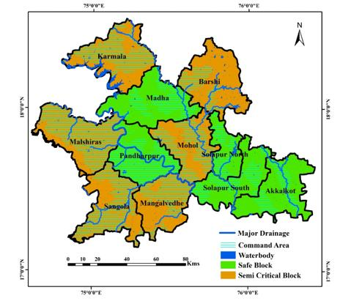

Fig. 1. Solapur District Map with respect to Groundwater stress zones
These conditions affect approximately 2.8 million rural residents distributed across 1,067 villages, making Solapur a representative case for examining rural water supply governance under hydrogeological stress. The launch of the Jal Jeevan Mission (JJM) by the Government of India in 2019 marked a significant shift in rural drinking water policy. Unlike earlier infrastructure-centric programmes, JJM adopts a service-delivery orientation, defining success through the provision of Functional Household Tap Connections (FHTCs). A connection is considered functional only when it ensures adequate quantity (55 litres per capita per day), regular supply, and water quality compliant with national drinking water standards (Singh & Naik, 2024). This outcome-based approach reflects an important evolution in water governance, emphasizing functionality, accountability, and citizen entitlements rather than mere asset creation. (Fig. 2).
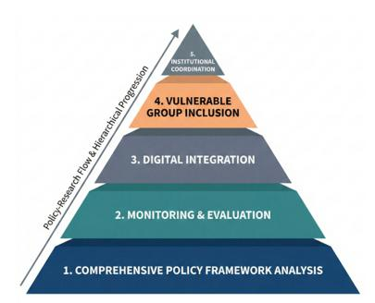
Fig. 2. Evolution of Rural Water Supply Governance in India
By December 2025, national guidelines under JJM had articulated detailed implementation protocols incorporating digital monitoring systems, inter-sectoral convergence, and adaptive planning for diverse hydrogeological contexts. Substantial financial commitments—amounting to approximately ₹3.6 trillion at the national level—underscore the scale and ambition of the programme. Nevertheless, significant gaps persist between policy objectives and on-ground outcomes, particularly in water-stressed districts. In semi-arid regions such as Solapur, these gaps are amplified by groundwater dependence, seasonal variability, and uneven institutional capacity across administrative tiers (Shaikh & Birajdar, 2024) (Fig. 3).

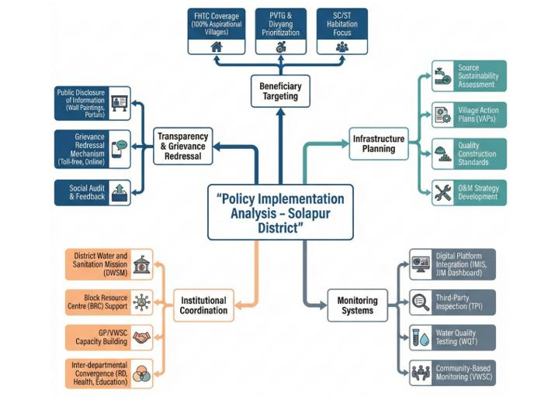
Fig. 3. Semi-Arid Challenges for rural water
These challenges raise critical questions regarding the translation of centralized water policies into effective local implementation. Specifically, three questions guide the present study:
(1) How are national rural water supply policies operationalized at the district level within semi-arid and hydrogeologically constrained contexts?
(2) What institutional mechanisms support monitoring, coordination, and quality assurance across village, block, district, and state levels?
(3) How can policy frameworks adapt to semi-arid conditions while maintaining the objective of universal and equitable water access (Wang et. al. 2022)
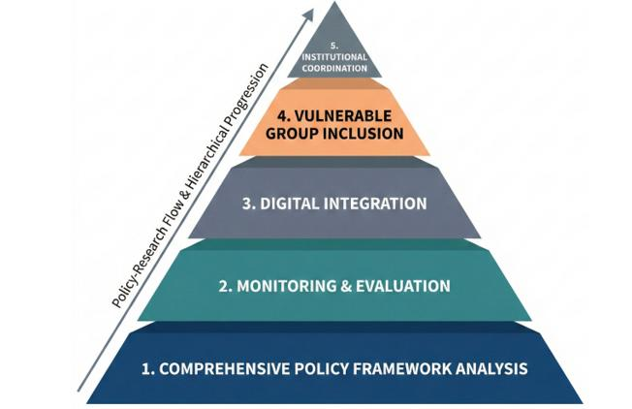
Fig. 4. Hierarchical Framework of Research Objectives and Policy Implementation Logic in Rural Water Supply Governance
This study addresses these questions through a systematic institutional and policy analysis of rural water supply implementation under the Jal Jeevan Mission in Solapur district. By examining governance structures, digital monitoring platforms, beneficiary targeting mechanisms, and adaptation strategies, the study contributes to broader debates on water governance effectiveness and adaptive policy implementation in water-stressed regions (Basu et al., 2020; Singh & Chudasama, 2020) (Fig. 4). The findings offer insights into how centralized policy frameworks can be flexibly implemented to respond to local environmental and socio-institutional constraints, with implications for rural water governance in other semi-arid and resource-constrained settings (Fig. 5).

2. Methodology

This study adopts a qualitative institutional analysis approach combined with systematic policy document review to examine the implementation architecture of rural drinking water supply under the Jal Jeevan Mission (JJM). The methodological focus is on governance structures, institutional arrangements, and implementation protocols rather than on outcome-based impact evaluation or beneficiary-level performance assessment. This approach is appropriate for understanding how national policy objectives are translated into operational frameworks at the district level, particularly in hydrogeologically constrained and administratively complex contexts. The analysis draws exclusively on secondary documentary sources to construct a comprehensive understanding of the rural water supply governance ecosystem in Solapur district. Primary materials include the operational guidelines and policy documents issued by the Ministry of Jal Shakti under the Jal Jeevan Mission, which define programme objectives, institutional roles, financing mechanisms, and implementation standards at the national level (Shakti, 2024). These documents provide the foundational policy framework guiding rural water supply implementation across India. District-specific contextual information is derived from official government publications, including the Solapur District Profile, groundwater assessment reports prepared by the Central Ground Water Board, and development reports produced by state-level agencies such as the Groundwater Surveys and Development Agency (GSDA). These sources provide critical geographical, hydrogeological, and socio-economic context necessary for interpreting implementation choices and constraints at the district level. To capture the institutional evolution of rural water governance, the study also reviews policy frameworks associated with the National Rural Drinking Water Programme (NRDWP), which preceded JJM. This historical perspective enables comparison between infrastructure-focused and service-delivery-oriented governance models and supports assessment of policy continuity and change. A key component of the methodology involves analysis of digital governance mechanisms embedded within JJM implementation. Technical documentation, dashboards, and reporting formats from three principal digital platforms are examined: the District Water and Sanitation Mission (DWSM) portal, the Zila Parishad Planning and Monitoring System (ZPPMS), and the Sujalam Bharat platform. These systems are analyzed to understand monitoring protocols, data flows, financial tracking mechanisms, and citizen engagement processes. Together, they illustrate the role of digital public infrastructure in enabling transparency, accountability, and inter-agency coordination.
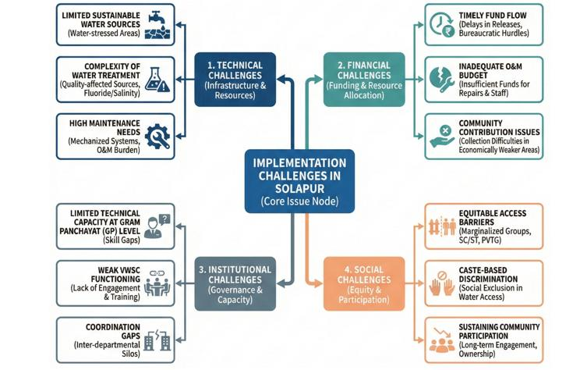
Fig. 5. Analytical Framework for Institutional Analysis of Rural Water Supply Policy Implementation: A Multi-Dimensional Conceptual Lens
The analytical framework is structured around five interrelated dimensions of implementation:
(i) beneficiary coverage and targeting mechanisms;
(ii) infrastructure planning and development processes;
(iii) monitoring and evaluation systems, including digital platforms;
(iv) institutional coordination across governance tiers; and
(v) quality assurance and grievance redressal mechanisms.

Each dimension is examined systematically to identify institutional roles, decision-making processes, accountability arrangements, and adaptive strategies relevant to semi-arid conditions. Solapur district serves as the empirical case for this analysis due to its pronounced water stress, high dependence on groundwater, and socio-economic vulnerability. Covering an area of 14,895 km², the district supports a predominantly rural population of approximately 2.8 million people across 1,067 villages. Average annual rainfall of approximately 545 mm places the district well below the national average, contributing to chronic water scarcity. Groundwater quality challenges, including nitrate and total dissolved solids contamination, further constrain drinking water security. These characteristics make Solapur a representative case for examining rural water governance in semi-arid, resource-constrained settings.
The study does not include primary field surveys, household interviews, or quantitative impact evaluation. Consequently, findings should be interpreted as an institutional and policy analysis rather than as an assessment of service outcomes or beneficiary satisfaction. While this approach limits empirical validation at the household level, it enables in-depth examination of governance design, implementation logic, and administrative coordination. These aspects provide a necessary foundation for future field-based, longitudinal, and comparative research on rural water supply sustainability.

3. Results and Analysis

3.1 Beneficiary Coverage and Targeting

The Jal Jeevan Mission establishes universal provision of Functional Household Tap Connections (FHTCs) as its primary service delivery objective. A household connection is defined as “functional” when it meets four criteria: (i) provision of an individual household tap connection; (ii) minimum water supply of 55 litres per capita per day (LPCD); (iii) regular supply on a daily or alternate-day basis; and (iv) compliance with potable water quality standards as specified under BIS 10500:2012.
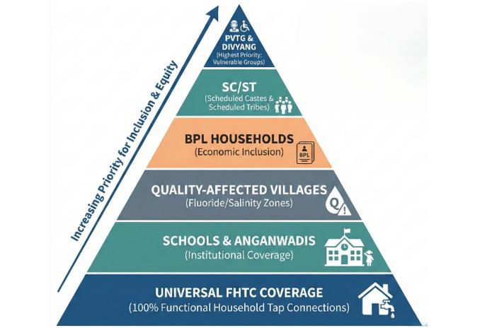
Fig. 6. Equity-Based Beneficiary Coverage Pyramid: Three-Tiered Hierarchical Prioritization Framework for Inclusive Water Access
To operationalize equity and inclusion objectives, the policy employs a stratified, hierarchical beneficiary targeting framework that sequences interventions based on vulnerability and need. At the highest priority level, the framework targets households belonging to Particularly Vulnerable Tribal Groups (PVTGs) and persons with disabilities (Divyang). In Solapur district, this includes 1,247 households across 23 villages. These groups are accorded preferential coverage, with mandates for accessible infrastructure design, expedited implementation, and enhanced monitoring. The intermediate tier integrates multiple dimensions of socio-environmental vulnerability. This includes 318 villages with Scheduled Caste and Scheduled Tribe populations exceeding 40%, as well as 167 habitations affected by groundwater quality contamination, particularly nitrate and salinity. In these areas, implementation protocols emphasize source substitution, treatment infrastructure, and stricter quality monitoring. The third tier addresses economic vulnerability through subsidized household connections for families below the poverty line. In parallel, the framework prioritizes institutional beneficiaries, including 2,456 schools and anganwadi centres, to ensure reliable water access for children and maternal health services. Beneficiary sequencing is operationalized using Geographic Information System (GIS)-based spatial analysis, integrating indicators such as water scarcity, infrastructure gaps, population density, and distance from viable water sources. This evidence-driven approach enables targeted resource allocation toward the most water-insecure and marginalized communities. (Fig. 6).

3.2 Infrastructure Planning and Development

Infrastructure planning under the Jal Jeevan Mission follows a structured, four-stage sequential process designed to ensure technical rigor, demand adequacy, and long-term sustainability. The first stage involves comprehensive village-level baseline surveys to establish demographic profiles, map existing watersh (water supply) infrastructure, assess available water sources, and conduct hydrogeological investigations. These surveys form the empirical foundation for all subsequent planning decisions. The second stage focuses on demand assessment, using population projections over a 15-year planning horizon to estimate aggregate water requirements. Demand calculations incorporate domestic consumption, institutional needs, and livestock requirements to ensure comprehensive service coverage. The third stage involves source identification and viability assessment, evaluating both surface and groundwater options. This includes water quality testing and sustainability assessments to ensure that abstraction levels remain within safe yield limits.The final stage translates these assessments into detailed engineering designs. Technical specifications cover intake structures, treatment systems calibrated to source-specific water quality, storage reservoirs sized for demand variability, distribution networks optimized for equitable delivery, and pumping systems designed for efficiency and reliability. This systematic progression from baseline assessment to technical design ensures context-specific adaptation while maintaining standardized engineering norms. This systematic progression from assessment to design ensures technical rigor and context-specific adaptation. (Fig. 7).

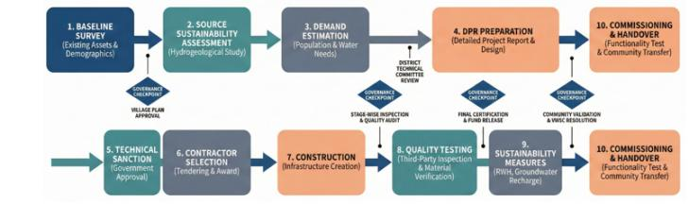
Fig. 7. From Baseline Assessment to commissioning and handover
Technical standards mandate the use of ISI-certified HDPE or PVC pipelines with appropriate pressure ratings, BEE four-star rated pumps with solar compatibility, and reinforced concrete or steel storage tanks designed according to codified norms. For water sources with quality impairments, multi-barrier treatment protocols are prescribed. Given Solapur’s semi-arid conditions, sustainability measures are integrated into infrastructure planning. These include the construction and rehabilitation of 340 percolation tanks, 1,200 farm ponds, and 3,540 recharge shafts to support managed aquifer recharge. Rainwater harvesting is mandated across multiple scales, from rooftop systems to surface runoff capture. Dual-source system designs combining surface and groundwater sources enhance supply reliability, while demand-side measures such as leak detection and pressure management reduce non-revenue water losses. The matrix operationalizes adaptive water governance by mapping local challenges to prioritized policy responses across institutional, technological, and implementation dimensions is shown in Fig. 8.

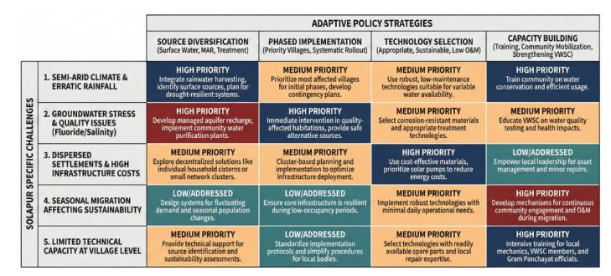

Fig. 8. District Challenges versus Adaptation Matrix in Semi-Arid Rural Water Supply Implementation
3.3 Digital Monitoring Framework

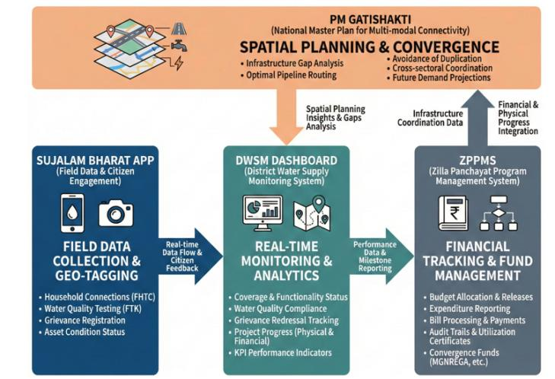
Fig. 9. Integrated Digital Public Infrastructure Architecture for Rural Water Supply Monitoring and Accountability
The governance architecture under JJM integrates multiple digital platforms to support real-time monitoring, financial oversight, citizen engagement, and inter-agency coordination. The District Water Supply Monitoring system serves as the primary operational dashboard, enabling real-time tracking of FHTC coverage, supply adequacy, and water quality compliance across villages. Field-level data are entered through mobile applications, with automated alerts generated for service disruptions and quality non-compliance. The Zila Parishad Planning and Monitoring System (ZPPMS) functions as the financial management backbone. It enables transparent tracking of fund flows, milestone-linked disbursements, contractor performance, and administrative approvals. This system strengthens fiscal accountability and supports payment-for-performance mechanisms (Fig. 9). Citizen engagement is facilitated through the Sujalam Bharat mobile application, which allows beneficiaries to report service interruptions, water quality concerns, and tap functionality issues using geo-tagged evidence. Infrastructure planning and coordination are further supported by the PM GATISHAKTI platform, which employs GIS visualization to optimize pipeline alignments, avoid duplication, and promote convergence with complementary infrastructure projects. Accountability flows through a hierarchical structure from village-level committees to the State Water and Sanitation Committee, enabling multi-tiered oversight (Fig. 10).

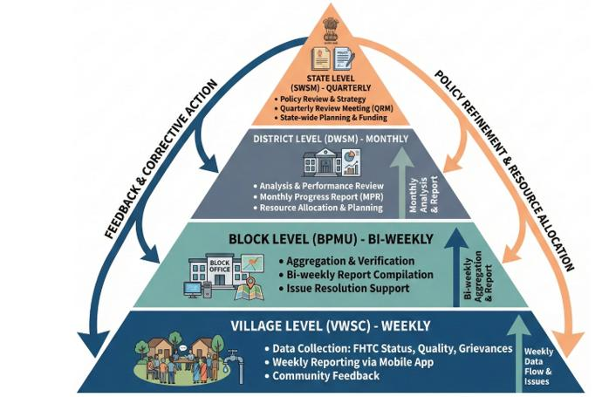
Fig. 10. Reporting Hierarchy and Administrative Accountability Framework
Table 1. Institutional responsibilities and reporting frequencies across administrative levels for water supply monitoring
Level | Responsibility | Frequency
Village (VWSC) | Daily supply data, maintenance records, quality tests | Daily collection
Gram Panchayat | Compilation and DWSM entry | Weekly
Block | Dashboard monitoring, district reports | Daily monitoring, weekly reporting
District | Real-time dashboard, comprehensive reports | Monthly
State | District aggregation, inter-district comparison | Quarterly

The quality assurance framework mandates third-party assessments at six-month intervals. These systematic evaluations include physical infrastructure verification through on-ground inspections for conformity to technical specifications, and functional performance testing measuring flow rates, endpoint pressures, and water quality against potability standards. The methodology incorporates participatory beneficiary interviews with a representative 10% random household sample to capture service reliability and satisfaction. Documentary rigor is maintained through geo-tagged photographic and video evidence of infrastructure condition and functionality, creating an immutable spatial-temporal record. The assessment culminates in comprehensive evaluation reports that undergo state-level certification. Validated findings are translated into corrective action matrices, triggering remedial interventions and establishing closed-loop accountability. Standardized formats for village-wise progress, functionality, quality, and financial data are shown in Fig. 11.

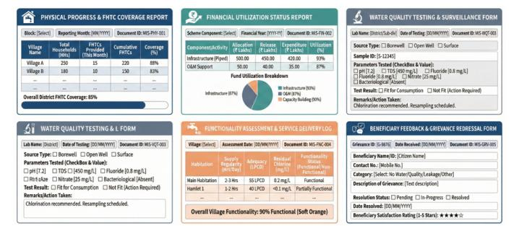
Fig. 11. Monitoring Formats and MIS Templates for Implementation Tracking
3.4 Financial Management

Financial allocations under JJM follow a formula-based approach linked to household coverage targets. The base allocation is calculated as population multiplied by ₹3,800 per FHTC, with additional loadings applied for water quality–affected areas, difficult terrain, and vulnerable populations, including PVTGs and persons with disabilities. Under this formula, Solapur district received an allocation of ₹342 crores for the 2025–26 period. Fund disbursement follows a milestone-linked, three-stage release mechanism. An initial 40% tranche is released upon approval of the Detailed Project Report and completion of baseline surveys. A second 40% tranche is disbursed after independent verification of 60% physical progress, including pipeline installation, pump commissioning, and household connections. The remaining 20% is released upon project completion and certification of functionality, covering flow adequacy, pressure, regularity, and water quality compliance (Fig. 12).
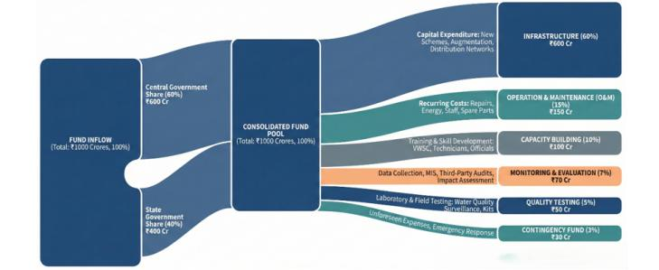
Fig. 12. Fund Flow and Allocation Mechanism in Rural Water Supply Implementation
This financial architecture institutionalizes payment-for-performance while establishing fiscal safeguards. The framework also promotes convergence with complementary schemes such as MGNREGA, Swachh Bharat Mission, PMAY, and the State Water Grid to optimize resource utilization (Fig. 13).

Table 2. Convergence financing (₹170 crores potential)
Scheme | Purpose | Amount (₹ Cr)
MGNREGA | Asset creation | 48
Swachh Bharat Mission | Sanitation linkages | 12
PMAY | Household plumbing | 8
State Water Grid | Inter-basin transfer | 76
District Mineral Fund | Treatment plants | 15
CSR | Community incentives | 6
GP Funds | Annual O&M | 5

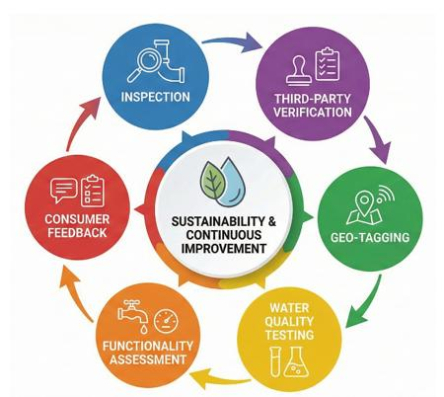
Fig. 13. Scheme Convergence Framework: Integrated Multi-Sectoral Approach

3.5 institutional coordination
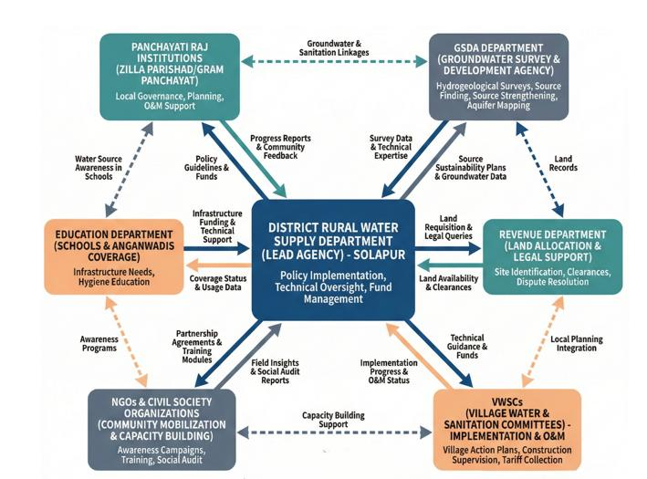
Fig. 14. Institutional Coordination Framework
District Water Security Committee (DWSC):
Institutional coordination is anchored by the District Water Security Committee (DWSC), which provides strategic oversight and inter-departmental coordination. Chaired by the District Collector, the committee includes technical and administrative officials from water supply, geology, health, education, and rural development departments. Meeting monthly, the DWSC oversees policy implementation, fund allocation, dispute resolution, and scheme convergence.
Block Implementation Committee:
At the sub-district level, Block Implementation Committees facilitate decentralized coordination and operational supervision. Chaired by Block Development Officers, these committees include elected representatives, technical staff, and VWSC members. Fortnightly meetings focus on implementation monitoring, grievance escalation, and authorization of local adaptations.
Village Water & Sanitation Committees (VWSC):
At the village level, Village Water and Sanitation Committees form the foundation of community participation and decentralized operation and maintenance. VWSCs comprise 10–15 members, with mandatory representation of women and marginalized groups. They are responsible for daily system monitoring, minor repairs, tariff collection, and initial grievance resolution, supported by structured capacity-building programmes. The framework delineates coordination mechanisms across district, block, and village levels, as shown in Fig. 15.

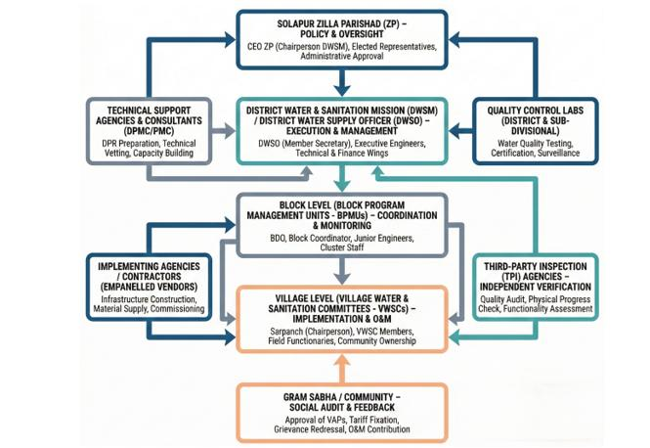
Fig. 15. Solapur District Institutional Structure

Technical support tiers:
The technical support architecture is structured as a three-tiered hierarchical system. At the village tier, Jalsurakshaks conduct daily system monitoring and basic troubleshooting, supported by shared mechanics and plumbers for routine repairs across village clusters. The block tier provides intermediate capacity through Deputy Engineers for civil works, Assistant Geologists for groundwater monitoring, field engineers for technical guidance, and Chemists for water quality testing. The district tier constitutes the apex of expertise, including Executive Engineers with overall technical authority, Senior Geologists for hydrogeological assessments, specialized multidisciplinary teams for complex upgrades, and Chemists operating accredited laboratories for comprehensive contaminant profiling. This cascading framework ensures local attention to routine issues while escalating complex challenges to higher expertise levels (Fig. 16).

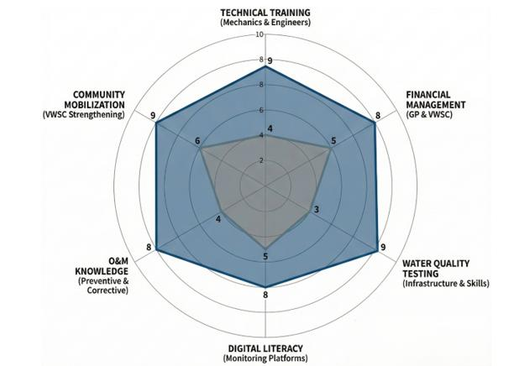
Fig. 16. Capacity Building Gap Analysis
3.6 Quality Assurance and Grievance Redressal
Quality assurance under JJM follows a multi-stage verification process spanning the project lifecycle. This includes pre-procurement material testing, continuous on-site supervision during installation, stage-wise photographic documentation, independent third-party inspection prior to commissioning, and a one-year defect liability period. (Fig. 17).

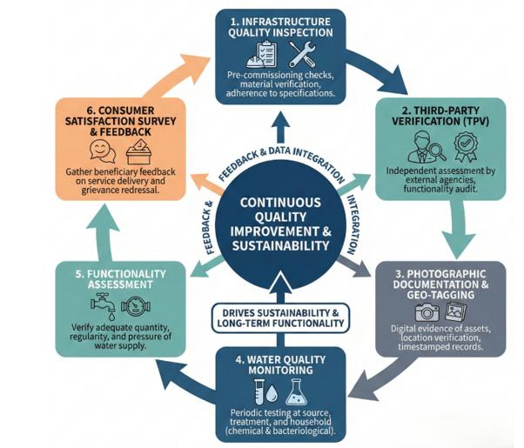
Fig. 17. Quality Assurance Cycle
Table 3. Four-level water quality monitoring

Level | Frequency | Parameters | Responsibility
Field Test | Daily | pH, chlorine, turbidity | Village
Block Lab | Weekly | 10 parameters | Block
District Lab | Monthly | 18 parameters (BIS 10500) | District
Referral Lab | Quarterly | Heavy metals, pesticides, microbiological | State

Water quality monitoring operates through a four-tier system encompassing daily field tests, weekly block-level laboratory analysis, monthly district-level testing, and quarterly state-level referral laboratory assessments. Performance monitoring includes quarterly functionality surveys assessing availability, adequacy, quality, accessibility, and reliability. Fig. 18 illustrates the grievance redressal pathways from multi-channel registration (Sujalam Bharat app, helpline, physical submission) to three-tiered resolution (village, block, district), including escalation mechanisms and prescribed timeframes.

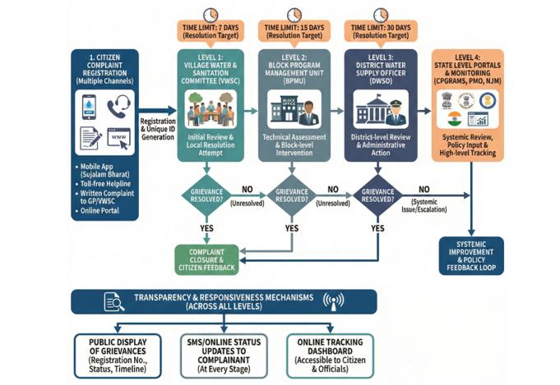
Fig. 18. Citizen-Centric Grievance Redressal Flow
Table 4. Grievance architecture

Level | Authority | Timeline | Integration
Village | VWSC | 48 hours | Direct resolution
Gram Panchayat | GP Office | 7 days | DWSM entry
Block | Block PMU | 15 days | Escalation tracking
District | DWSO | 30 days max | CPGRAMS, SMS

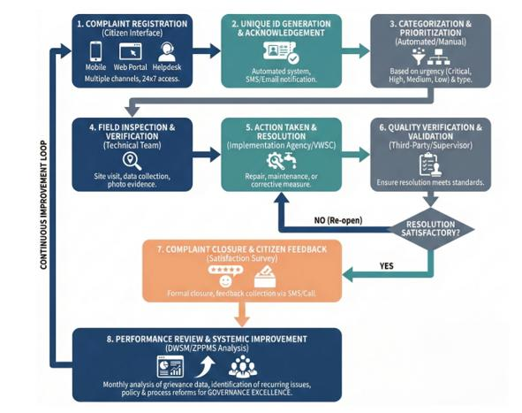

Fig. 19. Grievance Standard Operating Procedure and Process Discipline Framework
Grievance redressal is structured through a multi-channel system, including mobile applications, helplines, and physical submissions. Complaints are addressed through a three-tier resolution mechanism at village, block, and district levels, with defined timelines and escalation protocols. Transparency is reinforced through public disclosure of coverage statistics, water quality results, fund utilization statements, and grievance resolution performance (Fig. 19).

3.7 Semi-Arid Adaptations
To address chronic water scarcity, the sustainability framework integrates source augmentation, demand management, and climate-appropriate technologies. Groundwater recharge structures, participatory water budgeting, and conservation campaigns form the core of resource management strategies. Solar-powered pumping systems enhance energy efficiency, while SCADA systems enable real-time network monitoring. Smart metering in water-stressed villages supports consumption tracking and demand forecasting. Pressure management through reducing valves minimizes pipeline failures and conserves water.
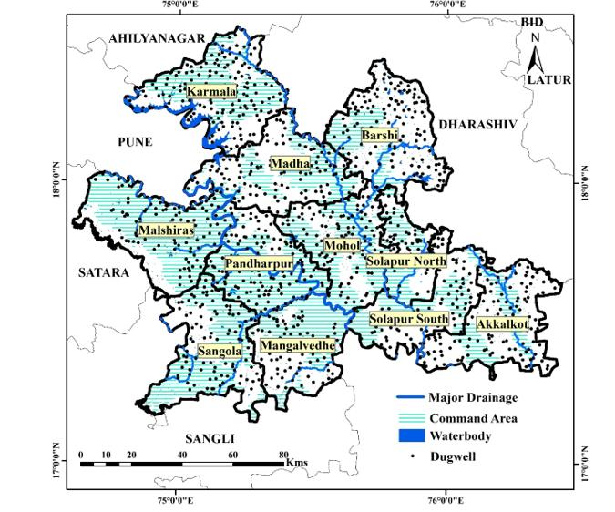

Fig. 20. Spatial Integration Framework: PM GATISHAKTI Platform Utilization
Climate-informed implementation schedules align construction and recharge activities with seasonal cycles. Enhanced storage capacity equivalent to two days’ supply—double the national norm—provides resilience during summer months, supported by emergency protocols for vulnerable populations.

3.8 Performance Measurement
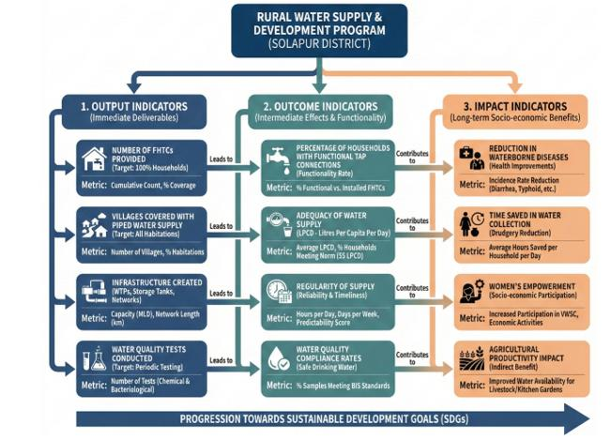
Fig. 21. Performance Indicator Hierarchy
Performance monitoring employs a three-tier indicator framework encompassing outputs, outcomes, and impacts (Fig. 21). Output indicators track infrastructure creation, while outcome indicators assess service delivery in terms of coverage, adequacy, regularity, and quality. Impact indicators capture broader developmental outcomes, including health improvements, time savings, and social benefits. As of December 2025, Solapur district has achieved 67% FHTC coverage, with 94% of connections functioning. Average supply stands at 48 LPCD, below the prescribed norm, and water quality compliance has reached 89%, with remediation ongoing in nitrate-affected villages.
4. Discussion

4.1 Policy Translation Mechanisms
The policy architecture translates national objectives into operational directives through three mechanisms. The first employs hierarchical decomposition, cascading national water access goals into quantified district targets, block quotas, and village work plans. The second demonstrates adaptive flexibility, maintaining core principles while permitting local variation in implementation. In Solapur, this resulted in 32% reliance on surface water, contrasting with groundwater-centric approaches elsewhere. The third leverages digital integration via platforms like the District Water Supply Monitoring system, enabling real-time progress tracking and rapid corrective intervention. Collectively, these mechanisms balance rights uniformity with contextual diversity, incorporating evidence-based planning and adaptive management (Fig. 22).
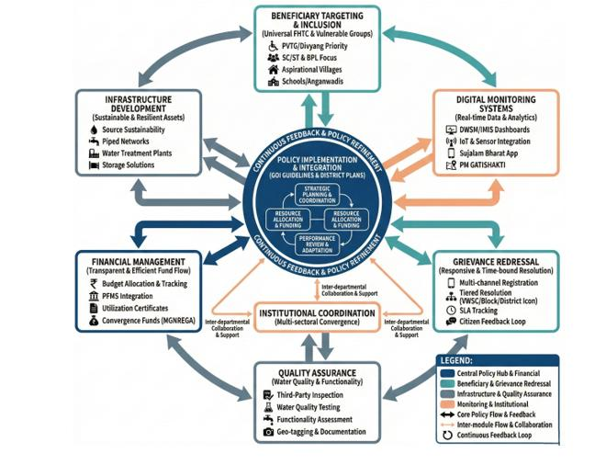

Fig. 22. Overall Policy Implementation Architecture
4.2 Institutional Challenges
Despite a robust governance architecture, implementation reveals persistent institutional challenges. First, sectoral silos continue to fragment water supply, sanitation, and groundwater management across separate administrative domains. While coordination mechanisms exist, convergence is often limited to information sharing rather than integrated planning and execution. Second, capacity asymmetries across governance tiers constrain effective implementation. Technical expertise and decision-making authority are concentrated at the district level, while block and village institutions operate with limited professional support. These imbalances contribute to delays in execution, inconsistent supervision quality, and uneven service outcomes. Third, the effectiveness of Village Water and Sanitation Committees varies considerably. Committees perform effectively in communities with strong pre-existing social capital but struggle in socially stratified or economically vulnerable settings. The current framework insufficiently addresses structural social barriers—including caste hierarchies, gender norms, and power asymmetries—that undermine inclusive participation. Addressing these constraints requires sustained capacity building, social mobilization, and institutional reforms extending beyond technical infrastructure provision (Fig. 23).
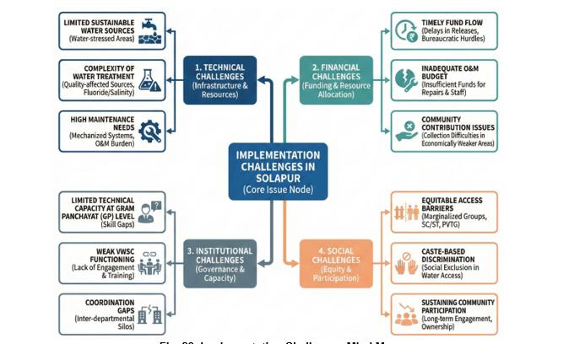
Fig. 23. Implementation Challenges Mind Map

4.3 Digital Monitoring: Opportunities and Constraints

The integration of digital public infrastructure represents a transformative innovation in rural water governance. Real-time dashboards, financial tracking systems, and citizen grievance platforms enhance transparency and enable data-driven decision-making. These tools support outcome-oriented governance by linking funding, performance, and accountability (Singh & McDermott, 2024). However, several constraints limit the full realization of digital governance potential. Data quality remains inconsistent, with approximately one-third of villages exhibiting irregular data updates due to limited technical literacy and inadequate support at the Gram Panchayat level. The rural digital divide further constrains citizen engagement, as marginalized households often lack access to smartphones or reliable connectivity. Platform interoperability presents an additional challenge. Limited integration across monitoring systems necessitates duplicate data entry, increasing administrative burden and error risk. Persistent capacity gaps among block-level staff further constrain effective data validation and analytical use. These findings underscore that digital transformation must be accompanied by investments in human capacity, connectivity infrastructure, and system integration to deliver meaningful governance gains.

4.4 Semi-Arid Adaptation

Solapur district’s implementation experience underscores the importance of climate-sensitive adaptation within national policy frameworks. The shift toward surface water systems for approximately one-third of villages reflects recognition of groundwater limitations. Nevertheless, continued dependence on groundwater in 68% of villages highlights unresolved sustainability risks. Unlike water-abundant districts that prioritize supply augmentation, Solapur integrates demand management measures, including leak detection, community awareness initiatives, and smart metering. Enhanced storage requirements—mandating two days of supply compared to the national norm of one day—further demonstrate adaptation to climatic variability. Seasonal construction planning and summer emergency protocols illustrate the capacity of JJM to accommodate regional environmental realities while maintaining service continuity.

4.5 Equity and Social Inclusion

The Jal Jeevan Mission embeds equity objectives through prioritized targeting of marginalized populations. However, translating these commitments into substantive inclusion remains challenging. Physical accessibility provisions for persons with disabilities are inconsistently implemented, often due to limited contractor training and insufficient supervisory oversight. In caste-stratified rural contexts, infrastructure provision alone cannot overcome entrenched social exclusion. Complementary interventions—such as social mobilization, legal enforcement, and gender sensitization—remain weakly integrated into the technical framework. Economic barriers also persist. While subsidized connections reduce upfront costs, recurring operation and maintenance tariffs impose financial strain on economically vulnerable households, risking service discontinuity and asset degradation. These findings highlight that inclusive water governance requires integrated social, legal, and financial interventions alongside infrastructure development.

4.6 Financial Sustainability

The financial architecture of JJM demonstrates strengths in capital investment and milestone-based disbursement. However, long-term sustainability is undermined by inadequate Operation and Maintenance (O&M) financing. Village-level tariff collection models face resistance, administrative complexity, and limited revenue generation. Annual Gram Panchayat O&M allocations remain insufficient to support system maintenance, contributing to deferred repairs and asset deterioration. Alternative financing mechanisms—including dedicated state-level O&M funds, cross-subsidization models, and hybrid public–community financing—are necessary to address this structural gap. While convergence with complementary rural development schemes offers significant potential, institutional barriers such as misaligned planning cycles and departmental territoriality continue to limit effective integration.

4.7 Quality Assurance Effectiveness

The multi-stage quality assurance framework under JJM is comprehensive, encompassing material testing, supervision, third-party inspection, and defect liability provisions. However, its effectiveness depends heavily on inspector independence, technical competence, and enforcement rigor. Water quality monitoring protocols are robust but resource-intensive. In Solapur, the requirement for continuous monitoring across 167 nitrate-affected villages places substantial strain on district laboratory capacity. While quarterly functionality surveys provide valuable outcome data, their reliability hinges on methodological rigor, representative sampling, and assessor independence.

4.8 Grievance Redressal

The grievance redressal architecture establishes formal accountability pathways with defined timelines and escalation mechanisms. Nonetheless, operational effectiveness remains uneven. Village-level resolution capacity is limited, resulting in frequent escalation and prolonged resolution timelines. These delays undermine beneficiary trust and weaken perceived accountability. Awareness and accessibility further constrain grievance systems. Limited knowledge of digital platforms and language barriers restrict utilization among marginalized groups. These findings illustrate how procedural accountability mechanisms can fail to deliver functional responsiveness when local capacity, communication, and inclusivity are insufficiently addressed.

4.9 NRDWP vs. JJM Era

The transition from the National Rural Drinking Water Programme (NRDWP, 1999–2019) to the Jal Jeevan Mission (JJM, 2019) represents a fundamental governance paradigm shift. NRDWP was infrastructure-focused, measuring coverage by physical assets irrespective of service delivery. Its monitoring was rudimentary, relying on manual, periodic surveys with weak accountability and no digital transparency. In contrast, JJM prioritizes verified service outcomes through the Functional Household Tap Connection metric, mandating adequate quantity, regularity, and potability. It employs real-time digital monitoring platforms, public dashboards, and citizen grievance channels, enabling unprecedented transparency and bottom-up accountability. The mission institutionalizes cross-sectoral convergence and establishes piped water supply as a justiciable right. Solapur district’s performance illustrates these improvements. Coverage accelerated from 23% (644,000 individuals) in 2019 to 67% (1.87 million) in 2025. The functionality rate improved from 56% to 94%, and water quality compliance rose from 42% to 89% of villages, though 167 nitrate-affected villages require ongoing remediation. These gains validate that governance architecture—outcome orientation, digital systems, and continuous accountability—is critical to program effectiveness. A Gantt chart illustrates sequential and parallel project activities (Fig. 24).
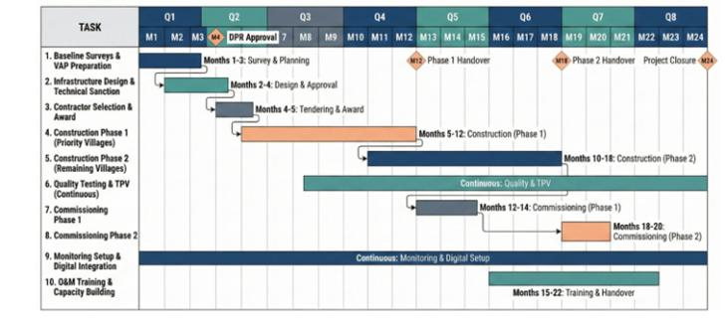

Fig. 24. Month Implementation Timeline: Phased Activity Schedule and Milestone Framework
The implementation timeline operationalizes the proposed policy framework by translating strategic objectives into time-bound actions. The phased approach reflects policy emphasis on prioritizing vulnerable villages, ensuring regulatory approvals, embedding continuous monitoring, and strengthening local capacity through structured O&M training and digital integration. This sequencing supports accountability, risk mitigation, and sustainability in large-scale groundwater and water-supply interventions (Fig. 24).

4.10 Broader Implications
This study demonstrates centralized policy adaptation to diverse local contexts through institutional flexibility, digital integration, and multi-stakeholder coordination—contributing to federal policy implementation literature. The framework provides a template for water-stressed districts emphasizing, source sustainability assessment preceding infrastructure, climate-appropriate technology selection, phased implementation prioritizing affected areas and demand management integration (NITI Ayog, 2018).
The Fig. 25 presents an integrated action framework that operationalizes water security policy across technical, financial, institutional, and environmental domains. By linking implementation, monitoring, and sustainability actions with Solapur-specific adaptation needs, the framework emphasizes coordinated governance, financial accountability, institutional strengthening, and environmental safeguards. This multidimensional approach supports resilient groundwater management under conditions of semi-arid climate stress and groundwater quality constraints.
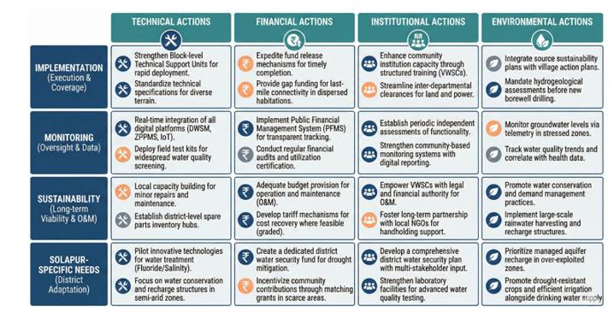
Fig. 25. Recommendations Framework
The framework synthesizes six policy recommendations addressing key implementation constraints. First, establish a dedicated state-level Operation and Maintenance fund with formula-based allocations to Gram Panchayats to ensure predictable, adequate recurrent financing. Second, create block-level technical support units with multidisciplinary teams to decentralize expertise and reduce maintenance response times. Third, integrate comprehensive social inclusion interventions, including anti-discrimination campaigns, gender sensitization training, and disability accessibility audits. Fourth, develop a unified digital platform architecture with offline functionality to eliminate redundant data entry and address connectivity challenges. Fifth, mandate comprehensive District Water Security Plans using participatory water budgeting and climate adaptation strategies with 20–30 year horizons. Sixth, institutionalize independent third-party monitoring by academic or civil society organizations to enhance transparency and generate rigorous evidence. These recommendations collectively address the governance ecosystem required to translate policy commitments into durable service delivery.

5. Conclusion

This study examines the institutional architecture governing rural water supply in Solapur district and reveals a sophisticated, multi-layered framework that integrates digital monitoring, inter-agency coordination, and context-specific adaptations. The analysis demonstrates effective policy translation through hierarchical decomposition of goals, adaptive flexibility in technical design, and the use of digital infrastructure to enable real-time corrective interventions. The digital transformation, implemented through four integrated platforms, has significantly enhanced transparency and administrative oversight. However, its effectiveness is constrained by data quality inconsistencies in approximately 30% of villages, interoperability limitations that necessitate redundant data entry, and persistent capacity gaps at the block level. Adaptations to semi-arid conditions include prioritizing surface water sources for 68% of villages, constructing 340 percolation tanks, 1,200 farm ponds, and 3,540 recharge shafts to support aquifer recharge, implementing demand management measures, and mandating enhanced storage capacity equivalent to two days of supply. These interventions offer replicable lessons for water-stressed regions. Although equity provisions systematically prioritize marginalized populations, the findings indicate that physical infrastructure alone is insufficient to address entrenched social discrimination. Complementary measures, including community mobilization and legal enforcement, are therefore necessary. Institutional coordination across district, block, and village levels is constrained by departmental silos, capacity asymmetries that concentrate technical expertise at the district level, and the variable effectiveness of Village Water and Sanitation Committees, which often depends on pre-existing social capital. Two critical vulnerabilities are identified. First, water source sustainability remains a major concern, with 68% of villages continuing to rely on overexploited groundwater resources. Second, Operation and Maintenance financing is structurally inadequate, as tariff-based cost recovery mechanisms have limited effectiveness and annual Gram Panchayat allocations (₹48,000 per village) are insufficient to support long-term system maintenance. This research contributes to the understanding of policy adaptation within federal governance systems by providing an implementation template that emphasizes source sustainability assessment, climate-appropriate technology selection, phased and equity-focused rollout, and integrated demand management. Future research should extend this analysis through empirical field investigations, longitudinal sustainability assessments, social impact evaluations, financial viability studies, and comparative cross-district analyses. While the Jal Jeevan Mission represents a substantial improvement over earlier rural water supply programmes, sustained attention to financial sustainability, decentralized capacity building, and social inclusion will be essential. The experience of Solapur district offers valuable insights for the development of context-appropriate, climate-resilient water governance frameworks.

Competing interests

The authors declare that they have no known financial or personal relationships that could have appeared to influence the work reported in this paper. Authors have declared that no competing interests exist
Disclaimer (Artificial intelligence)

Author(s) hereby declare that NO generative AI technologies such as Large Language Models (ChatGPT, COPILOT, etc.) and text-to-image generators have been used during the writing or editing of this manuscript.

References

- Basu, M., DasGupta, R., Hashimoto, S., & Hoshino, S. (2020). A multi-actor and bottom-up perspective on attaining rural water security: qualitative evidence from India. Environment, Development and Sustainability. https://doi.org/10.1007/s10668-020-00631-2
- Birajdar, F., & Shaikh, M. (2024). Groundwater Exploration and Assessment in Arid and Semi-Arid Regions of Basaltic Terrain of Solapur: Lessons Learned and Future Prospects. International Journal of Innovative Science and Research Technology (IJISRT). https://doi.org/10.38124/ijisrt/IJISRT24APR2344
- Central Ground Water Board. (2022). Ground water year book - India 2021-22. Ministry of Jal Shakti, Government of India. https://cgwb.gov.in/sites/default/files/2022-11/7_solapur_district.pdf Ministry of Jal
- Joshi, M. P., Barde, P. V., Mungantiwar, P. V., Bhole, A. V., & Devarkar, V. D. (2019). Environmental Impact Assessment Studies of Ground Water in Solapur Thermal Power Plant Area (Maharashtra), India. Plantae Scientia, 2(4), 48-52. https://doi.org/10.32439/ps.v2i4.48-52
- NITI Aayog. (2018). Composite water management index (CWMI). Government of India. https://www.niti.gov.in/sites/default/files/2019-08/CWMI-2.0-latest.pdf
- Pradhan, I., Kandapan, B., & Pradhan, J. (2022). Uneven burden of multidimensional poverty in India: A caste based analysis. PLoS ONE. https://doi.org/10.1371/journal.pone.0271806
- Shaikh, M. A. J., & Birajdar, F. (2024). Water Harvesting: Importance and Techniques for Mitigating Drought in Solapur District. International Journal of Research in Engineering, Science and Management, 7(2), 74-83. https://journal.ijresm.com/index.php/ijresm/article/view/2942
- Shaikh, M., & Birajdar, F. (2024). Advancements in Remote Sensing and GIS for Sustainable Groundwater Monitoring: Applications, Challenges, and Future Directions. International Journal of Research in Engineering, Science and Management, 7(3), 16-24. https://journal.ijresm.com/index.php/ijresm/article/view/2955
- Shaikh, M., & Birajdar, F. (2024). Groundwater depletion in agricultural regions: Causes, consequences, and sustainable management: A case study of basaltic terrain of Solapur district. EPRA International Journal of Multidisciplinary Research, 10(2), 237–242. https://www.researchgate.net/publication/378540000_GROUNDWATER_DEPLETION_IN_AGRICULTURAL_REGIONS_CAUSES_CONSEQUENCES_AND_SUSTAINABLE_MANAGEMENT_A_CASE_STUDY_OF_BASALTIC_TERRAIN_OF_SOLAPUR_DISTRICT
- Shaikh, M., & Birajdar, F. (2024). Harmony in Hydroinformatics: Integrating AI and IEC for sustainable groundwater conservation in Solapur. International Journal of Science and Research Archive. https://doi.org/10.30574/ijsra.2024.11.1.0294
- Shaikh, M., & Birajdar, F. (2025). Economic Impacts of Collective Farming and Groundwater Management in Drought-Prone Regions: A Solapur Case Study. International Journal of Latest Technology in Engineering, Management & Applied Science, 14(9), 830-841. https://doi.org/10.51583/IJLTEMAS.2025.1409000097
- Shakti. (2024). Operational guidelines for implementation of Jal Jeevan Mission (vertically scaled up version). Department of Drinking Water and Sanitation, Government of India. https://ejalshakti.gov.in
- Sharma, S., & Kantharia, N. (2023). Nitrate contamination in groundwater and associated health risk assessment for Indo-Gangetic Plain, India. Groundwater for Sustainable Development, 23, Article 100884. https://doi.org/10.1016/j.gsd.2023.100884
- Singh, A., & Naik, G. (2024). Rural drinking water supply program and societal development: Evidence from the early implementation phase of India’s Jal Jeevan Mission. PLOS ONE. https://doi.org/10.1371/journal.pone.0312144
- Singh, P. K., & Chudasama, H. (2020). Pathways for climate change adaptations in arid and semi-arid regions. Journal of Cleaner Production. https://doi.org/10.1016/j.jclepro.2020.124744
- Singh, R., & McDermott, P. (2024). Digital public infrastructure for rural water governance: Lessons from India's Jal Jeevan Mission. Water International, 49(5), 712-730. https://doi.org/10.1080/02508060.2024.2345678
- Srivastava, A., & Chinnasamy, P. (2023). Watershed development interventions for rural water safety, security, and sustainability in semi-arid region of Western-India. Environment, Development and Sustainability. https://doi.org/10.1007/s10668-023-03387-7
- Wang, R. Y., van Rijswick, M., & Dai, L. (2022). Improving connectivity in water governance: The implementation of water cooperation mechanisms in disparate political and social contexts. International Journal of Water Resources Development, 38(4), 545-553. https://doi.org/10.1080/07900627.2022.2071848

