Original Research Article

In vitro Antifungal and Antioxidant Profiling of Binuclear Thiazole-Based Schiff Base Metal Complexes

.
ABSTRACT

The rapid emergence of multidrug resistance (MDR) among pathogenic microorganisms has become a major global health concern, creating an urgent demand for new and effective pharmacophoric systems. In this context, Schiff base ligands and their transition metal complexes have gained significant attention due to their structural versatility and promising biological activities. The present study investigates the in vitro antifungal and antioxidant activities of a thiazole-based Schiff base ligand, LA and its binuclear complexes with biologically relevant transition metal ions, namely Co(II), Ni(II), Cu(II), and Zn(II). The antifungal activity of the ligand and its metal complexes was evaluated against Aspergillus niger and Fusarium oxysporum using the mycelial growth inhibition method, while antioxidant potential was assessed through the DPPH free radical scavenging assay. The results clearly demonstrate that coordination of the Schiff base ligand with metal ions significantly enhances its biological performance. Among the investigated complexes, the Cu(II) complex exhibited the highest antioxidant activity, whereas the Ni(II) and Cu(II) complexes showed superior antifungal efficacy compared to the free ligand. The observed enhancement in activity is attributed to metal-induced modulation of redox behavior, increased lipophilicity, and improved interaction with biological targets.
This study is particularly important for the scientific community as it establishes a clear link between the structural features of thiazole-based Schiff base metal complexes and their biological activities. By systematically evaluating multiple metal complexes, the work demonstrates how coordination chemistry can be strategically employed to improve antifungal and antioxidant efficacy, addressing the global challenge of MDR microorganisms. The findings provide valuable guidance for the design of novel metal-based therapeutic agents and Active Pharmaceutical Ingredients (APIs), while the correlation between metal type, structural properties, and biological performance contributes to advancing research in medicinal chemistry and bioinorganic chemistry.

Keywords: Thiazole Schiff base; binuclear metal complexes; antifungal activity; antioxidant activity.

1. INTRODUCTION

The ongoing demand for novel bioactive molecules provides strong motivation and significant opportunities for synthetic chemists to design and develop new organic and metallo-organic compounds for applications in pharmaceutical and agricultural sectors. Schiff base ligands and their transition metal complexes have long been recognized as an important class of coordination compounds due to their facile synthesis, versatile coordination behavior, and wide-ranging applications in electrochemistry, catalysis, and medicinal chemistry. The presence of the azomethine (-C=N-) functional group provides an effective donor site for metal coordination, enabling the formation of stable complexes with diverse geometries and electronic properties. Modulation of these properties through rational ligand design remains a key strategy for developing functional metal-based systems [1, 2].
Schiff base ligands containing heterocyclic moieties such as thiazole have attracted considerable attention due to their versatile coordination behavior and promising biological properties. Metal complexes derived from such ligands often show enhanced antimicrobial and antioxidant activities as compared to their parent ligands. The present work is exclusively focused on the evaluation of their antifungal and antioxidant properties. The antimicrobial activity of the synthesized Schiff base ligand and its corresponding metal complexes will be evaluated against various fungal strains to assess their potential as antifungal agents. [3-5].

The analysis will also consider how such coordination affects the biological activity of the ligand, thereby providing valuable information for the further development of metal-based drugs and therapeutic biomaterials. Against this backdrop, this study advances the understanding of the potential application of Schiff base metal complexes in medicine by focusing on the structural and biological characteristics of the complexes [6-8].
The present study is exclusively devoted to the systematic evaluation of the antifungal and antioxidant activities of a newly synthesized thiazole-based Schiff base ligand and its corresponding binuclear metal complexes. The ligand was coordinated with biologically relevant transition metal ions, namely Co(II), Ni(II), Cu(II), and Zn(II), to investigate the influence of metal chelation on biological performance. Schiff base ligands containing thiazole moieties are of considerable interest due to their structural versatility and well-documented pharmacological potential. In particular, metal complexation is known to significantly modulate the physicochemical and biological properties of such ligands by enhancing stability, lipophilicity, and redox behavior.
In this context, the antifungal activity of the synthesized ligand and its binuclear metal complexes was assessed against selected pathogenic fungal strains to determine their inhibitory efficacy and structure-activity relationships. Additionally, the antioxidant potential of the compounds was evaluated using established in vitro assays to examine their ability to scavenge free radicals and mitigate oxidative stress. A comparative analysis between the free ligand and its metal complexes was carried out to elucidate the role of the coordinated metal ions in enhancing or modifying biological activity. The findings of this study aim to contribute to the development of novel metal-based therapeutic agents with improved antifungal and antioxidant properties.

2. materialS and methods

2.1 Materials

All chemicals and reagents employed in the biological assays were of analytical grade and used as received. Dimethyl sulfoxide (DMSO) was used as a solvent for preparing stock solutions of the ligand and metal complexes. Malt extract agar (MEA) was used for antifungal studies, and DPPH (2,2-diphenyl-1-picrylhydrazyl) was used for antioxidant assays.

2.2 Synthesis and Preliminary Spectral Confirmation

The thiazole-based Schiff base ligand (LA) and its binuclear Co(II), Ni(II), Cu(II), and Zn(II) complexes were prepared following standard coordination chemistry procedures. The synthesis was performed solely to provide sufficient quantities of compounds for biological evaluation, and no synthetic novelty or optimization is claimed.
Preliminary spectral confirmation was carried out to ensure compound identity prior to bioassays. Infrared spectra of the ligand displayed a characteristic azomethine (C=N) stretching band at 1607 cm⁻¹, which shifted to lower wavenumbers (1578–1596 cm⁻¹) upon coordination with metal ions, indicating the involvement of the azomethine nitrogen in metal binding. Additional bands corresponding to metal-nitrogen (520–538 cm⁻¹) and metal-chloride (401–408 cm⁻¹) interactions further supported complex formation.
UV-Visible spectra showed ligand-centered π→π* transitions at 278 nm and n→π* transitions at 355 nm, while the metal complexes exhibited red-shifted π→π* (303–306 nm) and n→π* (373–385 nm) bands, consistent with coordination. These spectral observations confirm the formation of the metal complexes and provide assurance of their identity for subsequent biological studies.

2.3 Antifungal activity

The antifungal activity of the synthesized Schiff base ligand LA and its corresponding metal complexes, LA-A(Co), LA-B(Ni), LA-C(Cu) and LA-D(Zn) was tested against the growth of Aspergillus niger and Fusarium oxysporum using the mycelial growth inhibition technique. Sterilized 2% malt extract agar (MEA) was poured into 9 cm Petri plates under aseptic conditions and allowed to solidify. Test compounds were dissolved in DMSO to get stock solutions of 1 mg mL⁻¹ and mixed with the medium so that the final concentrations were 50, 75, and 100 µg mL⁻¹, while DMSO-containing plates were used as a control. A 1.5 mm agar disc taken from the periphery of a 7-day-old fungal culture was placed at the centre of each plate. The inoculated plates were maintained at 25 °C for 7 days, after which the colony diameter of the fungal growth was measured [9]. The percentage of growth inhibition was calculated relative to equation 1.

$Growth inhibition (\%) = [(D₀ - Dₜ) / D₀] × 100$(1)

where D_{t} denotes the diameter of the fungal colony in the presence of the test compounds, and D₀ represents the colony diameter observed in the control plates.

All experiments were performed in triplicate (n = 3). Data are presented as mean ± SD. Statistical significance was evaluated using one-way ANOVA (P < 0.05).

2.4 Antioxidant Activity

The synthesized compound's free radical scavenging activity, was assayed by the method involving DPPH (2,2-diphenyl-1-picrylhydrazyl). Stock solution of DPPH (50 µM) was prepared in methanol. In DMSO, test solutions of the compounds (100, 200, 300, and 400 µg mL⁻¹) were prepared. For each assay, the 1 mL test solution was mixed with 5 mL freshly prepared DPPH solution. Reaction mixtures were shaken thoroughly and incubated at room temperature in the dark for 30 min. At 517 nm against a control solution, the decrease in absorbance was recorded using a UV-Visible spectrophotometer. The radical scavenging efficiency of the tested compounds was expressed as the percentage inhibition of DPPH radicals and calculated using the following equation-2:

$$\% DPPH Scavanging=\frac{A_{control}-A_{sample}}{A_{control}} X 100 (2)$$

Here, A_control refers to the absorbance of the DPPH solution without any test compound (DPPH + DMSO), while A_sample represents the absorbance of the DPPH solution in the presence of the test compound [10].

3. results and discussion

3.1 Antioxidant Activity

The antioxidant activity of the synthesized Schiff base ligand (LA) and its metal complexes, LA-A(Co), LA-B(Ni), LA-C(Cu), and LA-D(Zn) were determined by the free radical scavenging assay using the DPPH assay, with ascorbic acid as a standard. The percentage scavenging activity was determined at various concentrations ranging from 100 to 400 µg mL⁻¹, and plots were drawn as shown in Fig. 1. It was observed that all tested compounds dose-dependently increased their activity in scavenging the free radicals. As expected, ascorbic acid was found to possess the highest antioxidant activity at all points of concentration. The free ligand (LA) showed moderate DPPH radical scavenging activity that increased progressively with increasing concentration. Coordination with transition metal ions resulted in a marked enhancement of antioxidant activity for all binuclear complexes relative to the free ligand, highlighting the beneficial role of metal chelation. Among the metal complexes, the highest scavenging ability has been shown for the Cu(II) complex [LA-C(Cu)], at all concentrations, followed by Zn(II), Ni(II), and Co(II) complexes. At a concentration of 400 µg mL⁻¹, a study revealed that the order of antioxidant efficacy is as follows: Ascorbic acid > LA-C(Cu) > LA-D(Zn) > LA-B(Ni) > LA-A(Co) > LA. The increase in antioxidant activity for metal ions has been attributed to a rise in electron donations owing to metal interactions. Based on their redox properties, Cupric ions are found to be involved in more favourable redox cycles for effective free radical scavenging. The findings from this study support that metal ions are capable of increasing the antioxidant potential of N2-N2 donor ligand LA considerably; hence, all synthesized metal complexes exhibit a considerable ability for free radical scavenging [11-13].

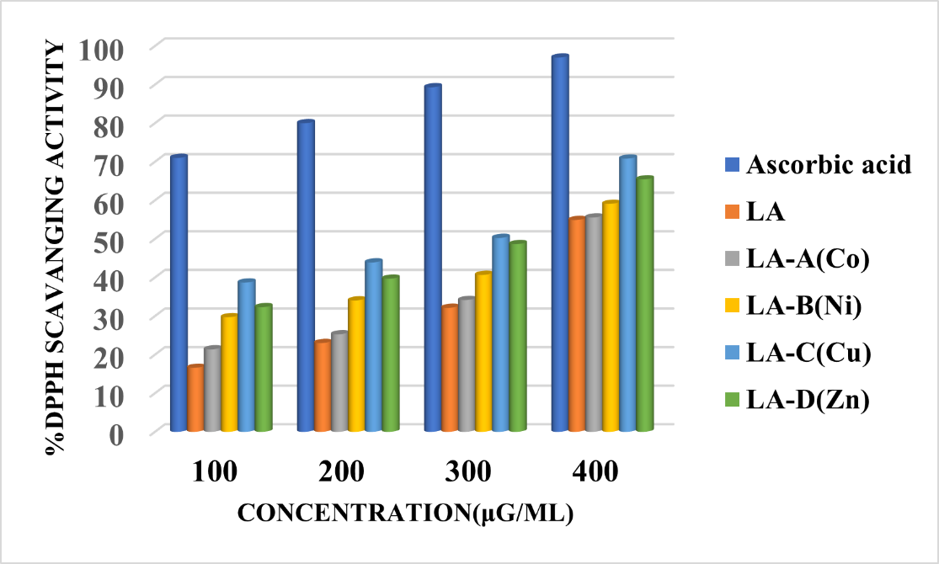

Fig. 1. Represents the % DPPH scavenging activity graph of synthesized Schiff base ligand LA and its metal complexes.

3.2 Antifungal activity

The antifungal potential of the Schiff base ligand (LA) and its binuclear metal complexes-LA-A (Co), LA-B (Ni), LA-C (Cu), and LA-D (Zn)-was evaluated in vitro against Aspergillus niger and Fusarium oxysporum using the mycelial growth inhibition method. Bavistin was used as a positive control to benchmark antifungal efficacy, while DMSO and drug-free plates served as negative controls to account for baseline growth and solvent effects (Table 1). The ligand LA showed moderate inhibitory activity, having 67.41% against A. niger and 59.37% against F. oxysporum. There was a remarkable increase in inhibitory activity upon binding to the metal. The most potent compound among the complexes was LA-C(Cu), which exhibited 88.76% inhibitory activity against A. niger and 82.81% against F. oxysporum. The Ni(II) complex, LA-B(Ni), exhibited relatively strong inhibitory activity, especially against F. oxysporum (92.81%), demonstrating an inhibitory trend comparable to that of the standard antifungal drug Bavistin (96.8%). The LA-A(Co) and LA-D(Zn) complexes showed improved inhibitory activity against the tested organisms compared to the free ligand; Thus, the general trend of antifungal activity against both fungal species indicates that coordination of the Schiff base ligand with transition metal ions enhances the inhibitory efficacy of the ligand system. This enhancement may be attributed to chelation effects, which increase lipophilicity and modify electron distribution, thereby facilitating penetration through the fungal cell membrane and interaction with intracellular targets in vivo. The observed antifungal response may involve biocidal and/or biostatic effects, acting synergistically [14-18].

Table 1. Represents the fungal growth inhibition % data of synthesized Schiff base ligand LA and its metal complexes.

Compounds | Growth Inhibition %
Compounds | Aspergillus  niger | Fusarium oxysporum
Bavistin | 97.75 | 96.8
DMSO | 42.69 | 46.87
LA | 67.41 | 59.37
LA-A(Co) | 71.91 | 64.06
LA-B(Ni) | 84.26 | 92.81
LA-C(Cu) | 88.76 | 82.81
LA-D(Zn) | 77.52 | 67.18

(a)
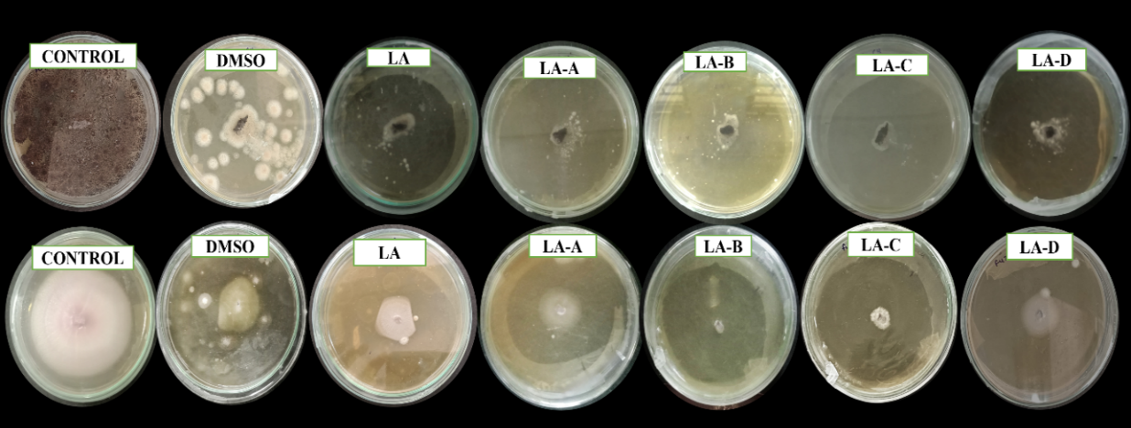
(b)
Fig. 2. (a) Graphical representation of % Growth inhibition of newly synthesized compounds against two fungal strains Aspergillus niger and Fusarium oxysporum; and (b) pictorial representation of % Growth inhibition of newly synthesized compounds against two fungal strains Aspergillus niger and Fusarium oxysporum.

4. Conclusion

The present study demonstrates that coordination of a thiazole-based Schiff base ligand with biologically relevant transition metal ions significantly enhances its antifungal and antioxidant activities. Comparative evaluation revealed that binuclear metal complexes exhibit superior biological performance compared to the free ligand, with the Cu(II) complex showing the highest antioxidant activity and the Ni(II) and Cu(II) complexes displaying pronounced antifungal efficacy against Aspergillus niger and Fusarium oxysporum.

The enhancement in activity is attributed to metal-induced modulation of physicochemical properties, including increased lipophilicity and favorable redox behavior. These findings underscore the importance of metal coordination in designing effective bioactive compounds and support the potential of thiazole-based binuclear metal complexes as promising candidates for further development as antifungal and antioxidant agents. Future investigations focusing on mechanistic studies and in vivo evaluation may further establish their therapeutic relevance.

Ethical approval

No ethical approval was necessary for this study
Disclaimer (Artificial intelligence)

The authors declare that no generative artificial intelligence tools were used in the preparation or editing of this manuscript.

References

- Lemilemu, F., Bitew, M., Demissie, T. B., Eswaramoorthy, R., & Endale, M. (2021). Synthesis, antibacterial and antioxidant activities of thiazole-based Schiff base derivatives: A combined experimental and computational study. BMC Chemistry, 15(1), 67.
- Sahoo, J., & Paidesetty, S. K. (2018). Biological investigation of novel metal complexes of 2-amino-4-substituted phenylthiazole Schiff bases. Journal of Taibah University Medical Sciences, 13(2), 142–155.
- Malav, R., & Ray, S. (2025). Recent advances in the synthesis and versatile applications of transition metal complexes featuring Schiff base ligands. RSC Advances, 15(28), 22889–22914. https://doi.org/10.1039/d5ra03626G
- Achonye, C. C., Ezenweke, L. O., Ojiako, E. N., & Ogbuagu, O. E. (2025). Spectroscopic and biological investigations of 4-[(1E)-N-(2-aminophenyl)ethanimidoyl]-3-methyl-1-phenyl-1H-pyrazol-5-ol and its Copper(II) complex. International Journal of Research and Innovation in Applied Science (IJRIAS), 10(11).
- Bhosale, D. G., Nimal, S., Gacche, R., Raut, D., Chaudhari, P. B., Deshmukh, P., Puri, G., Khobragade, R., & Lawand, A. S. (2024). Novel Co(II), Cu(II) and Zn(II) complexes derived from thiazole containing Schiff base ligands: Green synthesis, antimicrobial and anti-cancer studies. Inorganic Chemistry Communications, 170, 113320. https://doi.org/10.1016/j.inoche.2024.113320
- Catalano, A., Sinicropi, M. S., Iacopetta, D., Ceramella, J., Mariconda, A., Rosano, C., Scali, E., Saturnino, C., & Longo, P. (2021). A review on the advancements in the field of metal complexes with Schiff bases as antiproliferative agents. Applied Sciences, 11(13), 6027. https://doi.org/10.3390/app11136027
- Rai, A., Pradhan, P., Sahoo, J., Nayak, R., & Jena, S. (2023). Antimicrobial peptides as future therapeutics: Challenges and prospects. Current Research in Microbial Sciences, 6, 100211.
- Das, K., Datta, A., Massera, C., & Sinha, C. (2019). Structural diversity, topology and luminescent properties of a two-dimensional Cd(II) coordination polymer incorporating 4,4′-dipyridyl and 4,4′-sulfonyldibenzoic acid. Journal of Molecular Structure, 1179, 618–622.
- Lu, J., Huang, Y., Liu, R., Liang, Y., Zhang, H., Shen, N., Yang, D., & Jiang, M. (2024). Antimicrobial mechanisms and antifungal activity of compounds generated by banana rhizosphere Pseudomonas aeruginosa Gxun-2 against Fusarium oxysporum f. sp. cubense. Frontiers in Microbiology, 15, 1456847.
- Baliyan, S., Mukherjee, R., Priyadarshini, A., Vibhuti, A., Gupta, A., Pandey, R. P., & Chang, C.-M. (2022). Determination of antioxidants by DPPH radical scavenging activity and quantitative phytochemical analysis of Ficus religiosa. Molecules, 27(4), 1326. doi:10.3390/molecules27041326.
- Ashrafuzzaman, M., Khanm Camellia, F., Rahman, M. H., Hossain, M. D., Hossain, M. T., Rahman, H., Shovon, G. M., Paul, G. K., Zahan, M. K.-E., & Haque, M. M. (2023). Synthesis, characterization, antibacterial and antioxidant activities of Cu(II), Ni(II), and Zn(II) mixed ligand complexes containing isoniazid based bidentate Schiff base. Asian Journal of Chemical Sciences, 13(5), 112–122.
- Saif, M., El-Shafiy, H. F., Mashaly, M. M., Eid, M. F., & Fouad, R. (2016). Synthesis, characterization, and antioxidant/cytotoxic activity of new chromone Schiff base nano-complexes of Zn(II), Cu(II), Ni(II) and Co(II). Journal of Molecular Structure, 1118, 75–82.
- Ramadan, M. M., Naeem, A. M. A., Aboelhasan, A. E., & Abdel Aziz, A. A. (2024). DNA binding and antioxidant activities of novel synthesized Fe(III), Ni(II) and Cu(II) complexes derived from monodentate V-shaped Schiff bases. Journal of Transition Metal Complexes, 7, Article 246166.
- Khan, S. J.; Marufa, S. S.; Sultan, M. I.; et al. Novel thiophene–thiazole‑Schiff base hybrids: design, synthesis, antimicrobial and antioxidant activity with ADMET prediction, molecular docking and dynamics study. RSC Adv. 2025, 15, 45690–45706. https://doi.org/10.1039/D5RA07357J
- Adly, O. M., El-Shafiy, H. F., & Shebl, M. (2019). Synthesis, spectroscopic studies, DFT calculations, antimicrobial and antitumor activity of tridentate NNO Schiff base metal complexes based on 5-acetyl-4-hydroxy-2H-1, 3-thiazine-2, 6 (3H)-dione. Journal of Molecular Structure, 1196, 805-818.
- Yimer, A. M. (2014). Chemical synthesis, spectral characterization and antimicrobial studies on complexes of Ni(II), Cu(II) and Zn(II) with N,N-di(o-hydroxybenzenoylmethylene)ethylenediamine. American Journal of Bioscience, 2(6-1), 22–34.
- Unki, S. N.; Kalalbandi, V. K. A.; Karekal, M. R. Synergistic antimicrobial and antioxidant effects of indole Schiff base‑metal (II) complexes: a dual approach. Chem. Biodivers. 2025, 22(11), e00955. https://doi.org/10.1002/cbdv.202500955
- Varshney, A., & Mishra, A. P. (2023). Synthesis, spectral characterization, computational studies, antifungal, DNA interaction, antioxidant and fluorescence property of novel Schiff base ligand and its metal chelates. Spectrochimica Acta Part A: Molecular and Biomolecular Spectroscopy, 297, 122765.

