The effect of different magnetic field orientation to the early stage growth dynamics of magnetoprimed Brassica rapa

.
ABSTRACT

Aims: This study explores the difference in the germination dynamics of Brassica rapa seeds as exposed to different magnetic field orientation during magnetopriming.
Place and Duration of Study: Central Mindanao University (Bukidnon, Philippines) and Cebu Normal University (Cebu, Philippines), between September to October 2024.
Methodology: Seeds of B. rapa were exposed to either north or south magnetic poles of neodymium magnets (87.2 mT) for 6 h, 12 h, and 24 h (150 seeds per treatment and for control); these seeds were then germinated and were assessed for growth parameters. Microscopic assessments were made after 24 h and 48 h, while daily root and shoot length measurements were taken daily from day 3-7. Analysis of variance as well as Tukey’s post hoc analysis were employed in determining statistical difference.
Results: Results showed that north-primed seeds had longer hypocotyls and primary roots in the first 48 h, particularly those exposed for 6 h and 12 h. Though there were multiple changes in the dynamics of shoot and root lengths between days 3 through 7, 12 h north-primed and 24 h south-primed seeds were consistently shorter throughout this timeframe. These changes in dynamics were traced to be statistically significant. Also, more significant measurement changes in roots than shoots in the first four days, while it reverses in the last two days.
Conclusion: The differences between various treatments and control groups implies that magnetic orientation and time exposure can influence the dynamics of developmental changes at this growth stage in B. rapa which can further implicate that such approach can be efficient in improving crop yield. Changes in the seeds’ biomolecular structures when exposed to magnetic fields are the primary causes of the observed differences in magnetically treated seeds. Similar studies using different crops are hereby recommended.

Keywords: Brassica rapa, germination, magnetic field orientation, static magnetic field

1. INTRODUCTION

One of the emerging fields in biology is magnetobiology where distinct responses of different organisms are being studied. This field invokes concepts in physics, biology and even chemistry. In magnetobiological studies, different organisms are subjected to magnetic field intensities that are usually higher than the earth’s magnetic field. According to Volpe (2014), the response of biological systems to magnetic field is dependent on the organism’s complexities and that it affects macro and micromolecules, ions, cells and tissues. There are already known various applications of the different techniques and strategies developed in magnetobiology particularly in medicine and agriculture (Liboff, 2004; Makinistian, 2009; Buchachenko, 2014; Binhi & Rubin, 2022). In medicine for instance, the study of Prasad et al. (2017) had demonstrated that the exposure of the human oligodendrocyte cells to an oscillating static magnetic field had led to the expression of certain genes related to the enhanced myelination of the magnetically exposed neural cells implying early maturation. Further, the report also stipulated that aside from changes in myelination events, influx of calcium ions was also observed in these cells. Similar results were also reported by Jung et al. (2014), Ho et al. (2019), Özgün et al. (2019), and Dolgova et al. (2021).
In botanical terms, the effects of magnetic field to plants were also investigated especially on the early growth dynamics of plants. Early stage plant growth is a crucial stage for the success of a plant’s life cycle and is critical to the overall dynamics of an ecosystem (Paine et al., 2012) and that the key for this success lies on the quality of seeds (Starodubtseva & Livinskiy, 2018; Kokonov et al., 2021). There are various ways where seeds are primed or preconditioned prior to planting that eventually produce plants that can grow better and become more resilient to various environmental stressors (Di Girolamo & Barbanti, 2012; Jisha et al., 2012; Paparella et al., 2015). accordingly, priming strategies are economically and environmentally sustainable (Farooq et al., 2019). And one of the promising priming techniques is known as magnetopriming (Sarraf et al., 2020).
In magnetopriming, seeds are exposed to a specific range of magnetic intensity prior to sowing. Currently, there are already multiple reports that testify that the priming of seeds with magnetic field can result in an increase in yield and that magnetoprimed seeds are more resistant to specific environmental stress in several crops (Teixeira da Silva & Dobránszki, 2016). Several of these reports had attributed to the enhanced seed vigor that resulted from the exposure of magnetic field which can then account for better germination to maturation dynamics (Gupta et al., 2015). In addition, there are several biochemical events, particularly the expression of certain genes, that can cause significant advantage for magnetoprimed seeds during the germination phase including water uptake, enhanced seed metabolism and photosynthesis, and increased biomass accumulation (Bhardwaj et al., 2012; Kataria, 2017; Sarraf et al., 2021; Torres-Osorio et al., 2024).
According to the review paper by Maffei (2014), there are various applications of magnetopriming particularly in the future of agriculture that can help address the United Nation’s Sustainable Development Goal 2 (SDG 2) which specifically addresses the impending issues of food security through sustainable agricultural methodologies. Aside from being a sustainable agricultural strategy where it can potentially produce high-yielding and stress-resistant crops, the technique is also seen to be adapted for the futuristic interplanetary human agriculture.
Though the positive effect of magnetopriming to the overall growth of plants and its potential to be a strategy for a sustainable agriculture technique is well reported, it seems that these reports have not considered the specific magnetic orientation where these seeds were primed and with respect to time exposure. These two factors are deemed important especially that the inclusion of these two parameters is arguably not in consideration in magnetopriminng studies. This paper therefore investigates the impact of different magnetic orientation and length of exposure on the early stage growth of the economically-significant crop Brassica rapa.

2. material and methods

2.1 Magnetopriming
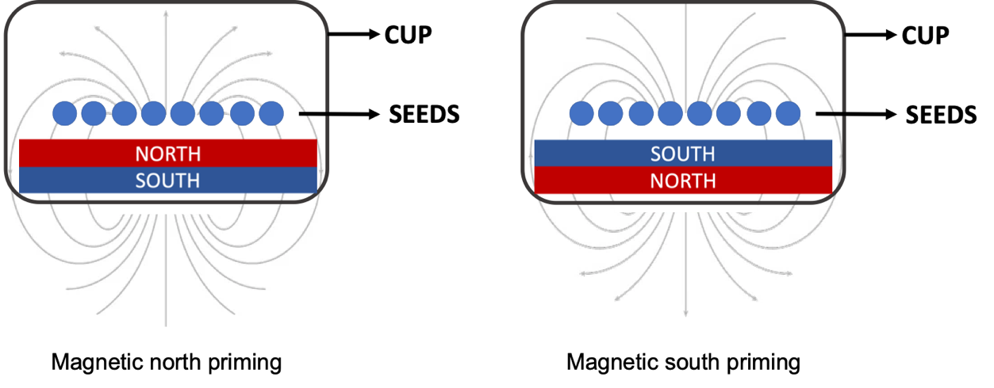
Seeds of B. rapa variety Pavito were purchased as pack from East-West Seed Company, Inc., Bulacan, Philippines. Approximately 150 seeds for the control and each of the treatment were placed in a specially 3D-printed cup with a permanent static neodymium disc magnet (NdFeB). The magnets used here had the following details: magnetic intensity - 87.2 mT (millitesla), diameter - 30 mm, thickness - 3 mm, and were firmly attached at the bottom of their respective cups. A cup then can either have south or north-oriented magnets (Figure 1) depending on how they were deliberately attached at the bottom of the cup. For the priming, these seeds were categorized based on what magnetic orientation they were exposed to and the length of exposure time (6 h, 12 h, 24 h). Hence, the following are the treatment groups: three north-primed groups (6N, 12N, 24N) and three south-primed groups (6S, 12S, 24S); meanwhile the control group (C) comprised the magnetically unexposed seeds. The priming commenced at 6:00 PM with the 24N and 24S groups being set-up first, followed by the 12N and 12S groups at 6:00 AM, and the 6N and 6S groups at 12:00 NN. Through this scheme, the termination of the magnetopriming of seeds was synchronized.

Figure 1. Schematic diagram of the principle of magnetopriming implemented in this study.

2.2 Germination
After magnetopriming, these seeds were transfered to their respective modified seedling trays, including the unexposed seeds of the control group. The seedling trays had the dimensions of 118 mm x 175 mm (length x width). Each trey had approximately 100 g of loam soil that was previously treated with hot water. Seeds were individually planted in their respective treys (50 seeds per trey with three replicates) with an approximate distance of 10 mm between each seed, and a depth of 10 mm (Figure 2). Employing the randomized complete block design (RCBD), three blocks were set up where each block has a representative for the treatment and control groups. The seeds were then allowed to germinate inside a modified greenhouse for up to 7 days. 30 germinated seeds from each trey were carefully harvested daily starting from day 3. Harvested plants were washed with water and were allowed to drip for 5 minutes. Using a digital caliper, shoot and root lengths were measured from individual plants. Data was then recorded. Both magnetopriming and growth measurements were conducted at Central Mindanao University, Maramag, Bukidnon, Philippines.
In another set-up, approximately 20 seeds per group were germinated in-situ where they were placed in their respective petri plates. Here, sterile paper towels were placed in between seeds. After placing these towels into their respective petri plates, the towels were moistened and then covered. These plates were placed in a cabinet under room temperature. Microscopic evaluation of 24 h germinated seed was done using low power objectives of a compound light microscope. After 48 h, another microscopic evaluation was done, this time using a stereomicrocope. Images were then generated using a smartphone.
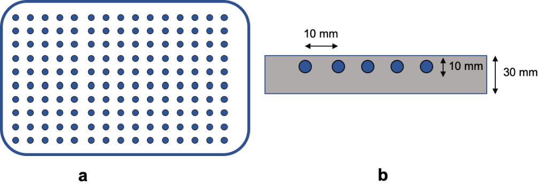

Figure 2. Schematic diagram of the set-up for the germination dynamics: placement of seeds in the seed trey (a), and the approximate measurements between seeds in the soil (b).

2.3 Analysis
For the statistical treatment, the analysis of variance (ANOVA) was employed to determine the significant differences of these measurements based on P = 0.05. Measurements that showed significance were further treated with Tukey’s Post-hoc analysis to determine the specific treatments that showed significance. Statistical analysis was made using JASP v. 0.18.3, a free downloadable statistical software. Meanwhile, pertinent graphs were generated using JupyterLab v. 3.6.3.

3. results and discussion

3.1 Results

Microscopic evaluation of B. rapa seeds primed to different magnetic orientations (north and south) as well as the unexposed seeds was employed after 24 and 48 hours. Per evaluation after 24 h germination, longer hypocotyls were observed in the seeds exposed to north magnetic field for 6 and 12 h (6N, 12N), while similar hypocotyl lengths were also observed in seeds exposed to the north magnetic field for 24 h (24N). Meanwhile seeds exposed to the south magnetic field for 6 h (6S) and 24 h (24S) showed the shortest hypocotyl, which was then followed by the control group (Figure 3a).

After 48 h, the primary root is now prominent with multiple root hairs. Here, 6N still exhibited a longer root; however, 6S had surpassed the root length of 12N, which was closely followed by the magnetically unexposed seeds (control). At this stage, both 12S and 24S showed the shortest roots (Figure 3b).

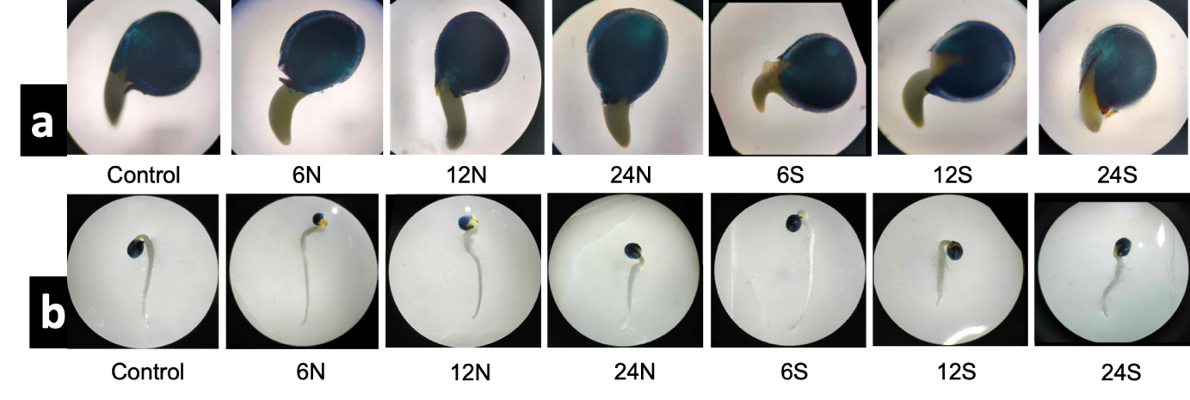
Figure 3. Microscopic evaluation of germinated seeds after (a) 24 h and (b) 48 h.

Then for days 3 through 7, representative images of germinated seeds are shown in Figure 4. Shown here that in this timeline, root lengths of most treatment groups exhibited consistency, though changes in lengths in some groups are also observed. For example, 24S showed shorter hypocotyl and primary root in the first 48 h and such trait persisted even after 7 days of growth. Also showing length consistency starting from 48 h is 6S; it is observed that 6S started as one of the shortest hypocotyls (Figure 3a).

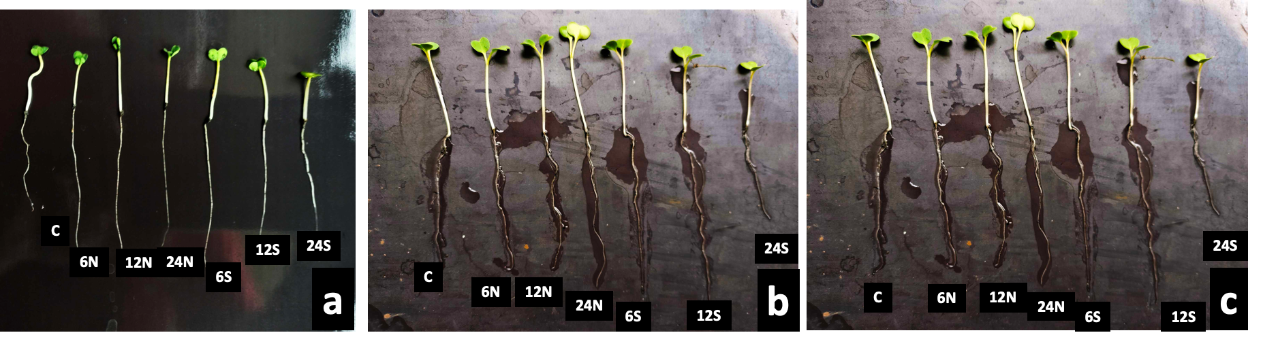

Figure 4. Growth comparison of representative germinated seeds after (a) 3 days, (b) 5 days, (c) 7 days.

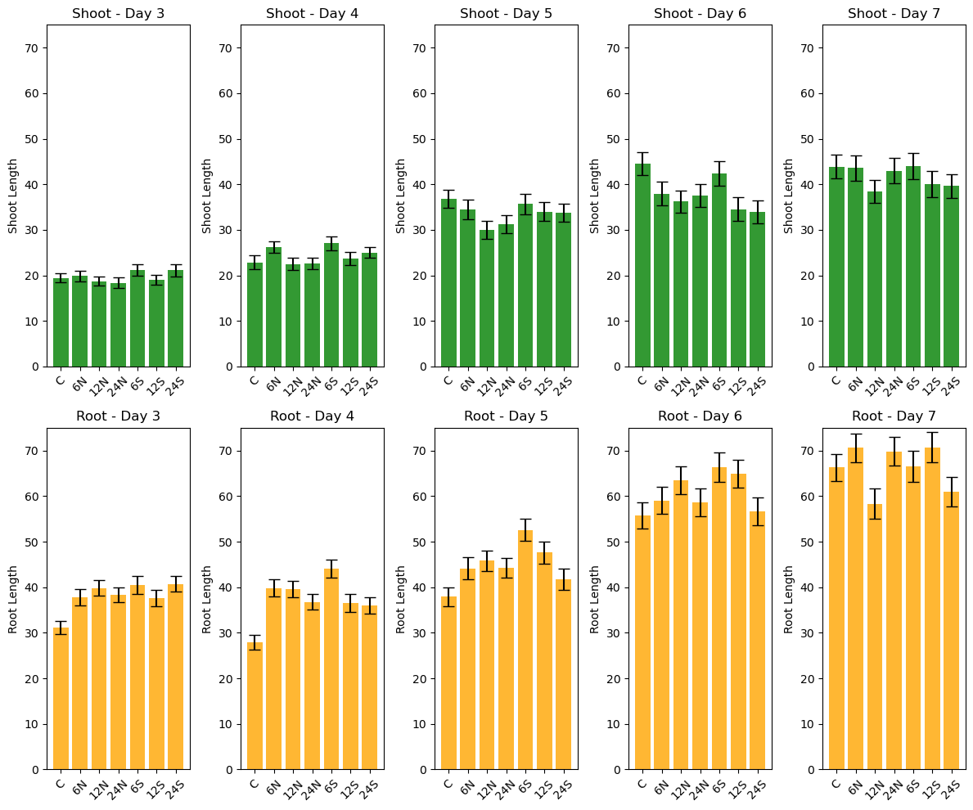

Figure 5. Average shoot and root growth measurements from days 3 to day 7

As seen in Figure 5, multiple changes in the average lengths of shoots and roots were observed, though overall consistency these measurements can be derived. For the shoot length, 6S has the longest shoot except only on day 6 where the control registered the longest shoot. Across this timeline, 12N, 12S and 24S consistently exhibited shorter shoot measurements; 24S is seen to have regressed in shoot length since it started as one of having the longest shoot in day 3 and ended up as one of the shortest on day 7.

In roots, the control group is consistently having shorter root length from days 3 to 7 but ended as having longer root lengths than 12N and 24S at the end in day 7. 12N, though it started as having longer hypocotyl after 24 h and primary root after 48 h, had ended as having the shortest average root length after day 7. 12N’s average root length coincides with its average shoot length. Meanwhile, 6S is also observed to exhibit consistency in its longer root and shoot average lengths. After day 7, 6N, 24N and 12S have the longest average root lengths, while 12N and 24S where the latter is consistent with its germinated hypocotyl length in the first 24 h growth.

Figure 6 shows the heatmaps of the average shoot and root lengths where it considers the relative measurements between treatments. Generally, root measurement heatmap hinted that there are more measurement changes within days 3 to 5 as compared to average shoot lengths (Figure 6a); however, this observation is reversed between days 5 to 7 as there are now more changes in measurements in shoots than in roots (Figure 6b). In roots, generally all the magnetically exposed seeds registered longer measurements as compared to the unexposed seeds. This can be crucial especially that at this stage the seeds are acquiring nutrients to fuel the growth burst of the plant and that longer roots can account for better absorption of nutrients. For 6S, even if it registered the highest average root length earlier than other treatment and control groups at day 5, yet its length in days 6 and 7 seems to have little changes.

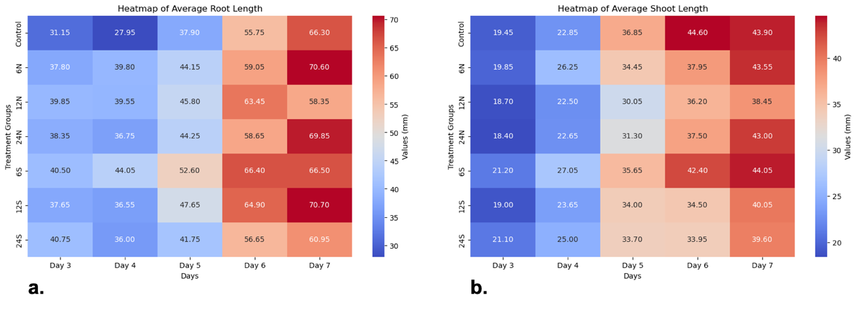
Figure 6. Heatmap showing the relative growth between control and treatment groups along the growth timeline: (a) average root length, (b) average shoot length

The summarized result for the analysis of variance (ANOVA) is presented in Table 1. Here, there are significant differences in the measurements of shoots and roots found all throughout the timeframe based on P=.05. But even if all growth days showed significant differences, higher statistical differences have been registered in days 5 to 7 (P=<.001) in shoots, while days 3 to 6 in roots (P=<.001). This statistical result seems to validate what is observed in the heat maps presented in Figure 6.

Table 1. Summarized P values of root and shoot length measurements from day 3 to day 7 (significant at P = .05)

Day | P value
Day | Shoot | Root
3 | .01* | <.001*
4 | .00* | <.001*
5 | <.001* | <.001*
6 | <.001* | <.001*
7 | <.001* | .01*

Since both shoot and root growth measurements showed statistical significance through ANOVA, the data was further subjected to Tukey’s post-hoc analysis in order to determine the difference between specific treatments and the value of their statistical difference. As for the shoot length (Table 2), days 3 and 4 consistently saw significant differences between 6S, 12N and 24N where the longer measurement of 6S is significantly higher than 12N and 24N. This shows that at this stage, shoot lengths of other groups are similar. At day 5, the length of the control group is now significant over 12N and 24N. On day 6, control’s shoot length is now significant against all treatments (where control’s P value is <.001) except 6S; 6S meanwhile statistically has longer shoots if compared to other treatments. At day 7, the control group’s significance over 12N is still observable in which the latter is traced to be having the shortest average shoot length.

Table 2. Summarized Tukey’s Post Hoc P values with significant difference in shoots (significant at P = .05)

Day | Groups |  | Mean Difference (SE) | P value
3 | 12N | 6S | 2.89 (±0.82) | .01
3 | 24N | 6S | 2.93 (±0.86) | .01
4 | 12N | 6S | 4.66 (±1.40) | .02
4 | 24N | 6S | 4.32 (±1.40) | .04
5 | Control | 12N | 6.61 (±1.40) | <.001
5 | Control | 24N | 5.36 (±1.37) | .00
5 | 6N | 12N | 4.83 (±1.39) | .01
5 | 12N | 6S | 5.83 (±1.32) | <.001
6 | Control | 6N | 6.64 (±1.46) | <.001
6 | Control | 12N | 8.47 (±1.46) | <.001
6 | Control | 24N | 7.01 (±1.49) | <.001
6 | Control | 12S | 10.14 (±1.49) | <.001
6 | Control | 24S | 10.66 (±1.49) | <.001
6 | 6N | 6S | 4.41 (±1.45) | .04
6 | 12N | 6S | 6.25 (±1.45) | <.001
6 | 24N | 6S | 4.79 (±1.48) | .02
6 | 6S | 12S | 7.92 (±1.48) | <.001
6 | 6S | 24S | 8.44 (±1.48) | <.001
7 | Control | 12N | 5.54 (±1.51) | .01
7 | Control | 24S | 4.48 (±1.47) | .04
7 | 6N | 12N | 5.06 (±1.46) | .01
7 | 12N | 24N | 4.49 (±1.46) | .04
7 | 12N | 6S | 5.68 (±1.43) | .00
7 | 6S | 12S | 4.13 (±1.39) | .05
7 | 12S | 24S | 4.62 (±1.39) | .02

Post-hoc analysis was also done for root lengths (Table 3). In roots, days 3 and 4 saw that the shorter length of roots in the control group as compared with the treatment groups is significant. For instance, except for 6N at day 3, the control group is statistically different against all treatments where it indicates that at this stage of development, the magnetically treated seeds are showing growth advantage over untreated seeds due to their longer roots, which can be crucial to the overall development of B. rapa. Untreated seeds’ root measurements are seen to persist up to day 6 against 6S and 12S. With reference to the heatmap in Figure 3a, this post-hoc analysis validates that significant changes in root lengths are observable within the days 3 to 5 timeframe.

Table 3. Summarized Tukey’s Post Hoc P values with significant difference in roots (significant at P = .05)

Day | Groups |  | Mean Difference (SE) | P value
3 | Control | 6N | 6.57 (±2.62) | .01
3 | Control | 12N | 8.88 (±1.91) | <0.001
3 | Control | 24N | 7.18 (±2.01) | .01
3 | Control | 6S | 10.17 (±1.92) | <0.001
3 | Control | 12S | 6.50 (±2.05) | .03
3 | Control | 24S | 9.52 (±2.03) | <0.001
4 | Control | 6N | 11.84 (±2.62) | <0.001
4 | Control | 12N | 11.57 (±2.56) | <0.001
4 | Control | 24N | 8.80 (±2.56) | .012
4 | Control | 6S | 15.91 (±2.53) | <0.001
4 | Control | 12S | 8.57 (±2.51) | .01
4 | Control | 24S | 7.80 (±2.58) | .04
4 | 6S | 24S | 8.11 (±2.62) | .04
5 | Control | 6S | 17.51 (±3.64) | <0.001
5 | Control | 12S | 12.98 (±3.62) | .01
5 | 6S | 24S | 10.85 (±3.50) | .04
6 | Control | 6S | 10.76 (±2.94) | .01
6 | Control | 12S | 9.45 (±2.92) | .02
6 | 6S | 24S | 9.66 (±2.90) | .02
7 | 6N | 12N | 12.33 (±3.90) | .03
7 | 12N | 12S | 12.14 (±3.82) | .03

Discussion

This study investigates how magnetic orientation and exposure time could affect the early stage growth dynamics of B. rapa as such a topic is least reported in magnetopriming studies. Based on the result, it is evident that magnetic orientation and length of exposure of seeds can indeed have significant impact to the overall germination dynamics and growth of seeds particularly in shoot and root lengths; such report is arguably one of the first to be made particularly in the context of using Philippine crop where duration of exposure with respect to magnetic field orientation has been factored in. Most previously reported magnetopriming studies did not specify (or had not considered) the distinct effects of the direction of magnetic field to biological systems. This report so far has reinforced the observation of Rosales et al. (2018) where they also analyzed the growth of various crops as response to the different magnetic polarities; however, the said study employed only around a maximum intensity of 2 mT as compared to this study’s 87.2 mT. The observations made here can potentially open up various research inquiries for plant scientists particularly on how different species of plants react to magnetic field. Hence in magnetopriming studies, duration of magnetic field exposure, species of crop, and the magnetic field orientataion can now all be factored in particularly on the germination performance of crops that are being studied. Currently, studies on magnetopriming in the Philippines remains to be unexplored and understudied, thus any existing strategies on magnetopriming and its modifications can provide multiple research inquiries to those that are working on crop production and plant physiology as well.

According to Ventura et al. (2012), the events that comprise seed vigor is a crucial property for seeds as such property can contribute to the overall performance of plants in the field. Multiple papers had already reported that the priming of seeds with magnetic fields had improved the quality and germination of soybeans (de Faria et al., 2023), onion (Zalama & Fathala, 2020), and tomato (Anand et al., 2019). The increased vigor of magnetoprimed seeds over their unexposed counterparts can grow to have roots and shoots that are longer, greater leaf area, higher water content, and are known to be stress tolerant (Abhary & Akhkha, 2021) and improved hydration especially during germination (Thomas et al., 2013). Further, Saletnik et al. (2022) emphasized that enhanced absorption of micro and macronutrients places magnetoprimed seeds at an advantage in terms of plant growth and development.

Exposing seeds to magnetic fields are also known to cause biochemical and genetic changes in plants. For example, Anand et al. (2019) reported that tomato seeds primed to magnetic fields for 30 min under 100 mT showed that multiple genes are being expressed that react with hydrogen peroxide (H2O2), a molecule related to cellular stress. These genes (AO, RACK1, ArcA2, SOD1, SOD9) were expressed in higher quantities in magnetoprimed seeds than those unexposed seeds. Several other similar reports were made by Kataria et al. (2022), Raipuria et al. (2021), Saletnik et al. (2022), and Wang et al. (2024). Currently, the expression of these genes, and possibly other genes, are all related to the development of stress tolerant properties among magnetoprimed seeds which are displayed even during the germination stage of plant development.

Though the actual cellular mechanism of the impact of magnetopriming is still largely unknown, a leading theory is that there are structural changes in the cells upon exposure to magnetic fields due to what is known as the Lorentz force when magnetic fields influence the behavior of ions where unpaired electron can become tiny magnets in cells. Zablotskii et al. (2021) had demonstrated that magnetic fields can indeed influence the flow of various molecules across the cell membrane. In their report, they discussed that magnetic fields can affect the diffusion rates of diamagnetic (zero net spin) and paramagnetic (nonzero net spin) molecules (with unpaired electrons), be transported into the cells or those molecules that are part of the structure of the cell membrane. Freire et al. (2020) reported that the Lorentz force can introduce some friction between the cellular membrane walls and ions that can eventually result in the reduction of the cell’s conductance; the reduction of conductance suppresses the cation potentials which therefore can further certain inhibit cellular activities. Hayashi and Kakikawa (2021) added that even at 50 mT, a relatively low intensity magnetic field, there are already observable changes in cell permeability in animal cell experiments (in comparison, this study employed 87.2 mT).

The biophysical properties described above, where changes in the cell’s molecular configuration particularly in the cell membrane, can then be responsible for the difference in the growth dynamics described in this study. It is still not clear, however, as to how much these magnetic exposure can cause changes inside the cells of the seeds especially when the length of exposure and the direction of the magnetic field will be factored in. And another concern is whether these biomolecular changes can either be permanent or temporary; also, whether these changes can be passed down to succeeding generations. In addition, existing literature still poorly describes the difference in magnetic orientations and its effects to the configurations of biomolecules that participate in the transfer of nutrients, and how it influences other metabolic events inside magnetoprimed cells. These concerns can be appropriately addressed in more advanced inquiries employing multiple approaches in biophysics and biochemistry particularly the omics-related technologies. The result of this study can provide hint that magnetic orientation can result to different molecular modifications particularly in cellular permeability.

4. Conclusion

In conclusion, the result of this study suggests that it is consistent with multiple results on the germination and growth advantage of magnetopriming seeds, adding validity to this technique that is geared towards sustainable food production. However, it is shown in this study that there is growth distinction during the earliest stages of plant development when seeds are primed to different magnetic orientation, implying that the different direction of the magnetic field can incur different responses; such observation can be an indication of potential physiological advantages when seeds are primed to specific magnetic field orientation with respect to the length of exposure. Hence, future magnetopriming studies can now consider magnetic orientation as a factor for biochemical and cellular events that are pertinent to plant growth in addition to magnetic intensity and exposure time.

Disclaimer (Artificial intelligence)
Author(s) hereby declare that NO generative AI technologies such as Large Language Models (ChatGPT, COPILOT, etc.) and text-to-image generators have been used during the writing or editing of this manuscript.

References

- Abhary M.K., Akhkha, A. (2023). Effects of neodymium magneto‐priming on seed germination and salinity tolerance in tomato. Bioelectromagnetics, 44(1-2), 47-56. https://doi.org/10.1002/bem.22438
- Anand, A., Kumari, A., Thakur, M., Koul, A. (2019). Hydrogen peroxide signaling integrates with phytohormones during the germination of magnetoprimed tomato seeds. Scientific Reports, 9(1), 8814. https://doi.org/10.1038/s41598-019-45102-5
- Bhardwaj J., Anand, A., Nagarajan, S. (2012). Biochemical and biophysical changes associated with magnetopriming in germinating cucumber seeds. Plant Physiology and Biochemistry, 57, 67-73. https://doi.org/10.1016/j.plaphy.2012.05.008
- Binhi, V.N., Rubin, A.B. (2022). Theoretical concepts in magnetobiology after 40 years of research. Cells, 11(2), 274. https://doi.org/10.3390/cells11020274
- Buchachenko A.L. (2014). Magnetic field-dependent molecular and chemical processes in biochemistry, genetics and medicine. Russian Chemical Reviews, 83(1), 1. 0.1070/RC2014v083n01ABEH004335
- de Faria R.Q., Dos Santos, A.R., Batista, T.B., Gariepy, Y., da Silva, E.A., Sartori, M.M., Raghavan, V. (2023). The Effect of Magneto-Priming on the Physiological Quality of Soybean Seeds. Plants, 12(7), 1477. https://doi.org/10.3390/plants1207147
- Di Girolamo, G., and Barbanti, L. (2012). Treatment conditions and biochemical processes influencing seed priming effectiveness. Italian Journal of Agronomy, 7(2), e25-e25. https://doi.org/10.4081/ija.2012.e25
- Dolgova, N., Wei, Z., Spink, B., Gui, L., Hua, Q., Truong, D., ... Zhang, Y. (2021). Low-field magnetic stimulation accelerates the differentiation of oligodendrocyte precursor cells via non-canonical TGF-β signaling pathways. Molecular Neurobiology, 58, 855-866. https://doi.org/10.1007/s12035-020-02157-0
- Farooq, M., Usman, M., Nadeem, F., ur Rehman, H., Wahid, A., Basra, S.M., Siddique, K.H. (2019). Seed priming in field crops: potential benefits, adoption and challenges. Crop and Pasture Science, 70(9), 731-771. https://doi.org/10.1071/CP18604
- Freire, M.J,, Bernal-Méndez, J., Pérez, A.T. (2020). The Lorentz force on ions in membrane channels of neurons as a mechanism for transcranial static magnetic stimulation. Electromagnetic Biology and Medicine, 39(4), 310-315. https://doi.org/10.1080/15368378.2020.1793172
- Gupta, M.K., Anand, A., Paul, V., Dahuja, A., Singh, A.K. (2015). Reactive oxygen species mediated improvement in vigour of static and pulsed magneto-primed cherry tomato seeds. Indian Journal of Plant Physiology, 20, 197-204. https://doi.org/10.1007/s40502-015-0161-8
- Hayashi, S., and Kakikawa, M. 2021. Exposure to 60 Hz magnetic field can affect membrane proteins and membrane potential in human cancer cells. Electromagnetic Biology and Medicine, 40(4), 459-466. https://doi.org/10.1080/15368378.2021.1958340
- Ho, S.Y., Chen, I.C., Chen, Y.J., Lee, C.H., Fu, C.M., Liu, F.C., Liou, H.H. (2019). Static magnetic field induced neural stem/progenitor cell early differentiation and promotes maturation. Stem Cells International, 2019(1), 8790176. https://doi.org/10.1155/2019/8790176
- Ibrahim, E.A. 2016. Seed priming to alleviate salinity stress in germinating seeds. Journal of Plant Physiology, 192, 38-46. https://doi.org/10.1016/j.jplph.2015.12.011
- Jisha, K.C., Vijayakumari, K., Puthur, J.T. (2013). Seed priming for abiotic stress tolerance: an overview. Acta Physiologiae Plantarum, 35, 1381-1396. https://doi.org/10.1007/s11738-012-1186-5
- Jung, I.S., Kim, H.J., Noh, R., Kim, S.C., Kim, C.W. (2014). Effects of extremely low frequency magnetic fields on NGF induced neuronal differentiation of PC12 cells. Bioelectromagnetics, 35(7), 459-469. https://doi.org/10.1002/bem.21861
- Kataria, S. (2017). Role of reactive oxygen species in magnetoprimed induced acceleration of germination and early growth characteristics of seeds. Reactive Oxygen Species in Plants: Boon or Bane‐Revisiting the Role of ROS, 75-88. https://doi.org/10.1002/9781119324928.ch4
- Kataria, S., Anand, A., Raipuria, R.K., Kumar, S., Jain, M., Watts, A., Brestic, M. (2022). Magnetopriming actuates nitric oxide synthesis to regulate phytohormones for improving germination of soybean seeds under salt stress. Cells, 11(14), 2174. https://doi.org/10.3390/cells11142174
- Kokonov, S.I., Ryabova, T.N., Votintsev, A.I., Mokeeva, S.A., Vorobyeva, S.L., Esenkulova, O.V. (2021). Influence of presowing seed treatment on the yield of variegated alfalfa and eastern galega. Plant Science Today, 8(2), 250-254. https://doi.org/10.14719/pst.2021.8.2.1000
- Liboff, A.R. (2004). Toward an electromagnetic paradigm for biology and medicine. The Journal of Alternative & Complementary Medicine, 10(1), 41-47. https://doi.org/10.1089/107555304322848940
- Maffei, M.E. (2014). Magnetic field effects on plant growth, development, and evolution. Frontiers in Plant Science, 5, 445. https://doi.org/10.3389/fpls.2014.00445
- Makinistian, L. (2016). A novel system of coils for magnetobiology research. Review of Scientific Instruments, 87(11). https://doi.org/10.1063/1.4968200
- Özgün, A., Marote, A., Behie, L.A., Salgado, A., Garipcan, B. (2019). Extremely low frequency magnetic field induces human neuronal differentiation through NMDA receptor activation. Journal of Neural Transmission, 126(10), 1281-1290. https://doi.org/10.1007/s00702-019-02045-5
- Prasad, A., Teh, D.B.L., Blasia, A., Chai, C., Wu, Y., Gharibani, P.M., ... All, A.H. (2017). Static magnetic field stimulation enhances oligodendrocyte differentiation and secretion of neurotrophic factors. Scientific Reports, 7(1), 6743. https://doi.org/10.1038/s41598-017-06331-8
- Paine, C.T., Marthews, T.R., Vogt, D.R., Purves, D., Rees, M., Hector, A., Turnbull, L.A. (2012). How to fit nonlinear plant growth models and calculate growth rates: an update for ecologists. Methods in Ecology and Evolution, 3(2), 245-256. https://doi.org/10.1111/j.2041-210X.2011.00155.x
- Paparella, S., Araújo, S.S., Rossi, G., Wijayasinghe, M.A.L.A.K.A., Carbonera, D., Balestrazzi, A. (2015). Seed priming: state of the art and new perspectives. Plant Cell Reports, 34, 1281-1293. https://doi.org/10.1007/s00299-015-1784-y
- Raipuria, R.K., Kataria, S., Watts, A., Jain, M. (2021). Magneto-priming promotes nitric oxide via nitric oxide synthase to ameliorate the UV-B stress during germination of soybean seedlings. Journal of Photochemistry and Photobiology B: Biology, 220, 112211. https://doi.org/10.1016/j.jphotobiol.2021.112211
- Rosales, S., Daniels, D., & Tzib, L. (2018). The Effects of Neodymium and Ceramic Magnets on the Germination and Growth Rate of Coriander (Coriandrum sativum) in Ex-vitro Conditions. Int J Adv Sci Res Eng, 4(9), 17-22. https://doi.org/10.31695/IJASRE.2018.32865
- Saletnik, B., Saletnik, A., Słysz, E., Zaguła, G., Bajcar, M., Puchalska-Sarna, A., Puchalski, C. (2022). The static magnetic field regulates the structure, biochemical activity, and gene expression of plants. Molecules, 27(18), 5823. https://doi.org/10.3390/molecules27185823
- Sarraf, M., Kataria, S., Taimourya, H., Santos, L.O., Menegatti, R.D., Jain, M., ... Liu, S. (2020). Magnetic field (MF) applications in plants: An overview. Plants, 9(9), 1139. https://doi.org/10.3390/plants9091139
- Sarraf, M., Deamici, K.M., Taimourya, H., Islam, M., Kataria, S., Raipuria, R.K., ... Brestic, M. (2021). Effect of magnetopriming on photosynthetic performance of plants. International Journal of Molecular Sciences, 22(17), 9353. https://doi.org/10.3390/ijms22179353
- Starodubtseva, G.P., Livinskiy, S.A., Gabriyelyan, S.Z., Lubaya, S.I., Afanacev, M.A. (2018). Process control of pre-sowing seed treatment by pulsed electric field. Acta Technologica Agriculturae, 21(1), 28-32. 10.2478/ata-2018-0006
- Teixeira da Silva, J.A., Dobránszki, J. (2016). Magnetic fields: how is plant growth and development impacted?. Protoplasma, 253(2), 231-248. https://doi.org/10.1007/s00709-015-0820-7
- Thomas, S., Anand, A., Chinnusamy, V., Dahuja, A., Basu, S. (2013). Magnetopriming circumvents the effect of salinity stress on germination in chickpea seeds. Acta Physiologiae Plantarum, 35, 3401-3411. https://doi.org/10.1007/s11738-013-1375-x
- Torres-Osorio, J., Villa-Carmona, E., Zamorano-Montanez, C. (2024). Physiological efficiency during the vegetative stage of tomato crops developed from magnetically treated seeds. Heliyon. https://doi.org/10.17632/7xp5zd7vgy.1
- Ventura, L., Donà, M., Macovei, A., Carbonera, D., Buttafava, A., Mondoni, A., ...Balestrazzi, A. (2012). Understanding the molecular pathways associated with seed vigor. Plant Physiology and Biochemistry, 60, 196-206. https://doi.org/10.1016/j.plaphy.2012.07.031
- Volpe, P. (2014). A theoretical overview of bioresponse to magnetic fields on the Earth’s surface. International Journal of Geosciences, 5(10), 1149. http://dx.doi.org/10.4236/ijg.2014.510097
- Zablotskii, V., Polyakova, T., Dejneka, A. (2021). Effects of high magnetic fields on the diffusion of biologically active molecules. Cells, 11(1), 81. 10.3390/cells11010081
- Zalama, M.T., Fathalla, F.H. (2020). Enhancement Onion Seed Germination and Seedling Vigor Traits through Magneto-Priming Techniques. Journal of Plant Production, 11(12), 1529-1537. 10.21608/jpp.2020.149826

