High-Performance Thin Layer Chromatographic (HPTLC) Quantification of Gallic Acid from Emblica officinalis Fruit Extract

Abstract
A dependable analytical method for phytochemical standardization and quantitative marker compound quantification in herbal formulations is High-Performance Thin Layer Chromatography (HPTLC). Emblica officinalis (Amla) is a therapeutically important medicinal fruit, widely used in Ayurvedic and nutraceutical preparations, with gallic acid recognized as its major bioactive constituent contributing to antioxidant potential. The present study aimed to develop and validate a simple, selective, and precise HPTLC method for the quantification of gallic acid in the methanolic fruit extract of E. officinalis. Methanolic extraction of dried fruit powder yielded 6.32% extract using a standard gravimetric method. Chromatographic separation was achieved on silica gel 60 F₂₅₄ plates using toluene: ethyl acetate: formic acid (5:4:1, v/v/v) as the mobile phase. A sharp and well-resolved peak of gallic acid was observed at Rf = 0.43 ± 0.02, matching the standard marker. Quantification was performed through densitometric scanning at 254 nm, and the calibration curve displayed excellent linearity with a correlation coefficient (R² = 0.998) over the selected concentration range. Validation of the method in accordance with ICH Q2(R1) guidelines confirmed high precision, accuracy, sensitivity, and reproducibility. The results indicate that gallic acid is a major phenolic constituent in E. officinalis fruit extract and support the utility of the developed HPTLC protocol for routine quality assessment and standardization of herbal raw materials and formulations containing E. officinalis.

Keyword- Emblica officinalis (Amla); Gallic acid; Methanolic extract; HPTLC; Antioxidant; Herbal medicine.

Introduction
“Emblica officinalis (commonly known as Amla or Indian gooseberry) is a medicinal plant widely used in Ayurvedic and traditional systems of medicine, valued for its nutritive and phytotherapeutic properties” (Foudah et al. 2022). The fruit of E. officinalis is rich in vitamin C, tannins, flavonoids, and phenolic acids, and has been reported to exhibit antioxidant, hepatoprotective, anti-inflammatory, cardioprotective and immunomodulatory activities (Sheoran et al.2019). Among the phenolic constituents, Gallic acid (3,4,5-trihydroxybenzoic acid) is a key bioactive marker, contributing significantly to the antioxidant and radical-scavenging efficacy of the extract. Research has indicated that Gallic acid exhibits antineoplastic, anti-inflammatory and free-radical-scavenging activity, making its accurate quantification in herbal preparations of high importance (Lu, Z et al. 2006).
Quality control of herbal extracts and formulations requires robust analytical approaches that can ensure consistency, authenticity and safety (Kumar et al.2025). Among chromatographic techniques, high-performance thin layer chromatography (HPTLC) presents several advantages in the context of phyto pharmaceutical standardization - including parallel multi-sample analysis, minimal solvent consumption, rapid throughput, and visual fingerprinting capability (Bidikar et al. 2023). Previous studies have successfully employed HPTLC to develop selective and precise methods for Gallic acid quantification in Amla is and related formulations Pallavi R., & Jha, S. (2021).
“In view of the expanding use of Amla fruit extracts in nutraceuticals and herbal formulations, a validated HPTLC method quantitative estimation of Gallic acid is timely and essential” (Borman et al. 2017). This study therefore aims to develop and validate a simple, selective and reproducible HPTLC method for fingerprinting the phytochemical profile of Amla is fruit extract and quantifying Gallic acid, in accordance with international method validation guidelines (Godiyal, et al. 2023).
Material & method
(HPTLC) Method for quantification
Pre-coated silica gel 60 F₂₅₄ HPTLC plates (50 × 100 mm; Merck, Darmstadt, Germany) were used as the stationary phase in High-Performance Thin-Layer Chromatography (HPTLC). Samples of the test substance (labelled KA1) were prepared in ethanol and applied to the plate in varying volumes (5.0, 6.0, 8.0, and 9.0 µL) using a CAMAG Linomat 5 automatic applicator (Serial No. 100632, CAMAG, Muttenz, Switzerland). Sample bands were applied 8.0 mm from the lower edge of the plate, with a band length of 8.0 mm and an inter-track distance of 10.4 mm. The dosage speed was set at 100 nL/s, and a pre-dosage volume of 0.20 µL was used to ensure accurate sample delivery (Alam et al. 2021).
Chromatographic development was performed in a twin-trough glass chamber (20 × 10 cm) pre-saturated for 20 minutes with a mobile phase as mentioned in the report. Saturation was carried out using appropriate filter paper liners to ensure consistent vapor phase conditions. Plates were developed up to a solvent front distance of 70 mm, followed by drying at ambient room temperature for 5 minutes.
Densitometric evaluation of the plates was conducted using a CAMAG TLC Scanner 3 (Serial No. 140507), operated under visionCATS software version 3.2.23095.1 (CAMAG, Switzerland). Scanning was performed in absorbance mode at multiple wavelengths- 254 nm and 366 nm using deuterium and tungsten lamps. The scanner was configured with automatic detector mode, a scanning speed of 20 mm/s, a resolution of 100 μm/step, and a slit dimension of 5 × 0.45 mm (micro) Gunjal Sanket, B., & Dighe, P. R. (2022).
Plant Material Collection and Preparation
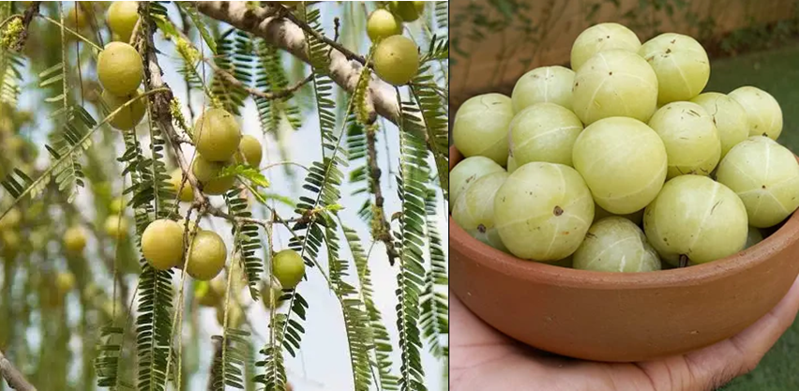
Fig.1: Emblica officinalis Fruit.
Fresh fruits of Emblica officinalis were collected from a local market in India during the winter season (Balaji et al. 2022). The fruits were washed thoroughly with distilled water, sliced into small pieces, and shade-dried for 10–12 days. The dried material was pulverized using an electric grinder and stored in an airtight container at room temperature for further analysis (Godiyal, et al. 2023)
Extraction Process of Emblica officinalis Fruits
Fresh fruits of Emblica officinalis were thoroughly washed with clean water to remove dirt and external contaminants. The cleaned fruits were sliced into small pieces and freeze-dried using liquid nitrogen. The dried fruit material was then finely powdered. From the powdered sample, 5.0 g was accurately weighed, wrapped in cheesecloth, and placed inside the thimble of a Soxhlet extractor. Methanol was selected as the extraction solvent and transferred into a round-bottom flask connected to the Soxhlet extractor and condenser assembly (Harborne et al. 1998). The solvent was heated using a heating mantle. As the solvent vapour entered the extraction chamber, it condensed and dripped onto the fruit powder in the thimble (Mehere et al. 2024). Once the solvent reached the siphon level, it flowed back to the round-bottom flask, initiating the next extraction cycle (Gandhi et al. 2022). This continuous hot-extraction process was carried out for 6 hours to ensure maximum recovery of bioactive phytochemicals from E. officinalis fruits (Singh et al. 2020). After the completion of extraction, the methanolic extract was concentrated and filtered through Whatman No. 41 filter paper. The concentrated extract was then subjected to qualitative phytochemical screening following standard protocols (Priyanka et al. 2020).
Preparation of Standard Solution
“A stock solution of gallic acid was prepared by dissolving 10 mg of accurately weighed gallic acid in methanol and making up the volume to 10 mL with methanol to obtain a final concentration of 1 mg/mL” (Thakker et al., 2011). A working standard solution of gallic acid (1 mg/mL) was further prepared in methanol and serially diluted to obtain concentrations ranging from 50–500 ng/spot for the development of the calibration curve (Wagner & Bladt, 2001).
Gallic acid (analytical grade, ≥98% purity) was procured from a certified supplier (e.g., Sigma-Aldrich, USA / Merck, Germany / HiMedia, India). Methanol of HPLC/analytical grade was obtained from a reputed manufacturer (e.g., Merck, Germany) (Sangeetha et al. 2017). All other chemicals and reagents used during the analysis were of analytical reagent (AR) grade and were used without further purification Prashar, Y., & Patel, N. (2020).
Chromatographic Conditions
“HPTLC aluminium plates pre-coated with silica gel F60₂₅₄ (10 × 10 cm) with 200 μm thickness (E. Merck, Germany) were used as the stationary phase. The plates were pre-washed with methanol and activated at 110°C for 10 minutes prior to chromatography” (Rudakova et al. 2022). “The samples were spotted in the form of bands, of 8 mm, with the help of a Camag 100 microliter syringe using a Camag Linomat V (Switzerland) sample applicator. A constant application rate of 100 nL s^{–1} was employed and the space between two bands was 12 mm. The slit dimension was kept at 6 mm × 0.45 mm, with a scanning speed of 20 mm/second, and a data resolution of 100 μm/step was employed” (Gupta et al. 2024). The mobile phase used was Toluene: Ethyl acetate: Formic acid (5:4:1 v/v/v). The developed plates were dried and scanned at λ = 254 nm using a CAMAG TLC Scanner 3. ICH Q2(R1), 2005; (Pawar et al., 2021). “The linear ascending development was carried out in a twin trough glass chamber saturated with the mobile phase. The optimized chamber saturation time for the mobile phase was 30 minutes at room temperature (25 ± 2°C). The length of the chromatogram run was 80 mm. Subsequently, the plate was allowed to dry at room temperature. The separated bands on the HPTLC plates were scanned over the wavelength of 200 – 400 nm. The source of radiation utilized was the tungsten lamp (or deuterium Illumination). The maximum absorbance was found at 278 nm. The images were captured on Camag reprostar 3 with Vision-CATS software 4.05” (Sawant et al. 2010).
Quantification of Gallic Acid
Quantification was done using peak area values obtained from the HPTLC chromatogram. A calibration curve was prepared from standard gallic acid concentrations, and the amount of gallic acid in the extract was calculated using linear regression analysis (Balkrishna et al. 2025). “The quantitative determination of gallic acid was performed on TLC aluminium plates pre-coated with silica gel 60F-254 as the stationary phase” (Singh et al. 2019). “The linear ascending development was carried out in a twin trough glass chamber saturated with a mobile phase consisting of toluene: ethyl acetate: formic acid (5:4:1) at room temperature (25 ± 2°C). Camag TLC scanner III was used for spectrodensitometric scanning and analysis, in the absorbance mode, at 254 nm” (Patel, N. V. & Telange, D. R., 2011).
Result & Discussion

Percentage Yield
The extractive yield of the methanolic extract of Emblica officinalis fruits was quantitatively determined using the standard gravimetric method. The weight of the empty dish (W₁) was recorded as 43.9776 g, while the weight of the dish containing the dried extract (W₂) was 44.2938 g. The net weight of the extract obtained was 0.3162 g, calculated as (W₂ – W₁). Considering the initial weight of the powdered fruit sample (Wₛ) as 5.0 g, the percentage extractive yield was computed using the formula:
The calculated methanolic extract yield of Emblica officinalis fruits was 6.32%, indicating a moderate concentration of extractable phytochemicals. This result reflects the efficiency of methanol as an extraction solvent due to its high polarity and ability to dissolve a wide range of secondary metabolites, including phenolics, flavonoids, tannins, alkaloids, and glycosides. The yield obtained in this study is consistent with previously reported methanolic extraction ranges for herbal materials, supporting the effectiveness and reproducibility of the adopted extraction procedure.
Table 1: Yield obtained from Emblica officinalis fruits
S. No | Sample | Yield content (%)
1 | Emblica officinalis fruits | 6.32

Calibration Curve and Quantitative Estimation
A calibration curve was constructed using standard gallic acid at three applied volumes (5 µL, 6 µL, and 8 µL). The corresponding peak areas were 0.05820, 0.07145, and 0.09560 AU, respectively (Table 1). A strong linear correlation was observed between the applied concentration and peak area. The calibration followed the regression equation:
Y=1.52x−36.412
where Y represents peak area and x represents concentration (ng/spot). The calculated correlation coefficient (R² = 0.998) demonstrated excellent linearity and suitability of the analytical range (Fig. 3).
Using this equation, the concentration of gallic acid in the methanolic extract of Emblica officinalis was calculated to be 412 ng/spot, indicating that gallic acid is one of the major phenolic constituents present in the extract according to (Zhang et al. 2020).

Method Validation
Method validation was performed following ICH Q2(R1) analytical guidelines. The method demonstrated excellent repeatability, with %RSD values for intra-day and inter-day precision found to be less than 2%, confirming the reliability of the method. Accuracy was assessed through recovery analysis, where gallic acid standard was spiked into pre-analyzed extract. The percentage recovery ranged between 97.8% and 99.4%, indicating high method accuracy.
Specificity testing showed clear separation of gallic acid without interference from other phytochemicals present in the extract. Sensitivity was confirmed by determining the limit of detection (LOD) and limit of quantification (LOQ), which were found to be 0.006 µg/spot and 0.020 µg/spot, respectively. Overall, the developed HPTLC method proved to be precise, robust, accurate, and suitable for routine qualitative and quantitative analysis of gallic acid in Emblica officinalis fruit extract and related herbal formulations.
Table 2: Linear regression data for standard gallic acid at 254 nm
Sr. No. | Concentration (ng) | Volume (µL)Gallic acid | Rf Value | Peak Area (AU) | Regression Equation | Correlation Coefficient (R²)
1 | 500 | 5 | 0.432 | 0.0582 | Y = 1.52x − 36.412 | 0.998
2 | 600 | 6 | 0.432 | 0.07145 | Y = 1.52x − 36.412 | 0.998
3 | 800 | 8 | 0.432 | 0.0956 | Y = 1.52x − 36.412 | 0.998

Table 3: Quantitative estimation of gallic acid in Emblica officinalis extract
Sample | Volume (µL) | Peak Area (AU) | Calculated Concentration (ng/spot)
Emblica officinalis methanolic extract | 5 | 0.0621 | 412 ng/spot
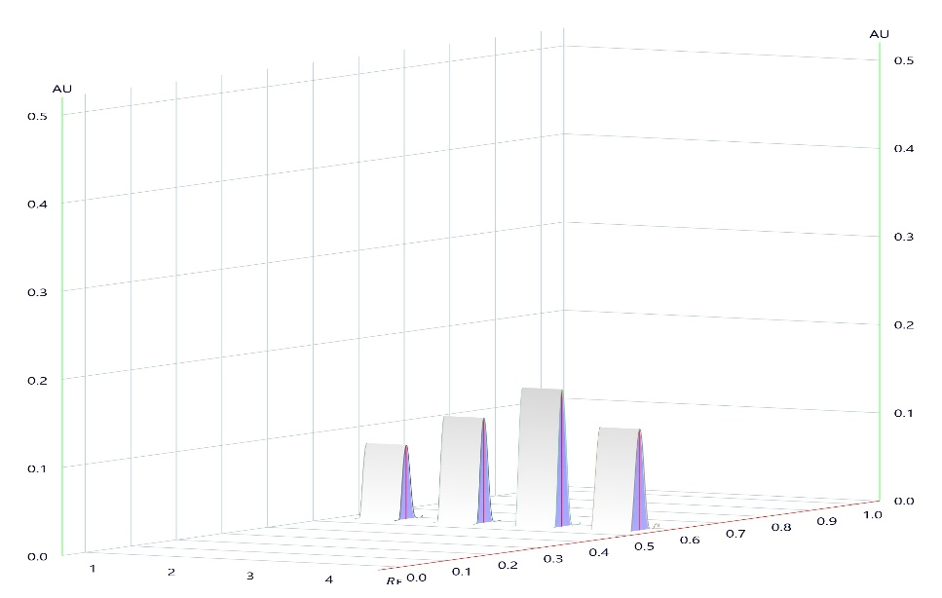

Fig. 2: 3D Densitometric Chromatogram of Gallic Acid Standard and Emblica officinalis Fruit Extract at 254 nm (Jeganathan & Kannan 2008).
Calibration results:
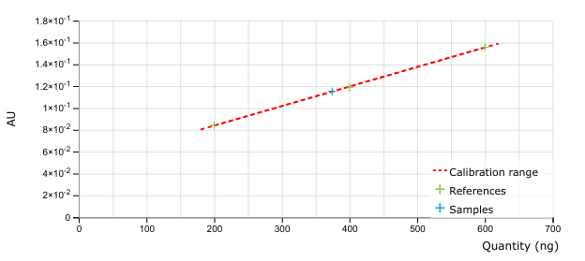
Fig. 3: Area calibration for substance Gallic acid @ 254 nm
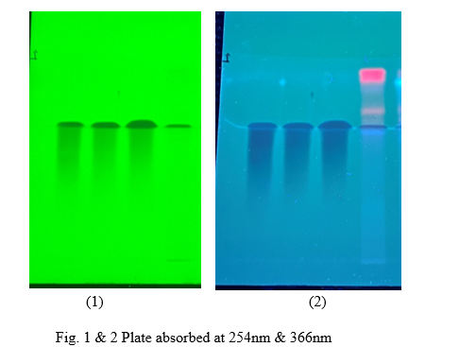

Fig. 4: Plate 1 & 2 : Plate absorbed at 254nm & 366 nm of Emblica officinalis Fruit Extract.
Discussion
The present study reports the successful development and validation of a high-performance thin-layer chromatographic (HPTLC) method for the quantitative estimation of gallic acid in the methanolic fruit extract of Emblica officinalis. Optimization of chromatographic conditions using silica gel 60 F₂₅₄ as the stationary phase and a mobile phase consisting of toluene: ethyl acetate: formic acid (5:4:1, v/v/v) resulted in sharp, compact, and well-resolved bands of gallic acid. The Rf value obtained for gallic acid in the extract (0.43 ± 0.02) closely matched that of the standard, confirming the specificity and selectivity of the developed method without interference from other phytoconstituents.
The methanolic extraction of E. officinalis fruits yielded 6.32%, indicating methanol as an effective solvent for the extraction of polar bioactive compounds such as phenolic acids and tannins. This extractive yield is consistent with earlier reports and reflects the efficiency and reproducibility of the Soxhlet extraction process used in the study.
Quantitative analysis demonstrated excellent linearity of the calibration curve for gallic acid over the selected concentration range, with a correlation coefficient (R²) of 0.998. The strong linear relationship between peak area and concentration confirms the reliability of the method for accurate quantification. Based on the regression equation, the gallic acid content in the methanolic fruit extract was calculated as 412 ng/spot, indicating that gallic acid is a major phenolic constituent of E. officinalis fruits and contributes significantly to its antioxidant potential.
Method validation carried out in accordance with ICH Q2(R1) guidelines established the robustness of the analytical procedure. The method showed excellent precision, with intra-day and inter-day %RSD values below 2%, and high accuracy, as indicated by recovery values ranging from 97.8% to 99.4%. The low limits of detection (0.006 µg/spot) and quantification (0.020 µg/spot) further demonstrated the high sensitivity of the method.

Conclusion
The present study successfully achieved its objective of developing and validating a simple, accurate, and reliable HPTLC method for the qualitative and quantitative estimation of gallic acid in the methanolic fruit extract of Emblica officinalis. The optimized chromatographic conditions produced well-resolved and reproducible peaks with a consistent Rf value, ensuring effective identification of the marker compound. Method validation in accordance with ICH Q2(R1) guidelines demonstrated excellent linearity, precision, accuracy, and sensitivity, confirming the suitability of the method for quantitative analysis. The estimation results established gallic acid as a major phytoconstituent of E. officinalis fruits, supporting its significance as a biochemical marker associated with the plant’s therapeutic and antioxidant properties.
Given the widespread use of E. officinalis fruits in Ayurvedic formulations and nutraceutical preparations, the validated HPTLC method developed in this study provides a practical and efficient analytical tool for routine quality control, standardization, and authentication of raw materials and herbal formulations containing E. officinalis (Patel et al., 2024). The findings reinforce the importance of chromatographic standardization to ensure consistency, safety, and efficacy of herbal products derived from this medicinal plant.

Disclaimer (Artificial intelligence)

Author(s) hereby declare that NO generative AI technologies such as Large Language Models (ChatGPT, COPILOT, etc) and text-to-image generators have been used during writing or editing of manuscripts.

References
- Harborne, A. J. (1998). Phytochemical methods a guide to modern techniques of plant analysis. springer science & business media.
- Lu, Z., Nie, G., Belton, P. S., Tang, H., & Zhao, B. (2006). Structure–activity relationship analysis of antioxidant ability and neuroprotective effect of gallic acid derivatives. Neurochemistry international, 48(4), 263-274.
- Wagner, H., & Bladt, S. (1996). Plant drug analysis: a thin layer chromatography atlas. Berlin, Heidelberg: Springer Berlin Heidelberg.
- Pawar, G., Parihar, S., & Saxena, H. O. (2024). Evaluation of secondary metabolites and chromatographic fingerprint profiling of stem bark of Holarrhena antidysenterica L. The Journal of Phytopharmacology, 13(1), 4-11.
- Kumar, M. M., Sharma, A., Rinka Juneja, D. T. P., Arif, M. M., Singh, M. A. D., & Kumar, A. (2025). Biological Evaluation of Herbal Preparations and Formulation Standardization: A Literature Study. Journal of Neonatal Surgery, 14(8s).
- Priyanka, K., & Ahmad, M. S. (2020). Phytoconstituents characterization of extricates prepared from seeds of Hallucinogenic plants. Indian J. Applied & Pure Bio. Vol, 35(2), 195-204.
- Thakker, V. Y., Shah, V. N., Shah, U. D., & Suthar, M. P. (2011). Simultaneous estimation of gallic acid, curcumin and quercetin by HPTLC method. J Adv Pharm Educ Res, 1, 70-80.
- Borman, P., & Elder, D. (2017). Q2 (R1) validation of analytical procedures: text and methodology. ICH quality guidelines: an implementation guide, 127-166.
- Godiyal, S., & Laddha, K. (2023). Validated high‐performance thin‐layer chromatographic method for quantification of gallic acid and ellagic acid in fruits of Terminalia chebula, Phyllanthus emblica, and Quercus infectoria. Journal of Separation Science, 46(6), 2200991.
- Sawant, L., Pandita, N., & Prabhakar, B. (2010). Determination of gallic acid in Phyllanthus emblica Linn. dried fruit powder by HPTLC. Journal of Pharmacy and Bioallied Sciences, 2(2), 105-108.
- Bhagiya, J., Jani, D., Gohil, A., & Singh, S. (2025). DETERMINATION OF GALLIC ACID CONTENT IN FOUR VARIETIES OF AMALAKI (PHYLLANTHUS EMBLICA LINN.) FRUIT BY HPTLC.
- Patel, K., Vasima, G., Shah, P., & Thakkar, V. (2024). Validated high‐performance thin‐layer chromatographic densitometric method for quantification of gallic acid, quercetin, and ursolic acid in the combined formulation of Emblica officinalis, Punica granatum Linn, and Ocimum sanctum Linn extracts. Separation Science Plus, 7(3), 2300083.
- Bidikar, C. M., Hurkadale, P. J., Nandanwadkar, S. M., Hegde, H. V., Singh, S., Khale, A., & Phanse, M. (2023). High-performance thin-layer chromatography fingerprint profile analysis and spectro-densitometric evaluation of antiproliferative antioxidants such as ellagic acid and gallic acid from four widely used Terminalia species. JPC–Journal of Planar Chromatography–Modern TLC, 36(2-3), 169-178.
- Sheoran, S., Nidhi, P., Kumar, V., Singh, G., Lal, U. R., Sourirajan, A., & Dev, K. (2019). Altitudinal variation in gallic acid content in fruits of Phyllanthus emblica L. and its correlation with antioxidant and antimicrobial activity. Vegetos, 32(3), 387-396.
- Pallavi, R., & Jha, S. (2021). A validated quantification of gallic acid and ellagic acid in Triphala using a high-performance thin-layer chromatography method. JPC–Journal of Planar Chromatography–Modern TLC, 34(5), 447-453.
- Prashar, Y., & Patel, N. (2020). High-performance thin-layer chromatography analysis of gallic acid and other phytoconstituents of methanolic extracts of Myrica nagi fruit. Pharmacognosy Research, 12(2), 95-101.
- Balaji, G., Sangaraju, R., Sinha, S. N., & Shashikala, P. (2022). Identification and characterization of Ethyl gallate from Ethyl acetate fraction of Phyllanthus emblica fruit, and invitro free radical scavenging activity. International journal of health sciences, 6(S8), 2390-2400.
- Balkrishna, A., Verma, S., M, P. R., Joshi, M., Tomer, M., Gohel, V., ... & Varshney, A. (2025). Comprehensive phytochemical profiling of Phyllanthus emblica L. flowers on UHPLC/MS quadrupole time of flight, HPTLC, HPLC, and NMR analytical platforms reveals functional metabolites with potent anti‐inflammatory effects in human (THP‐1) macrophages. Phytochemical Analysis, 36(1), 218-233.
- Sangeetha, S., Malay, K. S., Kavitha, R., Remya, P. N., & Saraswathi, T. S. (2017). Formulation and pharmacokinetic determination of gallic acid in Emblica Officinalis. Int. J. App. Pharm, 9, 9-13.
- Singh, M., Kumar, D., Naman, S., Madhavi, N., Singh, P. A., Bajwa, N., & Baldi, A. (2019). validation of Hptlc method for simultaneous estimation of ascorbic acid and gallic acid in amla juice preparation. J. Drug Deliv. Ther, 9(4), 227-231.
- Gandhi, S. P., Gawhane, A. R., Kapse, S. D., Nagore, D., & Chitlange, S. S. (2022). Validated High Performance Thin Layer Chromatography Method for Simultaneous Estimation for Gallic Acid and Quercetin in Polyherbal Blend and Their Quantitative Estimation.
- Foudah, A. I., Alam, P., Shakeel, F., Alam, A., Salkini, M. A., Alshehri, S., ... & Ross, S. A. (2022). A simple, cost-effective, and green HPTLC method for the estimation of ascorbic acid in solvent and ultrasound-assisted extracts of Phyllanthus emblica, Capsicum annuum, and Psidium guajava. Agronomy, 12(5), 1016.
- Patel, N. V., & Telange, D. R. (2011). Qualitative and quantitative estimation of gallic acid and ascorbic acid in polyherbal tablets. International Journal of Pharmaceutical Sciences and Research, 2(9), 2394.
- Singh, A., Sharma, H., Srivastava, B., & Singh, R. (2020). Markers Assessment in Triphala (Batch-I, II & III) and its ingredients from different geographical locations of India through TPC, TFC, HPLC & HPTLC. Current Traditional Medicine, 6(2), 106-120.
- Mehere, N., Kaushik, S., Upadhyay, M. K., Singh, D., Yadav, P., & Galib, R. (2024). Development of Amla Nutri-bar: Proximate analysis, gallic acid quantification and its validation through HPTLC, and spectroscopy. Journal of Drug Research in Ayurvedic Sciences, 9(Suppl 1), S92-S103.
- Gunjal Sanket, B., & Dighe, P. R. (2022). Analysis of herbal drugs by HPTLC: A review. Asian Journal of Pharmaceutical Research and Development, 10(2), 125-128.
- Gupta, L., Shenoy, A. S., & Tripathy, D. B. (2024). HPLC and HP‐TLC. Advances in Analytical Techniques for Forensic Investigation, 241-269.
- Rudakova, О. V., Gubar, S. M., Smielova, N. M., Кriukova, А. I., Bevz, N. Y., & Georgiyants, V. A. (2022). Selection of “Green” Conditions for Identifying Components in a Combined Medicine by TLC/HPTLC Methods.
- Zhang, Q., Cai, Z., Liu, Y., Lin, H., Wang, Q., Yan, J., ... & Huang, X. (2020). Comparison of bracketing calibration and classical calibration curve quantification methods in establishing a candidate reference measurement procedure for human serum 17β-estradiol by isotope dilution liquid chromatography tandem mass spectrometry. Microchemical Journal, 152, 104270.
- Alam, P., Salem-Bekhit, M. M., Al-Joufi, F. A., Alqarni, M. H., & Shakeel, F. (2021). Quantitative analysis of cabozantinib in pharmaceutical dosage forms using green RP-HPTLC and green NP-HPTLC methods: A comparative evaluation. Sustainable Chemistry and Pharmacy, 21, 100413.

