Range Extension of the Eastern Himalayan species Rohdea wattii (Asparagaceae) to the Eastern Ghats of Odisha, India

ABSTRACT
Rohdea wattii (C.B.Clarke) Yamashita & M.N.Tamura (Asparagaceae), previously known from the Eastern Himalaya, South China and North Vietnam, is here reported for the first time from Eastern Ghats, India. During a recent floristic survey in Odisha state, India, the species was collected from Barbara Reserve Forest, Hatigada, Khordha district. A detailed taxonomic description, information on habitat and phenology, along with colour photographs, are provided to facilitate accurate identification and future field recognition.

Key words: Asparagaceae, Barbara Reserve Forest, Campylandra wattii, Eastern Himalaya, Eastern Ghats

INTRODUCTION
Odisha harbours extensive and ecologically diverse forest ecosystems, covering nearly one-third of its geographical area. These forests encompass tropical semi-evergreen, moist and dry deciduous vegetation types, as well as ecologically significant mangrove ecosystems (Reddy et al., 2013). Among them, Barbara Reserve Forest, located in the Eastern Ghats near Chilika Lake, represents a distinct landscape unit spanning the districts of Khordha, Nayagarh and Ganjam, and supports heterogeneous vegetation, contributing to high floristic diversity (Kumar et al., 2022b). The genus Rohdea Roth comprises about 34 species distributed across the Eastern Himalaya, South China and North Vietnam (Tanaka, 2010; POWO, 2025). In India, the genus is represented by three species: Rohdea eucomoides (Baker) N.Tanaka, R. nepalensis (Raf.) N.Tanaka and R. wattii (C.B.Clarke) Yamashita & M.N.Tamura (Odyuo et al., 2017; POWO, 2025). During ongoing floristic investigations in Odisha (Kumar et al., 2022a, 2022b, 2025; Devi et al., 2023, 2024, 2025; Mishra et al., 2025), an unusual species of Rohdea was collected from Barbara Reserve Forest, Hatigada, Khordha district, at about 120 m a.s.l. Similar recent field-based additions to the flora of Odisha include the report of the Himalayan element Exacum paucisquamum as a first state record from Bonai Forest Division (Sanath Kumar et al., 2022). Detailed morphological examination and comparison with the protologue and type specimens confirmed its identity as R. wattii (Fig. 1), a rhizomatous perennial herb previously known from the Eastern Himalaya. This collection represents the first record of R. wattii from the Eastern Ghats of Odisha. The species was earlier reported from the lower Himalayan ranges of Northeast India, including Arunachal Pradesh, Manipur, Meghalaya, Nagaland and Sikkim (Dhatchanamoorthy et al., 2024; POWO, 2025). Among Indian species of Rohdea, R. wattii is readily distinguished by its elongate, stem-like rhizome with well-developed internodes, elliptic-ovate leaves with 6–7 pairs of primary veins, and a dense, terminal ellipsoid inflorescence bearing light-green, cupulate-subcampanulate flowers. In contrast, R. nepalensis and R. eucomoides typically possess shorter or less elongate rhizomes and differ in leaf shape and inflorescence structure.

MATERIALS AND METHODS
Specimens of Rohdea wattii were collected from Barbara Reserve Forest, Hatigada, Khordha district, Odisha, India. Voucher specimens were processed following standard herbarium techniques (Jain & Rao, 1977) and deposited in the Herbarium of the Ambika Prasad Research Foundation, Cuttack, Odisha. Habitat, habit and floral characters were documented in the field using a Nikon D300S digital camera with an 18–55 mm lens. Field surveys and specimen collection were conducted with prior permission from the Odisha Forest Department, and all activities complied with applicable forest, biodiversity, and ethical regulations governing research in reserve forests. Type specimens at BM, CAL and K were studied through high-resolution digital images available via institutional online databases. Identification of the Odisha collections was confirmed based on decisive characters including the elongate, stem-like rhizome with distinct internodes, elliptic-ovate leaves with 6–7 pairs of primary veins, a dense terminal ellipsoid inflorescence, cupulate-subcampanulate perianth, and included stamens, in agreement with the protologue and subsequent taxonomic treatments. All collections were made legally with institutional and forest department approval, and no protected or threatened species regulations were violated.

RESULTS AND DISCUSSION
Taxonomic treatment
Rohdea wattii (C.B.Clarke) Yamashita & M.N.Tamura, J. Pl. Res. 117(5): 369. 2004. Campylandra wattii C.B.Clarke, J. Linn. Soc., Bot. 25: 78, t. 32. 1889. Tupistra wattii (C.B.Clarke) Hook.f., Fl. Brit. India 6: 325. 1892.
Lectotype (designated by Dhatchanamoorthy et al., 2024): India, Manipur, Kupra, 6000 ft, 6 February 1882, G. Watt 5885 (CAL0000253817!); isolectotypes BM000617038!, K000846034! (Fig. 2).
Remaining syntype: India, Manipur, Mayang, 16 November 1885, C.B. Clarke 42045A (K003735742!, Fig. 3).
Perennial herbs, rhizomatous, 40–60 cm high. Rhizome 20–30 cm long, 1–1.5 cm thick, brownish-yellow when dried, stem like, elongate, terete, slightly curved. Stem as long as rhizome or little shorter, elongate, subterete, glabrous, internodes 1.5–4.5 cm long. Cataphylls or scaly leaves 1–2, present at base of each series of 2–3 consecutive foliage leaves, lanceolate, involute, chartaceous, 4–5.5 cm long, 1.2–1.6 cm wide midway, hyaline along margins, apex acuminate, many-veined. Leaves 6–12, elliptic-ovate or narrowly elliptic, 8–21 × 3.5–7.5 cm, chartaceous, apex acuminate, base cuneate, entire along margins, glabrous; primary veins 6–7 pairs; petiole 5–7 cm long, subcanaliculate, glabrous, basally widened and clasping. Inflorescence a terminal spike, ellipsoid, 2.5–3.5 cm long, densely-flowered, light green, apically terminating with several sterile bracts; peduncle 2.5–3 cm long, glabrous; fertile bracts 2, narrowly lanceolate, 6–15 × 2–5 mm, apex acute-shortly acuminate, minutely denticulate along margins, glabrous. Perianth cupulate-subcampanulate, 8–10 mm across, light green; tube 3.5–5 mm long; lobes 6, broadly ovate-suborbicular, 3–4.5 mm across, hyaline and obscurely-denticulate at margins, acute-shortly acuminate at apex, glabrous. Stamens 6; filaments 2–3 mm long, proximally adnate to tube and widened, incurved above; anther broadly ovate, 1–1.2 mm long, pale green. Ovary slightly depressed globose, 2.2–2.5 mm long, glabrous; style minute, inconspicuous; stigma 3-lobed, lobes ovate. Berries red when ripe, globose, 9–12 mm across, glabrous.

Diagnosis
Rohdea wattii is distinguished from the other Indian congeners (R. nepalensis and R. eucomoides) by the combined presence of an elongate, stem-like rhizome with well-developed internodes, elliptic-ovate leaves with 6–7 pairs of primary veins, and a dense terminal ellipsoid inflorescence bearing light-green, cupulate-subcampanulate flowers with included stamens (Dhatchanamoorthy et al., 2024). The Odisha collection conforms to the species concept of R. wattii through concordance of these decisive characters and agreement with the nomenclatural and typification framework established for the name, based on comparison with the protologue and type-linked material (Dhatchanamoorthy et al., 2024). This diagnostic circumscription is consistent with published taxonomic work in Rohdea (Tanaka et al., 2018).
Phenology: Flowering from late February to early May and fruiting from October to January.

Ecology and habitat: In Odisha, the species occurs in moist deciduous forests, primarily along stream margins within dense forest at about 120 m a.s.l. In the Eastern Himalaya, it is found in moist sites in dense forests, on hillsides and along valleys or streams, between 750 and 3000 m a.s.l. During the present survey, the species was encountered as a small, localized population along the shaded stream margin, indicating that the Odisha occurrence may be rare and potentially vulnerable to microhabitat disturbance.

Species examined: India, Odisha, Khordha district, Hatigada, Barbara Reserve Forest, 19º52ʹ42ʺ N, 85º01ʹ05ʺ E; 120 m a.s.l., 14, November, 2025, R.S Devi 192 (Herbarium of Ambika Prasad Research Foundation, Fig. 4).

Altitudinal and ecological aspects: The present collection from Barbara Reserve Forest at approximately 120 m a.s.l. represents a markedly lower elevational occurrence for Rohdea wattii compared to its previously known distribution in the Eastern Himalaya, where it has been reported from elevations ranging between 750 and 3000 m a.s.l. This unusually low-altitude record may reflect the presence of locally humid, shaded microhabitats along perennial stream margins within dense forest, which partially mimic the mesic conditions typical of montane environments. Similar downward altitudinal extensions have been documented in other forest-understorey taxa in the Eastern Ghats and may indicate broader ecological amplitude than previously recognized or relictual persistence under favourable microclimatic conditions.

Distribution: Bhutan, China, Vietnam and India (Tanaka, 2010; Tanaka et al., 2018). In India, Arunachal Pradesh, Manipur, Meghalaya, Nagaland, Sikkim (Odyuo et al., 2017) and present record from Odisha.

Conclusion
The present study documents the first record of Rohdea wattii from the Eastern Ghats of Odisha, India, extending both the geographical and ecological range of the species beyond its previously known Himalayan distribution. The identification is supported by critical diagnostic morphological characters and comparative evaluation with allied Indian congeners. The occurrence of the species at a markedly lower elevation (~120 m a.s.l.) highlights the role of localized, humid forest microhabitats in facilitating range extension of montane taxa. This finding underscores the floristic significance of the Eastern Ghats and emphasizes the need for continued botanical exploration and conservation attention in under-surveyed forest ecosystems of eastern India.

COMPETING INTERESTS DISCLAIMER:
Authors have declared that they have no known competing financial interests OR non-financial interests OR personal relationships that could have appeared to influence the work reported in this paper.
Ethical Approval:
As per international standards or university standards written ethical approval has been collected and preserved by the author(s).

Disclaimer (Artificial intelligence)
Author(s) hereby declares that NO generative AI technologies such as Large Language Models (ChatGPT, COPILOT, etc.) and text-to-image generators have been used during the writing or editing of this manuscript.

ACKNOWLEDGEMENTS
The authors are thankful to the Divisional Forest Officer (DFO), Khordha Forest Division, Odisha, for granting permission to conduct field surveys, and to the field staff for their assistance during collection. The authors also acknowledge the support and facilities provided by the Ambika Prasad Research Foundation, Cuttack, Odisha.

REFERENCES
- Devi, R. S., Kumar, S., & Singh, R. K. (2023). A new species of Smithia Aiton (Fabaceae) from Odisha state, India. Indian Forester, 149(4), 471–473. https://doi.org/10.36808/if/2023/v149i4/167627
- Devi, R. S., Kumar, S., & Singh, R. K. (2024). Lectotypification of three names in Aeschynomene (Fabaceae), a new species from Odisha, India and a new combination in Ctenodon. Journal of Biodiversity and Conservation, 8(1): 49–62.
- Devi, R. S., Mishra, S., Marndi, S., Singh, R. K., Mishra, A. K., & Kumar, S. (2025). Lindernia tamilnadensis (Linderniaceae), a new record to the flora of Odisha state, India from Mahanadi River areas of Cuttack. Species, 26, e15s1801. https://doi.org/10.54905/disssi.v26i77.e15s1801
- Dhatchanamoorthy, N., Devanathan, K., Lokho, K., Begum, S. N., & Balachandran, N. (2024). Rediscovery and lectotypification of Rohdea wattii (C.B.Clarke) Yamashita & M.N.Tamura (Asparagaceae) from Manipur, India. Phytotaxa, 641(2), 177–182. https://doi.org/10.11646/phytotaxa.641.2.9
- Jain, S. K., & Rao, R. R. (1977). A handbook of field and herbarium methods. Today & Tomorrow’s Printer and Publishers, New Delhi.
- Kumar, S., Marndi, S., Mishra, S., Devi, R. S., & Singh, R. K. (2025). Setaria viridis (L.) P.Beauv.: A new record to the grass flora of Odisha, India. Species, 26, e44s3197. https://doi.org/10.54905/disssi.v26i78.e44s3197
- Kumar, S., Mishra, S., Mishra, A. K., & Kumar, S. N. (2022a). Floral diversity of Koira & Barsuan Ranges of Bonai Forest Division, Odisha. Bonai Forest Division & Ambika Prasad Research Foundation, Odisha.
- Kumar, S. N., Mishra, S., Kumar, S. & Singh, R. K. (2022b). Zehneria bodinieri (H. Lév.) W.J. de Wilde & Duyfjes (Cucurbitaceae) – A new addition to the flora of Odisha, India. Geophytology, 51, 139–142.
- Mishra, S., Sethi, J., Kumar, S., & Singh, R. K. (2025). On the Occurrence of Solena Umbellata (Cucurbitaceae) in Eastern India: A Range Extension from the Western Ghats to Odisha with Detailed Taxonomic Report. Asian Journal of Biology, 21(9), 43–48. https://doi.org/10.9734/ajob/2025/v21i9551.
- Odyuo, N., Roy, D. K., & Averyanov, L. V. (2017). Rohdea extrorsandra (Asparagaceae), a new species from north-eastern India. Phytotaxa, 309(3), 283–287. https://doi.org/10.11646/phytotaxa.309.3.11
- POWO. (2025). Plants of the World Online. Royal Botanic Gardens, Kew. Available from: http://www.plantsoftheworldonline.org/ (accessed 24 November 2025).
- Sanath Kumar, N., Mishra, S., & Kumar, S. (2022). Exacum paucisquamum (Gentianaceae): A new record for Odisha State from Bonai Forest Division, Odisha, India. Asian Plant Research Journal, 10(2), 42–46. https://doi.org/10.9734/aprj/2022/v10i2188
- Reddy, C. S, Jha, C. S., & Dadhwal, V. K. (2013). Assessment and monitoring of long-term forest cover changes in Odisha, India using remote sensing and GIS. Environmental Monitoring and Assessment, 185, 4399–4415. https://doi.org/10.1007/s10661-012-2877-5
- Tanaka, N. (2010). A taxonomic revision of the genus Rohdea (Asparagaceae). Makinoa New Series, 9, 1–54.
- Tanaka, N., Hannon, D. P., Harder, D. K., Averyanov, L. V., & Lahmeyer, S. C. (2018). Rohdea harderi (Asparagaceae), a new species from northern Vietnam. Kew Bulletin, 73, 31. https://doi.org/10.1007/s12225-018-9756-3

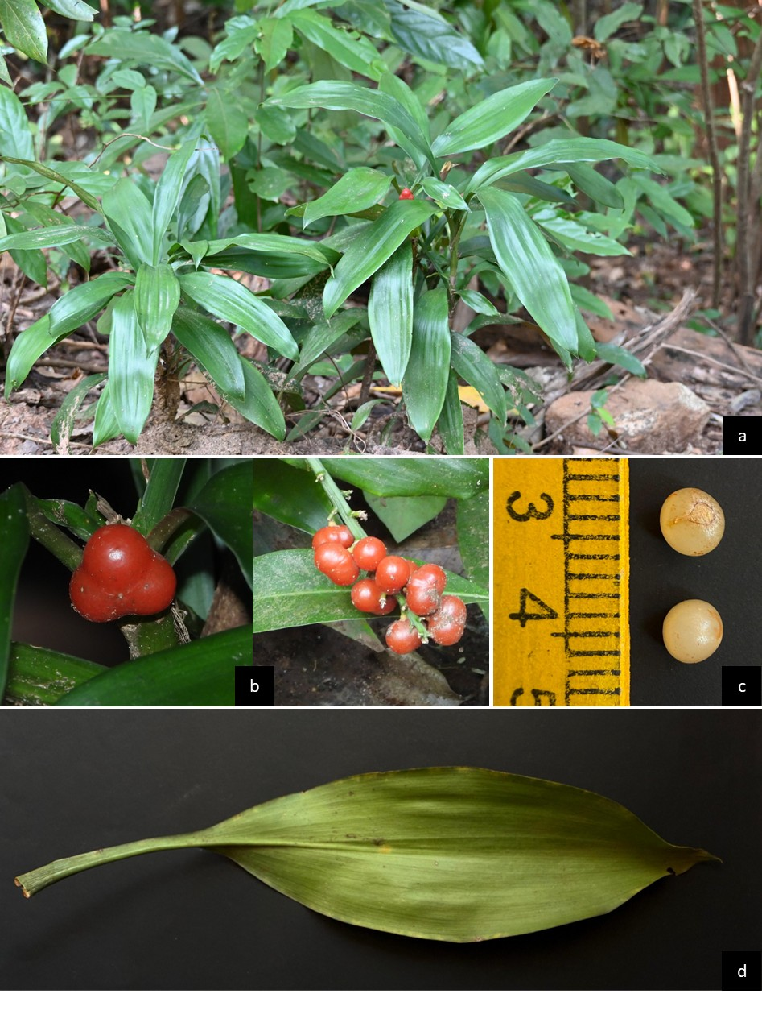
Fig. 1. Rohdea wattii. a) Habitat. b) Fruits. c) Seeds. d) Abaxial leaf surface

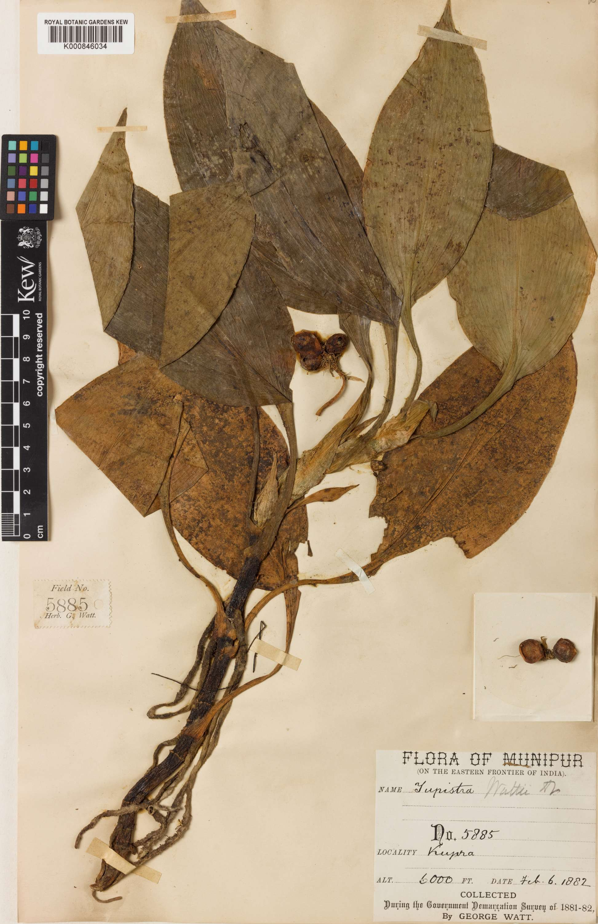
Fig. 2. Isolectotype of Campylandra wattii C.B.Clarke (K000846034).

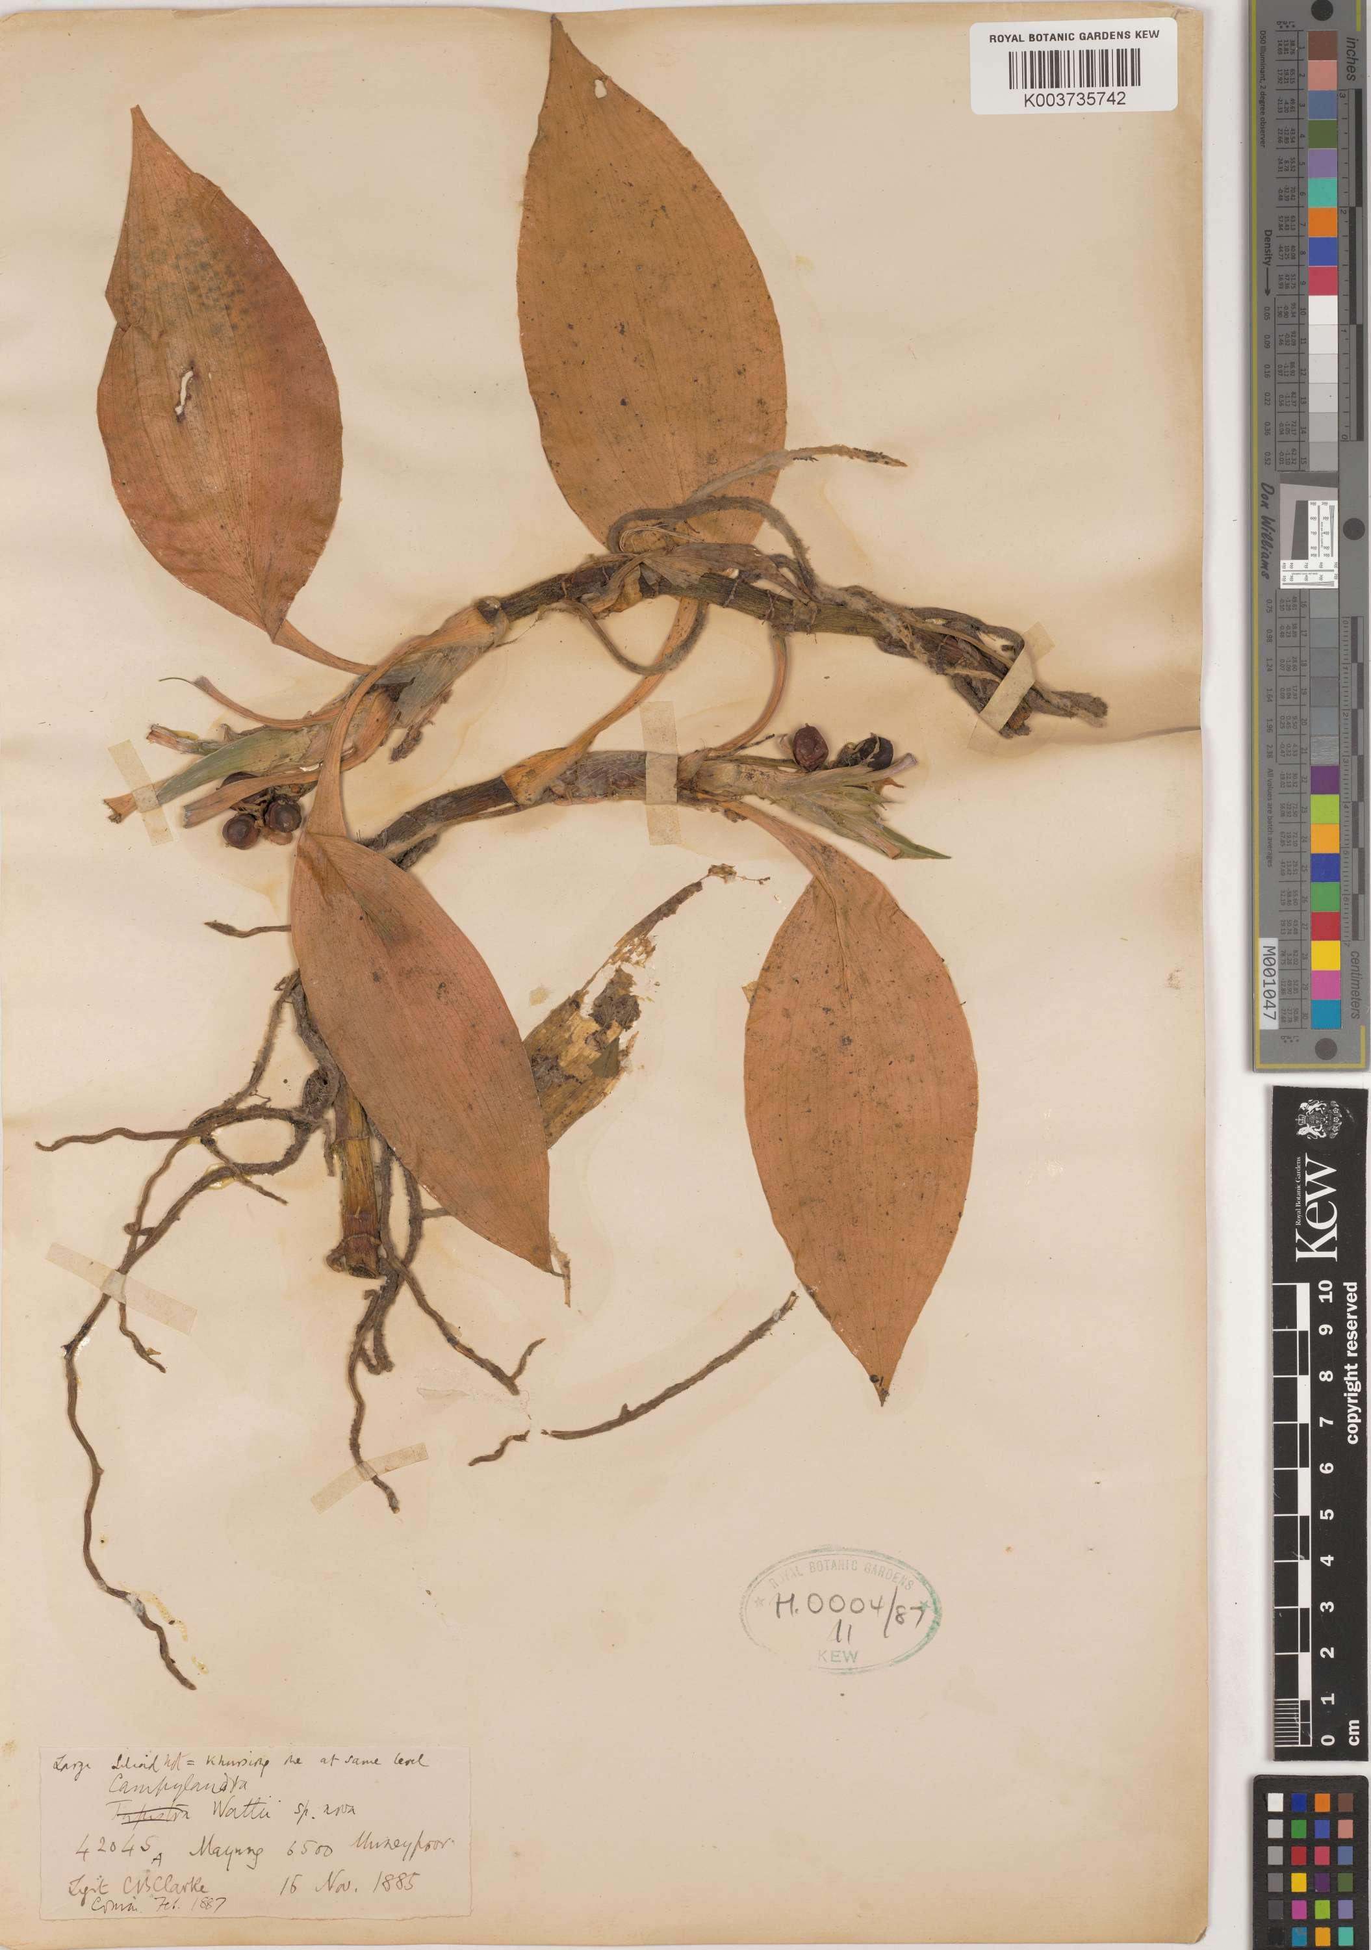
Fig. 3. Remaining syntype of Campylandra wattii C.B.Clarke (K003735742)

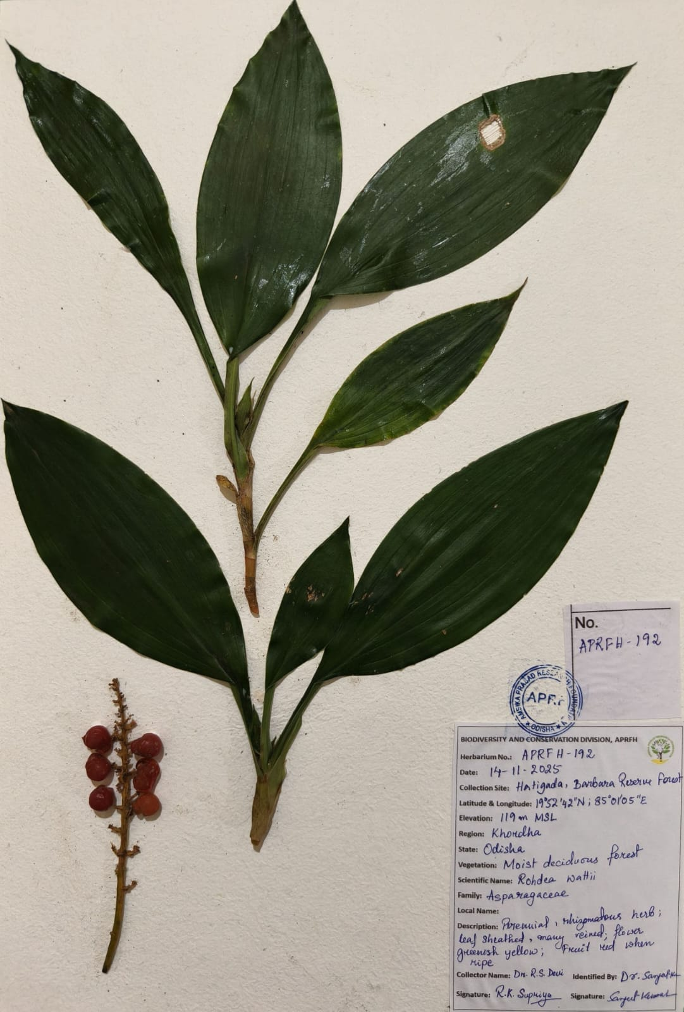
Fig. 4. Herbarium specimen of Rohdea wattii deposited in the Herbarium of the Ambika Prasad Research Foundation.

